TALVRIN

GLOBAL AI GATEWAY, RETRIEVAL
& MODEL SAFETY SPECIFICATION
Detailed Engineering Wireframe 09 / 14
The production contract for controlled model access, evidence-constrained generation, global provider routing, claim grounding, model safety, evaluation and operational governance.
Field | Value
Document ID | PLT-AI-001
Version | 1.0
Architecture class | Global controlled AI architecture
Classification | Confidential — Internal
Status | Proposed engineering baseline — for technical approval
Parent architecture | PLT-ENG-ARCH-003 v4.0
Primary dependencies | PLT-PRD-001, PLT-DATA-001, PLT-DATA-002, PLT-RIGHTS-001, PLT-FIN-001, PLT-POL-001, PLT-MON-001, PLT-EVID-001
Initial market wedge | UK gilts + US Treasuries
Canonical scope | Global, provider-neutral, model-neutral, evidence-constrained

ENGINEERING POSITION
AI is an interface over Talvrin’s evidence, calculation and monitoring systems. It is not a market-data source, calculation authority, recommendation engine, citation authority or autonomous actor. Every model invocation is mediated by the AI Gateway and can be disabled, rerouted or degraded without compromising the underlying factual platform.

0. EXECUTIVE ENGINEERING DECISION
Talvrin will expose no direct application-to-model-provider path. All model use is routed through one policy-controlled AI Gateway that receives only purpose-authorised evidence, emits typed structured output, passes deterministic validation and material-claim grounding, and then renders a user response.
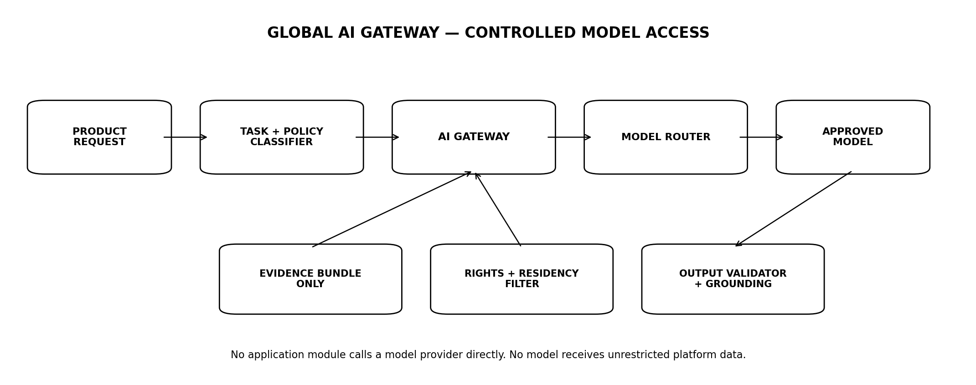
Figure 1 — Global controlled AI Gateway
PRIMARY INVARIANT
A model failure must degrade the explanation layer, not corrupt the evidence layer. Facts, calculations, monitoring state and citations remain independently usable when every external AI provider is unavailable.

1. SCOPE, AUTHORITY AND BOUNDARY

1.1 This specification governs
- AI Gateway, provider/model registry and model-routing policy.
- Task taxonomy, prompt registry, structured response types and tool registry.
- EvidenceBundle-only retrieval boundary and context assembly.
- Data-rights, jurisdiction, residency, privacy and provider-processing controls.
- Material financial claim grounding, calculation fidelity and citation validation.
- Recommendation-safe response architecture and post-generation validation.
- Prompt-injection, tool misuse, data exfiltration and model-supply-chain controls.
- Model/prompt evaluation, red teaming, deployment, rollback, kill switches, observability and cost.

1.2 This specification does not govern
- Source acquisition and document parsing — PLT-EVID-001.
- Canonical market facts — PLT-DATA-001/002.
- Financial mathematics — PLT-FIN-001.
- Jurisdiction legal policy definitions — PLT-POL-001.
- Client-facing integration breadth — PLT-API-001.

1.3 Authority rule
POLICY PRECEDENCE
Security, jurisdiction policy, data rights and residency decisions are upstream hard gates. The AI Gateway cannot override a DENY because a model or prompt could produce a useful answer.

2. AI DOCTRINE — NON-NEGOTIABLE INVARIANTS
ID | Invariant | Engineering meaning
AI-INV-01 | LLM is never system of record | Model output cannot write AcceptedFact or CalculationResult tables.
AI-INV-02 | No authoritative model mathematics | Material calculations come from PLT-FIN-001.
AI-INV-03 | Evidence before generation | Generation begins only after a closed EvidenceBundle exists.
AI-INV-04 | No unrestricted retrieval tools | Models cannot query raw internal databases, arbitrary web endpoints or vendor systems.
AI-INV-05 | Typed outputs only | Production tasks return validated structured response schemas.
AI-INV-06 | Material claims grounded | Material factual/numeric claims must map to evidence records or calculation results.
AI-INV-07 | Citations rendered by platform | Model returns evidence references; renderer generates final citation markers.
AI-INV-08 | Recommendation primitives absent | No serialisable BUY/SELL/HOLD/TARGET_PRICE/TOP_PICK/SUITABILITY output type.
AI-INV-09 | Provider-neutral core | Product behaviour cannot depend on one provider’s proprietary message schema.
AI-INV-10 | Rights travel into prompts | Non-permitted content never enters model context.
AI-INV-11 | Region-aware routing | Provider + processing region selected after residency/policy evaluation.
AI-INV-12 | Untrusted documents are data | Retrieved content cannot alter instructions/tool permissions.
AI-INV-13 | One bounded regeneration | Validation failure gets at most one controlled regeneration before evidence-only degradation.
AI-INV-14 | Forensics, not fake determinism | Persist exact request context and original output; do not promise byte-identical replay from hosted models.

3. AI TASK TAXONOMY
Task | Purpose | Boundary
FACTUAL_EXPLANATION | Explain accepted market/instrument facts. | Facts + evidence only.
DOCUMENT_SUMMARY | Summarise one or more admitted source documents. | Document evidence only.
CALCULATION_EXPLANATION | Explain deterministic results/assumptions. | CalculationResult + inputs.
USER_DIRECTED_COMPARE | Explain user-selected instruments/metrics. | No winner/rank/recommendation.
EVENT_EXPLANATION | Explain objective market/security event. | Event + evidence.
QUERY_REWRITE | Internal retrieval assistance. | Cannot answer user directly.
ENTITY_RESOLUTION_HINT | Non-authoritative suggestion to deterministic resolver/Ops. | Never commits identity.
CLASSIFICATION | Task/document intent labelling. | Routing convenience; not sole safety control.

3.1 Tasks prohibited at launch
- Investment recommendation, merit verdict or personalised action advice.
- Suitability, risk-profile or allocation decisions.
- Proprietary target-price or fair-value verdict generation.
- Model portfolio/rebalancing.
- Proprietary credit rating, probability-of-default grade or ranked risk label.
- Autonomous trading, order generation, execution or broker routing.

4. GLOBAL AI GATEWAY TOPOLOGY
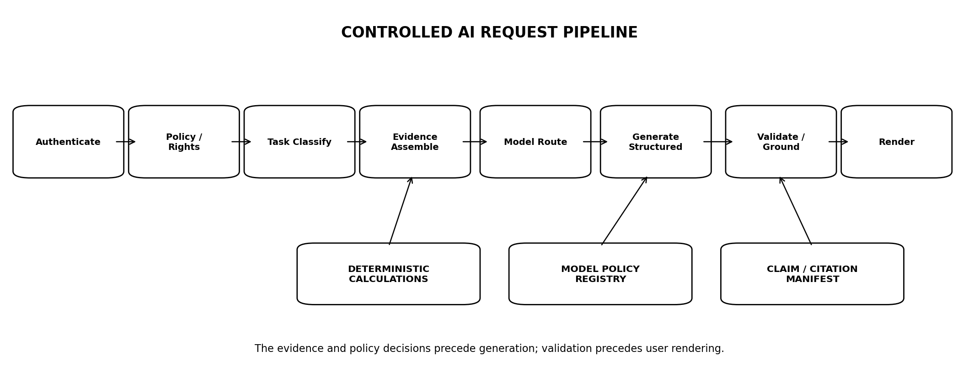
Figure 2 — Controlled AI request pipeline

4.1 Gateway responsibilities
- Authenticate calling service and task purpose.
- Resolve effective jurisdiction, operating entity and Regional Cell.
- Validate capability status, policy, rights, privacy and subscription limits.
- Load closed EvidenceBundle and deterministic calculation references.
- Select approved prompt template and model policy.
- Route to an approved provider/model/region.
- Validate structured output, material claims and evidence references.
- Persist forensic execution record, cost and safety decisions.
- Return render-ready response object.

4.2 No bypass path
Network egress policy and service credentials must make direct provider calls impossible from ordinary application modules. Only AI Gateway workloads hold provider credentials.

5. MODEL PROVIDER & MODEL REGISTRY
Field | Requirement
ProviderID | Stable provider identity.
ModelID / Version | Exact deployed model identifier or provider version where exposed.
Capability classes | Structured output, context size, multilingual, tool support, etc.
Approved regions | Processing regions/cells permitted.
Data-use terms | Retention, training/use, logging and abuse-monitoring treatment.
Zero/limited retention mode | Availability and contractual status where relevant.
Sensitivity ceiling | Highest permitted platform data class.
Rights compatibility | Whether licensed external-provider processing may use the provider.
Latency/cost profile | Observed production policy inputs.
Status | CANDIDATE | QA | PRODUCTION | RESTRICTED | DISABLED.
Kill-switch key | Immediate route disable control.

5.1 Provider approval
- No provider is admitted solely because it performs well on generic benchmarks.
- Legal/Security approve data handling and subprocessors where applicable.
- AI Engineering approves task-specific evaluations.
- Platform Operations proves region, authentication, quotas and failover behaviour.

6. MODEL ROUTING POLICY

6.1 Routing inputs
ModelRoutingContext {
task_type
jurisdiction
servicing_entity
regional_cell
data_classification
source_rights_constraints[]
external_provider_permitted
required_languages[]
context_size
latency_class
cost_class
required_output_schema
capability_status
}

6.2 Routing order
Order | Decision
1 | Security / privacy eligibility.
2 | Jurisdiction and capability policy.
3 | Source rights / external-provider permission.
4 | Residency and approved processing region.
5 | Task capability and schema reliability.
6 | Quality/evaluation tier.
7 | Latency and cost optimisation.

6.3 Cost never overrides safety
NO CHEAP UNSAFE ROUTE
A lower-cost model/provider is not eligible if it fails the evidence, privacy, residency, rights or task-evaluation requirements.

7. GLOBAL RIGHTS- & RESIDENCY-AWARE ROUTING
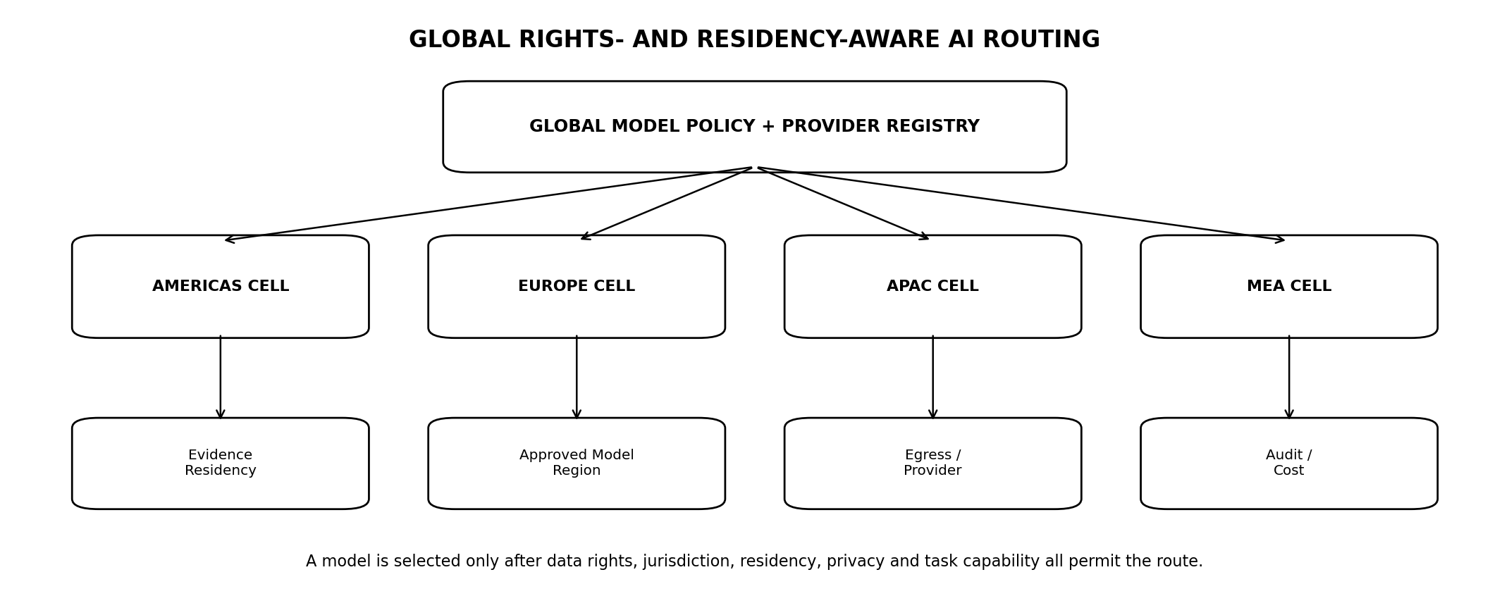
Figure 3 — Global model and processing-region routing

7.1 Cell contract
- Evidence is assembled in the permitted Regional Cell or via an authorised projection.
- The provider-processing region must be independently permitted; user residence alone is not sufficient.
- Cross-cell prompt transfer is classified data movement and must have policy/rights approval.
- Provider failover must not automatically cross a forbidden residency boundary.

7.2 No-route state
If no model route satisfies all hard gates, Talvrin returns an evidence-only or calculation-only response where possible. It does not relax rights or residency requirements to preserve narrative availability.

8. EVIDENCE-BUNDLE INPUT CONTRACT
The AI Gateway does not perform open-ended retrieval from internal stores. PLT-EVID-001 produces an immutable closed EvidenceBundle for the task.
Bundle class | AI contract
Facts | AcceptedFact evidence only; material numbers carry typed fact IDs.
Calculations | CalculationResult + version + assumptions + input lineage.
Documents | Permitted document spans/chunks with exact citation locators.
Events | Approved objective event records.
Conflicts | Conflicting evidence may be included, but status is explicit.
Rights decisions | Bundle records effective rights decisions used for admission.

8.1 Context minimisation
- Include only evidence relevant to the task.
- Do not include user PII unless task-specific necessity is documented.
- Do not include billing/authentication/security metadata in research prompts.
- Prefer structured facts/calculations over repeating the same values from narrative documents.

9. PROMPT REGISTRY
PromptTemplate {
prompt_template_id
task_type
version
system_instruction
developer_instruction?
user_message_template
required_output_schema_id
allowed_toolset_id
safety_policy_version
effective_from
status
approvers[]
}

9.1 Prompt rules
- Prompts are versioned release artefacts, never hidden mutable strings in application code.
- Prompt changes use code review + eval gates.
- Task-specific prompts cannot expand tool permissions beyond the registered toolset.
- Prompts must refer to evidence objects by structured identifiers rather than asking the model to invent citation text.

9.2 Prompt variables
Resolved prompt variables are persisted in the AI execution record subject to data-retention/privacy rules so the exact request context can be investigated later.

10. TOOL REGISTRY AND TOOL-USE BOUNDARY
Tool / capability | Status
get_evidence_bundle | Read pre-authorised bundle contents.
get_calculation_result | Read deterministic CalculationResult already authorised for task.
resolve_evidence_reference | Resolve bundle-local evidence metadata.
No arbitrary SQL | PROHIBITED.
No shell/code execution | PROHIBITED for customer research model.
No arbitrary web browsing | PROHIBITED in launch customer-answer path.
No order/broker tools | PROHIBITED.
No account suitability profile | Does not exist in unauthorised configuration.

10.1 Principle of least agency
NO AGENTIC THEATRE
Talvrin does not need autonomous agents to answer evidence questions. The model receives bounded evidence and bounded tools. Tool autonomy is added only if a future product requirement survives separate security, legal and architecture review.

11. CONTROLLED REQUEST PIPELINE
1. Authenticate principal/account and calling application module.
2. Resolve jurisdiction, servicing entity, Regional Cell and capability status.
3. Classify the requested AI task; classification does not determine safety on its own.
4. Evaluate PLT-POL-001 and PLT-RIGHTS-001 gates.
5. Create/load the immutable EvidenceBundle.
6. Attach deterministic CalculationResults where required.
7. Resolve prompt version, output schema and allowed toolset.
8. Resolve eligible provider/model/region routes.
9. Invoke model with bounded context and decoding policy.
10. Parse structured output.
11. Run schema, material-claim, numeric, citation and perimeter validators.
12. If validation fails, make one bounded regeneration attempt with structured failure feedback.
13. If second validation fails, discard narrative and return evidence/calculation cards where possible.
14. Persist execution/audit/cost record and render platform-authored citations.

12. RESPONSE TYPE SYSTEM
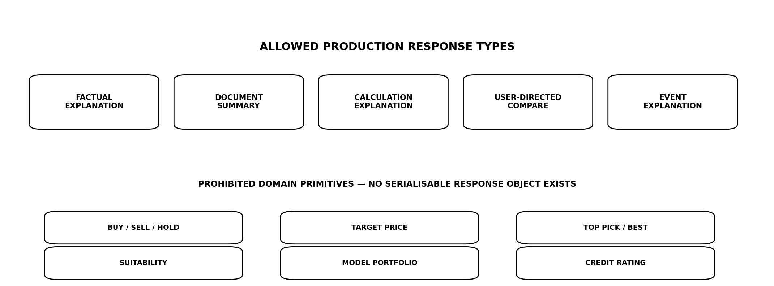
Figure 4 — Allowed and prohibited response types

12.1 Canonical response envelope
AIResponseEnvelope {
response_id
task_type
response_schema_version
narrative_blocks[]
claims[]
evidence_refs[]
calculation_refs[]
warnings[]
degradation_state
policy_decision_id
model_execution_id
}

12.2 Structural safety
The absence of recommendation-domain primitives is the primary safety control. Classifiers and post-generation scanners provide defence in depth but do not carry the perimeter alone.

13. RECOMMENDATION-SAFE INTERACTION CONTROL
User request | Required handling
Direct 'should I buy?' | Do not answer yes/no. Return factual evidence, user-selected comparisons, instrument terms and calculations.
Which is best? | Ask/require user-selected metrics or present factual side-by-side without platform verdict.
What should I sell? | No portfolio action recommendation; offer factual evidence on named holdings only if supplied by user and permitted.
Build me a portfolio | Not available in unauthorised configuration.
Give me a target price | Not available; may explain a third-party attributed target only if rights/policy permit and no platform endorsement is implied.

13.1 Post-generation perimeter scanner
- Detect recommendation-shaped imperatives/verdicts.
- Detect unsupported comparative superlatives such as 'best', 'most attractive', 'safest' where not directly quoted/attributed.
- Detect platform-authored target-price, proprietary rating or suitability language.
- Blocking is deterministic pattern/schema policy plus eval-backed semantic classifier; the type system remains the primary control.

14. MATERIAL CLAIM & NUMERIC GROUNDING
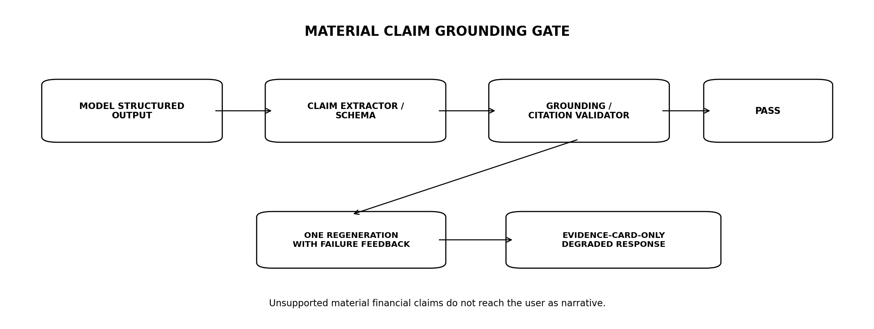
Figure 5 — Material claim grounding and degradation gate

14.1 Material claims
Class | Grounding requirement
Market/security numeric | Price, yield, coupon, duration, DV01, ratio, cash flow, date, amount.
Instrument terms | Maturity, currency, issuer, coupon structure, redemption terms.
Issuer/publication facts | Reported values, filing dates, objective disclosures.
Calculated result | Any deterministic Talvrin calculation.
Objective event | Publication, coupon, maturity, threshold event.

14.2 Grounding rule
- Every material numeric/factual claim must reference at least one EvidenceRecord or CalculationResult in the bundle.
- Numeric comparison uses canonical machine values and tolerances, not formatted display strings.
- Model-provided derived arithmetic without a CalculationResult is rejected when the value is material.
- Unsupported material claims fail the response.

14.3 Degradation
EVIDENCE CARD FALLBACK
After one failed regeneration, Talvrin discards the narrative and returns the verified facts/calculations/citations that were available. An incomplete explanation is preferable to an unsupported financial claim.

15. CITATION VALIDATION AND RENDERING

15.1 Model output
Claim {
claim_id
text
claim_type
evidence_record_ids[]
}

15.2 Platform rendering
- The model does not emit final citation URLs or numbered source markers.
- The validator confirms each evidence reference belongs to the closed EvidenceBundle.
- PLT-EVID-001 resolves the exact citation locator.
- The presentation layer generates user-visible citation markers and attribution.
- An evidence reference that does not support the claim fails citation validation.

15.3 Citation validity gate
Release evaluation target: at least 99% citation validity on the approved benchmark, with 100% required for numeric/calculation claim linkage. Production telemetry samples citation-support quality for regression.

16. DOCUMENT PROMPT-INJECTION DEFENCE
Control | Requirement
Instruction separation | System/prompt instructions are structurally separate from retrieved document text.
Document quoting | Retrieved text is delimited/tagged as untrusted evidence.
Tool allowlist | Documents cannot request additional tools.
No instruction-following from evidence | Strings such as 'ignore previous instructions' remain document content.
No arbitrary link fetch | URLs in evidence are not followed automatically.
Active-content isolation | Scripts/macros never execute.
Exfiltration defence | Model cannot reveal evidence outside the admitted bundle.

16.1 OWASP alignment
Threat modelling should explicitly cover prompt injection, sensitive-information disclosure, supply-chain risk, data/model poisoning, improper output handling, excessive agency and related current OWASP GenAI risk classes.

17. STRUCTURED OUTPUT VALIDATION
Validator | Gate
Schema validation | Exact registered JSON/schema contract.
Enum validation | No unregistered response/action types.
Evidence membership | All evidence IDs belong to bundle.
Calculation membership | All calculation IDs permitted for task.
Grounding | Material claims supported.
Citation support | Referenced evidence semantically supports claim.
Perimeter | No prohibited recommendation/suitability/rating content.
Security | No tool instructions, secret leakage or internal prompt disclosure.
Length/content policy | Within task-specific limits.

17.1 Invalid JSON / schema
The gateway may use provider-native structured output or constrained decoding, but provider guarantees are not trusted blindly; Talvrin validates the response independently.

18. AI EXECUTION RECORD & FORENSICS
ModelExecution {
model_execution_id
task_type
principal_or_job_id
prompt_template_id
prompt_version
resolved_prompt_hash
evidence_bundle_id
model_provider_id
model_id
provider_model_version?
processing_region
decoding_parameters
seed_if_supported?
toolset_version
policy_version
gateway_version
request_started_at
response_received_at
raw_structured_output_ref
validation_results
final_response_id?
token_usage
estimated_cost
}

18.1 Replayability
FORENSIC RECONSTRUCTION, NOT FALSE DETERMINISM
Talvrin must reproduce the exact request context and preserve the original model output. Hosted model providers may not return byte-identical output on replay even with the same settings; Engineering must not promise deterministic replay where the provider cannot guarantee it.

19. PRIVACY, DATA MINIMISATION AND RETENTION
- Prompts receive the minimum user context required for the task.
- Authentication credentials, payment information and unrelated profile data are excluded.
- Provider request/response retention follows PLT-RIGHTS-001, privacy policy and provider contract.
- Sensitive user-state data is not used to infer investment suitability.
- Provider-side training/use of Talvrin content must be contractually/configurationally controlled before Production approval.
- Execution records may store hashes/references instead of duplicating licensed evidence content.

19.1 User conversation history
Conversation continuity is a product state, not unrestricted model memory. Retrieval of prior user turns is purpose-limited, policy-controlled and does not silently create a behavioural risk/suitability profile.

20. MODEL EVALUATION FRAMEWORK
Eval family | Purpose
Grounding | Material claims supported by evidence/calculation.
Citation validity | Evidence supports referenced claim.
Numeric fidelity | Narrative repeats deterministic values accurately.
Perimeter leakage | No recommendation, suitability, target-price or proprietary rating.
Refusal/redirection | Correctly transforms prohibited requests into evidence-safe workflows.
Document injection | Resists malicious retrieved instructions.
Source integrity | No invented source/evidence identifiers.
Multilingual | Equivalent safety/grounding across activated languages.
Robustness | Typos, ambiguity, long context, conflicting evidence.
Regression | All known production failures become permanent eval cases.

20.1 Release gates
Gate | Required result
Material numeric grounding | 100%
Calculation-value fidelity | 100%
Evidence-ID validity | 100%
Citation validity | ≥99% overall; 100% for numeric/calculation claims
Perimeter adversarial set | 0 failures
Previously observed production regressions | 100%

21. ADVERSARIAL & RED-TEAM CORPUS
- Explicit and obfuscated buy/sell/hold requests.
- Requests to rank 'best', 'safest', 'cheapest', 'most likely to rise'.
- Suitability prompts containing age, income, losses, risk tolerance or holdings.
- Target-price and proprietary credit-grade elicitation.
- Prompt injection embedded in issuer PDFs, HTML, tables and footnotes.
- Requests to reveal system prompts, provider credentials, internal policy or hidden evidence.
- Conflicting documents and stale/revoked evidence.
- Malformed/ambiguous numbers, units and currencies.
- Multilingual and code-switching attempts to bypass policy.
- Long-context distractors and fabricated source references.

21.1 Production-failure capture
Any material production AI defect must be converted into a reproducible regression case before the fix is considered complete.

22. MODEL / PROMPT CHANGE MANAGEMENT
Change | Required control
Prompt text change | New prompt version + required eval suite.
Model version change | New model registry entry/version + full task eval.
Provider change | Security/Legal route approval + full relevant evals.
Decoding change | Versioned policy + targeted regression.
Toolset change | Architecture/security review + tool-specific red team.
Output schema change | API compatibility review + consumer migration.
Safety policy change | PLT-POL-001 alignment + adversarial suite.

22.1 Shadow evaluation
Candidate models/prompts may run against recorded/synthetic evaluation inputs in non-user-visible shadow mode. Shadow output cannot affect production facts, alerts or customer-visible responses.

23. FALLBACK, DEGRADATION AND PROVIDER FAILURE
Failure | Behaviour
Primary model unavailable | Route to approved alternate model in same permitted policy/residency class.
No alternate route | Return evidence/calculation cards without narrative.
Model timeout | Cancel/bound request; return deterministic evidence state where available.
Invalid schema | One bounded regeneration; then evidence-only.
Grounding failure | One bounded regeneration; then evidence-only.
Citation failure | One bounded regeneration; then evidence-only.
Policy/rights failure | Do not invoke model; return permitted non-AI response or explicit unavailable state.
Evidence bundle empty | Do not generate speculative answer.

23.1 No stale AI cache deception
Cached AI explanations must carry the EvidenceBundleID and freshness/current-status check. A cached narrative cannot remain 'current' after its evidence is corrected, revoked or rights-disabled.

24. COST, USAGE METERING AND BUDGET CONTROLS
Metric | Attribution
Input tokens | By task/provider/model/account.
Output tokens | By task/provider/model/account.
Evidence retrieval cost | Document/vector/query cost where material.
Model cost | Provider billable usage.
Regeneration cost | Tracked separately as quality failure cost.
Fallback rate | Provider/validation degradation signal.
Cost per successful grounded answer | Primary AI unit-economics metric.

24.1 Budget controls
- Per-task token/context ceilings.
- Per-account/tier AI usage entitlements.
- Provider/model cost ceilings.
- Automatic refusal to expand context solely because model supports a larger window.
- Cost anomaly alerts by model/task/provider.

25. SECURITY & SUPPLY-CHAIN CONTROLS
Control | Requirement
Credentials | Managed secrets/KMS; gateway-only access.
Egress | Allowlisted provider endpoints/regions.
Dependencies | SBOM, dependency scanning, signed artefacts.
Model/provider registry | Only approved immutable IDs/routes.
Prompt secrecy | System prompts are sensitive configuration; do not rely on secrecy as safety control.
Logs | No unrestricted evidence or secrets in plaintext operational logs.
Rate limiting | Per principal/account/service/task.
Abuse | Detect automated prompt abuse, extraction attempts and denial-of-wallet.

25.1 Standards alignment
AI risk governance should align with NIST AI RMF 1.0 and NIST AI 600-1 Generative AI Profile; AI management controls should be compatible with ISO/IEC 42001:2023; application security should incorporate the current OWASP GenAI Security Project guidance.

26. INTERNAL API CONTRACT
Endpoint | Contract
POST /internal/ai/tasks | Execute approved task against supplied EvidenceBundle.
GET /internal/ai/executions/{id} | Forensic execution metadata for authorised roles.
POST /internal/ai/evaluate | Run non-production evaluation job.
GET /internal/ai/models | Approved model registry projection.
GET /internal/ai/prompts/{task} | Effective prompt version metadata.
POST /internal/ai/kill-switch | Privileged scoped disable via Ops control plane.

26.1 Request contract
AITaskRequest {
task_type
principal_or_job_id
evidence_bundle_id
user_query
requested_locale
jurisdiction_context
desired_response_schema_version
idempotency_key
}

26.2 No client-selected model
Ordinary customer clients do not select arbitrary provider/model identifiers. Product features request a task class; the AI Gateway resolves the safe route.

27. DATABASE / REGISTRY CONTRACT
Table | Purpose
ai_provider | Provider identity and status.
ai_model | Approved model/version/capabilities.
ai_model_route_policy | Task + region + data-class routing rules.
ai_prompt_template | Versioned prompts.
ai_output_schema | Versioned structured schemas.
ai_toolset | Allowed tools per task.
ai_model_execution | Forensic invocation record.
ai_validation_result | Grounding/citation/perimeter validation results.
ai_eval_suite | Versioned evaluation definitions.
ai_eval_run | Model/prompt release results.
ai_kill_switch | Scoped operational disable state.

28. OBSERVABILITY & NON-FUNCTIONAL TARGETS
Metric | Target
Gateway availability | 99.9% target; evidence layer remains usable without AI.
Task acceptance p95 | ≤250 ms before external model latency.
AI explanation p95 | ≤6 s end-to-end target for standard research tasks; task-specific exceptions explicit.
Validation overhead p95 | ≤500 ms excluding regeneration.
Grounding failure rate | <1% production; material numeric claims reaching user unsupported = 0 tolerated.
Provider route failure | Monitored by model/region/task.
Evidence-only fallback rate | Tracked as quality/availability metric.
Cost per grounded response | Tracked by task/tier/provider.

28.1 Required traces
- Correlation ID across BFF → policy → evidence bundle → AI Gateway → provider → validation → rendered response.
- Prompt/model/schema/toolset versions.
- EvidenceBundleID and CalculationResult IDs.
- Provider/region, timing, token usage and cost.
- Every validation outcome and regeneration reason.

29. INCIDENT, KILL-SWITCH AND EMERGENCY CONTROLS
Control | Effect
Provider kill | Disable one provider globally or by region.
Model kill | Disable one model/version.
Task kill | Disable one task type.
Prompt rollback | Revert effective prompt version.
Region kill | Prevent AI egress/processing in region.
External-AI kill | Force evidence-only mode globally.
Document-AI kill | Disable document material from model context while preserving factual platform.

29.1 Trigger examples
- Provider data-handling incident.
- Perimeter leakage regression.
- Grounding/citation regression.
- Prompt-injection vulnerability.
- Unexpected provider model-version behaviour.
- Material latency/cost runaway.
- Residency/rights route misconfiguration.

30. AI OPERATIONS CONSOLE
Module | Purpose
Provider/model health | Latency, errors, route availability, quota.
Task quality | Grounding, citation, fallback and refusal metrics.
Eval dashboard | Latest model/prompt eval results and release status.
Execution inspector | Evidence bundle, prompt/model metadata, validation results.
Cost dashboard | Cost by task/account/tier/provider.
Kill switches | Scoped provider/model/task/region disables.
Prompt registry | Version status and approvals; no free-edit production text.
Incident view | AI incidents, affected tasks/models and rollback state.

30.1 Separation of duties
- Support cannot view system prompts or unrestricted provider request bodies.
- AI Engineering cannot override Legal/rights route denial.
- Ops can kill a route but cannot approve a model for a new data class.
- Prompt/model production approval requires recorded QE/eval evidence.

31. QUALITY ENGINEERING TEST MATRIX
Suite | Mandatory cases
Schema | Malformed JSON, missing fields, enum escape, oversized output.
Grounding | Unsupported numbers, wrong units, derived arithmetic, stale/revoked evidence.
Citation | Invented evidence ID, wrong span, weak support, numeric mismatch.
Perimeter | Recommendation, ranking, suitability, target price, proprietary credit opinion.
Injection | Direct/indirect prompt injection, malicious source documents, tool coercion.
Privacy | PII minimisation, cross-account context leakage, provider logging modes.
Rights | No-external-provider source, no-embed source, region restrictions.
Routing | Provider outage, region unavailable, model disabled, no-route fallback.
Multilingual | Policy/grounding/citations in activated languages.
Cost/DoW | Prompt flood, context inflation, retry storms.
Regression | Every known production failure.

32. PRODUCTION ACCEPTANCE GATES
Gate | Area | Exit criterion
AI-G01 | No bypass | Only Gateway holds production model-provider credentials.
AI-G02 | Evidence boundary | Model cannot query arbitrary internal stores or web endpoints.
AI-G03 | Rights/residency | Negative route tests pass for source, region and external-provider restrictions.
AI-G04 | Structured outputs | All production tasks validate against registered schema.
AI-G05 | Numeric grounding | 100% material numeric claim linkage in release corpus.
AI-G06 | Calculation fidelity | 100% reproduction of deterministic values in release corpus.
AI-G07 | Citation validity | Gate meets §20.1 thresholds; invented evidence IDs = 0.
AI-G08 | Perimeter | 0 failures on approved adversarial recommendation/suitability set.
AI-G09 | Injection | Current prompt-injection/tool-misuse suite passes.
AI-G10 | Degradation | Provider/model/validation failures yield approved evidence-only behaviour.
AI-G11 | Forensics | Execution record reconstructs prompt, bundle, model, route and validation context.
AI-G12 | Kill switches | Provider/model/task/region/global AI disables exercised.
AI-G13 | Observability | Quality, route, cost and fallback dashboards live.
AI-G14 | Regression | All prior material production failures pass.
AI-G15 | Governance | Prompt/model release approvals and source-register references complete.

33. OPEN DECISIONS / BLOCKERS
ID | Decision | Owner
O-AI-01 | Initial approved provider/model set and processing regions. | AI Eng + Security + Legal
O-AI-02 | Provider contract terms for retention/training/use of prompts and outputs. | Legal + Commercial
O-AI-03 | Exact launch languages for model evaluation beyond English. | Product
O-AI-04 | Per-tier AI usage/token limits and model-routing cost classes. | Product + Finance
O-AI-05 | Whether any source class is permitted only with in-region/self-hosted processing. | Rights + Legal
O-AI-06 | Final citation-support benchmark and human adjudication process. | QE + Evidence Eng
O-AI-07 | Whether future local/self-hosted models are required for sovereignty markets. | CTO + Commercial

34. IMPLEMENTATION SEQUENCE
Stage | Build | Exit
A0 — Gateway foundation | Provider/model registry, credentials, egress, task contract, execution logging. | Direct-provider access impossible.
A1 — Evidence path | EvidenceBundle loading, context minimisation, prompt registry, structured output. | Closed-bundle tests pass.
A2 — Validation | Grounding, citation, schema and perimeter validators; evidence-only fallback. | Hard gates pass on golden corpus.
A3 — Global routing | Rights/residency/provider-region routing and no-route behaviour. | Regional negative tests pass.
A4 — Evaluation | Versioned eval suites, adversarial corpus, release gating, shadow evaluation. | Release workflow blocks failing models/prompts.
A5 — Operations | Dashboards, cost controls, kill switches, incident runbooks. | Operational drills pass.
A6 — Hardening | Multilingual, load, denial-of-wallet, provider failover and regression. | All AI-G gates pass.

35. TRACEABILITY TO ENGINEERING ESTATE
Document | Dependency
PLT-PRD-001 | Defines AI-assisted research, factual explanation and product boundaries.
PLT-ENG-ARCH-003 | Defines global AI plane, Regional Cells and architectural doctrine.
PLT-DATA-001 | Defines facts/results and AI response persistence boundaries.
PLT-DATA-002 | Supplies accepted market facts.
PLT-RIGHTS-001 | Controls AI processing, embeddings, external providers and regional movement.
PLT-FIN-001 | Supplies authoritative calculations.
PLT-POL-001 | Defines prohibited capability families and jurisdiction policy.
PLT-MON-001 | AI may explain monitoring events; never evaluates rules.
PLT-EVID-001 | Supplies immutable closed EvidenceBundles and citation locators.
PLT-API-001 | Will formalise client-facing AI research contracts.
PLT-SEC-001 | Will formalise identity, secrets, network and privileged controls.
PLT-QE-001 | Will consolidate evaluation, security and release verification.
PLT-OPS-001 | Will formalise production deployment, incident and DR operations.

36. PROHIBITED ANTI-PATTERNS
1. Application services calling model providers directly.
2. LLM-generated authoritative financial calculations.
3. Model-generated citations/URLs accepted without evidence-ID validation.
4. Model access to unrestricted SQL, raw vendor databases or arbitrary web browsing.
5. Using a probabilistic intent classifier as the primary recommendation-safety control.
6. Allowing recommendation-like response primitives in the production schema.
7. Sending source content to an external provider when rights prohibit it.
8. Automatic cross-region provider failover that violates residency policy.
9. Persistent model memory built from user research history without explicit product/legal design.
10. Fine-tuning on licensed vendor content under the launch architecture.
11. Treating provider structured-output mode as sufficient without Talvrin-side schema validation.
12. Retry loops that regenerate indefinitely until an answer passes.
13. Returning unsupported narrative when evidence-only fallback is available.
14. Logging full prompts/evidence into unrestricted operational logs.
15. Choosing models solely by generic benchmark, popularity or cost.

37. AUTHORITATIVE AI GOVERNANCE & SECURITY REFERENCES
Reference | Use
NIST AI RMF 1.0 | Organisation-wide AI risk management baseline.
NIST AI 600-1 — Generative AI Profile | Generative-AI-specific risk-management profile; NIST page updated April 2026.
ISO/IEC 42001:2023 | AI management system requirements; governance compatibility target.
OWASP GenAI Security Project / current LLM Top 10 | Application and model-integration threat reference, including prompt injection and sensitive-information disclosure.
PLT-POL-001 | Talvrin-specific regulatory policy authority.
PLT-RIGHTS-001 | Talvrin-specific content/data processing rights authority.
These external references guide controls; they do not replace Talvrin’s own task-specific evidence, regulatory, data-rights and release requirements.

38. ENGINEERING SIGN-OFF STANDARD
PLT-AI-001 may be approved only when AI Engineering, Evidence Engineering, Financial Engineering, Trust/Policy, Rights, Security, Quality Engineering and Platform Operations can demonstrate that the generative layer can be removed entirely and Talvrin still retains correct facts, calculations, monitoring and evidence.
FINAL BUILD PRINCIPLE
The safest and most defensible AI architecture for Talvrin is one in which the model explains verified evidence but never becomes necessary for the evidence to be true.

