TALVRIN

GLOBAL APPLICATION API
& INTEGRATION CONTRACT
Detailed Engineering Wireframe 10 / 14
The stable interface contract between Talvrin clients, backend domains and approved external integrations.
Field | Value
Document ID | PLT-API-001
Version | 1.0
Architecture class | Global client/API integration contract
Classification | Confidential — Internal
Status | Proposed engineering baseline — for technical approval
Parent architecture | PLT-ENG-ARCH-003 v4.0
Primary dependencies | PLT-PRD-001, PLT-DATA-001, PLT-DATA-002, PLT-RIGHTS-001, PLT-FIN-001, PLT-POL-001, PLT-MON-001, PLT-EVID-001, PLT-AI-001
Canonical scope | Global web, mobile, internal-ops and future enterprise/API clients

ENGINEERING POSITION
Talvrin’s public/client API is a stable product contract, not a mirror of internal tables or modules. Clients request business capabilities; the server resolves policy, rights, entitlements, jurisdiction, residency and data-source details behind the contract.

0. EXECUTIVE ENGINEERING DECISION
Talvrin will use a versioned REST/JSON API as the primary client contract, with asynchronous job resources for long-running work and SSE/WebSockets only where a demonstrable product requirement justifies a live connection. Internal module/event contracts remain private.
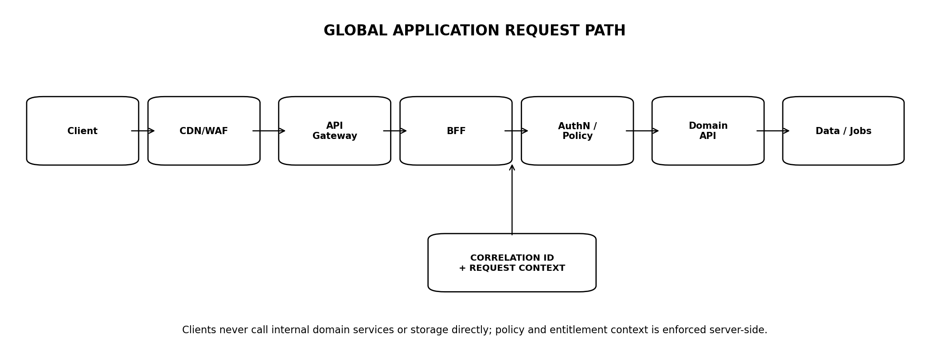
Figure 1 — Canonical global application request path
PRIMARY INVARIANT
No client can bypass authentication, policy, rights, entitlement, capability status or Regional Cell routing by calling a lower-level service endpoint.

1. SCOPE AND AUTHORITY
- Resource naming, request/response envelopes and stable client-facing semantics.
- Authentication/authorisation context propagation.
- REST endpoint standards, filtering, sorting, pagination and field selection.
- Idempotency and optimistic concurrency.
- Asynchronous jobs, server-sent events and future webhook contracts.
- Errors, degradation, warnings and retry semantics.
- Rate limits, quotas and abuse controls.
- Versioning, compatibility, deprecation and schema governance.
- API observability, documentation, SDK generation and acceptance gates.

1.1 Out of scope
- Internal database schema — PLT-DATA-001.
- Domain calculation/evidence/monitoring rules — their owning specifications.
- Detailed identity/security controls — PLT-SEC-001.
- Production infrastructure and deployment — PLT-OPS-001.

1.2 Authority rule
DOMAIN OWNS MEANING
PLT-API-001 owns transport and contract semantics. Domain specifications own business meaning. The API layer must not re-implement financial, evidence, monitoring or regulatory logic.

2. API DOCTRINE — NON-NEGOTIABLE INVARIANTS
ID | Invariant | Meaning
API-INV-01 | Business resources, not tables | URLs/resources do not expose database design.
API-INV-02 | Server-side policy | Client-supplied jurisdiction/tier/rights claims are hints at most, never authority.
API-INV-03 | Stable machine contracts | Enums, errors, pagination and IDs are versioned.
API-INV-04 | Opaque IDs | Internal IDs are non-semantic and brand-neutral PLT-prefixed/opaque identifiers.
API-INV-05 | Idempotent mutations | Retry-safe creation and command endpoints.
API-INV-06 | Explicit time | All timestamps are ISO-8601/RFC3339-style UTC instants; market/user time zones are separate fields.
API-INV-07 | Explicit money | Amount always travels with currency; no implicit account/locale currency.
API-INV-08 | Explicit units | Financial metrics carry unit/scale/convention metadata.
API-INV-09 | No silent degradation | Stale/delayed/unavailable/restricted states are explicit.
API-INV-10 | No internal errors leaked | Stack traces, vendor payloads and restricted data never reach clients.
API-INV-11 | Backward compatibility by default | Additive changes preferred; breaking changes require new major contract.
API-INV-12 | No arbitrary model selection | Clients request AI task capability, not provider/model.
API-INV-13 | No arbitrary raw vendor access | Licensed raw payload endpoints do not exist.
API-INV-14 | No hidden recommendation fields | API schemas contain no prohibited recommendation primitives.

3. API SURFACE MODEL
Surface | Purpose
Public application API | Web/mobile authenticated product clients.
Public unauthenticated API | Minimal discovery/public-site data only where explicitly approved.
Internal operations API | Privileged admin/ops functions; separate auth/audit.
Internal service API | Private module-to-module calls; not a customer contract.
Enterprise API | Future contract-scoped structured feeds/data access subject to rights.
Webhook delivery | Future outbound integration surface; not an inbound command channel.

3.1 Namespace
/api/v1/...
/internal/v1/...
/ops/v1/...
Do NOT include consumer brand in resource paths.
Do NOT expose service names, database schemas or vendor names in stable public paths.

3.2 Client types
- Web BFF / web application.
- Mobile application.
- Internal Operations Console.
- Future approved enterprise/API consumer.

4. AUTHENTICATION & REQUEST CONTEXT
Authentication is delegated to the identity architecture; every request reaching a protected endpoint carries a server-verified request context.
RequestContext {
request_id
correlation_id
principal_id
account_id?
session_id?
auth_strength
user_jurisdiction
servicing_entity
regional_cell
locale
user_timezone
subscription_tier
capability_manifest_version
}

4.1 Header contract
Header | Use
Authorization | Standard bearer/session mechanism from approved identity architecture.
Idempotency-Key | Required on retryable business mutations.
If-Match | Used for optimistic concurrency where exposed.
Accept-Language | Preference only; server validates activated locale.
X-Request-ID | Optional client request ID; server generates canonical request_id.

4.2 Client-controlled context
DO NOT TRUST CLIENT CONTEXT
A client may request a locale or display currency. It may not authoritatively declare its legal jurisdiction, subscription rights, data-professional status, market-data entitlement or processing region.

5. RESOURCE NAMING & URI DESIGN
Rule | Contract
Plural nouns | /instruments, /documents, /watchlists, /alerts.
Nested resources | Use only when lifecycle is truly subordinate; avoid deep nesting.
Commands | Use explicit action endpoint only where state transition is not naturally CRUD, e.g. /rules/{id}/pause.
Identifiers | Opaque IDs in path; external identifiers used as search/filter inputs.
No verbs for reads | GET /instruments/{id}, not /getInstrument.
No internal version field in path | API major version is transport contract; domain object version travels in representation.

5.1 Canonical resource domains
/instruments /issuers /markets
/facts /evidence /documents
/calculations /comparisons /watchlists
/monitoring/rules /monitoring/alerts
/research /jobs /account
/subscriptions /exports

6. REPRESENTATION ENVELOPE
{
"data": { ... },
"meta": {
"request_id": "…",
"as_of": "2026-08-30T18:20:00Z",
"knowledge_time": "…",
"data_status": "CURRENT",
"warnings": []
}
}

6.1 Resource metadata
- Use as_of/knowledge_time only when meaningful to the resource; do not fabricate timestamps.
- Rights-restricted/masked fields are omitted or represented with explicit restriction metadata according to endpoint contract.
- Warnings are typed machine-readable objects, not free-form strings only.

6.2 No universal wrapper for files
Binary exports and approved document downloads may use content responses with signed/short-lived delivery references where rights permit; they must not be base64-wrapped inside ordinary JSON.

7. TYPES, MONEY, NUMBERS, DATES & ENUMS
Type | Contract
Timestamp | UTC instant with Z/offset; preserve source/market timezone separately.
Date | YYYY-MM-DD when calendar date has no time-of-day.
Money | Decimal string + ISO currency code; never binary float.
Percentage/rate | Decimal string + unit basis; basis points vs percent explicit.
Quantity | Decimal string + unit.
Identifier | String opaque ID.
Enum | Uppercase stable machine token; additions treated as compatibility event.
Boolean | Only where truly two-state; do not encode UNKNOWN as false.

7.1 Numeric serialization
{
"value": "4.5123",
"unit": "PERCENT",
"display_precision": 2,
"calculation_result_id": "…"
}
The API never asks clients to reconstruct authoritative financial values from display-formatted strings.

8. PAGINATION, FILTERING, SORTING & SEARCH

8.1 Pagination
Pattern | Rule
Cursor pagination | Default for changing collections and timelines.
Page-number pagination | Permitted only for stable admin/reporting collections.
Limit | Server-capped; default and maximum endpoint-specific.
Cursor | Opaque; clients must not parse.
{
"data": [...],
"meta": {
"next_cursor": "opaque",
"has_more": true
}
}

8.2 Filters
- Filters are allowlisted per resource.
- Unknown filter names return a validation error rather than being silently ignored.
- Time-range filters state whether they apply to valid time, knowledge time, publication time or creation time.

8.3 Search
Search endpoints may combine exact identifiers, structured fields and text retrieval, but match semantics and result type are explicit. Search is discovery; it is not authoritative fact reconciliation.

9. IDEMPOTENCY & RETRY SAFETY

9.1 Mutation requirements
Operation | Rule
POST create | Idempotency-Key required for financially/materially meaningful or retry-prone creation.
Command endpoints | Idempotency-Key required.
PUT/PATCH | Concurrency control where lost update is material.
Delete/retire | Repeat request returns stable final state where safe.

9.2 Idempotency record
IdempotencyRecord {
principal_id
endpoint_scope
idempotency_key
request_hash
response_status
response_body_ref
created_at
expires_at
}

9.3 Conflict
Reusing an Idempotency-Key with a materially different request body returns a conflict error; it must not create a second business object.

10. OPTIMISTIC CONCURRENCY
- Mutable client-owned resources such as watchlists, preferences and monitoring rules expose a resource_version/ETag.
- PATCH/PUT requiring protection accepts If-Match or equivalent version precondition.
- Stale versions return 412 PRECONDITION_FAILED or documented 409 conflict; server does not silently overwrite.
- Immutable domain versions such as RuleVersion or EvidenceBundle are never edited in place.

10.1 Patch semantics
Use JSON Merge Patch or explicit endpoint-specific patch schemas; do not accept arbitrary deep object mutation when field-level policy differs.

11. ASYNCHRONOUS JOBS
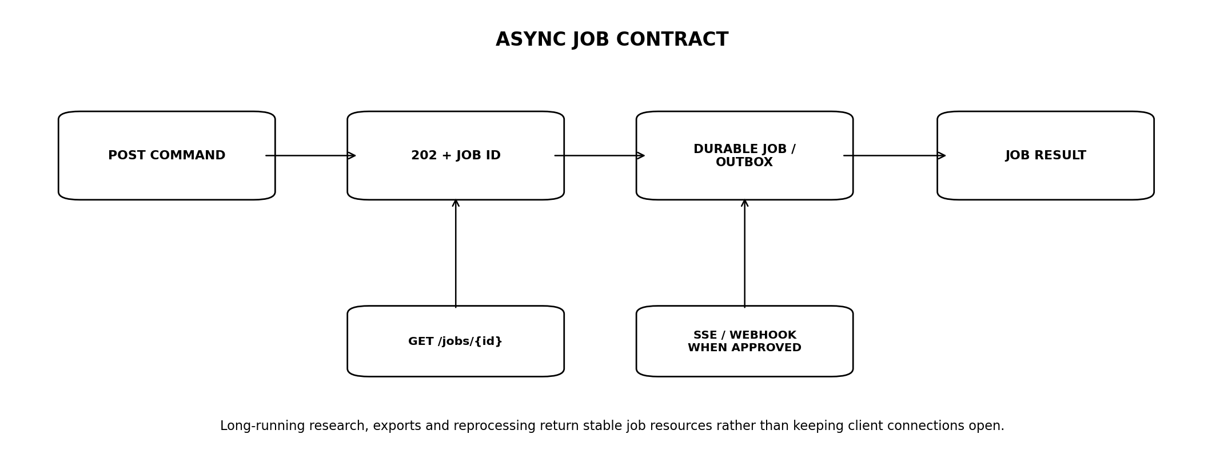
Figure 2 — Long-running asynchronous job contract
State | Meaning
QUEUED | Accepted but not started.
RUNNING | Active processing.
SUCCEEDED | Result reference available.
FAILED | Terminal with typed error.
CANCEL_REQUESTED | Cancellation requested; not yet confirmed.
CANCELLED | Stopped without successful result.
EXPIRED | Result or job metadata aged out under retention policy.

11.1 Job resource
Job {
job_id
job_type
status
progress?
submitted_at
started_at?
completed_at?
result_ref?
error?
expires_at?
}

11.2 Suitable job classes
- Long document research requests.
- Large exports.
- Controlled reprocessing/backfill.
- Bulk enterprise operations.
- Any workload whose normal completion should not depend on an open client HTTP connection.

12. SERVER-SENT EVENTS & WEBSOCKETS
Mechanism | Policy
SSE | Preferred for one-way server progress/event streams where polling is materially inferior.
WebSocket | Use only where true bidirectional low-latency interaction is required.
Polling | Default for ordinary async jobs if update frequency is low.

12.1 Constraints
- Live channels do not bypass policy or entitlement checks.
- Reconnect uses cursor/event_id where supported.
- No client assumes event stream is the system of record; resources remain queryable.
- Market-data streaming is not implied by using WebSocket/SSE; vendor latency rights still govern.

13. CANONICAL ERROR MODEL
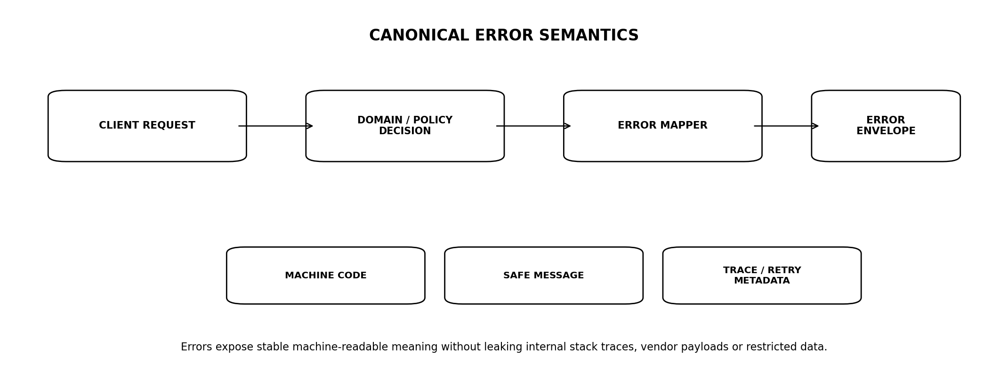
Figure 3 — Canonical error mapping
{
"error": {
"code": "DATA_UNAVAILABLE",
"message": "Required market data is currently unavailable.",
"request_id": "…",
"retryable": true,
"retry_after_seconds": 60,
"details": []
}
}

13.1 Stable error families
Code | Meaning
VALIDATION_ERROR | Malformed or semantically invalid request.
UNAUTHENTICATED | No valid identity/session.
FORBIDDEN | Authenticated but operation not permitted.
NOT_FOUND | Resource absent or intentionally indistinguishable from inaccessible.
CONFLICT | State/idempotency/business conflict.
PRECONDITION_FAILED | Resource version/If-Match mismatch.
RATE_LIMITED | Quota/rate exceeded.
DATA_DELAYED | Data usable but delayed; often warning rather than hard error.
DATA_UNAVAILABLE | Required data unavailable.
RIGHTS_RESTRICTED | Requested data/action prohibited by effective rights.
CAPABILITY_UNAVAILABLE | Feature not active for jurisdiction/account/status.
POLICY_BLOCKED | Jurisdiction/regulatory policy blocks action.
JOB_FAILED | Async job terminal failure.
INTERNAL_ERROR | Unexpected server failure; opaque to client.

14. HTTP STATUS SEMANTICS
Status | Use
200 | Successful synchronous read/update.
201 | Resource created synchronously.
202 | Accepted asynchronous command/job.
204 | Successful command with no body where appropriate.
400 | Malformed request / basic validation.
401 | Unauthenticated.
403 | Authenticated but explicitly forbidden.
404 | Not found or intentionally concealed inaccessible resource.
409 | State/business/idempotency conflict.
412 | Optimistic-concurrency precondition failed.
422 | Well-formed request failing domain semantic validation.
429 | Rate limited.
500 | Unexpected internal error.
502/503 | Dependency/service unavailable where gateway semantics justify.

14.1 No status-code overloading
Domain-specific states such as STALE or DELAYED are usually represented in successful resource metadata when a useful permitted result still exists; do not misuse 500-class errors for expected product degradation.

15. WARNINGS & DEGRADATION CONTRACT
Warning {
code
severity // INFO | WARNING | MATERIAL
message_key
data_status?
source_id?
effective_at?
}
Warning | Meaning
DATA_DELAYED | Resource returned with explicit timestamp/latency state.
DATA_STALE | Resource returned with stale marker; product behaviour follows domain policy.
PARTIAL_EVIDENCE | Research response has known evidence coverage limitation.
RESTRICTED_FIELDS | Some fields omitted/masked due rights or plan.
LATE_EVENT | Monitoring event arrived after original valid time.
CORRECTED | Previously shown result has a correction/supersession.

16. RATE LIMITING, QUOTAS & FAIR USE
Dimension | Use
Anonymous/IP | Public-surface abuse protection.
Principal | Interactive product protection.
Account | Shared team/API consumption.
Endpoint class | Expensive research/export/calculation limits.
Provider-backed task | AI/vendor quotas and cost controls.
Enterprise API | Contract-specific request/data quotas.

16.1 Rate-limit response
{
"error": {
"code": "RATE_LIMITED",
"retryable": true,
"retry_after_seconds": 30
}
}

16.2 No hidden economic throttling
If a paid tier changes cadence, data latency or quota, the entitlement is explicit in product configuration and reflected in machine-readable capability/limit metadata.

17. DOMAIN ENDPOINT CATALOGUE — CORE
Endpoint | Purpose
GET /instruments/{id} | Canonical instrument summary + permitted factual state.
GET /instruments/{id}/facts | Accepted facts with time/status/evidence references.
GET /instruments/{id}/events | Objective lifecycle/market events.
GET /issuers/{id} | Issuer summary.
GET /documents | Search/filter eligible documents.
GET /documents/{id} | Logical document metadata.
GET /evidence/records/{id} | Authorised evidence projection.
POST /calculations | Run approved deterministic calculation.
POST /comparisons | Create user-directed comparison result.
GET /markets/{id} | Market/venue/calendar metadata where exposed.

18. MONITORING & PERSISTENT-STATE ENDPOINTS
Endpoint | Purpose
GET /watchlists | List user/account watchlists.
POST /watchlists | Create watchlist.
PATCH /watchlists/{id} | Update metadata/version.
POST /watchlists/{id}/items | Add user-selected instrument.
DELETE /watchlists/{id}/items/{instrument_id} | Remove item.
POST /monitoring/rules | Create rule.
POST /monitoring/rules/{id}/versions | Create immutable edited version.
POST /monitoring/rules/{id}/pause | Pause.
POST /monitoring/rules/{id}/resume | Resume after validation.
GET /monitoring/alerts | Alert history.
GET /monitoring/coverage | Coverage statement/incidents.

19. RESEARCH & AI ENDPOINTS
Endpoint | Purpose
POST /research | Create synchronous or async factual research task depending class.
GET /research/{id} | Saved/retrievable research artefact where product supports.
POST /research/{id}/follow-ups | Context-bounded follow-up using permitted prior state.
GET /research/{id}/evidence | EvidenceBundle/citation manifest projection.
POST /research/document-summary | Task-specific source-grounded summary.

19.1 Response contract
NO MODEL VENDOR LEAKAGE
Public responses do not expose provider-specific message IDs, hidden prompts, raw chain metadata or vendor implementation details. They expose Talvrin response/evidence objects.

20. ENTITLEMENTS & CAPABILITY MANIFEST

20.1 Capability endpoint
GET /account/capabilities
{
"data": {
"jurisdiction": "…",
"features": {
"research": {"status":"AVAILABLE"},
"monitoring": {"status":"AVAILABLE","max_rules":50},
"real_time_data": {"status":"RESTRICTED"}
}
}
}

20.2 Manifest role
- Allows clients to render correct controls without guessing availability.
- Does not replace server-side enforcement.
- Versioned/cached with short enough TTL for material policy/rights changes.
- Can describe upgrade-needed vs legally unavailable vs temporarily restricted distinctly.

21. EXPORT & DOWNLOAD CONTRACT
Export | Rule
CSV / structured export | Only approved fields/datasets; rights checked at job creation and delivery.
Document download | Only where source rights allow; use controlled short-lived URL/stream.
Large export | Async job.
API feed | Separate enterprise entitlement and data-rights review.

21.1 Export manifest
ExportJob {
export_job_id
principal/account
requested_resource
field_set
source_ids[]
rights_decision_ids[]
status
created_at
expires_at
download_ref?
}

22. WEBHOOK CONTRACT — FUTURE ENTERPRISE
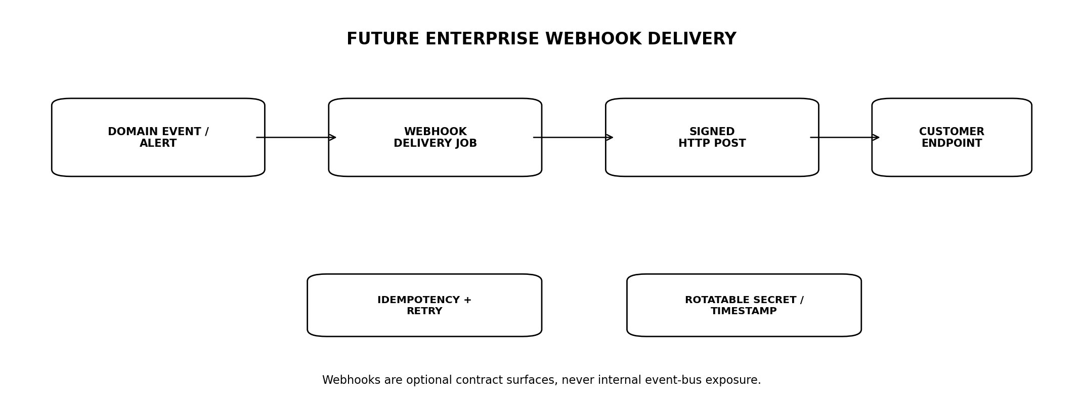
Figure 4 — Future enterprise webhook delivery
Control | Requirement
Signing | HMAC/asymmetric signing with timestamp and rotatable secret/key.
Replay prevention | Timestamp tolerance + event/delivery ID.
Retries | At-least-once with exponential backoff.
Idempotency | Receiver deduplicates delivery_id/event_id.
Endpoint verification | Ownership/handshake before activation.
Payload rights | Only contractually permitted fields.
Dead letter | Visible to customer/admin after retry exhaustion.

22.1 Event examples
- monitoring.alert.created
- monitoring.alert.corrected
- document.published
- job.completed
- Only events explicitly contracted and rights-permitted.

23. VERSIONING & COMPATIBILITY

23.1 Major API version
Use a stable major path (e.g. /api/v1). Additive non-breaking changes remain in the same major version. Breaking changes require a new major contract or an explicitly versioned representation.

23.2 Breaking changes
Change | Treatment
Removing field | Breaking unless field was explicitly optional/experimental with policy.
Renaming field | Breaking.
Changing field type/unit meaning | Breaking.
Changing enum semantics | Breaking.
Adding optional field | Normally additive.
Adding enum value | Potentially breaking for closed clients; clients must be instructed to tolerate unknown values where appropriate.
Tightening validation | Compatibility review required.

23.3 Deprecation
- Publish deprecation notice and replacement.
- Instrument usage before removal.
- Do not remove a materially used endpoint without migration path and approved sunset.

24. SCHEMA GOVERNANCE & OPENAPI
- Every public/client endpoint is described in machine-readable OpenAPI 3.1-compatible specification or later approved equivalent.
- Schemas are generated/validated from a single contract source, not manually duplicated across services and docs.
- CI blocks undocumented endpoint additions and incompatible schema drift.
- Examples are contract tests, not decorative prose.
- Internal events use their own schema registry/versioning; do not publish internal event schemas as public APIs.

24.1 Generated SDKs
Where SDKs are produced, generate from the approved API schema and add thin ergonomic wrappers only. Business rules must not live solely in SDKs.

25. SECURITY & PRIVACY API CONTROLS
Control | Requirement
Object access | Server verifies account/principal access on every resource.
Enumeration | Opaque IDs, rate limits, no sequential exposure.
Field-level rights | Projection filtered server-side.
PII | Only endpoint-required personal data returned.
Secrets | Never return provider credentials, internal keys or signed long-lived URLs.
Audit | Material mutations and privileged reads emit audit events.
CORS / origins | Restricted to approved web clients; not an auth mechanism.
CSRF | Required controls for cookie/session-based web flows.

25.1 BOLA / IDOR
OBJECT AUTHORIZATION IS NOT OPTIONAL
Knowing an opaque resource ID never grants access. Cross-account resource access is a P1 security defect and must be covered by automated tests.

26. API OBSERVABILITY & NFRs
Metric | Target
Core read p95 | ≤200 ms for instrument/fact reads at launch.
Calculation p95 | ≤300 ms when inputs already present.
BFF aggregation p95 overhead | ≤100 ms excluding downstream domain work.
Error envelope coverage | 100% non-2xx responses use canonical error contract except infrastructure-level edge failures.
Request traceability | 100% application requests carry request_id/correlation_id.
Availability | Aligned to PLT-ENG-ARCH-003/OPS; API layer target 99.5% launch, higher per critical internal services.

26.1 Required telemetry
- Latency/error rate by endpoint, client type, region and status.
- 429 rates and quota exhaustion.
- Policy/rights/capability denial rates.
- Idempotency conflicts.
- Async job duration/failure.
- Payload size and slow-client indicators.

27. FAILURE & DEGRADATION MATRIX
Failure | API behaviour
Policy service down | Protected/gated operation fails closed; safe ungated reads only if explicitly designed.
Rights service down | Rights-gated response denied/degraded.
Market-data source stale | Successful response may include STALE/DELAYED state if domain permits.
AI provider down | Research endpoint returns evidence-only degradation or async failure state.
Notification provider down | Monitoring resource remains authoritative; delivery status shows failure.
Regional Cell unavailable | Failover only to pre-authorised cell; otherwise explicit unavailable.
Database failover | Requests may return retryable service-unavailable; no split-brain mutation.

28. CLIENT CACHING & CONDITIONAL REQUESTS
- ETag/If-None-Match may be used for stable resource representations.
- Cache-Control is endpoint- and rights-aware.
- Private/user-specific responses are never accidentally made public-cacheable.
- Market-data caching obeys source latency/rights.
- Capabilities/policy-sensitive responses use conservative TTLs and explicit invalidation where material.

28.1 Cache key safety
Server-side caches include entitlement/jurisdiction/latency class where response content differs. A premium real-time response cannot be served from cache to a delayed-data account.

29. LOCALISATION & GLOBAL EXPERIENCE
Concern | Contract
Locale | Controls display strings only; canonical values remain locale-neutral.
Currency | Display/convert only when product request says so; original currency retained.
Time zone | User display and quiet-hour preferences; server keeps canonical UTC instants.
Language | Activated locale pack; errors use message_key + localised text.
Number format | Client presentation concern; API decimals use locale-independent syntax.

29.1 Geographic neutrality
No API schema may hard-code UK/US-only identifiers, settlement assumptions, date formats or currencies. Market- and jurisdiction-specific fields are supplied through typed packs/metadata.

30. TESTING & CONTRACT VERIFICATION
Suite | Mandatory cases
Schema | Request/response validation against contract.
Backward compatibility | Automated diff for breaking changes.
AuthZ | Cross-account/BOLA, role, capability, jurisdiction.
Rights | Field/data/action negative tests.
Idempotency | Retry same request; conflicting key/body.
Concurrency | Stale ETag/If-Match.
Pagination | No duplicates/skips under concurrent inserts for cursor endpoints.
Errors | Stable code/status/message-key mapping.
Degradation | STALE/DELAYED/RESTRICTED/UNAVAILABLE responses.
Async | Job lifecycle, cancellation, expiration.
Rate limit | Quota/rate headers and retry semantics.
Global | Locales, time zones, regions, currencies.
Security | Injection, mass assignment, oversized payloads, enumeration.

31. PRODUCTION ACCEPTANCE GATES
Gate | Area | Exit criterion
API-G01 | Contract coverage | 100% public/client endpoints represented in approved schema.
API-G02 | No bypass | No public path reaches internal service/storage without gateway/BFF/auth/policy.
API-G03 | AuthZ | Cross-account/BOLA suite passes.
API-G04 | Rights/policy | Negative tests pass for field/action/jurisdiction restrictions.
API-G05 | Idempotency | Material mutation retry tests pass.
API-G06 | Concurrency | Lost-update protection passes on protected resources.
API-G07 | Errors | Canonical error/status mapping complete.
API-G08 | Degradation | Delayed/stale/unavailable/restricted states correctly represented.
API-G09 | Async | Job lifecycle and failure/cancellation tests pass.
API-G10 | Compatibility | Automated breaking-change check enforced in CI.
API-G11 | Global | Locale/timezone/currency/Regional Cell tests pass.
API-G12 | Performance | Core launch endpoint p95 targets met at test envelope.
API-G13 | Observability | Trace/metrics/error dashboards live.
API-G14 | Docs/SDK | Published contract examples and generated clients pass smoke tests.

32. OPEN DECISIONS / BLOCKERS
ID | Decision | Owner
O-API-01 | Whether the first mobile client uses identical BFF endpoints or a mobile-specific BFF projection. | Product + Eng
O-API-02 | Which research tasks are synchronous vs async at launch. | Product + AI Eng
O-API-03 | Whether SSE is required at launch for research progress. | Product
O-API-04 | Enterprise API/webhook launch timing and minimum contract scope. | Commercial
O-API-05 | Initial per-tier API/rate limits and export quotas. | Product + Finance
O-API-06 | Public unauthenticated instrument/search surface, if any, and data-rights implications. | Product + Rights

33. IMPLEMENTATION SEQUENCE
Stage | Build | Exit
P0 — Contract foundation | Naming, envelope, errors, IDs, time/money/unit types, OpenAPI pipeline. | Contract lint + CI active.
P1 — Core reads | Instruments, issuers, facts, documents, evidence, markets. | AuthZ/rights tests pass.
P2 — Deterministic commands | Calculations, comparisons, watchlists, monitoring rules. | Idempotency/concurrency pass.
P3 — Monitoring/research | Alerts, coverage, research tasks, evidence manifests. | Async/degradation pass.
P4 — Commercial/global | Capabilities, subscriptions, export, regional/locale metadata. | Global and entitlement tests pass.
P5 — Enterprise/deferred | API feeds/webhooks if commercially approved. | Contract/security/rights gates pass.
P6 — Hardening | Performance, load, compatibility, SDKs, docs, operational dashboards. | All API-G gates pass.

34. TRACEABILITY TO ENGINEERING ESTATE
Document | Dependency
PLT-PRD-001 | Defines product capabilities and journeys exposed through APIs.
PLT-ENG-ARCH-003 | Defines BFF/gateway/domain topology and global cells.
PLT-DATA-001 | Defines canonical data types and object IDs.
PLT-DATA-002 | Defines market-data status/freshness/corrections.
PLT-RIGHTS-001 | Defines field/action rights and export/API restrictions.
PLT-FIN-001 | Defines deterministic calculation contracts.
PLT-POL-001 | Defines jurisdiction/capability policy.
PLT-MON-001 | Defines monitoring resource semantics.
PLT-EVID-001 | Defines evidence/document/citation resources.
PLT-AI-001 | Defines research/AI task contract and provider abstraction.
PLT-SEC-001 | Will define detailed identity, sessions, RLS/ABAC and API security.
PLT-QE-001 | Will consolidate contract/performance/security release verification.
PLT-OPS-001 | Will define gateway deployment, scaling, SLO and incident operations.

35. PROHIBITED ANTI-PATTERNS
1. Exposing database table names or internal service names as public resources.
2. Trusting client-supplied jurisdiction, entitlement or rights assertions.
3. Using binary floating-point JSON numbers for authoritative monetary values.
4. Returning null/empty fields to conceal STALE, UNAVAILABLE or RIGHTS_RESTRICTED states.
5. Public endpoints that return unrestricted raw vendor payloads.
6. Direct client selection of AI provider/model.
7. Breaking response schemas without version/deprecation process.
8. Offset pagination for rapidly changing alert/event timelines where duplicates/skips matter.
9. Mutating monitoring RuleVersions or EvidenceBundles in place.
10. Creating duplicate business resources when a client retries a timed-out POST.
11. Returning stack traces, SQL errors, provider credentials or internal prompts.
12. Treating CORS as authentication.
13. Putting business logic only in mobile/web SDKs.
14. Using WebSockets because they look real-time when polling/SSE is sufficient.
15. Publishing internal event-bus schemas as customer integration contracts.

36. ENGINEERING SIGN-OFF STANDARD
PLT-API-001 may be approved only when Product Engineering, Backend Engineering, Trust/Rights, Security, Quality Engineering and Platform Operations can demonstrate that a client can use every launch capability through stable, documented contracts without learning or depending on Talvrin’s internal database, vendor or deployment topology.
FINAL BUILD PRINCIPLE
The API should make Talvrin easier to evolve, not harder. Internal architecture may change; the client contract should change only when the product meaning changes.

