TALVRIN

GLOBAL EVIDENCE, PROVENANCE
& DOCUMENT INTELLIGENCE SPECIFICATION
Detailed Engineering Wireframe 08 / 14
The production contract for source artefacts, provenance, document acquisition, parsing, evidence records, evidence bundles, citation locators, retrieval and correction lineage.
Field | Value
Document ID | PLT-EVID-001
Version | 1.0
Architecture class | Global evidence + document intelligence architecture
Classification | Confidential — Internal
Status | Proposed engineering baseline — for technical approval
Parent architecture | PLT-ENG-ARCH-003 v4.0
Primary dependencies | PLT-PRD-001, PLT-DATA-001, PLT-DATA-002, PLT-RIGHTS-001, PLT-FIN-001, PLT-POL-001, PLT-MON-001
Initial market wedge | UK gilts + US Treasuries
Canonical scope | Global, multi-source, multi-format, multi-language, multi-jurisdiction

ENGINEERING POSITION
Talvrin does not treat a document, a parsed chunk or an AI summary as truth. The immutable source artefact is evidence; extracted observations are claims made by that source; accepted facts are separately reconciled; calculations are separately reproducible; citations bind user-visible claims back to the exact evidence used.

0. EXECUTIVE ENGINEERING DECISION
Talvrin will operate a typed evidence architecture in which every material user-visible factual claim can be traced to an immutable source artefact, a location within that artefact or an accepted fact/calculation derived from it, and the rights profile that authorised its use.
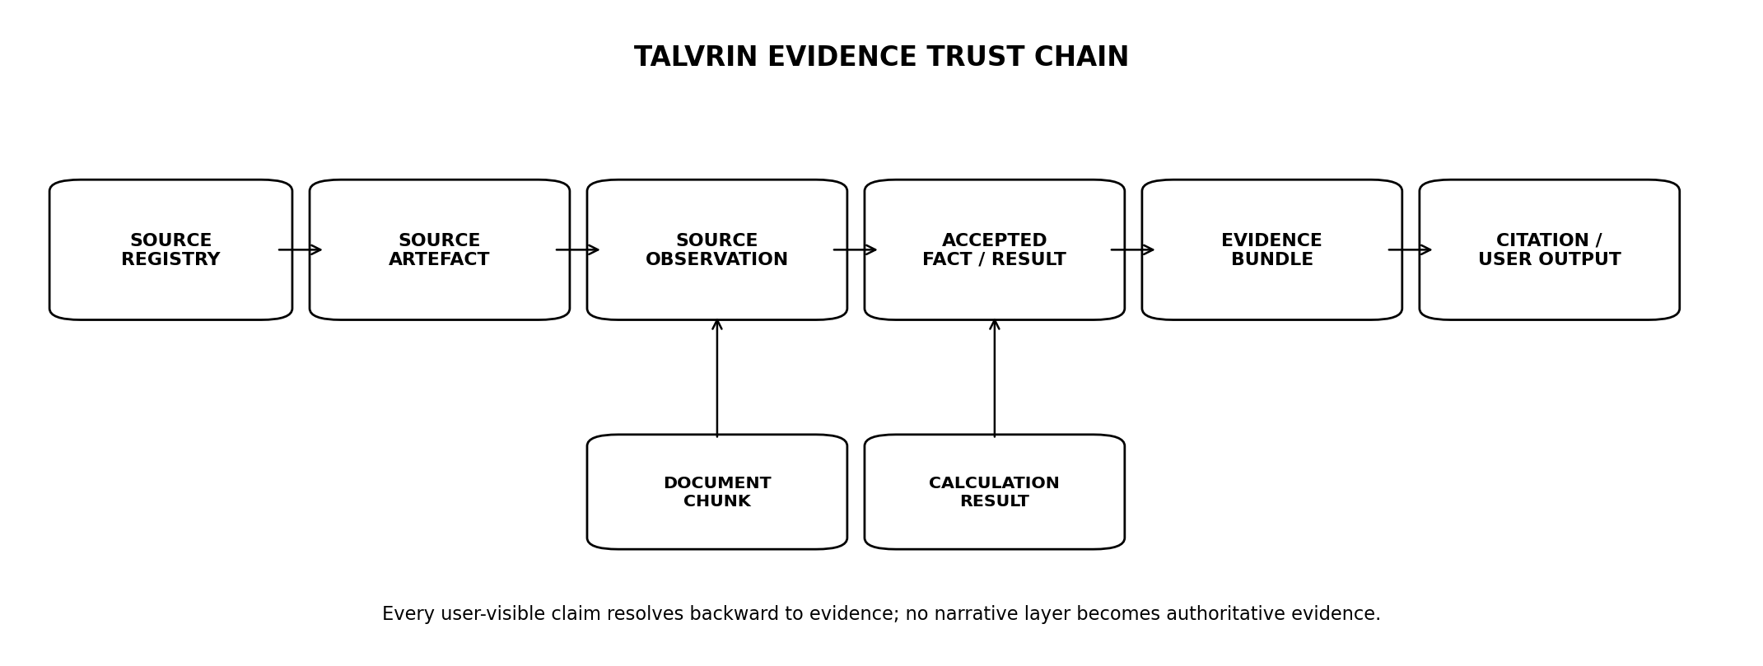
Figure 1 — Canonical evidence trust chain
PRIMARY TRUST RULE
No narrative layer may manufacture provenance. Evidence is assembled before AI generation, and the AI layer can reference only evidence objects already admitted to the bundle.

1. SCOPE, AUTHORITY AND DOMAIN BOUNDARY

1.1 Governed capabilities
- Source artefact identity, acquisition metadata, checksums, immutable storage references and source-version lineage.
- Document classification, parsing, structural segmentation, table/footnote extraction, OCR fallback and parser-version governance.
- Source observations extracted from documents and their linkage to accepted facts.
- Evidence records, citation locators, evidence bundles and claim-to-evidence manifests.
- Lexical, structured and semantic retrieval over permitted document content.
- Document corrections, supersession, withdrawal and downstream provenance impact.
- Rights-aware indexing, embedding, caching, retention and source-specific purge.
- Evidence operations, quality controls, audit and production acceptance.

1.2 Out of scope
- Market-data reconciliation policy itself — PLT-DATA-002.
- Calculation formulae — PLT-FIN-001.
- Jurisdiction policy — PLT-POL-001.
- AI generation and model safety — PLT-AI-001.
- Public/client endpoint details beyond this domain — PLT-API-001.

1.3 Conflict rule
SOURCE OF AUTHORITY
PLT-RIGHTS-001 governs whether content may be retrieved, stored, indexed, embedded, processed by AI, displayed or exported. PLT-DATA-001 governs canonical temporal/data semantics. This specification governs how permitted evidence is represented and used.

2. EVIDENCE DOCTRINE — NON-NEGOTIABLE INVARIANTS
ID | Invariant | Engineering meaning
EVID-INV-01 | Source artefact ≠ accepted fact | A document states or contains evidence; it does not automatically become platform truth.
EVID-INV-02 | Original before transformation | Where storage is permitted, original bytes are retained before parsing/transformation.
EVID-INV-03 | Every transformation is versioned | Parser, OCR, normaliser, table extractor and chunker versions are persisted.
EVID-INV-04 | Locator precision | Citations resolve to a stable document location: page/section/span/table-cell or equivalent.
EVID-INV-05 | Evidence bundle is closed | AI/research generation may use only evidence objects admitted to the bundle.
EVID-INV-06 | Rights travel with evidence | Every artefact, chunk, embedding and evidence record has a non-null rights profile.
EVID-INV-07 | Historical evidence is immutable | Corrections create superseding versions/status; prior user outputs are not silently rewritten.
EVID-INV-08 | No mixed-source purge trap | Embeddings/index partitions must be source-addressable and rebuildable.
EVID-INV-09 | Quotes are bounded | Display/extract lengths obey rights and product policy; a citation may point to more than Talvrin is allowed to reproduce.
EVID-INV-10 | No model-authored source | AI may not invent or resolve a source reference that is not present in the evidence bundle.
EVID-INV-11 | Numeric provenance is typed | Material numbers resolve to AcceptedFact or CalculationResult, not merely a document chunk.
EVID-INV-12 | Unavailable evidence is explicit | Missing/withdrawn evidence is a state, never silently replaced with uncited prose.

3. CANONICAL EVIDENCE OBJECT MODEL
Object | Purpose
Source | Legal/operational origin registered in Source Registry.
SourceArtefact | One immutable acquired payload/file/page/API object from a source.
Document | Logical document identity across versions/publications.
DocumentVersion | Specific published/acquired version of a document.
DocumentStructure | Parser-generated page/section/table/footnote hierarchy.
DocumentChunk | Retrieval unit with exact parent/offset metadata.
SourceObservation | Structured claim/observation extracted from a source artefact.
EvidenceRecord | Typed evidential reference to fact/result/document material.
EvidenceBundle | Closed set of evidence supplied to a research/AI task.
CitationLocator | Stable pointer to exact supporting location.
ClaimEvidenceLink | Maps an output claim/span to one or more evidence records.

3.1 Separation of identities
DocumentID = logical publication identity
DocumentVersionID = one published/retrieved version
SourceArtefactID = one acquired byte-level artefact
ChunkID = parser-version-specific retrieval unit
EvidenceRecordID = stable evidential reference
EvidenceBundleID = immutable closed evidence set
CitationLocatorID = precise source location

4. SOURCE ARTEFACT ACQUISITION
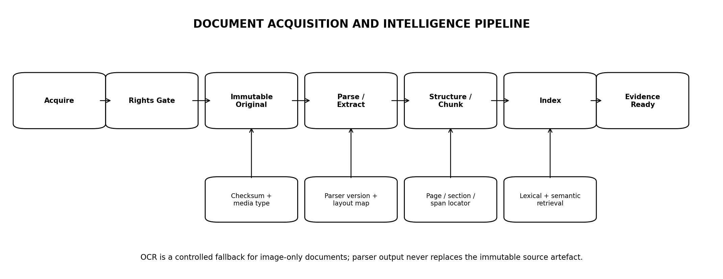
Figure 2 — Document acquisition and intelligence pipeline

4.1 Required acquisition metadata
Field | Contract
source_id | Source Registry identity.
source_artifact_id | Opaque internal ID.
source_uri / acquisition_ref | Original source location/reference where permitted.
retrieved_at | Platform acquisition timestamp.
published_at | Source publication time if known.
media_type | PDF, HTML, XML, JSON, XBRL, image or other approved type.
byte_length | Raw size.
content_hash | Cryptographic checksum over acquired bytes.
rights_profile_id | Non-null effective rights profile.
storage_class | Permitted retention/storage treatment.
acquisition_job_id | Connector/job lineage.

4.2 Acquisition rules
- Acquisition must be idempotent on source-specific identity plus content hash/version semantics.
- HTTP 200 or successful download does not prove content completeness; minimum-size, media-type and structural checks are required.
- Redirect chains, content encoding and response headers relevant to provenance are recorded where useful.
- Robots/website terms are not substitutes for contractual/legal source approval; Source Registry status governs ingestion.

5. IMMUTABLE ORIGINALS, HASHING AND STORAGE

5.1 Storage classes
Class | Use
EVIDENCE_MANIFEST_WORM | Tamper-evident audit manifests/checksums/metadata; retention may be long and independently governed.
LICENSED_RAW_RETENTION | Vendor/source payloads subject to contractual retention and purge.
PUBLIC_SOURCE_ARCHIVE | Official/public artefacts where retention is permitted.
EPHEMERAL_PROCESSING | Temporary decrypted/intermediate files; short TTL.
WORM ≠ VENDOR PAYLOAD
Do not place all licensed raw content under an irrevocable retention lock. Tamper-evident manifests and raw content have different retention/purge obligations. The storage class is chosen from the effective rights profile.

5.2 Hashing
- At least one approved cryptographic content hash is stored for acquired artefacts.
- Parser outputs reference the hash of the exact source artefact they were produced from.
- Hash mismatch on retrieval is a security/data-integrity incident.
- Hash equality may support duplicate detection but does not by itself determine legal/document identity.

6. DOCUMENT IDENTITY, VERSIONING AND SUPERSESSION
Event | Meaning
NEW_DOCUMENT | New logical publication.
NEW_VERSION | Same logical document, newly published/reissued content.
RESTATEMENT | Issuer/source republishes changed content for same reporting/document purpose.
CORRECTION | Talvrin parser/extraction corrected without source changing original bytes.
WITHDRAWN | Source withdraws/retracts the document or access.
SUPERSEDED | Later approved version replaces current-use version while history remains.

6.1 Identity keys
Document identity may use source-native filing/accession/publication identifiers where available, combined with issuer/instrument/document-type metadata. Fuzzy matching may assist an Ops review queue but cannot silently merge two document identities.

6.2 Version immutability
- A DocumentVersion row is immutable after acceptance except administrative status fields.
- A parser correction does not modify original artefact bytes.
- Changing parser output creates a new ParsedDocumentVersion tied to parser_version.

7. DOCUMENT CLASSIFICATION
Class | Examples / use
Issuer financial report | Annual, interim, quarterly or statutory financial reports.
Offering / security document | Prospectus, offering circular, pricing supplement, terms.
Regulatory filing | Official filing/announcement submitted to a regulator or filing system.
Exchange / venue announcement | Market notice or issuer release published by venue.
Sovereign / government publication | Debt-management, treasury, central-bank or statistics publication.
Corporate action / lifecycle notice | Coupon, redemption, tender, split, dividend or similar factual event.
Methodology / rulebook | Official calculation, market or regulatory methodology source.
Other approved source | Explicit source-specific type with governance review.

7.1 Classification controls
- Prefer deterministic source metadata and document identifiers over model-only classification.
- ML/LLM classification may propose a label but low-confidence or material ambiguity routes to Ops review.
- Document type is versioned and auditable because downstream extraction/retrieval rules depend on it.

8. PARSING AND STRUCTURAL EXTRACTION

8.1 Parser output contract
ParsedDocumentVersion {
parsed_document_version_id
document_version_id
source_artifact_id
parser_name
parser_version
parse_started_at
parse_completed_at
language_codes[]
page_count?
extraction_quality
structure_map_ref
text_ref
table_manifest_ref
footnote_manifest_ref
warnings[]
}

8.2 Structural hierarchy
- Page or source-native block.
- Section / heading hierarchy.
- Paragraph / text span.
- Table → row → cell coordinates.
- Footnote/endnote and reference anchors where extractable.
- Bounding boxes or DOM/XPath/source offsets where available and rights-permitted.

8.3 Parser quality
Status | Behaviour
PASS | Structure/text sufficient for evidence use.
PARTIAL | Usable sections exist; missing/corrupt regions identified.
FAILED | Not evidence-ready; no semantic index admission.
QUARANTINED | Potential corruption, malicious content or source mismatch requires Ops review.

9. OCR AND IMAGE-ONLY DOCUMENTS
OCR is a fallback path for scanned/image-only artefacts, not the default ingestion method.
- OCR output is never treated as the immutable source; it references the original image/PDF artefact.
- OCR engine/version, language pack, confidence and page-level warnings are persisted.
- Low-confidence numeric/table regions are prohibited from automatic structured fact extraction without secondary validation.
- Where exact evidence cannot be recovered reliably, Talvrin may expose the source page image/reference without generating a factual claim from the uncertain text.
FINANCIAL NUMBERS REQUIRE HIGHER ASSURANCE
A readable paragraph may be sufficient for narrative retrieval while a coupon rate, maturity date or monetary amount from the same OCR page may still be below the threshold for structured financial use.

10. TABLE, FOOTNOTE AND FORMULA EXTRACTION
Structure | Requirement
Tables | Preserve table identity, row/column coordinates, header associations and cell text.
Footnotes | Maintain anchor relationship to referring text/table where possible.
Formulas | Preserve source formula text/image reference; do not execute arbitrary embedded formulas.
Units | Extracted units are contextual metadata; structured facts still pass DATA-002 normalisation.
Merged cells | Represent span metadata; do not flatten in a way that invents header relationships.

10.1 Numeric extraction
Structured numeric extraction produces SourceObservation candidates, never AcceptedFacts directly. Candidates carry source, locator, parser version, confidence and extraction method into the reconciliation pipeline.

11. CHUNKING AND RETRIEVAL UNITS

11.1 Chunk doctrine
- Chunks are retrieval artefacts, not evidence authority.
- Chunk boundaries should respect structural headings/paragraphs/tables rather than arbitrary token counts where possible.
- Every chunk retains DocumentVersionID, source artefact hash, rights profile, structural locator and parser/chunker version.
- Overlapping chunks are permitted but must be reproducible from the same source structure.

11.2 Chunk contract
DocumentChunk {
chunk_id
parsed_document_version_id
source_id
rights_profile_id
chunker_version
ordinal
text
page_start / page_end?
section_path[]
source_offsets?
bounding_refs?
table_refs[]
token_estimate
content_hash
}

11.3 Rebuildability
All chunks and embeddings are derived artefacts. They must be rebuildable from permitted stored source/parser outputs and purgable by source_id/document_version_id.

12. INDEXING AND RETRIEVAL ARCHITECTURE
Mode | Use
Structured retrieval | Issuer, instrument, document type, date, source, market, jurisdiction, reporting period.
Lexical retrieval | Exact names, identifiers, phrases, accounting terms, section names.
Semantic retrieval | Conceptual document search only within rights-permitted corpus.
Fact retrieval | Canonical AcceptedFacts via data layer; semantic search is not the source of authoritative facts.

12.1 Launch implementation
Launch implementation uses PostgreSQL full-text search plus pgvector for the licence-constrained corpus. A separate vector store is deferred until the architecture trigger is met.

12.2 Hybrid ranking
- Structured filters are applied before semantic ranking when scope is known.
- Exact identifier/document matches outrank semantic similarity.
- Source authority, recency and document status may be explicit ranking features but must not fabricate factual truth.
- Withdrawn/quarantined documents are excluded from normal retrieval.

13. EVIDENCE RECORD TYPES
Type | Meaning
FACT | AcceptedFact reference with provenance chain.
CALCULATION | CalculationResult reference with input-fact lineage.
DOCUMENT_SPAN | Document text span/page/section.
DOCUMENT_TABLE_CELL | Specific table cell/range with header context.
DOCUMENT_PAGE | Page-level evidence where more precise extraction is unavailable.
SOURCE_METADATA | Source publication/identity metadata.
EVENT | Approved factual event record.

13.1 EvidenceRecord
EvidenceRecord {
evidence_record_id
evidence_type
source_id
rights_profile_id
fact_id?
calculation_result_id?
document_version_id?
citation_locator_id?
evidence_status
valid_time?
knowledge_time
created_at
}

14. CITATION LOCATORS

14.1 Locator hierarchy
Source form | Locator
PDF/page | Page index + optional bounding box / character range.
HTML | DOM structural path + text offsets + source snapshot/version.
XML/XBRL | Element/concept/context identifiers + source document version.
Table | Table ID + row/column/cell coordinates + header path.
Plain text | Paragraph/span offsets within versioned parsed artefact.

14.2 Stability contract
- A citation locator always resolves against a specific DocumentVersion/ParsedDocumentVersion.
- Re-parsing may create a new locator set; historical citations retain the parser version they used.
- UI deep-linking may map an old locator to a new rendition, but the evidential record preserves the original reference.

14.3 Citation display
User-facing citations show sufficient source identity and location to verify the claim. Attribution text and excerpt length are determined by rights policy, not by retrieval convenience.

15. EVIDENCE BUNDLES
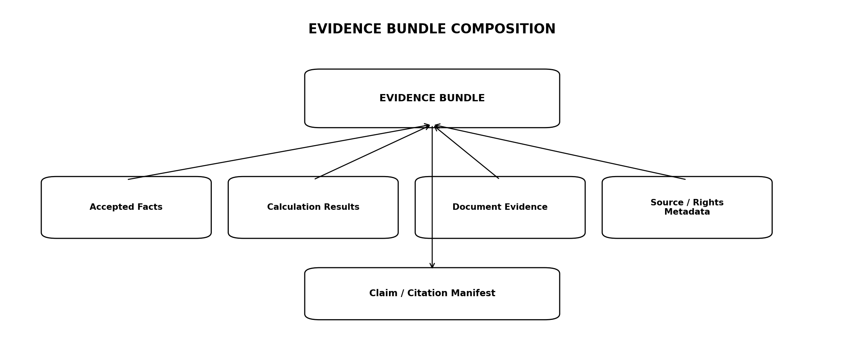
Figure 3 — Evidence bundle composition

15.1 EvidenceBundle contract
EvidenceBundle {
evidence_bundle_id
purpose_type
principal_or_job_id
created_at
knowledge_time
jurisdiction_context
evidence_record_ids[]
source_ids[]
rights_decision_ids[]
policy_decision_id
bundle_hash
status
}

15.2 Bundle rules
- Bundle is immutable once supplied to an AI/research generation step.
- Every item has passed rights and policy evaluation for the requested purpose.
- Bundles may contain conflicting source evidence; conflict state must be explicit.
- Bundle size limits are deterministic and logged; truncation cannot silently remove the only evidence supporting a material claim.
- Bundle hash supports forensic identity, not legal authorship.

16. CLAIM-TO-EVIDENCE MANIFEST

16.1 Purpose
Every generated research answer or saved evidence summary should be able to persist a manifest linking material claims to the evidence records that supported them.
ClaimEvidenceLink {
output_artifact_id
claim_id
output_span_start
output_span_end
claim_type // FACTUAL | NUMERIC | CALC_EXPLANATION | SOURCE_SUMMARY
evidence_record_ids[]
support_status // SUPPORTED | PARTIAL | UNSUPPORTED | SUPERSEDED
}

16.2 Materiality
- All numeric market/security claims are material.
- Instrument terms, dates, issuer facts and factual event claims are material.
- Pure connective language or clearly identified interpretation may not require its own evidence link, but must not contradict the evidence bundle.

17. FACT EXTRACTION AND OBSERVATION HANDOFF
Document intelligence may extract structured candidates, but it does not accept them as canonical facts.
Document extraction
↓
SourceObservation candidate
+ document_version_id
+ citation_locator_id
+ parser/extractor version
+ confidence / method
↓
PLT-DATA-002 validation + reconciliation
↓
AcceptedFact
↓
EvidenceRecord(FACT)

17.1 Extraction confidence
Class | Use
DETERMINISTIC | Structured source/XML/XBRL/known field mapping.
HIGH_CONFIDENCE | Parser/extractor with strong validation.
REVIEW_REQUIRED | Ambiguity, OCR uncertainty, conflicting labels/units.
REJECTED | Cannot be safely interpreted as structured observation.

18. DOCUMENT RIGHTS, EMBEDDINGS AND AI PROCESSING
Action | Required rights
Store original | Requires STORE permission.
Index text | Requires INDEX permission.
Create embeddings | Requires EMBED permission.
External AI prompt | Requires AI_PROCESS + EXTERNAL_PROVIDER permission.
Display excerpt | Requires DISPLAY and excerpt-length/attribution policy.
Export document/excerpt | Requires EXPORT/REDISTRIBUTE as applicable.

18.1 Embedding isolation
SOURCE-ADDRESSABLE EMBEDDINGS
Every embedding row/index partition must be attributable to source_id and document_version_id so a vendor/source can be purged and the index rebuilt without deleting unrelated content.

18.2 Fine-tuning prohibition
Licensed vendor content may not be used for model fine-tuning or persistent model adaptation unless a future explicitly approved architecture and contract says otherwise. The launch architecture prohibits it.

19. DOCUMENT SECURITY AND PROMPT-INJECTION DEFENCE
Control | Requirement
Untrusted content | All external documents are data, never instructions.
Tool isolation | Retrieved text cannot invoke tools or change system policy.
Active content | Scripts/macros/embedded executables are not executed.
File validation | Media/type/signature and archive bomb limits.
Link handling | External links are not automatically followed by AI/tooling.
Prompt injection | Document strings attempting to override instructions are treated as quoted evidence.
Malware | Suspicious artefacts quarantine before parsing/indexing.

19.1 Trust boundary
Parsing workers run in least-privilege isolated workloads with restricted egress and no access to user credentials or unrelated source content.

20. CORRECTION, WITHDRAWAL AND REVOCATION PROPAGATION
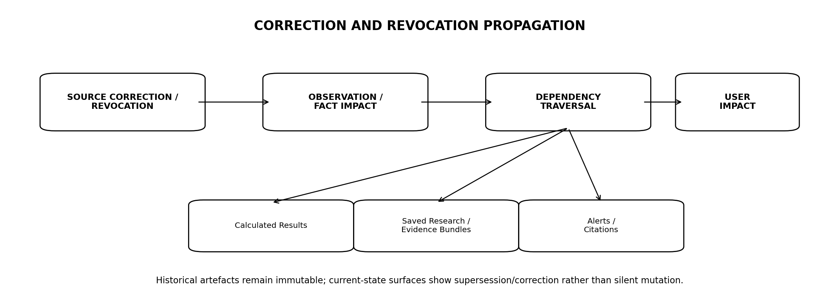
Figure 4 — Evidence correction and revocation propagation
Event | Behaviour
Source document superseded | New version becomes current; old remains historical.
Source withdrawal | Document/evidence marked WITHDRAWN/REVOKED; normal retrieval stops.
Parser correction | New ParsedDocumentVersion; prior citations remain resolvable historically.
Fact correction | Claim/evidence dependency graph identifies affected outputs.
Rights withdrawal | Evidence becomes inaccessible for current use; historical audit metadata retained as permitted.

20.1 User-impact classes
- Previously delivered alert based on affected fact → PLT-MON-001 correction path.
- Saved research output with affected claim → mark claim/output evidence status SUPERSEDED or CORRECTED on next access and, where product policy requires, notify.
- Transient unsaved AI chat → historical record remains; future retrieval uses current evidence state.
- Current instrument/evidence page → immediately reflects latest accepted status.

21. EVIDENCE QUALITY AND STATUS MODEL
Status | Meaning
VERIFIED | Evidence artefact and locator pass validation; source status eligible.
PARTIAL | Evidence usable with known extraction/coverage limitation.
CONFLICT | Competing evidence/source observations unresolved.
STALE | Evidence is old relative to the product context but still valid historical evidence.
SUPERSEDED | Newer source/version replaces current-use status.
WITHDRAWN | Source withdrew material.
QUARANTINED | Security/quality review required.
PURGED | Content removed under rights/retention workflow; tombstone metadata remains where permitted.

21.1 Status is not confidence theater
Talvrin must not collapse provenance quality into a simplistic 'trust score'. Status describes operational/evidential state; it is not a proprietary credit/reliability rating.

22. GLOBAL LANGUAGE, LOCALE AND TRANSLATION
- Original-language source is authoritative evidence.
- Machine translation is a derived aid and carries translation engine/version metadata.
- Translated text must never replace the original locator.
- Numeric/date/currency parsing uses locale-aware deterministic rules.
- Search may index translated helper text where rights permit, but citations resolve to the original source.
- Material translation ambiguity may require user-visible qualification or human review.

22.1 Multilingual retrieval
Query translation or multilingual embeddings may expand recall, but the retrieved evidence set remains source-specific and rights-gated. Cross-language semantic similarity does not establish factual equivalence.

23. GLOBAL REGIONAL-CELL AND RESIDENCY MODEL
Concern | Rule
Global metadata | Document/source identities and non-sensitive registries may be globally addressable subject to policy.
Region-bound content | Raw artefacts/chunks/embeddings remain in permitted processing/storage cells.
AI routing | Evidence bundle can leave a cell only if rights + residency + policy permit the selected provider/region.
Cross-cell retrieval | Returns permitted projections/evidence references, not unrestricted source payloads.
Failover | No emergency replication bypasses source or residency restrictions.

23.1 Cell migration
Moving a document corpus or index between Regional Cells requires a manifest of content classes, rights profiles, residency permissions, checksums and post-migration purge of the old location where required.

24. API AND INTERNAL SERVICE CONTRACTS
Endpoint | Contract
GET /evidence/bundles/{id} | Permitted evidence bundle metadata and evidence records.
GET /evidence/records/{id} | Typed evidence record with authorised projection.
GET /documents/{id} | Logical document metadata/current eligible version.
GET /documents/{id}/versions | Version history where permitted.
GET /documents/versions/{id}/citations/{locator} | Resolve user-verifiable citation target.
POST /internal/documents/acquire | Controlled acquisition job.
POST /internal/documents/{id}/reparse | Audited parser-version replay.
POST /internal/evidence/bundles | Create immutable evidence bundle for approved purpose.

24.1 No raw-content bypass
No generic 'get raw source bytes' application endpoint exists. Raw access is privileged and purpose-specific, with rights enforcement and audit.

25. DATABASE AND INDEX CONTRACT
Table | Purpose
source_artifact | Acquisition metadata/hash/storage reference/rights.
document | Logical identity.
document_version | Published/source version.
parsed_document_version | Parser-version-specific extraction.
document_chunk | Retrieval unit.
citation_locator | Precise source location.
evidence_record | Typed evidence object.
evidence_bundle | Closed evidence set.
evidence_bundle_item | Bundle membership/order.
claim_evidence_link | Output claim → evidence records.
document_processing_job | Acquisition/parse/index workflow state.

25.1 Key constraints
- rights_profile_id non-null on artefacts, chunks and evidence records.
- content_hash non-null on stored immutable source artefacts.
- citation locator references an exact versioned document representation.
- evidence_bundle membership immutable after status READY.
- claim_evidence_link cannot reference evidence outside its output’s evidence bundle unless explicitly classified as post-hoc correction metadata.

26. OBSERVABILITY AND NFRs
Metric | Target
Document acquisition success | ≥99.5% for healthy approved sources excluding source-side unavailability.
Parse queue lag p95 | ≤5 min for normal-priority documents at launch volume.
Citation resolution p95 | ≤250 ms excluding raw-source fetch.
Lexical/structured retrieval p95 | ≤400 ms launch corpus.
Evidence bundle construction p95 | ≤800 ms excluding document acquisition/model calls.
Source withdrawal propagation | ≤4 h to normal retrieval suppression; faster where contractual requirement is tighter.
Purge drill | Before first paid source renewal and thereafter at least annually per material source class.

26.1 Required telemetry
- Acquisition volume/errors by source and media type.
- Parser success/partial/failure and version distribution.
- OCR invocation and low-confidence numeric regions.
- Chunk/index counts by source and rights profile.
- Retrieval latency and zero-result rates.
- Citation-resolution failures.
- Evidence bundle size/source mix.
- Withdrawn/superseded/purged evidence counts.

27. QUALITY ENGINEERING TEST MATRIX
Suite | Mandatory cases
Acquisition | Duplicate, corrupt, truncated, redirect, content-type mismatch, hash mismatch.
Versioning | New version, restatement, withdrawal, parser correction.
Parsing | PDF, HTML, XML/XBRL, tables, footnotes, multi-column, scanned/OCR.
Locators | Page/span/table-cell stability and historical resolution.
Rights | Store/index/embed/AI/display/export negative cases.
Retrieval | Structured, lexical, semantic, hybrid filters, withdrawn exclusion.
Evidence bundles | Closed-set membership, hashing, conflict inclusion, rights failures.
Claims | Unsupported citation, numeric claim mapped only to document, superseded evidence.
Security | Prompt injection, malicious embedded content, archive bomb, unauthorised raw access.
Purge | Source-specific chunks/embeddings/raw objects removed and index rebuilt.
Global | Multilingual, locale/date/number formats, region-bound content and cross-cell denial.

28. EVIDENCE OPERATIONS CONSOLE
Module | Purpose
Acquisition health | Source/document queues, failures, checksum/status.
Document inspector | Version history, parser output, source artefact metadata.
Citation inspector | Resolve locator to source region/span/table cell.
Extraction review | Structured observation candidates requiring human review.
Rights impact | Documents/chunks/indexes affected by rights expiry/termination.
Correction impact | Facts/calculations/alerts/research outputs dependent on evidence.
Purge console | Scoped rehearsed/production purge with evidence manifest.
Security quarantine | Malicious/corrupt artefacts and release workflow.

28.1 Separation of duties
- Evidence Ops may review extraction and document status but cannot alter vendor rights.
- Rights Ops may change effective permissions but not rewrite source content.
- Support cannot access unrestricted raw vendor content.
- Engineering parser replays are audited and cannot silently replace historical evidence.

29. PRODUCTION ACCEPTANCE GATES
Gate | Area | Exit criterion
EVID-G01 | Acquisition | Original artefact/checksum lineage proven for all launch document sources.
EVID-G02 | Rights | No store/index/embed/AI/display/export bypass in negative suite.
EVID-G03 | Versioning | Supersession, withdrawal and parser correction preserve history.
EVID-G04 | Parsing | Launch formats achieve approved extraction quality thresholds.
EVID-G05 | Locators | All user-visible citations resolve to exact versioned evidence.
EVID-G06 | Facts | Document extraction can create SourceObservations only; cannot write AcceptedFacts.
EVID-G07 | Bundles | AI/research bundle is immutable and closed after creation.
EVID-G08 | Numeric provenance | Material numbers resolve to AcceptedFact or CalculationResult evidence.
EVID-G09 | Security | Prompt-injection/malicious-document suite passes.
EVID-G10 | Purge | Source-specific raw/chunks/embeddings purge drill passes.
EVID-G11 | Corrections | Withdrawal/revocation impact traversal identifies dependent outputs.
EVID-G12 | Global | Multilingual and region-bound evidence routing tests pass.
EVID-G13 | Observability | Source/parser/retrieval/citation dashboards operational.
EVID-G14 | Ops | Quarantine, reparse, correction and purge runbooks exercised.

30. OPEN DECISIONS / BLOCKERS
ID | Decision | Owner
O-EVID-01 | Initial authoritative filing/document sources per launch market and exact acquisition method. | Data + Legal
O-EVID-02 | Permitted excerpt lengths/attribution rules per licensed source. | Legal + Commercial
O-EVID-03 | OCR engine and deployment location for scanned source classes. | Engineering + Security
O-EVID-04 | Launch multilingual scope beyond English source documents. | Product
O-EVID-05 | Human-review thresholds for low-confidence structured extraction. | Data + Financial Eng
O-EVID-06 | Retention periods for raw public-source artefacts vs licensed vendor documents. | Legal + Ops
O-EVID-07 | Whether saved research artefacts trigger proactive correction notifications beyond alert corrections. | Product + Legal

31. IMPLEMENTATION SEQUENCE
Stage | Build | Exit
E0 — Core evidence model | Source artefact, document/version, parser version, locator, evidence record/bundle tables. | Constraints + rights linkage pass.
E1 — Acquisition | Launch source/document connectors, checksums, storage classes, quarantine. | Acquisition golden cases pass.
E2 — Parsing | PDF/HTML/XML-XBRL parsing, structure map, table/footnote handling, OCR fallback. | Quality thresholds met.
E3 — Retrieval | Chunking, FTS, pgvector, structured filters, source-addressable indexes. | Retrieval/citation SLO met.
E4 — Evidence bundles | Closed bundles, claim links, citation manifest, fact/calculation evidence integration. | Bundle/claim suites pass.
E5 — Corrections/purge | Supersession, withdrawal, impact traversal, source purge/rebuild. | Purge + correction drills pass.
E6 — Global hardening | Languages, Regional Cells, residency routing, Ops console, runbooks. | All EVID-G gates pass.

32. TRACEABILITY TO ENGINEERING ESTATE
Document | Dependency
PLT-PRD-001 | Defines user evidence/research/document requirements.
PLT-ENG-ARCH-003 | Defines evidence plane, object storage, global cells and architecture triggers.
PLT-DATA-001 | Defines SourceObservation, AcceptedFact and canonical database semantics.
PLT-DATA-002 | Consumes document-extracted SourceObservations and reconciles facts.
PLT-RIGHTS-001 | Controls every evidence acquisition/processing/display/export action.
PLT-FIN-001 | Provides reproducible CalculationResults and input-fact lineage.
PLT-POL-001 | Controls jurisdiction/capability use and customer-facing evidence behaviour.
PLT-MON-001 | Consumes evidence for alerts and correction propagation.
PLT-AI-001 | Will consume only closed EvidenceBundles.
PLT-API-001 | Will formalise client-facing document/evidence endpoints.
PLT-SEC-001 | Will formalise access, quarantine, raw-source and privileged controls.
PLT-QE-001 | Will consolidate evidence/retrieval/security release verification.
PLT-OPS-001 | Will formalise processing infrastructure, DR, monitoring and runbooks.

33. PROHIBITED ANTI-PATTERNS
1. Treating a parsed document chunk as an AcceptedFact.
2. Allowing an LLM to invent or choose a source not present in the EvidenceBundle.
3. Storing licensed content in a mixed embedding index that cannot be purged by source.
4. Applying irrevocable WORM retention to all licensed raw source payloads.
5. Overwriting a historical DocumentVersion or citation locator after re-parsing.
6. Using semantic similarity alone to determine an authoritative financial fact.
7. Generating a citation that points only to a source homepage when precise evidence exists.
8. Using OCR-derived financial numbers as structured truth without required assurance.
9. Sending source content to an external model without explicit rights permission.
10. Fine-tuning models on licensed vendor content under the launch architecture.
11. Following instructions embedded inside a retrieved document.
12. Executing macros/scripts or active content from source files.
13. Silently dropping withdrawn evidence while leaving dependent saved outputs appearing current.
14. Cross-region evidence replication without residency and source-rights checks.
15. Giving Support unrestricted access to raw licensed documents.

34. ENGINEERING SIGN-OFF STANDARD
PLT-EVID-001 may be approved only when Evidence Engineering, Data Engineering, Financial Engineering, AI Engineering, Trust/Rights, Security, Quality Engineering and Platform Operations can reconstruct any material research claim from the exact evidence available at the relevant knowledge time and can remove or supersede that evidence without destroying historical auditability.
FINAL BUILD PRINCIPLE
Talvrin should never ask the user to trust a sentence because the model sounds confident. The platform should be able to show the source, the exact evidence, the accepted fact or calculation derived from it, and what changed when that evidence later changed.

