TALVRIN

GLOBAL PLATFORM OPERATIONS,
DEPLOYMENT & PRODUCTION READINESS SPECIFICATION
Detailed Engineering Wireframe 13 / 14
The production operating contract for environments, deployment, Regional Cells, observability, service levels, incident response, disaster recovery, capacity, cost and launch readiness.
Field | Value
Document ID | PLT-OPS-001
Version | 1.0
Architecture class | Global platform operations and production readiness
Classification | Confidential — Internal
Status | Proposed engineering baseline — for technical approval
Parent architecture | PLT-ENG-ARCH-003 v4.0
Primary dependencies | PLT-PRD-001 through PLT-QE-001
Launch topology | One selected production Regional Cell + pre-approved disaster-recovery cell
Canonical scope | Global Control Plane + Regional Execution Cells; multi-market and multi-jurisdiction

ENGINEERING POSITION
Operations is part of the product contract. Talvrin is not production-ready merely because application servers respond. Market-data freshness, monitoring coverage, evidence integrity, rights/policy decisions, notification delivery, security controls and recovery readiness must all be observable and operable.

0. EXECUTIVE OPERATING DECISION
Talvrin will launch as a deliberately lean, production-grade platform: a modular application stack in one selected Regional Cell, backed by managed PostgreSQL, object storage and Redis, with transactional outbox/durable jobs, independent observability and a pre-authorised disaster-recovery path. Global expansion adds Regional Cells without changing domain contracts.
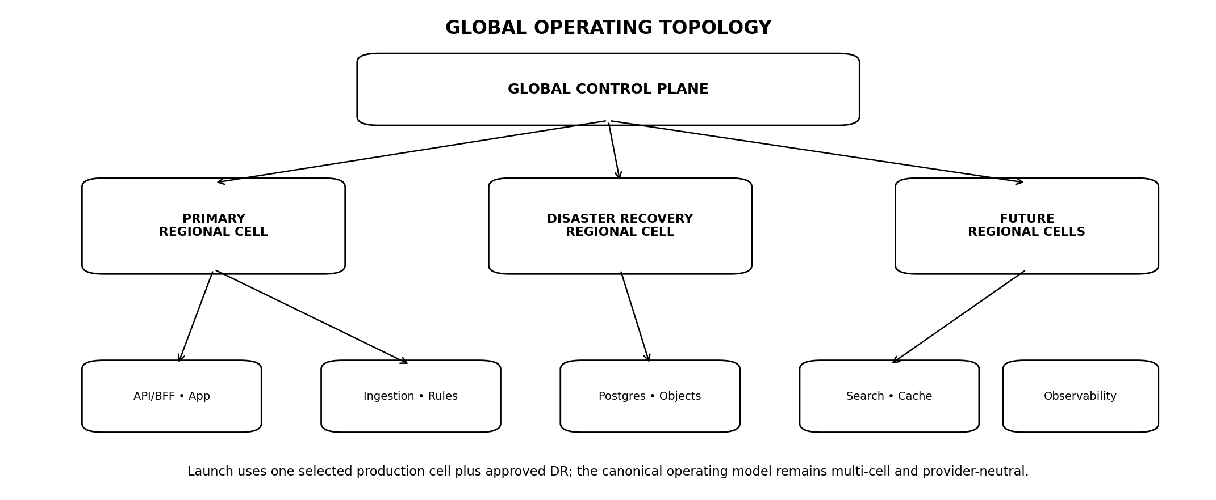
Figure 1 — Canonical global operating topology
PRIMARY INVARIANT
Operations must distinguish service availability from product correctness. A healthy HTTP endpoint with stale market data, dead monitoring evaluators or blocked rights/policy decisions is a degraded product and must be reported as such.

1. SCOPE, AUTHORITY AND OPERATING BOUNDARY
- Environment hierarchy, infrastructure ownership and Regional Cell topology.
- Infrastructure as Code, configuration, secrets and deployment controls.
- Release promotion, feature flags, kill switches and change management.
- Logs, metrics, traces, synthetics, dashboards, alerts and service-level objectives.
- On-call, incident management, operational communications and post-incident review.
- Backup, restore, disaster recovery, failover, capacity, performance and cost controls.
- Database, object, queue, cache, search, AI-provider, source/vendor and notification operations.
- Production readiness review, runbook standards and go-live gates.

1.1 Authority rule
OPS DOES NOT REDEFINE DOMAIN LOGIC
PLT-OPS-001 controls how systems are deployed, observed, recovered and operated. It does not redefine facts, calculations, monitoring semantics, rights, policy or security. During incidents, fail-safe domain behaviour remains in force.

2. OPERATIONS DOCTRINE — NON-NEGOTIABLE INVARIANTS
ID | Invariant | Engineering meaning
OPS-INV-01 | Immutable deployments | Production runs traceable signed/versioned artefacts, not mutable server changes.
OPS-INV-02 | IaC is source of infrastructure truth | Manual cloud changes are emergency-only and reconciled.
OPS-INV-03 | No direct production editing | Application/database/config changes use controlled deployment or audited emergency procedure.
OPS-INV-04 | Observability precedes launch | Every Tier-0 dependency and domain health signal has telemetry/runbook/owner.
OPS-INV-05 | Recovery is rehearsed | RTO/RPO claims require restore/failover evidence.
OPS-INV-06 | One incident commander | Major incidents have explicit command and communication ownership.
OPS-INV-07 | Kill switches are independent | Critical providers/features can be disabled without full redeploy.
OPS-INV-08 | Regional policy survives failure | DR/failover cannot bypass residency or data rights.
OPS-INV-09 | Caches are disposable | Redis/index/cache loss must not destroy system-of-record truth.
OPS-INV-10 | Queue work is restartable | Durable jobs are idempotent/replay-safe.
OPS-INV-11 | Monitoring monitors itself | Evaluator/coverage health has independent alerting.
OPS-INV-12 | Capacity is measured | Scale components only from observed/tested triggers.
OPS-INV-13 | Cost is observable | Provider/source/AI/infra costs map to services and product workloads.
OPS-INV-14 | Runbooks are executable | A runbook is incomplete if an on-call engineer cannot safely use it under pressure.

3. ENVIRONMENT MODEL
Environment | Purpose
LOCAL | Developer workstation/container; no production credentials/data.
CI | Ephemeral automated verification.
INTEGRATION | Multi-service integration and provider sandbox tests.
STAGING | Production-like release qualification; same control mechanisms.
PRODUCTION | Customer-serving environment.
DR | Pre-approved recovery environment/cell; normally warm/cold according to service class.

3.1 Isolation
- Separate cloud accounts/projects/subscriptions where feasible for production vs non-production.
- Separate credentials, keys, databases, object stores and provider tokens.
- Production data is not replicated into lower environments except explicit controlled diagnostic workflows.
- Staging cannot depend on production databases to appear realistic.

4. GLOBAL CONTROL PLANE & REGIONAL CELLS
Plane | Operating contract
Global configuration | Feature/capability registry, deployment metadata and globally safe configuration.
Global security governance | Approved IAM, crypto, logging and security baseline.
Global source/methodology registries | Authoritative configuration metadata; content locality follows rights.
Regional application plane | API/BFF/application workers for users routed to cell.
Regional data plane | Permitted PostgreSQL/object/cache/search/index state.
Regional monitoring plane | Rule evaluators, coverage watcher and notification routing.
Regional evidence/AI processing | Only where residency, rights and provider policies permit.

4.1 Adding a Regional Cell
- Approved residency/business requirement exists.
- Security/KMS/observability baseline reproducible from IaC.
- Source/provider rights and routes certified.
- Data replication/classification rules defined.
- DR and on-call coverage established.
- PLT-QE-001 global routing and failover suites pass.

5. LAUNCH DEPLOYMENT PROFILE
The launch profile deliberately avoids premature distributed-system complexity.
Component | Launch posture
Application | Modular monolith / bounded modules behind BFF/API; horizontally scalable stateless compute.
Database | Managed PostgreSQL 16+ as system of record.
Object storage | Managed durable object store; source/evidence storage classes per rights.
Cache | Redis for ephemeral cache/session/coordination uses only.
Jobs/events | PostgreSQL durable queue + transactional outbox.
Search | PostgreSQL FTS/pgvector initially; dedicated search/vector only on trigger.
CDN/WAF | Managed edge protection.
Observability | Independent managed/open telemetry pipeline with central dashboards/alerts.

5.1 Deferred infrastructure triggers
Technology | Adoption trigger
Kafka/streaming platform | ≥3 independent replay consumer groups OR sustained >5,000 fact-events/min.
Temporal/workflow engine | Workflow >3 human-in-loop steps or >24 hours.
Graph database | Monitoring traversal p95 >150 ms at depth ≥3.
Time-series database | Tick-level intraday enters production scope.
Separate vector DB | Corpus >2M chunks or retrieval p95 >400 ms.
Active-active multi-region | Enterprise RTO target <15 minutes or proven business requirement.
Microservices split | ≥3 teams need independent release cadence or bounded scaling/security requires.

6. INFRASTRUCTURE AS CODE
- All durable production infrastructure is defined in version-controlled IaC.
- Changes receive peer review, security/static checks and plan/diff inspection.
- Remote state is encrypted, access-controlled and protected from accidental deletion.
- Reusable modules encode the minimum security/observability baseline for every Regional Cell.
- Manual emergency changes create a reconciliation ticket and are codified immediately after containment.

6.1 IaC ownership
Owner | Responsibility
Platform team | Shared network, compute, database, object, KMS, monitoring modules.
Service owner | Service-specific resource requests/limits/configuration.
Security | IAM, KMS, public-access and guardrail policies.
QE | IaC validation and environment conformance checks.

7. BUILD ARTEFACTS & SUPPLY CHAIN
Control | Requirement
Source revision | Exact Git commit/tag.
Build | Reproducible CI pipeline where practical.
Dependencies | Lockfile/SBOM captured.
Container/package | Immutable digest; no floating 'latest' in production.
Signing | Approved artefact signing/attestation.
Registry | Private, access-controlled, retention/scanning policies.
Promotion | Same qualified artefact promoted across environments; do not rebuild for production.

7.1 Provenance
DeploymentArtifact {
release_id
source_commit
artefact_digest
sbom_ref
build_pipeline_id
signature_ref
created_at
release_evidence_id
}

8. CONFIGURATION & FEATURE MANAGEMENT
Class | Rule
Static application config | Version-controlled, environment-specific values injected at deploy.
Secrets | Managed secret store only.
Feature flags | Typed, owned, expiry/review date, auditable.
Capability flags | PLT-POL-001 / product status; not ordinary developer toggles.
Kill switches | Independent emergency controls with clear scope.
Vendor/source routes | Registry-driven; no hard-coded production endpoints in business logic.

8.1 Feature-flag hygiene
- Every temporary flag has owner and removal date.
- Flag combinations affecting policy/rights/security require dedicated tests.
- Default state for new high-risk capability is disabled.
- Flags cannot bypass database migrations or incompatible schemas.

9. DEPLOYMENT & CHANGE MANAGEMENT
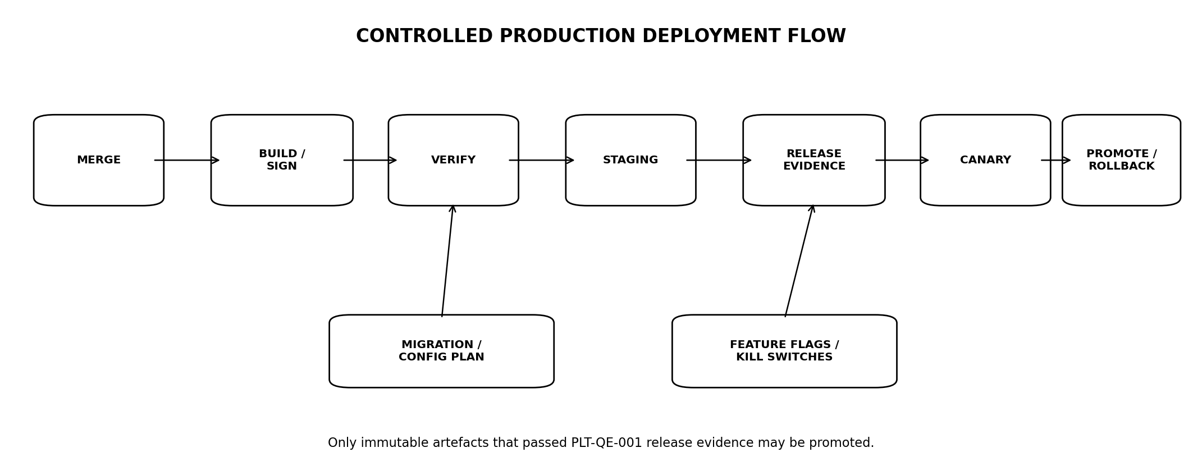
Figure 2 — Controlled production deployment flow

9.1 Change classes
Class | Treatment
STANDARD | Routine low-risk pre-approved pattern; full automated gates.
NORMAL | Ordinary product/infrastructure change requiring release evidence.
HIGH-RISK | Schema, financial methodology, rights/policy, auth/security, global routing or critical provider change.
EMERGENCY | Incident/legal/security fix under PLT-QE emergency process.

9.2 Production deployment rule
NO FRIDAY MYTH — USE RISK, NOT CALENDAR SUPERSTITION
Deploy when the team can observe and recover. High-risk changes require appropriate staffing/market-context awareness; arbitrary day-of-week rules do not substitute for release evidence and rollback readiness.

10. DATABASE MIGRATION OPERATIONS
- Expand-contract for backward-compatible schema evolution.
- Online index/build/backfill patterns for material tables.
- Application remains N-1 compatible during rolling deployment where required.
- No destructive column/table removal until old code and data dependencies are proven absent.
- Migration duration/locks measured in staging against representative scale.
- Forward-fix preferred; rollback path documented where genuinely safe.

10.1 Migration states
PRECHECK → APPLY → VERIFY → BACKFILL → VERIFY_INVARIANTS → COMPLETE
Any integrity failure:
STOP → preserve evidence → restore/forward-fix plan → incident if production impact.

11. COMPUTE, SCHEDULING & AUTOSCALING
Workload | Scaling signal
Stateless application | Scale horizontally on CPU/concurrency/request metrics.
Ingestion workers | Scale by queue depth, source cadence and processing lag.
Monitoring evaluators | Scale by evaluation queue age/rule fan-out.
Document workers | Scale by parse queue age and memory/CPU class.
AI Gateway | Scale by request concurrency; provider quotas remain hard constraints.
Coverage/dead-man | Independent small critical workloads; protect from noisy-neighbour starvation.

11.1 Resource controls
- Per-workload CPU/memory requests/limits where scheduler supports.
- Concurrency caps for database-heavy jobs.
- Provider rate limits respected centrally.
- Autoscaling cannot exceed downstream database/provider safe capacity without corresponding limits.

12. POSTGRESQL PRODUCTION OPERATIONS
Area | Operating requirement
High availability | Managed HA configuration within production region/cell.
Backups | Automated encrypted point-in-time capability where provider supports.
Connection pooling | Bounded pool; protect database from autoscaling storms.
Maintenance | Controlled windows with compatibility/availability planning.
Vacuum/statistics | Monitored; prevent table/index bloat.
Slow queries | Tracked by fingerprint; critical query budgets.
Replication | Only to pre-approved DR/read locations.
Extensions | Allowlist; upgrade tested.

12.1 Database alerts
- Storage saturation/forecast.
- Connection exhaustion.
- Replication lag/backup failure.
- Transaction age/lock contention.
- CPU/IO anomalies.
- Critical query latency and error rate.

13. OBJECT STORAGE, CACHE, SEARCH & INDEX OPERATIONS
System | Operations contract
Object storage | Versioning where appropriate, checksum/integrity, lifecycle policies, no public access.
Redis | Ephemeral; persistence only where explicitly justified; loss must be survivable.
FTS/pgvector | Rebuildable derived indexes, health/size/query latency monitored.
Dedicated index future | Adoption only after trigger; source-addressable purge remains mandatory.
Lifecycle policies | Must not conflict with data-rights purge/retention.

13.1 Rebuild drill
At least one staging exercise must prove search/vector/cache state can be destroyed and rebuilt from authorised source-of-truth data without losing canonical facts or user state.

14. DURABLE JOBS, OUTBOX & QUEUE OPERATIONS
Signal/control | Requirement
Queue depth | By job class.
Oldest job age | Primary backlog health signal.
Retry count | By error family.
Dead letter | Explicit terminal/ops-review state.
Idempotency | Every retry-safe business job has stable key.
Poison job | Isolate after bounded retry; do not block partition/queue.
Replay | Controlled by job class and domain policy.

14.1 Backlog recovery
RECOVERY WITHOUT DUPLICATION
Scaling workers to drain a backlog must not create duplicate alerts, facts, calculations or notifications. Domain idempotency is verified before backlog concurrency is increased.

15. OBSERVABILITY ARCHITECTURE
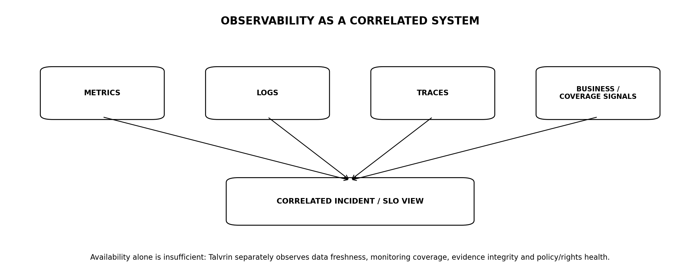
Figure 3 — Correlated observability system

15.1 Telemetry pillars
Signal | Use
Metrics | Rates, errors, saturation, queues, coverage, freshness, costs.
Logs | Structured events with request/correlation IDs; redacted/minimised.
Traces | Cross-service request/job path and external dependency timing.
Synthetics | Critical user/product journeys.
Domain health | Data freshness, monitoring coverage, evidence/citation, policy/rights availability.

15.2 Correlation
correlation_id
API request
→ policy/rights decision
→ data query/calculation
→ evidence bundle / AI execution
→ monitoring/job/outbox
→ external provider delivery

16. SERVICE CATALOGUE & OWNERSHIP
Catalogue field | Requirement
Service/module | Stable owner/team and technical lead.
Tier | T0 critical, T1 important, T2 supporting.
Dependencies | Upstream/downstream critical dependencies.
SLOs | Availability/latency/domain-specific objectives.
Runbooks | Top failure modes.
Pager | On-call route for T0/T1.
Dashboard | Canonical operational view.
Repository / deploy unit | Traceable artefact source.

16.1 Tier examples
Tier | Illustrative scope
T0 | Identity, API/BFF, PostgreSQL, rights/policy PDP, monitoring evaluator/coverage, source acceptance core.
T1 | Evidence parsing/search, AI Gateway, notifications, document acquisition.
T2 | Non-critical admin/reporting/support functions.

17. SERVICE LEVEL OBJECTIVES & ERROR BUDGETS
Objective | Target
Platform availability | 99.5% launch minimum; target 99.9% after operational maturity.
Core read latency | ≤200 ms p95 where PLT-API applies.
Calculation | ≤300 ms p95 with inputs present.
AI standard research | ≤6 s p95 target.
EOD publication freshness | ≤30 min after publication for activated sources/metrics.
Monitoring evaluation | ≤60 s after accepted eligible fact.
Alert delivery | ≤120 s after fire for normal enabled transport.
Monitoring coverage | ≥99.9% eligible rule evaluations within configured SLO.

17.1 Error-budget policy
- Burn-rate alerts identify rapid SLO consumption.
- Exhausted critical error budget constrains risky feature release until reliability is restored.
- Domain SLOs are tracked separately; strong HTTP uptime cannot offset poor monitoring coverage or source freshness.

18. ALERTING & PAGING STANDARD
Signal class | Meaning
PAGE | Human action required now to prevent/limit material impact.
TICKET | Action required but not immediate.
DASHBOARD | Useful context/analysis; no direct action.
LOG ONLY | Diagnostic evidence.

18.1 Pager quality
- Every page names service, symptom, likely impact and runbook.
- Pages are deduplicated/grouped to avoid incident storms.
- No page based solely on CPU if there is no user/system impact.
- Every persistent noisy alert is tuned or removed; alert fatigue is an operational defect.

19. ON-CALL OPERATING MODEL
- 24/7 automated paging for T0 production conditions after public launch.
- Named primary/secondary rota with escalation.
- On-call engineer has safe JIT access, runbooks and communication channels.
- Workload/rota design respects sustainable staffing; chronic after-hours pages trigger engineering work.
- Domain specialists (Data, Security, Financial Engineering, AI) have escalation paths rather than all sitting in one pager rotation.

19.1 Handover
Shift/rota handover includes open incidents, degraded sources/providers, risky releases, maintenance, expiring certificates/secrets and unresolved capacity concerns.

20. INCIDENT SEVERITY MODEL
Severity | Definition | Response
SEV0 | Active security/tenant breach; corrupt authoritative market/calculation output at scale; system-wide monitoring silently failed; major legal/rights exposure. | Immediate incident command; executives/security/legal as applicable.
SEV1 | Critical service unavailable or material subset has incorrect/degraded behaviour with serious customer impact. | Immediate page; incident commander.
SEV2 | Significant degradation with workaround/limited blast radius. | Urgent response during/after hours by policy.
SEV3 | Minor/local operational issue. | Ticket/normal engineering.

21. INCIDENT RESPONSE LIFECYCLE
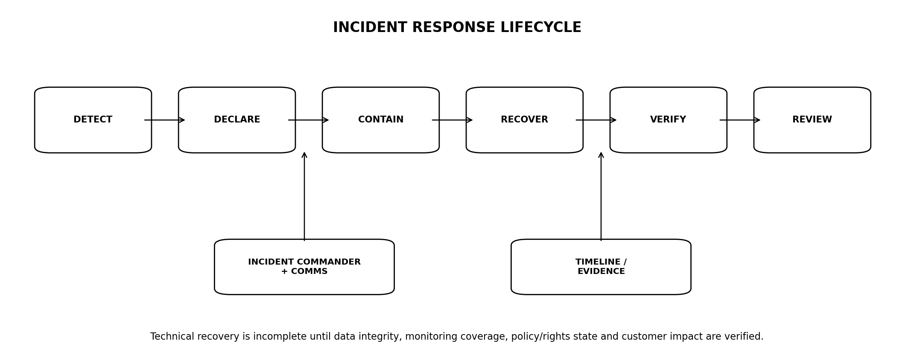
Figure 4 — Incident response lifecycle
1. Detect and declare incident/severity.
2. Assign incident commander and technical leads.
3. Establish customer/data/market/jurisdiction blast radius.
4. Contain: kill feature/provider/source/route or revoke access as required.
5. Recover service/data path from known-good state.
6. Verify correctness: data freshness, calculations, evidence, rights/policy and monitoring coverage.
7. Communicate internal/external status according to severity and legal obligations.
8. Close only when residual risk is understood and follow-up owners exist.
9. Complete blameless post-incident review for SEV0/SEV1 and selected recurring SEV2.

22. OPERATIONAL COMMUNICATIONS
Channel | Purpose
Internal incident channel | Single real-time command log.
Incident document/timeline | Facts, decisions, timestamps, owners.
Status page | Customer-visible only for approved incidents; factual, concise, no speculation.
Customer support brief | Consistent impact/workaround messaging.
Executive/legal escalation | SEV0/SEV1 and regulated/privacy/source-rights cases.
Post-incident report | Material incidents after verification/root cause.

22.1 Communication doctrine
Do not state root cause before evidence supports it. Operational updates distinguish confirmed impact, investigation and mitigation.

23. BACKUP & RECOVERY CLASSES
Class | Data | Launch objective
Class A — Critical mutable | Identity/account, user state, monitoring rules, policy/rights configuration. | Proposed RPO ≤5 min; RTO ≤2 h.
Class B — Canonical/recoverable | Accepted facts, evidence metadata, calculation lineage, audit metadata. | Proposed RPO ≤15 min; RTO ≤4 h.
Class C — Rebuildable derived | Caches, FTS/vector/search indexes, transient projections. | No durable RPO; rebuild target ≤8 h.
Class D — Source-replayable raw | Permitted source payloads depending contract/retention. | Recovery from backup or authorised source replay.

23.1 Objective status
RTO/RPO MUST BE RATIFIED
These are engineering launch objectives, not external contractual promises. Final values require Platform, Product and Board/Commercial approval and must be proven by drills.

24. DISASTER RECOVERY
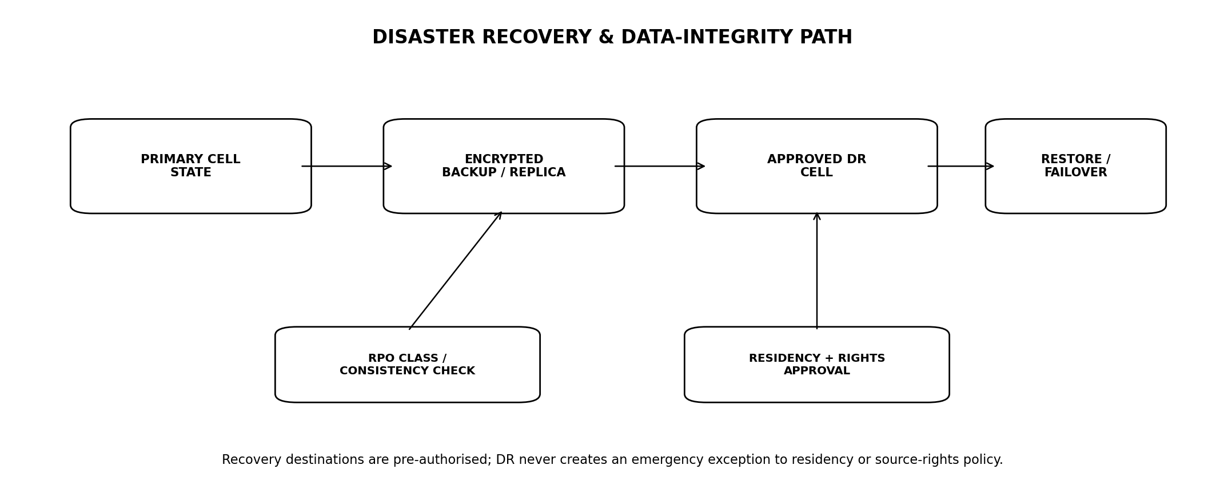
Figure 5 — Disaster recovery and data-integrity path
- DR destination is selected and approved before launch; no improvised region during outage.
- Backups/replicas use encrypted region-appropriate keys.
- Failover procedure identifies DNS/routing, database, object, queue, secrets, provider routes and monitoring.
- DR validation includes policy/rights/residency checks before customer traffic.
- Recovery reconciles queued/outbox work to prevent duplicate business events.
- Failback is a separate controlled change after primary cell integrity is proven.

24.1 Active-active trigger
Active-active multi-region is deferred until an enterprise/business requirement demands RTO below 15 minutes or reliability evidence justifies the complexity. It is not a launch prestige feature.

25. BACKUP & RESTORE DRILLS
Drill | Minimum evidence
Database PITR | Quarterly minimum restore drill for critical production-class data.
Object storage | Sample integrity/retrieval and lifecycle validation.
Configuration/IaC | Recreate critical environment components from code.
Secrets/KMS | Recover/rotate without exposing plaintext secrets.
Deletion/purge | Restored state re-applies deletion/right-revocation tombstones.
Full service | At least annual end-to-end DR exercise after launch; more frequent as enterprise commitments grow.

25.1 Drill result
RecoveryDrill {
drill_id
scope
source_backup_or_replica
started_at
recovered_at
measured_rpo
measured_rto
integrity_checks[]
policy_rights_checks[]
defects[]
signoff
}

26. SOURCE, VENDOR & MARKET-DATA OPERATIONS
Operation | Requirement
Source heartbeat | Expected publication/feed cadence.
Schema drift | Alert/quarantine before corrupt acceptance.
Freshness | Metric/source/calendar-specific SLO.
Rights expiry | Advance alert + fail-closed transition.
Vendor incident | Impact map to facts, monitoring, evidence and customers.
Source switch | Controlled precedence/reconciliation change with QE.
Purge/termination | Runbook with DB/object/index/cache verification.

26.1 Market calendar ops
- Calendar pack changes are versioned and reviewed before effective date.
- Unexpected market closure/holiday change supports emergency pack update with audit.
- Monitoring and freshness expectations use the effective calendar version.

27. NOTIFICATION & EXTERNAL PROVIDER OPERATIONS
Provider class | Operational signals
Email/push | Provider health, rate limits, rejection/error codes, latency.
AI providers | Latency, errors, quotas, cost, model-version behaviour, regional route.
Identity provider | Login/MFA/federation availability.
Market/source vendors | Feed/publication health, credentials, rights status.
Webhooks future | Delivery success, signing secret rotation, dead letter.

27.1 Provider failover
Failover routes are prequalified by Security, Rights, Policy and QE. 'Try another provider' is not an incident-time architecture decision.

28. CAPACITY MANAGEMENT & FORECASTING
Capacity domain | Forecast inputs
API/application | Requests/concurrency/CPU/memory.
PostgreSQL | Connections, CPU/IO, storage, table/index growth.
Monitoring | Active rules, evaluations/sec, fan-out, queue age.
Documents | Acquisition/parse rate, object volume, corpus/chunks.
Search | Index size and query p95.
AI | Requests/tokens/provider quotas/cost.
Notifications | Alert bursts/provider limits.

28.1 Headroom
- Define minimum headroom for T0 resources before launch.
- Market/news spikes are tested separately from average load.
- Capacity alerts use time-to-exhaustion forecasts, not only fixed percentage thresholds.
- Scale architecture only after measured bottleneck and trigger evidence.

29. COST & FINOPS OPERATIONS
Cost class | Required attribution
Infrastructure | By environment, Regional Cell and service.
Database/storage | Growth and backup/egress cost.
Market/source licences | Mapped to product/data usage.
AI | Cost per successful grounded response/task/tier.
Notifications | Per transport and alert volume.
Observability | Telemetry volume/retention.
Data transfer | Cross-region/provider egress; especially residency routes.

29.1 Budget guardrails
- Monthly budget/forecast alerts.
- Unexpected step-change anomaly alerts.
- AI/context and log-volume ceilings.
- Non-production auto-shutdown/scale-down where safe.
- Cost optimisation cannot weaken data retention, security, correctness or required observability.

30. CERTIFICATE, DOMAIN & DNS OPERATIONS
- Automated certificate issuance/renewal with expiry alerts.
- DNS managed through controlled/IaC process where practical.
- Domain registrar access protected by strong MFA and restricted roles.
- CAA/DNSSEC considered according to provider/support model.
- Critical DNS changes are high-risk production changes with rollback.
- Internal service discovery is not exposed as public DNS architecture.

31. SECRETS, KEYS & CREDENTIAL OPERATIONS
Credential | Operational control
Application secrets | Automatic/regular rotation where provider supports.
Database credentials | Short-lived/workload identity preferred; rotate.
Vendor API credentials | Source/provider owner, expiry and rotation runbook.
KMS keys | Rotation and disable/delete policy.
Break-glass credentials | Offline/secure custody; tested; immediate alert on use.
Certificate keys | Managed, non-exportable where practical.

32. MAINTENANCE & PATCHING
- OS/runtime/database/provider maintenance tracked in service catalogue.
- Critical security patches use accelerated process per PLT-SEC-001.
- Managed-service maintenance windows reviewed against market/product criticality.
- Patch staging/smoke/rollback evidence retained.
- End-of-life runtimes/services have planned migration before vendor support expires.

33. RUNBOOK STANDARD
Runbook {
runbook_id
service
symptom / trigger
user/domain impact
prerequisites / access
diagnostic steps
safe mitigations
rollback / stop conditions
escalation
verification steps
communication notes
owner
last_tested_at
}

33.1 Mandatory Tier-0 runbooks
- Database unavailable/degraded.
- Market/source outage or schema drift.
- Monitoring evaluator/coverage failure.
- Policy/rights service failure.
- Cross-tenant/security incident.
- AI/provider outage and evidence-only mode.
- Notification-provider outage.
- Regional Cell failover.
- Mass correction/revocation.
- Queue backlog/poison job.

34. PRODUCTION ACCESS & OPERATIONS SECURITY
- JIT/PAM access per PLT-SEC-001.
- Production console/database access uses named identities and audit.
- Support uses purpose-built tools, not cloud/admin consoles.
- Destructive commands require peer/dual control where blast radius is high.
- Emergency access is time-bounded and reviewed.
- Operational scripts/tools are versioned and tested.

35. OPERATIONAL READINESS REVIEW (ORR)
ORR area | Exit evidence
Ownership | Service owner, pager and escalation confirmed.
Architecture | Production topology/IaC reviewed.
Security | SEC gates/pass, secrets/keys/access ready.
QE | Release gates and golden suites pass.
Observability | Dashboard, alerts, synthetics, domain health live.
Capacity | Load/soak/headroom evidence.
Recovery | Backup/restore and DR evidence.
Runbooks | Tier-0 runbooks tested.
Dependencies | Providers/sources/contracts/quotas/rights ready.
Customer operations | Support/status/incident communication prepared.

36. GO-LIVE READINESS CHECKLIST
1. Production account/project and network baseline created exclusively through approved IaC.
2. Production identity, KMS, secrets, database, object, cache, queue/outbox and observability operational.
3. Launch Source/Market/Jurisdiction/Asset/Locale/Residency packs activated and signed off.
4. PLT-QE-001 master release gates pass for launch build.
5. Security penetration-test blockers closed.
6. Monitoring coverage watcher/dead-man independently verified.
7. Source freshness/degradation and rights expiry alerts verified.
8. Backups complete and at least one production-like restore drill passed.
9. DR cell/location approved and runbook exercised to the agreed launch depth.
10. On-call rota, paging, incident command and status communications ready.
11. Capacity/headroom and provider quotas validated.
12. Rollback, kill-switch and evidence-only AI degradation verified.
13. First-launch canary plan and rollback thresholds approved.

37. PRODUCTION ACCEPTANCE GATES
Gate | Area | Exit criterion
OPS-G01 | IaC | All durable production infrastructure represented in approved IaC.
OPS-G02 | Artefacts | Production release uses signed/immutable artefact linked to QE evidence.
OPS-G03 | Configuration | Secrets, flags, capability and kill-switch controls verified.
OPS-G04 | Database | HA, backups, PITR/restore and migration runbook verified.
OPS-G05 | Observability | T0 metrics/logs/traces/domain health dashboards operational.
OPS-G06 | Paging | Tier-0 pages route to named on-call with tested runbook.
OPS-G07 | Monitoring health | Coverage/dead-man failure drill passes.
OPS-G08 | Source operations | Freshness, schema drift, rights expiry and purge runbooks pass.
OPS-G09 | Capacity | Launch load/spike/soak/headroom evidence accepted.
OPS-G10 | DR | Pre-approved DR route and measured restore evidence accepted.
OPS-G11 | Global policy | No failover/replication route bypasses residency/rights.
OPS-G12 | Security ops | JIT access, key/secret rotation and audit verified.
OPS-G13 | Providers | Critical external-provider health/quota/failover states validated.
OPS-G14 | Incident response | SEV0/SEV1 tabletop and communication path exercised.
OPS-G15 | ORR | Formal operational readiness review complete with no unresolved launch blocker.

38. OPEN DECISIONS / BLOCKERS
ID | Decision | Owner
O-OPS-01 | Cloud/provider selection and first production Regional Cell. | CTO + Platform
O-OPS-02 | Approved disaster-recovery region/cell and final launch RTO/RPO classes. | CTO + Board + Legal
O-OPS-03 | Production compute platform: managed containers/VMs vs orchestration platform based on team capability. | Platform
O-OPS-04 | Observability/SIEM tooling and retention. | Platform + Security
O-OPS-05 | 24/7 on-call staffing/rotation and escalation coverage at launch. | CTO + Engineering
O-OPS-06 | Status-page provider and external incident communication policy. | Product + Legal
O-OPS-07 | Cost budgets and per-environment/provider guardrails. | Finance + CTO

39. IMPLEMENTATION SEQUENCE
Stage | Build | Exit
O0 — Platform baseline | Cloud accounts, IAM, network, KMS, IaC modules, environments. | Staging reproducible from code.
O1 — Data/runtime | Postgres, object, Redis, compute, jobs/outbox, edge. | Core system deploys repeatably.
O2 — Deployment | Build/sign/promotion, flags, migrations, rollback. | Release candidate canary flow works.
O3 — Observability | Metrics/logs/traces/domain health, service catalogue, paging. | T0 pages/runbooks verified.
O4 — Resilience | Backups, restore, DR, queue/source/provider failure drills. | Measured recovery evidence.
O5 — Capacity/FinOps | Load/soak/spike, headroom, quotas, cost allocation. | Launch envelope accepted.
O6 — ORR / launch | On-call, comms, providers, kill switches, production canary. | All OPS-G gates pass.

40. TRACEABILITY TO ENGINEERING ESTATE
Document | Operations dependency
PLT-PRD-001 | Product launch journeys and service expectations.
PLT-ENG-ARCH-003 | Canonical global topology, launch stack and deferral triggers.
PLT-DATA-001 | Database/storage ownership, lifecycle and capacity envelope.
PLT-DATA-002 | Source ingestion, freshness, reconciliation and replay operations.
PLT-RIGHTS-001 | Rights expiry, vendor termination and purge operations.
PLT-FIN-001 | Methodology/calculation release and correction operations.
PLT-POL-001 | Capability/jurisdiction activation and emergency policy controls.
PLT-MON-001 | Rule coverage, dead-man, notification and correction operations.
PLT-EVID-001 | Document acquisition, indexes, evidence correction and purge.
PLT-AI-001 | Provider/model routing, cost, kill switches and evidence-only fallback.
PLT-API-001 | Gateway/BFF, SLO and client degradation contracts.
PLT-SEC-001 | Privileged access, KMS, secrets, incident/security operations.
PLT-QE-001 | Release evidence, canary, resilience and readiness verification.

41. PROHIBITED ANTI-PATTERNS
1. Production infrastructure created manually without IaC because it is 'temporary'.
2. Deploying mutable image/tag 'latest' to production.
3. Rebuilding a different artefact for production after staging qualification.
4. Direct SSH/manual edits on production servers as ordinary operations.
5. Treating HTTP uptime as proof market data and monitoring are correct.
6. Pages based on noisy infrastructure metrics with no user/domain impact.
7. An incident process without a single incident commander.
8. Backups counted as recovery evidence without restore drills.
9. Emergency DR to a region that has not been approved for residency/source rights.
10. Adding Kafka/Kubernetes/microservices solely for perceived enterprise credibility.
11. Letting autoscaling overwhelm PostgreSQL or external providers.
12. Using Redis/search as unrecoverable system-of-record state.
13. Clearing queue backlogs without domain idempotency guarantees.
14. Failing over AI or market-data providers without prequalified rights/security/policy routes.
15. Operating Tier-0 services without tested runbooks and named on-call ownership.

42. OPERATIONS REFERENCE BASELINE
Reference | Use
NIST SP 800-61r3 | Current NIST incident-response recommendations; published April 2025.
NIST Cybersecurity Framework 2.0 | Operational cybersecurity governance and recovery context.
OpenTelemetry semantic conventions | Vendor-neutral telemetry model where adopted.
PLT-QE-001 | Authoritative Talvrin release/canary/verification standard.
PLT-SEC-001 | Authoritative Talvrin privileged access/security response standard.
External standards guide operations; availability, RTO/RPO or certification claims remain Talvrin-specific and require measured evidence and formal approval.

43. ENGINEERING SIGN-OFF STANDARD
PLT-OPS-001 may be approved only when Platform Engineering, Backend Engineering, Data Engineering, Security, Quality Engineering, Trust/Rights, Financial Engineering and Product can operate the launch system from dashboards and runbooks, recover it from failure, prove its domain health, and deploy or roll it back without relying on undocumented individual knowledge.
FINAL BUILD PRINCIPLE
Production readiness is the ability to know what is happening, know what changed, stop the blast radius, recover from known-good state, prove correctness after recovery, and learn permanently from every failure.

