TALVRIN

GLOBAL JURISDICTION, CAPABILITY
& REGULATORY POLICY SPECIFICATION
Detailed Engineering Wireframe 06 / 14
Executable global policy contract for non-regulated-by-design product delivery, jurisdiction activation, feature gating, recommendation-safe interactions, operating-entity control and evidential reconstruction.

Field | Value
Document ID | PLT-POL-001
Version | 1.0
Architecture class | Global policy-as-code + jurisdiction activation specification
Classification | Confidential - Internal
Status | Proposed engineering baseline - for Legal, Compliance and technical approval
Governing architecture | PLT-ENG-ARCH-003 v4.0 - Global Backend Architecture
Product contract | PLT-PRD-001 v1.0
Initial launch wedge | UK gilts + U.S. Treasuries; global platform architecture
Regulatory baseline verified | 30 August 2026
Default doctrine | DENY unless the capability, jurisdiction, data rights and operating entity are affirmatively permitted

BINDING ENGINEERING RULE
A jurisdiction is not supported merely because the service is technically reachable there. A customer-facing capability may execute only where an ACTIVE jurisdiction activation record identifies the servicing entity, the permitted capability set, the current legal basis, required controls and an effective-dated approval.

0. EXECUTIVE ENGINEERING DECISION
Talvrin will implement regulatory perimeter control as a server-side, versioned, evidence-producing policy system. The platform will not rely on disclaimers, prompt wording, client-side hiding, probabilistic classifiers or developer judgement to keep launch functionality outside activities for which the servicing entity lacks the required permission.
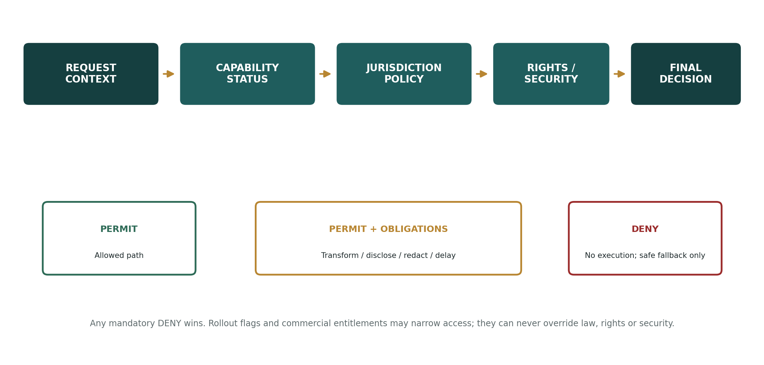
Figure 1 — Global policy decision path
BOARD MANDATE TRANSLATED INTO CODE
If a requested capability cannot be kept within the approved perimeter for the user, jurisdiction, operating entity and context, the system must deny or transform that request. “Ship with a disclaimer” is not an accepted remediation.

1. SCOPE, AUTHORITY AND POLICY HIERARCHY

1.1 What this specification governs
- Jurisdiction and territorial feature activation across Talvrin’s global platform.
- Operating-entity assignment for customer-facing capabilities.
- Regulatory capability classification and executable server-side feature gating.
- Recommendation-safe response families for AI, comparisons, calculations, monitoring and notifications.
- Financial-promotion / customer-communication review controls where the applicable jurisdiction pack requires them.
- Credit-rating, research-opinion, execution, arranging, suitability and personalisation boundaries.
- Policy-as-code schemas, decision semantics, audit evidence, change control, testing and operational controls.

1.2 What it does not govern
- Data-vendor licence permissions: governed by PLT-RIGHTS-001. The final request still requires both regulatory policy and data-rights permission.
- Financial methodology: governed by PLT-FIN-001.
- Authentication and security controls: governed by PLT-SEC-001, although security decisions outrank product policy.
- Product-plan entitlements: commercial access can narrow an allowed capability but can never legalise a prohibited one.
- Legal advice itself: every jurisdiction pack requires documented Legal/Compliance approval before activation.

1.3 Authority order
Priority | Control | Rule
1 | Emergency / security | Kill switches, incident containment, authentication and abuse controls override all product permissions.
2 | Capability status | Only PRODUCTION or correctly scoped RESTRICTED capabilities are externally callable.
3 | Jurisdiction / regulatory policy | Determines whether the servicing entity may provide the requested capability in the resolved context.
4 | Data rights | Determines whether the required datasets and processing actions are contractually permitted.
5 | Commercial entitlement | Determines whether the customer’s plan/account has access.
6 | Rollout / feature flag | Controls exposure only inside the already-permitted envelope.

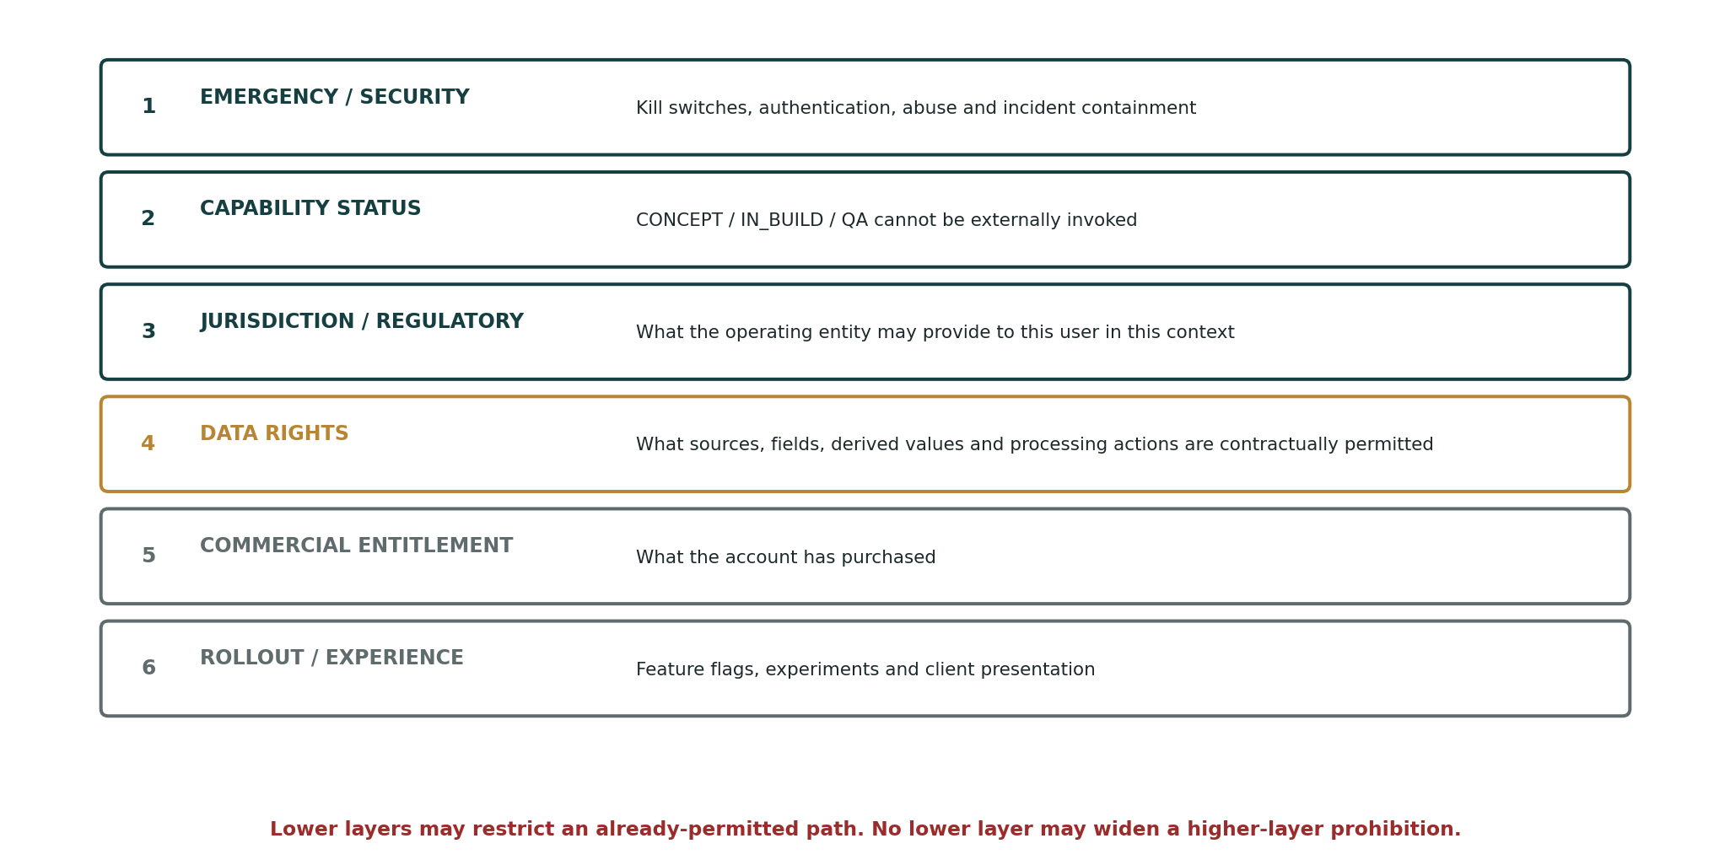
Figure 2 — Policy precedence: lower layers cannot widen higher-layer permission

2. GLOBAL POLICY DOCTRINE
ID | Doctrine | Engineering meaning
P-01 | Deny by default | An unknown jurisdiction, missing activation, policy error or ambiguous servicing entity returns DENY.
P-02 | Structural controls first | The product type system must omit prohibited output families; prompts and classifiers are supplementary controls.
P-03 | No global legal shortcut | A capability permitted in one market is not presumed permitted elsewhere.
P-04 | Jurisdiction ≠ region | User jurisdiction, instrument jurisdiction, venue, operating entity, data source territory and processing region are separate attributes.
P-05 | User direction matters | Comparison metrics, alert thresholds and directions are user-selected where that distinction is part of the approved perimeter.
P-06 | No hidden suitability | Research state must not silently become risk tolerance, wealth, vulnerability or suitability inference in the unauthorised configuration.
P-07 | Copy is executable risk | Marketing, onboarding, empty states, notifications and CTAs are versioned controlled artefacts where the pack requires review.
P-08 | Disclaimers do not cure product behaviour | A prohibited capability remains prohibited even if accompanied by legal text.
P-09 | Effective dates are first-class | Policy changes have valid/effective windows; historical decisions remain reconstructable.
P-10 | Any mandatory DENY wins | No aggregation rule may permit a request when an applicable higher-order policy denies it.
P-11 | Safe transformation is explicit | Where permitted, a prohibited recommendation request may be transformed into an evidence response; the transformation itself is logged.
P-12 | Jurisdiction activation expires | Every activation has a legal review date / expiry; stale activation is not silently treated as current.

3. POLICY ARCHITECTURE
The launch implementation is a module inside the modular monolith with its own database schema, service interface and write authority. It is deliberately designed so it can later become an independent policy service without changing client contracts.
Component | Launch implementation | Responsibility
Policy Decision Point (PDP) | Server-side domain module | Evaluates regulatory/capability policy and returns decision + obligations.
Policy Registry | PostgreSQL | Stores versioned jurisdiction packs, capability policies, output-family rules and activation records.
Policy Enforcement Points (PEPs) | BFF + domain service entry points | Block invocation before protected business logic executes; apply returned obligations.
Copy Registry | PostgreSQL / controlled content store | Stores versioned customer-facing copy classifications and approvals.
Policy Audit | Append-only audit index + WORM manifest | Records decision context, versions, obligations, result and policy hash.
Operations Console | Privileged internal surface | Legal/Compliance activation, suspension, version review and emergency control.

NO BYPASS PATH
A domain service that can serve a regulated-sensitive capability without presenting a PolicyContext to the PDP is a release-blocking architectural defect.

4. CANONICAL POLICY CONTEXT
Every protected request is normalised into a typed PolicyContext. Individual services may supply domain-specific attributes, but the canonical envelope is stable and versioned.
PolicyContext {
request_id
occurred_at
principal: { user_id, account_id, client_class, account_jurisdiction,
verified_residence_country?, current_country_signal?, organisation_id? }
service: { operating_entity_id, channel, application_id, capability_id,
capability_status, subscription_tier }
market: { instrument_ids[], issuer_ids[], asset_classes[], venue_mics[],
instrument_jurisdictions[], market_pack_ids[] }
action: { operation, output_type_requested, communication_context,
personalization_inputs_present, user_selected_inputs,
execution_adjacency, export_requested, ai_task_type? }
data: { source_rights_profile_ids[], data_region, processing_region }
policy: { jurisdiction_pack_id, policy_version, effective_at }
}

Field family | Hard requirement
Principal | Jurisdiction resolution must use approved account/onboarding evidence. IP/geolocation is a signal only unless Legal has approved a stronger use.
Operating entity | Cannot be inferred from brand or DNS. Must resolve from the activation record.
Capability | Stable `capability_id` independent of UI copy and brand.
Output type | Typed contract; “free text” is not a policy type.
Personalisation | Explicit boolean plus declared inputs; no hidden behavioural inference.
User selection | Persist the instruments, metrics, direction and thresholds the user chose where material to the perimeter.
Policy version | Mandatory on every decision for historical reconstruction.

5. DECISION MODEL AND OBLIGATIONS
The PDP returns one terminal decision and zero or more obligations. This avoids proliferating ambiguous pseudo-decisions while still supporting controlled transformations.
PolicyDecision {
decision: PERMIT | DENY
reason_codes[]
obligations[]
jurisdiction_pack_id
policy_version
operating_entity_id
evidence_refs[]
decided_at
decision_id
}

Obligation | Meaning
TRANSFORM_TO_EVIDENCE | Replace recommendation-shaped request with factual/source-linked response family.
DISPLAY_DISCLOSURE | Render pack-approved disclosure copy/version.
REDACT_FIELD | Remove a prohibited field or metric from the response.
DISABLE_CTA | Remove transaction/partner/purchase adjacency.
REQUIRE_COPY_VERSION | Only an approved customer-copy version may be rendered.
REQUIRE_USER_SELECTION | Do not proceed until the user explicitly selects instrument/metric/direction/threshold.
REQUIRE_HUMAN_REVIEW | Route the operation to a controlled internal review; no automatic customer result.
DELAY_DATA | Apply a legally/contractually required latency class where policy invokes it.
LOG_EVIDENCE_PACK | Persist enhanced evidence sufficient for regulator-response reconstruction.

FAILURE SEMANTICS
PDP timeout, registry corruption, unknown pack, stale mandatory activation, missing operating entity or invalid policy signature -> DENY. The user receives a neutral unavailable message, not a speculative result.

6. GLOBAL JURISDICTION ACTIVATION LIFECYCLE
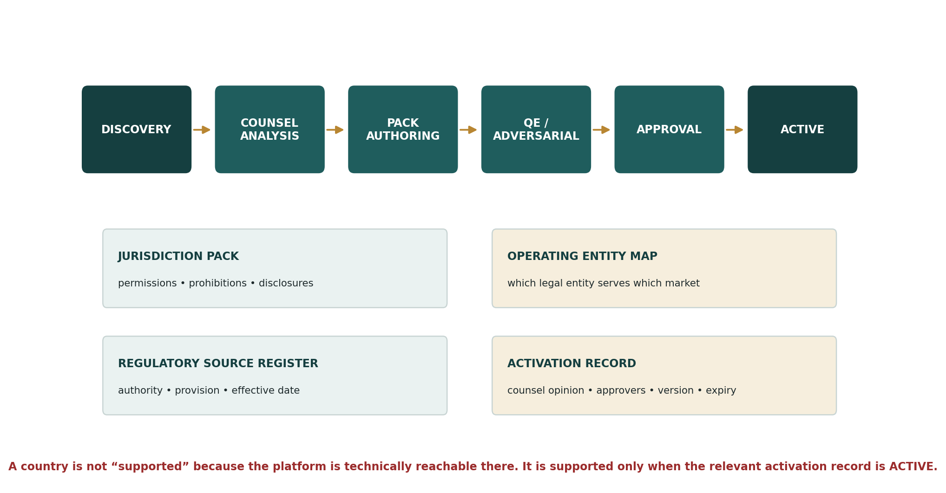
Figure 3 — Jurisdiction activation lifecycle
State | External capability status | Transition requirement
DISCOVERY | None | Market/product/legal scope identified.
LEGAL_ANALYSIS | None | Counsel maps relevant regulated activities, exclusions/exemptions and communication rules.
DRAFT | None | Versioned jurisdiction pack authored.
QA | None | Policy tests and adversarial suite executed.
APPROVED | Not yet live | Named Legal/Compliance + Product + Engineering approval.
ACTIVE | Only listed capabilities | Activation date reached; monitoring active.
SUSPENDED | Denied | Emergency/legal/regulatory or operational suspension.
EXPIRED | Denied | Review/expiry date passed without renewal.
RETIRED | Denied | Market/support withdrawn; historical evidence retained.

6.1 Activation record
JurisdictionActivation {
activation_id
jurisdiction_code
servicing_operating_entity_id
jurisdiction_pack_version
permitted_capability_ids[]
client_classes[]
distribution_channels[]
effective_from / effective_to
counsel_opinion_ref
compliance_approval_ref
engineering_release_ref
review_due_at
status
}
GLOBAL DOES NOT MEAN SIMULTANEOUS
Talvrin’s architecture is global from day one. Customer-facing regulatory activation remains market-by-market and capability-by-capability.

7. JURISDICTION PACK MODEL
Pack domain | Required contents
Identity | ISO jurisdiction code, regulator(s), legal source register, servicing entity, effective dates.
Capability permissions | Allowed/denied/review-required capability IDs and output families.
Advice boundary | Relevant definitions/tests for advice, personal recommendation, general advice or equivalent.
Public recommendation / research | Rules concerning investment recommendations, analyses/reports, ratings or strategy suggestions.
Promotion / communication | Invitation/inducement, advertising, disclosure or approval requirements where applicable.
Execution adjacency | Rules for purchase CTAs, broker links, introductions, arranging or dealing.
Client classification | Retail/professional/accredited/institutional or local equivalents if used by the approved service.
Required disclosures | Exact approved copy IDs and presentation conditions.
Record keeping | Decision/copy/evidence retention obligations.
Localisation | Required legal terminology and language constraints.
Review trigger | Effective-date change, regulator publication, product expansion, operating-entity change, enforcement development.

8. CAPABILITY TAXONOMY
Every externally invokable function must have a stable capability ID and a policy classification. A page or UI route is not a capability boundary.
Capability ID | Function | Policy class
CAP.FACT.DISPLAY | Display accepted factual evidence | FACTUAL
CAP.CALC.DETERMINISTIC | Run approved deterministic calculation | FACTUAL_DERIVED
CAP.COMPARE.USER | User-selected factual comparison | USER_DIRECTED
CAP.DOC.EXPLAIN | Source-grounded document explanation | FACTUAL_EXPLANATION
CAP.MONITOR.USER_RULE | Evaluate user-authored objective rule | USER_DIRECTED
CAP.ALERT.OBJECTIVE | Notify objective event / rule match | FACTUAL_EVENT
CAP.SEARCH.DISCOVERY | Search source-linked instruments/documents | DISCOVERY
CAP.AI.EVIDENCE_QA | Generate explanation constrained to evidence bundle | FACTUAL_EXPLANATION
CAP.EXPORT.DATA | Export permitted facts/results | CONTROLLED_EXPORT

Future capabilities require classification before implementation begins. “We will decide at launch” is not acceptable for regulatory-sensitive behaviour.

9. STRUCTURAL PROHIBITIONS — UNAUTHORISED CONFIGURATION
Family | Prohibition | Structural control
REC.BUY_SELL_HOLD | Buy / sell / hold verdict or equivalent merits conclusion | No response type; no API schema; no notification template.
REC.TARGET_PRICE | Platform-authored target price, fair-value verdict or “upside/downside” action conclusion | No calculation/output family.
REC.TOP_PICK | Top picks, best ideas, best bond/share, platform-chosen ranking by investment merit | No ranking primitive.
SUITABILITY.PROFILE | Risk-tolerance, objectives/needs or financial-situation questionnaire used to recommend | No suitability domain in unauthorised product.
PORTFOLIO.MODEL | Model portfolios, allocations, rebalancing or personalised allocation | No portfolio-recommendation service.
SEGMENT.SUGGESTION | Ready-made investment suggestion to a consumer segment | Denied unless a future authorised jurisdiction pack expressly permits.
CREDIT.RATING | Proprietary credit score, PD grade, rating category, low/medium/high credit verdict | No proprietary rating type.
EXECUTION.ORDER | Order entry, routing, dealing, trade facilitation | No execution domain at launch.
EXECUTION.PURCHASE_CTA | Instrument-level “Buy now”, broker deep link or transaction hand-off | Denied at launch.
ALERT.ACTION | Notification that tells the user what action to take | Template type absent.
AI.HIDDEN_RULE | AI-created threshold/metric/rule not explicitly selected by user | Monitoring API rejects non-user origin.
ML.SUITABILITY_FEATURE | Research behaviour used as risk/suitability feature | Feature pipeline connector denies classified sources.

10. RECOMMENDATION-SAFE RESPONSE CONTRACT
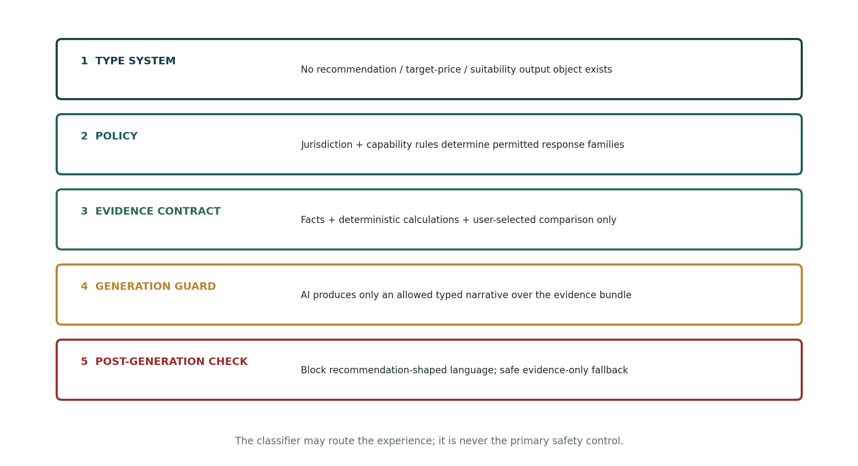
Figure 4 — Recommendation-safe control stack

10.1 Allowed response families
AllowedOutputType = FACTUAL_EVIDENCE | CALCULATION_RESULT | USER_DIRECTED_COMPARISON | DOCUMENT_EXPLANATION | OBJECTIVE_EVENT | USER_RULE_ALERT | SOURCE_DISCOVERY | NEUTRAL_EDUCATION
No generic `RECOMMENDATION`, `OPINION`, `RANKING` or `ADVICE` object exists in the unauthorised schema.

10.2 “Should I buy this?” control path
1. Authenticate and resolve the servicing entity and applicable jurisdiction activation.
2. Classify intent only for routing convenience; classifier output does not grant or deny legal permission.
3. PDP denies recommendation output and, where the pack permits, returns `TRANSFORM_TO_EVIDENCE`.
4. Retrieve source-linked facts and approved deterministic calculations.
5. If comparison is helpful, require the user to choose instruments/metrics rather than the platform selecting “better”.
6. AI may explain only the evidence bundle in an allowed typed response.
7. Post-generation policy check blocks recommendation-shaped constructions.
8. Return evidence/citations or an evidence-only fallback; log transformation and policy versions.

11. USER-DIRECTED COMPARISON AND MONITORING CONTROLS
Domain | Binding rule | Evidence retained
Comparison | User selects instruments and metrics. Platform does not select a winner or merit metric. | Instrument IDs, metric IDs, sort selection/direction, as-of time.
Sorting | User may sort factual results by a user-selected metric where the jurisdiction pack permits; UI must not label the top row “best”. | Sort metric/direction + UI copy version.
Alert threshold | User selects metric, operator, threshold and direction. No server-supplied instrument-specific threshold. | Rule snapshot + user-origin marker.
Objective templates | Coupon, maturity, filing publication and other non-merits events may use neutral templates. | Template ID + pack permission.
Notification | State what occurred and cite the user rule/event. No action recommendation. | Trigger facts, evaluated values, template version.
Watchlist | Persistent state only. Watchlisting must not alter recommendation logic. | State event only; `no_ml_feature` classification.

NEUTRAL CATALOGUE ORDERING
Where the platform presents available metrics or alert types, use neutral/alphabetic/domain ordering or a user-selected order. “Recommended metric”, “popular trade” or merit-based ordering requires a separately approved capability.

12. AI POLICY CONTROLS
Control | Requirement
Tool registry | AI has no tool capable of executing trades, modifying policy, creating hidden alert rules or querying suitability profiles.
Output schema | Model response must validate against an allowed output type before rendering.
Evidence boundary | Narrative may use only the evidence bundle assembled by deterministic services.
Numeric grounding | Material financial numeric claims must resolve to FactID or CalculationResultID under PLT-AI-001.
Recommendation guard | Post-generation control blocks recommendation/merits constructions defined in the active pack.
Fallback | If safe regeneration fails, return the factual evidence card without narrative.
Provider routing | AI provider/region is separately governed by rights, privacy and residency; regulatory policy cannot override those controls.
Logging | Persist model request context, evidence bundle, output type, policy decision and guard result.

Prompt text is not treated as a regulatory perimeter control. Removing a sentence from a prompt must never be capable of exposing a prohibited response family.

13. CUSTOMER COMMUNICATION, MARKETING AND FINANCIAL-PROMOTION CONTROL
Customer-facing copy is a live regulatory risk surface. The system therefore treats copy as versioned configuration with jurisdiction-aware approval status, rather than arbitrary strings embedded in frontend code.
CopyArtifact {
copy_id, version, surface, channel, jurisdiction_scope[], audience_class[],
capability_context[], communication_class,
review_requirement: NONE | INTERNAL | LEGAL | AUTHORISED_APPROVAL,
approval_refs[], effective_from, effective_to, status, content_hash
}

Surface | Examples | Control
Marketing | Homepage, campaign, social, landing page | Pack determines whether review/approval is required; invitations/inducements are not treated as ordinary product copy.
Onboarding | Value propositions, example tasks, empty-state prompts | No “beat the market”, “best investments” or action-oriented investment language in unauthorised configuration.
Instrument page | Headlines, banners, CTAs | No purchase/execution CTA at launch; factual labels only.
Notifications | Email, push, in-app | Objective event / user-rule templates only; versioned and pack-scoped.
AI scaffolding | Suggested questions / prompt chips | Do not seed recommendation requests or platform-authored merits questions.
Educational content | Explainers / glossary | Neutral educational content; pack may still impose local communication rules.

UK-SPECIFIC CORRECTION RETAINED
The UK financial-promotion restriction is not a rule that “all website copy needs authorised approval”. The pack must identify whether a communication is an invitation or inducement and apply the relevant section 21 control only where engaged. [R3]

14. EXECUTION, DEALING, ARRANGING AND TRANSACTION ADJACENCY
Behaviour | Launch status | Technical rule
Order entry / execution | DENY | No order domain or broker credentials.
Instrument-level purchase CTA | DENY | CTA component cannot receive `instrument_id` for purchase/deep-link action.
Broker deep link with instrument prefill | DENY | Not implemented.
Generic educational statement that brokers exist | PACK-CONTROLLED | No specific solicitation/arrangement without approval.
Account aggregation / holdings import | DEFERRED | Requires separate perimeter/privacy review before capability exists.
Partner referral / introduction | DEFERRED | Requires explicit jurisdiction and commercial/legal pack before implementation.

Future transaction adjacency must be treated as a new capability family, not a small UI enhancement. It therefore requires an ADR, jurisdiction-pack changes, API changes and Legal approval before engineering begins.

15. CREDIT RATINGS, RESEARCH OPINIONS AND RANKING CONTROLS
Output | Unauthorised posture
Third-party credit rating | May be displayed only where data rights and jurisdiction pack permit; attributed, source-linked and not modified into a Talvrin grade.
Talvrin credit score / PD grade | PROHIBITED.
“Low risk / high risk” issuer label | PROHIBITED when functioning as a proprietary creditworthiness verdict.
User-selected factual credit metrics | Potentially permitted subject to pack; no platform verdict.
Research report / analysis | Must be classified by jurisdiction pack. Some markets regulate issuance/promulgation of investment research even where not personalised.
Platform ranking | No merit-based ranking. User-selected factual sorting is separately governed under §11.

16. PERSONALISATION, SUITABILITY AND USER-STATE BOUNDARY
State / signal | Permitted use at launch | Prohibited use
Watchlist | Continuity, retrieval, monitoring requested by user | Inferring preference for “similar investments” or buy likelihood.
Search history | Session continuity / recent-history UI where privacy permits | Risk-profile or suitability feature.
Saved comparisons | Restore user workspace | Choosing future “recommended” instruments.
Alert history | Coverage/audit and user history | Inferring trading intent.
Account country/client class | Jurisdiction and entitlement resolution | Investment suitability.
Subscription tier | Commercial entitlement | Proxy for wealth/risk appetite.
Holdings/portfolio | Not in launch scope | No personalised portfolio recommendation logic.

DATA-LINEAGE CONTROL
Tables marked `no_ml_feature` must be denied to feature-store/model-training connectors. Exceptions require a new policy capability and named Legal approval; an analytics engineer cannot waive this classification.

17. OPERATING ENTITY AND TERRITORIAL RESOLUTION
The brand is not the regulated entity. The PDP must know which legal entity is providing the service and which territorial rules apply to the specific request.
Dimension | Examples | Rule
Customer/account jurisdiction | Country of residence / organisation establishment | Resolved from approved onboarding/account data.
Current location signal | Country-level network/device signal where permitted | May trigger a conservative restriction; never sole proof of residency unless approved.
Servicing entity | Configured Talvrin/Zoiko legal entity | Resolved only through activation record.
Instrument jurisdiction | Issuer/security legal jurisdiction(s) | Policy input, not a substitute for customer jurisdiction.
Venue | MIC / exchange / trading venue | May introduce local market rules or communication context.
Distribution channel | Web, app, email, API | Pack may differ by channel.
Processing region | Regional execution cell / AI region | Residency/privacy input; not equivalent to legal service jurisdiction.

FinalApplicablePolicy = intersection(all mandatory jurisdiction/entity/channel/capability controls)
Where multiple applicable policies conflict, the more restrictive mandatory control wins until Legal resolves the conflict and issues a new effective-dated pack.

18. REPRESENTATIVE JURISDICTION REFERENCE PACKS
REFERENCE-ONLY BASELINE
The summaries below are engineering posture, not final legal opinions. They demonstrate how global packs differ. No market becomes ACTIVE until local counsel signs the exact capability set against current law and regulator guidance.

18.1 United Kingdom — reference / launch pack
Area | Verified regulatory baseline (30 Aug 2026) | Engineering posture
Advice vs information | FCA PERG states advice involves opinion/recommendation as to a course of action; information is fact/figures. Article 53 advice can apply even to website/publication advice, so “not personalised” is not enough by itself. [R1] | No merits recommendation; factual evidence/calculation/user-directed comparison only.
Targeted support | COBS 9B has applied since 6 April 2026; the regulated activity covers ready-made suggestions by reference to pre-defined consumer segments. [R2] | No segment-based ready-made investment suggestions in unauthorised configuration.
Financial promotions | Section 21 concerns invitations or inducements to engage in investment activity; apply pack-specific copy classification rather than blanket approval of all copy. [R3] | Copy registry + communication classification.
Investment recommendations | UK MAR Article 20 applies to persons producing/disseminating investment recommendations or information suggesting an investment strategy. [R4] | No platform-authored investment-strategy recommendation.
Credit ratings | Separate UK CRA perimeter requires counsel before any proprietary creditworthiness rating capability. | No proprietary credit rating / grade.

18.2 United States — reference / launch pack
Area | Verified baseline | Engineering posture
Investment adviser definition | 15 U.S.C. §80b-2(a)(11) includes compensated advice and analyses/reports concerning securities, with enumerated exclusions including bona fide publications of general and regular circulation. [R5] | Do not assume exclusion solely because Talvrin publishes information.
Publisher exclusion | Lowe v. SEC focused on disinterested, impersonal publication offered to the public and not individualized to a client’s portfolio/needs. [R6] | Keep non-regulated configuration impersonal and factual; interactive/persistent-state product requires specific counsel analysis.
Treasury-only statutory exclusion | The statute separately excludes certain advice solely concerning direct U.S. government obligations. [R5] | Do not architect around this: Talvrin is multi-asset and the platform must survive expansion.
State law | State investment-adviser / securities requirements can remain relevant. | Activation record requires federal + applicable state analysis for intended distribution model.

18.3 European Union / EEA — reference pack
Area | Verified baseline | Engineering posture
MiFID II advice | MiFID II defines investment advice as personal recommendations to a client relating to transactions in financial instruments. [R7] | No personal recommendations; jurisdiction pack must reflect member-state implementation / exemptions.
Suitability | Where investment advice is provided, suitability rules use objectives, financial situation and risk tolerance; automated delivery does not remove firm responsibility. [R7] | No suitability data model in unauthorised configuration.
MAR recommendations | EU MAR defines investment recommendations / strategy suggestions and Article 20 imposes objective-presentation/conflict requirements. [R8] | No platform-authored investment strategy/price-value opinion in non-regulated pack.
Member-state layer | Authorisation/perimeter analysis can vary through national implementation and competent authority practice. | Use EU core pack + country child pack; never one blanket “EU = active” flag.

18.4 Australia — reference pack
Area | Verified baseline | Engineering posture
Financial product advice | ASIC states providing financial product advice generally requires AFS authorisation; its guidance distinguishes factual information, general advice and personal advice. [R9] | Factual-information path only unless counsel approves a licensed/authorised advice configuration.
General vs personal | General advice can still be financial product advice; absence of personalisation is not a universal safe harbour. [R9] | Do not treat “impersonal” as sufficient; apply Australia-specific output rules.
Dealing/arranging | ASIC identifies dealing/arranging as separate regulated financial services. [R9] | No execution / arranging adjacency at launch.

18.5 India — reference pack
Area | Verified baseline | Engineering posture
Investment advisers | SEBI Investment Advisers Regulations remain in force and were last amended 25 November 2025; SEBI issued a 2026 master circular. [R10] | No personalised investment advisory service without India-specific legal/registration analysis.
Advice / recommendations | SEBI guidance/regulations regulate registered investment advisers; separate research-analyst rules can also be relevant to securities research/recommendations. | Factual evidence product only until counsel classifies research/explanation features.
Performance/return claims | SEBI guidance contains controls around advice/recommendations and claims. | Marketing/copy pack requires India-specific review before activation.

18.6 Hong Kong — reference pack
Area | Verified baseline | Engineering posture
Advising | SFC identifies Type 4 as Advising on Securities and Type 5 as Advising on Futures Contracts. [R11] | No merits advice unless appropriately licensed/approved.
Credit ratings | SFC identifies Type 10 as Providing Credit Rating Services. [R11] | No proprietary credit rating.
Execution / dealing | Type 1 and Type 2 cover securities/futures dealing activities. [R11] | No dealing/transaction path at launch.

18.7 Singapore — reference pack
Area | Verified baseline | Engineering posture
Financial advisory services | Singapore’s Financial Advisers framework covers advice through publications/writings and research analyses/reports concerning investment products; current regulations also distinguish situations where only factual information is provided and no advice/recommendation is given. [R12] | Factual-information configuration only until Singapore counsel approves the exact research/AI surfaces.
General-circulation recommendations | Current regulations contain specific conditions/disclaimer treatment for recommendations to the public/sections of the public. [R12] | Do not rely on a disclaimer as architecture; recommendations remain outside the unauthorised response type system.
Research reports | Issuing/promulgating research analyses/reports is a separately recognised financial advisory service category. [R12] | Document/AI explanations require pack-specific classification before activation.

18.8 DIFC / UAE — reference pack
Area | Verified baseline | Engineering posture
Advising | DFSA GEN 2.11 defines Advising on Financial Products by reference to merits advice on buying, selling, holding, subscribing for or underwriting a particular financial product, including statements/opinions/reports intended or reasonably regarded as intended to influence selection. [R13] | No merits/influence-oriented investment output in unauthorised DIFC configuration.
Specified financial service | DFSA GEN 2.2.2 lists Advising on Financial Products as a specified Financial Service. [R13] | Activation requires explicit DFSA perimeter analysis for servicing entity/business model.
Credit rating / arranging | DFSA separately identifies credit-rating and arranging activities. [R13] | No proprietary ratings or arranging at launch.

18.9 All other markets
Canada, Japan, Brazil, South Africa, Gulf jurisdictions outside the DIFC example and every other market are represented by separate effective-dated jurisdiction packs. Where securities regulation is provincial/state/member-state based, the pack hierarchy must model that subdivision. An absent pack returns DENY for protected capabilities.

19. POLICY-AS-CODE SPECIFICATION
Policies must be declarative, reviewable and testable. The implementation may use OPA/Rego or an equivalent rules engine, but the persisted policy contract is provider-neutral.
policy "CAP.MONITOR.USER_RULE" {
when capability_status in [PRODUCTION, RESTRICTED]
require jurisdiction_activation.status == ACTIVE
require output_type == USER_RULE_ALERT
require rule.origin == USER_DEFINED
require rule.metric_selected_by_user == true
require rule.threshold_selected_by_user == true
deny if execution_adjacency == true
deny if recommendation_language_required == true
obligations += [LOG_EVIDENCE_PACK]
}

Rule property | Requirement
Deterministic | Same PolicyContext + same policy version -> same decision.
Pure evaluation | No network calls inside rule evaluation; necessary facts are supplied in PolicyContext or trusted registries.
Versioned | Immutable released versions; change creates new version.
Effective-dated | Future rule changes can be staged without altering historical decisions.
Test-bound | Every rule has positive, negative and boundary tests.
Human-readable reason | Decision exposes stable reason codes mapped to operator/customer-safe explanations.
Signed release | Production policy bundle is checksummed/signed and linked to approval record.

20. POLICY DATA MODEL
Entity | Key fields / purpose
jurisdiction_pack | jurisdiction_code, version, legal_sources, effective interval, status, hash.
jurisdiction_activation | servicing entity + client/channel/capability scope + approval refs + review date.
capability_policy | capability_id, output families, predicates, obligations, effective dates.
operating_entity | legal entity identity, home jurisdiction, permissions profile, supported channels.
copy_artifact | versioned customer-facing copy, communication class, jurisdiction/channel/audience scope.
copy_approval | reviewer, authority, approval type, scope, dates.
policy_decision | context hash, policy hash/version, terminal decision, obligations, reason codes.
regulatory_source | authority, title, provision, URL, publication/effective date, last verified.
legal_opinion_ref | external/internal counsel memo reference; never raw confidential memo text in ordinary product logs.
policy_incident | unexpected perimeter behaviour, containment, affected capability/markets, remediation.

All entities use neutral `PLT-` identifiers. Brand changes must not require policy-data migration.

21. INTERNAL POLICY API CONTRACT
POST /internal/policy/evaluate
Request: PolicyContext
Response: PolicyDecision
GET /internal/policy/capabilities/{capability_id}/manifest
Response: effective allowed/denied state for resolved jurisdiction + obligations
POST /internal/policy/copy/evaluate
Request: { copy_id, version, surface, principal_context, capability_context }
Response: PolicyDecision

API rule | Requirement
Authentication | Workload identity only; no public direct PDP endpoint.
Timeout | Strict low-latency budget; timeout -> DENY for protected path.
Idempotency | Decision is pure; audit write uses request/decision ID for deduplication.
Caching | Only immutable versioned policy bundles; never cache a broader permission across jurisdiction/account contexts.
Observability | Trace includes decision ID, capability ID, jurisdiction pack version and reason code; no unnecessary personal data.
Bulk manifests | BFF may request capability manifest for UX shaping, but each protected command still re-evaluates server-side.

22. COPY GOVERNANCE WORKFLOW
1. Product/Marketing creates a CopyArtifact using a controlled copy ID.
2. System classifies surface, channel, capability context, intended audience and jurisdiction scope.
3. Applicable jurisdiction pack returns required review type.
4. Named reviewer approves/rejects the exact content hash and version.
5. Only ACTIVE approved version may render where approval is mandatory.
6. Changing punctuation or CTA text creates a new version if content hash changes.
7. Historical customer communication is reconstructable from copy version + decision/audit record.
NO COPY IN SOURCE CODE
Regulatory-sensitive customer copy must not exist only as anonymous frontend strings. Engineering may still bundle static neutral UI labels, but any surface classified by policy as controlled must resolve through the Copy Registry.

23. AUDIT, EVIDENCE AND REGULATOR-RESPONSE PACK
For any customer-visible protected output, Talvrin must be able to reconstruct why the system believed the behaviour was permitted at that time.
Evidence item | Required
PolicyContext snapshot / hash | Yes
Jurisdiction activation ID/version | Yes
Operating entity ID | Yes
Capability ID/status | Yes
Policy bundle version/hash | Yes
Terminal decision + reason codes + obligations | Yes
Copy artifact/version if customer communication | Where applicable
Evidence bundle / calculation IDs | For evidence/calculation/AI outputs
AI request/model/prompt policy versions | For AI outputs
User-selection evidence | For comparison/rule paths where legally material
Delivery/notification template version | For alerts
Timestamp + correlation ID | Yes

The regulator-response pack is generated from references; it must not depend on mutable current configuration.

24. FAILURE AND DEGRADATION SEMANTICS
Failure | System behaviour | User/operator outcome
PDP unavailable | DENY protected operation | Neutral unavailable message; P1/P2 based on blast radius.
Jurisdiction pack missing | DENY | Unsupported jurisdiction/capability message; activation ops alert.
Activation expired | DENY | Capability unavailable; Legal/Compliance alerted before expiry via scheduled control.
Copy approval expired | Do not render controlled copy | Fallback neutral approved copy if pack supplies one; otherwise suppress surface.
Policy bundle signature/hash mismatch | DENY + isolate bundle | Security incident.
Conflicting mandatory policies | DENY | Policy conflict queue; no “least restrictive” merge.
AI guard unavailable | No AI narrative | Return evidence-only path if independently permitted.
Rights engine denies data | Policy cannot override | Return rights-aware unavailable state.
Emergency kill switch | Immediate DENY | Surface disabled regardless of cached manifests.

25. POLICY CHANGE MANAGEMENT
Change type | Required process
Regulator rule/guidance change | Source register update -> Legal analysis -> new pack version -> tests -> approval -> effective date.
New country/market | New pack + activation; never copy an existing country and change the ISO code.
New capability | Capability classification before engineering implementation; pack impact matrix required.
Operating entity change | New activation records; historical decisions retain old entity.
New output language/template | Copy classification and review according to affected packs.
Emergency restriction | Kill switch may precede full pack release; follow with documented policy version/remediation.
Legal interpretation change | New effective-dated version; do not overwrite historical policy.

Legal and Compliance own legal interpretation. Engineering owns faithful implementation, deterministic evaluation and evidence. Product owns proposed customer behaviour but cannot self-approve perimeter changes.

26. VERIFICATION AND ADVERSARIAL TEST SUITE
Suite | Minimum coverage / gate
Policy unit tests | Every rule: permit, deny, boundary, missing-field and effective-date cases.
Jurisdiction matrix | Every ACTIVE pack × every launch capability × relevant client/channel class.
No-bypass tests | Direct domain invocation without PDP must fail.
Type-system tests | Forbidden response objects cannot be instantiated/serialized.
Recommendation adversarial set | Prompt variations, indirect requests, ranking requests, “what would you do”, implied suitability; zero forbidden output.
Comparison tests | No server default winner/metric; user selection logged.
Monitoring tests | No server-supplied threshold; notification contains event only.
Copy tests | Unapproved/expired copy cannot render in controlled surface.
Jurisdiction expiry chaos | Expiry during session -> next command denied; stale client manifest cannot override.
PDP outage chaos | Protected capabilities deny; evidence-only fallback only if separately allowed.
Historical reconstruction | Sampled decisions reproducible from archived policy bundle + context.
Regression corpus | Every production policy incident becomes a permanent release test.

RELEASE GATE
A known perimeter violation is not a tolerated flaky test. It blocks release until the rule, type system or product behaviour is corrected.

27. NON-FUNCTIONAL TARGETS AND OBSERVABILITY
Metric | Launch target
PDP evaluation p95 | ≤25 ms in-process / local service path excluding external systems.
Policy decision availability | ≥99.99% architectural target; failure still denies safely.
Policy bundle propagation | ≤5 min ordinary release; ≤60 s emergency restriction/kill switch.
Activation expiry warning | 30d / 14d / 7d / 24h alerts to owners.
Audit decision write | ≥99.99%; protected output must not complete if mandatory audit persistence cannot be guaranteed.
Historical reconstruction | 100% sampled protected decisions reconstructable from retained artefacts.
Active-pack review coverage | 100% reviewed by `review_due_at`; expired pack cannot remain active.
Adversarial policy regression | 0 forbidden output failures on release gate set.

- Dashboard by jurisdiction/capability: permits, denies, transforms, reason codes and trend.
- Unknown-jurisdiction / missing-pack attempts.
- Upcoming activation/copy/source review expiry.
- Emergency kill-switch status and propagation.
- Policy-version adoption across regional cells.
- Recommendation-guard blocks and evidence-only fallbacks.

28. POLICY OPERATIONS CONSOLE
Module | Permitted actions | Role boundary
Jurisdiction Packs | Draft, compare versions, stage, retire | Legal/Compliance author; Engineering cannot alter legal meaning.
Activations | Approve/suspend/reactivate scoped capabilities | Dual approval for production activation.
Capability Matrix | View effective state by country/entity/channel | Read for Product/Support; write tightly controlled.
Copy Registry | Submit/review/activate content versions | Marketing/Product submit; required reviewer approves.
Regulatory Sources | Maintain authority/provision/effective-date references | Legal/Compliance.
Kill Switches | Immediate capability/jurisdiction disable | On-call Security/Compliance with audited break-glass rights.
Decision Explorer | Reconstruct request decisions | Compliance/Support scoped access; PII minimised.
Policy Incidents | Record, contain, remediate, bind regression test | Cross-functional.

All privileged policy changes are append-only audited. No administrator may both author and solely approve a production jurisdiction activation unless an emergency break-glass procedure is invoked and subsequently reviewed.

29. PRODUCTION ACCEPTANCE GATES
Gate | Acceptance criterion
G-01 | All launch capabilities have stable capability IDs and classifications.
G-02 | No prohibited output family exists in API/domain schemas.
G-03 | Every launch jurisdiction has an ACTIVE, effective-dated activation with named servicing entity and approval references.
G-04 | Unknown/expired/missing jurisdiction state deterministically denies.
G-05 | PDP is enforced at every protected domain entry point; bypass tests pass.
G-06 | Rights, security and capability status can independently deny; no precedence bug can override them.
G-07 | User-directed comparison and monitoring requirements are enforced and logged.
G-08 | Recommendation adversarial suite has zero forbidden-output failures.
G-09 | Controlled copy cannot render without the approval required by the active pack.
G-10 | Policy outage chaos test produces safe denial/fallback behaviour.
G-11 | Historical decision reconstruction is demonstrated end-to-end.
G-12 | Emergency kill switch disables the scoped capability inside propagation SLO.
G-13 | Activation-expiry controls and owner alerts are operational.
G-14 | Policy audit stream is tamper-evident and production monitored.
G-15 | Legal/Compliance sign-off confirms the exact launch capability matrix, not merely this architecture document.

30. OPEN DECISIONS / BLOCKERS
ID | Decision | Blocks | Owner
O-01 | Final launch servicing legal entity/entities and jurisdiction-to-entity mapping. | Activation | Board / Legal
O-02 | Jurisdiction-specific counsel opinions for launch markets and distribution model. | Activation | Legal
O-03 | Whether any professional/adviser workflow requires a distinct account/client classification or terms. | Pro/Team scope | Product + Legal
O-04 | Whether third-party credit ratings will be displayed at launch. | Credit-rating display capability | Legal + Data Rights
O-05 | Whether generic broker/partner referrals are in launch scope. | Any transaction adjacency | Commercial + Legal
O-06 | Public marketing communication classification and review workflow per launch market. | External launch copy | Marketing + Legal
O-07 | Initial jurisdiction-pack review cadence after launch. | Operations | Compliance
O-08 | Whether future holdings import is strategically required; if yes, separate perimeter/privacy review before design. | Future roadmap | Product + Legal

31. IMPLEMENTATION SEQUENCE
Phase | Build | Exit criterion
P0 | Capability registry + policy schema + PDP contract + deny-by-default path | Unknown jurisdiction/capability denies in integration test.
P1 | Jurisdiction pack + activation data model + operating-entity resolver | Reference pack evaluates deterministic contexts.
P2 | PEPs at BFF/domain boundaries + capability manifest | No-bypass suite passes.
P3 | Structural output types + comparison/monitoring user-selection constraints | Forbidden response objects absent; user-origin tests pass.
P4 | Copy Registry + approval flow + notification template controls | Expired/unapproved copy cannot render.
P5 | AI recommendation-safe integration + post-generation guard | Adversarial suite passes zero-failure gate.
P6 | Audit/regulator-response pack + decision explorer + kill switches | Historical reconstruction + emergency disable demonstrated.
P7 | Launch-jurisdiction legal packs + final approval | All G-01–G-15 gates satisfied.

32. PROHIBITED ANTI-PATTERNS
1. “Not financial advice” disclaimer used as the primary perimeter control.
2. Client-side hiding of a feature while the backend remains callable.
3. One global `regulated=false` flag.
4. Using IP country as the only jurisdiction determination.
5. Hard-coding legal rules inside arbitrary product-service conditionals.
6. Allowing a feature flag or paid plan to override a legal/data-rights denial.
7. Using an LLM classifier as the primary recommendation-safety mechanism.
8. Generating unrestricted free text and attempting to redact it after the fact as the only control.
9. Server-supplied “recommended” comparison metrics or instrument-specific alert thresholds in the unauthorised configuration.
10. Overwriting an old legal policy when interpretation changes.
11. Leaving an expired jurisdiction activation active because engineering has not deployed a replacement.
12. Embedding regulated-sensitive marketing copy directly in frontend source without controlled versioning where review is required.
13. Assuming EU, U.S., Canada or any other multi-layer jurisdiction can be represented by a single undifferentiated rule where local law differs.
14. Adding a broker link/order CTA as “just a frontend change”.

33. AUTHORITATIVE REGULATORY SOURCE REGISTER — BASELINE
The sources below were verified for this engineering baseline on 30 August 2026. Each production jurisdiction pack must pin the exact source/provision versions and counsel interpretation applicable at activation. URLs are references, not an automatic legal-rule ingestion mechanism.
Ref | Authority | Source | URL
R1 | UK FCA | PERG 8.27–8.28 — advice / information | https://handbook.fca.org.uk/handbook/perg8
R2 | UK FCA | COBS 9B Targeted Support — effective 6 April 2026 | https://handbook.fca.org.uk/handbook/cobs9b
R3 | UK FCA | Financial promotions / section 21 overview | https://www.fca.org.uk/firms/financial-promotions-and-adverts/approving-financial-promotions
R4 | UK FCA | UK Market Abuse Regulation — investment recommendations | https://www.fca.org.uk/markets/market-abuse/regulation
R5 | United States Code | 15 U.S.C. §80b-2(a)(11) — investment adviser definition/exclusions | https://uscode.house.gov/view.xhtml?req=granuleid:USC-prelim-title15-section80b-2
R6 | U.S. Supreme Court | Lowe v. SEC, 472 U.S. 181 (1985) | https://supreme.justia.com/cases/federal/us/472/181/
R7 | ESMA / EU | MiFID II Article 4 definition of investment advice; Article 25 suitability context | https://www.esma.europa.eu/publications-and-data/interactive-single-rulebook/mifid-ii/article-4-definitions
R8 | EUR-Lex | Regulation (EU) No 596/2014 (MAR), Article 20 and definitions | https://eur-lex.europa.eu/eli/reg/2014/596
R9 | ASIC | Giving financial product advice / RG 244 | https://www.asic.gov.au/regulatory-resources/financial-services/giving-financial-product-advice
R10 | SEBI | Investment Advisers Regulations / 2026 Master Circular | https://www.sebi.gov.in/legal/master-circulars/feb-2026/master-circular-for-investment-advisers_99569.html
R11 | Hong Kong SFC | Licensing — types of regulated activity | https://www.sfc.hk/en/Regulatory-functions/Intermediaries/Licensing/Do-you-need-a-licence-or-registration
R12 | Singapore Statutes Online | Financial Advisers Regulations / current provisions on factual information and recommendations | https://sso.agc.gov.sg/SL/FAA2001-RG2
R13 | DFSA Rulebook | GEN 2.11 — Advising on Financial Products; GEN 2.2.2 specified activities | https://dfsaen.thomsonreuters.com/rulebook/gen-211-advising-financial-products

ENGINEERING SIGN-OFF STANDARD
PLT-POL-001 is complete for implementation only when Legal/Compliance own the jurisdiction content, Engineering can prove the PDP/PEP controls and no-bypass tests, Product accepts the constrained behaviour, and every launch activation satisfies the production gates above. This document is the global policy architecture; it does not itself activate a market.

