TALVRIN

GLOBAL QUALITY ENGINEERING,
VERIFICATION & RELEASE STANDARD
Detailed Engineering Wireframe 12 / 14
The release-control standard that turns Talvrin requirements, domain invariants, safety gates and operational objectives into repeatable evidence before and after production deployment.
Field | Value
Document ID | PLT-QE-001
Version | 1.0
Architecture class | Global quality engineering and release assurance
Classification | Confidential — Internal
Status | Proposed engineering baseline — for technical approval
Parent architecture | PLT-ENG-ARCH-003 v4.0
Primary dependencies | PLT-PRD-001 through PLT-SEC-001
Canonical scope | Global product, all launch and future Regional Cells, all activated markets/assets/jurisdictions

ENGINEERING POSITION
Quality Engineering is not a final testing phase. It is the system that proves every release preserves Talvrin’s factual integrity, calculation determinism, monitoring coverage, evidence lineage, regulatory perimeter, data rights, security boundaries and user-visible reliability.

0. EXECUTIVE QUALITY DECISION
Talvrin will operate one release assurance system in which requirements are traceable to automated or exercised verification, hard gates are machine-enforced wherever possible, and production telemetry is part of quality evidence rather than a separate operations concern.
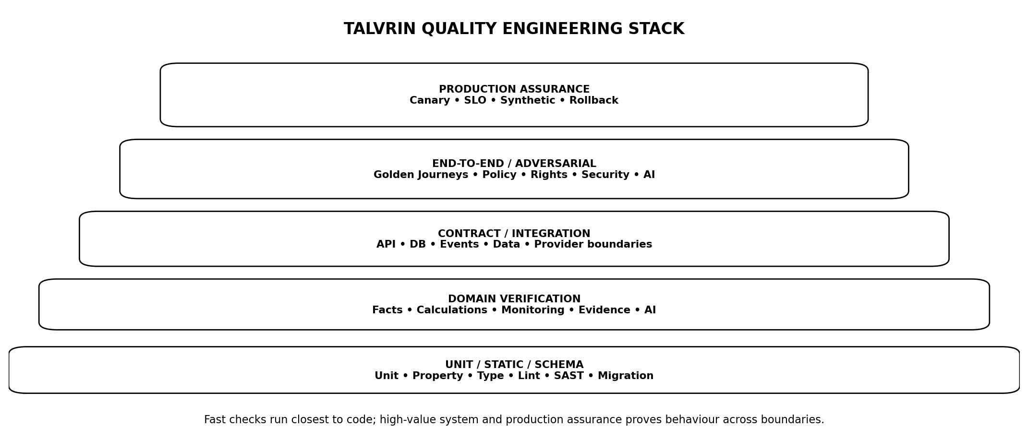
Figure 1 — Talvrin Quality Engineering verification stack
PRIMARY INVARIANT
No release is 'green' because unit tests pass. A release is green only when the applicable domain, safety, rights, security, performance, resilience, accessibility and production-readiness gates have passed for the exact build being deployed.

1. SCOPE, AUTHORITY AND QUALITY BOUNDARY
- Verification strategy, test levels, ownership and evidence requirements.
- Requirement-to-test traceability and release evidence.
- Domain-specific quality gates for data, calculations, monitoring, evidence, AI and policy.
- API, security, privacy, performance, resilience, accessibility and globalisation verification.
- Defect management, escaped-defect feedback and regression policy.
- Test data, environments, mocks/stubs/sandboxes and external-provider qualification.
- Release qualification, canary verification, rollback criteria and post-release closure.

1.1 Authority rule
HARD GATES CANNOT BE VOTED AWAY
A product owner, developer or executive approval does not convert a failed numeric-grounding, tenant-isolation, rights, policy, security or data-integrity gate into PASS. Emergency release exceptions require the explicit emergency process defined here and are never silent.

2. QUALITY DOCTRINE — NON-NEGOTIABLE INVARIANTS
ID | Invariant | Engineering meaning
QE-INV-01 | Test the contract, not implementation trivia | Verification follows requirements and invariants.
QE-INV-02 | Fastest valid test first | Push deterministic checks down to unit/schema/property tests.
QE-INV-03 | Golden values for finance | Financial results require authoritative golden corpora and independent validation.
QE-INV-04 | No test-only safety | Production enforcement must exist; tests prove it.
QE-INV-05 | Every escaped defect becomes regression | Material production failures permanently improve the suite.
QE-INV-06 | No flaky green | Flaky tests are defects; quarantined tests cannot satisfy release gates.
QE-INV-07 | Data state is tested | Late/stale/revoked/corrected/unavailable are first-class cases.
QE-INV-08 | Global from first schema | Locales, calendars, currencies, jurisdictions and cells are not postponed architecture assumptions.
QE-INV-09 | Production is verified | Canary, synthetics, telemetry and rollback are part of release evidence.
QE-INV-10 | Test evidence is immutable enough to audit | Build, test version, inputs and results are retained.
QE-INV-11 | Manual testing is purposeful | Use humans for exploratory/usability/legal judgement, not repeatable machine checks.
QE-INV-12 | Independence scales with risk | Critical financial/security controls receive independent implementation/review.
QE-INV-13 | No fixture lies | Mocks cannot silently diverge from external/provider contracts.
QE-INV-14 | Accessibility is a release property | WCAG 2.2 AA is tested across critical journeys, not checked once at design time.

3. QUALITY MODEL AND CHARACTERISTICS
Talvrin uses ISO/IEC 25010:2023 as a reference quality model, adapted to the product’s regulated-boundary and financial-evidence risks.
Characteristic | Talvrin interpretation
Functional suitability | Correct facts, calculations, rules, evidence, workflows.
Performance efficiency | Latency, throughput, capacity and resource efficiency.
Compatibility | APIs, browsers/devices, providers, data formats and integrations.
Interaction capability | Usability, accessibility and predictable interaction.
Reliability | Availability, fault tolerance, recoverability and monitoring coverage.
Security | Confidentiality, integrity, authenticity, accountability and resistance.
Maintainability | Modularity, analysability, testability and safe modification.
Flexibility | Global packs, markets/assets/jurisdictions without core forks.
Safety / domain assurance | Talvrin extension: recommendation perimeter, rights, financial integrity and evidence provenance.

4. TEST LEVELS & OWNERSHIP
Level | Primary owner | Purpose
Static / schema | Developer + CI | Types, lint, schema, migrations, policy definitions, SAST.
Unit | Developer | Pure business functions, parsers, predicates, calculations, validators.
Property-based | Developer/QE | Invariant exploration across generated inputs.
Component | Owning team | Module with real DB/cache but controlled dependencies.
Contract | Owning + consumer team | API/events/provider/schema compatibility.
Integration | QE + owning teams | Multiple real modules and infrastructure dependencies.
System / E2E | QE | Golden user journeys through production-like stack.
Adversarial | QE/Security/Policy/AI | Abuse, safety, rights, injection and policy-boundary attacks.
Performance / resilience | QE + Platform | Load, soak, chaos, failover, recovery.
Exploratory / usability | QE/Product/Design | Human-discovered gaps and interaction quality.
Production assurance | QE + Ops | Canary, synthetics, SLOs and rollback.

5. REQUIREMENT-TO-TEST TRACEABILITY
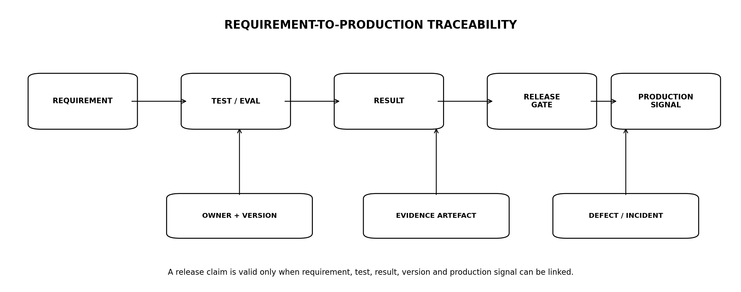
Figure 2 — Requirement-to-production traceability
TraceabilityRecord {
requirement_id
requirement_version
owner
risk_class
verification_ids[]
release_gate_ids[]
latest_passed_build
production_signal_ids[]
open_defect_ids[]
}

5.1 Coverage rules
- Every MUST/SHALL requirement has at least one verification method.
- Every production acceptance gate has a named executable/manual evidence source.
- Critical domain invariants require direct tests, not indirect journey coverage only.
- Requirements without automated verification require a documented reason and manual protocol.

6. RISK-BASED TEST CLASSIFICATION
Risk class | Definition | Release effect
Q0 — Critical | Could corrupt financial truth, breach tenants/data, violate hard regulatory/rights boundary, silently stop monitoring. | Hard release blocker; independent verification.
Q1 — High | Material user harm/research error, major workflow failure, security weakness without immediate breach. | Release blocker unless formal emergency exception.
Q2 — Medium | Degraded workflow/accuracy/usability with workaround. | Fix or explicitly defer with owner/date.
Q3 — Low | Cosmetic/minor inconvenience. | Normal backlog.

6.1 Automatic Q0 classes
- Cross-tenant access or RLS bypass.
- Incorrect authoritative calculation or golden-value drift.
- Rights/policy bypass exposing prohibited data/action.
- AI material numeric claim without grounding.
- Duplicate/false monitoring alert caused by deterministic idempotency defect where material.
- Monitoring silently reported healthy while not evaluating.
- Tampering/corruption of evidence/fact lineage.

7. TEST DATA STRATEGY
Class | Policy
Synthetic canonical data | Default for functional/unit/system tests.
Golden financial instruments | Curated authoritative cases with expected values/conventions.
Anonymised production-derived | Only approved/minimised cases; no raw user/vendor data copied casually.
Vendor sandbox/sample | Used where contract allows and representative.
Malicious corpus | Security, injection, parser and AI adversarial cases.
Global edge corpus | DST, holidays, locales, currencies, encodings, language and calendar extremes.

7.1 Production data prohibition
NO CONVENIENCE COPIES
Production user data or licensed vendor payloads are not copied into test environments merely because they are realistic. Use synthetic or rights-approved representative data unless an explicit controlled diagnostic workflow is authorised.

8. ENVIRONMENT STRATEGY
Environment | Purpose
Local | Fast developer checks; containers/fakes as appropriate.
CI ephemeral | Isolated repeatable unit/component/contract stack.
Integration | Shared or ephemeral multi-service environment with controlled dependencies.
Staging | Production-like topology, policy, migrations, observability and release candidate.
Shadow | Non-user-visible candidate evaluation against replay/synthetic workloads.
Production canary | Small controlled real-traffic deployment with rollback.

8.1 Environment parity
- Schema/migration topology matches production.
- Feature/capability flags are testable under same control mechanisms.
- Security controls are not disabled merely for staging convenience.
- External-provider test modes are explicitly documented where they differ from production.

9. TEST DOUBLES & EXTERNAL DEPENDENCIES
Double | Rule
Stub | Deterministic narrow response for unit/component tests.
Mock | Behaviour assertion; use sparingly for contracts.
Fake | Functional local implementation e.g. in-memory/provider simulator.
Sandbox | Vendor-provided environment; contract differences documented.
Record/replay | Permitted only for non-sensitive/right-cleared fixtures with redaction.

9.1 Contract drift defence
- Provider schemas are checked against current contract/sample responses.
- Mocks/fakes are versioned with the provider contract.
- Critical provider integrations have scheduled live/sandbox contract tests.
- Provider-breaking changes create release-blocking compatibility defects when relevant.

10. DATA MODEL & DATABASE VERIFICATION
Area | Required verification
Schema constraints | PK/FK/check/unique/non-null/domain invariants.
Bitemporal | Valid-time vs knowledge-time queries, corrections, restatements, revocations.
RLS | Cross-account read/write/delete denial.
Migrations | Forward migration, rollback/roll-forward strategy, backfill, large-table safety.
Concurrency | Lost update, uniqueness race, idempotency.
Retention/purge | Rights-specific purge and tombstones.
Indexes | Query-plan/performance regression for critical reads.

10.1 Migration gate
Every production schema migration must be exercised against a representative-size staging dataset and classified as online, bounded-lock or maintenance-required. Unbounded table rewrite risk is a release blocker.

11. MARKET DATA & RECONCILIATION VERIFICATION
- Connector schema drift and malformed payloads.
- Identity ambiguity and deterministic resolution.
- Source precedence, tolerance and conflict/quarantine cases.
- Late/out-of-order/backfilled data.
- Restatements, corrections and revocations.
- CURRENT/DELAYED/STALE/UNAVAILABLE transitions.
- Source outage, recovery and reconciliation replay.
- Rights expiry/purge interaction.

11.1 Golden source packs
Each activated Market/Source Pack carries a conformance suite with valid, invalid, edge and correction fixtures. A new source cannot reach PRODUCTION without passing the pack suite.

12. FINANCIAL CALCULATION VERIFICATION
DUAL IMPLEMENTATION FOR GOLDENS
Critical launch financial calculations are validated against an independent implementation or authoritative worked examples. Reusing the same library/code path to generate the expected answer is not independent validation.
Suite | Requirement
Golden values | Authoritative/independent expected result.
Boundary cases | Settlement on coupon date, near maturity, zero/negative rates where valid.
Convention cases | Day count, calendars, clean/dirty price, rounding.
Property tests | Monotonicity/invariants where mathematically applicable.
Precision | No intermediate rounding drift.
Historical replay | Pinned methodology/calendars reproduce historical result.
Correction | Changed input facts produce new immutable calculation result and affected-output propagation.

12.1 Release tolerance
Tolerance is methodology-specific and approved by Financial Engineering. A broad generic tolerance that masks formula or convention defects is prohibited.

13. MONITORING, RULES & ALERTING VERIFICATION
- Initial-state vs true crossing.
- Equality, crossing above/below, hysteresis, debounce and re-arm.
- Late/out-of-order/backfill/correction/revocation.
- Market calendars, early close and DST.
- Duplicate trigger/idempotent evaluation.
- Delivery retry and deduplication.
- Coverage lapse and independent dead-man detection.
- Policy/rights/capability changes while rule is armed.
- Regional Cell routing and user quiet hours.

13.1 Coverage soak
Before launch, staging must operate continuous representative monitoring long enough to demonstrate the configured coverage SLO and expose queue, scheduler, source and heartbeat failure modes.

14. EVIDENCE & DOCUMENT INTELLIGENCE VERIFICATION
Suite | Requirement
Acquisition | Checksum, truncation, media mismatch, duplicate/version.
Parsing | PDF/HTML/XML/XBRL, tables, footnotes, image/OCR, multilingual.
Citation | Page/span/cell locator resolution and historical stability.
Rights | Store/index/embed/AI/display/export negative tests.
Security | Prompt injection, active content, malware/quarantine.
Purge | Source-addressable chunks/embeddings/raw artefacts.
Corrections | Supersession/withdrawal and dependent-output impact.

15. AI & MODEL VERIFICATION
Gate family | Release threshold
Material numeric grounding | 100% required on release corpus.
Calculation fidelity | 100% exact approved values.
Evidence-ID validity | 100%.
Citation validity | ≥99% overall; numeric/calculation claims 100%.
Recommendation perimeter | 0 failures in approved adversarial set.
Prompt injection/tool misuse | 0 release-blocking failures.
Rights/residency route | All negative cases denied.
Schema | 100% valid structured output after permitted regeneration/fallback.
Regression corpus | 100% prior material production failures.

15.1 Model/prompt qualification
Every production model, prompt, output-schema or safety-policy change is a release artefact with a versioned evaluation run. Generic vendor benchmarks never substitute for Talvrin task evaluation.

16. API & CONTRACT VERIFICATION
- OpenAPI/schema validation and breaking-change diff.
- AuthN/AuthZ and BOLA/IDOR.
- Rights/policy/entitlement field projection.
- Money/date/unit/time serialization.
- Cursor pagination under concurrent change.
- Idempotency and conflicting keys.
- Optimistic concurrency.
- Canonical errors/warnings/degradation.
- Async jobs, cancellation, expiry and retries.
- Rate limits and client caching.

17. SECURITY & PRIVACY VERIFICATION
Area | Required verification
Identity | Passkey/password/MFA/recovery/session revocation.
Authorisation | RBAC/ABAC/RLS/field-level/cross-account.
Application | ASVS/API abuse, injection, CSRF, SSRF, mass assignment.
Crypto/secrets | KMS permissions, rotation, secret leakage.
Cloud/network | Public exposure, IAM, egress, segmentation.
Supply chain | SAST/SCA/SBOM/signing/CI identity.
Privacy | Deletion, minimisation, logging/redaction, regional controls.
Incident | Break glass, key/session revoke, kill switches.

17.1 Independent testing
Independent penetration testing is required before paid public launch of the material attack surface, with blocking findings remediated/retested in accordance with PLT-SEC-001.

18. ACCESSIBILITY VERIFICATION
Talvrin’s web product targets WCAG 2.2 Level AA for critical customer journeys.
Method | Coverage
Automated | Semantic structure, labels, contrast candidates, ARIA misuse, common violations.
Keyboard | All critical flows operable without pointer.
Focus | Visible, logical and not obscured.
Screen reader | Core flows with representative desktop/mobile assistive technology.
Zoom/reflow | 200%/400% where applicable; responsive content remains usable.
Target/input | Minimum target size and non-drag alternatives.
Authentication | Accessible authentication flow without unnecessary cognitive tests.
Errors | Programmatic association and recovery guidance.

18.1 Automation limit
AUTOMATED A11Y ≠ CONFORMANCE
Automated scanners catch only part of accessibility defects. Release evidence for critical journeys includes keyboard and assistive-technology verification.

19. GLOBALISATION & LOCALISATION VERIFICATION
- Locales, pluralisation, long strings and right-to-left readiness where activated.
- Currency/number/date formats without changing canonical values.
- IANA time zones, DST and ambiguous/non-existent local times.
- Market calendars and holidays per pack.
- Multilingual document/AI retrieval and safety where activated.
- Regional Cell routing/residency/provider restrictions.
- Non-ASCII issuer/instrument names and identifiers.
- Jurisdiction-specific capability activation/denial.

20. PERFORMANCE, LOAD & CAPACITY
Test | Purpose
Baseline | Critical p50/p95/p99 latency and resource use.
Load | Expected peak launch traffic.
Stress | Beyond capacity to identify controlled degradation.
Spike | Market/news event surge.
Soak | Memory/connection/leak/queue stability.
Fan-out | Single fact/event triggering high rule cardinality.
Large corpus | Document/search/vector scale.
Cost | AI/provider/data cost under realistic workload.

20.1 Performance regression budget
Critical endpoints and jobs have versioned performance budgets. Significant regression requires owner review even if absolute SLO remains barely within threshold.

21. RESILIENCE, CHAOS & RECOVERY VERIFICATION
- Database failover/restore.
- Object-storage/source/provider unavailability.
- Queue worker death and backlog recovery.
- Monitoring evaluator death/dead-man page.
- Policy/rights service unavailability.
- AI provider/model route outage.
- Regional Cell failover only to pre-authorised locations.
- Backup restore with deletion/purge reapplication.
- Clock/time-sync fault and calendar defect scenarios.

21.1 Recovery evidence
RTO/RPO claims are valid only after exercised restore/failover. Architecture diagrams and backup configuration are not recovery evidence.

22. USER-JOURNEY / SYSTEM ACCEPTANCE SUITE
Journey | Acceptance intent
J1 | Discover instrument → inspect facts/evidence → calculate.
J2 | Compare user-selected instruments/metrics with no platform verdict.
J3 | Open issuer/security document → grounded summary → citation verification.
J4 | Create watchlist → monitoring rule → crossing → alert → evidence.
J5 | Data becomes delayed/unavailable → visible degradation/coverage.
J6 | Source corrects/revokes fact → calculation/alert/research correction.
J7 | Policy/rights changes → feature/data becomes safely restricted.
J8 | AI unavailable → evidence/calculation workflow still usable.
J9 | Account/session recovery and security-sensitive changes.
J10 | Global locale/timezone/Regional Cell variant of critical flow.

23. EXPLORATORY TESTING
- Charters focus on new/changed risk, not random clicking.
- Product, Design, Financial Engineering, Data, Security and QE may co-run specialist charters.
- Findings become reproducible defect/test cases where appropriate.
- Exploratory testing does not replace deterministic acceptance gates.

23.1 Suggested charters
- Can a sophisticated user accidentally interpret comparison/AI copy as a recommendation?
- Can stale/corrected information look current anywhere in the product?
- Can source/citation navigation break the evidence chain?
- Can a user create a rule whose semantics differ from what the UI communicates?

24. DEFECT LIFECYCLE & SEVERITY
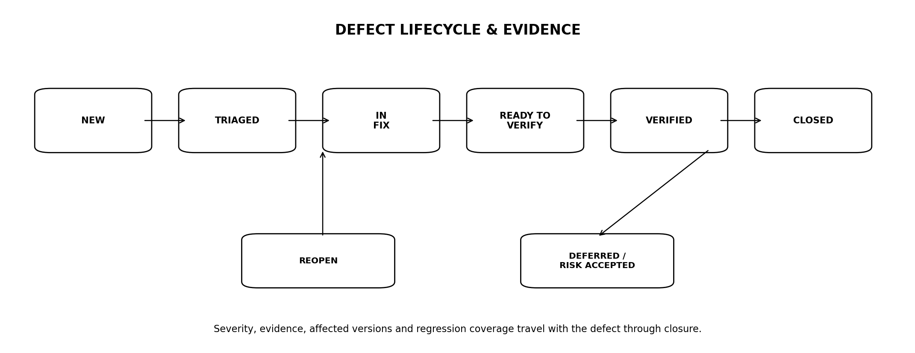
Figure 3 — Defect lifecycle and verification evidence
Severity | Meaning | Treatment
P0 / Blocker | Q0 integrity/security/regulatory/rights failure or total critical service failure. | Release blocked; immediate response.
P1 / Critical | Material incorrect behaviour/security issue with serious user/business impact. | Release blocked unless formal emergency exception.
P2 / Major | Important defect with workaround or limited scope. | Fix or approved deferral.
P3 / Minor | Low-impact defect/cosmetic. | Backlog permissible.

24.1 Required defect fields
Defect {
defect_id
severity
quality_risk_class
affected_builds[]
environment
reproduction
expected / actual
evidence_refs[]
requirement_ids[]
root_cause?
regression_test_ids[]
owner
target_release
}

25. FLAKY TEST POLICY
FLAKY IS FAILED ENGINEERING
A nondeterministic test is not allowed to create confidence by occasionally passing. Flaky tests are assigned an owner and repair SLA; while quarantined they do not satisfy any release gate.
- Track flake rate and retries by test.
- Automatic retries may diagnose flakiness but cannot turn a failed hard gate into PASS.
- Quarantine requires ticket, owner and expiry.
- Repeated flaky tests indicate environment/concurrency/design defects requiring root-cause analysis.

26. RELEASE QUALIFICATION FLOW
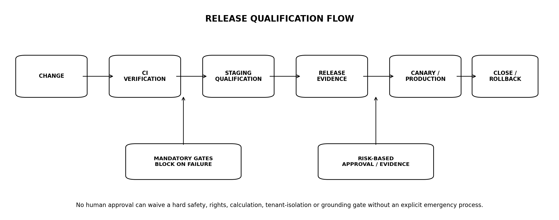
Figure 4 — Release qualification and production flow
1. Freeze the release candidate/build identifier and dependency manifest.
2. Run required CI/static/unit/property/component/contract checks.
3. Apply database migrations in staging and verify rollback/forward plan.
4. Run applicable domain golden and system acceptance suites.
5. Run security, rights, policy, AI, accessibility, performance and resilience gates for changed risk.
6. Generate immutable release evidence manifest.
7. Obtain only the human approvals required by risk/change class.
8. Deploy canary with production synthetics and telemetry.
9. Promote, pause or rollback using predeclared criteria.
10. Close release only after production verification window passes.

27. CHANGE-BASED TEST SELECTION
Change type | Minimum required regression
Calculation code/methodology | Full affected asset/methodology golden suite + downstream API/AI/monitoring checks.
Source connector/reconciliation | Source pack + fact/correction + downstream monitoring/evidence.
Monitoring engine | Full monitoring golden/coverage/idempotency/calendar suite.
Policy/rights | Full affected jurisdiction/source negative tests and no-bypass.
AI prompt/model | Full task eval + adversarial + grounding/citation suite.
Schema/migration | Migration/integrity/performance/rollback checks.
UI only | Accessibility/visual/interaction + affected E2E; domain contracts still smoke tested.
Infrastructure | Resilience/security/performance/synthetic verification.

27.1 Risk expansion
The matrix defines a minimum. QE may expand scope when shared components, blast radius or weak isolation make change impact broader.

28. RELEASE EVIDENCE MANIFEST
ReleaseEvidence {
release_id
git_commit / artefact_digest
dependency_manifest_ref
schema_migration_versions[]
configuration_versions[]
prompt/model/policy versions[]
test_run_ids[]
acceptance_gate_results[]
known_defects[]
risk_acceptances[]
approvers[]
canary_plan
rollback_plan
created_at
}

28.1 Reproducibility
The exact build, configuration, pack versions and external model/provider versions used for qualification must be identifiable. 'Latest staging' is not a valid release identity.

29. EMERGENCY RELEASE EXCEPTION
Control | Rule
Eligibility | Active security/data-integrity/availability incident or urgent legal/regulatory fix; not schedule pressure.
Authority | Named incident commander + technical owner + security/policy owner where relevant.
Non-waivable | Tenant isolation, known corrupt financial output, rights/policy prohibition cannot be knowingly shipped as normal service.
Evidence | Document failed/skipped tests, reason, compensating controls and rollback.
Time limit | Exception expires; full verification/remediation follows immediately.
Postmortem | Required for Q0/Q1 emergency release.

30. PRODUCTION CANARY & SYNTHETIC ASSURANCE
Signal | Requirement
Canary cohort | Small controlled traffic/region/account percentage.
Synthetic journeys | Critical factual/calculation/monitoring/research paths.
Error/latency | Compare to baseline and rollback thresholds.
Data integrity | Check fact/calculation/citation/alert invariants.
Security/policy | Monitor DENY anomalies and auth failures.
Business signals | Watch research completion/alert delivery without using vanity metrics alone.

30.1 Rollback triggers
- Any Q0 invariant failure.
- Material calculation/evidence corruption.
- Cross-tenant/security breach indicator.
- Policy/rights bypass.
- Monitoring coverage collapse.
- Severe latency/error regression beyond declared threshold.

31. PRODUCTION QUALITY FEEDBACK LOOP
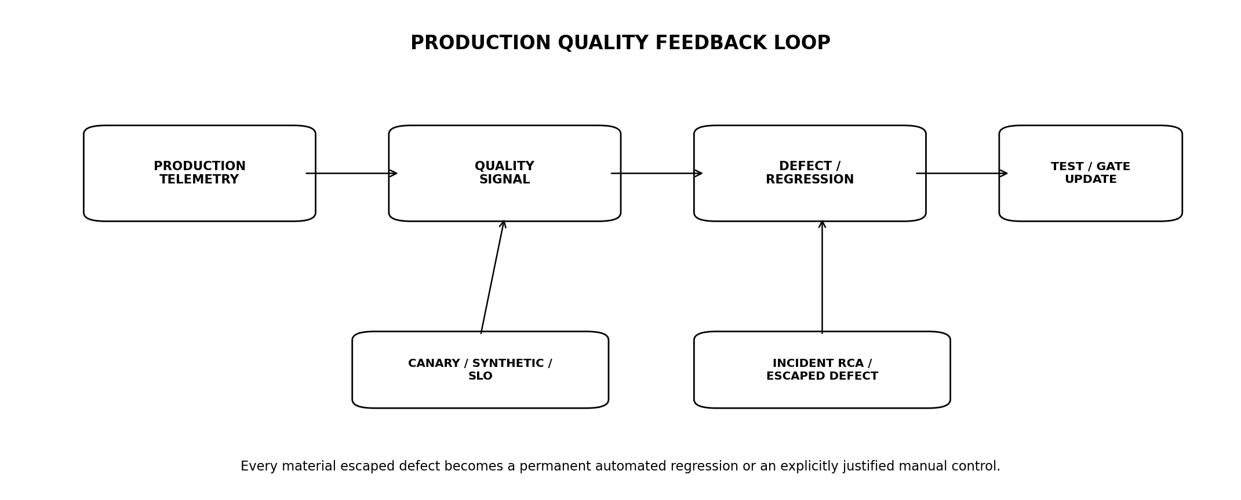
Figure 5 — Production quality feedback loop
- Escaped defects are tagged by missed verification layer/root cause.
- Every Q0/Q1 escaped defect creates a permanent regression test/eval where technically possible.
- Repeated defect classes trigger process/design improvement, not just more tests.
- SLO/error-budget trends influence release risk and capacity work.
- Customer-reported evidence/citation/calculation issues enter the same defect taxonomy.

32. QUALITY METRICS & SCORECARD
Metric | Target / interpretation
Release pass rate | Informational; not optimised at expense of test value.
Escaped Q0/Q1 defects | Target 0.
Defect escape rate | By domain/severity.
Flaky-test rate | Target continuous reduction; hard gates 0 unresolved flake.
Mean verification time | Optimise without reducing required coverage.
Requirement traceability | 100% MUST/SHALL coverage.
Golden corpus pass | 100% required for affected critical domains.
Monitoring coverage | ≥99.9% eligible rules per domain target.
AI grounding/perimeter | Per PLT-AI-001 hard thresholds.
Accessibility critical journeys | 100% WCAG 2.2 AA acceptance for activated release scope.

33. QUALITY OPERATIONS DASHBOARD
Module | Purpose
Release readiness | Gate status, blockers, known defects, candidate build.
Domain quality | Data/calculation/monitoring/evidence/AI pass trends.
Flakiness | Top flaky tests, owners, quarantine age.
Performance | Critical latency/capacity regression.
Security | Blocking vulnerabilities/test failures.
Accessibility | Critical journey defects.
Production escapes | Q0/Q1 incidents and regression completion.
Provider/source contracts | Live/sandbox contract-test health.

34. QUALITY ENGINEERING ROLES & RESPONSIBILITIES
Role | Accountability
Developer | Own unit/component/property tests and fix defects.
Quality Engineer | Risk model, system/contract/adversarial verification, release evidence.
Financial Engineer | Calculation methodology/golden values independent sign-off.
Data Engineer | Source/reconciliation/data-quality suites.
Security Engineer | Security verification, pen-test remediation and threat tests.
AI Engineer | Model/prompt eval implementation and regression.
Platform/Ops | Performance/resilience/canary/synthetic/rollback.
Product/Design | Acceptance meaning, usability and accessibility participation.
Legal/Policy/Rights | Approve interpretation/packs; QE verifies executable behaviour.

34.1 Independence
Quality Engineering provides independent release evidence but does not become the sole owner of quality. Owning teams remain responsible for testable design and defect prevention.

35. AUTOMATION ARCHITECTURE
- Test code versioned with production code or clearly linked repositories.
- Parallel execution with deterministic isolation.
- Ephemeral databases/environments where cost-effective.
- Stable seeded synthetic fixtures and golden corpora.
- Machine-readable JUnit/JSON/eval results stored with release evidence.
- CI stages separate fast blockers from longer qualification suites.
- Nightly/continuous suites never become excuses to skip required release gates.

36. NON-FUNCTIONAL QE TARGETS
Metric | Target
Fast PR verification | Target ≤15 min for blocking developer feedback path.
Release qualification | Parallelised; duration budget owned and measured.
Flaky hard-gate tests | 0 unresolved at release.
Requirement traceability | 100% MUST/SHALL.
Test evidence retention | Long enough to support release/incident audit; policy-defined.
Golden corpus versioning | 100% immutable/versioned.
Critical production synthetics | Continuous/appropriate cadence under OPS standard.

37. MASTER RELEASE ACCEPTANCE GATES
Gate | Area | Exit criterion
QE-G01 | Traceability | All applicable MUST/SHALL requirements mapped to passing verification.
QE-G02 | Data | Canonical schema, reconciliation, corrections, rights/purge suites pass.
QE-G03 | Finance | Affected golden calculation corpus 100% passes.
QE-G04 | Monitoring | Rule semantics, idempotency, coverage and dead-man gates pass.
QE-G05 | Evidence | Citation, provenance, correction and purge gates pass.
QE-G06 | AI | Grounding, calculation fidelity, citation and perimeter gates pass.
QE-G07 | API | Contract/authz/idempotency/error/compatibility gates pass.
QE-G08 | Security | No blocking security defects; tenant isolation and required pen-test gates pass.
QE-G09 | Accessibility | Critical activated journeys satisfy WCAG 2.2 AA verification.
QE-G10 | Global | Locale/timezone/calendar/jurisdiction/Regional Cell suites pass.
QE-G11 | Performance | Critical workloads meet approved p95/capacity budgets.
QE-G12 | Resilience | Required failover/restore/chaos scenarios pass.
QE-G13 | Known defects | No unresolved P0/Q0; P1 handled only under approved criteria.
QE-G14 | Release evidence | Exact build/config/migration/model/policy/test manifest complete.
QE-G15 | Production assurance | Canary/synthetic window passes or rollback executed.

38. OPEN DECISIONS / BLOCKERS
ID | Decision | Owner
O-QE-01 | Final CI/CD platform and test-result/evidence repository. | CTO + Platform
O-QE-02 | Approved independent calculation reference implementation/tooling. | Financial Eng
O-QE-03 | Browser/device/accessibility test matrix for launch. | Product + QE
O-QE-04 | External penetration-test provider/scope. | Security
O-QE-05 | Release cadence and standard canary duration. | Product + Ops
O-QE-06 | Exact P1 emergency-release authority chain. | CTO + Security + Product
O-QE-07 | Quality dashboard/tooling and defect-system integration. | QE + Engineering Ops

39. IMPLEMENTATION SEQUENCE
Stage | Build | Exit
Q0 — Foundations | Risk classes, traceability schema, defect taxonomy, CI result format. | Minimum release evidence generated.
Q1 — Domain goldens | Data, finance, monitoring, evidence, API core suites. | Critical domain gates executable.
Q2 — Safety/security | Policy/rights/AI/security/adversarial suites. | Hard safety gates executable.
Q3 — Global/accessibility | Locale/calendar/region + WCAG critical journeys. | Global/a11y gates executable.
Q4 — Performance/resilience | Load/soak/chaos/restore/canary synthetics. | Operational gates executable.
Q5 — Release automation | Manifest, dashboard, change-based selection, blocker automation. | One-button evidence collection.
Q6 — Launch rehearsal | Full production-candidate qualification + canary/rollback exercise. | All QE-G gates pass.

40. TRACEABILITY TO ENGINEERING ESTATE
Document | QE dependency
PLT-PRD-001 | Requirements and golden user journeys.
PLT-ENG-ARCH-003 | Architecture NFRs, deferral triggers and production topology.
PLT-DATA-001 | Database/schema/bitemporal/RLS acceptance.
PLT-DATA-002 | Ingestion/reconciliation/source-quality acceptance.
PLT-RIGHTS-001 | Rights/entitlement negative and purge acceptance.
PLT-FIN-001 | Financial methodology golden tests.
PLT-POL-001 | Jurisdiction/capability policy tests.
PLT-MON-001 | Rule/coverage/alerting test corpus.
PLT-EVID-001 | Document/evidence/citation/security tests.
PLT-AI-001 | Model/prompt grounding/safety evals.
PLT-API-001 | Contract/idempotency/compatibility verification.
PLT-SEC-001 | Security/privacy testing and pen-test gates.
PLT-OPS-001 | Will define production deployment, SLO, incident and DR evidence.

41. PROHIBITED ANTI-PATTERNS
1. Treating QA as a phase after development is 'finished'.
2. Generating golden expected results from the same calculation code under test.
3. Allowing flaky tests to pass a hard release gate through retries.
4. Copying production user/vendor data into test for convenience.
5. Accepting UI-hidden controls as security/policy verification.
6. Testing only happy-path current market data.
7. Using one giant end-to-end suite instead of faster lower-level invariant tests.
8. Mocking external providers indefinitely without live/sandbox contract checks.
9. Manual sign-off replacing deterministic financial/rights/security hard gates.
10. Accessibility conformance based only on automated scanning.
11. Performance testing only after production complaints.
12. Disaster-recovery claims without restore/failover exercises.
13. Closing escaped Q0/Q1 defects without permanent regression coverage.
14. Deploying an unidentifiable 'latest' build without exact release evidence.
15. Using pass-rate percentage as a quality objective while reducing difficult/high-value tests.

42. STANDARDS & REFERENCE BASELINE
Reference | Use
ISO/IEC 25010:2023 | Current product quality model; nine quality characteristics.
WCAG 2.2 | W3C Recommendation; Talvrin critical web journeys target Level AA.
OWASP ASVS 5.0.0 | Application security verification baseline, referenced through PLT-SEC-001.
NIST SP 800-115 | Security testing and assessment techniques reference.
PLT-SEC-001 / PLT-AI-001 | Talvrin-specific security and AI evaluation authorities.
Standards guide test design and coverage. Passing Talvrin's release gates does not by itself constitute external certification or formal standards conformance.

43. ENGINEERING SIGN-OFF STANDARD
PLT-QE-001 may be approved only when Quality Engineering, Product Engineering, Data Engineering, Financial Engineering, AI Engineering, Security, Trust/Rights, Design/Accessibility and Platform Operations agree that the release system can prove the exact build is safe enough to deploy and can detect quickly when production behaviour contradicts that evidence.
FINAL BUILD PRINCIPLE
Quality is evidence. Talvrin should be able to answer: what requirement did we intend, how did we prove it, what exact build passed, what happened after release, and what permanent test was added when we were wrong?

