TALVRIN

GLOBAL DATA RIGHTS, ENTITLEMENTS
& SOURCE GOVERNANCE SPECIFICATION
Detailed Engineering Wireframe 04 / 14
Authoritative engineering contract for source-rights modelling, entitlement resolution, rights-aware data access, derived-data inheritance, AI processing permissions, caching, attribution, export/API controls, regional routing, vendor lifecycle and purge across Talvrin’s global public-markets platform.
FIELD | VALUE
Document ID | PLT-RIGHTS-001
Version | 1.0
Architecture class | Global launch + target governance contract
Product | Talvrin — Evidence and monitoring for public markets
Classification | Confidential — Internal
Status | Proposed engineering baseline — for technical, Legal and Commercial approval
Governing architecture | PLT-ENG-ARCH-003 v4.0
Data-model dependency | PLT-DATA-001 v1.0
Ingestion dependency | PLT-DATA-002 v1.0
Initial market wedge | UK gilts + US Treasuries; global architecture remains market-neutral

GOVERNING DECISION
Talvrin does not “own” permission to use market data merely because Engineering can retrieve it. Every data operation is permitted only when product entitlement, jurisdiction policy, residency routing and the source’s contractual rights all permit that exact action.

0. EXECUTIVE ENGINEERING DECISION
PLT-RIGHTS-001 establishes one global, machine-enforceable rights and entitlement model for every external data source and every downstream use of that source. Rights are not implemented as UI checks, contractual PDFs, spreadsheet notes or developer convention. They are executable data.
CORE RULE
Retrieve ≠ Store ≠ Cache ≠ Index ≠ Embed ≠ External-AI Process ≠ Display ≠ Derive ≠ Export ≠ API Redistribute. Each action is evaluated independently.

0.1 Non-negotiable controls
ID | CONTROL | ENFORCEMENT
RG-01 | Every governed artefact has a non-null rights_profile_id. | Database constraint + ingestion contract.
RG-02 | No downstream service receives unfiltered restricted payloads. | Rights-aware data-access boundary returns an allowed projection only.
RG-03 | Unknown, expired or internally inconsistent rights deny the requested action. | Deny-by-default evaluator.
RG-04 | Derived values preserve source licence lineage. | Calculation/evidence lineage graph + derived-data evaluator.
RG-05 | Licensed content never enters an external AI provider unless that exact source/action is permitted. | AI Gateway receives rights-cleared chunks only.
RG-06 | Vendor exit and purge are designed before source activation. | Purge plan is a source certification gate.
RG-07 | Commercial plan entitlement can narrow rights, never widen vendor rights. | Final decision is the intersection of all applicable policies.
RG-08 | Rights changes take effect without application deployment. | Versioned configuration + effective dates + cache invalidation.
RG-09 | Every permit/deny/mask/delay decision is auditable. | PolicyDecision + RightsDecision records.
RG-10 | Global expansion occurs through Source, Market, Jurisdiction and Residency packs; core code is not forked. | Pack activation workflow + architecture gate.

1. SCOPE, AUTHORITY AND BOUNDARIES

1.1 Governed by this specification
- Source Registry fields that carry contractual and operational rights.
- RightsProfile schema, action vocabulary, territorial scope, latency, attribution, retention and effective dating.
- Product/account entitlements and the final entitlement intersection.
- Rights-aware data-access enforcement and filtered projections.
- Derived-data rights propagation through accepted facts and calculation lineage.
- Document indexing, chunking, embeddings, AI-processing and external-provider permissions.
- Caching, storage, retention, deletion and vendor purge.
- Display, export, download, API and redistribution controls.
- Global residency, regional processing and cross-border restrictions.
- Source onboarding, rights certification, renewal, suspension and termination.
- Operations, audit evidence, negative testing and production gates.

1.2 Explicitly outside this document
- Jurisdiction-specific financial-services perimeter decisions — PLT-POL-001.
- Canonical entity/fact schemas — PLT-DATA-001.
- Connector acquisition/normalisation mechanics — PLT-DATA-002.
- Financial methodology — PLT-FIN-001.
- User-facing pricing bands — Product/Commercial approval; this specification only implements resulting entitlements.
- General privacy/security controls — PLT-SEC-001, except where rights or residency enforcement requires an interface.

2. RIGHTS DOCTRINE
DOCTRINE | ENGINEERING CONSEQUENCE
Rights are action-specific. | Permission to retrieve does not imply permission to display, export, embed or send to an AI provider.
Rights are source-specific. | Two sources for the same metric may permit different uses.
Rights are temporally versioned. | A contract amendment creates a new effective version; historical decisions remain reconstructable.
Rights are territorial. | Permission can vary by user territory, serving region, data centre, venue or operating entity.
Rights survive transformation where contractually required. | Normalisation or calculation is not presumed to extinguish licence restrictions.
Rights are fail-closed. | Evaluator error, missing profile, expiry or ambiguity denies the operation.
Rights are observable. | Denied and degraded outcomes are explicit product/ops states, never silent missing fields.
Rights are measurable economics. | Per-user/source entitlement and usage must support licence-cost attribution.
Rights are reversible. | Vendor exit must have a tested purge/rebuild path before source activation.

3. GLOBAL RIGHTS DECISION ARCHITECTURE
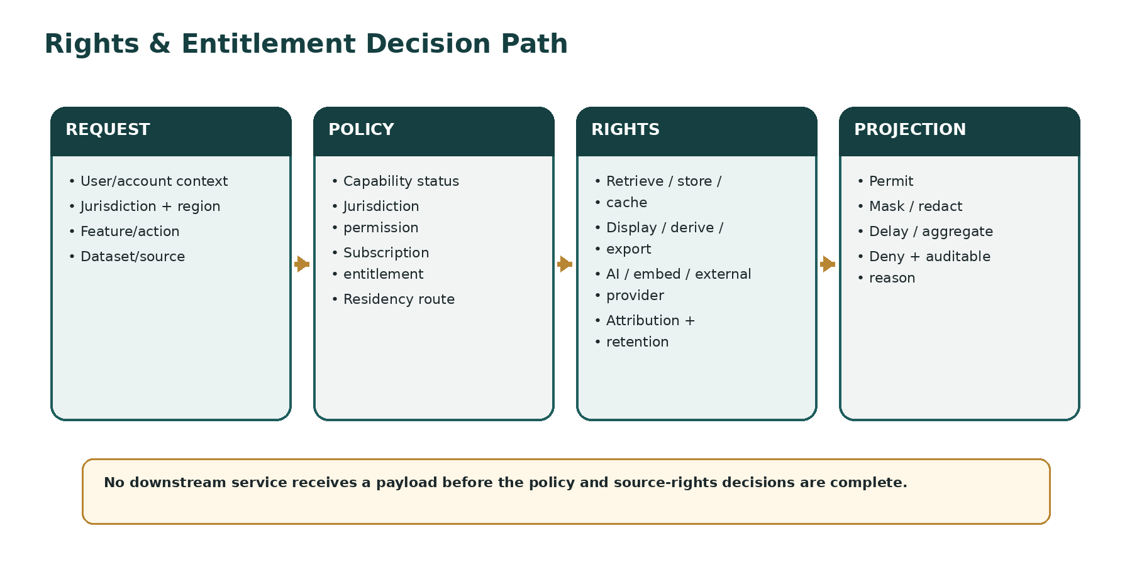
The decision path has two distinct control domains. PLT-POL-001 decides whether the feature/action may operate for the user, jurisdiction and capability state. PLT-RIGHTS-001 decides whether the requested source content may be used for that exact data action. Both must permit the request.

3.1 Final-decision intersection
FINAL_DECISION = intersection(
capability_status,
jurisdiction_policy,
residency_route,
subscription_entitlement,
account_contract_entitlement,
source_rights,
dataset_field_rights,
requested_action
)
if any required decision is UNKNOWN / ERROR / EXPIRED:
DENY

4. SOURCE REGISTRY CONTRACT
Every external source is represented by a Source Registry record before any connector can be certified for Production. The registry is the authoritative machine-readable link between Commercial/Legal obligations and Engineering enforcement.

4.1 Mandatory source fields
FIELD GROUP | MANDATORY FIELDS
Identity | source_id, provider_id, dataset_id, canonical name, source class, authority class, market/venue references.
Commercial | contract_id, order/schedule reference, licence owner, internal commercial owner, cost model, metering basis.
Legal | legal owner, operating-entity scope, governing agreement, territory, approved processing regions, restrictions.
Temporal | effective_from, effective_to, renewal_date, notice_date, termination_date, review_due_at.
Rights | rights_profile_id plus action-specific overrides where contract permits.
Operations | connector_id, production status, source pack, source-health SLO, escalation owner.
Attribution | required attribution text/template, logo/source-mark usage rules, link-back requirements.
Exit | purge_plan_id, post-termination rights, rebuild source, contract-specific deletion deadline.

4.2 Source lifecycle
DISCOVERED
→ COMMERCIAL_REVIEW
→ LEGAL_REVIEW
→ RIGHTS_MODELLED
→ ENGINEERING_CERTIFICATION
→ STAGING
→ PRODUCTION
→ SUSPENDED | RENEWAL_REVIEW
→ TERMINATING
→ PURGE_IN_PROGRESS
→ TERMINATED

ACTIVATION GATE
No source enters Production until its rights profile, attribution obligations, retention class, permitted processing regions and tested purge path are all approved.

5. RIGHTS PROFILE DATA MODEL

5.1 Core object
RightsProfile {
rights_profile_id
version
status
effective_from
effective_to
territory_scope[]
operating_entity_scope[]
processing_region_scope[]
user_category_scope[]
action_permissions{}
latency_class
retention_policy_id
attribution_policy_id
derived_data_policy_id
ai_policy_id
export_policy_id
override_policy
approved_by_legal
approved_by_commercial
approved_at
}

5.2 Action vocabulary
ACTION | QUESTION ANSWERED
RETRIEVE | May Talvrin acquire the source content?
STORE_RAW | May Talvrin retain the original payload/artefact?
STORE_NORMALISED | May Talvrin persist transformed source observations?
CACHE | May Talvrin cache content, and for how long?
INDEX_LEXICAL | May content enter full-text/search indexes?
EMBED | May vector embeddings be generated and retained?
AI_INTERNAL | May content be processed by models inside the approved trust boundary?
AI_EXTERNAL | May content be sent to an external model provider?
DISPLAY | May content or a field derived from it be rendered to the end user?
DERIVE | May calculations/derived metrics be produced?
EXPORT | May the user download/export the content or permitted derivative?
API | May it be served through an API or machine interface?
REDISTRIBUTE | May it be redistributed beyond the licensed end-user context?
ATTRIBUTION | What attribution is mandatory for the permitted display/use?

5.3 Permission states
STATE | SEMANTICS
ALLOW | Action is permitted for the matching scope.
DENY | Action is prohibited.
CONDITIONAL | Action permitted only when all attached conditions evaluate true.
LIMITED | Action permitted with quantitative/qualitative limits: delay, fields, counts, devices, users, retention, aggregation.
UNKNOWN | Not modelled or unresolved. Treated as DENY.
EXPIRED | Previously permitted but outside effective period. Treated as DENY.

6. TERRITORY, REGION AND OPERATING-ENTITY SCOPE
Talvrin is global. Source rights therefore cannot be represented by a single boolean such as licensed=true. Every applicable permission may be conditioned by territorial, entity and processing-location context.
DIMENSION | EXAMPLES | RULE
User jurisdiction | Country/territory of customer or account. | Used where the licence differentiates end-user territory.
Serving region | Regional Cell serving the request. | Must be permitted by residency/deployment and source-processing rules.
Processing region | Location in which data or AI processing occurs. | May differ from serving region; cannot be assumed permitted.
Operating entity | Contracting/operating legal entity. | Only entities named or permitted by contract may consume the data.
Instrument/venue territory | Market, exchange, issuer or instrument jurisdiction. | May alter source licence or market-data fee class.
User category | Private/non-professional, professional, enterprise/API, etc. | Classification must be evidence-backed when vendor pricing/rights require it.

6.1 No jurisdiction-region equivalence
GLOBAL RULE
A French user researching a Japanese security using a US vendor through a European Regional Cell may involve four different scopes. The rights engine evaluates them independently; “region = jurisdiction” is prohibited.

7. RIGHTS-AWARE DATA ACCESS BOUNDARY
Rights are enforced at the lowest reusable data-access boundary capable of preventing prohibited payloads from reaching downstream services. Product services request a use-case projection, not unrestricted source rows.

7.1 Request contract
DataUseRequest {
principal_id
account_id
jurisdiction_id
serving_region_id
processing_region_id
operating_entity_id
feature_id
requested_action
dataset_id / source_id
fields_requested[]
latency_requested
export_or_api_context
ai_processing_context
as_of
}

7.2 Decision contract
RightsDecision {
decision_id
outcome: PERMIT | MASK | REDACT | DELAY | AGGREGATE | DENY
allowed_fields[]
denied_fields[]
permitted_latency
max_cache_ttl
attribution_policy_id
derived_data_constraints[]
retention_constraints[]
reasons[]
source_rights_versions[]
decided_at
}

7.3 No bypass path
- Database roles used by product/AI/monitoring services cannot query raw licensed payload tables directly.
- Privileged Data Operations access is separate, audited and purpose-limited.
- Rights-aware repositories/views expose only the filtered projection required for a declared action.
- Cache population occurs after the rights decision and uses rights-aware cache keys.

8. PRODUCT AND ACCOUNT ENTITLEMENTS
Commercial plans define what Talvrin chooses to offer; source rights define what Talvrin is legally/contractually permitted to offer. These are separate layers.
LAYER | EXAMPLE | CAN IT WIDEN SOURCE RIGHTS?
Product plan | Free / Core / Research / Pro / Team/API. | No.
Account contract | Enterprise-specific permitted datasets/features. | No.
Vendor classification | Professional/non-professional or equivalent vendor class. | No; must match evidence and contract.
Source rights | Dataset-specific rights and conditions. | Authoritative contractual ceiling.
Jurisdiction policy | Whether feature/action is legally enabled. | No; independent ceiling.
Capability status | Whether Engineering has released it. | No; independent ceiling.

8.1 Entitlement object
EntitlementGrant {
grant_id
principal_or_account_id
entitlement_code
scope_type
scope_id
value / limit
effective_from
effective_to
source: PLAN | CONTRACT | VENDOR_CLASS | ADMIN
evidence_ref
status
}

9. FIELD-LEVEL AND DATASET-LEVEL CONTROLS
A single dataset may contain fields governed by different rights. The minimum enforcement granularity is therefore the field group or field where contractually required.
EXAMPLE | ENFORCEMENT
Real-time price restricted; static terms permitted. | Projection returns terms and either delayed price or no price.
Display permitted; export prohibited. | UI receives field, export service receives DENY.
Derived yield permitted; raw vendor price not exportable. | Calculation may run if DERIVE allowed, but export policy evaluates the derived lineage before release.
Document may be searched but not shown verbatim. | Index/search may be permitted; UI returns metadata/citation only within allowed extract limits.
Dataset available only to professional users. | Entitlement classification becomes a mandatory decision input.

10. DERIVED-DATA RIGHTS INHERITANCE
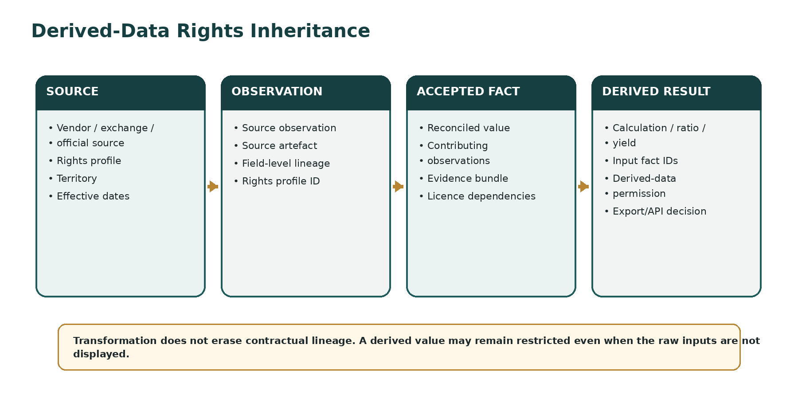
Talvrin must never assume that a calculation “cleans” or extinguishes source restrictions. Every material derived result retains the licence lineage of its inputs and evaluates the applicable derived-data terms before display, storage, export or API use.

10.1 Inheritance algorithm
- Retrieve every source/right dependency from the input FactIDs and Evidence Bundle.
- For the requested action, evaluate each dependency’s derived-data policy.
- Apply any contractually defined aggregation, transformation or independence exceptions explicitly — never infer them.
- Compute the most restrictive resulting constraints across applicable dependencies.
- Record the RightsDecision and source-rights versions on the derived output/use event.

10.2 Mixed-source accepted facts
CRITICAL RULE
An AcceptedFact may be reconciled from multiple SourceObservations. Its rights lineage must therefore include every contributing source used to establish the accepted value, unless a documented reconciliation policy proves a specific source did not contribute to the displayed/derived result.

11. AI, RAG, EMBEDDINGS AND MODEL PROCESSING
RIGHT | CONTROL
AI_INTERNAL | Allows processing only inside Talvrin-approved infrastructure/trust boundary.
AI_EXTERNAL | Allows the exact content to leave Talvrin for an approved external model provider.
EMBED | Allows embeddings to be generated and stored. Separate from lexical indexing.
PERSISTENT_CONTEXT | Allows content to persist in caches/vector stores beyond the immediate request where explicitly permitted.
MODEL_TRAINING | Default DENY. Licensed vendor content may not be used for fine-tuning or persistent model adaptation unless a future contract explicitly permits it and Board/Legal approve the architecture change.

11.1 Prompt assembly invariant
for chunk in evidence_bundle:
assert rights(chunk, requested_action=AI_EXTERNAL, provider, region) == ALLOW
if any chunk fails:
exclude the chunk or route to an approved internal/non-model evidence path
never send the unapproved content externally

11.2 Embedding partitioning
- Every embedded chunk retains source_id, rights_profile_id and content checksum.
- Indexes must be rebuildable after removal of any terminated source.
- Mixed-source vector stores are permitted only when per-source deletion/rebuild is demonstrably achievable.
- Embedding rights expiry invalidates/deletes affected vectors within the contractual window.

12. DOCUMENT AND EXTRACT RIGHTS
Document rights frequently differ from structured market-data rights. Each document and chunk inherits a rights profile and may also carry extract-length, attribution and display restrictions.
USE | REQUIRED DECISION
Acquire issuer/regulatory document | RETRIEVE.
Retain original | STORE_RAW + retention class.
Parse and store text | STORE_NORMALISED.
Full-text search | INDEX_LEXICAL.
Vector search | EMBED.
AI summary | AI_INTERNAL and/or AI_EXTERNAL depending on route.
Show quotation/extract | DISPLAY + extract limit + attribution.
Download original | EXPORT / redistribution rights.
Serve via API | API + redistribution rights.

13. CACHE AND LATENCY ENFORCEMENT
Cache policy must be rights-aware. A fast cache hit is not a valid reason to bypass the licence or serve a user a latency class they are not entitled to.
cache_key = hash(
source_or_dataset,
fields,
latency_class,
entitlement_class,
jurisdiction,
serving_region,
rights_profile_version
)

RULE | REQUIREMENT
TTL | Never exceeds the most restrictive applicable cache retention/refresh rule.
Latency | Real-time, delayed and end-of-day values are separate entitlement/cache classes.
Rights change | Profile version change invalidates affected cached projections.
Region | Restricted content cannot be cached in a non-permitted processing/storage region.
Redis | Ephemeral only; no use as a long-term store or workaround for retention constraints.

14. ATTRIBUTION AND DISPLAY OBLIGATIONS
Attribution is executable metadata, not hard-coded footer copy. Display services receive the attribution obligations applicable to the exact fields/sources shown.

14.1 AttributionPolicy
AttributionPolicy {
attribution_policy_id
version
required_text
required_source_name
required_link
required_logo_asset_ref
placement_rule
proximity_rule
minimum_visibility
locale_variants{}
effective_from
effective_to
}

- If two displayed values require different attribution, the response must preserve both obligations or use a legally approved combined treatment.
- Attribution requirements flow into screenshots/exports where the licence requires them.
- The client may choose presentation, but may not suppress mandatory attribution.

15. EXPORT, DOWNLOAD, API AND REDISTRIBUTION
Exports are a materially different rights event from on-screen display. Every export/API action receives its own decision and audit record.
CHANNEL | MINIMUM CONTROLS
CSV/XLSX/PDF export | Field-level export permission, row/record limits, attribution, account/tier, source lineage, audit record.
Print/share | Treat as redistribution where contractually required; preserve attribution/limitations.
Public link | Default DENY for licensed source content unless a specific sharing model is approved.
Enterprise API | Contract/account entitlement + source API/redistribution permission + metering + rate controls.
Webhook/alert payload | Evaluate content rights independently of the rule’s ability to fire.
Support/admin export | Purpose-limited privileged path; not a workaround for customer export restrictions.

15.1 Export artefact manifest
ExportManifest {
export_id
user_id / account_id
requested_format
field_set
row_count
source_ids[]
rights_decision_id
attribution_policy_ids[]
generated_at
expiry_at
download_events[]
}

16. RETENTION, DELETION AND WORM BOUNDARY
Talvrin separates immutable audit evidence from licensed content. A storage control that makes contractual deletion impossible is not acceptable source governance.
ARTEFACT | DEFAULT GOVERNANCE
Audit decision manifest | Tamper-evident/WORM where retention policy permits; contains identifiers, hashes and decisions, not vendor payload content.
Raw licensed payload | Retention exactly as permitted; object storage lifecycle must support contractual deletion.
Normalised observation | Retain only if STORE_NORMALISED permits it; source_id and rights profile remain attached.
Accepted fact | May require recomputation/replacement on source exit depending on contribution and derived-data terms.
Document text/chunks | Retention/purge by source and document rights.
Embeddings | Deletable/rebuildable by source.
Caches | Expire no later than permitted TTL; purgeable on rights change.
User export | Logged; Talvrin cannot silently recall a user-downloaded artefact, so export permission must be correct before generation.

17. VENDOR EXIT, TERMINATION AND PURGE
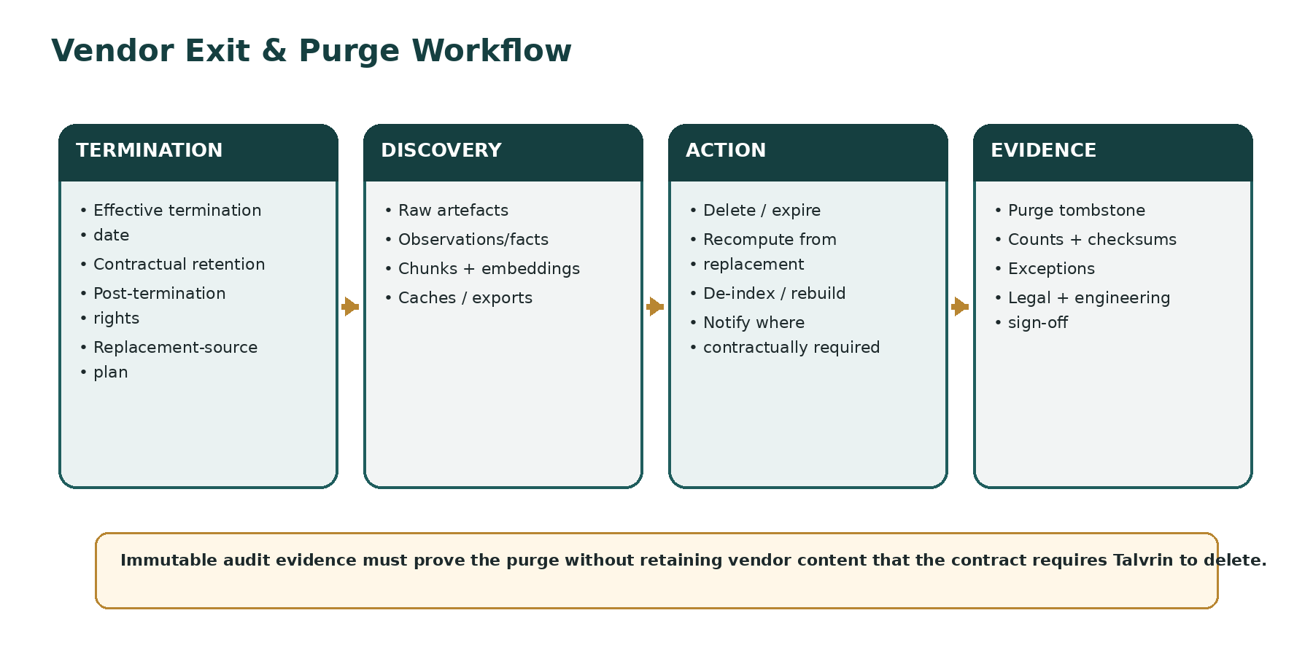

17.1 Purge plan is mandatory before activation
ARTEFACT CLASS | REQUIRED EXIT STRATEGY
Raw payloads | Source-keyed object discovery + lifecycle/delete within contract window.
Source observations | Source-keyed deletion/tombstone or retained only if post-termination rights permit.
Accepted facts | Identify dependency; replace/reconcile from authorised sources or mark unavailable as required.
Derived results | Re-evaluate rights lineage; preserve only where contract permits; otherwise withdraw/recompute.
Search chunks | Source-keyed de-index/delete.
Embeddings | Source-keyed delete and index rebuild.
Caches | Invalidate immediately or by contractual deadline.
Model adaptation | Prohibited by default specifically to avoid irreversible contamination.
Exports | Maintain manifest for notice/audit obligations; do not assume recall capability.

17.2 Purge evidence
- PurgeRun ID and source/contract reference.
- Counts of discovered, deleted, retained-by-right and failed artefacts per store.
- Checksums/identifiers sufficient to evidence deletion without retaining prohibited source content.
- Recomputation and replacement-source outcomes.
- Exceptions, legal disposition and Engineering remediation.
- Commercial + Legal + Engineering sign-off where required.
TEST REQUIREMENT
Execute a rehearsed purge drill in staging before first Production activation of a paid/licensed source and again before material renewal where architecture or storage topology changed.

18. RIGHTS CHANGES, RENEWALS AND EMERGENCY SUSPENSION
EVENT | SYSTEM BEHAVIOUR
Contract amendment | Create new RightsProfile version with effective time; re-evaluate impacted caches/processes.
Renewal pending | Source enters RENEWAL_REVIEW; expiry alarms start before deadline.
Rights expire | Deny newly prohibited operations; invalidate caches; mark impacted features/datasets explicitly unavailable/delayed.
Dispute/uncertainty | Emergency SUSPEND relevant action/source; fail closed until resolved.
Vendor outage | Data availability semantics are handled under PLT-DATA-002; rights remain intact unless contract changes.
Operating entity change | Do not assume rights transfer; new entity must be explicitly covered.

18.1 Emergency kill switches
- Disable a source globally or by territory.
- Disable one action class only (e.g. AI_EXTERNAL while DISPLAY remains permitted).
- Disable export/API while retaining internal processing.
- Force latency downgrade where vendor entitlements require it.
- Disable a processing region or external AI provider.

19. GLOBAL RESIDENCY AND CROSS-BORDER DATA MOVEMENT
Rights decisions and residency decisions are separate but intersect. Source content may be contractually restricted to specified processing or storage locations even when personal-data residency would permit broader movement.
CLASSIFICATION | MOVEMENT RULE
GLOBAL_REPLICABLE | May move between approved cells subject to ordinary policy.
REGION_BOUND | May remain only inside specified regional cell(s).
JURISDICTION_BOUND | May be processed only under specified jurisdictional locations/conditions.
SOURCE_RESTRICTED | Vendor contract defines allowed processing/storage regions.
NO_EXTERNAL_AI | Content may not leave approved Talvrin processing boundary for model providers.
NO_CROSS_CELL | No replication outside the source/serving cell without a new decision.

19.1 Cross-cell transfer contract
CrossCellTransferRequest {
data_ids[]
source_ids[]
from_region
to_region
purpose
action
rights_decision_id
residency_decision_id
encryption_context
}

20. PROFESSIONAL / NON-PROFESSIONAL AND OTHER VENDOR CLASSIFICATIONS
Some data vendors price or license data according to user classification. Talvrin must treat any such classification as an evidence-backed entitlement attribute, never an inferred marketing segment.
- Classification vocabulary is source/vendor-specific and versioned.
- Where self-certification is permitted, store the user declaration, versioned wording, timestamp and renewal/expiry requirements.
- Where evidence is required, store only the minimum evidence necessary and govern it under PLT-SEC-001.
- Classification changes trigger entitlement recomputation and may alter fees/latency/datasets.
- Unknown classification must not default to the cheaper or broader entitlement class.

21. RIGHTS OPERATIONS CONSOLE
Legal, Commercial, Data Operations and authorised Engineering users require a controlled interface over rights data. Direct database edits are prohibited.
MODULE | CAPABILITIES
Source Registry | Create/edit source metadata, owners, contracts, effective dates and lifecycle.
Rights Profiles | Version action permissions, territories, regions, user classes and conditions.
Attribution | Manage approved attribution policies/locales/assets.
Entitlements | Inspect account/user grants and vendor classifications.
Impact analysis | Show features, datasets, users, caches, indexes and derived outputs affected by a rights change.
Purge | Initiate/review purge runs, evidence and exceptions.
Decision explorer | Explain why a specific use was permitted, masked, delayed or denied.
Kill switches | Emergency suspend by source/action/territory/region/provider.
Renewals | Upcoming expiry, review and notice dashboards.

21.1 Separation of duties
CHANGE | MINIMUM APPROVAL
Grant new display/export/API rights | Legal/Commercial approval as applicable.
Enable external AI processing | Legal approval + AI/Security owner.
Extend retention | Legal/Commercial approval; cannot exceed contract.
Production source activation | Legal + Commercial + Engineering certification.
Emergency restriction | Authorised Legal/Compliance/Data Ops may narrow rights immediately; widening requires normal approval.
Purge completion | Engineering evidence + Legal/Commercial sign-off where required.

22. AUDIT AND EVIDENCE MODEL
For any customer-facing use of licensed data, Talvrin must be able to reconstruct the source-rights state that permitted the action at that time.
AUDIT OBJECT | REQUIRED CONTENT
RightsDecision | Request context, action, sources, profile versions, conditions, outcome, reason codes, timestamp.
EntitlementDecision | Plan/account/vendor classification inputs and resulting grant/limit.
ProfileChange | Before/after, approvers, effective time, contract/legal evidence reference.
SourceActivation | Certification evidence and approved purge plan.
ExportManifest | Fields, sources, rights decision, attribution, user/account, generated/download time.
PurgeRun | Artefact counts, outcomes, exceptions, evidence and sign-off.
EmergencyAction | Kill switch target, actor, reason, scope, start/end time.

23. FAILURE AND DEGRADATION SEMANTICS
FAILURE | BACKEND OUTCOME | USER/OPS OUTCOME
Rights service unavailable | DENY gated licensed-data action. | Explicit temporarily unavailable/restricted state; page on-call.
Profile missing | DENY. | Source not production-eligible; Data Ops incident.
Profile expired | DENY affected action. | Explicit unavailable/delayed state as configured; renewal escalation.
Attribution unavailable | DENY display where attribution is mandatory. | Do not render unattributed licensed value.
Subscription service unavailable | Use safely cached signed entitlement only within approved TTL; otherwise DENY. | Explicit entitlement-verification failure.
Region classification failure | DENY transfer/processing. | Do not route to arbitrary fallback region.
Purge failure | Quarantine affected source from reactivation. | Critical Legal/Engineering incident; retry + exception workflow.
Unexpected source in lineage | DENY derived display/export until resolved. | Evidence/data-rights incident.

24. PERFORMANCE, CACHING AND SCALE TARGETS
METRIC | LAUNCH TARGET | DESIGN NOTE
Rights decision p95 | ≤20 ms for cached profile path. | Not including external vendor calls; evaluator must not call vendors synchronously.
Entitlement decision p95 | ≤20 ms. | Signed/versioned grants locally available.
Combined gated data read overhead p95 | ≤40 ms. | Measured excluding underlying data read.
Rights change propagation | ≤60 s to all launch instances/caches. | Emergency kill switch target ≤15 s where infrastructure permits.
Expiry alerting | 30/14/7/1 day configurable pre-expiry alerts. | Contract-specific notice periods may be earlier.
Purge inventory completeness | 100% governed stores discovered by automated inventory. | New stores cannot be introduced without registering purge adapter.
Decision audit coverage | 100% gated operations. | Sampling is prohibited for allow/deny decisions.

25. SECURITY AND PRIVILEGE BOUNDARIES
- Product services receive least-privilege rights-aware database roles/views.
- Raw-source stores are accessible only to ingestion/rights-aware data services and privileged Data Operations workflows.
- Rights profile changes require authenticated privileged identities; no shared credentials.
- Contract documents and sensitive commercial terms are not exposed to ordinary product services; profiles contain the executable abstraction and evidence reference.
- All outbound vendor and AI traffic uses controlled egress and an approved provider/source combination.
- Secrets and vendor credentials are managed independently of rights profiles.

26. VERIFICATION AND QUALITY ENGINEERING

26.1 Mandatory test suites
SUITE | REQUIRED COVERAGE
Action matrix | Every ALLOW/DENY/CONDITIONAL/LIMITED action class per test source.
Territory/region | User jurisdiction × serving region × processing region × operating entity combinations.
Field projection | Restricted fields never appear in downstream payloads/logs/caches.
Latency | Real-time user cannot leak to delayed user cache and vice versa.
Derived lineage | Mixed-source facts and calculations resolve to correct restrictive rights outcome.
AI | External model receives only chunks with AI_EXTERNAL permission; no prohibited chunk leakage.
Export/API | Display-allowed/export-denied and other channel asymmetries.
Attribution | Mandatory attribution present; missing policy blocks display.
Expiry/change | Effective-dated profile changes and cache invalidation.
Vendor classification | Unknown or expired classification denies restricted entitlement.
Cross-cell | Restricted data cannot replicate to unapproved regions.
Purge drill | Discovery + deletion/rebuild + evidence across every governed store.
Chaos | Rights/PDP/entitlement service failures fail closed with explicit degradation.
Audit | Every decision is reconstructable from immutable audit records.

26.2 Negative-test doctrine
RELEASE RULE
Positive tests prove that permitted data works. Negative tests prove that prohibited data cannot escape. For Talvrin’s rights perimeter, negative tests are release gates, not optional security regression tests.

27. DATABASE AND API IMPLEMENTATION CONTRACTS

27.1 Principal tables
TABLE | WRITE OWNER | PURPOSE
source_registry | Rights/Source Governance module | Canonical source and contract lifecycle metadata.
rights_profile | Rights/Source Governance module | Versioned executable permissions and conditions.
rights_action_rule | Rights/Source Governance module | Action-level rules/limits/territorial conditions.
attribution_policy | Rights/Source Governance module | Versioned display/attribution obligations.
retention_policy | Rights/Source Governance module | Retention/deletion parameters.
entitlement_grant | Account/Entitlement module | User/account/product/vendor-class grants.
rights_decision | Rights evaluator | Immutable decision audit.
entitlement_decision | Entitlement evaluator | Immutable entitlement decision audit.
export_manifest | Export/API module | Per-export rights/evidence record.
purge_plan | Rights/Source Governance module | Pre-activation vendor exit plan.
purge_run | Purge orchestrator | Execution/evidence for termination purge.
source_activation | Rights/Source Governance module | Market/territory/region activation state.

27.2 Service endpoints — internal
POST /internal/rights/evaluate
POST /internal/entitlements/evaluate
GET /internal/rights/profiles/{id}?as_of=
POST /internal/rights/impact-analysis
POST /internal/sources/{id}/suspend
POST /internal/purge/plan/{source_id}/validate
POST /internal/purge/runs
GET /internal/decisions/{decision_id}/explain

These are illustrative internal contracts. PLT-API-001 will define formal API schemas and error vocabulary. No public client receives direct access to source-rights administration endpoints.

28. GLOBAL PACK MODEL
Global expansion must not require rights logic forks. New markets and jurisdictions activate versioned packs that reference the same core rights vocabulary.
PACK | RIGHTS CONTENT
Source Pack | Sources/datasets, contracts, action rights, attribution, retention, processing-region constraints.
Market/Venue Pack | Exchange/venue-specific datasets, market-data user classes and venue licensing references.
Jurisdiction Pack | Feature/legal policy references; rights layer consumes the approved context but does not duplicate legal perimeter logic.
Residency/Deployment Pack | Permitted storage/processing regions and transfer classes.
Locale Pack | Attribution wording/localisation where required; never changes substantive rights.
Asset/Methodology Pack | May reference derived-data policies for calculations; does not create independent vendor rights.

29. PRODUCTION ACCEPTANCE GATES
GATE | PASS CONDITION
R-01 | Every Production source has an approved, effective RightsProfile and non-null rights_profile_id on governed artefacts.
R-02 | Rights-aware data-access path has no unauthorised raw bypass from product, monitoring, AI or export services.
R-03 | Action asymmetry tests pass: retrieve/store/cache/display/derive/AI/export/API/redistribute evaluated independently.
R-04 | Territory, operating entity, user classification and processing-region test matrix passes.
R-05 | Derived-data lineage and restrictive inheritance pass for mixed-source calculations.
R-06 | AI Gateway cannot include any chunk lacking the required AI permission.
R-07 | Cache/latency isolation prevents entitlement leakage.
R-08 | Attribution obligations are machine-enforced and tested.
R-09 | Export/API manifests and rights audits are complete.
R-10 | Source expiry/emergency suspension propagates within approved target.
R-11 | Staging vendor-purge drill succeeds across every governed store.
R-12 | Decision reconstruction produces the exact source-rights versions and inputs for sampled customer actions.
R-13 | No licensed content is used for model fine-tuning/persistent adaptation absent explicit future approval.
R-14 | Open commercial/legal rights blockers for launch datasets are resolved or the affected source/feature remains disabled.

30. OPEN DECISIONS AND BLOCKERS
ID | DECISION / BLOCKER | OWNER | BLOCKS
O-1 | Final source/vendor contracts and exact action rights for launch datasets. | Commercial + Legal | Source activation
O-2 | Identifier licensing and display/storage terms for relevant identifier providers. | Commercial + Legal | Affected identifiers
O-3 | Vendor professional/non-professional classification rules and evidence requirements. | Commercial + Legal | Entitlement activation
O-4 | Permitted processing/storage regions for each source and external AI provider. | Legal + Security | Regional routing / AI
O-5 | Derived-data rights for launch calculations, storage, history, export and API. | Commercial + Legal | PLT-FIN-001 outputs
O-6 | Document extraction, indexing, embedding and quotation limits for each source class. | Legal | PLT-EVID-001 / AI
O-7 | Retention versus deletion deadlines and any post-termination residual rights. | Legal + Eng | Purge plan
O-8 | Whether Team/API launches with any redistributable structured data. | Board + Commercial + Legal | API commercial launch

31. IMPLEMENTATION SEQUENCE
PHASE | BUILD | EXIT CRITERION
R0 — Vocabulary & schema | Rights actions, profiles, source registry, attribution/retention policies, entitlements. | Schema migration passes; all rights objects versioned/effective-dated.
R1 — Evaluator | Rights and entitlement decision services + audit. | Action-matrix and fail-closed tests pass.
R2 — Data-access enforcement | Rights-aware repositories/projections + cache keys. | No raw bypass; field/latency negative tests pass.
R3 — Derived & evidence lineage | Calculation/evidence rights inheritance. | Mixed-source derived tests pass.
R4 — AI/document controls | Index/embed/model-processing gates. | AI leakage suite passes.
R5 — Export/API/attribution | Export manifests, API restrictions, attribution delivery. | Channel-asymmetry tests pass.
R6 — Vendor lifecycle | Expiry, impact analysis, kill switches, purge orchestration. | Staging purge drill evidenced.
R7 — Globalisation | Region/entity/user-class matrices + packs. | Launch source packs certified for activated markets.

32. PROHIBITED ANTI-PATTERNS
# | PROHIBITED
1 | A single `licensed=true` flag for a source or dataset.
2 | Treating display permission as permission to export, API-serve or send to an AI model.
3 | Putting data-rights checks only in the frontend/BFF.
4 | Allowing product/AI/monitoring services to read raw licensed tables directly.
5 | Assuming a calculated/derived value is automatically free of source restrictions.
6 | Embedding vendor content into an index that cannot be deleted/rebuilt by source.
7 | Using licensed vendor content for model fine-tuning or persistent adaptation by default.
8 | Hard-coding attribution text in clients instead of versioned policies.
9 | Caching real-time data and serving it to delayed/non-entitled users.
10 | Storing vendor content in WORM beyond a contractual deletion deadline.
11 | Activating a source without a tested exit/purge design.
12 | Assuming rights transfer automatically to a new operating entity, region or jurisdiction.
13 | Defaulting an unknown vendor user classification to the least restrictive/cheapest class.
14 | Allowing emergency restrictions only through a software deployment.
15 | Creating country-specific forks of the rights engine instead of versioned global packs.

33. TRACEABILITY TO THE ENGINEERING ESTATE
DOCUMENT | INTERFACE
PLT-PRD-001 | Defines product/tier behaviours that entitlement grants implement.
PLT-ENG-ARCH-003 | Defines global policy/rights planes, regional cells and fail-closed doctrine.
PLT-DATA-001 | Defines rights_profile_id lineage and canonical persisted entities.
PLT-DATA-002 | Consumes Source Registry and rights gates during acquisition/normalisation.
PLT-FIN-001 | Consumes derived-data permissions and records rights lineage on calculations.
PLT-MON-001 | Evaluates rights for monitored metrics and notification payloads.
PLT-EVID-001 | Implements document, chunk, citation, extract and evidence-rights inheritance.
PLT-AI-001 | Consumes AI_INTERNAL/AI_EXTERNAL/EMBED decisions before prompt assembly.
PLT-API-001 | Defines client/API contracts and export error semantics.
PLT-POL-001 | Provides jurisdiction/capability decision; rights engine remains source-contract authority.
PLT-SEC-001 | Provides identity, privileged access, encryption and sensitive evidence controls.
PLT-QE-001 | Owns negative, purge, chaos and release-gate verification.
PLT-OPS-001 | Owns deployment, observability, expiry alerts, runbooks and incident execution.

34. FINAL ENGINEERING POSITION
Talvrin’s data-rights architecture is not a compliance appendix to the market-data platform. It is part of the data plane itself. The platform must know, at machine speed and with historical evidence, not only what a number is and where it came from, but what Talvrin is permitted to do with that number for this user, in this jurisdiction, through this channel, in this region, at this time.
IMPLEMENTATION MANDATE
No data without lineage. No use without a rights decision. No expansion without a source/market/jurisdiction/residency pack. No vendor activation without an exit path.

End of PLT-RIGHTS-001 v1.0

