TALVRIN

GLOBAL SECURITY, PRIVACY
& ACCESS CONTROL SPECIFICATION
Detailed Engineering Wireframe 11 / 14
The production security contract for identity, authentication, authorisation, data isolation, encryption, secrets, privacy, secure delivery, detection and response.
Field | Value
Document ID | PLT-SEC-001
Version | 1.0
Architecture class | Global security and privacy architecture
Classification | Confidential — Internal
Status | Proposed engineering baseline — for technical approval
Parent architecture | PLT-ENG-ARCH-003 v4.0
Primary dependencies | PLT-PRD-001, PLT-DATA-001, PLT-DATA-002, PLT-RIGHTS-001, PLT-FIN-001, PLT-POL-001, PLT-MON-001, PLT-EVID-001, PLT-AI-001, PLT-API-001
Canonical scope | Global public-markets platform, all Regional Cells and control-plane services

ENGINEERING POSITION
Talvrin will use zero-standing-privilege, deny-by-default and defence-in-depth principles. Identity, account isolation, policy, rights, encryption and audit are server-side controls. No client, administrator, service or Regional Cell is trusted merely because it is inside the network.

0. EXECUTIVE SECURITY DECISION
Talvrin’s security model treats every request as an authenticated principal acting on a specific resource in a specific account, jurisdiction and Regional Cell. Authentication establishes identity; authorisation is evaluated at each resource boundary; sensitive data remains protected by regional encryption keys and least-privilege service identities.
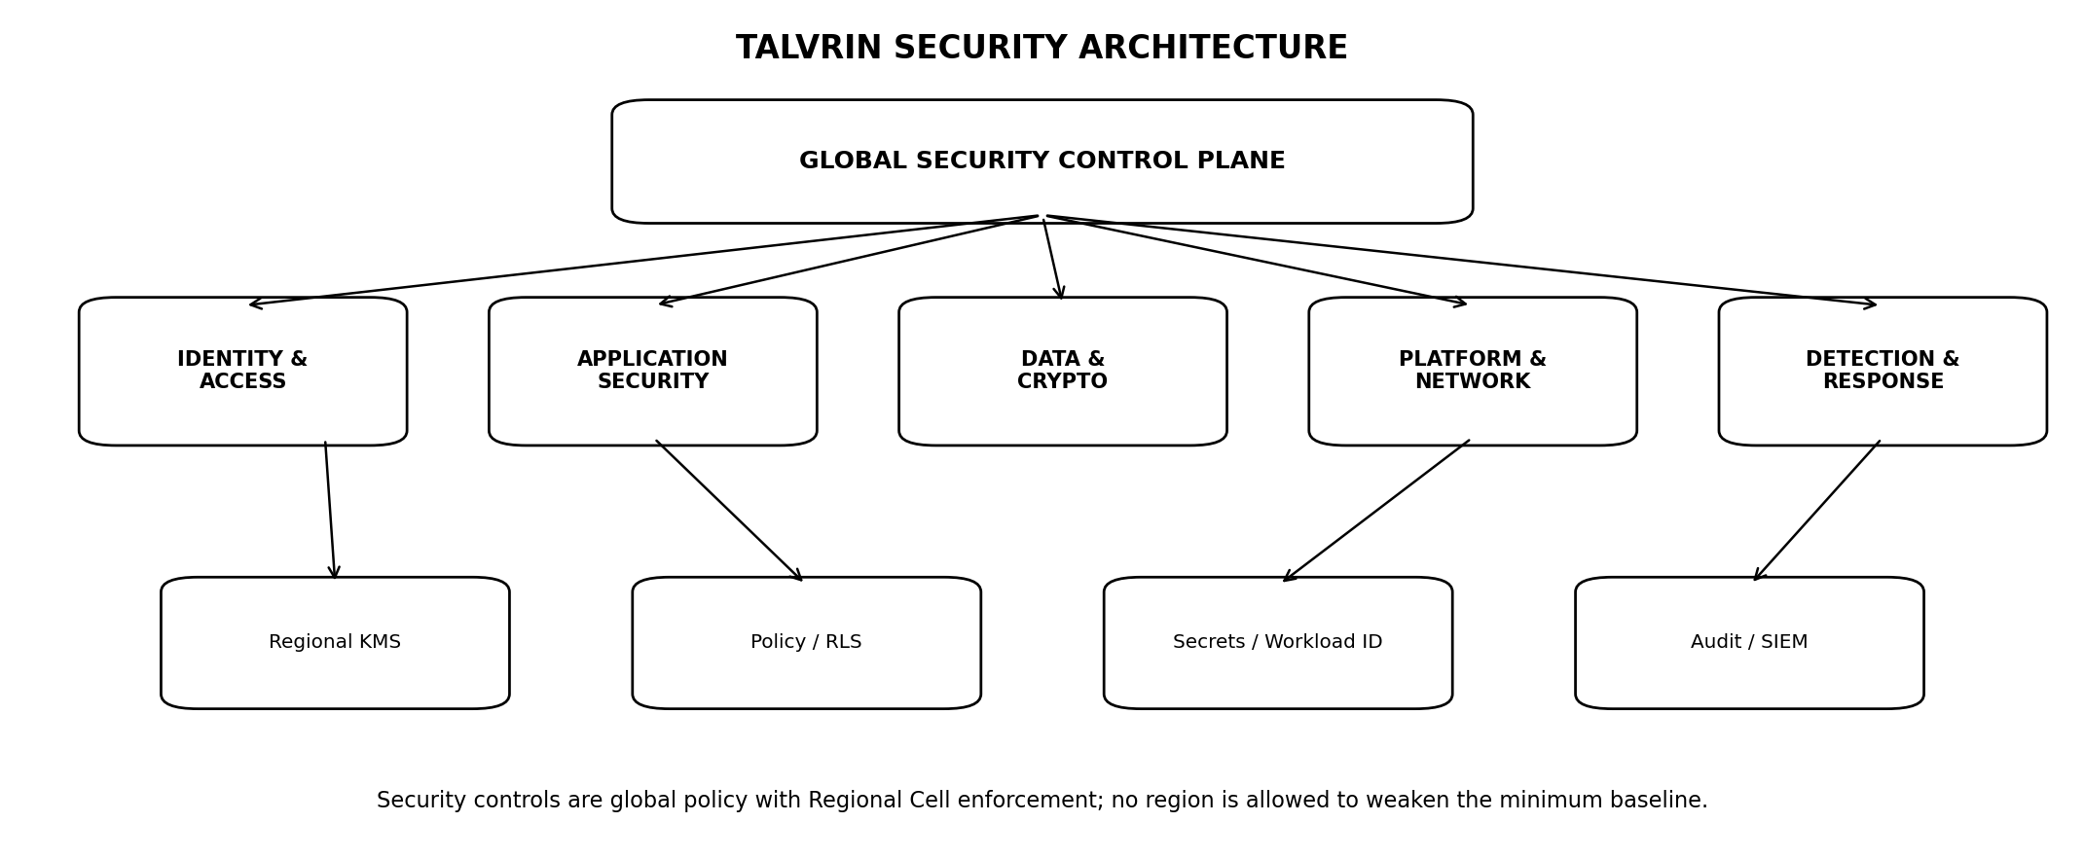
Figure 1 — Global security architecture
PRIMARY INVARIANT
A compromised web client, API token, employee account, service workload or Regional Cell must not automatically grant access to another user, another account, another source entitlement or another region.

1. SCOPE, AUTHORITY AND SECURITY BOUNDARY
- Consumer and enterprise identity, authenticators, account recovery, sessions and federation.
- RBAC, ABAC, policy enforcement, tenant isolation, row-level security and field projection.
- Workload identity, service-to-service authentication and secrets management.
- Encryption at rest/in transit, KMS/key hierarchy and regional key ownership.
- Application, API, web, mobile, network, database, object-storage and infrastructure security.
- Privileged access, break-glass, audit, detection, incident response and security operations.
- Privacy engineering, minimisation, retention, deletion, residency and cross-border controls.
- Secure SDLC, supply chain, vulnerability management, penetration testing and release gates.

1.1 Authority rule
SECURITY PRECEDENCE
Where security, jurisdiction policy or data-rights controls disagree, the most restrictive effective decision governs until the conflict is resolved through controlled policy change. Local service code may not override a security DENY.

2. SECURITY DOCTRINE — NON-NEGOTIABLE INVARIANTS
ID | Invariant | Engineering meaning
SEC-INV-01 | Deny by default | Absent explicit authorisation, access is denied.
SEC-INV-02 | Zero standing privilege | Production admin access is just-in-time and time-bounded.
SEC-INV-03 | Tenant isolation is enforced twice | Application authorisation + database RLS/partition boundary where applicable.
SEC-INV-04 | No network trust | Internal network location does not grant identity or authorisation.
SEC-INV-05 | Strong authentication | Passkeys preferred; MFA required for privileged and elevated-risk operations.
SEC-INV-06 | Secrets never in code | Managed secret stores/KMS only.
SEC-INV-07 | Regional key separation | Residency-bound data uses region/cell-scoped keys.
SEC-INV-08 | Least data | Only purpose-required data is collected, exposed, logged and retained.
SEC-INV-09 | Immutable security audit | Material security/admin events are tamper-evident and append-only.
SEC-INV-10 | No shared admin accounts | Every privileged action maps to an individual or workload identity.
SEC-INV-11 | Recovery is authentication | Account recovery is treated as a high-risk authentication flow.
SEC-INV-12 | Fail closed on identity/policy uncertainty | No silent fallback to broad access.
SEC-INV-13 | Security controls are testable | Every material control has an automated or exercised verification path.
SEC-INV-14 | Customer data is not training data by default | Use for model training/adaptation requires explicit future approval and rights/privacy basis.

3. SECURITY ARCHITECTURE & TRUST ZONES
Zone | Trust treatment
Internet / client zone | Untrusted web/mobile/browser/device traffic.
Edge zone | CDN, DDoS protection, WAF, rate limiting, bot controls.
Application zone | API Gateway, BFF, authenticated application services.
Domain zone | Business modules with workload identities and narrow data access.
Data zone | PostgreSQL, object storage, search/index, caches; no public ingress.
Security control zone | Identity, KMS, secrets, audit/SIEM, policy engines.
Operations zone | Privileged administration via PAM/bastion/JIT controls.

3.1 East-west controls
- Service-to-service calls require authenticated workload identity.
- Network policy limits service communication to declared dependencies.
- Database access is restricted to owning modules/service roles.
- Egress is deny-by-default for sensitive processing workloads, with explicit allowlists.

4. DATA CLASSIFICATION
Class | Examples / handling
S0 — Public | Approved public information; integrity still required.
S1 — Internal | Non-public operational/configuration information.
S2 — Confidential | User/account data, licensed source metadata/content, internal product data.
S3 — Restricted | Credentials, secrets, security artefacts, sensitive PII, privileged audit, highly restricted vendor data.

4.1 Classification propagation
- Derived objects inherit the highest applicable sensitivity unless an approved transformation lowers it.
- Logs/traces must not accidentally promote S2/S3 payloads into unrestricted observability systems.
- Regional residency and vendor/source rights may impose additional handling beyond sensitivity class.

5. IDENTITY & ACCOUNT MODEL
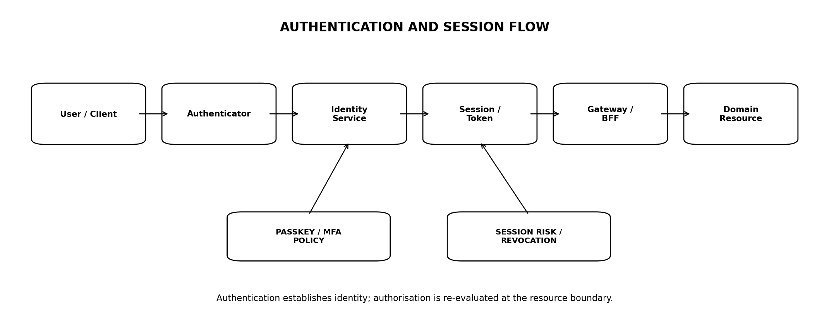
Figure 2 — Authentication and session flow
Object | Meaning
Principal | Individual human identity or controlled workload identity.
Account | Commercial/tenant ownership and collaboration boundary.
Membership | Principal’s relationship to account with role/attributes.
Session | Authenticated interactive state.
Authenticator | Passkey, password+MFA, federation authenticator or approved recovery method.
Service identity | Non-human workload identity with narrow scope and rotation.

5.1 Consumer identity
Launch consumer accounts should support low-friction email-based enrolment with passkey encouragement. Regulatory identity proofing is not introduced unless a specific future capability legally requires it.

5.2 Enterprise identity
Future team/enterprise accounts may support SAML/OIDC federation and SCIM-style provisioning only after PLT-API/Commercial scope activation.

6. AUTHENTICATION POLICY
Method | Policy
Passkey / WebAuthn | Preferred phishing-resistant authenticator for supported clients.
Password | Permitted fallback where necessary; strong breached-password screening and rate limits.
TOTP / authenticator app | Acceptable additional factor/fallback.
SMS OTP | Not preferred; only approved fallback/recovery contexts with risk controls.
Email link/code | May support low-risk verification/recovery; not sufficient for privileged administration.
Enterprise federation | Trusted only from approved IdP configuration with signed assertions and strict audience/issuer checks.

6.1 MFA requirements
- Mandatory for all privileged/admin users.
- Mandatory for sensitive account-security changes.
- Step-up authentication for recovery, authenticator changes, export of sensitive account data and elevated-risk operations.
- Consumer baseline may be risk/feature appropriate, but passkey adoption should be actively supported.

6.2 NIST alignment
Authentication architecture should be compatible with NIST SP 800-63-4 and SP 800-63B-4 concepts, adapted to Talvrin’s risk profile rather than claiming a federal assurance level without formal assessment.

7. PASSWORD & AUTHENTICATOR CONTROLS
- Passwords stored only with a modern memory-hard password hashing algorithm and unique salts.
- Do not impose composition rules that reduce usability without security benefit; screen against known compromised/common passwords.
- No periodic password rotation absent compromise/risk trigger.
- Authenticator registration/removal creates an auditable security event.
- Passkey credentials are scoped to the legitimate relying-party origin.
- Recovery codes, if offered, are high-entropy, single-use and stored hashed.

7.1 Brute force / credential stuffing
Control | Requirement
Rate limits | Per account, IP/device/risk cluster and endpoint.
Progressive friction | Risk-based delay/challenge without disclosing account existence.
Breach monitoring | Compromised credential indicators trigger protective flows.
No account enumeration | Login/recovery responses do not reveal whether an email exists beyond approved UX.

8. SESSION MANAGEMENT
Session {
session_id
principal_id
account_context?
auth_time
auth_strength
issued_at
absolute_expiry
idle_expiry
device_binding_ref?
risk_state
revoked_at?
}

8.1 Session rules
- Secure, HttpOnly, SameSite-protected cookies for browser sessions; no tokens in localStorage for privileged session material.
- Short-lived access tokens where token architecture is used; refresh/session state revocable server-side.
- Session fixation prevented by rotating session identifiers after authentication/elevation.
- Security-sensitive operations can require recent authentication.
- User can view/revoke active sessions.
- Password/authenticator compromise response revokes relevant sessions.

9. ACCOUNT RECOVERY
RECOVERY IS A HIGH-RISK AUTH FLOW
A secure login with a weak recovery process is not secure. Recovery must resist SIM-swap, mailbox compromise, social engineering and support-agent bypass.
Path | Rule
Self-service recovery | Use pre-enrolled trusted channels/authenticators where possible.
Lost-all-factors | Higher-friction recovery with waiting period/manual review depending risk.
Support override | No single support agent can bypass strong recovery controls for privileged/high-value account cases.
Notification | Out-of-band notification on recovery initiation/completion.
Post-recovery | Revoke old sessions and optionally old authenticators depending recovery type.

10. AUTHORISATION MODEL — RBAC + ABAC
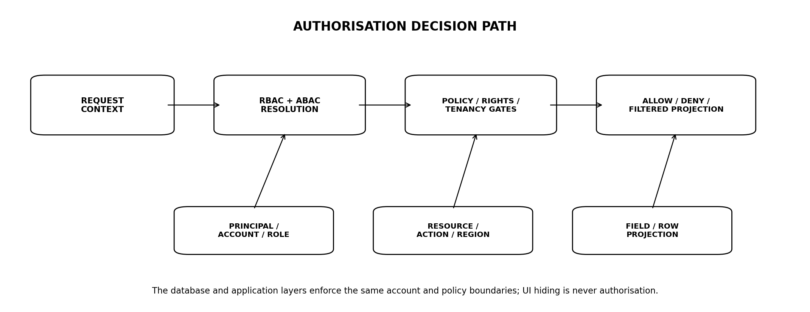
Figure 3 — Authorisation decision path
AuthorizationContext {
principal_id
account_id
roles[]
principal_attributes
resource_type
resource_id
action
resource_owner_account_id
jurisdiction
regional_cell
capability_status
rights_decisions[]
}

10.1 Roles
Role | Scope
ACCOUNT_OWNER | Commercial/account administration, subject to step-up.
ACCOUNT_ADMIN | Delegated account management.
RESEARCH_USER | Normal research/monitoring use.
READ_ONLY | Read-only team access where future team feature allows.
SUPPORT | Scoped support tools; no broad raw data.
DATA_OPS | Source/data operations.
SECURITY_OPS | Security operations.
PLATFORM_ADMIN | JIT privileged infrastructure role only.

10.2 ABAC dimensions
- Account/resource ownership.
- Jurisdiction/operating entity.
- Regional Cell/data-residency class.
- Data rights/source entitlement.
- Capability status/subscription entitlement.
- Security risk/step-up state.
- Purpose/action and sensitivity classification.

11. TENANT ISOLATION & ROW-LEVEL SECURITY
TWO INDEPENDENT BOUNDARIES
Application services authorise account access, and PostgreSQL RLS/ownership constraints enforce the same isolation for tenant-owned tables. A missed application check must not become a cross-account data breach.

11.1 RLS requirements
- Tenant/user-state tables carry account_id or principal_id as required by canonical model.
- Database roles used by application services do not have BYPASSRLS.
- Privileged maintenance roles are distinct and JIT-controlled.
- Automated tests attempt cross-tenant reads/updates/deletes on every tenant-owned table.
- Background jobs set explicit tenant/security context before access.

11.2 Global registries
Global reference tables such as instruments/markets may be shared, but joins to user state must not create inference or leakage of another account’s watchlists, saved research or rules.

12. FIELD-LEVEL & PURPOSE-BASED ACCESS
Data | Access rule
Licensed content | Filter/omit according to source rights and purpose.
PII | Return only endpoint-required fields.
Security/audit data | Restricted to Security/Ops roles.
Raw source payloads | Privileged purpose-specific access only.
AI evidence | Only evidence admitted to task’s rights/policy bundle.
Support tools | Masked/minimised views by default.

12.1 No UI-only masking
Field suppression occurs in backend/data-access policy before serialization. A hidden UI column is not a security control.

13. SERVICE-TO-SERVICE IDENTITY
Control | Requirement
Workload identity | Short-lived cryptographic identity issued by platform/IAM.
mTLS / signed tokens | Approved mutual authentication mechanism.
Service role | Narrow permissions for owned dependencies only.
Credential rotation | Automatic/short-lived; no long-lived shared secrets where avoidable.
Audience restriction | Tokens valid only for intended target service.
No user impersonation | Service may act for a user only through explicit delegated context and audit.

13.1 Background jobs
Durable jobs carry job identity plus original principal/account/purpose context where needed. Workers do not run as a universal superuser.

14. PRIVILEGED ACCESS & PAM
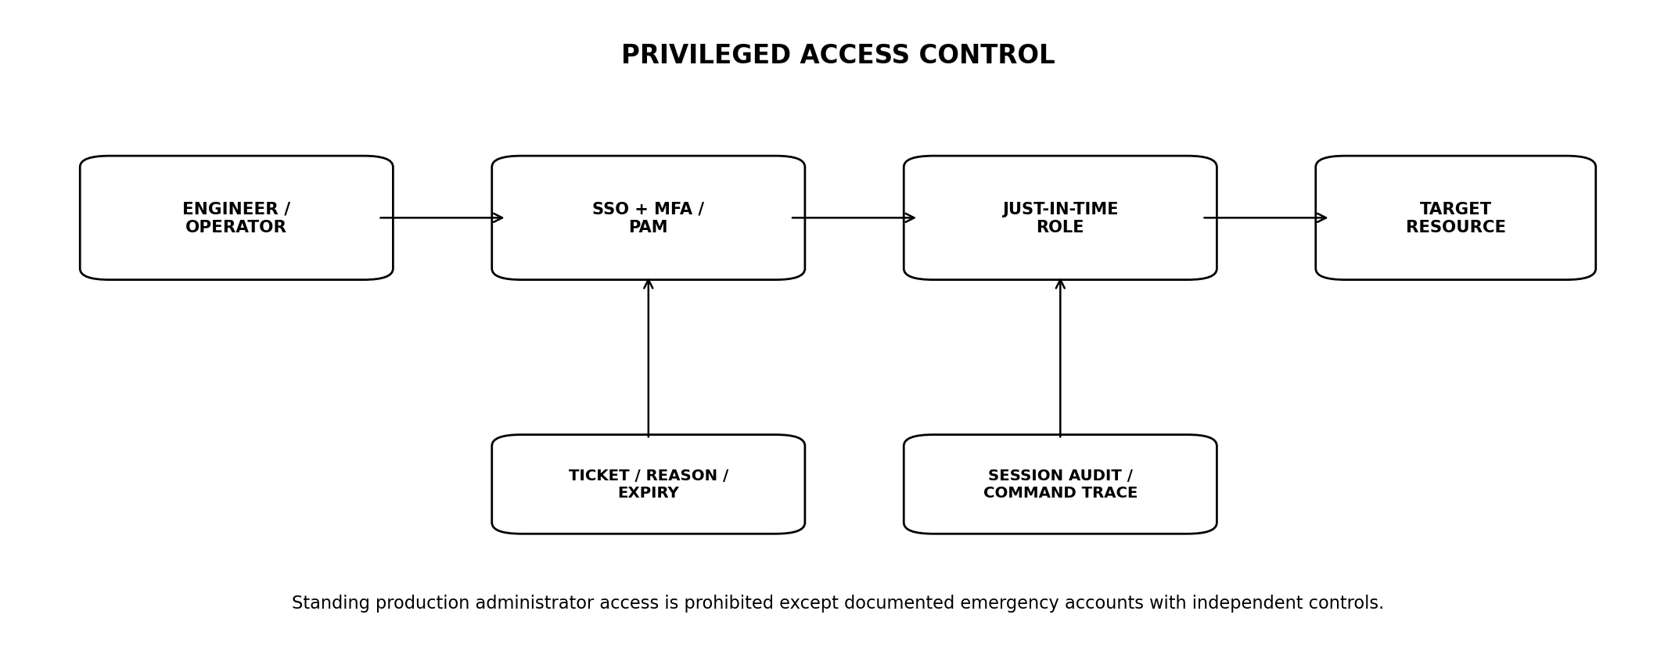
Figure 4 — Just-in-time privileged access
Control | Requirement
SSO + phishing-resistant MFA | Required for workforce privileged access.
JIT role grant | Time-bounded, approved, reason/ticket linked.
PAM/bastion | Central privileged entry point where applicable.
Session audit | Record access metadata and privileged actions; command/session recording where lawful/appropriate.
No shared accounts | Individual accountability mandatory.
Production data access | Exceptional, purpose-specific and minimised.
Break glass | Separate emergency identities, offline/secure custody, immediate alert/review.

15. CRYPTOGRAPHY & KEY MANAGEMENT
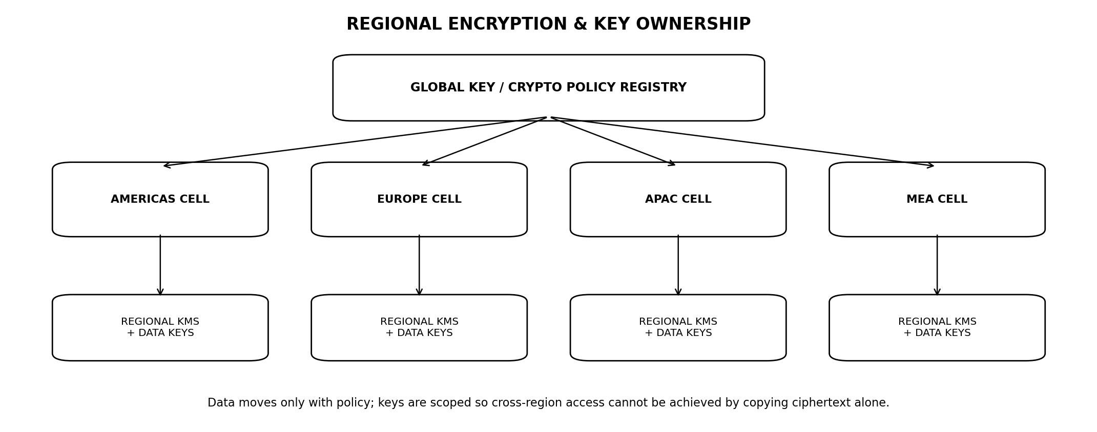
Figure 5 — Regional encryption and key ownership
Area | Requirement
In transit | TLS 1.2+ minimum; prefer TLS 1.3 where supported; strong cipher policy.
At rest | Managed encryption for databases, object storage, backups, logs and queues.
Application-level encryption | Use for selected S3 fields/artefacts where threat model requires.
KMS/HSM | Provider-managed KMS/HSM-backed key hierarchy.
Rotation | Defined automatic/manual rotation without mass data rewrite where envelope encryption permits.
Separation | Different key domains for production/non-production and Regional Cells.
Access | Key-use permission separate from ciphertext access.

15.1 Envelope encryption
Regional KMS key
↓ encrypts
Data Encryption Key (DEK)
↓ encrypts
Database field / object / backup
Copying ciphertext without authorised key access does not grant plaintext access.

15.2 Key deletion
Cryptographic erasure may support deletion workflows only when retention/legal/source-rights requirements and key scoping make it valid; it is not a universal substitute for object/database deletion.

16. SECRETS MANAGEMENT
- All production secrets reside in an approved managed secret store or KMS-backed mechanism.
- No secrets in source code, container images, build logs, issue trackers or ordinary environment dumps.
- Prefer workload identity over static credentials.
- Secrets are scoped per environment/service and rotated.
- Access to secrets is auditable.
- CI/CD uses dedicated workload identities with least privilege.

16.1 Secret scanning
Pre-commit/repository/CI secret scanning is mandatory, with revocation procedures for detected credentials. Treat a committed secret as compromised even if subsequently removed from Git history.

17. DATABASE SECURITY
Control | Requirement
Network | Private endpoints/no public database ingress.
Roles | Per-module application roles; least privilege.
RLS | Tenant-owned data enforcement.
DDL | Migration role separate from runtime role.
Backups | Encrypted and access-controlled.
Extensions | Allowlist and security review.
Audit | Privileged/admin/schema changes logged.
Queries | Parameterized queries/ORM safe bindings; no dynamic SQL from user text.

17.1 Production query access
Human ad-hoc production queries use controlled read-only/JIT roles, purpose-based approval and audit. Analysts/support do not receive direct database credentials.

18. OBJECT STORAGE, SEARCH & CACHE SECURITY
System | Requirement
Object storage | Private buckets/containers, bucket policy deny public access, short-lived signed access only.
Object Lock | Only approved evidence/audit classes; never indiscriminate licensed-data locking.
Search/vector index | Rights/source/tenant filters enforced before result exposure.
Redis/cache | No unrestricted sensitive payloads; TTLs; network isolation; entitlement-aware cache keys.
Backups/snapshots | Encrypted, region/residency controlled and restore-tested.

18.1 Cache poisoning / isolation
Cache keys include all security-relevant response dimensions (principal/account/entitlement/jurisdiction where applicable). Public and private content never share ambiguous keys.

19. API & WEB APPLICATION SECURITY
Control | Requirement
Input validation | Schema + semantic allowlists; reject unknown dangerous fields.
Output encoding | Context-appropriate encoding; no unsafe HTML injection.
CSRF | Required for cookie-authenticated state-changing browser flows.
CORS | Restrictive approved origins; never relied on for auth.
CSP | Strong Content Security Policy for web app.
Clickjacking | frame-ancestors / equivalent controls.
SSRF | Outbound fetch allowlists and metadata-service protection.
File upload | Type/size/content validation, malware scanning, isolated processing.
Mass assignment | Explicit writable-field schemas.
BOLA/IDOR | Per-object authorisation tests.

19.1 OWASP baseline
Application controls should be verified against OWASP ASVS 5.0.0 at an agreed assurance level and supplemented by API-specific abuse cases.

20. MOBILE CLIENT SECURITY
- Use platform secure storage for session/refresh material.
- Do not embed private API secrets in the mobile application.
- Certificate pinning is optional and must consider operational/recovery tradeoffs; ordinary TLS validation remains mandatory.
- Passkeys/device biometrics may unlock local authenticator use but do not replace server-side authorisation.
- Sensitive screenshots/clipboard behaviour may be constrained where justified by threat model without harming accessibility.
- Root/jailbreak detection may inform risk but is not a sole access-control decision.

21. EDGE, NETWORK & INFRASTRUCTURE SECURITY
Control | Requirement
DDoS | Managed edge protection and capacity controls.
WAF | Managed rules + app-specific high-confidence controls.
Bot/rate limits | Credential stuffing, scraping and abuse controls.
Network segmentation | Private data services; explicit east-west policies.
Egress | Allowlist sensitive workloads; DNS/HTTP egress observability.
Cloud IAM | Least privilege, no shared root/admin use.
Infrastructure as Code | Peer-reviewed, scanned and versioned.
Non-production | Separated accounts/projects/subscriptions and keys from production.

22. SECURE SDLC & SOFTWARE SUPPLY CHAIN
Practice | Requirement
Threat modelling | Required for new trust boundaries/material capabilities.
Code review | Peer review for production changes.
SAST | Automated static analysis.
SCA | Dependency and licence/security scanning.
Secrets scanning | Repository and CI.
DAST/API security | Pre-production automated testing.
SBOM | Generated for production artefacts.
Artefact signing | Signed build/container artefacts where platform supports.
Branch protection | Required reviews/status checks.
CI/CD identity | Short-lived workload identity; no shared deploy credentials.

22.1 Dependency policy
- Pin/lock dependency versions as appropriate.
- Monitor critical/security advisories.
- Abandoned/high-risk packages require replacement or documented exception.
- Transitive dependencies are included in inventory.

23. VULNERABILITY MANAGEMENT
Class | Response
Critical exploitable internet-facing | Emergency remediation/mitigation target measured in hours, not normal sprint cadence.
High | Time-bounded SLA based on exploitability/exposure.
Medium/Low | Risk-based remediation backlog.
Zero-day | Threat-specific response, temporary compensating controls, accelerated patch.
False positive | Documented evidence and expiry/revalidation.

23.1 Vulnerability sources
- Code/dependency/container/cloud/IaC scanners.
- Vendor/security advisories.
- External penetration tests.
- Bug bounty/disclosure channel when activated.
- Production detection/incident findings.

24. LOGGING, AUDIT & SECURITY TELEMETRY
Event family | Minimum audit
Authentication | Success/failure, authenticator changes, recovery, MFA changes.
Authorisation | Material DENY events and privileged ALLOW actions.
Admin | JIT grant, role changes, break-glass use, production data access.
Data rights/policy | Material permission changes and bypass attempts.
Secrets/KMS | Privileged secret/key access and key administration.
Security controls | WAF/rate-limit/bot/IDS alerts.
Change | Production deployment/config/security policy changes.

24.1 Log safety
- Never log passwords, MFA secrets, session tokens, raw private keys or full payment credentials.
- Mask/minimise PII and licensed content.
- Use structured logs with request/correlation IDs.
- Security audit stream is tamper-evident and retention-controlled.

25. SECURITY MONITORING & DETECTION
Detection area | Examples
Identity anomaly | Credential stuffing, impossible/abnormal login patterns, recovery abuse.
Privilege anomaly | Unexpected role grants, unusual production access.
Data access anomaly | Cross-account denial spikes, bulk reads/exports.
KMS/secrets anomaly | Unusual key/secret access.
Application abuse | Injection attempts, scraping, API enumeration, denial-of-wallet.
Infrastructure | Unexpected egress, public exposure, configuration drift.
Supply chain | Unsigned/unapproved artefact or dependency risk.

25.1 Detection ownership
Every Tier-0 detection has an owner, severity mapping, runbook, test method and paging route. A dashboard without an actionable response path is not a control.

26. INCIDENT RESPONSE & BREACH HANDLING
1. Detect and classify severity.
2. Contain compromised identities/services/keys/routes.
3. Preserve evidence and establish incident timeline.
4. Eradicate root cause and rotate/revoke affected credentials/keys.
5. Recover from known-good state and verify integrity.
6. Assess affected users, accounts, jurisdictions and vendor/source obligations.
7. Execute legal/privacy/regulatory notification process where applicable.
8. Convert root cause into permanent engineering controls/tests.

26.1 Security kill switches
Scope | Emergency control
Identity | Revoke principal/account/all sessions.
API | Disable endpoint/capability/region.
Source | Disable vendor/source retrieval/display.
AI | Disable provider/model/task/region/global AI.
Monitoring | Suspend affected metric/source/cell.
Keys | Disable/rotate compromised key hierarchy.

27. PRIVACY ENGINEERING
Principle | Engineering rule
Data minimisation | Collect only product-required user/account data.
Purpose limitation | Use data only for declared/approved product/security purposes.
Separation | Identity/account data separate from licensed market/evidence content where practical.
Access transparency | Privileged access to user data auditable.
Deletion | User/account deletion workflow across primary/derived stores, subject to legal/contractual retention.
Export/access | Privacy request workflows distinct from market-data export rights.
Model use | No silent user-data model training or suitability profiling.

27.1 Privacy by default
Research history, watchlists and monitoring rules are user state for product continuity; they are not automatically converted into behavioural marketing or investment-risk profiles.

28. RETENTION, DELETION & ERASURE
Data class | Rule
User account data | Retention by product/legal policy; delete/anonymise when no longer required.
Security logs | Long enough for detection/forensics; minimise unnecessary PII.
Audit records | Retained according to governance/legal policy; may require immutable metadata.
Licensed data | Source-specific retention/purge under PLT-RIGHTS-001.
Evidence artefacts | Storage class/rights-specific.
Backups | Deletion ages out through documented backup retention; restore processes re-apply deletion tombstones where necessary.

28.1 Deletion manifest
DeletionJob {
subject_or_account_id
requested_at
legal_holds[]
primary_stores[]
derived_stores[]
vendor/source constraints[]
backup_tombstone_ref
completed_at?
verification_status
}

29. GLOBAL RESIDENCY & CROSS-BORDER SECURITY
Concern | Security requirement
Regional user state | Stored/processed in permitted Regional Cell.
Regional keys | Cell-scoped KMS/key hierarchy.
Cross-cell transfer | Requires residency + policy + rights classification.
Support access | Workforce geography/access constraints where required.
Backups | Remain in approved geography/region classes.
Third parties | Provider processing location evaluated independently.

29.1 No emergency bypass
FAILOVER IS A POLICY DECISION
Disaster recovery does not authorise uncontrolled cross-border replication. If no pre-approved recovery region exists, the service may be unavailable rather than violate residency/source restrictions.

30. THIRD-PARTY & VENDOR SECURITY
- Security review proportional to data/access criticality.
- Contractual security/privacy obligations for material processors/subprocessors.
- Provider inventory with owner, data class, regions and credentials.
- SSO/MFA for workforce SaaS where supported.
- Least-privilege API scopes and key rotation.
- Offboarding/termination removes access and triggers source/data purge where relevant.
- Material vendor incidents feed Talvrin incident process.

31. BACKUP, RESTORE & SECURITY OF RESILIENCE
Control | Requirement
Encryption | All backups encrypted with approved regional keys.
Access | Restore privileges JIT and restricted.
Integrity | Regular restore drills from known-good backups.
Ransomware | Backup immutability/segmentation appropriate to threat model.
Secrets | Restored environments do not resurrect expired/revoked secrets without control.
Deletion | Restore procedure re-applies deletion/purge state where needed.

32. THREAT MODEL — LAUNCH PRIORITIES
Threat | Primary controls
Account takeover | Phishing, credential stuffing, weak recovery.
Cross-tenant access | BOLA/IDOR, RLS bypass, cache-key error.
Licensed-data leakage | API/export/cache/log/AI/provider route.
Prompt/document injection | Untrusted evidence manipulating model/tool behaviour.
Privileged insider misuse | Standing admin, direct DB/raw-data access.
Supply-chain compromise | Dependency/build/CI credential compromise.
Cloud misconfiguration | Public storage/database/network exposure.
Data corruption | Unauthorized fact/evidence/calculation mutation.
Denial of monitoring | Evaluator/source failure hidden as healthy state.
Regional-policy bypass | Improper replication/failover/provider routing.

33. SECURITY TESTING MATRIX
Suite | Mandatory cases
Identity | Passkey/password/MFA/recovery/session fixation/revocation.
AuthZ | Role/ABAC/field-level/cross-account/RLS/service identity.
API/web | ASVS/API abuse, CSRF, XSS, SSRF, injection, mass assignment.
Data | Encryption, KMS permissions, secret access, backup restore.
AI/evidence | Prompt injection, rights leakage, provider route, evidence exfiltration.
Network/cloud | Public exposure, egress, IAM privilege escalation, IaC drift.
Supply chain | SAST/SCA/SBOM/signing/deploy identity.
Privacy | Deletion, minimisation, logs, export/access workflows.
Incident | Session revocation, key rotation, break-glass, kill switches.
Global | Regional keys, cross-cell denial, pre-approved DR.

34. PENETRATION TESTING & INDEPENDENT ASSURANCE
- Independent penetration test before public paid launch of material attack surface.
- Retest material findings after remediation.
- Annual or major-change cadence thereafter based on risk.
- Scope includes authenticated application/API, account isolation, admin/ops surfaces and cloud configuration.
- AI/evidence prompt-injection testing is included, not treated as separate marketing exercise.
- Future SOC 2/ISO 27001 programmes consume this control baseline but do not replace technical verification.

35. SECURITY OPERATIONS CONSOLE
Module | Purpose
Identity security | Account takeover signals, recovery/MFA changes, session revocation.
Privileged access | Active JIT roles, approvals, break-glass state.
Cloud/IAM posture | Critical misconfigurations and drift.
Vulnerability | Open critical/high findings and SLAs.
Secrets/keys | Rotation status, anomalous access.
Incident | Open security incidents, scope and containment.
Regional posture | Cell health, key state, cross-region exceptions.
Audit search | Privileged and material security event investigation.

36. NON-FUNCTIONAL SECURITY TARGETS
Metric | Target
Auth service availability | ≥99.9% target; fail secure.
Session revocation propagation | ≤60 s for high-risk forced revocation.
Critical secret/key revocation | Immediate control-plane action; dependent services rotate/reconnect.
Security-event ingestion | ≤60 s p95 to detection pipeline for Tier-0 events.
JIT privilege default duration | ≤1 hour unless approved task requires shorter/longer explicit window.
Cross-tenant security defects | 0 tolerated in release.
Critical known exploitable vulnerabilities at release | 0.
Restore/security drill | At least quarterly for critical production data/services.

37. PRODUCTION ACCEPTANCE GATES
Gate | Area | Exit criterion
SEC-G01 | Identity | Passkey/password/MFA/recovery/session suites pass.
SEC-G02 | Tenant isolation | Cross-account application + RLS test suite passes on every tenant table.
SEC-G03 | Authorisation | RBAC/ABAC/field projection negative tests pass.
SEC-G04 | Privileged access | No standing production admin role; JIT/PAM and break-glass drill pass.
SEC-G05 | Secrets | Repository/CI secret scan clean; runtime secrets managed/rotatable.
SEC-G06 | Encryption | Regional KMS, TLS and backup encryption verified.
SEC-G07 | API/web | Agreed OWASP ASVS 5.0.0 verification set passes.
SEC-G08 | Cloud/network | No unintended public data-service ingress; egress controls verified.
SEC-G09 | Supply chain | SAST/SCA/SBOM/build identity/release controls active.
SEC-G10 | Privacy | Deletion/export/minimisation/log-redaction workflows pass.
SEC-G11 | Global | Cross-cell/residency/key isolation tests pass.
SEC-G12 | Detection | Tier-0 alerts reach Security/Ops and runbooks are exercised.
SEC-G13 | Incident | Session revoke, key/secret rotation and kill-switch tabletop passes.
SEC-G14 | Pen test | No unresolved launch-blocking critical/high findings.
SEC-G15 | Observability | Security/audit dashboards and immutable audit path operational.

38. OPEN DECISIONS / BLOCKERS
ID | Decision | Owner
O-SEC-01 | Final identity provider / authentication implementation and passkey rollout strategy. | CTO + Security
O-SEC-02 | Consumer MFA policy beyond passkey encouragement and step-up events. | Product + Security
O-SEC-03 | Enterprise SSO/SCIM launch timing. | Commercial + Product
O-SEC-04 | Cloud/KMS provider(s) and initial Regional Cell locations. | Platform + Legal
O-SEC-05 | SIEM/detection platform and on-call operating model. | Security + Ops
O-SEC-06 | External penetration-testing partner and launch scope. | Security
O-SEC-07 | Formal SOC 2 / ISO 27001 certification timeline, if commercially required. | Board + Security

39. IMPLEMENTATION SEQUENCE
Stage | Build | Exit
S0 — Identity foundation | Principal/account/session/authenticator model; passkey/password/MFA; recovery. | Identity threat tests pass.
S1 — Authorisation/isolation | RBAC/ABAC, RLS, service identities, field projection. | Cross-tenant suites pass.
S2 — Crypto/secrets | Regional KMS, encryption, secrets, workload credentials. | Key/secret drills pass.
S3 — App/platform hardening | WAF/API/web/network/DB/object/cache controls. | ASVS/cloud tests pass.
S4 — Privacy/global | Deletion, minimisation, residency/cross-cell controls. | Privacy/global suites pass.
S5 — Detection/response | Audit, SIEM, alerts, incident/kill-switch/runbooks. | Tier-0 exercises pass.
S6 — Assurance | Pen test, supply-chain hardening, launch security review. | All SEC-G gates pass.

40. TRACEABILITY TO ENGINEERING ESTATE
Document | Dependency
PLT-PRD-001 | Defines account, user-state and security-related product requirements.
PLT-ENG-ARCH-003 | Defines trust zones, Regional Cells, resilience and global architecture.
PLT-DATA-001 | Defines tenant-owned schemas and RLS targets.
PLT-DATA-002 | Defines source ingestion trust and data integrity.
PLT-RIGHTS-001 | Defines source/action data rights.
PLT-FIN-001 | Defines calculation integrity/immutability.
PLT-POL-001 | Defines jurisdiction/capability policy.
PLT-MON-001 | Defines monitoring security, coverage and privileged replay boundaries.
PLT-EVID-001 | Defines source artefact security, quarantine and evidence access.
PLT-AI-001 | Defines provider secrets, prompt injection, model routing and AI data boundaries.
PLT-API-001 | Defines API auth context, object authorisation and error contracts.
PLT-QE-001 | Will consolidate security verification and release gates.
PLT-OPS-001 | Will define deployment, SIEM, backup/restore and incident operating procedures.

41. PROHIBITED ANTI-PATTERNS
1. Shared production administrator accounts.
2. Standing broad cloud/database administrator roles for engineers.
3. Application database users with BYPASSRLS.
4. Trusting UI visibility or CORS as authorisation.
5. Long-lived provider/service secrets embedded in code or container images.
6. Storing session tokens in browser localStorage as the default web-session pattern.
7. SMS as the only MFA/recovery method for privileged access.
8. Silent account recovery by support without strong evidence and audit.
9. Public database/object-storage endpoints for convenience.
10. Cross-region disaster recovery that bypasses residency/source-rights policy.
11. Logging passwords, tokens, private keys, full licensed payloads or unnecessary PII.
12. Allowing AI/provider routes to receive data without rights/residency checks.
13. Treating network location as service identity.
14. Restoring backups without reapplying deletions/revocations.
15. Shipping critical known exploitable vulnerabilities because a compliance scan passed.

42. CURRENT SECURITY STANDARDS BASELINE
Reference | Use
NIST Cybersecurity Framework 2.0 | Overall cybersecurity-risk governance taxonomy.
NIST SP 800-63-4 + 63B-4 | Current digital identity/authentication guidance, final July 2025.
OWASP ASVS 5.0.0 | Current application-security verification baseline, released May 2025.
OWASP API Security Top 10 | API threat/abuse reference.
ISO/IEC 27001:2022 | Information-security management system reference baseline.
PLT-RIGHTS-001 / PLT-POL-001 | Talvrin-specific rights and jurisdiction policy authorities.
These standards guide engineering and assurance. Talvrin must not claim certification, assurance level or compliance merely because controls are mapped to a standard.

43. ENGINEERING SIGN-OFF STANDARD
PLT-SEC-001 may be approved only when Security Engineering, Backend Engineering, Platform Operations, Data Engineering, Trust/Rights, Privacy/Legal and Quality Engineering can prove account isolation, least privilege, cryptographic protection, secure recovery, controlled administration, regional enforcement and incident containment through repeatable tests and drills.
FINAL BUILD PRINCIPLE
Talvrin’s security objective is not to make compromise impossible. It is to make compromise difficult, access narrowly scoped, blast radius bounded, misuse detectable, recovery fast, and every material privileged action attributable.

