AI Assistant

RBAC & Authorization Specification
Global Core Standard | Zero Trust | Least Privilege | Object/Property Safe | Evidence-Ready

EXECUTIVE DOCTRINE Zoiko Rooms authorizes every request from explicit identity, active subject scope, resource relationship, action, market/policy context, resource state and authentication assurance. The AI model may request a decision; it may never create, override or infer permission. Authorization is deny-by-default, least-privilege, continuously re-evaluated for consequential actions, and evidenced.

Field | Value
Document ID | ZR-AI-AUTH-001
Version | 1.0 — Global Platform Standard
Date | 19 August 2026
Status | Build-ready authorization contract; production release requires security architecture, IAM, application security, privacy, product, engineering and QA approval.
Owner | Zoiko Rooms Product Security / Identity & Access Architecture
Applies to | Web, mobile, AI Assistant BFF, Conversation Orchestrator, Policy Decision Point, RAG, typed tools/adapters, authoritative domain APIs, staff/support surfaces and service-to-service access.
Language | American English

Document Map
- 1. Purpose, Scope & Authorization Doctrine
- 2. Normative Requirements & Non-Negotiable Invariants
- 3. Principal, Identity & Subject Taxonomy
- 4. Authorization Reference Architecture
- 5. Hybrid Access-Control Model — RBAC + ABAC + ReBAC
- 6. Active Subject Scope & Persona Switching
- 7. Role & Entitlement Catalogue
- 8. Renter Authorization Rules
- 9. Host Authorization Rules
- 10. Dual-Role Account Separation
- 11. Staff, Operations & Privileged Authorization
- 12. Service / Workload Identity & Machine Authorization
- 13. Object-Level Authorization
- 14. Property / Field-Level Authorization
- 15. Function / Action-Level Authorization
- 16. A0–A3 Authorization Semantics
- 17. A2 Consequential Action Authorization
- 18. Jurisdiction, Market & Policy Context
- 19. PDP / PEP / PIP Decision Contract
- 20. Tokens, Sessions, Delegation & Step-Up Authentication
- 21. Deny, Challenge, Redaction & Explainability
- 22. Privileged Access / Break-Glass
- 23. Audit, Evidence & Telemetry
- 24. Caching, Performance & Consistency
- 25. Failure, Degradation & Fail-Closed Behaviour
- 26. Policy Administration, Versioning & Release
- 27. Authorization Threat Model
- 28. Verification, Negative Testing & Acceptance Gates
- 29. Traceability & Engineering Handoffs
- 30. Critical Refinement Decisions
- 31. Approval Gate
- Appendix A. Role-to-Capability Matrix
- Appendix B. Canonical Decision Pseudocode
- Appendix C. Standards Baseline

Normative Language
MUST / SHALL = binding P0 requirement. SHOULD = required default unless an approved exception documents the reason, compensating control and expiry. MAY = optional. “Authorization” means a deterministic permit/deny/challenge decision made outside the model runtime.

1. Purpose, Scope & Authorization Doctrine
This specification defines how the Zoiko Rooms AI Assistant decides whether a human or machine principal may read, retrieve, disclose, propose, confirm or execute an operation. It is the binding authorization contract between Product, Identity, Security, Backend, AI, Data, Support, Compliance and QA.
CORE RULE Authentication establishes who the principal is. Authorization determines what that principal may do now. A valid login, role label, API token, conversation, prompt, tool call or model decision never implies authorization by itself.

1.1 In scope
- Customer and staff principals; service/workload identities; delegated and organization-scoped access where enabled.
- Conversation access; live account/domain reads; RAG eligibility; citation disclosure; tool availability; object/property/function authorization; consequential action authorization.
- Subject-scope and persona switching; step-up authentication; JIT privileged access; policy versioning; evidence; denial and challenge states.
- Authorization requirements across public client APIs, private orchestration APIs and authoritative Zoiko Rooms domain adapters.

1.2 Out of scope
- Identity proofing implementation details, credential recovery and authentication UI beyond the authorization-relevant requirements specified here.
- Business rules that determine legal eligibility or compliance outcomes. Those remain authoritative domain/rules-as-code decisions.
- Prompt safety as an authorization substitute. Prompt Engineering & AI Guardrails remains a separate control plane.

2. Normative Requirements & Non-Negotiable Invariants
ID | Invariant | Binding requirement
AUTH-I-001 | Deny by default | Any request not explicitly permitted SHALL be denied.
AUTH-I-002 | Least privilege | Grant only the minimum action/resource/property scope required for the current purpose.
AUTH-I-003 | Server-side enforcement | Authorization SHALL be enforced server-side at every protected boundary; UI hiding is not a security control.
AUTH-I-004 | No model authority | Models, prompts, RAG results and tool outputs SHALL NOT grant or expand permissions.
AUTH-I-005 | Object re-check | Every endpoint/tool receiving a resource identifier SHALL perform object-level authorization.
AUTH-I-006 | Property re-check | Returned and writable fields SHALL be authorized independently of object access.
AUTH-I-007 | Function re-check | Possession of a resource SHALL NOT imply permission to invoke every function on it.
AUTH-I-008 | Active subject scope | Customer authorization SHALL be evaluated in one explicit active persona/subject scope.
AUTH-I-009 | A2 reauthorization | Consequential actions SHALL be re-authorized immediately before side effect.
AUTH-I-010 | Market binding | Market/jurisdiction policy context SHALL be resolved and bound before market-dependent access/actions.
AUTH-I-011 | Decision evidence | Protected decisions SHALL emit a decision ID and policy/version evidence.
AUTH-I-012 | No stale privilege | Role, relationship, session, resource or policy changes SHALL invalidate affected cached decisions.

3. Principal, Identity & Subject Taxonomy
Principal class | Examples | Authorization treatment
Anonymous | Signed-out visitor | Public-only capabilities; no customer data; no protected tools.
Customer person | Authenticated renter/host | Stable account principal plus one active subject scope.
Organization member | Managed host/operator where organization capability is enabled | Principal + organization membership + delegated role + resource relationship; never inferred from email domain.
Staff person | Support, payments, compliance, trust/safety, AI ops, security | Separate staff identity plane; explicit staff mode; purpose/case/task binding for customer access.
Privileged administrator | Emergency/IAM/platform administrator | JIT elevation; step-up; approval or break-glass controls; enhanced evidence.
Workload/service | BFF, orchestrator, PDP, adapters, workers | Cryptographic workload identity; service-to-service policy; no shared long-lived credentials.
Automation/job | Scheduled reconciliation or policy task | Dedicated workload identity with narrow job capability and data scope.

3.1 Actor, subject and effective principal
The system SHALL distinguish the authenticated actor from the subject on whose behalf the action is performed. For ordinary customer activity actor = subject. For delegated organization access, support-assisted access and service-to-service flows, the relationship SHALL be explicit and auditable.
AuthorizationSubject = {
actor_principal_id, subject_principal_id, active_persona, organization_id?,
delegation_id?, staff_case_id?, purpose_code?, authentication_assurance,
session_id, tenant_or_partition_scope
}

4. Authorization Reference Architecture
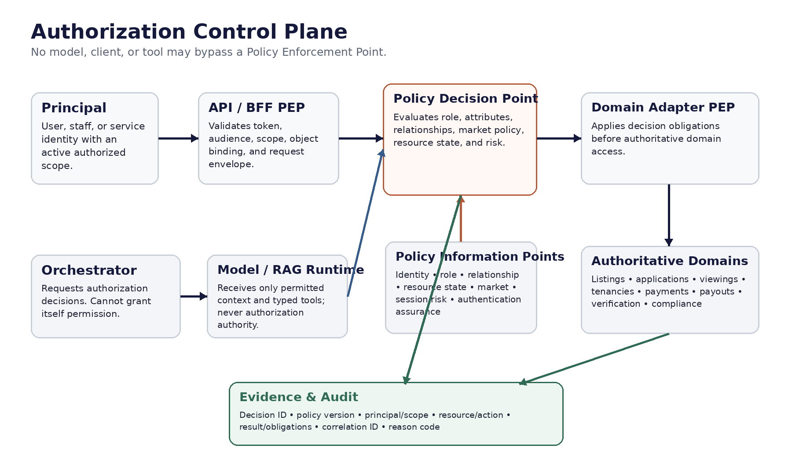
Figure 1 — Authorization control plane and mandatory enforcement boundaries.

4.1 Enforcement placement
Boundary | PEP requirement | Why
Client API / BFF | Authenticate, validate token/audience, normalize resource/action request, apply coarse route scope. | Stops unauthenticated and obviously out-of-scope requests early.
Conversation Orchestrator | Request explicit decision before exposing protected context or tool. | Prevents prompt/model state from becoming an authorization path.
RAG retrieval | Filter corpus/release/access class before retrieval and again before answer assembly. | Prevents staff/restricted knowledge leakage.
Typed tool / domain adapter | Re-authorize object, properties and function against authoritative current state. | Prevents BOLA/BOPLA/BFLA and stale decisions.
Authoritative domain service | Enforce domain-native authorization invariant where feasible. | Defence in depth and independent truth boundary.
Evidence service | Write decision/action evidence under service identity only. | Prevents users/models from tampering with authorization records.

5. Hybrid Access-Control Model — RBAC + ABAC + ReBAC
Zoiko Rooms SHALL use a hybrid model. RBAC assigns coarse capability families; ABAC evaluates subject/object/action/environment attributes; relationship-based rules verify ownership, tenancy, organization membership, case assignment or delegated authority. The PDP combines these into one deterministic result.
Layer | Question answered | Examples
RBAC | What capability family may this principal ever exercise? | Renter, Host, Support Agent, Payments Ops, Compliance Reviewer, Security Analyst.
ABAC | Do current attributes permit the operation? | Authentication assurance, market, resource state, time, risk, policy version, data class.
ReBAC | What relationship authorizes this object? | Applicant owns application; host controls listing; staff assigned to case; member delegated by organization.
Policy obligations | What constraints apply if permit? | Redact fields, require step-up, require A2 confirmation, limit projection, force evidence, set TTL.

ANTI-PATTERN Do not encode every resource relationship into named roles (for example, HOST_OF_LISTING_123). Do not use role alone to decide access to customer objects.

6. Active Subject Scope & Persona Switching
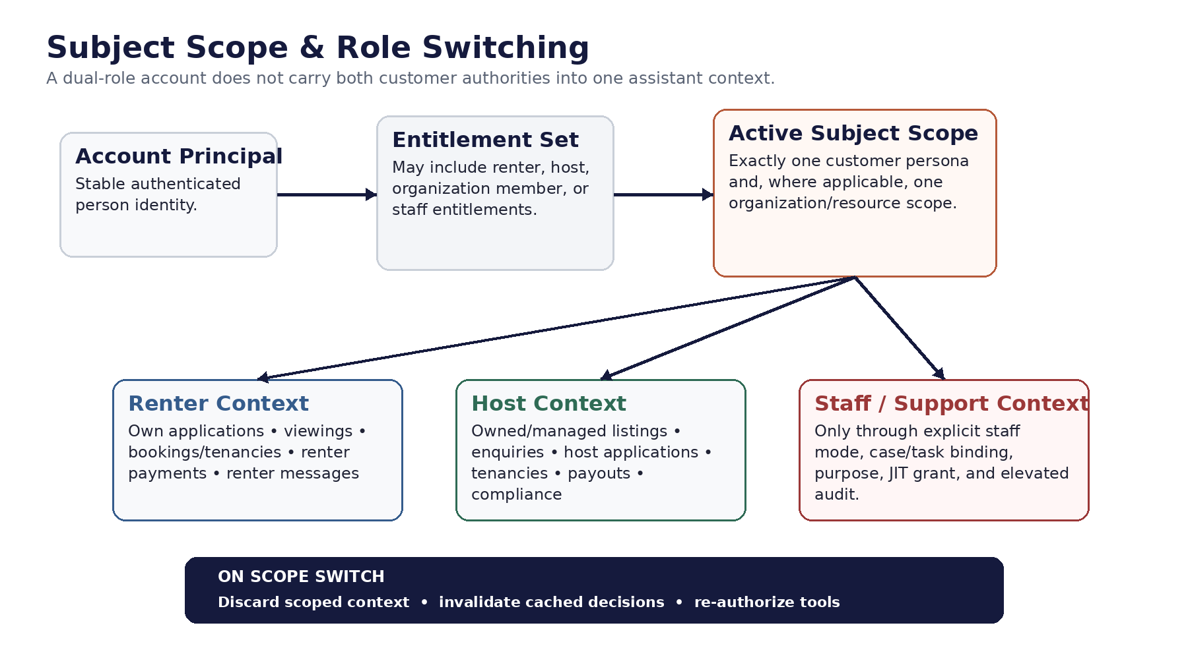
Figure 2 — Active subject scope and separation of renter, host and staff contexts.

6.1 Binding rules
- A dual-role customer account MAY possess renter and host entitlements but SHALL operate the Assistant under one explicitly selected active persona at a time.
- Conversation context, cached authorization decisions, tool allowlists, retrieved account data and sensitive projections SHALL be bound to active subject scope.
- Switching Renter ↔ Host SHALL invalidate scoped context and re-resolve permitted tools and resource access before the next protected operation.
- No Assistant response SHALL merge renter-private and host-private data merely because the same human owns both personas.
- Staff mode SHALL use a separate entry point/context indicator and SHALL NOT be silently activated from a customer session.

7. Role & Entitlement Catalogue

7.1 Customer roles
Role / entitlement | Purpose | Default AI authority
Renter | Find rooms; manage own application/viewing/tenancy/payment context. | Read own resources; prepare permitted renter actions; A2 only where action policy allows.
Host | Manage owned/authorized listings, enquiries, applicants, tenancies, payouts and compliance context. | Read host-authorized resources; prepare permitted host actions; A2 where allowed.
Dual-role entitlement | Account can enter Renter or Host persona. | No additive permission; requires explicit active persona.
Organization member (flagged capability) | Act for an organization-managed host account. | Limited by organization role + assigned portfolio/resources + delegation status.

7.2 Staff roles
Role | Allowed purpose | Prohibited by default
Support Agent L1 | Customer service on assigned case; bounded account/context lookup. | Payments mutations, identity overrides, compliance determinations, broad search/export.
Support Specialist L2 | Escalated troubleshooting with expanded diagnostics. | Unbounded customer browsing; privileged configuration.
Payments Operations | Payment/payout investigation through finance-authorized surfaces. | Changing ledger truth outside authoritative finance workflows.
Trust & Safety | Safety reports, abuse/escalation workflows. | General customer browsing unrelated to assigned matter.
Compliance Operations | Review compliance evidence/workflows under market policy. | AI-created legal outcome; cross-market access without purpose.
Knowledge Reviewer / Release Manager | Approve/release governed knowledge. | Customer transaction data unless separately authorized.
AI Operations | Model/prompt/runtime operations and redacted diagnostics. | Raw customer data by default; authorization policy administration.
Security Analyst | Security investigation under approved incident scope. | Business operations unrelated to incident.
Auditor / Read-only | Evidence and control review. | Operational mutation.
Privileged IAM / Platform Admin | Emergency or approved administrative change. | Standing day-to-day customer access; self-approval of elevation.

8. Renter Authorization Rules
Resource family | Read | Prepare / execute | Required relationship
Saved / search preferences | Own only | Own preference actions as allowed. | subject_principal_id = owner.
Application | Own application + permitted public listing context | Submit/withdraw/update only via allowed workflow and resource state. | Applicant is active renter subject.
Viewing | Own viewing request/booking | Request/reschedule/cancel within policy. | Renter is participant; listing relationship valid.
Booking / tenancy / stay | Own contract/stay facts | Only explicit supported actions; legal status not inferred by AI. | Renter party to authoritative record.
Payment / deposit / charge | Own authoritative financial facts | Only supported payment action workflows; A2/strong controls where consequential. | Renter is liable/beneficiary party as domain defines.
Messages | Threads in which renter is authorized participant | Send/compose only through messaging policy. | Participant relationship.
Verification | Own status and allowed explanations | No AI override of verification outcome. | Subject is verification principal.

9. Host Authorization Rules
Resource family | Read | Prepare / execute | Required relationship
Listing | Owned/managed listing + public listing data | Draft/update/publish only if host has management authority and state permits. | Owner/manager/delegated portfolio relationship.
Enquiry / applicant | Only for listings host is authorized to manage; privacy projection applies. | Supported communication/workflow actions only. | Listing-control relationship + applicant data projection policy.
Viewing | Viewings for managed listings | Confirm/reschedule/cancel where workflow allows. | Host controls related listing.
Tenancy / stay | Host-side records for managed property/listing | Only explicit supported actions; no AI legal determination. | Host party/manager relationship.
Payout | Own/organization-authorized payouts | No payout rerouting through conversational free-form tools. | Beneficiary account/organization relationship.
Compliance | Compliance state/evidence for controlled listing/property | Upload/request/remediate only through governed workflow. | Host controls resource + market pack permits.
Messages | Authorized host threads | Send/compose under participant and content policy. | Participant + listing relationship.

10. Dual-Role Account Separation
- Dual-role is an entitlement property, not a super-role.
- The Assistant SHALL NOT union renter and host permissions into one decision context.
- Each protected request SHALL carry active_persona and subject_scope_version.
- Cross-persona references SHALL require an explicit scope transition or a separately authorized neutral/public read.
- A pending A2 confirmation SHALL be invalidated if the user changes active persona before execution.
- Conversation summaries retained across scope switches SHALL exclude protected data from the prior persona unless the new scope is independently authorized to view it.
P0 TEST A user who is both renter and host must not be able to ask the Assistant, while in Host mode, for private renter-side payment or application details merely because the same account owns both personas.

11. Staff, Operations & Privileged Authorization

11.1 Staff access principles
- Staff authorization SHALL be purpose-bound. Customer access requires an active approved case/task/incident where the role requires it.
- Staff search SHALL minimize bulk enumeration and apply rate, purpose and query controls.
- High-risk data projections SHALL require stronger role/assurance and may require approval or JIT elevation.
- Staff SHALL NOT impersonate a customer to bypass customer authorization. Assisted flows must preserve actor ≠ subject evidence.
- The AI Assistant SHALL visually and technically distinguish staff context from customer context.

11.2 Separation of duties
Sensitive capability | Maker | Checker / independent control
Authorization policy release | IAM/Policy Engineer | Security Architect / designated approver
Privileged role grant | Authorized IAM operator | Independent approver or approved JIT workflow
Knowledge controlled release | Knowledge maker | Reviewer / Release Manager
A2 action | Authorized customer/staff actor | Deterministic policy + user confirmation + domain reauthorization; not AI self-approval
Break-glass elevation | Eligible privileged principal | Incident reason + step-up + automatic expiry + post-event review

12. Service / Workload Identity & Machine Authorization
Machine-to-machine access SHALL use workload identities distinct from human identities. Services SHALL authenticate cryptographically and be authorized to narrow API audiences/functions. Shared static credentials and broad “backend” roles are prohibited.
- Each service/workload SHALL have a unique identity and narrowly defined audience/resource permissions.
- Workload identity issuance SHOULD use short-lived credentials with attestation; SPIFFE/SPIRE or an equivalent workload-identity framework MAY be used.
- The Conversation Orchestrator SHALL not possess direct payment, database or policy-administration credentials.
- Model-provider credentials SHALL be usable only by the Model Gateway, not by browser/mobile clients or unrelated services.
- Background jobs SHALL use job-specific service identities; scheduled automation must not reuse administrator credentials.
- Service-to-service authorization SHALL validate caller identity, audience, method/function, environment and where relevant tenant/market scope.

13. Object-Level Authorization
Every protected object identifier supplied by the client, model, RAG result or another service SHALL be treated as attacker-controlled until the current principal-to-object relationship is verified.

13.1 Required object checks
- Resolve the object from the authoritative domain; do not authorize from client-supplied owner/tenant fields.
- Verify ownership, party, participant, assigned-portfolio, organization membership or staff case relationship as appropriate.
- Re-check relationship after redirects, aliases, parent-child traversal and batch operations.
- For list/search endpoints, authorize the query scope before retrieval and post-filter results where policy requires.
- Do not treat UUIDs, opaque IDs or unguessable identifiers as access control.

14. Property / Field-Level Authorization
Control | Requirement
Read projection | PDP/adapter SHALL select the allowed response projection; sensitive fields are omitted/redacted server-side.
Write allowlist | Only explicitly writable properties for the current role/resource state SHALL be accepted. Unknown or unauthorized fields SHALL be rejected, not silently mass-assigned.
Derived fields | Derived/inferred sensitive attributes SHALL receive the same or stronger protection as source fields.
Staff diagnostics | Diagnostic fields SHALL be separately scoped and shall not leak into customer surfaces or model context without authorization.
RAG metadata | Restricted/staff-only metadata SHALL not be exposed merely because an answer cites a knowledge object.

15. Function / Action-Level Authorization
Access to a resource or API family SHALL NOT imply permission to invoke all actions on that resource. Each command/tool function SHALL have an explicit permission name, action tier and policy mapping.
Function class | Examples | Authorization posture
Read | Get own application status; get host payout status. | Object + property + market/purpose checks.
Prepare | Create draft action intent; calculate proposed change. | Current authority + resource state; no side effect.
Confirm | Bind user confirmation to exact prepared action. | Same principal/scope; confirmation eligibility; expiry.
Execute | Submit/withdraw/reschedule/publish/other permitted side effect. | Fresh reauthorization + confirmation if A2 + idempotency + authoritative domain enforcement.
Administrative | Change policy, grant roles, release privileged config. | Not available to ordinary Assistant; dedicated privileged workflows only.

16. A0–A3 Authorization Semantics
Tier | Meaning | Authorization requirement
A0 — Answer | No protected side effect. | Public or authorized data/knowledge access only; property projection enforced.
A1 — Assist / Prepare | Draft or prepare without committing side effect. | Principal may initiate workflow; resource/action permit required; output marked non-final.
A2 — Confirmed Consequential Action | Side effect only after exact user confirmation. | Fresh prepare authorization + bound confirmation + immediate execute reauthorization + receipt.
A3 — Prohibited / Human-Controlled | AI is not permitted to autonomously decide or execute. | Block, route to governed human/domain workflow, or provide safe explanation.

NO PRIVILEGE THROUGH AGENCY A higher action tier never increases a principal’s underlying permissions. A2 confirmation proves intent; it does not create authorization.

17. A2 Consequential Action Authorization
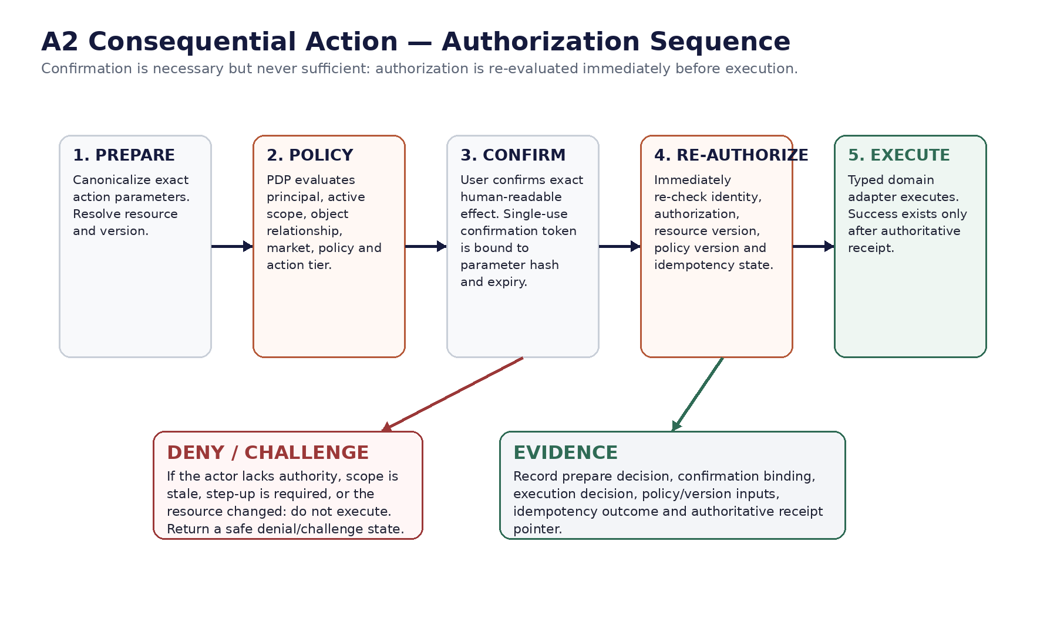
Figure 3 — A2 prepare/confirm/re-authorize/execute sequence.

17.1 Confirmation binding
An A2 confirmation SHALL be single-use, short-lived and bound to: actor principal, subject principal, active persona/scope, action type, target resource(s), canonical parameter hash, resource version, policy/market-pack version, expiration, nonce and action-intent ID. Any material change SHALL invalidate confirmation.

17.2 Execution reauthorization
- Revalidate authentication/session and required assurance.
- Re-evaluate role/attributes/relationships using current policy and current authoritative resource state.
- Reject stale resource versions or changed consequential parameters.
- Enforce idempotency and reconcile unknown commit status before retry.
- Treat only the authoritative domain receipt as success.

18. Jurisdiction, Market & Policy Context
Authorization is global-core first and market-aware. Market packs may restrict capabilities, required evidence, data projections, role eligibility, step-up requirements or supported actions, but SHALL NOT silently broaden a global deny.
Context field | Rule
market_id / jurisdiction_id | Resolved from the transaction/resource context, not merely IP address or UI locale.
market_pack_version | Bound to protected market-dependent decisions and A2 confirmation where relevant.
locale | Presentation only; never used as authorization evidence.
locality overlay | May narrow or condition operations where a certified locality rule exists.
unknown / conflicting market | Return clarification or safe deny for market-dependent protected operations.
cross-market staff access | Requires role, purpose and data-residency authorization; not implied by global staff status.

19. PDP / PEP / PIP Decision Contract

19.1 Canonical request
AuthorizationRequest {
decision_id, actor, subject, active_scope, authentication_context,
action: {name, tier}, resource: {type, id, version?}, properties?,
relationships?, organization_id?, market_context, purpose?,
environment: {channel, service, risk, time}, policy_version_hint?
}

19.2 Canonical response
AuthorizationDecision {
result: PERMIT | DENY | CHALLENGE | NOT_APPLICABLE,
reason_code, policy_version, evaluated_at, expires_at?,
obligations: {allowed_projection?, redact_fields?, require_step_up?,
confirmation_required?, max_decision_ttl?, evidence_level?}
}

19.3 Policy Information Points
PIP | Authoritative inputs
Identity / IAM | Principal status, role grants, organization membership, delegation, assurance.
Resource domain | Owner/party/participant relationship, state, version, sensitivity/classification.
Market Policy | Certified market pack, locality overlays, action constraints.
Risk / Session | Session validity, device/session risk, recent step-up, anomalous access signals.
Case / Purpose | Staff case assignment, incident, purpose code, JIT grant.

20. Tokens, Sessions, Delegation & Step-Up Authentication

20.1 Access tokens/assertions
- Tokens SHALL be audience-restricted and short-lived; authorization decisions SHALL not trust client-readable claims for mutable relationships without authoritative validation where required.
- Scopes/roles in tokens MAY support coarse admission but SHALL NOT replace current object/property/function authorization.
- OAuth deployments SHALL follow current OAuth 2.0 security best current practice; insecure/legacy modes SHALL not be introduced for convenience.
- Refresh/session lifecycle SHALL propagate revocation or role/relationship changes within a defined maximum security propagation window.

20.2 Step-up
The PDP MAY return CHALLENGE with a required authentication assurance level or fresh-auth age. Consequential or privileged operations SHALL specify which actions require phishing-resistant or otherwise stronger authentication in the Identity standard; the Assistant must not fake or bypass step-up.

20.3 Delegation
- Delegation SHALL be explicit, scoped, time-bounded where appropriate, revocable and evidenced.
- Delegation SHALL identify delegator, delegate, organization/resource scope, allowed capabilities and expiry.
- No delegation SHALL be inferred from shared email address, payment instrument, device or prior conversation.

21. Deny, Challenge, Redaction & Explainability
Decision | User-visible behavior | Security behavior
DENY | State that the requested information/action is not available in the current access context; offer permitted next step when useful. | Do not reveal existence of sensitive objects where that itself is protected.
CHALLENGE | Ask for required re-authentication, scope switch or approved workflow step. | Do not execute until challenge is satisfied and decision re-evaluated.
PERMIT + obligations | Return only authorized projection or action path. | PEP enforces redaction, confirmation, TTL and evidence obligations.
NOT_APPLICABLE | Route to another policy/domain or safe unsupported state. | Never convert to permit by default.

21.1 Reason codes
Reason codes SHALL be stable, machine-readable and non-sensitive, for example: AUTH_SCOPE_MISMATCH, AUTH_OBJECT_RELATIONSHIP_MISSING, AUTH_PROPERTY_DENIED, AUTH_FUNCTION_DENIED, AUTH_STEP_UP_REQUIRED, AUTH_POLICY_CONTEXT_UNRESOLVED, AUTH_RESOURCE_STALE, AUTH_JIT_REQUIRED. User-facing copy SHALL not expose internal policy logic or sensitive existence information.

22. Privileged Access / Break-Glass
- Privileged access SHALL be just-in-time wherever feasible and automatically expire.
- Elevation requires strong authentication, reason/purpose, bounded scope and enhanced audit.
- Emergency break-glass SHALL be a distinct path, never a hidden “admin override” inside the Assistant.
- Break-glass use SHALL notify designated security/operations channels and trigger post-event review.
- Privileged administrators SHALL not be able to self-approve policy changes that materially expand their own standing access.
- Production secrets and policy signing keys SHALL be accessible only through dedicated privileged controls; the AI runtime has no access.

23. Audit, Evidence & Telemetry

23.1 Minimum authorization evidence
Field | Requirement
decision_id / correlation_id | Globally traceable across BFF, orchestrator, PDP, adapter and domain receipt.
principal / subject / scope | Stable IDs or approved pseudonymous identifiers; include actor≠subject relationship where applicable.
action / resource | Type, ID/hash as allowed, version, property set and action tier.
decision | Permit / deny / challenge / not-applicable + stable reason code.
policy evidence | Policy bundle/version/hash, market pack version, obligations.
authn evidence | Assurance level/freshness indicators without logging authenticators/secrets.
purpose / case / delegation | When staff/delegated access applies.
outcome | For actions, link to execution attempt and authoritative receipt/unknown-commit reconciliation.

23.2 Privacy rules
- Do not log raw access tokens, passwords, secrets or unnecessary conversation text.
- Authorization telemetry SHALL not become a secondary customer-behavior profiling dataset.
- Denied attempts MAY be security-significant but shall still observe data minimization and retention policy.

24. Caching, Performance & Consistency
Decision class | Caching rule
Public/static | May use normal application caching subject to content policy.
Protected read — low volatility | Short decision cache MAY be used only when keyed by principal, active scope, action, resource, property projection, relationship version and policy version.
Money/compliance/verification sensitive read | Prefer authoritative-now checks or very short bounded TTL according to domain consistency class.
A2 execute | No authorization decision cache across confirmation→execute. Immediate reauthorization is mandatory.
Staff privileged/JIT | No stale entitlement caching beyond approved JIT/role propagation window.
Policy/role revocation | Invalidate or bypass affected caches within the defined security propagation SLO.

25. Failure, Degradation & Fail-Closed Behaviour
Failure | Required behavior
PDP unavailable | Protected operations fail closed; public content may continue if separately safe.
PIP/resource relationship unavailable | Do not infer ownership/authority; return retry, partial or handoff.
Market policy unresolved | Block market-dependent protected operation; request clarification where possible.
Identity/session uncertainty | Challenge/re-authenticate; no protected side effect.
Audit/evidence write degraded | A2/privileged operations fail closed if mandatory evidence cannot be durably recorded according to policy.
Policy bundle verification fails | Do not load or use unsigned/invalid policy; retain last approved safe version where deployment policy permits.

26. Policy Administration, Versioning & Release

26.1 Policy lifecycle
DRAFT → REVIEW → APPROVED → SIGNED → CANARY → ACTIVE → SUPERSEDED / REVOKED. Production PDPs SHALL consume only signed approved bundles. Emergency revocation must be independently controllable from model, prompt and knowledge releases.

26.2 Policy-as-code controls
- Policies SHALL be source-controlled, peer-reviewed, machine-tested and signed.
- Each policy change SHALL include affected roles/actions/resources/markets, migration/rollback plan and regression tests.
- Policy simulation against representative production-shaped authorization requests SHALL be a release gate.
- Breaking permission expansions SHALL receive explicit security/product approval and cannot ride unnoticed inside unrelated releases.
- Role/permission inventory SHALL be periodically reviewed for unused grants, privilege creep and toxic combinations.

27. Authorization Threat Model
Threat | Example | Control
BOLA / IDOR | User substitutes another application/payment ID. | Authoritative object relationship check on every object access.
BOPLA / mass assignment | Client/model asks for hidden field or writes privileged property. | Server-side projection/write allowlist.
BFLA | Renter calls host/admin function. | Explicit function policy at route/tool/domain adapter.
Role confusion | Dual-role context leaks renter data into host session. | Single active subject scope + context invalidation.
Prompt/tool privilege escalation | Model requests a tool not authorized for principal. | Tool allowlist + PDP/PEP outside model.
Stale authorization | User removed from organization after action prepared. | Immediate A2 execution reauthorization.
Staff overreach | Support browses unrelated customers. | Purpose/case binding, JIT where needed, search controls, audit.
Token replay / audience abuse | Token used against wrong service/resource. | Audience restriction, short lifetimes, secure OAuth practices, service PEP.
Policy tampering | Unsigned bundle broadens access. | Signed bundles, controlled release, verification, rollback.
Service lateral movement | Compromised worker calls payment APIs broadly. | Unique workload identity, least privilege, mTLS/attestation where appropriate.

28. Verification, Negative Testing & Acceptance Gates

28.1 Required test families
- Role matrix tests; object ownership/relationship tests; property projection tests; function-level tests; dual-role scope-switch tests; market-context tests; staff purpose/JIT tests; service identity tests; token audience/revocation tests; A2 stale-confirmation/re-authorization tests; failure/degraded-mode tests; policy migration/rollback tests.

28.2 Release-blocking acceptance criteria
ID | Gate | Pass condition
AUTH-AC-001 | Default deny | Unmapped protected request returns DENY, not permit.
AUTH-AC-002 | Renter BOLA | Renter cannot access another renter’s application/viewing/payment by ID substitution.
AUTH-AC-003 | Host BOLA | Host cannot access applicant/tenancy/payout data for an unmanaged listing.
AUTH-AC-004 | Property control | Unauthorized sensitive fields are absent/redacted even when object access is permitted.
AUTH-AC-005 | Function control | Customer cannot invoke staff/admin or wrong-persona function through API/tool manipulation.
AUTH-AC-006 | Dual-role isolation | Host context cannot read renter-private resources without explicit scope change and reauthorization.
AUTH-AC-007 | Scope cache invalidation | Persona switch invalidates scoped context and cached decisions.
AUTH-AC-008 | A2 bound confirmation | Changing target/parameters/resource version invalidates confirmation.
AUTH-AC-009 | A2 reauthorization | Role/relationship revoked after prepare but before execute causes execution denial.
AUTH-AC-010 | Market binding | Unresolved/conflicting market context blocks market-dependent protected action.
AUTH-AC-011 | Step-up | Action requiring higher authentication assurance returns CHALLENGE and cannot execute before completion.
AUTH-AC-012 | Staff purpose | Staff without assigned case/purpose cannot read protected customer object.
AUTH-AC-013 | JIT expiry | Expired privileged grant stops authorizing immediately within defined propagation SLO.
AUTH-AC-014 | Workload isolation | Model runtime/service identity cannot directly invoke unauthorized domain or policy-admin API.
AUTH-AC-015 | Token audience | Token presented to incorrect audience/resource is rejected.
AUTH-AC-016 | Policy signature | Unsigned/invalid policy bundle is rejected by PDP runtime.
AUTH-AC-017 | Fail closed | PDP/PIP outage cannot become implicit permit for protected operation.
AUTH-AC-018 | Evidence | Protected permit/deny/challenge and every A2 execution can be reconstructed from decision evidence.
AUTH-AC-019 | Batch/list scope | Bulk/list endpoint cannot enumerate objects outside authorized query/resource scope.
AUTH-AC-020 | No AI authority | Prompt injection/model output cannot cause privilege expansion, permission bypass or unauthorized tool exposure.

29. Traceability & Engineering Handoffs
Upstream / downstream artifact | Authorization traceability obligation
PRD | Roles, user outcomes and action-risk tiers map to permission families.
FRS | Every protected functional requirement maps to object/property/function authorization rules.
API / OpenAPI | Each protected operation declares authentication, required coarse scope and PDP/adapter enforcement behavior.
Database / ERD | Authorization data is referenced, not duplicated as transaction truth; row security remains defence in depth.
Knowledge Base | Corpus access class and market release are enforced before/after retrieval.
UI/UX Figma | Active persona, authorization challenge, denied state, step-up and staff mode are represented truthfully.
Technical Architecture | PDP/PEP/PIP and trust boundaries implement this specification.
Prompt / Guardrails | Prompts never grant authority; tool policy consumes deterministic authorization results.
AI/RAG Specification — next | Retrieval permission, document/chunk eligibility and provenance inherit this authorization contract.
Security/Privacy | Identity assurance, session controls, PAM, logging, encryption and privacy constraints align to these decisions.
Conversation Flow | Every protected branch carries scope, decision and challenge/denial state.
AI Evaluation/Test Cases | Authorization adversarial and regression suites include AUTH-AC-001…020.

30. Critical Refinement Decisions
Rejected pattern | Why rejected | Approved refinement
Pure RBAC | Role explosion and weak object granularity. | Hybrid RBAC + ABAC + relationship checks + policy obligations.
Client/UI authorization | Bypassable and inconsistent. | Server-side PEPs at every protected boundary.
Model-decided permission | Non-deterministic and jailbreakable. | Model may request; deterministic PDP decides.
Dual-role union | Cross-persona leakage and excessive authority. | One active persona/scope at a time.
Confirmation = authorization | User intent does not prove current permission. | A2 confirmation plus immediate execution reauthorization.
UUID secrecy | Opaque IDs are still attacker-controlled identifiers. | Object relationship validation on every access.
Broad staff role | Excessive insider access. | Purpose/case binding, JIT, separation of duties and enhanced evidence.
Global staff means global data | Conflicts with residency/market/purpose controls. | Market/data scope evaluated in every staff decision.
Long-lived backend credential | Lateral-movement blast radius. | Unique short-lived workload identity and service policy.
Cached authorization for execution | Stale privilege/resource/policy risk. | A2 execution never relies on cached authorization.

31. Approval Gate
This document becomes binding for production only after approval by Product Security / IAM Architecture, Global Engineering, Application Security, Backend/Platform, AI Engineering, Privacy, relevant Compliance/Legal stakeholders, QA and Product ownership. Any exception to a MUST/SHALL requirement requires a documented risk owner, compensating control, expiry and remediation plan.
Approval | Owner | Evidence required
Architecture | CTO / Architecture | PDP/PEP/PIP implementation and trust-boundary review.
Security / IAM | Product Security / IAM | Threat model, role matrix, JIT/PAM and negative-test approval.
Engineering | Backend / Platform / AI | API, adapter, service identity and failure-mode implementation.
Privacy / Compliance | Privacy + market compliance | Purpose, data projections, staff/customer access and market-policy review.
QA / Release | QA + Release Engineering | AUTH-AC-001…020 passing in release candidate with evidence.
Product | Product owner | Role/action semantics and customer/staff experience approved.

Appendix A. Role-to-Capability Matrix
Legend: R = permitted read subject to object/property policy; P = prepare; X = execute where action policy permits; J = JIT/purpose-bound staff capability; — = not granted by role.
Capability | Renter | Host | Support L1 | Payments Ops | Compliance Ops | AI Ops | Security | Priv Admin
Public guidance | R | R | R | R | R | R | R | R
Own renter resources | R/P/X | — | J | J(finance) | — | — | J(incident) | J
Managed host resources | — | R/P/X | J | J(finance) | J | — | J(incident) | J
Customer conversation diagnostics | Own | Own | J(case) | J(case) | J(case) | J(redacted) | J(incident) | J
Payment/payout operational detail | Own renter | Own host | Limited | J/R | Limited | — | J(incident) | J
Compliance evidence/status | Own/party | Managed | Limited | — | J/R | — | J(incident) | J
Knowledge admin | — | — | — | — | — | Limited ops | J(incident) | J
Authorization policy admin | — | — | — | — | — | — | Review | J (controlled)
Role grant / JIT admin | — | — | — | — | — | — | Review | J (controlled)
Break-glass | — | — | — | — | — | — | Eligible by policy | Eligible by policy

The matrix is intentionally coarse. It never replaces object, property, function, relationship, purpose, market, authentication-assurance or resource-state evaluation.

Appendix B. Canonical Decision Pseudocode
authorize(req):
assert authenticated_or_public(req)
assert valid_active_subject_scope(req)
role_caps = resolve_role_capabilities(req.actor, req.subject, req.scope)
if req.action not in role_caps: return DENY(AUTH_FUNCTION_DENIED)
attrs = load_current_identity_resource_relationship_market_risk_attributes(req)
if not object_relationship_permits(attrs): return DENY(AUTH_OBJECT_RELATIONSHIP_MISSING)
projection = property_policy(req, attrs)
decision = evaluate_signed_policy_bundle(req, attrs, projection)
if decision.requires_step_up and not satisfied(req): return CHALLENGE(AUTH_STEP_UP_REQUIRED)
return decision

execute_A2(intent, confirmation):
verify_confirmation_exact_binding(intent, confirmation)
fresh = authorize(build_execute_request(intent)) # no cached decision
if fresh.result != PERMIT: stop
return typed_domain_adapter.execute_with_idempotency(intent)

Appendix C. Standards Baseline
Reference baseline verified for this specification on 19 August 2026. These references inform the design; Zoiko Rooms requirements may be stricter.
Reference | Use in this specification
NIST SP 800-207 — Zero Trust Architecture | Resource-centric, continuously evaluated access; no implicit trust from network location.
NIST SP 800-207A — ZTA Model for Application-Level Access Control | Granular application policy enforcement across distributed/cloud-native services.
NIST SP 800-162 (updated 2019) — Attribute Based Access Control | Subject, object, operation and environment attributes evaluated against policy.
NIST SP 800-63-4 / 800-63B-4 (2025) — Digital Identity Guidelines | Current identity, authentication, federation and assurance reference baseline.
RFC 9700 / BCP 240 — OAuth 2.0 Security Best Current Practice | Current security guidance for OAuth deployments and token flows.
OWASP Authorization Cheat Sheet | Deny by default, least privilege and authorization on every request.
OWASP API Security Top 10 — 2023 | BOLA, broken authentication, property-level and function-level authorization risk framing.
SPIFFE specifications (optional implementation reference) | Portable cryptographic workload identity for distributed services.

