ZOIKO ROOMS

AI Assistant
Security / Privacy Specification Wireframe
Security Architecture • Privacy Engineering • Data Protection • Operational Assurance

Build-ready control specification for Security, Privacy, AI/ML, Platform, Backend, SRE, Compliance, Legal, Product, Knowledge Operations and QA.
Control | Value
Document ID | ZR-AI-SEC-PRIV-001
Version | 1.0 — Global Platform Standard
Date | 19 August 2026
Status | Build-Ready Engineering Wireframe — Approval Required
Owner | Zoiko Rooms Security / Privacy / AI Platform
Scope | Global Core; jurisdiction adaptation; England launch profile
Upstream | Engineering; PRD; FRS; API; DB/ERD; KB; UI/UX; Technical Architecture; Prompt/Guardrails; RBAC; AI/RAG
Next document | Conversation Flow Specification

Binding doctrine
Security and privacy controls are independent enforcement mechanisms. Neither model behaviour nor prompt wording may replace authorization, data classification, purpose limitation, encryption, retention, audit, market applicability or authoritative domain controls.

1. Executive Security & Privacy Doctrine
Zoiko Rooms shall operate the AI Assistant as a zero-trust, privacy-by-design subsystem within the broader Rooms platform. The Assistant is intentionally less trusted than the authoritative domain services it orchestrates. All personal-data processing, model interaction, retrieval, tool use and operational telemetry must remain bounded by deterministic security and privacy controls.
- No model, prompt, RAG result, user message or tool output may expand authorization.
- Data collection and disclosure are minimized to the purpose, principal, market and transaction context.
- Protected customer and staff data are never treated as general model context.
- Consequential actions use typed APIs, exact confirmation, fresh authorization and authoritative receipts.
- External processors receive only the minimum approved data under enforceable contractual, security and transfer controls.
- Residency, retention and privacy-rights behaviour are policy-driven by market pack rather than hard-coded to England or another jurisdiction.
- Private chain-of-thought is not intentionally stored or exposed.
- Safety-critical degradation fails closed where security, authorization, market applicability or evidence cannot be established.
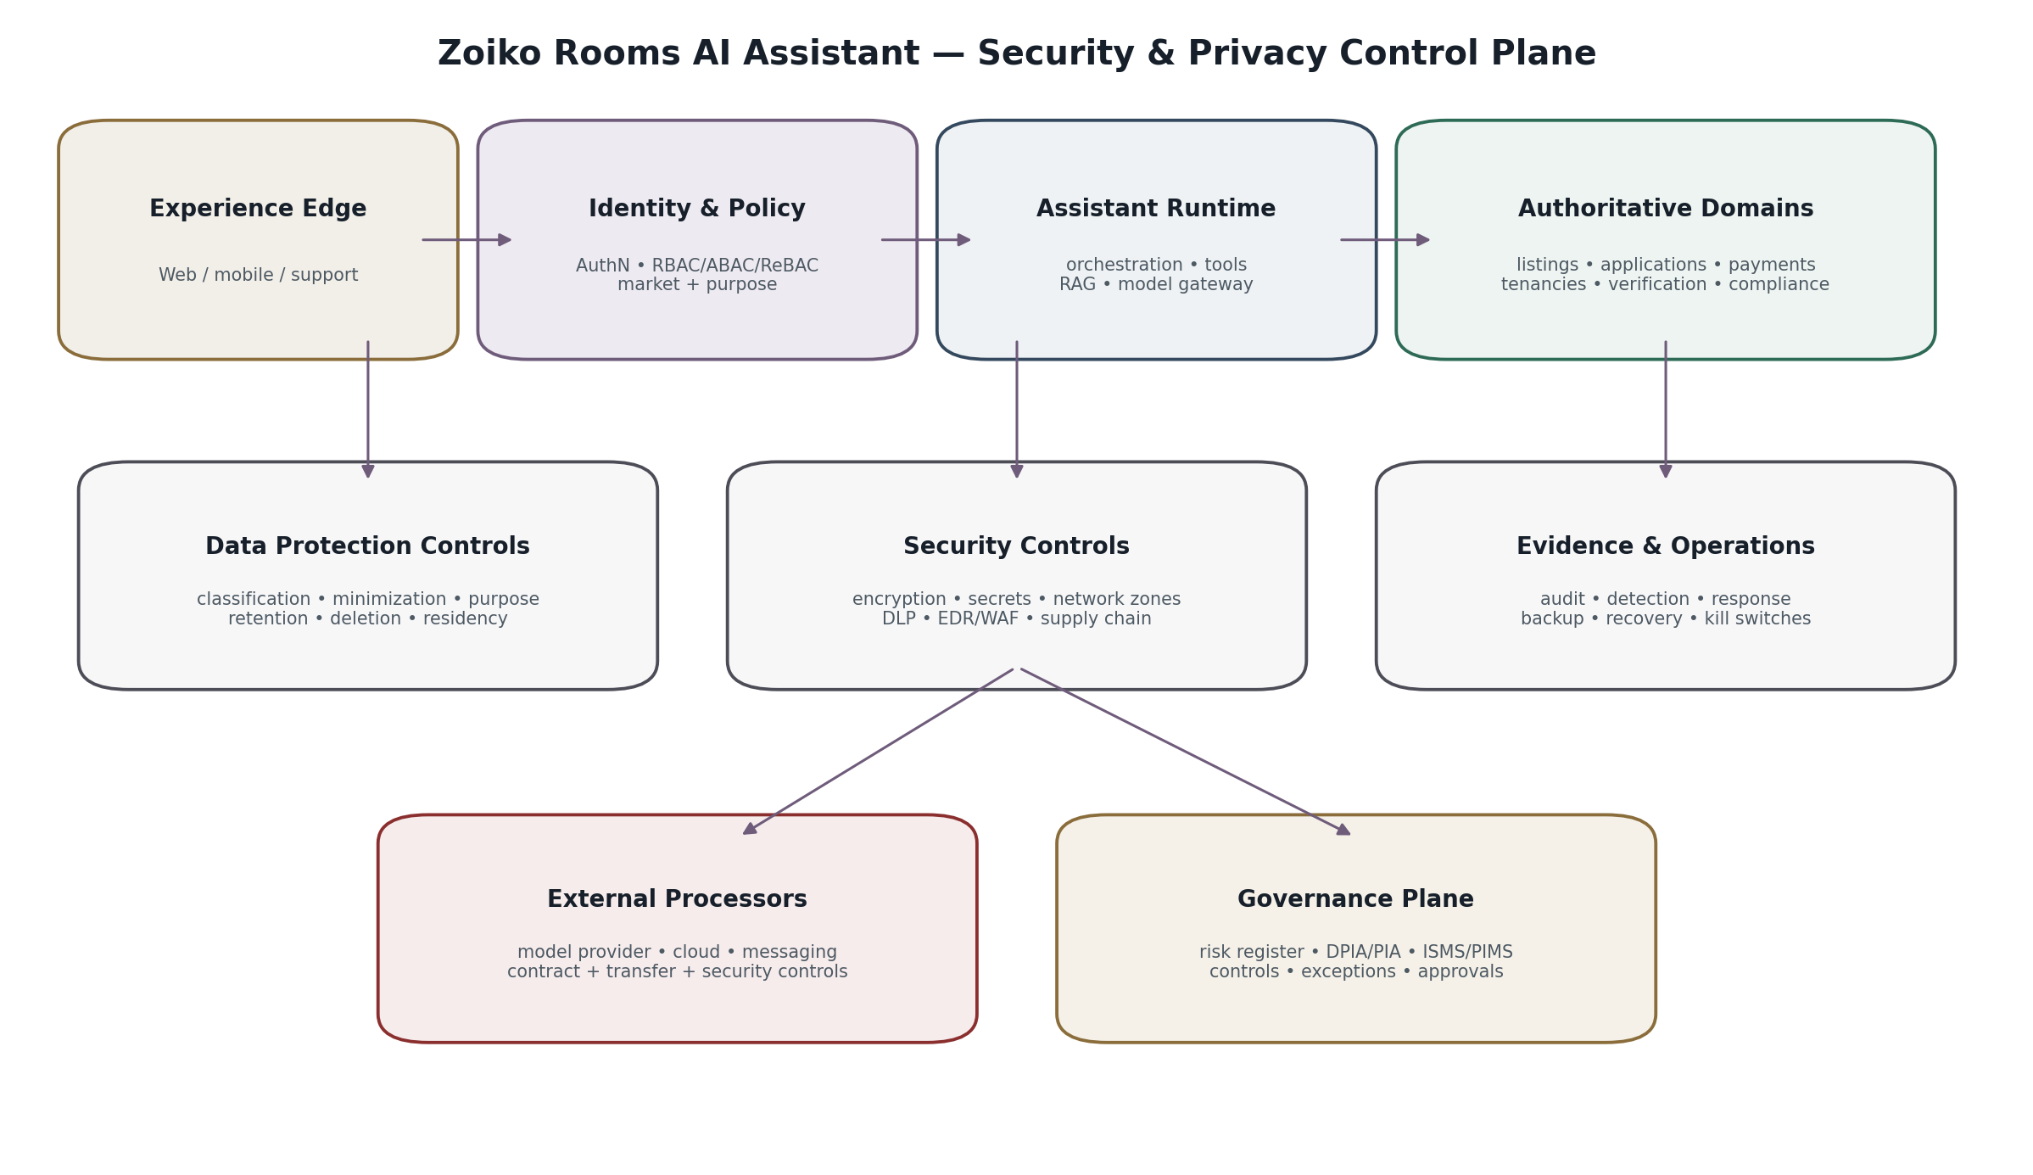
Figure 1 — Security & Privacy Control Plane

2. Security Objectives & Privacy Outcomes
Objective | Binding outcome
Confidentiality | Data is available only to authorized principals, services and processors for approved purposes.
Integrity | Prompts, policies, market packs, knowledge releases, actions, receipts and audit evidence are tamper-resistant and versioned.
Availability | Resilience preserves safe access without bypassing policy, residency or authoritative-truth constraints.
Authenticity | Human and workload identities are strongly authenticated and audience-bound.
Accountability | Security/privacy-relevant decisions and changes are reconstructable from evidence.
Data minimization | The Assistant processes the smallest sufficient data set for each task.
Purpose limitation | Data collected for one purpose is not silently reused for model training, marketing or unrelated analytics.
User control | Applicable access, deletion, correction, consent/choice and complaint workflows are supported through governed market policies.
Market correctness | Privacy/legal rules are selected from resolved jurisdiction/market context, not guessed from locale.

3. Threat Model & Trust Boundaries
Boundary / threat | Primary controls
Internet → Experience Edge | TLS, WAF/bot/rate controls, authentication, request validation, CSRF/origin protections where applicable.
Experience Edge → Assistant Runtime | Authenticated session, subject scope, schema validation, trace binding, least privilege.
Assistant Runtime → Model Provider | Egress allowlist, processor contract, data minimization, no-training terms, encryption, provider-specific isolation.
Assistant Runtime → RAG | Pre-retrieval authorization, market/access filters, release eligibility, injection-resistant context assembly.
Assistant Runtime → Domain APIs | Workload identity, typed API, object/property/function authorization, idempotency, fresh policy.
Staff → Protected Operations | SSO/MFA, purpose/case binding, JIT privilege, separation of duties, evidence.
Supply chain | Signed artifacts, SBOM, provenance, dependency scanning, secrets scanning, controlled CI/CD.
Insider / compromised account | Least privilege, anomaly detection, JIT, session revocation, DLP, evidence and periodic access review.
Prompt/tool abuse | Instruction hierarchy, typed tools, allowlists, action tiering, output validation, independent authorization.
Data exfiltration | DLP, content classification, egress controls, redaction, tool/result minimization, provider restrictions.

Critical distinction
Prompt injection is treated as an application-security input problem, not as a reason to grant the model more authority. Even a fully compromised model response must be unable to exceed deterministic tool, authorization, data and network boundaries.

4. Data Classification & Handling Standard
Tier | Examples | Handling
D0 Public | Published help, public listing content approved for public display | Public integrity controls; no customer scope required.
D1 Internal | Architecture metadata, non-sensitive operational configuration | Authenticated workforce/service access; no public exposure.
D2 Personal | Name, contact details, account identifiers, messages, preferences | Purpose-bound access, encryption, minimization, retention schedule.
D3 Sensitive Personal | Identity/verification data, precise payment-related personal data, protected dispute/support content | Strong access controls, enhanced logging restrictions, need-to-know, strict processor rules.
D4 Restricted | Secrets, credentials, security evidence, privileged legal/security material | Dedicated vault/restricted stores; never general RAG/model context.
D5 Authoritative Financial/Legal-State | Ledger facts, payout/payment state, compliance/verification outcomes, signed action receipts | Domain-authoritative only; no optimistic/model-derived mutation or display.

ID | Priority | Requirement | Verification
SEC-PRIV-FR-001 | P0 | Every data object or processing flow shall have a classification, owner, purpose, market scope and retention treatment. | Data inventory / schema / control review.

ID | Priority | Requirement | Verification
SEC-PRIV-FR-002 | P0 | D4 data shall not enter general model prompts, general RAG indexes or unrestricted telemetry. | DLP and negative integration tests.

5. Privacy-by-Design Data Lifecycle
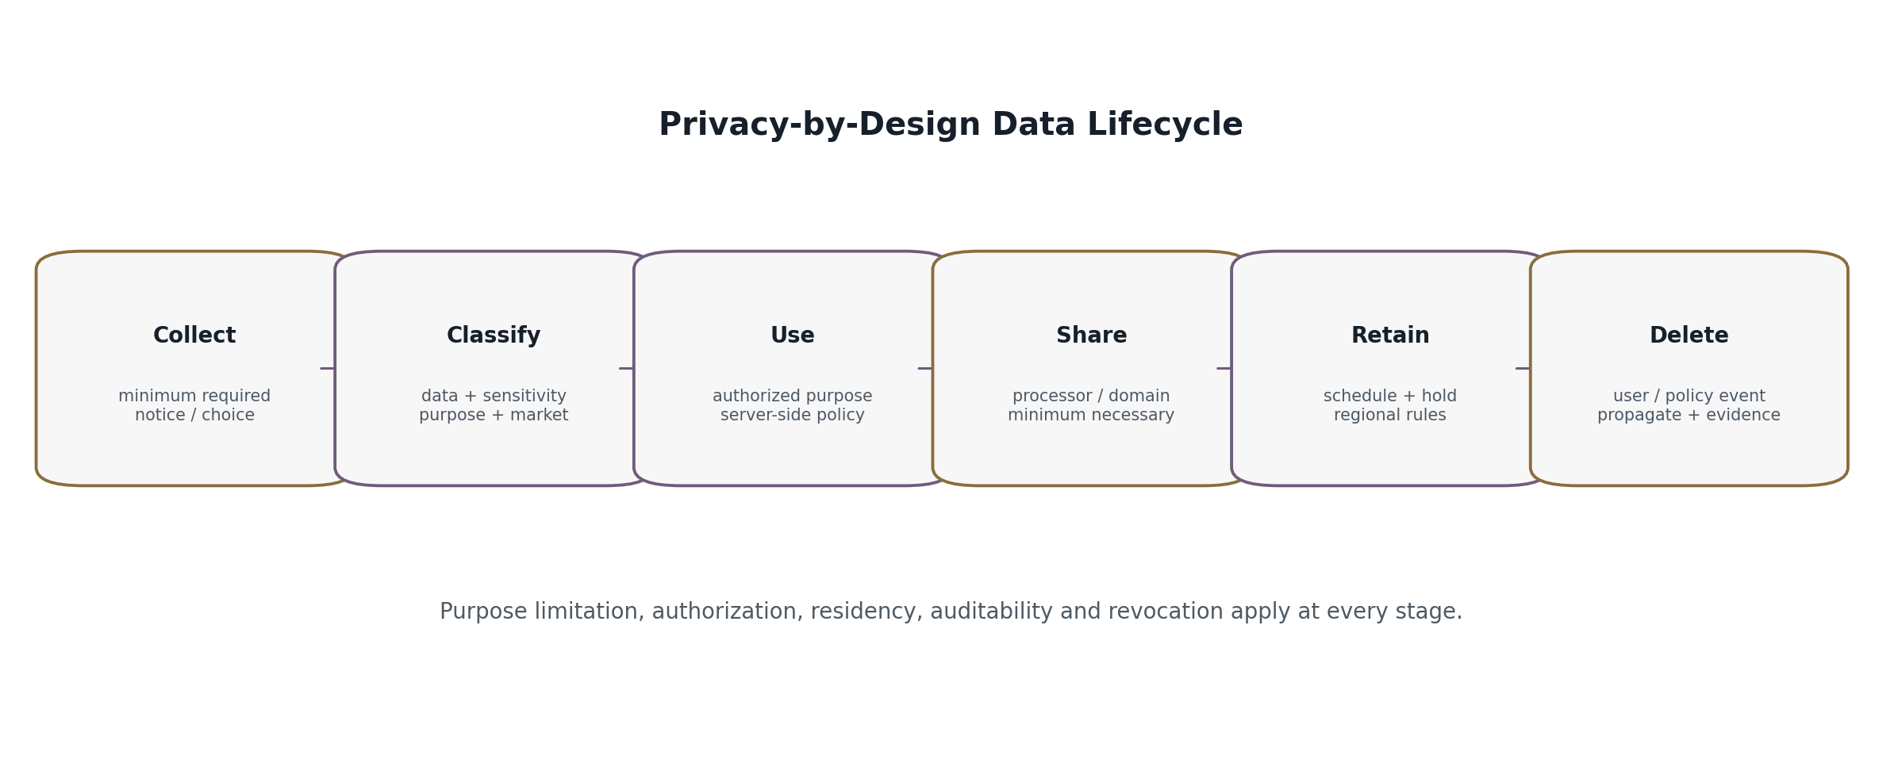
Figure 2 — Privacy-by-Design Data Lifecycle
Stage | Required controls
Collect | Purpose and necessity documented; minimum fields; user notice/choice where applicable; no speculative collection for future AI use.
Classify | Assign data tier, controller/processor role, market, purpose, retention, residency and sharing restrictions.
Use | Authorize principal/service/purpose; minimize context; bind processing to requested task.
Share | Use approved processor/domain path; minimum necessary payload; transfer/security requirements satisfied.
Retain | Apply versioned retention schedule and legal/security hold logic; avoid indefinite conversation/model logs.
Delete | Delete or irreversibly de-identify per policy; propagate to dependent stores/providers where contractually required; preserve lawful minimal evidence.

6. Processing Inventory & Purpose Registry
Processing family | Primary purpose | Typical data | Authoritative owner
Conversation | User assistance and task orchestration | Prompt text, bounded conversation state | Assistant Platform
Account explanation | Explain current Rooms state | Authorized domain payload + guidance | Domain service + Assistant
Knowledge retrieval | Answer governed guidance | Query, eligible chunks, provenance | Knowledge/AI Platform
Consequential action | Prepare/confirm/execute user-authorized operation | Action parameters, auth decision, receipt | Authoritative domain
Human handoff | Support/escalation | Minimum context manifest, case metadata | Support/Trust domain
Security telemetry | Detect, investigate and respond | Security events, identifiers, minimized diagnostics | Security/SRE
AI evaluation | Quality/safety assurance | Controlled samples, expected outputs, metadata | AI Evaluation
Product analytics | Measure product health | Event metadata designed to avoid unnecessary conversation content | Product Analytics

Purpose-control rule
Conversation data, support content or evaluation samples must not be repurposed for external model training, advertising, unrelated profiling or marketing merely because the data already exists. New purposes require explicit governance and, where applicable, user choice or other lawful basis.

7. Identity, Authentication & Session Security
Control | Specification
Customer authentication | Use platform identity service; phishing-resistant or stronger authentication options supported by platform policy; step-up for sensitive operations.
Staff authentication | Enterprise SSO + MFA; privileged roles require stronger assurance and JIT elevation.
Workload identity | Short-lived service credentials; explicit audience; no shared generic backend secrets.
Session binding | Session bound to principal, active subject/persona, device/risk context as supported, and policy version.
Scope switching | Invalidate protected caches/context and pending confirmations when renter/host or delegated scope changes.
Session expiry | Protected operations reauthenticate/step-up as policy requires; no silent indefinite sessions.
Token storage | No tokens in model prompt, RAG corpus, client logs or analytics payloads.
Revocation | Compromised sessions/tokens can be centrally revoked and propagated.

8. Authorization & Least Privilege
This specification inherits ZR-AI-AUTH-001 in full. Security/privacy controls must enforce authorization before protected data enters retrieval, model context, tool execution, staff views, exports or telemetry.
Decision dimension | Examples
Principal | Customer, staff, service identity.
Active subject scope | Renter, Host, organization/delegated scope.
Object | Listing, application, tenancy, payment, payout, verification, case.
Property | Permitted fields only; redact diagnostic/internal/sensitive properties.
Function | Read, prepare, confirm, execute, export, delete, administer.
Purpose | User request, support case, security incident, evaluation, compliance review.
Context | Market, locality, authentication assurance, risk, resource version, time.

ID | Priority | Requirement | Verification
SEC-PRIV-FR-003 | P0 | Authorization shall be enforced before any protected data is sent to an LLM or external processor. | Cross-principal/provider leakage tests.

9. Encryption, Key Management & Secrets
Area | Requirement
In transit | TLS for external and service-to-service traffic; certificate validation; modern protocol baseline controlled centrally.
At rest | Encryption for databases, object stores, indexes, backups and queues holding protected data.
Key management | Central KMS/HSM-backed key management; environment/region separation; controlled rotation; auditable use.
Application secrets | Secrets manager only; no secrets in source code, prompts, config repositories, tickets, logs or knowledge corpus.
Provider credentials | Dedicated workload/provider credentials with least privilege and rapid revocation.
Field protection | Additional envelope/field-level protection for designated D3/D4 elements where threat model requires.
Rotation | Key/secret rotation policy with emergency rotation playbook and dependency testing.
Cryptographic agility | Algorithms and parameters centrally governed so deprecated mechanisms can be replaced without redesigning product semantics.

10. Network, Egress & Runtime Isolation
Zone | Allowed communication
Public Edge | Only approved ingress to authenticated/public application endpoints.
Application Zone | Assistant/BFF to approved internal services through authenticated service mesh/API controls.
AI Runtime Zone | Model Gateway/RAG components; no direct database or payment-provider credentials.
Data Zone | Databases/indexes/object storage accessed only by designated services.
Privileged Ops Zone | Restricted administrative tooling; workforce JIT access.
External Processor Egress | Explicit provider endpoints only; deny-by-default egress; DNS/URL allowlisting where appropriate.

- No general outbound internet access from action execution workers.
- Model runtime must not initiate arbitrary network requests based on model text.
- Tool connectors are typed, pre-registered and policy-enforced.
- Administrative planes are separated from customer-serving runtime credentials.

11. AI / Model Provider Security & Privacy
Control | Provider requirement
Data use | Contractually prohibit training/improvement use of Zoiko Rooms customer content unless separately approved for a defined purpose.
Retention | Use minimum provider retention compatible with service/security needs; document unavoidable provider retention.
Subprocessors | Inventory and change control; assess security/privacy and transfer implications.
Region/residency | Route only to approved processing locations for the applicable market/data class.
Security assurance | Document provider certifications/controls, incident commitments, access controls and vulnerability management.
Isolation | Tenant/request isolation and no cross-customer data exposure.
Content filtering | Provider controls may supplement but never replace Zoiko Rooms policy/authorization.
Deletion | Provider-side deletion/expiry mechanisms included in data lifecycle and incident playbooks.
Fallback | Fallback provider must satisfy the same or stricter data/security constraints for that market/risk class.

Provider-neutral privacy rule
A provider change is a security/privacy change, not just a model-quality change. Production promotion requires processor, residency, retention, contract, threat-model and evaluation review before traffic moves.

12. RAG / Knowledge Security & Privacy
Risk | Control
Poisoned source | Governed source registry, quarantine, maker-checker release, provenance, anomaly detection.
Indirect prompt injection | Retrieved content treated as data; no instruction elevation; tool/action isolation.
Protected corpus leakage | Pre-retrieval authorization + market/access filters + post-retrieval validation.
Vector leakage | Partition/namespace controls; source sensitivity inherited by embeddings/indexes.
Revoked content | Logical eligibility gate overrides physical vector persistence.
Sensitive indexing | D3/D4 requires explicit approval; D4 excluded from general RAG.
Stale regulated guidance | Effective-date/freshness/market-pack enforcement and emergency revocation.

13. Prompt, Tool & Agentic Security
Control family | Binding rule
Instruction precedence | Platform safety/policy cannot be overridden by user or retrieved text.
Tool schemas | Strict typed schemas; reject extra/unexpected fields; canonicalize consequential parameters.
Tool allowlist | Model can propose only pre-authorized tools for current route/context.
A2 actions | Exact confirmation + fresh authorization + idempotency + authoritative receipt.
A3 actions | Human-controlled/prohibited; no autonomous execution.
Tool output | Untrusted data; sanitize/minimize before model reuse.
Loop/budget control | Bound tool calls, recursion, retries, tokens, time and cost.
Egress | Tools cannot become arbitrary HTTP/file/network executors.
Prompt secrecy | Do not expose private policy/security prompts or secrets; do not claim prompts are a security boundary.

14. Logging, Telemetry & DLP
Telemetry | Default treatment
Conversation content | Not logged into general observability by default; dedicated protected storage only where product requires conversation persistence.
Prompt/completion bodies | Off by default in platform telemetry; sampling requires approved purpose and access controls.
Retrieved chunks | Log IDs/scores/versions, not full content by default.
Domain payloads | Log references and outcomes; redact personal/financial values not required for diagnosis.
Auth decisions | Decision ID, policy version, subject/object/action and outcome; no secret policy internals.
Security events | Sufficient detail for detection/response with access-controlled security store.
Secrets/tokens | Never log.
DLP | Scan appropriate ingress/egress/log pipelines for secrets and high-risk data patterns; block/quarantine according to policy.

ID | Priority | Requirement | Verification
SEC-PRIV-FR-004 | P0 | General application logs shall not contain access tokens, passwords, API keys, full payment credentials or raw D4 material. | Automated log-content tests and DLP scans.

15. Retention, Deletion, Legal Holds & Backups
Data class / store | Retention control
Conversation history | Purpose/feature/market schedule; user deletion workflow where applicable; no indefinite default.
Action evidence | Retain according to transaction, dispute, security and market requirements; immutable evidence pointers where required.
Security logs | Security-defined retention with access controls and integrity protection.
AI evaluation samples | Short, purpose-bound, versioned dataset retention; expiry unless approved benchmark corpus.
RAG indexes/embeddings | Lifecycle tied to source eligibility and knowledge release.
Provider data | Contracted retention/expiry; include in deletion propagation.
Backups | Encrypted; access restricted; deletion handled through documented backup-expiry/restore re-deletion process.
Legal/security hold | Hold overrides normal deletion only for documented scope/purpose; release hold when basis ends.

16. Data Residency, Transfers & Regional Cells
Control | Requirement
Regional cell | Customer transactional/personal data processed/stored in approved region for market/contract constraints.
Control plane | Globally distributed configuration must exclude restricted transactional payloads unless explicitly permitted.
Cross-region failover | Not automatic when it would violate residency, authorization or market policy.
Model processing | Provider endpoint/region must be approved for relevant data class and market.
Support access | Cross-border workforce access is policy-controlled, purpose-bound and auditable.
Transfers | Required legal/contractual transfer mechanism and security assessment are represented as market policy, not product hard-code.
Unknown residency requirement | Fail to approved alternative/human workflow; do not silently route to another region.

17. Privacy Rights & User Controls
Control | Product/engineering behavior
Access / export | Authenticated, scope-limited export from authoritative stores; exclude other users, secrets and protected internal evidence.
Correction | Route to authoritative owning domain; Assistant must not rewrite authoritative records directly.
Deletion | Orchestrate governed deletion request with eligibility checks, holds and dependent-store propagation.
Consent / choice | Versioned, auditable state where consent/choice is required; withdrawal must affect future processing.
Objection / restriction | Market policy determines supported restriction and handling workflow.
Complaint / escalation | Human escalation path with evidence and privacy/security routing.
Clear conversation / activity | Where offered, accurately describe what is deleted versus retained for transaction/security/legal purposes.

Transparency rule
The UI must not imply “everything deleted” when transaction records, security evidence or legally required records remain. Privacy controls must describe actual system behavior, including relevant retention exceptions.

18. Market Adaptation & England Launch Profile
The security/privacy implementation is global-core first. Legal bases, notices, retention periods, transfer mechanisms, age/eligibility rules, consent requirements and individual-rights workflows are resolved through market policy packs and legal review. England is the launch profile only and must not become the implicit global privacy model.
Layer | Security/privacy responsibility
Global Core | Technical minimization, encryption, authorization, evidence, secure SDLC, processor controls and privacy lifecycle primitives.
Jurisdiction Adaptation Framework | Defines which privacy/security behaviours are market-variable and required fields for a certified pack.
Market Pack | Approved notice/lawful-purpose mapping, retention overrides, transfer/residency controls, rights workflows and legal contacts.
Locality / contract overlay | Additional contractual or local constraints where applicable.
England profile | Initial launch configuration; no automatic inheritance by other markets.

19. Secure SDLC & Supply Chain
Stage | Required controls
Design | Threat model, privacy impact screen, data-flow diagram, abuse cases, security/privacy acceptance criteria.
Code | Peer review, static analysis, secrets scanning, dependency controls, secure coding standard.
Build | Isolated CI, pinned dependencies where practical, signed artifacts, provenance, SBOM.
Test | Unit/integration/security/privacy/adversarial tests; authorization and DLP negative tests.
Release | Risk-based approvals, environment separation, canary, rollback, signed configuration.
Operate | Vulnerability monitoring, runtime detection, patching, access review, incident drills, dependency/model/provider reassessment.

Reference baseline
Secure development shall map to NIST SSDF and current OWASP ASVS verification requirements, supplemented by OWASP GenAI/LLM security requirements for AI-specific attack surfaces.

20. Vulnerability Management & Security Testing
Control | Requirement
Asset inventory | All Assistant services, endpoints, dependencies, models, providers, indexes and admin surfaces inventoried.
SAST/SCA/secrets | CI-enforced scans with severity-based release blocks.
DAST/API testing | Authenticated and unauthenticated coverage including BOLA/BFLA/property authorization.
AI red teaming | Prompt injection, indirect injection, tool misuse, exfiltration, poisoning, model manipulation and excessive agency.
Penetration testing | Independent risk-based testing before major launches and periodically thereafter.
Patch SLA | Severity/exploitability-based remediation objectives owned by Security; exceptions require documented risk acceptance.
Bug bounty / disclosure | Coordinated vulnerability disclosure process as platform maturity requires.
Regression | Every fixed P0/P1 vulnerability receives automated regression coverage where feasible.

21. Security / Privacy Incident Response
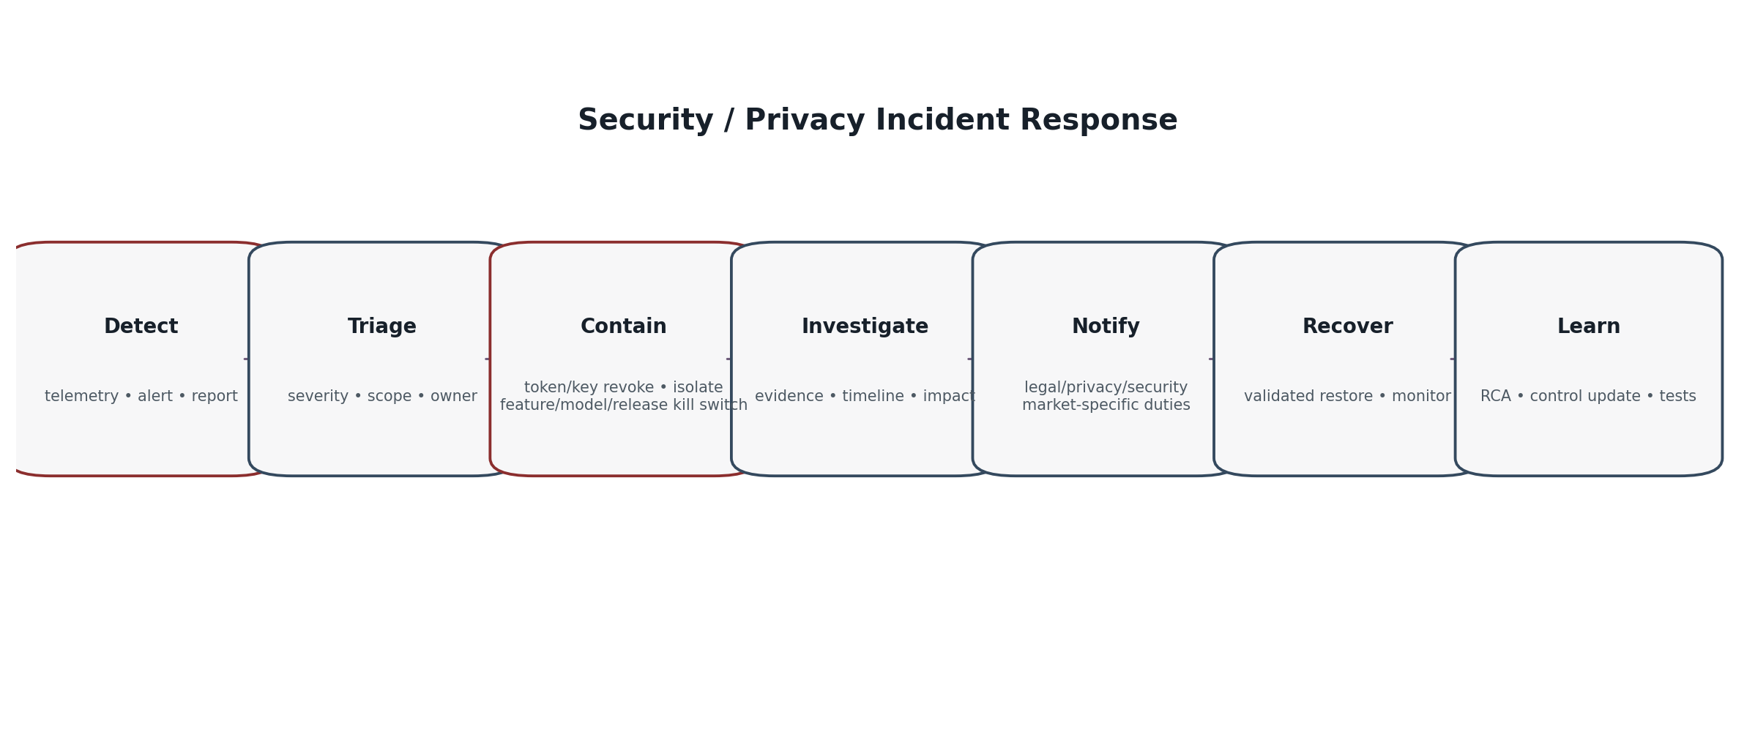
Figure 3 — Security / Privacy Incident Response
Capability | Requirement
Detection | Security and privacy signals route to staffed/on-call ownership according to severity.
Containment | Revoke tokens/keys, isolate service, disable provider/tool/model/knowledge release/market pack independently.
Investigation | Preserve evidence integrity and reconstruct identity, policy, data, model, tool and release versions.
Assessment | Determine affected data, principals, markets, processors, systems and risk/impact.
Notification | Legal/privacy/security teams determine customer/regulator/partner notices under applicable market obligations.
Recovery | Restore only after security validation; re-run privacy/security acceptance criteria for affected path.
RCA | Blameless technical root cause plus accountable control correction, tests and risk-register update.

22. Backup, Recovery & Business Continuity
Area | Requirement
Backups | Encrypted, access-controlled, integrity-checked and regionally compliant.
Restore tests | Periodic restoration tests include authorization, secrets, knowledge-release eligibility and privacy-deletion semantics.
RPO/RTO | Defined per data/service class; authoritative financial/evidence systems use stricter objectives than replaceable AI caches.
Model/RAG outage | System routes to safe degradation; never reconstructs protected truth from stale conversation.
Region failure | Failover only to approved region; otherwise controlled unavailability/handoff.
Evidence | DR events and restoration versions are auditable.

23. Operational Access, Privileged Administration & Insider Risk
Control | Requirement
JIT privilege | Privileged access is time-bound and approved.
Purpose binding | Support/security/privacy access tied to case, incident, change or other documented purpose.
Separation of duties | No single operator can unilaterally approve and deploy high-risk prompt/policy/market/security changes where maker-checker is required.
Session recording/evidence | Privileged actions produce appropriate audit evidence without exposing unnecessary customer content.
Break glass | Separate emergency path, strongly authenticated, short-lived, alerting-enabled and post-reviewed.
Access reviews | Periodic role, group, service-account and processor access review; stale access removed.
Data export | Restricted, purpose-bound, encrypted and monitored; bulk export requires enhanced approval.

24. Privacy / Security Impact Assessment Triggers
Trigger | Required review
New data category or sensitive field | Data classification + privacy/security assessment.
New model/provider/subprocessor | Security, privacy, contract, retention, transfer/residency and fallback review.
New market | Market privacy/security pack and legal validation.
New consequential action | Threat model, authorization, confirmation, evidence, fraud/abuse review.
Persistent memory / personalization | Purpose, user control, minimization, retention, inference and deletion assessment.
New analytics/evaluation use | Purpose compatibility, minimization, de-identification and access/retention assessment.
Cross-region processing | Residency/transfer, security and continuity assessment.
Material architecture change | Updated threat model and regression gates.

25. Security & Privacy Control Matrix
Domain | Minimum controls
Identity | MFA/step-up, workload identity, token audience, revocation.
Authorization | Deny-default, RBAC/ABAC/ReBAC, object/property/function/purpose enforcement.
Data | Classification, minimization, encryption, retention, deletion, DLP, residency.
AI/RAG | Provider controls, injection resistance, corpus governance, model routing, claim/citation validation.
Actions | A0–A3, exact A2 confirmation, fresh authorization, idempotency, authoritative receipt.
Infrastructure | Network segmentation, egress controls, secrets/KMS, hardening, patching.
SDLC | Threat/privacy design, SAST/SCA/DAST, SBOM/provenance, signed release, regression.
Operations | Monitoring, anomaly detection, incident response, DR, access review, kill switches.
Governance | Risk register, ISMS/PIMS mapping, policy exceptions, evidence, periodic review.

26. Release-Blocking Acceptance Gates
ID | Release-blocking criterion
SEC-PRIV-AC-001 | Protected data is denied by default without authenticated principal, valid subject scope and authorization.
SEC-PRIV-AC-002 | Cross-user, cross-host and cross-role object access is blocked.
SEC-PRIV-AC-003 | Sensitive properties are redacted even when parent object is readable.
SEC-PRIV-AC-004 | Access tokens, secrets and D4 content are absent from general logs and model prompts.
SEC-PRIV-AC-005 | External model/provider receives only approved minimum payload and approved region route.
SEC-PRIV-AC-006 | Provider fallback cannot bypass retention, residency, contract or security requirements.
SEC-PRIV-AC-007 | Indirect prompt injection cannot expand tool, authorization or network privileges.
SEC-PRIV-AC-008 | RAG retrieval cannot cross access-class or market boundary.
SEC-PRIV-AC-009 | D5 financial/compliance state is sourced only from authoritative domains.
SEC-PRIV-AC-010 | A2 execution requires valid exact confirmation and fresh authorization.
SEC-PRIV-AC-011 | Scope switch invalidates protected context/caches and stale confirmations.
SEC-PRIV-AC-012 | Deletion workflow propagates to Assistant-owned dependent stores and records lawful exceptions.
SEC-PRIV-AC-013 | Expired/revoked consent or choice state affects future processing where applicable.
SEC-PRIV-AC-014 | Region failover does not violate residency/market policy.
SEC-PRIV-AC-015 | Backup restore re-applies security, authorization and deletion requirements.
SEC-PRIV-AC-016 | DLP detects prohibited secret/token leakage in tested ingress/egress/log paths.
SEC-PRIV-AC-017 | Kill switches independently disable model, provider, tool/action, knowledge release and market pack.
SEC-PRIV-AC-018 | Security incident evidence can reconstruct principal, policy, model, release, tool and affected data path.
SEC-PRIV-AC-019 | Staff protected-data access requires role plus documented purpose/case and valid privilege window.
SEC-PRIV-AC-020 | Break-glass access alerts, expires and receives post-event review.
SEC-PRIV-AC-021 | CI blocks exposed secrets and critical/high-risk security failures per release policy.
SEC-PRIV-AC-022 | Signed production artifacts/configuration reject unauthorized or tampered promotion.
SEC-PRIV-AC-023 | Prompt/completion/retrieved-content telemetry logging is off by default and cannot be enabled without approved controls.
SEC-PRIV-AC-024 | Market privacy behavior is selected from certified policy, never inferred from locale.
SEC-PRIV-AC-025 | A model or prompt change cannot create new access to data or tools absent deterministic policy change.
SEC-PRIV-AC-026 | Security/privacy regression suite passes before model/provider/index/prompt/market-pack promotion.
SEC-PRIV-AC-027 | Vulnerability/penetration tests cover BOLA, property/function auth, injection, exfiltration and excessive agency.
SEC-PRIV-AC-028 | Privacy rights export excludes other principals, secrets and privileged internal evidence.
SEC-PRIV-AC-029 | Legal/security holds block deletion only for documented scope and release correctly when the hold ends.
SEC-PRIV-AC-030 | No private chain-of-thought is intentionally persisted or exposed through logs, exports, support or user interfaces.

27. Traceability to Approved Zoiko Rooms AI Documents
Upstream document | Security / privacy obligations inherited
Engineering Wireframe | AI is not system of record; authoritative domains remain protected truth.
PRD | Trust, transparency, global market architecture and correctly authorized actions.
FRS | Answerability, action tiers, failure/handoff and auditability.
API | Public/private boundary, auth, idempotency, typed errors and A2 execution semantics.
Database / ERD | Data ownership, retention holds, evidence pointers, no embeddings in transactional DB.
Knowledge Base | Source security, access classes, release/revocation and RAG eligibility.
UI/UX | Truthful provenance, privacy controls, sensitive UX and safe failure states.
Technical Architecture | Six planes, regional cells, network zones, evidence and resilience.
Prompt / Guardrails | Instruction hierarchy, injection resistance and no prompt-based authorization.
RBAC / Authorization | Principal/subject/purpose/object/property/function authorization.
AI / RAG | Protected retrieval, provider-neutral models, grounding/citation and telemetry minimization.

27.1 Downstream handoff
Remaining original-list document | Carry-forward
Conversation Flow | Consent/choice prompts where applicable, privacy disclosures, auth/step-up, safe degradation, handoff and incident/privacy escalation states.
AI Evaluation / Test Cases | SEC-PRIV-AC gates, red-team scenarios, privacy/data-leakage tests, provider/regional/deletion/rights tests.

28. Standards & Primary Reference Baseline
Reference | Use | Status/source
NIST CSF 2.0 | Enterprise cybersecurity risk outcomes: Govern, Identify, Protect, Detect, Respond, Recover. | NIST CSWP 29 (2024)
NIST SP 800-53 Release 5.2.0 | Security and privacy control catalogue for systems and organizations. | NIST CSRC (2025 release update)
NIST Privacy Framework | Privacy risk-management framework; current NIST program includes PF 1.1 development. | NIST Privacy Framework
NIST SP 800-218 / 800-218A | Secure Software Development Framework and GenAI/dual-use model community profile. | NIST CSRC
NIST SP 800-207 / 207A | Zero Trust and cloud-native application-level access control. | NIST CSRC
OWASP ASVS 5.0.0 | Application security verification requirements; version 5.0.0 released in 2025. | OWASP
OWASP GenAI LLM Top 10 2026 | Current LLM/GenAI application risk baseline. | OWASP GenAI
OWASP Agentic Top 10 2026 | Agentic system risks including goal/tool/identity/context abuse. | OWASP GenAI
OWASP LLMSVS v2.0 | Specific LLM security verification requirements/tests. | OWASP
ISO/IEC 27001:2022 | Information security management systems requirements. | ISO
ISO/IEC 27701:2025 | Privacy Information Management System requirements/guidance. | ISO

Jurisdiction note
This engineering specification is not a substitute for market-specific legal advice. Certified market packs must translate applicable privacy, communications, consumer, housing and data-transfer obligations into approved product policy before launch.

29. Critical Analysis & Refinement Decisions
Rejected pattern | Tier-1 decision
“The model provider is secure, so we are secure” | Independent Zoiko Rooms security/privacy enforcement before, during and after provider processing.
One global privacy configuration | Global core + certified market packs + regional data/processor routing.
Log everything for debugging | Metadata-first observability; content logging off by default.
Prompt rules as access control | Deterministic identity/authorization/data/network boundaries.
AI service gets broad domain credentials | Typed least-privilege service identities; no universal backend key.
Automatic cross-region failover | Failover only to policy-approved regions; otherwise safe unavailability.
Delete = remove primary row only | Lifecycle deletion propagation, provider handling, backups and lawful evidence exceptions.
Role-only staff access | Role + purpose/case + JIT + evidence + periodic review.
Same provider fallback everywhere | Fallback must meet market/data-class security/privacy contract.
Security scan at release only | Secure SDLC from design through runtime and continuous reassessment.
AI red team replaces app security | AI red team supplements ASVS/API/infra/identity/privacy testing; it does not replace them.

30. Formal Approval Gate
Production gate
No security/privacy-sensitive AI Assistant capability may enter production until its data flows, processors, authorization, market routing, retention/deletion, logging, incident response and release-blocking tests are approved and evidenced. Quality improvements do not override failed security or privacy gates.

Approver | Approval scope
Security | Threat model, controls, vulnerability testing, incident readiness.
Privacy / DPO-equivalent function | Processing inventory, minimization, rights, retention, provider/transfer/residency controls.
Platform / Architecture | Network, workload identity, regional cells, resilience and kill switches.
AI / ML | Model/RAG/tool security implementation and model/provider change controls.
Product | User transparency, privacy controls, safe degradation and support routes.
Compliance / Legal | Certified market-policy translation and launch conditions.
SRE | Telemetry, detection, backup/restore, operational access and response readiness.
QA / Security Testing | SEC-PRIV-AC-001 through SEC-PRIV-AC-030 evidence.

END OF DOCUMENT 12 — SECURITY / PRIVACY SPECIFICATION WIREFRAME

