AI Assistant

Technical Architecture Documentation
Global Core Specification | Jurisdiction-Aware | Transaction-Safe | AI/RAG-Ready
Field | Value
Document ID | ZR-AI-ARCH-001
Version | 1.0 - Build-Ready Architecture Standard
Date | 19 August 2026
Status | Approval Candidate - binding architecture after approval
Owner | Zoiko Rooms Product & Engineering
Audience | Architecture, Platform, AI, Backend, Frontend, SRE, Security, Privacy, QA, Data, Support
Upstream contracts | ZR-AI-ENG-WF-001; PRD; FRS; API; Database/ERD; Knowledge Base; UI/UX Figma
Next document after approval | Prompt Engineering / AI Guardrail Documentation

Architecture doctrine The AI Assistant interprets, explains, retrieves and orchestrates. It is never the system of record, never the legal/compliance decision-maker, and never permitted to bypass deterministic Zoiko Rooms authorization, policy, payment, verification or tenancy workflows.

This document is deliberately vendor-neutral at the core. Runtime classes and protocols are binding; a cloud, model provider, vector engine, message broker or policy implementation may change without changing the product trust contract, provided all acceptance gates remain satisfied.

Document Map
Section | Architecture decision
1-3 | Purpose, invariants, system context and six-plane reference architecture
4-6 | Component catalog, authority boundaries and runtime data flows
7-9 | A0-A3 action architecture, RAG and model gateway
10-12 | Identity/policy, persistence and event/workflow architecture
13-16 | Deployment, network zones, resilience, SLOs and capacity
17-20 | Observability, security, privacy and DevSecOps
21-24 | DR, environments, ADRs and release-blocking acceptance gates
25-28 | Traceability, critical refinement, standards baseline and approval gate

Normative Language
MUST / SHALL = binding P0 requirement. SHOULD = default architecture unless an approved ADR documents an equivalent or stronger control. MAY = optional implementation choice. "Authoritative" means the owning Zoiko Rooms domain service or evidence ledger, not the model, cache, embedding index or conversation transcript.

1. Purpose, Scope & Architecture Doctrine
This specification defines the production architecture for the Zoiko Rooms AI Assistant across authenticated web/mobile experiences and tightly bounded signed-out help surfaces. It transforms the approved functional/API/data/knowledge/UX contracts into deployable service boundaries, runtime flows and operational controls.

1.1 Required architecture outcomes
- One global Assistant architecture that adapts through jurisdiction/market packs instead of country-specific forks.
- Deterministic authority for identity, money, application/tenancy state, verification and compliance outcomes.
- Bounded AI agency: no model-selected privilege escalation, arbitrary tool execution or autonomous high-risk workflow completion.
- Evidence-ready operations: model, prompt, retrieval, policy, action and domain-receipt versions are correlatable without storing private chain-of-thought.
- Regional failure containment and graceful degradation without hallucinated fallback.
- Replaceable model and retrieval providers behind stable internal contracts.

1.2 Non-negotiable invariants
ID | Invariant | Enforcement
ARCH-I01 | Model runtime has no direct production database, payment processor, identity-directory or object-store write credentials. | Network policy + service identity + adapter-only access
ARCH-I02 | Live transaction truth is read from owning APIs; RAG is not a transaction database. | Orchestrator routing + response validator
ARCH-I03 | A2 actions use prepare -> explicit confirmation -> re-authorization -> execute -> authoritative receipt. | Action coordinator + policy PDP
ARCH-I04 | A3 actions remain deterministic workflow/human-controlled unless separately approved. | Tool registry deny-by-default
ARCH-I05 | Cross-account and cross-market context is denied by default. | Subject scope + tenant/market context envelope
ARCH-I06 | No private chain-of-thought persistence or telemetry. | Logging contract + DLP + code review
ARCH-I07 | Control-plane loss cannot silently grant broader capability. | Fail-closed policy cache and signed releases
ARCH-I08 | Unknown commit never becomes "success" in UI. | Receipt reconciliation state machine

2. System Context & Trust Boundaries

2.1 External actors and systems
Boundary | Examples | Trust posture
User edge | Renter, Host, Dual-role user, signed-out visitor | Untrusted input; authenticated identity is necessary but not sufficient for authorization
Zoiko Rooms authoritative domains | Identity/Tenancy, Listings, Applications, Viewings, Tenancies/Stays, Messages, Payments/Payouts, Verification, Compliance | Trusted only through authenticated, typed APIs; resource-level authorization still required
Knowledge platform | Approved KB releases, jurisdiction packs, locality overlays | Trusted only when release is active, signed/versioned and policy-eligible
Model providers | Primary/secondary LLM endpoints | External processor/service dependency; no authority; bounded data contract
Observability/security services | OTel collectors, SIEM, alerting, audit/evidence | Privileged operational plane; privacy-minimized telemetry
Human support | Authorized Zoiko Rooms support/operations | Least privilege; handoff context is explicit and audited

2.2 Data classes crossing the Assistant
Class | Examples | Architecture rule
Public | Published help, public listing facts | May enter prompt context when applicable
Account-confidential | Application status, tenancy reference, user messages | Use minimum fields; subject-bound; never cross principal boundary
Financial-sensitive | Payment/payout amounts, ledger status | Authoritative API only; no optimistic UI; telemetry redacted
Compliance-sensitive | Verification/compliance status, supporting evidence metadata | Outcome from deterministic service; AI may explain but not decide
Restricted operations | Staff SOPs, fraud/security controls, secrets | Never retrieved into customer context; separate access class and index
Secrets/credentials | API keys, tokens, private keys | Never stored in prompts, KB, logs or user-visible errors

3. Six-Plane Reference Architecture
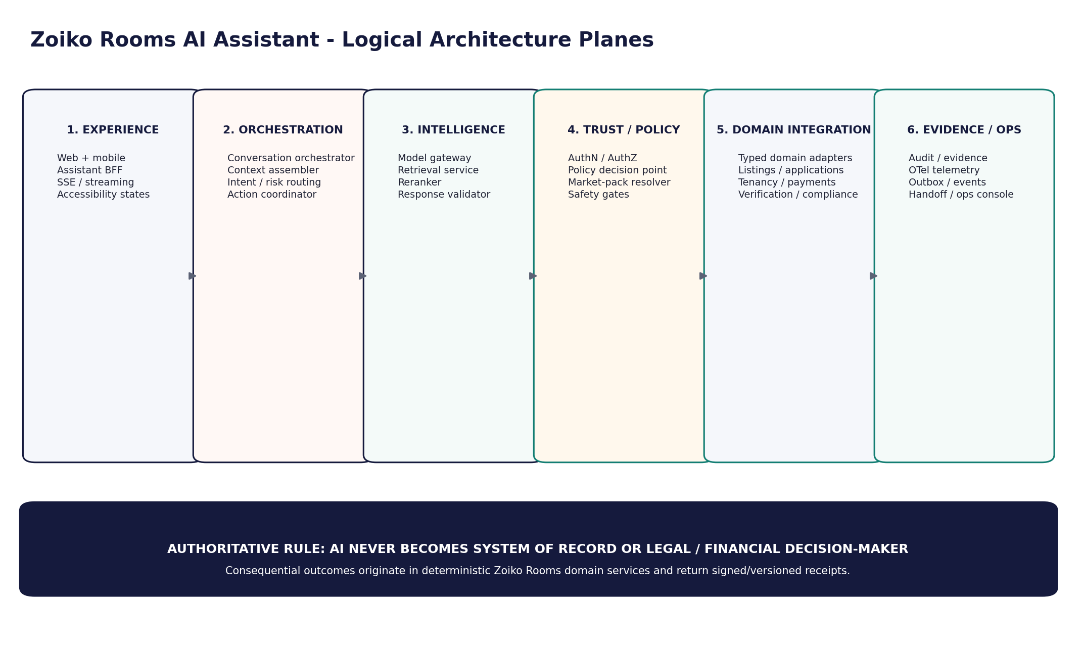
Figure 1. Logical architecture planes

3.1 Plane responsibilities
Plane | Owns | Must not own
Experience | Assistant shell, state rendering, accessibility, user confirmation UI | Authorization policy, account truth, action success determination
Orchestration | Conversation lifecycle, context assembly, routing, action coordination | Domain records, open-ended autonomous goals
Intelligence | Model routing, retrieval, reranking, response validation | Privileges, authoritative decisions, raw secret access
Trust / Policy | Identity context, authorization decisions, market-pack eligibility, safety gates | User-facing business state
Domain Integration | Typed read/action adapters to authoritative services | General-purpose arbitrary execution
Evidence / Operations | Audit pointers, telemetry, handoff, ops controls | Private chain-of-thought or unredacted conversational payloads by default

4. Component Architecture Catalog
Component | Responsibility | State | Scale / failure rule
Edge / WAF / API Gateway | TLS termination, abuse controls, request limits, routing | Stateless | Multi-AZ; reject malformed/oversized traffic before Assistant runtime
Assistant BFF | Client session facade, SSE, API contract enforcement | Stateless + short-lived connection state | Horizontally scalable; no domain authority
Conversation Orchestrator | Turn lifecycle, planner-free bounded routing, dependency coordination | Stateless with persisted session refs | Fail closed on missing policy/context
Context Assembler | Build server-authoritative context envelope | Ephemeral | Never trust client-supplied role/tenant/market as authoritative
Intent / Risk Router | Classify question/action family and A0-A3 risk | Ephemeral | Deterministic rules override model classification
Policy Decision Point | Evaluate principal/resource/action/context and market constraints | Policy cache + signed bundles | Deny on stale/unknown mandatory policy
Authorization Adapter | Resolve identity claims, roles, object permissions | Ephemeral/cache | No authorization inferred from conversation text
Knowledge Retriever | Policy-filtered hybrid search against approved releases | Dedicated retrieval index | No live transaction truth
Reranker / Citation Builder | Rank eligible chunks and bind provenance | Ephemeral | Cannot add source not returned by retrieval
Model Gateway | Provider abstraction, routing, budgets, redaction, retries | Config + provider health | No domain credentials; output treated as untrusted until validated
Response Validator | Grounding, citation, policy, UI-state validation | Ephemeral | Converts unsupported answer to clarification/abstain/handoff
Tool / Action Broker | Allowlisted typed actions; risk enforcement | Registry/config | No dynamic code, shell, SQL or arbitrary URL execution
Action Coordinator | Prepare/confirm/execute state machine | Assistant DB | A2 confirmation single-use and exact-parameter-bound
Domain Adapters | Typed APIs for listings, applications, money, compliance, etc. | Stateless | Use service identity; narrow scopes; idempotent writes
Event Publisher / Outbox | Reliable event emission after state changes | Durable outbox | At-least-once delivery; consumers idempotent
Handoff Service | Package user-approved context for human support | Durable metadata + secure content refs | Minimum necessary; access logged
Evidence Adapter | Append evidence pointers / tamper-evident records | Durable downstream | No silent audit loss for consequential actions
OTel Collector | Receive/scrub/export traces, metrics, logs | Buffered | Telemetry failure cannot expose raw sensitive payloads
Ops Control Service | Kill switches, provider disable, release rollback | Privileged control plane | MFA/step-up + change audit

5. Authority & Integration Boundaries

5.1 Authoritative service map
Domain | Authoritative capability used by Assistant | Assistant behavior
Identity / Tenancy | Principal, account, role, tenant/organization, authentication assurance | Reference only; never synthesize roles
Listings | Listing facts, availability attributes, host-owned configuration | Read through adapter; writes only approved typed actions
Applications | Application state, required next steps, decision status | Explain current state; never approve/reject
Viewings | Slots, booking state, cancellation rules | May coordinate bounded actions if policy allows
Bookings / Tenancies / Stays | Authoritative contract/stay state and dates | Display current state; no AI-generated legal status
Messages | Conversation/message metadata and allowed send actions | No impersonation; explicit sender context
Payments | Ledger-derived balance, charges, receipts, refunds | Read authoritative only; no fabricated balance or optimistic success
Payouts | Payout status, destination state, hold/release state | Host-scoped; bank-detail changes outside AI launch scope
Verification | Verification status and approved next-step codes | Explain output; no independent identity determination
Compliance | Market-specific requirement state and evidence status | Deterministic outcome; AI may explain approved guidance

5.2 Integration contract
- Typed adapters. Each domain call uses a versioned schema and explicit operation, not a generic REST proxy or model-authored URL.
- Least privilege. Each adapter receives only the service scopes required for its domain and environment.
- Context binding. Principal, subject/tenant, market, resource ID, trace ID and request purpose are propagated independently of model text.
- Concurrency. Mutable resources use resource versions/ETags where supported; stale state requires re-prepare.
- Errors. Domain errors map to stable Assistant error classes; the model never rewrites denial as success.
- Receipts. Consequential writes return an authoritative receipt or remain pending/unknown; no local success inference.

6. Runtime Request & Response Flows

6.1 A0 informational answer
- Edge validates request, identity/session context and abuse limits.
- BFF creates correlation identifiers and forwards a bounded request envelope.
- Orchestrator resolves market/role/context and classifies the request.
- Router selects approved knowledge retrieval or static product response.
- Retriever applies access, market, release, time and source-trust filters before search/rerank.
- Model Gateway receives only minimum eligible context; Response Validator checks support and citations.
- Client renders Guidance with provenance, or clarification/abstention if support is insufficient.

6.2 A1 live-account answer
- Authorization is evaluated against the requested resource before any domain fetch.
- Owning domain service returns authoritative data plus resource/version metadata.
- Model may explain the structured result but cannot change status or infer missing business state.
- Client labels the response as Account Data; money/status remains exactly bound to authoritative payload values.

6.3 Mixed answer
When a response combines account truth with guidance, the orchestrator keeps the two evidence channels separate. The final answer must preserve source type per claim: live account fact from the authoritative API; explanatory guidance from an approved knowledge release. If either channel is unavailable, the answer degrades explicitly rather than filling gaps generatively.

7. A0-A3 Action Architecture
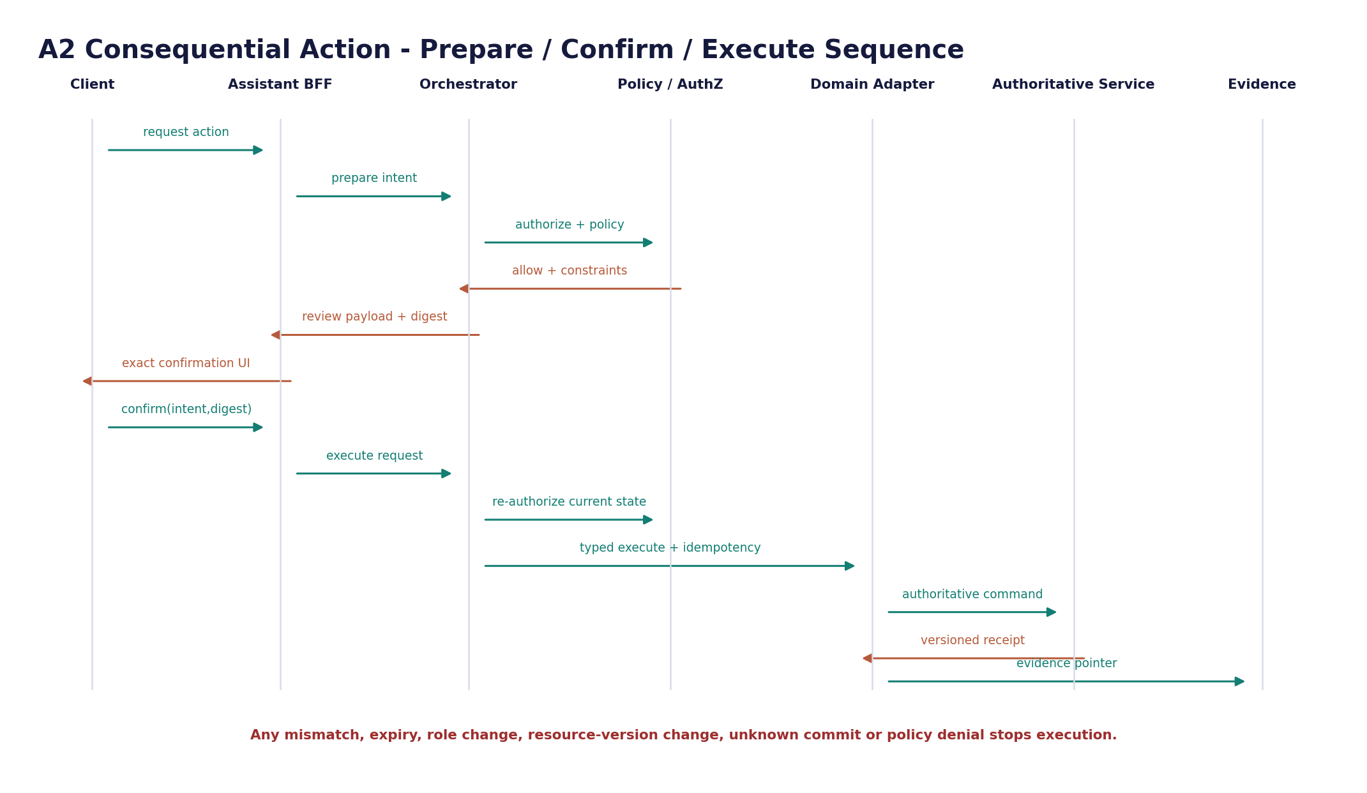
Figure 2. A2 prepare-confirm-execute sequence
Tier | Architecture treatment | Examples
A0 - Inform | No side effect. Retrieval or read-only explanation. | FAQ, policy explanation
A1 - Assist | Read-only account operation or reversible preparation. | Check status, prefill/view available choices
A2 - Confirmed action | Prepare exact payload; user confirms; re-authorize; idempotent execute; receipt. | Book/cancel where product policy classifies as A2
A3 - Restricted | Assistant may explain or route to deterministic workflow/human; no autonomous completion. | High-risk money, legal/compliance determinations, sensitive account/security changes

7.1 A2 confirmation binding
Binding field | Requirement
principal_id | Same authenticated principal at prepare, confirm and execute
subject_scope | Same renter/host/organization context
action_type | Exact allowlisted operation
canonical_parameter_hash | Cryptographic digest of normalized parameters shown to the user
resource_version | Version/ETag observed during prepare; mismatch forces new review
market_policy_version | Policy/market pack used to approve the action
expires_at | Short-lived confirmation window
nonce / confirmation_id | Single-use; replay rejected
idempotency_key | Stable per intended execution; safe retry semantics

8. RAG & Knowledge Runtime Architecture

8.1 Retrieval pipeline
Stage | Required architecture behavior
Query construction | Create minimal retrieval query from user question + resolved context; do not leak unrelated account data into search
Eligibility filter | Filter by corpus access class, market/jurisdiction, locality, language, effective date, release state and principal entitlement before ranking
Hybrid search | Use lexical + vector retrieval where supported; no raw embedding decisions bypass metadata policy
Reranking | Rerank only eligible candidates; retain source/chunk/version identity
Context packing | Deduplicate, order by authority/relevance, enforce token budget and preserve citation anchors
Generation | Treat retrieved text as untrusted data, not instructions; tool access is independently policy-controlled
Validation | Claim support, citation integrity, market applicability and answerability checks
Outcome | Answer, partial answer, clarification, human review or abstention - never unsupported completion

8.2 RAG prohibitions
- No transaction status, financial balance or account entitlement sourced from embeddings.
- No customer retrieval over staff-only or restricted security/SOP corpora.
- No ingestion-time trust of document instructions; source content is data.
- No retrieval from superseded/revoked releases after revocation propagation deadline.
- No cross-market fallback for regulated guidance unless an explicit global-core article is approved for both markets.
- No citation generated from model memory or from a source not present in the retrieval result.

9. Model Gateway & Inference Architecture

9.1 Gateway contract
Capability | Architecture rule
Provider abstraction | Providers are selected by policy/config, not by user prompt or model self-selection
Model routing | Route by capability, risk tier, language, context size, latency/cost budget and approved market availability
Provider failover | Failover only to pre-approved models with equivalent data-processing and safety controls
Prompt registry | Use version-addressable templates; actual prompt/guardrail content belongs to the next specification
Data minimization | Redact/exclude fields not necessary for the turn; never send service credentials
Output contract | Prefer structured outputs for routing/tool schemas; reject schema-invalid output
Timeouts / budgets | Per-call deadline, token ceiling, retry ceiling and total turn budget
Safety | Provider safety controls supplement, never replace, Zoiko Rooms policy enforcement
Logging | Record model/provider/template version, token counts and outcome metadata; not private chain-of-thought

9.2 Provider portability
The internal Model Gateway contract SHALL prevent business logic from depending on provider-specific SDK objects. Provider-specific adapters translate standardized message/tool schemas, safety metadata, streaming events and usage accounting into the internal contract. Model replacement must not require client or domain-service changes.

10. Identity, Authorization & Policy Architecture

10.1 Context envelope
Field family | Source of truth | Rule
Principal | Identity service/session token | Server resolved; never taken from conversational text
Role / mode | Authorization service | Renter/Host/Dual role switch does not grant permissions
Subject / tenant | Identity + object ownership/membership | Required on every account-scoped request
Market / jurisdiction | Transaction/property context + approved resolver | User locale is not legal jurisdiction
Assurance | Authentication context | Step-up may be required for sensitive operations
Resource version | Owning domain service | Used for stale-state control
Purpose / action | Orchestrator + action registry | Explicit operation; no generic execute privilege

10.2 Policy enforcement points
- At edge/BFF for endpoint/session eligibility and coarse abuse controls.
- Before retrieval for corpus/access/market eligibility.
- Before every authoritative domain read for object-level access.
- At action prepare for whether the action can be offered.
- Immediately before execute for current identity, role, resource version, policy and risk constraints.
- Before handoff/export/delete operations for scope and data-minimization rules.
Zero Trust rule Network location, previous conversation turns, prior successful actions, model confidence and cached UI state never establish authorization. Access is evaluated for the concrete principal, resource, operation and current context.

11. Data, Persistence & Cache Architecture
Store | Permitted contents | Prohibited contents / rule
Assistant PostgreSQL | Conversation metadata, bounded messages, context refs, policy/model metadata, action-intent state, handoff/feedback/evidence pointers | No authoritative money/compliance/listing copies; no embeddings; no secrets; no private chain-of-thought
Dedicated retrieval index | Approved knowledge chunks/embeddings + access/market/release metadata | No live transaction truth; no staff/customer index mixing without explicit isolation controls
Encrypted object store | Approved large payloads/attachments where required by product flows | Use short-lived signed access; malware/DLP screening; not model-direct
Distributed cache | Short-lived policy, session, feature and domain read caches where semantically safe | No cache may override authoritative consistency requirement; money defaults no optimistic cache
Evidence ledger | Tamper-evident records/pointers for consequential actions and critical governance changes | Append-only semantics; Assistant cannot rewrite history
Telemetry backend | Redacted traces, metrics, logs, security events | No unrestricted transcript logging by default

11.1 Consistency classes
Class | Use | Examples
C0 - Authoritative-now | Must read current owning service; no stale success. | Payment balance, A2 execution preconditions, compliance outcome
C1 - Bounded stale | Short TTL accepted if product semantics allow; source/version shown internally. | Public listing metadata, non-sensitive preferences
C2 - Eventual | Operational analytics or non-user-visible projections. | Usage metrics, aggregate reporting

12. Eventing, Workflow & Delivery Semantics
Pattern | Rule
Transactional outbox | Assistant state transition and event publication commit atomically where events represent durable state
At-least-once delivery | Consumers MUST be idempotent; event IDs and semantic dedupe keys required
Ordering | Guarantee only within documented aggregate/partition scope; never infer global ordering
Dead-letter handling | Quarantine poison messages; alert by severity; controlled replay with audit
Schema evolution | Backward-compatible event schemas by default; breaking changes require versioned topic/type or migration
Long-running operations | Represent as explicit pending/running/succeeded/failed/unknown states; do not hold request threads indefinitely
Unknown commit | Reconcile against authoritative receipt/status endpoint before retrying write

13. Global Deployment Topology
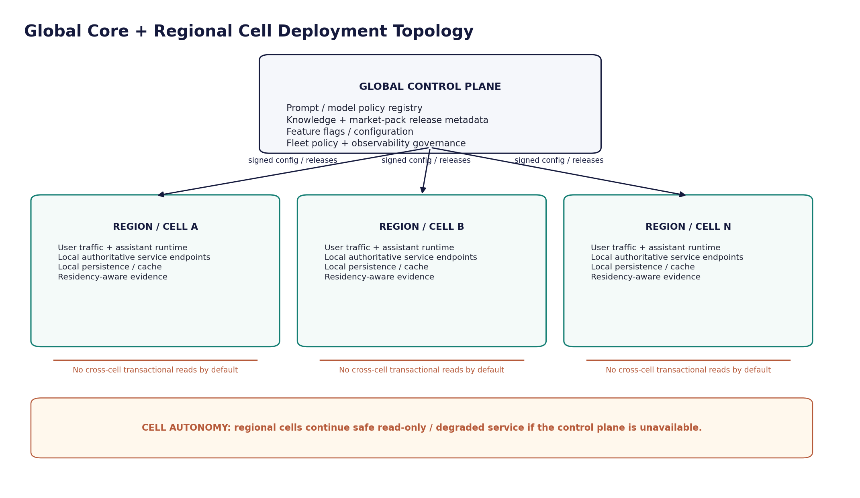
Figure 3. Global control plane and regional cell topology

13.1 Cell doctrine
Control | Requirement
Cell routing | User/account/property context resolves to a home cell; cross-cell reads are exceptional and policy-governed
Data locality | Account conversations and operational persistence remain in their assigned data region unless an approved data-transfer rule applies
Control-plane dependency | Cells cache signed last-known-good configuration; loss of control plane never broadens permissions
Blast radius | Provider, retrieval, cache or domain failures are contained per cell where possible
Global rollouts | Progressive/canary by cell and market; rollback independently available
Market packs | Signed version selected by transaction/property context; deployment code does not embed England-specific branches

13.2 Reference runtime
Preferred runtime class: containerized stateless services on a Kubernetes-compatible orchestration layer, backed by managed or equivalently hardened stateful services. Kubernetes-specific objects are implementation mechanisms rather than product semantics; health probes, disruption budgets, autoscaling and network policies SHALL be configured where Kubernetes is used.

14. Network & Security Zones
Zone | Permitted communication | Default denial
Z0 Internet/Client | HTTPS to edge only | No direct service/database/model-provider access
Z1 Edge/BFF | BFF to approved internal APIs and orchestrator | No database credentials; no unrestricted egress
Z2 Assistant Runtime | Orchestrator to PDP, Model Gateway, Retrieval, typed adapters | No direct payment/DB/object-store writes
Z3 AI / Retrieval | Model provider and retrieval backends through controlled egress | No domain-service credentials; no lateral customer-data browsing
Z4 Domain / Data | Typed adapter calls to authoritative services and Assistant stores | No inbound model-provider connectivity
Z5 Privileged Ops | Deployment, secret/key, rollback and security operations | No general employee access; step-up + audited sessions

14.1 Service-to-service security
- Workload identity or short-lived service credentials; no long-lived shared secrets in application images.
- mTLS or equivalently authenticated service transport for sensitive east-west traffic.
- Explicit egress allowlists for model providers, approved external dependencies and telemetry exporters.
- NetworkPolicies or equivalent segmentation to prevent model/runtime pods from reaching databases or privileged control endpoints directly.
- Secret material resolved at runtime from an approved secrets manager backed by KMS/HSM controls.

15. Resilience, Degradation & Failure Architecture

15.1 Dependency degradation matrix
Dependency unavailable | Permitted behavior | Forbidden behavior
Model provider | Retry within budget; failover to pre-approved equivalent; otherwise deterministic error/handoff | Send to unapproved provider or claim completion
Knowledge retrieval | Answer only from authoritative live data/static deterministic response if sufficient; otherwise abstain | Use stale/revoked corpus or web search in regulated flow
Policy decision service | Use signed non-expired policy cache only where explicitly allowed; otherwise deny/degrade | Assume allow
Authoritative domain API | Show unavailable/pending state; safe retry for reads | Infer status from transcript/cache when C0 required
Evidence service | For A2, fail or queue only if policy explicitly permits durable local evidence handoff | Execute critical action with untraceable audit gap
Control plane | Continue on last-known-good signed config within TTL | Fetch unsigned config or broaden capabilities
Telemetry backend | Buffer/drop according to data class and backpressure policy | Block critical user flow indefinitely or log sensitive fallback payloads

15.2 Reliability patterns
- Per-dependency deadlines, bounded retries with jitter, circuit breakers and bulkheads.
- No retry of non-idempotent writes without an idempotency key and authoritative reconciliation strategy.
- Backpressure at BFF/orchestrator before memory/queue exhaustion; explicit 429/503 behavior.
- Readiness checks depend only on dependencies required for safe traffic; liveness checks detect deadlock without restart loops.
- Pod/instance disruption budgets and multi-zone replicas for stateless P0 services where orchestration supports them.

16. SLOs, Capacity & Performance Budgets
Values below are launch engineering targets and SHALL be validated with production-like load tests before GA. They are not substitutes for business SLAs.
Metric | P0 target / budget | Measurement
Assistant API availability | >= 99.95% monthly excluding approved maintenance | Edge/BFF successful request SLI
Read-only account answer p95 | <= 2.5 s to first useful token when dependencies healthy | End-to-end distributed trace
Guidance answer p95 | <= 3.5 s to first useful token | Retrieval + model trace
A2 prepare p95 | <= 2.5 s | Prepare endpoint
A2 execute acknowledgment p95 | <= 2.0 s or explicit pending state | Execute endpoint to receipt/pending
Policy decision p99 | <= 100 ms in-region | PDP span
Retrieval p95 | <= 700 ms before generation | Retriever span
Error budget | Release/change gating tied to P0 burn rate | SRE dashboard
Queue saturation | Alert before user-impact threshold; autoscale on depth/age | Queue telemetry
Token/context budget | Per-intent ceilings; hard cap per turn and conversation | Model Gateway usage metrics

16.1 Capacity model
- Scale BFF and orchestration on concurrent connections, CPU, queue age and request rate rather than CPU alone.
- Scale retrieval separately from model traffic; model concurrency is governed by provider quotas plus local admission control.
- Reserve capacity for authentication/policy/domain reads so generation spikes cannot starve authorization or transactional operations.
- Load tests must include streaming connections, long context, multilingual queries, dependency latency, provider rate limits and A2 confirmation bursts.

17. Observability & Operational Telemetry

17.1 OpenTelemetry contract
The reference telemetry plane SHALL use OpenTelemetry-compatible traces, metrics and logs with W3C trace context propagation. At the document date, the official OpenTelemetry Specification is 1.59.0 and OTLP is 1.11.0; implementations may advance versions under compatibility testing.
Signal | Required dimensions | Privacy rule
Trace | trace_id, request_id, session_id pseudonym, component, operation, market, risk tier, model/provider version, KB release, policy version | No raw prompt/response by default; sensitive attributes prohibited
Metric | latency, availability, error class, queue depth, token use, provider throttling, retrieval outcome, abstention/handoff rate | Aggregate; no user text
Log | security decision, state transition, dependency error, deployment/release metadata | Structured, redacted, bounded retention
Audit/evidence | principal, action, resource ref, policy/version, confirmation digest, receipt/evidence pointer | Immutable/tamper-evident path for consequential actions

17.2 Correlation requirements
- One trace context spans edge -> BFF -> orchestrator -> policy/retrieval/model/domain adapter as technically feasible.
- Model invocation, retrieval run, policy decision and action intent IDs are stored as references to support incident reconstruction.
- Telemetry sampling never drops required security/audit evidence; audit is a separate durability class from observability sampling.
- Dashboards separate dependency failure, product abstention and safety denial so quality degradation is not mistaken for infrastructure outage.

18. AI / Application Security Architecture
Threat | Architecture control
Prompt injection / indirect injection | Retrieved/user content is untrusted data; tool permissions independent; instruction hierarchy enforced in gateway/validator; suspicious content can be excluded/flagged
Excessive agency / tool misuse | Allowlist; typed schemas; risk tiers; prepare-confirm-execute; no arbitrary URL/shell/SQL tools
Memory/context poisoning | Bounded server-owned context; no cross-account memory; persisted context is typed and provenance-aware
Sensitive data disclosure | Minimized prompt payloads; DLP/redaction; provider allowlist; output validator; restricted corpora isolation
Broken authorization | PDP before retrieval/domain read/action; object-level checks; re-authorization on execute
Supply-chain compromise | Signed builds, provenance, SBOM, dependency scanning, image signing and admission policy
Model/provider compromise | Provider abstraction, egress isolation, no domain credentials, kill switch, secondary provider
RAG poisoning | Quarantine/approval/signed releases; source trust; release rollback/revocation
Denial / resource exhaustion | Rate limits, token budgets, concurrency admission, queue bounds, circuit breakers
Audit evasion | Correlation IDs, durable action state, authoritative receipts and evidence ledger pointers

Threat modelling SHALL be maintained against the current OWASP GenAI LLM Top 10 and OWASP Top 10 for Agentic Applications, with architecture tests mapped to concrete controls rather than checklist compliance.

19. Privacy, Residency & Data Lifecycle Architecture
Area | Architecture requirement
Data minimization | Only fields necessary for the active turn/action enter Assistant or provider context
Conversation retention | Policy-driven by data class, user controls, legal/security holds and market requirements; retention is configurable by market
Model-provider retention/training | Contract/config must match approved privacy posture; customer data is not silently opted into provider training
Residency | Conversation/persistence/evidence assigned to regional cell; cross-border transfer requires approved policy
Deletion | Delete Assistant-owned eligible content; retain separately governed authoritative/evidence records where law/contract requires
Analytics | No sensitive prompt text, financial details or compliance evidence in product analytics
Private reasoning | Private chain-of-thought is never a persistence requirement and must not be requested from model providers for logging

20. DevSecOps, Release & Software Supply Chain

20.1 Artifact pipeline
- Source changes require review, automated tests and policy checks.
- Build in controlled CI with reproducible/provenance-capable process.
- Generate SBOM for deployable artifacts and scan dependencies/images.
- Sign build artifacts/images and verify signature/provenance at deployment.
- Deploy progressively to non-production, then canary cell/market, then wider fleet.
- Gate promotion on architecture tests, safety/evaluation results, SLO health and security findings.
- Preserve rollback for application, prompt/policy configuration, knowledge release and model routing independently.

20.2 Supply-chain baseline
Target SLSA v1.2 Build L3-equivalent controls for production artifacts where tooling permits, with provenance verification in the deployment path. Generate an SPDX 3.0-compatible SBOM (or an approved equivalent that preserves required component/license/provenance fields).
Change type | Independent release unit | Required gate
Application code | Container/service artifact | Unit/integration/contract/security + architecture acceptance tests
API schema | OpenAPI canonical artifact | Breaking-change detection + client/adapter compatibility
Prompt/template | Versioned prompt package | AI evaluation + security/guardrail approval
Model routing | Signed configuration | Quality/safety/cost/latency evaluation + canary
Knowledge release | Immutable signed KB release | Content approval + retrieval/security evaluation
Market pack | Signed jurisdiction pack | Legal/compliance owner approval + regression suite
Policy bundle | Signed authorization/safety policy | Policy unit tests + deny-path tests + rollback

21. Disaster Recovery & Business Continuity
Capability | Target / rule
Stateless Assistant services | Recreate from signed artifacts/config; no local state dependency
Assistant transactional DB | Multi-AZ; encrypted backups; point-in-time recovery; RPO <= 5 min target, RTO <= 60 min target subject to platform validation
Knowledge index | Rebuildable from signed knowledge releases; index not sole source of truth
Policy/model config | Replicated signed last-known-good bundles; emergency freeze/rollback
Evidence pointers | Durable independently from conversational cache; restore validation required
Regional failover | Not automatic if it would violate residency/authority constraints; use market-approved runbook
DR testing | At least semiannual full restoration exercise plus routine automated restore verification

Safety over availability If only an unsafe cross-region or unverified fallback is available, the Assistant SHALL degrade or become temporarily unavailable rather than violate residency, authorization, evidence or transaction-integrity controls.

22. Environment, Configuration, Secrets & Feature Controls
Control | Requirement
Environment separation | Dev/test/staging/prod use separate identities, secrets, data boundaries and provider projects/accounts where feasible
Production data | No uncontrolled copying to lower environments; approved masked/synthetic datasets for testing
Secrets | Central secrets manager; short-lived credentials; rotation; no source-control or prompt storage
KMS/HSM | Environment/region scoped encryption keys; key-use audit; separation of duties for sensitive key operations
Feature flags | Server-authoritative; market/role/cell scoped; safe defaults; kill switch for tools/provider/retrieval/action families
Configuration | Signed/versioned for policy-critical settings; schema validation; rollback; no mutable ad-hoc production config
Debug modes | Cannot disable authorization, redaction or action confirmation in production

23. Architecture Decision Record (ADR) Register
ADR | Decision | Status
ADR-001 | AI is orchestration/explanation layer, not system of record | Locked
ADR-002 | Six-plane architecture with typed boundaries | Locked
ADR-003 | Global Core + regional cell deployment model | Locked
ADR-004 | Client API separated from private orchestration plane | Locked
ADR-005 | Model Gateway abstracts providers | Locked
ADR-006 | RAG index separated from Assistant transactional DB | Locked
ADR-007 | A2 prepare-confirm-execute with re-authorization and receipt | Locked
ADR-008 | A3 remains deterministic/human controlled at launch | Locked
ADR-009 | Event delivery is at-least-once with idempotent consumers | Locked
ADR-010 | OpenTelemetry-compatible observability | Locked
ADR-011 | Kubernetes-compatible container runtime is preferred, not product-coupled | Recommended
ADR-012 | Cloud/model/vector/broker vendors remain replaceable behind contracts | Locked
ADR-013 | No private chain-of-thought persistence | Locked
ADR-014 | Signed market/knowledge/policy releases with rollback | Locked
ADR-015 | Cross-region failover cannot bypass residency/policy | Locked

23.1 ADR change control
Any proposal that weakens a Locked ADR requires a new superseding ADR, Security/Privacy review where applicable, impacted acceptance-test updates and explicit architecture approval. Convenience, model capability or provider feature availability is not sufficient reason to bypass a locked trust boundary.

24. Release-Blocking Architecture Acceptance Gates
ID | Gate | Evidence
ARCH-AC-001 | Model runtime cannot directly connect to production transactional databases or payment endpoints. | Network/connectivity test + IAM review
ARCH-AC-002 | Cross-account object retrieval is denied even if prompt contains a valid foreign object ID. | Negative authorization test
ARCH-AC-003 | Staff/restricted KB content cannot be retrieved in customer context. | Retrieval security suite
ARCH-AC-004 | Revoked knowledge/market release is no longer answerable within its defined revocation SLO. | Rollback/revocation test
ARCH-AC-005 | A2 confirmation cannot be replayed, altered or used after expiry. | Action state-machine tests
ARCH-AC-006 | Resource-version change between prepare and execute forces re-review. | Concurrency test
ARCH-AC-007 | Unknown write commit never renders as success until authoritative reconciliation. | Fault-injection test
ARCH-AC-008 | Policy service failure does not broaden privileges. | Dependency failure test
ARCH-AC-009 | Control-plane outage leaves cell on signed last-known-good config only. | Isolation test
ARCH-AC-010 | Provider failover uses only approved provider/model/config combinations. | Failover test
ARCH-AC-011 | Trace correlation covers BFF -> orchestrator -> policy/retrieval/model/domain paths without sensitive payload leakage. | OTel trace + privacy audit
ARCH-AC-012 | Telemetry and application logs contain no raw secrets or prohibited sensitive fields. | Automated DLP/log scan
ARCH-AC-013 | Container/artifact deployment rejects unsigned or provenance-failing production artifacts. | Supply-chain admission test
ARCH-AC-014 | Regional DR does not cross residency boundary without approved policy. | DR tabletop + technical drill
ARCH-AC-015 | Load test meets launch SLO targets under expected concurrency plus dependency latency/rate-limit scenarios. | Performance report
ARCH-AC-016 | Kill switches can independently disable a model, tool/action family, retrieval release and market pack. | Operational drill
ARCH-AC-017 | A3 workflows cannot be completed through model/tool chaining. | Adversarial agentic test
ARCH-AC-018 | No private chain-of-thought is persisted in DB, logs, evidence or analytics. | Schema/log/provider config audit

25. Traceability & Downstream Handoffs
Upstream contract | Architecture realization | Downstream validation
Engineering Wireframe | Authority boundaries, bounded agency, global architecture doctrine | Architecture acceptance tests
PRD | User outcomes, risk tiers, market adaptability | SLO/UX/operational metrics
FRS | Functional SHALL requirements | Component ownership + integration test map
API Documentation | Public/private API separation and action contracts | Gateway/BFF/adapters + contract tests
Database / ERD | Assistant-owned persistence boundaries | DB migration/RLS/retention implementation
Knowledge Base | Signed releases and retrieval eligibility | Retriever/index/release pipeline
UI/UX Figma | Truthful state communication and A2 confirmation | BFF/SSE/state-machine behavior
Next: Prompt/AI Guardrails | Prompt hierarchy, tool-use policy, refusal/abstention logic | Model Gateway/Validator policy package
Later: RBAC / AI-RAG / Security-Privacy / Conversation Flow / Evaluation | Specialist control detail | Must conform to this architecture; cannot redefine authority boundaries

26. Critical Analysis & Refinement Decisions
Rejected pattern | Why rejected | Refined architecture
Monolithic chatbot service | Combines model, tools, policy and persistence into one privilege boundary | Six-plane architecture with typed services and least privilege
LLM as universal router/agent | Prompt injection can influence tool choice and scope; nondeterministic control plane | Deterministic intent/risk gates plus allowlisted tools
RAG for all answers | Embeddings become stale shadow truth for transactions | Separate Knowledge Guidance from Authoritative Account Data
Direct tool execution after model response | No exact user intent binding; replay/stale-state risk | Prepare-confirm-re-authorize-execute-receipt
Global shared transaction database for Assistant | Residency/blast-radius/cross-tenant risk | Regional cells; typed references to domain authorities
Automatic cross-region failover | Can violate market/residency/data-transfer constraints | Policy-approved failover only; safety over availability
Provider SDK coupling | Makes model replacement expensive and propagates provider semantics | Internal Model Gateway contract
Full transcript telemetry | Creates privacy/security liability and weak signal-to-noise | Structured metadata + sampled/redacted content only where approved
One release train for code/prompts/knowledge/policy | Unsafe rollback coupling | Independent versioned release units with compatibility gates

27. Standards & Reference Baseline
The architecture is designed to align with the following primary technical standards/guidance current or authoritative at the document date. They inform controls; Zoiko Rooms requirements remain binding where stricter.
Reference | Architecture use
NIST SP 800-207 - Zero Trust Architecture | Resource-centric, continuous access decisions; no implicit trust from network location
NIST SP 800-207A - application/service identity and granular policy in cloud-native environments | Policy enforcement and workload identity patterns
OWASP GenAI LLM Top 10 2026 | Prompt injection, data exposure, model/application security threat baseline
OWASP Top 10 for Agentic Applications 2026 | Agency, tool use, memory/context and autonomous-workflow threat baseline
OpenTelemetry Specification 1.59.0 / OTLP 1.11.0 | Vendor-neutral traces, metrics and logs; correlation and export protocol
Kubernetes official workload/network/disruption guidance | Health probes, autoscaling, disruption budgets and network segmentation where Kubernetes is used
RFC 9700 - OAuth 2.0 Security Best Current Practice | OAuth threat and security baseline for applicable authorization flows
RFC 9457 - Problem Details for HTTP APIs | Canonical machine-readable API error semantics inherited from API specification
SLSA Specification v1.2 | Build provenance and production artifact supply-chain hardening
SPDX 3.0 | Software bill-of-materials representation

28. Approval Gate
Approval effect Approval of ZR-AI-ARCH-001 v1.0 makes this the binding Technical Architecture baseline for the Zoiko Rooms AI Assistant. Implementations may vary in vendor/product selection only where the architecture contract, authority boundaries, data protections, release gates and acceptance tests remain intact.

Approver | Decision | Approver | Decision
Global CTO / Architecture | Approve / Conditions / Reject | Head of Engineering | Approve / Conditions / Reject
Security | Approve / Conditions / Reject | Privacy / Data Protection | Approve / Conditions / Reject
Product | Approve / Conditions / Reject | SRE / Platform | Approve / Conditions / Reject

