ZOIKOTAX™
GLOBAL TAX & REGULATORY CONTENT / COUNTRY PACK STANDARD
Legal-content supply chain · Pack governance · Rule provenance · Production certification
ZTAX-CONT-001 | Version 1.0
Constitutional specification for content engineering, tax/regulatory operations, QA, platform engineering and audit
Field | Value
Document ID | ZTAX-CONT-001
Version | 1.0
Status | For approval
Class | CONSTITUTIONAL
Owner | Chief Content & Regulatory Officer
Co-owner | Chief Technology Officer / Chief Architect
Approvers | CTO · CPO · CCRO · General Counsel
Governed by | ZTAX-GOV-001 v3.0
Depends on | ZTAX-STR-003 · ZTAX-ARCH-001 v2.0 · ZTAX-PRD-000 · ZTAX-DOM-001
Review cadence | Quarterly health review + event-triggered review
CONSTITUTIONAL PURPOSE
This standard defines how ZoikoTax converts global law and regulator material into traceable, versioned, testable, signed, deployable and replayable content. A tax rate in a database is not a supported jurisdiction; only a governed PRODUCTION pack may authorize authoritative outcomes.

Contents & Engineering Navigation
• 1. Purpose, authority and non-goals
• 2. Constitutional content principles
• 3. Content object model
• 4. Source authority hierarchy
• 5. Source acquisition, licensing and provenance
• 6. Global regulatory monitoring
• 7. AI-assisted ingestion and extraction
• 8. Human interpretation and rule authoring
• 9. Temporal model and retroactivity
• 10. Pack architecture and composability
• 11. Pack manifest and dependency resolution
• 12. Jurisdiction and geospatial content
• 13. Telecom product / revenue classification content
• 14. Responsibility and obligation content
• 15. Calculation-rule content schema
• 16. Exemptions, elections and certificates
• 17. Registration and compliance-calendar content
• 18. Returns, filing and authority-adapter content
• 19. E-invoicing / CTC content profiles
• 20. Localization, language and currency
• 21. Rule precedence, conflicts and ambiguity
• 22. Verification, golden tests and certification
• 23. Content release train and signed bundles
• 24. Emergency change management
• 25. Pack suspension, withdrawal and incident response
• 26. Content SLAs, freshness and quality metrics
• 27. Security, segregation of duties and access control
• 28. Privacy and evidence handling
• 29. Content sourcing and redistribution boundaries
• 30. Content operations organization and RACI
• 31. Customer communication and transparency
• 32. Managed-compliance readiness
• 33. Production Definition of Done
• 34. Normative requirements
• 35. Required machine-readable artifacts
• 36. Appendices and implementation templates

1. Purpose, Authority & Non-Goals
ZTAX-CONT-001 is the authoritative content-governance standard for every tax, fee, levy, regulatory assessment, registration trigger, filing obligation, e-invoice/CTC profile and legal-content artifact executed or surfaced by ZoikoTax.

1.1 It governs
• source authority and provenance
• legal/regulatory monitoring
• AI-assisted extraction and change detection
• human interpretation and content approval
• rule and pack authoring
• country/regulatory-pack composition and precedence
• effective dating, retroactivity and historical replay
• golden-test certification
• signed-bundle compilation and distribution
• emergency changes, suspension and withdrawal
• content freshness, quality and customer notification
• licensing/redistribution boundaries
• content operations and segregation of duties

1.2 It does not govern
• the calculation algorithm itself — ZTAX-DET-001
• canonical domain identities/lifecycles — ZTAX-DOM-001
• privacy implementation details — ZTAX-PRIV-001
• AI authority/model-risk controls — ZTAX-AIGOV-001
• API contracts — ZTAX-INT-001
• software deployment mechanics — ZTAX-DEVOPS-001

2. Constitutional Content Principles
1. Authority before convenience — Official/binding sources outrank vendor data, commentary and inferred web content.
2. Provenance is mandatory — Every production content object points to the source set, interpretation and approvers behind it.
3. Law and code are separate release trains — Legal content changes do not require an application release unless the execution model itself changes.
4. Bitemporality where legally necessary — The platform distinguishes when a rule was legally valid from when Zoiko learned or recorded it.
5. No silent ambiguity — Conflicts and unresolved legal questions become explicit states and queues.
6. Human authority over AI legal conclusions — AI accelerates monitoring, extraction and drafting; a qualified human approves production meaning.
7. Composable packs, not country forks — Shared content is inherited through explicit package dependencies; application code remains global.
8. Tests gate legal promotion — A pack cannot enter PRODUCTION until its required conformance/golden suites are green.
9. Historical reproducibility — Every historical decision can identify the exact pack/rule/source versions that governed it.
10. Support claims are capability-specific — A country may be supported for determination but not filing, CTC or managed compliance; marketing must expose the matrix.
11. Suspension is safer than guessing — A pack can be suspended immediately when authority, licensing or content integrity is uncertain.
12. Customer overlays cannot rewrite law — Tenant configuration may select permitted elections/mappings but cannot bypass immutable legal constraints.

3. Content Object Model
Object | Canonical purpose
Authority | Government, regulator, fund administrator, court, municipality or other legally relevant body.
SourceDocument | Immutable captured primary/secondary source with provenance, publication metadata, language and checksum.
Instrument | Statute, regulation, order, ruling, tariff, official table, licence condition, filing specification or guidance.
InterpretationRecord | Qualified human analysis linking facts, instrument text, ambiguity, rationale and proposed executable treatment.
RuleDefinition | Executable legal/tax rule independent of deployment packaging.
RateTable | Effective-dated rate/amount/threshold data referenced by rules.
JurisdictionDatasetRef | Versioned geospatial/administrative dataset reference used by jurisdiction resolution.
ClassificationMapping | Product/service or regulatory-revenue classification content.
ResponsibilityRule | Legal allocation of incidence, collection, reporting, remittance or economic-bearer role.
ObligationTemplate | Rule for creation of a recurring/event-driven registration, filing, contribution or reporting obligation.
FilingSpecification | Form/schema/workpaper/authority submission semantics.
CTCProfile | E-invoicing/e-reporting semantic and authority lifecycle profile.
PackManifest | Signed manifest declaring components, dependencies, versions, capability scope and effective state.
RuleBundle | Compiled immutable execution bundle deployed to a regional cell/private runtime.
ContentChange | Governed change request with impact, tests, approvals and release evidence.

4. Source Authority Hierarchy
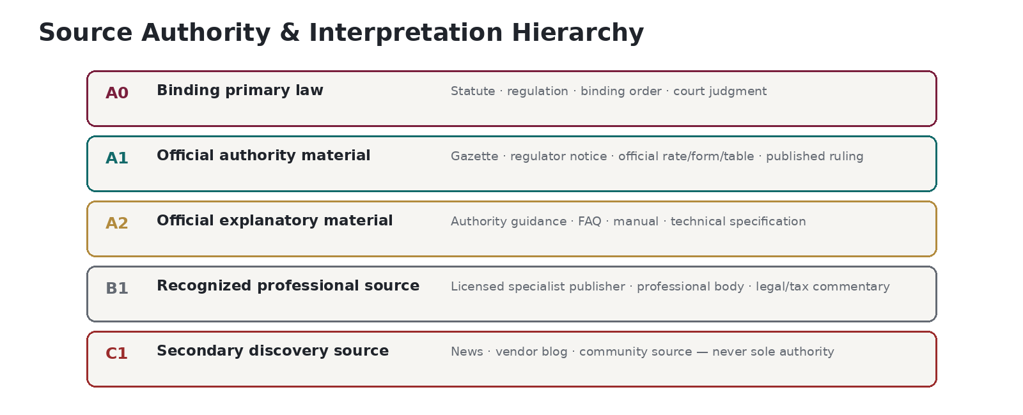
Class | Source class | Examples | Production rule
A0 | Binding primary authority | Enacted statute, regulation, binding court judgment, legally effective order/licence condition. | May directly ground production rule.
A1 | Official operational authority | Official gazette, regulator/tax authority notice, rate table, form, ruling, published determination. | May directly ground production rule where legally operative.
A2 | Official explanatory authority | Official manuals, FAQs, implementation guidance, technical specifications. | Interpretive support; cannot override A0/A1.
B1 | Licensed/recognized specialist source | Professional tax/legal publisher, standards body, recognized commentary. | Corroboration/discovery; production use requires authority analysis and licensing rights.
B2 | Institutional/specialist analysis | Industry association, academic/professional analysis. | Context/corroboration only unless jurisdiction recognizes it.
C1 | Unverified secondary web/community | Vendor blog, news article, community discussion, scraped page. | Discovery only; never sole production authority.
U | Unknown authority | Source authority cannot be established. | Fail closed; cannot support production content.
AUTHORITY COLLISION RULE
A lower-authority source may identify a possible issue but may not silently override a higher-authority source. Conflicts require an InterpretationRecord and governed human resolution; unresolved conflicts block the affected content or produce an explicit ambiguity state.

5. Source Acquisition, Licensing & Provenance
• Every source capture MUST record source URI/location, publisher/authority, publication date, retrieved_at, legal/effective dates where known, language, jurisdiction, document type, content hash and acquisition method.
• Where legally permissible and operationally necessary, an immutable source copy or licensed archival reference MUST be retained so future replay does not depend on a mutable URL.
• Source terms, copyright/licensing restrictions and redistribution rights MUST be recorded and linked to ZTAX-SRC-001.
• Robots/scraping access does not establish legal permission to ingest or redistribute content. Access rights and use rights are separate.
• For licensed sources, the license identifier, permitted uses, geography, user classes, redistribution/derived-output permissions and expiry/termination obligations MUST be machine-readable.
• Source provenance MUST survive translation, OCR/extraction, normalization and AI processing; transformations produce child artifacts rather than replacing originals.
Field | Meaning
source_id | Canonical immutable ID
authority_id | Publishing authority
authority_class | A0/A1/A2/B1/B2/C1/U
source_type | Statute/order/rate/form/guidance/etc.
jurisdiction_scope | Applicable jurisdiction(s)
published_at | Publication time
legal_effective_from/to | If known
retrieved_at | Knowledge/acquisition time
language | BCP 47 tag
source_uri | Canonical URI or repository ref
content_hash | Immutable content digest
license_ref | ZTAX-SRC license ID
archive_ref | Immutable archival object/ref
supersedes/source_relation | Document lineage
extraction_status | UNPROCESSED/EXTRACTED/REVIEWED

6. Global Regulatory Monitoring
ZoikoTax SHALL maintain a source-monitoring inventory for every PRODUCTION/MANAGED pack. Monitoring frequency is risk-based and explicitly configured per source; there is no false claim that every authority changes on the same cadence.
Monitor class | Examples | Minimum policy
Critical rate/filing feeds | Official rate tables, contribution factors, filing calendars, e-invoice schemas | At least daily where machine-published; otherwise business-day monitoring during relevant change windows.
Primary legislation/regulations | Gazettes, regulator rulemaking, tax authority publications | Daily/weekly according to jurisdiction publication cadence and pack risk.
Court/administrative decisions | Relevant courts/tribunals/rulings | Periodic + alert feeds where available.
Authority forms/technical specs | Return schemas, APIs, CTC/e-invoice validation rules | Daily around mandate/schema release windows; otherwise periodic.
Secondary corroboration | Licensed specialist sources | Risk-based; never substitutes for primary authority.
• A monitoring event creates a RegulatoryChangeCandidate, never an automatic production rule.
• Source disappearance, authentication failure, licence expiry or stale-feed detection creates a source-health incident.
• Every PRODUCTION pack has an owner accountable for source completeness; automated monitoring does not remove human accountability.

7. AI-Assisted Ingestion & Extraction
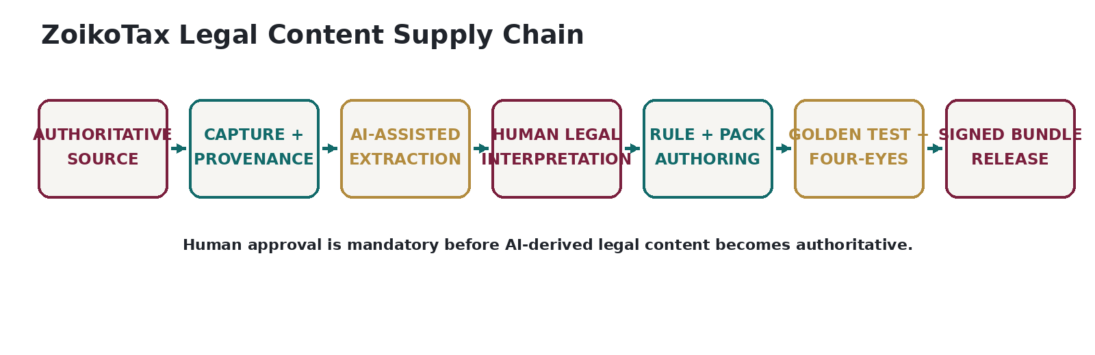
• AI may classify source type, extract candidate effective dates, identify changed clauses/rates/forms, translate/summarize, propose affected rules and generate draft tests.
• AI outputs MUST retain model/prompt/retrieval provenance and source-span references sufficient for a reviewer to verify the proposal.
• AI MUST abstain or flag low confidence where source authority, language, effective date or legal meaning is uncertain.
• Untrusted source text is treated as data, never executable instruction; prompt injection and retrieval poisoning controls are governed by ZTAX-AIGOV-001.
• No AI principal may transition a ContentChange or RuleDefinition to APPROVED/PRODUCTION.
• Machine translation may assist review but cannot become the sole legal authority where official text in another language governs; qualified language/legal review is required according to jurisdiction risk.

8. Human Interpretation & Rule Authoring
Interpretation element | Required content
Facts | What changed, source passages, dates, affected jurisdictions/services/customer types.
Authority analysis | Which source controls and whether it is binding, explanatory or conflicting.
Legal interpretation | Plain-language effect on taxability, basis, sourcing, responsibility, filing or obligation.
Ambiguity | Known unresolved questions, alternative interpretations, customer elections/facts required.
Executable mapping | RuleDefinition/RateTable/Classification/ObligationTemplate changes proposed.
Impact | Affected packs, customers, products, periods, filings and potential retroactivity.
Verification | Required golden/regression tests and expected outcomes.
Approvals | Author, independent reviewer, legal/content approver and effective date.
FOUR-EYES MINIMUM
No material production content change may be approved by the same person who authored it. High-impact or legally ambiguous changes additionally require designated senior content/legal approval.

9. Temporal Model, Publication Delay & Retroactivity
Content must distinguish at least five time concepts; collapsing them into one effective_date is prohibited.
Time | Meaning
legal_valid_from / to | When the rule legally applies.
published_at | When the authority publicly issued it.
known_at | When ZoikoTax acquired/recorded the source.
approved_at | When ZoikoTax approved the executable interpretation.
deployment_effective_at | When the bundle may execute in a target environment.
• Retroactive legal changes MUST be represented without rewriting what ZoikoTax knew historically.
• A replay request can choose legal-correctness view or historical-system-behavior view as defined by ZTAX-EVID-001.
• Future-effective content may be deployed ahead of time but must not activate before its legal/effective window.
• Where a source is published late, the pack may require restatement/assessment analysis; the content system must preserve both legal and knowledge time.

10. Pack Architecture & Composability
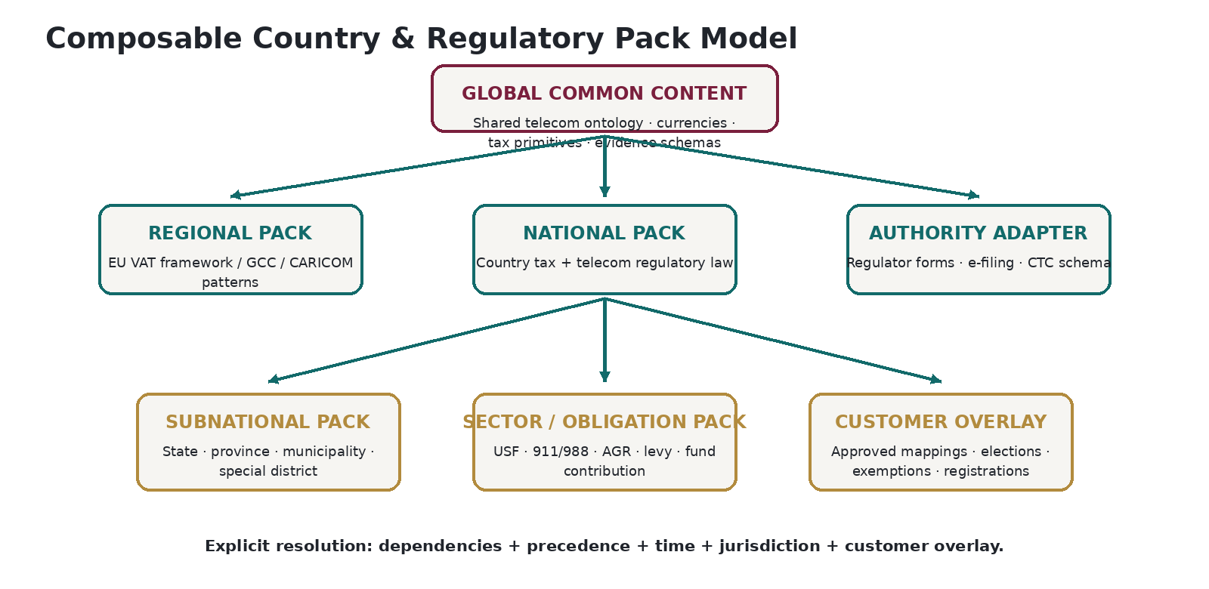
A “country pack” is a commercial shorthand, not necessarily one technical package. ZoikoTax uses composable packages with explicit dependencies and precedence.
Package type | Purpose
GLOBAL | Shared ontology, currencies, canonical tax types, generic calculation primitives, evidence schemas.
REGIONAL | Regional legal frameworks or shared standards (for example EU-wide rules where legally applicable).
NATIONAL | Country-level tax and telecom regulatory law.
SUBNATIONAL | State/province/county/municipal/special-district content.
SECTOR/OBLIGATION | Telecom-specific contribution/levy/assessment content independent of ordinary tax.
AUTHORITY-ADAPTER | Forms, filing schemas, regulator API/SFTP/RPA/CTC adapters.
CUSTOMER-OVERLAY | Approved customer mappings/elections/exemptions/registrations; cannot override immutable legal constraints.

11. Pack Manifest & Dependency Resolution
Manifest field | Requirement
pack_id / version | Stable package ID + semantic version.
scope | Countries/regions/authorities and capability matrix.
status | RESEARCH/VALIDATION/PILOT/PRODUCTION/MANAGED/SUSPENDED/WITHDRAWN.
legal_effective_window | Pack-level applicability; component rules can be narrower.
dependencies | Exact compatible package/version ranges.
conflicts | Explicit incompatible packs/versions.
precedence | Declared resolution order where content overlaps.
components | Rules/rates/classifications/forms/CTC/jurisdiction refs.
source_set_hash | Digest of authoritative source set used.
golden_suite_ref | Required verification package/version.
signature | Signing identity, algorithm, timestamp and certificate/key reference.
expiry / freshness | Mandatory refresh/review deadline if applicable.
withdrawal_plan | Required response if pack is suspended/withdrawn.

12. Jurisdiction & Geospatial Content
• Jurisdiction content MUST represent hierarchy and special taxing/regulatory districts independently of postal geography.
• Geospatial boundaries and address/rooftop datasets MUST be version-pinned and licensed for the intended deployment model.
• Situs/place-of-supply rules reference evidence types and precedence; raw evidence handling is governed by ZTAX-PRIV-001.
• Boundary changes, annexations, municipality code changes and special district changes are content events with effective dates.
• Jurisdiction IDs are canonical ZoikoTax IDs mapped to external authority/vendor IDs; vendor IDs are never canonical primary keys.

13. Telecom Product & Regulatory-Revenue Classification Content
Classification content must maintain two independent systems of meaning:
Classification | Answers | Examples
Taxability classification | What is the service/product for transaction tax purposes? | mobile voice, data, VoIP, device, digital content, bundled component
Regulatory-revenue classification | How must revenue be categorized for a regulatory contribution/report? | end-user vs carrier, interstate/intrastate/international, assessable/non-assessable, service category
• Mappings are versioned and effective-dated.
• Customer SKU mappings are overlays linked to the canonical ontology; they do not redefine the ontology.
• AI may propose mappings, but production mappings require governed approval according to confidence/risk thresholds.
• Bundle decomposition content specifies component identity and allocation policy references; detailed calculation execution belongs to DET-001.

14. Responsibility & Obligation Content
Role | Legal question
INCIDENCE | On whom law imposes the charge.
COLLECTION | Who must collect from the customer.
REPORTING | Who must report transaction/revenue.
REMITTANCE | Who must pay the authority.
ECONOMIC_BEARER | Who bears cost after contract/pricing allocation.
• Responsibility rules may depend on legal entity, licence/authorization, customer/reseller status, contractual role, nexus/registration and evidence.
• Rule outcome states are RESOLVED, AMBIGUOUS or UNSUPPORTED; AMBIGUOUS never silently falls back.
• Obligation templates define trigger, obligated party, authority, basis, period, due-date method, reporting/payment path and evidence requirements.

15. Calculation-Rule Content Schema
Rule field | Meaning
rule_id/version | Stable ID + semantic version
jurisdiction_scope | Where the rule applies
authority_ids | Issuing/administering authority
charge_type | Tax, fee, levy, contribution, assessment, surcharge
product/service predicates | Canonical classification predicates
customer/provider predicates | B2B/B2C, exempt, wholesale, reseller, regulated entity, etc.
taxable/base formula ref | Basis and exclusions; executable form governed by DET-001
rate/amount ref | RateTable or formula inputs
threshold/cap/tier ref | Stateful/periodic dependencies
tax-on-tax dependencies | Explicit DAG edges
sourcing rule ref | JUR-001 content mapping
responsibility ref | OBL-001 mapping
rounding policy ref | DET-001 policy ID
effective/legal time | valid_from/to + knowledge/provenance
sources | SourceDocument/Instrument links
interpretation_ref | Approved human interpretation
test_refs | Golden/regression cases
risk/impact class | Change control rigor

16. Exemptions, Elections & Certificates
• Exemption content defines authority, eligible party/product, required evidence/certificate, validity dates, geographic scope and whether exemption affects taxability, regulatory revenue, or both.
• Customer elections (for example permitted allocation/safe-harbor methods) must be enumerated by rule; configuration cannot invent an unsupported method.
• Certificate templates and validation rules are content objects; customer documents are operational records, not legal content.
• Expired/revoked evidence must cease future applicability while preserving historical decisions.

17. Registration, Calendar & Obligation Content
Content | Required semantics
Registration trigger | Conditions creating registration/authorization requirement.
Filing frequency | Monthly/quarterly/annual/event-driven/etc.
Period definition | Calendar, fiscal, custom authority period.
Due-date rule | Fixed date, N days after period, business-day adjustment, holiday calendar.
Extension rule | Permitted extensions and evidence.
Threshold/de minimis | Registration/filing/contribution threshold.
Amendment window | When/how returns may be amended.
Payment rule | Due date and permitted payment mechanism metadata.
Evidence | Acknowledgement/receipt/confirmation required.

18. Returns, Filing & Authority-Adapter Content
• A FilingSpecification defines field semantics, source-data mapping, validation, calculation tie-outs, schema/form version and submission channel.
• AuthorityAdapter versions are pinned to returns/periods so later portal/schema changes cannot alter historical filing evidence.
• Manual/RPA-assisted filing must be explicitly classified and controlled; “API unavailable” is not permission for an ungoverned workaround.
• Authority acknowledgement, rejection and uncertain-submission semantics are content/workflow inputs and must be mapped per authority.

19. E-Invoicing / Continuous Transaction Controls Profiles
• CTCProfile describes jurisdiction mandate, participant scope, invoice/reporting trigger, semantic format/profile, transport/accredited network, validation rules, tax/regulatory line constraints, status lifecycle and correction/cancellation semantics.
• Standards such as EN 16931, UBL/CII or Peppol are referenced/versioned where applicable; jurisdiction profiles control the actual legal requirement.
• ZoikoTax may partner for transport/access-point functions while owning telecom semantic validation and tax/regulatory integrity.
• A format being technically accepted does not prove tax/legal correctness; CTC validation and tax determination remain separate controls.

20. Localization, Language, Currency & Calendar
• All content objects carry canonical locale/language metadata; BCP 47 language tags are used where technically appropriate.
• Official legal text and reviewed translations remain linked; translation never replaces the authority source.
• Currency uses ISO 4217-compatible codes where applicable, including explicit treatment for non-standard/legacy units when legally required.
• Time zones use IANA identifiers; statutory deadlines are evaluated in the authority jurisdiction time zone/calendar.
• Business-day rules reference versioned holiday/business-calendar datasets where required.
• Number/date formatting is presentation metadata and must not alter authoritative decimal/date semantics.

21. Rule Precedence, Conflicts & Ambiguity
Resolution dimension | Rule
Legal hierarchy | Higher-binding authority wins when legally applicable.
Specificity | More specific jurisdiction/service/customer rule may override general rule only when authority permits.
Effective time | Only rules valid for the transaction/obligation time participate.
Pack dependency precedence | Manifest declares inheritance/override boundaries.
Customer overlay | Applies only within options explicitly allowed by governing law/content.
Ambiguity | If deterministic resolution is not legally supported, result is AMBIGUOUS/UNSUPPORTED rather than guessed.

22. Verification, Golden Tests & Pack Certification
• Every material rule change must have positive, negative and boundary tests appropriate to its predicates and effective dates.
• Golden tests are authored from approved legal interpretations and expected outcomes; they gate pack promotion.
• Regression selection must include all impacted dependency packs and customer-overlay archetypes, not only the changed country.
• Where a rule is intentionally ambiguous, verification confirms the explicit ambiguity/failure state rather than manufacturing a numeric answer.
• A PRODUCTION pack requires full required-suite pass, source/provenance completeness, licensing clearance, approver signatures and no unresolved P0/P1 content defects.
• QA must be independent of the content author for production certification.
Gate | Production requirement
Source completeness | All required authority sources captured/provenance complete.
Legal approval | Interpretations approved at required risk tier.
Executable validation | Rule/pack schemas valid and dependency graph resolves.
Golden tests | 100% of required pack promotion tests green.
Regression | No unexplained regression across affected packs.
Licensing | Intended distribution/deployment permitted.
Security/privacy | No prohibited data/source leakage.
Operational readiness | Monitoring, owner, SLA, suspension/withdrawal plan configured.
Customer claim matrix | Supported capabilities accurately exposed.

23. Content Release Train & Signed Bundles
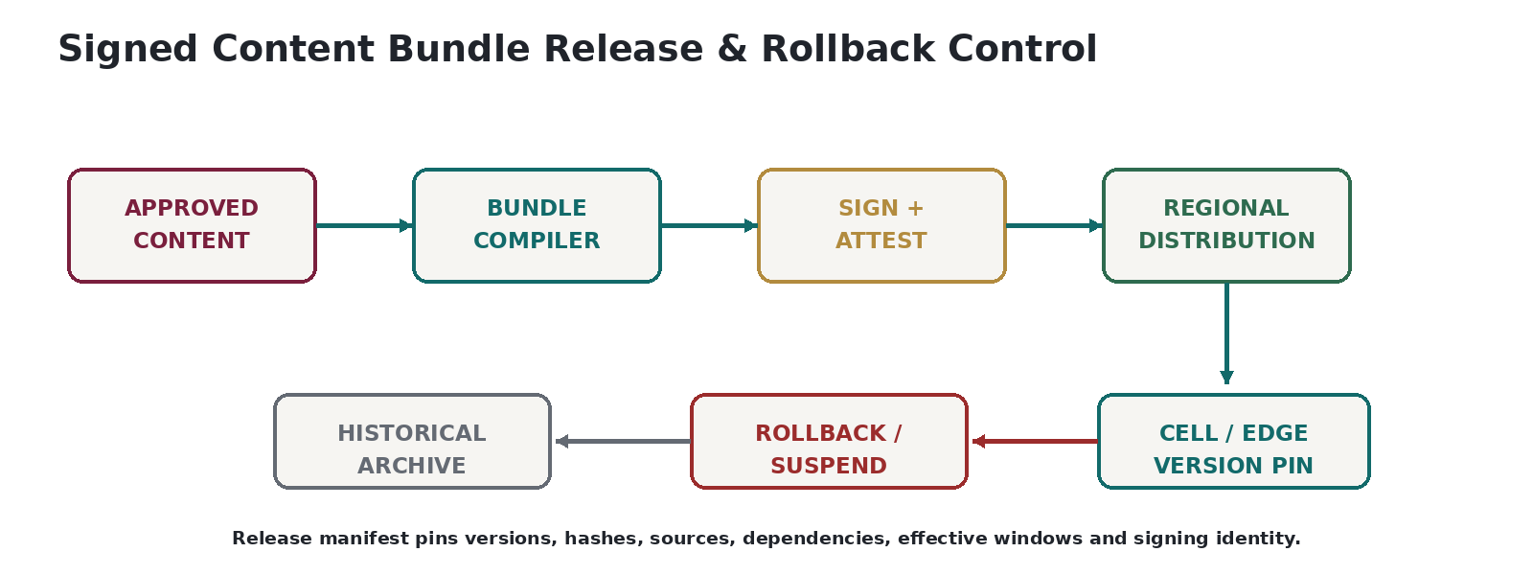
• Application code, legal content, AI models and authority adapters have separate release trains.
• A content release compiles only APPROVED content into an immutable bundle; the bundle manifest records exact component versions and hashes.
• Production runtimes verify signature, dependency compatibility, effective window, expiry/freshness and rollback policy before activation.
• Anti-rollback controls prevent accidental activation of an older bundle unless an authorized rollback/suspension procedure explicitly permits it.
• Freshness/expiry controls prevent indefinitely using stale content when a pack requires a newer review or authority feed.
• Historical bundles remain archived for replay even after supersession, suspension or withdrawal.

24. Emergency Content Change Management
Control | Emergency rule
Trigger | Unexpected authority change, emergency legislation, rate correction, filing outage/schema change, critical defect or legal injunction.
Authority | Named emergency content approvers; author cannot self-approve.
Minimum evidence | Source, impact assessment, affected packs/customers, emergency tests, rollback/suspension plan.
Deployment | Can bypass normal cadence but not provenance, signatures, approval or verification.
Post-event review | Mandatory retrospective and complete normal documentation within defined time.
Customer impact | Material billing/filing effects communicated under severity policy.

25. Pack Suspension, Withdrawal & Content Incidents
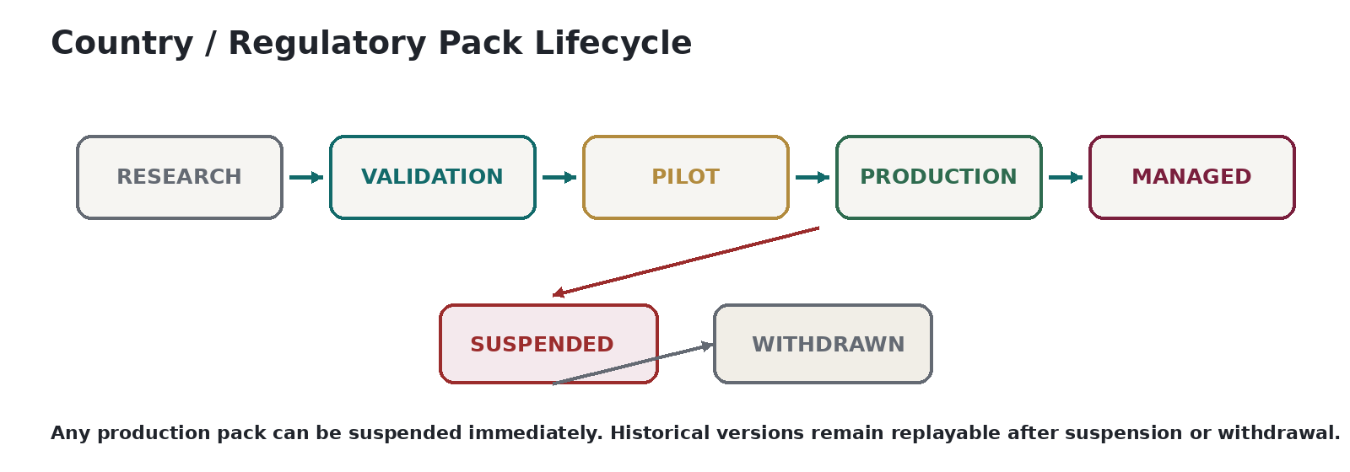
• SUSPENDED means the pack cannot authorize new production outcomes for the affected scope unless an explicit degraded-mode policy exists.
• WITHDRAWN permanently retires new use; historical versions remain available for replay/audit.
• Suspension decision records scope, reason, effective time, in-flight behavior, customer notification, filing impact and remediation owner.
• Open obligations/returns are not deleted when a pack is suspended; they enter governed review states.
• Cells/private runtimes must receive revocation/suspension metadata even if they retain old bundles for replay.
• A license termination can trigger suspension even if legal content remains correct.
Severity | Definition | Minimum response
C0 | Potential issue, no known production impact | Investigate; no customer action yet.
C1 | Confirmed content defect with limited/non-material impact | Correct + notify affected customers per policy.
C2 | Material tax/filing exposure or broad customer impact | Immediate suspension/mitigation + executive incident command.
C3 | Systemic legal-content integrity failure | Global/pack-wide emergency controls, potentially disable authoritative output.

26. Content SLAs, Freshness & Quality Metrics
Targets are configurable by pack risk and authority cadence. The standard prohibits marketing “always current” without measurable monitoring/approval performance.
Metric | Definition
Source monitoring coverage | % required PRODUCTION sources actively monitored and healthy.
Detection latency | Publication → change candidate.
Interpretation latency | Candidate → approved interpretation.
Production latency | Publication/knowledge → effective bundle, by change class.
Provenance completeness | % production rules with complete authority/source chain.
Golden pass rate | Required tests passing at promotion; must be 100% for mandatory suite.
Content defect rate | Confirmed customer/QA content defects per defined denominator.
Stale-pack exposure | Customers/transactions on pack past mandatory freshness window.
Suspension recovery time | Time to safe resolution or supported alternative.
Retroactive correction accuracy | Correct bitemporal/restatement treatment of retroactive changes.

27. Security, Segregation of Duties & Access
• Content author, content approver, release signer and production-platform administrator are distinct privileges.
• Production signing keys are not accessible to general content authors or AI services.
• Break-glass content changes require dual authorization and immutable audit evidence.
• Source credentials/licensed feeds are secrets governed by SEC-001 and may not be embedded in rule bundles.
• All approvals, overrides, pack promotions, suspensions and withdrawals generate immutable audit events.
• Customer-specific overlays are tenant-isolated and cannot modify global canonical content.

28. Privacy & Evidence Handling
• Legal sources/content should be non-personal where possible; personal data in rulings/cases must be minimized and handled under PRIV-001.
• Situs evidence policy is referenced by content rules but raw subscriber/network evidence is not embedded into global country packs.
• Examples/test fixtures must use synthetic or properly de-identified data unless a controlled exception exists.
• Legal-hold/retention rules apply to source evidence and interpretation records according to EVID-001.

29. Content Sourcing & Redistribution Boundaries
• ZTAX-SRC-001 is authoritative for licence rights; CONT-001 records and enforces those rights in pack manifests.
• A source permitted for internal research may still be prohibited from embedding, redistributing or exposing in customer/private runtimes.
• Rule logic derived from licensed content must be reviewed for derivative-use and redistribution rights before compilation into customer-distributed bundles.
• If private/edge distribution is not permitted, the pack declares permitted deployment modes rather than silently violating licence terms.
• Source loss/termination requires impact analysis, replacement plan and possible pack suspension.

30. Content Operations Organization & RACI
Role | Accountability
CCRO | Accountable for content policy, authority hierarchy, production pack integrity and content SLAs.
Country/Regional Content Owner | Accountable for specific pack coverage, source inventory and change triage.
Tax/Regulatory Analyst | Researches sources, drafts interpretations and rules.
Content Engineer | Implements executable content, schemas, pack manifests and tests.
Legal/Tax Reviewer | Independent legal/technical interpretation review based on risk tier.
Content QA | Independent verification/golden/regression certification.
Release Approver | Authorizes signed bundle release; cannot be sole author.
Platform/SRE | Operates distribution infrastructure without legal-content approval authority.
AI System | Discovery/extraction/proposal assistant only; never accountable approver.

31. Customer Communication & Transparency
• Customer-facing capability matrix must distinguish DETERMINATION, REGULATORY OBLIGATIONS, FILING, CTC/E-INVOICE, MANAGED COMPLIANCE and SHADOW support by jurisdiction.
• Material content changes may produce release notes/impact notices with effective date, affected charge/obligation and required customer action without disclosing restricted licensed content.
• Known ambiguity, unsupported scope or suspended coverage must be visible in UI/API/contractual support status; never hidden behind generic “supported country” language.
• Customers can identify the pack/rule version used for an authoritative decision through audit/explanation interfaces.

32. Managed-Compliance Readiness
Readiness dimension | MANAGED requirement
PRODUCTION content | Determination/obligation content certified.
Filing specification | Current form/schema + field mappings + validations.
Authority credentials | Custody/process defined; legal agency/POA complete where required.
Calendar | Due-date/holiday/extension rules verified.
Workpapers | Reconciliation/tie-out rules defined.
Submission path | API/SFTP/portal/manual controlled workflow tested.
Acknowledgement | Success/reject/uncertain states mapped.
Notice process | Authority notice/case routing defined.
Operational ownership | Named team and service hours/escalation.
Liability boundary | LEG-001 posture and customer engagement terms aligned.

33. Production Definition of Done
• Pack manifest valid, dependencies/conflicts resolved and signature verified.
• All required authority/source records complete and licensed for intended use.
• Interpretations approved at required risk level.
• All mandatory golden/regression tests green.
• No unresolved critical/high content defects.
• Monitoring inventory active and pack owner/on-call path assigned.
• Capability support matrix accurately declared.
• Suspension/withdrawal procedure and historical replay artifacts present.
• Customer overlays/configuration rules cannot bypass mandatory content.
• Production bundle hash/version registered and distributed only to permitted deployment modes.

34. Normative Requirements
Requirement ID | Normative requirement | Verify | Delegates
ZTAX-CONT-REQ-0001 | All authoritative production content MUST be traceable to one or more registered source documents and an approved interpretation. | AUDIT | CONT/EVID
ZTAX-CONT-REQ-0002 | Unknown-authority sources MUST NOT independently ground production rules. | TEST | CONT
ZTAX-CONT-REQ-0003 | Lower-authority sources MUST NOT silently override higher-authority sources. | TEST | CONT
ZTAX-CONT-REQ-0004 | Every production content object MUST record legal validity and knowledge/provenance time where the distinction can affect historical replay. | INSPECTION | DOM/EVID
ZTAX-CONT-REQ-0005 | Country/regulatory content MUST be deployable through packages rather than country-specific application forks. | ANALYSIS | ARCH
ZTAX-CONT-REQ-0006 | Every pack MUST declare capability scope and status. | TEST | CONT
ZTAX-CONT-REQ-0007 | Every pack MUST declare exact dependencies and incompatible/conflicting package relationships. | TEST | CONT
ZTAX-CONT-REQ-0008 | Pack dependency resolution MUST be deterministic. | TEST | CONT/DET
ZTAX-CONT-REQ-0009 | Every production rule MUST reference a stable rule ID and version. | TEST | DET
ZTAX-CONT-REQ-0010 | Rule sources and interpretation references MUST survive compilation into bundle metadata/evidence. | TEST | EVID
ZTAX-CONT-REQ-0011 | AI-generated proposals MUST remain non-authoritative until human approval. | AUDIT | AIGOV
ZTAX-CONT-REQ-0012 | An AI principal MUST NOT approve or sign a production content release. | TEST | AIGOV/SEC
ZTAX-CONT-REQ-0013 | Material production changes MUST be independently reviewed by someone other than the author. | AUDIT | CONT
ZTAX-CONT-REQ-0014 | High-risk ambiguous changes MUST require escalated legal/content approval. | AUDIT | CONT/LEG
ZTAX-CONT-REQ-0015 | Every material rule change MUST carry impact analysis. | INSPECTION | CONT
ZTAX-CONT-REQ-0016 | Every material rule change MUST carry appropriate verification/golden tests. | TEST | QA
ZTAX-CONT-REQ-0017 | Mandatory golden suites MUST pass before PRODUCTION promotion. | TEST | QA
ZTAX-CONT-REQ-0018 | A PRODUCTION pack MUST have an active monitoring inventory for required sources. | AUDIT | CONT
ZTAX-CONT-REQ-0019 | Source monitoring failures MUST create an operational/content-health event. | DEMONSTRATION | DEVOPS
ZTAX-CONT-REQ-0020 | Source licensing terms MUST be linked to pack components where third-party rights affect use/distribution. | AUDIT | SRC
ZTAX-CONT-REQ-0021 | A pack MUST NOT be distributed to a deployment mode prohibited by source/licensing rights. | TEST | SRC/SEC
ZTAX-CONT-REQ-0022 | Production bundles MUST be immutable and cryptographically signed. | TEST | EVID/SEC
ZTAX-CONT-REQ-0023 | Runtime activation MUST verify bundle signature and compatibility. | TEST | ARCH
ZTAX-CONT-REQ-0024 | Historical superseded bundles MUST remain retrievable for authorized replay. | DEMONSTRATION | EVID
ZTAX-CONT-REQ-0025 | A runtime MUST NOT activate a future-effective rule before its effective window. | TEST | DET
ZTAX-CONT-REQ-0026 | Retroactive content changes MUST NOT overwrite historical knowledge-time records. | TEST | DOM/EVID
ZTAX-CONT-REQ-0027 | Customer overlays MUST NOT override mandatory legal constraints. | TEST | DOM/DET
ZTAX-CONT-REQ-0028 | Customer-specific mappings MUST be tenant-isolated. | TEST | SEC
ZTAX-CONT-REQ-0029 | Taxability and regulatory-revenue classifications MUST remain independent content dimensions. | TEST | CLS
ZTAX-CONT-REQ-0030 | Responsibility content MUST resolve the five responsibility roles independently where applicable. | TEST | OBL
ZTAX-CONT-REQ-0031 | AMBIGUOUS responsibility or legal interpretation MUST NOT silently default to RESOLVED. | TEST | OBL
ZTAX-CONT-REQ-0032 | Jurisdiction content MUST reference versioned jurisdiction/geospatial datasets. | TEST | JUR
ZTAX-CONT-REQ-0033 | Vendor/external jurisdiction IDs MUST NOT become ZoikoTax canonical primary keys. | INSPECTION | DOM
ZTAX-CONT-REQ-0034 | Authority form/schema versions MUST be pinned to filings/periods. | TEST | COMP
ZTAX-CONT-REQ-0035 | CTC/e-invoice profiles MUST distinguish format/transport validation from tax/legal correctness. | TEST | CTC
ZTAX-CONT-REQ-0036 | Official-language legal text MUST remain linked to translated/normalized derivatives. | AUDIT | CONT
ZTAX-CONT-REQ-0037 | Machine translation MUST NOT become the sole authority for production interpretation where official text governs and review is required. | AUDIT | CONT
ZTAX-CONT-REQ-0038 | Currency and statutory time-zone semantics MUST be explicit and machine-readable. | TEST | DOM/DET
ZTAX-CONT-REQ-0039 | Business-day/holiday calendars used for deadlines MUST be versioned where applicable. | TEST | COMP
ZTAX-CONT-REQ-0040 | Every production pack MUST define suspension behavior. | INSPECTION | CONT
ZTAX-CONT-REQ-0041 | Every production pack MUST define withdrawal behavior. | INSPECTION | CONT
ZTAX-CONT-REQ-0042 | SUSPENDED content MUST NOT silently continue authorizing new outcomes outside explicit degraded-mode policy. | TEST | ARCH/DET
ZTAX-CONT-REQ-0043 | WITHDRAWN content MUST remain available for historical replay when required. | DEMONSTRATION | EVID
ZTAX-CONT-REQ-0044 | Content incident severity MUST be recorded and linked to affected packs/customers/releases. | AUDIT | CONT
ZTAX-CONT-REQ-0045 | Emergency releases MUST preserve source provenance, approval, signing and verification. | AUDIT | CONT/QA
ZTAX-CONT-REQ-0046 | Emergency release authors MUST NOT be sole approvers. | AUDIT | CONT
ZTAX-CONT-REQ-0047 | Production signing credentials MUST be segregated from general authoring privileges. | AUDIT | SEC
ZTAX-CONT-REQ-0048 | All content promotions, suspensions, withdrawals and overrides MUST be immutably audited. | AUDIT | EVID
ZTAX-CONT-REQ-0049 | Pack support claims MUST be capability-specific. | INSPECTION | PRD/COM
ZTAX-CONT-REQ-0050 | A jurisdiction MUST NOT be marketed as supported solely because a rate exists. | AUDIT | PRD/COM
ZTAX-CONT-REQ-0051 | A MANAGED pack MUST satisfy the managed-compliance readiness controls in this standard. | AUDIT | COMP
ZTAX-CONT-REQ-0052 | A content source MUST record content hash/checksum or equivalent immutable identity. | TEST | EVID
ZTAX-CONT-REQ-0053 | Source transformations MUST preserve lineage to the original source. | TEST | CONT
ZTAX-CONT-REQ-0054 | Source disappearance or license termination MUST trigger impact assessment. | DEMONSTRATION | SRC/CONT
ZTAX-CONT-REQ-0055 | Licensed content MUST NOT be exposed verbatim to customers unless display rights permit it. | AUDIT | SRC
ZTAX-CONT-REQ-0056 | Rule precedence MUST be explicit, deterministic or return an ambiguity/failure state. | TEST | DET
ZTAX-CONT-REQ-0057 | Pack manifests MUST carry source-set and verification references. | TEST | CONT/QA
ZTAX-CONT-REQ-0058 | Content release evidence MUST identify author, reviewer, approver, bundle hash and effective window. | AUDIT | EVID
ZTAX-CONT-REQ-0059 | Pack activation MUST be atomic from the perspective of authoritative decision evaluation. | TEST | ARCH
ZTAX-CONT-REQ-0060 | Partial deployment of mutually dependent rules MUST be prevented. | TEST | ARCH
ZTAX-CONT-REQ-0061 | Rate tables MUST be independently versioned/effective-dated where rates change without rule-logic change. | TEST | DET
ZTAX-CONT-REQ-0062 | Filing/return schema changes MUST be versioned independently from tax calculation rules. | TEST | COMP
ZTAX-CONT-REQ-0063 | Authority-adapter changes MUST have an independent release version. | TEST | COMP/DEVOPS
ZTAX-CONT-REQ-0064 | AI extraction output MUST include source-span/provenance references sufficient for human verification. | AUDIT | AIGOV/AI
ZTAX-CONT-REQ-0065 | Low-confidence AI legal extraction MUST be review-queued or abstained according to AIGOV thresholds. | TEST | AIGOV
ZTAX-CONT-REQ-0066 | Test fixtures containing personal/customer data MUST be prohibited unless a controlled exception exists. | AUDIT | PRIV
ZTAX-CONT-REQ-0067 | Global country packs MUST support non-US jurisdictions without application-architecture changes solely for country law. | ANALYSIS | ARCH
ZTAX-CONT-REQ-0068 | Content SLIs MUST be measured by pack/change class rather than represented by unsupported universal “real-time” claims. | AUDIT | CONT
ZTAX-CONT-REQ-0069 | Every production pack MUST have a named accountable owner. | AUDIT | CONT
ZTAX-CONT-REQ-0070 | Every production pack MUST have a defined review/freshness policy. | AUDIT | CONT
ZTAX-CONT-REQ-0071 | Expired mandatory review/freshness state MUST surface operationally and may block/suspend authoritative use according to pack policy. | TEST | CONT/ARCH
ZTAX-CONT-REQ-0072 | Content changes affecting historical periods MUST trigger impact/reconciliation assessment. | AUDIT | FIN/CONT
ZTAX-CONT-REQ-0073 | Pack manifest and rule bundle formats MUST be schema-validated in CI. | TEST | QA/DEVOPS
ZTAX-CONT-REQ-0074 | Production pack artifacts MUST be reproducible from registered source/rule/test versions or have a documented deterministic build exception. | DEMONSTRATION | DEVOPS/EVID
ZTAX-CONT-REQ-0075 | Legal source retention MUST follow EVID/LEG retention and legal-hold requirements. | AUDIT | EVID/LEG
ZTAX-CONT-REQ-0076 | No content object MUST rely only on a mutable external URL for historical proof. | AUDIT | EVID
ZTAX-CONT-REQ-0077 | Pack customer overlays MUST carry their own version and effective time. | TEST | DOM
ZTAX-CONT-REQ-0078 | Pack state changes MUST emit domain/audit events. | TEST | INT/EVID
ZTAX-CONT-REQ-0079 | Pack release notes MUST identify material customer-impacting changes without exposing restricted content. | INSPECTION | CONT/COM
ZTAX-CONT-REQ-0080 | A content defect correction MUST preserve the superseded erroneous version for audit/replay. | TEST | EVID
ZTAX-CONT-REQ-0081 | The system MUST distinguish a content defect from an authority retroactive change. | TEST | CONT/EVID
ZTAX-CONT-REQ-0082 | Pack withdrawal MUST define treatment of open obligations and unfiled returns. | INSPECTION | COMP
ZTAX-CONT-REQ-0083 | Content QA MUST be organizationally independent from sole authorship for production certification. | AUDIT | QA
ZTAX-CONT-REQ-0084 | Every authoritative content release MUST be linked to requirement/verification evidence under ZTAX-GOV-001. | AUDIT | GOV/QA
ZTAX-CONT-REQ-0085 | No unsupported legal interpretation MUST be hidden by an AI-generated natural-language explanation. | TEST | AIGOV
ZTAX-CONT-REQ-0086 | Content APIs/UI MUST expose pack status and version for authoritative decisions where user/auditor workflows require it. | TEST | INT/UX
ZTAX-CONT-REQ-0087 | Pack dependency cycles MUST be rejected at build time. | TEST | CONT
ZTAX-CONT-REQ-0088 | Emergency pack suspension MUST propagate through configured cells/private runtimes within the defined NFR objective. | TEST | NFR/ARCH
ZTAX-CONT-REQ-0089 | Pack version pinning MUST prevent silent customer migration to incompatible major versions. | TEST | COM/ARCH
ZTAX-CONT-REQ-0090 | Content teams MUST be able to stage future-effective content without premature activation. | DEMONSTRATION | CONT/DET
ZTAX-CONT-REQ-0091 | Country pack generated human views MUST be derived from machine-readable source-of-truth artifacts, not maintained independently. | TEST | CONT
ZTAX-CONT-REQ-0092 | Each content object MUST declare its authoritative owner/domain. | INSPECTION | DOM/CONT
ZTAX-CONT-REQ-0093 | Every release MUST preserve an immutable evidence manifest linking source, interpretation, rules, tests, approvals and bundle hash. | AUDIT | EVID

35. Required Machine-Readable Artifacts
Artifact | Purpose
source-register.yaml | Authorities, source inventory, cadence, health, license refs.
pack-manifest.schema.json | Schema for pack manifests.
pack-manifest.yaml | Per-pack scope, dependencies, capability matrix, state, hashes/signature refs.
rule-definition.schema.json | Executable rule metadata schema.
rate-table.schema.json | Rates, amounts, thresholds, tiers and validity.
classification-map.yaml | Canonical product and regulatory-revenue mappings.
responsibility-rules.yaml | Responsibility predicates/outcomes.
obligation-templates.yaml | Registration/return/contribution obligation triggers.
filing-specs/* | Authority form/schema mappings.
ctc-profiles/* | E-invoice/e-reporting jurisdiction profiles.
golden-tests/* | Legal-content test vectors.
content-change.yaml | Change request, interpretation, impact and approvals.
bundle-manifest.json | Compiled production release identity.
suspension-record.yaml | Scope/reason/in-flight behavior/customer notification.
content-sli.yaml | Pack freshness/monitoring/SLA configuration.

36. Implementation Templates

36.1 Illustrative pack manifest
pack_id: ZTAX-CP-GBR-TELECOM-v1
status: PRODUCTION
capabilities: [DETERMINE, OBLIGATIONS, FILE]
legal_scope: [GB]
dependencies:
- ZTAX-CP-GLOBAL-COMMON@^2.0
- ZTAX-CP-GBR-VAT@^3.1
components:
rules_hash: sha256:...
source_set_hash: sha256:...
golden_suite: ZTAX-GOLD-GBR-TELECOM-v1.4
valid_from: 2027-01-01T00:00:00Z
review_due: 2027-03-31
signing_identity: ztax-content-prod-01
permitted_deployment_modes: [CLOUD_CELL, PRIVATE_RUNTIME]
withdrawal_plan_ref: ZTAX-WD-GBR-TELECOM-v1

36.2 Illustrative content change
change_id: ZTAX-CHG-2027-001842
source_ids: [SRC-GBR-OFCL-000882]
affected_packs: [ZTAX-CP-GBR-TELECOM]
change_class: STRUCTURAL_RULE
legal_valid_from: 2027-04-01
known_at: 2027-02-14T10:32:11Z
interpretation_ref: INT-GBR-2027-0044
author: analyst:2048
reviewer: counsel:113
test_refs: [GOLD-GBR-401, GOLD-GBR-402, REG-GBR-882]
impact: "Affects retail mobile service classification and filing workpaper mapping"
status: APPROVED

36.3 Rule-authoring checklist
• Authority class established and source captured
• Jurisdiction/service/customer scope explicit
• Legal and knowledge time explicit
• Ambiguity documented
• Executable predicates and outcomes mapped
• Dependencies/precedence explicit
• Responsibility/obligation implications assessed
• Historical/retroactive impact assessed
• Golden and regression tests authored
• Licensing/distribution rights verified
• Independent review complete
• Release/suspension implications complete

Appendix A — Pack Capability Matrix
Capability | Meaning
DETERMINE | Native authoritative tax/fee calculation
CLASSIFY | Canonical product + regulatory-revenue classification
JURISDICTION | Situs/place-of-supply resolution
OBLIGATIONS | Regulatory obligation discovery/computation
REGISTRATIONS | Registration/authorization operations
FILE | Return/workpaper/submission support
REMIT | Remittance instruction/control support
CTC | E-invoicing/e-reporting profile support
MANAGED | Zoiko-managed compliance operations
SHADOW | Parallel assurance/comparison support

Appendix B — Required ADRs Before EFFECTIVE Status
ADR | Decision
ADR-CONT-001 | Pack composition/dependency/versioning model
ADR-CONT-002 | Authority hierarchy and conflict policy
ADR-CONT-003 | Bitemporal content representation
ADR-CONT-004 | Rule/pack manifest formats and signing
ADR-CONT-005 | Source archival/licensing enforcement model
ADR-CONT-006 | AI proposal/review handoff model
ADR-CONT-007 | Golden-test ownership and pack certification
ADR-CONT-008 | Emergency release and suspension propagation
ADR-CONT-009 | Private-runtime redistribution model
ADR-CONT-010 | Localization/translation review model

Appendix C — Engineering Handoff
• ZTAX-DET-001 consumes RuleDefinition, RateTable, pack precedence and signed-bundle semantics.
• ZTAX-JUR-001 consumes jurisdiction datasets, sourcing rules and evidence-class references.
• ZTAX-CLS-001 owns detailed telecom ontology/classification execution while CONT governs provenance/promotion.
• ZTAX-OBL-001 consumes ResponsibilityRule and ObligationTemplate content.
• ZTAX-COMP-001 consumes registrations/calendars/filing specs/authority adapters.
• ZTAX-CTC-001 consumes CTCProfile content.
• ZTAX-QA-001 owns verification mechanics and pack certification execution.
• ZTAX-SRC-001 owns licensing legal analysis; CONT enforces its resulting permissions.
• ZTAX-AIGOV-001 owns AI authority/model-risk controls; CONT owns human legal approval flow.
• ZTAX-EVID-001 owns immutable release/source/decision evidence and historical replay.

Production Gate
NO PACK = NO AUTHORITATIVE CLAIM
A jurisdiction, tax, levy, obligation, filing or e-invoicing capability is not production-supported until the required package is PRODUCTION (or MANAGED where managed service is claimed), its governing sources and licensing are complete, required tests are green, the signed bundle is registered, and runtime activation has succeeded. Unknown or unsupported content fails explicitly; ZoikoTax never manufactures legal coverage.

Approval
Role | Name | Date | Signature
Chief Technology Officer
Chief Product Officer
Chief Content & Regulatory Officer
General Counsel
End of ZTAX-CONT-001 v1.0

