ZOIKOTAX™
CANONICAL DOMAIN MODEL, DATA MODEL & LIFECYCLES
Global Telecom Tax, Regulatory & Obligation Platform
ZTAX-DOM-001 | Version 1.0
Constitutional domain specification · implementation baseline
Document ID | ZTAX-DOM-001
Version | 1.0
Status | For approval / BASELINED-FOR-BUILD candidate
Class | CONSTITUTIONAL
Owner | Chief Architect
Approvers | CTO · CPO · Chief Content & Regulatory Officer · DPO/Privacy · General Counsel
Depends on | ZTAX-STR-003 · ZTAX-ARCH-001 v2.0 · ZTAX-GOV-001 v3.0 · ZTAX-PRD-000 v1.0
Delegates to | CLS-001 · DET-001 · JUR-001 · OBL-001 · FIN-001 · COMP-001 · EVID-001 · PRIV-001 · AIGOV-001
Review cadence | Quarterly health review + change-triggered review
CONSTITUTIONAL DECISION
This document defines ZoikoTax’s canonical nouns, identities, relationships, temporal semantics, monetary primitives, aggregate boundaries and lifecycle invariants. A production implementation that contradicts these invariants is non-conformant even if the API appears to work.

0. Engineer Quick Start
TEN RULES ENGINEERS MUST REMEMBER
1) Facts ≠ decisions ≠ statuses ≠ analytics. 2) Canonical IDs are internal and immutable. 3) Legal/text labels never become logic keys. 4) Monetary values are decimal + currency. 5) Taxability ≠ regulatory classification. 6) Committed history is append-only. 7) Legal content can be bitemporal. 8) Ambiguity is a state, never a hidden default. 9) Every authoritative decision pins versions/provenance. 10) Country-specific law enters through packs, not source-code forks.
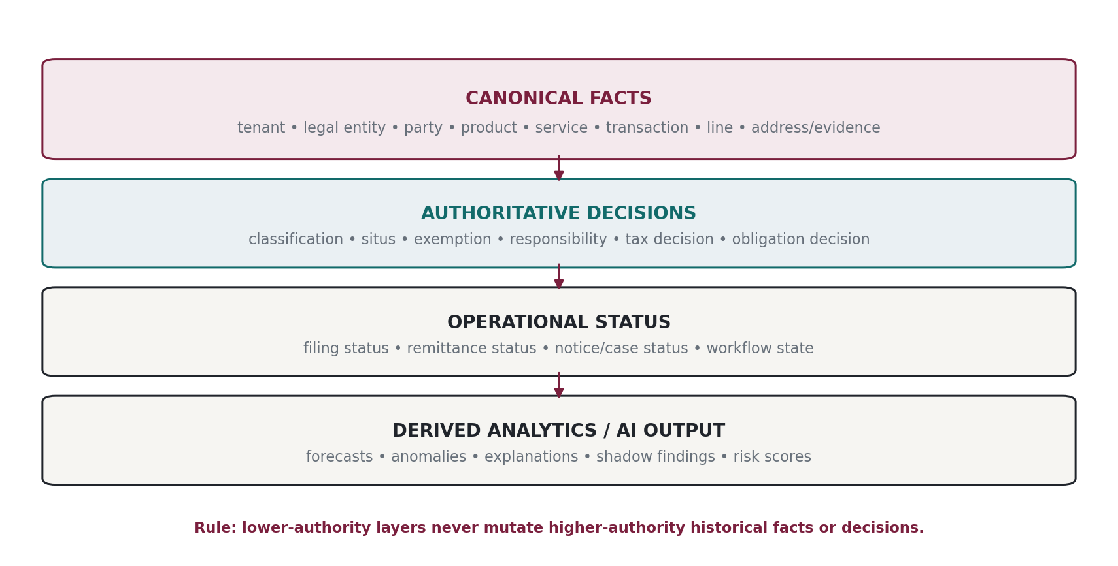
Figure 1 — Record authority layers. Derived or advisory layers cannot rewrite authoritative history.

0.1 What this document owns
• Canonical entity names and identity rules.
• Aggregate roots and transactional consistency boundaries.
• Temporal models: instant, local civil time, valid time, system/knowledge time, filing periods and accounting periods.
• Money, currency, percentage, rate, quantity, allocation and rounding primitives.
• Authoritative facts/decision/status/analytics separation.
• Fiscal document and correction lifecycles.
• Required links among transactions, classifications, situs, responsibilities, tax decisions, obligations, filings and evidence.
• Canonical failure-state and immutability semantics.
• System-of-record and data-ownership rules at the domain level.
• Schema invariants later specifications MUST preserve.

0.2 What this document deliberately does not own
• Exact tax formula/rule DSL: ZTAX-DET-001.
• Product classification ontology values: ZTAX-CLS-001.
• Jurisdiction/situs evidence precedence: ZTAX-JUR-001.
• Responsibility algorithms and obligation rules: ZTAX-OBL-001.
• Tax-control subledger posting rules: ZTAX-FIN-001.
• Evidence hashing/WORM/legal-hold mechanics: ZTAX-EVID-001.
• PII retention and lawful-basis rules: ZTAX-PRIV-001.
• AI model architecture and authority controls: ZTAX-AIGOV-001 / ZTAX-AI-001.

1. Critical Domain Review & v1.0 Decisions

1.1 Structural defects this model prevents
Anti-pattern | Constitutional correction
God Transaction object | Do not place commercial facts, tax decisions, filing status, evidence, AI explanations and reconciliation results in one mutable row. Separate authority layers and aggregate roots.
External IDs as primary keys | BSS/ERP IDs are mutable namespace-bound references. ZoikoTax uses canonical IDs and stores external references with source-system namespace and effective history.
Tax-only classification | Taxability and regulatory-revenue classification are independent; one may not be inferred from the other.
One global tenant home region | Routing is by tenant/legal entity/data domain. A multinational commercial tenant may span cells without centralizing raw fiscal/PII data.
Single timestamp meaning | created_at, event time, legal effective time, accounting period, filing period and knowledge time are different concepts.
Float money | Binary floating point is forbidden for authoritative fiscal amounts; currency/scale/rounding are explicit.
Mutable historical row | Committed fiscal history is never overwritten; corrections link to predecessor decisions/documents.
Bitemporal everything | Bitemporality is mandatory where retroactive legal/configuration knowledge changes historical interpretation; ordinary operational rows remain simpler.
Polymorphic JSON dumping ground | Extensible metadata is permitted only behind versioned schemas. Core legal/financial semantics remain typed and queryable.
Soft-delete of evidence | Authoritative/evidentiary records use retention/withdrawal/tombstone semantics; destructive deletion is limited to data classes legally eligible for deletion.

1.2 Domain authority hierarchy
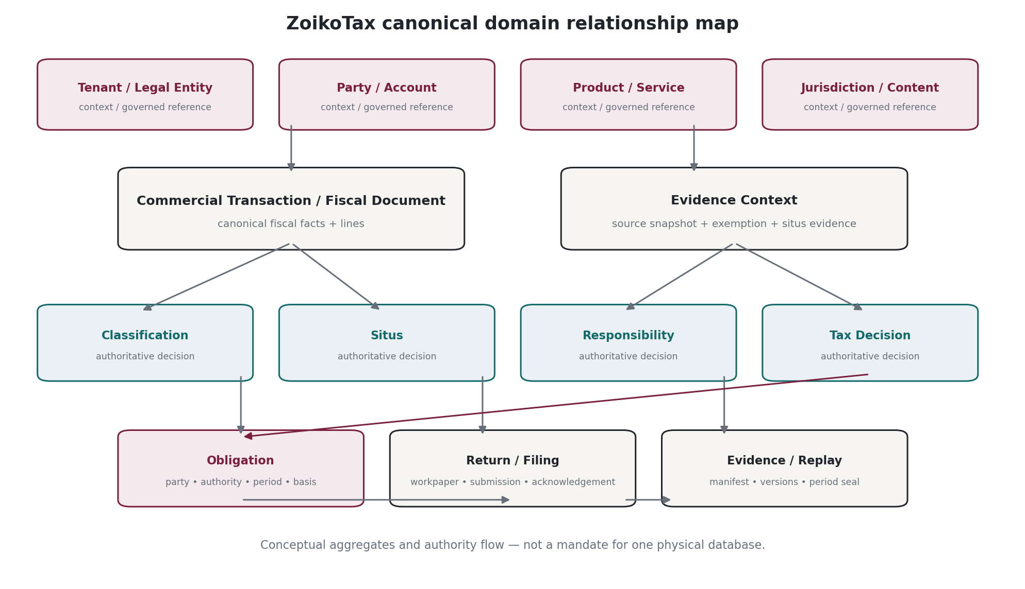
Figure 2 — Canonical aggregate relationship map. It is conceptual, not a mandate for one database schema.

2. Domain Doctrine & Invariants
Invariant | Required rule
D1 — Canonical identity | Every authoritative entity has an immutable ZoikoTax canonical ID. External identifiers are references, never canonical keys.
D2 — Explicit authority class | Every record type is classified as FACT, AUTHORITATIVE_DECISION, OPERATIONAL_STATUS, ANALYTIC, AI_PROPOSAL or EVIDENCE.
D3 — Append-only fiscal truth | Committed financial/tax history is corrected with successor records and explicit links; UPDATE-in-place is not an accounting correction.
D4 — Global schema | Country-specific behavior is data/content/configuration expressed through governed extension points; no country-specific fork of canonical entities.
D5 — Temporal explicitness | Every time field states whether it represents an instant, civil local time, valid interval, system-known interval, fiscal period or due date.
D6 — Money explicitness | Amount without currency is invalid; rate without unit/basis is invalid; rounding without policy is invalid.
D7 — Ambiguity explicitness | AMBIGUOUS, CONFLICTED, UNSUPPORTED, STALE and SUSPENDED are valid domain outcomes where applicable.
D8 — Reproducibility | Authoritative outcomes pin sufficient inputs, content/configuration versions and evidence references for historical replay.
D9 — Tenant isolation | Every tenant-owned authoritative record carries tenancy/legal-entity/data-cell context or derives it through an enforced aggregate boundary.
D10 — Source provenance | Imported facts retain source system, source object type, external ID and ingestion/correlation metadata.
D11 — No display-text logic | Names, labels and translations are presentation data; enums/codes/IDs drive logic.
D12 — AI separation | AI proposals/analytics never share authoritative record types or status fields that could make them appear legally authoritative.

3. Identity, Keys, Namespaces & References

3.1 Canonical identifier standard
ZoikoTax SHOULD use UUIDv7 for new internal canonical entity IDs because RFC 9562 standardizes the time-ordered UUIDv7 form. Where creation-time disclosure is inappropriate for a public resource identifier, a separate opaque public alias MAY be generated. Database implementation MUST NOT depend on lexical ordering as a substitute for an explicit event/system timestamp.
Identifier | Representation | Rule
Canonical ID | UUIDv7 | Immutable internal identity; never recycled.
Public alias | Opaque UUID/random alias | Optional when external enumeration/time leakage is a concern.
External reference | source_system + namespace + external_id | Links BSS/ERP/CRM/regulator objects; unique within source namespace and effective period.
Natural/legal identifier | Typed value + issuing authority + jurisdiction | Tax ID, company number, licence number; never primary key.
Correlation ID | UUID/string | Cross-service trace/workflow correlation; not entity identity.
Idempotency key | Client-provided opaque string + operation scope | Controls exactly-once business effect under retries.
Content/rule ID | Stable semantic ID + version | Identity survives versions; bundle hash pins exact executable content.
Document number | Jurisdiction/customer sequence | Business-visible number; not canonical database identity.

3.2 External reference invariants
• An external reference MUST include source_system_id and namespace/object_type.
• Re-keying or merger of a source system MUST create a new reference mapping rather than mutate historical source attribution.
• One canonical object MAY have multiple concurrent external references.
• External references MAY be bitemporal where source ownership changes historically.
• Incoming unknown external references MUST NOT auto-create a legal entity, registration or exemption without explicit onboarding rules.

4. Tenant, Organization, Party & Legal-Entity Model

4.1 Canonical hierarchy
TENANCY MODEL
Commercial Tenant → Organization Group → Legal Entity → Brand/Business Unit → Billing/Tax Account → Customer/Subscriber/Service context. An MVNE/MVNA tenant can host multiple downstream MVNO legal entities while preserving independent tax registrations, pack configuration, evidence and filings.
Entity | Meaning
Tenant | Commercial/security boundary; subscription, data policy, default configuration and partner/OEM hierarchy.
OrganizationGroup | Optional corporate grouping used for ownership/reporting; not automatically a legal taxpayer.
LegalEntity | Entity that can hold registrations, licences, establishments, nexus, filing responsibility and obligations.
BusinessUnit/Brand | Commercial subdivision. It cannot silently inherit legal responsibility unless configured.
Party | Canonical abstraction for ORGANIZATION or PERSON where needed. Minimize personal data; source systems may remain SoR.
CustomerAccount | Billing/commercial account reference relevant to tax treatment; distinct from Party.
Subscriber/ServiceAccount | Telecom service identity/context; may be external reference only where detailed storage is unnecessary.
PartnerTenant | OEM/MVNE parent relationship; never bypasses downstream tenant isolation.

4.2 Legal entity attributes
Field | Type | Constraint / meaning
legal_entity_id | UUIDv7 | Canonical identity
tenant_id | UUIDv7 | Owning tenant
legal_name | text | Display/legal name; not logic key
entity_type | enum | CORPORATION / PARTNERSHIP / GOVERNMENT / INDIVIDUAL / OTHER
incorporation_jurisdiction_id | ref | Reference to jurisdiction graph
tax_identifiers | child collection | Typed identifiers with issuer/effective dates
registrations | relation | Tax/regulatory registrations
establishments | relation | Fixed/business establishments relevant to sourcing
licences_authorizations | relation | Telecom licences/authorizations
residency_routes | relation | Data-domain to cell routing

5. Time, Calendars, Periods & Bitemporality

5.1 Time primitives
Primitive | Representation | Use
Instant | UTC timestamp with offset-normalized storage | For events, ingestion, creation, submission, acknowledgement. Serialize Internet timestamps using RFC 3339-compatible form.
LocalCivilDateTime | local date/time + IANA tzid | For statutory deadlines and events defined in local civil time. Offset alone is insufficient for future dates.
LocalDate | calendar date | For legal effective dates, invoice dates and periods where time-of-day is not relevant.
ValidInterval | [valid_from, valid_to) | When a legal/configuration fact is effective in the world.
SystemInterval | [system_from, system_to) | When ZoikoTax stored/believed a version; used for bitemporal audit.
FiscalPeriod | typed period + timezone/calendar | Accounting/tax reporting period; may not equal calendar month.
FilingPeriod | authority-defined period | Quarter/month/year or custom authority period; coupled to due-date rule.
DueDate | local date/time + authority timezone | Deadline, not a generic UTC instant until rules resolve it.
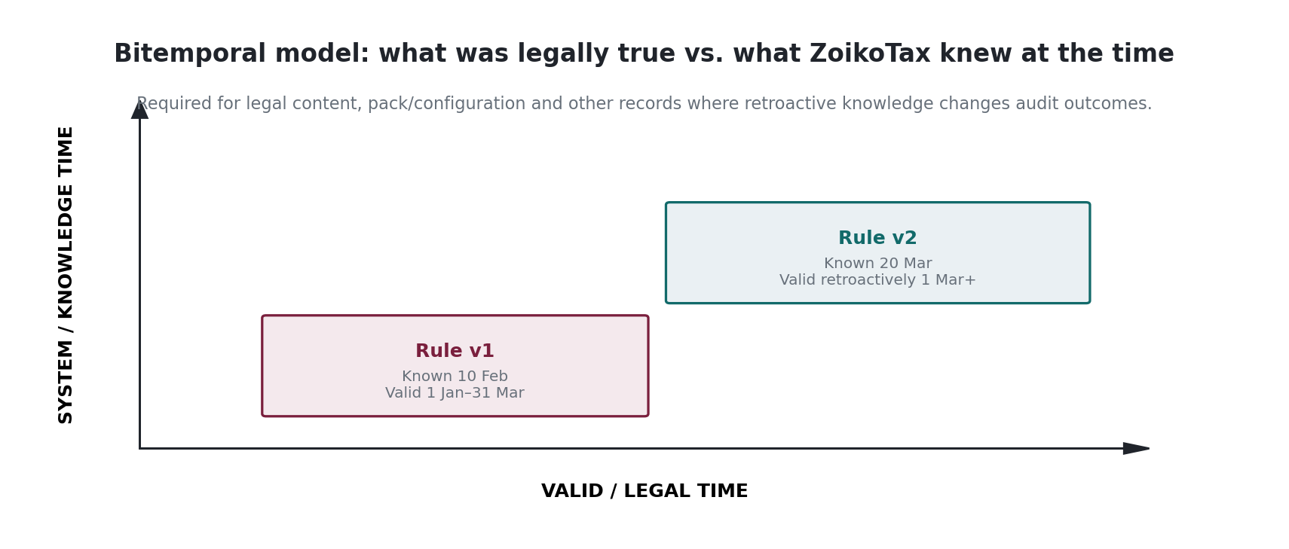
Figure 3 — Bitemporal content/configuration model.

5.2 Bitemporal classes
Class | Examples | Rule
T0 — Immutable fact | Event/fiscal fact | Append-only; occurrence time + recorded time.
T1 — Valid-time | Registration, exemption, relationship | valid_from/valid_to; history retained.
T2 — Bitemporal | Legal rule, source interpretation, pack/configuration, material classification mapping | valid interval + system/knowledge interval.
T3 — Operational status | Workflow status | Mutable current projection plus immutable transition history.

5.3 Time-zone and locale baseline
Persist IANA Time Zone Database identifiers, not only numeric offsets. As of this document date, IANA publishes tzdb releases such as 2026b; production MUST pin the tzdb version used by a decision or due-date calculation where a later timezone-rule change could alter historical interpretation. Locale/language tags use BCP 47; presentation formats SHOULD pin/use the platform-supported stable CLDR release, but localized formatting never determines legal logic.

6. Money, Currency, Rates, Quantities & Rounding

6.1 Money type
MONEY INVARIANT
There is no authoritative Amount field. There is a Money value: decimal amount + ISO 4217 currency code + optional accounting scale metadata. Binary floating-point is prohibited for authoritative monetary arithmetic.
Type | Representation | Rule
Money.amount | arbitrary/implementation-bounded decimal | No binary float. Database NUMERIC/DECIMAL or integer minor-unit representation only if rule can prove sufficient scale.
Money.currency | ISO 4217 alpha code | Codes sourced from the ISO 4217 Maintenance Agency. Historical currencies remain representable for replay.
Rate.value | decimal rational | Explicit basis: percent, per-unit, flat, fraction, basis points, monetary-per-unit.
Percentage | decimal | Store 0.388 or 38.8 consistently per schema; never ambiguous.
Quantity | decimal + unit | Minutes, messages, bytes, units, subscribers, numbers, devices, etc.
FXRate | decimal + base/quote + source + timestamp/date | Exact source and rate date pinned where used.
RoundingPolicy | policy ID/version | Mode, scale, level (component/line/document/return), ordering and residual allocation.
Allocation | basis + weights + residual rule | Bundle allocation must reconcile exactly to source amount.

6.2 Required arithmetic rules
• All intermediate precision rules MUST be declared by DET-001; database/UI display scale MUST NOT truncate authoritative precision.
• Zero-decimal currencies, three-decimal currencies and currencies whose minor units change historically MUST be supported.
• Tax-inclusive extraction, tax-on-tax compounding and allocation residual distribution MUST be deterministic and versioned.
• Negative values are valid only with an explicit semantic (credit/reversal/adjustment); sign MUST NOT be used to infer lifecycle state.
• Currency conversion never mutates the original money. Store original and converted money with FX provenance.
• Rounding occurs only at explicit policy points; double-rounding is prohibited.

7. Jurisdiction, Authority & Location Primitives
Entity | Meaning
Jurisdiction | Canonical legal/tax geography or competence domain; hierarchical or overlapping.
Authority | Body empowered to impose/administer/report/collect an obligation.
JurisdictionEdge | Typed relationship: CONTAINS / OVERLAPS / ADMINISTERED_BY / REPORTS_TO / SPECIAL_DISTRICT_OF.
Address | Structured postal/service address with normalized components and provider version.
GeoResolution | lat/long/precision/geocoder/provider/version; evidence, not automatically legal situs.
SitusEvidence | Typed evidence class and reference/hash/retention class.
SitusDecision | Authoritative resolution of applicable jurisdiction(s) for a purpose.
Establishment | Legal entity presence/fixed establishment/business establishment relevant to place-of-supply.

7.1 Jurisdiction graph rules
• Jurisdiction IDs MUST be stable even when names change.
• Political geography and tax/regulatory jurisdiction are not assumed identical.
• Overlapping special districts MUST be modelled as multiple applicable jurisdiction nodes, not forced into a single-parent tree.
• Postal code is an input, not a jurisdiction key.
• Geocoder result and legal situs result are separate records.
• Country pack references the jurisdiction dataset/version it was validated against.

8. Product, Offering, Service & Bundle Model
Entity | Meaning
ProductOffering | Commercial SKU/offer as sold by tenant; may be imported from BSS/catalog.
CanonicalServiceComponent | ZoikoTax ontology component used for tax/regulatory logic.
ProductMapping | Effective-dated mapping from external SKU/component to canonical service component(s).
BundleDefinition | Composition of components and commercial allocation basis.
ServiceInstance | Optional minimal service context (mobile line, DID, broadband circuit, IoT connection) when needed for tax/situs.
UsageSummary | Normalized usage facts used for taxation/allocation without requiring ZoikoTax to become the rating engine.
TaxAttributeSet | Typed attributes that affect classification (prepaid/postpaid, B2B/B2C, fixed/mobile, etc.).

8.1 Product-mapping invariant
NO TAX LOGIC IN CUSTOMER SKU TEXT
Customer SKU names/descriptions may assist AI classification but are never authoritative logic keys. Authoritative treatment references a versioned ProductMapping and canonical service component ID.

9. Transaction, Fiscal Document & Line Model

9.1 Commercial transaction vs fiscal document
A CommercialTransaction represents normalized commercial facts submitted for fiscal treatment. A FiscalDocument represents a legally/accountingly meaningful document or document intent (quote, invoice, credit note, refund, adjustment). They may be 1:1, 1:N or N:1 depending on source system and jurisdiction.
Entity | Meaning
CommercialTransaction | Immutable normalized event/envelope from upstream commercial system.
TransactionLine | Commercial line with quantity, net/gross basis, product mapping reference and service/customer context.
FiscalDocument | Document aggregate with document type, lifecycle, legal entity, customer/account, currency and totals.
FiscalLine | Fiscal representation of one or allocated commercial line; owns linked classification/situs/tax decisions.
AdjustmentLink | Explicit relation to predecessor document/line/decision: REVERSES / CREDITS / RESTATES / AMENDS / REBILLS.
DocumentNumber | Business/legal number generated or supplied under documented sequence authority.
SourceSnapshotRef | Hash/reference to normalized source payload for evidence and replay.
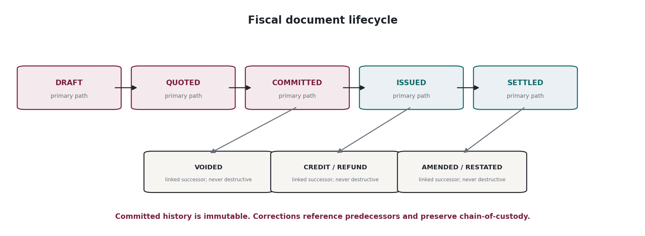
Figure 4 — Canonical fiscal document lifecycle and non-destructive correction model.

9.2 Document invariants
• QUOTE/PREVIEW MUST NOT create authoritative liability or committed obligation unless an explicit jurisdiction-specific rule says otherwise.
• COMMIT is idempotent by business idempotency key and fiscal scope.
• ISSUED document totals MUST reconcile to line/component amounts under declared rounding/allocation policy.
• VOID applies only where legally/operationally allowed before irrevocable downstream use; otherwise a correcting successor is required.
• A credit/refund MUST identify what it corrects; orphan negative tax lines are prohibited for authoritative history.
• A document may be amended by an authority filing process without mutating the underlying original transaction facts.

10. Dual Classification Model
FOUNDATIONAL DOMAIN RULE
Every relevant revenue/fiscal line has two logically independent classifications: (A) TAXABILITY CLASSIFICATION and (B) REGULATORY-REVENUE CLASSIFICATION. They may correlate but one MUST NOT be inferred from the other.
Entity | Meaning
ClassificationDecision | Immutable authoritative decision header: type, status, confidence state, method, effective context, mapping version.
TaxabilityClassification | Canonical service/tax category used for tax determination.
RegulatoryRevenueClassification | Authority/form/revenue-bucket classification used for contributions and reporting.
ClassificationProposal | AI/advisory suggestion; never authoritative until promoted through governed workflow.
ClassificationOverride | Human/governed tenant-specific decision with reason, authority/evidence, scope and effective dates.
ClassificationPrecedent | Optional reusable approved rationale scoped to tenant/jurisdiction; cannot silently become global law.

10.1 Decision status
• RESOLVED — authoritative mapping exists.
• AMBIGUOUS — multiple defensible mappings; human/content decision required.
• UNSUPPORTED — product/jurisdiction/capability not covered by production content.
• STALE — mapping references withdrawn/expired content and must be re-evaluated.

11. Situs & Evidence Decision Model
Entity | Meaning
SitusContext | Purpose: transaction tax / regulatory reporting / VAT place-of-supply / other.
SitusEvidenceRef | Typed evidence class, source, hash/reference, observed_at and privacy/retention class.
SitusCandidate | Candidate jurisdiction + rule/evidence basis.
SitusDecision | Chosen jurisdiction set + status + rule reference + rejected conflicts.
SitusConflict | Competing evidence or legal rules; explicit resolution workflow.
JurisdictionVersionRef | Pinned jurisdiction/geospatial dataset version.

11.1 Privacy boundary
DOM-001 stores the shape of evidence references and classes, not universal raw-evidence retention. PRIV-001 and JUR-001 determine whether a raw address/IP/device/network fact is retained, vaulted, tokenized, hashed, referenced externally or discarded after derivation. A hash is evidence of a value, not proof of the legal truth of that value.

12. Exemption, Certificate & Qualification Model
Entity | Meaning
Exemption | A tax/regulatory treatment reducing or eliminating an obligation under defined scope.
Certificate | Document/evidence supporting exemption/resale/wholesale/government status.
QualificationDecision | Whether the exemption applies to party/product/jurisdiction/date/charge type.
CertificateValidation | Issuer/format/status/expiry/revocation validation result.
ExemptionUsage | Link from authoritative decision to exemption/certificate version used.
ExemptionOverride | Governed exceptional determination with reason/evidence and expiry.
• Expired/revoked certificate versions remain retained for historical replay.
• An exemption MAY be valid for one charge type and invalid for another.
• Wholesale/resale status is not a global boolean. It is scoped by jurisdiction, relationship, service, evidence and effective period.
• Missing certificate does not silently mean taxable or exempt when law permits alternative evidence; outcome follows the applicable rule/pack.

13. Content, Rule & Pack Reference Model
Entity | Meaning
AuthorityInstrument | Statute/regulation/order/rate table/guidance/form/specification.
SourceArtifact | Immutable retrieved source copy/metadata/license classification.
Interpretation | Human-approved statement mapping source(s) to executable rule intent.
RuleSemanticId | Stable ID of a logical rule across versions.
RuleVersion | Effective/knowledge-dated executable version.
RuleBundle | Signed immutable executable set for runtime.
CountryRegulatoryPack | Governed package aggregating content, data, tests, schemas and lifecycle state.
PackCapability | Tax determination / filing / CTC / managed service capability advertised by a pack.

13.1 Pinned references
• Authoritative decisions store semantic IDs AND exact version/hash references.
• Source URLs alone are insufficient evidence; immutable source artifact identity is required where legally/licensing permitted.
• Pack status is version-specific. A new pack version does not rewrite historical support status.
• Application release, rule bundle, AI model and authority adapter versions are separate dimensions.

14. Authoritative Decision Model
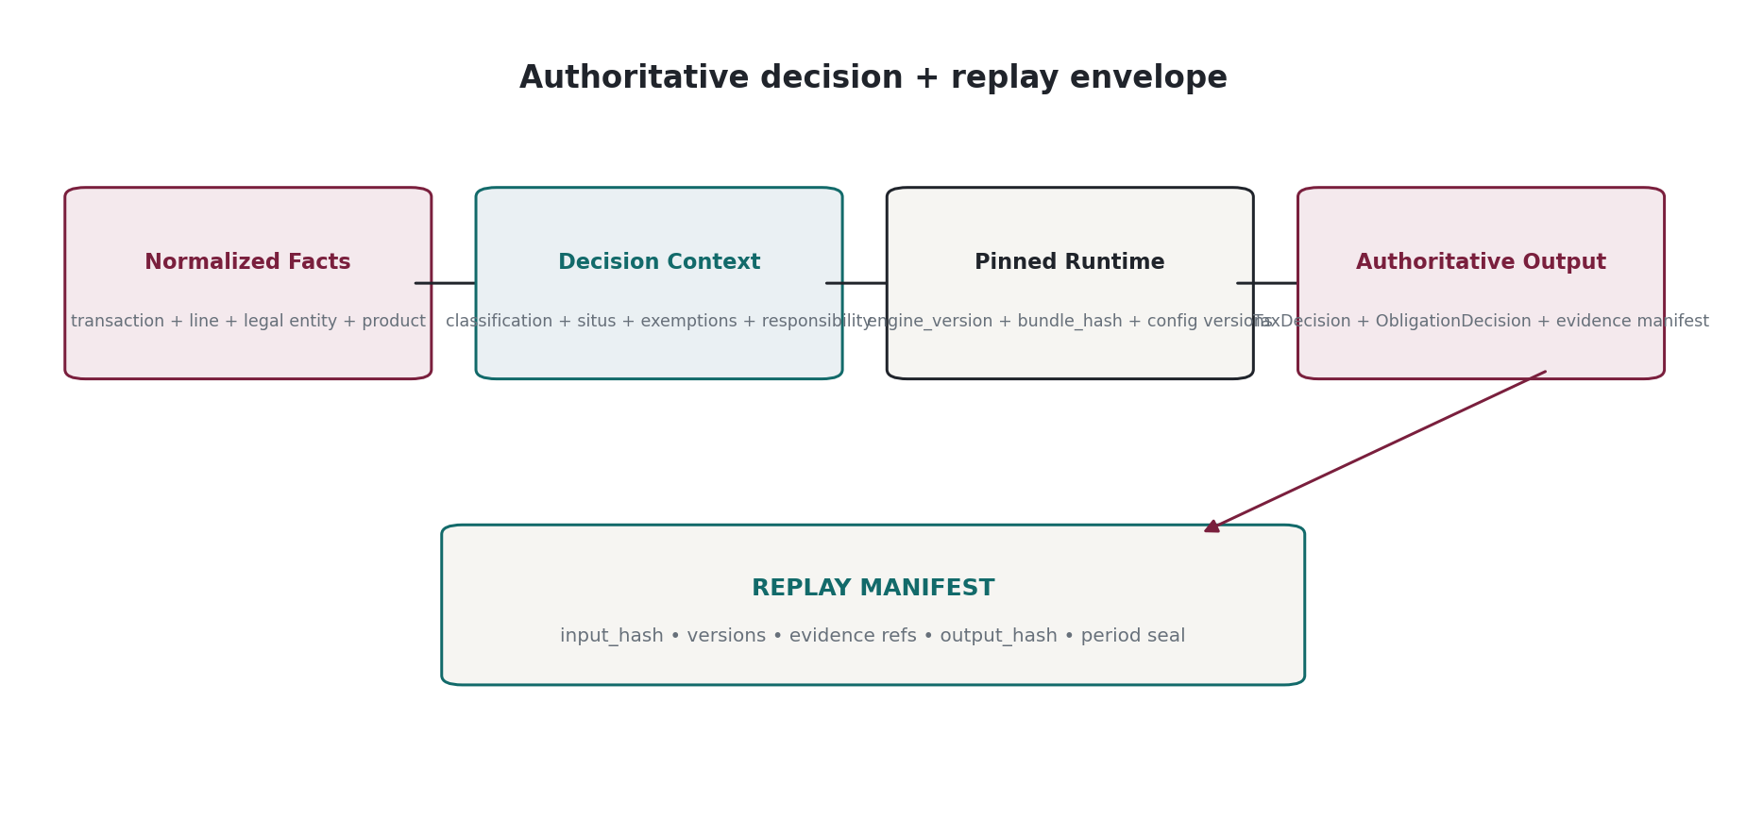
Figure 5 — Authoritative decision and replay envelope.

14.1 Decision record classes
Record | Authority
TaxDecision | Authoritative computed tax/fee result for fiscal scope.
ClassificationDecision | Authoritative taxability/regulatory-revenue classification.
SitusDecision | Authoritative applicable jurisdiction/place-of-supply result.
ResponsibilityResolution | Authoritative five-role responsibility result.
ObligationDecision | Authoritative liability/reporting obligation conclusion for party/authority/period.
DecisionStatus | Mutable workflow/operational status separated from immutable decision facts.
DecisionAnalytics | Derived scores, anomaly flags, materiality, forecast; rebuildable and non-authoritative.
DecisionExplanation | Source-backed human-readable explanation bound to exact decision/version; may be AI-assisted but labeled accordingly.

14.2 Minimum immutable decision envelope
Field | Purpose
decision_id | canonical UUIDv7
decision_type | typed enum
tenant_id / legal_entity_id | scope
document_id / line_id | fiscal subject
event_time / decision_time | temporal
effective_date | legal evaluation date
classification_refs | taxability + regulatory
situs_decision_id | jurisdiction
responsibility_resolution_id | role attribution
exemption_usage_refs | exemptions/certificates
engine_version | code/runtime identity
rule_bundle_hash | exact executable content
pack_version_refs | legal capability context
jurisdiction_dataset_version | geospatial/legal geography
rounding_policy_id/version | monetary semantics
fx_ref | if currency conversion used
input_fingerprint | canonical normalized input hash
evidence_manifest_id | provenance
result_amounts | structured money results
reason_codes | machine-readable reasons
status | RESOLVED/AMBIGUOUS/UNSUPPORTED/etc.
supersedes/reverses_decision_id | correction chain if any
output_hash | integrity/replay

15. Responsibility Model
Role/record | Meaning
IncidenceParty | On whom law imposes economic/legal charge.
CollectorParty | Who must collect from customer, if any.
ReportingParty | Who must report revenue/transaction.
RemittingParty | Who must remit/pay authority.
EconomicBearer | Who bears cost after contract/wholesale indemnities.
ResponsibilityBasis | Rule, contract, registration/licence and evidence references.
ResolutionStatus | RESOLVED / AMBIGUOUS / UNSUPPORTED.
ResponsibilityOverride | Governed scoped override with expiry and evidence.
Responsibility roles MAY point to the same party or to different parties. The domain model must never collapse them into one “taxpayer” field.

16. Obligation Model
ATOMIC OBLIGATION
Obligation is the canonical unit connecting classified revenue/transactions to an authority, responsible party, calculation basis, period, due date and discharge workflow. It covers both transaction-level charges and period-level regulatory liabilities.
Field | Meaning
obligation_id | Canonical identity
obligation_kind | TRANSACTION_CHARGE / PERIODIC_CONTRIBUTION / REGISTRATION / INFORMATION_RETURN / PAYMENT / DOCUMENT / OTHER
party_id | Responsible legal entity
authority_id | Authority owed/reported to
jurisdiction_ids | Applicable jurisdictions
charge_type_id | Canonical tax/fee/levy/contribution type
basis | transaction / revenue bucket / subscriber / quantity / flat / other
period_id | Filing/accounting/legal period
amount | Money if monetary; nullable for non-monetary obligations
due_at | Authority-local due date/time
decision_refs | Underlying classification/tax/responsibility decisions
status | DISCOVERED / READY / DUE / FILED / PAID / ACCEPTED / DISPUTED / SUPERSEDED etc.
discharge_refs | Return/filing/remittance/evidence records

16.1 Transaction vs period obligation
• A transaction tax may create line-level tax decisions and an aggregate payable obligation.
• A revenue-based telecom contribution may aggregate classified revenue across a period and create one or more periodic obligations.
• Obligation amount may be unknown at discovery time; status and basis remain explicit.
• Obligation discovery does not equal legal filing acceptance. Each stage is separately recorded.

17. Stateful Threshold & Accumulator Model
Entity | Meaning
AccumulatorDefinition | Rule-owned definition of period/scope/key/basis/threshold/tier/reset behavior.
AccumulatorKey | Tenant + legal entity + jurisdiction/authority + charge + subject dimensions + period.
AccumulatorEvent | Append-only contribution/reversal to accumulator.
AccumulatorSnapshot | Derived checkpoint for performance; rebuildable from events.
ThresholdDecision | Decision that references pre/post accumulator state and rule version.
ConcurrencyToken | Serialization/version used to prevent double consumption under concurrent commits.
• Accumulator state MUST support reversals and late-arriving events without corrupting historical period state.
• Commit semantics MUST guarantee exactly-once business effect even when infrastructure delivery is at-least-once.
• Snapshots are not authority; event history and deterministic rule define authority.
• Period close/lock semantics must be explicit for accumulators used in filed liabilities.

18. Registration, Return, Filing, Remittance, Notice & Case Model
Entity | Meaning
Registration | Legal entity authorization/registration with authority, jurisdiction, charge scope, IDs and effective dates.
FilingRequirement | Pack-derived requirement defining form/schema/cadence/due-date rule/authority.
FilingPeriod | Concrete instance of reporting period for legal entity + requirement.
Workpaper | Calculated/reportable data set supporting a return, with version and tie-out state.
Return | Prepared statutory/regulatory declaration for a filing period.
FilingSubmission | Attempt to transmit return/data; immutable attempt record.
AuthorityAcknowledgement | Receipt/accepted/rejected/pending/duplicate/other authority response.
RemittanceInstruction | Approved instruction to customer treasury/payment provider; not fund custody by default.
RemittanceConfirmation | Evidence of execution/settlement from payment source/authority.
Notice | Inbound authority communication; immutable source + classification.
Case | Operational container for notice, audit, discrepancy, amendment or regulatory issue.

18.1 Submission state machine
• PREPARED → REVIEWED → APPROVED → SUBMISSION_PENDING → SUBMITTED → ACCEPTED.
• REJECTED is terminal for an attempt, not for the return; corrected return creates new version/submission attempt.
• UNCERTAIN_SUBMISSION is mandatory when transmission outcome is unknown; retry logic must not create duplicate legal submissions without authority-specific idempotency/deduplication controls.
• AMENDED links to previous accepted return; it does not erase it.

19. E-Invoice / CTC Domain Model
Entity | Meaning
CanonicalInvoice | ZoikoTax semantic invoice model linked to FiscalDocument.
InvoiceProfile | Jurisdiction/network profile, schema version and constraints.
InvoicePayload | Generated UBL/CII/other payload with hash/version.
ClearanceSubmission | Attempt sent through certified partner/network/authority.
ClearanceStatus | SENT / RECEIVED / CLEARED / REJECTED / CANCELLED / UNKNOWN.
GovernmentIdentifier | Authority-assigned invoice/clearance ID where applicable.
EReportingRecord | Periodic/near-real-time report distinct from invoice clearance where regime requires.
CTCReconciliation | Tie between fiscal document, submitted payload, clearance outcome and accounting/filing data.

20. Tax Control Subledger & Reconciliation Model
Entity | Meaning
TaxLedgerAccount | Control-account dimension, not enterprise GL account.
TaxLedgerEntry | Immutable debit/credit control posting tied to fiscal/obligation decision.
PostingBatch | Atomic posting set for document/period action.
GLMapping | Effective-dated mapping to customer ERP/GL accounts; external GL remains SoR.
ReconciliationRun | Defined comparison scope/time/inputs/version.
ReconciliationItem | Matched/unmatched component across calculated, invoiced, collected, adjusted, reported, remitted, GL.
Variance | Amount + category + materiality + reason/workflow status.
PeriodLock | Prevents silent mutation after fiscal/reporting close; adjustments create successor postings.
• Ledger entries balance within each posting batch under FIN-001 rules.
• A reconciliation result is derived analytics/workflow evidence; it does not alter original tax decisions.
• GL mapping changes are effective-dated and cannot restate historical postings without explicit restatement process.
• Collected amount may be external-source data; ZoikoTax stores normalized fiscal facts/provenance necessary for reconciliation.

21. Evidence, Provenance & Replay Domain Model
Entity | Meaning
EvidenceRecord | Typed evidence metadata and storage/reference pointer.
EvidenceArtifact | Immutable bytes/object when ZoikoTax is authorized to retain them.
EvidenceReference | Pointer/hash to customer/authority/source-system evidence retained elsewhere.
EvidenceManifest | Ordered/set manifest of all evidence and version references supporting a decision.
ReplayManifest | Canonical normalized inputs + code/content/config/dataset refs + expected output hash.
PeriodSeal | Signed/Merkle-style aggregate integrity proof for a period/tenant scope.
LegalHold | Retention override preventing eligible deletion for scoped evidence/records.
ApprovalRecord | Who approved what version, when, under which role/segregation rule.

21.1 Provenance chain
SourceArtifact → Interpretation → RuleVersion → RuleBundle → Decision → Obligation → Return/Filing → Acknowledgement/Remittance → PeriodSeal

22. AI / Intelligence Domain Records
AI records are explicitly non-authoritative unless and until their output is promoted through a separate governed human/deterministic workflow. The record shape must make this impossible to confuse.
Record | Meaning
AIInvocation | Model/provider/version/prompt/template/tool/retrieval context metadata, policy and timing.
AIProposal | Suggested classification/rule/change/resolution with confidence and provenance.
AIExplanation | Human-readable explanation of an authoritative decision, linked to the exact decision.
AnomalyFinding | Derived risk/finding with model/rule/version and evidence refs.
Forecast | Scenario/assumptions/horizon/output; never a booked liability.
ModelEvaluation | Dataset/version/metrics/thresholds/result used for release governance.
HumanReview | Reviewer, disposition, edits, reason and promotion target.
PromotionLink | Explicit link from approved proposal to authoritative rule/mapping/change record; AI record itself remains non-authoritative.

23. Shadow Assurance Domain Model
Entity | Meaning
ShadowRun | Scope, period, tenant, source engines/data and comparison policy.
IncumbentResult | Normalized third-party/current-system output with source/version where available.
ZoikoShadowResult | ZoikoTax non-impact parallel output or analysis.
Difference | Typed delta: amount / classification / situs / obligation / registration / reconciliation / evidence.
MaterialityAssessment | Financial/regulatory/customer impact estimate and threshold policy.
RootCauseHypothesis | Derived/AI-assisted explanation; non-authoritative until reviewed.
ShadowFinding | Reviewable customer finding, status and remediation references.
CorpusPermission | Contract/data-rights flag governing whether de-identified data may be retained for platform improvement.

24. Aggregate Roots & Transactional Consistency Boundaries
Aggregate root | Consistency rule
TenantConfiguration | Tenant/legal-entity configuration; versioned. Do not update fiscal decisions in same transaction.
FiscalDocument | Document + lines + commit-time decisions that must be atomically consistent for authoritative commit.
Obligation | Obligation header + status transitions + links; filing/remittance are separate aggregates.
Return | Return version + workpaper snapshot + approval state; submissions are child attempts/separate append-only records.
Accumulator | Concurrency-protected key + events; optimized snapshots may be separate.
EvidenceManifest | Immutable manifest; evidence artifacts may live in object storage.
CountryPack | Content package identity/status; rule bundle immutable once published.
Case | Operational workflow; cannot mutate source notice/authoritative fiscal records.
ReconciliationRun | Derived run + items/variances; source records read-only.
AIProposal | Independent advisory aggregate; promotion creates/updates a different governed authoritative aggregate.

24.1 Cross-aggregate rule
NO DISTRIBUTED ACID REQUIREMENT
Use local ACID transactions inside an aggregate boundary plus transactional outbox/domain events for cross-aggregate propagation. A business workflow may be eventually consistent while still achieving exactly-once business effect through idempotency and state-machine guards.

25. System of Record & Data Ownership Matrix
Data domain | System of record | Boundary
Tenant/security metadata | ZoikoTax | Global metadata plane; no raw subscriber transaction data.
Legal entity tax configuration | ZoikoTax | Authoritative for ZoikoTax treatment; source corporate master may remain external.
Customer/account/product commercial master | Usually external BSS/CRM/ERP | ZoikoTax retains normalized snapshot/version refs needed for fiscal explanation.
Tax/regulatory content | ZoikoTax governed content system / licensed source | Executable ZoikoTax interpretation is authoritative for ZoikoTax decisions.
Tax/obligation decisions | ZoikoTax | Immutable authoritative decisions for supported production pack.
Invoice business document | BSS/ERP or ZoikoTax depending operating mode | ZoikoTax owns fiscal semantic representation when it generates/clears the document.
Tax control subledger | ZoikoTax | Control ledger only; enterprise GL remains external.
Filing/return created by ZoikoTax | ZoikoTax | Authority acknowledgement is external evidence.
Payment funds | Customer treasury/payment provider | ZoikoTax default is instruction/confirmation, not custody.
Raw high-risk situs evidence | Defined by PRIV/JUR/pack | May remain external; ZoikoTax stores minimum evidence reference/class.
AI proposal/analytics | ZoikoTax | Non-authoritative derived data with model/version provenance.

26. Logical Storage Mapping & Physical Independence
The canonical model is logical. It does not require one relational database. Each bounded context owns its storage; cross-context reads use APIs/events/read models. PostgreSQL/PostGIS is the default authoritative relational/geospatial store in ARCH-001; object storage is used for immutable artifacts; columnar stores serve analytics/reconciliation projections.
Store class | Data | Rule
Relational authoritative | tenant/legal entity, product mappings, fiscal document, decisions, obligations, returns/status, config | PostgreSQL-class store with constraints/transactions.
Geospatial | jurisdiction geometries, address/geocode indexes | PostGIS/geospatial index; version pinned.
Object/WORM | source artifacts, filing payloads, evidence artifacts, signed bundles | Immutable/object-lock where evidence policy requires.
Event backbone | domain events/outbox propagation | Kafka-compatible; at-least-once delivery, idempotent consumers.
Columnar analytics | reconciliation, TaxOps, large historical analyses | ClickHouse-class/warehouse; never source of authoritative decision truth.
Search | support/audit text and metadata discovery | Search index derived from authoritative sources.
Vector retrieval | regional legal/content retrieval for AI | Non-authoritative retrieval index with provenance.

27. Partitioning, Indexing & Scale Keys
• Every high-volume fiscal table MUST have a clear tenant/legal-entity/cell partitioning strategy.
• Partition keys MUST avoid cross-tenant hot spots and must not require global sequential IDs.
• FiscalDocument/TaxLine/TaxDecision indexes SHOULD optimize tenant + legal_entity + event/effective date + external reference + period queries.
• Obligation/filing indexes SHOULD optimize legal_entity + authority + filing_requirement + period + status/due date.
• Evidence object paths MUST not expose PII or secrets in key names.
• Time-based table partitioning MUST not be used where retroactive effective dates make operational date a poor routing key without an alternate index.
• Analytics projections MAY denormalize; authoritative OLTP schemas MUST preserve domain integrity over dashboard convenience.

28. Canonical State Machines
Aggregate | State model
Classification/Situs/Responsibility | PENDING → RESOLVED | AMBIGUOUS | UNSUPPORTED | CONFLICTED; later SUPERSEDED by a new decision, not mutated.
FiscalDocument | DRAFT → QUOTED → COMMITTED → ISSUED → SETTLED with explicit VOID/CREDIT/REFUND/REBILL/AMENDMENT successors as applicable.
Obligation | DISCOVERED → DATA_REQUIRED → READY → DUE → REPORTED/FILED → PAID/ACCEPTED; DISPUTED/AMENDED/SUPERSEDED branches.
Return | DRAFT → PREPARED → REVIEWED → APPROVED → SUBMISSION_PENDING → SUBMITTED → ACCEPTED | REJECTED | UNCERTAIN_SUBMISSION → AMENDED if needed.
CountryPack | RESEARCH → VALIDATION → PILOT → PRODUCTION → MANAGED; SUSPENDED or WITHDRAWN with historical replay retained.
ExemptionCertificate | PENDING → VALID → EXPIRED/REVOKED/REJECTED; prior validity retained historically.
ShadowFinding | DETECTED → REVIEWED → CONFIRMED | DISMISSED → REMEDIATION_PLANNED → RESOLVED.
AIProposal | PROPOSED → UNDER_REVIEW → APPROVED_FOR_PROMOTION | REJECTED; approval does not itself mutate authoritative target.
Case | OPEN → INVESTIGATING → ACTION_REQUIRED → WAITING_EXTERNAL → RESOLVED → CLOSED; reopening creates transition history.

29. Canonical Domain Events
Event | Meaning
FiscalDocumentCommitted | Document became authoritative; triggers downstream posting/obligation/evidence.
TaxDecisionCreated | New authoritative tax decision.
TaxDecisionSuperseded | Successor decision references prior decision.
ClassificationResolved | Authoritative mapping available.
SitusConflictDetected | Evidence/rules conflict; work item required.
ResponsibilityAmbiguous | Five-role resolution unresolved.
ObligationDiscovered | New obligation identified.
ObligationAmountUpdated | Period-level recomputation produced successor amount/version.
ReturnApproved | Human/control approval complete.
FilingSubmitted | Submission attempt recorded.
AuthorityAcknowledged | Authority response stored.
RemittanceInstructionApproved | Instruction ready for external execution.
PackActivated | Pack version effective in cell/tenant scope.
PackSuspended | Pack authoritative use blocked.
EvidencePeriodSealed | Period integrity seal generated.
ShadowFindingConfirmed | Reviewed material finding confirmed.
AIProposalPromoted | Governed promotion created authoritative target version.

29.1 Event envelope minimum
• event_id; event_type; event_version; occurred_at; recorded_at; tenant_id; legal_entity_id where applicable; aggregate_type/id/version; correlation_id; causation_id; data_cell_id; actor/principal; schema_version; payload hash/classification.
• Events are immutable facts. Consumers build projections; they do not reinterpret historical events using current rules unless explicitly performing replay/recalculation.

30. Data Quality, Validation & Error Semantics
Class | Behavior
Syntactic validity | Schema/type/format correctness. Reject before domain processing.
Referential validity | Referenced canonical IDs/source mappings exist and are in permitted tenant/cell scope.
Temporal validity | Effective dates/periods and source observations are logically consistent.
Monetary validity | Currency, scale, signs, totals and allocation reconcile.
Legal-content validity | Required PRODUCTION pack/capability and rule version exist.
Evidence sufficiency | Required evidence classes exist for decision purpose.
Ambiguity | Multiple legal/product/situs/responsibility interpretations remain; return governed state, not generic validation error.
Unsupported | Capability/jurisdiction not supported. Distinct from system failure.
System error | Unexpected infrastructure/software failure; retry semantics separate from business rejection.

31. Concurrency, Idempotency & Mutation Rules
• Mutating public operations MUST scope idempotency key to tenant + operation + endpoint/business action and retain outcome long enough to protect realistic retry windows.
• A repeated identical commit returns the same business outcome/reference; a reused key with different normalized payload is a conflict.
• Optimistic concurrency/version fields are required on mutable configuration/status aggregates.
• Authoritative immutable decision/fiscal fact rows do not use last-write-wins.
• Accumulator updates require serialization/CAS/advisory-lock or equivalent mechanism proven under concurrent duplicate delivery.
• Cross-cell transaction commits are prohibited for authoritative fiscal aggregates; route the aggregate to one cell and federate approved summaries/events.
• Background recalculation creates a new decision/version; it cannot overwrite original result.

32. Data Classification, Privacy & Retention Hooks
Class | Examples
D0 — Public/Reference | Public rates, public legal instruments, public jurisdiction metadata.
D1 — Tenant Business | Product catalogue, configuration, aggregate obligations.
D2 — Confidential Fiscal | Invoices, tax decisions, returns, revenue classifications, financial reconciliations.
D3 — Personal/Sensitive | Customer identity, address, device/network/situs evidence, support content containing PII.
D4 — Secrets/Regulator Credentials | Private keys, filing credentials, authority tokens, payment authorization secrets.
• Every domain record type MUST declare data classification and residency behavior in its governing capability/privacy specification.
• Retention policy is attached by data class/record type/pack/customer/legal hold; no universal retain-all or discard-all rule.
• Deletion of legally eligible personal data MUST preserve integrity of retained financial/evidence chains using tombstones/tokenization/redaction where appropriate and legally valid.
• Audit logs must not copy raw D3/D4 payloads indiscriminately.

33. Schema & Database Invariants
• Use explicit enums/code tables for stable domain states; never infer state from nullable fields.
• Use CHECK/foreign-key/exclusion constraints where they enforce constitutional rules without creating cross-service coupling.
• Tenant/legal-entity ownership columns are NOT nullable on tenant-owned authoritative aggregates.
• Use unique constraints for canonical source reference and idempotency scopes.
• Core amounts/rates/quantities are typed columns or validated value objects, not unvalidated JSON.
• JSONB/extensions are permitted for jurisdiction-specific auxiliary attributes only with schema_version and governing pack/spec.
• Every mutable status aggregate carries version/revision for concurrency control and immutable transition history.
• No cascaded hard-delete across authoritative fiscal/evidence aggregates.
• Database timestamps are UTC instants; local statutory dates/timezones are separate typed fields.
• All schemas use snake_case or the approved engineering convention consistently; API names are mapped, not implicitly coupled to physical column names.

34. Schema Evolution, Compatibility & Migration
• Expand → migrate/backfill → dual-read/dual-write if needed → verify → contract. Destructive contract waits until all supported application versions and replay requirements are safe.
• A renamed legal/business concept keeps stable canonical identity; aliases/deprecation metadata preserve historical meaning.
• Enum changes require unknown/forward-compatible handling in integrations; do not break event consumers by reusing enum values.
• Historical decisions remain readable after schema evolution; replay service provides adapters if canonical internal representation changes.
• Migrations affecting immutable evidence hashes require new canonicalization/version, never recalculation of old hashes in place.
• Country-pack schema versions are independent from application DB schema versions.

35. End-to-End Domain Examples

35.1 Retail mobile invoice — native mode
1. BSS sends CommercialTransaction with customer/account, service address/PPU evidence references, SKU, usage summary and amounts.
2. ZoikoTax resolves ProductMapping → canonical mobile service components.
3. Independent TaxabilityClassification and RegulatoryRevenueClassification decisions are created.
4. SitusDecision resolves applicable jurisdictions for each purpose.
5. Exemption qualification and ResponsibilityResolution are evaluated.
6. DET creates TaxDecision records under pinned rule bundle/version and rounding policy.
7. FiscalDocument commits atomically with lines/decisions; evidence manifest and outbox event are created.
8. Obligation Engine creates transaction and/or period obligation contributions.
9. Tax control subledger posts; downstream invoice/ERP receives deterministic result.
10. Later credit creates successor document/decisions and reversing ledger/accumulator events; original history remains unchanged.

35.2 Regulatory contribution — period mode
1. Revenue lines are classified into authority-specific regulatory buckets.
2. Accumulator events aggregate assessable revenue by legal entity/period/category.
3. Published contribution rule/factor is applied using exact bundle/version.
4. ObligationDecision produces periodic liability and due-date context.
5. Workpaper and return link back to contributing revenue classifications and evidence.
6. Filing submission and authority acknowledgement are recorded as separate immutable events.
7. Remittance instruction is approved; customer treasury executes; confirmation reconciles liability without ZoikoTax holding funds by default.

35.3 Cross-border VAT / place-of-supply
1. Commercial facts identify seller legal entity, customer type, service component and evidence classes.
2. JUR-001 resolves place-of-supply under the active pack, potentially using establishment/customer-location/use-and-enjoyment rules.
3. TaxDecision records VAT treatment, rate/base, jurisdiction and rule provenance.
4. If evidence conflicts, SitusDecision is CONFLICTED/AMBIGUOUS and the configured policy determines block, degraded quote or review; the system does not silently use billing address.

36. Normative Domain Requirements
Requirement ID | Area | Normative requirement | Verification | Delegates
ZTAX-DOM-REQ-0001 | IDENTITY | Every authoritative domain entity MUST have an immutable ZoikoTax canonical identifier distinct from external source identifiers. | TEST | DOM
ZTAX-DOM-REQ-0002 | IDENTITY | New canonical identifiers SHOULD use UUIDv7 unless a documented ADR approves another representation for a bounded context. | INSPECTION | ARCH/DOM
ZTAX-DOM-REQ-0003 | IDENTITY | External references MUST include source-system and namespace/object-type context and MUST NOT be used as canonical primary keys. | TEST | INT/DOM
ZTAX-DOM-REQ-0004 | GLOBAL | Canonical schemas MUST NOT use localized display labels or country-specific names as logic keys. | TEST | DOM/CONT
ZTAX-DOM-REQ-0005 | TENANCY | Tenant-owned authoritative aggregates MUST be attributable to tenant, legal entity and execution/residency context. | TEST | SEC/DOM
ZTAX-DOM-REQ-0006 | TENANCY | A commercial tenant MUST support multiple legal entities and data-domain routes across regional cells without centralizing raw fiscal/PII data by default. | DEMONSTRATION | SEC/ARCH
ZTAX-DOM-REQ-0007 | AUTHORITY | FACT, AUTHORITATIVE_DECISION, OPERATIONAL_STATUS, ANALYTIC, AI_PROPOSAL and EVIDENCE record classes MUST be distinguishable in schema/metadata. | INSPECTION | DOM
ZTAX-DOM-REQ-0008 | AUTHORITY | Derived analytics or AI outputs MUST NOT mutate authoritative facts or historical decisions. | TEST | AIGOV/AI
ZTAX-DOM-REQ-0009 | TIME | Authoritative event timestamps MUST represent unambiguous instants; statutory local deadlines MUST retain IANA timezone context. | TEST | DOM/NFR
ZTAX-DOM-REQ-0010 | TIME | Legal/content/configuration records whose historical interpretation may change retroactively MUST support valid-time and system/knowledge-time history. | TEST | CONT/DOM
ZTAX-DOM-REQ-0011 | TIME | Operational tables MUST NOT be made bitemporal merely for consistency if version/audit history meets the actual requirement. | INSPECTION | DOM
ZTAX-DOM-REQ-0012 | MONEY | Authoritative monetary values MUST use deterministic decimal semantics and explicit ISO 4217 currency codes. | TEST | DET/FIN
ZTAX-DOM-REQ-0013 | MONEY | Binary floating-point types MUST NOT be used for authoritative fiscal amounts, tax bases, rates or FX calculations. | TEST | DET/FIN
ZTAX-DOM-REQ-0014 | MONEY | Rounding policy and level MUST be explicit/versioned for any authoritative decision that rounds. | TEST | DET/FIN
ZTAX-DOM-REQ-0015 | MONEY | Currency conversion MUST preserve original money and pin FX source/rate/date when conversion influences an authoritative result. | TEST | DET/FIN
ZTAX-DOM-REQ-0016 | PRODUCT | External SKU/product text MUST NOT directly determine authoritative tax treatment without a versioned product mapping/classification decision. | TEST | CLS
ZTAX-DOM-REQ-0017 | CLASSIFICATION | Taxability classification and regulatory-revenue classification MUST be modeled as independent authoritative decisions. | TEST | CLS/DOM
ZTAX-DOM-REQ-0018 | CLASSIFICATION | Classification ambiguity MUST produce an explicit non-resolved state rather than a hidden default. | TEST | CLS
ZTAX-DOM-REQ-0019 | JURISDICTION | Geocoding/address normalization results MUST be distinct from legal situs/place-of-supply decisions. | TEST | JUR
ZTAX-DOM-REQ-0020 | JURISDICTION | Jurisdiction identifiers MUST remain stable across display-name changes and support overlapping/special jurisdictions. | TEST | JUR/CONT
ZTAX-DOM-REQ-0021 | PRIVACY | Situs evidence records MUST support evidence-class and retention/reference semantics without requiring universal raw-data retention. | INSPECTION | PRIV/JUR
ZTAX-DOM-REQ-0022 | EXEMPTION | Exemption qualification MUST be scoped by jurisdiction, charge/service, party/evidence and effective period; it MUST NOT be a global customer boolean. | TEST | DET/CONT
ZTAX-DOM-REQ-0023 | FISCAL | CommercialTransaction and FiscalDocument MUST be separate canonical concepts. | INSPECTION | FIN/INT
ZTAX-DOM-REQ-0024 | FISCAL | QUOTE/PREVIEW operations MUST NOT create committed fiscal liability unless an explicit governed rule requires such effect. | TEST | FIN/INT
ZTAX-DOM-REQ-0025 | FISCAL | Committed fiscal documents and authoritative tax decisions MUST be immutable. | TEST | FIN/EVID
ZTAX-DOM-REQ-0026 | FISCAL | Corrections MUST create linked reversal/credit/refund/rebill/amendment/restatement records rather than overwrite committed history. | TEST | FIN
ZTAX-DOM-REQ-0027 | FISCAL | Negative monetary values MUST NOT be used as the sole mechanism for inferring lifecycle semantics. | TEST | FIN
ZTAX-DOM-REQ-0028 | DECISION | Every authoritative decision MUST pin engine/runtime version, executable content/bundle hash, applicable pack/configuration versions and evidence/provenance references sufficient for replay. | AUDIT | EVID/CONT
ZTAX-DOM-REQ-0029 | DECISION | Decision facts MUST be separated from mutable operational status and rebuildable analytics. | INSPECTION | DOM
ZTAX-DOM-REQ-0030 | DECISION | A successor decision MUST explicitly reference the decision it supersedes/reverses/restates when correcting historical authoritative output. | TEST | EVID/FIN
ZTAX-DOM-REQ-0031 | RESPONSIBILITY | Incidence, collection, reporting, remittance and economic-bearer roles MUST be modeled independently. | TEST | OBL
ZTAX-DOM-REQ-0032 | RESPONSIBILITY | Responsibility resolution MUST support RESOLVED, AMBIGUOUS and UNSUPPORTED outcomes. | TEST | OBL
ZTAX-DOM-REQ-0033 | OBLIGATION | Obligation MUST be modeled as an atomic party-authority-period-basis responsibility capable of representing monetary and non-monetary obligations. | TEST | OBL/COMP
ZTAX-DOM-REQ-0034 | OBLIGATION | Transaction-level decisions and period-level regulatory obligations MUST remain connected through traceable contributing records. | DEMONSTRATION | OBL/EVID
ZTAX-DOM-REQ-0035 | ACCUMULATOR | Stateful thresholds/tiering MUST use append-only contribution/reversal events or an equivalently replayable model; mutable counters alone are insufficient authority. | TEST | DET/FIN
ZTAX-DOM-REQ-0036 | ACCUMULATOR | Concurrent commits MUST not double-consume thresholds or caps under duplicate/retried delivery. | TEST | DET/NFR
ZTAX-DOM-REQ-0037 | COMPLIANCE | Return, FilingSubmission and AuthorityAcknowledgement MUST be separate record types. | INSPECTION | COMP
ZTAX-DOM-REQ-0038 | COMPLIANCE | Submission uncertainty MUST be representable independently from rejection or success. | TEST | COMP
ZTAX-DOM-REQ-0039 | REMITTANCE | RemittanceInstruction and RemittanceConfirmation MUST be separate from fund custody and from filing state. | INSPECTION | REM
ZTAX-DOM-REQ-0040 | CTC | CanonicalInvoice/FiscalDocument, generated CTC payload, submission attempt and clearance outcome MUST be separately traceable. | TEST | CTC
ZTAX-DOM-REQ-0041 | LEDGER | ZoikoTax tax-control subledger records MUST be distinct from the customer enterprise GL while supporting effective-dated GL mappings. | INSPECTION | FIN
ZTAX-DOM-REQ-0042 | LEDGER | Reconciliation records MUST not mutate original source decisions or postings. | TEST | FIN
ZTAX-DOM-REQ-0043 | EVIDENCE | EvidenceManifest and ReplayManifest MUST be immutable once bound to an authoritative decision, except through superseding manifests. | TEST | EVID
ZTAX-DOM-REQ-0044 | EVIDENCE | Historical replay MUST not depend on current mutable mappings or current rule content. | DEMONSTRATION | EVID/QA
ZTAX-DOM-REQ-0045 | AI | AIProposal, AIExplanation, AnomalyFinding and Forecast MUST be schema-distinct from authoritative decision records. | INSPECTION | AIGOV/AI
ZTAX-DOM-REQ-0046 | AI | Promotion of AI output MUST create/update a separately governed authoritative record while retaining the original AI proposal and review trail. | AUDIT | AIGOV/CONT
ZTAX-DOM-REQ-0047 | SHADOW | Shadow results/findings MUST be distinguishable from production-authoritative decisions and MUST not alter billing/filing outcomes. | TEST | SHD
ZTAX-DOM-REQ-0048 | PACK | Country/regulatory pack identity/version/status MUST be modeled independently from application, AI and authority-adapter versions. | TEST | CONT/DEVOPS
ZTAX-DOM-REQ-0049 | PACK | SUSPENDED/WITHDRAWN pack versions MUST remain available for historical replay and must not silently disappear from decision provenance. | AUDIT | CONT/EVID
ZTAX-DOM-REQ-0050 | AGGREGATE | Cross-aggregate workflows MUST NOT require distributed two-phase commit; business idempotency and event/state-machine guards must provide exactly-once business effect. | ANALYSIS | ARCH/INT
ZTAX-DOM-REQ-0051 | EVENT | Domain events MUST carry event ID/version, aggregate identity/version, tenant/cell context, occurrence/record time, correlation/causation and schema version. | TEST | INT/DEVOPS
ZTAX-DOM-REQ-0052 | EVENT | Events MUST be immutable and versioned; consumers MUST tolerate duplicate delivery according to INT/NFR contracts. | TEST | INT/NFR
ZTAX-DOM-REQ-0053 | STORAGE | Analytics/search/vector projections MUST NOT become authoritative systems of record for fiscal decisions or legal content. | AUDIT | ARCH
ZTAX-DOM-REQ-0054 | STORAGE | Tenant/legal-entity ownership constraints MUST be enforced in storage/authorization layers appropriate to deployment tier. | TEST | SEC
ZTAX-DOM-REQ-0055 | SCHEMA | Core fiscal semantics MUST use typed fields/value objects; unvalidated JSON blobs MUST NOT carry authoritative money, state, jurisdiction, rule or responsibility semantics. | TEST | DOM
ZTAX-DOM-REQ-0056 | SCHEMA | Extensible jurisdiction-specific fields MUST carry schema/version ownership and MUST NOT change canonical semantics without a versioned specification change. | INSPECTION | DOM/CONT
ZTAX-DOM-REQ-0057 | MIGRATION | Schema evolution MUST preserve readability and replay of historical authoritative decisions. | DEMONSTRATION | MIG/EVID
ZTAX-DOM-REQ-0058 | MIGRATION | Changes to evidence canonicalization/hash algorithms MUST create a new version and MUST NOT rewrite historical evidence hashes in place. | AUDIT | EVID
ZTAX-DOM-REQ-0059 | IDEMPOTENCY | A reused idempotency key with a materially different normalized payload MUST fail as a conflict. | TEST | INT
ZTAX-DOM-REQ-0060 | QUALITY | A production-authoritative record MUST be traceable from canonical facts through decisions/obligations to governing content and verification/release evidence. | AUDIT | GOV/QA/EVID
ZTAX-DOM-REQ-0061 | SOURCE | Normalized fiscal facts imported from external systems MUST retain source-system and source-object provenance sufficient to explain authoritative treatment. | AUDIT | INT/EVID
ZTAX-DOM-REQ-0062 | STATUS | Operational status transitions for returns, filings, obligations, cases and certificates MUST retain immutable transition history even where current state is mutable. | TEST | COMP/DOM
ZTAX-DOM-REQ-0063 | DELETE | Authoritative fiscal/evidence records MUST NOT be hard-deleted except where a documented legal/privacy process permits and preserves required chain integrity. | AUDIT | PRIV/EVID
ZTAX-DOM-REQ-0064 | LOCALE | Language/locale data MUST use standardized language tags and MUST be presentation metadata, not legal-rule identity. | TEST | UX/DOM
ZTAX-DOM-REQ-0065 | TIMEZONE | IANA timezone identifier and relevant tzdb version MUST be retained where civil-time interpretation can affect due dates or historical replay. | TEST | COMP/EVID
ZTAX-DOM-REQ-0066 | CURRENCY | The platform currency reference dataset MUST be sourced from the authoritative ISO 4217 maintenance source and support historical currency codes required for replay. | AUDIT | CONT/FIN
ZTAX-DOM-REQ-0067 | REASON | Authoritative non-resolved outcomes MUST expose machine-readable reason codes separate from free-text explanation. | TEST | INT/UX
ZTAX-DOM-REQ-0068 | VERSION | Mutable configuration and operational aggregates MUST use explicit revision/concurrency control; last-write-wins is not acceptable for high-impact configuration. | TEST | ARCH/NFR
ZTAX-DOM-REQ-0069 | PERIOD | Accounting/filing period locks MUST be modeled independently from record creation timestamps and MUST prevent silent mutation of closed periods. | TEST | FIN/COMP
ZTAX-DOM-REQ-0070 | GLOBAL | No canonical entity or lifecycle in this specification may require source-code alteration solely because a new country/regulatory pack is activated. | DEMONSTRATION | CONT/QA

37. Verification & Conformance Matrix
Domain | Minimum proof | Method
Identity | UUID/source-ref uniqueness, re-keying, duplicate imports | Property + integration tests
Temporal | retroactive legal change, effective-date boundaries, timezone DST changes | Golden temporal test vectors
Money | multi-scale decimals, zero/three-decimal currencies, inclusive tax, allocation residuals | Property-based + golden calculation tests
Immutability | attempted update/delete of committed decisions/documents | Database/service contract tests
Dual classification | taxability vs regulatory mismatch cases | Golden classification suite
Lifecycle | credit/refund/rebill/amendment chains | State-machine tests
Accumulator | duplicate/reordered/concurrent events | Concurrency/chaos/property tests
Evidence/replay | historical decision reconstructs identical normalized output/hash | Replay conformance suite
Tenancy | cross-tenant/cross-cell reference and query attacks | Security integration tests
AI separation | AI proposal cannot become authoritative without promotion control | AIGOV policy/database tests
Pack portability | activate non-U.S. pack without canonical source-code changes | Demonstration + pack certification
Schema evolution | old events/decisions readable after new schema deploy | Backward-compatibility tests

38. ADRs Required Before EFFECTIVE Status
ADR | Decision
ADR-DOM-001 | Canonical identifier representation and public alias policy.
ADR-DOM-002 | Bitemporal storage implementation pattern for content/configuration.
ADR-DOM-003 | Money decimal precision/scale/value-object implementation.
ADR-DOM-004 | Canonical event envelope and aggregate-version policy.
ADR-DOM-005 | FiscalDocument atomic commit boundary and outbox transaction.
ADR-DOM-006 | Accumulator concurrency/serialization model.
ADR-DOM-007 | Evidence canonicalization/hash versioning.
ADR-DOM-008 | Tenant/legal-entity/cell routing key and storage isolation.
ADR-DOM-009 | Jurisdiction graph/geospatial dataset version model.
ADR-DOM-010 | Extension-field/JSON schema governance.
ADR-DOM-011 | Historical schema evolution/replay adapter strategy.
ADR-DOM-012 | Soft deletion/tombstone/redaction semantics by record authority class.

39. Standards & Reference Baseline
Reference | Use
RFC 9562 (2024) | Universally Unique IDentifiers; UUIDv7 is standardized and time-ordered.
RFC 3339 + updates | Internet timestamp profile used for interoperable instant serialization.
IANA Time Zone Database | Canonical timezone identifiers/data; platform pins tested tzdb versions for relevant historical/civil-time calculations.
ISO 4217 Maintenance Agency (SIX) | Authoritative currency code maintenance source; current and historical currency lists.
BCP 47 / RFC 5646 | Language tags for locale/language metadata.
Unicode CLDR | Locale-formatting/reference data; presentation only, not legal logic.
ZTAX-ARCH-001 v2.0 | Global architecture, regional cell, storage and service boundaries.
ZTAX-GOV-001 v3.0 | Documentation authority, requirement and verification governance.
ZTAX-PRD-000 v1.0 | Global product charter and constitutional scope.

40. Canonical Domain Glossary
Term | Definition
Authoritative decision | A deterministic/governed record permitted to drive fiscal/compliance outcomes.
CommercialTransaction | Normalized commercial facts submitted for tax/compliance treatment.
FiscalDocument | Legally/accountingly meaningful fiscal document or document intent.
TaxDecision | Authoritative tax/fee calculation result.
Obligation | Atomic responsibility to calculate/report/file/pay/perform something for authority/party/period.
Pack | Governed jurisdiction/regulatory content package with status/version/capabilities/tests.
RuleBundle | Signed immutable executable rule set distributed to runtime.
Bitemporal | Tracks both legal validity and when ZoikoTax knew/recorded a version.
Replay | Reconstructing a historical decision using pinned inputs/code/content/config/evidence references.
EvidenceManifest | Immutable set/order of evidence and version references supporting a decision.
Tax Control Subledger | ZoikoTax fiscal control ledger; not customer enterprise general ledger.
Situs | Legally relevant jurisdiction/place-of-supply determination for a defined purpose.
ExternalReference | Namespaced pointer to source-system object; not canonical identity.
AIProposal | Non-authoritative machine-generated recommendation requiring governed promotion where applicable.
ShadowFinding | Non-impact comparison/assurance finding; not automatically authoritative.

41. Engineering Handoff
NEXT SPECIFICATION DEPENDENCIES
This domain model is deliberately semantic. DET-001, CLS-001, JUR-001, OBL-001, FIN-001, COMP-001, EVID-001, PRIV-001 and INT-001 MUST refine behavior without redefining these canonical identities or silently creating competing nouns.

41.1 Immediate implementation backlog enabled by this document
• Create canonical domain schema package/value-object library for IDs, Money, Rate, Quantity, TimeInterval, ReasonCode and version refs.
• Create logical ER/domain-model repository and schema ownership map.
• Implement base tenancy/legal-entity/external-reference primitives.
• Implement immutable FiscalDocument/Decision interfaces and correction-link abstractions.
• Implement requirement/conformance fixtures for DOM-REQ set.
• Prototype bitemporal content/config storage pattern and accumulator concurrency pattern under ADRs.
• Create event envelope and transactional outbox reference implementation.
• Create replay manifest canonicalization prototype without yet hard-coding tax formulas.

41.2 Production gate
ZTAX-DOM-001 may be BASELINED-FOR-BUILD after architecture, privacy, security and content owners confirm the schema boundaries. It becomes EFFECTIVE only after the registered DOM requirements, required ADRs and verification evidence satisfy ZTAX-GOV-001.

42. Approval
Role | Name | Date | Signature
Chief Technology Officer
Chief Product Officer
Chief Content & Regulatory Officer
Data Protection Officer / Privacy
General Counsel
End of ZTAX-DOM-001 v1.0

