ZOIKOTAX™
EVIDENCE LEDGER, REPLAY, RETENTION & LEGAL HOLD
Global Telecom Tax, Regulatory & Obligation Platform
ZTAX-EVID-001 | Version 1.0
Constitutional evidence and historical reproducibility specification
Document ID | ZTAX-EVID-001
Version | 1.0
Status | For approval / build baseline
Date | 29 August 2026
Class | CONSTITUTIONAL
Owner | Chief Architect, jointly with Chief Content & Regulatory Officer
Approvers | CTO · Chief Content & Regulatory Officer · General Counsel · CISO/DPO for relevant controls
Depends on | ZTAX-GOV-001 · ZTAX-PRD-000 · ZTAX-DOM-001 · ZTAX-CONT-001 · ZTAX-SEC-001 · ZTAX-PRIV-001
CONSTITUTIONAL OUTCOME
For any authoritative historical decision, filing, obligation, content release or fiscal record, ZoikoTax must be able to prove WHAT was processed, WHICH approved rules/data were used, WHO/WHAT authorized it, WHEN it was known/effective, WHAT output was produced, and WHETHER the evidence has remained intact — without rewriting the past.

1. Executive Engineering Doctrine
• Evidence is a first-class product domain, not an audit log appended after calculation.
• Historical reproducibility requires pinned inputs, versions, content, configuration, algorithms and evidence — not merely the current database state.
• Tamper-evident means verifiably detectable modification. It does not require blockchain, a globally serialized ledger, or public disclosure.
• A cryptographic hash proves integrity only when the corresponding canonical object, lawful retained derivative, or independently retrievable source can be produced and verified.
• Committed authoritative history is append-only. Corrections create linked successor, reversal, amendment, restatement or disposition records; they do not overwrite prior evidence.
• Retention is policy-driven by jurisdiction, purpose, customer contract, assurance/replay needs, privacy and legal hold. No universal statutory period is assumed.
• Legal hold suspends disposition but does not silently expand access rights or data residency.
• AI evidence records provenance and outputs required for governance; private chain-of-thought is never a required or retained evidentiary artifact.
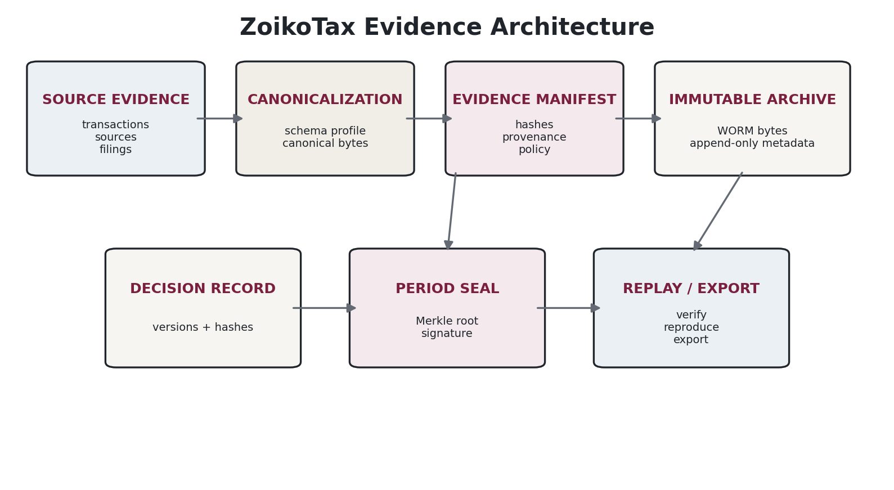
Figure 1 — Evidence architecture: source material is canonicalized, manifested, immutably archived, sealed and replayable.

1.1 Scope
This specification governs evidence for tax determination, regulatory revenue classification, responsibility resolution, obligations, fiscal documents, reconciliation, filings, remittance instructions/confirmations, country-pack/content changes, authority acknowledgements, e-invoicing/CTC events, Shadow Assurance, configuration changes and AI-assisted control activities.

1.2 Explicitly out of scope
• Customer enterprise records-management policy except where mapped into ZoikoTax retention controls.
• General-purpose document management or e-discovery unrelated to ZoikoTax records.
• Storage of passwords, signing private keys or regulator credentials inside the evidence ledger.
• A claim that technical integrity alone establishes legal admissibility in every jurisdiction.
• Replacing tax/legal counsel judgments about jurisdiction-specific evidentiary requirements.

2. Evidence Record Classes & Authority
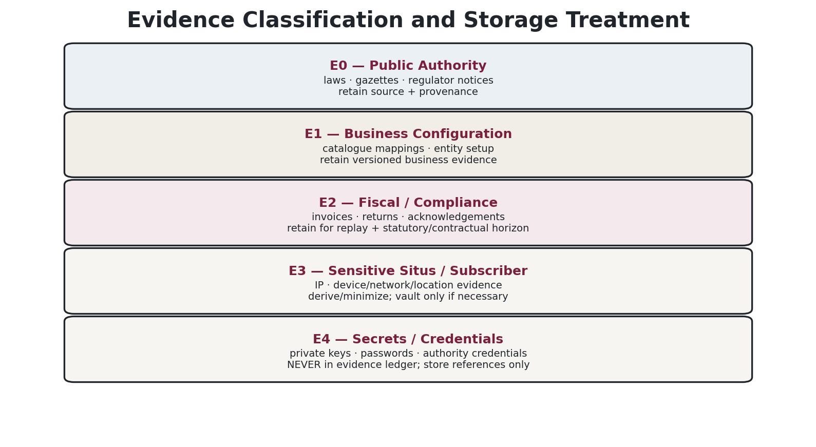
Figure 2 — Evidence classes determine storage, minimization, retention and export treatment.
Class | Examples | Required treatment
E0 — Public Authority | laws, regulations, gazettes, official rate tables, regulator notices, filing specs | Archive authoritative copy/reference, provenance and content hash; public redistribution still subject to source terms.
E1 — Business / Configuration | tenant legal entities, product mappings, tax settings, elections, exemptions metadata | Versioned business evidence; every authoritative decision points to the effective configuration version.
E2 — Fiscal / Compliance | transaction inputs, invoices, tax decisions, obligations, returns, filings, acknowledgements, reconciliation | Primary replay/audit evidence; retained under policy and immutable after commit/seal.
E3 — Sensitive Situs / Subscriber | IP/network/device/location/CDR-derived evidence, personal identifiers where necessary | Minimize/derive/tokenize; raw evidence stored only when required for lawful purpose, replay or dispute; stronger access controls.
E4 — Secrets / Credentials | private keys, passwords, authority credentials, tokens | Never copied into evidence payloads. Ledger stores credential/key reference, key ID, assurance metadata and use event only.
HASH-ONLY CAUTION
If raw evidence is deliberately discarded, the retained digest proves only that a specific byte sequence existed when hashed; it does not allow ZoikoTax to reconstruct or substantively inspect that evidence later. DOM/PRIV/LEG must therefore decide whether a lawful retained derivative, secure raw vault, customer-held pointer, or source re-fetch capability is required.

3. Canonical Evidence Object Model
Evidence is represented by an immutable EvidenceObject plus an EvidenceManifest that links the object to its source, subject, retention, residency and cryptographic proof.
Field | Normative meaning
evidence_id | Globally unique opaque ID; never derived from customer source key.
tenant_id / legal_entity_id | Ownership and legal context.
residency_cell | Physical processing/storage boundary.
evidence_class | E0–E4.
evidence_type | SOURCE_SNAPSHOT, INPUT, DECISION, FILING_PAYLOAD, ACKNOWLEDGEMENT, CONFIG_VERSION, CONTENT_APPROVAL, etc.
subject_refs[] | Typed links to transaction/decision/obligation/return/pack/case.
source_ref | Source system/authority/customer object identity.
canonicalization_profile | How bytes were normalized before hashing.
content_digest | Algorithm + digest of canonical evidence bytes.
content_length / media_type | Integrity and safe rendering metadata.
captured_at | System capture time.
source_observed_at | When source was observed, if known.
valid_time | Legal/business validity interval when applicable.
provenance | Actor/workload, connector, authority/source, import job, chain-of-custody events.
retention_policy_id | Resolved policy and disposition behavior.
legal_hold_refs[] | Zero or more active/released hold links.
encryption_profile / key_ref | Envelope-encryption metadata; not private key material.
signature_refs[] | Signatures/seals/timestamp tokens where applicable.
supersedes / corrects | Lineage without mutation.
status | ACTIVE, SEALED, DISPOSED, TOMBSTONED, QUARANTINED; content bytes immutable once ACTIVE.

3.1 Evidence graph relations
• SUPPORTS — evidence substantiates a decision/obligation/filing.
• DERIVED_FROM — a minimized/normalized item derives from source evidence.
• SUPERSEDES — newer evidence replaces operational use but does not erase history.
• CORRECTS — a correction record identifies an error in a prior item.
• INCLUDED_IN_SEAL — evidence digest is a leaf/member of a signed period seal.
• PRODUCED_BY — output tied to engine, content bundle, adapter, workflow or AI invocation.
• ACKNOWLEDGES — authority/provider response linked to submitted payload.
• RECONCILES_TO — calculated/invoiced/collected/reported/remitted/GL evidence relation.

4. Canonicalization, Hashing, Signatures & Time Evidence

4.1 Canonical byte representation
Every hashed object must declare a canonicalization profile. JSON evidence should use a deterministic canonical representation; RFC 8785 JCS is an appropriate profile where its numeric constraints are compatible. Monetary values that exceed JSON number precision must be represented as canonical strings/typed decimal fields before JCS. Binary documents are hashed as exact bytes; structured internal objects may use deterministic schema serialization.
Control | Standard
Digest | SHA-256 minimum baseline for new evidence; algorithm ID stored with every digest. Crypto policy must permit migration to stronger/alternative approved hashes without rewriting old evidence.
Signature | Approved digital-signature profile with key ID, algorithm, certificate/public-key chain and signature time metadata. FIPS 186-5 is a current conventional signature baseline; crypto policy must be algorithm-agile.
Post-quantum readiness | Do not force PQ signatures onto all evidence before ecosystem/tooling maturity. Architecture must support dual/hybrid or future re-sealing with FIPS 204 ML-DSA / FIPS 205 SLH-DSA profiles when policy requires.
Keys | Signing keys isolated in HSM/KMS class controls, non-exportable where supported; lifecycle, rotation, revocation, recovery and compromise response follow key-management policy.
Trusted time | System time is required for operations; high-assurance seals may additionally obtain RFC 3161-compatible trusted timestamp tokens or equivalent qualified service where contract/regulation requires.
Long-term validation | Archive verification material needed to validate old signatures/timestamps must be retained or reproducibly retrievable; cryptographic renewal/re-sealing occurs before algorithms/certificates become insufficient for the target retention horizon.

4.2 Why no blockchain
A tenant-scoped append-only evidence ledger, immutable object storage, digital signatures, bounded Merkle trees and trusted timestamps provide the required integrity and replay properties without the privacy, deletion, throughput, key-recovery and cross-tenant coupling problems of a blockchain. Blockchain is prohibited unless a later ADR proves a specific legal/customer requirement that these controls cannot satisfy.

5. Period Sealing & Tamper-Evident Ledger
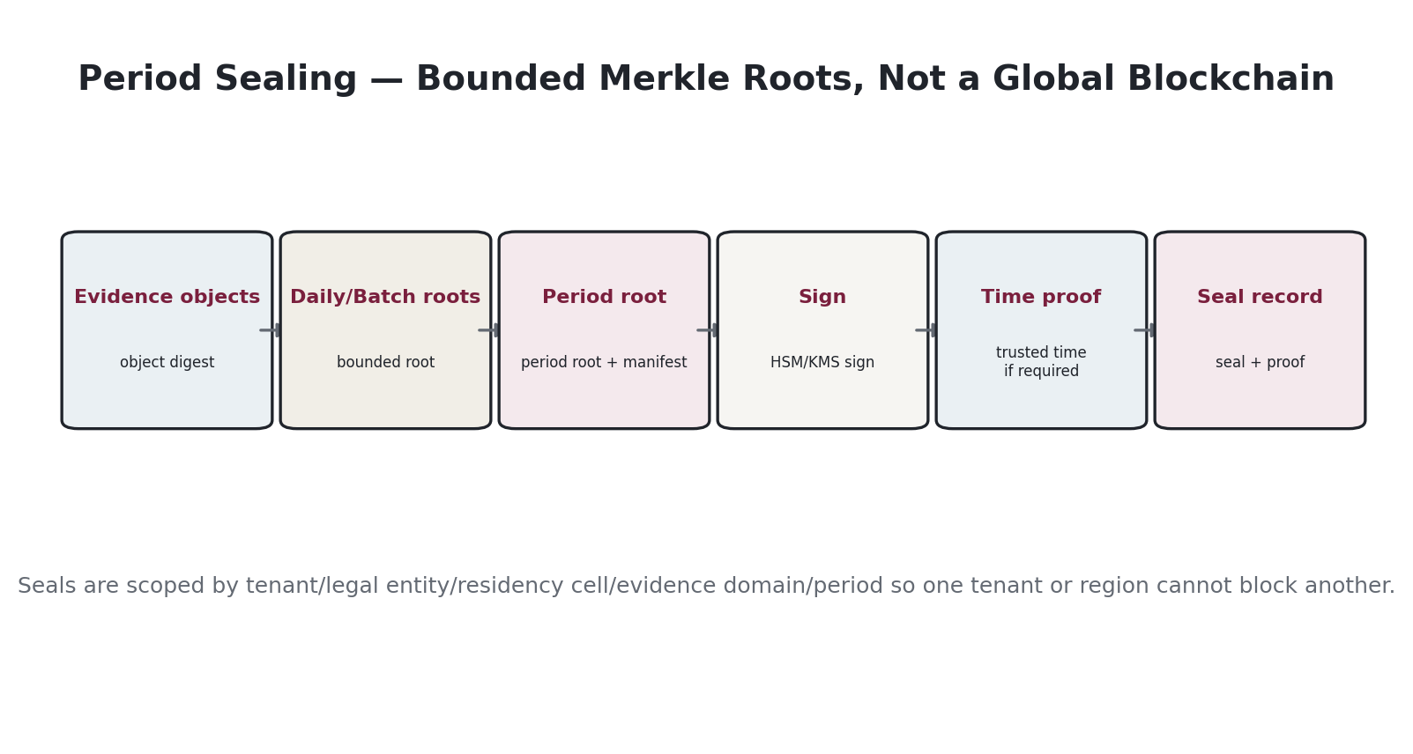
Figure 3 — Period sealing uses bounded Merkle trees and signatures; there is no single global chain.

5.1 Seal scope
A seal scope MUST be bounded by tenant, legal entity, residency cell, evidence domain and period/batch. This prevents one tenant, country or storage outage from serializing or blocking unrelated evidence.
Seal field | Meaning
seal_id | Opaque ID.
scope | tenant/legal entity/cell/domain/period.
leaf_count | Number of canonical evidence digests.
merkle_root | Root digest and tree profile.
manifest_hash | Hash of ordered seal manifest.
signing_key_ref | Key/certificate identity.
signature | Detached signature over canonical seal envelope.
trusted_timestamp_ref | Optional/required by assurance profile.
previous_seal_ref | Optional continuity link within same scope; not required for global ordering.
created_at / sealed_at | Operational chronology.
verification_material | Certificate chain/status material or references required for validation.
seal_status | VALID, SUPERSEDED_BY_RESEAL, COMPROMISED_KEY_REVIEW, INVALID.

5.2 Seal lifecycle
• OPEN — evidence may enter the batch/period.
• CUTOFF — no new normal items; late items require adjustment/amendment path.
• SEALED — Merkle root and signature committed; leaf set immutable.
• RESEALED — cryptographic renewal adds a new proof over the prior seal/evidence; prior seal retained.
• EXCEPTION — compromise or verification failure requires incident/case handling; never silently regenerate the original seal.

6. Historical Replay & Reproducibility
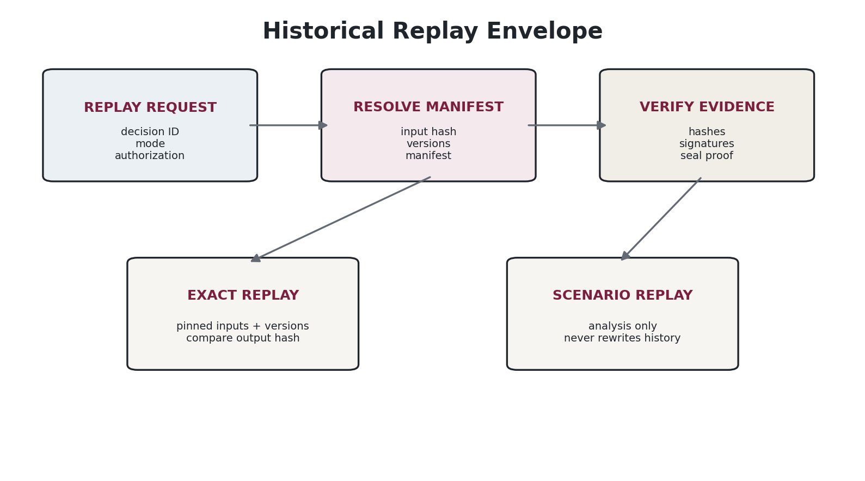
Figure 4 — Replay first verifies the manifest and evidence, then executes a pinned or analytical replay mode.
Replay mode | Rule
EXACT | Re-execute the original canonical input using the same engine version, rule bundle, datasets, mappings, exemption/version, FX/rounding profile and state snapshot. Expected output hash MUST match, subject to documented platform determinism rules.
VERIFY_ONLY | Do not recalculate; verify evidence existence, digests, signatures, seal inclusion, configuration/content lineage and stored output integrity.
AS_KNOWN_THEN | Reconstruct what ZoikoTax knew at the original knowledge time where bitemporal content is relevant; used for investigation, not alteration.
CURRENT_LAW_SCENARIO | Run historical facts through current/effective-at-selected-date rules for analysis. Output is explicitly NON-AUTHORITATIVE and cannot overwrite original history.
AMENDMENT_SIMULATION | Calculate proposed correction/amendment against a closed/previous period. Produces a proposal requiring the appropriate compliance/fiscal workflow.

6.1 Replay envelope — minimum pinned dependencies
• canonical input object hash and schema version
• engine/runtime version and build provenance
• signed tax/regulatory content bundle hash(es)
• country/regulatory pack versions and dependency lockfile
• jurisdiction/geospatial dataset version and provider/license reference
• product ontology and customer mapping versions
• exemption/certificate/qualification version
• responsibility policy and legal-entity configuration version
• FX source/rate/time and rounding/allocation profile
• stateful accumulator snapshot/version and concurrency token where applicable
• feature flags that could affect authoritative behavior
• evidence manifest hash and period seal reference
• expected authoritative output hash and decision identity
REPLAY IS A PRODUCT SLO
A replay failure caused by missing retained dependencies, incompatible binaries, missing source objects or unverifiable signatures is a production control defect. The platform must monitor replayability continuously, not discover failures during an audit years later.

7. Evidence Requirements by Domain
Domain | Minimum evidence
Tax determination | canonical request, normalized lines, classification refs, jurisdiction evidence, exemption evidence, content/bundle versions, state snapshot, decision output, rounding/allocation trace.
Regulatory obligation | revenue classification, responsibility resolution, obligation basis/period, legal authority, thresholds/accumulators, generated obligation and changes.
Fiscal documents | source transaction, document version, line allocations, commit/credit/refund/rebill/amendment lineage, clearance status where applicable.
Filing | workpaper inputs, return rendering/data file, approvals, submitted bytes/hash, adapter/version, credential reference/use event, receipt/acknowledgement, status transitions, amendments.
Remittance | authorized payment instruction, amount/currency/account reference, approvals, external execution reference and confirmation; no customer funds or secrets in ledger.
E-invoicing / CTC | canonical invoice, mapped authority/network payload, validation results, submission ID, clearance/rejection response, resubmission chain.
Country/content release | source snapshots, interpretation record, reviewer approvals, golden results, signed pack manifest, bundle hash, deployment/activation evidence.
Shadow Assurance | normalized customer input, incumbent output/payload hash where permitted, ZoikoTax comparison output, materiality/root-cause classification, analyst disposition.
AI-assisted workflow | use case, model/provider/version, prompt/template version or instruction hash, retrieval/source refs, tool invocation metadata, output hash, confidence/abstention, reviewer disposition. No private chain-of-thought requirement.
Security/admin | actor/workload identity, privileged action, authorization context, before/after control metadata where lawful, tamper-evident audit event; never plaintext secrets.

8. Filing, Authority Acknowledgement & Chain of Custody
• Every outbound filing/submission payload is hashed before transmission.
• The adapter/network/portal version and transmission attempt ID are recorded.
• Authority credentials are referenced by credential ID/key alias and use event; plaintext credentials are excluded.
• The exact transport outcome is recorded: ACCEPTED, REJECTED, RECEIVED_UNCONFIRMED, TIMEOUT_UNKNOWN, NETWORK_FAILURE, MANUAL_SUBMISSION_ATTESTED, or equivalent governed state.
• A retry is a new transmission attempt linked to the same or amended filing; it does not erase the prior uncertain/failed attempt.
• Authority receipts, confirmation numbers, signed acknowledgements and rejection details are archived with content hash and provenance.
• Manual portal workflows require operator identity, dual-control where specified, captured submission evidence and attestation/checklist—not fabricated API certainty.

9. Legal Content & Source Evidence
ZTAX-CONT-001 governs the content supply chain; this document governs its evidentiary record. Each content change must be reconstructible from authority source through production bundle.
Stage | Required evidence
Source | authority/source ID, retrieval method, published/effective date, captured bytes or durable official reference, hash, licence/provenance.
Interpretation | analyst interpretation record, assumptions, affected products/jurisdictions/obligations, ambiguity/escalation.
Proposal | structured rule change/diff, AI extraction/proposal metadata if used.
Review | independent reviewer, legal/content approvals, comments/disposition.
Verification | golden vectors, regression impact, failed/waived tests.
Bundle | signed immutable pack/bundle manifest and dependency lock.
Deployment | target cells/runtimes, activation time, staged rollout, rollback/suspension state.
Decision linkage | every authoritative decision references the content bundle(s) that governed it.

10. Retention, Archival Tiers & Disposition
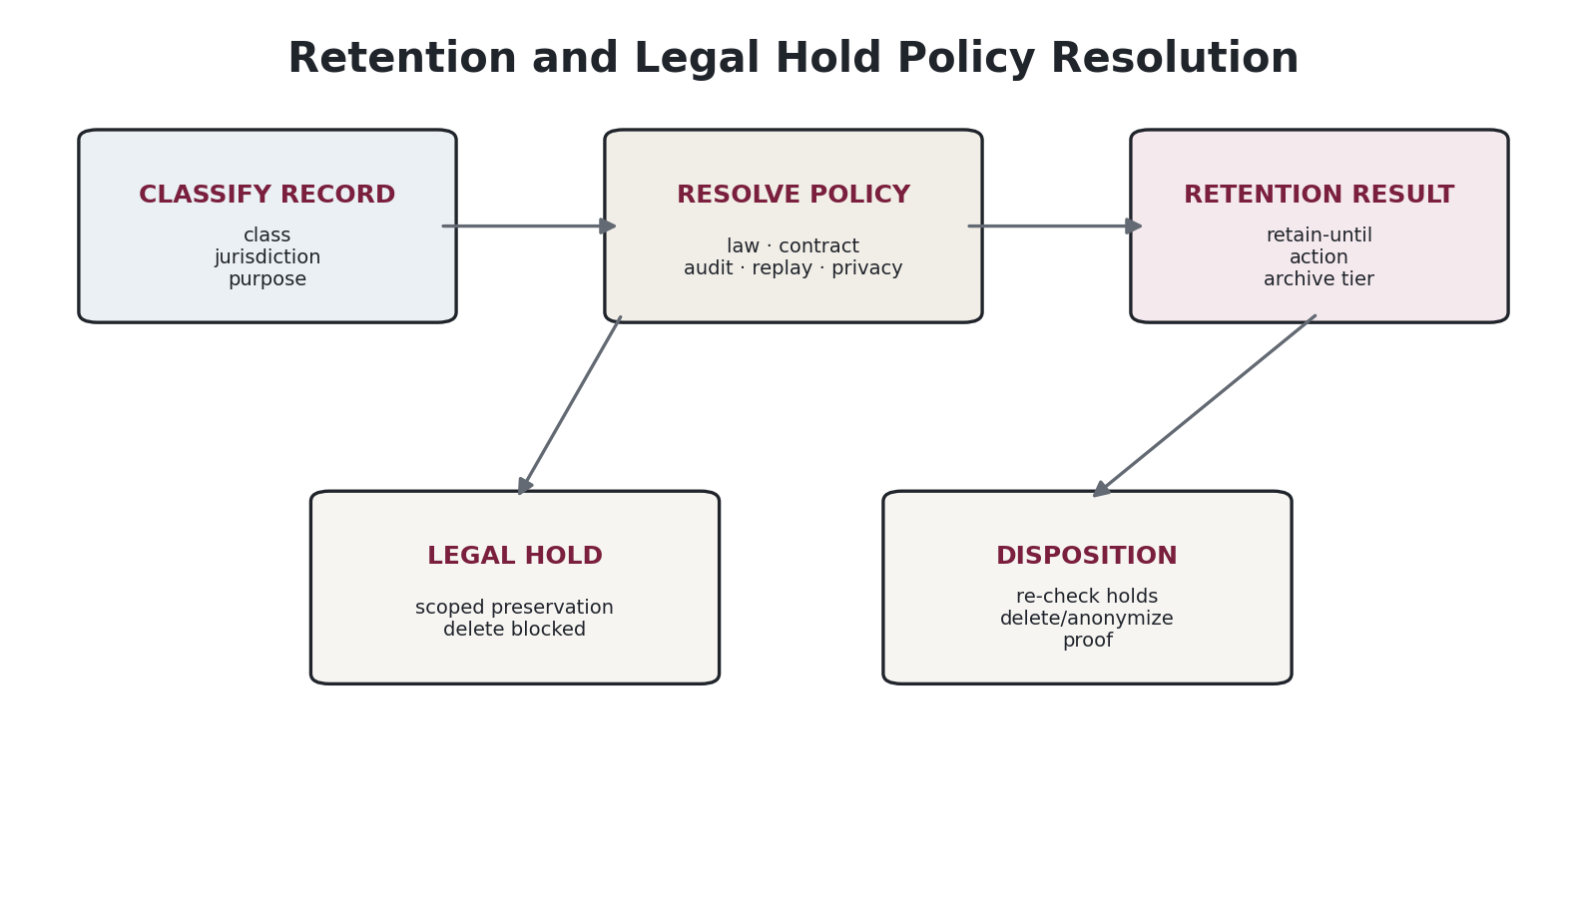
Figure 5 — Retention is resolved from record class, legal/customer context, replay needs, privacy and legal hold.

10.1 Policy resolution precedence
• active legal hold or preservation order;
• mandatory statutory/regulatory retention;
• contractual/customer retention commitment;
• audit/assurance and historical replay requirement;
• legitimate operational/security requirement;
• privacy minimization and deletion requirements.
Where requirements conflict, Legal/Privacy owns the resolution; the platform must not silently choose the longest or shortest period.
Tier | Use | Rule
HOT | frequent operational/audit access | encrypted regional primary store; indexed metadata; immutable committed objects.
WARM | occasional replay/compliance access | lower-cost immutable storage with retrieval SLO.
ARCHIVE | long-term preservation | WORM/immutable archive; verification metadata online; restore procedure tested.
DISPOSED | retention satisfied and no hold | content deleted/anonymized according to policy; tombstone/proof-of-disposition retained if lawful and necessary.

10.2 Disposition safety
• Disposition jobs MUST re-resolve legal holds immediately before deletion.
• Deletion must be idempotent and auditable.
• Disposition of a parent evidence object must evaluate dependency/replay references; dangling evidence proofs are prohibited.
• Cryptographic erase may be used only where key destruction is an approved and verifiable deletion method for that storage profile.
• Disposal evidence records what class/range was destroyed, under which policy and job, without retaining the deleted personal content.
• Backups/replicas must age out under documented deletion/retention mechanics; “deleted from primary” is not sufficient.

11. Legal Hold & Preservation
Field | Rule
hold_id | Unique case/hold identity.
authority | Legal/court/regulator/internal investigation/customer contractual hold authority.
scope | tenant/legal entity/record types/subjects/period/jurisdiction/case.
issued_by / approved_by | Authorized legal/compliance actors.
effective_at | Hold start.
notification_state | Required internal/customer notifications and confidentiality controls.
preservation_actions | Deletion suspension, archive tier pinning, export freeze if required.
access_policy | Hold does not automatically grant access; ordinary least privilege remains.
release_at / released_by | Controlled release.
release_reason | Case closure/order/authorization.
audit_trail | All scope changes and searches/exports linked to hold.
• A legal hold applies to records matched by scope even if their normal retention has expired.
• Hold scope changes are versioned and effective-dated; prior scope history is immutable.
• Evidence may be exported for legal review without altering the canonical archive. Export package hashes and chain-of-custody are retained.
• Release from hold does not mean immediate deletion; normal retention policy is re-evaluated.

12. Storage, Residency & Isolation Architecture
Component | Store | Boundary
Evidence metadata SoR | regional relational store | identity, manifest, relationships, retention/hold, seal membership; storage-layer tenant controls.
Immutable evidence bytes | regional WORM-capable object store | source snapshots, filings, acknowledgements, invoices, signed manifests; object versioning/retention lock as policy requires.
Replay binaries/artifacts | artifact registry + immutable archive | engine container/package, rule runtime dependencies, schemas; content-addressable identity.
Analytics projection | regional/approved aggregate stores | not the evidence SoR; rebuildable from governed events/evidence.
Search index | regional derived index | never sole copy; rebuildable; redact/minimize sensitive fields.
Key material | regional HSM/KMS | private keys never in evidence archive; evidence stores key refs and public verification material.
Cross-region reporting | approved aggregates/metadata only | raw E2/E3 evidence does not centralize merely for convenience.

13. Audit / Customer Evidence Package
ZoikoTax must generate a self-describing export for an authorized decision, period, filing, pack or case without requiring direct database access.
• package_manifest.json with package ID, scope, generated time, requestor and schema version;
• authoritative decision/obligation/filing records;
• canonical evidence objects or permitted extracts/pointers;
• content/pack manifests and legal-source evidence permitted for export;
• configuration/mapping/exemption versions;
• seal inclusion proof and signature/timestamp verification material;
• replay manifest and verification result;
• chain-of-custody/export audit events;
• README human summary explaining verification steps;
• redaction report identifying any evidence intentionally withheld under privacy/licensing/security restrictions.
EXPORT IS NOT RAW DATABASE DUMP
Evidence packages are policy-filtered, scoped, deterministic exports. They must preserve integrity proofs while enforcing tenant isolation, data minimization, source licensing and privileged-data restrictions.

14. Authorization, Segregation of Duties & Evidence Access
Role | Evidence authority
Evidence writer service | append allowed for owned evidence types; no update/delete of committed bytes.
Evidence verifier | read/verify; cannot change evidence.
Content approver | may approve content records; cannot alter archived source snapshots or seals.
Compliance operator | may attach filing/ack evidence to authorized workflow; cannot rewrite decision evidence.
Legal hold administrator | may create/change/release holds under Legal authorization; no broad content read implied.
Auditor/read-only | scoped evidence export/view; no mutation.
Platform/SRE | infrastructure operation; content access requires JIT/break-glass and immutable audit evidence.
AI workload | may read only explicitly authorized/minimized evidence and write proposal/provenance records; no deletion/seal/hold authority.

15. Corrections, Amendments & Evidence Integrity
• Evidence bytes become immutable at commit; metadata that must change is represented as a new version/event unless explicitly designated mutable operational metadata.
• Incorrect evidence is quarantined or marked CORRECTED_BY; it is not replaced in-place.
• A corrected tax/fiscal decision creates a new decision linked to the original and corresponding fiscal adjustment workflow.
• A filing amendment links original return, original submission/ack, amendment workpaper, new submission and authority response.
• If a source document is later withdrawn/changed by an authority, the captured historical source remains retained where policy permits, and the content system records the later supersession/withdrawal.
• If a signing key is compromised, prior signatures are not silently regenerated. Incident analysis determines affected evidence; surviving independent timestamps/seals are evaluated and re-sealing may establish continuing integrity prospectively.

16. Cryptographic Agility & Long-Term Validation
• Every digest/signature/timestamp stores algorithm and parameter identifiers; no “implicit SHA” fields.
• Crypto profiles are configuration/content-independent security policy objects with effective dates and approved/deprecated states.
• Verification must continue to support historical algorithms long enough to validate retained evidence, even after new signing is prohibited.
• Re-sealing/renewal adds stronger contemporary proof over existing evidence roots; it never changes original content digests.
• Certificate/public-key validation material and revocation/status evidence required for historical verification must be archived or durably referenced.
• Post-quantum migration is a planned crypto-agility function, not a reason to prematurely abandon interoperable current profiles.

17. Evidence APIs & Domain Events
Contract | Purpose
POST /evidence | Create/commit an evidence object under authorized type and idempotency key.
GET /evidence/{id} | Return authorized metadata/content or redacted representation.
POST /evidence/{id}/verify | Verify content digest, signatures, seal membership and dependency status.
POST /replays | Create replay job with explicit replay mode and authorization.
GET /replays/{id} | Replay status/result/evidence.
POST /period-seals | Close/seal authorized scope; privileged workflow only.
GET /period-seals/{id}/proof | Return inclusion/verification proof.
POST /legal-holds | Create hold; Legal authorization required.
PATCH /legal-holds/{id} | Versioned scope/release operations.
POST /evidence-exports | Generate scoped audit/customer package.

Core events:
• EvidenceCommitted
• EvidenceQuarantined
• EvidenceCorrectionLinked
• EvidenceDispositionEligible
• EvidenceDisposed
• LegalHoldApplied
• LegalHoldScopeChanged
• LegalHoldReleased
• PeriodCutoffReached
• PeriodSealed
• PeriodResealed
• SealVerificationFailed
• ReplayRequested
• ReplayCompleted
• ReplayMismatchDetected
• EvidenceExportGenerated
• SigningKeyCompromiseDeclared

18. Failure Semantics & Incident Handling
State | Required behavior
HASH_MISMATCH | Stored/retrieved bytes do not match manifest digest. Quarantine object, block authoritative export/replay using it, open security/evidence incident.
SIGNATURE_INVALID | Seal/manifest signature fails. Block trust assertion; investigate key/material integrity.
MISSING_DEPENDENCY | Replay dependency unavailable. Replay fails closed; never substitute “nearest” version.
SEAL_INCOMPLETE | Expected eligible evidence not included in seal. Period remains exception state until governed remediation.
RETENTION_CONFLICT | Policy rules conflict or cannot resolve. Hold disposition; escalate Legal/Privacy.
HOLD_SCOPE_UNCERTAIN | Potential legal-hold match cannot be confidently resolved. Preserve rather than delete; escalate.
TIME_SOURCE_DEGRADED | Trusted/system time quality outside profile. Record degraded time assurance; high-assurance sealing may pause.
ARCHIVE_UNAVAILABLE | Evidence bytes unavailable. Authoritative writes/replay degrade according to NFR; no false success.
KEY_COMPROMISE | Signing key suspected/confirmed compromised. Stop new signatures, rotate, assess evidence, re-seal where appropriate.
REPLAY_MISMATCH | Exact replay output hash differs. Sev-appropriate correctness incident; original record remains unchanged.

19. Evidence SLOs & Operational Metrics
Metric/control | Target doctrine
Evidence commit durability | No acknowledged authoritative decision is considered durable until its evidence metadata and required evidence bytes/outbox are committed under the defined atomicity boundary.
Replayability coverage | 100% of production-authoritative decisions must have a complete replay manifest or a registered documented exception that blocks production promotion.
Seal verification | Scheduled verification samples plus complete verification before audit export/period close as defined by assurance profile.
Orphan references | Zero unresolved evidence references for EFFECTIVE production records.
Disposition safety | Zero deletions with active legal hold; zero unlogged privileged disposition.
Evidence age/freshness | Authority acknowledgements/content source snapshots tracked by type-specific expectations; missing evidence alerts.
Restore validation | Periodic immutable archive restore + verification exercises; frequency set by NFR/SEC.
Cross-tenant leakage | Zero tolerance; any confirmed leak is critical incident.

20. Verification & Test Strategy
• Property tests: canonicalization produces invariant bytes; any material byte change changes digest.
• Golden tests: manifest + seal creation/verification against fixed vectors.
• Mutation tests: corrupt object, manifest, tree node, signature and timestamp; verification must fail deterministically.
• Replay tests: exact replay across archived engine/content/config versions reproduces expected hashes.
• Retention tests: policy precedence, legal hold race conditions, disposition idempotency and replica aging.
• Concurrency tests: simultaneous evidence commit/seal cutoff/disposition does not lose or double-count leaves.
• DR tests: restore evidence metadata/bytes/keys/public verification material and complete replay after regional recovery.
• Security tests: privilege escalation, tenant boundary, malicious file/render payload, decompression bombs, path traversal, metadata injection, signing-key misuse.
• Privacy tests: E3 minimization/tokenization, export redaction, deletion propagation and legal-hold override.
• Long-term crypto tests: verification of archived signatures after key rotation/deprecation; re-seal flow.

21. Normative Requirement Register
Requirement ID | Normative requirement | Verification | Owner
ZTAX-EVID-REQ-0001 | All production-authoritative records MUST have a registered evidence manifest. | AUDIT | Evidence Platform
ZTAX-EVID-REQ-0002 | Committed evidence content MUST be immutable; corrections MUST create linked records. | TEST | Evidence Platform
ZTAX-EVID-REQ-0003 | External source identifiers MUST NOT be canonical primary keys. | INSPECTION | Domain
ZTAX-EVID-REQ-0004 | Every evidence object MUST be assigned an evidence class and residency cell. | TEST | Evidence Platform
ZTAX-EVID-REQ-0005 | E4 secrets/credentials MUST NOT be stored as evidence payloads. | TEST | Security
ZTAX-EVID-REQ-0006 | Every digest MUST record algorithm identity and canonicalization profile. | TEST | Evidence Platform
ZTAX-EVID-REQ-0007 | JSON canonicalization MUST be deterministic; JCS MAY be used when data constraints are compatible. | TEST | Platform
ZTAX-EVID-REQ-0008 | Authoritative monetary values included in canonical JSON MUST use lossless typed/string representation, not binary floating-point JSON semantics. | TEST | Domain/Determination
ZTAX-EVID-REQ-0009 | New evidence hashing MUST meet the approved cryptographic profile; SHA-256 is the minimum baseline at v1.0. | AUDIT | Security
ZTAX-EVID-REQ-0010 | Signature keys MUST be managed outside the evidence archive and referenced by key identity. | AUDIT | Security
ZTAX-EVID-REQ-0011 | Evidence signatures MUST be verifiable without access to private signing keys. | TEST | Security
ZTAX-EVID-REQ-0012 | Crypto algorithms MUST be versioned/effective-dated and support deprecation/migration. | INSPECTION | Security
ZTAX-EVID-REQ-0013 | Period seals MUST be scoped so unrelated tenants/legal entities/residency cells do not share a mandatory global ordering dependency. | INSPECTION | Architecture
ZTAX-EVID-REQ-0014 | A sealed leaf set MUST NOT be mutated. | TEST | Evidence Platform
ZTAX-EVID-REQ-0015 | Re-sealing MUST add new proof and MUST NOT alter original evidence digests. | TEST | Evidence Platform
ZTAX-EVID-REQ-0016 | Exact replay MUST use pinned historical dependencies and MUST NOT substitute newer versions. | TEST | Replay
ZTAX-EVID-REQ-0017 | Exact replay MUST compare the reproduced authoritative output hash with the stored expected hash. | TEST | Replay
ZTAX-EVID-REQ-0018 | Scenario replay outputs MUST be explicitly non-authoritative. | TEST | Replay
ZTAX-EVID-REQ-0019 | A replay failure due to a missing dependency MUST fail closed. | TEST | Replay
ZTAX-EVID-REQ-0020 | Every authoritative decision MUST reference engine/runtime and content bundle versions sufficient for replay. | TEST | Determination/Obligation
ZTAX-EVID-REQ-0021 | Stateful calculations MUST pin the relevant accumulator/state snapshot/version. | TEST | Determination
ZTAX-EVID-REQ-0022 | Evidence retention MUST be resolved by policy and MUST NOT assume one statutory period globally. | AUDIT | Privacy/Legal
ZTAX-EVID-REQ-0023 | Active legal hold MUST block normal disposition for in-scope evidence. | TEST | Legal Hold
ZTAX-EVID-REQ-0024 | Legal hold MUST NOT by itself grant broader evidence read access. | TEST | Security
ZTAX-EVID-REQ-0025 | Disposition MUST be idempotent and auditable. | TEST | Evidence Platform
ZTAX-EVID-REQ-0026 | Disposition MUST re-check legal hold immediately before destructive action. | TEST | Evidence Platform
ZTAX-EVID-REQ-0027 | Backup/replica deletion behavior MUST be included in retention/disposition design. | INSPECTION | Platform/SRE
ZTAX-EVID-REQ-0028 | Evidence export MUST enforce tenant, privacy, licensing and privilege constraints. | TEST | Evidence Export
ZTAX-EVID-REQ-0029 | Evidence export MUST contain a manifest and integrity verification material. | TEST | Evidence Export
ZTAX-EVID-REQ-0030 | Filing payloads MUST be hashed before external transmission. | TEST | Compliance
ZTAX-EVID-REQ-0031 | Every filing attempt MUST be a separate immutable transmission-attempt record. | TEST | Compliance
ZTAX-EVID-REQ-0032 | Unknown filing outcome MUST be represented explicitly and MUST NOT be converted to success without evidence. | TEST | Compliance
ZTAX-EVID-REQ-0033 | Authority acknowledgements MUST be linked to the exact submitted payload/attempt where determinable. | TEST | Compliance
ZTAX-EVID-REQ-0034 | Manual filing evidence MUST record operator identity and governed attestation/checklist. | AUDIT | Compliance
ZTAX-EVID-REQ-0035 | Country/content production releases MUST retain source, interpretation, approval, verification, bundle and deployment evidence. | AUDIT | Content
ZTAX-EVID-REQ-0036 | Every authoritative decision MUST link to the content bundle(s) that governed it. | TEST | Domain
ZTAX-EVID-REQ-0037 | AI provenance evidence MUST record model/provider/version and source/retrieval references appropriate to the use case. | AUDIT | AI
ZTAX-EVID-REQ-0038 | ZoikoTax MUST NOT require storage of private AI chain-of-thought as evidence. | INSPECTION | AI Governance
ZTAX-EVID-REQ-0039 | AI workloads MUST NOT have evidence seal, legal-hold, disposition or authoritative rule-promotion privileges. | TEST | Security/AI
ZTAX-EVID-REQ-0040 | Shadow evidence MUST preserve comparison provenance without altering production billing. | TEST | Shadow
ZTAX-EVID-REQ-0041 | Search/analytics indexes MUST be rebuildable and MUST NOT be the sole evidence copy. | TEST | Platform
ZTAX-EVID-REQ-0042 | Raw E2/E3 evidence MUST remain in approved residency cells unless an approved transfer basis exists. | AUDIT | Privacy/Security
ZTAX-EVID-REQ-0043 | Evidence metadata storage MUST enforce tenant isolation below the application UI layer. | TEST | Security
ZTAX-EVID-REQ-0044 | Evidence bytes MUST be encrypted in transit and at rest under the approved security profile. | AUDIT | Security
ZTAX-EVID-REQ-0045 | Privileged evidence access MUST be logged immutably. | AUDIT | Security
ZTAX-EVID-REQ-0046 | Canonical evidence ingestion MUST validate media type, size and malicious-content controls. | TEST | Security
ZTAX-EVID-REQ-0047 | Evidence manifests MUST reject duplicate/conflicting canonical identities. | TEST | Evidence Platform
ZTAX-EVID-REQ-0048 | Evidence graph references MUST preserve referential integrity or explicit tombstone semantics. | TEST | Evidence Platform
ZTAX-EVID-REQ-0049 | An evidence object under active dispute/quarantine MUST NOT be silently discarded. | TEST | Evidence Platform
ZTAX-EVID-REQ-0050 | Key compromise MUST stop new signing with the affected key and trigger impact assessment. | DEMONSTRATION | Security
ZTAX-EVID-REQ-0051 | Period seal verification failures MUST create an incident/case and block trust assertions for affected scope. | TEST | Evidence Platform
ZTAX-EVID-REQ-0052 | Retention policy changes MUST be versioned and auditable. | AUDIT | Privacy/Legal
ZTAX-EVID-REQ-0053 | Legal-hold scope changes MUST be versioned and auditable. | AUDIT | Legal
ZTAX-EVID-REQ-0054 | Release of legal hold MUST re-evaluate normal retention before deletion. | TEST | Legal Hold
ZTAX-EVID-REQ-0055 | Evidence disposition MUST preserve a minimal proof-of-disposition only where lawful/necessary. | AUDIT | Privacy
ZTAX-EVID-REQ-0056 | Cryptographic erase MUST only be used where the relevant security/privacy policy accepts key destruction as deletion. | INSPECTION | Security/Privacy
ZTAX-EVID-REQ-0057 | Audit evidence packages MUST be reproducible for the same scope/version subject to permitted redactions. | TEST | Evidence Export
ZTAX-EVID-REQ-0058 | Exports MUST disclose redactions/omissions caused by privacy, licensing or security restrictions. | TEST | Evidence Export
ZTAX-EVID-REQ-0059 | Historical verification MUST retain/retrieve public-key/certificate/status material required to validate archived signatures. | TEST | Security
ZTAX-EVID-REQ-0060 | Trusted timestamps MUST be supported for assurance profiles that require independent time evidence. | DEMONSTRATION | Security
ZTAX-EVID-REQ-0061 | System time quality/degradation MUST be observable for evidence operations. | TEST | Platform/SRE
ZTAX-EVID-REQ-0062 | No production decision MAY be acknowledged as durable before its required evidence commit boundary is satisfied. | TEST | Architecture
ZTAX-EVID-REQ-0063 | Evidence write APIs MUST require idempotency for retryable mutations. | TEST | Platform
ZTAX-EVID-REQ-0064 | Evidence domain events MUST be emitted through a transactional outbox or equivalent atomic pattern. | TEST | Platform
ZTAX-EVID-REQ-0065 | Evidence events MAY be delivered at least once but business effects MUST be idempotent. | TEST | Platform
ZTAX-EVID-REQ-0066 | Schema evolution MUST preserve readability/verifiability of historical evidence. | TEST | Platform
ZTAX-EVID-REQ-0067 | Evidence canonicalization profile changes MUST be versioned and MUST NOT change old digests. | TEST | Evidence Platform
ZTAX-EVID-REQ-0068 | Evidence IDs MUST be opaque and globally unique within the ZoikoTax namespace. | TEST | Domain
ZTAX-EVID-REQ-0069 | Deletion jobs MUST prevent races with hold placement and sealing through concurrency control. | TEST | Evidence Platform
ZTAX-EVID-REQ-0070 | Sealing MUST have deterministic leaf ordering or an explicitly defined Merkle construction profile. | TEST | Evidence Platform
ZTAX-EVID-REQ-0071 | Seal manifests MUST be canonicalized before hashing/signing. | TEST | Evidence Platform
ZTAX-EVID-REQ-0072 | Seal signatures MUST identify the signing key/profile and verification material. | TEST | Security
ZTAX-EVID-REQ-0073 | A compromised/expired crypto profile MUST be replaceable prospectively without invalidating stored canonical bytes. | ANALYSIS | Security
ZTAX-EVID-REQ-0074 | Long-term archive policy MUST define cryptographic renewal/re-sealing triggers. | AUDIT | Security
ZTAX-EVID-REQ-0075 | Evidence source provenance MUST distinguish authority source, customer source, derived evidence and AI proposal. | TEST | Evidence Platform
ZTAX-EVID-REQ-0076 | Derived evidence MUST retain a DERIVED_FROM link to the source/pointer when lawful and available. | TEST | Evidence Platform
ZTAX-EVID-REQ-0077 | A hash-only record MUST declare when source bytes are not retained by ZoikoTax. | TEST | Evidence Platform
ZTAX-EVID-REQ-0078 | Customer-held evidence pointers MUST include stable locator/identity and integrity metadata where contract permits. | INSPECTION | Integration
ZTAX-EVID-REQ-0079 | Evidence retrieval permissions MUST be evaluated at request time and MUST not be encoded solely in object URLs. | TEST | Security
ZTAX-EVID-REQ-0080 | Presigned/object-access URLs MUST be short-lived and scoped where used. | TEST | Security
ZTAX-EVID-REQ-0081 | Evidence archive restore procedures MUST be tested periodically under NFR-defined cadence. | DEMONSTRATION | SRE
ZTAX-EVID-REQ-0082 | Replay binaries/artifacts needed for the retention horizon MUST be archived or reproducibly rebuildable from signed provenance. | AUDIT | Platform
ZTAX-EVID-REQ-0083 | Software supply-chain provenance for replay artifacts MUST be retained. | AUDIT | DevSecOps
ZTAX-EVID-REQ-0084 | Country-pack suspension MUST preserve historical replayability of earlier authoritative decisions. | TEST | Content/Evidence
ZTAX-EVID-REQ-0085 | Content withdrawal MUST NOT cause historical source/bundle evidence to disappear while still required for replay/legal purposes. | TEST | Content/Evidence
ZTAX-EVID-REQ-0086 | Reconciliation evidence MUST link each reconciled layer to source records and variance disposition. | TEST | Finance
ZTAX-EVID-REQ-0087 | Fiscal amendments MUST preserve links to original decisions/documents and associated evidence. | TEST | Finance
ZTAX-EVID-REQ-0088 | Customer-config changes affecting tax outcomes MUST create versioned evidence. | TEST | Product/Domain
ZTAX-EVID-REQ-0089 | Exemption/certificate decisions MUST reference the evidence/version used at decision time. | TEST | Exemptions
ZTAX-EVID-REQ-0090 | Jurisdiction/situs decisions MUST reference the evidence class and resolved evidence digest/pointer used. | TEST | Jurisdiction
ZTAX-EVID-REQ-0091 | Sensitive raw situs evidence MUST not be retained by default when a lawful minimized derivative is sufficient. | AUDIT | Privacy
ZTAX-EVID-REQ-0092 | Retention/legal hold policy resolution conflicts MUST fail safe and be escalated rather than guessed. | TEST | Privacy/Legal
ZTAX-EVID-REQ-0093 | Cross-tenant or cross-residency evidence linking MUST be prohibited unless explicitly modeled and authorized. | TEST | Security/Domain
ZTAX-EVID-REQ-0094 | Evidence package generation MUST be asynchronous for large scopes and MUST expose progress/failure states. | TEST | Platform
ZTAX-EVID-REQ-0095 | Evidence rendering/viewing MUST sandbox untrusted document formats. | TEST | Security
ZTAX-EVID-REQ-0096 | Evidence metadata changes designated operationally mutable MUST be separately audited from immutable content metadata. | TEST | Evidence Platform
ZTAX-EVID-REQ-0097 | Evidence verification MUST be possible independently of current search indexes/analytics stores. | TEST | Evidence Platform
ZTAX-EVID-REQ-0098 | Replay jobs MUST record requester, purpose, authorization, mode, versions and result. | AUDIT | Replay
ZTAX-EVID-REQ-0099 | Replay output MUST never mutate the source authoritative record. | TEST | Replay
ZTAX-EVID-REQ-0100 | Exact replay mismatch MUST raise a correctness incident and preserve both original and replay results. | TEST | Replay
ZTAX-EVID-REQ-0101 | Evidence export generation MUST itself create evidence of the export. | TEST | Evidence Export
ZTAX-EVID-REQ-0102 | Production pack promotion MUST fail if required evidence/golden verification artifacts are absent. | TEST | QA/Content
ZTAX-EVID-REQ-0103 | Evidence control SLIs MUST be observable and alertable. | DEMONSTRATION | SRE
ZTAX-EVID-REQ-0104 | There MUST be zero silent evidence fallback from immutable archive to an unverified cached copy. | TEST | Platform
ZTAX-EVID-REQ-0105 | Evidence data models MUST support legal-hold and retention policy changes without rewriting historical decision records. | ANALYSIS | Domain
ZTAX-EVID-REQ-0106 | This specification MUST be mapped into SEC, PRIV, QA, NFR, COMP, FIN, CONT and AIGOV requirements without restating conflicting normative text. | INSPECTION | Architecture
ZTAX-EVID-REQ-0107 | Merkle inclusion proofs MUST be verifiable from the stored leaf digest, tree profile and seal root. | TEST | Evidence Platform
ZTAX-EVID-REQ-0108 | Large evidence objects MAY be chunked, but chunking profile and root digest MUST be deterministic and versioned. | TEST | Evidence Platform
ZTAX-EVID-REQ-0109 | Compressed evidence MUST be hashed according to a declared profile that avoids ambiguity between compressed and logical content. | TEST | Evidence Platform
ZTAX-EVID-REQ-0110 | External timestamps MUST be validated against their trust policy at verification time and the policy/version MUST be recorded. | TEST | Security
ZTAX-EVID-REQ-0111 | Evidence objects imported from customers MUST retain source ingestion job and original integrity metadata where provided. | TEST | Integration
ZTAX-EVID-REQ-0112 | Bulk imports MUST produce per-object results plus an import-level manifest. | TEST | Integration
ZTAX-EVID-REQ-0113 | A failed evidence upload MUST NOT leave a committed manifest pointing to absent content. | TEST | Evidence Platform
ZTAX-EVID-REQ-0114 | Evidence commit and authoritative decision commit MUST use an atomic or provably recoverable consistency pattern defined by ARCH/NFR. | ANALYSIS | Architecture
ZTAX-EVID-REQ-0115 | Legal-hold searches/exports MUST be recorded as privileged evidence-access events. | AUDIT | Legal/Security
ZTAX-EVID-REQ-0116 | Evidence held beyond normal retention MUST remain subject to data minimization and access-control requirements. | AUDIT | Privacy
ZTAX-EVID-REQ-0117 | Period cutoff exceptions MUST identify the late evidence item, reason, approver and resulting adjustment/amendment path. | TEST | Finance/Compliance
ZTAX-EVID-REQ-0118 | A period seal MUST not imply that the underlying tax filing is legally final unless the compliance state separately establishes finality. | INSPECTION | Compliance
ZTAX-EVID-REQ-0119 | Evidence verification APIs MUST return structured reason codes rather than a single boolean. | TEST | Platform
ZTAX-EVID-REQ-0120 | Verification status MUST distinguish integrity failure, trust-policy failure, missing dependency and authorization failure. | TEST | Platform
ZTAX-EVID-REQ-0121 | The evidence archive MUST support versioned malware scanning/render isolation without modifying canonical original bytes. | TEST | Security
ZTAX-EVID-REQ-0122 | Source licence restrictions MUST be enforceable in evidence export policy. | TEST | Content/Legal
ZTAX-EVID-REQ-0123 | Public legal-source evidence MUST still carry provenance and retrieval time even when no confidentiality applies. | TEST | Content
ZTAX-EVID-REQ-0124 | Evidence aliases/display names MUST NOT be used as integrity identifiers. | TEST | Domain
ZTAX-EVID-REQ-0125 | Clock synchronization sources and tolerated skew MUST be defined by NFR/SEC for authoritative evidence events. | INSPECTION | SRE/Security
ZTAX-EVID-REQ-0126 | Evidence retention policy resolution MUST be reproducible from versioned policy inputs. | TEST | Privacy/Legal
ZTAX-EVID-REQ-0127 | Evidence destruction MUST not delete shared content required by other active tenants/legal entities unless storage is physically deduplicated with reference-safe semantics. | TEST | Platform
ZTAX-EVID-REQ-0128 | Physical deduplication, if used, MUST not weaken tenant isolation, retention or legal-hold semantics. | ANALYSIS | Architecture
ZTAX-EVID-REQ-0129 | Evidence encryption key rotation MUST not change content digests. | TEST | Security
ZTAX-EVID-REQ-0130 | Customer-managed keys, where offered, MUST define hold/replay behavior if the customer revokes or destroys a key. | ANALYSIS | Security/Legal
ZTAX-EVID-REQ-0131 | The platform MUST distinguish integrity proof from legal admissibility in user-facing language and audit exports. | INSPECTION | Legal/Product
Total normative requirements: 131

22. Mandatory Architecture Decision Records
ADR | Decision required
ADR-EVID-001 | Canonicalization profiles per evidence media/schema type.
ADR-EVID-002 | Evidence commit atomicity boundary with authoritative decisions.
ADR-EVID-003 | Immutable object-store/WORM technology and retention-lock mode.
ADR-EVID-004 | Merkle tree construction, leaf ordering and seal scope.
ADR-EVID-005 | Signing algorithm/profile, HSM/KMS model and key hierarchy.
ADR-EVID-006 | Trusted timestamp assurance profiles and providers.
ADR-EVID-007 | Long-term cryptographic renewal / post-quantum transition strategy.
ADR-EVID-008 | Replay artifact retention/rebuild model.
ADR-EVID-009 | Evidence metadata SoR and tenant isolation implementation.
ADR-EVID-010 | Retention policy engine and legal-hold race-control design.
ADR-EVID-011 | Sensitive situs evidence minimization/vault/customer-pointer strategy.
ADR-EVID-012 | Audit export package format and independent verifier tooling.
ADR-EVID-013 | Large-object chunking/deduplication policy, if any.
ADR-EVID-014 | Cross-region evidence aggregate/metadata policy.
ADR-EVID-015 | Manual filing evidence capture and attestation mechanism.

23. Engineering Handoff — First Implementation Backlog
Priority | Backlog item
P0 | Define EvidenceObject/EvidenceManifest schemas and IDs; implement append-only metadata constraints.
P0 | Implement canonicalization/digest library as a shared, versioned package with golden vectors.
P0 | Implement regional immutable evidence object store with encryption and tenant-scoped paths/keys.
P0 | Implement evidence commit/outbox consistency path for one reference decision flow.
P0 | Implement evidence verification API and CLI/library.
P0 | Implement period-seal prototype with deterministic Merkle profile and HSM/KMS signature.
P0 | Implement exact replay envelope for one native decision type.
P0 | Implement retention policy schema and legal-hold object; destructive disposition remains disabled until Legal/Privacy signoff.
P0 | Implement access-control matrix and immutable privileged evidence audit.
P1 | Implement audit evidence package exporter + independent verification utility.
P1 | Implement filing submission/ack evidence integration.
P1 | Implement content-pack evidence chain integration.
P1 | Implement AI provenance evidence according to AIGOV.
P1 | Implement archive restore/replay DR exercise.
P1 | Implement crypto profile registry, rotation and re-seal workflow.
P2 | Implement trusted timestamp service profile where assurance/customer requirements justify.
P2 | Implement post-quantum/hybrid signature experiment behind crypto-agility interface; no production mandate until security ADR approves.

24. Standards & Reference Baseline
Reference | Relevance | Official source
NIST FIPS 180-4 — Secure Hash Standard | Defines SHA-2 family including SHA-256; NIST notes it is planned for revision. ZoikoTax therefore records algorithm IDs and keeps hash policy crypto-agile. | https://csrc.nist.gov/pubs/fips/180-4/upd1/final
NIST FIPS 186-5 — Digital Signature Standard | Current conventional digital-signature baseline; digital signatures detect unauthorized modification and authenticate signatory identity. | https://csrc.nist.gov/pubs/fips/186-5/final
NIST SP 800-57 Part 1 Rev. 5 | Key-management guidance for cryptographic keying material, lifecycle and protection. | https://csrc.nist.gov/pubs/sp/800/57/pt1/r5/final
NIST FIPS 204 / FIPS 205 | Post-quantum ML-DSA and SLH-DSA signature standards, approved August 2024; relevant to long-term crypto agility, not an automatic v1 signing mandate. | https://csrc.nist.gov/pubs/fips/204/final ; https://csrc.nist.gov/pubs/fips/205/final
RFC 8785 — JSON Canonicalization Scheme | Defines an invariant JSON representation suitable for repeatable hashing/signing when data constraints are compatible. | https://www.rfc-editor.org/rfc/rfc8785.html
RFC 3161 — Time-Stamp Protocol | Defines TSA request/response protocol used to prove that data existed before a time. | https://www.rfc-editor.org/rfc/rfc3161.html
RFC 4998 / RFC 6283 — Evidence Record Syntax | Long-term evidence-record concepts including archive timestamps/hash trees. ZoikoTax uses these as design references, not a claim of protocol conformance unless separately implemented/tested. | https://www.rfc-editor.org/info/rfc4998/ ; https://www.rfc-editor.org/info/rfc6283/
NIST SP 800-53 Rev. 5 / current control set | Reference for audit/accountability, integrity, access and contingency controls. | https://csrc.nist.gov/publications/sp800

25. EFFECTIVE / Production Gate
• Evidence schemas and relationship constraints approved and versioned.
• Canonicalization/digest golden vectors green across supported languages/runtimes.
• Evidence commit consistency demonstrated under crash/retry/duplicate scenarios.
• Immutable storage, tenant isolation, encryption and privileged access controls verified.
• Period sealing and independent verification tool pass golden/mutation tests.
• Exact replay succeeds for representative authoritative decision types using archived dependencies.
• Retention and legal-hold policy model approved by Legal/Privacy; destructive disposition tested but gated.
• Archive restore + verification + replay DR exercise completed.
• Filing/content/AI/Shadow evidence integrations satisfy their delegated requirements.
• No P0 requirement or ADR unresolved; waivers are explicitly approved, scoped and expiring.
PRODUCTION BLOCKER
ZoikoTax MUST NOT claim historical reproducibility, audit-grade evidence, or immutable decision lineage for a capability until that capability can generate, verify, retain and replay the evidence mandated by this standard.

Approval
Role | Name | Date | Signature
Chief Technology Officer
Chief Content & Regulatory Officer
General Counsel
Chief Information Security Officer
Data Protection Officer / Privacy Lead
End of ZTAX-EVID-001 v1.0

