ZOIKOTAX™
GLOBAL PRODUCT CHARTER & SCOPE BOUNDARY
AI-Native Global Telecom Tax, Regulatory, E-Invoicing & Obligation Platform
ZTAX-PRD-000 | Version 1.0
Constitutional product contract for Product · Engineering · Tax Content · Compliance · Security · QA · Operations
Document ID | ZTAX-PRD-000
Version | 1.0
Status | For approval
Class | CONSTITUTIONAL
Date | 29 August 2026
Owner | Chief Product Officer
Co-owners | Chief Technology Officer · Chief Content & Regulatory Officer
Approvers | CPO · CTO · Chief Content & Regulatory Officer · General Counsel
Dependencies | ZTAX-STR-003 · ZTAX-ARCH-001 v2.0 · ZTAX-GOV-001 v3.0
Review cadence | Quarterly health review; event-triggered normative review
CONSTITUTIONAL PRODUCT MANDATE
ZoikoTax is a GLOBAL, FULL-STACK, AI-NATIVE telecom tax and regulatory platform. It must be capable of operating above incumbent tax engines and compliance providers, coexisting with them, or replacing them end-to-end. Global architecture is Day-1; jurisdictional legal coverage is activated through governed production packs.
Approval of this Charter authorizes capability specifications and engineering to proceed within the boundaries below. Any material expansion, contraction or contradiction requires controlled revision under ZTAX-GOV-001.

1. Engineer Quick Start
IF YOU READ ONLY TWO PAGES
Build one global platform. Never encode a country, tax authority, tax type, filing form, language, currency, vendor or AI model as a hard-coded architectural assumption. Country law lives in governed packs; authoritative financial outcomes come from deterministic approved rules; AI is foundational but never bypasses the authority boundary.
Question | Engineering answer
What ZoikoTax is | A global telecom tax, regulatory, obligation, filing, e-invoicing, reconciliation, evidence and intelligence platform.
What it must support | Native full-stack, federated with incumbent engines, Shadow Assurance, OEM/embedded, and managed-compliance operating modes.
What makes it different | AI-native intelligence + deterministic fiscal execution + dual classification + responsibility resolution + obligation control + replayable evidence.
How globality works | One canonical platform; law, rates, forms, authority rules and CTC profiles arrive through signed jurisdiction/country/regulatory packs.
What AI may do | Monitor, retrieve, classify, detect, predict, recommend, draft and explain under provenance/evaluation controls.
What AI may not do | Invent production law/rates, bypass approved rules, approve filings, authorize remittance, silently resolve legal ambiguity, or become the sole basis of an authoritative fiscal outcome.
What failure looks like | Explicit AMBIGUOUS / UNSUPPORTED / SUSPENDED / CONFLICTED states; never an undocumented default.
What is never deleted | Authoritative fiscal decisions, obligations, filings, adjustments, evidence and replay lineage; corrections are additive.
What ZoikoTax does not become | A telecom rating/charging engine, general ledger, bank/payment custodian by default, general legal-advice engine, or national e-invoice clearance network operator.
How to know a feature is production-ready | Its governing specs are EFFECTIVE, applicable pack is PRODUCTION, verification is green, controls and runbooks exist, and release evidence is sealed.

1.1 Non-negotiable engineering invariants
• Global behavior must work for a non-U.S. jurisdiction without a source-code fork.
• Taxability classification and regulatory-revenue classification are independent dimensions.
• Legal incidence, collection, reporting, remittance and economic bearer are independent responsibility roles.
• Every authoritative decision is version-pinned, explainable and historically replayable.
• Every production legal rule has authority, provenance, effective dates, approval and verification evidence.
• No silent default is permitted for legal, situs, responsibility or content ambiguity.
• Monetary computation uses deterministic decimal arithmetic and governed rounding/allocation rules.
• Fiscal history is append-only; reversals, credits, amendments and restatements link to prior records.
• Raw sensitive situs/network evidence is minimized according to ZTAX-PRIV-001; no universal retain-or-discard shortcut is permitted.
• Tenant isolation, residency and privileged access are enforced by platform controls, not developer convention.
• AI unavailability must not make authoritative deterministic calculation incorrect.
• Global content/control-plane unavailability must not corrupt an already loaded, valid runtime configuration.
• Customer funds are not held by ZoikoTax unless a separately approved legal/regulatory architecture explicitly authorizes custody.
• No jurisdiction is marketed as supported without the required PRODUCTION pack state and verification evidence.
• External incumbent engines are adapters, not canonical sources of ZoikoTax domain truth.

2. Purpose, Authority & Boundaries

2.1 Purpose
ZTAX-PRD-000 is the constitutional product contract. It fixes the product mandate, target users, capability boundaries, operating modes, authoritative-output model, global support model, critical journeys, exclusions and release-readiness rules. It deliberately does not duplicate the detailed behavior owned by downstream specifications.

2.2 Authority
This Charter is subordinate only to applicable external law/regulatory authority, enforceable customer obligations, ZTAX-STR-003 and ZTAX-GOV-001. ZTAX-ARCH-001 and all capability specifications must implement this Charter. Conflicts follow ZTAX-GOV-001 §3 and block the affected release until reconciled.

2.3 Explicitly delegated detail
Concern | Authoritative specification
Canonical entities/data/state machines | ZTAX-DOM-001
Country-pack/content governance | ZTAX-CONT-001
Evidence/replay | ZTAX-EVID-001
Security/residency | ZTAX-SEC-001
Privacy/situs evidence | ZTAX-PRIV-001
AI authority/model risk | ZTAX-AIGOV-001
Tax determination mathematics | ZTAX-DET-001
Jurisdiction/situs | ZTAX-JUR-001
Product/revenue classification | ZTAX-CLS-001
Responsibility/obligations | ZTAX-OBL-001
Fiscal lifecycle/subledger/reconciliation | ZTAX-FIN-001
Filing/compliance operations | ZTAX-COMP-001
Remittance controls | ZTAX-REM-001
E-invoicing/CTC | ZTAX-CTC-001
Shadow Assurance | ZTAX-SHD-001
Migration/onboarding | ZTAX-MIG-001
External/internal contracts | ZTAX-INT-001
Non-functional requirements | ZTAX-NFR-001
Verification/certification | ZTAX-QA-001
Commercial entitlements | ZTAX-COM-001

3. Product Mandate

3.1 Product statement
PRODUCT STATEMENT
ZoikoTax™ is the global telecom fiscal-compliance infrastructure that determines and explains transaction taxes and telecom-specific charges; classifies regulatory revenue; resolves jurisdiction and responsibility; creates and manages obligations; supports e-invoicing, returns, filing and remittance workflows; reconciles fiscal outcomes; preserves replayable evidence; and uses AI throughout the operating model to detect change, accelerate classification, surface risk and explain decisions.

3.2 Category
Primary category: Global Telecom Tax & Regulatory Obligations Platform. Technical category: Telecom Fiscal Compliance Infrastructure. The product is telecom-specific commercially even where core abstractions are intentionally reusable.

3.3 Outcome promise
For every supported telecom transaction or reporting period, ZoikoTax must be able to answer, within its configured scope: what applies; where it applies; how much; who is responsible; what customer recovery is permitted/configured; what registration/filing/reporting obligation follows; when it is due; what evidence supports the outcome; and how the result ties back to source transactions and downstream reporting.
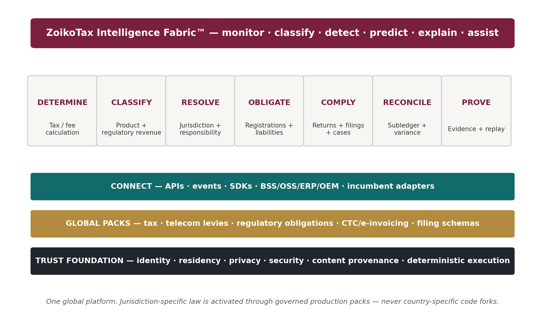
Figure 1 — ZoikoTax full-stack capability model

4. Users, Buyers & Tenant Structure

4.1 Organizations that use ZoikoTax
• Mobile Network Operators (MNOs)
• Full, light and hybrid MVNOs
• MVNEs and MVNAs
• Wholesale carriers and telecom aggregators
• VoIP and SIP providers
• UCaaS, CCaaS and CPaaS providers
• ISPs, broadband and fixed-wireless providers
• IoT/M2M connectivity providers
• Satellite communications providers
• Enterprise telecom/communications providers
• BSS/OSS platforms embedding ZoikoTax
• Tax/compliance service providers operating under approved partner models

4.2 Primary personas
Persona | Primary jobs-to-be-done
Tax Director / Head of Tax | Policy ownership, taxability, exemptions, returns, audit defense, content confidence.
Regulatory Compliance | Telecom levies, registrations, regulator calendars, filings, notices and cases.
CFO / Finance | Liability, recovery, accruals, reconciliation, exposure, audit and controls.
Revenue Assurance | Leakage, missing tax/fees, classification anomalies, reconciliation breaks.
Billing / BSS Engineering | Quote/commit integration, adjustments, invoice lines, high-volume reliability.
Product / Commercial | SKU onboarding, bundles, market launch readiness, customer recovery presentation.
CTO / CIO / Platform Engineering | Architecture, APIs, residency, reliability, security and OEM embedding.
Content & Regulatory Analyst | Source monitoring, rule authoring, review, pack promotion and legal provenance.
Compliance Operations | Workpapers, filing, authority acknowledgements, notices, amendments and case resolution.
Auditor / Control Reviewer | Read-only evidence, historical replay, approval and control lineage.
System Integrator / OEM Partner | API/SDK integration, tenant provisioning, mapping and certification.

4.3 Canonical tenancy hierarchy
The canonical hierarchy is conceptually: Platform → OEM/Partner (optional) → Tenant/Operator → Legal Entity → Brand/Business Unit → Customer/Account → Service/Subscription → Transaction/Fiscal Document. A tenant may span multiple legal entities and residency cells. Detailed identity and temporal semantics belong to ZTAX-DOM-001.

5. Product Operating Modes
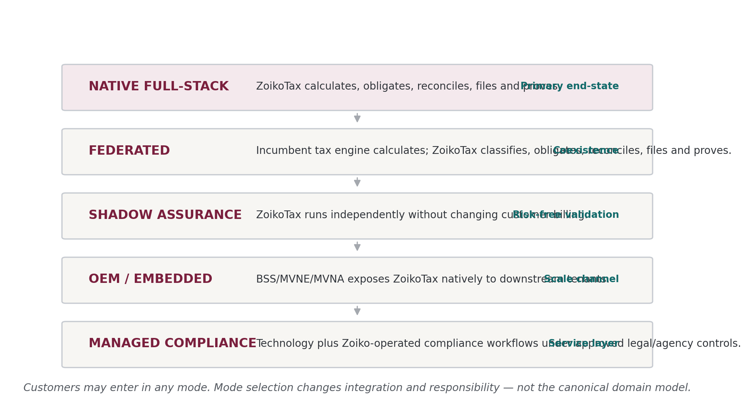
Figure 2 — Supported customer operating modes
Mode | Meaning | Charter rule
Native Full-Stack | ZoikoTax owns tax determination and downstream obligations/compliance within supported packs. | Must support quote, commit, adjust, classify, obligate, reconcile, file/e-invoice where configured and prove.
Federated | A third-party engine remains the tax calculator while ZoikoTax consumes its results plus source billing data. | ZoikoTax remains authoritative for its own classification, responsibility, obligation, reconciliation and evidence domains.
Shadow Assurance | ZoikoTax analyzes copied data without changing billing or filing production outcomes. | All findings are explicitly non-authoritative until customer review/promotion; zero impact on source billing path.
OEM / Embedded | A BSS/MVNE/MVNA or other platform exposes ZoikoTax capabilities to downstream tenants. | Strict tenant isolation, partner administration and independently attributable legal entities are mandatory.
Managed Compliance | ZoikoTax technology plus approved operational services. | Human approvals, POA/agency controls, credentials, audit evidence and advice boundaries apply.

6. Global Coverage & Support Model
GLOBALITY RULE
“Global” describes product architecture and commercial scope from inception. It does not mean every jurisdiction is legally certified on launch day. Legal support is activated through governed country/regulatory packs with explicit status, owner, scope, effective dates and verification evidence.
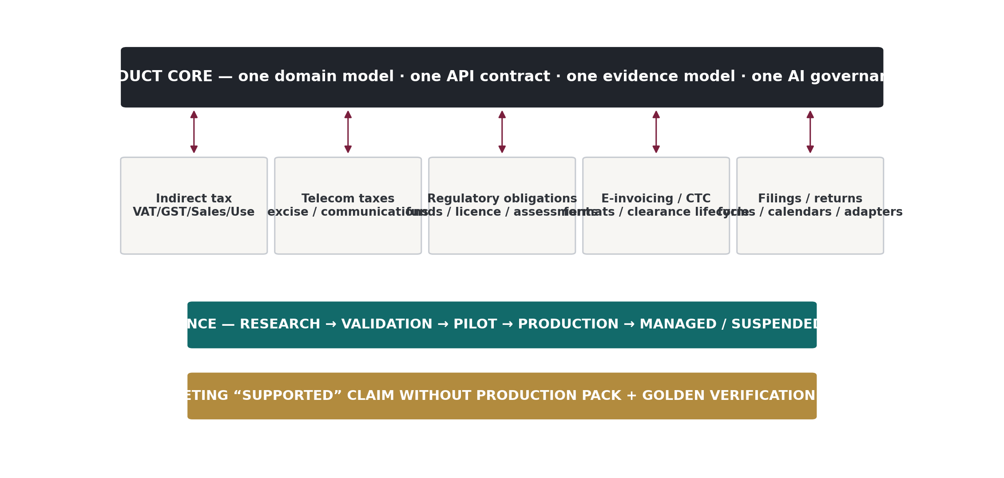
Figure 3 — Global core and jurisdiction-pack model

6.1 Tax and regulatory domains in scope
Domain | Scope
General indirect tax | VAT, GST, sales tax, use tax, consumption tax and equivalent indirect transaction taxes.
Telecom-specific transaction charges | Communications taxes, telecom excise, airtime/data/SIM/activation taxes or fees, emergency-service charges and similar sector-specific customer/provider charges.
Regulatory financial obligations | Universal-service-type contributions, regulatory assessments, licence/authorization charges, revenue-share or turnover-based telecom levies, gross-revenue assessments and similar sector obligations.
Customer recovery / pass-through | Configured recovery treatment, invoice presentation and distinction between statutory liability and economic recovery.
Exemptions / resale / wholesale | Certificates, resale treatment, wholesale/inter-carrier distinctions and jurisdiction-specific eligibility.
E-invoicing / CTC | Telecom invoice semantic validation, country/region mapping, clearance/e-reporting status lifecycle and reconciliation through adapters/partners.
Returns / filings | Registrations, workpapers, returns, submissions, acknowledgements, amendments, notices and audit/case workflows.
Cross-border / multi-currency | Place-of-supply/situs rules, FX references, currency rounding and multi-entity reporting subject to pack support.

6.2 Localization requirements
• Unicode-safe names/addresses/authority text; display labels must never be logic keys.
• ISO-based country/currency identifiers or explicitly governed equivalents; pack-specific sub-jurisdiction identifiers may extend them.
• Local tax labels, invoice presentation, date/time/number/currency formats and authority terminology without changing canonical semantics.
• Timezone-aware effective dates, filing calendars, deadlines and business-day/holiday rules.
• Multi-language source ingestion and AI-assisted analysis; authoritative rule interpretation remains governed by qualified reviewers.
• No assumption that tax is customer-borne, percentage-based, invoice-line-based, monthly, or denominated in the billing currency.

7. Authoritative Capability Scope
Capability | Charter scope | Detailed owner
Determine | Native quote/commit/adjust computation of supported taxes, fees and contributions. | ZTAX-DET-001
Classify | Product/SKU decomposition plus independent taxability and regulatory-revenue classification. | ZTAX-CLS-001
Jurisdiction | Situs/place-of-supply/geospatial resolution using governed evidence hierarchies. | ZTAX-JUR-001
Exempt | Certificates, wholesale/resale/customer/entity exemption eligibility and lifecycle. | ZTAX-DET-001 / DOM
Responsibility | Resolve incidence, collection, reporting, remittance and economic bearer. | ZTAX-OBL-001
Obligations | Create registrations, reporting, filing, contribution and deadline obligations. | ZTAX-OBL-001
Fiscal Lifecycle | Quote, commit, invoice, credit, refund, reversal, rebill, amendment and restatement. | ZTAX-FIN-001
Tax Control Subledger | Authoritative tax liability/recovery postings and accounting bridge. | ZTAX-FIN-001
Reconcile | Calculated ↔ invoiced/cleared ↔ collected ↔ adjusted ↔ reported ↔ remitted ↔ accounting. | ZTAX-FIN-001
Comply / File | Registrations, returns, workpapers, approvals, submissions, acknowledgements, notices and cases. | ZTAX-COMP-001
Remit | Prepare/authorize/track remittance instructions under approved funds-control model. | ZTAX-REM-001
E-Invoicing / CTC | Telecom semantic validation/enrichment, mapping, adapter lifecycle and status reconciliation. | ZTAX-CTC-001
Prove | Evidence ledger, source-to-decision lineage, period sealing and historical replay. | ZTAX-EVID-001
Shadow | Parallel assurance and discrepancy analysis with no source-system impact. | ZTAX-SHD-001
Connect | REST/events/webhooks/SDKs/bulk/OEM/BSS/ERP/authority adapters. | ZTAX-INT-001
Intelligence Fabric™ | Regulatory monitoring, classification assistance, anomaly/risk detection, forecasting, explanation and workflow assistance. | ZTAX-AI-001 / AIGOV
Content Ops | Source ingestion, rule proposals, approvals, signed packs, suspension/withdrawal and content metrics. | ZTAX-CONT-001
TaxOps | Operational health, correctness, content freshness, anomalies, filing status, reconciliation and audit support. | ARCH / NFR / QA

8. AI Foundation & Authority Boundary
AI IS PART OF THE PRODUCT FOUNDATION
ZoikoTax is not a conventional tax engine with an AI assistant bolted on. The Intelligence Fabric™ is a platform capability spanning regulatory intelligence, onboarding, classification, anomaly detection, forecasting, filing/reconciliation assistance and explainability. Its authority is deliberately bounded so fiscal correctness remains deterministic and auditable.

8.1 Required AI-native use cases
• Monitor authoritative and approved secondary sources for change signals.
• Diff legislation, guidance, forms, schemas and rate tables across revisions.
• Extract candidate facts/rules with source provenance and confidence.
• Map customer SKUs/bundles to canonical telecom ontology; flag low-confidence or novel products.
• Recommend regulatory-revenue classifications and detect inconsistent historical mappings.
• Assist responsibility and obligation discovery by identifying missing facts and competing interpretations.
• Detect anomalous effective rates, missing tax calls, reconciliation breaks, filing variances and unusual jurisdiction shifts.
• Forecast fiscal exposure, filing workload and content-impact scenarios using governed inputs.
• Assist workpaper preparation, regulator-response drafting and case summarization without autonomously filing.
• Explain deterministic decisions in natural language with source-backed retrieval and decision provenance.
• Generate test cases and identify regression gaps; never self-approve production legal content.

8.2 AI authority states
State | Meaning
ADVISORY | AI output has no authoritative fiscal effect. Examples: explanation, anomaly finding, draft response.
PROPOSAL | AI proposes a classification, rule candidate or workflow action. Requires governed review before authoritative use.
ASSISTED | AI participates inside a workflow, but deterministic controls/human approval determine the authoritative outcome.
PROHIBITED | Direct model-to-rule promotion, direct model-to-tax amount write, filing approval, remittance authorization, silent legal ambiguity resolution, or unsupported citation generation.

9. Authoritative Output Model
ZoikoTax must make the authority of every output explicit. The UI, APIs, events and evidence records must distinguish the following classes; they may not be conflated by naming or schema.
Output | Purpose | Authority rule
Preview / Quote | Deterministic calculation preview without final fiscal commitment. | May be authoritative as a quote under contract, but does not create final obligation unless committed.
TaxDecision | Committed transaction tax/fee result. | Authoritative within supported pack/configuration; immutable lineage.
RegulatoryClassification | Regulatory revenue classification for reporting/contribution purposes. | Authoritative when approved/configured; independent of taxability.
ResponsibilityResolution | Incidence/collection/reporting/remittance/economic bearer resolution. | RESOLVED may be authoritative; AMBIGUOUS/UNSUPPORTED may not silently progress.
Obligation | Party/authority/type/period/due-date/basis/amount/status record. | Authoritative when generated from effective rules/configuration.
Filing/Return State | Prepared/approved/submitted/accepted/rejected/amended lifecycle. | Authority depends on acknowledgement/evidence; uncertain submission must remain explicit.
Remittance Instruction/State | Payment preparation/approval/execution acknowledgement. | ZoikoTax tracks authority; custody boundary governed separately.
AI Finding / Explanation | Advisory or proposal output. | Never authoritative merely because confidence is high.
Analytics / Forecast | Derived reporting, scenario or prediction. | Non-authoritative unless separately promoted into a governed decision workflow.
Shadow Finding | Difference/anomaly finding against source/incumbent systems. | Non-authoritative until reviewed/promoted.

10. Critical Product Journeys
Journey | Minimum outcome
J01 — Provision global tenant | Create tenant/OEM relationship, legal entities, residency placement, entitlements, roles and base configuration.
J02 — Onboard product catalogue | Ingest SKUs/bundles, decompose canonical service components, AI-assist mappings, review exceptions and version mappings.
J03 — Quote/commit transaction | Normalize request, classify, resolve situs/exemptions/responsibility, calculate deterministic result, commit decision/evidence.
J04 — Adjust fiscal document | Credit/refund/reversal/rebill/amend with linked lineage, period rules and no destructive edits.
J05 — Generate regulatory obligations | Aggregate/classify revenue or activity, resolve responsible party, create due-dated obligations and readiness status.
J06 — Prepare/file return | Build workpapers, reconcile, approve, submit/track, capture acknowledgement and preserve filing evidence.
J07 — E-invoice/CTC lifecycle | Validate/enrich telecom invoice, transform through adapter, submit through certified network/authority, handle rejection and reconcile status.
J08 — Reconcile period | Tie calculation, invoice, collection, adjustments, filings, remittance and subledger/GL bridge; create actionable exceptions.
J09 — Handle notice/audit | Ingest notice, link affected periods/decisions/evidence, assign case, respond, track outcome and amendments.
J10 — Regulatory change lifecycle | Detect source change, create proposal, human interpretation/review, regression impact, approve signed pack, future-effective activation.
J11 — Shadow Assurance | Ingest copied source/incumbent outputs, compare classification/obligation/tax where applicable, score materiality, produce non-impact report.
J12 — Migrate incumbent | Map configuration/data, run parallel validation, reconcile, cut over, preserve historical evidence and rollback path.
J13 — Auditor replay | Select historical decision/period, reconstruct exact versions/input/evidence, compare expected/actual and export audit package.
J14 — Suspend pack | Block new authoritative use as defined, protect in-flight workflows, notify customers, preserve historical replay, manage remediation.
J15 — OEM downstream tenant | Provision child tenant with isolated data/configuration/content entitlement while maintaining partner-level administration boundaries.

11. Explicit Scope Boundaries

11.1 ZoikoTax owns
• Tax/regulatory fiscal determination within supported packs.
• Canonical telecom tax/regulatory classification and responsibility resolution.
• Tax/regulatory obligations, workpapers, filing state, evidence and reconciliation.
• Tax control subledger and accounting bridge for ZoikoTax-controlled fiscal postings.
• Telecom e-invoice/CTC semantic validation and lifecycle state, with network transport partnerable.
• Content/rule governance and signed pack distribution.
• AI intelligence for approved tax/compliance use cases.
• APIs/events/SDKs/adapters required to integrate billing, BSS/OSS, ERP, authorities and partners.

11.2 ZoikoTax integrates with but does not replace
• Telecom mediation, rating, charging and network usage platforms.
• Customer master/CRM and product catalogues as commercial systems of record.
• ERP/general ledger as enterprise accounting system of record.
• Payment processors, banks and customer treasury as default funds-execution/custody systems.
• Identity providers and enterprise directories.
• Certified national/regional e-invoicing access points or clearance providers where partnering is the chosen model.
• External tax engines during federated/shadow/migration modes.

11.3 Out of scope unless separately chartered
• General telecom BSS/OSS functions unrelated to tax/regulatory compliance (rating, charging, order management, provisioning, network mediation).
• Corporate income tax, payroll tax, customs/trade, transfer pricing, property tax and non-telecom industry compliance as primary product scope.
• Operating a bank, payment institution or holding customer funds by default.
• Providing unqualified legal/tax advice through software or AI; advisory services require separately governed professional engagement.
• Operating every national e-invoicing/clearance network directly; transport/accreditation may be partnered while Zoiko owns telecom semantics and lifecycle.
• Using customer data to train general models or unrelated products without explicit contractual/legal authorization.
• Silent unsupported-country fallback to generic VAT or nearest jurisdiction.
• Blockchain as a default evidence architecture.
• Hard-coded country logic inside application code when the concern belongs in a governed pack.
• Any marketing claim of “complete global coverage” unsupported by live pack status.

12. Failure, Ambiguity & Support-State Semantics
State | Charter meaning
RESOLVED | Required facts/rules support one authoritative outcome.
AMBIGUOUS | Multiple legally plausible outcomes or missing disambiguating fact. Human/configuration resolution required.
UNSUPPORTED | Capability/jurisdiction/charge is outside current PRODUCTION pack scope.
CONFLICTED | Evidence sources or jurisdiction facts conflict beyond configured resolution policy.
SUSPENDED | Pack/capability temporarily blocked because of legal/content/licensing/operational risk.
STALE | Required content/data exceeds freshness policy; outcome may be blocked or restricted according to spec.
DEGRADED | Non-authoritative/ancillary subsystem unavailable; core deterministic path operates under defined degradation policy.
UNCERTAIN_SUBMISSION | Authority submission outcome cannot be proven accepted/rejected; duplicate submission is prohibited until resolved.
FAIL EXPLICITLY
A legal/compliance platform is allowed to say “I cannot determine this safely.” It is not allowed to invent a plausible result and hide the uncertainty.

13. Integration & Ecosystem Boundary
Integration class | Examples / boundary
Upstream transaction sources | BSS/billing, ERP, order/CPQ, product catalogue, mediation summaries, CRM/customer master, exemption sources.
Downstream financial/compliance | Invoices, ERP/GL, data warehouse, regulator/authority systems, filing networks, e-invoice access points, treasury/payment execution.
Tax ecosystem | CereTax, CCH SureTax, Avalara, Vertex and customer-built engines via adapter contracts in federated/shadow/migration modes.
Identity/security | Enterprise IdP, SCIM, workload identity, SIEM/SOC and customer key-management integration where supported.
OEM/partner | BSS, MVNE/MVNA and implementation partners provisioning/managing downstream tenants under scoped delegated authority.
All external integration behavior, versioning, idempotency, error semantics, bulk/event/webhook contracts and compatibility commitments are delegated to ZTAX-INT-001.

14. Product Data & Trust Boundaries
• Global metadata/content may be globally distributed subject to source licences and policy; tenant-sensitive operational data is placed in authorized residency cells.
• A multinational tenant may span multiple cells by legal entity/data domain. Cross-cell management views use approved summaries/projections rather than centralizing raw sensitive records by default.
• Content/rule bundles are versioned, signed and provenance-linked; customer runtime decisions pin the exact versions used.
• Sensitive subscriber/network location data is not a product prerequisite for every transaction. When needed, collection/retention follows evidence-class policies and data minimization.
• Secrets, regulator credentials and POAs are segregated from ordinary application data and subject to stronger access/audit controls.
• Customer data used for model improvement, benchmarking or aggregated corpus creation requires explicit contractual/legal basis and tenant-configurable controls.

15. Commercial & Entitlement Scope
The product must support commercial packaging without allowing commercial configuration to alter legal correctness. Entitlements determine whether a tenant may access a capability/pack/service; they may not rewrite a tax rule, suppress a legally required result or cause an unsupported pack to appear supported.
• Plan/tier entitlements and OEM rights.
• Production country/regulatory pack entitlements.
• Usage/active-subscriber/billed-line metrics and contract limits.
• Managed filing/compliance service entitlements.
• Trial/evaluation modes with clearly non-authoritative or bounded production permissions.
• Upgrade/downgrade/effective-date behavior without retroactively changing historical decisions.
• Enterprise/private deployment and dedicated residency/security options.
Detailed commercial enforcement belongs to ZTAX-COM-001.

16. Capability Release Map
RELEASE PRINCIPLE
Global architecture is not phased by country. Product capability matures in releases; jurisdiction support is activated continuously through packs. The release map is a sequencing aid, not permission to create country-specific shortcuts.
Release family | Capability emphasis | Charter outcome
Foundation | Governance, domain/content/evidence/security/privacy/AI authority, tenancy/residency, core platform, requirement/verification system. | No authoritative production output until applicable specs/packs are EFFECTIVE.
Global Core | Product/revenue classification, native determination, jurisdiction, responsibility/obligations, fiscal lifecycle, APIs, initial PRODUCTION packs, AI intelligence services. | Global-by-design quote/commit/obligation capability.
Compliance Operations | Returns/filings, e-invoice/CTC lifecycle, remittance controls, reconciliation/TaxOps, managed compliance, Shadow Assurance, migration. | Commercial full-stack operation across activated packs.
Tier-1 Scale | OEM/embedded scale, additional residency/private deployment patterns, advanced AI/forecasting, high-volume/edge capabilities where demand justifies, expanding country/regulatory packs. | Scale and coverage expansion without changing canonical product model.

17. Product Readiness & Claim Controls

17.1 Production capability gate
• Governing Constitutional/Specification documents are EFFECTIVE.
• Required country/regulatory pack is PRODUCTION (or MANAGED where service commitment requires it).
• Verification/conformance evidence is green and linked to the release/pack.
• Security, privacy, residency and AI-governance gates are satisfied.
• Content freshness and source/provenance requirements are satisfied.
• Monitoring, alerts, operational ownership and runbooks exist.
• Rollback/suspension/recovery paths are proven.
• Historical replay/evidence capture is verified.
• Customer-visible documentation and support boundaries match actual capability.

17.2 Marketing/support claim control
• “Supported country/jurisdiction” means the relevant capability pack is PRODUCTION; “MANAGED” additionally means Zoiko supports managed compliance operations for that pack.
• “Global” may describe platform architecture and market scope, not universal live legal coverage.
• AI accuracy claims require defined evaluation metric, dataset/scope and current model/version evidence.
• Availability/latency claims require measured workload class and deployment topology; no universal number may be claimed without NFR evidence.
• “Filed” or “accepted” requires regulator/network evidence appropriate to the authority workflow; submission attempt is not acceptance.

18. Normative Charter Requirements
The following requirements are constitutional. Detailed specifications may strengthen them but may not weaken or contradict them. Verification methods follow ZTAX-GOV-001: TEST, INSPECTION, ANALYSIS, AUDIT or DEMONSTRATION.
Requirement ID | Domain | Normative requirement | Verify | Delegated to
ZTAX-PRD-REQ-0001 | GLOBAL | ZoikoTax MUST use one canonical global product/domain architecture; jurisdiction-specific law MUST be supplied through governed packs/adapters rather than country-specific application forks. | INSPECTION | ARCH/DOM/CONT
ZTAX-PRD-REQ-0002 | GLOBAL | A non-U.S. production pack MUST be implementable without changing canonical source-code semantics solely to accommodate the country. | DEMONSTRATION | CONT/QA
ZTAX-PRD-REQ-0003 | GLOBAL | The product MUST support multiple currencies, timezones, localized labels and legal entities without using display text as logic keys. | TEST | DOM/DET
ZTAX-PRD-REQ-0004 | GLOBAL | A multinational tenant MUST be able to operate legal entities/data domains in more than one residency cell under one commercial tenancy. | DEMONSTRATION | SEC/DOM
ZTAX-PRD-REQ-0005 | SCOPE | ZoikoTax MUST support Native Full-Stack, Federated, Shadow Assurance, OEM/Embedded and Managed Compliance operating modes. | DEMONSTRATION | ARCH/INT/SHD/COMP
ZTAX-PRD-REQ-0006 | SCOPE | ZoikoTax MUST provide native tax determination in supported production packs while retaining adapter-based coexistence with third-party engines. | TEST | DET/INT
ZTAX-PRD-REQ-0007 | SCOPE | ZoikoTax MUST support transaction taxes/fees and non-transaction regulatory financial obligations as separate but connected fiscal concepts. | TEST | DOM/DET/OBL
ZTAX-PRD-REQ-0008 | SCOPE | ZoikoTax MUST support returns/filings, reconciliation, evidence and e-invoicing/CTC lifecycle within activated capabilities; transport/accreditation MAY be partner-delivered. | DEMONSTRATION | COMP/FIN/EVID/CTC
ZTAX-PRD-REQ-0009 | CLASSIFICATION | Taxability classification and regulatory-revenue classification MUST be independent authoritative attributes and MUST NOT be implicitly derived from one another. | TEST | DOM/CLS
ZTAX-PRD-REQ-0010 | RESPONSIBILITY | Legal incidence, collection, reporting, remittance and economic bearer MUST be separately resolvable roles. | TEST | OBL
ZTAX-PRD-REQ-0011 | AUTHORITY | Every authoritative decision MUST identify the governing content/rule version and sufficient provenance for historical reconstruction. | AUDIT | EVID/CONT
ZTAX-PRD-REQ-0012 | AUTHORITY | AI output MUST NOT independently create or alter authoritative tax law/rates, approve filings, authorize remittance or bypass deterministic execution. | AUDIT | AIGOV
ZTAX-PRD-REQ-0013 | AUTHORITY | AI-assisted legal/content/classification outputs entering authoritative workflows MUST carry provenance and a governed review/promotion path. | AUDIT | AIGOV/CONT
ZTAX-PRD-REQ-0014 | AUTHORITY | The system MUST distinguish authoritative decisions, advisory AI outputs, derived analytics and Shadow findings in schemas and user-facing states. | INSPECTION | DOM/UX/INT
ZTAX-PRD-REQ-0015 | AMBIGUITY | Legal, jurisdiction, responsibility or content ambiguity MUST produce an explicit governed state and MUST NOT silently default. | TEST | JUR/OBL/CONT
ZTAX-PRD-REQ-0016 | SUPPORT | A jurisdiction/capability MUST NOT be represented as supported unless the applicable pack is in PRODUCTION or MANAGED state. | AUDIT | CONT/COM/UX
ZTAX-PRD-REQ-0017 | MONEY | Authoritative monetary calculations MUST use deterministic numeric semantics; floating-point binary arithmetic MUST NOT be used for fiscal amounts. | TEST | DET/DOM
ZTAX-PRD-REQ-0018 | MONEY | Rounding, allocation, tax-inclusivity, tax-on-tax order, FX and period/threshold state MUST be explicit and versioned where applicable. | TEST | DET/FIN
ZTAX-PRD-REQ-0019 | LIFECYCLE | Committed fiscal history MUST be immutable; corrections MUST use linked adjustments, reversals, credits, refunds, rebills, amendments or restatements. | TEST | FIN/DOM
ZTAX-PRD-REQ-0020 | LIFECYCLE | Post-period-lock changes MUST NOT silently mutate a closed fiscal period. | TEST | FIN
ZTAX-PRD-REQ-0021 | EVIDENCE | ZoikoTax MUST be able to replay an authoritative historical decision using the effective engine/content/configuration/evidence references for that decision. | DEMONSTRATION | EVID/QA
ZTAX-PRD-REQ-0022 | EVIDENCE | Evidence retention MUST follow evidence-class, legal, customer and legal-hold policies; the product MUST NOT enforce a universal retain-all or discard-all rule. | AUDIT | PRIV/EVID
ZTAX-PRD-REQ-0023 | SECURITY | Tenant isolation MUST be enforced through storage/IAM/infrastructure controls appropriate to the deployment tier and MUST NOT rely solely on application filtering. | TEST | SEC
ZTAX-PRD-REQ-0024 | PRIVACY | Sensitive situs/network evidence MUST be minimized and purpose-bound, with collection/retention governed by ZTAX-PRIV-001 and applicable pack policy. | AUDIT | PRIV/JUR
ZTAX-PRD-REQ-0025 | RESILIENCE | Failure of AI services MUST NOT make an otherwise deterministic supported tax calculation incorrect. | TEST | AI/NFR/DET
ZTAX-PRD-REQ-0026 | RESILIENCE | Failure of a remote source website or global content-authoring service during transaction execution MUST NOT cause the runtime to query unapproved live web content or invent a result. | TEST | ARCH/NFR/DET
ZTAX-PRD-REQ-0027 | API | Every mutating public integration operation MUST support idempotent business effect under retries/redelivery according to ZTAX-INT-001. | TEST | INT
ZTAX-PRD-REQ-0028 | API | Quote and commit semantics MUST be distinguishable; a non-committing preview MUST NOT accidentally create a fiscal obligation. | TEST | INT/FIN
ZTAX-PRD-REQ-0029 | COMPLIANCE | A filing/submission workflow MUST preserve the distinction between prepared, approved, submitted, accepted, rejected, amended and uncertain states. | TEST | COMP
ZTAX-PRD-REQ-0030 | COMPLIANCE | No return/filing sign-off or remittance authorization requiring human accountability MAY be silently completed by AI. | AUDIT | AIGOV/COMP/REM
ZTAX-PRD-REQ-0031 | REMITTANCE | ZoikoTax MUST default to preparing/authorizing/tracking remittance without customer-fund custody unless a separately approved legal/regulatory model enables custody. | INSPECTION | LEG/REM
ZTAX-PRD-REQ-0032 | CTC | ZoikoTax MUST own canonical telecom invoice tax/regulatory semantics and lifecycle reconciliation even where clearance-network transport is partner-delivered. | DEMONSTRATION | CTC
ZTAX-PRD-REQ-0033 | SHADOW | Shadow Assurance MUST operate without changing the customer's production billing/filing outcome and MUST label findings as non-authoritative until reviewed/promoted. | TEST | SHD
ZTAX-PRD-REQ-0034 | MIGRATION | Migration from an incumbent engine MUST support parallel validation, reconciliation, cutover controls, historical continuity and rollback appropriate to the integration. | DEMONSTRATION | MIG/SHD
ZTAX-PRD-REQ-0035 | CONTENT | Every production rule/pack MUST have an accountable owner, source/provenance, effective dates, approval and verification evidence. | AUDIT | CONT/QA
ZTAX-PRD-REQ-0036 | CONTENT | A PRODUCTION pack MUST define suspension/withdrawal behavior for in-flight decisions, open obligations, filings and customer notification. | INSPECTION | CONT/COMP
ZTAX-PRD-REQ-0037 | AI | The Intelligence Fabric MUST support source-backed regulatory change monitoring, classification assistance, anomaly detection and deterministic-decision explanation as foundational platform use cases. | DEMONSTRATION | AI/AIGOV
ZTAX-PRD-REQ-0038 | AI | AI model/prompt/retrieval configuration used in customer-visible or content workflows MUST be versioned and evaluable under ZTAX-AIGOV-001. | AUDIT | AIGOV/AI
ZTAX-PRD-REQ-0039 | COMMERCIAL | Entitlements MUST control access to capabilities/packs/services but MUST NOT change the legal correctness of an authoritative decision. | TEST | COM/DET
ZTAX-PRD-REQ-0040 | COMMERCIAL | Historical decisions MUST remain bound to the effective content/configuration accepted at the time; plan upgrades/downgrades MUST NOT retroactively rewrite fiscal history. | TEST | COM/EVID
ZTAX-PRD-REQ-0041 | OPERATIONS | Every authoritative production capability MUST expose observable health/failure states, accountable ownership and a runbook. | AUDIT | NFR/DEVOPS
ZTAX-PRD-REQ-0042 | OPERATIONS | TaxOps MUST expose correctness/content/filing/reconciliation issues separately from generic infrastructure health. | DEMONSTRATION | ARCH/NFR/UX
ZTAX-PRD-REQ-0043 | CLAIMS | Published product-support, AI-performance and service-level claims MUST be backed by current registered evidence for the stated scope. | AUDIT | GOV/QA/NFR/AIGOV
ZTAX-PRD-REQ-0044 | BOUNDARY | ZoikoTax MUST NOT become the authoritative telecom rating/charging engine or enterprise general ledger merely to implement tax workflows. | INSPECTION | ARCH/FIN
ZTAX-PRD-REQ-0045 | BOUNDARY | Customer or third-party data MUST NOT be used to train general models or unrelated products absent explicit contractual/legal authorization. | AUDIT | PRIV/AIGOV
ZTAX-PRD-REQ-0046 | OEM | OEM/embedded mode MUST preserve downstream tenant/legal-entity isolation, evidence attribution and independent compliance configuration. | TEST | SEC/DOM/INT
ZTAX-PRD-REQ-0047 | AUDIT | A read-only auditor/control-review experience MUST be able to retrieve decision, approval, content and filing provenance without granting operational mutation privileges. | DEMONSTRATION | UX/EVID/SEC
ZTAX-PRD-REQ-0048 | DATA | External source systems MAY remain systems of record for customer/product/account data; ZoikoTax MUST retain the normalized fiscal facts/version references necessary to explain authoritative outcomes. | ANALYSIS | DOM/EVID
ZTAX-PRD-REQ-0049 | PACK | Country/regulatory pack activation MUST be independently versionable from application, AI-model and authority-adapter releases. | DEMONSTRATION | CONT/DEVOPS
ZTAX-PRD-REQ-0050 | QUALITY | No authoritative capability may reach production without traceability from governing requirement to verification evidence and release/pack version. | AUDIT | GOV/QA/DEVOPS

19. Charter Glossary
Term | Charter definition
Authoritative | An output/state permitted to drive fiscal, filing, compliance or financial operation within its supported scope.
Country/Regulatory Pack | Signed/versioned governed package that activates jurisdiction-specific legal/content behavior without changing canonical architecture.
TaxDecision | Committed transaction-level tax/fee determination with immutable lineage.
Regulatory Classification | Independent classification of revenue/activity for regulatory reporting/contribution purposes.
Responsibility Resolution | Resolution of incidence, collection, reporting, remittance and economic-bearer roles.
Obligation | Atomic party-authority-period/type/basis/amount/due-date/status compliance liability or requirement.
Tax Control Subledger | ZoikoTax fiscal control ledger for tax liability/recovery and reconciliation; not the enterprise general ledger.
Shadow Assurance | Non-impact parallel analysis against customer/source/incumbent systems.
Intelligence Fabric™ | AI-enabled platform capabilities for regulatory intelligence, classification, anomaly/risk detection, forecasting, workflow assistance and explanation.
Deterministic Rule | Approved executable logic that produces reproducible authoritative outcomes from defined inputs/versioned content.
Production Pack | Pack approved for authoritative customer use for the stated scope.
Managed Pack | Production pack with Zoiko-supported managed compliance operations.
Situs / Place of Supply | Legally relevant location determination used to apply tax/regulatory rules.
Bitemporal | Modeling both when a rule/fact is legally valid and when the system knew/recorded it.
Fiscal Document | Quote/invoice/credit/refund/rebill/amendment or equivalent tax-relevant document state.
Evidence Manifest | Versioned references/hashes identifying the facts, content and controls supporting an authoritative outcome.
OEM Tenant | Downstream tenant served through a partner/platform integration while retaining ZoikoTax isolation and attribution.
Content Authority | Source hierarchy and human approval structure governing legal/tax/regulatory content.
Ambiguous | State where the platform cannot safely produce one authoritative legal outcome without additional fact/decision.
Unsupported | State where required behavior is outside activated PRODUCTION pack/capability scope.

20. Engineering Handoff & Next Specifications
THIS CHARTER IS COMPLETE WHEN IT CREATES NO PRODUCT AMBIGUITY — NOT WHEN IT CONTAINS EVERY IMPLEMENTATION DETAIL
Engineering should be able to answer: what product are we building, for whom, in which modes, which capabilities are mandatory, what outputs are authoritative, what AI may do, how global support works, what is excluded, and what conditions permit production. The detailed “how” now moves into the controlled specification estate.
Next constitutional/specification workstream | Purpose
ZTAX-DOM-001 | Canonical Domain Model, Data Model & Lifecycles
ZTAX-CONT-001 | Global Tax & Regulatory Content / Country Pack Standard
ZTAX-EVID-001 | Evidence Ledger, Replay, Retention & Legal Hold
ZTAX-LEG-001 | Legal, Liability & Regulatory Posture
ZTAX-SRC-001 | Content Sourcing, Licensing & Redistribution
ZTAX-SEC-001 | Security, IAM, Tenant Isolation & Residency
ZTAX-PRIV-001 | Privacy Engineering & Situs Evidence Handling
ZTAX-AIGOV-001 | AI Governance, Model Risk & Authority Boundary
ZTAX-NFR-001 | Non-Functional Requirements baseline

21. Approval
Role | Name | Date | Signature
Chief Product Officer
Chief Technology Officer
Chief Content & Regulatory Officer
General Counsel
End of ZTAX-PRD-000 v1.0

