ZOIKOSHIELD / PRODUCT • DESIGN • ENGINEERING

Public AI Chatbot
Detailed Wireframe 01
Launcher, first-open welcome, public discovery and safe entry to assistance
DOCUMENT STATUS — PROPOSED FOR APPROVAL
Version 1.0 • October 24, 2026 • U.S. English • Scope: Wireframe 01 only. This document is an engineering design specification, not confirmation of deployed functionality, trademark clearance, product certifications, or final website route names.

Executive design decision
Design a polished, deliberately simple cybersecurity assistant entry point that helps a first-time visitor understand ZoikoShield, navigate to plans and pricing, request a demo, or reach legitimate support. The chatbot must increase trust without implying access to customer environments or incident response authority.
ATTRIBUTE | CONTROLLED DESIGN DECISION
Business | ZoikoShield • enterprise cybersecurity platform
Primary user | CISO/security leadership, SOC and IT operations, MSSP evaluators, procurement, and existing customers seeking public support routes
Assistant identity | Internal working name: Zhield (per v7.7 naming register). Production display: approved_display_name; fallback “ZoikoShield Assistant” until Brand/Legal sign-off.
Core first-open jobs | Discover capabilities • view plans/pricing • book a demo • contact support
Trust posture | AI is explicitly disclosed. No claim to see incidents, assets, configurations, or security posture without authentication and product authorization.
Brand source | Official ZoikoShield product logo/favicon must be imported from the controlled asset library; branded structural palette: Deep Navy #103848, Shield Red #C04044, white/neutrals.
Status / approval | Draft — Product, Brand, Security/Privacy, Accessibility, Engineering and Legal gates outstanding

Scope boundary
Included: launcher behavior, open/welcome view, first-action routing, first-input affordance, copy, desktop/mobile geometry, failure states, accessibility, instrumentation, proposed integration contract, and acceptance tests. Not included: the full message-thread experience, knowledge answer cards, lead form, human handoff form, or authenticated support workflows; those require separate approved wireframes.

01 / Desktop: public website + welcome panel
Reference layout. Dimensions below are implementation targets, not a replacement for the official Figma/token source.
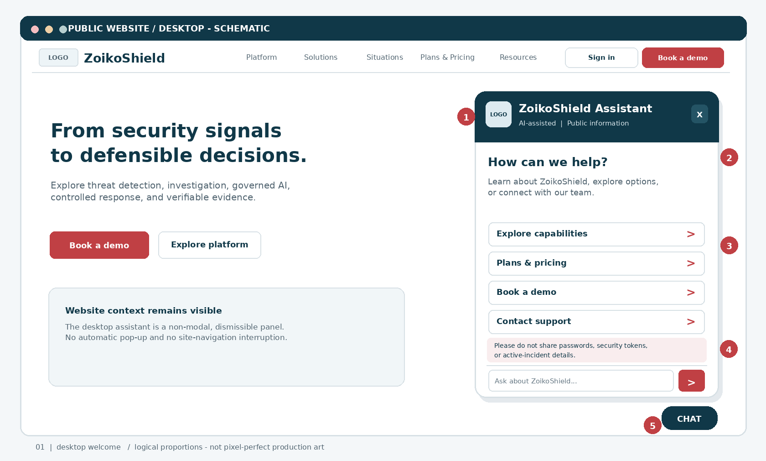
Figure 1. Desktop public-site overlay at a 1440 CSS px baseline. “LOGO” blocks deliberately mark the approved product-logo asset slot; do not substitute a generated or unrelated shield emblem. Content and button labels are proposals subject to published-route/content validation.
MARKER | UI CONTRACT
01 | Header uses brand asset, approved assistant display name, visible AI disclosure and close button.
02 | First-screen heading and helper text orient the visitor; no false personalisation or incident status.
03 | Deterministic quick actions, shown before AI chat input. Four entries fit without overwhelming the panel.
04 | Sensitive-information warning is visible at initial entry, without blocking navigation.
05 | Collapsed launcher remains the only persistent overlay when the panel is closed.

02 / Mobile: full-screen welcome
The mobile presentation is a focus-contained full-screen dialog with safe-area and keyboard support.
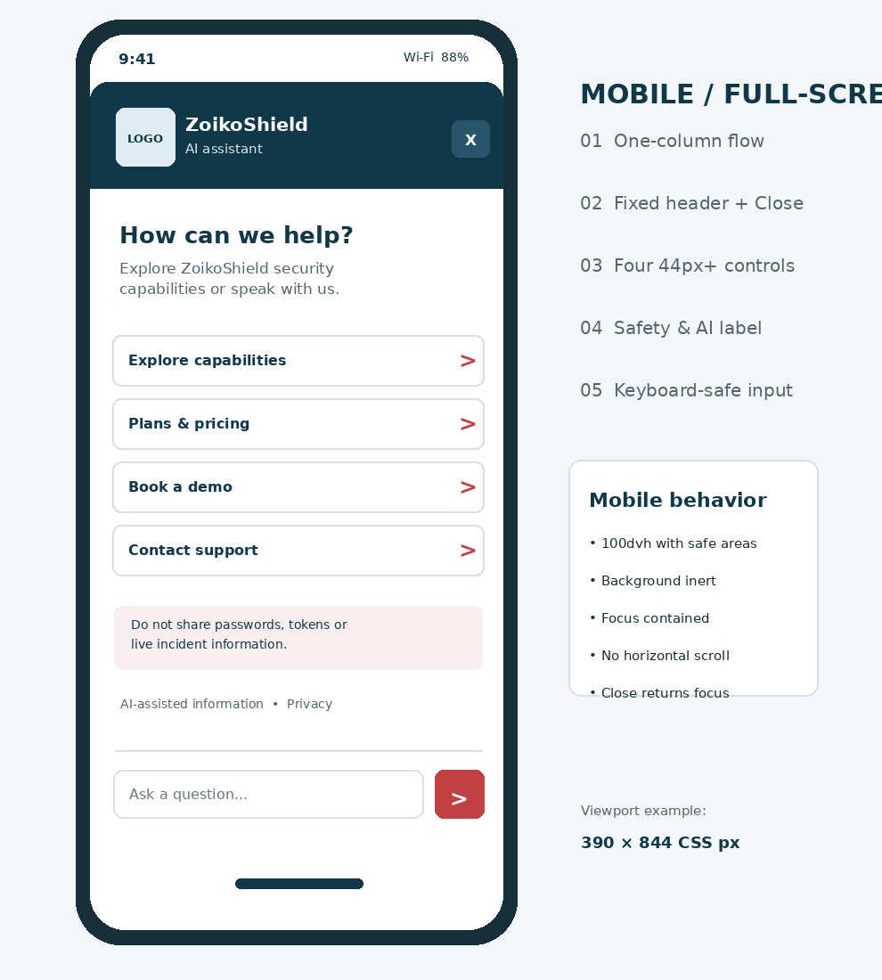
Figure 2. Mobile illustrative view at a 390 × 844 CSS px baseline. The visual is schematic; typography and spacing obey the component dimensions on the following pages.
DESKTOP VS. MOBILE ACCESSIBILITY MODE
Desktop: a modeless dialog; the underlying page remains available, with no focus trap. Mobile: a true modal dialog with inert background, focus contained, Escape/back/Close dismissal where platform conventions permit, and focus returned to the launcher. Do not set aria-modal="true" on the desktop modeless version.

03 / Component anatomy and specifications
Stable component identifiers permit design-to-code reconciliation and precise defect reporting.
ID | ELEMENT | BUILD SPECIFICATION
ZS01 | Launcher | 56×56 CSS px minimum; offset 24px desktop, 16px mobile + safe-area; brand icon + accessible label “Open ZoikoShield Assistant”; never auto-expand.
ZS02 | Panel container | Desktop target width 420px, max-width calc(100vw − 32px); max-height min(720px, calc(100dvh − 96px)); 16px radius. Mobile 100dvh with dynamic viewport and safe-area insets.
ZS03 | Header brand | Approved logo asset, product/assistant name, explicit “AI assistant” or “AI-assisted”; names set from signed, server-owned display registry.
ZS04 | Dismiss controls | Always-visible Close (minimum 44×44 px target); close also via Escape. Restore focus to trigger.
ZS05 | Welcome statement | Heading <= two lines preferred: “How can we help?”; supporting sentence no more than two compact lines at default text size.
ZS06 | Quick actions | Four vertically stacked full-width navigation buttons, each at least 44px tall with visible focus ring and deterministic route key.
ZS07 | Safety notice | Concise: “Do not share passwords, security tokens, or live incident details.” Screen-reader readable, not color-only.
ZS08 | Composer | Single-line input that can expand to 4 lines; send disabled when empty or pending; no client secrets in payload; max length 2,000 characters, server verified.
ZS09 | Privacy access | Always-visible privacy link near composer; open approved privacy-policy route, not a dead end.
ZS10 | Human route | Contact support quick action and always-accessible human escalation in a later conversation state; business-hours expectation only if verified.
ZS11 | Connection feedback | Loading skeleton no fake AI typing; unavailable notice + retry + direct support route; no loss of site functionality.
ZS12 | Instrumentation | Anonymous session and interaction event IDs; consent-dependent analytics; never emit message body, email, IP, credentials or customer data to product telemetry.

04 / Content, task taxonomy and navigation
Every first-open action must resolve through the published ZoikoShield route registry, not hallucinated chatbot-generated URLs.
PRIORITY | ACTION / USER INTENT | DESTINATION & DETERMINISTIC BEHAVIOR
P0 | Explore capabilities | Route key WEB_CAPABILITIES. Show approved public summary of detection, investigation, governed AI, controlled response and verifiable evidence; claims follow content governance.
P0 | Plans & pricing | Route key WEB_PRICING. Public price facts only where approved/current; otherwise show quote/demo pathway and explicitly state that actual commercial terms are confirmed by sales.
P0 | Book a demo | Route key WEB_DEMO. Open established demo journey; never impersonate calendar availability or claim a meeting was booked without confirmation.
P0 | Contact support | Route key WEB_SUPPORT; route to canonical help/support entry. For time-critical security incidents, direct existing customers to their contracted incident channel; do not offer emergency handling in public chat.
P1 | Free-text product question | Only on user submission: create scoped anonymous session, apply input screening, route to separate public Q&A service backed by approved public content; source-linked responses in a later wireframe.

Production copy kit
SLOT | APPROVED-BY-DESIGN DRAFT WORDING
Collapsed launcher | “Ask ZoikoShield” (accessible label: “Open ZoikoShield Assistant”)
Title | “ZoikoShield Assistant” [replace only with authorized display name]
Disclosure | “AI-assisted • Public information”
Opening heading | “How can we help?”
Opening support | “Explore ZoikoShield security capabilities or connect with our team.”
Composer placeholder | “Ask about ZoikoShield…”
Notice | “Do not share passwords, tokens, or live incident information.”
Unavailable | “The assistant is temporarily unavailable. You can still explore our site or contact support.”

05 / Interaction states, triggers and transitions
A deterministic state machine avoids duplicate sessions, unexpected opening and dead-end failures.
STATE | ENTER WHEN | VISIBLE UX / EXIT
S0 CLOSED | Initial page render or Close action | Only launcher visible; no chat session, model request or marketing popup. Activate -> S1. Focus on launcher after close.
S1 OPEN_LOADING | User activates launcher | Panel shell and short neutral loading indicator; fetch public config and route registry. Timeout -> S5. Valid config -> S2.
S2 WELCOME_READY | Config + assets valid | Welcome heading, 4 quick actions, warning, composer, privacy link. Link activation -> public route. Valid first message -> S3.
S3 FIRST_MESSAGE_PENDING | Submitted valid text | Disable duplicate send; allow Close; show accessible progress indicator. BFF validates and acknowledges; then hand off to Wireframe 02 conversation experience.
S4 VALIDATION_WARNING | Input empty, too long, or blocked | Inline reason adjacent to composer; preserve safe input where possible; focus warning or input appropriately. User edits -> S2.
S5 UNAVAILABLE | Config fetch fails, service 5xx, timeout | Show failure banner, retry button and route to support/contact. Site remains operational; retry -> S1.
S6 RESTRICTED/ABUSE | Server rate-limit / abuse decision | Calm non-technical error, no attack details. No retry storm. Alternative human/site route; cool-down honored.

Interaction invariants
The chatbot opens only following an intentional action; no unsolicited overlay, auto-play sound, or attention-stealing motion.
A quick action follows a server-approved canonical route, independent of model completion or internet inference.
Open/close works in any state; closing never traps focus, loses website scroll position, or initiates privileged activity.
Only the chat content area scrolls; header and composer remain available; the mobile keyboard must not cover the input.
Conversations and personally identifiable information are not persisted client-side without a separately approved privacy basis and retention design.

06 / Security, authority and privacy controls
The public assistant is an untrusted entry surface, not an extension of the authenticated ZoikoShield SOC.
CONTROL AREA | MANDATORY ENGINEERING CONTRACT
Authorization boundary | Anonymous public principal only. No service tokens or routes granting tenant data, alerts, cases, threat hunting, evidence ledger, playbooks, SOAR actions, administrator functions or privileged identity workflows.
Knowledge isolation | Allowlisted public-document corpus; ingestion provenance, classification, approval version, locale and expiry checks. Never index internal demo guides, source code, tenant screenshots or proprietary operating manuals.
Prompt injection | Treat user text and retrieved material as untrusted data. Fixed instruction hierarchy, scoped retrieval, link validation, unsafe-output filters, red-team tests; never let retrieved instructions override policy.
Secrets / PII | Detect and avoid soliciting sensitive inputs; mask/redact in support records and application logs; telemetry stores event metadata only. Restrict retention and access by policy.
Action gating | No direct account changes or bookings from free-form text. Links are deterministic; later lead/support actions require explicit consent and server-side validation.
Transport & browser | HTTPS only, secure cookies when applicable, CSRF defense for stateful actions, restrictive CORS/CSP, output encoding, no chat text in query strings, safe external-link attributes.
Abuse resilience | Server-side rate limiting and bot protection, input limits, payload/content scanning, token/cost ceilings, circuit breaker; graceful public FAQ fallback.
Misleading authority | Never claim live monitoring, threat remediation, emergency response, compliance certification or contractual coverage based on public chat alone.

AUTHORITY GUARDRAIL
Public chatbot ⇢ public marketing information, deterministic navigation, controlled sales/support referrals. Authenticated ZoikoShield operations ⇢ separate trust boundary with WebAuthn/SSO, tenant isolation, ABAC, approvals and auditable security controls. No direct public-to-privileged API or model-tool bridge is permitted.

07 / Engineering architecture and integration
Proposed reference design; endpoint names below are interface contracts for confirmation by Engineering, not assertions about existing deployed routes.
LAYER | RESPONSIBILITY AND CONTROLS
Public site / widget | Accessible React/Next.js widget or framework-neutral embed; lazy-loaded, isolated styling; brand tokens obtained from approved asset pipeline; site remains functional if assistant fails.
Public assistant BFF | Separate public entry API: configuration, canonical navigation keys, abuse controls, consent state and anonymous session lifecycle. Do not proxy into internal SOC APIs.
Public knowledge service | Versioned public-content registry with source approval, freshness metadata, retrieval filter and evidence of last publication; LLM optional for first-open actions.
Lead & support adapters | Future independently approved wireframes. No ticket, email or CRM write in Wireframe 01 except deterministic navigation to existing owned pages.
Audit & observability | Content-free product telemetry, security event alerts, request correlation IDs, uptime/error monitoring; restricted structured logs and sampling policies.

Suggested public BFF contract (illustrative)
OPERATION | MINIMAL WIRE CONTRACT / BEHAVIOR
GET /public-assistant/config | Returns config_version, assistant_display_name, display_clearance_state, locale, brand_asset_refs, routes{capabilities,pricing,demo,support,privacy}, feature_flags, content_policy_version; signed/validated server-side.
POST /public-assistant/session | Called on first valid message, not on page view/open; returns opaque session_id, expiry and request limits; no tenant identity inferred.
POST /public-assistant/message | Accepts session_id, message, locale, client_request_id, consent flags; returns 202 / acknowledgement + correlation_id; AI/content replies defined by later Wireframe 02.
429 / 503 envelope | Consistent {code, retry_after?, correlation_id, public_message}; do not expose policy internals, logs, model names or stack traces.

Route and name controls
Do not hardcode URLs or the provisional “Zhield” display spelling in UI source. Brand/legal-approved configuration must determine production name and exact logo/favicon asset references. The launch build must default to “ZoikoShield Assistant” whenever clearance is pending, unsupported, or absent.

08 / Accessibility, responsiveness and behavior
Release target: WCAG 2.2 AA, with native-element-first semantics and manual assistive-technology verification.
TOPIC | OBSERVABLE REQUIREMENT
Keyboard | Launcher, four actions, input, Send, Privacy and Close reachable in logical order; Escape closes; focus returns to the invoking control.
Dialog semantics | Desktop modeless: role="dialog", labelled by visible title, aria-modal="false" or omitted; allow focus to move to site. Mobile modal: aria-modal="true", background inert, contained focus.
Focus visibility | Visible 2px or stronger distinct focus ring; no focus target fully covered by sticky header/composer (WCAG 2.4.11).
Targets | At least 44×44px clickable controls as preferred design baseline; WCAG 2.5.8 AA minimum compliance still independently tested.
Visual contrast | Text at least 4.5:1 (large text >=3:1); icons and controls >=3:1 against adjacent colors, subject to exceptions in WCAG. Brand red on white ~5.17:1, navy on white ~12.49:1.
Zoom and reflow | No content loss or horizontal scrolling at 320 CSS px wide, 200% text and 400% zoom; respect user font-size preferences.
Announcements | Status updates via polite live region; no reading entire reply into repeated alerts; descriptive screen-reader labels for icon-only controls.
Reduced motion | Disable unnecessary movement with prefers-reduced-motion; no blinking or auto-intrusive prompts.
Mobile virtual keyboard | Use 100dvh/visual viewport handling, safe-area padding and anchored composer; scroll selected field into view, retain close control.
Localization | en-US baseline; long text test; bidirectional/layout compatibility before any additional locales, not assumed complete.

Geometry and tokens
Eight-point spacing grid; 16px body text at 100% preferred; ≥24px panel heading; 12–16px radii; desktop panel width 420px with minimum 16px viewport clearance; launcher 56px diameter; controls ≥44px high; page content may remain interactive on desktop. Use approved assets and token variables rather than rasterizing icons or hardcoding CSS values.

09 / Quality, telemetry and nonfunctional targets
A high-trust public assistant must be observable without becoming a customer-data collection channel.
SIGNAL | EVENT / DENOMINATOR / PRIVACY RULE
widget_open | Count user-initiated openings; include page_category, widget_version, locale, device_type only.
quick_action_selected | Record action_key and approved route_key, never user query text or URL query parameters.
first_message_started | Count anonymous validated first submissions; no body or message excerpts in analytics.
first_message_failed | Reason category only (network, unavailable, validation, abuse); correlate via opaque request ID.
widget_closed | Capture S0 entry and prior state; drop-off analysis by funnel, consent-dependent tracking.
support_route_selected | Measure route success to canonical support entry, not resolution unless independently instrumented.

Proposed service-quality SLOs / performance budgets
CATEGORY | ACCEPTANCE TARGET FOR PILOT (VALIDATE IN STAGING)
Responsiveness | Core launcher interaction responds visibly <= 200ms at p75 on supported devices; no main-thread blocking.
Web vitals | Do not degrade host site CWV thresholds: INP <= 200ms, CLS <= 0.1, LCP <= 2.5s at p75 under agreed measurement methodology.
Load strategy | Lazy-load welcome panel on invocation; do not bundle model/markdown libraries into homepage critical path.
Reliability | 100% of simulated config/BFF outages fall back to still-functional public navigation and visible support link.
Security | Zero privileged/internal endpoint access by anonymous assistant token or browser execution path in test harness.
Accessibility | Automated axe checks plus manual screen reader, zoom/reflow, keyboard, mobile keyboard and high-contrast assessment.
Observability | Actionable error correlation without credentials, conversation bodies or private identifiers in business analytics.

10 / Engineering acceptance tests
Definition of Done: passing evidence for every P0 test below, attached to the implementation ticket.
TEST ID | GIVEN / WHEN | THEN / PASS CONDITION
AT-01 | New visitor loads a public page | Launcher is present and focusable; panel does not auto-open or start a chat session.
AT-02 | Visitor activates launcher | Welcome renders approved brand/name, AI disclosure, 4 action buttons, safety warning, composer and privacy link.
AT-03 | Visitor selects each quick action | Correct canonical route opens; no model request; non-existent routes block release.
AT-04 | Desktop keyboard user opens and closes | Logical focus and Escape behavior; no keyboard trap; focus restores to launcher.
AT-05 | Mobile user opens, rotates, changes keyboard | Full-screen layout reflows, background inert, keyboard does not obscure input; close is reachable.
AT-06 | User submits empty / 2,001-char input | Validation prevents send and shows an accessible, nontechnical explanation.
AT-07 | User submits a first valid query | One anonymous session established, deduplicated request dispatched to public BFF; no internal SOC endpoint reached.
AT-08 | Network offline / 503 / timeout / 429 | Assistant offers controlled retry or fallback; host website remains usable and no leaked stack trace.
AT-09 | User pastes API key, password, incident record | Client guidance and server-side screening/masking; sensitive input not present in analytics/logging pipeline.
AT-10 | Anonymous user attempts prompt injection | No cross-tenant read, privileged action, system prompt disclosure or unapproved source retrieval.
AT-11 | User at 400% zoom and 320 CSS px | No horizontal page scroll, content overlap, clipped buttons, or hidden focused controls.
AT-12 | Name clearance flag absent / denied | Fallback “ZoikoShield Assistant” used; Zhield not rendered publicly without authorization.
AT-13 | Reduced motion and screen reader active | State changes announced appropriately, controls clearly named, no forced autoplay or animation.
AT-14 | Consent-dependent analytics disallowed | Assistant still works; optional marketing analytics withheld; essential security logs remain policy-controlled.

11 / Critical design review and incorporated refinements
Review deliberately prioritizes public trust, product boundaries, accessibility, implementability and decision discipline.
EARLIER RISK / DESIGN WEAKNESS | REFINEMENT EMBODIED IN V1.0
Generic cybersecurity bot without clear tasks | Four intent-led public routes designed for buyer/support journeys; premium uncluttered first-open experience.
App-like or SOC-like capability promises | Explicit anonymous public-only permissions; no incident remediation or tenant data claims.
Unverified working name becoming public-facing | Internal Zhield identifier retained; public fallback until formal Brand/Legal approval.
Chat popup obstructing site usability | No auto-open; modeless desktop pattern and intentionally modal mobile full-screen presentation.
Overloaded first screen with multiple sales widgets | Exactly four primary routes; secondary disclosure and privacy present but not visually competing.
Unsafe default prompting for sensitive details | Prominent warning, client/server validation and PII minimization.
Marketing claims disconnected from product proof | Versioned public corpus, route registry, verified claims and human-supported pathways.
Beautiful mockup but no engineering contract | IDs, state transitions, proposed APIs, design tokens, QA cases and release gates in the same file.

Decisions required for approval
1. Product owner: approve the four welcome actions, ordering, page-specific trigger rules, and copy. 2. Brand: provide controlled ZoikoShield SVG/PNG logo and favicon asset IDs, and token pack. 3. Legal/IP: approve public assistant display name or require fallback. 4. Web engineering: confirm existing canonical route keys. 5. Security/Privacy: approve logging, abuse handling, public-only endpoint isolation and retention. 6. Accessibility/QA: validate desktop modeless and mobile modal behavior with assisted testing.
RELEASE / APPROVAL GATE
Only Wireframe 01 is presented in this document. No build is to be described as approved or production-ready solely because this specification exists. Do not advance to Wireframe 02 until the founder approves this individual wireframe.

Sources and authoritative references
Internal: ZoikoShield architecture and demo reference supplied Oct 13, 2026; Zoiko Group Public AI Chatbots Master Product & Engineering Guide v7.7 (Oct 20, 2026); prior ZoikoShield public homepage, demo and navigation design briefs. Public: W3C WCAG 2.2 (https://www.w3.org/TR/WCAG22/); W3C WAI-ARIA dialog pattern (https://www.w3.org/WAI/ARIA/apg/patterns/dialog-modal/); OWASP Top 10 for LLM Applications 2025 (https://genai.owasp.org/llm-top-10/); NIST AI RMF GenAI Profile (https://www.nist.gov/publications/artificial-intelligence-risk-management-framework-generative-artificial-intelligence); ICO AI data minimization (https://ico.org.uk/).

