ZOIKOSHIELD / PRODUCT • DESIGN • ENGINEERING

Public AI Chatbot
Detailed Wireframe 04
Human-support routing, secure public handoff, non-incident enquiries and failure-safe confirmation
DOCUMENT CONTROL
Version 1.0 • October 24, 2026 • American English • ZS-CHAT-WF-004. One independently approvable design proposal. It specifies intended behavior, not verified live staffing, an incident-response service-level agreement, deployed integration or legal clearance.

Executive design decision
Make assistance trustworthy and easy to reach without turning an anonymous AI chat into a privileged customer-support console. Visitors explicitly choose product help, general support, authenticated customer support, or a possible-security-incident route. Only a non-incident public enquiry can create a public support request; case ownership, responder availability and true security incident workflows remain in verified downstream systems.
DIMENSION | CONTROLLED DESIGN REQUIREMENT
Continuity | Builds on WF-001 launcher, WF-002 evidence-grounded conversation and WF-003 demo enquiry; this is NOT a duplicate sales/demo flow.
Scope | Support routing, safe request review/submit, case receipt, uncertain outcome, and a controlled redirect to customer support.
Identity | Internal working assistant name Zhield; public label “ZoikoShield Assistant” unless approved Brand/Legal server configuration authorizes another.
Design system | Navy #103848 and red #C04044 reference the prior wireframes; the diagrams use “LOGO” slots instead of an unverified logo/favicon.
Continuity IDs | ZS51–ZS70 are new UI/flow components; AT-51–AT-72 are this document’s P0 acceptance tests. No renumbering of previous gates.
Never permitted | Anonymous SOC/SIEM access, privileged diagnosis or response, tenant lookup by arbitrary email, incident evidence upload, secret capture, false “agent online” promises.
Release gate | Founder design sign-off for WF-004 is distinct from security, privacy, legal/brand, operations, engineering and production validation.

NON-NEGOTIABLE
A public help request is not a cybersecurity incident ticket and does not establish an incident-response obligation or SLA. Existing customers must use independently verified secure channels for incidents.

01 / Desktop: support-route selection
Four plain-language destinations; public navigation remains uninterrupted.
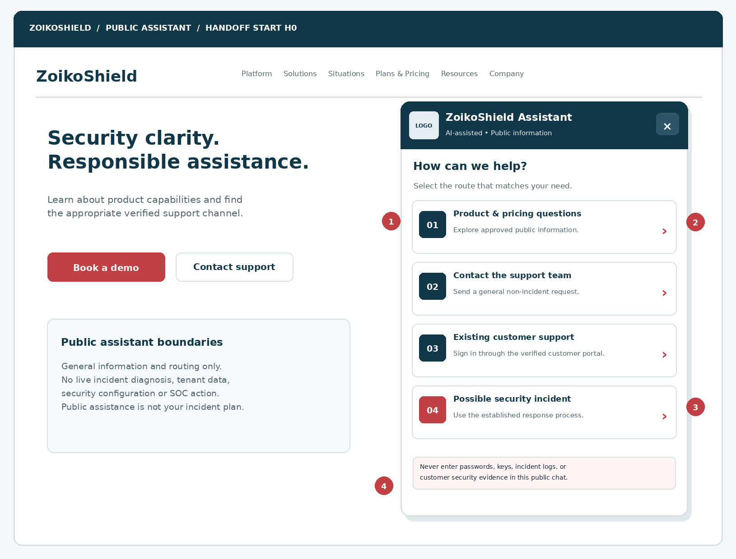
Figure 1 — Representative website and assistant panel. The logo slot must be replaced only with supplied approved artwork. Four separate routes eliminate ambiguous “speak to an agent now” expectations.
MARKER | IMPLEMENTATION RULE
01 | Context selection is user-driven and never creates a ticket or gathers personal data.
02 | Four destination cards carry visible intent, summary and keyboard-reachable target.
03 | Incident warning appears before any data-entry screen; dangerous or confidential material is excluded.
04 | Public website navigation, chat close, Escape behavior and keyboard focus are preserved.

02 / Route taxonomy and decision matrix
Deterministic routing outweighs model-based guesswork.
VISIBLE ROUTE | INTENT KEY | OUTCOME / AUTHORITY
Product & pricing questions | public_product_help | Continue WF-002 public, source-grounded answers; links only to approved public URLs.
General non-incident support | public_support_request | Open H2 intake and H3 review; BFF accepts one public enquiry if validated.
Existing customer support | verified_customer_portal | Display approved login/help center link; no portal credential fields in chatbot.
Possible security incident | security_incident_route | Show immediate route notice / approved response procedure; no incident intake and no triage claims.

Escalation trigger precedence
PRIORITY | TRIGGER / CLASSIFICATION | REQUIRED BEHAVIOR
P0 | User states active compromise, ransomware, account takeover, exfiltration, outage or attack under way. | Do not solicit details. Show safe immediate action wording and approved support-channel link where available; suggest established incident process.
P0 | Passwords, tokens, log snippets, vulnerability secrets, personal/customer data pasted. | Interrupt form ingestion, warn and suppress storage/forwarding; only redacted security event may be logged.
P1 | Customer reports trouble using account or accessing purchased services. | Offer verified customer portal. Do not infer account ownership from email or promote visitor to customer role.
P2 | Public questions, documentation, non-urgent website or sales navigation. | Answer from approved public sources or offer limited general support request.
P3 | Abusive content or repetitive requests. | Graceful moderation and rate safeguards; public contact alternatives and normal website retained.

AVAILABILITY HONESTY
Display human hours, response expectations, support channels, regional numbers, contract entitlements and live-agent status only from an operationally maintained verified registry. If absent, say “Send a request” or “See contact options”—never invent a 24/7 hotline.

03 / Mobile: support selection and rescue route
No buried high-priority choice, overflow trap or dependent scrolling container.
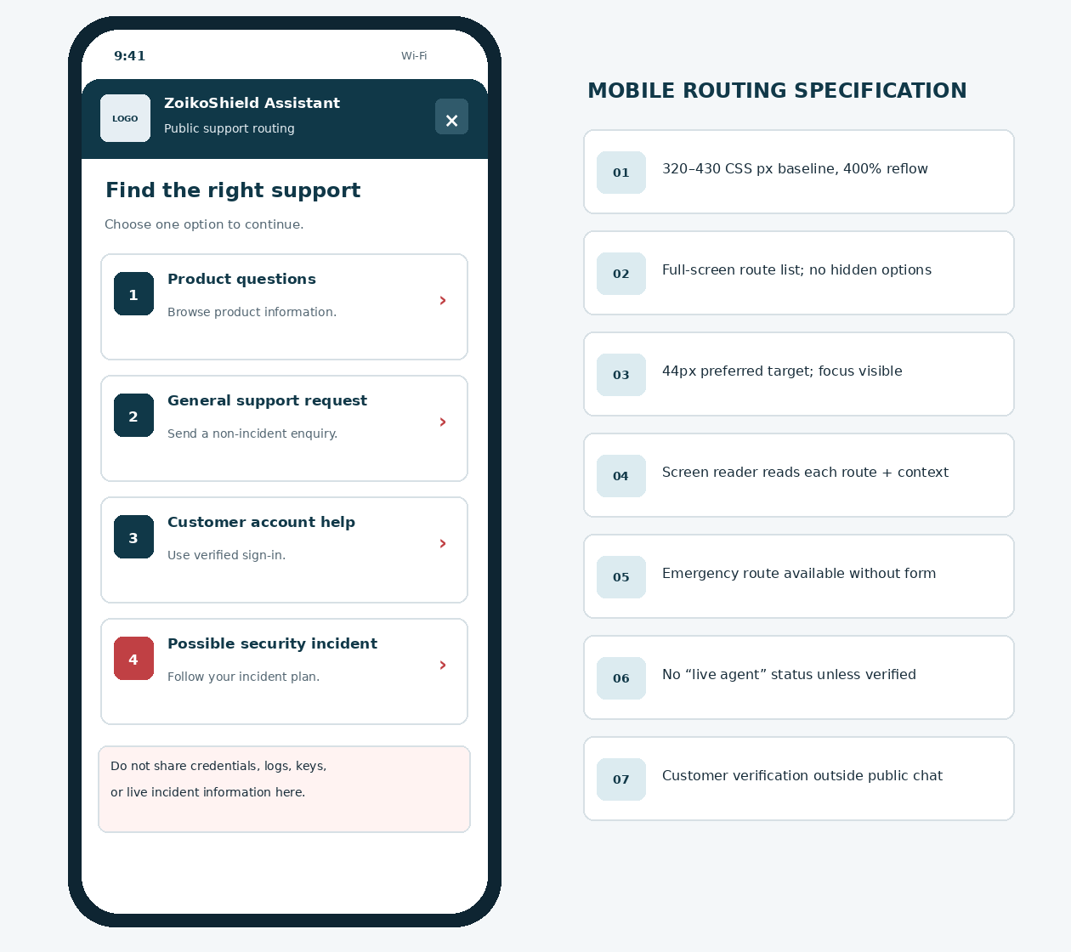
Figure 2 — Proposed phone view. The suspected-incident path remains directly visible and reachable; it does not require a lengthy form or an account sign-in step to receive general safety routing.
RESPONSIVE INTERACTION
At 320 CSS px width and up to 400% zoom, choices wrap vertically, body content scrolls freely and route buttons remain accessible. Do not block the incident path behind chat-message generation or network availability.

04 / Component inventory — ZS51 through ZS70
Stable semantic component IDs for implementation, Figma and test automation.
ID | COMPONENT | BEHAVIOR / ENGINEERING CONTRACT
ZS51 | Handoff entry action | Accessible “Contact support” action from verified AI reply or public navigation.
ZS52 | Route chooser | Four card buttons with intent, description, heading and distinct semantic names.
ZS53 | Safety routing panel | Incident guidance; never accepts incident evidence or simulates severity assessment.
ZS54 | Verified channel link | Allowlisted absolute HTTPS link; approved market/entitlement variant only.
ZS55 | No-live-agent notice | Truthful asynchronous or unavailable messaging; no fake queue position.
ZS56 | Request step header | “General support request” with scope and 2-step review indicator.
ZS57 | Identity fields | Work email, name and organization; labelled and validated client/server.
ZS58 | Topic control | Approved taxonomy and non-sensitive issue category; no free-form hidden routing.
ZS59 | Limited description | Optional max-500 text, screening and clear no-secrets hint; no attachments.
ZS60 | Transcript-sharing choice | Unchecked; reviewed, sanitized summary only, separate permission evidence.
ZS61 | Privacy link | Trusted notice, version ID and minimal intake processing explanation.
ZS62 | Review screen | Readable summary with editing; sensitive fields never rendered into telemetry.
ZS63 | Submit action | Idempotent request; no LLM tool invocation; approved public BFF only.
ZS64 | Accepted receipt | Server-confirmed opaque reference + clear follow-up instructions.
ZS65 | Unknown-result recovery | Safe retry with original request key; never assert receipt prematurely.
ZS66 | Inline validation | Specific errors announced and linked to accessible field labels.
ZS67 | Abort/back control | Return to conversation/chooser; no auto-transcript sync or URL PII.
ZS68 | Service unavailable | Website contact alternatives remain available; no dead-end panel.
ZS69 | Operator routing metadata | Server-only approved category, locale, source route and queue mapping.
ZS70 | Handoff analytics | PII-free event schema and outcome state with bounded correlation identifiers.

05 / General enquiry: minimal input and review
An anonymous, non-incident support request—not a SOC ticket or account access.
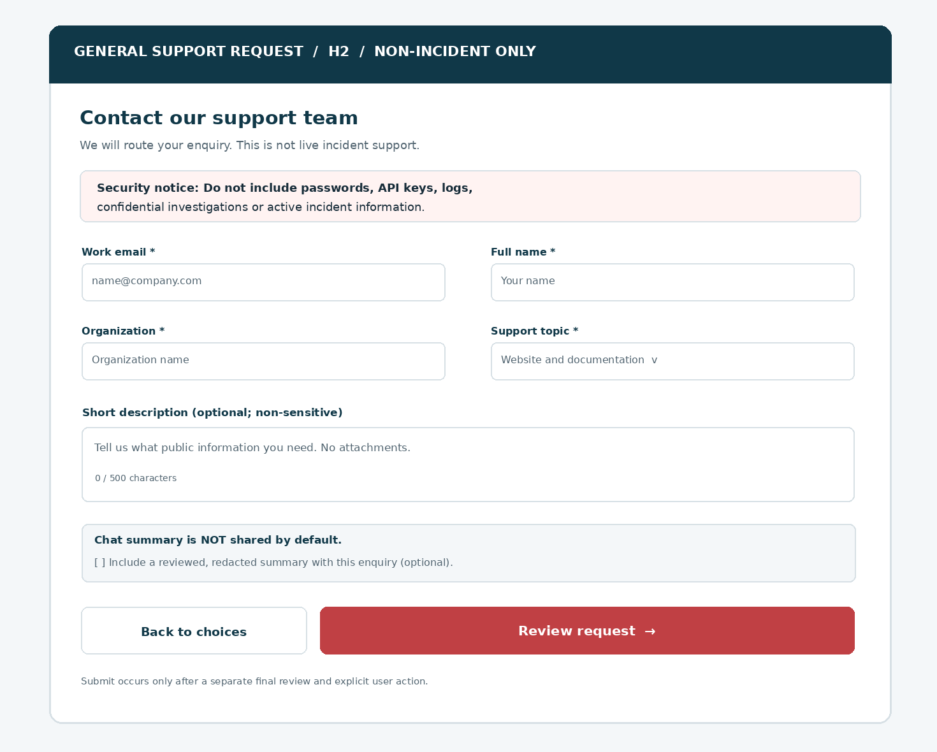
Figure 3 — General support form. Sample field values are placeholders. Transcript sharing is explicit and OFF by default; a final review screen follows before submission.

Step 2: required review screen
Show a label/value summary and an Edit action; repeat “No credentials, logs or incident details.” Include the approved Privacy Notice link and a separate, unchecked “Include reviewed chat summary” control. Only “Submit support request” sends the public BFF call. Recheck permitted topic and schema server-side.
SERVICE VERSUS MARKETING
No marketing checkbox is bundled into this support form. It does not inherit the WF-003 demo marketing preference or silently reclassify a support enquiry into a sales lead.

06 / Deterministic state model H0–H6
Only server acknowledgement permits “request received.”
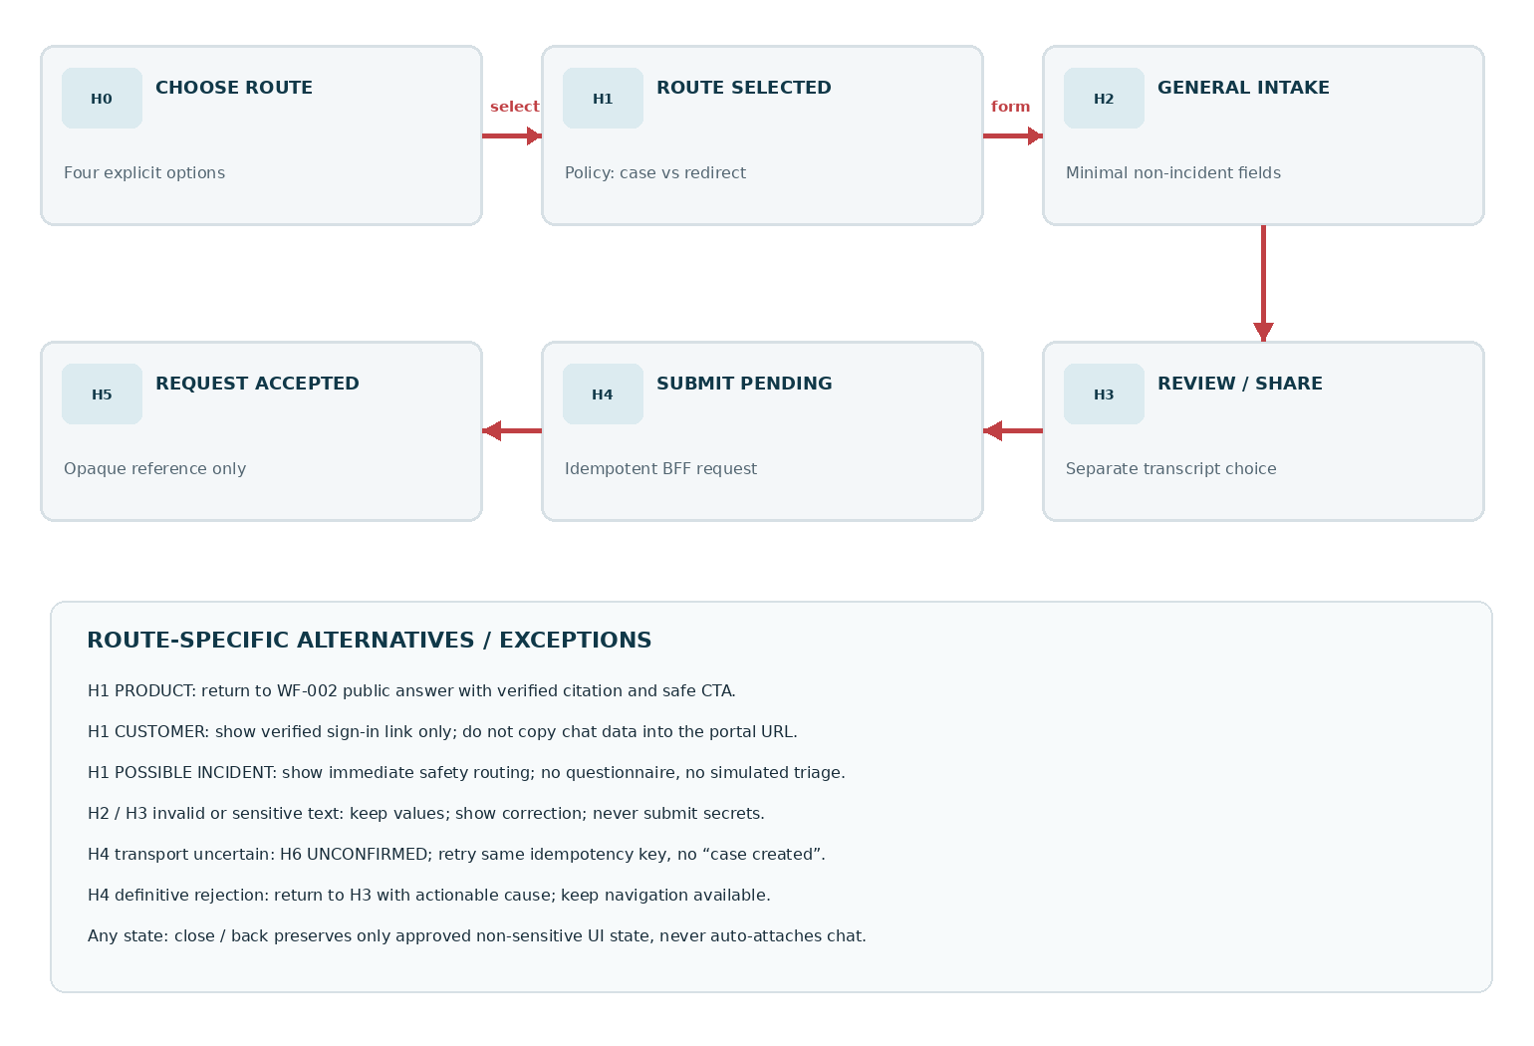
Figure 4 — Public support request flow. Customer portal and urgent-incident routing branch at H1 and intentionally bypass the public request form.
STATE | USER-FACING COPY / TRANSITION
H0 / H1 | Select destination; no submission, personal data capture or privilege implied.
H2 | General-support form; validation runs on advance and server rechecks on submit.
H3 | Review summary + optional redacted transcript-sharing choice; Edit remains available.
H4 | “Submitting request…” with no duplicate action; original idempotency key retained.
H5 | “Your support request was received” only with accepted server reference.
H6 | “We could not confirm receipt” + same-key retry and alternate public channel.

07 / Data schema, retention and privacy classification
Collect only what can safely serve a non-incident support request.
KEY | REQ. | VALIDATION / HANDLING
request_type | Yes | Enum public_nonincident_support; assigned server-side, immutable after acceptance.
email | Yes | String, max 254, format validation; canonicalize with care; access-controlled PII.
name | Yes | Trimmed Unicode 1–120 chars; no dangerous control characters; PII.
organization | Yes | Trimmed Unicode 1–160 chars; no automatic tenant association.
topic_key | Yes | Enum website_help, documentation, product_question, general_other; server allowlist.
description | No | 0–500 chars; no credentials, incident details, log dumps or security evidence. Reject/quarantine securely.
transcript_share | No | Boolean false default; separately user-initiated and reviewable; not marketing consent.
summary_payload | No | Server-generated *redacted* excerpt only if explicitly permitted; length cap, policy validation and preview.
notice_version | Yes | Approved jurisdiction-specific notice ID, validated server-side before submit.
locale | Yes | Allowlisted BCP 47 locale from product config; never claims legal region by IP alone.
idempotency_key | Yes | Opaque UUID/ULID; stable on uncertainty retry, server uniqueness window approved.
source_route | Yes | Allowlisted public page/chat entry key; no PII in URL, analytics or query.
request_ref | Response | Opaque non-enumerable reference returned only for accepted outcome.
correlation_id | Server | Short-lived security and diagnostics join; no user email in tracing.

Privacy engineering
Define controller/processor roles, permitted storage locations, appropriate transfer controls, object-level access authorization, deletion/retention windows and deletion request pathways before launch. Retention is a policy decision—not an invented fixed number. Do not reuse support-enquiry records to train models or for marketing without independent authority.
USER DISCLOSURE
“We’ll use your business contact details to respond to this support request. Do not include sensitive security information. [Privacy Notice].” Review lawful basis and market-specific copy with Legal/Privacy.

08 / Verified channels and handoff ownership
Support routing uses a server-side signed/approved registry, not a model’s guess.
SCENARIO | PUBLIC ACTION | PROTECTED DOWNSTREAM OWNER
Potential incident — anonymous visitor | Show generic incident safety route and verified published contact options, where available. | Customer organization’s incident process / authorized ZoikoShield incident response team if covered by an agreed service.
Potential incident — existing customer | Offer verified secure sign-in support entry; no incident details pasted into public chat. | Authenticated customer portal and incident management process subject to entitlements.
Account access / billing question | Verified customer sign-in. No account lookup, billing disclosure or impersonation from public chat. | Authenticated support desk with authorization checks.
Website, docs or public integration enquiry | Optional general public support request; route by topic, market and declared source. | Non-privileged public support queue.
Sales/demo request | Return WF-003; do not create a public support ticket for sales. | SalesOps / CRM enquiry integration.
AI unable to answer / retrieval weak | Disclose limitation, link verified docs or start route chooser. | Approved public support process; no “human agent online” promise.
Service cannot accept requests | Retain public links; status copy truthfully states unavailable. | SRE/Support operations; monitored queue only when actually deployed.

Ownership separation
Public intake creates an asynchronous enquiry only. The support desk decides assignment, eligibility verification, and specialist escalation after human or service-owned rules apply. Any P0 security incident service-level commitment, emergency telephone number, customer contract entitlement or secure evidence transfer must be sourced from approved commercial and operations records, not this design proposal.
LINK INTEGRITY
Use a signed/approved configuration containing channel_id, market, label, approved_https_url, availability_source, review_at, and owner. Unknown or expired values become “See official support page”—not fabricated contact details.

09 / API boundary and request/response examples
Illustrative v1 design contract: finalize names against actual OpenAPI and architecture.

Endpoints (proposed—not asserted as deployed)
ROUTE | METHOD | BOUNDARY / EXPECTED BEHAVIOR
/api/public/support/options | GET | BFF returns market-appropriate approved route labels, link display and freshness flags. No tenant context.
/api/public/support/requests | POST | Deterministic validation, abuse controls, privacy notice match, idempotent durable intake.
/api/public/support/requests/status | GET | Accepts opaque short-lived receipt token if feature approved; avoid enumerable or public lookup by email.
/api/public/chat/summary-preview | POST | If enabled: generates redacted consented preview only; no raw protected data or implicit transcript attachment.

Payload illustration
POST /api/public/support/requests
Idempotency-Key: <opaque-stable-key>
{ "request_type": "public_nonincident_support", "email": "visitor@example.org",
"name": "Sample Visitor", "organization": "Example Organization",
"topic_key": "documentation", "description": "Question about public setup docs",
"transcript_share": false, "notice_version": "<approved-id>",
"source_route": "public_chat" }
OUTCOME | UI BEHAVIOR / EXAMPLE FIELDS
202 Accepted | {status:"accepted", reference:"<opaque>", request_id:"<opaque>"}; show H5 only after durable acceptance.
400/422 / 409 | Definite validation rejection or idempotency conflict; correct data, respect same-key payload contract.
401/403 | Public endpoint unexpected auth/authorization policy failure; no attempt to borrow logged-in customer token.
429 | Cooldown and accessible alternate contact route; public website unaffected.
503 / timeout | H6 unconfirmed when transport receipt uncertain; same-key safe retry; never fabricate reference.

API HARDENING
Same-origin boundaries as applicable, validated origin/CSRF mitigations, schema allowlists, PII redaction, rate limits and bot defenses, payload size caps, durable request/queue transaction, outbox dedupe and per-request audit event are server requirements.

10 / Secure handoff architecture and processing
Enforce service authority outside the LLM and outside the public browser.
STAGE | PROCESSING LAYER | VERIFICATION / GUARANTEE
1 | Public chat component | Collect only explicit intent; no use of authenticated session tokens or private API paths.
2 | Public website BFF | Re-evaluate input classification and allowlisted route; require correct notice version.
3 | Abuse/secrets gate | Limit requests; detect likely credentials/logs; redact or refuse safely without incident disclosure.
4 | Durable intake store | Atomic acceptance + idempotency uniqueness + opaque public receipt; PII access control.
5 | Transactional outbox | Record intended support delivery in same durable transaction; consumers retry without duplicate cases.
6 | Public support queue adapter | Least-privilege service integration; route by approved category; never open incident case automatically.
7 | Support operations | Manual verification / categorization; approved service response channel and response targets.
8 | Privacy/audit oversight | Data retention, subject request procedures, failure metrics and restricted staff access evidence.

Non-negotiable trust boundary
The public assistant has no authority to read production SOC telemetry, tenant cases, customer secrets, private knowledge stores, billing records or privileged support entitlements. Chat model outputs may propose text or route identifiers, but cannot directly create a ticket or call a protected tool. The BFF owns all write authorization, deduplication and final outcome.

Operational alerts and fallbacks
Monitor accepted-to-delivered latency, outbox backlog, duplicate suppression, redaction rejection count, abuse controls and unavailable-channel rate. Alert assigned operations owners on queue failure; never expose internal incident IDs, stack traces or queue infrastructure to a public visitor.
CURRENT-STATE CAVEAT
ZoikoShield’s 13 October 2026 reference describes shield-core, shield-ingest, shield-ai, shield-action and shield-anchor as user-supplied internal architecture. The public support BFF and queue in this wireframe are proposed implementation boundaries, not claims they exist in those services.

11 / Acknowledgement, uncertainty and service failure
A receipt is not a meeting, a live-agent connection or a security response.
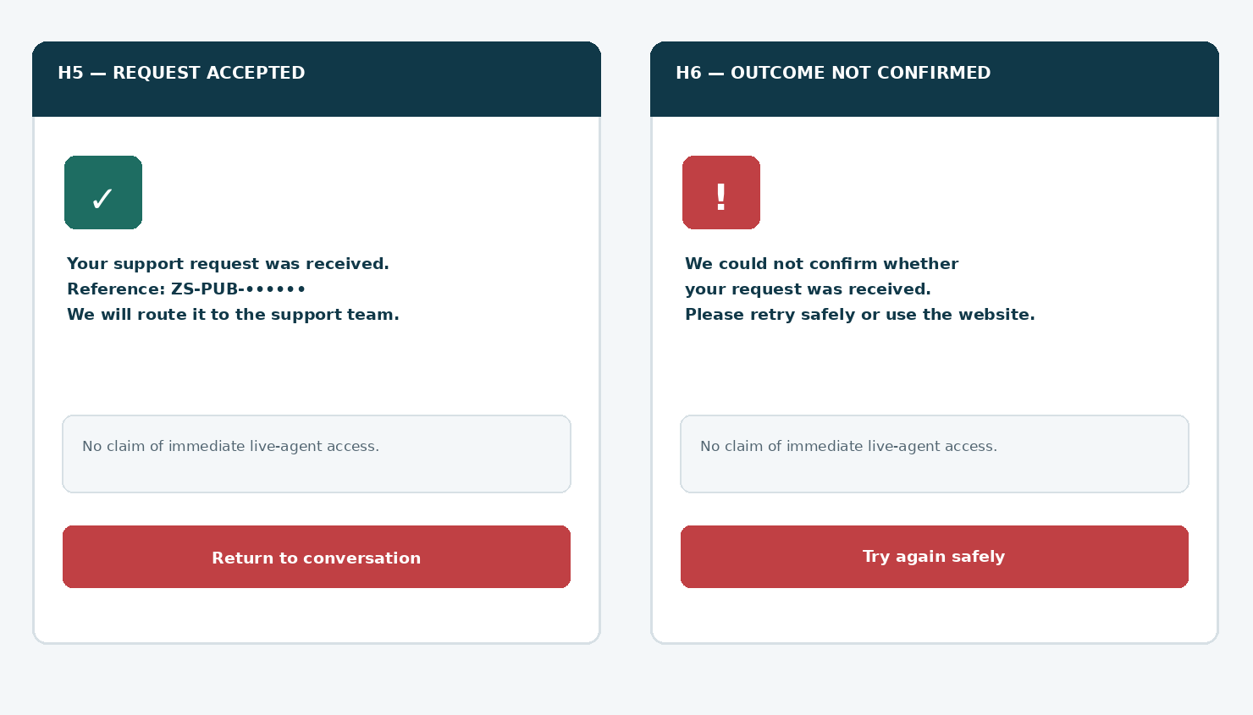
Figure 5 — Critical distinction between confirmed server acceptance and unknown delivery. The reference shown is illustrative, never generated on the client. If receipt status is uncertain, the Retry control reuses the original idempotency key.
CONDITION | VISIBLE UX | OPERATIONAL REQUIREMENT
Accepted by durable intake | Request received + opaque reference + neutral next steps. | Outbox retries remain internal; no statement that an agent has responded.
CRM/helpdesk down after accepted | Keep accepted UI; never tell visitor form failed. | Queue/retry with monitoring, dead-letter recovery and no duplicate ticket.
Timeout before response | Receipt unconfirmed + safe retry/fallback. | Same idempotency key and request hash enforce at-most-one acceptance.
Definite validation error | Field-specific correction, move focus to error summary. | No durable intake; preserve non-sensitive draft until corrected.
System offline / no approved link | Static verified support page link if configured; no false availability. | Fail closed for submit, fail open for normal website use.

12 / Exact UX copy and content-control catalogue
Product-reviewed messages, not unrestricted model-authored policy promises.
COPY KEY | RECOMMENDED USER-FACING STRING
handoff.title | How can we help?
handoff.intro | Choose the option that best matches your question.
handoff.product | Product and pricing questions
handoff.general | Contact the support team
handoff.customer | Existing customer support
handoff.incident | Possible security incident
handoff.incident_body | If you suspect an active security incident, follow your organization’s incident response procedures. For account-specific help, use the verified customer support channel. Do not share incident details in this public chat.
handoff.form_title | General support request
handoff.form_notice | This form is for non-incident questions. Do not include passwords, API keys, logs or confidential security information.
handoff.summary_opt | Include a reviewed, redacted summary of this chat with my request (optional).
handoff.submit | Submit support request
handoff.accepted | Your support request was received. Reference: {reference}.
handoff.unknown | We could not confirm whether your request was received. You can safely try again.
handoff.unavailable | This request option is temporarily unavailable. Use the official contact page.
handoff.agent_unknown | A live support agent is not connected through this chat.
handoff.privacy | We’ll use these details to respond to your request. Read the Privacy Notice.

Copy governance
Locale is American English initially; use versioned content keys and approved regional copy as markets expand. Display “human support” only for real ownership and channels. Do not show “immediate”, “guaranteed response”, “24/7 monitoring”, “security certified”, severity labels, or predicted breach impact unless independently verifiable and approved.

13 / Security, privacy and abuse threat model
Public cybersecurity assistants have an elevated obligation to avoid privilege confusion.
THREAT / FAILURE MODE | MANDATORY MITIGATION | TEST EVIDENCE
Prompt injection requests SOC access | Only predefined route keys; LLM output cannot call private tools. | Adversarial test and explicit deny trace.
User pastes live logs or API secrets | Input screening and no automatic transcript replication; redact in logs. | Redaction test using synthetic secrets.
Fake “live agent” / false SOC availability | Availability supplied solely from verified service registry. | Copy snapshot and config source inspection.
Forged support ticket reference | Server-generated opaque ID; idempotent acceptance only. | Signed acceptance evidence / id collision tests.
Cross-account support impersonation | No public account lookup or private record disclosure; verified portal redirect. | Unauthorized enumeration and privilege test.
Mass ticket-spam / model exhaustion | Rate limits and resource budgets; accessible alternate support links. | Burst / resource cap telemetry test.
Malicious redirect or phishing | Canonical HTTPS allowlist, no user-controlled URL redirects, clear origin. | Open redirect/link provenance test.
Stored XSS / HTML injection | Plain-text allowlist, escape output in ticket and UI, sanitize markdown/links. | Encoded payload round-trip test.
Sensitive transcript attached silently | Default off and redacted preview; separate affirmative user action. | Capture validation and privacy evidence.
Queue loss or duplicate delivery | Transactional outbox, dedupe, dead-letter operations monitoring. | Fault injection and reconciliation record.

STANDARDS ALIGNMENT
Use OWASP Top 10 for LLM Applications (2025) for prompt injection, sensitive information disclosure and excessive agency testing; use OWASP API Security for public BFF misuse patterns. These are design/test references, not certifications.

14 / Accessibility, responsive layout and interaction law
WCAG 2.2 AA is the intended verification target, not a compliance claim.
AREA | IMPLEMENTATION AND PASS CONDITION
Keyboard and focus | Every route card is a semantic button/link. Shift+Tab and Tab order matches visual order. Focus enters new dialog heading and returns to invoking CTA on dismissal.
Live state/status | Screen reader hears form errors, confirmed receipt and unconfirmed outcome via appropriate live status patterns; no disruptive focus jumps.
Errors | Label remains visible; error text names the field and remedy; summary targets field via focus and aria-describedby.
Responsive | At 320 CSS px and 200–400% zoom, no horizontal page scroll or inaccessible action; controls do not overlap mobile keyboard.
Target sizes | Prefer >=44×44 CSS px; meet applicable WCAG 2.2 minimum targets and adequate spacing/focus visibility.
Contrast | Text, icons, states and keyboard focus must pass relevant ratios measured against actual approved token combinations; color is never the only signal.
Touch, motion, time | No surprise chat auto-popup; close always accessible; reduced-motion, scroll restoration and tolerant timeouts.
Forms and autofill | Appropriate autocomplete=email/name/organization; no CAPTCHA inaccessible dead end; corrections preserve values.
User agency | Direct website navigation, back and close available throughout; incident route never obstructed by a slow AI answer.
Accessibility matrix | Chrome/Edge/Firefox/Safari; desktop keyboard and NVDA/VoiceOver; iOS VoiceOver and Android TalkBack; 320px, 400% zoom, reduced motion.

Review mechanics
A user must affirmatively choose to share any redacted chat summary, inspect the preview and be able to undo the choice without abandoning the support request. For failure states, preserve safe draft content only for the current form lifetime; avoid storing it as a general conversation or browser query parameter.
USABILITY ACCEPTANCE
Within two actions from a failed AI answer, a visitor can select an appropriate support route; within one action from the route list, an existing customer can reach the verified sign-in destination without entering credentials in the public chat.

15 / P0 engineering acceptance tests — part A
Record screen captures, accessibility results and redacted HTTP/queue evidence.
ID | SCENARIO | PASS CONDITION
AT-51 | Visitor opens Contact support from WF-001/002 | H0 route chooser opens; no data submit, lead or ticket created.
AT-52 | Select each of four route cards | Only the mapped deterministic destination opens; each action is keyboard accessible.
AT-53 | Visitor selects possible incident | Guidance shown immediately; no public incident intake or security diagnosis attempted.
AT-54 | Visitor types “production ransomware active” | Safe incident route offered; no invented severity or promises; sensitive details not forwarded.
AT-55 | Visitor selects existing customer support | Only verified HTTPS portal link; no account lookup or credential capture.
AT-56 | Verified support URL missing or expired | Static safe fallback; no phone number, status or redirect fabricated.
AT-57 | A model output requests live SIEM/tenant data | No privileged path executed; public assistant remains in approved data scope.
AT-58 | General support fields required missing | Accessible field errors; no POST or ticket created.
AT-59 | Optional description contains synthetic API key | Blocked/redacted before acceptance; no secret in queue, logs or analytics.
AT-60 | User does not opt into transcript sharing | No transcript, raw messages or summary attached to support case.
AT-61 | User opts in to summary sharing | Preview is redacted, consent recorded, user may undo and complete request.
AT-62 | Review screen navigates back and forward | User-entered non-sensitive fields preserved; submit only on final click.

16 / P0 engineering acceptance tests — part B
Only signed off with evidence from Security, Privacy, SupportOps and Accessibility.
ID | SCENARIO | PASS CONDITION
AT-63 | User presses final submit rapidly twice | One durable request and one public reference; downstream helpdesk dedupe.
AT-64 | Helpdesk queue fails after BFF accepted | Accepted receipt persists; outbox retries; no false UI rejection.
AT-65 | Client transport times out before receipt | H6 uncertainty, same-key retry, no false accepted statement.
AT-66 | Idempotency key reused with changed payload | Definitive conflict does not merge/edit accepted ticket; safe instruction returned.
AT-67 | Spam burst / repeated automated requests | Rate limiting mitigates abuse; website and contact alternatives still work.
AT-68 | Cross-origin request / XSS injection payload | CSRF/origin as appropriate and output-escaping controls stop exploitation.
AT-69 | 320px viewport, 400% zoom and virtual keyboard | No obscured controls or horizontal scroll; incident route reachable.
AT-70 | Keyboard + screen reader full journey | Routes, review, optional summary, errors and receipt announced/focused correctly.
AT-71 | Analytics enabled / disabled across journey | No email/name/message content or actual tenant identifiers in product analytics.
AT-72 | Brand config public name and logo change | Only approved active token/name/asset used; working name never hard-coded in UI.

Regression suite across earlier wireframes
Repeat WF-001 launcher close/reopen and focus tests, WF-002 public-retrieval citation and refusal tests, and WF-003 demo intake separation/idempotency tests. Verify that an existing demo draft cannot be recategorized as a support request or silently reused for support marketing.
EVIDENCE GATE
Store per-test owner, build hash, test date, expected/actual output, screenshot/video, synthetic data redaction, service-trace evidence, defect number and approval signature in the engineering quality register.

17 / Critical design review and refinements
A high-conversion chatbot is not an acceptable substitute for secure service operations.
COMMON WEAK PATTERN / RISK | REFINED REQUIREMENT IN WIREFRAME 04
Single “Talk to a human” button with unverified availability | Four deterministic destinations, no “online agent” presence unless verified by operations.
Public chat asks for SIEM logs or confidential incident details | No uploads, prominent warning, secrets detection and referral to secure incident channels.
AI turns chat into incident severity score | No classification or remediation command from anonymous public interaction.
Support ticket appears created before server persistence | H5 shown only after durable intake; H6 visible on unknown outcomes.
Pasted chat transcript automatically attached | Optional OFF-by-default, reviewed, redacted summary and distinct permission state.
Support and sales lead forms share a CRM purpose | Separate purpose, retention and routing; WF-003 demo link is not silently converted.
Marketing or support status leaked across anonymous visitors | BFF authorizes every action; no tenant/account lookup via email or assistant memory.
Brittle fail-close takes down navigation | Chat failure isolated; website/verified help links always remain.
A shiny dark UI becomes keyboard-inaccessible | Semantic cards, error focus, accessible notices, 320px reflow and 400% zoom tests.
Vague response time and security-grade promises | Approved service registry is sole source of hours, SLA, emergency channels and entitlements.

P0 owner decisions before production
Product/Founder: approve route labels and non-incident boundary. SupportOps: own support portal URLs, market coverage, ticketing adapter, queue, hours and escalation SOP. Commercial/Legal: verify any contracted incident entitlements and public commitments. Privacy: approved notice, retention, subject rights and consented summary sharing. Brand: actual logo/favicon and public name. Engineering/Security: BFF authority, anti-abuse, redaction, durable outbox. QA/Accessibility: evidence AT-51–AT-72.

18 / Build package, sign-off and source register
One coherent build deliverable—no speculative dashboard programme.
HANDOFF ASSET | ENGINEERING RELEASE REQUIREMENT
Figma / UX | H0–H6 desktop/mobile screens, fig references, all 20 new ZS components, empty/error/loading/accepted/uncertain variants.
Frontend | Accessible typed route selector, non-incident form/review, notice, opt-in preview, safe close/back and status messages.
Public API / BFF | Approved OpenAPI, validation, channel config allowlist, anti-abuse, no tenant authority, idempotency and transactional outbox.
Service operations | Verified destination registry, owner/runbook, queue case mapping, outage recovery and source-of-truth hours/SLA.
Privacy / Brand / Legal | Approved public label, logo/favicon, notice and consent terms, retention/data locations, actual customer incident contact claims.
Security and QA | Threat-model test results and AT-51–AT-72 signed P0 evidence; regressions against WF-001/002/003.
Approvals | Founder approves this document as WF-004 only. Production deployment requires separate independent gates.

Standards and authoritative references
Internal references (user-provided design baselines, not independently verified production controls): ZoikoShield Live Demo Master Guide and Step-by-Step Demo Links (October 13, 2026); Zoiko Group Public AI Chatbots Master Product & Engineering Guide v7.7 (October 20, 2026); ZoikoShield Chatbot Wireframes 01–03 (October 24, 2026).
External standards: W3C WCAG 2.2 (https://www.w3.org/TR/WCAG22/); OWASP Top 10 for LLM Applications 2025 (https://genai.owasp.org/llm-top-10/); OWASP API Security Top 10 (https://owasp.org/API-Security/); NIST SP 800-61 Revision 3 (April 2025, https://csrc.nist.gov/pubs/sp/800/61/r3/final). These are implementation guidance, not assertions of conformance or certification.
FOUNDER APPROVAL CHECKPOINT
Wireframe 04 only. Do not start Wireframe 05 until the founder explicitly approves this document. Each additional wireframe remains independently scoped and version-controlled.

