ZOIKOSHIELD / STRATEGY • PRODUCT • DESIGN • ENGINEERING

Public AI Chatbot
Detailed Wireframe 05
Guided solution discovery, customer-priority exploration and evidence-grounded product guidance
DOCUMENT CONTROL
Version 1.0 • October 24, 2026 • American English • ZS-CHAT-WF-005. Approval-stage engineering specification, not proof that any depicted integration, capability, public claim or security certification is deployed. Implement individual wireframes sequentially, after founder approval.

Executive product decision
Provide an optional, low-friction, buyer-oriented discovery experience in the anonymous ZoikoShield chatbot. Visitors select a general business priority and, optionally, a professional role or environment category. A deterministic discovery ruleset and approved public capability registry return no more than three relevant areas to explore, with eligible source links and transparent limitation copy. No cybersecurity scoring, customer configuration reading, automated security diagnosis, or sales-data capture is permitted.
CONTROL DIMENSION | DECISION / INHERITED BOUNDARY
Sequential scope | WF-001 launcher/welcome; WF-002 conversation and sources; WF-003 demo request; WF-004 human support. This document addresses guided solution discovery only.
Identity | Zhield is the internal working assistant name; default safe public label is “ZoikoShield Assistant” pending explicit Brand/Legal authorization.
Design references | Use the prior working palette Navy #103848 / Red #C04044; replace every “LOGO” placeholder with actual approved product logo/favicon.
New IDs | ZS71–ZS92 component inventory; AT-73–AT-98 independently testable criteria. Prior identifiers remain unmodified.
Authentication | Anonymous, informational, public-only. No SOC, case, detection engine, telemetry, customer logs, tenant read, ABAC bypass, or SOAR access.
Release assurance | Design approval is distinct from security, legal/brand, product-claims, privacy, accessibility, operations and engineering go-live sign-off.

USER-FACING DISCLOSURE
This guide suggests public product areas to explore. It does not assess your environment, confirm product suitability, or make security recommendations for a live incident.

01 / Desktop: guided discovery entry (SD0–SD2)
One question at a time. No anonymous customer security assessment.
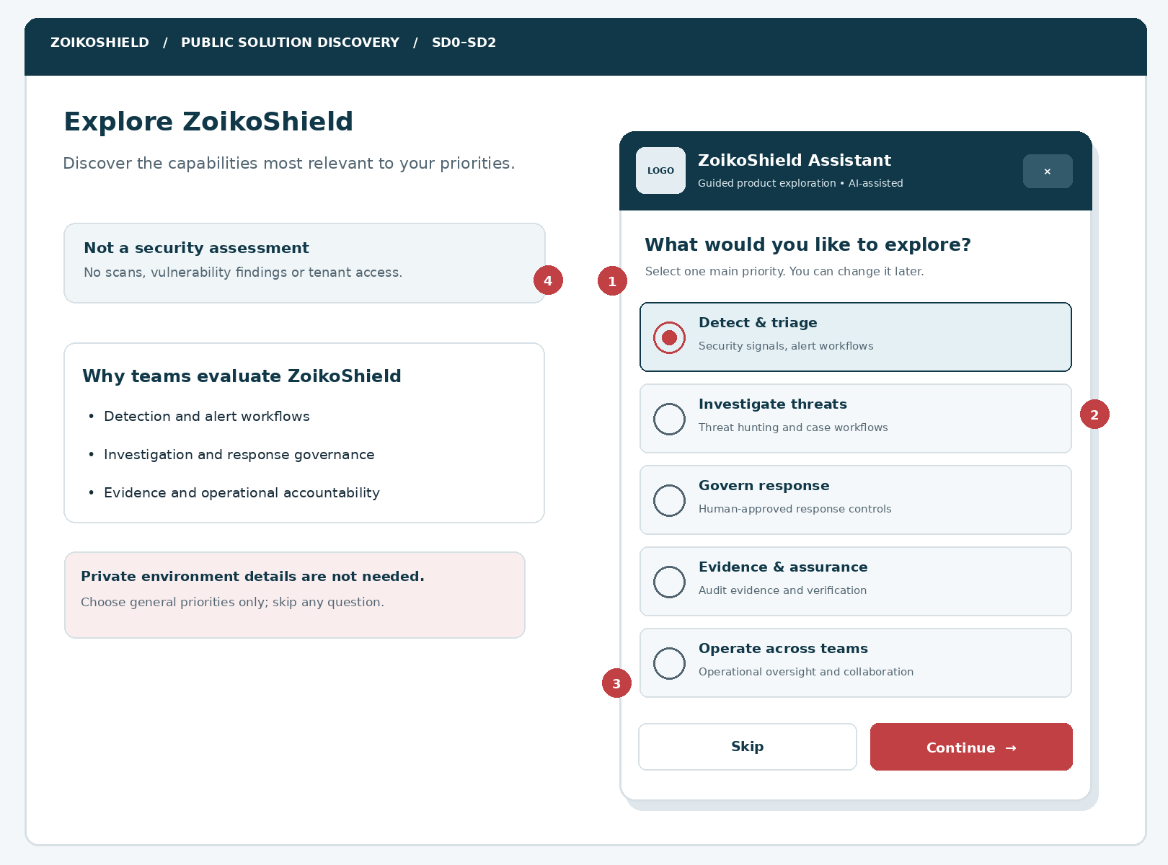
Figure 1 — Suggested public website composition and discovery panel. Component placement is illustrative; logo, page navigation, and product claims are configuration-controlled. The selected topic uses both color and a selected-state indicator.
MARKER | ENGINEERING INTENT
01 | Question title, context and optionality are readable without additional clicks.
02 | At most five priority cards displayed at this step; scroll and keyboard navigation remain usable.
03 | Skip and Continue are distinct; selected choice can be revised.
04 | Privacy and scope note makes clear that no live environment is being examined.

02 / Mobile: reflow and interaction contract
Maintain equal product discovery access at 320 CSS pixels and keyboard zoom.
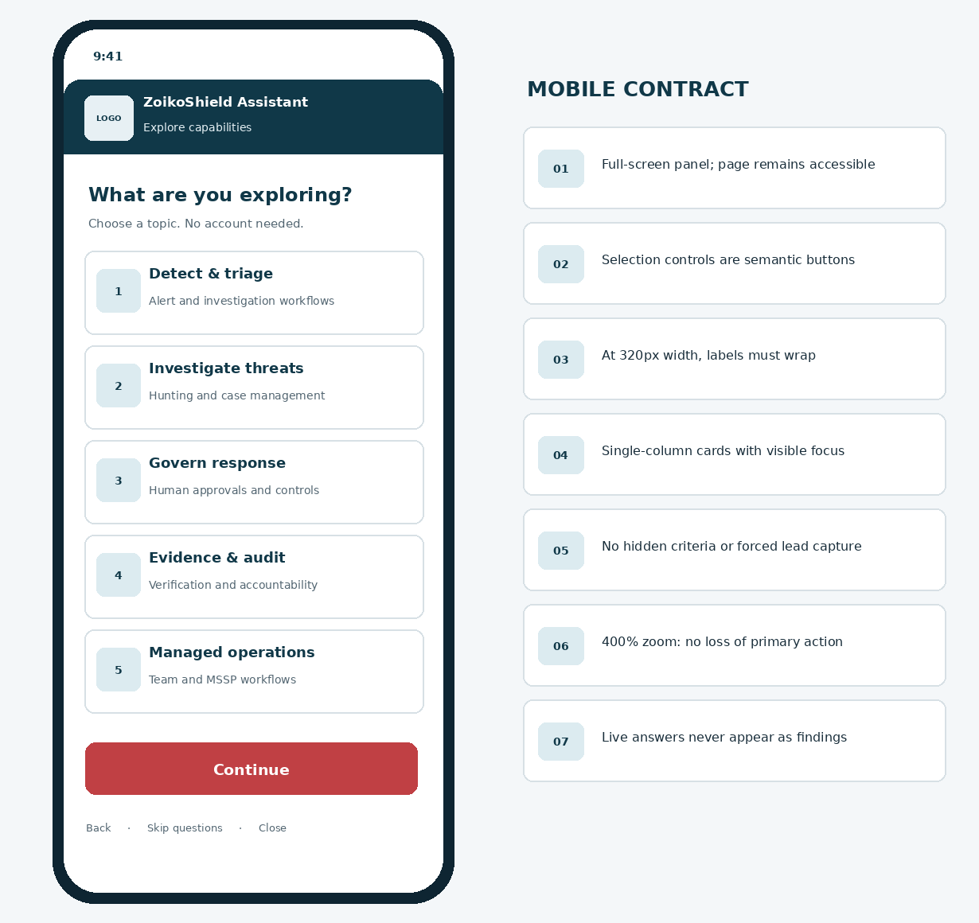
Figure 2 — Representative mobile public assistant. A full-screen conversation treatment avoids cramped floating overlays; keyboard and screen-reader order follows the visual sequence.
VIEWPORT RULES
At narrow widths or 400% zoom, use natural document flow, sticky actions only when they do not obscure content, an uninterrupted scroll region, visible selected/focus/error states, and a safely accessible close control.

03 / Discovery information architecture
Inputs are shallow enums, never a hidden sales qualification form.
STEP | QUESTION / UI COPY | CHOICE SET / DATA OWNERSHIP
SD0 / Entry | “Explore solutions for your priorities” | Launch from approved prompt, capability link, or a public chatbot reply. No required login.
SD1 / Priority | “What would you like to explore?” | detect_triage; investigation; governed_response; evidence_assurance; managed_operations. Choose ONE. Skip supported.
SD2 / Role | “Which best describes your role?” (optional) | security_lead; soc_analyst; it_admin; grc_audit; msp_mssp; exploring. No name or job title free text.
SD2 / Environment | “Which environment is closest?” (optional) | multi_cloud; hybrid; on_prem; unsure; prefer_not_say. Never request vendors, locations, topology, IPs or assets.
SD3 / Match | “Finding public areas to explore…” | Server applies versioned rules and valid approved source registry; no AI-generated scoring.
SD4 / Result | “Areas to explore” | 1–3 results, concise plain-language reasons, approved source links, limitation disclosure.
SD5 / Refine | “Change priorities” | Edit choices or reset. No silent profile persistence or account association.
SD6 / CTA | “Read more / Request a demo / Contact support” | Verified docs via WF-002; demo via WF-003; support via WF-004.
SD7 / Failure | “Guided discovery is unavailable” | Static approved platform or documentation links; normal site unaffected.

Decision hierarchy
Deterministic step logic controls matching, prioritization, visibility, CTA and source eligibility. The language model can help explain publicly approved text after server authorization, but it cannot invent claims, add unapproved products, change priority mapping, override source status or infer a customer’s vulnerabilities.

04 / Discovery state machine and transitions
Versioned states enable reproducible QA and explainable recommendations.
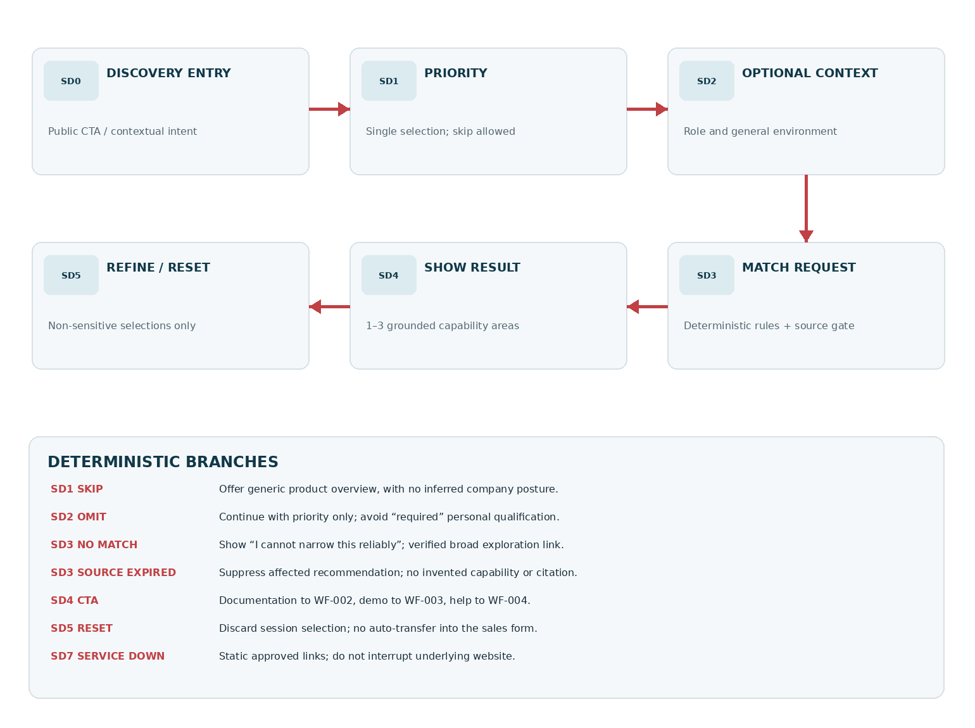
Figure 3 — SD0–SD7. A successful recommendation must be gated by source/claim eligibility. An explicit back or reset preserves/clears only voluntary non-sensitive choices within the short-lived session.
FAIL-SAFE ROUTING
An error in discovery must never prevent use of the public website, documented support route or existing authenticated console. No speculative phone number, operational status, SOC availability or SLA can appear.

05 / Component inventory — ZS71–ZS92
Stable component contracts shared between product design, frontend, BFF and QA.
ID | COMPONENT | REQUIRED BEHAVIOR / SEMANTICS
ZS71 | Discovery entry CTA | Explicit public intent; opens SD0 and preserves unrelated chat.
ZS72 | Scope disclosure | States informational guidance; no environment review or assessment.
ZS73 | Progress indicator | Step label (“1 of 2 optional questions”); no misleading qualification completeness.
ZS74 | Priority selection | Single-select semantic group, keyboard-operable; clear selection.
ZS75 | Role selector | Optional fixed taxonomy; choose “Just exploring” without inference.
ZS76 | Environment selector | Optional broad categories; allow “Prefer not to say.”
ZS77 | Skip context | Moves ahead; no hidden default customer profile.
ZS78 | Back/edit action | Non-destructive navigation and focus restoration.
ZS79 | Match loading | Text status and cancellable request; no fake analysis progress.
ZS80 | Recommendation card | Capability area, approved factual summary, reason and source link.
ZS81 | Source badge | Approved source title/URL and freshness metadata from registry.
ZS82 | Result disclaimer | No security findings, capability entitlement or procurement guarantee.
ZS83 | Result CTA rail | Read more, WF-003 demo and WF-004 support destinations.
ZS84 | Refine control | Reopen previous non-sensitive choices, regenerate matched results.
ZS85 | Reset control | Clear temporary selections and request context.
ZS86 | No-match fallback | Truthful uncertainty and public overview links.
ZS87 | Offline/failure fallback | Recover without breaking website/previous conversation.
ZS88 | Server config adapter | Versioned choice labels, eligibility flags and locale.
ZS89 | Match policy engine | Deterministic rule version + approved source filters.
ZS90 | Public BFF client | Typed, bounded, anti-abuse request; no authenticated privileges.
ZS91 | Safe event emitter | No personal, free-text, security incident or tenant data.
ZS92 | Handoff context guard | No auto-transfer into lead/support payload; asks explicit new confirmation.

06 / Approved capabilities and destination catalogue
Examples describe *information areas*, not independently verified commercial feature availability.
CAPABILITY AREA | RELEVANT PUBLIC EXPLORATION | CLAIM / SOURCE GATE
Detection and triage | OCSF normalization concepts; event ingestion and alert investigation workflows. | Only display exact capability scope, release state and availability approved in the public capability register.
Threat investigation | Threat-hunting concepts, evidence-informed case investigation and analyst workflows. | No assertion of real-time threat identification, guaranteed detection quality, or autonomous defense.
Governed response | Human-review gates, response proposals, playbook governance and response oversight. | Never imply unattended SOAR execution or a customer entitlement that has not been verified.
Evidence and audit | Evidence provenance, audit-readiness materials, cryptographic verification concepts. | No certification, legal admissibility or compliance guarantee without approved external/legal substantiation.
Managed / multi-team | Team workflows and planned/publicly supported MSSP use cases. | Limit claims to currently public, approved, market-relevant features; never expose tenant/MSSP fleet.
General platform | High-level platform overview and demo navigation. | Show generic overview if no matching claim is publication-eligible.

Source publication rule
A recommendation is eligible only if source.approved_for_public = true, source.market contains active locale, source.claim_status = approved, source.published_at is valid, source.revoked_at is null, and product capability is permitted for the product release/market. Product team—not LLM output—owns this content. Unknown fields fail closed.
LIVE PLATFORM BOUNDARY
The October 13 ZoikoShield demo architecture describes services including shield-core, shield-ingest, shield-ai, shield-action and shield-anchor. This public assistant is a separate, least-privileged experience and must not expose internal architecture secrets or consume production telemetry.

07 / Matching matrix and rule precedence
No opaque fit score. Return the smallest useful grounded set.
PRIORITY CODE | FIRST CAPABILITY | OPTIONAL SECOND / THIRD | OVERRIDE AND SAFETY CONDITIONS
detect_triage | Detection and triage | Threat investigation; evidence and audit | Only public approved features, never claims about existing threats.
investigation | Threat investigation | Detection and triage; governed response | No AI-produced exploit guidance or direct customer case links.
governed_response | Governed response | Threat investigation; evidence and audit | Clearly identify approval-gated actions if publicly documented.
evidence_assurance | Evidence and audit | Governed response; general platform | Never imply regulator acceptance or certification.
managed_operations | Managed / multi-team | Detection and triage; evidence and audit | No tenant enumeration, entitlement assumptions or real MSSP context.
no_priority | General platform | None unless public registry justifies | No fabricated personalized “recommendation.”

Deterministic ranking
1. Validate enums. 2. Resolve fixed base priority map. 3. Filter every area against publication eligibility and market. 4. Remove duplicate claims. 5. Cap at three. 6. Attach independent source IDs and an approved explanation template. 7. If fewer than one eligible source remains, return no_match. Role/environment may reorder eligible secondary items only under a reviewed policy; never override publication gates.
INPUT CASE | EXPECTED POLICY RESULT
No role provided | Use priority map with no unspoken buyer assumption.
Role = grc_audit; priority = investigation | Respect investigation as first; permitted evidence area may be secondary only.
Role = msp_mssp; managed_operations priority | Show approved multi-team materials; do not offer real fleet actions.
Environment = on_prem | Do not claim deployment support unless registry explicitly confirms it.
Only source revoked / expired | Suppress affected items; generic fallback if no approved items remain.

08 / Results: source-grounded exploration cards
Editorial, not diagnostic. Source links are as important as the recommendation itself.
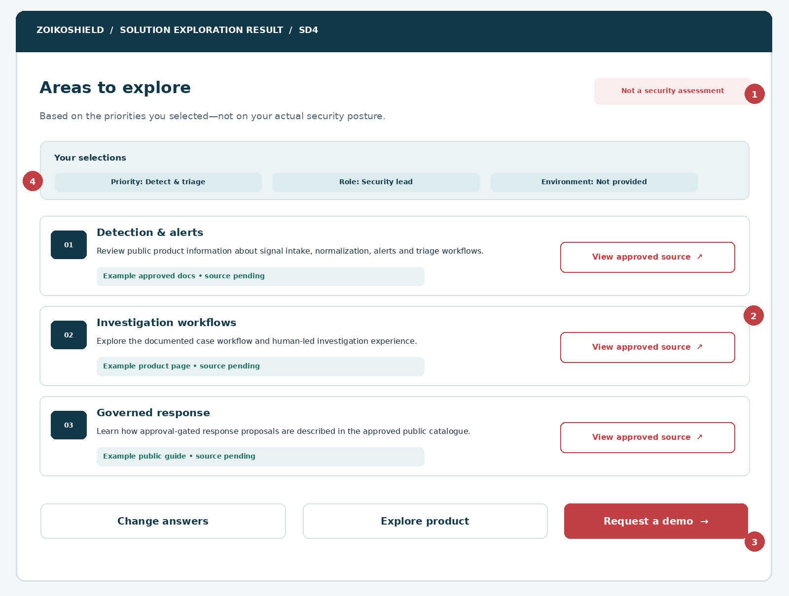
Figure 4 — Example cards use placeholder source labels. In production, each source badge must be backed by a real approved document ID, immutable version and verified URL. Illustrative source labels here are placeholders rather than claims of currently published materials.
MARKER | EXPERIENCE REQUIREMENT
01 | “Not a security assessment” remains visible in the results screen.
02 | Approved sources must be clickable, accessible, stable HTTPS URLs resolved server-side.
03 | “Request a demo” opens WF-003 with a user-confirmed handoff; no automatic lead creation.
04 | Selections displayed back to user; omitted environment never synthesized.

09 / Copy deck and content safety
Plain American English: credible, concise and careful about what is known.
SCREEN / ROLE | APPROVED PROPOSED MICROCOPY | DISALLOWED CLAIM STYLE
Entry | “Explore areas of ZoikoShield that relate to your priorities.” | “Discover your security score in 60 seconds.”
Disclosure | “This guide uses your selections, not data from your environment.” | “We have analyzed your company’s security.”
Priority question | “What would you like to explore first?” | “What is your biggest unaddressed vulnerability?”
Optional context | “You can skip these questions.” | “Tell us which customer systems are exposed.”
Loading | “Finding relevant public information…” | “Running threat analysis against your environment…”
Result heading | “Areas to explore” | “Your definitive security solution”
Result reason | “You selected detection and triage, so these public materials may be relevant.” | “You are at high risk, so you need this module.”
No match | “I can’t narrow this reliably. Here are public areas you can browse.” | “You do not have security gaps.”
CTA | “Request a demo” / “Explore documentation” | “A specialist is standing by” unless verified.
Source not public | Suppress item, offer eligible resources. | Expose draft / internal doc or invent a URL.

Evidence and hallucination guard
Responses must be generated from publication-eligible metadata and an approved, versioned prompt template. Unsupported assertions are blocked by claim-level validation, not merely appended with a disclaimer. If an answer relies on live data, commercial availability or present-day pricing, it must link to the verified approved source or clearly state that information is not available.

10 / Public API and front-end integration
Proposed contracts, subject to backend engineering validation.
METHOD / ENDPOINT | REQUEST / RESPONSE CONTRACT | BOUNDARY
GET /api/public-chat/discovery/config | locale query; returns schema_version, options, labels, disclaimer, expiry and approved CTA URLs. | Public allowlisted configuration only; no admin feature flags/secrets.
POST /api/public-chat/discovery/match | Body: session_nonce, config_version, priority, optional role/environment. Response: outcome, ruleset_version, items, sources, ctas and correlation_id. | Typed enums; bounded rate/size; secure public BFF; no LLM privileged tool.
POST /api/public-chat/discovery/feedback | Optional anonymous coarse result helpful/not_helpful enum; no free-text payload. | Abuse controls; separate consent/analytics policy if needed.
GET /api/public-chat/discovery/health | Optional BFF-only readiness check; response degraded/available, no internal topology. | Internal monitoring cannot leak service architecture.
WF-003 transition | Open demo intake screen. User reviews any proposed context before including it. | No auto-transfer of answers / personal details / message history.
WF-004 transition | Open public support route selector. | No incident details or prospective buyer metadata forwarded.

Non-functional contract
Use consistent error schema; schema-version negotiation; request correlation; server-generated short-lived non-authenticating nonce; origin validation; rate limiting; cache invalidation on source revocation; defensive URL allowlists; content-security-policy compliance; stable focus and history. UI never assumes a 200 status signifies a real approved match if the body declares no_match/degraded.

11 / Canonical request and response examples
Illustrative shapes only; implementation should be registered as versioned OpenAPI / JSON Schema.
Request — POST /api/public-chat/discovery/match
{
"schema_version": "1.0",
"config_version": "approved-config-id",
"session_nonce": "opaque-short-lived-value",
"priority": "detect_triage",
"role": "security_lead",
"environment": null,
"locale": "en-US"
}
Result — the examples below are structurally representative, not real published source IDs.
{
"outcome": "matched",
"ruleset_version": "approved-rules-id",
"recommendations": [{
"area_id": "detection_triage",
"reason_template_key": "selected_priority_match",
"source_ids": ["approved-public-source-id"]
}],
"disclaimer_key": "discovery_not_security_assessment",
"correlation_id": "opaque-request-id"
}
DO NOT TRUST CLIENT FIELDS
The backend must independently resolve source eligibility, URL and visible claim text from its public registry. Frontend-selected IDs, role and environment are untrusted routing hints, not security principals or tenant-authorization evidence.

12 / Privacy, persistence and commercial handoff
Keep the public discovery interaction genuinely lightweight.
CONTROL | ENGINEERING RULE / VERIFICATION EVIDENCE
Data minimization | Do not request employee identity, name, email, phone, organization URL, IP address, named vendors, asset inventory, incidents, SOC cases, credentials or logs.
Anonymous session | Selections held in component state or short-lived first-party session under approved policy; no default cross-session profiling or tenant association.
Storage limits | Backend stores approved de-identified event/diagnostic data only, if required. Retention and cross-border transfer must be specified by Privacy rather than invented.
Consent and demo | WF-003 is the only lead intake journey. On demo action, start a fresh form; show any proposed optional prefill only after explicit review and never transfer it silently.
Support | WF-004 handles support purpose separately; no automatic copying of discovery answers into a support case.
Analytics | Allow coarse role_group and priority_code only if privacy assessment approves; never send raw text, email, IP, cookies/tokens, unknown vendor strings or transcript.
Model behavior | No prompts containing live customer posture. Model does not train on visitor choices unless separately authorized by policy and provider configuration.
Deletion / reset | “Start over” clears temporary choices and associated BFF state; show truthful treatment for any previously recorded aggregate events.
Threat detection | Block or discard secrets, incident evidence or credential strings entered outside the allowed enum controls; safe alternate routing.
Customer rights | Privacy notice accessible at every step; approved policies for access/erasure requests apply where personal data is processed.

PRIVACY IS A RELEASE DEPENDENCY
The anonymous “discovery” label does not exempt analytics identifiers and network metadata from applicable privacy rules. Privacy counsel must authorize tracking configuration, retention, notice, processor roles and regional data transfers.

13 / Security threat model and hard boundaries
Cybersecurity buyers will judge credibility by the assistant’s restraint.
THREAT / FAILURE | REQUIRED DEFENSE | P0 OWNER
Prompt injection from site copy or retrieved public documentation | Treat all retrieved content as data; allowlisted source IDs and output escaping; no tool authority changes. | AI Security
LLM suggests privileged SOC query or remediation | Do not expose authenticated tool or endpoint in public assistant; separate public BFF and identities. | AppSec / Backend
Fake or tampered source document | Signed/versioned source registry, approval records, revocation and cached result invalidation. | KnowledgeOps
Inaccurate capability or current availability | Market and release gating, approved claim IDs, not unrestricted RAG text. | Product / Commercial
Sensitive text pasted into selector or query | Use enum-only controls; no free-text capture, secret checks and redacted logs. | Privacy / AppSec
Untrusted link supplied by model | Server-resolved allowlisted HTTPS destinations; no arbitrary redirect or tracking-link PII. | Frontend / AppSec
Overconsumption / spam | Rate limits, per-session quotas, request timeout and bounded recommendation size. | SRE
User infers a risk score from marketing result | Prominent non-diagnostic copy; no scores, charts of risk, red/yellow security posture states. | Product / UX
Cross-user session leakage | Opaque non-authenticating session IDs, scoped caches, no identity-based enrichment. | Backend / QA
Handoff silently triggers CRM or ticket | Require WF-003/004 explicit purpose-specific action and submission. | Frontend / Ops

14 / No match, partial source and outage UX
Transparent uncertainty improves trust—and prevents false commercial promises.
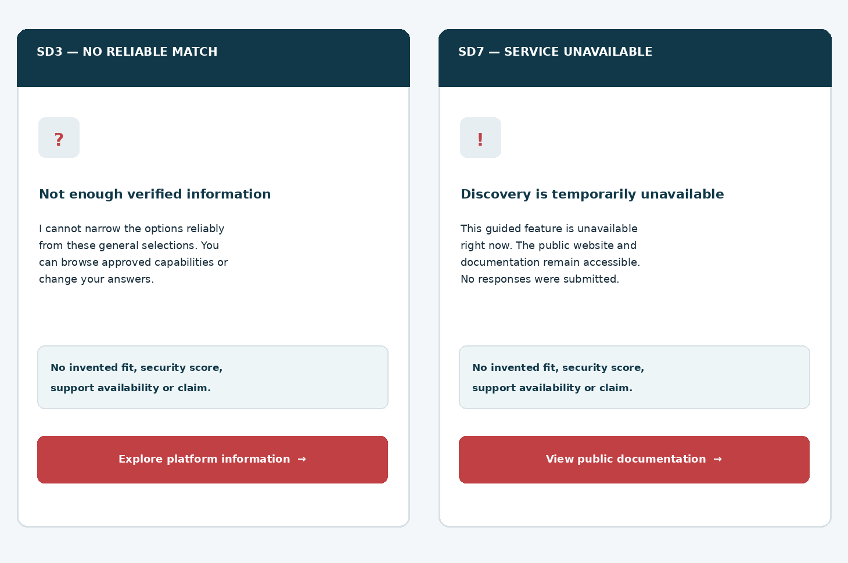
Figure 5 — Distinct “no reliable match” and “service unavailable” screens. Neither invents a personalized solution or claims that the underlying platform is down. Static verified documentation remains open.
TRIGGER | UI BEHAVIOR
No selection and user skips all | Show generic capabilities overview, explicitly not a personalized match.
No approved source for priority | Hide unsupported card; explain limits; link public overview.
One of three approved sources revoked | Remove only revoked item; update explanation and count, never show stale citation.
Network timeout / 429 / 5xx | Truthful retry where safe, preserve non-sensitive choices, open public navigation.
URL registry unavailable | Disable broken CTA; show approved generic product page if locally verified.
Accessibility live-region overloaded | Announce concise change once; avoid streaming a new “assessment” state.

15 / Accessibility and responsive acceptance
Target WCAG 2.2 AA; compliance is a tested outcome, not a design claim.
CONTROL | IMPLEMENTATION EXPECTATION
Navigation | Priority cards are native radio controls or buttons with consistent selected state, keyboard focus and accessible group labels.
Target size | WCAG 2.2 SC 2.5.8 minimum at least 24×24 CSS px or applicable exception; design target 44×44 CSS px for primary controls.
Focus | Opening discovery focuses heading; transitions focus first meaningful heading; Back restores the last relevant control.
Contrast | Text and icons use measured AA-eligible combinations; never rely solely on navy/red or outline weight for selected and error states.
Reflow | 320 CSS px, 400% zoom, landscape and mobile virtual keyboard; no two-dimensional scrolling for normal chat content.
Announcements | Loading, no-match and changed result count announced once with polite live region; errors announced clearly.
Reduced motion | Respect prefers-reduced-motion; no animated risk rings, fake progress timers or distracting flashing.
Screen reader | Each recommendation reads title, reason, source status and unique “View source” destination label.
Controls | Skip, Back, Reset and Close remain available; Escape semantics align with modal/full-screen implementation.
Language | American English default; approved localization without truncation, invalid assumptions about market or jurisdiction.

STANDARDS PRECISION
WCAG SC 2.5.8 specifies a 24×24 CSS pixel AA minimum with enumerated exceptions; 44×44 in this document is a UX target, not a misstatement of the criterion.

16 / Performance, instrumentation and observability
Fast enough for public discovery, without making unverified availability promises.
ASPECT | PROPOSED ENGINEERING TARGET / EVIDENCE
First interaction | Lazy-load discovery UI; measure INP/LCP as applicable and avoid affecting core marketing page performance.
Matching result | Engineering SLO proposal: p95 match API ≤ 1,200 ms under agreed synthetic load, excluding third-party public site latency. Validate before committed SLA.
Timeout | Proposed client timeout 8 seconds; show SD7 fallback, no repeated automatic submitting storms.
Availability | Track match outcomes, no_match, source_revoked, config_failed, 429/5xx; do not claim platform availability based on discovery health.
Grounding | Track recommended_item_has_approved_source ratio; target 100% enforced at server, not a sampled quality aspiration.
Analytics events | discovery_opened, priority_selected, context_skipped, match_succeeded, match_unavailable, source_opened, demo_cta_clicked, reset.
Privacy safe | No raw content, IP, referrer with query-string PII, identity, prompt text, logs, access tokens, contact details or customer tenant IDs.
Tracing | Opaque correlation_id per request; no user-derived identifiers; redacted telemetry fields and short diagnostic retention.
Release flags | Staged roll-out with kill switch; config-version-aware results; fallback static approved product links.
Regression | WF-001 entry/focus, WF-002 citations, WF-003 demo submission and WF-004 support routing all re-tested.

17 / P0 engineering acceptance tests — AT-73 to AT-85
Tests use synthetic approved sources and deterministic fixture rules.
TEST | SCENARIO | EXPECTED RESULT / EVIDENCE
AT-73 | Enter discovery from launcher and source-grounded chat answer | SD0 opens; no contact capture and no privileged request.
AT-74 | Select each priority one at a time | Correct taxonomy key; only one selection; visible/accessible selected state.
AT-75 | Skip priority and both context questions | Generic overview; no fabricated “customized match.”
AT-76 | Choose security_lead with no environment | Role optional; environment remains null throughout request/result.
AT-77 | Choose prefer_not_say environment | No inference or substitution; no “on-prem” default.
AT-78 | Deterministic match for detect_triage | Approved base order returned; rule version recorded; maximum three cards.
AT-79 | Public source revoked one second before match | Affected card suppressed; no revoked citation or cached old claim.
AT-80 | Public source wrong market/release state | Excluded; user sees only current permitted region-eligible material.
AT-81 | Result has zero eligible items | SD3 no_match with honest copy and verified generic links.
AT-82 | User edits role or priority | New deterministic result; old result discarded; focus restored.
AT-83 | User resets discovery | All ephemeral answers cleared; no fake history deletion promise.
AT-84 | User opens source and returns | Verified allowed HTTPS page opens; results preserved; no PII in URL.
AT-85 | Visitor selects “Request a demo” | WF-003 opens, no implicit lead, user decides what details to submit.

18 / P0 engineering acceptance tests — AT-86 to AT-98
Release blocked for any failure of source authorization or public/private boundary.
TEST | SCENARIO | EXPECTED RESULT / EVIDENCE
AT-86 | Visitor selects Contact support | WF-004 chooser opens; no auto-incident or support case creation.
AT-87 | Model says to inspect customer SIEM logs | Public BFF has no privileged method; suggestion blocked/replaced.
AT-88 | Retrieved source attempts prompt injection | Source treated as data; no role/tool change, unsafe output or unauthorized link.
AT-89 | Prompt asks for a vulnerability score | No assessment score; link to appropriate approved context instead.
AT-90 | Malicious JSON enum / oversized request | Server validation rejects safely; no matching engine bypass.
AT-91 | Cross-visitor / cross-tenant replay | No data leakage, unauthorized session association or private route.
AT-92 | Client network loss while matching | SD7 explanation, static URLs and no site lockup.
AT-93 | Config disabled by kill switch | Discovery CTA hidden/disabled; standard public chat remains healthy.
AT-94 | 24px AA target checks; 44px UX target | Formal criteria met and preferred target documented for every critical control.
AT-95 | Keyboard + VoiceOver/NVDA full journey | All controls, state and source links discoverable; focus order stable.
AT-96 | 320px viewport at 400% and landscape | No clipped content/CTA, nested scroll trap or loss of response.
AT-97 | Synthetic PII/secret injected in request/analytics | No sensitive data in request except allowed enums; events redacted.
AT-98 | Public assistant legal name and logo config changed | Only approved label and original product assets shown; no hard-coded working name.

Regression and evidence packet
Record fixture, build hash, ruleset/source snapshot, owner, expected/actual, browser/viewport, accessibility audit, redacted trace, screenshot, status and defect reference. Obtain sign-off from Product, Security, Privacy, Brand, QA, Engineering and Support/Sales on routes before release.

19 / Critical design review and incorporated refinements
Evaluated against buyer trust, deterministic engineering and cybersecurity-specific risk.
WEAK DESIGN / RISK | REFINED DECISION IMPLEMENTED HERE
“Take a security assessment” collects sensitive architecture | Relabel as “Explore capabilities”; high-level controlled enums only.
All visitors must answer many discovery questions | One priority plus optional role/context; skip remains available.
Opaque AI fit score and unsubstantiated ROI promise | Deterministic 1–3 eligible public areas; no score or savings estimate.
Model invents a product feature based on role | Publication-approved capability and claim gating, versioned source IDs.
Marketing CTA silently becomes a sales lead | Distinct WF-003 review and consent required before submission.
Same controls used in anonymous and authenticated SOC | Separate public BFF; no shared tenant authority or privileged calls.
Recommendations lack verifiable context | Each capability card links to approved source with version/status.
Source becomes revoked but stays cached | Eligibility invalidation / source revocation dominates cache and model text.
Chat overlay covers mobile navigation | Full-screen accessible reflow, close/back and focus management.
Result falsely implies immediate cybersecurity safety | Prominent non-diagnostic disclaimer and uncertainty mode.
Service error blocks public marketing site | Independent fallback with static verified links; site always navigable.

Approval-critical decisions
Product/Founder: confirm category labels and CTA placements. Brand: official logo/favicon and permission for public persona name. Commercial/Product Marketing: publish an approved capability/claims register with market and release rules. Security: public BFF separation and prompt-injection resistance. Privacy: analytics/session policy. Frontend/UX: semantic component definitions and mobile reflow. KnowledgeOps: versioning/revocation. QA: AT-73–AT-98 evidence.

20 / Engineering handoff and controlled references
An actionable build contract, not another open-ended design programme.
DELIVERABLE OWNER | DEFINITION OF DONE
Design Systems / Figma | Five annotated screen families, ZS71–ZS92 components, all supported states, selected/hover/focus/error variants, responsive constraints.
Product / Commercial | Approved capability publication registry, geography/release availability, user copy and CTA mapping.
Frontend Engineering | Typed flows SD0–SD7, accessible interactions, safe source cards, focus/reflow, retry/back/reset.
Backend / Public API | Versioned config and match endpoints, source authorization, schemas, rate limits, correlation, isolation from privileged Shield services.
AI / KnowledgeOps | Prompt boundary, generated text policy and content validation; public source approval/version/freshness/revocation.
Privacy / Legal / Security | No secret collection, lead-purpose separation, compliant notice/analytics, tested lack of privilege, brand/legal checks.
QA / Launch Management | Automated and manual AT-73–AT-98 packet; regressions WF-001 through WF-004; no launch until gates pass.
Founder approval | Approval of WF-005 alone. A subsequent wireframe must not be initiated without fresh instruction.

Source and standards register
Internal user-supplied references: ZoikoShield Live Demo Master Guide and Step-by-Step Demo Links Guide (Oct. 13, 2026); Zoiko Group Public AI Chatbots Product & Engineering Guide v7.7 (Oct. 20, 2026); ZoikoShield Public Chatbot Wireframes 01–04 (Oct. 24, 2026). Internal architecture notes are design reference, not independent proof of production readiness.
External implementation references (verified Oct. 24, 2026): W3C WCAG 2.2, https://www.w3.org/TR/WCAG22/ ; W3C WCAG SC 2.5.8 explanatory guidance, https://www.w3.org/WAI/WCAG22/Understanding/target-size-minimum ; OWASP Top 10 for LLM Applications 2025, https://genai.owasp.org/llm-top-10/ ; OWASP API Security Top 10, https://owasp.org/API-Security/ . These are guidance sources and do not imply tested conformance.
STOP / APPROVAL CHECKPOINT
Wireframe 05 only. Status: design awaiting founder approval. Do not proceed to Wireframe 06 unless instructed.

