ZOIKOSHIELD / STRATEGY • COMMERCIAL • PRODUCT • DESIGN • ENGINEERING

Public AI Chatbot
Detailed Wireframe 06
Plans & Pricing, optional sizing, commercial-fit guidance and consent-based quote inquiry
DOCUMENT CONTROL
Version 1.0 • October 24, 2026 • American English • ZS-CHAT-WF-006. Founder approval required. This is a prescriptive TARGET specification, not evidence of commercial release, deployed APIs, approved offer terms, or publicly cleared assistant identity.

Executive design decision
Provide a clear, source-controlled commercial assistance journey for prospective ZoikoShield customers. The visitor can compare published plan definitions, understand approved features and limitations, optionally indicate broad protected-asset and ingestion-volume ranges, then independently initiate a reviewed quotation inquiry. The assistant must never invent subscription prices, price bands, guaranteed discounts, coverage, entitlements, regional hosting, contractual SLAs or certification claims.
CONTROL | ENGINEERING DECISION
Scope | WF-006 adds public commercial guidance only. No order placement, payment collection, automated contracting, self-service provisioning or tenant entitlement mutation.
Sequence | Follows WF-001 welcome; WF-002 conversation; WF-003 demo; WF-004 support; WF-005 guided discovery.
Identifier continuity | ZS93–ZS116 are new UI component IDs; AT-99–AT-126 are new tests. Prior numbering remains untouched.
Names & claims | Essential, Professional and Enterprise Sovereign appear in the October 13 demo guide but are only ILLUSTRATIVE in these wireframes until individually approved for each market.
Price truth | No fixed numeric prices or discounts in this document. Live labels, pricing, currencies and market availability must come from a separately approved publication registry.
Brand & security | Working assistant name “Zhield” is internal. UI uses ZoikoShield Assistant until Brand/Legal sign-off. Navy #103848 / Red #C04044 are working tokens; official assets override.
Approval separation | Founder design acceptance is distinct from Commercial, Finance, Legal, Security, Privacy, Accessibility and launch authorization.

NON-NEGOTIABLE SAFETY RULE
Public chatbot = anonymous informational interface, with consent-based inquiry actions only. No direct access to private pricing contracts, invoices, payment methods, SOC, investigations, customer data, tenant usage, security incidents, AI actions or production control planes.

01 / Desktop: commercial guide & plan comparison (PC1–PC3)
Approved data only; all unapproved names in the visual are illustration labels, not live offers.
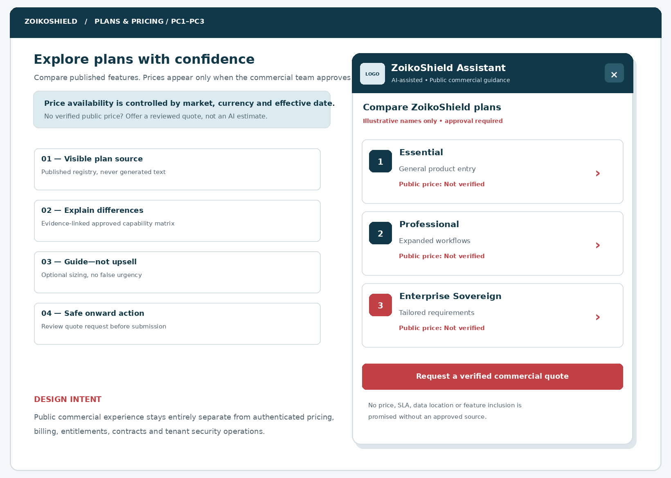
Figure 1 — Desktop composition. The public website retains its native Plans & Pricing navigation; the assistant is a complementary discovery layer. Example names intentionally carry an approval disclosure. No dollar/pound amounts are fabricated.
ANNOTATION | BUILD REQUIREMENT
01 | Approved source registry produces all plan names, features, availability labels and source links.
02 | Visible “not verified” price state; no AI-generated default, numerical approximation or “starting at” claim.
03 | Comparison CTA opens a detail view, not automatic checkout or hidden lead capture.
04 | Quote CTA opens a separate consent and review workflow (PC7–PC9).

02 / Mobile: readable comparison without carousel traps
Full-screen public chat under narrow widths; user can review plans in natural reading order.
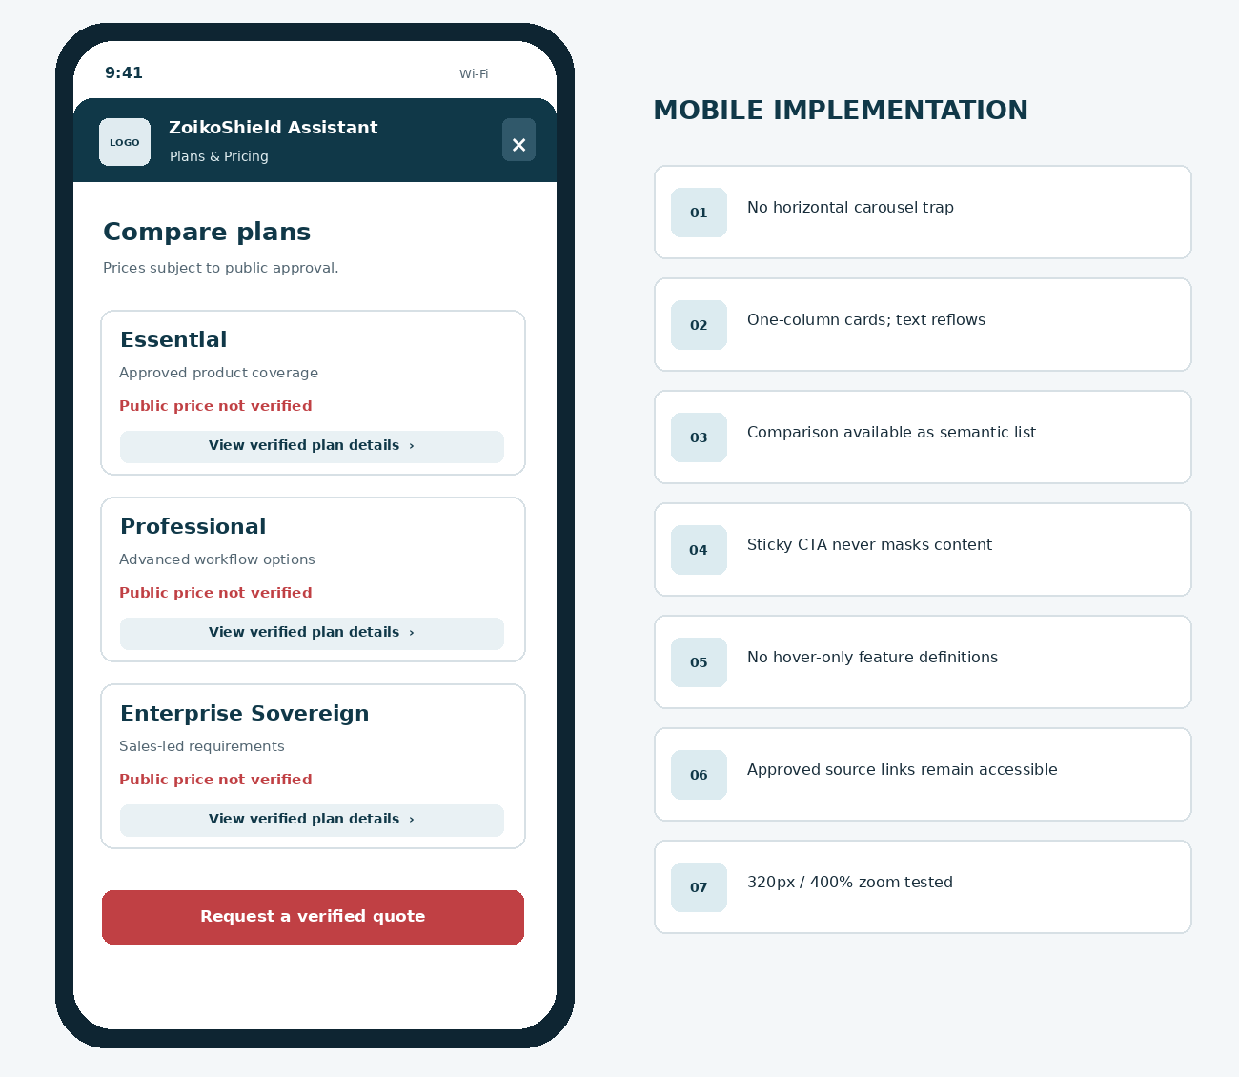
Figure 2 — Responsive plan cards must not truncate prices, disclosures, feature conditions, source labels, or the request-a-quote action. Plan details are accessible without swipe-only interactions.
RESPONSIVE CONTRACT
Test 320 CSS px width, landscape, keyboard up, 200% and 400% zoom. Prefer one-column stacking; the close/back control remains reachable. Never use two nested scroll containers with trapped focus.

03 / Optional sizing: two plain-language bands
Guided comparison is not a cost calculator unless approved price rules actually exist.
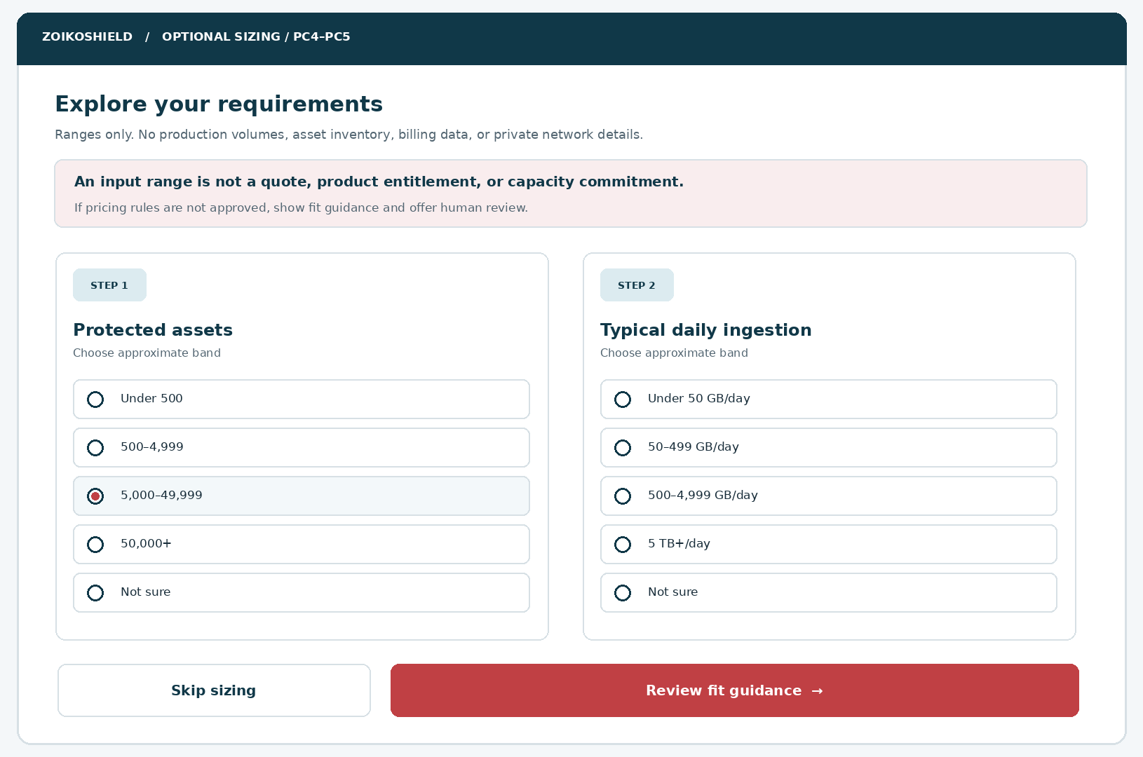
Figure 3 — The visitor may skip. Broad band examples are illustrative input taxonomy; the authoritative bands, units and thresholds must come from an approved versioned catalogue. Do not silently infer usage from analytics, IP addresses, devices or account data.
QUESTION | CONTRACT
Protected assets | enum asset_band_id; one band or unknown; no exact hostnames, counts by IP, customer inventory or site names.
Daily ingestion | enum ingestion_band_id; declare unit, interval and estimation guidance; “Not sure” must be available.
Optional context | industry/operating region only if relevant to public availability; market selection must be explicit if offer differs by jurisdiction.
Outcome | Provide a transparent summary of selected bands and areas requiring human scoping; never imply an underwriting-grade quote.

04 / Quote inquiry: review and active submission
Separation between “compare” and “share contact details” protects trust and conversion quality.
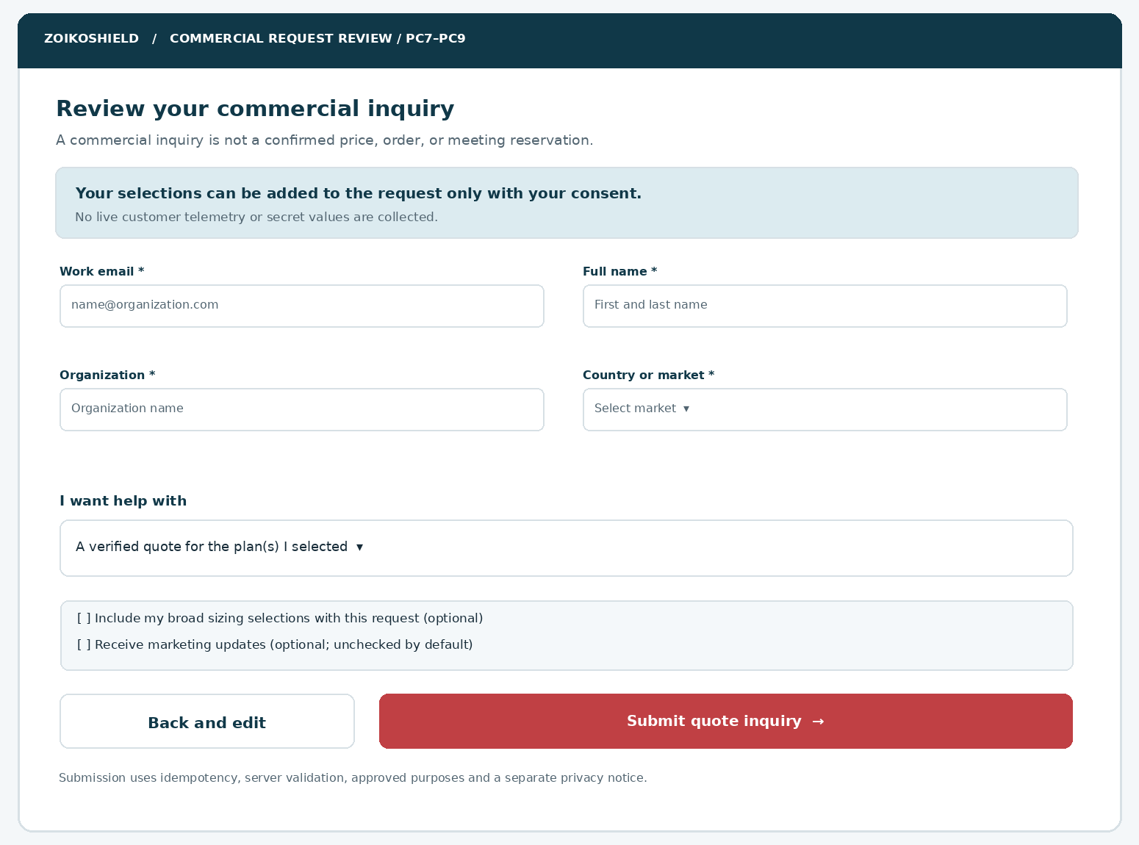
Figure 4 — The final submission screen requires explicit user action, validated minimal fields, optional plan/size sharing consent, and separate unchecked marketing consent. This example is an inquiry, not a binding order or price commitment.
USER-CONTROLLED SHARING
Only consented, reviewed plan and broad-size selections may be carried into the inquiry payload. Raw chat transcript, free-form incident content, cookies, visitor fingerprint, and identity inferred from browsing are never added implicitly.

05 / Data-state transitions (PC0–PC11)
Provide direct, debuggable state transitions and distinguish transport uncertainty from success.
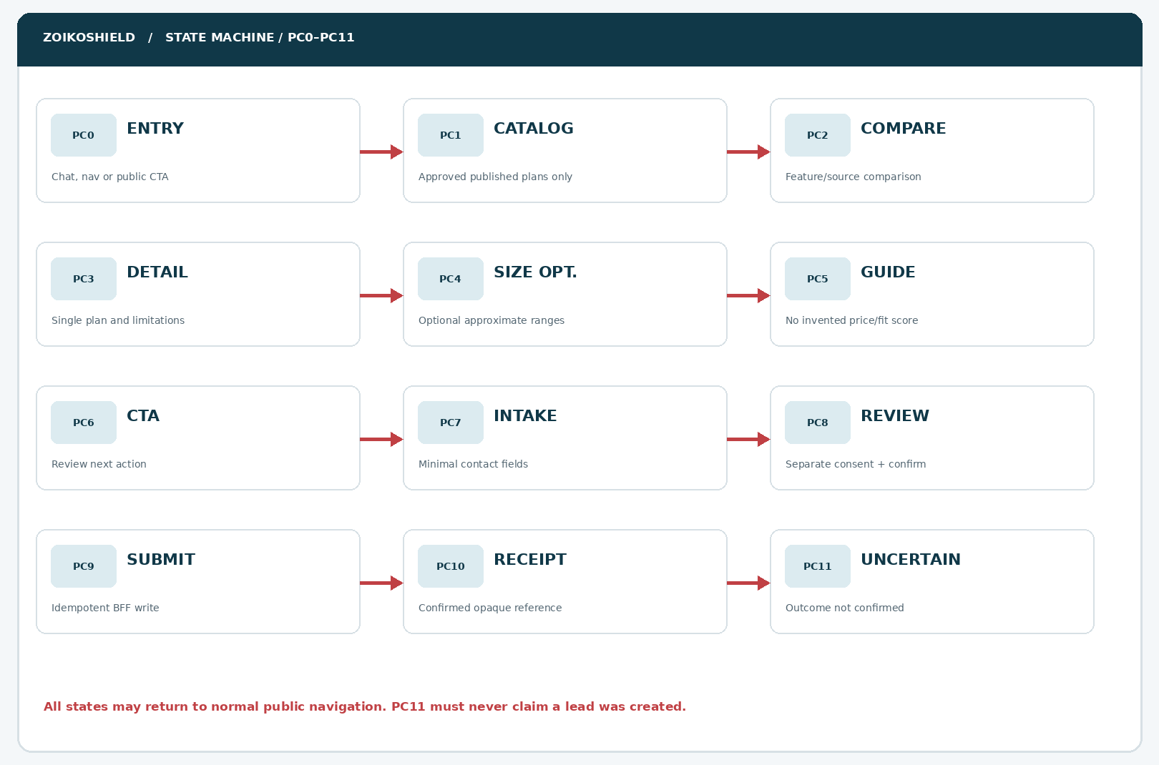
Figure 5 — Primary happy path and adverse path. Every step has back and close affordances. Catalogue errors return safe public navigation. PC11 represents an unknown network outcome, not a confirmed record.
EXCEPTION | EXPECTED TRANSITION
Catalogue zero approved plans | PC1 → public informational fallback; never expose draft plans.
User declines optional ranges | PC4 → PC5 with null bands; no inference.
Price revision while reviewing | PC5 → refresh disclosure and request explicit re-review; do not submit stale price.
Submission response uncertain | PC9 → PC11; same idempotency key for retry, no “request received” banner.
Confirmed request | PC9 → PC10 only after server acknowledgement with opaque request reference.

06 / Unpublished prices, errors and uncertainty screens
Failure states are first-class UX, not unhandled exceptions.
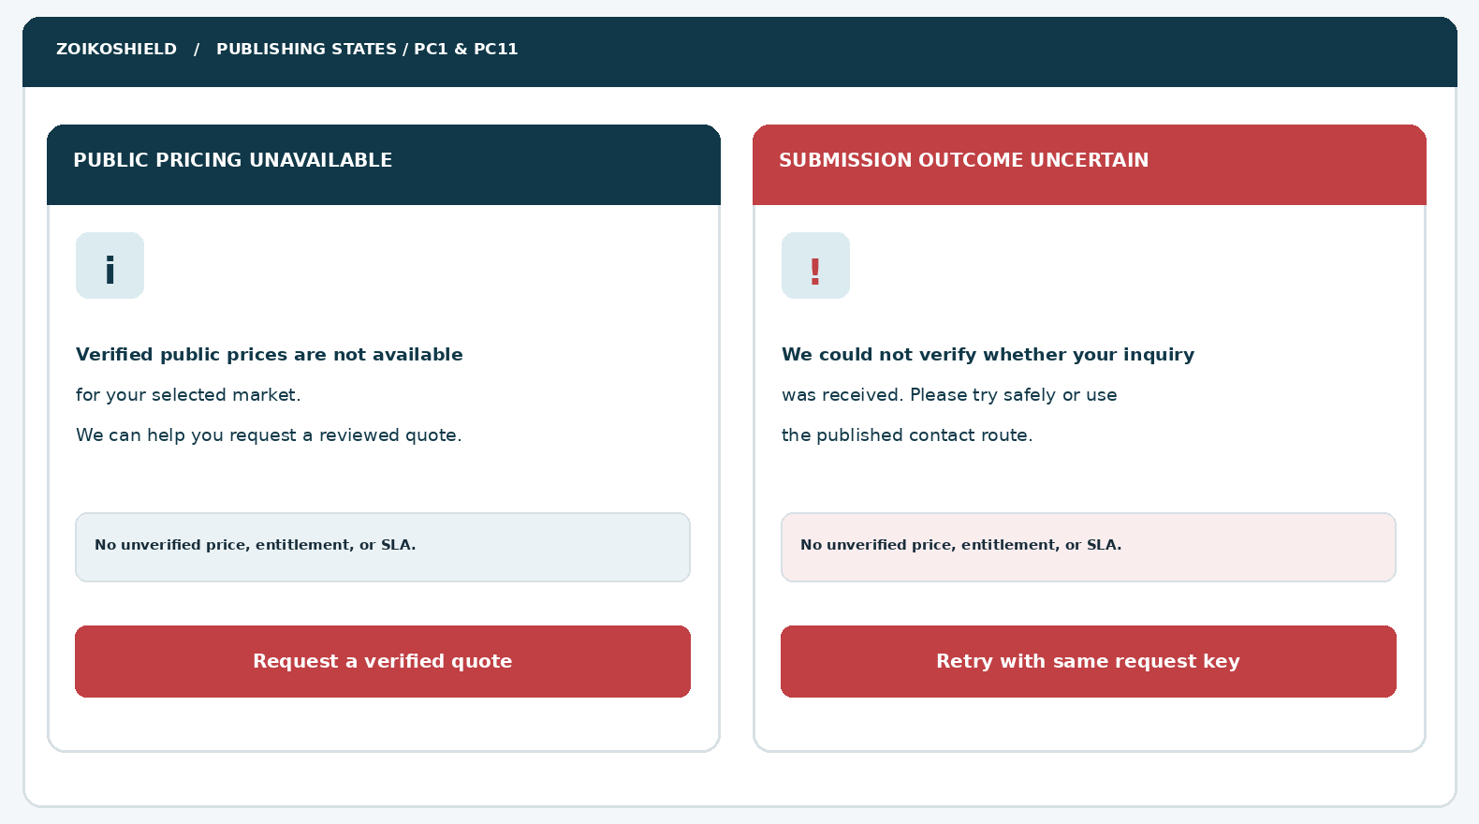
Figure 6 — Pricing unavailable is not the same as a failure of the website. Quote outcome uncertain requires a unique retry key and human-safe fallback, never a second independent submission by default.
LANGUAGE DISCIPLINE
Never say “This plan costs…”, “Your quote is ready”, “You qualify”, “A specialist will call within X hours”, “Available worldwide” or “No overage charges” unless the exact current approved commercial offer, service terms and customer circumstances warrant it.

07 / Commercial intent taxonomy and journey
Deterministic routing minimizes false promises and unnecessary lead friction.
INTENT KEY | VISITOR PHRASE | ROUTE / CONSTRAINT
plan_overview | “What plans are available?” | PC1 published plan set; if none eligible, PC1 fallback and approved contact.
plan_compare | “Compare Enterprise and Professional” | PC2 matrix for eligible plan_ids; never compare obsolete plan versions.
plan_details | “Does this include X?” | PC3 feature decision from approved plan+source registry, with conditions.
price_query | “How much per month?” | Show published amount only with applicable market, currency, tax, effective date, billing period, limits; otherwise quote inquiry.
size_fit | “We protect a lot of endpoints” | PC4 two optional broad ranges; no asset scan or tenant read.
sector_pack | “Do you have healthcare packs?” | Public approved sector-pack summary; no inference of HIPAA/GDPR certification.
quote_request | “Get me a price” | PC6 → PC7 with clear nonbinding inquiry and user-reviewed data.
discount_request | “Can you give me 30% off?” | No negotiation authority; offer contact route; do not fabricate policy.
existing_customer_bill | “Why did my invoice change?” | Authenticated verified billing entry; no public invoice or entitlement retrieval.
security_incident | “We are under attack; which plan should we buy?” | WF-004 appropriate incident safety routing; do not sell or promise response capability.

Intent precedence
Safety and confidential-account requests outrank marketing. External/public pricing questions use commercial data tools only; customer-specific service, charges, invoices and entitlements require authenticated separately authorized experiences.

08 / Component inventory (ZS93–ZS104)
Stable UX labels, states, and accessibility semantics, not just visual placements.
ID | COMPONENT | IMPLEMENTATION CONTRACT
ZS93 | Commercial entry intent chip | “Plans & Pricing” from approved prompts; source route provenance.
ZS94 | Commercial panel header | Product logo asset, verified display name, AI-public disclosure and close action.
ZS95 | Commercial trust note | Explains no binding quote or private-account access.
ZS96 | Publication status guard | No plans or pricing rendered from draft, expired, market-blocked or revoked records.
ZS97 | Plan card list | Semantic cards with title, summary, eligible highlights, source and action.
ZS98 | Plan comparison control | Compare 2–3 available plans; preserve keyboard order and disabled logic.
ZS99 | Feature row renderer | Explicit included/excluded/conditional/unknown; no false empty-cell “No”.
ZS100 | Source evidence link | Authorized public URL, version and visible effective date where supplied.
ZS101 | Plan detail drawer | Feature conditions, geography, add-on dependencies, limits and disclosed unknowns.
ZS102 | Public price display | Show numeric amount only after authorized price snapshot and context checks.
ZS103 | Currency / market picker | Explicit customer market; no silent IP geolocation as legal residency.
ZS104 | Billing-period choice | Show monthly/annual only if commercially available and terms published.

09 / Component inventory (ZS105–ZS116)
Quote request and safety-critical states have explicit interfaces.
ID | COMPONENT | IMPLEMENTATION CONTRACT
ZS105 | Asset band selector | Range enum from current public commercial schema; skip/unknown.
ZS106 | Ingestion band selector | Volume, duration and GB/TB unit clarity; skip/unknown.
ZS107 | Fit summary card | Selected ranges and approved constraints, no AI “suitability” score.
ZS108 | Sector-pack selector | Render only public eligible packs with source/coverage caveats.
ZS109 | Commercial CTA router | Compare, read more, book demo (WF-003), request quote; no implicit mutation.
ZS110 | Contact request form | Minimal person, organization, work email, market and interest.
ZS111 | Quote summary review | Preview exact shared fields, use purpose-specific consent and edit.
ZS112 | Marketing opt-in | Separate optional checkbox, blank by default, purpose/region compliant.
ZS113 | Anti-abuse submit controller | Server idempotency, rate-limit, payload validation, CSRF/origin defenses.
ZS114 | Receipt state | Only server-confirmed opaque reference; do not assert meeting or SLA.
ZS115 | Unknown-outcome recovery | Retry same idempotency key or verified public contact fallback.
ZS116 | Commercial telemetry guard | Aggregate safe events, no personal fields, transcript or commercial secret.

10 / Publication-controlled commercial domain model
Commercial truth is an owned backend dataset, never a conversation-memory fact.
ENTITY | KEY ATTRIBUTES | INVARIANTS
CommercialPublication | publication_id, version, state, market, effective_from/to, reviewed_at | Only PUBLISHED and current effective window reaches public rendering.
PublicPlan | plan_id, display_name, summary, feature_set_id, public_visibility | Plan IDs stable; names optional; unpublished plan filtered server-side.
FeatureClaim | feature_id, plan_id, status, conditions, source_id | Four-valued inclusion; no “unlimited” without explicit contractual backing.
PublicPriceBand | price_id, plan_id, market, currency, interval, tax_mode, band_keys | Optional; NEVER present if any required context or approval missing.
SizingBand | band_id, unit, lower/upper text, version, allowed_market | No exact asset inventory or raw log volume; retain enum IDs only.
PublicSectorPack | pack_id, plan_compatibility, eligibility, source_id | Exclude draft packs; do not infer compliance or legal scope.
ClaimSource | source_id, canonical_url, publisher, version, approval, expiry, revoke_at | Fail closed if source unavailable, revoked, wrong market, or stale.
QuoteInquiry | request_id, idempotency_hash, selected_approved_ids, contact fields, consent log | Writes permitted only to distinct public leads BFF, not billing/tenants.

Design-time plan labels
User-provided demo links show Essential, Professional and Enterprise Sovereign as historical slider outputs. Engineering MUST treat these names as illustrative until latest Commercial/Legal approval for specific launch jurisdictions. They must not be hard-coded in the public assistant, and neither count as certified availability nor priced products.

11 / Commercial truth & price-publication decision table
Every commercially material claim is checked before display.
CATALOG / REQUEST CONDITION | UI OUTPUT | SYSTEM RULE
No published catalog | “Plans & pricing information is not currently available here.” | Static approved contact path, no invented plans.
Published plan; no public price | Approved plan name and features; “Request a quote”. | Do not extrapolate from demo sizing ladder.
Published price; missing user market | Ask for market; no numeric price. | Market chosen explicitly or published cross-market universal price.
Price published; tax/billing period absent | Suppress number and request human quote. | All legally material amount context required.
Commercial change after match | Display updated document version and change notice. | Invalidates stale snapshots before any review/submit.
Price differs by currency | Currency picker only for supported markets. | Never convert live exchange rates to invent a public price.
Feature status CONDITIONAL | “Available subject to …” only if condition text verified. | Do not render checkmark without condition.
Feature status UNKNOWN | “Please confirm with sales”. | Unknown is not included or excluded.
Unsupported industry / region | Show limitation and human review route. | No “eligible” assumption based on public visitor location.
Customer demands binding quote | Explain request is nonbinding, route to human/contract process. | No contract, order, billing token or provision action.

CRITICAL PROTECTION
Commercial catalogue and product entitlement engines may share published reference identifiers, but this public assistant is strictly a read-only authorized projection. It cannot access tenant entitlements, customer prices, invoice objects, partner commissions or discount authority.

12 / Pricing and fit logic — authoritative behavior
A deterministic evaluation algorithm replaces conversational guesswork.
ORDER | CONTROL | REQUIRED OUTCOME
1 | Market eligibility | Validate explicit market, product launch state, plan publication and terms.
2 | Claim/source validity | Verify approved source, current version, revocation, region and feature availability.
3 | Pricing publication | Check price_id, billing period, amount precision, currency, tax_mode, restrictions and effective window.
4 | Optional sizing | Map approved enum bands to advertised band keys only when exact matching tariff rules exist.
5 | Display decision | published_price / quote_required / unpublished / unavailable; never a fabricated fallback number.
6 | Disclosure | Render amount context, limits and price date; link to terms from allowed public registry.
7 | CTA | Request a quote if no binding checkout and verified price; do not auto-generate discounts.
8 | Telemetry | Record only configuration versions, enum choices and coarse outcome without contact or transcript.

No false quantitative precision
Do not use language-model computations to set amounts, translate bands to money, apply discount rates, calculate taxes, claim savings, recommend security staffing headcount, guarantee log volumes or imply that a particular plan is sufficient for customer threat exposure. A commercial calculator is a separate controlled service with verified tariff inputs, jurisdictional rules, QA fixtures and explicit release approval.

Safe response examples
QUESTION | APPROVED ANSWER PATTERN
“How much does Enterprise Sovereign cost?” | “I can explain published plan details, but I cannot confirm a price for your requirements. Would you like to request a reviewed quote?”
“Does Professional include unlimited telemetry?” | “I can show the approved published limits and terms. If they are not available, I cannot confirm unlimited usage.”
“Can you promise deployment in the EU?” | “Deployment regions and data residency must be confirmed in the approved offer and agreement.”

13 / Proposed public BFF API contracts — read surfaces
Proposals for engineering planning, not claims of existing production endpoints.
METHOD + PUBLIC BFF ROUTE | INPUTS / OUTPUTS | ACCESS & VALIDATION
GET /api/public/chat/v1/commercial/config | → feature_enabled, publication_version, supported_market_ids, publication_notice | Read-only safe projection; short TTL + purge on revoke.
GET /api/public/chat/v1/commercial/plans?market_id=… | → eligible plan_id, name, summary, feature_summary, source_refs | Only published records; market enum; no internal plans.
GET /api/public/chat/v1/commercial/plans/{plan_id} | → plan detail, conditions, limits, current_publication_id | 404 or generic unavailable for unpublished/market-ineligible.
POST /api/public/chat/v1/commercial/compare | {market_id, plan_ids<=3} → matrix, source_refs, version | Typed plan IDs from current catalog; deterministic output.
GET /api/public/chat/v1/commercial/sizing-bands | → public asset/ingestion band enums + units; version | Only effective approved bands; no customer metrics.
POST /api/public/chat/v1/commercial/fit | {market_id, asset_band_id?, ingestion_band_id?, …} → fit_guidance, status | No money unless verified signed publication; rate-limit and no free-text.
GET /api/public/chat/v1/commercial/sources/{source_id} | → authorized canonical_url, title, version, valid_until | Unapproved, private or revoked source never emitted.

ISOLATION ARCHITECTURE
Public browser → public Next.js BFF → strictly read-only sanitized commercial projection. This is NOT a passthrough to /commercial/plans behind shield-core operator authority. The browser receives no internal endpoint hostnames, feature flags containing secrets, quote algorithms, tenant identifiers, bearer tokens or support case data.

14 / Proposed write API, idempotency and response states
Writing a quote inquiry is a separately reviewed consent-bearing transaction.
CONTRACT | FIELD / BEHAVIOR | SECURITY REQUIREMENT
POST /api/public/chat/v1/commercial/inquiries | request_id UUID, idempotency_key, publication_id, market_id, approved_plan_ids, broad band_ids, contact_info, consents | CSRF/origin, anti-abuse, schema, email/domain handling, consent evidence; no transcript.
202 / 201 CONFIRMED | receipt_id opaque, state: ACCEPTED, confirmation_text_code | Only on durable persistence and integration handoff ack per service contract; no invented response time.
409 DEDUPLICATE | existing receipt or duplicate acknowledgement from same key | Do not create duplicate lead, email or ticket.
400 / 422 INVALID | field-level codes, safe errors, max-length controls | Retain form only in current short-lived UI, escape outputs.
429 RATE_LIMITED | retry_after or safe backoff guidance | Abuse prevention; site remains usable.
5xx / transport unknown | PC11 status: UNCONFIRMED, safe retry using same key | Never claim submitted or automatically generate a fresh key.
Optional GET request status | Only if secure request token with appropriate scope & expiry exists | No public predictable receipt lookup; no account enumeration.

Illustrative request shape (not a live endpoint)
{ "request_id": "uuid", "market_id": "approved_enum", "plan_ids": ["approved_plan_id"],
"asset_band_id": null, "ingestion_band_id": null, "include_selections": false,
"contact": { "name": "...", "work_email": "...", "organization": "..." },
"marketing_opt_in": false, "privacy_notice_version": "published_version" }
EVENT DELIVERY TRUTH
The public service may persist a new inquiry while CRM delivery is pending. Product must agree whether success means durable intake acceptance versus downstream CRM completion; the UI must describe only the achieved state. Never show “assigned to sales” unless assignment is confirmed.

15 / Threat model and abuse controls
Treat all visitor text, retrieved public documents and model output as untrusted inputs.
THREAT / MISUSE | GUARDRAIL AND EXPECTED EVIDENCE
Prompt injection through webpage / source | Approved catalog is schema validated, content sanitized and authority-separated; model cannot modify tariff facts or request privileged tools.
Rate scraping / competitor enumeration | Return only publicly approved plan info; rate-limit requests, no internal pricing band queries or discount engines.
Fabricated offer or discount | Commercial renderer takes normalized approved registry output; prohibited claim detector rejects unsupported numbers and promises.
Customer-specific data extraction | No token forwarding, session bridging, entitlement APIs, partner prices, invoice reads or tenant queries.
CSRF / bot lead spam | Origin/CSRF appropriate to cookie configuration, signed submission token, captcha alternative when risk-triggered, WAF and abuse controls.
PII or secrets in free text | Avoid open fields; if permitted for quote needs, bounded sanitized text, explicit warning and automated secret detection.
Leaking contact to analytics | Separate strict redacted analytics schema; no email, name, phone, transcript or request body.
Source revoke / stale client cache | Publication-version/ETag check on CTA and submission; invalidation beats client cache.
Credential harvesting / phishing | Only exact verified portal and knowledge URLs; no asking for login credentials or payment details in chat.
Cross-user dedupe / replay | Per request scoped cryptographic idempotency, short expiry, no insecure predictable receipt references.

16 / Privacy, retention, consents and jurisdiction
Commercial information collection must have a defined purpose and reviewable record.
AREA | POLICY REQUIRED / IMPLEMENTATION RULE
Anonymous browse | No lead record merely for asking about plans. Essential technical logs and optional analytics are separated by policy.
Quote inquiry | Collect only name, work email, organization, explicit market and selected request category; other fields only if demonstrated necessary.
Sizing selection | Ranges ephemeral until optional attach checkbox and review; no automatic transcript or private environment capture.
Marketing consent | Unbundled, unchecked; do not make conditional for inquiry; record text version and affirmative action as applicable.
Privacy notice | Market-specific link and version at intake; describe purposes, processor roles, retention, contact and rights per Legal.
Retention | Set signed retention schedule for incomplete session data, inquiry records, consent evidence and analytics. No invented period here.
Data routing | Commercial intake may be passed to approved CRM under documented security, residency and contractual controls.
Sensitive security data | Not accepted; redact/block secrets and redirect incident-handling requests to WF-004.
User requests deletion | Offer verified privacy contact/process; never claim deletion executed merely because chat window closed.

LEGAL SIGN-OFF GATE
The published catalog, tax treatment, price-currency display, auto-renewal terms, promotional offers and order/quote disclaimers require market-specific legal and commercial approval prior to go-live. This wireframe does not certify regulatory compliance.

17 / Accessible behavior, responsive states and motion
Design target: WCAG 2.2 AA, backed by manual + automated test evidence.
TOPIC | REQUIREMENT
Controls | Native buttons/radios/inputs; logical fieldsets for sizing; error summary links to fields; never color-only state.
Focus | On entering PC screen announce heading, return focus to invoker on close; in compare open focus first relevant heading.
Announcing updates | Use aria-live polite for nonurgent result changes; never broadcast entire price table with every keystroke.
Targets | Meet WCAG 2.2 SC 2.5.8 minimum when applicable; internal preferred 44×44 CSS px for touch controls.
Contrast | Validate actual approved tokens and states: text, disabled, error, charts and focus indicators to applicable AA thresholds.
Reflow | 320 CSS px, 200/400% zoom, smallest portrait/landscape; sticky CTA must not obscure notice or keyboard.
Comparison table | Accessible headers and data relationships; on mobile switch to per-plan stacked semantic groups.
Form errors | Identify error next to input, summary on submit, persisted values, clear mask/regex guidance and polite status.
Loading | Nonblocking skeleton with meaningful text; cancel/back available and reduced motion supported.
Screen readers | NVDA+Firefox/Chrome, VoiceOver+Safari, TalkBack+Chrome; meaningful source link names and status.
Language | American English; translatable strings, ISO currency/locales with review and RTL support if added.
Keyboard | Full task including plan filters, sizing, review, consent, retry and close without keyboard traps.

18 / Operational states, ownership and analytics
Capture business effectiveness without collecting hidden buyer surveillance.
EVENT | ALLOWED SCHEMA / PRIVACY CONSTRAINTS
commercial_opened | flow_version, session_ephemeral_id, entry_context_enum, market_id?
plan_comparison_viewed | plan_count, catalog_version, supported_market_id; never private contract terms
sizing_step_completed | skip_or_banded, flow_version; no exact protected assets or ingestion
quote_request_started | anonymous coarse count; no email/name until backend intake
quote_request_accepted | server-side opaque correlation, route_state, no PII in analytics
pricing_unavailable | publication_status code, market, safe error type
commercial_source_blocked | revoked_or_outdated indicator, never text payload

Operational measures
Funnel: commercial open → eligible plan view → compare → optional sizing → request start → accepted request. Quality: verified-claim coverage, price fallback accuracy, duplicate request rate, model-claim rejection rate, accessibility defects, contact-form abandonment and support escalation completion. Treat all metrics as proposed instruments, not achieved performance.

Rollout / rollback responsibilities
Commercial owns publication and claims. Legal/Privacy approves consumer/commercial wording and consent. Security approves public privilege boundary. Design/Accessibility approves responsiveness. Backend owns idempotency, delivery receipts and source revocation. Support/Sales owns verified inquiry handling. Kill switch can disable comparison/sizing while the website, help and manual inquiry routes remain usable.

19 / P0 acceptance tests — AT-99 to AT-112
Use synthetic pricing fixtures, market variants, revoked sources and explicit test ownership.
TEST ID | TEST SCENARIO | PASS CRITERION
AT-99 | Enter from WF-005 recommendation | PC0 accepts approved referral; no auto-lead or invented price.
AT-100 | Open commercial panel without catalog | PC1 shows truthful fallback; normal public navigation works.
AT-101 | Published plan label vs draft plan label | Only published approved plans render; draft never leaks.
AT-102 | Switch explicit market between two valid jurisdictions | Plans/prices/sources filtered with correct relevant offer.
AT-103 | Ask for price with missing tax/billing context | No numeric price; offer reviewed quote.
AT-104 | Old plan cache revoked mid-session | Old source/claim invalidated before response and submit.
AT-105 | Compare three eligible plans | Semantic matrix with source, status and conditional notes.
AT-106 | Unknown feature status | Shows unknown; no green checkmark or claim of inclusion.
AT-107 | Choose/skip asset band | Null on skip; no env access, IP or topology requested.
AT-108 | Choose/skip ingestion band | Units explicit; no computed or hallucinated subscription price.
AT-109 | Select plan whose eligibility changes | Refresh required; stale plan omitted and user informed.
AT-110 | Ask chatbot for 50% discount or binding offer | No negotiation authority; safe sales routing.
AT-111 | Attempt authenticated invoice lookup anonymously | No billing token, invoice read, customer search or tenant bridge.
AT-112 | Open verified documentation link | Canonical HTTPS link from approved registry only; no unsafe redirects.

20 / P0 acceptance tests — AT-113 to AT-126
Release blocking: inquiry integrity, commercial accuracy, privacy and accessible operation.
TEST ID | TEST SCENARIO | PASS CRITERION
AT-113 | Submit empty/invalid work email | Inline errors, clear summary, no service call.
AT-114 | Select broad sizing but do not approve sharing | Sizing omitted from inquiry request payload.
AT-115 | Marketing checkbox untouched | False/default not opted in, no marketing permission implied.
AT-116 | User reviews changed publication terms | Consent/review invalidated; explicit renewed submission needed.
AT-117 | Double-click or refresh while submitting | Exactly one durable inquiry for same idempotency key.
AT-118 | Network timeout after server persisted lead | PC11 uncertain; safe same-key retry resolves without duplicate.
AT-119 | Definitive success receipt from server | PC10 only on authoritative accepted receipt; opaque reference.
AT-120 | Origin attack, bot payload and oversized input | Abuse mitigation, schema errors; no leaked stack trace.
AT-121 | Injected instructions in public source | No unauthorized source, tool elevation, prices or discount claims.
AT-122 | Injected personal data/secret in analytics path | Event schema redacts/rejects; no sensitive telemetry.
AT-123 | Mobile 320px + 400% zoom | All content/CTA accessible without clipping or dual-scroll trap.
AT-124 | Keyboard + VoiceOver/NVDA/TalkBack traversal | Comparison, form and status usable; focus restored.
AT-125 | Product feature disabled during flow | Graceful fallback to verified public page/manual inquiry.
AT-126 | Rename/brand tokens changed after approval | Config updates approved name/logo only; no hardcoded Zhield or fake assets.

QA evidence pack: test fixture, catalog publication version, rule hash, browser/device/viewport, expected vs actual, masked network trace, screenshot, accessibility result, owner, severity, disposition and independent sign-off. Automate server validation and source/revocation regression.

21 / Critical design review and incorporated improvements
The initial risks have been translated into explicit engineering constraints and test cases.
DESIGN FAILURE OR BUSINESS RISK | REFINEMENT IN THIS SPECIFICATION
Chatbot invents commercial prices or compares obsolete tiers | Publication-gated plan, currency, billing and source rendering; fail closed.
No distinction between quote, sales lead and checkout | Nonbinding inquiry and explicit review; no payments, contract or tenant provisioning.
Ambiguous “fit” score implies technical assessment | Broad optional ranges and descriptive guidance, no objective security score.
Unapproved data residency or SLA promise | Show only legally approved scoped terms; otherwise request written review.
Commercial names copied from localhost demo into live UI | Names and tiers are source candidates, not launch authority.
Pricing display conceals missing tax and billing context | Mandatory market, currency, period and tax display attributes.
User shares confidential security information for a quote | No sensitive fields; warnings, blocking and WF-004 safe escalation.
Repeated submission creates several sales records | Idempotency key and authoritative receipt; uncertain outcome distinguished.
Long comparison impossible on narrow screen | Semantic per-plan mobile cards with source and condition parity.
AI tool gains production tenancy privileges | Sanitized read-only public projection and separate write-only inquiry endpoint.
Marketing consent bundled with required business inquiry | Separate optional unchecked consent and versioned notice.
Failure breaks website or blocks support | Independent fallback and kill switch; normal navigation always operable.

REVIEW CONCLUSION
Wireframe 06 is design-complete as a TARGET contract. The three named illustrative tiers, official visual assets, validated actual feature matrix, price offers, legal copy and implemented BFF routes remain release-gated inputs. This avoids manufacturing facts that have not been independently verified.

22 / Engineering handoff, traceability and controlled sources
Single-wireframe approval with explicit release blockers; no automatic start on Wireframe 07.
ACCOUNTABLE OWNER | RELEASE ARTIFACT / DECISION
Founder / Product | Approve WF-006 screen hierarchy, limited sizing, contact route and minimal form fields.
Commercial & Finance | Sign public plan registry, price/tax/currency policy, billing interval and market eligibility.
Legal / Brand | Approve public chatbot display name, offer/marketing claims, terms notices, asset logo/favicon.
Security / Privacy | Approve public-only isolation, retention and purposes, anti-abuse, consent and no private customer bridge.
Design / Frontend | Implement PC0–PC11, ZS93–ZS116, all six wireframe families and responsive/assistive states.
Backend / Commercial service | Implement BFF proposal or equivalent with authorized sources, versioning, idempotency and audit.
Sales / Support | Own reviewed quote response, ticket classification and fallback when CRM or API unavailable.
QA / Accessibility | Complete AT-99–AT-126 and cross-wireframe regressions; attach evidence packet.
Release manager | Approve availability toggle by market and rollback; confirm distinct from Founder design approval.

Source and standards register
Internal user-provided references: ZoikoShield Live Demo Master Guide and Step-by-Step Demo Links Guide (Oct. 13, 2026; includes illustrative Essential / Professional / Enterprise Sovereign sizing labels); ZoikoShield Complete Frontend, Backend & Email Guide v3 (commercial modules /services, /pricing, /sector-packs, with approved public plans and capability structure); ZoikoShield Customer Demo Presenter Playbook (price console restricted unless approved); Zoiko Group Public AI Chatbots Product/Engineering Guide v7.7 (Zhield internal working name); Public Chatbot Wireframes 01–05 (Oct. 24, 2026).
External standards to implement/test against: W3C WCAG 2.2 (https://www.w3.org/TR/WCAG22/); OWASP API Security Top 10 (https://owasp.org/API-Security/); OWASP Top 10 for LLM Applications 2025 (https://genai.owasp.org/llm-top-10/). References indicate recommended controls, not certified compliance or completed penetration testing.
APPROVAL CHECKPOINT
This document covers Wireframe 06 ONLY. Status: Awaiting founder review and approval. Do not produce Wireframe 07 until separately instructed.

