ZOIKOSHIELD / PRODUCT • SECURITY • SOLUTIONS ARCHITECTURE • DESIGN • ENGINEERING

Public AI Chatbot
Detailed Wireframe 08
Integrations, deployment options and secure technical evaluation guidance
DOCUMENT CONTROL
Version 1.0 • October 24, 2026 • American English • ID ZS-CHAT-WF-008 • FOR FOUNDER APPROVAL. Target implementation specification only; no unverified connector support, tenant deployment option, live API endpoint, security attestation, or production readiness claim is asserted.

Executive product decision
Make technical discovery faster for security leaders, procurement reviewers, solution architects and channel partners, without blurring anonymous product guidance with authenticated connector provisioning. Published availability is a bounded, versioned claim—not something inferred from an internal dashboard, connector code name, or sales demonstration.
DIMENSION | MANDATED DECISION
Sequence | WF01 welcome → WF02 conversation → WF03 demo lead → WF04 support → WF05 discovery → WF06 commercial → WF07 Trust Center → WF08 technical evaluation.
Component/test numbering | ZS141–ZS166 (26 components); AT155–AT188 (34 P0 tests); I0–I14 explicit journey states.
Identity and brand | Zhield is an internal working chatbot name; public UI retains ZoikoShield Assistant unless Product/Brand/Legal approve a different display name. Use approved logo/favicon artwork.
Source hierarchy | Public publication registry + release/region/entitlement gate; internal connector/service inventories remain non-public evidence until explicitly approved.
Trust boundary | No public connector authentication, API keys, OAuth callback, customer health checks, live SOC data, tenant endpoints, response orchestration, or deployment change.
Claim types | PUBLIC_APPROVED, IN_EVALUATION, NOT_VERIFIED, RETIRED, RESTRICTED. Only PUBLIC_APPROVED may be stated as currently available.
A11y and security | WCAG 2.2 AA design target; OWASP LLM/API threat tests; manual assistive-technology QA and independent security gates.
Approval | Design approval ≠ connector certification, market release, SLA, region commitment or production authorization.

PRODUCT DOCTRINE
Offer helpful, scoped guidance and a verified route to solution engineering. Never ask anonymous prospects to paste actual connector URLs, access credentials, SIEM queries, IP addresses, tenant identifiers or incident event samples.

01 / Desktop integration discovery — I0 to I2
Convey public scope, a clear hierarchy of signal categories and reliable route selection.
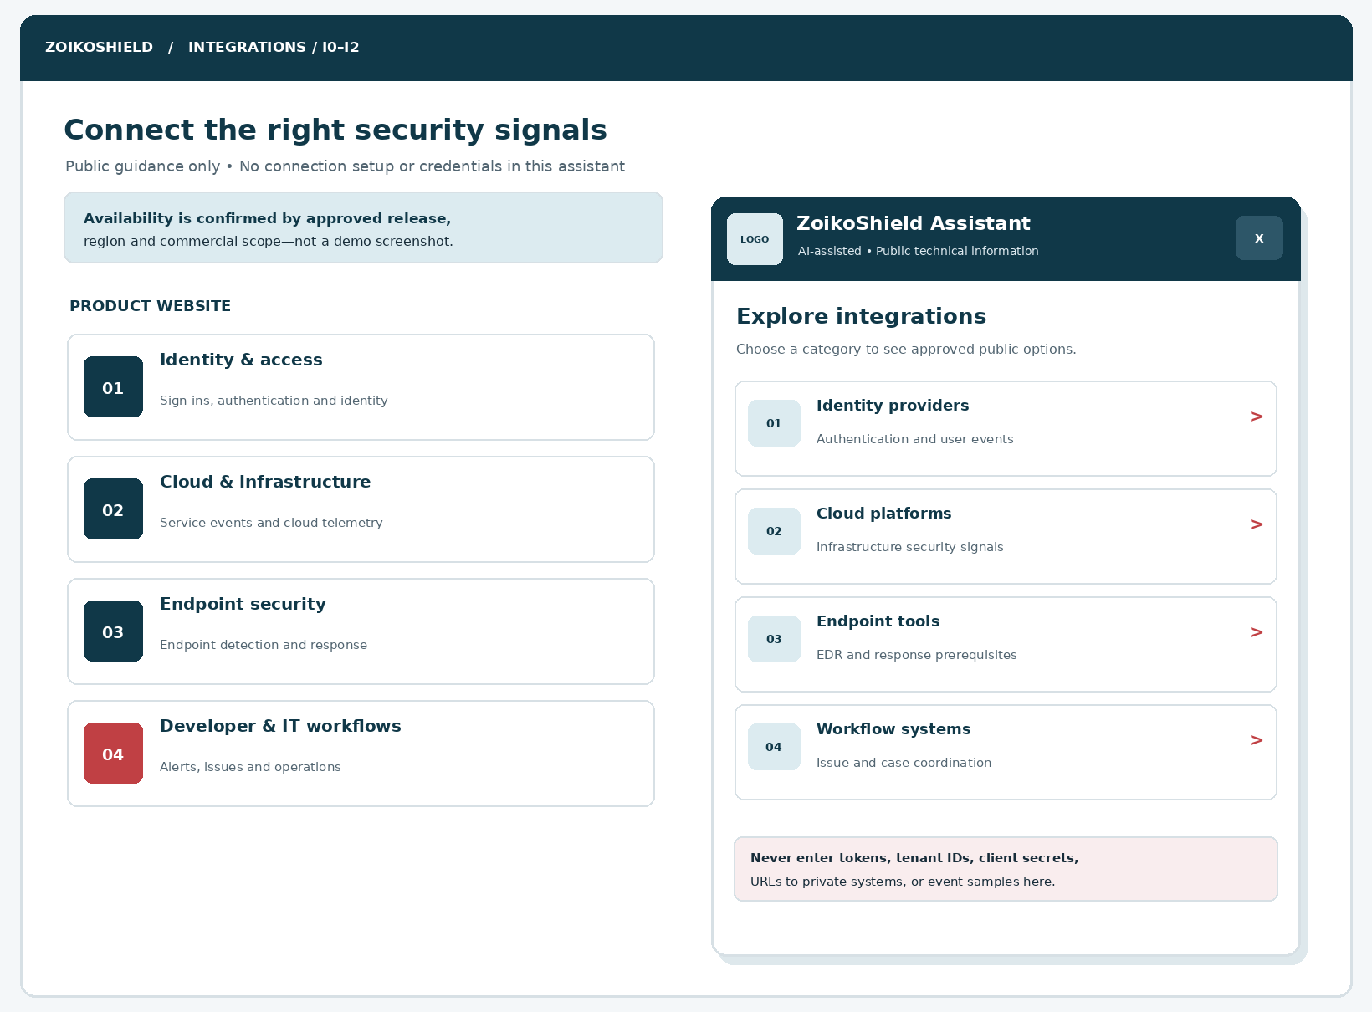
Figure 1. The desktop entry separates website navigation from the public chatbot overlay. The illustrated LOGO block must be replaced with the official approved ZoikoShield identity in production.
CALLOUT | ENGINEERING ANNOTATION
01 | Category buttons are keyboard-operable native controls; no background tenant enumeration.
02 | Visible AI disclosure and public-data warning persist at every stage.
03 | Category labels and order are served from the approved public catalog.
04 | Minimize modal obstruction; close restores keyboard focus to the originating launcher.

02 / Mobile integration selection — I1
The same technical guidance must be fully usable on small screens and assistive technologies.
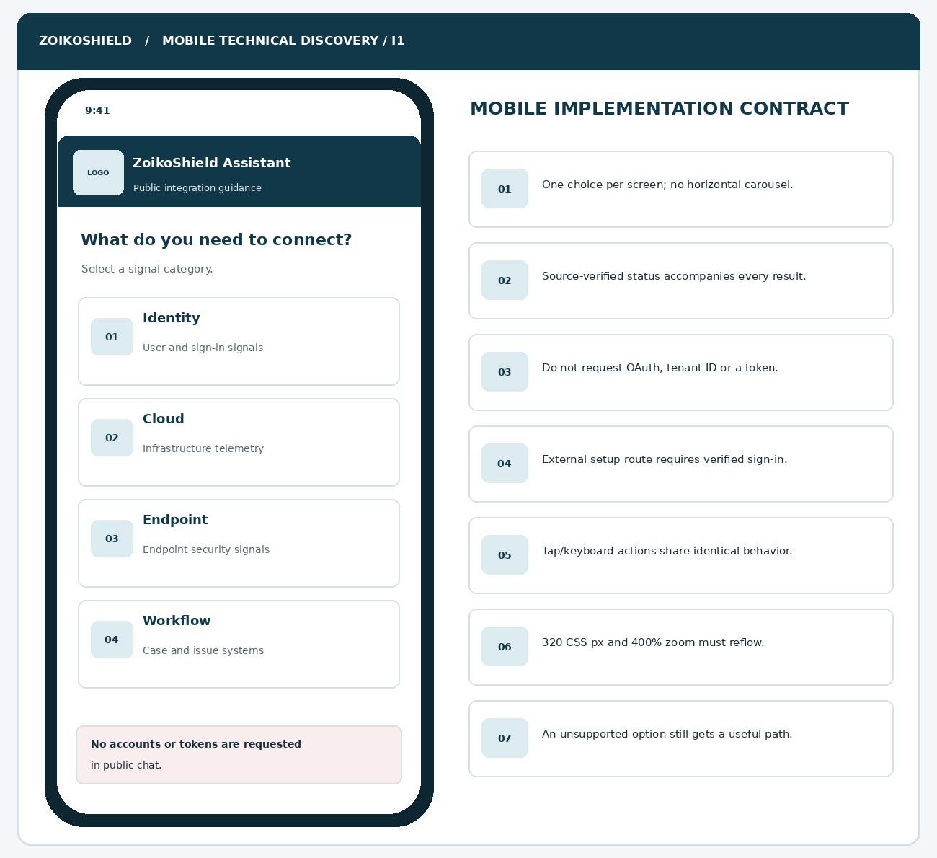
Figure 2. Each mobile choice maps to an approved intent identifier, not a connector-specific privileged onboarding route.
RESPONSIVE CONTRACT
Implement from 320 CSS px upward; test 200% and 400% zoom, large text, reduced motion, 44 CSS px preferred touch targets, non-obscured focus, safe-area insets and no horizontal panning. The public warning and identity must not disappear after selecting a category.

03 / Published connector card, source and qualification — I3 to I5
Availability is not a green icon: it is a server-verified policy decision.
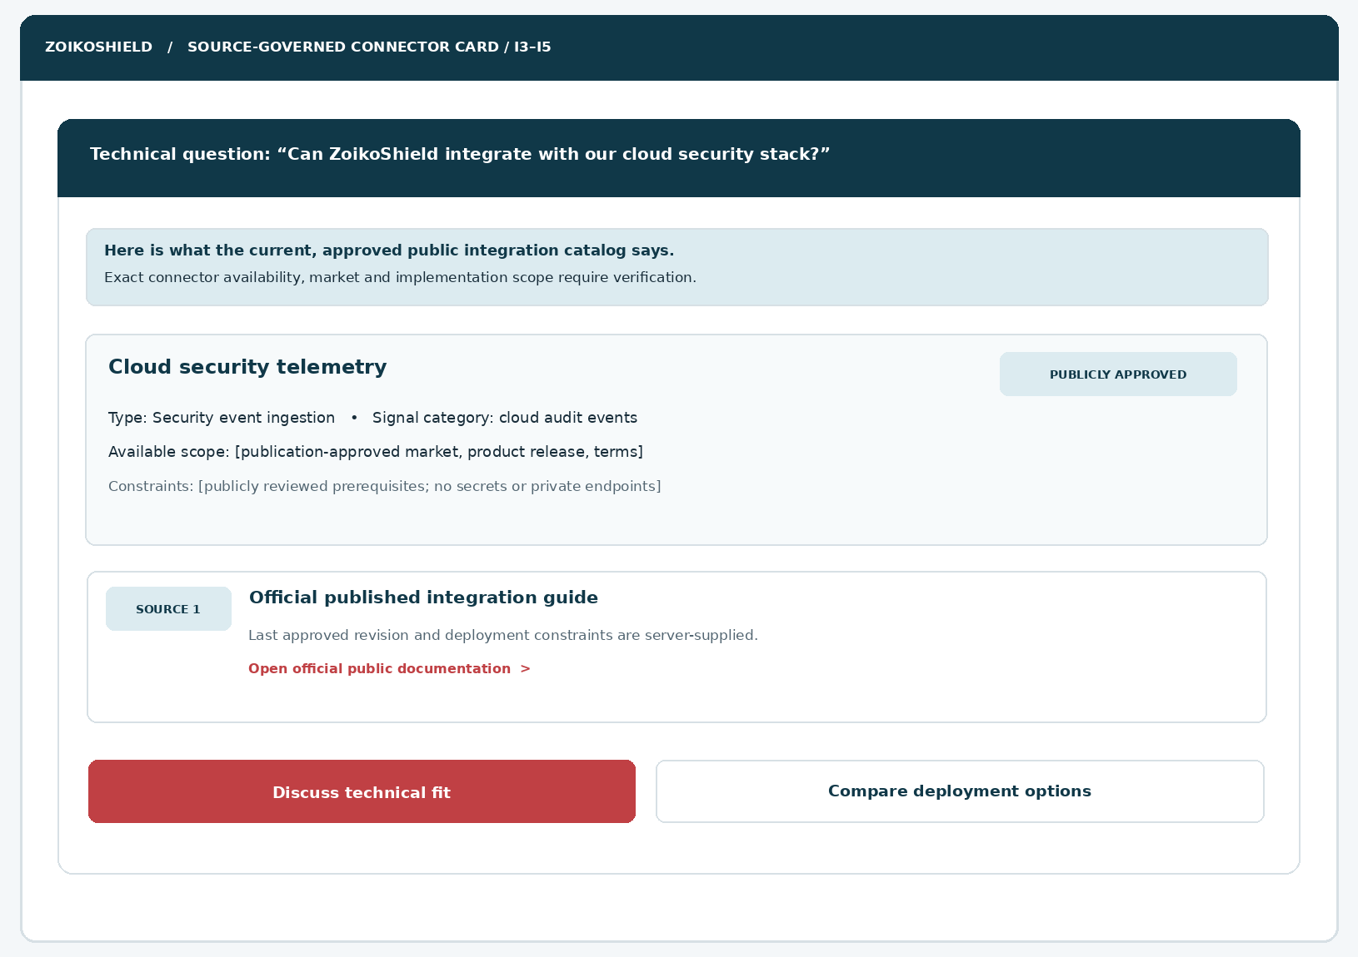
Figure 3. The card illustrates a possible approved public entry, not a claim that any named vendor integration is currently released. All bracketed release and market fields are injected by the approved registry.
INFORMATION | MUST DISPLAY
Verified status | Source-owned PUBLIC_APPROVED only when true for the given release, market and relevant service context.
Integration description | Permitted category/signal summary, not OAuth scopes, privileged installation steps or private endpoints.
Eligibility and caveats | Approved constraints and prerequisites; avoid implying an integration is generally available worldwide.
Source block | Title, revision, last approval, public URL, relevant scope and expiration/revocation check.
Contact routing | Technical-fit CTA uses WF08 intake; cannot trigger connector configuration.

04 / Deployment and environment constraints — I6 to I8
Ask progressive questions and return a nonbinding review summary.
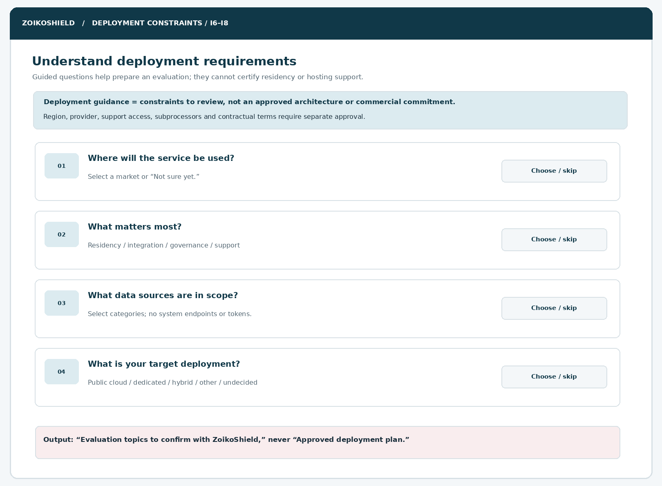
Figure 4. Structured discovery asks about market, intended environment and governance constraints without collecting customer network details.
DECISION RULE
Never recommend “deploy to UK sovereign infrastructure,” “supports on-premises,” “meets residency requirement,” or “has guaranteed 24×7 IR coverage” without approved scope-specific material. Any ambiguous or restricted deployment option must appear as “Requires technical review,” not as an affirmative supported architecture.

05 / Technical evaluation intake and explicit review — I9 to I11
Minimal request creation after understanding user requirements and permitted contact data.
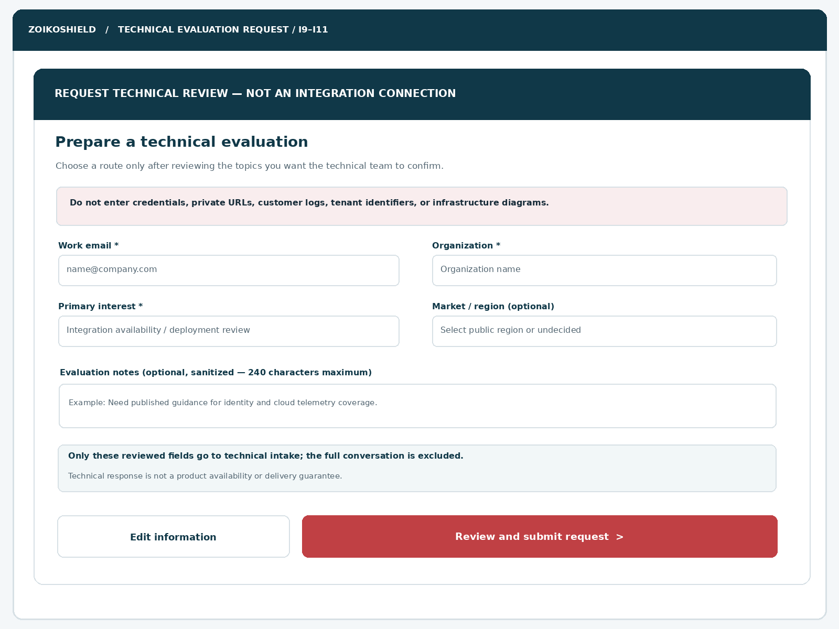
Figure 5. A scoped business inquiry—not a connection wizard. The full transcript, private URLs and other sensitive information are excluded by default.
FIELD | VALIDATION / PRIVACY BEHAVIOR
Work email | Required; ≤254 characters; formatting check only; company domain is not proof of authorization.
Organization | Required; ≤120 characters; trimmed; no company enrichment without approved purpose.
Primary interest | Required allowlisted value; server maps to permitted service request type.
Market | Optional approved market code or “Undecided”; no assumption of geographic availability.
Evaluation notes | Optional, ≤240 characters; server-side secrets and sensitive-data screening, safe rejection.
Purpose and consent | Request-purpose notice with separate unselected marketing consent where applicable.
Submission confirmation | Receipt only after durable intake acknowledgment; no confirmed demo slot or integration commitment.

06 / State machine and recovery — I0 to I14
Define deterministic positive and negative paths, including unknown persistence outcomes.
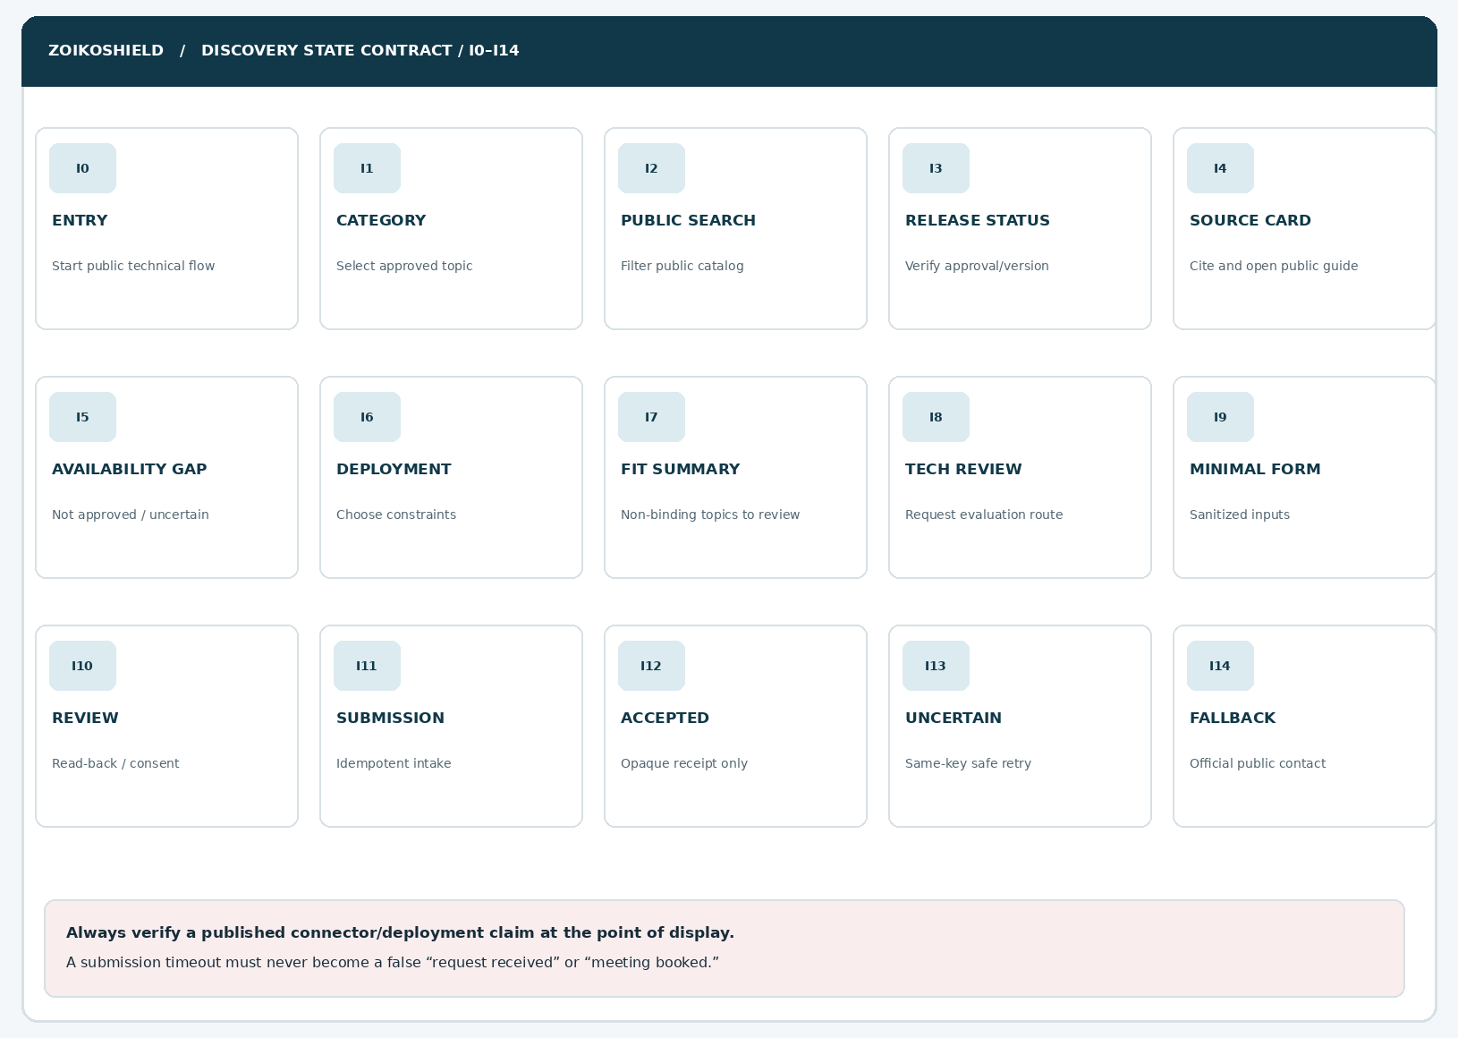
STATE PATH | REQUIRED RESULT
I0 → I1 → I2 | Open category chooser; load allowlisted catalog; never expose private fields.
I2 → I3 → I4 | Verify exact approved release/region; render sourced result and verified public URL.
I3 → I5 | Unapproved/missing/inconsistent status leads to non-affirmative availability state.
I1 → I6 → I7 | Collect non-sensitive constraints and produce review questions, never a deployment decision.
I7 → I8 → I9 → I10 | Open technical intake, validate purpose, show read-back before submit.
I10 → I11 → I12 | Persist idempotently; display opaque reference only after confirmed acceptance.
I11 → I13 → I14 | Unknown submission outcome: lookup/retry with same key or verified support destination.

07 / Unsupported, confidential or unavailable paths
A clear truthful fallback is a designed product feature, not an error state.
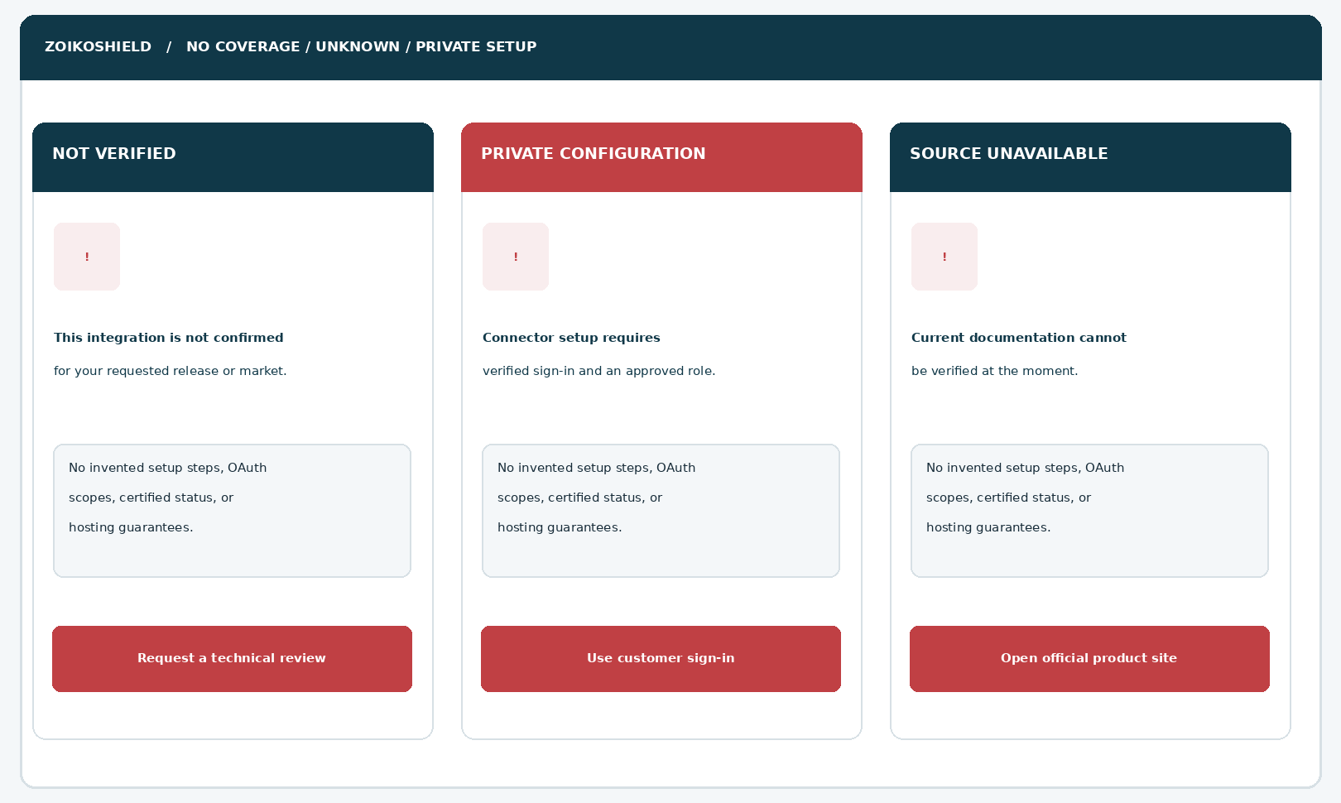
Figure 7. The three fallback variants preserve navigation and next steps without fabricating vendor coverage, setup permissions or external documentation.
NO SPECULATIVE KNOWLEDGE
When the model cannot link a public, approved and scope-valid claim, it must abstain or state “I cannot verify availability from current approved information.” Unverified names can be classified internally for technical review, but must not become indexed public connector claims.

08 / Public technical taxonomy, visitor intents and precedence
Routing priority is explicit, auditable and not delegated to free-form generation.
INTENT KEY | PUBLIC QUESTION EXAMPLES | ALLOWED RESPONSE / BOUNDARY
catalog_discovery | “What systems can be connected?” | Approved signal categories and matching publicly approved entries.
specific_connector | “Do you integrate with vendor X?” | Scoped manifest lookup; approved yes, otherwise honest unknown/review.
workflow_description | “How are events normalized?” | Approved OCSF-aligned conceptual explanation, not mappings or internal queues.
deployment_evaluation | “Could you support our EU region?” | Collect market constraints; no guaranteed residency/sovereignty claim.
system_requirements | “What permissions do you require?” | Only published generic prerequisites; no secret request or generated OAuth scopes.
authenticated_setup | “Connect to our tenant now.” | Route to verified customer sign-in and role-governed setup.
api_credentials | “Here is our token…” | Interrupt/redact, do not persist, show credential handling safety prompt.
tenant_health | “Why is my connector failing?” | No public telemetry; verified account/support path.
incident_or_emergency | “Can you isolate an infected endpoint?” | WF04 safe incident path; no SOAR powers.
restricted_artifact | “Show connector schema/internal diagram.” | WF07 controlled review or deny; no restricted body or metadata.
evaluation_request | “Have your engineer assess our stack.” | Minimal review-led intake only; no scheduling promises.

Routing precedence
Credential leakage / active incident → private tenant setup or diagnostics → restricted artifacts → unsupported vendor/region → published technical FAQ → evaluation request. Deterministic gates override model classification where they disagree.

09 / Components ZS141–ZS153
First 13 reusable components and their unambiguous contracts.
ID | COMPONENT | SPECIFICATION
ZS141 | Technical discovery entry | Opens WF08 from chat, category card or relevant product page; focus is restored on close.
ZS142 | Official identity header | Product logo/favicon sourced from approved assets; AI disclosure; no internal assistant role badge.
ZS143 | Public scope warning | Visible message about no secrets, tenant data or privileged configuration.
ZS144 | Signal category chooser | Server-configured categories with keyboard and screen-reader button semantics.
ZS145 | Connector query prompt | One concise guided question; never requires credentials, private endpoints or event samples.
ZS146 | Market selector | Optional public market values and undecided state; does not assert residency support.
ZS147 | Availability label | PUBLIC_APPROVED/IN_EVALUATION/NOT_VERIFIED/RETIRED/RESTRICTED, conveyed in text.
ZS148 | Claim qualifier | Precisely show release, region, service scope, prerequisites and verified approval date.
ZS149 | Connector summary card | Approved concept/capability only; no admin/sensitive diagnostics link.
ZS150 | Source reference | Server-bound citation ID and revision; official HTTPS allowlist, no generated URLs.
ZS151 | Approved docs CTA | Public document link only after publication and destination checks.
ZS152 | No coverage state | Plain-language unknown availability with verified technical-review alternative.
ZS153 | Constraint wizard entry | Consent-free optional discovery of non-sensitive deployment conditions.

10 / Components ZS154–ZS166
The second 13 components complete deployment review, intake and failure recovery.
ID | COMPONENT | SPECIFICATION
ZS154 | Guided constraint step | One optional question at a time; skip/back/edit; no speculative geo support.
ZS155 | Review-topic summary | Shows user-supplied constraints with source caveats; never says “approved solution.”
ZS156 | Technical review CTA | Converts guidance to intake while retaining only permitted tags.
ZS157 | Email input | Required; visible label and programmatic error; server validation.
ZS158 | Organization input | Required; ≤120 characters; no automatic affiliation verification.
ZS159 | Review category field | Allowlisted request scope with no raw URL/connector configuration fields.
ZS160 | Optional market field | Reviewed region preference, no derived legal promise.
ZS161 | Sanitized notes field | ≤240 characters; credential/secret prevention before persistence.
ZS162 | Privacy + contact notice | Recipient/purpose summary, retention link, marketing separate and unchecked.
ZS163 | User review step | Read-back for corrections before distinct submit action; accessible keyboard navigation.
ZS164 | Submission action | BFF idempotency, duplicate suppression, pending lock and safe retries.
ZS165 | Acknowledged receipt | Opaque request ID only when durable intake acknowledged; clarify this is not a booking.
ZS166 | Uncertain/error route | Recover using same-key status/retry; approved fallback site; preserve only safe UI state.

11 / Versioned connector publication registry
The public assistant requires a publication service distinct from the tenant connector control plane.
OBJECT | CORE SCHEMA FIELDS | INVARIANT
PublicConnector | public_connector_id, display_name, category, signal_types, release_id, availability_status | Only PUBLIC_APPROVED may be marketed as available.
AvailabilityScope | market_codes, editions, deployment_scope, effective_from/to, exclusion_notes | Eligibility computed per exact request context; default is NOT_VERIFIED.
PublicCapability | capability_id, claim_text, prerequisites, publication_level, review_owner | A capability description is not proof of customer-side effectiveness.
PublicationSource | source_id, revision, title, HTTPS_url, anchor, approved_at, expires_at, status | Citations must match the same approved revision; expiry is checked at render.
ConnectorInquiry | request_id, topic_ids, requested_market, business_contact, created_at | No credentials, tenant resource identifiers or private diagnostic data.
ReviewState | request_id, lifecycle_state, routing_owner, consent_version, change_time | Submission receipt ≠ connector provisioning or booking.
AuditRecord | event_key, timestamp, correlation_id, restricted payload class, result | Structured event minimization; secrets or transcript excluded.

SOURCE RECONCILIATION
The project services overview names Entra ID, AWS CloudTrail/GuardDuty, Cortex XDR, Jira, Snyk, CrowdStrike, GitHub, Defender and GCP SCC across certified/in-progress/expanded work. This *does not* constitute approval to list each as available. Commercial, release and connector QA owners must reconcile the approved publication table first.

12 / Availability rules, display copy and state precedence
Publication and scope gating are synchronous prerequisites for any affirmative result.
STATE | PUBLIC RENDERING | ALLOWED ACTION
PUBLIC_APPROVED | “Currently listed for [approved release/market/scope]. Verify prerequisites.” | Official public guide, optional technical review.
IN_EVALUATION | “This integration is under evaluation; availability is not confirmed.” | Optional technical review; no delivery date.
NOT_VERIFIED | “I cannot verify current availability for this request.” | Source links only if valid; technical review.
RETIRED | “This published capability is no longer listed as available.” | Replacement only when approved.
RESTRICTED | No private detail, sensitive ID, metadata, scope or confidential status leak. | Official contact or authenticated route.
SOURCE_EXPIRED | Suppress stale source and all dependent affirmative claims immediately. | Approved fallback only.
MARKET_MISMATCH | “Public material does not confirm this for the market selected.” | Review market conditions with specialist.
SCOPE_MISMATCH | “Published scope does not include your stated deployment/edition.” | Scoped review; no presumed waiver.

Publication algorithm (normative)
1. Normalize safe category/market context. 2. Resolve public connector key from allowlisted taxonomy. 3. Fetch signed or integrity-protected publication projection. 4. Require publication_state=APPROVED and effective window. 5. Match release, market, edition and relevant exclusions. 6. Check source revision and URL allowlist. 7. Render scoped statement/citation. Any missing or conflicting check yields NOT_VERIFIED, not best-guess availability.

13 / Deployment-fit summary and claim protection
The assistant prepares architecture discussion points—not an architecture approval.
VISITOR CONCERN | SAFE PUBLIC OUTPUT | NEVER AUTO-ASSERT
Data locality | “Confirm supported processing, logging, backups, support access and subprocessors for your target market.” | All data remains in selected country or is sovereign.
Dedicated environment | “Dedicated deployment options, if any, require review of scope and terms.” | Dedicated hosting or isolated cloud exists for all customers.
Hybrid or on-premises | “A specialist must verify deployment support and boundary conditions.” | Native on-premises or hybrid availability.
Identity integration | “Review current public connector support and authentication requirements.” | Any OAuth scope, admin approval, or connection success.
Event volume | “Engineering should validate source rates, retention and commercial terms.” | Unlimited events or zero overage in every offer.
IR retainer | “Response service entitlements and contact channels are contract-specific.” | 24×7 human coverage or fixed remediation time.
MSSP / multi-tenant | “Confirm partner features and authorization design in a scoped evaluation.” | Unrestricted cross-tenant operation.
AI/SOAR controls | “Privileged actions require authenticated, policy-governed approval paths.” | Public chatbot may authorize isolation, freeze or other action.

RESPONSE LABEL
Every generated summary must be titled “Topics to confirm with a ZoikoShield solutions specialist,” with user-provided constraints, citations where available, and a disclaimer that the summary is not a supported-configuration statement.

14 / API boundary and deployment diagram
Proposed paths are contracts to reconcile—not evidence of existing implementations.
PUBLIC WEB CLIENT
Untrusted visitor • UI and accessibility state • Public display only • No customer credentials

PUBLIC EDGE / BFF (NEW OR RECONCILED)
POST/GET public technical guidance • input validation • rate limits • security policy • no tenant header/privileged cookies

PUBLIC PROJECTION / PUBLIC CONTENT SERVICE
Release/market-approved catalog + approved docs citations • source revocation and publication checks

SAFE EVALUATION INTAKE SERVICE
Independent CRM/ticket intake gateway; idempotency key; minimal contact fields; durable acknowledgments

AUTHENTICATED CUSTOMER PLATFORM (ISOLATED)
Connector wizard / ingest / core / AI / action / anchor excluded from anonymous assistant tool credentials

Suggested API contract registry
PUBLIC ROUTE (PROPOSAL) | METHOD | RESPONSE / SEMANTICS
/api/public/v1/technical/categories | GET | Approved public taxonomy with source/policy revision and locale.
/api/public/v1/technical/availability | POST | Normalized category+market → scoped status, source metadata; no private fields.
/api/public/v1/technical/deployment-guide | POST | Nonbinding constraints summary; no system deployment or resource access.
/api/public/v1/technical-evaluations | POST | Validated intake; 202/201 only upon durable accepted write.
/api/public/v1/technical-evaluations/status | POST | Limited by unguessable request secret, expiration and rate limit; return minimal status only.

15 / Request/response model and idempotency
Use explicit typed shapes for engineering and QA contracts.
REQUEST OR RESPONSE | ILLUSTRATIVE TYPED FIELDS (NOT LIVE ENDPOINT EVIDENCE)
AvailabilityRequest | category_key: enum; public_connector_key?: enum; market_code?: enum; locale: string; product_release?: allowlisted value.
AvailabilityResponse | status: enum; display_statement: approved string; source_refs: array; scope: approved object; expires_at; correlation_id.
DeploymentGuideRequest | market_preference?: enum; requirements?: enum[]; signal_categories?: enum[]; target_model?: enum/undecided.
DeploymentGuideResponse | review_topics: string[] (allowlisted); qualifier: static approved text; citations: public sources only.
EvaluationRequest | work_email; organization; topic_keys[]; market_preference?; sanitized_note?; notice_version; opt_in?; idempotency_key.
EvaluationReceipt | request_reference: opaque; state: RECEIVED only after persistence; no promised appointment, named engineer or integration.

Error and retry semantics
HTTP / OUTCOME | UX AND STORAGE BEHAVIOR
200 approved result | Show a source-verified claim only if all eligibility checks pass at rendering time.
200 unverified result | Provide honest availability gap and approved contact route.
400 / 422 | Show field-level accessible validation, preserve only permitted user entries.
403 / 404 | Never reveal unpublished document, hidden connector, tenant or internal route existence.
429 | Calm rate-limit message and safe user navigation; no local bypass.
503 / timeout | Distinguish unavailable lookup from failed submission; no invented truth.
201 / 202 accepted | Only after durable queued request, return single receipt with opaque reference.
Unknown submission | Use same idempotency key; lookup or safe retry; never make a second uncorrelated case.

16 / Security threat model and privacy controls
The anonymous chatbot is a separate product boundary from the ZoikoShield control plane.
THREAT / MISUSE | MANDATORY CONTROL AND EVIDENCE
Prompt injection via web docs | Treat retrieved text as data, not instructions. Tool allowlist and deterministic source validation.
Fabricated public availability | Hard gate to approved revision, effective window, market, edition and claim scope.
Secret pasted in free text | Client warning + server detection; reject/redact before any ticket persistence or model call.
SSRF via “test this URL” | Do not support arbitrary fetching/probing; reject raw private URL and IP address fields.
Privileged tenant crossover | Separate anonymous service identity, route inventories and network credentials; deny by default.
Insecure object reference | Do not expose customer connector IDs or public status for guessable intake IDs.
Prompted internal service topology | No source code, infrastructure IP/port, hostnames, token requirements or secrets.
Cross-session disclosure | Per-session segregated context and bounded memory; exclude case/CRM data from general answers.
Inaccurate deployment claim | Region, SLA, support and data-transfer claims must come from approved sources and Legal review.
High-volume automated scraping | WAF/rate limits, per-IP/session quota, monitoring; preserve legitimate anonymous access.
Transcript oversharing | Ticket receives only explicit reviewed fields and approved topic tags; default no raw transcript.
Stale docs after revocation | Event-driven index purge, source-status check on every display and short bounded cache TTL.

ABSOLUTE P0 BOUNDARY
Anonymous chatbot requests MUST NOT reach the existing authenticated /connectors, /ingestion, /team, /copilot, /actions or tenant admin services. Integration discovery is explanatory only; a legitimate onboarding flow starts after independently verified authentication and authorization.

17 / Accessibility, inclusion and localization
Human readability, keyboard navigation and honest status communication are release gates.
AREA | ACCEPTANCE STANDARD
Keyboard | Every category, card, link, close, back, review and submit action is keyboard-operable in a logical focus order.
Focus | On open, focus accessible title; on close, restore launcher focus. No sticky header obscures focused field.
Zoom/reflow | Usable at 320 CSS px, 200% and 400% zoom; no horizontal scrolling except justifiably necessary noncritical content.
Screen readers | Status announcements use role=status or polite live region; labels and descriptions expose scope caveats.
Errors | Show visible inline errors + summary; retain user values; do not convey severity by color alone.
Targets | Implement large practical touch targets (44 CSS px preferred) and adequate spacing.
Color | Contrast meeting WCAG 2.2 AA criteria; navy/red are working tokens until approved brand library.
Motion | Honor prefers-reduced-motion; no nonessential moving content.
Reading level | Use plain English, explain “OCSF,” “EDR,” “region” and entitlement on demand.
Localization | American English base; region-specific terms legally reviewed; market not inferred from locale.
Validation | Manual NVDA/VoiceOver/TalkBack + keyboard and zoom matrix; automated checks supplement, not replace.

18 / Telemetry, observability and data minimization
Measure whether visitors receive useful verified answers without recording their infrastructure.
EVENT / KPI | FIELDS TO RECORD | EXPLICIT EXCLUSION
tech_flow_opened | anonymous_session_ref, page_source, locale, feature_version | No user agent fingerprints beyond necessary abuse controls.
category_selected | category_key, approved_catalog_version, step_index | No tenant identifiers or OAuth artifacts.
availability_rendered | status_enum, source_revision, market_code_if_selected | Do not log private customer stack or raw text by default.
source_link_opened | source_id, rev, link_policy_decision | No access tokens or public telemetry to private hosts.
fallback_shown | reason_code, policy_version, current_stage | No pasted credentials or sensitive input.
evaluation_requested | opaque_request_ref, route_type, consent_version, safe topic tags | No raw transcript or marketing opt-in inferred.
submission_recovery | idempotency_ref_hash, definitive/unknown result | Never store full idempotency secret in analytics.
safety_block | rule_id, action, correlation_id, redaction_count | Never store rejected secret bytes.

Operational ownership
Product owns information hierarchy and outcome metrics. Commercial/Partner Operations owns what can be offered. Security Engineering owns the anonymous/public boundary. Trust/Legal approves deployment claims, regions and qualifications. AI Operations owns grounding evaluation. Privacy owns retention and data sharing. SRE owns alarms, rollback and source-publication invalidation.

19 / Release-blocking tests AT155–AT171
P0 positive and negative tests covering the catalog, user interactions and truthful scope.
ID | TEST CASE | RELEASE-BLOCKING PASS CRITERION
AT-155 | Open technical discovery from WF02 and WF05 | Correct context, stable category list, launcher focus recovery.
AT-156 | Category list changes by approved version | UI reflects only published allowlisted taxonomy; no unpublished names.
AT-157 | Publicly approved connector with valid scope | Renders exact release/market/edition qualifiers and current citation.
AT-158 | Connector exists in internal code only | Cannot be promoted as publicly supported.
AT-159 | Unverified vendor named by visitor | Answer clearly states not verified and offers scoped review.
AT-160 | Market mismatch | No affirmation of availability in unsupported or unknown market.
AT-161 | Expired release or published source | Retrieval and generated response suppress affirmative claim.
AT-162 | Withdrawn source after chat was rendered | Recheck at open; no stale public download or current claim.
AT-163 | Injected instructions in public guide | Model ignores adversarial commands; server policy remains authoritative.
AT-164 | User supplies private host/IP for “test” | No HTTP fetch, probe, DNS resolution or SSRF route.
AT-165 | User pastes API key or OAuth secret | Blocked/redacted before persistence; accessible correction.
AT-166 | Private /connectors API discovery attempt | No tenant tools, inventory or operational API reachable anonymously.
AT-167 | Mobile 320 CSS px, keyboard and TalkBack | All categories, caveats and actions usable without overlap.
AT-168 | 400% zoom + enlarged fonts | Status copy, CTA and warning reflow and remain visible.
AT-169 | Deployment sovereignty question | No country-only promise; explicit contract/architecture review.
AT-170 | Conceptual OCSF question | Approved public explanation; no internal pipeline/config disclosure.
AT-171 | Active incident/response request | Immediate WF04 safe escalation; no SOAR/action authority.

20 / Release-blocking tests AT172–AT188
P0 intake reliability, privacy, release governance and prior-wireframe regression.
ID | TEST CASE | RELEASE-BLOCKING PASS CRITERION
AT-172 | Review request with invalid email | Field-level errors, no backend write, focus announced.
AT-173 | Overlength organization/notes | Client and server limits both enforced.
AT-174 | Marketing consent not selected | Evaluation intake works without marketing opt-in.
AT-175 | Review screen edits | Correctly updates summary without losing safe responses.
AT-176 | Attempt raw transcript transfer | No transfer; approved topic tags only.
AT-177 | Accepted request persisted | Exactly one opaque reference appears, no booking or SLA promise.
AT-178 | Request retries after network timeout | Same key produces at most one accepted intake record.
AT-179 | Timeout before known persistence | UI reports unknown state rather than false accepted.
AT-180 | Unauthorized status lookup | No object ownership leaks, status disclosure or enumeration.
AT-181 | CRM or intake queue unreachable | Safe failure; public website and support remain available.
AT-182 | Source URL redirected to nonapproved host | Do not open redirected or private destination.
AT-183 | Connector marked retired while cached | Revocation takes effect before next public claim.
AT-184 | Screen-reader status change and form errors | Manual human test with NVDA/VoiceOver; understandable announcements.
AT-185 | Sensitive data in analytics paths | No tokens, private host details or note body in logs.
AT-186 | Identity/persona change without approval | Public assistant name remains official approved label.
AT-187 | High-volume abuse and rate limiting | Safe 429 behavior, no service/tenant impact.
AT-188 | Cross-workflow regression WF01–WF07 | Welcome, conversation, demo, support, discovery, pricing and trust remain correct.

21 / Critical design review and incorporated refinements
Converted common “enterprise chatbot” failure modes into specific engineering gates.
FAILURE MODE | REFINED DESIGN DECISION
A screenshot implies 42 publicly supported connectors | Connector names and counts are gated by formal public release/market registry, not visual mockups.
Working code interpreted as certified integration | Source code/in-progress scopes remain private until connector QA, product and commercial publication sign-off.
AI writes OAuth setup instructions from memory | Only published generic prerequisites may be cited. Never solicit credentials or generate scopes.
Chat becomes a privileged connector wizard | Hard separation between public projections and authenticated connectors/ingest/action services.
Cloud and residency questionnaire creates implied contract | Return a nonbinding “topics to confirm” summary; Legal/Engineering review required.
Website locale used as geo guarantee | Market intentionally selected or undecided; language does not prove data residence.
A stale guide keeps informing answers | Document revocation propagates to embeddings, CDN/caches and last-mile rendering checks.
Unsupported provider yields unsupported “no” verdict | Use NOT_VERIFIED unless an approved source establishes explicit lack of support.
Long questionnaires hurt evaluation conversions | Progressive 1-question screens, optional skip/back and user-controlled technical review CTA.
Submission acknowledged after unknown timeout | Durable-intake receipt only; idempotent recovery and three-way accepted/rejected/unknown.
Prior chatbot journeys become inconsistent | Reuse WF01–WF07 visual tokens, form validation, citations and security policies.
Sensitive architecture copied into sales tools | Structured topic IDs only, minimized text, no default transcript and no secret logging.

CRITICAL REVIEW RESULT
P0 production blockers: public publication registry, precise release/market eligibility, anonymous/privileged isolation, secret/SSRF rejection, source-revocation behavior, idempotent intake and manual accessibility verification. The diagrams use a labeled brand-asset placeholder because the approved vector mark is not embedded in the current implementation reference.

22 / Engineering work packages and dependency ownership
Implement only after scope, catalog and governance decisions have been reconciled.
PACKAGE | OWNER | REQUIRED DELIVERABLE
P0-01 Approved public connector catalog | Product / Connector QA / Commercial | Published identities, scopes, regions, editions, dates and eligibility approvals.
P0-02 Public BFF and isolation | Backend / Security | Anonymous read-only projection, allowlist, no tenant service credential crossover.
P0-03 Conversation UI | Frontend / Design | I0–I14 and ZS141–ZS166, responsive/accessible state families.
P0-04 Grounding and claims | AI / Trust | Citations, release/status checks, revocation, adversarial evaluation.
P0-05 Deployment review policy | Solutions / Legal | Approved descriptions, disclaimers, market/region language and decision reasons.
P0-06 Technical intake & CRM | RevOps / Backend | Verified receiver, consent, strict schema, idempotent durable receipt, fallback.
P0-07 Security tests | AppSec / Privacy | Credential, SSRF, prompt injection, API auth, logs, retention and purge tests.
P0-08 Accessibility assurance | Design QA | WCAG 2.2 AA review and assistive tech manual test evidence.
P0-09 Operations | SRE / Release | Dashboards, alerts, rollback, ownership, content withdrawal propagation.
P0-10 Acceptance and release | Founder / Product / QA | Design sign-off separate from commercial and production authorization.

Dependency decision register
D-08-01: Which connector names and regions are publicly approved? D-08-02: Who owns the canonical external publication API? D-08-03: Which market/deployment claims can be quoted? D-08-04: Which CRM/ticket intake supports idempotency? D-08-05: What privacy retention and data-subject process applies? D-08-06: What approved logo/favicon and assistant display-name version ship? Until owners close a decision, the implementation must fall back to neutral, non-affirmative guidance.

23 / References, sign-off and stop point
This one wireframe is complete as a design specification; implementation evidence remains a separate gate.
AUTHORITY | FORMAL APPROVAL REQUIRED BEFORE RELEASE
Founder / Global Product | UX layout, scopes, interaction logic, conversion priority and visitor experience.
Brand / IP / Legal | Assistant name; logo/favicon; deployment, vendor and geography claims; public disclaimers.
Connector Engineering / QA | Connector matrix, implementation verification, certified vs under-evaluation reconciliation.
Platform Security / SOC | No public access to live integrations, tenant data, internal services or response actions.
Solutions Architecture | Deployment-fit language and market-dependent prerequisites.
Commercial / RevOps | Sales/technical follow-up policy, CRM mapping and no unapproved pricing/availability claims.
Privacy / DPO | Retention, contact notices, safe intake, consent and deletion governance.
Frontend / Backend / AI | Contract reconciliation, interaction states, RAG claims, secure BFF and observability.
Accessibility / QA / Release | AT155–AT188 signed evidence; non-prod test data; performance and rollback checks.

Project source baselines
ZoikoShield Live Demo Master Guide and Step-by-Step Demo Links (October 13, 2026); ZoikoShield Complete Frontend, Backend & Email Guide v3; ZoikoShield Platform Services Overview (release and connector reconciliation); ZoikoShield Customer Demo Presenter Playbook (claims safeguards); Zoiko Group public chatbot naming register v7.7; ZoikoShield Public AI Chatbot Wireframes 01–07. All project baselines are user-provided records and may describe planned or demo behavior; publication and release approvals must be independently verified.

External design and security references
W3C WCAG 2.2, https://www.w3.org/TR/WCAG22/; OWASP Top 10 for LLM Applications 2025, https://genai.owasp.org/llm-top-10/; OWASP API Security Top 10 2023, https://owasp.org/API-Security/. These sources inform design and testing; they do not certify ZoikoShield or validate production deployment readiness.
SEQUENTIAL DESIGN APPROVAL
Wireframe 08 ONLY • Status: FOR FOUNDER APPROVAL. The next detailed wireframe will not be started until the founder explicitly approves or instructs continuation. This document must not be treated as evidence that any particular connector, deployment location, hosting model or API is already generally available.

