ZOIKOSHIELD / PRODUCT • DESIGN • ENGINEERING

Public AI Chatbot
Detailed Wireframe 02
Conversation workspace, sourced answers, controls, safety states and resilient public Q&A
DOCUMENT STATUS — PROPOSAL FOR APPROVAL
Version 1.0 • October 24, 2026 • U.S. English • Scope: Wireframe 02 only. Continues Wireframe 01, not a replacement. Designed and specified; no claim of production implementation or independently certified compliance.

Executive design decision
Create an uncluttered, traceable conversation experience for cybersecurity buyers and public-site visitors. It must return accurate product information with source provenance; keep the user in control of input, scrolling, and retry; and provide clear routes to pricing, demos, support and approved documentation. It must never present itself as a live SOC analyst, tenant-aware copilot, emergency-response channel or autonomous security operator.
DIMENSION | APPROVED-TO-BUILD PROPOSAL
Scope | Anonymous public web chatbot: user messages, grounded responses, sources, follow-ups, utility actions, error/retry and safe deflection.
Continuity | Inherits ZS01–ZS12 and the welcome-to-first-message handoff from WF-001; components in this document are ZS13–ZS32.
Identity | Internal working name: Zhield; display controlled by approved_display_name. Default public label: “ZoikoShield Assistant” until Brand/Legal authorization.
Assets & palette | Official product logo/favicon are controlled assets; diagram shows LOGO slot only. Layout tokens: #103848 navy, #C04044 red, white and neutral surfaces.
Safety | No tenant data, logs, cases, threat evidence, active alerts, SOAR commands or privileged system paths. Public approved-content retrieval only.
Approval | Founder → Product/Brand → Security/Privacy → Accessibility → Engineering/QA; each sign-off independent.

Scope exclusions
This document does not implement lead capture, ticket creation, human-chat transfer, customer authentication or incident-response escalation forms. These are independently designed flows with consent and authorization gates. Public demo and support CTAs are deterministic navigation only.

01 / Desktop conversation panel
At the original 420 CSS px target width; website remains operable and modeless.
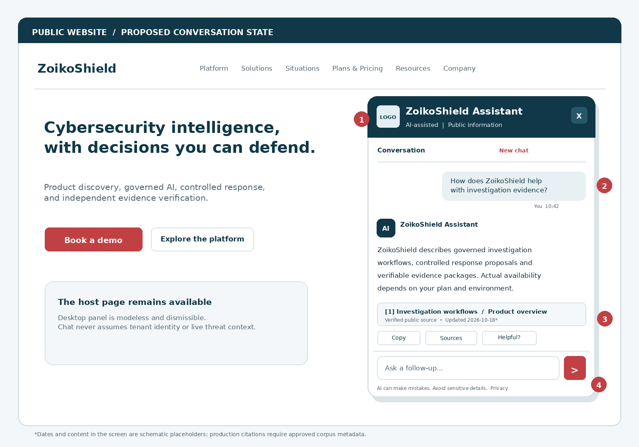
Figure 1. Annotated conversation after one user question and one source-backed assistant reply. The product logo slot and fictional source date are schematic; actual citations must be generated only from an approved public-source registry.
MARKER | BEHAVIOR / INTENTION
01 | Persistent assistant identity, explicit AI disclosure, Close, plus a plainly labeled New chat control.
02 | User and assistant turns visually distinct; messages ordered chronologically and labelled for assistive technologies.
03 | Citations are individual clickable, verified source records; utility actions never imply certification or real-time facts.
04 | Composer stays visible; no page clipping or scroll hijacking. Sensitive-input reminder remains available.

02 / Mobile full-screen conversation
One-column view, sticky composer, bounded thread scroll and safe-area accommodation.
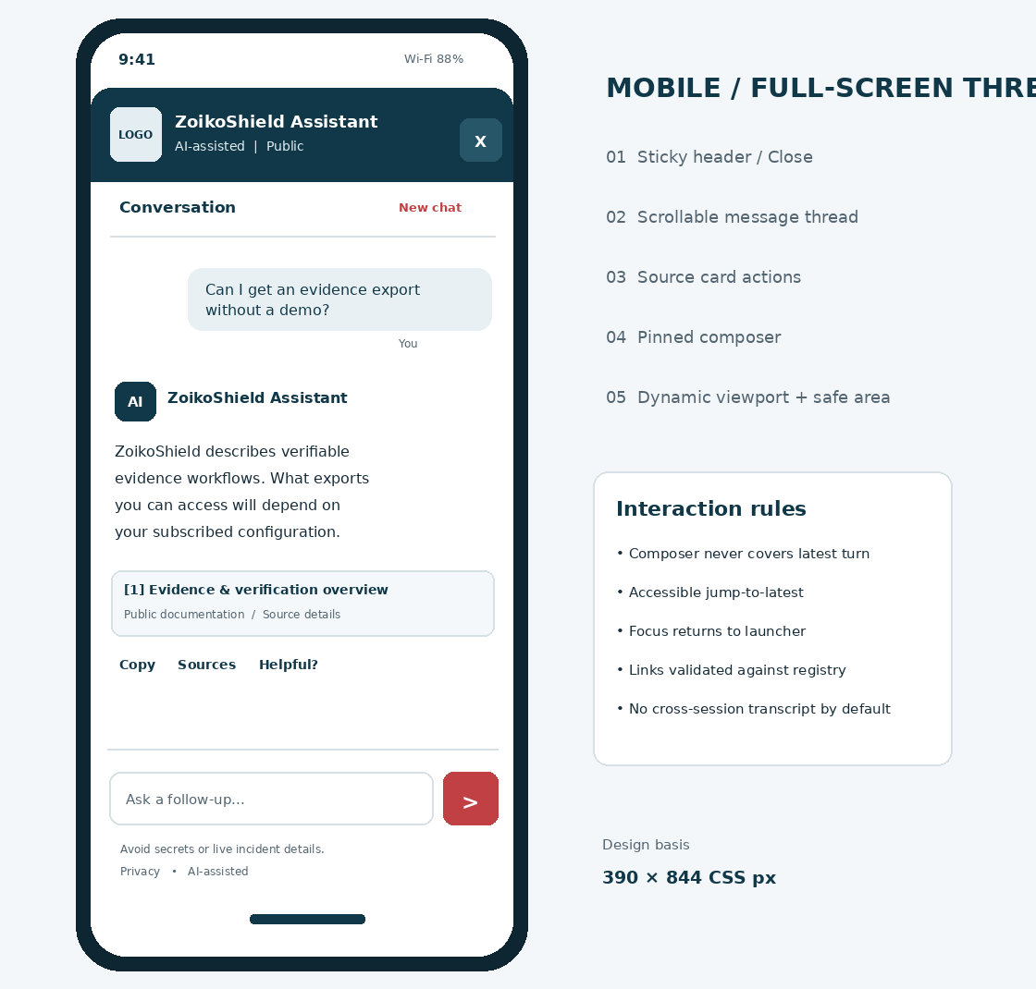
Figure 2. Schematic layout for a 390 × 844 CSS px mobile viewport. Full-screen mobile presentation is modal; background inert, focus contained, and on Close focus returns to launcher.
MOBILE NON-NEGOTIABLE
Use dynamic viewport units and safe-area insets. Test iOS/Android virtual keyboard, zoom, orientation changes and screen readers. Scroll the thread, not the outer page; never anchor the composer underneath an on-screen keyboard.

03 / Design tokens, anatomy and grid
Build at the component level; component IDs are stable for tickets and QA evidence.
ID | COMPONENT | SPECIFICATION
ZS13 | Thread header | Approved logo, display name, “AI-assisted • Public information”; Close, accessible New chat; 44×44 px targets; no online/live SOC badge.
ZS14 | Message viewport | Flexible, independently scrollable; padding 16–24 px; row gap 16 px; scroll anchor obeys reader position.
ZS15 | User bubble | Right aligned, max-width 85%; body text min 16 px; wrapping for long words/URLs; no credential masking solely in browser.
ZS16 | Assistant turn | Left aligned, readable 1-column text; “AI” label not human impersonation; source cards after substantive claims.
ZS17 | Citation card | Number, short verified public title, source type, content revision/freshness if exposed, safe destination; visible truncation with full accessible name.
ZS18 | Answer utilities | Copy answer, View sources, Helpful? yes/no if enabled; copy only visible sanitized response and public source URLs, never hidden prompts.
ZS19 | Suggested follow-ups | Zero to three intent-led chips derived only from allowed public intents; not generated URLs/actions; each at least 44 px tall.
ZS20 | Message composer | Expandable up to 4 lines; 2,000 Unicode code points max target (server enforcement); send, live count near limit, meaningful field label.
ZS21 | Send / Stop | Send during ready state; Stop generation during processing if cancellation is supported; disabled/visible state described via accessibility APIs.
ZS22 | Jump to latest | Shown only when reader scrolled away from latest and new turns arrive; activate to scroll/focus sensibly, no forced auto-scroll.
ZS23 | Safety disclosure | Persistent concise reminder via static caption or accessible info control: no passwords, tokens or live incident details.
ZS24 | New chat | Explicit reset confirmation only if user-generated text would be lost; clears ephemeral local state, server revokes/rotates session per policy.

Responsive implementation note
Desktop: 420 CSS px target, modeless, with 24 px viewport clearance. Mobile (<768 CSS px): full-screen 100dvh with safe-area padding, inert background and pinned composer. At 320 CSS px / 400% zoom: no clipping, horizontal scroll or obscured focused controls.

04 / Interaction state model
User-facing states are explicit, recoverable, and traceable to server response codes.
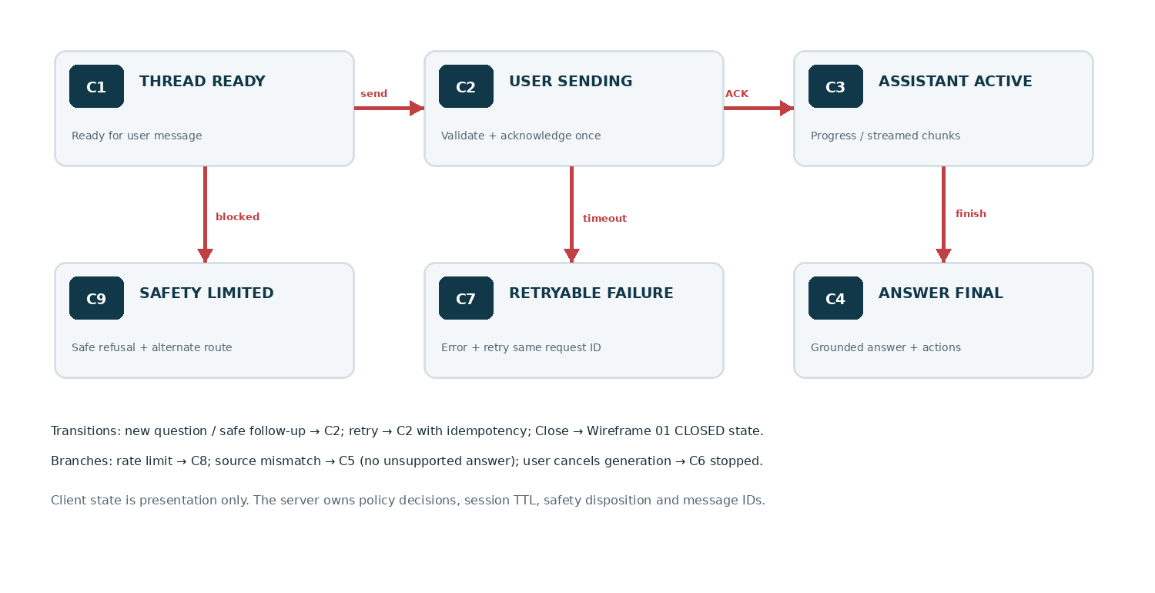
STATE | TRIGGER | UI REQUIREMENT
C1 THREAD_READY | Welcome has handed off / prior turn complete | Composer enabled, source action availability tied to final reply; no misleading “live monitoring” status.
C2 USER_SENDING | Valid message submitted | Render user message once as pending; lock duplicate submit by client_request_id; do not discard typed content on rejection.
C3 ASSISTANT_ACTIVE | ACK and processing/streaming | Polite progress, optionally incremental sanitized text; Stop only if cancellation implemented; no fabricated typing or progress percentage.
C4 ANSWER_FINAL | Answer passed server policy and citation checks | Finalize response atomically with source cards and feedback actions; cursor remains stable and send re-enabled.
C5 LIMITED/UNSOURCED | Evidence absent, stale or insufficient | Say limitation clearly; do not invent cites; show documented product links or human route.
C6 STOPPED | User requests supported cancellation | Stop display; label partial answer as incomplete and non-authoritative; offer re-ask.
C7 RETRYABLE_ERROR | Timeout / 502/503 / interrupted stream | Inline explanation + retry with idempotency; preserve question and completed turns.
C8 RATE_LIMITED | 429 or automated abuse check | Respect Retry-After and bounded UI retry; site navigation and support still available.
C9 SAFETY_LIMITED | Sensitive submission or forbidden intent | Brief non-punitive warning, no unsafe detail echo; direct to public docs or contracted channels.

05 / Message types & content presentation
One coherent thread renderer, not a different design for every type of answer.
TYPE | DESIGN TREATMENT | REQUIRED GATE
USER_TEXT | Right bubble; preserve readable whitespace and safe line wraps. | Input length and server validation; no raw HTML; no query text in URL.
ASSISTANT_TEXT | Left block in restrained prose; short headings and concise paragraphs. | Sanitized structured blocks, not unchecked model HTML.
SOURCED_ANSWER | Inline [1], [2] anchors next to applicable claims; source cards below answer. | Only approved public registry records; no source → limited-answer fallback.
OFFICIAL_NAV | Clearly styled link/card “Open public documentation,” “View plans & pricing,” “Book a demo.” | Server-known route key; host validates route; user activates explicitly.
CLARIFICATION | Ask a single short question when intent cannot be resolved confidently. | Never ask for tenant details, credentials or active incident log samples.
SAFE_REFUSAL | Acknowledge limits and offer safe public alternative/contracted help path. | No internal policy text or threat detection technique disclosure.
SERVICE_ERROR | Inline status, Retry, Visit Help Center; session remains usable. | No stack traces, raw error IDs except safe correlation ID.
SENSITIVE_REDACTED | Explain sensitive information should not be sent; mask only the minimum if retention is necessary. | Server-side detection/redaction before model or persistent logging.
STREAM_PARTIAL | Unfinalized neutral container; utilities and source cards withheld until validated final state. | Monotonic sequence, buffer limits and final policy/citation verification.

Copy rules
Prefer short specific sentences, not sales superlatives. Avoid “we detected,” “we secured your account,” “your incidents,” and claims of real-time telemetry.
Product capability statements must be supported by an approved public source; account-specific plan entitlement is not inferred from marketing copy.
Do not present CISOs, engineers or customers with invented metrics, live incident counts, pricing, certifications or contractual promises.
Dates in UI must be populated from actual source metadata; examples in this document are nonproduction placeholders.

06 / Evidence, citations and provenance
Make source quality visible without overwhelming the panel.
FIELD | CONTRACT / DISPLAY TREATMENT
source_id | Stable opaque registry identifier; never a scraped URL accepted directly from model output.
title | Approved public title; truncate visually but full accessible label exposed.
canonical_url | Exact allowlisted HTTPS URL or internally registered route key; no javascript:, data: or arbitrary redirects.
classification | Must equal PUBLIC_APPROVED and approved for the current product/locale/market.
published_at / updated_at | Optional validated timestamps; omit when unavailable rather than inventing freshness.
revision / document_hash | Backend provenance for auditing; not necessary to show hash to customer.
eligible_claim_ids | Structured mapping between cited claims and source snippets for eval and traceability.
revoked_at / expires_at | Server filters unavailable/stale entries from retrieval and rendering; cached views invalidate on revocation.
locale / jurisdiction | Ensure market-specific claims and commercial content match the user’s selected market; do not infer legal coverage.
public_citation_label | Safe formatted title and description; present original publication as source attribution, not certification.

Citation logic (P0)
Every material factual claim about security capabilities, integrations, service assurances, architecture or pricing either has an eligible public source, is explicitly marked as general guidance, or is withheld. Citation tokens must resolve through server-issued source_ids and cannot be fabricated in model prose.
On source validation failure: suppress unverified cards, drop any unsupported assertion, and render C5 LIMITED/UNSOURCED with a deterministic capability or demo route. No citation to locked internal demo playbooks, internal diagrams, tenant assets, SOC event evidence, or nonpublic architecture is permitted.
DO NOT CONFUSE TECHNICAL CAPABILITY WITH CERTIFICATION
Statements about SOC 2, ISO 27001, compliance coverage, incident response SLAs, uptime, pricing and availability require separately approved and current externally shareable evidence. A UI badge or model-generated statement is not proof.

07 / Composer, scrolling and conversation controls
High-quality interaction preserves reading position, reduces accidental disclosure and prevents duplicate requests.
INTERACTION | DETERMINISTIC EXPECTED BEHAVIOR
Enter / Shift+Enter | Desktop: Enter sends if nonempty and no IME composition; Shift+Enter inserts newline. Mobile: use native keyboard semantics; explicit Send always exists.
Empty / whitespace | Send disabled; no network request. Input feedback is not announced repeatedly.
Input length | Target max 2,000 code points; count visibly at 1,800+; enforce on server; reject payloads above hard gateway limits.
Paste long text | Preserve text with clear overflow; warn about sensitive data; never auto-send pasted content.
Send pending | Keep text visible until ACK; client_request_id de-duplicates; on rejection restore draft for correction.
Stream and scroll | Auto-follow only if user already at the bottom threshold (e.g. <= 80 px); otherwise preserve scroll and display Jump to latest.
New chat | If unsent draft exists, confirm discard; clear locally and expire session token server-side according to retention policy.
Stop generation | Only display if cancellation is implemented end-to-end; cancel generation safely without pretending deletion of server logs.
Copy answer | Clipboard output strips hidden markup and internal metadata; include public citations only if user chooses “Copy with sources.”
Source open | User click opens exact eligible HTTPS source; safe rel and no referer leakage of chat text; no generated search URLs.
Feedback | Optional one-click helpful/not helpful reason-code metric without collecting entire content; no toast demanding user rating.
Refresh / back | No unapproved local-storage transcript retention; use ephemeral session recovery only if Privacy explicitly approves it.
Close / re-open | Desktop returns focus to launcher; session preservation within same tab/TTL is configurable, not assumed forever.

Focus/announcement contract
Keep keyboard focus in the composer after Send by default while the response is announced in a concise polite status region. Do not move focus to each incoming token or read the whole stream repeatedly. Provide a skip/jump mechanism for long conversations and label every source card accessibly.

08 / Fallback and sensitive-content response matrix
No broken spinner, impossible escalation promise or exposure of internal diagnostics.
SCENARIO | USER-VISIBLE MESSAGE / ACTION | SERVER CONTROL
Unavailable model / retrieval | “I can’t answer that right now. You can open our documentation or contact the team.” Retry available. | 503 with correlation_id; circuit breaker; public route fallback.
Interrupted stream | “The reply was interrupted. Retry your question?” Label partial content as incomplete. | idempotency lookup; last sequence checksum; no silent mixing of two generations.
No trusted source | “I don’t have a verified public source for that detail.” Offer overview/demo. | Strict eligible-source check; abstain on claims without grounding.
Credentials detected | “For your security, don’t send passwords, API keys or tokens here.” Encourage credential rotation through proper channels if already exposed. | Redact before model/tools/logs; privacy incident evaluation where necessary.
Live incident / emergency | “This public assistant can’t review active incidents. Existing customers should use their contracted incident channel.” | No telemetry lookup, live triage or response action from anonymous session.
Request to run SOAR action | “This chat can explain product capabilities, but can’t run security actions.” | Block internal action tools, arbitrary webhooks and privileged APIs.
Unauthorized customer question | “I can help with public product information. For account-specific help, use your secure support route.” | No identity inference from browser cookie or referrer; cross-origin isolation.
429 throttling | “Too many requests. Please try again later, or use the website links.” | Retry-After respected; server limits by risk class.
Malicious prompt/URL | “I can’t follow instructions that change my role or access private systems.” Offer allowed task. | Reject command/tool injection, unsafe destinations and retrieval policy bypass.
Ambiguous pricing / service tiers | “Pricing and coverage depend on approved commercial terms. You can review the pricing page or request a quote.” | Only current approved offer registry; do not infer contract or discounts.

EMERGENCY-LANGUAGE SAFEGUARD
Do not advertise this public chatbot as a 24/7 SOC, emergency hotline, monitoring service, incident triage service, or alternative to a customer’s contracted incident-response process. Even if that service exists elsewhere, anonymous chat has no authority to execute it.

09 / Proposed service contract — front end ↔ public BFF
Illustrative interface design for engineering reconciliation; these endpoints are not asserted to exist.
API / EVENT | REQUEST & RESPONSE SEMANTICS | CRITICAL GUARD
POST /public-assistant/session | WF-001 creates anonymous opaque session only after first valid message; returns session_id, expiry, allowed capabilities. | No app tenant token or SOC access; no visitor identity guess.
POST /public-assistant/message | {session_id, client_request_id, message, locale, consent_state}; 202 {message_id, correlation_id, status}. | Body validated/redacted; idempotency uniqueness; message length and cost budgets.
GET /public-assistant/messages/:id/events | SSE or equivalent server-bounded stream: acknowledged, progress, delta, final, safety_limited, error. | Origin/session auth; sequence monotonicity; no raw internals; bounded buffer.
POST /public-assistant/messages/:id/cancel | Best-effort cancellation with status; UI renders STOPPED only on confirmed cancel/stop or local disconnect label. | Abort processing/tools where supported; release cost budget; auditable state.
POST /public-assistant/feedback | {message_id, rating, reason_code?, consent_state}; minimal metadata. | No body in analytics; abuse limits.
POST /public-assistant/session/end | End the anonymous session; invalidate future authorizations. | Deletion/retention action follows approved policy; no false “permanently deleted” claim.
GET /public-assistant/sources/:id | Resolves verified public source_id into safe title, URL, revision & citation eligibility. | Never fetch arbitrary URL chosen by LLM; allowlist + revocation checks.

Message response envelope — suggested stable shape
Every terminal server message should contain: message_id, client_request_id, session_id, status, created_at, safe_blocks[], citations[{source_id, claim_refs}], suggested_actions[{route_key, label}], safety_disposition, policy_version, public_correlation_id. A final state must be emitted once and once only for a request.

Transport and compatibility
Use HTTPS; same-site public BFF when feasible; short-lived anonymous bearer/secure cookie, CSRF controls where applicable, strict origin policy, and enforce limits server-side. Event streams may fall back to short polling without changing visible conversation semantics. Actual endpoint names, schemas, auth mechanism and streaming transport require backend owner approval.

10 / Safe rendering, retrieval and streaming pipeline
The model proposes content; the server and renderer enforce authority.
STAGE | REQUIRED PROCESSING AND FAILURE BEHAVIOR
01 Accept | Rate-limit by risk profile, validate message body, reject multipart/suspicious payloads, issue idempotent receipt and correlation ID.
02 Minimize | Detect secrets/PII; redact or block high-risk inputs before model inference, persistent logs, third-party plugins or observability.
03 Scope | Resolve product=ZoikoShield, channel=PUBLIC_ANONYMOUS, locale and feature flags from server configuration only.
04 Retrieve | Search allowlisted PUBLIC_APPROVED corpora with source classification, expiry, locale/market filters and document revision integrity checks.
05 Draft | Generate concise public answer using only eligible approved content; never expose system prompts, internal URLs, source code, tenant data or privileged tool routes.
06 Validate | Apply claim/evidence checks, harmful output filtering, markdown/URL sanitation and restricted actions policy. Fail closed to C5/C9.
07 Stream | Emit safe rendered text deltas only with monotonic sequence; keep citation/source UI disabled until final validated completion.
08 Commit | Persist only approved minimal session content and audit metadata per retention design; emit one terminal event; expose verified sources and supported CTAs.
09 Observe | Track response latency, grounded answer score, refusal reason, citation validity, errors and user-chosen actions, without conversation content in product analytics.
10 Recover | On timeout/disconnect resume via idempotency/known status or offer retry; never double-bill, double-send or merge responses of different requests.

Rendering allowlist
Allow plain text, paragraphs, short headings, bullets, inline links and constrained code formatting when needed for public product explanations. Do not render model-supplied raw HTML, iframes, SVG scripts, inline event handlers, arbitrary HTML attributes, executable Markdown, or browser navigation from model text. Use React-safe text nodes, validated link components and a canonical-route registry for product CTAs.

11 / Security model and abuse-case acceptance
Treat public chat as an attacker-reachable interface into a public-only content plane.
THREAT | PROHIBITED OUTCOME | VERIFICATION EVIDENCE
Prompt injection in user input | Overrides instructions, reveals internal prompts or executes privileged SOC workflows. | Adversarial prompt suite + restricted-tool inventory proof.
Indirect injection in docs | Retrieved text changes system behavior, exfiltrates prompt or navigates to attacker URL. | Poisoned-corpus tests + allowlisted citation validation.
Sensitive information disclosure | Chat reveals credentials, customer data, private docs, demos or internal operations. | Canary/synthetic secrets and tenant isolation probes.
Unsafe output rendering | LLM text results in XSS or unsafe URL invocation. | Browser security tests, CSP report and injection harness.
Excessive agency | Assistant starts a scan, alert action, SOAR playbook, policy edit, export or account change. | No such public tools in runtime; explicit deny tests.
Cost/abuse overload | Bot floods cause runaway tokens, queue denial or uncontrolled retry. | Quota, time budget, rate limit and circuit-breaker tests.
Cross-product/tenant contamination | Answers about one Zoiko app or customer leak into ZoikoShield responses. | Corpus product_id scoping, tests and trace inspection.
Telemetry oversharing | PII or chat body lands in product analytics, error breadcrumbs or trace metadata. | Analytics payload audit and synthetic secret sampling.

Authority mapping
PUBLIC_ANONYMOUS permits only: public Q&A, approved citations, canonical website links, and safe support/demo navigation. Explicitly deny: /auth/*, /tenants/*, /alerts/*, /cases/*, /ai/* internal copilot, /actions/*, /anchor/*, privileged verifier data, customer secrets and all state-changing SOC operations, irrespective of how the user phrases a request.
BUILD SEPARATION
The October 13 ZoikoShield internal demo architecture can inform public terminology but must not be indexed into public retrieval by default, or used as evidence that a feature is publicly available. Backend services shield-core/ingest/ai/action/anchor are not internet-facing tools for this assistant.

12 / Accessibility, performance and observability
Release target: WCAG 2.2 AA; manual assistive-technology tests remain mandatory.
CONCERN | ACCEPTANCE REQUIREMENT
Semantics | Conversation labelled as a region/log with turn labels; modeless desktop dialog vs mobile modal as defined in WF-001.
Live announcements | Use one concise polite status (“Preparing an answer”, “Answer ready”) and optional summary; never repeatedly announce streaming deltas.
Keyboard | Tab order header → thread actionable items → composer; Escape closes; Enter/Shift+Enter/IME tested; visible focus.
Screen readers | Turn boundaries, source-link titles, button state and reply completion distinguishable with NVDA/JAWS/VoiceOver/TalkBack.
Zoom/reflow | 320 CSS px, 200% text, 400% zoom; composer never overlaps focused item; no forced horizontal scrolling.
Contrast | Body copy target 4.5:1; nontext UI 3:1; visible focus ring and disabled states independently checked.
Motor access | 44×44 px preferred controls, 2.5.8 AA independently verified; no hover-only core actions.
Motion | Respect prefers-reduced-motion; no auto-scroll unless reader is already anchored at latest.
Internationalization | en-US initial. Message content, timestamp formatting and source titles localization-ready; no unreviewed jurisdiction claims.
Web vitals | Lazy-load chat bundle; avoid degraded host CWV. Targets inherited: INP ≤200 ms, CLS ≤0.1, LCP ≤2.5 s at p75.
Latency targets | Pilot SLO proposal: send UI feedback ≤200 ms p75; show meaningful processing state ≤600 ms; full answer availability measured, not fabricated.
Reliability | 100% tested BFF/model outages yield recoverable UI and direct public routes; no broken website operation.

Telemetry event schema
Only event names, state/reason, device class, approved route_key, widget_version, opaque correlation_id, performance bucket and consent flag go to product analytics. Do not log raw prompts, AI replies, email, phone, IP addresses, browser fingerprints, customer identifiers, content snippets or unredacted error messages to marketing/product analytics.

13 / P0 engineering acceptance tests
Release blocking unless explicitly waived with signed risk acceptance; evidence to attach to implementation ticket.
TEST | GIVEN / WHEN | REQUIRED OUTCOME
AT-15 | Valid first message from WF-001 | One conversation session, one user turn, correct message id, no double send.
AT-16 | Source-backed product question | Readable answer with eligible public source card(s) and actionable source links.
AT-17 | Missing/revoked/stale public sources | No invented citations; safe limited answer and canonical overview/demo route.
AT-18 | Mobile full-screen at 390×844; keyboard open | Header/Close/input remain available; no horizontal scroll or unreadable message clipping.
AT-19 | At 320px, 400% zoom and large font | Thread reflows; no hidden focus or obscured composer.
AT-20 | Screen reader + keyboard + IME input | Controls, turn boundaries, status changes and copy/source links are announced once, accurately.
AT-21 | User scrolls into earlier response; new tokens arrive | Scroll position retained; Jump to latest appears, no forced jump.
AT-22 | Repeat click Send / retry same request | Idempotent message; one final answer; no duplicate billable calls.
AT-23 | Model stream drops mid-response | Clear interruption state; partial answer flagged incomplete; retry retains transcript order.
AT-24 | Prompt injection / poisoned public doc | No system prompt, hidden source, arbitrary link, internal endpoint or account data exposure.
AT-25 | Paste API key/secret/incident log sample | Server-side prevention/redaction; no secret in model request, analytics or error logs.
AT-26 | User asks for live threat monitoring, SOAR, cases, tenant data | Refusal, scope boundary and safe authorized customer route; no privileged network call.
AT-27 | 429, 503, offline and timeouts | Deterministic actionable fallbacks; no site disruption or error-detail leakage.
AT-28 | Press Copy / View sources / New chat | Sanitized clipboard; validated URLs; safe session reset / confirmation.
AT-29 | Legal name clearance denied / asset revision | Fallback display name and official asset registry used; no hardcoded Zhield brand in public UI.
AT-30 | Consent-dependent analytics disabled | Chat remains functional; nonessential analytics suppressed; essential security audit separated.

14 / Critical design review & incorporated refinements
Test the intended conversation against the failure modes of a public cybersecurity chatbot.
RISK IN AN ORDINARY CHATBOT | REFINEMENT APPLIED HERE
One uninterrupted block of AI-generated prose | Clear answer hierarchy, user/assistant separation, discreet source cards, limited follow-up chips.
Model produces plausible fake sources | Backend-issued public source IDs, eligibility filtering, provenance, citation-fail-closed behavior.
Suggestion chips become unauthorized actions | All route keys resolved by registry; no model-generated actions or unapproved URLs.
Inconsistent response to interrupted streaming | Explicit C3/C6/C7 states; idempotency and partial-answer status.
Streaming forces users to bottom | Reader-controlled auto-follow and Jump to latest control.
Soft security wording, hard internal model access | Strict public-only capability boundary and blocked internal API route families.
Anonymous conversations become customer records by accident | Data minimization, source separation, no automatic durable transcript, explicit retention decision.
Beautiful layout without acceptance tests | Component IDs ZS13–ZS24, message contract, safety matrix and 16 P0 tests.
AI tone implies operational authority | Explicit public assistant disclosure, cautious claims and route to contracted incident channels.

Engineering implementation sequence
Phase A: approved design tokens and public-only BFF policy → Phase B: thread renderer, composer, state machine and safe-links → Phase C: approved corpus/provenance and response-policy enforcement → Phase D: streaming, errors, accessibility and observability → Phase E: red-team, content evaluation, Product/Brand/Legal reviews and release sign-off. No phase is considered deployed on the strength of this document.

Approval decisions and open dependencies
Owner approvals required: (1) Product to sign conversation copy, actions and supported intents; (2) Brand to supply exact logo/favicon token package; (3) Legal/IP to authorize public display identity; (4) Security/Privacy to confirm retention, redaction, public corpus, rate limits and incident-channel copy; (5) Engineering to accept real API transport/schemas; (6) Accessibility/QA to furnish device, screen-reader and adversarial test evidence.

15 / Build handoff, traceability and references
A short release record prevents this wireframe from becoming an unsupported assertion of delivery.
REGISTER ITEM | ENGINEERING DELIVERABLE / ARTIFACT
Source of truth | This document ZS-CHAT-WF-002; predecessor WF-001, October 24, 2026. Approved Figma/asset tokens supersede illustrative geometry only when formally linked.
Components | ZS13–ZS24; connect to existing WF-001 ZS01–ZS12 without duplicate headers/launcher implementations.
Data contracts | OpenAPI/BFF request-response schema with exact names after approval; public corpus source registry, approved route manifest, error enumerations.
Trust and privacy | Explicit public principal policy; content eligibility rules; retention/DPIA review where applicable; adversarial model evaluation report.
Testing and evidence | AT-15 through AT-30, paired with the WF-001 AT-01 through AT-14 checks; keyboard/mobile/browser matrices and security proofs.
Design deliverables | Production Figma component variants, tokens, content specification, accessible naming map, responsive constraints and prototype of all C1–C9 states.
Change control | No assistant-name, logo, action, API, corpus or public capability change without versioned product owner and appropriate control owner approvals.
Version status | PROPOSED • not founder-approved • not a claim of engineering completion.

Source and standards register
Internal: ZoikoShield Live Demo Master Guide and ordered demo-links guide (user-provided, October 13, 2026; restricted engineering reference, NOT public chatbot corpus); Zoiko Group Public AI Chatbots Master Product & Engineering Guide v7.7 (October 20, 2026); ZoikoShield Chatbot Wireframe 01 v1.0 (October 24, 2026).
Public: W3C WCAG 2.2, https://www.w3.org/TR/WCAG22/ ; WAI ARIA Authoring Practices dialog pattern, https://www.w3.org/WAI/ARIA/apg/patterns/dialog-modal/ ; OWASP Top 10 for LLM Applications (2025), https://genai.owasp.org/llm-top-10/ . These are external reference standards, not evidence of independent ZoikoShield certification.
FOUNDER SIGN-OFF CHECKPOINT
Only Wireframe 02 is delivered in this file. Upon approval, the next separately scoped wireframe can address the lead/demo enquiry form or human support-handoff journey. Do not advance until expressly approved.

