ZOIKOSHIELD / PRODUCT • DESIGN • ENGINEERING

Public AI Chatbot
Detailed Wireframe 03
Demo-request journey, consent separation, CRM handoff and trustworthy confirmation
DOCUMENT CONTROL
Version 1.0 • October 24, 2026 • U.S. English • ZS-CHAT-WF-003. Standalone, engineering-ready design proposal for founder review. This specification describes intended behavior and is not evidence of a deployed integration, legal approval or certified security control.

Executive design decision
Build a short, progressive, accessible demo-enquiry experience reachable from the anonymous ZoikoShield chatbot. A visitor can request contact with the sales team without providing credentials, uploading incident evidence, or entering a protected customer environment. The journey captures only essential business contact information, shows a review step, records separate communication choices, and returns a reference only after server acceptance.
DIMENSION | DESIGN SPECIFICATION
Purpose | Convert qualified public interest into a customer-requested sales/demo enquiry; not a meeting reservation or a SOC support ticket.
Continuity | Inherits WF-001 launcher/welcome and WF-002 conversation, evidence, safety and CTA routing. Component IDs ZS33–ZS50; test IDs AT-31–AT-50.
Identity | Internal assistant working name “Zhield”; public UI defaults to “ZoikoShield Assistant” unless an approved server-side brand/legal configuration authorizes another name.
Brand | Navy #103848 and red #C04044 inherited from prior wireframes; official supplied logo/favicon slots only; illustrative diagrams are not final logo assets.
Non-goals | No authenticated account linking; no chatbot access to SIEM logs, alerts, cases, AI copilot or SOAR; no instant meeting slot promise; no marketing auto-enrolment.
Approval gate | Founder approves this wireframe alone. Product, Brand, Security, Legal/Privacy, Accessibility, Sales Operations and Engineering gates remain separate.

CUSTOMER-EXPERIENCE INVARIANT
“Book a demo” may be a website CTA label, but this form submits a demo request only. Do not present a meeting as booked unless a later, separately approved scheduling service returns a confirmed booking.

01 / Desktop enquiry card in conversation
Anchored to a clearly requested CTA; the public host page stays functional.
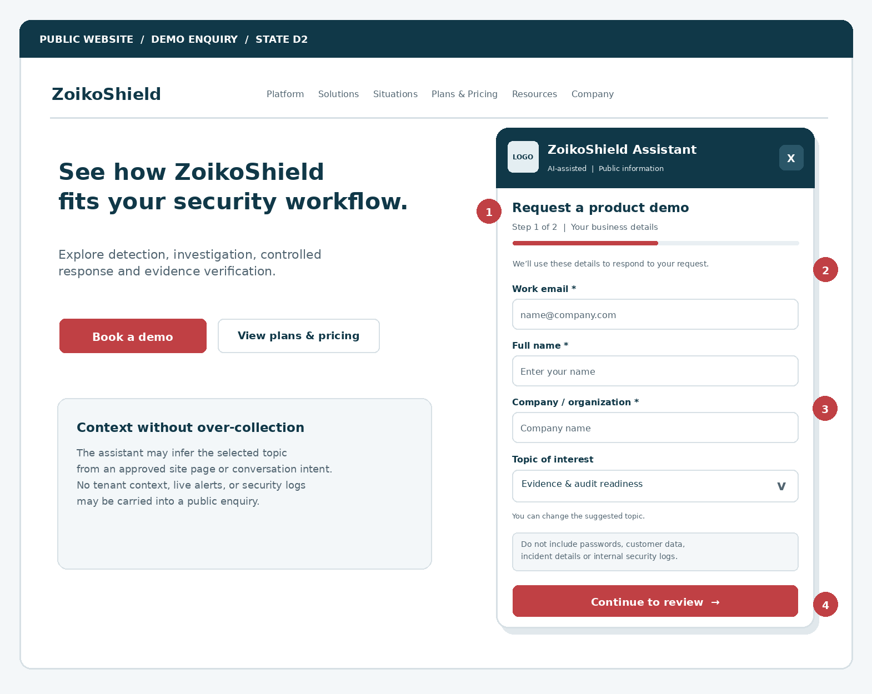
Figure 1. Schematic desktop demo request at 420 CSS px panel width (enlarged for document visibility). Fields, progress, private-data caution and deterministic Next action are shown inside the established public chatbot surface.
MARKER | REQUIREMENT
01 | CTA context may preselect an interest; no private tenant, active incident or generated free-text record is copied into the form.
02 | Explicit step title, visual progress and stable accessible labels; Continue moves to review, not to CRM submission.
03 | Sensitive-input warning is adjacent to form action; server also validates and excludes security-sensitive payloads.
04 | Host navigation, close control and keyboard affordances remain available; a visitor can exit without submitting.

02 / Review, consent and final submit
No surprise data transfer and no bundled marketing permission.
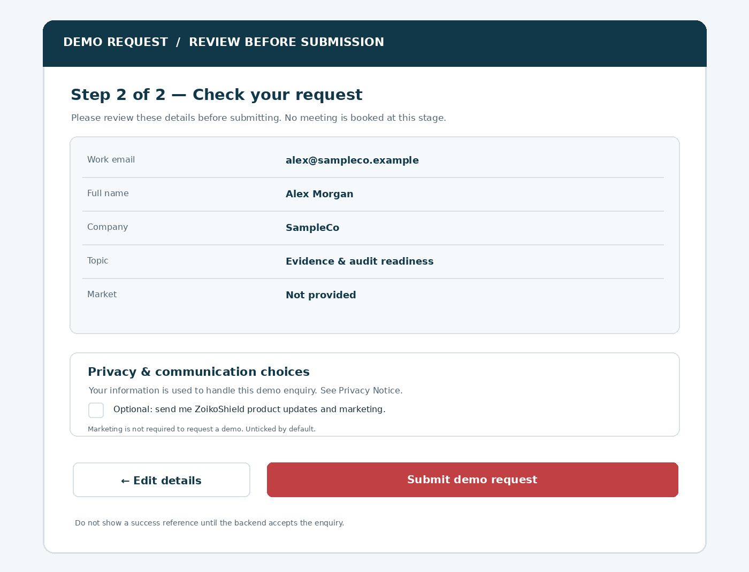
Figure 2. Proposed review screen. SampleCo and the email address are fictional examples. Production values must be escaped, validated and masked appropriately in non-authorized telemetry.
LEGAL SEPARATION
Customer-requested contact for the enquiry is distinct from ongoing promotional emails. The optional marketing checkbox is OFF by default; it cannot be required to obtain a response. Legal must approve final jurisdiction-specific wording, lawful bases, notices and suppression behavior before go-live.

03 / Mobile full-screen enquiry
Progressive form, minimum fields, no horizontal scrolling.
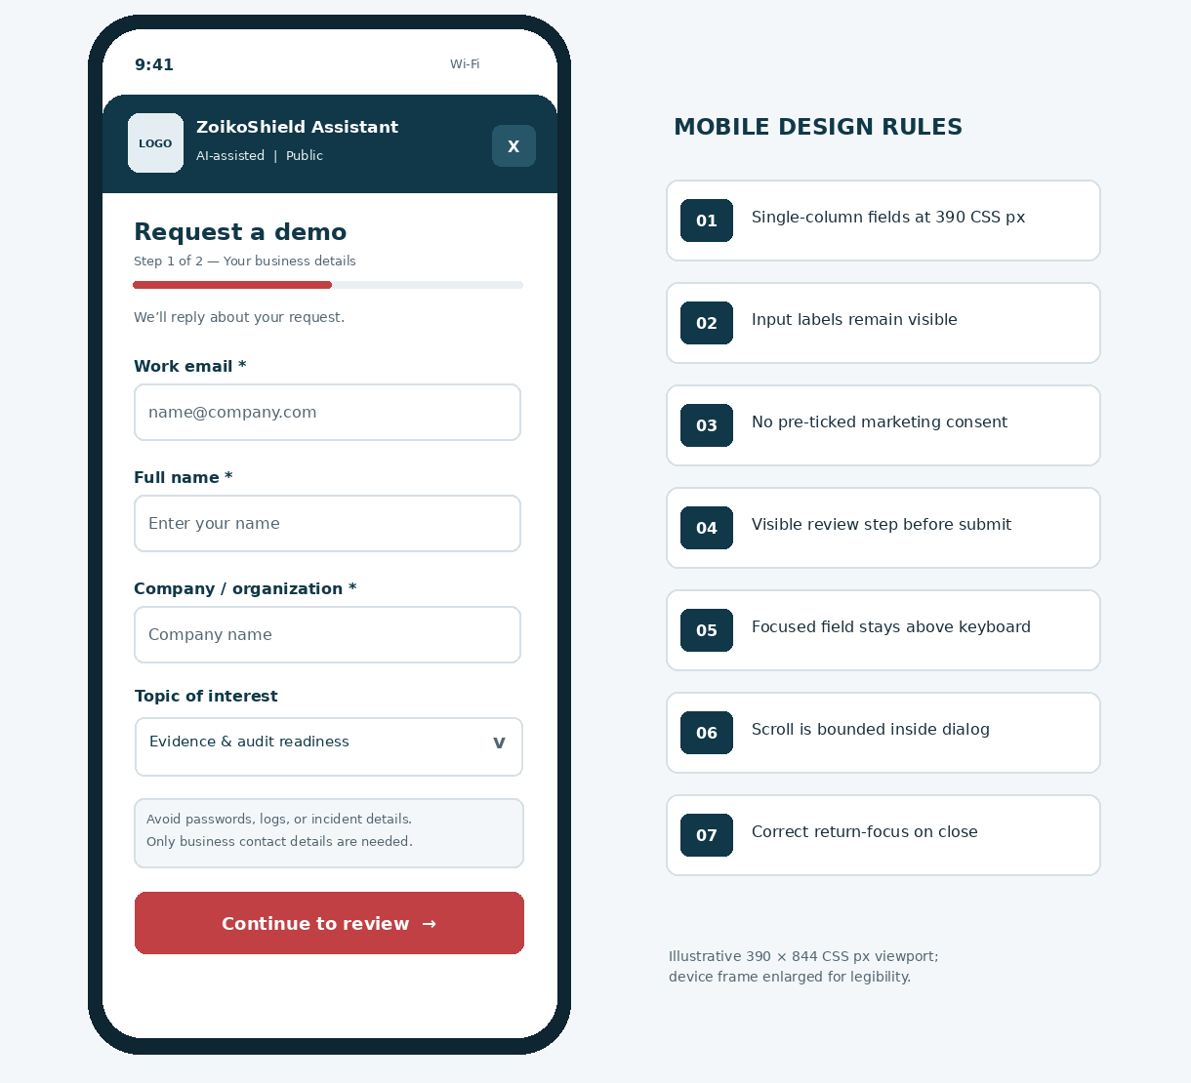
Figure 3. Mobile single-column interaction (illustrative 390 × 844 CSS px baseline). The keyboard may reduce visible height: keep the focused field and validation message in view, with content scrolling independently inside the full-screen chatbot.
MOBILE BEHAVIOR
Do not pin a large action bar over form fields; the Next button can follow form content in the scroll container. Use native email autofill, appropriate inputmode and a 44px preferred interaction height. Never use SMS OTP as a prerequisite for an anonymous demo enquiry.

04 / Entry routes and qualification scope
Every entry point resolves to the same deterministic flow, not a model-executed action.
ENTRY POINT | PRE-FILL ALLOWED | FIRST VIEW / RESULT
WF-001 “Book a demo” quick action | intent=demo_request; approved page key | Open D1: confirm a demo request then show concise details step.
WF-002 answer CTA | Approved product topic key only | Show link/CTA to request a demo; click starts D1.
Plans & Pricing page | plan_interest key if listed in allowed manifest | Topic may be suggested and editable; never quote a non-public contract price.
Solutions or Situations page | Approved solution taxonomy key | Suggested interest label; no hidden notes derived from sensitive text.
Free-form “talk to sales” | Classified intent + explicit user confirmation | Ask whether user wants a demo or public support; do not silently submit.
Direct deep link / refresh | Signed/allowlisted route + token-free context | Same form with generic topic; no PII in URL/query, analytics or local storage.

Qualification philosophy
Prefer a low-friction request over an intrusive sales survey. Avoid mandatory headcount, infrastructure inventory, budget, contract amount, security incidents, existing tooling, phone number or project deadline. Sales may obtain those details later through an appropriate staffed conversation, not a public chatbot.

Content taxonomy and ordering
ORDER | SELECTABLE INTEREST / ROUTE KEY | CLAIM CONTROL
01 | Security operations & detection / sec_ops | Public approved feature claims only.
02 | Incident investigation / investigation | Explain platform workflows, not live incident support.
03 | Governed AI assistance / ai_governance | No autonomous response or unapproved certification assertions.
04 | Evidence & audit readiness / evidence | No unverified attestation, named certification or export guarantee.
05 | Integrations & deployment / integrations | Feature availability and implementation scope may vary.
06 | Plans & commercial options / commercial | Route to current approved plans/pricing URL where available.
07 | General product overview / general | Safe default category.

INTERNATIONAL DATA BOUNDARY
Do not infer visitor jurisdiction from IP into visible form fields. An optional market selection can assist routing, but is not a substitute for legal/data-transfer decisions and must not silently change the notice or language.

05 / Component anatomy & design tokens
New IDs continue the previously used ZS01–ZS32 sequence; no redundant widget foundations.
ID | ELEMENT | BEHAVIOR / DIMENSIONS
ZS33 | Demo intent card | Title + explanatory copy + Start / Cancel, attached to chat thread; semantic region.
ZS34 | Step/progress header | “Step 1 of 2”; screen reader text; bar purely supplemental; never imply countdown.
ZS35 | Business email | Visible label; email autofill; type=email; server-side canonicalization and validation.
ZS36 | Full name | Plain text; trim/length validation; never require first/last split.
ZS37 | Company name | Plain text; user-entered company/organization; no enrichment without approved basis.
ZS38 | Topic selector | Server-approved taxonomy keys; one selection, editable; neutral default.
ZS39 | Optional fields group | Market, role, free-text context only if approved; collapsed or omitted by default.
ZS40 | Sensitive-content notice | Inline warning before submission; prohibit password, token, log and incident uploads.
ZS41 | Continue button | Goes to local review only; blocking validation, disabled only while transition pending.
ZS42 | Review summary | Read-only output from validated draft; Edit action; accessible ordered key/value list.
ZS43 | Privacy notice link | Opens approved notice without deleting form; URL from trusted configuration.
ZS44 | Marketing checkbox | Optional, independent, unchecked, accurately recorded with notice version.
ZS45 | Submit request | Single idempotent POST; visible progress; disables duplicate click while pending.
ZS46 | Confirmation panel | Displayed only after server ACCEPTED; public opaque reference + next steps.
ZS47 | Field error / summary | Specific correction text and focus path; aria-describedby / error summary.
ZS48 | Retry recovery | Distinguish retryable/unknown completion and preserve idempotency key.
ZS49 | Exit / resume | Close safely; discard by default; do not quietly persist PII beyond chosen policy.
ZS50 | Sales-routing boundary | Server-side integration status only; never promise human response SLA not approved.

Shared visual tokens
Use WF-001/002 design token set: #103848 navy, #C04044 red, white and cool neutral surfaces, 8px spacing grid, body text target 16 CSS px, >=44px preferred controls, at least 16px page edge clearance, card radius 12–16px and strong visible keyboard focus. Exact brand tokens and asset manifests require Brand approval.

06 / Canonical data dictionary
Enforce the same schema in UI, public BFF and CRM mapping; do not trust client flags.
FIELD / KEY | NEED | CONSTRAINTS / SOURCE | STORE / EXPOSURE
enquiry_type | Required | Enum demo_request; set by action and rechecked server-side. | Server metadata; immutable per request.
contact_email | Required | Email syntax + MX-independent format check; <=254 chars; no disposable email blanket block. | PII encrypted/controlled; omitted from product analytics.
contact_name | Required | 1–120 Unicode chars after trim; reject control characters. | PII; available only to authorized sales processors.
organization_name | Required | 1–160 Unicode chars; no automated public enrichment by default. | PII/business data; minimal CRM mapping.
topic_key | Required | Exactly one approved enum; allow “general”; no model-injected keys. | Allowlisted routing value.
market_country | Optional | Country/market ISO key only when selected; no IP prefill. | Use for legitimate routing, subject to privacy approval.
job_role | Optional | 0–80 Unicode chars, plain text; not used for access control. | Optional contact context.
context_note | Optional | 0–500 chars; auto-detect and block likely secrets; prompt: “No sensitive details.” | Higher sensitivity; omit from analytics and outbound alerts where unnecessary.
marketing_opt_in | Optional | Boolean false until active selection; version/source recorded. | Separate lawful-purpose preference record.
notice_version | Required | Server-issued immutable approved privacy notice ID for submission. | Evidence of displayed notice.
idempotency_key | Required | Random opaque UUID generated once per submission attempt; reused for safe retry. | Short-lived deduplication registry, not user-facing.
correlation_id | Required | Opaque server-issued ID; no email or personal data embedded. | Security logs only; access-controlled.
source_route_key | Required | Allowlisted public site/widget entry key; never arbitrary href. | Product analytics may receive approved route key.

07 / Review, notices and communication choices
Service follow-up and unsolicited promotional communications require different treatment.
UX / POLICY QUESTION | REQUIRED DECISION & IMPLEMENTATION
Why do you need my email? | Copy states: “We’ll use your details to respond to this demo enquiry.” Link privacy notice; do not imply this is a mailing-list signup.
Is consent compulsory? | Marketing opt-in is optional, never pre-checked or tied to the request. Data processing for enquiry handling uses a counsel-approved lawful basis as applicable; do not present all contact processing as “consent required” without analysis.
Which legal jurisdiction? | Legal/Privacy owns privacy notice, transfer mechanisms and channel rules per launch market. Regulatory statements are counsel-reviewed, not model-generated.
Is a meeting booked? | No. Success says request received, subject to business follow-up; no invented response time, calendar link or invite.
If I untick marketing? | Service response still proceeds. Send no optional marketing messages via this field, regardless of CRM defaults.
If marketing is checked? | Record affirmative action, displayed notice/purpose version, timestamp and source context in a segregated preference/evidence store. Respect withdrawal and suppression policies.
Could I leave the flow? | Cancel discards unsubmitted draft by default. No auto-save of form PII into ordinary chat transcript, URL, browser storage or analytics.
Should we include a phone field? | Not in core path. Add only after customer request and approved purpose; never require it for submit.

Suggested final review copy
“Please check the details below. We’ll use them to respond to your request for a ZoikoShield demo. A meeting is not scheduled yet. Do not submit credentials, log files, or confidential incident information. [Privacy Notice]”

Marketing preference copy — illustrative pending Legal approval
“Yes, I would also like to receive occasional ZoikoShield product updates and marketing by email. I can unsubscribe at any time.” Use market-specific notices and controller identification approved by counsel; the checkbox starts unchecked.
LEGAL REVIEW SOURCE
UK ICO B2B marketing guidance distinguishes corporate and individual subscribers and separately requires lawful, transparent processing of business contact details. Implementations must follow the laws for the actual territory, and legal review determines whether an opt-in is needed for particular marketing channels.

08 / State model and failure handling
Keep rendering deterministic. Only the server can acknowledge final acceptance.
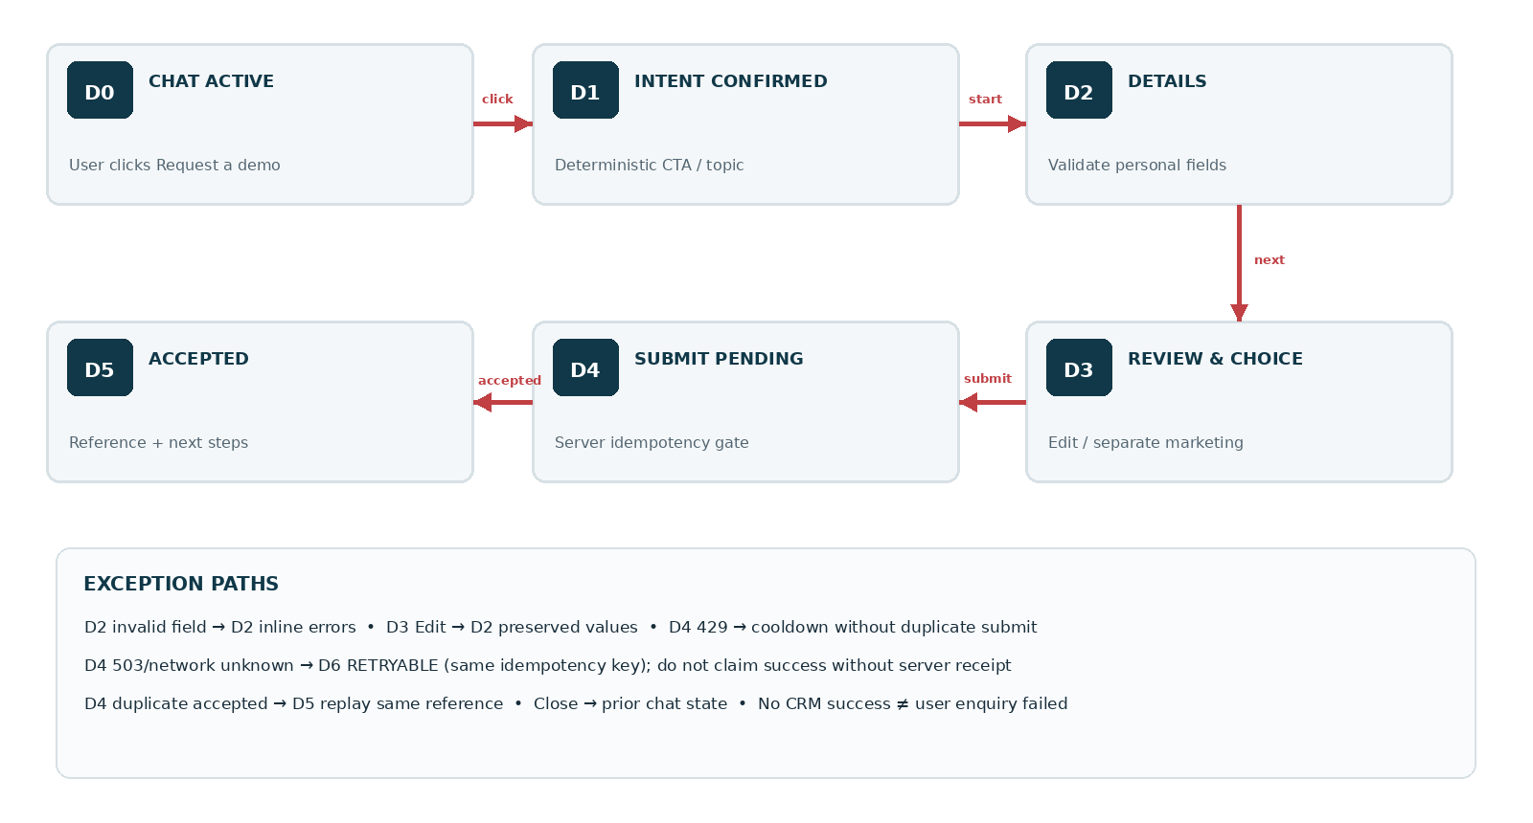
Figure 4. D0–D6 are discrete UI states. A CRM delivery pending state must not cause the public UI to fabricate a confirmed booked meeting. Separate the accepted enquiry receipt from downstream CRM/sales assignment.
STATE | DISPLAY | ALLOWED TRANSITIONS
D0–D1 | Chat CTA clicked, user chooses demo enquiry. | D2 or close to prior chat.
D2 | Details form; field errors inline. | D3 on valid Continue; close/discard.
D3 | Summary + independent marketing choice. | D2 Edit, D4 submit, close/discard.
D4 | Submitting…; same request key, no second call. | D5 accepted, D6 unresolved, or corrected D3 for definite rejection.
D5 | Request received with opaque reference; next steps. | Return to chat, see public help, close.
D6 | Could not confirm receipt; Try again (safe key). | D4 retry, alternate site route, cancel.

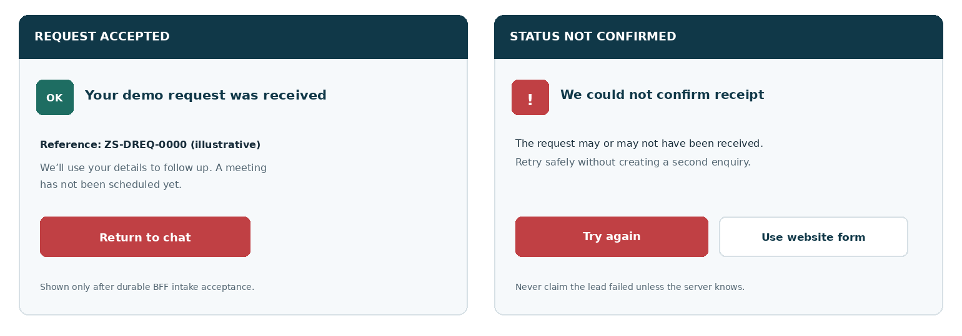
Figure 5. Accepted receipt versus uncertain outcome. Both labels are deliberate: neither should imply a calendar booking or an unverified CRM/email delivery.

09 / Interaction rules and guardrails
One unambiguous action at a time; no irreversible submit before review.
TRIGGER | REQUIRED BEHAVIOR / EDGE CASE
CTA clicked | Client checks approved route key, opens D1 and announces context. Never posts lead on CTA click alone.
Field blur / input | Avoid intrusive errors before first attempted progression. Show inline validation after blur or Continue; preserve valid fields.
Continue clicked | Run local validation; scroll/focus first invalid field and render text error summary; on success D3 with unchanged values.
Edit details | Return to D2 with fields intact; marketing preference retained only in the controlled draft, never auto-enabled.
Enter in input | Enter moves focus or follows native form semantics only where explicit; must not skip review or submit silently.
Submit clicked | Freeze draft snapshot; generate stable idempotency key and call server once; show spinner plus accessible status.
User double taps | Both clicks resolve to same request; no duplicate CRM record, confirmation email or sales notification.
Network times out | UI says “We couldn’t confirm receipt” without asserting failure/success; retry same key for exact payload.
Definite server rejection | Show actionable validation/safety issue, return to review/edit, do not submit sensitive data.
Success accepted | Display server reference, conservative response-time message and return-to-chat; never reveal sales owner internal contact.
Close while composing | No submission; erase PII from form memory promptly and show a small clear exit warning if needed.
Refresh mid-submit | Do not expose personal data in address bar/session analytics; if durable recovery not implemented, provide server-safe retrieval only with validated opaque attempt token.

Success/receipt distinction
ACCEPTED means the public intake service durably recorded a valid request and queued allowed downstream processing. It does not mean a sales representative was assigned, an email was delivered, a calendar meeting was scheduled, or the visitor is now a customer. Those are separately verifiable events.

10 / Public API proposal and transport
Illustrative API surface; engineering must reconcile final paths with approved gateway ownership.
API BOUNDARY
Suggested route: POST /api/public/chatbot/v1/demo-requests. This route must be implemented in a constrained public BFF, not by granting public chat access to existing /auth, /tenants, /alerts, /cases, /actions or internal AI/case-management service paths.

OPERATION / FIELD | EXAMPLE / RULE
POST create request | Content-Type: application/json; transport TLS; request body version=1; body contains allowlisted fields only.
Request meta | enquiry_type, topic_key, source_route_key, notice_version; optional marketing_opt_in false; contact fields as schema.
Idempotency-Key header | Client-generated opaque UUID; server binds key to normalized request hash and TTL; same key + different body → conflict.
201/202 accepted | { status: "accepted", public_reference: "ZS-DREQ-…", next_step: "sales_followup" }; reference contains no PII.
400/422 invalid | { error_code: "FIELD_INVALID", field_errors: {...} } or "SENSITIVE_CONTENT"; sanitize and localize.
409 conflict | Only for same key/different payload; exact duplicate gets original accepted result without creating another record.
429 throttled | Retry-After when safe; accessible human challenge if risk policy requires, without inaccessible CAPTCHA lockout.
503/unavailable | Never claim request receipt; preserve safe retry state and provide direct approved demo page fallback.
GET status if built | Only if explicitly approved; requires opaque proof bound to attempt, protected against enumeration and expiry; otherwise not implement.
Webhook/CRM | Never exposed to browser; verified service credentials, signed messages if relevant, bounded retries and DLQ.

Content and trust invariants
Reject unknown fields and invalid enums server-side. Validate Content-Type, request size, origin policy, CSRF/same-site protections appropriate to the deployment, abuse limits and per-purpose authorization. Never execute or fetch an LLM-generated webhook URL. The assistant may suggest entry, but the form submission itself is a deterministic application workflow.

11 / Sales operations, delivery and CRM boundary
Enquiry intake is a business transaction; do not tie success to a fragile CRM API call.
STAGE | OWNER / BEHAVIOR | EVIDENCE / EXCEPTION
01 Validate | Public BFF validates fields, enum, notice, rate control, sensitive-content heuristics. | Store accepted normalized intake only; rejected data excluded from CRM.
02 Durable accept | Intake service commits request and idempotency marker atomically; returns accepted reference. | One canonical enquiry record per key.
03 Outbox event | Server emits demo_request.accepted via durable transactional outbox. | At-least-once delivery; dedupe by enquiry ID.
04 CRM mapping | Server integration maps fields into approved lead/enquiry object; optional marketing separately flagged. | No transcript, internal docs or secret content appended.
05 Territory routing | SalesOps configuration uses explicit optional market/topic taxonomy and fallback queue. | Unknown market routes to generic manual triage.
06 Acknowledgment email | Send only after verified supported communications workflow; template has privacy-safe reference. | Email delivery independently tracked, not guaranteed by UI.
07 Sales handling | Assigned sales agent reviews, contacts using approved channel; meeting booked only via separate scheduler. | Queue aging/internal escalation subject to operational SOP.
08 Failure recovery | Transient CRM/email failure stays queued; backoff, dead-letter and supervised replay. | Operational alerts are internal only; no public false-negative.
09 Suppression | Before optional marketing, honor channel/jurisdiction consent and global suppression state. | Consent evidence and withdrawal audited separately.

Suggested internal mappings — decision pending
Canonical enquiry_id → external_crm_id mapping; contact_email and contact_name → restricted contact record; organization_name → company; topic_key → campaign/product interest (controlled); source_route_key → attribution (allowlisted); market_country → territory when explicitly provided; marketing_opt_in → a separate consent/preference service, never assumed TRUE from a demo request.
OPERATIONAL TRUTH
Keep three distinct states: INTAKE_ACCEPTED, CRM_DELIVERY_STATE and EMAIL_DELIVERY_STATE. Never use an email-send failure to retroactively change an accepted public request to “not received.”

12 / Security, privacy and abuse testing
Treat the anonymous enquiry interface as attacker-reachable and limit its authority to create a low-privilege lead.
RISK | MANDATORY CONTROL | QA EVIDENCE
CRM injection / XSS | Escaped display, strongly typed schemas, output encoding, safe log formats, no executable rich text. | Payload corpus with script/formula/CRLF/CSV injection.
Prompt injection via conversation | LLM cannot dictate field names, consent, hidden choices or endpoint URL; only approved schema and route. | Adversarial prompt suite + blocked tool inventory.
PII and secrets in context note | Length bounds, detection/blocking of likely keys/logs, privacy warning; minimize free text. | Synthetic secret scanning through intake, logs, CRM and emails.
Automation/spam abuse | Sliding-window caps, IP-risk controls under privacy policy, adaptive friction, accessible alternative. | Burst, bot and false-positive tests.
Duplicate submissions | Server idempotency and transactional uniqueness; at-least-once worker dedupe. | Parallel POST/retry and queue replay tests.
Cross-tenant exposure | Anonymous principal has no tenant claims; lead pipeline separate from security products/CRM private objects. | Route inventory and tenant isolation probes.
CSRF / cross-origin misuse | CSRF/same-site/origin validation suitable for cookies and deployment; explicit allowed origins. | Malicious origin submission attempts.
Consent manipulation | Server ignores client claims that user is subscribed without proof of affirmative opt-in; version-locked copy. | Tampered checkbox and version replays.
Data retention abuse | Approved retention windows, per-purpose access controls, deletion/correction process, processor agreements. | Retention configuration, deletion job and access audit.
Endpoint disclosure | No CRM tokens, endpoint secrets, source code, sales user details or operational queue IDs to browser. | Network tab and API schema scan.
Outage and unknown outcome | No invented success; durable outbox, bounded retry, poison-message dead letter and owner alerts. | Fault injection and recovery trace.

Secure configuration controls
Use approved_display_name and approved asset manifest; anti-abuse policy versions; contact field schema; jurisdiction notice resolver; marketing preference workflow; secure CRM connector credentials; feature toggles for all optional fields; service-level rate/timeout budgets. Any of these may fail closed without blocking normal website navigation.

13 / Accessibility, responsive behavior and performance
Release target: WCAG 2.2 AA plus real-device/manual assistive-technology verification.
AREA | CONCRETE ACCEPTANCE REQUIREMENT
Form semantics | Each input has visible programmatic label, autocomplete where appropriate, explicit required indication and helpful instructions.
Error identification | Show field-specific textual errors, with focus path and summary; not red-only or color-only messages.
Review & submit | Review values announced with meaningful headings; Edit retains form values; optional checkbox read accurately as unchecked.
Keyboard | Tab and Shift+Tab cover all fields/actions in order; Enter cannot bypass review; Escape follows WF-001 close rules.
Screen readers | Validation errors associated via aria-describedby; one polite status during submit; announce success/reference once.
Reflow | 320 CSS px, 200% text size, 400% zoom without horizontal overflow, overlapping submit bar, or clipped notice.
Target size | Preferred 44×44 CSS px; meet WCAG target-size rules and visible focus requirements at every breakpoint.
Mobile keyboard | Visible focused input/error above iOS/Android keyboard; optional page scroll restoration; stable close affordance.
Copy clarity | Explain “request”, “review” and “received”; never use “appointment confirmed” without booked slot.
Internationalization | en-US baseline; locale-ready labels, countries, name lengths, Unicode input and regulatory notices.
Performance budgets | Proposed: immediate local click feedback ≤200ms p75; form code lazy-loaded; avoid CLS/INP/LCP regression.
Failure modes | Offline/timeout recoverable without losing all fields or asserting receipt; page remains fully usable.

Privacy-preserving analytics
Allow event names such as demo_flow_opened, demo_step_completed, demo_validation_error, demo_submit_started, demo_submit_accepted and demo_submit_unknown, each with anonymous event ID, approved route/topic key, device class, control version and bucketed performance. Exclude name, email, organization, notes, IP, raw response body, full transcript, marketing preference and CRM identifiers from product analytics.

14 / Exact UX copy and localization keys
Copy values are proposed release candidates and need Product/Brand/Legal approval.
KEY | COPY (EN-US CANDIDATE)
demo.entry.title | Request a ZoikoShield product demo
demo.entry.body | Tell us how to reach you. We’ll follow up about your request. This does not schedule a meeting.
demo.details.title | Your business details
demo.details.helper | Only share business contact information. Please do not include confidential security information.
demo.field.email | Work email
demo.field.name | Full name
demo.field.company | Company or organization
demo.field.topic | Topic of interest
demo.field.market | Country or market (optional)
demo.field.note | Additional context (optional — no confidential details)
demo.next | Continue to review
demo.review.title | Review your demo request
demo.review.body | Please check your details before sending. No meeting has been scheduled.
demo.review.marketing | Optional: I’d like to receive ZoikoShield product updates by email.
demo.review.submit | Submit demo request
demo.pending | Submitting your request…
demo.success.title | Your demo request was received
demo.success.body | Our team will review it and follow up using the contact details you provided.
demo.success.reference | Reference: {public_reference}
demo.unknown | We couldn’t confirm whether your request was received. You can retry safely.
demo.error.email | Enter a valid email address.
demo.error.required | Complete this field to continue.
demo.error.sensitive | Remove passwords, tokens, or confidential security details before continuing.
demo.cta.edit | Edit details
demo.cta.cancel | Cancel request
demo.cta.retry | Try again

PLAIN-LANGUAGE RULE
Avoid “Instantly booked,” “Certified,” “100% secure,” “24/7 sales response,” “We emailed you” or specific features/entitlements without verified public evidence and approved service operation.

15 / Engineering acceptance tests — P0
Attach screen capture, browser traces, redacted server receipt/queue evidence and owner sign-off to the ticket.
ID | GIVEN / ACTION | PASS CONDITION
AT-31 | Visitor clicks WF-001 Book a demo | D1 opens with correct context; no lead created on CTA click.
AT-32 | WF-002 provides suggested demo link | Explicit confirmation precedes details; route key approved.
AT-33 | Submitted required fields empty | Text errors identify fields; first issue focused; no POST.
AT-34 | Valid business details entered | Review D3 preserves exact normalized values; one more action needed.
AT-35 | Marketing preference untouched | Default false; demo request can complete without promotional opt-in.
AT-36 | Marketing actively checked | Timestamp/notice/purpose evidence stored separately; marketing suppressed when no lawful permission.
AT-37 | Notes contain sample API key/log | Intake blocks/redacts; secrets absent CRM, email, telemetry and trace.
AT-38 | User submits twice in rapid succession | One canonical intake and CRM outbox event; same public reference.
AT-39 | Public BFF accepts but CRM temporarily down | Public confirmation retained; internal retry eventually occurs; no false failure.
AT-40 | Transport times out before receipt known | D6 unknown; retry same key; no fabricated “request received”.
AT-41 | 409 same key / changed body | Conflict handled safely; user must start a new attempt after edits.
AT-42 | Spam burst / abuse pattern | Rate control + accessible human alternative; website remains responsive.
AT-43 | Spoofed cross-origin POST | Origin/CSRF checks reject where applicable; no accepted enquiry.
AT-44 | Model proposes internal endpoint/CRM action | No privileged tool invocation; only public BFF allowlisted action.
AT-45 | 320px/400% zoom and virtual keyboard | No obscured inputs, CTA, errors, or horizontal scroll; mobile close reachable.
AT-46 | Keyboard, VoiceOver, NVDA or TalkBack | All labels, errors, checkbox state and success status announced accurately.
AT-47 | Analytics enabled/disabled | No contact PII in analytics or marketing profile unless independently authorised.
AT-48 | Name, copy, theme asset updated | Approved config propagates; placeholder not shipped as logo; no hardcoded Zhield.
AT-49 | Accepted response reference returned | Shows one opaque valid reference and no false calendar booking statement.
AT-50 | User closes before final submit | No request sent; drafts cleared according to approved policy; prior chat restored.

16 / Critical review and incorporated refinements
Quality is defined by safe conversion, not the number of fields collected.
WEAK CONVENTIONAL PATTERN | REFINEMENT INCORPORATED
A long questionnaire inside a small chat window | Three required contact fields plus one simple interest key; optional details minimized and hidden by default.
The “Book a demo” button implies a calendar appointment | Explicit request-only status; separate scheduling service required for confirmed meeting.
Marketing approval hidden inside Terms | Unbundled optional default-OFF checkbox; separate recorded preference purpose.
Instant success page before durable backend write | Server-owned acceptance and opaque reference, independent from CRM/email delivery.
Retry duplicates sales leads | Stable idempotency key and transactional intake/outbox with downstream dedupe.
LLM is allowed to build CRM payloads | Deterministic, validated form schema and restricted server-controlled route mapping.
Failure messages reveal internals or assert the wrong result | Distinct known rejection versus unknown outcome; safe retry and accessible fallback.
Collect SIEM configuration or incident descriptions to qualify | Explicit sensitive-content minimization, no upload, no tenant/session authority.
“Accessible” without practical success tests | Semantics, error focus, native autofill, screen-reader/zoom/mobile keyboard matrix.
Leads sent straight to marketing analytics | PII-excluded event taxonomy and purpose-separated communication preferences.

Remaining design risks and owner decisions
P0 approvals: (1) Founder/Product: demo enquiry rather than live scheduling and exact CTA copy; (2) SalesOps: allowed interests, CRM owner and fallback queue; (3) Legal/Privacy: contact-processing lawful basis, jurisdiction notice, retention and marketing wording; (4) Security: public BFF, anti-abuse, secrets filter and idempotency policy; (5) Brand: official logo/favicon and public display name; (6) Engineering: actual endpoints/CRM connector reliability; (7) Accessibility/QA: manual and automated evidence.
CHANGE CONTROL
No “best practice” diagram should be mistaken for an implemented control. Link final approved Figma, code PRs, OpenAPI, privacy/legal decisions, security verification, sales SOP and test records to this document ID before release.

17 / Build handoff, release sequence & references
One complete work package; no speculative expansion beyond this independently approvable flow.
DELIVERABLE | REQUIRED ARTIFACT / ACCEPTANCE RECORD
UI/Figma | D0–D6 desktop/mobile variants, 18 components ZS33–ZS50, error cases, 320px reflow, 200% text, 400% zoom.
Frontend | Typed field schema, progress/review, independent marketing choice, accessible errors, safe form lifecycle.
Public BFF | Formal API contract; server validation; security middleware; rate policy; idempotency transaction; receipt generation.
Data security | Field classification, encryption/access controls, retention/deletion policy, incident logging redaction, no PII analytics.
Sales integration | Durable outbox, CRM mapping, dedupe, fallback queue, delivery states and operational runbook.
Legal/comms | Approved notice content and version registry; lawful basis per territory; optional marketing and suppression logic.
Testing | P0 AT-31–AT-50 evidence; regression against WF-001 AT-01–AT-14 and WF-002 AT-15–AT-30.
Decision control | Founder approval of WF-003 before beginning any separate Wireframe 04. Production release is a later gate.

Implementation order
A. Confirm product and legal copy → B. UX components and responsive prototypes → C. public BFF schemas and privacy controls → D. durable intake/outbox and CRM adapter → E. state failures, keyboard/mobile/a11y → F. security/adversarial/consent QA → G. owner approvals and monitored controlled rollout.

Source and standards register
Internal: ZoikoShield Live Demo Master Guide and Step-by-Step Demo Links (user-supplied October 13, 2026; restricted engineering references, not approved public assistant knowledge sources); Zoiko Group Public AI Chatbots Master Product & Engineering Guide v7.7 (October 20, 2026); ZoikoShield Chatbot Wireframes 01 and 02 (October 24, 2026).
External: W3C WCAG 2.2 https://www.w3.org/TR/WCAG22/ ; W3C Error Identification https://www.w3.org/WAI/WCAG22/Understanding/error-identification ; UK ICO B2B marketing https://ico.org.uk/for-organisations/direct-marketing-and-privacy-and-electronic-communications/business-to-business-marketing/ ; ICO consent guidance https://ico.org.uk/for-organisations/uk-gdpr-guidance-and-resources/lawful-basis/a-guide-to-lawful-basis/consent/ ; OWASP API Security https://owasp.org/API-Security/ . These references do not constitute ZoikoShield certification.
FOUNDER REVIEW CHECKPOINT
This document delivers Wireframe 03 only. The next logical independent workstream is an authenticated-support boundary or a public support enquiry/human-handoff design, but it must not begin until Wireframe 03 is expressly approved.

