ZOIKOSHIELD / STRATEGY • SECURITY • TRUST • PRODUCT • DESIGN • ENGINEERING

Public AI Chatbot
Detailed Wireframe 07
Trust Center guidance, security-assurance answers and controlled document-access requests
DOCUMENT CONTROL
Version 1.0 • October 24, 2026 • American English • Document ZS-CHAT-WF-007 • Design approval pending. This is a prescriptive TARGET build specification; no certification, public Trust Center deployment, restricted-content availability, implemented API, or actual document-release process is asserted.

Executive product decision
Give buyers, procurement teams and security reviewers a fast, source-verifiable public answer to common trust questions. Segregate public documentation from restricted audit and security materials; require explicit human-approved access review. An AI answer cannot manufacture attestations, production assurance, certifications, third-party commitments, access rights or private tenant evidence.
DESIGN AXIS | MANDATORY IMPLEMENTATION DECISION
Purpose | Provide public security/privacy/assurance orientation and links to approved current publications; route qualified controlled document requests.
Sequence | Follows WF01 welcome; WF02 public answers; WF03 demo; WF04 support; WF05 solution discovery; WF06 plans/pricing.
Stable numbering | UI components ZS117–ZS140; test cases AT-127–AT-154; state codes T0–T12. Do not reuse prior IDs.
Brand | Working internal assistant name Zhield; show ZoikoShield Assistant until Product/Brand/Legal approval. Use approved logo/favicon; placeholders in diagrams only.
Visual tokens | Working reference navy #103848 / red #C04044; use the current approved ZoikoShield token/asset library for production.
Security boundary | The public BFF can read only approved public projections; it must not query customer evidence, SOC, audits, tenant telemetry, private contracts or privileged assurance systems.
Claims gate | Never label a product “SOC 2 certified,” “ISO 27001 certified,” “fully compliant,” or “guaranteed sovereign” without approved evidence matching the precise wording, scope, date and entity.
Sign-off | Founder approval is visual/functional design acceptance only; Legal, Trust, Security, Privacy, Accessibility and release gates remain separate.

SAFETY DOCTRINE
A published description of a security capability is not verification that a particular deployment is production-ready. A control mapping is not certification. A chatbot-generated explanation is not a security assessment or substitute for approved trust documentation.

01 / Desktop: Trust Center category guidance (T0–T1)
Position the assistant beside official public site navigation—not in place of it.
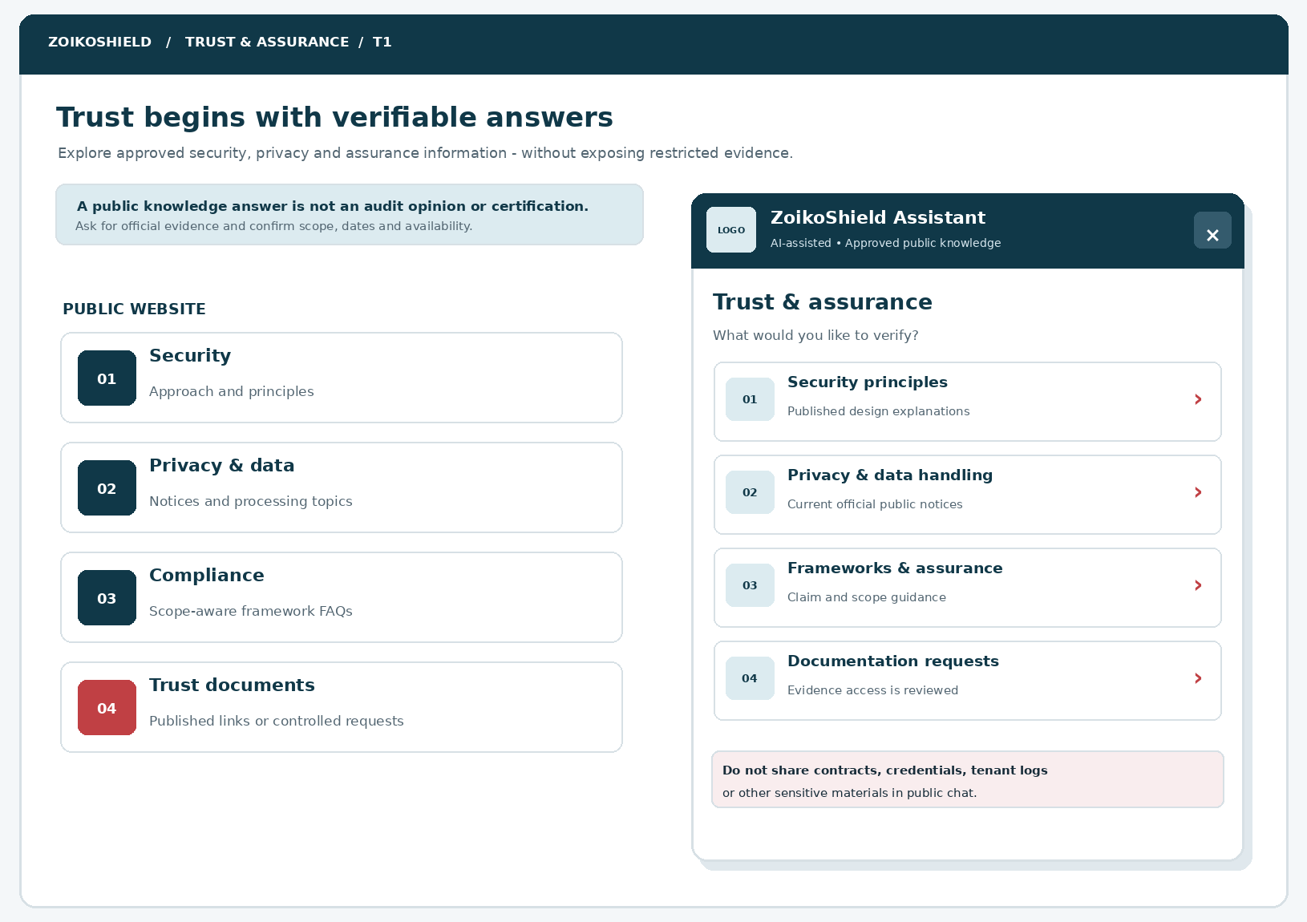
Figure 1 — Desktop public trust entry. Official logo and favicon replace the labeled placeholders at implementation. The Trust Center menu and category cards must be published from a legal-reviewed taxonomy.
CALLOUT | ENGINEERING REQUIREMENT
01 | Source-owned category names; do not expose unpublished topics by pre-populating private catalog entries.
02 | AI disclosure stays visible and accessible; no operational-role implication.
03 | The restricted-document CTA creates an access-review request, never an immediate file release.
04 | Warnings remain readable at 200% zoom and when color is unavailable.

02 / Mobile: first-class trust navigation
Single-column topics with no hidden carousel or nested-scroll traps.
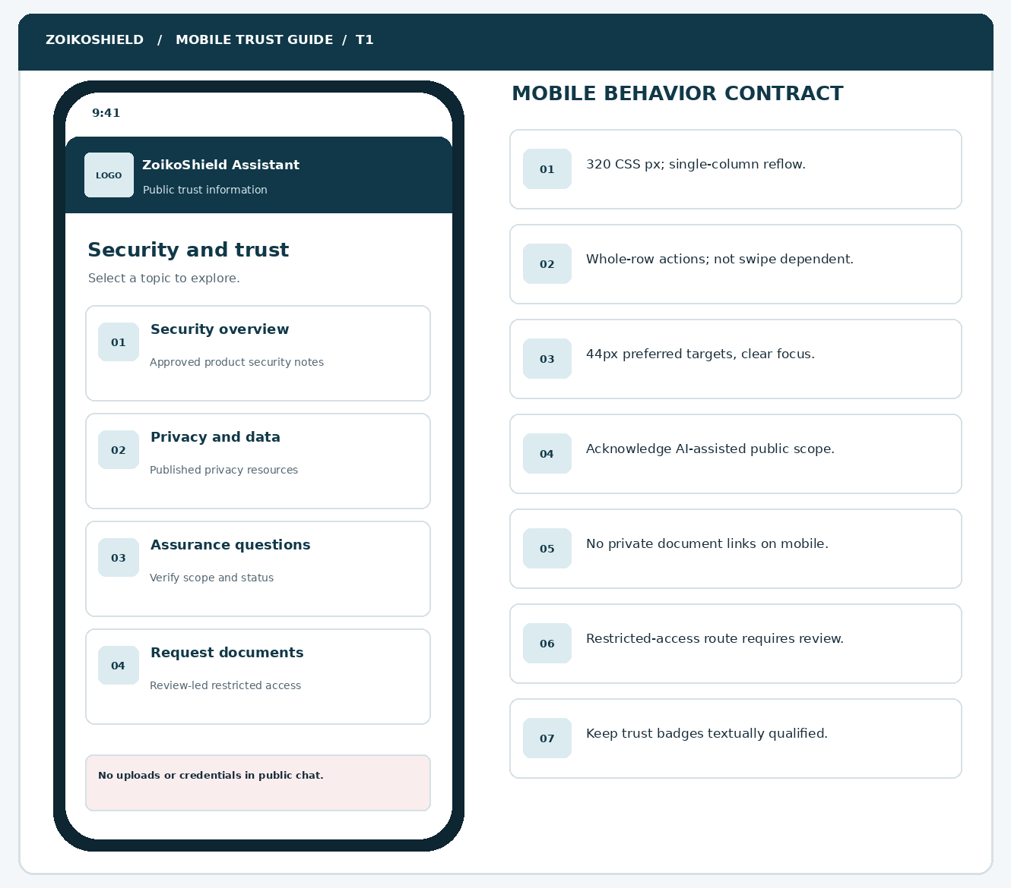
Figure 2 — Mobile layout supports keyboard operation, touch and assistive reading without requiring a desktop feature detour.
RESPONSIVE ENVELOPE
At 320 CSS px and 400% browser zoom, all categories, source notices, CTA text and close controls must reflow. Prefer whole-row buttons, visible focus, safe-area insets and native scroll. Maintain equivalent disclosure and request functionality on mobile.

03 / Verified answer with citation & provenance (T2–T4)
A trust answer must be attributable, time-bounded and marked as a public explanation.
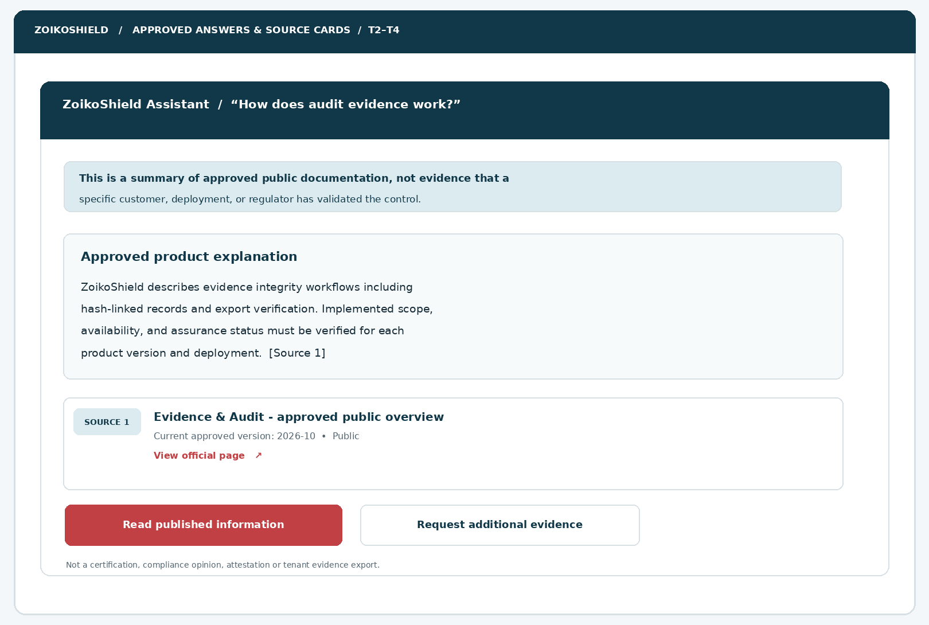
Figure 3 — Approved answer with a human-readable source card. Source URL must resolve to the approved external public origin; extracted content itself is untrusted for instruction-following.
ANSWER ELEMENT | REQUIRED SYSTEM SEMANTICS
Summary | Generate only from eligible source paragraphs; reflect product-version and deployment qualifiers.
Citation token | Deterministic link to approved source_id, revision and paragraph anchor; no invented citations.
Status label | “Public • Current approved version” only when registry assertions confirm it.
Qualifier | Explicitly separate described controls, implemented features, audit status and customer-specific verification.
Open source | Link resolves to allowlisted HTTPS; no redirect chain to a blocked/private host.
Request additional evidence | Starts controlled workflow, never discloses private metadata or credentials.

04 / Restricted assurance request: minimal intake (T5–T8)
Optional commercial due diligence, with privacy and security limits designed into the form.
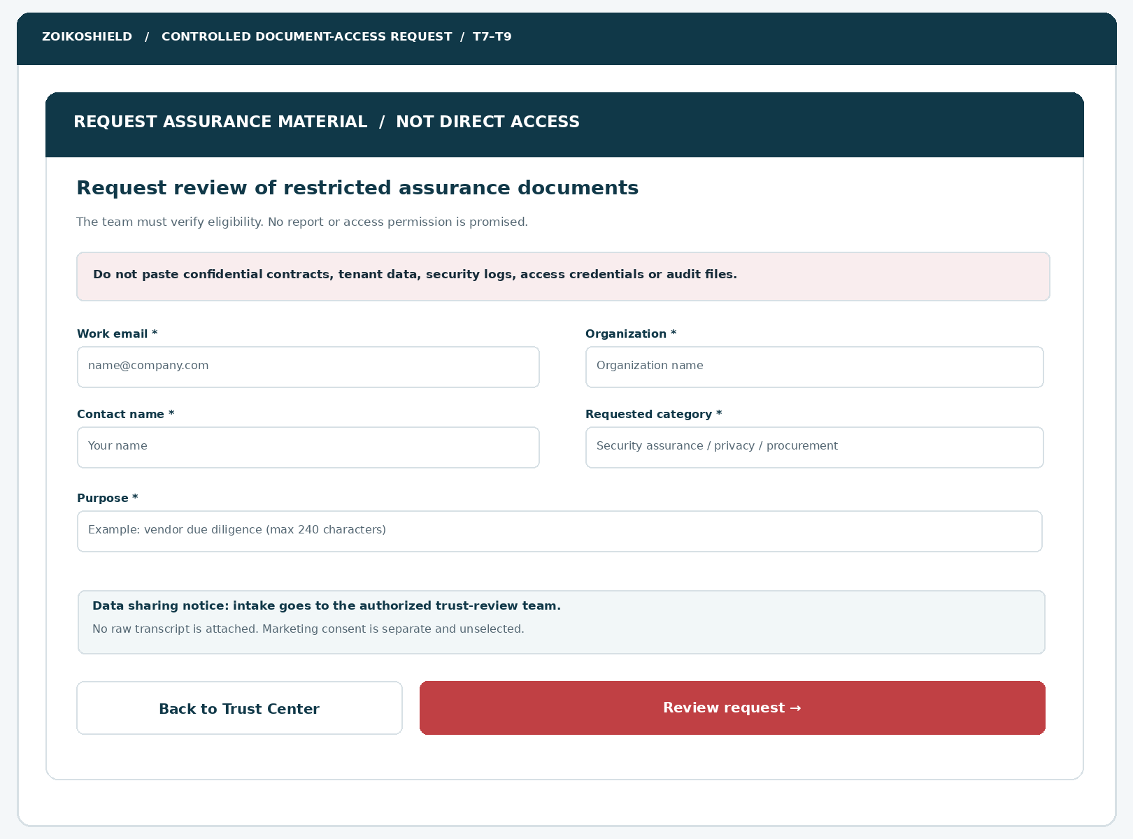
Figure 4 — Separate reviewed request. Required data is purpose-limited; marketing consent, if used, is separately recorded and unchecked.
CRITICAL SEPARATION
The public assistant must not accept files, deliver reports inline, embed access tokens in chat messages, send restricted links through public transcripts, or assume an NDA is signed. Any approved delivery happens through an independently authenticated controlled workflow.

05 / Trust journey state machine T0–T12
Explicit states make fallback, revocation and uncertain submission testable.
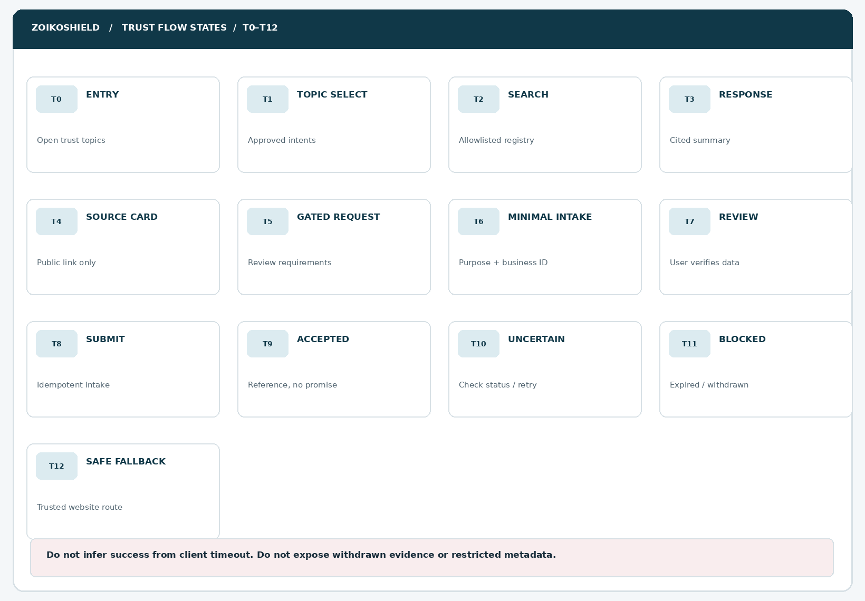
TRANSITION | MUST HAPPEN
T0→T1 | Open stable category list with keyboard focus anchored to title.
T1→T2→T3 | Search only approved public source projection; cite eligible evidence.
T3→T4 | Render an official public link after allowlist and publication check.
T3→T5→T8 | Open request → validate → review → submit idempotently; no direct access.
T8→T9 | Only durable intake acknowledgment can show received reference.
T8→T10 | Unconfirmed outcome: status lookup or same-key retry; never false success.
Any→T11→T12 | Expired/withdrawn/unverified evidence leads to an accurate fallback, not stale quotation.

06 / Restricted, unverified & withdrawn scenarios
The highest-trust interaction is sometimes a well-explained “not verified.”
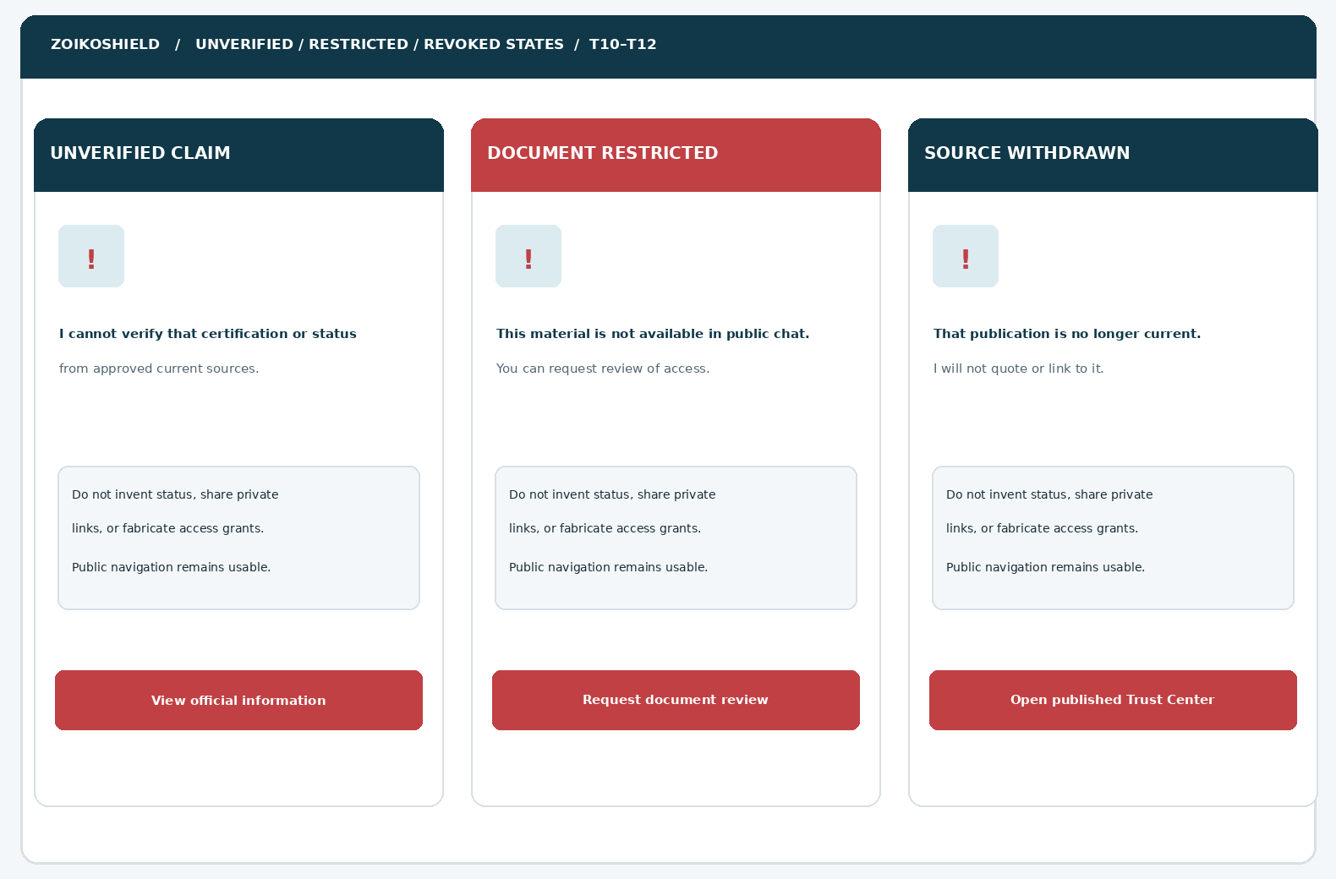
Figure 6 — Three failure-safe states. Text explains the reason and leaves valid next actions available; no attachment or AI recovery may bypass source permissions.
USER REQUEST | SAFE EXAMPLE RESPONSE
“Are you SOC 2 certified?” | “I can only confirm audit or attestation status from current approved documentation. I cannot verify that claim here; request reviewed evidence.”
“Send your pen-test report.” | “Detailed assessment materials may be restricted. You can submit an access-review request; access is not automatically granted.”
“Are all customer records UK-only?” | “Residency depends on the relevant service and deployment terms. See approved documentation or request a scoped review.”
“Give me a private audit export.” | “I cannot access customer or internal audit exports from public chat. Use the authorized authenticated process.”

07 / Public trust taxonomy and intent routing
Deterministic policy rules take precedence over generative prose.
TOPIC KEY | APPROVED SUBJECT EXAMPLES | ROUTE / MANDATORY BOUNDARY
security_overview | Product security posture, secure-by-design concepts | Approved overview; no proof of deployed control unless verified.
identity_access | Passkeys, RBAC/ABAC, JIT design explanations | High-level only. No customers, roles, elevations or internal policy definitions.
data_handling | Privacy notice, subprocessors, retention | Link current published notices; do not infer contract-specific defaults.
data_residency | Region support, transfers, sovereignty | Scoped document; never guarantee universal geographic containment.
incident_response | Published IR practice and escalation | General process; live incident → WF04 verified emergency route.
assurance_status | SOC 2, ISO 27001, ISO 27701, frameworks | Separate certification / attestation / mapping / design / intended roadmap.
evidence_integrity | Hash chain, Merkle, timestamp and verifier | Product description only; no tamperproof/unhackable assertions.
restricted_report | Auditor letter, pen-test, full policy, detailed diagram | Human-reviewed request; no public access to materials.
private_user_request | Tenant compliance exports, security logs, cases | Refuse public access; verified signed-in route as applicable.
unsupported_claim | Outdated document, unverified standard or availability | Explicit abstention with latest approved source or contact route.

Intent priority
Risk-routing order: active incident > secrets/data upload > private-tenant request > restricted-document request > unsupported assurance claim > ordinary published trust FAQ. An LLM can classify the phrase but may not override deterministic access policy or the domain registry.

08 / Components ZS117–ZS128
All IDs extend the approved numbering sequence; component functionality is explicit.
ID | COMPONENT | DEFINITION & ACCEPTANCE CONTRACT
ZS117 | Trust topic entry | Visible launcher with source-owned trust label; opens T1, restores focus on close.
ZS118 | Assistant identity | Approved product logo/favicon, AI disclosure and text label; no internal control-plane badge.
ZS119 | Topic chooser | Four minimum categories with accessible button semantics, robust active state.
ZS120 | Scope qualifier | Persistent distinction: public information, not assessment or legal certification.
ZS121 | Trust content heading | Real h2 heading; exposed in accessible reading order and browser history state.
ZS122 | Answer region | Grounded short explanation; paragraph breaks; response may not include executable HTML.
ZS123 | Inline citation | Source-link reference bound to returned server-approved source_id and revision.
ZS124 | Source details card | Publisher, document title, scope, date, current state, allowed public link.
ZS125 | Publication status | Explain current, expired, withdrawn or unverified explicitly without decorative only color.
ZS126 | View official page | Allowlisted external link with accessible destination label and noopener isolation.
ZS127 | Evidence request entry | Restricted CTA; route to request assessment without public file exposure.
ZS128 | No-sensitive-data prompt | Clear warning and hard limits before chat input and form submission.

09 / Components ZS129–ZS140
Intake, feedback and failure states are specified as carefully as the happy path.
ID | COMPONENT | DEFINITION & ACCEPTANCE CONTRACT
ZS129 | Work email | Accessible validation, 254 character maximum, no hidden lookup of personal account data.
ZS130 | Organization | Business name, trimmed length ≤120, not used as proof of affiliation.
ZS131 | Contact name | Human readable name, maximum 120 characters, user-editable.
ZS132 | Material category | Published allowlisted categories only; server maps category key, not raw report ID.
ZS133 | Request purpose | 240-character constrained free text; block secrets; explain purpose and retention.
ZS134 | Privacy notice | Prominent link and purpose summary; marketing consent separate and unselected.
ZS135 | Request review | Read-back of provided fields and submitted category; edit without loss.
ZS136 | Submit action | One explicit consented action; disabled while pending; idempotency key in BFF.
ZS137 | Receipt / reference | Opaque ticket reference only when authoritative intake acceptance confirmed.
ZS138 | Uncertain outcome | Same-key retry or status lookup; no “submitted” success claim.
ZS139 | Withdrawn claim | Preserves context without quoting revoked text; routed to current approved contact.
ZS140 | Back / close | Back behavior, restore origin focus, no silent transcript transfer to reviewer.

10 / Trust publication registry & provenance model
Content permissions are data-level policies, enforced before retrieval and before display.
DOMAIN OBJECT | REQUIRED FIELDS / SOURCE | STRICT INVARIANT
PublicAsset | asset_id, revision, title, type, topic, locale, status, public_url, doc_digest | Only PUBLIC_APPROVED is searchable and displayable.
SourceClaim | claim_id, claim_type, statement, entity, scope, valid_from/to, approvers | Claim state and precise scope checked at response time.
PublicCitation | asset_id + revision + passage_id + url + published_at | Citation points to same version as answer; no source fabrication.
RestrictedCategory | category_key, generic_label, access_request_enabled | Generic only; do not enumerate sensitive report inventory.
TrustRequest | opaque request_id, category_key, purpose, business email, status | Purpose minimized; evidence access never granted by chat intake.
AccessDecision | request_id, reviewer_id, policy_result, basis, expiry | Held in controlled service; NOT accessible in anonymous chat.
AuditEvent | event_id, time, event_key, correlation_id, least-PII payload | Write-only append event; segregated retention and service accounts.

Canonical source statuses
STATUS | PUBLIC ASSISTANT DISPLAY
PUBLIC_APPROVED | May summarize and cite, subject to expiry, market, license and exact claim policy.
PUBLIC_SUMMARY_ONLY | Show approved summary only; not the source document body or download.
RESTRICTED / UNPUBLISHED | Never retrieve private body or enumerate confidential inventory; optionally show generic request category.
EXPIRED / WITHDRAWN | Do not quote, cache-serve or link as current. Invalidate embeddings and answer caches.
UNKNOWN / UNVERIFIED | No affirmative claim; offer safe documented or human-reviewed next steps.

11 / Assurance claims & evidence policy matrix
Precision of wording matters as much as the factual content.
CLAIM TYPE | PERMITTED WORDING IF APPROVED | NEVER INFER
Certification | “[Entity / service] holds [certificate] valid until [date], scope [x]” when verified. | Any other entity, product, region or timeframe covered.
Attestation / examination | “A report for [period] can be reviewed through the approved process,” if true. | “Certified” or unrestricted distribution of the audit report.
Framework mapping | “Capabilities map to selected control categories; details vary by version.” | A completed independent audit or legal compliance.
Roadmap / prototype | “Planned” or “demonstration capability” per approved product status. | Production SLA, available connector, or operational effectiveness.
Data locality | “Region options subject to solution design / contract review.” | All records, subprocessors or support access remain in jurisdiction.
Evidence integrity | “Cryptographic techniques support verification of changes when implemented.” | Immutable forever, impossible to tamper, certified evidence.
Penetration testing | Published general testing statement, with date/scope if approved. | Zero vulnerabilities, unlimited access to report or unconditional guarantee.
AI and SOC | “AI supports governed analysis with user oversight,” if release verified. | Autonomous resolution, human-equivalent decisions or privileged action via public chat.

TRUTH-PRESERVING EXAMPLE
A demo playbook or dashboard screenshot that mentions SOC 2, ISO 27001, GDPR or control mappings is never sufficient alone to assert ZoikoShield holds certification, passed an audit, or satisfies legal obligations. The claim registry must carry verified documentary proof and review sign-off.

12 / Request lifecycle & controlled delivery architecture
The chatbot handles an intake request—not the granting of assurance-document access.
STAGE | SYSTEM INTERACTION | HARD PROHIBITION
01 Initiate | User selects generic document category, sees a clear access-review explanation. | No automatic exposing report titles or confidential metadata.
02 Minimize | Collect work email, name, organization, category, brief purpose. | No credential, company registration file, audit upload, freeform logs.
03 Review | Present all fields, privacy summary and optional separate marketing choice. | Do not bundle marketing with the access request.
04 Persist | BFF validates policy, CAPTCHA/risk where required, idempotent write to intake queue. | Do not call secured evidence store directly from public browser.
05 Acknowledge | Return opaque reference and “received for review” only on durable acceptance. | Never claim approved/rejected or meeting scheduled at intake.
06 Human review | Authorized Trust reviewer checks authorization, scope, NDA/contract as applicable. | No LLM-based authorization or bypass based on email domain.
07 Controlled share | If approved, separate verified identity workflow + scoped time-limited access. | No bearer URL in public transcript, analytics or routine email body.
08 Revoke/expire | Access grants short-lived and revocable; immutable decision log. | No reused public report URL / caching private content.
09 Uncertain | Transport outcome unconfirmed → same-key status lookup or retry. | Never show a false received receipt.

Request status and ticket semantics
Client-visible: NOT_STARTED, DRAFT, VALIDATION_ERROR, REVIEW, PENDING, ACCEPTED_INTAKE, UNCERTAIN and UNAVAILABLE. Reviewer-only: TRIAGE_PENDING, MORE_INFO_NEEDED, APPROVED, DENIED, EXPIRED and REVOKED. A public browser must not query reviewer-only states or approvals by guessing request IDs.

13 / Proposed public BFF API contracts
New design interfaces to be reconciled against the actual repository before build.
METHOD / ROUTE (PROPOSAL) | PURPOSE & MINIMUM RESPONSE | SERVER CONTROL
GET /api/public/trust/topics | Approved category list, locale, version, cache status. | Public allowlisted projection only.
GET /api/public/trust/search?q= | Public snippets, citations, source IDs/revision, claim check state. | Query normalized; corpus ACL before and after retrieval.
GET /api/public/trust/sources/:public_id | Current public source metadata and allowlisted safe URL. | Opaque public IDs; no restricted document metadata.
GET /api/public/trust/claims/:id | Current approved claim state, scope and date. | No raw certificates, internal decision notes or unpublished content.
GET /api/public/trust/request-categories | Generic categories and required field schema. | No inventory enumeration.
POST /api/public/trust/requests | Validate, idempotent durable intake, return opaque ref. | Abuse defense, audit, privacy minimization, no automated grant.
GET /api/public/trust/requests/status | Status by confidential client-issued receipt nonce/session binding. | Do not expose request IDs globally; short TTL and rate limits.
POST /api/public/trust/feedback | Lightweight answer quality score and optional non-sensitive reason. | Reject secrets; avoid persistent visitor fingerprinting.

ISOLATION ENFORCEMENT
Browser → dedicated public Next.js BFF → publication-controlled trust projection and isolated inquiry store. No direct network path from public UI to shield-core tenant endpoints, /audit, /ledger, AI internal governance, signed evidence stores or the authenticated evidence library. Reject ambiguous routes server-side.

14 / Proposed data contracts, errors and state coherency
Use explicit status, publication version and permission semantics across all layers.
OBJECT | ILLUSTRATIVE REQUIRED FIELDS | INVARIANT / FAILURE PATH
TrustAnswer | answer_id, text, citations[], verified_at, approval_revision | Citations never empty for factual assurance; abstain otherwise.
Citation | public_source_id, revision, passage_id, published_url, claim_scope | URL must be public HTTPS allowlist and revision current.
ClaimDecision | claim_id, decision=ALLOW|QUALIFY|ABSTAIN, scope | No external user text or model judgment can widen ALLOW.
TrustRequestDraft | category_key, full_name, org_name, email, purpose, notice_version | Server validation canonical; no implicit chat transcript.
TrustRequestReceipt | request_ref, received_at, status=ACCEPTED_INTAKE | Only after durable persistence; opaque reference.
API error | error_code, correlation_id, can_retry, user_safe_message | Never include internal stack, secret policy, private asset ID.
Source revocation event | asset_id, revision, revoked_at, reason_code | Immediately invalidate retrieval index/answers/cache and safe links.

Idempotency, freshness and rollback contract
Use a per-request client-generated UUID/opaque idempotency token, bound to hashed validated payload and short server retention; return same receipt for replay within policy. After a timeout, first perform a status lookup. Retries must neither create duplicate Trust tickets nor trigger repeated CRM notifications. Reject cached factual answers when a cited source has become expired, withdrawn or out of scope; fall back to reviewed public pages. Rollback disables the trust-request feature while preserving the basic public website and support route.

15 / Abuse cases, threat model and security controls
Trust surfaces attract deliberate exfiltration and impersonation attempts.
THREAT | PREVENTATIVE CONTROL / REQUIRED EVIDENCE
Prompt injection in public PDFs | Extract into a non-executable data plane; strip instructions; model may not promote document text to authority.
Sensitive corpus mixing | Separate physical/logical index for public assets; deny-by-default permissions before recall, recheck before render.
Hidden report enumeration | Return generic request categories, constant-shape errors, no restricted IDs/titles/counts.
Forged certification statements | Versioned structured claim registry + approver identity + scope/time validator; force abstention.
Leaked signed report URL | Never embed tokens/URLs in conversation, logs, analytics, email previews; out-of-band access workflow.
SSRF / malicious citation URLs | No client-derived fetch target; enforce HTTPS host allowlist, redirect policy and DNS validation.
PII leakage in model prompts | Minimal fields; redact unneeded PII and block raw user-submitted files, logs and credentials.
Ticket submission spam | Rate limits by privacy-preserving risk signals, honeypot, adaptive human challenge, queue controls.
Cross-session request status | Bind receipt lookup to unguessable nonce and original short-lived session; avoid global identifier search.
Revoked source in answer cache | Event-driven purge plus request-time registry check; negative test with hot revocation.
Role override/jailbreak | Server-side authorization immutable to conversation text; no tools able to release evidence.
HTML / Markdown injection | Escape and sanitize rendered content; strict CSP; strip unsafe links and scripts.

16 / Privacy, retention and legally controlled access
Consent to request review is not consent to broadly process or distribute data.
CONTROL | REQUIRED SPECIFICATION OR ACCOUNTABLE DECISION
Purpose | State the explicit purpose of handling a vendor-assurance document request and subsequent reviewer communications.
Lawful basis / notice | Privacy/Legal determine market-specific lawful basis and link current official notice; no unsupported compliance claims.
Minimization | Required only contact name, work email, organization, category and short purpose; no attachment uploads.
No transcript sharing | Default request payload excludes full conversation, tracking history, cookies, IP enrichment and hidden model notes.
Marketing choice | If offered, unchecked and independently optional, with separate consent text/version/timestamp.
Retention | Document owner defines retention periods and deletion rules for tickets, PII, consent and audit events before launch.
Subject rights | Publish current request/privacy contact route and practical retrieval/deletion processes as locally required.
Subprocessors | Any access-review vendor and email provider included in approved privacy review and transfers assessment.
Confidentiality | NDA or approved contractual controls implemented by authorized review team where necessary.
External sharing | Authentic identity, least privilege, short expiry, watermarking where suitable, revocation and download policy.
Localization | Offer English (US) baseline; add localized approved legal copy by market; do not auto-translate contractual claims.
Operational logging | Structured security logs exclude data contents, secrets and private documents; control access and deletion.

COMPLIANCE IS A RELEASE GATE
This specification seeks alignment with relevant privacy, security and accessibility requirements. It is not a legal determination, certification report, SOC 2 attestation or proof that the described processing is already implemented.

17 / Accessibility, localization and responsive acceptance
Target WCAG 2.2 AA; verify through real assistive and human testing.
TEST DIMENSION | MINIMUM ACCEPTANCE REQUIREMENT
Keyboard | All chat, category, source and request controls operable by Tab/Shift+Tab/Enter/Space with visible focus.
Focus | Opening panel moves focus to title; errors focus summary; closing returns focus to launcher.
Reading order | Assistant statement → source qualification → citation → actions; no confusing DOM/visual mismatch.
Screen reader | Status changes announced non-intrusively; citations have meaningful names including destination.
Forms | Persistent labels, programmatic errors, help text, clear required status; review before irreversible submit.
Reflow | 320 CSS px and 400% zoom; no horizontal page scroll or clipped evidence notices.
Target size | Aim ≥44 × 44 CSS px for touch controls; verify WCAG 2.2 minimum target exceptions.
Contrast | At least 4.5:1 body text and 3:1 essential UI boundaries where applicable.
Motion | Respect reduced-motion; animated typing/status not the sole channel for information.
State persistence | Back and forward controls retain non-sensitive form data without sending unsubmitted records.
Long answers | Source cards and qualification text reflow; no truncation of legal disclaimers.
Localization | Time/date display market-aware and human-readable; avoid ambiguity in certification expiry labels.

18 / Operational observability, data quality & ownership
Monitor trust-answer correctness rather than merely chatbot engagement.
EVENT KEY | PERMITTED ANALYTICS SCHEMA / RESTRICTION
trust_open | anonymous session bucket, locale, release version, not raw IP or personal fingerprint.
trust_topic_select | approved topic_key, content_revision and anonymous event_id.
trust_answer_served | claim_status, source_count, response template version; no full answer with PII.
trust_abstention | reason enum: no_source, expired, restricted, scope_mismatch or unverified.
trust_source_open | public_source_id and target domain; no private path or report token.
trust_request_started | generic category only, no contact data.
trust_request_accepted | opaque correlation reference plus accepted status; no email/name in analytics.
trust_request_uncertain | error class, retry_count and idempotency outcome.
trust_source_revoked | public_source_id, previous revision, purge complete, alert state.
trust_feedback | positive/negative and categorized reason; optional text only after PII screening.

Service objectives and operational guardrails
The engineering team must define and verify numeric SLIs/SLOs with Product and Security before launch; do not fabricate latency, uptime or successful response guarantees. Monitor citation eligibility (target 100% for factual public trust claims), abstention correctness, stale-document incidents, request duplicate prevention, privacy rejections, mobile completion, accessible error resolution and unsafe-claim escalations.

Emergency safe rollback
Trust publication access and restricted-request intake require independent feature controls. Invalidate local/CDN cache when evidence is revoked, suspend inquiry creation if its service fails, keep website navigation and existing WF04 support routing operable, and provide tested after-hours incident owner handoff.

19 / P0 acceptance tests — AT-127 through AT-140
Use synthetic metadata, revoked source fixtures and private-asset trap documents.
ID | SCENARIO | RELEASE-BLOCKING PASS CRITERION
AT-127 | Public trust topics show only approved categories | No private report counts or titles in UI, payload, logs or autocomplete.
AT-128 | Open / close / focus restoration | Keyboard and screen reader traverse predictable focus without trap.
AT-129 | Approved public Q&A from source | Answer includes exact grounded claim, scoped qualifier and current citation.
AT-130 | Cited source permission revocation | Cached answers and public source links fail closed immediately.
AT-131 | No source for requested certification | Model abstains; does not assert certification, audit or guarantee.
AT-132 | Source scope does not include customer region | Answer preserves entity/region/version qualifiers or abstains.
AT-133 | Restricted report metadata probe | No existence/ID/title leakage beyond allowed generic request category.
AT-134 | Prompt injection in public document | Retrieved instructions ignored; no tool escalation or secret disclosure.
AT-135 | Unapproved third-party citation domain | Server rejects; no off-domain download or open redirect.
AT-136 | Source attribution and time metadata | Version/review date displayed accurately; no false freshness badge.
AT-137 | Mobile trust layout at 320 CSS px | No clipped sources, CTAs, warnings or horizontal scrolling.
AT-138 | 400% zoom + enlarged text | Natural reflow with usable focus order and no hidden trust content.
AT-139 | Active incident in trust FAQ | Deterministic WF04 route invoked; no unauthorized incident triage.
AT-140 | User pastes token/credential | Submission blocked/redacted with accessible, nonjudgmental instruction.

20 / P0 acceptance tests — AT-141 through AT-154
Request integrity, privacy controls, controlled-review guardrails and cross-flow regression.
ID | SCENARIO | RELEASE-BLOCKING PASS CRITERION
AT-141 | Restricted request form required validation | Programmatic labels/errors; no request on invalid submission.
AT-142 | Request with explicit review | User can edit field values and sees precise request summary.
AT-143 | Optional marketing consent default | Unchecked; absent consent does not block legitimate trust request.
AT-144 | No transcript bleed to trust team | Intake excludes chat log, secret history and hidden analytics data.
AT-145 | Accepted request on durable write | Unique opaque reference shown; not “report approved” or “scheduled”.
AT-146 | Timeout after persistence | Same idempotency key yields same request, no duplicate ticket/email.
AT-147 | Timeout before persistence | Show uncertain outcome; status lookup or same-key safe retry only.
AT-148 | Anonymous request ID guessing | Public status/approval endpoint gives no data to non-owner.
AT-149 | Requester organization spoofing | No automatic trust document access based on email/domain.
AT-150 | Private audit/SOC/case tool access | No public BFF path or model authority to protected services.
AT-151 | Request queue unavailable | Graceful safe fallback preserves website and WF04 contact options.
AT-152 | Accessible errors and status updates | NVDA/VoiceOver + keyboard manual pass; human verified.
AT-153 | Withdrawal + CDN/index purge | Source removed from search, citation, embeddings, caches and preview.
AT-154 | Cross-flow regression WF01–WF06 | Navigation, demos, support, pricing remain intact and correctly scoped.

21 / Critical design review and incorporated refinements
Design risks are converted to defensible technical requirements and release evidence.
INITIAL FAILURE RISK | REFINEMENT AND ENGINEERING DISPOSITION
Security theater: trust icons imply certification | Use source-verified, scoped claims and explicit abstention whenever status cannot be confirmed.
Trust Center becomes private evidence search | Independent public publication registry with deny-by-default indexing and rendering.
Sensitive report inventory exposed by request UI | Generic category-only request route; no enumerable IDs, counts or filenames.
AI auto-grants access to detailed audit materials | Separate authenticated reviewer workflow and policy-authorized delivery; chatbot cannot grant access.
Old report remains visible after withdrawal | Event-driven removal + rendering-time revocation checks + CDN purge regression.
NDA and approval status asserted without evidence | Require explicit reviewer decision state, external contract checks and honest intake receipt.
Public chat becomes incident response interface | Route incident intents to verified WF04 safety path; no privileged telemetry or controls.
Marketing capture hidden in trust questionnaire | Separate optional marketing choice; transparent purpose and consent; minimal intake.
Long mobile disclaimers become unusable | Source cards and qualifiers reflow; focus control and 400% zoom requirements.
Synthetic documentation is mistaken for deployed assurance | Release gate requires real dated legal/security-reviewed facts per product version/market.
“Received” shown after unknown timeout | Three-way distinction accepted / rejected / unknown with idempotent recovery.
Brand identity silently changed | Internal Zhield remains a registry value; public display subject to counsel and Brand approval.

CRITICAL REVIEW CONCLUSION
The highest-risk gaps are public/private corpus separation, certification-claim proof, restricted-material release decisions, and source revocation. These are P0 release blockers, not optional polish. The diagrams deliberately use official-asset placeholders pending the approved ZoikoShield file and preserve the previously established palette as a working reference.

22 / Engineering handoff & staged approval
One independently reviewed wireframe. No move to Wireframe 08 without a new founder instruction.
OWNER | REQUIRED SIGN-OFF EVIDENCE
Founder / Product | Accept WF07 hierarchy, categories, UX text, business conversion route and boundaries.
Brand / Legal | Approve all public text, entity/region claims, assistant name, official logo/favicon, NDA representations.
Security & Trust | Approve publication registry, public/private corpus partition, report taxonomy and reviewer policy.
Privacy / DPO | Approve notice text, marketing choice, request retention, recipient list, purpose and rights processing.
Trust / Vendor Assurance Ops | Define real evidence-approval SLAs (if any), reviewer queue, access decision and secure delivery.
Frontend / Design | Implement T0–T12, ZS117–ZS140, all six visual families and interaction variants.
Backend / AI | Implement or reconcile proposed public BFF and claim/source validation; no privileged path.
QA / Accessibility | Execute AT127–AT154 including assistive tools, red-team fixtures and mobile regression.
Release / SRE | Approve feature flags, source revoke invalidation, monitoring, rollback and operations ownership.

Controlled sources and standards
User-provided project baselines: ZoikoShield Live Demo Master Guide and Step-by-Step Demo Links (Oct. 13, 2026); ZoikoShield Complete Frontend, Backend & Email Guide v3 (trust/evidence and tenant/public separation); ZoikoShield Customer Demo Presenter Playbook (avoids unsupported SOC 2/ISO/sovereignty claims); Zoiko Group Public AI Chatbots Master Guide v7.7 (Zhield as internal working name); ZoikoShield Public Chatbot Detailed Wireframes 01–06 (Oct. 24, 2026).
External implementation references: W3C WCAG 2.2 Recommendation (https://www.w3.org/TR/WCAG22/); OWASP Top 10 for LLM Applications 2025 (https://genai.owasp.org/llm-top-10/); OWASP API Security Top 10 (https://owasp.org/API-Security/); NIST CSF 2.0 (https://www.nist.gov/cyberframework). These are design/test references, not proof of ZoikoShield certification or conformance.
FORMAL APPROVAL CHECKPOINT
Wireframe 07 ONLY • Status: FOR FOUNDER APPROVAL. Approval of this document does not certify the Trust Center, approve restricted-report sharing, assert implementation readiness, or authorize production release. Do not start Wireframe 08 until separately instructed.

