ZOIKOSHIELD / GLOBAL PRODUCT • EXPERIENCE • SECURITY • ENGINEERING

Public AI Chatbot
Detailed Wireframe 10
Help Center, Knowledge Base & Safe Guided Troubleshooting
DOCUMENT CONTROL
Version 1.0 • October 24, 2026 • ZS-CHAT-WF-010 • American English • Controlled design proposal for founder approval. Examples are illustrative. Proposed interfaces, content sources and integration contracts require engineering validation and approval before deployment.

Executive design decision
Deliver an evidence-led self-service support journey in which visitors can find public ZoikoShield documentation, understand approved product concepts, complete low-risk website troubleshooting, and move to an authenticated or human-assisted route when needed. The public assistant must never become a privileged diagnostic tool, an incident-response console, or an ungoverned source of cybersecurity advice.
CONTROL | DESIGN BASELINE
Sequence | WF01 launcher → WF02 conversation → WF03 demo → WF04 support → WF05 discovery → WF06 commercial → WF07 trust → WF08 integrations → WF09 onboarding → WF10 public help.
Components / tests | ZS193–ZS218 (26 new components); AT225–AT262 (38 release-blocking acceptance tests); states K0–K13.
Public identity | “Zhield” remains an internal working name. Display “ZoikoShield Assistant” until separate Product, Brand and Legal approval. Inject approved official product assets.
Source boundary | Only current, published, market-eligible, audience=PUBLIC knowledge records may be retrieved and cited; no internal/tenant records or raw incident evidence.
Actions boundary | No tenant lookups, integration setup, token exchange, security control changes, scans, actions or account recovery from anonymous chat.
Correct outcome | Visitor either resolves a public information issue using traceable guidance or reaches a verified next-step destination; success is measured separately from unsafe advice and unsupported claims.

PRIORITY RULE
If a user reports a possible active security incident, compromise, or urgent account issue, immediately route to the approved WF04 safety path. Do not delay with ordinary troubleshooting or pretend the chatbot is monitoring an incident.

01 / Desktop entry and public help destinations — K0 to K2
A simple help front door that preserves the normal website navigation.
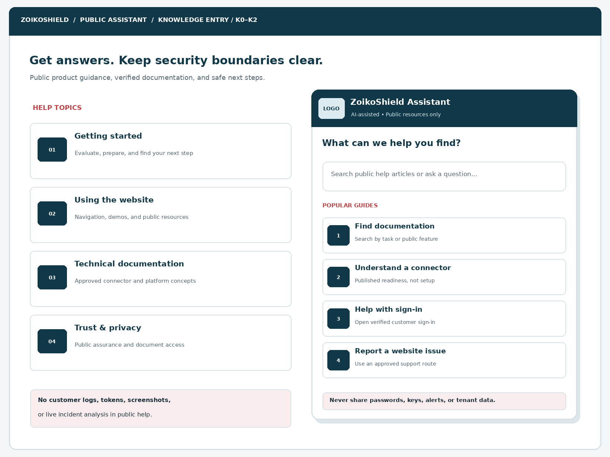
Figure 1. Desktop help landing concept. The wordmark area is a placeholder for the approved ZoikoShield logo and favicon.
ELEMENT | ENGINEERING ANNOTATION
D10-01 | Search input appears before topic cards; Enter triggers public search with server-side authorization and quotas.
D10-02 | Approved high-priority topics are config-driven; never infer product availability from internal menu screenshots.
D10-03 | Non-sensitive data warning remains visible and announced to assistive technology.
D10-04 | Exit and fallback leave the website functional, even if public AI, search or citation service fails.

02 / Mobile help and accessibility — K1 to K3
A single-column, keyboard-complete help experience at narrow widths.
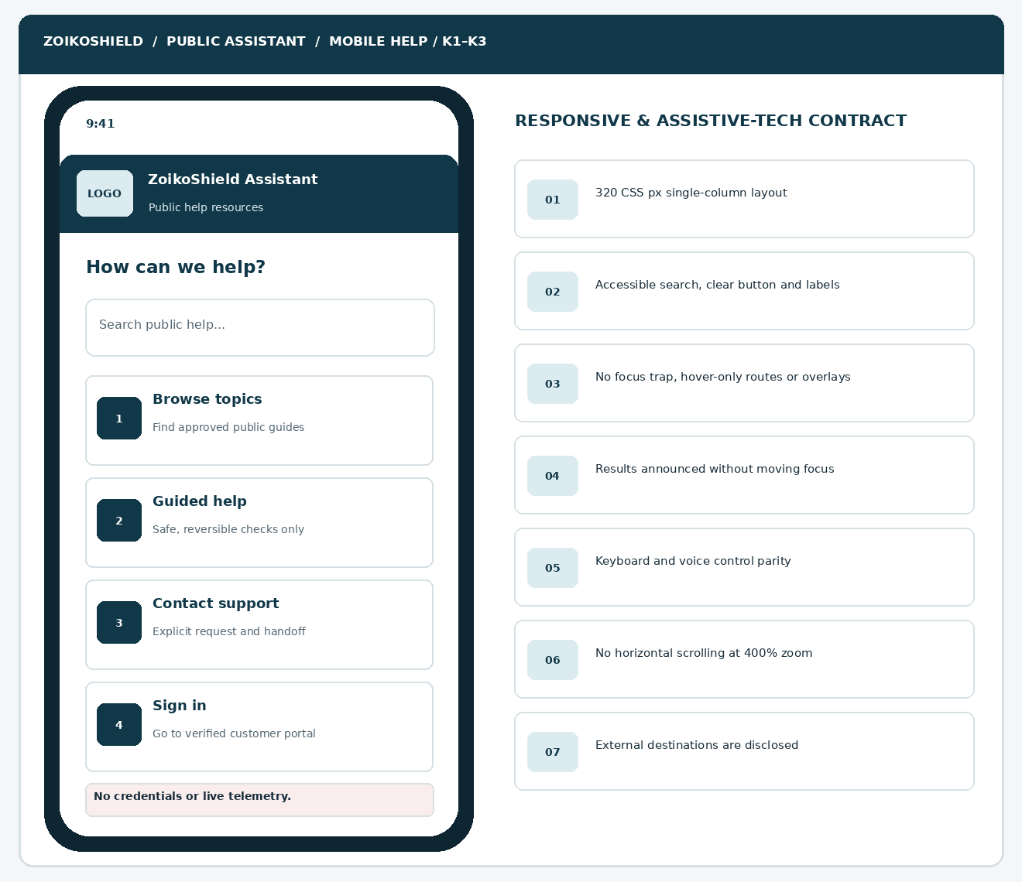
Figure 2. Mobile navigation concept illustrating a stacked search bar, topic cards and safe sign-in routing.
ELEMENT | ENGINEERING ANNOTATION
M10-01 | At 320 CSS px all controls reflow with no horizontal content scroll and at least 200–400% zoom.
M10-02 | Search, clear, topic, exit and retry have explicit accessible names and visible focus styles.
M10-03 | Screen-reader announcements report result counts, not every result body automatically.
M10-04 | The external authenticated sign-in destination opens separately without transferring guest privileges.

03 / Search results and public source discovery — K3 to K5
Use publisher-controlled retrieval, visibility filters and relevance grading.
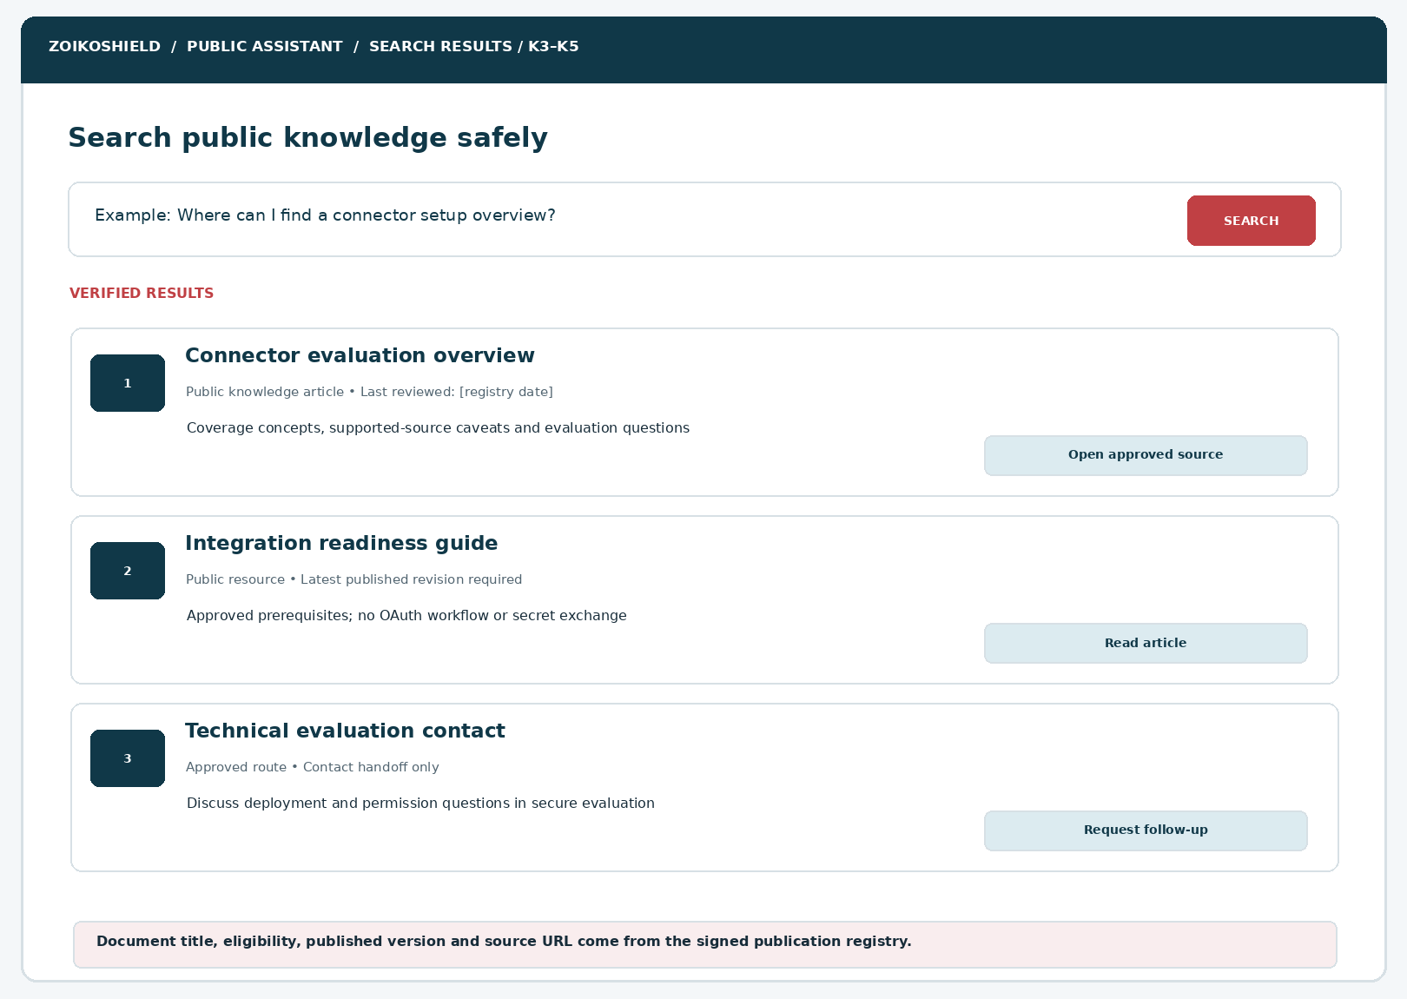
Figure 3. Results display approval metadata, source currency and distinct article versus handoff actions.
ELEMENT | ENGINEERING ANNOTATION
SR10-01 | Search term is bounded; returned items are allowed, current and versioned PUBLIC content.
SR10-02 | Each result shows title, article kind, last-reviewed metadata, excerpt and exact approved destination.
SR10-03 | Never render internal document IDs, tenant names, secrets, signed private file URLs or unverified availability.
SR10-04 | Zero results offers topic browsing, query revision or support route; it never invents a relevant answer.

04 / Guided troubleshooting and safe step feedback — K5 to K8
Troubleshooting is limited to allowed public-site and non-privileged documentation tasks.
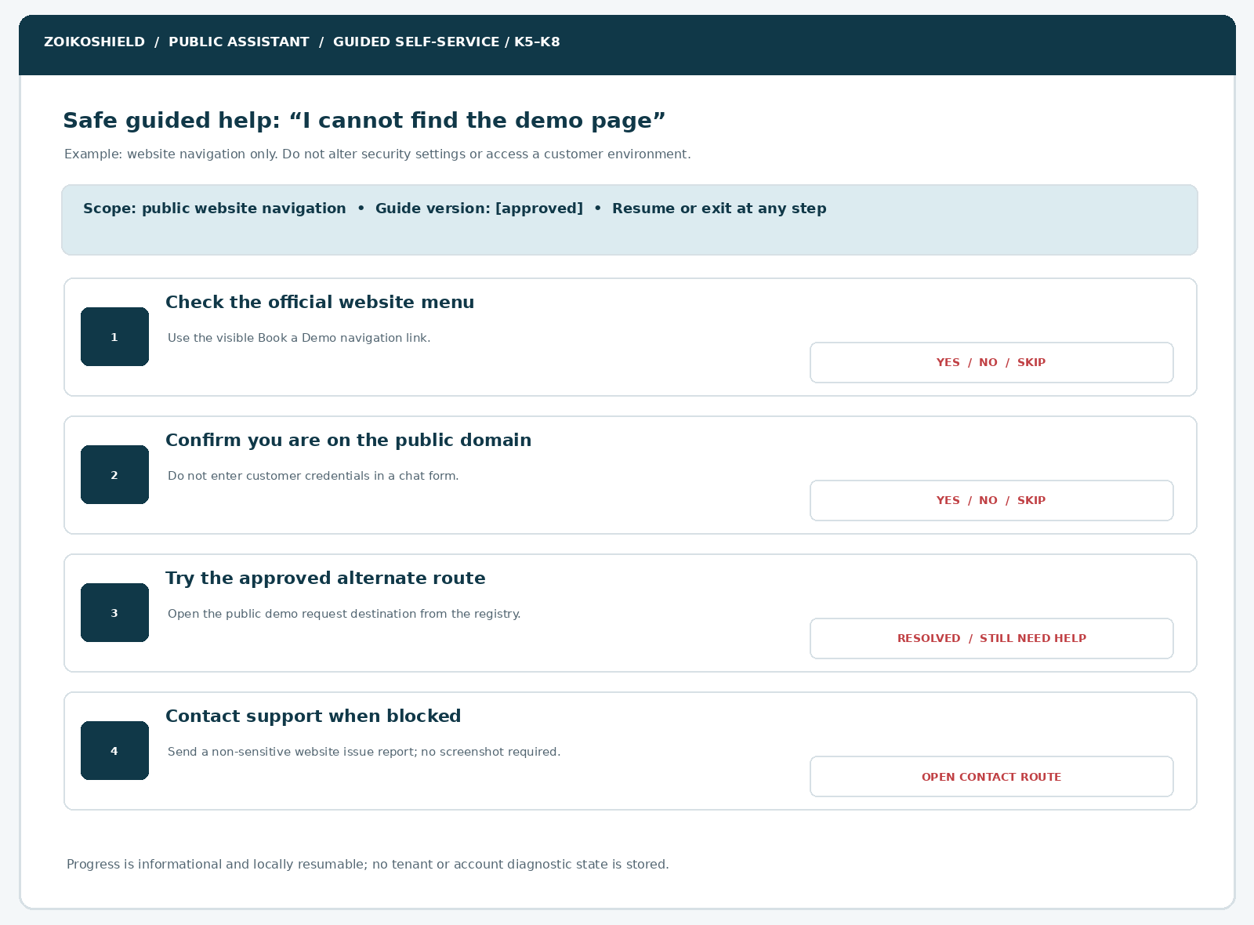
Figure 4. Example of reversible website-navigation help. The live registry determines actual destinations.
ELEMENT | ENGINEERING ANNOTATION
GT10-01 | Step count and branching are deterministic; model text can explain, but cannot invent new actions.
GT10-02 | Back, Skip, Resolved, Still need help and Exit are available; no forced progress.
GT10-03 | Do not recommend disabling MFA, alerting, EDR, encryption, logs, or firewalls as a troubleshooting step.
GT10-04 | No collection or upload of screenshots, logs, credential fragments, tenant identifiers or network captures.

05 / Evidence-rich responses and source revocation — K4 to K6
Approved citations are a required trust control, not a decorative footer.
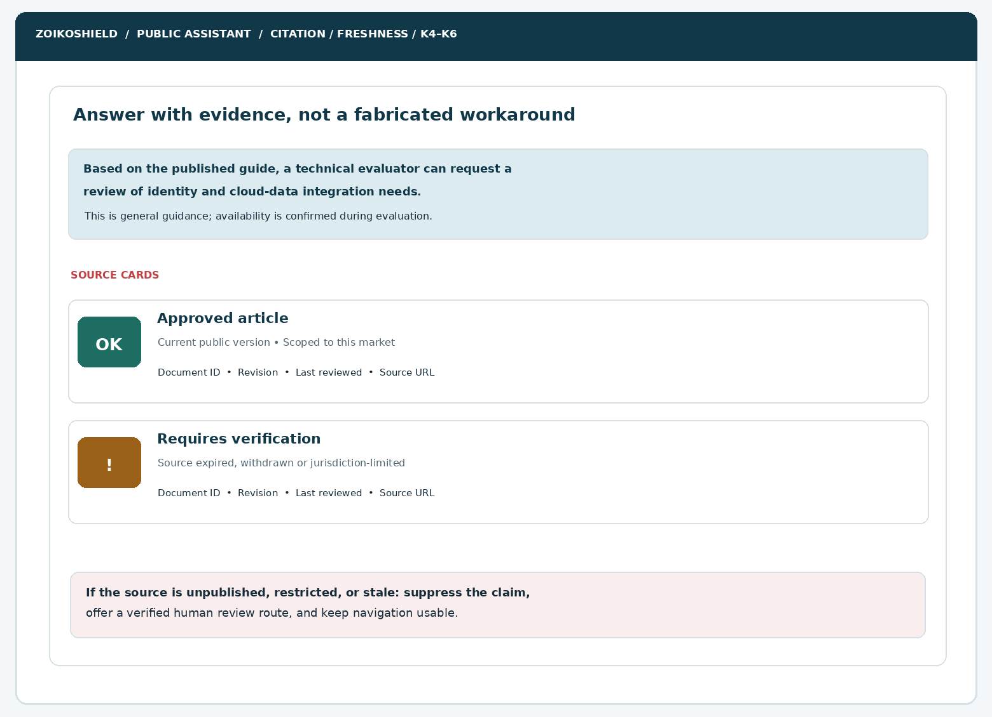
Figure 5. Side-by-side publication statuses: source eligible versus outdated or inaccessible.
ELEMENT | ENGINEERING ANNOTATION
P10-01 | The response must bind each material product claim to approved current source IDs and applicable markets.
P10-02 | Citation link must resolve to an allowlisted destination that retains the article version and relevant anchor.
P10-03 | Expired, withdrawn, private or mismatched content must fail closed rather than fall back to uncited synthesis.
P10-04 | A remediation message must distinguish “not verified” from “not available” and offer a governed follow-up.

06 / Resolution, escalation and source-failure screens — K8 to K13
A self-service resolution is not a customer service ticket confirmation.
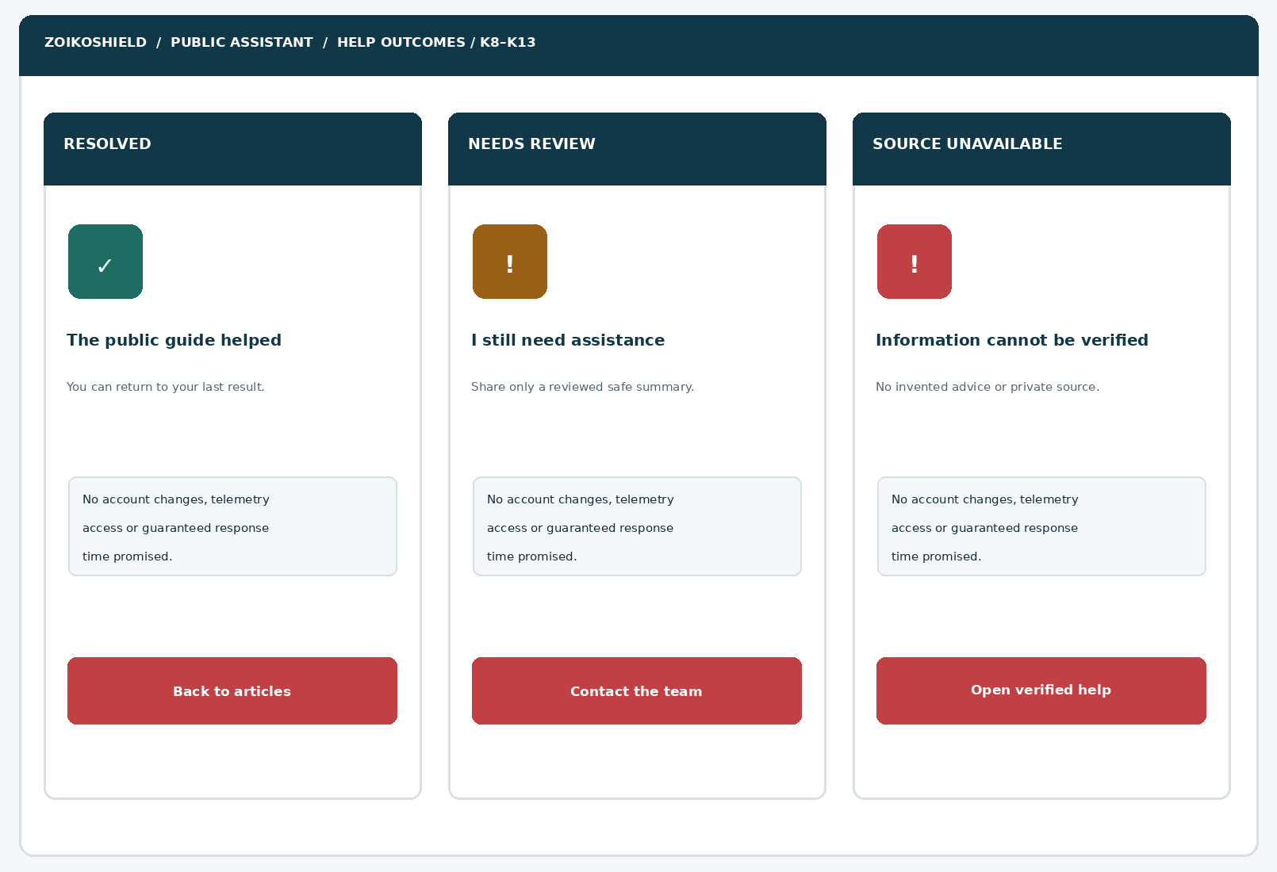
Figure 6. Three distinct final-state screens; each uses independent text, not status colors alone.
ELEMENT | ENGINEERING ANNOTATION
O10-01 | Resolved is recorded only after visitor feedback; it does not establish actual repair of a customer environment.
O10-02 | Escalation reuses the WF04 request-and-review intake, with explicit data sharing and durable acknowledgment.
O10-03 | Source, search and AI failures route to approved static help or a verified contact channel.
O10-04 | No response-time, incident-severity, ticket creation or live-human availability claims without actual confirmation.

07 / Deterministic knowledge and help state machine
Interaction model is auditable, predictable and independent of model wording.
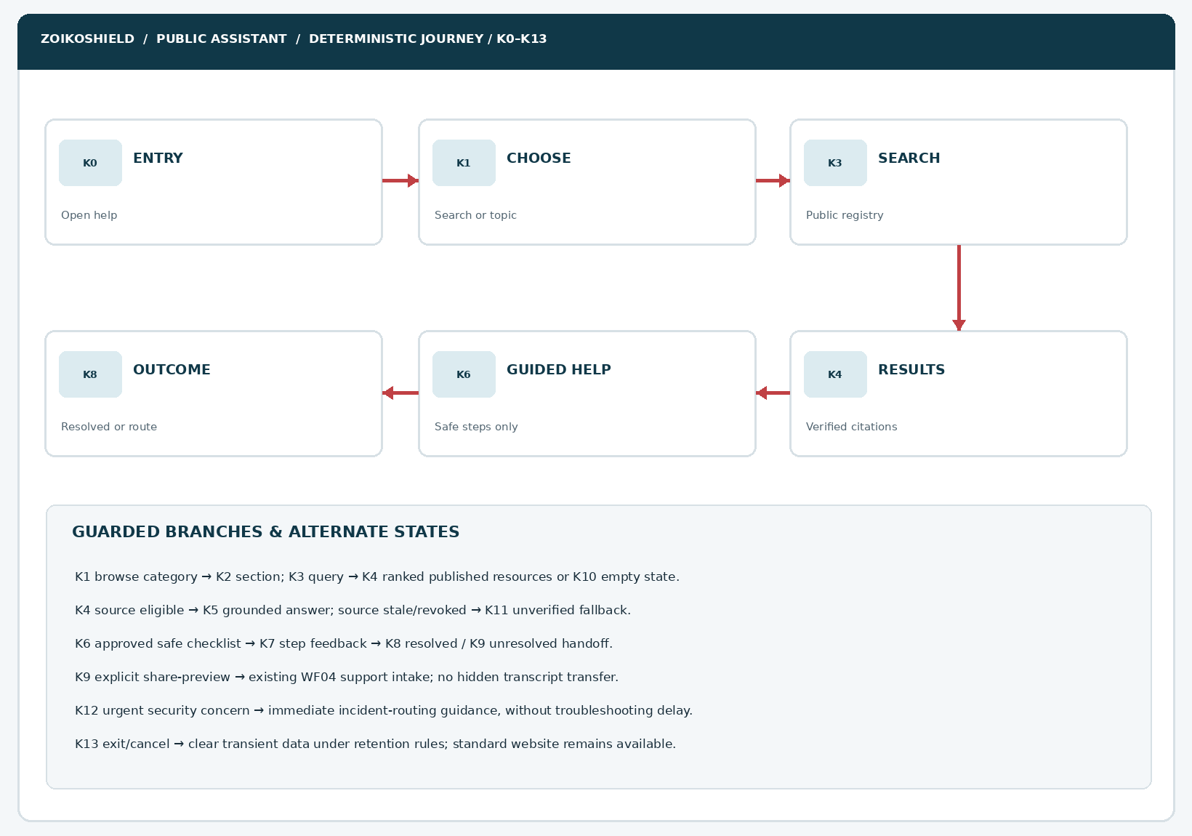
Figure 7. State and exception map K0–K13: published search, guided help, confirmation and safe incident routing.
ELEMENT | ENGINEERING ANNOTATION
SM10-01 | Policy engine chooses branch from approved intent and audience; model cannot override publication eligibility.
SM10-02 | Help flows carry only opaque public flow IDs and non-sensitive step selections; not tenant sessions.
SM10-03 | Expired knowledge, tampered URLs, abuse signals and prompt injections cannot cause private retrieval.
SM10-04 | Closing a panel restores focus and clears short-lived unauthenticated context per approved retention rules.

08 / Product requirements and content boundaries
CAPABILITY | ALLOWED PUBLIC BEHAVIOR | PROHIBITED BEHAVIOR OR ADDITIONAL GATE
General FAQs | Answer source-backed public company/product questions with citation and date. | Invent certification, live features, guaranteed uptime, user/customer numbers or license rights.
Public knowledge search | Filter published audience PUBLIC, market, language, effective date, and content status. | Query intranet, ticket databases, tenant documentation, SOC evidence, engineering runbooks or private indexes.
Safe guided help | Low-risk website navigation, resource location, definitions and next-step checks. | Alter browser security, collect credentials, test an external IP/domain, or execute code.
Existing customers | Link to allowlisted authenticated portal and official support paths. | Impersonate support staff or confirm customer identity from claims typed in chat.
Commercial / trust questions | Return to WF06/WF07 verified registers, with explicit unknown states. | Publish restricted contract values, unapproved third-party claims or unverifiable audit findings.
Potential incidents | Immediately show approved human incident route and user-owned response plan. | Investigate, triage live telemetry, grade incident severity or operate SOAR from public chat.

Success metrics and guardrails
Primary: independently confirmed completion of a public help task and accessible transition to the correct owned channel. Guardrails: cited-answer coverage, verified-source clickthrough, erroneous security claims, privacy/secret leakage, unsafe-action suggestions, unresolved query rate, accessible completion, complaint rate and useful escalation (not volume alone).

09 / Components ZS193–ZS205
Every component requires a stable identifier, event schema, empty/error/disabled states and a keyboard contract.
ID | UI COMPONENT | ENGINEERING ACCEPTANCE
ZS193 | Help Center launch link | Visible in approved website pages; launcher and expanded experience use shared focus state.
ZS194 | Help landing headline | Approved copy; declares AI assistance and public-only information boundary.
ZS195 | Public search input | Max 200 Unicode chars; paste sanitization, clear control, keyboard submit and helpful errors.
ZS196 | Topic category tiles | Server-configured published categories; cannot expose unpublished module titles.
ZS197 | Public search result count | Announced accessibly; no claims about private index size.
ZS198 | Result item card | Title, description, source eligibility, review metadata and primary action.
ZS199 | Filter chips | Kind, language, audience/public facet and relevance; accessible removable filters.
ZS200 | Source provenance metadata | Publisher ID, version, public revision and date, with no private lineage values.
ZS201 | Approved document link | Exact allowlisted URL; open safely with no credential-bearing query string.
ZS202 | Verified answer callout | Public only, evidence-linked; acknowledges uncertainty and source conditions.
ZS203 | Citation expansion panel | Shows source title/date/revision and stable destination; dismissible by keyboard.
ZS204 | Source freshness warning | Suppress unsupported positive claim when source is stale, revoked or uncertain.
ZS205 | No-results panel | Suggest browse, rephrase or contact; no synthetic nonexistent article.

10 / Components ZS206–ZS218
Safe self-service and escalation controls stay deterministic.
ID | UI COMPONENT | ENGINEERING ACCEPTANCE
ZS206 | Help flow intent selector | Only allow approved public issue categories; urgent incident intent preempts normal flow.
ZS207 | Guided step container | Step metadata from published signed guide registry; no arbitrary code/action fields.
ZS208 | Step instruction text | Plain-language, reversible, appropriate for anonymous website use.
ZS209 | Step feedback controls | Resolved / Still blocked / Skip / Back; no forced disclosure or technical data.
ZS210 | Guide progress indicator | Progress by numbered steps, not implied operational remediation percentage.
ZS211 | Source/flow version chip | Show documented published guide version; revoke live flow safely when superseded.
ZS212 | Escalation action card | Reuse WF04 safe support route; avoid auto-submission of prompt history.
ZS213 | Share-preview drawer | Explicitly show allowlisted topic, resource and step labels before any transfer.
ZS214 | Customer portal handoff | Verified current login destination; no public sessions or redirect secrets.
ZS215 | Urgent incident redirect | Visible immediate advisory and verified incident route; no public severity claim.
ZS216 | Degraded content fallback | Approved fixed route if model/retrieval fails; no dead-end spinner.
ZS217 | Feedback widget | Task helped? yes/no/skip; prevent analytics payload of full free text by default.
ZS218 | Close / restore control | Release resources and restore launcher focus; minimal ephemeral data retention.

11 / Canonical state contract and navigation policy
STATE | LABEL | USER-VISIBLE REQUIREMENT
K0 | CLOSED | Launcher available; no query sent until purposeful user interaction.
K1 | HELP_HOME | Search field, topic cards and public scope warning.
K2 | CATEGORY | Published, audience-filtered category content.
K3 | SEARCH_PENDING | Debounced query sent via public BFF; accessible in-progress status.
K4 | RESULTS_READY | Approved sources ranked with citation metadata.
K5 | ARTICLE_OR_ANSWER | Grounded snippet or linked public article; no private content.
K6 | GUIDED_HELP | User starts approved deterministic reversible guide.
K7 | STEP_REVIEW | Selected step and allowlisted yes/no/skip response.
K8 | RESOLVED | Task feedback only; no operational fix claim.
K9 | ESCALATE | Explicit reviewed information-sharing step; WF04 intake owns submission.
K10 | NO_RESULTS | Browsable static next step; no manufactured help text.
K11 | SOURCE_OR_SERVICE_UNAVAILABLE | Fail closed on citations; show verified static fallback.
K12 | SAFETY_REDIRECT | Potential incident or secret present; priority safe support pathway.
K13 | EXIT | Clean ephemeral state and restore normal website interaction.

Transition invariants
Every transition records only a pseudonymous flow ID, state code, outcome type and content registry version unless an approved privacy purpose expressly allows more. No state transition is authorized by LLM text, user-supplied prompt content or retrieved article instructions. Source revocation forces K11. Unsafe intent preempts to K12 without persisting the hazardous payload.

12 / Knowledge publication registry and policy evaluation
REGISTRY ATTRIBUTE | TYPE / MEANING | RULE
article_id, revision | Opaque stable IDs; immutable publication revision | Must resolve and be current before retrieval or display.
status, visibility | DRAFT / APPROVED / PUBLISHED / WITHDRAWN; PUBLIC / AUTHENTICATED / INTERNAL | Only status=PUBLISHED and visibility=PUBLIC are eligible.
market, locale, audience | Explicit applicability selectors | Deny if market or audience is absent or does not match request context.
effective_from, effective_to, reviewed_at | Temporal content and evidence metadata | Current eligibility and freshness must both pass.
claims, claim_category | Approved product and performance statements | No generated new certainty, legal commitments or availability.
canonical_url, allowed_host | Publisher-registered secure HTTPS route | Never form URLs from model output or user-supplied domains.
sensitivity, safety_risk | Security handling and safe-guidance categorization | Private, credential, live-operations or risky-action content is excluded.
owner, reviewer, checksum | Evidence ownership and content integrity metadata | Two-role publication review recommended; signed revision hash for integrity.

ISOLATION INVARIANT
Use a distinct public content index and credentials for the public assistant. A query-time filter on a mixed private/public knowledge store is not a sufficient primary boundary. Publication to the public index must itself be approval-controlled, scanned and reversible.

13 / Safe guide authoring and troubleshooting taxonomy
CLASS | ALLOWED EXAMPLES | DO NOT PUBLISH AS PUBLIC “FIX”
Public web navigation | Find product pages; explain menu paths; locate demo / pricing information. | Bypass account gates, manipulate identities, or spoof sign-in screens.
Website display issues | Check browser refresh or supported browser guidance only if published and tested. | Ask users to disable browser protections, antivirus, MFA or security filtering.
Public documentation gaps | Find source article; offer verified contact path. | Give unsupported vendor-specific commands or guess production connector scopes.
Private login and permissions | Point to official authenticated help center and supported identity recovery. | Collect OTPs, passwords, keys, security codes or perform user enumeration.
Connector troubleshooting | Explain conceptual readiness; route customer-specific logs to secured support. | Request OAuth tokens, cloud keys, production configuration exports or firewall changes.
Active cybersecurity concern | Suggest contacting existing internal response team / official secure incident channel. | Diagnose breach, assign severity, ask for indicators or direct containment actions.

Mandatory guide authoring controls
A guide is a reviewed state machine with guide_id, revision, permitted intents, locale, audience=PUBLIC, maximum steps, allowed response options, approved source IDs, human route and rollback/expiration status. Steps are plain text and link IDs. Reject commands, scripts, embedded HTML, open redirects, form fields for secrets, third-party URLs and arbitrary model-executable tools. Publish from a reviewed pipeline only.

14 / Proposed public API and BFF interface contracts
METHOD / ROUTE (PROPOSAL) | REQUEST / RESPONSE CONTRACT | GUARDRAIL
GET /api/public/help/home | Return versioned topic tiles, help notice and registry revision. | Cache only PUBLIC fragments; never tenant context.
POST /api/public/help/search | {query,locale,market,cursor}; {request_id,results[],next_cursor}. | Strict limits, audience ACL before and after retrieval, content provenance.
GET /api/public/help/articles/{id} | Approved article metadata/content with revision and canonical URL. | PUBLISHED/PUBLIC current only; 404 for restricted or withdrawn.
POST /api/public/help/guides/start | {guide_id,revision}; {flow_id,step,expires_at}. | Idempotent ephemeral flow; guide allowlist.
POST /api/public/help/guides/step | {flow_id,step_id,choice}; {next_state,step?}. | Reject out-of-order transitions and unsupported choices.
POST /api/public/help/feedback | {flow_id,outcome,source_ids}; {acknowledged}. | Minimal feedback, rate limits and abuse protection.
GET /api/public/help/routes/{route_id} | {route_id,kind,url,approved_at}; no user URL parameter. | Server-approved external host with HTTPS and redirect policy.

CONTRACT STATUS
All endpoints above are PROPOSED BFF contracts, not verified existing production routes. Align their final paths with ZoikoShield’s actual Next.js service and the approved public help architecture; do not expose shield-ingest, shield-action, shield-anchor or tenant-level shield-core endpoints.

15 / Backend processing sequence and service boundaries
STAGE | PROCESSING | FAILURE BEHAVIOR
1 User action | Browser sends bounded query to same-origin public BFF, no tenant credentials. | Network failure keeps standard help link available.
2 Abuse defenses | IP/device coarse abuse protection, CSRF for mutations, query bounds and bots policy. | 429 accessible retry message without leaking rules.
3 Publication gate | Resolve approved article index and registry revision under public-only identity. | Deny unpublished, market-inapplicable or revoked content.
4 Hybrid retrieval | Index lexical/semantic matches in PUBLIC index; rerank vetted eligible sources. | Empty-state result rather than broadening to private search.
5 Response composer | Use only citations to retrieved approved snippets; redact secret echoes. | Uncertainty or handoff instead of unsupported claim.
6 Client render | Sanitize markup; strict CSP; accessible citations, states and navigation. | Generic user-safe failure with observable request correlation ID.
7 Guided steps | Flow interpreter validates revision, transition and step status server-side. | Fail closed; preserve harmless progress when possible.
8 Human handoff | WF04 owns explicit share-preview, consent, durable request/receipt. | No confirmation until acknowledged by authoritative system.

Data flow and retention
Keep document queries and ephemeral flow choices separate from visitor identity; do not add unneeded fingerprinting. Define a purpose-specific retention matrix for query diagnostics, rate limits, feedback and support requests; encrypt in transit and at rest, mask secrets in request traces, and control analytics sampling. The public assistant must never inherit production SOC identities, customer RLS tenant context or internal analyst connectors.

16 / Security abuse-case matrix and defense in depth
THREAT / ANTI-PATTERN | PREVENTIVE CONTROL | REQUIRED NEGATIVE TEST
Prompt injection in public article | Treat all retrieved text as untrusted data; no tool privilege and no instruction elevation. | Document says “ignore prior rules”; response ignores it.
Unpublished document indexed | Publish-only pipeline + distinct public index + admission checks. | Internal doc canary never appears in response/results.
Retrieval race after revocation | Post-retrieval eligibility validation and short cache invalidation. | Withdrawn revision disappears even during cached search.
Cross-tenant / account request | Public BFF has no private tenancy scope; deny account resolution. | Request for another tenant returns only safe public guidance.
URL manipulation / open redirect | Registry-mapped destination IDs; reject arbitrary URLs. | Injected callback or redirect target denied.
Secrets pasted in query | Detect/mask and do not echo/store sensitive strings. | Canary token absent from logs/analytics/model payload.
Content/HTML injection | Plain text rendering or stringent sanitization and CSP. | XSS payload cannot execute in result or article.
Denial-of-service / cost exhaustion | Rate limit, max source chunks, timeouts and circuit-breakers. | Repeated long prompts fail safely; navigation remains.
Unsafe security remediation advice | Allowlisted public guide steps + protected terminology tests. | Instruction to turn off EDR/MFA is refused/routed safely.
False support case creation | Receipt gated on WF04 durable acknowledgement. | Search/help feedback never displays ticket success.

17 / Accessibility, performance and reliability requirements
QUALITY AREA | RELEASE EXPECTATION | VERIFICATION EVIDENCE
WCAG 2.2 AA objective | Semantic headings, labels, 4.5:1 normal-text contrast, visible focus, screen reader announcements. | Automated axe + NVDA/VoiceOver/TalkBack manual matrices.
Responsive layout | 320 CSS px reflow and up to 400% zoom; logical heading and reading order. | Chrome, Safari, Firefox + Android/iOS manual tests.
Interaction | No keyboard traps, predictable focus after close, no invisible status-only color state. | All K0–K13 keyboard and voice-input tests.
Answer responsiveness | Proposed P95 first meaningful search response <= 2.5 s on agreed reference environment. | Production-like synthetic run with document-count and load baselines.
Reliability | Approved static Help Center remains usable during AI/index outage. | Chaos test AI unavailable, stale registry and BFF errors.
Localization | American English baseline; locale-specific articles and explicit fallback, not mixed jurisdictional claims. | Locale/applicability fixtures and snapshot tests.
Security telemetry | Coarse failure counts, source revocation alerts, no raw sensitive transcript logging. | Security and Privacy signed observability evidence.

TARGETS VS. CLAIMS
Performance targets and publication controls are design acceptance requirements, not proof of current behavior. Accessibility conformance must be established through actual testing, including assistive technology, rather than asserted from this Word document alone.

18 / Analytics, consent and customer trust
EVENT | FIELDS PERMITTED BY DEFAULT | EXCLUDED BY DEFAULT
help_opened | Anonymous flow token, timestamp bucket, locale, page surface. | IP address stored indefinitely, tenant ID, customer profile or raw transcript.
search_submitted | Query length/category, registry version, result count, latency bucket. | Full search text with PII or secret content.
source_opened | Article ID, revision, click origin and publisher class. | Signed private source URL or source payload.
guide_step_done | Guide ID/revision, safe step ID, choice code and dwell bucket. | Screenshots, credentials, environment data or commands.
help_outcome | Resolved/unresolved/skip; friction reason code. | Unreviewed complaint free text / hidden contact data.
support_handoff | Only consented purpose and review-approved public topic labels. | Chat transcript or session memory without separate affirmative consent.

Consent behavior
Reading public help requires no lead form or marketing opt-in. Analytics must honor applicable privacy and cookie choices. Any request to contact support uses the existing WF04 data-sharing review and privacy notice; a “No” response to optional marketing cannot block help access.

19 / Release-blocking tests AT225–AT243
TEST | BLOCKING EXPECTED OUTCOME
AT225 | Public help entry renders and closes correctly without breaking primary website navigation.
AT226 | Only PUBLISHED/PUBLIC documents appear in topic browser; DRAFT/INTERNAL are excluded.
AT227 | Market, locale and audience eligibility filters are enforced both before and after retrieval.
AT228 | A revoked document is unavailable in search, cache, source card and synthesized response.
AT229 | Result cards display source title, revision, public review date and approved canonical URL.
AT230 | No-result query renders K10 browse/rephrase/escalate rather than fabricated citations.
AT231 | Document URL cannot be constructed from model/user input; redirects outside allowlist fail.
AT232 | A public prompt cannot query tenant cases, evidence, connectors, alert telemetry or secrets.
AT233 | Source prompt injection cannot change assistant roles, tool calls or content classification.
AT234 | Pasted credential/API-key canaries are absent from model payload, logs and analytics.
AT235 | Source cards with withdrawn/expired evidence suppress unsupported positive claims.
AT236 | An article lacking current market approval produces honest uncertainty, not a universal claim.
AT237 | Search result metadata and links are navigable with keyboard and announced accessibly.
AT238 | Mobile UI functions at 320px and 400% zoom with no trapped, hidden or clipped controls.
AT239 | Screen-reader result-count announcements do not steal keyboard focus.
AT240 | Guide interpreter rejects out-of-order steps, forged flow IDs and invalid choice values.
AT241 | Guide remains usable with Back, Skip, Exit and explicit step review.
AT242 | Safe guidance never recommends disabling EDR, MFA, logging, firewalls or encryption.
AT243 | An active-incident intent immediately switches to WF04 priority route without requesting logs.

20 / Release-blocking tests AT244–AT262
TEST | BLOCKING EXPECTED OUTCOME
AT244 | No flow can claim an account, incident or production security state has been checked.
AT245 | User feedback remains voluntary; help resources stay accessible after Skip.
AT246 | Help resolution feedback is not misrepresented as a technical fix or closed support case.
AT247 | WF04 escalation shows exact selected fields and requires explicit reviewed submission.
AT248 | Unsolicited full chat transcripts cannot be transferred into CRM/support tools.
AT249 | Support request success appears only after durable authoritative acknowledgment.
AT250 | Network-uncertain handoff state does not show false receipt; retry is idempotent.
AT251 | Existing-customer links use verified portal registry destinations without auth-data leakage.
AT252 | AI/retrieval timeout gracefully falls back to verified static help.
AT253 | Rate-limited search shows safe retry guidance without blocking ordinary website access.
AT254 | HTML/script payloads in user queries and document bodies cannot execute.
AT255 | Very long/malformed Unicode search payloads are rejected without exception leaks.
AT256 | Query logs have no prohibited raw PII/secret text and observe approved retention policies.
AT257 | Analytics events honor applicable consent preferences and data minimization.
AT258 | Cache keys cannot mix distinct locales, markets, or publication epochs.
AT259 | No hidden user identity or tenant is inferred from IP, referrer or typed email.
AT260 | US English microcopy, date/source labels and focus-state accessibility pass.
AT261 | Production feature flag disables AI layer while static help/search fallback works.
AT262 | Founder, Brand, Security, Privacy, Engineering, QA and SRE release gates are evidenced.

21 / Critical design analysis and incorporated refinements
POTENTIAL FAILURE | REFINEMENT IN WF10 | ENGINEERING / QA PROOF
Generic AI answers masquerade as official instructions | Source-eligibility engine plus visible verifiable citations. | Citation/claim and source revocation harness.
Search mixes private and public documents | Isolate separate PUBLIC index with review-controlled publication. | Private tenant and internal content canaries absent.
“Troubleshooting” encourages unsafe cyber actions | Strict public-safe guide taxonomy with no executable actions. | Unsafe advice adversarial tests and allowlisted step schemas.
User finds no article and is abandoned | No-results screen with browse, query revision and human contact. | K10 and K11 fallback UX tested.
Knowledge claims silently go stale | Temporal publication controls and cache/response revalidation. | Withdrawn revision kill-switch and freshness monitoring.
Visitor thinks issue is fixed by an AI answer | Resolved status based on user feedback only and clear context. | Content assertion and analytics validation tests.
Support routing silently shares sensitive context | WF04 explicit preview and no transcript sync by default. | Network capture before user-approved submission.
Mobile controls are crowded or screen reader skips content | Single-column semantic cards and result/live-region rules. | Assistive-tech + reflow matrix.
Internal capability claims leak into product guidance | Public claim registry and source approval review. | Cross-check all claims with Demo Presenter claim sheet.

DESIGN CONCLUSION
WF10 prioritizes safe factual self-service rather than maximizing automation. An anonymous assistant should remain competent at published information and rigorously limited on customer-account operations, security investigations and privileged actions.

22 / Engineering work packages, rollout and governance
PACKAGE | RESPONSIBLE OWNER | EVIDENCE AT COMPLETION
WP10-01 Content ownership | Product + Technical Writing | Published-public articles, taxonomy, approved dates and revision ownership.
WP10-02 Publication control | Security + Data Platform | Separate PUBLIC index, release/revoke control, integrity and access tests.
WP10-03 UX implementation | Frontend + Design + A11y | Seven Figma variants, ZS193–ZS218, focus/mobile/component QA.
WP10-04 Guided help engine | Backend + Security | Deterministic approved step interpreter and K0–K13 transition tests.
WP10-05 Search and grounded responses | Search + AI Engineering | Vetted retrieval, citations, freshness gates, prompt-injection defense tests.
WP10-06 Support integration | Support Ops + RevOps + Privacy | WF04 preview and authoritative receipt, minimal data transfer.
WP10-07 Observability | SRE + Security + Privacy | Outage, revocation and unsafe-answer alerts; no raw secret capture.
WP10-08 Release assurance | QA + Product + Legal | AT225–AT262 signed evidence; rollback/fallback and brand acceptance.

Rollout decision gates
GATE | REQUIRED DECISION / DELIVERABLE
G0 Founder / Product | Approve public help categories, troubleshooting boundaries and design variants.
G1 Brand / Legal | Approve persona display, company assets, user copy and public claims.
G2 Knowledge governance | Approve PUBLIC corpus eligibility, controlled publishing and source revocation.
G3 Security / Architecture | Confirm isolation, threat model, API privileges and runtime failure boundaries.
G4 Privacy / Support | Confirm data minimization, optional feedback and WF04 explicit intake flow.
G5 Accessibility / QA | Evidence all controls, devices, source lifecycles and tests AT225–AT262.
G6 SRE / Release | Feature flags, monitoring, rollback, static help fallback and operational ownership.

23 / Engineering handoff, reference baseline and approval

Reference baseline
SOURCE | DESIGN USE / CAVEAT
ZoikoShield Chatbot Wireframes 01–09, October 2026 | UI patterns, consent, support intake, authenticated boundary, component/test continuity.
ZoikoShield Live Demo Master Guide, October 13, 2026 | Backend-service domains and public/authenticated differentiation; demonstration claims require release verification.
ZoikoShield Complete Frontend, Backend & Email Guide v3 | Public service pages, Next.js BFF pattern and product lifecycle; not proof of public chatbot APIs.
ZoikoShield Customer Demo Presenter Playbook | Claim discipline and prohibition on overstated compliance, connector readiness and support commitments.
Zoiko Group Public AI Chatbots Naming & Engineering Guide v7.7 | Zhield as internal working identity; product-specific public scope, release gates and branding.
WCAG 2.2 (W3C); OWASP LLM & API Security | Design requirements for accessibility, injection, excessive agency and API privilege minimization.

Design-to-build handoff manifest
This Word document includes seven embedded visual wireframes, component IDs ZS193–ZS218, states K0–K13, content-registry and BFF target schemas, security controls, measurable nonfunctional requirements, AT225–AT262 release tests and a controlled decisions register. On approval, Design supplies accessible component variants with official brand assets, Engineering validates actual API implementation feasibility and QA records test evidence per ID.
SEQUENTIAL APPROVAL
This deliverable is Wireframe 10 only. Await explicit Founder approval before preparing Wireframe 11. Design approval does not imply production feature availability, legal clearance, certification, penetration-test completion or public launch approval.

APPROVER | DECISION / SIGNATURE / DATE
Founder / Product | Pending
Brand / Legal | Pending
Security / Privacy | Pending
Backend / Architecture | Pending
Frontend / Accessibility | Pending
QA / SRE | Pending

