ZOIKOSHIELD / GLOBAL PRODUCT • DESIGN • SECURITY • ENGINEERING

Public AI Chatbot
Detailed Wireframe 11
Conversation Feedback, Privacy Controls & Session Management
DOCUMENT CONTROL
v1.0 • October 24, 2026 • ZS-CHAT-WF-011 • American English • Engineering design for founder approval. This document specifies proposed UI and API behavior, not verified deployment, approved legal notices, or proof of data-erasure capability.

Executive product decision
Give visitors understandable control over their anonymous public chatbot experience: optional feedback; a clear view of the current conversation; safe local copy/save actions; genuinely informed chat-clearing decisions; consent choices; and an authoritative route for privacy rights requests. The interaction must never overclaim deletion, shared history, or confidential account access.
CONTROL | MANDATORY BASELINE
Sequence | WF01 launcher → WF02 conversation → WF03 demo → WF04 support → WF05 solution discovery → WF06 pricing → WF07 trust → WF08 integrations → WF09 onboarding → WF10 help → WF11 privacy and session controls.
Numbering | 26 new components ZS219–ZS244; 36 release-blocking tests AT263–AT298; 15 states P0–P14.
Assistant identity | Use ZoikoShield Assistant as the public-safe display placeholder. “Zhield” is an internal working name pending formal separate legal and brand approval.
Platform boundary | This is an anonymous public website experience, not the authenticated ZoikoShield SOC copilot. No customer account, tenant information, SOC cases, telemetry or security actions.
Data rights | Clear visible chat ≠ all server data erased. Data-access or deletion inquiries route through verified privacy controls with authoritative receipts and any required identity verification.
User trust | Optional choices stay optional, no dark patterns or preselected marketing consent, and no hidden transfer of chat content during a support handoff.

FOUNDER REVIEW FOCUS
Approve the exact menu labels and data-handling intent. Engineering, Privacy, Legal and Security must reconcile actual storage, regional data rights, vendors and retention periods before these controls can be deployed as true product claims.

01 / Desktop conversation settings — P0 to P3
The main conversation remains readable while settings are a distinct, accessible panel.
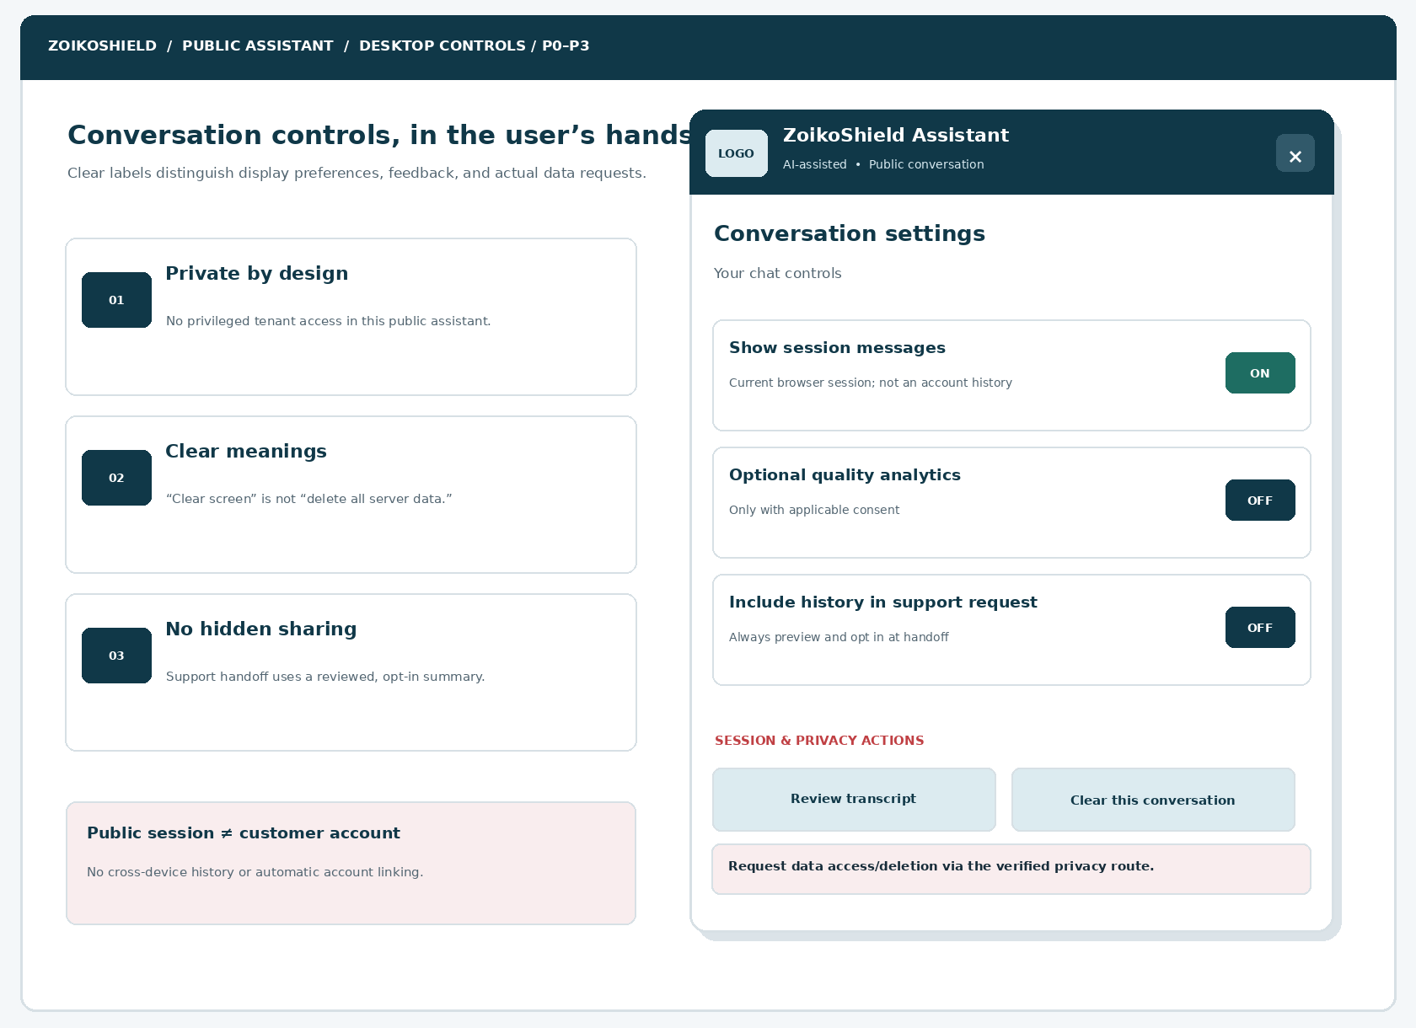
Figure 1. Desktop concept showing session controls and unambiguous descriptions; logo is a placeholder for the official approved product asset.
ELEMENT | ENGINEERING ANNOTATION
D11-01 | Settings entry stays near conversation actions; it is keyboard operable and does not obscure a response unexpectedly.
D11-02 | Current-session display switch is a UI preference; do not represent it as server retention control.
D11-03 | Optional analytics consent uses separate scope, neutral language and a permitted default determined by legal settings.
D11-04 | Public privacy route is verified and does not reveal an internal DPO name or unapproved address.

02 / Mobile settings and assistive technology — P2 to P4
Tap-friendly priorities; no horizontally scrolling consent controls.
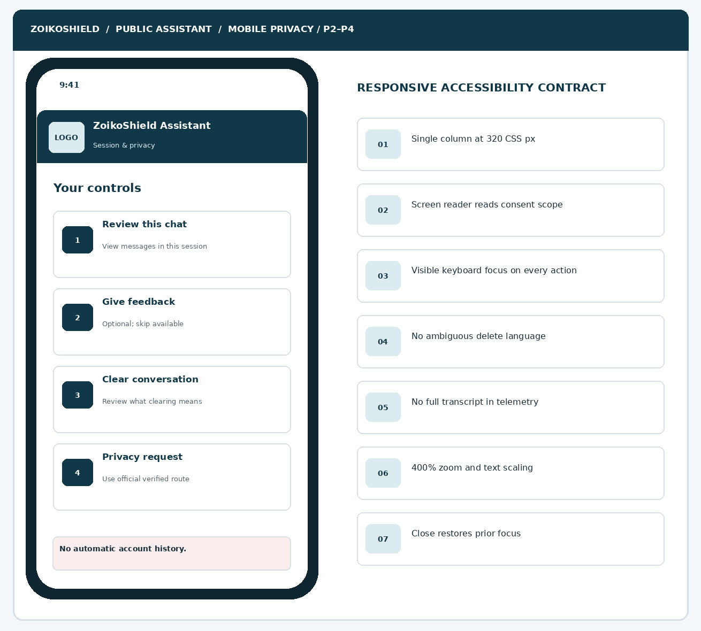
Figure 2. Mobile one-column control hierarchy with distinct feedback, chat clearing and privacy request destinations.
ELEMENT | ENGINEERING ANNOTATION
M11-01 | 320 CSS px baseline with 200–400% reflow and no horizontal content scroll except genuine two-dimensional content.
M11-02 | All choices are native controls with accessible names, states, purpose and focus restoration.
M11-03 | Privacy action names include their outcome and do not rely on color or icons alone.
M11-04 | The normal site and emergency/security contact paths remain available if session services fail.

03 / Helpful-answer feedback — P4 to P6
Measure task usefulness without making the user disclose more than necessary.
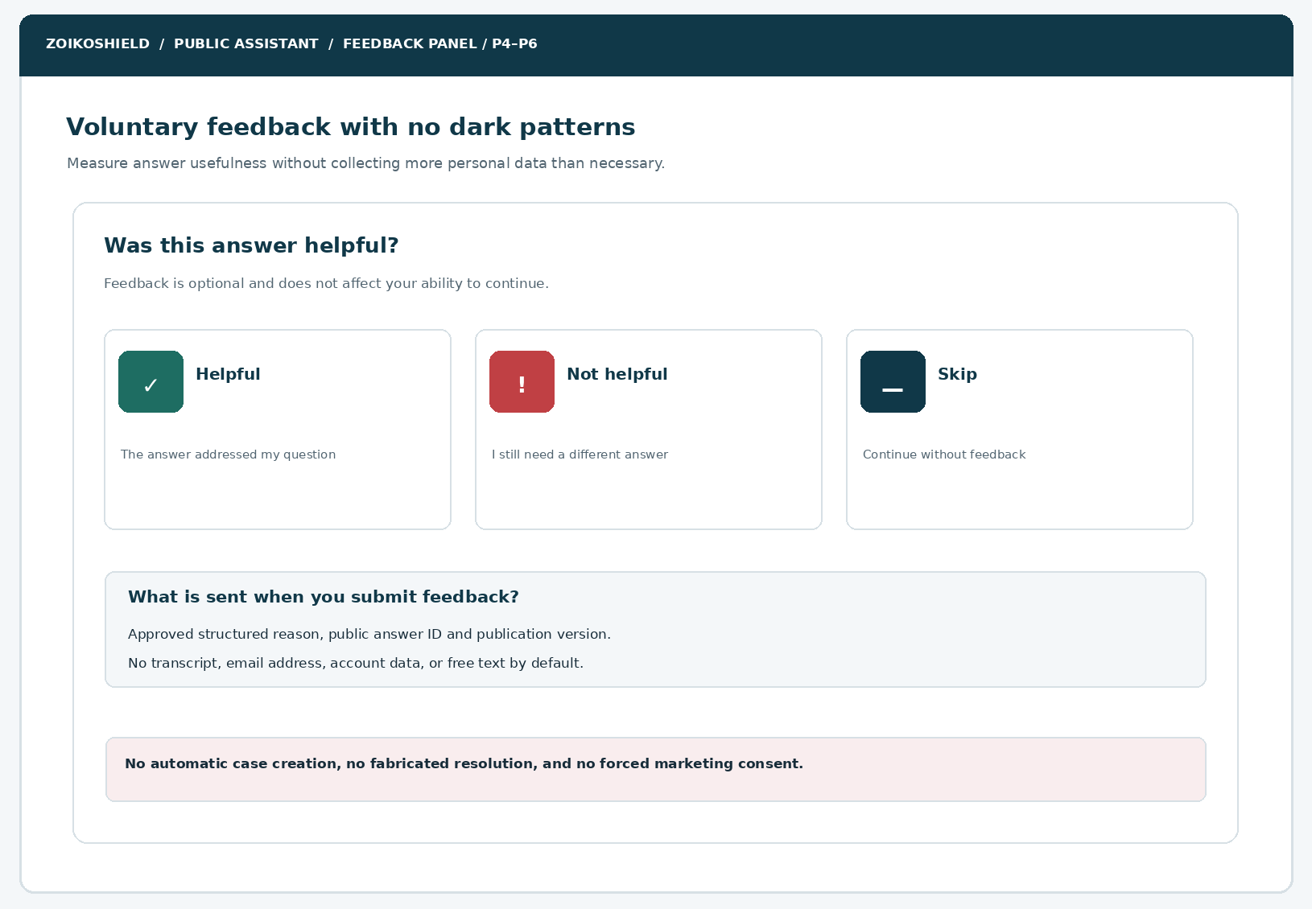
Figure 3. Optional post-answer feedback states and approved minimized feedback event attributes.
ELEMENT | ENGINEERING ANNOTATION
FB11-01 | Helpful, Not helpful and Skip are equally reachable; feedback is not required to continue.
FB11-02 | Submitted status requires an authoritative response; duplicate clicks are idempotent.
FB11-03 | Capture structured answer ID, public source version and optional reason only; no full transcript or free text by default.
FB11-04 | Negative feedback cannot automatically create a customer support case or infer a breach/incident.

04 / Clearing visible messages vs privacy erasure — P6 to P9
Two conceptually separate operations with explicit confirmation and accurate outcomes.
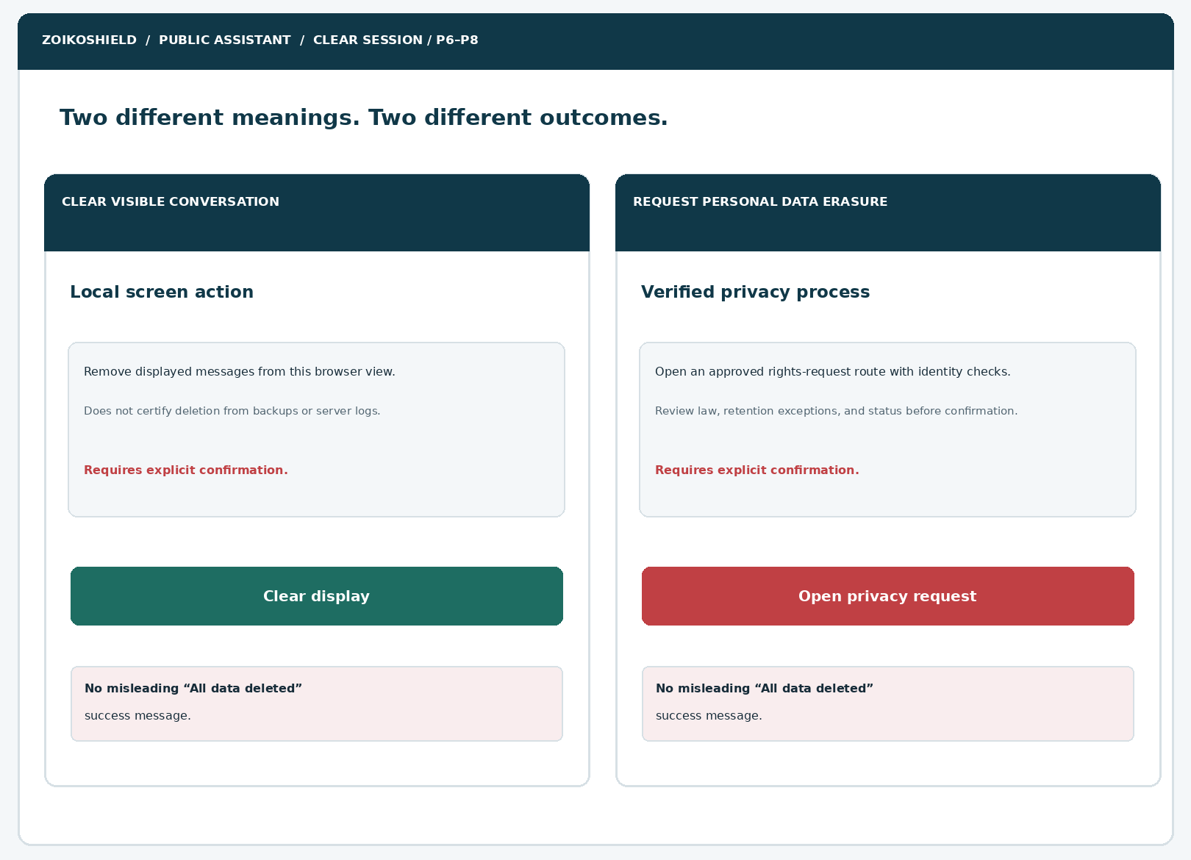
Figure 4. Desktop parallel outcomes that prevent ambiguous “delete my chat” messages.
ELEMENT | ENGINEERING ANNOTATION
CL11-01 | For clear-display, name specific local storage behavior and whether an active server session remains subject to retention.
CL11-02 | Clear action requires scope preview and optional Cancel; an accepted action returns to an empty welcome view.
CL11-03 | Privacy erasure requests require separate rights handling, legal exception review and verified system acknowledgment.
CL11-04 | Never claim global or backup deletion, or imply that clearing the panel affects audit/security logs.

05 / Transcript review, copy and explicit sharing — P3 to P12
User-initiated portability is distinct from implicit transcript disclosure.
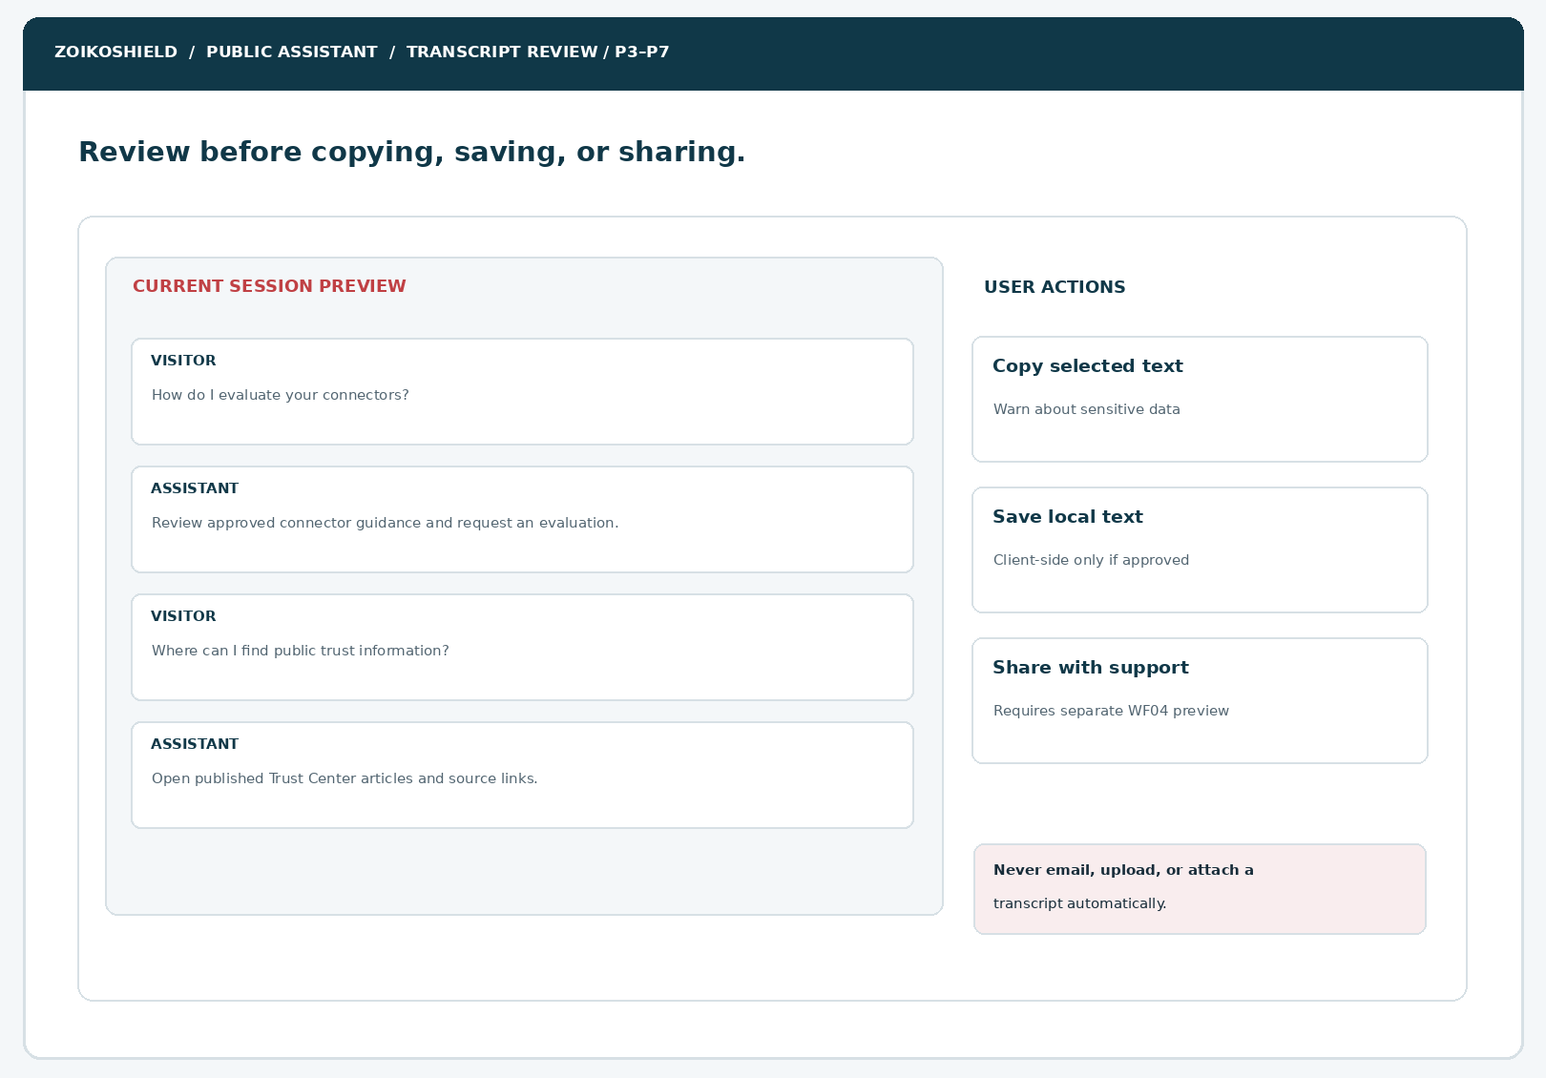
Figure 5. Session preview with local copy/save options and a separately gated support handoff.
ELEMENT | ENGINEERING ANNOTATION
TR11-01 | Review shows only messages from the current eligible session; no arbitrary historical or cross-device data.
TR11-02 | Client-side copy or local text export is only enabled if the approved policy permits it; warn users about sensitive content.
TR11-03 | Before WF04 support handoff, show the exact redacted fields and require an opt-in confirmation.
TR11-04 | Do not send full transcript through analytics, CRM, email, URL query parameters or support logs.

06 / State machine and consent/rights exception branches
Maintain deterministic UI state separate from storage truth.
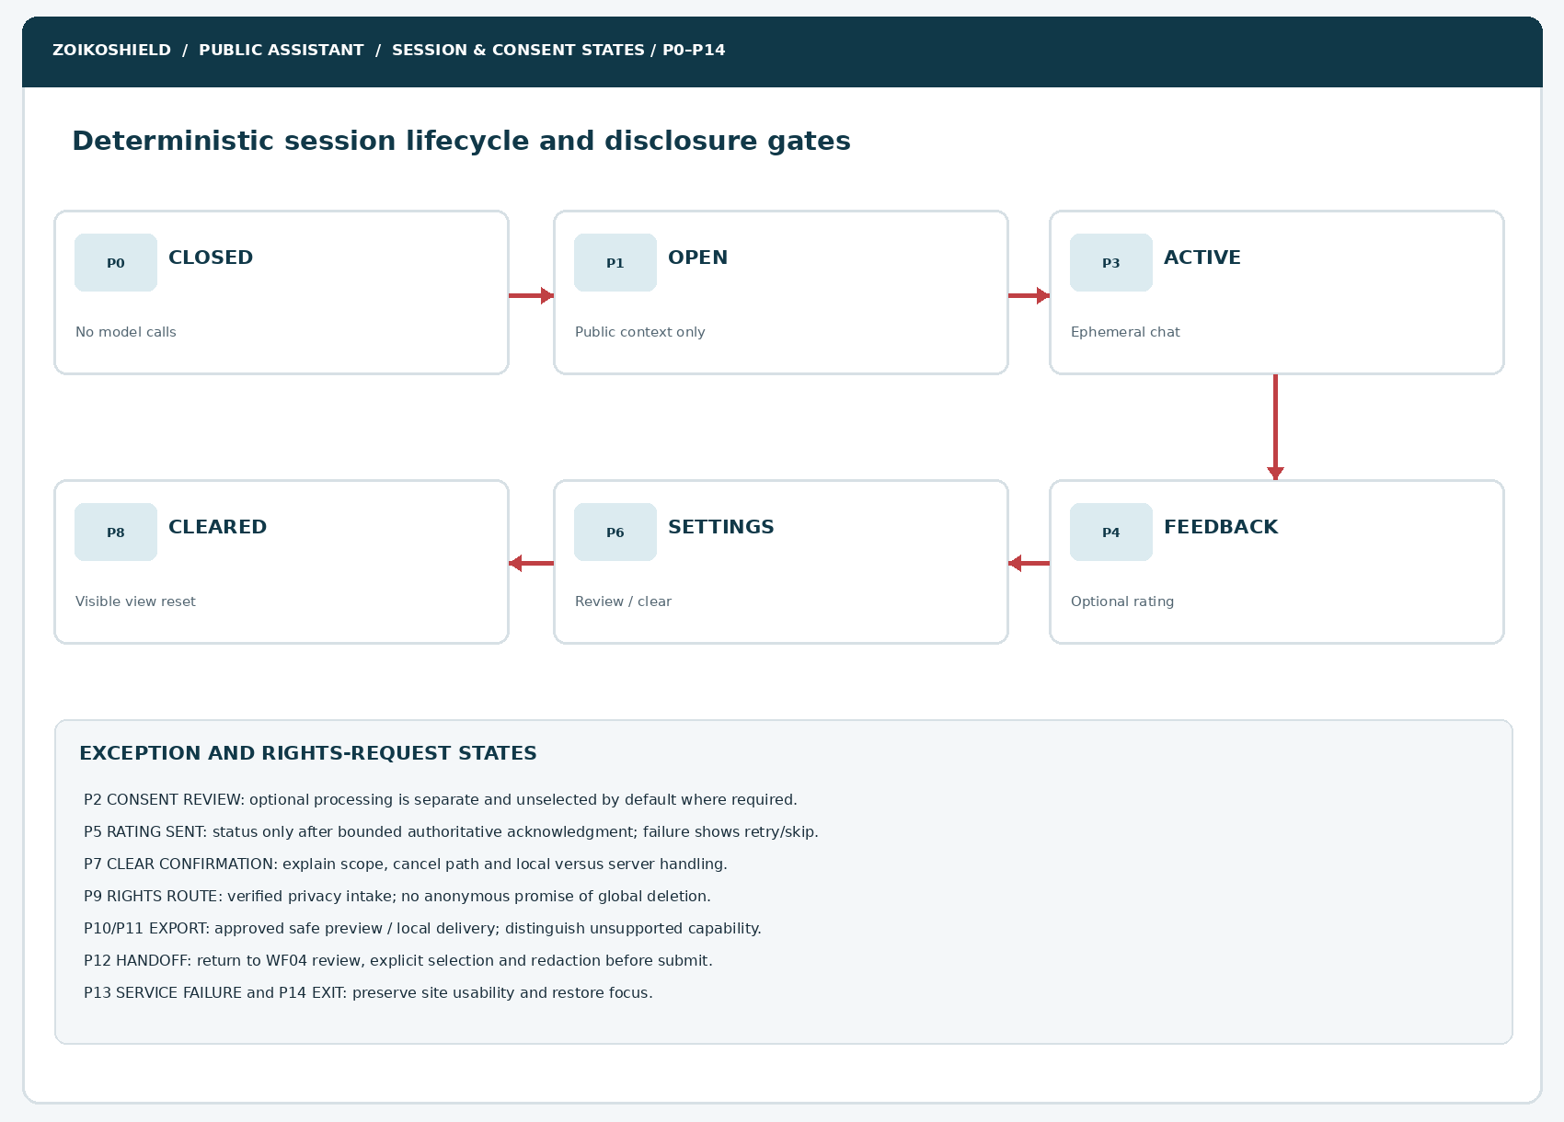
Figure 6. States P0–P14; model-generated text has no authority to alter consent or deletion results.
ELEMENT | ENGINEERING ANNOTATION
ST11-01 | Backend attests whether feedback or rights request is accepted; UI derives the final receipt only from that response.
ST11-02 | Consent changes immediately affect optional analytics collection and any approved vendors.
ST11-03 | Expired guest sessions lose functionality safely; user can start a new public session without account impersonation.
ST11-04 | An unavailable privacy service still exposes verified contact instructions; never fake a request number.

07 / Confirmations, uncertain outcomes and fallbacks
Only clear acknowledgments support a success claim.
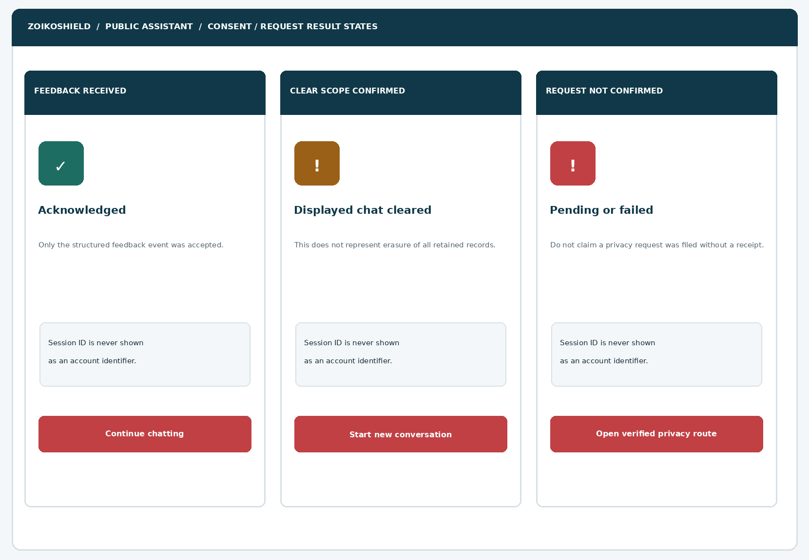
Figure 7. Distinct receipts for feedback, local clear actions, and unconfirmed rights requests.
ELEMENT | ENGINEERING ANNOTATION
RC11-01 | “Feedback received” appears only after feedback-service acknowledgment.
RC11-02 | “Displayed chat cleared” reports only confirmed local UI clearing, not total data erasure.
RC11-03 | A network-uncertain privacy request offers safe retry or official external route with an idempotency key.
RC11-04 | Any outcome preserves normal site navigation, user control, and WCAG-compliant status announcements.

08 / Scope, non-goals and privacy semantics
AREA | PERMITTED PRODUCT BEHAVIOR | PROHIBITED CLAIM OR ACTION
Anonymous conversation | Current session transcript preview; ephemeral session identifier; approved automatic expiration. | Implicit login, cross-device history, persistent customer identity, durable chat archive without legal basis.
Feedback | Optional structured helpful/not-helpful, reason codes and local confirmation. | Forced text explanation, PII capture by default, unsolicited case/CRM creation.
Consent | Present controls and details for optional processing where applicable; store governed purposes and versions. | Bundled agreement, preselected optional marketing consent, UI switch with no technical enforcement.
Clear chat | Clear current displayed message list and approved browser storage in confirmed scope. | Claim universal server, backup, security-log or third-party erasure.
Privacy rights | Use legal-reviewed route for access, deletion, objection or inquiries as applicable by jurisdiction. | Promise unconditional erasure, instant completion, or anonymous account-data export.
Copy / download | User-triggered selected copy or approved sanitized local export. | Silent automatic email, CRM attachment, remote share or unsafe export link.
Support handoff | Reuse WF04 explicit review, minimization and receipt semantics. | Attach transcript automatically or leak sensitive sources to support agents.
Operational chat | Link separately to verified authenticated help; new secure context where appropriate. | Reuse anonymous guest authority to retrieve customer tenant or incident records.

Operational success and failure metrics
Primary: users can find and understand a privacy control and complete the intended action without inaccurate data-processing claims. Track voluntary feedback engagement, clarification requests, abandoned privacy-intake attempts, local-clear errors, consent-enforcement failures, improper sharing, rights-request receipt failures, 320px task success, screen-reader completion, and any data-leak incidents. Do not optimize toward maximizing permission opt-ins.

09 / Components ZS219–ZS231
Controls are semantic, versioned and subject to legal-copy publication review.
ID | UI COMPONENT | BUILD REQUIREMENTS
ZS219 | Conversation settings button | Keyboard focusable with an accessible name and accurate expanded state.
ZS220 | Settings panel header | Display official logo slot, “public assistant” notice and clear close control.
ZS221 | Session scope description | Explain current browser/session behavior, retention and limits from approved policy.
ZS222 | Privacy notice link | Allowlisted current policy version, market and language; no guessed policy URL.
ZS223 | Optional analytics preference | Neutral consent control; affects approved vendors and collection immediately.
ZS224 | Marketing communications preference | Separate from analytics and support consent; only show if relevant and lawful.
ZS225 | Feedback entry point | Appears for eligible public answer; never interrupts response reading.
ZS226 | Helpful rating control | Clear radio/button selection and one submit confirmation path.
ZS227 | Unhelpful reason selector | Structured optional reasons; no raw personal data input required.
ZS228 | Feedback skip and dismiss | Equally reachable; no retaliatory feature restrictions or repeated nagging.
ZS229 | Feedback processing status | Pending, accepted, rejected, unavailable; live-region status accessible.
ZS230 | Session transcript view | Includes only current approved public messages; scrub internal metadata.
ZS231 | Transcript select/copy | User initiated, no hidden clipboard collection, and safe warning before copying.

10 / Components ZS232–ZS244
Session control design must match actual backend retention mechanics.
ID | UI COMPONENT | BUILD REQUIREMENTS
ZS232 | Local export action | Optional approved TXT/JSON export of user-visible content, client-side where feasible.
ZS233 | Share-preview step | Explicit user-selected fields and redaction before WF04 transfer.
ZS234 | Clear conversation trigger | Names the action as clearing this view/session, not deleting all history.
ZS235 | Clear scope modal | Exactly states local/server affected resources; Confirm and Cancel controls.
ZS236 | Clear acknowledgement | Affirms only the actual completed operation; restores empty chat state.
ZS237 | Data rights request link | Market-eligible rights information and authenticated or verified form route.
ZS238 | Data rights scope notice | Legal-reviewed retention exceptions, identity verification and processing details.
ZS239 | Privacy request receipt | Show server-issued opaque reference, action and status only after acceptance.
ZS240 | Uncertain-outcome card | Distinct retries and alternatives; no false completion message.
ZS241 | Session expiry notice | Explain expired chat without leaking identity, allowing safe new session.
ZS242 | Consent version indicator | Show approved notice/purpose version and effective date as applicable.
ZS243 | Feedback/privacy error panel | Safe retry/fallback with no raw stack trace or secret log.
ZS244 | Close/restore focus | Dismiss controls and return focus to invoker; respect screen-reader state.

11 / Canonical interaction-state contract P0–P14
STATE | LABEL | USER-VISIBLE INVARIANT
P0 | CLOSED | Public launcher visible; no background private history retrieval.
P1 | CHAT_OPEN | Displays verified public exchange; no implicit authenticated identity.
P2 | CONSENT_REVIEW | Separate lawful-purpose choices and public data notice.
P3 | SESSION_ACTIVE | Current guest session messages with documented expiry and minimization.
P4 | FEEDBACK_SELECT | Helpful/unhelpful/skip; none preselected.
P5 | FEEDBACK_RESULT | Acknowledged success or distinct uncertain/error state.
P6 | SETTINGS_OPEN | Controls, links and scope description reachable by keyboard.
P7 | CLEAR_REVIEW | Precise deletion scope before confirmation.
P8 | DISPLAY_CLEARED | Visible browser state reset; limited truthfully worded acknowledgment.
P9 | RIGHTS_REQUEST | Verified privacy route, confirmation only with issued receipt.
P10 | TRANSCRIPT_REVIEW | Read user-visible session messages in a stable accessible view.
P11 | COPY_EXPORT | User-triggered approved local action; no automatic remote transmission.
P12 | HANDOFF_PREVIEW | Reuses WF04 opt-in structured summary and redaction.
P13 | DEGRADED | Feedback/consent/privacy service unavailable; fallback stays active.
P14 | EXIT | Return focus and clear ephemeral UI resources based on retention policy.

Transitions and prohibitions
Consent cannot be changed by model-generated text, chat prompt instructions or an analytics event. A privacy request receipt must be issued by the competent data-rights service. A locally cleared chat view must never be indistinguishable from a fulfilled server erasure request. All uncertain network outcomes are explicitly labeled unconfirmed.

12 / End-to-end user journeys and detailed validation
FLOW | STEP | VALIDATION / EXPECTED RESPONSE
J11-A Feedback | Read answer → choose helpful/not helpful/skip → optional reason → submit. | Feedback includes public response reference and minimal category. Backend may reject unknown answer ID.
J11-B Settings | Open controls → read privacy notices → adjust optional preference → confirm. | Purpose-scoped consent recorded and enforced; rejected write reverts optimistic UI.
J11-C Clear display | Select clear → see exact storage scope → cancel or confirm → empty chat. | Only approved client/session state affected; confirmation reflects actual result.
J11-D Rights request | Select verified route → understand scope → identity verification if required → submit. | No in-chat promise of identity verification or erasure; receipt only after accepted transaction.
J11-E Transcript | Open preview → select copy/export → acknowledge privacy warning → local result. | Export contains only user-visible public content and allowed metadata; no private IDs or tokens.
J11-F Support sharing | Choose contact support → preview selected redacted context → consent → WF04 intake. | No transcript auto-share; support request receipt must be authoritative.
J11-G Failure/expiry | Session expires or API errors → display nondeceptive fallback → new guest session. | No stale reauthorization, old message retrieval or covert continuity across devices.

13 / Consent and retention decision matrix
DATA CLASS | DEFAULT DESIGN POSTURE | STORAGE / EXPIRATION / RIGHTS REQUIREMENT
Public message text | Ephemeral minimum necessary to answer; no tenant credentials allowed. | Privacy-approved session TTL, redaction and processor retention; no invented time period.
Session pseudonym | Opaque, scoped, unguessable; not a login credential. | Rotate on new session; no cross-tenant/account joins; limit persistence.
Helpful rating | Separate low-risk structured event; optional. | Purpose-specific record; do not include message body by default.
Optional analytics | Disabled until lawful consent where required. | Versioned proof and enforced vendor suppression/revocation.
Marketing consent | Independent from service/chat access; not preselected. | Separate purpose, jurisdiction and unsubscribe/withdraw route.
Security/abuse metadata | Necessary minimum under reviewed security basis. | Restricted logging/retention under legal and security approved policy.
Support handoff | Only user-reviewed selected details after action. | WF04 consent, record owner, support retention and verified receipt.
Rights requests | Verified identity and jurisdiction-aware handling when required. | Formal DSAR/erasure workflow, exception review and defensible audit receipt.

NO INVENTED RETENTION PROMISES
Engineering must supply actual data-flow inventory, model-provider retention terms, logging topology, regional deployments, analytics vendors and support systems before specific period, portability or deletion guarantees are written into the public UI.

14 / Proposed backend architecture & trust boundary
LAYER | PROPOSED RESPONSIBILITY | SEPARATION REQUIREMENT
Public Next.js BFF | Orchestrate anonymous chat settings, feedback status and privacy route discovery. | No direct browser calls to internal SOC/tenant services; separate public endpoints.
Conversation service | Issue short-lived scoped session tokens, controlled message retention and clear-scope actions. | Cannot read authenticated customer transcripts or tenant data from guest token.
Consent service | Record purpose/version, enforce on collectors and report authoritative preferences. | Model cannot write consent; no optional vendor receives data pre-grant where consent is required.
Feedback service | Accept bounded structured feedback linked to public answer ID. | No transcript body, account data or sensitive telemetry.
Rights processing | Verified DSR intake, jurisdiction/applicability review and durable opaque receipt. | Public chatbot cannot silently erase backups, legal holds or unrelated account records.
Support bridge | Use WF04 explicit preview and permissioned request creation. | Does not automatically attach raw transcript or privileged records.
Analytics/security | Data-minimized events, abuse protection, and incident monitoring. | Separate purpose, limited access, sanitization and retention.

Public BFF service boundary
Existing ZoikoShield reference architecture uses a Next.js frontend gateway and domain-isolated backend services. The endpoints below are new target contracts for this public assistant. They are design proposals; engineers must reconcile route ownership, deployed services and vendor/processor controls rather than assuming that these routes already exist.

15 / API contracts (proposed, not existing)
METHOD / PATH | PURPOSE | SEMANTICS
GET /api/public/chat/session-policy | Retrieve approved locale-aware scope, allowed controls, expiry descriptor and notice IDs. | Cache policy only by publication epoch, locale and market; do not reveal internal system state.
POST /api/public/chat/feedback | Submit answer rating, optional reason, policy_version and idempotency key. | 202/200 only after accepted event; 400 invalid; 429 throttled; 5xx uncertain.
GET /api/public/chat/consent | Read purpose-scoped permitted preference flags for the guest context. | Return no personal profile. Do not imply verified identity.
PUT /api/public/chat/consent | Update optional purpose flags and legal notice version with CSRF controls. | Atomic acknowledgement or revert; propagate to approved collectors.
POST /api/public/chat/session/clear | Optional server-side session deletion in expressly approved scope only. | If not supported, do not call; client clear UI behavior must be accurate.
GET /api/public/privacy/routes | Return verified privacy rights destinations, applicable disclosures and contact. | Jurisdiction and language-aware, no invented operational guarantees.
POST /api/public/privacy/requests | Only if formal DSR intake contract and identity verification is built. | Return receipt ID and status; idempotency, rate limits and authenticated verification as needed.
POST /api/public/support/preview | Reuses WF04 to prepare an explicitly selected redacted handoff. | No implicit chat capture; authoritative case creation occurs only after final submit.

Response envelopes & safety requirements
CONTRACT | ILLUSTRATIVE TYPED ENVELOPE
Feedback accepted | { "event_id": "opaque", "status": "accepted", "request_id": "opaque", "answer_id": "public-answer" }
Consent updated | { "purposes": { "analytics": false }, "notice_version": "approved-v", "status": "accepted" }
Privacy route | { "type": "rights_request", "market": "approved-market", "url": "allowlisted-url", "verification_required": true }
Privacy request accepted | { "request_ref": "opaque", "status": "received", "next_step": "verification_required" }
Error envelope | { "error": { "code": "REQUEST_UNCONFIRMED", "safe_message": "Please retry using the verified route." } }

SECURITY NOTE
Never log raw chat payloads in HTTP access logs, exception traces, product analytics or distributed tracing by default. Inspect configured logging, telemetry and third-party AI settings before launch.

16 / Security, threat model and abuse cases
THREAT | CONTROL / NEGATIVE TEST
Prompt-injection requests “ignore privacy rules” | Consent/erasure/copy actions are deterministic authorized backend operations independent of model output.
Guest token impersonation | Opaque, bound, short-lived session; rotate and enforce CSRF/origin anti-replay defenses.
Cross-session data exposure | Unauthorized session IDs return no history; isolation tests for concurrent browsers/markets.
Data exfiltration via transcript export | Only current user-visible public session messages; scrub secrets and never include credentials.
Deletion confirmation spoofing | Server deletion claims require response signed/validated from authoritative controller; local clear phrasing separate.
Tracker ignores consent withdrawal | Preference propagation tests across first/third-party events; block or revoke appropriately.
Analytics or support auto-sharing | Network inspection asserts no full transcript in beacons, error logs, CRM or outbound URLs.
Race between clear, feedback, stream | Abort in-flight response, clear view safely, and prevent resurrected stale messages.
Malformed Unicode/oversized selections | Enforce typed schema, length/content limits and output escaping without stack trace.
Rights-request abuse / flooding | Purposeful identity verification, rate limiting and service-specific idempotency without blocking public notices.

17 / UX, localization, accessibility and nonfunctional targets
REQUIREMENT | ACCEPTANCE THRESHOLD / METHOD
WCAG 2.2 AA design target | Semantic dialog role and labels; focus trap only for true modal; Escape and focus restoration; visible state in text.
Responsive and zoom | 320 CSS px at 400% zoom where applicable, no horizontal scroll, adequate pointer targets and legible content.
Consent clarity | Plain English; do not conflate essential security processing, optional analytics and marketing.
Status feedback | Screen-reader polite live region for confirmed action; no false resolved/received events.
Loss of network | Retain user control, offer verified static policy route and preserve website navigation.
Accessibility flows | NVDA + Chrome, VoiceOver + Safari, keyboard only, reduced motion and high-contrast browser modes.
Performance budgets (targets) | Settings drawer interaction < 150 ms local target; remote writes show nonblocking pending/error without fabricated guarantees.
Localization | US English default; rights labels and regional claims reviewed per launch market; date/time labels are clear.
Data handling | No disclosure of personal or tenant records and privacy/legal copy approved for actual processors.
Analytics health | No feedback success without authoritative acknowledgement; data-minimized event payload tests.

18 / Analytics and observability taxonomy
EVENT / METRIC | ALLOWED ATTRIBUTES | FORBIDDEN ATTRIBUTES
chat_settings_opened | Control_id, device_class, locale, policy_revision. | Full transcript, URL query secrets, account email.
chat_feedback_submitted | Answer_id, rating_code, registry_version, result. | Free-form incident narrative, IP/device fingerprint as identity.
chat_consent_changed | Purpose_code, notice_version, result, jurisdiction band. | Personal identifiers or hidden implicit approvals.
chat_clear_reviewed | Approved local scope_code, cancel_or_confirm, result. | Actual chat content and unrelated customer account info.
chat_copy_requested | Selected_scope, client_output_result. | Copied text itself or clipboard contents.
chat_rights_route_opened | Route_type, policy_version, market_code. | Secret request details or full message history.
chat_handoff_previewed | Selected_fields_count, redaction_outcome. | Transcript body or sensitive redaction source text.
chat_privacy_error | Safe error_code, severity, correlation_id. | Raw PII, tokens, internal stack trace or third-party credentials.

Incident monitoring and rollback
Monitor unintended downstream data transmission, anomalous feedback submission rates, policy mismatch, preference propagation failures, orphaned rights requests, and inadvertent transcript exposure. Release controls must independently disable optional feedback/export while retaining essential public help, privacy notice access and verified support routes.

19 / Release-blocking acceptance tests AT263–AT280
TEST | BLOCKING EXPECTED OUTCOME
AT263 | Settings open and close work with mouse, keyboard and screen reader.
AT264 | Dialog close restores focus to invoking control and supports Escape.
AT265 | Mobile 320px, zoom/reflow and touch targets pass accessible design checks.
AT266 | Public assistant contains no authenticated customer history or SOC case data.
AT267 | Helpful/unhelpful/skip available with no forced choice or reason.
AT268 | Feedback event excludes transcript, email and tenant identifiers.
AT269 | Feedback duplicate submit uses idempotency and single user-visible receipt.
AT270 | Lost feedback acknowledgment shows uncertain outcome, not success.
AT271 | Failed consent write reverts optimistic UI and reports rejection.
AT272 | Analytics requests honor applicable ungranted/withdrawn consent states.
AT273 | Marketing preference remains independent of support/analytics purposes.
AT274 | Consent displays actual approved notice/version and relevant scope.
AT275 | Current-session transcript contains user-visible content only.
AT276 | Selection/copy is user initiated; copied text absent from telemetry.
AT277 | Local export includes no bearer tokens, internal IDs or private logs.
AT278 | Support handoff requires selected, redacted summary and explicit approval.
AT279 | Clear dialog accurately identifies affected browser/server data scope.
AT280 | Clear cancellation does not mutate messages or data.

20 / Release-blocking acceptance tests AT281–AT298
TEST | BLOCKING EXPECTED OUTCOME
AT281 | Clear confirmed resets UI; pending model stream cannot restore old content.
AT282 | Local clear never reports global erasure of logs, servers or backups.
AT283 | Privacy rights request route resolves to approved current publisher destination.
AT284 | Rights request success requires authoritative backend receipt or service confirmation.
AT285 | Identity verification/retention exceptions are not invented by model text.
AT286 | A rights request timeout is shown as unconfirmed with safe next steps.
AT287 | Public guest token cannot access authenticated tenant data or any other session.
AT288 | Cross-origin and CSRF attacks cannot change preferences or clear server state.
AT289 | Malformed payload, prompt injection and oversized text cannot bypass policy.
AT290 | Provider, analytics and logging sinks contain no prohibited raw message content.
AT291 | Session timeout and refresh use documented persistence and erase/restart behavior.
AT292 | Localization policy does not present a universal right or legal assurance.
AT293 | All key actions have clear screen-reader status and are not color-only.
AT294 | Consent/privacy service outage retains normal website navigation.
AT295 | Feature flag removes optional export/feedback without hiding privacy contact.
AT296 | Data subject access and erasure test evidence reconciles actual vendor processors.
AT297 | WF04 support preview and WF10 help regression suite pass with WF11 enabled.
AT298 | Founder, Brand, Legal, Privacy, Security, Engineering, QA and SRE release decisions recorded.

21 / Critical design analysis & incorporated refinements
DESIGN RISK | REFINEMENT | TEST / PROOF
User confuses screen clearing with deletion | Separate action labels, disclosures and receipts for each operation. | AT279–AT286 actual-store and UX audits.
Feedback captures sensitive incidents | Use optional structured short-code payloads, no free-form details by default. | AT267–AT270 payload examination.
Consent settings are cosmetic | Require technical enforcement and authoritative purpose/version acceptance. | AT271–AT274 vendor sink testing.
Chat history appears tied to account | Explicit guest-session scope and no cross-device promises. | AT266, AT275, AT287.
Support referral leaks transcripts | WF04 redacted field review with explicit approval and receipt. | AT278, AT297 traffic tests.
Privacy rights intake implies guaranteed erasure | Rights route, verification and legal exception controls; truthful uncertainty. | AT283–AT286 legal/engineering signoff.
Errors silently remove controls | Offer fallback contact and retain site usability. | AT294–AT295 chaos testing.
Accessibility leaves controls unusable | Semantic modals, accessible focus, short labels and zoom testing. | AT263–AT265, AT293.
Response streaming races after clear | Abort and session-epoch guard prevents resurrected messages. | AT281 concurrent-response harness.
Metrics optimize for consent opt-ins | Measure understanding and task outcomes instead of permission volume. | Analytics and ethics review with privacy owner.

EXECUTIVE REFINEMENT
This wireframe favors truthful data control over cosmetic controls. A credible enterprise-security brand must not disguise guest-session behavior or claim erasure beyond what ZoikoShield’s actual processors and storage systems can demonstrate.

22 / Engineering work packages, responsibilities & gates
WORK PACKAGE | OWNER | DEFINITION OF DONE
WP11-01 UX and states | Frontend / Design | Seven diagrams, P0–P14 states and ZS219–ZS244 implemented with accessible components.
WP11-02 Data inventory | Privacy / Security | Map session stores, logs, model processors, analytics, retention, deletion authority.
WP11-03 Consent engine | Backend / Privacy | Purpose/version state, enforcement at vendors, withdrawal and replay tests.
WP11-04 Feedback service | Backend / AI Governance | Bounded structured events, acknowledgement, idempotency, abuse controls.
WP11-05 Clear and export | Frontend / Backend | Meaningful scope, abort-stream cleanup, safe copy/export and actual receipt.
WP11-06 Rights routing | Privacy Ops / Legal | Jurisdiction-reviewed notices, available request path, verified intake and status.
WP11-07 Support integration | Support Ops / Engineering | WF04 exact sharing preview, redaction and authoritative case receipt.
WP11-08 Security/QA | AppSec / QA / SRE | AT263–AT298 evidenced, no hidden sharing, monitored rollout and rollback.

Sequential approval and production release gates
GATE | EVIDENCE BEFORE RELEASE
G0 Founder / Product | Approve labels, scope, privacy control visibility and placement.
G1 Legal / Privacy | Approve actual purposes, lawful basis, market variation, retention and rights claims.
G2 Security / Architecture | Approve guest isolation, data-flow inventory, CSRF, race and processor review.
G3 Brand / Content | Approve official product logo, favicon, public display name and copy.
G4 Backend / Support | Prove feedback, consent, clearing, rights request and support handoff contracts.
G5 Accessibility / QA | Prove responsive states, all 36 tests and cross-browser keyboard/screen-reader paths.
G6 SRE / Operations | Prove monitoring, feature flags, rollback, static routes and on-call escalation.

23 / Handoff manifest, baseline and founder approval
REFERENCE SOURCE | HOW ENGINEERING SHOULD APPLY IT
ZoikoShield Wireframes 01–10 (October 2026) | Sequential interaction and component continuity; WF04 explicit handoff, WF10 public help.
ZOIKOSHIELD_LIVE_DEMO_MASTER_GUIDE.md (October 13, 2026) | Source-described service separation, tenant controls and AI governance, not evidence that guest privacy APIs exist.
ZoikoShield Complete Frontend/Backend Guide v3 | Next.js BFF pattern and service responsibility; map only when actual code confirms APIs.
ZoikoShield Customer Demo Presenter Playbook | Avoid unverified security, legal compliance, support and data residency claims.
Zoiko Group Public AI Chatbots v7.7 | Zhield internal naming; public persona dependent on Brand/Legal decision.
WCAG 2.2 / OWASP API and LLM security principles | Accessible control semantics and guest-session authorization controls.

Required engineering handoff artifacts
Design must supply approved logo/favicon and responsive Figma variants for all seven diagrams, textual UI copy, interactive focus behavior, 26 component states, session and consent privacy policy, actual backend API mapping, data lineage and processor/retention documentation, 36 signed acceptance-test cases, localization matrix and an SRE rollback/fallback playbook. No claims of a fully functional data rights engine are made by this design-only specification.
SEQUENTIAL APPROVAL
This document is Wireframe 11 only. Await explicit founder approval before producing Wireframe 12. Design approval is separate from engineering acceptance, Legal/Privacy review, security signoff and launch authorization.

APPROVER | DECISION / SIGNATURE / DATE
Founder / Product | Pending
Brand / Legal | Pending
Privacy / Security | Pending
Backend / Architecture | Pending
Frontend / Accessibility | Pending
QA / SRE | Pending

