ZOIKOSHIELD / PRODUCT • CYBERSECURITY • DESIGN • ENGINEERING

Public AI Chatbot
Detailed Wireframe 09
Getting Started, Onboarding Readiness & Guided Next Steps
DOCUMENT CONTROL
v1.0 • October 24, 2026 • American English • ZS-CHAT-WF-009 • Proposed specification for founder approval. Product screens, URLs and API contracts are target designs, not independently verified deployed functions or signed commercial terms.

Executive design decision
Provide a safe, useful first-mile onboarding journey for prospects, new evaluators, partners and existing customers—while preventing the public AI assistant from becoming a provisioning channel, account recovery mechanism or security assessment. Each visitor receives an approved public pathway or a useful preparation checklist, never false confirmation that an account, trial, connector or deployment is ready.
DECISION | IMPLEMENTATION CONTROL
Sequence | WF01 launcher → WF02 conversation → WF03 demo → WF04 support → WF05 solution discovery → WF06 commercial → WF07 trust → WF08 technical evaluation → WF09 onboarding readiness.
Component and QA IDs | ZS167–ZS192 (26 components), AT189–AT224 (36 release-blocking tests), O0–O14 explicit journey states.
Persona & identity | “Zhield” remains a working internal assistant name. Public display defaults to “ZoikoShield Assistant” until Brand/Legal/Product sign-off; use official supplied assets.
Guest boundary | Public AI can explain steps and collect approved non-sensitive planning topics. It cannot create tenants, initiate OAuth, bypass registration or perform privileged checks.
Release integrity | Account creation, trials, provisioning, marketplace activation, support hours and launch-readiness claims require separate publication/legal/release checks.
Source & CTAs | Versioned public onboarding articles, navigation registry and governed contact-routing destinations; no generated URLs or stale hardcoded availability.
Security & accessibility | WCAG 2.2 AA target; human assistive-tech testing; server-side request integrity, privacy minimization and security release gates.

PRODUCT BOUNDARY
A public checklist is a conversation aid—not a vulnerability scan, risk assessment, product eligibility decision, deployment architecture, compliance finding, onboarding completion certificate or signed order.

01 / Desktop getting-started entry — O0 to O2
One clear decision at a time; product navigation and chatbot remain distinct.
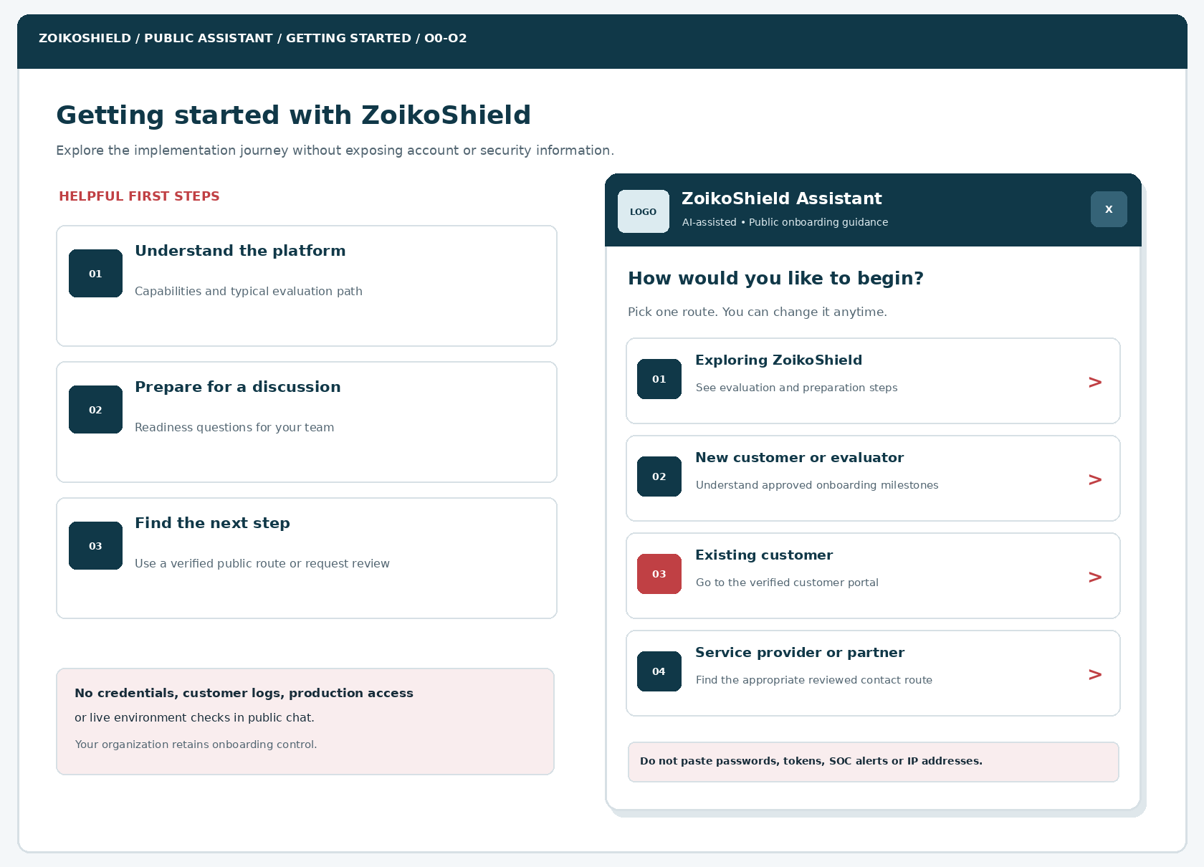
Figure 1. Desktop visual wireframe. The LOGO area is an engineering placeholder; replace with the approved ZoikoShield logo and favicon.
CALLOUT | ENGINEERING REQUIREMENT
D09-01 | Website header and CTA remain accessible when the chatbot is collapsed or unavailable.
D09-02 | Four deterministic visitor routes use allowlisted intent identifiers; content is versioned.
D09-03 | The security warning is persistent, concise, keyboard accessible and screen-reader readable.
D09-04 | Existing customers leave the anonymous flow through a verified public sign-in destination.

02 / Mobile visitor routing — O1 to O3
Full-screen content must maintain focus, reading order and undoable choices.
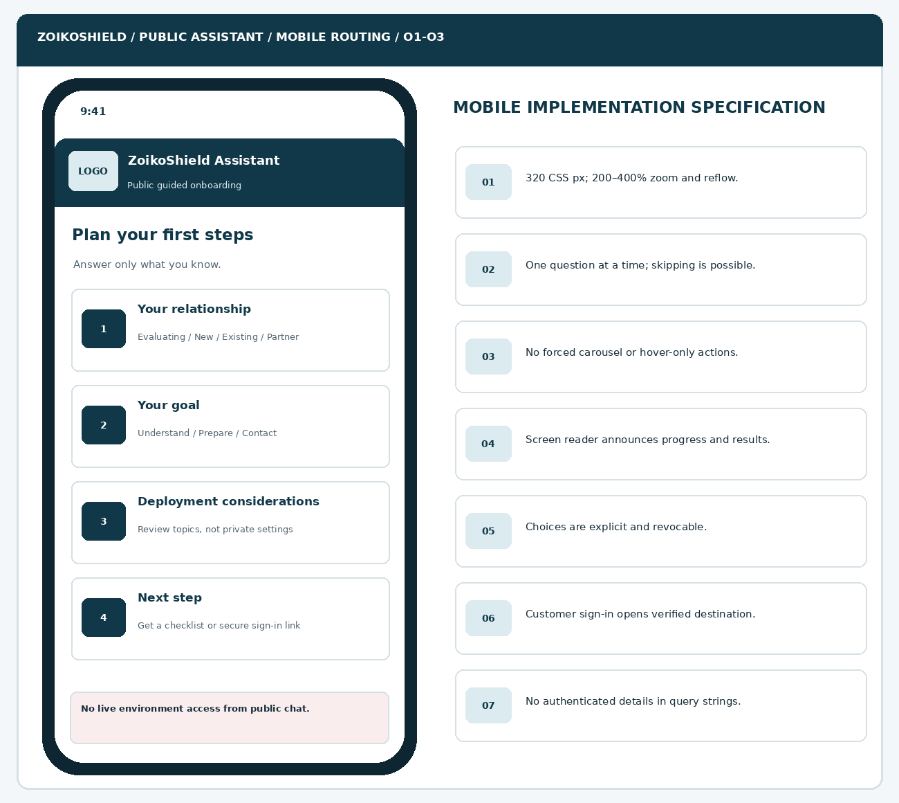
Figure 2. 320 CSS px target with single-column choices; diagram is illustrative, not a production screenshot.
CALLOUT | ENGINEERING REQUIREMENT
M09-01 | All action names contain context; screen-reader names are not just “Continue”.
M09-02 | The last choice and skip navigation remain available at 400% zoom.
M09-03 | No customer status or identity is inferred from work email or referrer data.
M09-04 | Dialog close restores focus to the launcher; no viewport-trapping scroll.

03 / Non-sensitive preparation questions — O3 to O5
Collect only planning information that makes a future conversation more useful.
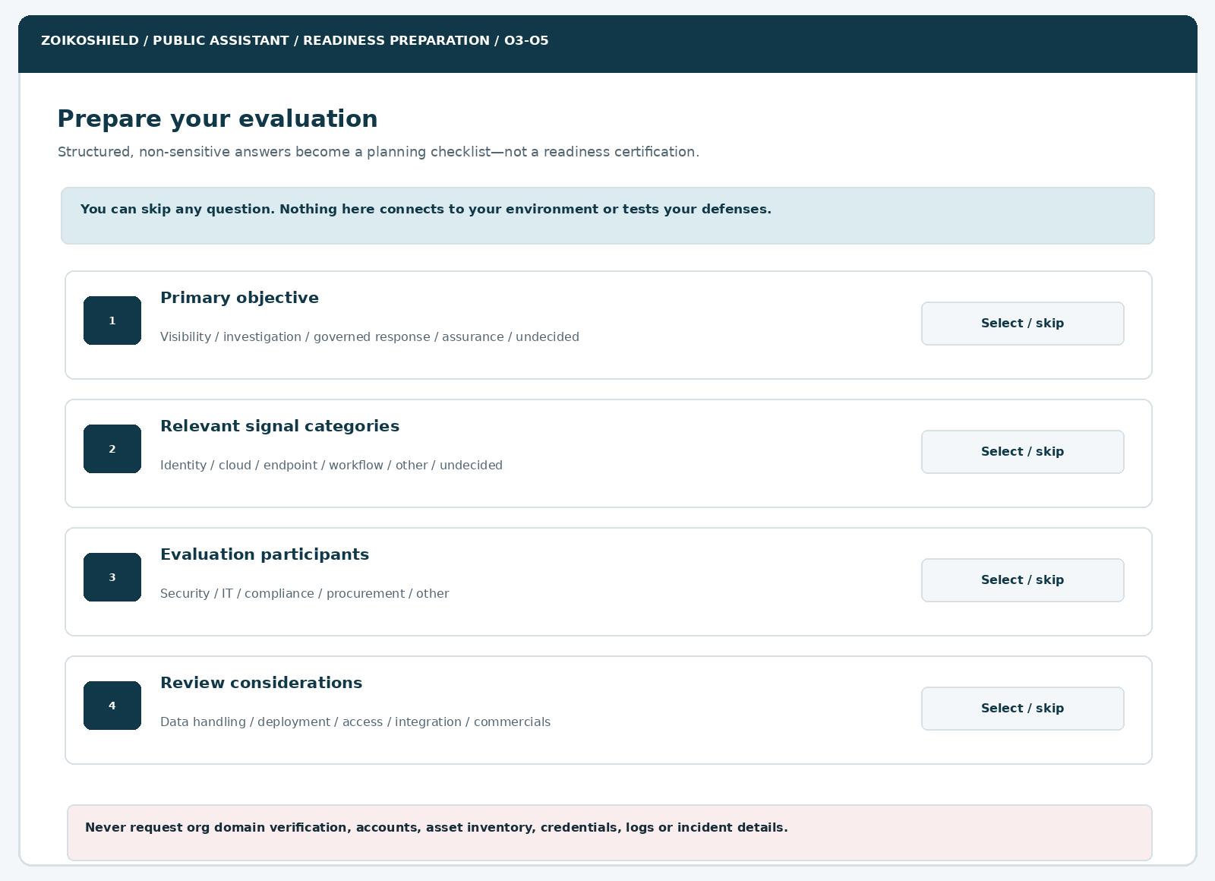
Figure 3. Progressive readiness questions support selection, back, skip and review without private telemetry.
CALLOUT | ENGINEERING REQUIREMENT
Q09-01 | Every question has controlled intent options and an explicit “I’m not sure” choice.
Q09-02 | Questions do not request user counts, asset IDs, architecture maps, event samples or privileged account access.
Q09-03 | Selection state is ephemeral by default and cannot silently become an external CRM record.
Q09-04 | Free-text entry is avoided; if enabled, it is constrained, filtered and never used for machine actions.

04 / Readiness checklist & next-step cards — O5 to O7
Provide genuinely useful next actions without grading customer maturity.
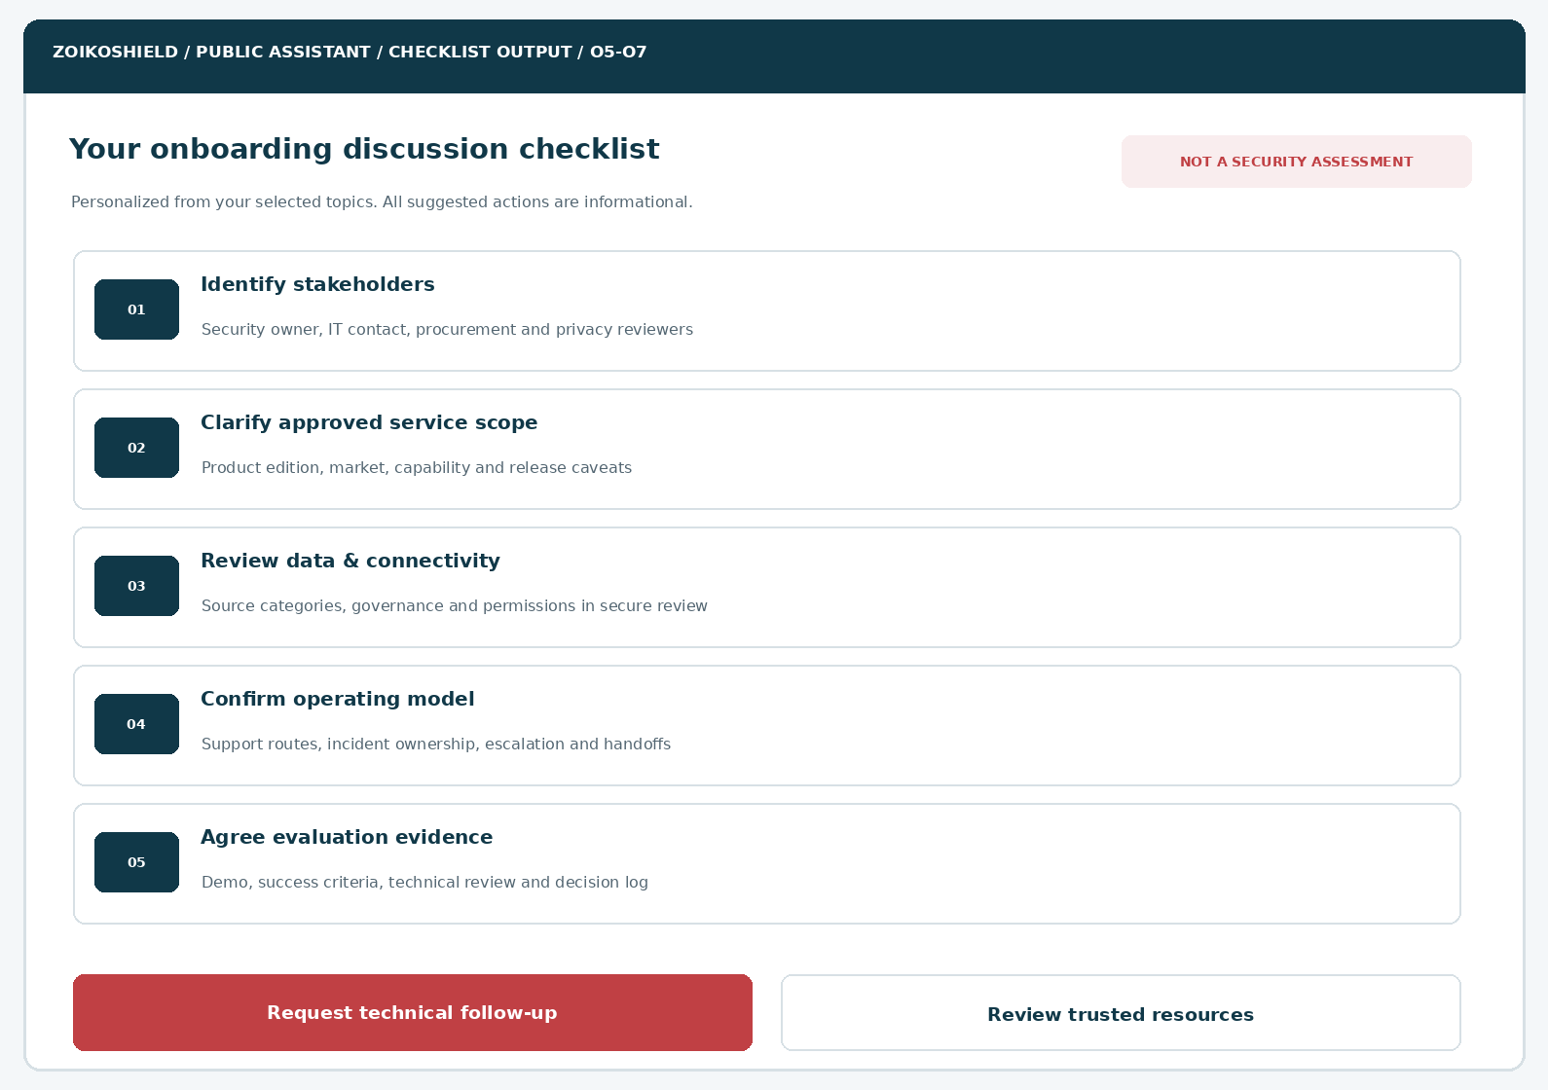
Figure 4. Readiness checklist derives from approved content plus selected visitor interests; it is expressly non-binding.
CALLOUT | ENGINEERING REQUIREMENT
C09-01 | Checklist cards show source ownership and update date in the actual UI.
C09-02 | Each card links only to approved public articles or opens the governed technical-contact route.
C09-03 | No percentage score, maturity rating, audit badge, launch eligibility or artificial deadline.
C09-04 | A user can copy a privacy-minimized checklist; sensitive answers are excluded.

05 / Contact handoff: editable share review — O8 to O11
Support the technical evaluation team without sending an invisible full transcript.
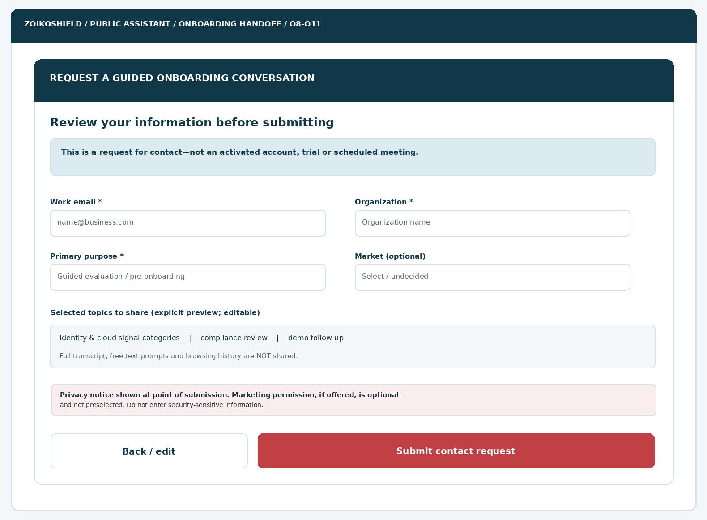
Figure 5. Only explicitly previewed, allowed data is shared at submission; no activation or appointment is implied.
CALLOUT | ENGINEERING REQUIREMENT
H09-01 | Required identity fields are validated on client and server; no autofilled private context.
H09-02 | The selected-topic summary is generated from allowlisted values and visibly editable.
H09-03 | Marketing consent, if relevant, remains separate and unselected by default.
H09-04 | The final submit button fires a CSRF-resistant, idempotent backend request.

06 / Confirmed, uncertain and unavailable outcomes — O11 to O14
A visual difference is required between success and transport ambiguity.
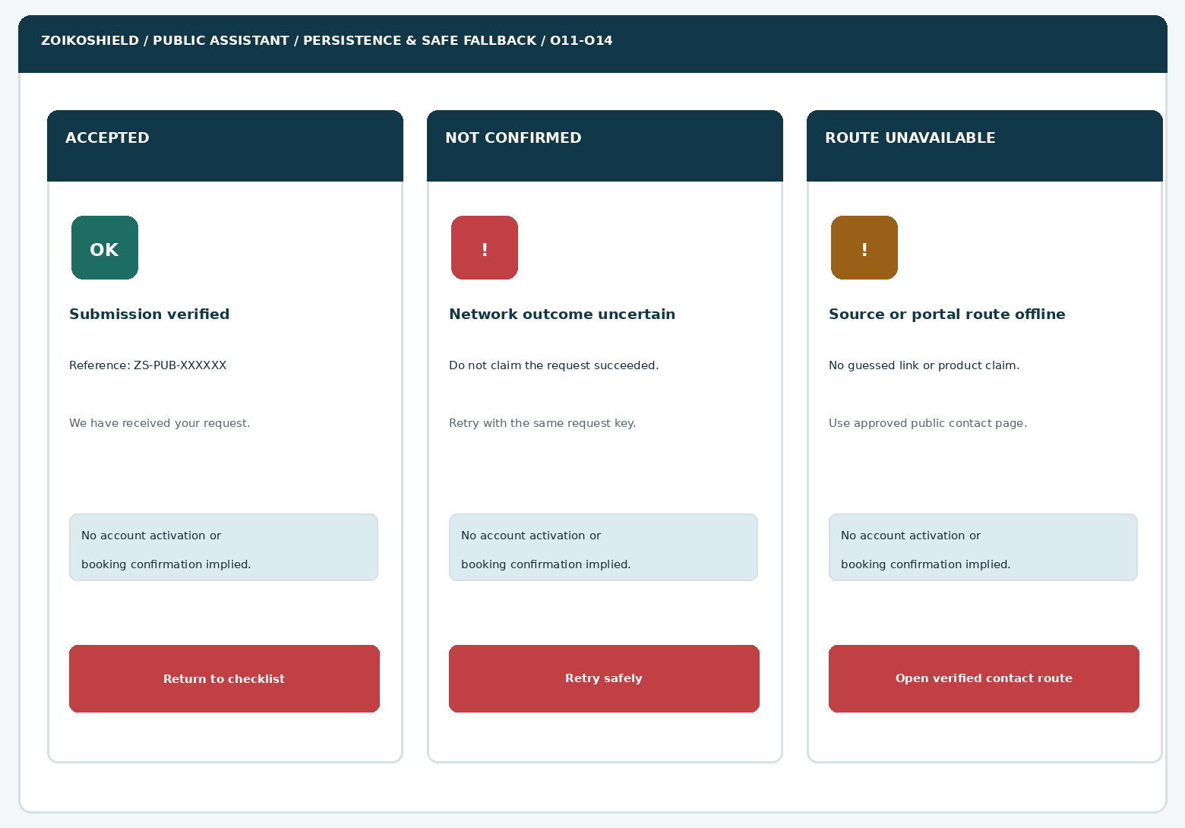
Figure 6. Only acknowledged durable persistence produces a confirmation; fallbacks preserve honest status.
CALLOUT | ENGINEERING REQUIREMENT
S09-01 | Opaque receipt ID after durable acceptance; confirmation makes no delivery timing promise.
S09-02 | Transport timeout is “outcome not confirmed,” never success; same key on retry.
S09-03 | If route registry is offline, show only a verified locally approved fallback path.
S09-04 | All states display accessible text, not status conveyed by color alone.

07 / Complete state map — O0 to O14
Deterministic transitions are unit-testable and resistant to assistant prompt injection.
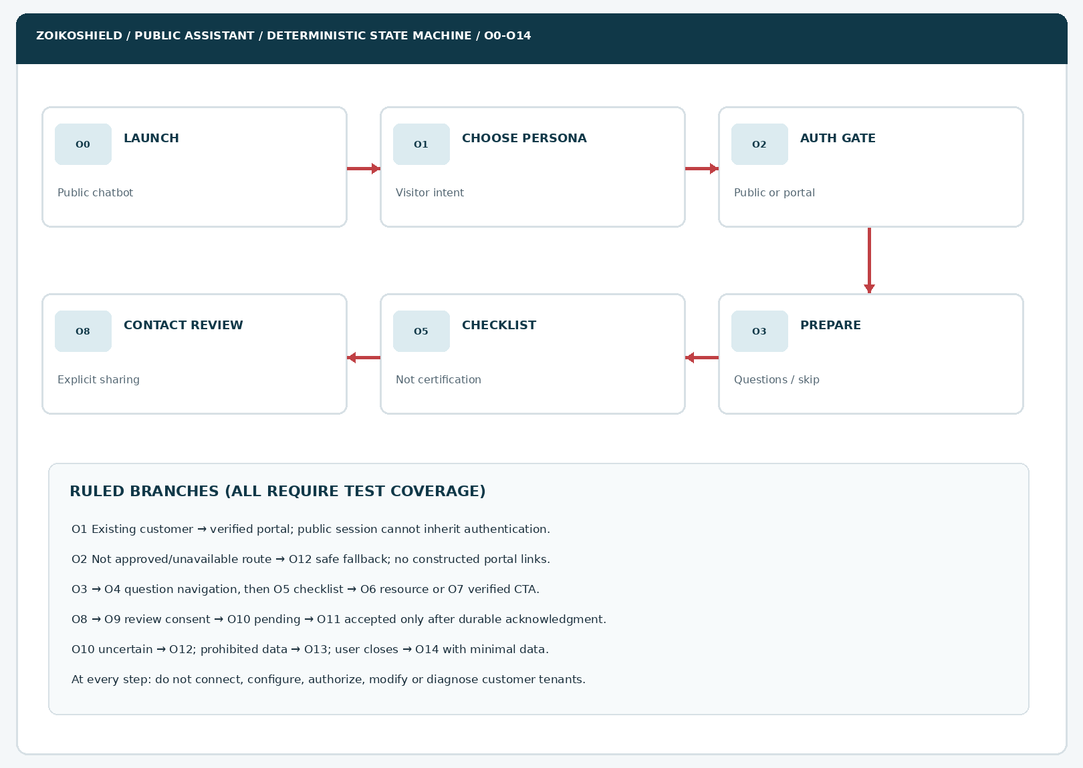
Figure 7. Canonical user-visible flow; guarded service and routing branches are listed below the diagram.
CALLOUT | ENGINEERING REQUIREMENT
SM09-01 | A change of persona invalidates incompatible collected state and changes only public content.
SM09-02 | Existing-customer entry never prompts for passwords or emulates the protected portal.
SM09-03 | Every mutating public intake action uses server authorization and idempotency.
SM09-04 | Abort clears unpublished drafts subject to an approved retention policy.

08 / Information architecture, personas and intent precedence
Wireframe 09 is a public onboarding preparation assistant, not a generic “AI implementer.” Explicit route selection outranks language-model guesses; the visitor can always switch paths.
VISITOR ROUTE | ALLOWED GUIDANCE | FORBIDDEN OR GATED BEHAVIOR
Exploring / evaluator | Overview, approved capabilities, preparation checklist, trust/pricing/technical resources | False trial availability, actual vulnerability posture, unapproved capability claims
New / purchasing organization | Approval-controlled milestones, stakeholders, product prerequisites, technical review options | Tenant creation, configuration, credentials, live SOC samples, signed SLA or firm rollout timeline
Existing customer | Verified sign-in/help center, non-sensitive documentation and safe support routing | Password reset inside chat, tenancy lookups, user enumeration, account recovery by conversational assertion
Partner / service provider | Published MSSP/partner evaluation path and contact routing | Reseller eligibility, partner pricing, delegated privileges or partner certification assertions

Intent and route precedence
PRIORITY | SIGNAL | OUTCOME
P0 | Potential active incident or urgent account compromise | Immediately route to WF04 safe incident instructions; do not continue onboarding prompts.
P1 | Credentials, customer PII or internal security configuration entered | Do not echo or persist; suppress sensitive material and explain secure channel.
P2 | Existing customer request requiring account context | Verified portal and approved account support route; no implied authentication transfer.
P3 | Explicit visitor route and safe planning intent | Show approved onboarding checklist steps.
P4 | General ambiguous question | Ask at most one simple routing question; provide “explore” and “skip” choices.

MANDATORY VISITOR PROTECTION
Avoid user-provided “I am the CISO/administrator” assertions as an authorization mechanism. Account access and organizational roles must be verified in the authenticated system, never by public chatbot dialog.

09 / Components ZS167–ZS179
Each component must have a documented owner, states, event payload and accessibility check.
ID | COMPONENT | REQUIRED BEHAVIOR / ACCEPTANCE TARGET
ZS167 | Public onboarding entry CTA | Open + analytics event; available from approved pages; keyboard focus returns on close.
ZS168 | Assistant branded header | Verified company logo slot; AI disclosure; accessible title; no implied human status.
ZS169 | Visitor route chooser | Four config-driven values; radio/button semantics; reset incompatible selections.
ZS170 | Identity boundary warning | Do not collect credentials or live security data; visible at intake and preview.
ZS171 | Existing-customer sign-in CTA | Signed/approved route registry URL; no fabricated links or session impersonation.
ZS172 | Partner route card | Show only currently published program or approved contact alternative.
ZS173 | Progress navigation | Back, Continue, Skip; announces steps without artificial completion metric.
ZS174 | Primary-objective picker | Server-allowlisted categories; multi/single selection according to schema.
ZS175 | Signal-category picker | Cloud/identity/endpoint/workflow categories only; no vendor support inference.
ZS176 | Stakeholder picker | Public role categories not individual persons or account invites.
ZS177 | Deployment concern chooser | Topic-level review flags; not a residency eligibility or actual hosting decision.
ZS178 | Edit/review selections | Editable summary; no invisible form fields or transcript collection.
ZS179 | Source provenance link | Document title/date/audience/version; external link to exact verified domain.

10 / Components ZS180–ZS192
No visual state can be treated as a guarantee of production availability.
ID | COMPONENT | REQUIRED BEHAVIOR / ACCEPTANCE TARGET
ZS180 | Readiness checklist card | Topic-specific safe next steps; no grade; source-linked version.
ZS181 | Checklist copy/export control | User initiated; sanitized topics only; no raw chat transcript or account details.
ZS182 | Source-expired warning | Disable affirmative claims and replace with “Requires review” path.
ZS183 | CTA routing service | Policy-bound ID maps to approved URL or intake workflow; reject arbitrary URLs.
ZS184 | Work-email field | Required for request; <=254; safe server-side normalization, reject control chars.
ZS185 | Organization field | Required; <=120; no lookup-based customer data leakage.
ZS186 | Request-purpose selector | Allowlist; one or more reviewed intent identifiers.
ZS187 | Optional market selector | Allowlist; unknown is valid; must not become availability guarantee.
ZS188 | Shared-topics preview | Explicit review, clear/modify fields; exclude prompts and private browsing.
ZS189 | Privacy / marketing controls | Point-of-use privacy notice; separate optional, unselected marketing consent.
ZS190 | Idempotent submission control | One pending request; retry same key; loading disable duplicate clicks.
ZS191 | Receipt / uncertain response | Confirmed durable receipt vs unknown outcome distinctly and accessibly displayed.
ZS192 | Fallback and exit controls | Verified website/support route, cancel/back, closure restores focus.

11 / Readiness planning content model & localization
Content is maintained in a versioned, authorized public guide catalog. This can be integrated with the WF02 citation governance layer and WF07 Trust Center source ownership, without sharing private tenant knowledge or protected operations documents.
REGISTRY FIELD | DATA TYPE / VALIDATION | PURPOSE
guide_id | Opaque immutable identifier | Link intent to the approved guide or checklist unit.
revision / published_at | Semver or monotonic version and ISO timestamp | Prevent stale or revoked text from appearing as current.
language / market | BCP 47 language; explicit public market rule | Select localized copy and applicable jurisdiction caveats.
audience | public, gated, retired | Only public entries are eligible for anonymous access.
topic_ids / prerequisites | Allowlisted categories and public dependency IDs | Deterministic contextual checklist generation.
claim_status | approved / review_required / retired | Fail closed on missing or contradictory evidence.
source_document_id / URL | Approved public source ID and canonical verified URL | Ground guidance with links and revision dates.
route_id | Stable internal key, never generated free-form URL | Navigate only to approved onboarding/contact destinations.
expiration / reviewer | Time and approving owner | Revalidate time-sensitive claims and transitions.

Sample copy rules
DO | DO NOT
“Here are the questions to prepare for a technical review.” | “Your environment is ready for production.”
“We can explain published evaluation and onboarding steps.” | “I have connected or assessed your organization.”
“A team member can review your specific deployment needs.” | “Your UK sovereign deployment is guaranteed.”
“Use the verified customer sign-in page to access your account.” | “Share your API key or admin login here.”
“Your contact request was received” only after confirmed acceptance. | “Your demo/trial/customer tenant has been created” without authoritative evidence.

12 / Evaluation checklist generation algorithm
The checklist is assembled by deterministic content selection, not a free-form AI implementation plan. The model may explain an approved step; it cannot insert its own security control, procurement promise or tenant configuration.
STEP | DECISION | REQUIRED SAFE BEHAVIOR
1 | Resolve explicit persona and locale | Default to generic public explorer when unspecified; never infer organizational identity.
2 | Validate selected topic IDs | Reject unexpected or model-generated categories and any sensitive free text.
3 | Query approved public guide registry | Require audience=public, claim_status=approved and non-expired revision.
4 | Select topic-linked next steps | Apply deterministic precedence; no “onboarded” or risk-grade score.
5 | Annotate each claim with source | Cite specific public document, revision and applicability.
6 | Render meaningful empty/failure state | Offer public overview or reviewed technical handoff; do not fabricate.
7 | Share only through opt-in preview | Safe allowlisted topic IDs, no conversation transcript by default.

SOURCE CONFLICTS
If published guidance and the roadmap/internal technical plan conflict, public knowledge wins unless reviewed content is withdrawn. If two public sources disagree, do not reconcile by guessing; show “Needs review” and a verified contact route.

13 / Boundary architecture and event flow
LAYER | RESPONSIBILITY | FORBIDDEN INTERACTION
Website / React UI | Semantic components, keyboard focus, accessible state, safe topic selections | No direct internal security microservice calls or credential collection.
Public chat BFF | Session rotation, origin protection, limits, request validation, source-policy enforcement | No blind forwarding to internal shield-core, shield-ingest or shield-action APIs.
Public content service | Only approved guides, destination registry and versioned copy | No unrestricted retrieval of operational runbooks or customer evidence.
Deterministic orchestration | Intent precedence, checklists, guardrails and safe output validation | No AI-generated URLs, source IDs, API actions or entitlement decisions.
Contact intake service | Durable idempotent accepted receipts, privacy notice version, reviewed fields | No automatic tenant, account or trial creation.
Authenticated application | Separate real login, onboarding and product entitlements | No transfer of anonymous authority via chat transcript or claimed identity.
Audit / operations | Minimal event metadata, incident and DLQ monitoring under defined retention | No raw passwords, full transcripts, customer incidents or token leakage in telemetry.

Sequence contract
Visitor choice → verified public route policy → allowed optional planning answers → source-governed checklist → (a) public resource, (b) verified authenticated portal handoff, or (c) reviewable contact request → BFF validation → durable intake receipt. At no point does a public intent receive shield-action privileges, instantiate a tenant, use privileged connectors or read account state.
ARCHITECTURE DEPENDENCY
The previously provided ZoikoShield demo architecture describes Next.js, shield-core, shield-ingest, shield-ai, shield-action and shield-anchor. This public chatbot requires a hard public-facing boundary and dedicated allowlisted adapters; these target APIs must not be assumed to exist in current production code.

14 / Proposed public API contracts
OPERATION (PROPOSED) | BEHAVIOR | AUTHORIZATION / CACHING
GET /api/public-chat/onboarding/routes | Approved persona choices, route IDs, publication revision | Anonymous, rate limited, no private account enumeration; short cache.
GET /api/public-chat/onboarding/questions | Approved topics, language, market-scoped copy | Anonymous, ETag/versioned, safe fallback for unavailable records.
POST /api/public-chat/onboarding/checklist | Inputs: allowlisted topic IDs; output: source-linked safe steps | Validation-only; no customer execution context or configuration writes.
GET /api/public-chat/onboarding/destinations/{route_id} | Verified external URL or controlled support route | Server-side allowlist, scheme/domain/path binding; no redirect injection.
POST /api/public-chat/onboarding/contact-requests | Validated contact request with idempotency key | CSRF/origin controls, abuse limits, durable acceptance semantics.
GET /api/public-chat/onboarding/contact-requests/status/{receipt_token} | Retrieve limited receipt status for uncertain outcome | Short-lived opaque capability token; no user list or enumeration.
GET /api/public-chat/onboarding/privacy-notice | Version, locale, data purpose and retention summary | Content-approved only; if missing disable form submission.

JSON shape (illustrative contract, not a deployed endpoint)
POST /api/public-chat/onboarding/contact-requests
Idempotency-Key: <opaque server accepted nonce>
{ "intent_id": "guided_evaluation", "work_email": "user@example.org",
"organization": "Example Organization", "market": "undecided",
"shared_topic_ids": ["identity_signals", "evidence_review"],
"privacy_notice_version": "approved_revision_id",
"marketing_opt_in": false }
201 { "status": "accepted", "reference": "opaque_public_reference" }
202 { "status": "pending", "status_token": "short_lived_opaque_token" }
4xx { "status": "rejected", "reason_code": "validated_safe_code" }
5xx/timeout => outcome unknown; retry using same idempotency key.
ERROR SEMANTICS
A 200/201 from a front-end proxy is not enough: confirmation requires durable acknowledged creation by the intended backend. Pending/timeout paths must not state a request was received until status is resolved.

15 / State model, persistence and user agency
STATE | ENTRY / GUARD | EXIT ACTION AND PERSISTENCE RULE
O0 Entry | Launcher opened on permitted public page | Initialize anonymous short-lived session.
O1 Persona choice | Explicit user selection; do not infer from domain | Store persona ID in transient UI state; allow change.
O2 Route policy | Approved public vs authenticated route decision | Send existing customer to verified separate portal.
O3 Preparation | Public questionnaire enabled; can skip | Only allowed categories; no live account context.
O4 Editing | User goes back/changes topic | Reset dependent checklist items.
O5 Checklist | Source registry passes publication checks | Generate cited planning steps; no maturity score.
O6 Resources | Valid public article / comparison route | Open verified URL without sensitive query parameters.
O7 Guided next step | Eligible CTA / technical review path | Move to approved contact flow or verified resource.
O8 Contact start | Explicit consent to begin request | Clear unrelated metadata; restrict fields.
O9 Review | Required fields and notice validated | Show exactly what will be sent.
O10 Pending | User initiates explicit submit | Use idempotency key; block duplicate concurrent submit.
O11 Accepted | Durable backend acknowledgment | Show opaque reference and contact-route context.
O12 Unavailable/unknown | Network failure, disabled route, status ambiguity | Safe retry or verified website path; never mark accepted.
O13 Sensitive/invalid | Prohibited secret or malformed field | Do not persist secret; explain correction.
O14 Exit | User dismisses or restarts | Minimize or clear draft under configured retention policy.

16 / Security abuse cases and privacy policy
THREAT / RISK | P0 EXPECTED CONTROL | VERIFICATION EVIDENCE
Prompt injection in retrieved public pages | Source provenance and role-separated instruction policy; data not executable instructions | Adversarial retrieval tests; no route or tool changes.
SSRF/open redirect via AI links | Server-resolved route IDs; explicit destination allowlist | Fuzz URLs, schemes, Unicode hostnames and redirect chains.
Customer or tenant enumeration | Do not expose “customer exists” or account state in anonymous flow | Equal-safe portal routing and abuse/security tests.
Credential/exfiltration attempt | No password/token fields; redact and reject input; never echo in logs | Secret canary test and logging inspection.
Bulk or spam contact submissions | Rate limit, bot resistance, server-side validation, abuse monitoring | Automated traffic and retry tests; no per-IP sensitive telemetry exposure.
Unwanted CRM transfer | Required review step; topic IDs shared only after user action | Network trace proves no pre-submit CRM disclosure.
PII retention creep | Purpose-bound records, retention configuration, deletion and legal hold logic | DPIA/retention schedule and purge tests.
Privileged workflow reachability | Public BFF allowlist; deny-by-default service-to-service policy | Attempt forbidden shield-action/core/ingest operations.
Fake live readiness claim | Source publication gate and output validation | Red-team “you are cleared / trial ready” prompts.
Session cross-over | Rotate anonymous session; no leakage between visitors | Parallel anonymous user isolation tests.

DATA MINIMIZATION REQUIREMENT
Retain only defined business-contact fields on a valid submitted request, plus separate approved consent evidence. Before submission, do not send full transcript or selected topics to the CRM. Analytics use event IDs and coarse step names rather than prompt text or personal information.

17 / Accessibility, responsive and localization contract
AREA | REQUIRED BEHAVIOR | QA METHOD
WCAG 2.2 AA | Target all applicable AA criteria, including labels, focus, error association, reflow and contrast | Manual keyboard + axe/automated + NVDA/VoiceOver review.
Small viewports | Single-column 320 CSS px view; 200–400% zoom; no horizontal document scroll | Browser matrix at 320, 360, 768, 1440 and 400%.
Screen reader | Announce step changes using restrained live region; readable checklist headings | NVDA/JAWS/VoiceOver full-task test.
Navigation / cancellation | Back, skip, exit and edit always work; prevent focus loss | Keyboard only and reduced-motion route tests.
Form errors | Specific summary and inline errors; preserve safe entered values | Empty/invalid and server-rejected form scenarios.
Timing and progress | No forced speed, idle deadline without warning or deceptive progress percentage | Slow reader tests and suspended/reopened flow.
Mobile touch | Comfortable targets, safe-area and keyboard-visible submit | iOS/Android touch and zoom.
Localization | American English baseline; other locales only after reviewed translation and market mapping | Long labels, plural, RTL where supported; date/notice locale.

18 / Observability, content operations and business metrics
EVENT / METRIC | ALLOWED ATTRIBUTES | PROHIBITED ATTRIBUTES
onboarding_opened | session pseudonym, deployment revision, locale, page source type | Full page URL query, identity, visitor email.
persona_selected | allowlisted route ID | Guessed employer/account status.
planning_step_viewed | approved step ID, safe locale | User text, network details or named assets.
checklist_generated | source catalog revision, topic count, success flag | Raw conversation or customer environment evidence.
verified_route_opened | approved route ID and content revision | Destination credentials or signed customer links.
contact_request_status | accepted/rejected/unknown counts with reason code | Names, emails, notes, complete submission body.
source_policy_rejected | source or article ID, rejected reason | Restricted document content.
a11y_error / abandonment | anonymous step and device class where permitted | Precise identity or inferred disability status.

Operational service levels: propose, do not invent
The UX must never advertise an unapproved 24×7 support promise, trial start duration, “onboard in minutes” statement, guaranteed sales response time or account activation SLA. Define targets separately in an approved commercial/operations record. Operational dashboards should track duplicate submissions, source freshness, broken approved links, elevated error rates, unauthorized route attempts and consent mismatches.

19 / Release-blocking acceptance tests AT189–AT206
TEST | RELEASE-BLOCKING EXPECTED RESULT
AT189 | Entry opens with correct approved brand and public AI disclosure.
AT190 | Public onboarding entry respects closed/disabled chatbot state and website navigation.
AT191 | Visitor route chooser keyboard operable; all options have unique accessible names.
AT192 | Existing-customer route displays only approved authenticated portal link.
AT193 | Partner route does not infer program enrollment, certification or privilege.
AT194 | Selecting a route never creates an account/tenant, connector or support ticket.
AT195 | Credential/paste attempt is blocked/redacted without echo or logs.
AT196 | Question navigation supports back, skip, change and browser focus restoration.
AT197 | Unknown/empty interests yield useful generic approved checklist rather than invented details.
AT198 | Checklist is generated exclusively from approved unexpired public sources.
AT199 | Withdrawn or contradictory guide returns “Requires review” non-affirmative state.
AT200 | Readiness output does not make compliance, security grade or production-readiness claim.
AT201 | Every approved checklist item has eligible source, revision and verified public route.
AT202 | Copy/export excludes full transcript and personal/sensitive fields.
AT203 | An injected external URL does not override server route allowlist.
AT204 | Existing-customer and public sessions are strictly separated.
AT205 | 320px and 400% zoom reflow without inaccessible, clipped actions.
AT206 | Keyboard and screen reader can finish, skip and exit all readiness steps.

20 / Release-blocking acceptance tests AT207–AT224
TEST | RELEASE-BLOCKING EXPECTED RESULT
AT207 | Form request fields enforce required/optional/length validation in browser and server.
AT208 | Disallowed market or free-text intent is rejected; no hidden fallback to unreviewed offer.
AT209 | Full transcript is not submitted or transferred before/after request by default.
AT210 | A user can view/edit all shared allowlisted topics immediately before submission.
AT211 | Privacy notice version and purpose are shown before consent/submit.
AT212 | Marketing consent remains independent and unchecked until intentional opt-in.
AT213 | Network trace proves no CRM payload before final user submission.
AT214 | Accepted receipt displays only after durable backend record acknowledgement.
AT215 | Timeout leads to unknown status; never displays false success.
AT216 | Same idempotency key produces one accepted request under duplicate click/retry.
AT217 | Pending status token cannot enumerate other visitors or leak user data.
AT218 | Source registry outage yields verified non-AI fallback destination, not fabricated link.
AT219 | Public API rejects cross-service call attempts to shield-core/ingest/action tenant operations.
AT220 | Prompt injection in knowledge text cannot change routing, authorization or user data handling.
AT221 | PII and secret canaries are absent from logs, analytics and exception tracing.
AT222 | Mobile keyboard/touch/assistive-tech task tests pass for intake and error flows.
AT223 | Privacy retention/deletion and safe cancellation work per approved schedule.
AT224 | Production feature flag rollback disables intake without affecting normal site navigation.

21 / Critical design review and incorporated improvements
ORIGINAL FAILURE PATTERN | REFINEMENT INCORPORATED | RESULTING ENGINEERING OBLIGATION
“Book onboarding” as if confirmed | Use contact-request or verified external booking only | Ack-gated wording; no invented appointment slots.
Checklists feel like an audit or cyber maturity score | Show practical discussion preparations, no grades | UI content test excludes scores and certification badges.
Public assistant impersonates protected setup wizard | Separate anonymous guide from actual signed-in onboarding | Portal link from signed publication registry; privileged denial tests.
Long mandatory questionnaire drives abandonment | Progressive, skippable single-topic selection | All four categories can be skipped without breaking the result.
AI-generated documentation citations are unreliable | Versioned approved sources with revocation | Document metadata and freshness audit required.
Enquiry data silently syncs to CRM | Explicit review with listed topic fields | Share-preview and pre-submit network inspection.
Retry screen risks duplicate leads | Stable idempotency key + status lookup | Crash, timeout and concurrent-click test coverage.
Onboarding could expose sensitive IT details | Prevention, redaction, no attachments and secure handoff | Input, AI, logging and downstream DLP controls.
False reassurance for active incidents | Immediate WF04 safe incident route precedence | No onboarding gate can delay an urgent official support pathway.

DESIGN CONCLUSION
This wireframe improves customer readiness without creating security or legal obligations the platform cannot substantiate. Do not convert source-backed suggested next steps into “your system is ready,” “your integration is certified,” or “your account is activated.”

22 / Implementation plan, owners and evidence
WORK PACKAGE | OWNER | COMPLETION EVIDENCE
WP09-01 Approved UX library | Product + Brand + Design | Figma variants, logos/favicon, copy/interaction/locale sign-off.
WP09-02 Public guide registry | Product + Content + Security | Versioned approved source store, audience filter, revocation and source QA.
WP09-03 Route resolution policy | Backend + Security | Verified destination registry, deny-by-default and redirect/SSRF test evidence.
WP09-04 Responsive components | Frontend + Accessibility | ZS167–ZS192 implementation screenshots, unit and AT tests.
WP09-05 Contact intake | Backend + RevOps + Privacy | Validated request pipeline, consent metadata, idempotency and CRM field mapping.
WP09-06 Monitoring and retention | SRE + Privacy + Security | Metrics, incident alerts, failure injection and data lifecycle tests.
WP09-07 Release gating | QA + Legal + Product | AT189–AT224 sign-off; claim sheet, penetration tests and rollback record.

Open dependencies
GATE | OWNER DECISION BEFORE PUBLIC RELEASE
G0 Product / Founder | Approve exact visitor routes, CTA hierarchy, checklist categories and UX screens.
G1 Brand / Legal | Approve official wordmark/favicon, public assistant display name, public claims and terms.
G2 Platform / Security | Approve split between anonymous guide and authenticated onboarding; confirm secure route design.
G3 Data / Privacy | Approve all fields, privacy notice, optional marketing consent, retention and vendor data processing.
G4 Sales / RevOps | Confirm actual contact workflow, CRM acknowledgment and routing owners.
G5 Accessibility / QA | Complete mobile, AT, a11y, abuse, source freshness and performance tests.
G6 Release / SRE | Production evidence, observability, feature flags, rollback and launch verification.

23 / Reference baseline, handoff manifest and approval

Project references
REFERENCE | HOW APPLIED
ZoikoShield Public Chatbot WF01–WF08 (October 2026) | Sequential UI patterns, source controls, consent and lead workflows; component and test continuity.
ZoikoShield Live Demo Master Guide, October 13, 2026 | Source-claimed separate Next.js and security-service architecture; verified production status not assumed.
ZoikoShield Complete Frontend, Backend & Email Guide v3 | Public commercial routes and authenticated platform architecture separated.
ZoikoShield Customer Demo Presenter Playbook | Approved claim discipline; no invented availability, certification, commitments or live privileges.
Zoiko Group Public AI Chatbots naming governance v7.7 | Zhield internal working name; branded public implementation pending approval.
W3C WCAG 2.2 Recommendation | Accessibility objective for controls, errors, focus and reflow.
OWASP Top 10 for LLM Applications / API Security guidance | Prompt-injection, excessive agency and API abuse testing principles.

Hand-off package
Engineering receives this Word wireframe as normative target UI specification, all seven embedded reference diagrams, 26 unique component definitions, 15 states, proposed public API schemas, 36 release-blocking tests, source-publication governance and a dependency/approval register. Product/Design must translate approved screens into production Figma with official assets; Engineering reconciles interfaces against actual services; QA attaches evidence to each test ID.
APPROVAL STOP POINT
WIRE­FRAME 09 ONLY: Await explicit founder approval before Wireframe 10. Approval of this design does not verify implementation, certification, commercial activation, or production launch.

APPROVAL ROLE | DECISION / SIGNATURE / DATE
Founder / Product | Pending
Brand / Legal | Pending
Security / Privacy | Pending
Engineering / Architecture | Pending
Accessibility / QA | Pending
SRE / Release | Pending

