ZOIKO HR

HR Chatbot
Technical Architecture Documentation
Reference architecture • service boundaries • AI orchestration • security • deployment • resilience • observability
Implementation-grade architecture baseline for the Zoiko HR Chatbot, defining how the approved product, functional, API, data, knowledge and design contracts are realized as a secure, scalable and operable production system.
ARCHITECTURE DOCTRINE
The model is a bounded reasoning component, not a trusted authority. Identity, tenant isolation, permissions, source eligibility, workflow validation, confirmation, execution, reconciliation and audit are deterministic platform responsibilities. The architecture must remain safe when the model, retrieval index, provider network or downstream systems fail.

Document ID: ZHR-AI-ARCH-001 | Version 1.0 | Status: Architecture implementation baseline
Prepared for CTO, Solution Architecture, Backend, Front-End, AI/ML, DevOps/SRE, Security, Data, QA and Product Engineering.
Upstream approved artifacts: Engineering Wireframe v1.0; PRD v1.0; FRS v1.0; API Documentation Wireframe v1.0; Database Schema / ER Diagram Wireframe v1.0; Knowledge Base Wireframe v1.0; UI/UX Figma Design Files Wireframe v1.0.

Document Control
Field | Baseline
Architecture owner | Zoiko HR / Global Technology architecture authority
Implementation stack | React / Next.js experience; Python / Django service layer; PostgreSQL persistence. Exact managed infrastructure providers remain deployment decisions unless separately approved.
Primary purpose | Define production component boundaries, control flows, integration patterns, infrastructure responsibilities and non-functional architecture.
Architecture style | Modular service-oriented application with explicit domain boundaries; stateless compute; externalized state; asynchronous workers for non-interactive processing.
System-of-record doctrine | Zoiko HR, Zoiko Payroll and ZoikoTime retain authority over their business records; chatbot stores bounded orchestration, evidence and audit state.
AI doctrine | Provider-abstracted, policy-bounded AI orchestration with deterministic authorization, retrieval eligibility and action execution.
Availability posture | Graceful degradation by capability; failure of AI/retrieval must never corrupt HR/Payroll/Time records.
Security posture | Zero-trust between logical boundaries, deny-by-default authorization, least privilege, encryption in transit/at rest, audited privileged operations.
Change control | Changes to trust boundaries, data ownership, authorization, execution semantics, external providers or residency require architecture review and ADR.

Contents
Section | Required architecture output
1 | 1. Scope, assumptions and architecture goals
2 | 2. Architecture principles and quality attributes
3 | 3. System context and trust boundaries
4 | 4. Logical component architecture
5 | 5. Front-end architecture
6 | 6. Backend application architecture
7 | 7. AI orchestration architecture
8 | 8. Authorization and policy architecture
9 | 9. Knowledge retrieval architecture
10 | 10. Conversation and context architecture
11 | 11. Controlled action architecture
12 | 12. Attachment processing architecture
13 | 13. Integration architecture
14 | 14. Data architecture
15 | 15. Eventing and asynchronous processing
16 | 16. Caching, rate limiting and concurrency
17 | 17. Security architecture
18 | 18. Privacy, residency and retention architecture
19 | 19. Observability and audit architecture
20 | 20. Deployment topology
21 | 21. Environment strategy
22 | 22. Scalability and capacity architecture
23 | 23. Reliability and graceful degradation
24 | 24. Disaster recovery and continuity
25 | 25. Performance architecture and budgets
26 | 26. CI/CD, IaC and release architecture
27 | 27. Feature flags and emergency controls
28 | 28. API and interface governance
29 | 29. Testing architecture
30 | 30. Operational runbooks and SRE ownership
31 | 31. Architecture traceability
32 | 32. Release gates and Definition of Done
App. | Appendix A. Service catalogue
App. | Appendix B. Port / protocol / trust matrix
App. | Appendix C. Architecture decision register
App. | Appendix D. Failure-mode matrix

1. Scope, Assumptions and Architecture Goals
This document specifies the technical architecture required to implement the approved Zoiko HR Chatbot. It governs service composition and infrastructure behaviour, while upstream product artifacts remain authoritative for user-visible behaviour and permissions.
Goal | Architecture implication
Trustworthy answers | Retrieval eligibility and evidence provenance are evaluated before response generation; cited source versions are preserved.
Safe self-service actions | Every consequential write follows deterministic draft, validation, review, server-bound confirmation, idempotent execution and reconciliation.
Tenant isolation | Tenant context is authenticated once and enforced again at every sensitive service/data boundary.
Global operation | Jurisdiction, legal entity, worker population, residency and language are explicit context inputs; no market is silently treated as the default.
Low operational risk | Capability-level circuit breakers and kill switches allow selective degradation without disabling the entire HR product.
Provider portability | AI provider and derived search/index technologies sit behind adapters; product contracts must not depend on provider-specific semantics.
Engineering velocity | Clear modules, stable APIs, schema ownership, contract tests and observability reduce cross-team ambiguity.
Auditability | Security- and action-relevant decisions emit evidence events sufficient to reconstruct who requested, authorized, confirmed and executed a change.

Assumptions
- Zoiko HR already provides authenticated workforce identities, tenant membership, roles/scopes and core HR APIs required by approved chatbot use cases.
- Zoiko Payroll and ZoikoTime expose governed service APIs; the chatbot does not connect directly to their underlying databases.
- Knowledge sources are administered through the approved Knowledge Base lifecycle and have publish state, applicability and version metadata.
- External model providers, search/vector engines, object stores, cache products and managed cloud primitives remain replaceable infrastructure choices unless separately ratified by an ADR.
- The first production architecture should favor a well-governed modular deployment over premature microservice fragmentation; logical service boundaries are mandatory even where several modules initially share one Django deployment.
NON-GOAL
This architecture does not authorize engineering to create a shadow employee master, payroll ledger, time ledger, unrestricted prompt endpoint, direct model-to-database connection or direct model-to-downstream-system write path.

2. Architecture Principles and Quality Attributes
ID | Principle | Required application
ARC-P01 | Deterministic controls outside the model | Authorization, eligibility, workflow state, confirmation, validation and execution are code/policy services.
ARC-P02 | Deny by default | Missing tenant, scope, source applicability or policy evidence results in restriction or no-answer.
ARC-P03 | System-of-record integrity | Authoritative data is read/written only through owning-system APIs.
ARC-P04 | Evidence over confidence | Answer eligibility depends on provenance and applicability, not only model confidence.
ARC-P05 | No hidden reasoning persistence | Store bounded model metadata and result/evidence references; never store hidden chain-of-thought.
ARC-P06 | Idempotent writes | Retries cannot create duplicate HR actions.
ARC-P07 | Graceful degradation | Read, knowledge, action and handoff capabilities can fail independently.
ARC-P08 | Stateless compute | Interactive compute nodes remain horizontally scalable; durable state is externalized.
ARC-P09 | Least privilege | Every service identity and tool gets the minimum data/action scope.
ARC-P10 | Observability by design | Each request carries correlation, tenant-safe telemetry and audit IDs end to end.
ARC-P11 | Regional containment | Residency-sensitive data stays within its approved region/cell.
ARC-P12 | Versioned contracts | APIs, schemas, prompts, policies, models and knowledge sources are version identifiable.

Quality attribute priorities
Attribute | Priority | Architectural target
Security / tenant isolation | P0 | No unauthorized cross-tenant or out-of-scope data disclosure; all privileged decisions auditable.
Correctness / integrity | P0 | No AI pathway can bypass deterministic action validation or mutate authoritative stores directly.
Availability | P0 | Core HR product remains usable when chatbot dependencies fail; chatbot degrades by capability.
Auditability | P0 | Consequential action and sensitive access decisions are reconstructable from evidence records.
Performance | P0 | Interactive answer path is streamed; deterministic gates add bounded overhead; latency budgets measured per stage.
Scalability | P1 | Stateless API/orchestration nodes scale horizontally; queues absorb asynchronous bursts.
Portability | P1 | Provider-specific model/search interfaces are adapter-bound.
Maintainability | P1 | Domain modules own schemas/contracts; architecture dependency rules tested in CI.

3. System Context and Trust Boundaries
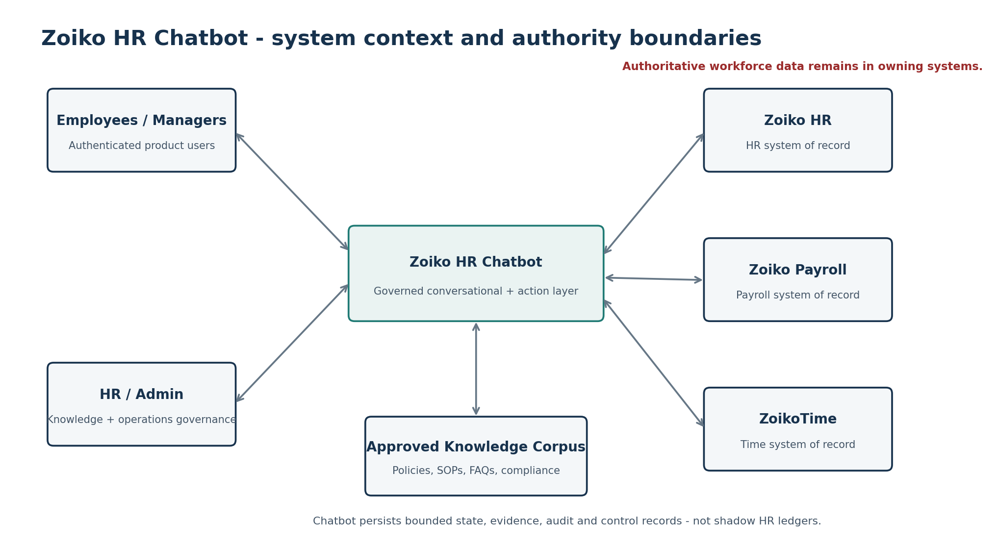
Figure 1. System context and authority boundaries.
Boundary | Inside | Outside / controlled dependency | Rule
User trust boundary | Authenticated web session, interaction UI | User device/browser | Never trust client-supplied tenant, subject or permission scope without server validation.
Chatbot application boundary | API, orchestrator, policy, action, evidence services | Zoiko core systems and model/search providers | All outbound calls pass typed adapters and policy-aware service identities.
Authoritative-data boundary | Read/write adapters | Zoiko HR / Payroll / Time | No direct database access from chatbot services.
Knowledge boundary | Published source metadata, derived chunks/index | Unapproved uploads, drafts, external web | Only published, applicable, authorized source versions enter governed retrieval.
AI-provider boundary | Model gateway and request scrubber | External/managed model endpoint | Minimize transmitted data, pin approved models, timeout/circuit-break and log metadata safely.
Operations boundary | Admin controls and SRE tooling | Human operators | Privileged actions are strongly authenticated, least-privilege and audited.

4. Logical Component Architecture
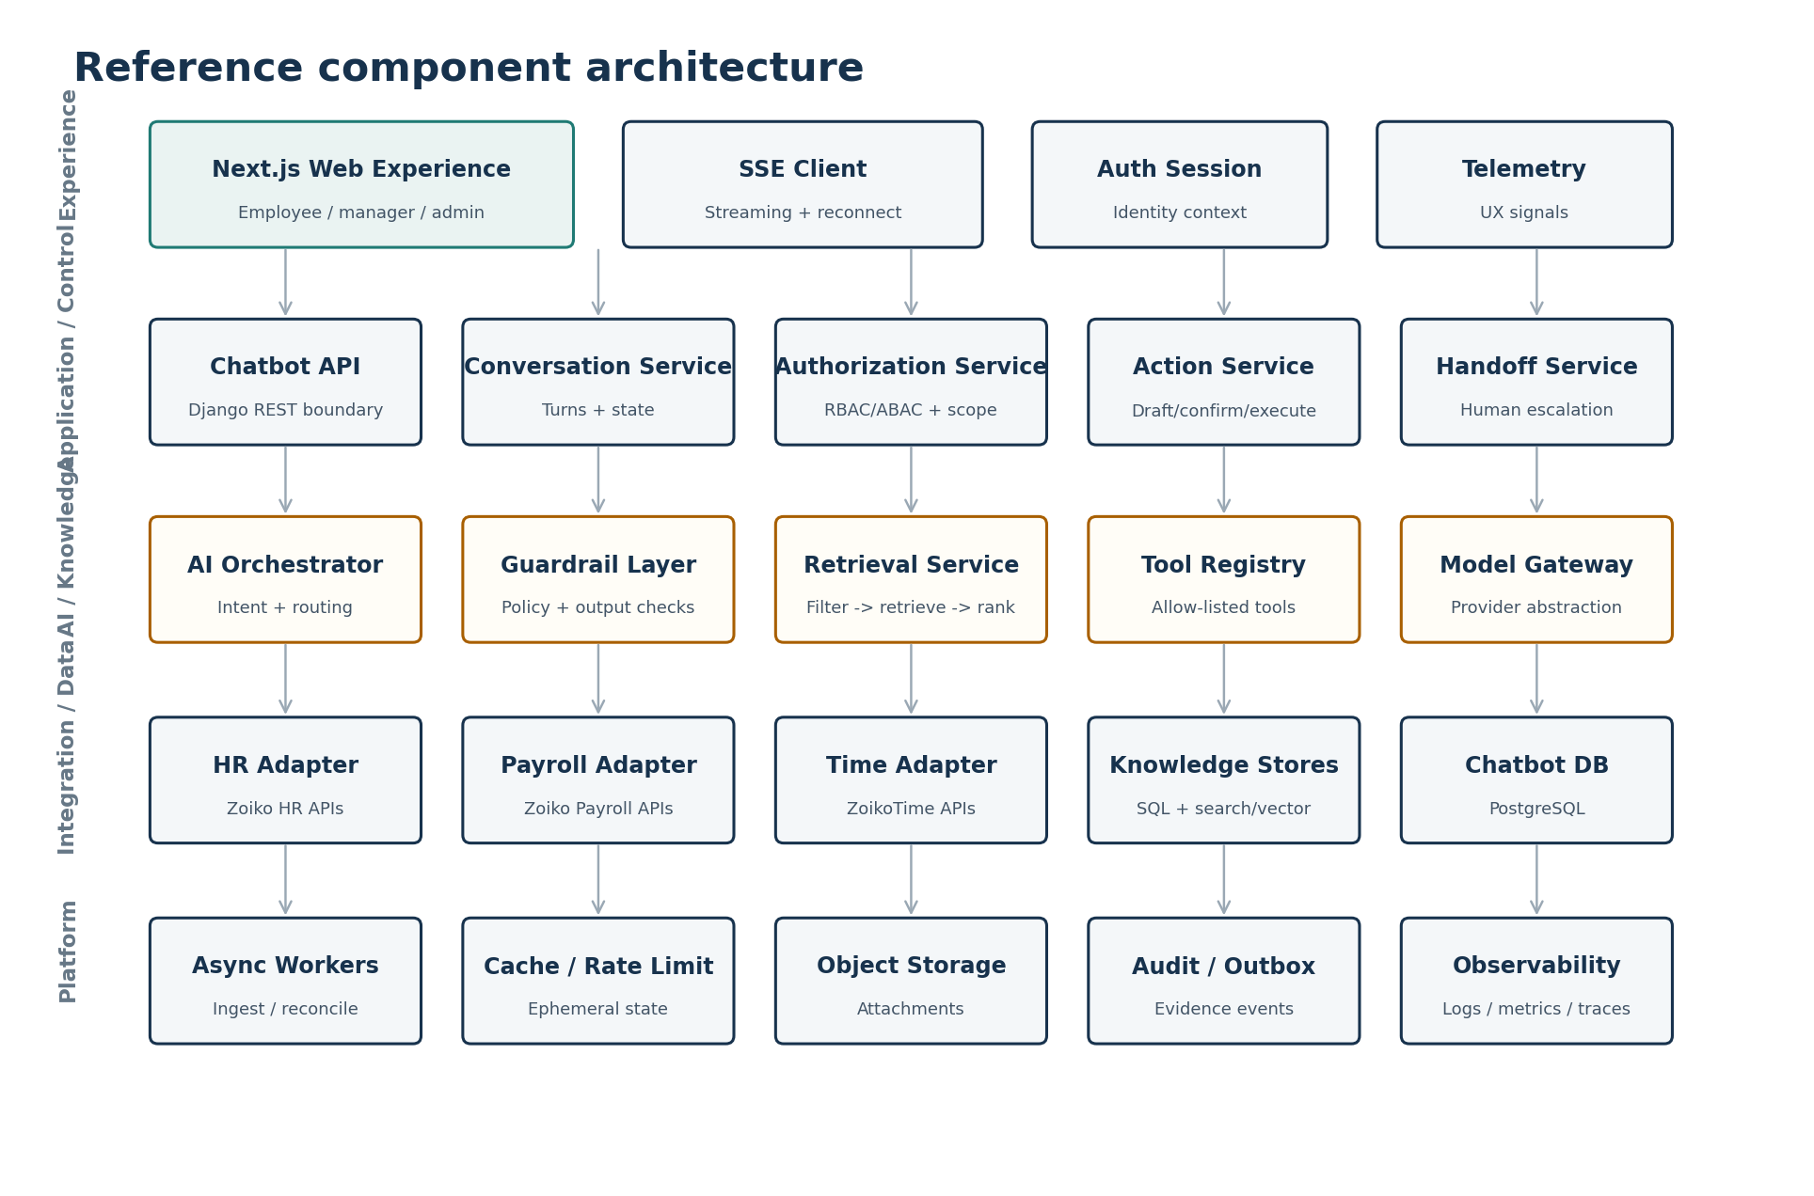
Figure 2. Reference component architecture.
The diagram is a logical decomposition. It does not require one network service or container per box on day one. The initial production deployment may combine compatible modules inside a Django application boundary, but module ownership and dependency rules must remain explicit so components can be isolated later without redesigning contracts.
Component | Primary responsibility | Owns durable data? | May call
Chatbot API | HTTP/SSE contract, request validation, correlation, response envelopes | No | Conversation, AuthZ, Orchestrator, Action, Handoff
Conversation Service | Session/turn lifecycle and resumable bounded context | Yes - chatbot state | Chatbot DB, Orchestrator
Authorization Service | Resolve user/tenant/subject/team scope and capability grants | Policy snapshots/evidence only | Zoiko HR identity/authorization APIs
AI Orchestrator | Intent classification, route selection, tool sequencing, bounded synthesis | Run metadata only | Guardrails, Retrieval, Tool Registry, Model Gateway
Guardrail Layer | Input/output/tool policy checks and safe refusal/degradation | Policy version refs | Policy store / configuration
Retrieval Service | Apply eligibility filters, retrieve/rank knowledge, return evidence pack | Derived retrieval telemetry | Knowledge metadata, search/vector index
Action Service | Draft, validate, confirmation binding, execute, reconcile | Workflow/evidence state | AuthZ, adapters, DB
Tool Registry | Allow-listed callable operations + schemas + policy tags | Configuration | Typed tool adapters only
Model Gateway | Approved model routing, timeout/retry, provider abstraction | Usage metadata | Approved model providers
Integration Adapters | Typed HR/Payroll/Time calls, circuit breaker, mapping | No authoritative data | Owning system APIs
Audit / Outbox | Append evidence and reliably publish operational events | Yes | Observability/event sinks
Async Workers | Ingestion, indexing, reconciliation, cleanup, notifications | Job state | DB, stores, adapters

5. Front-End Architecture
The chatbot experience is implemented within the Zoiko HR React/Next.js application and consumes the approved API contract. The browser is a presentation and interaction client, not a policy authority.
Area | Required architecture
Rendering | Use server/client rendering boundaries appropriate to Zoiko HR; sensitive assistant conversation data must not be serialized into public/static artifacts.
State | Local ephemeral UI state for composer/panels; server-authoritative conversation/workflow state for resumability and consequential actions.
Streaming | SSE client supports incremental answer events, final evidence envelope, heartbeat/timeout, reconnect and terminal error states.
Session | Use existing Zoiko HR authenticated session/token mechanism. Never place long-lived secrets, service credentials or provider keys in browser code.
Tenant context | Display tenant/workspace context, but server derives/validates effective tenant and permissions.
Action confirmation | Render server-returned review payload and confirmation expiry/version. Client cannot alter hidden execution payload between validate and confirm.
Sources | Citation UI opens exact source/version metadata allowed to the user; source drawer never exposes restricted corpus metadata.
Attachments | Direct-to-object-store upload may use short-lived signed upload authorization; completion must be registered and scanned server-side before retrieval.
Accessibility | WCAG 2.2 AA interaction semantics from Figma specification; live regions for streaming status without excessive screen-reader chatter.
Telemetry | Capture product events without prompt/body leakage by default. Any text telemetry requires explicit classification and minimization.

Front-end security rules
- No authorization decisions based solely on route visibility, hidden controls or client-side role flags.
- No raw model-provider calls from browser JavaScript.
- No client-supplied tool name or downstream endpoint is trusted; only server-resolved tool/action IDs are executable.
- Sanitize rendered rich text/markdown; disallow active HTML/script content from model or source excerpts.
- Use CSRF protections appropriate to the chosen session architecture and same-site deployment.

6. Backend Application Architecture
The preferred implementation is a modular Django service layer with explicit package boundaries and dependency direction. Teams may later extract high-load or high-risk modules into separate deployables without changing product contracts.
zhr_chatbot/
api/ # HTTP/SSE transport, serializers, error envelopes
conversations/ # sessions, turns, bounded context
authorization/ # tenant, subject, team scope and capability checks
orchestration/ # intent routing and deterministic control flow
guardrails/ # input/output/tool policy enforcement
retrieval/ # eligibility, query, rank, evidence pack
actions/ # draft, validate, confirm, execute, reconcile
integrations/ # HR / Payroll / Time typed adapters
knowledge/ # source metadata and ingest coordination
handoff/ # escalation / case payload construction
audit/ # evidence events and transactional outbox
operations/ # kill switches, feature flags, health/admin controls
workers/ # asynchronous jobs and scheduled tasks
Dependency rule | Enforcement
Transport does not contain business authorization | API handlers call domain services; no role/scope branching duplicated in views.
Orchestrator cannot write authoritative HR data | It can request a typed action draft; only Action Service executes through adapters.
Model Gateway cannot access databases | It receives only prepared bounded context and returns provider-neutral model output.
Retrieval cannot bypass eligibility | Filter evaluation is mandatory before vector/semantic ranking results can be exposed.
Adapters hide provider/domain implementation | Domain services call typed interfaces, not raw URLs/SDKs scattered across code.
Audit is not best-effort for consequential actions | Execution transaction must bind evidence/outbox writes according to the database design.
Cross-module imports follow dependency graph | CI architecture tests or import rules reject forbidden dependency direction.

7. AI Orchestration Architecture
AI orchestration is a policy-constrained state machine. Model calls are tools within that state machine; they are not the application controller.
Stage | Deterministic responsibility | AI responsibility | Failure behaviour
Request intake | Normalize request; attach identity, tenant, locale, correlation | Optional intent suggestion | No model call if session/tenant invalid.
Intent routing | Map allowed routes and capability policy | Classify ambiguous natural language | Fallback to safe clarification or information-only route.
Context assembly | Select authorized profile fields, conversation summary, evidence/tool schemas | None | Drop unauthorized/unnecessary fields.
Retrieval | Apply source eligibility, dates, scope, policy | Optional query rewrite/rerank if bounded | No eligible evidence => no reliable answer.
Tool planning | Expose allow-listed schemas permitted for current route | Select from allowed tools / fill typed args | Unknown tool or invalid args rejected.
Generation | Construct bounded provider request and output contract | Synthesize user-facing language | Timeout/provider failure => degraded response; no invented completion.
Output validation | Schema, citation, sensitive-data, policy and action-state checks | None | Reject/repair within bounded retry policy or return safe failure.
Persistence | Store result, evidence refs, model/version/latency/usage metadata | None | No hidden reasoning storage.

Model gateway contract
Control | Required behaviour
Provider abstraction | Domain code uses provider-neutral request/response objects; provider SDKs stay inside the gateway.
Approved model allow-list | Model ID/version/capability class selected from environment policy, never client input.
Data minimization | Only context necessary for the specific request is transmitted; secrets and disallowed identifiers are removed/masked.
Timeouts | Hard connection/read/generation budgets; no unbounded provider wait.
Retries | Only safe/transient failures; never retry a model-triggered consequential action.
Fallback | Fallback model is explicitly approved for the same data classification and residency; otherwise degrade.
Structured outputs | Use typed schema validation for intent/tool/action objects; free text cannot directly invoke tools.
Usage control | Per-tenant/user quotas and global spend/capacity protections.
Observability | Record model/provider/version, latency, token/usage counts, policy result and correlation ID without hidden reasoning.

PROMPT BOUNDARY
Exact system prompts, prompt templates, jailbreak defences, prohibited-content logic and model-evaluation suites belong to Document 9 (Prompt Engineering / AI Guardrail Documentation). This architecture defines where those controls execute and how they are versioned, observed and fail safely.

8. Authorization and Policy Architecture
Authorization is evaluated server-side before sensitive retrieval, data access, tool exposure and action execution. The effective decision combines authenticated identity, tenant membership, actor role, target subject/team scope, capability, data classification and contextual constraints.
Policy input | Examples | Source
Actor | user_id, role grants, employment/admin status | Zoiko HR identity/authorization context
Tenant | tenant_id, organization state, region | Authenticated tenant context
Subject | self, employee_id, team members | Requested target resolved server-side
Capability | policy.answer, profile.read, leave.submit, team.read, source.admin | Action/tool registry
Scope | self, direct reports, delegated population, admin domain | Zoiko HR authorization graph
Data classification | general, internal, confidential, restricted | Schema/field/tool metadata
Context | jurisdiction, legal entity, worker type, effective date | Worker/profile and request context
Operational policy | feature flag, kill switch, maintenance state | Operations control service

Enforcement points
- At API request admission for tenant/session validity.
- Before subject/team data is fetched.
- Before retrieval eligibility filters are constructed.
- Before a tool schema becomes visible to the orchestrator.
- At action draft validation and again immediately before execution.
- Before evidence/source detail is returned to the client.
- At administrative knowledge and emergency-control endpoints.

9. Knowledge Retrieval Architecture
Retrieval is filter-first and evidence-producing. A search/vector engine is a derived index, not an authority store. The source metadata database determines whether a source version is eligible for a given user/request before ranking.
Step | Architecture behaviour | Output
1. Resolve context | Tenant, jurisdiction, entity, worker population, language, date, permissions | Eligibility context
2. Source filter | Published state; effective/expiry dates; audience; access class; applicability | Eligible source/version IDs
3. Query build | User question + safe rewrite + domain constraints | Provider-neutral query
4. Retrieve | Lexical/semantic/hybrid search only within eligible IDs | Candidate chunks
5. Rank | Relevance plus source authority/recency/business rules | Ranked evidence
6. Evidence pack | Exact source/version/section IDs + excerpts + metadata | Bounded generation context
7. Generate | Model uses evidence pack and response contract | Candidate answer
8. Validate | Citations reference supplied evidence; contradictions/no-answer handled | Final answer envelope

Derived-index rules
- Every chunk carries stable source_version_id and tenant/access metadata sufficient for pre-filter or post-verified filtering.
- Index deletion/supersession jobs are idempotent and reconciled against source lifecycle state.
- Retrieval results from stale or unavailable indexes never expand eligibility; database metadata remains the authority.
- No external web search is part of the governed employee-answer path unless a future product requirement explicitly introduces and governs it.
- Embedding text must be minimized to approved source content; access-controlled content must not be mixed into globally shared indexes without enforceable partitioning.

10. Conversation and Context Architecture
Concern | Architecture rule
Conversation persistence | Persist user-visible turns, bounded metadata, evidence references and workflow links per approved database schema.
Context window | Assemble only necessary recent turns plus approved summary/state; do not indiscriminately resend full history to the model.
Summaries | Generated summaries are non-authoritative convenience state; they carry version/time and can be regenerated.
Sensitive data | Apply field-level classification and minimization; avoid storing duplicate authoritative data in turn metadata.
Multi-session resume | Resume from server-authoritative workflow state and conversation metadata; expired confirmation cannot be resurrected from transcript.
Deletion | Conversation deletion/retention follows tenant policy and privacy controls, subject to legal hold/evidence obligations.
Cross-tenant isolation | Conversation ID lookups are tenant-scoped and authorized before object retrieval.
Prompt injection persistence | Do not promote user/model text into system instructions or durable guardrail configuration.

11. Controlled Action Architecture
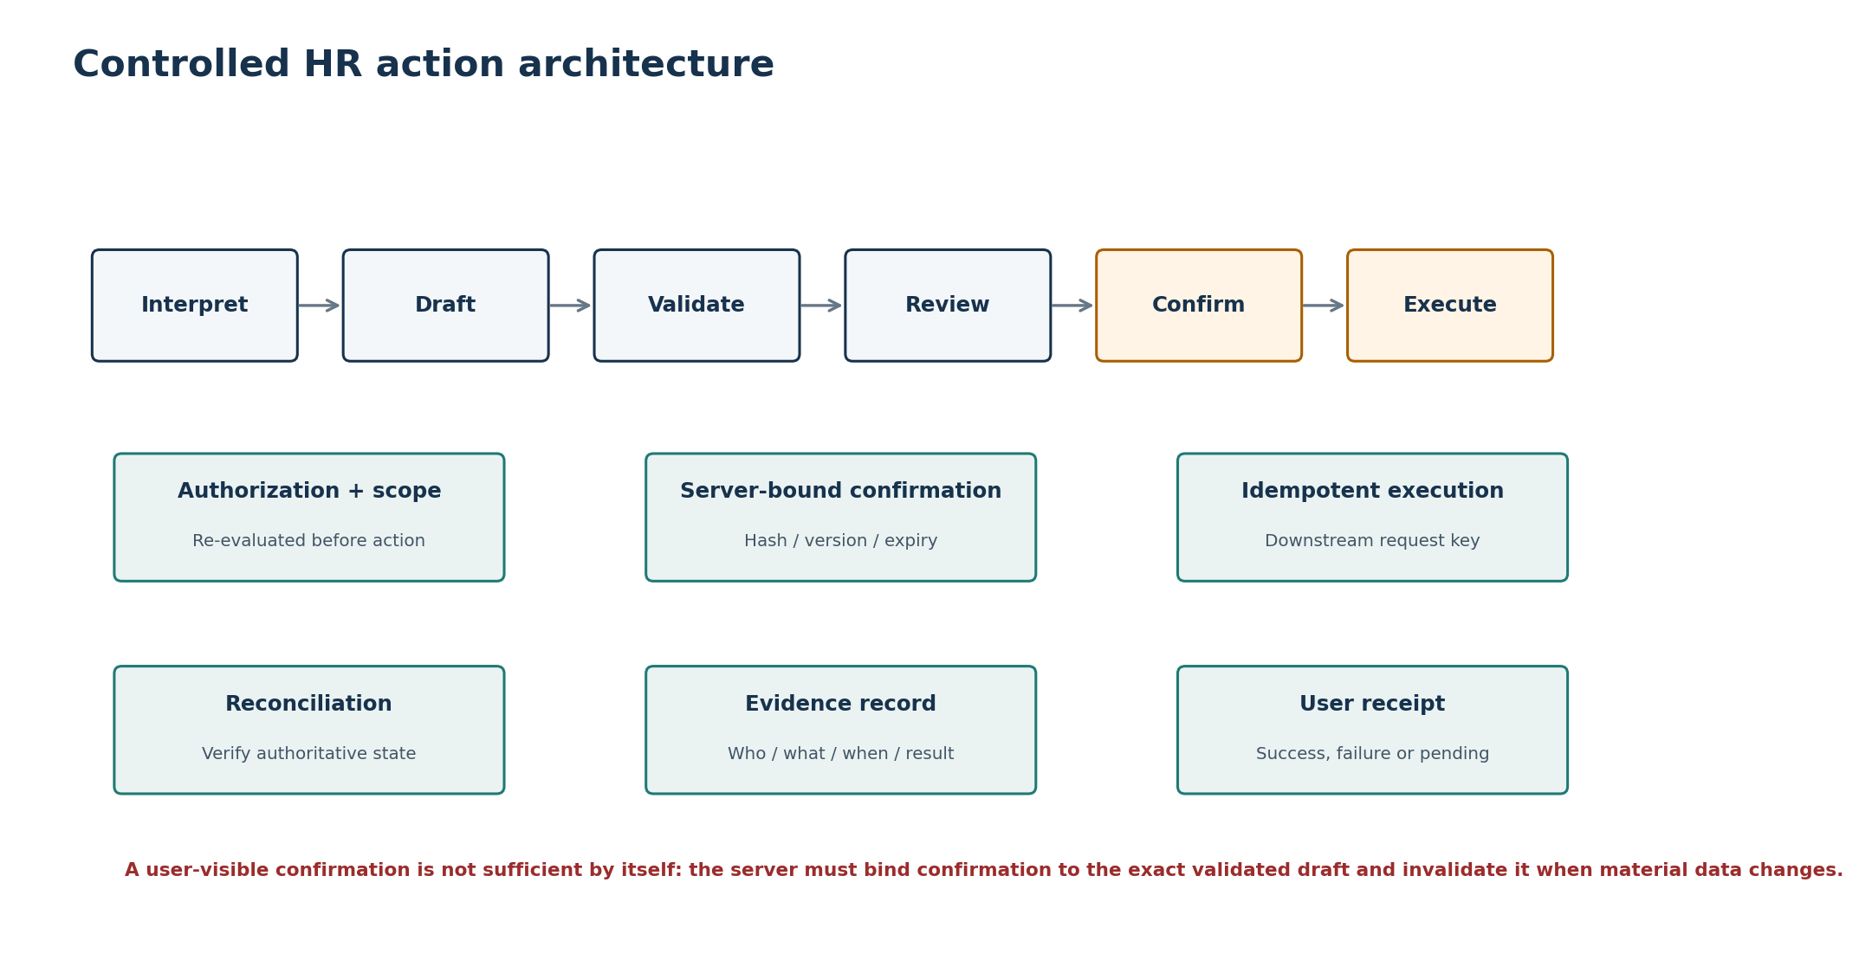
Figure 3. Controlled action path and evidence chain.
State | Owner | Required invariants
DRAFT | Action Service | Typed action kind; actor/tenant/subject bound; no execution side effect.
VALIDATED | Action Service + adapter validation | Current permissions, field rules and downstream prerequisites checked.
REVIEWABLE | Action Service | Human-readable normalized payload generated from validated server state.
CONFIRMABLE | Action Service | Confirmation token/hash binds action ID, version, material payload, actor and expiry.
CONFIRMED | Action Service | Explicit user confirmation accepted while token valid and state unchanged.
EXECUTING | Action Service | Idempotency key reserved; authorization rechecked; downstream call in progress.
SUCCEEDED / FAILED / PENDING | Adapter + Action Service | Outcome recorded without inventing success; pending reconciled asynchronously.
RECONCILED | Action Service + worker | Authoritative downstream state verified where required; evidence finalized.

Execution protections
- The model may propose a typed action draft but cannot mark it validated, confirmed or executed.
- Material edits after validation invalidate the prior confirmation binding.
- Idempotency keys are unique at the action boundary and persisted before or atomically with downstream execution semantics.
- Network timeouts after downstream submission produce UNKNOWN/PENDING rather than an assumed failure; reconciliation determines final state.
- Execution is disabled when the relevant capability kill switch is active, even if an old draft remains visible.

12. Attachment Processing Architecture
Attachment-based questions are a P1 capability and must use a quarantine-first pipeline. User files are not automatically promoted into the governed Knowledge Base.
Stage | Control | Failure handling
Upload authorization | Short-lived signed upload scoped to tenant/user/conversation, size/type policy | Reject before storage if policy cannot be established.
Quarantine | Object stored in non-executable quarantine location | No model/retrieval access yet.
Malware/content scan | Type validation, malware scan, decompression limits, unsafe-content checks | Mark REJECTED; prevent processing; expose safe reason.
Extraction | Text/metadata extraction in sandboxed worker | Failure yields unsupported/unreadable state.
Classification | Determine confidentiality and whether requested use is permitted | Restrict if policy disallows use.
Ephemeral retrieval | Build per-attachment derived representation scoped to authorized conversation/user | Never mix into shared governed corpus by default.
Answer | Cite attachment name/page/section where supported; maintain provenance | No reliable answer if extraction insufficient.
Expiry/deletion | Delete derived artifacts according to attachment retention policy | Reconciliation job removes orphaned derived data.

13. Integration Architecture
All Zoiko platform integrations use typed adapters with explicit ownership, timeout, retry, circuit-breaker and data-mapping policy. Integration calls are never emitted directly by model-generated URLs or arbitrary tool names.
Integration | Primary use | Pattern | Critical controls
Zoiko HR | Identity context, employee profile, team scope, HR workflows | Synchronous API + events where available | Strong service auth; tenant/subject scope; field minimization; authoritative response IDs.
Zoiko Payroll | Pay information and approved payroll workflows | Synchronous API; asynchronous reconciliation for writes | No shadow payroll ledger; restricted fields; no action without explicit capability.
ZoikoTime | Attendance/time data and approved workflows | Synchronous API + reconciliation | Manager scope; period/date validation; no silent edits.
Knowledge storage/index | Policy/SOP/FAQ/compliance retrieval | Metadata DB + derived search/vector index | Published/applicable filters; exact provenance.
Human case/support | Escalation handoff | API/event integration | Minimized context; consent/notice; case ID returned.
Model provider | Generation/classification | Model Gateway | Data minimization, approved model, residency/classification, timeout/circuit breaker.
Object storage/scanner | P1 attachments | Signed upload + async scanning | Quarantine, malware scan, short-lived access URLs.

Adapter standard
Requirement | Rule
Timeouts | Connect/read/total timeouts defined per endpoint class; never inherit infinite SDK defaults.
Retries | Only idempotent reads or explicitly idempotent writes; exponential backoff with jitter and retry caps.
Circuit breaker | Open on sustained dependency failure; capability returns degraded state rather than cascading resource exhaustion.
Bulkheads | Separate pools/queues where failure of one dependency could starve unrelated chatbot capabilities.
Schema mapping | Convert external payloads to internal domain DTOs at adapter boundary.
Error mapping | Map provider/domain errors to approved API error taxonomy; preserve correlation/reference IDs.
Service identity | Per-environment, least-privilege credentials; no shared developer secrets in source code.
Observability | Record dependency name, operation, latency, result class and request correlation without sensitive body logging.

14. Data Architecture
The approved Database Schema / ER Diagram remains authoritative for entity definitions. This section specifies storage roles and access patterns.
Store | Role | Authoritative? | Architecture constraints
PostgreSQL | Chatbot state, workflow, evidence, source metadata, idempotency, outbox | Yes for chatbot-owned records | HA configuration; encrypted; tenant-aware indexing; migrations controlled.
Search/vector index | Derived knowledge retrieval representation | No | Rebuildable from published source versions; access partitioning/filters; versioned index jobs.
Object storage | Quarantined/processed attachments and approved knowledge binaries | Authoritative for binary object only | Encryption, lifecycle policies, malware quarantine, signed URLs.
Cache | Rate limits, ephemeral locks, hot metadata, transient session assistance | No | Loss must not corrupt durable state; namespaces include tenant where relevant.
Queue/broker | Asynchronous work transport | No | At-least-once assumed unless proven otherwise; consumers idempotent.
Observability store | Operational logs/metrics/traces | No business authority | Redaction, access controls, separate retention.
Zoiko HR/Payroll/Time | Business records | Yes | Access only through owning APIs; chatbot DB stores reference IDs and evidence, not replacement ledgers.

Transaction boundaries
- Database transactions must be short and cannot span external network calls.
- Use a transactional outbox to bind durable state change and downstream event publication when event delivery matters.
- Use optimistic versioning or row locks only where the workflow design requires serialization; avoid broad locks around model/network calls.
- Every tenant-scoped repository method requires tenant context as an explicit input; unscoped “get by ID” patterns are prohibited for tenant-owned records.
- Large model payloads/source binaries do not belong in relational columns when object storage/reference semantics are sufficient.

15. Eventing and Asynchronous Processing
Workload | Sync/async | Why | Idempotency key
Interactive turn admission | Sync | Immediate user contract | request_id / turn_id
Knowledge retrieval | Sync | Required to answer | turn_id + retrieval_run_id
Model generation | Sync/stream | Interactive response | model_run_id; generation not reused as action
Knowledge ingestion | Async | CPU/IO intensive and reviewable | source_version_id + ingest_version
Index update/removal | Async | Derived rebuildable data | source_version_id + index generation
Attachment scanning/extraction | Async | Untrusted file processing | attachment_id + processing version
Action reconciliation | Async when outcome uncertain | Downstream confirmation may lag | action_execution_id
Audit/event forwarding | Async via outbox | Reliable decoupling | outbox_event_id
Retention/deletion jobs | Async/scheduled | Lifecycle enforcement | object_id + policy revision
Quality/evaluation jobs | Async | Non-interactive | evaluation_run_id

Worker rules
- Assume at-least-once delivery and make handlers idempotent.
- Persist retry count, next attempt, terminal reason and correlation ID for operationally relevant jobs.
- Poison messages move to a dead-letter or failure queue after bounded retries and create an operational alert where business impact warrants.
- Workers use separate service identities from web/API nodes and receive only the permissions required by their job class.
- Queue backlog, oldest-message age and failure rate are SRE metrics, not hidden implementation details.

16. Caching, Rate Limiting and Concurrency
Concern | Rule
Response caching | Do not cache personalized assistant answers across users. Cache only well-classified, safe derived metadata where scope is explicit.
Knowledge metadata cache | May cache published-source metadata with short TTL and version invalidation; database remains authority.
Authorization cache | Only if source of truth semantics support it; short-lived; include tenant/user/scope revision; recheck before consequential execution.
Rate limiting | Layered by user, tenant, IP/risk signal and expensive capability; return standard retry metadata without revealing security thresholds.
Model quotas | Per-tenant/user budgets and global provider safeguards; quota exhaustion degrades clearly.
Distributed locks | Use narrowly for workflow races/reconciliation where optimistic versioning is insufficient; locks have owner and expiry.
Concurrent edits | Workflow version/ETag mismatch invalidates stale confirmation and requires refresh.
Replay | Idempotency record returns original compatible result for safe duplicate execution requests.

17. Security Architecture
Security controls are defense-in-depth and apply even when the model behaves incorrectly. The architecture assumes prompt injection, malicious files, compromised user sessions, dependency failures and attempts to cross tenant or role boundaries.
Threat | Primary controls | Detection / evidence
Cross-tenant access | Server-derived tenant context; tenant-scoped repositories; authorization; DB constraints/partitioning where appropriate | Denied-access event; anomalous tenant-ID mismatch metrics
Broken object authorization | Subject/team scope checks on every sensitive resource | Authorization decision ID + target subject
Prompt/tool injection | System/tool separation; allow-listed schemas; input/output guardrails; no arbitrary URLs/SQL | Guardrail result and blocked tool event
Sensitive-data leakage | Minimization; field classification; output validation; restricted logging | DLP/redaction metrics; security alert on policy breach
Malicious attachment | Quarantine; malware/type scan; sandboxed extraction; limits | Scan result and processing event
Credential theft | Managed secrets; rotation; short-lived workload identity where available | Credential-use telemetry; privileged-access logging
Replay/duplicate action | Confirmation binding + expiry; idempotency; state/version checks | Duplicate/replay rejection event
Provider compromise/outage | Gateway; data minimization; approved endpoint list; circuit breaker; provider disable switch | Provider health and routing audit
DoS/cost abuse | Edge/WAF; layered rate limits; request size limits; queue/capacity guards | Rate-limit/cost anomaly metrics
Supply-chain compromise | Locked dependencies, SCA/SAST, signed build artifacts, least-privilege CI | Build provenance and security scan results

Secrets and key management
- No secrets in source control, Figma, OpenAPI examples, Postman exported environments or client bundles.
- Use a managed secrets/KMS mechanism per environment; rotate credentials and encryption keys under documented procedures.
- Service-to-service credentials are distinct by environment and privilege domain.
- Logs never contain bearer tokens, cookies, API keys or raw secrets; structured logging middleware redacts known sensitive headers.

18. Privacy, Residency and Retention Architecture
Control area | Architecture requirement
Data minimization | Only retrieve/transmit/store fields needed for the current capability. Favor stable references over copied authoritative records.
Regional residency | Route tenant data to an approved regional cell/storage boundary; cross-region model/search providers must be explicitly approved for classification/residency.
Purpose limitation | AI provider payloads and derived indexes are used only for approved chatbot purposes; no provider training on tenant data unless contractually and technically approved.
Retention | Apply record-class retention from database/knowledge specifications to conversations, attachments, evidence, telemetry and derived indexes.
Deletion | Deletion propagates to derived search/vector/object artifacts unless legal hold or evidence obligations require retention.
Legal hold | Hold state prevents destructive cleanup for in-scope evidence while preserving access controls.
Telemetry privacy | Operational telemetry uses IDs/classifications, not raw prompt/answer bodies by default.
Data export | Privacy/subject exports include only authorized/in-scope chatbot-owned records and appropriately reference authoritative Zoiko systems.

19. Observability and Audit Architecture
Operational observability and formal audit evidence are related but distinct. Logs/traces optimize operations; audit records prove sensitive decisions and actions. Neither is a replacement for the other.
Signal | Minimum dimensions | Do not include by default
Request metrics | route, capability, tenant-safe key, result class, latency, HTTP status | Prompt/answer bodies
Model metrics | provider, model ID, route, latency, usage/tokens, timeout/fallback, policy result | Hidden reasoning or unrestricted text
Retrieval metrics | eligible source count, candidate count, ranking duration, no-answer/conflict result | Restricted source text in logs
Action metrics | action type, state transition, downstream dependency, outcome, reconciliation age | Sensitive payload values
Queue metrics | queue name, depth, oldest age, retries, DLQ count | Job content bodies
Audit evidence | actor, tenant, subject, capability, decision/action IDs, timestamps, policy/source versions, outcome | Secrets; unnecessary payload duplicates
Trace context | trace_id, request_id, turn_id, action_id where applicable | Raw tokens/credentials

Minimum dashboards
- End-user request success, latency, no-answer, restricted and degraded rates.
- Model provider availability, latency, error and fallback rate by approved model.
- Retrieval eligibility/no-evidence/conflict rate and index freshness.
- Action draft/confirmation/execution/reconciliation funnel, failure and pending age.
- Authorization denials and anomalous cross-scope attempts.
- Queue backlog, worker failure/DLQ, attachment scan failure and knowledge-ingestion health.
- Database/cache/object-store health, connection saturation and capacity trends.
- Cost/usage by tenant/capability with privacy-safe aggregation.

20. Deployment Topology
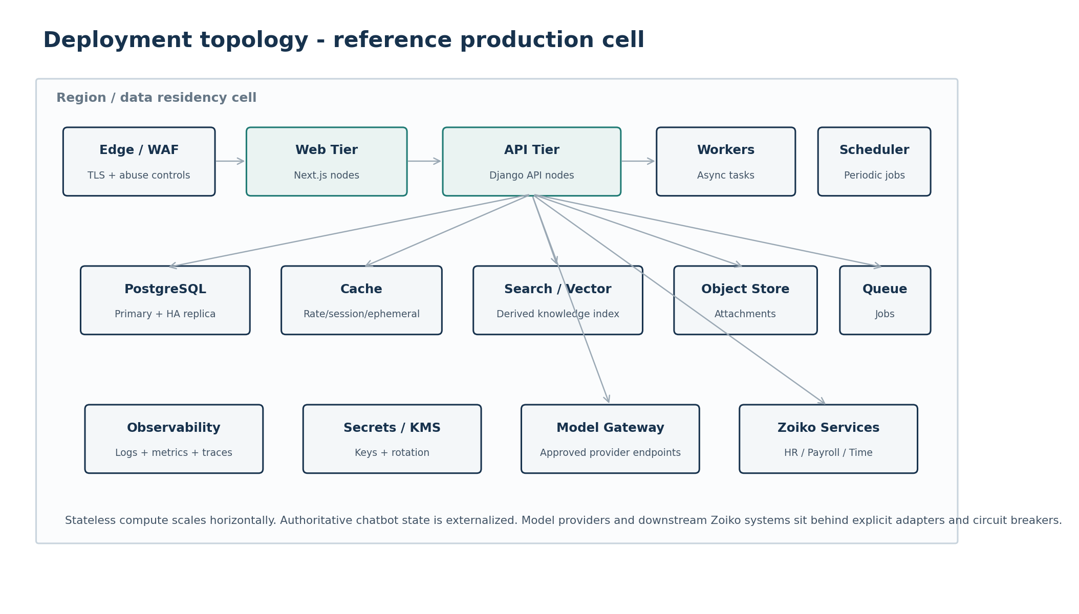
Figure 4. Reference production regional cell.
The topology is provider-neutral. The production implementation should use managed HA primitives where they materially improve reliability/security, while preserving the logical contracts in this document.
Tier | Scaling / HA | Network posture
Edge/WAF | Managed or horizontally redundant | Public ingress; only approved routes; TLS termination/re-encryption per platform standard.
Next.js web | Horizontal replicas; stateless | No direct DB/model access from browser-facing code paths beyond server-approved internal interfaces.
Django API/orchestration | Horizontal replicas; stateless | Private access to stores/adapters; inbound only from approved edge/web/service paths.
Workers/scheduler | Independent autoscaling; scheduler singleton/leader semantics | Private; no public ingress.
PostgreSQL | Primary + HA/replica/backups | Private network only; encrypted; restricted admin plane.
Cache/queue/search/object | Managed HA as appropriate | Private endpoints where available; least-privilege service identities.
Model gateway | Controlled egress to approved providers | Egress allow-list/proxy and provider-specific policy.
Zoiko services | Private/service network or secured API gateway | Mutual/service authentication and explicit endpoint allow-list.

21. Environment Strategy
Environment | Purpose | Data policy | External integrations
Local | Developer iteration | Synthetic/local fixtures only; no production secrets | Mocks/sandboxes by default
Development | Shared integration | Synthetic or approved non-production data | Non-production Zoiko services and approved model sandbox
Test / QA | Automated and manual verification | Deterministic seeded datasets; privacy-safe | Mocks + controlled non-prod integrations
Staging / Pre-prod | Production-like release validation | Production-like synthetic/masked data only under policy | Non-prod or specifically isolated provider endpoints
Production | Customer/employee use | Approved tenant data only | Production Zoiko systems and approved providers

Environment isolation rules
- No shared database, cache namespace, object bucket or secrets between production and non-production.
- Production data is not copied to developer laptops or lower environments unless an explicit approved sanitization process exists.
- Feature-flag defaults, model allow-lists and kill switches are environment-specific and configuration-controlled.
- Migration rehearsals occur against production-like schema/volume before release-sensitive database changes.

22. Scalability and Capacity Architecture
Dimension | Scale strategy | Primary bottleneck signals
Concurrent chat turns | Horizontal API/orchestration replicas; connection-aware SSE capacity | Active streams/node, event-loop/thread saturation, connection pool usage
Model demand | Concurrency controls, per-tenant quotas, provider pool/fallback, prompt minimization | Provider rate-limit, queueing latency, token/cost rate
Retrieval | Partition/filter indexes, cache safe metadata, scale search tier separately | Query p95/p99, vector/lexical CPU/memory, candidate count
Database | Tenant-aware indexes, connection pooling, read replicas only for safe read paths | Connections, locks, slow queries, replication lag
Async jobs | Worker autoscaling from queue depth/oldest age | Backlog age, retries, worker utilization
Attachments | Object store direct upload, async scanner/extractor pools | Scan queue age, object throughput, extraction failure
Knowledge ingestion | Batch/stream workers and isolated indexing resources | Ingest backlog, index freshness SLA
Downstream systems | Client-side bulkheads, circuit breakers and quotas | Dependency latency/error/saturation

Capacity planning inputs
- Peak authenticated users and peak simultaneous chatbot sessions per tenant/region.
- Average and p95 turns per session, prompt/evidence size and streaming duration.
- Retrieval corpus size, chunk count, updates per day and jurisdiction/tenant partition shape.
- Action execution volume and reconciliation rate.
- Attachment volume, size distribution and scan/extraction CPU cost.
- Model token usage and provider concurrency/rate limits.
- Database row growth and retention policy by entity class.

23. Reliability and Graceful Degradation
Failure | Required user/system behaviour | Must remain available
Model provider unavailable | Stop generation; show explicit temporary degraded state; offer retry/handoff where appropriate | Zoiko HR core product, non-AI HR navigation
Retrieval/search unavailable | Do not fabricate policy answer; return no-reliable-answer/degraded state | Authorized direct HR data reads/actions that do not depend on knowledge, subject to policy
Knowledge metadata DB unavailable | Treat knowledge eligibility as unavailable; block governed policy answers | Unrelated Zoiko HR functionality
Zoiko HR API unavailable | Block affected profile/action capabilities; do not use stale data as authoritative unless specifically approved | Policy-only answers if identity/context remains safely established
Payroll unavailable | Block payroll data/action capability only | General HR/time capabilities
ZoikoTime unavailable | Block time capability only | General HR/payroll capabilities
Cache unavailable | Fall back to durable state where safe; reduce throughput; never bypass rate/security controls | Core requests within safe capacity
Queue unavailable | Interactive read path may continue; defer/disable async-dependent functions | Safe synchronous capabilities
Audit/outbox persistence unavailable during action | Do not execute consequential action if required evidence cannot be durably bound | Information-only path
Kill switch active | Immediately disable configured generation/action/tool scope | Unaffected platform capabilities

FAIL CLOSED WHERE CONSEQUENCES MATTER
If the system cannot establish authorization, source eligibility, valid confirmation or required action evidence, the affected operation must not proceed. Availability is never purchased by silently removing a P0 control.

24. Disaster Recovery and Continuity
Asset | Recovery requirement | Validation
Chatbot PostgreSQL | Encrypted backups, point-in-time recovery where supported, cross-failure-domain copy under residency policy | Scheduled restore test; integrity and tenant isolation validation
Knowledge source binaries | Versioned/lifecycle-protected object storage appropriate to policy | Restore/re-index rehearsal
Search/vector index | Rebuildable from source versions; backup optional according to rebuild time objective | Full rebuild timing test
Cache | Disposable | Cold-start/failure test
Queue | Durability appropriate to business jobs; outbox protects event intent | Broker failover + replay/idempotency test
Configuration/flags/policies | Version-controlled or durably backed up | Restore known-good config; emergency control test
Secrets/keys | Managed recovery and rotation procedures | Access recovery exercise; no secret in backup exports
Observability | Retention according to incident/audit needs | Confirm critical audit is independently durable where required

RTO/RPO governance
Exact numerical RTO/RPO targets must be approved by the Zoiko HR service owner/SRE team based on business criticality and platform dependencies. Architecture must distinguish: (a) chatbot convenience services, (b) action/evidence state, and (c) authoritative HR/Payroll/Time systems. The chatbot cannot claim a stronger recovery guarantee than its dependencies provide.

25. Performance Architecture and Budgets
Performance is measured stage-by-stage so model latency is not allowed to hide avoidable application/database delay. Numerical targets below are engineering budgets for the chatbot layer and must be calibrated with production telemetry rather than treated as external contractual SLAs.
Path | Engineering budget / objective | Instrumentation
API admission + auth context | Target p95 <= 250 ms excluding external identity outage | server span: request/auth
Authorization decision | Target p95 <= 150 ms from available auth context | authz span + cache/source tag
Knowledge eligibility + retrieval | Target p95 <= 900 ms for normal corpus query | filter/retrieve/rank subspans
Time to first streamed content | Target p95 <= 2.5 s under healthy provider conditions | client + server + provider timestamps
Non-AI direct data card | Target p95 <= 1.5 s excluding downstream degradation | adapter + API spans
Action validate/review | Target p95 <= 1.5 s excluding downstream degradation | validation + adapter spans
Confirmation execution response | Return accepted/succeeded/pending within bounded downstream timeout | action execution span + state
SSE heartbeat | Maintain connection observability and detect dead streams | stream heartbeat/error counters

Performance anti-patterns
- Calling the model before authorization or source eligibility is established.
- Embedding entire source documents or full conversation history per turn.
- Holding database transactions open during model or downstream network calls.
- Executing multiple redundant downstream reads because the orchestrator lacks a typed request plan.
- Logging full prompts/responses synchronously on the critical path.

26. CI/CD, Infrastructure-as-Code and Release Architecture
Pipeline stage | Blocking controls
Source | Protected branches, reviewed changes, secret scanning, signed/attributed commits according to platform policy.
Static checks | Formatting/lint, type checks, import/dependency architecture rules, SAST, dependency/SCA scan.
Unit/domain tests | Authorization, state machines, confirmation binding, idempotency, mappings, guardrail integration points.
Contract tests | OpenAPI validation; adapter/provider contracts; schema compatibility.
Database | Migration lint/review, backward-compatible deploy sequence, rehearsal for high-risk changes.
Build | Reproducible container/package build; SBOM; vulnerability scan; immutable artifact ID.
Deploy non-prod | IaC plan/apply through controlled identity; config validation; smoke tests.
Pre-prod gates | E2E P0 journeys, security tests, AI evaluation/guardrail suite, load/resilience tests, rollback rehearsal.
Production rollout | Progressive/canary or phased rollout where platform supports it; feature flags default-safe; health gates.
Post-deploy | SLO/error/cost/security monitoring; automated or manual rollback thresholds; deployment evidence retained.

Deployment compatibility rule
Database and API changes must support at least the overlap window needed for rolling deploys. A release must not require every web/API/worker node and schema migration to switch atomically unless a specifically engineered maintenance mode is approved.

27. Feature Flags and Emergency Controls
Control | Granularity | Fail-safe default | Audit requirement
Generation kill switch | Global / region / tenant / capability | Generation disabled | Actor/system, scope, reason, time, prior/new state
Action kill switch | Global / region / tenant / action type | Writes disabled | Same + affected action class
Tool disable | Tool/action adapter | Unavailable to orchestrator | Tool ID + reason
Model disable/routing | Provider/model/capability | Approved alternate or degrade | Old/new route + approver
Knowledge source disable | Source/version | Excluded from eligibility | Source/version + reason
Feature flag | Tenant/cohort/environment | Safe approved default | Change history and owner
Maintenance mode | Capability or service | Block affected operations explicitly | Window + operator + user message key

Control-plane separation
- Emergency controls must be changeable without deploying application code.
- Privileged control APIs/UI require stronger authorization than ordinary HR administration.
- Action kill-switch evaluation occurs server-side immediately before execution, not only at draft creation.
- Control state is cached only with sufficiently short TTL or push invalidation to meet emergency-response requirements.
- Every change is durable and auditable; a disabled control cannot silently revert after restart.

28. API and Interface Governance
Interface class | Governance rule
Public product API | OpenAPI is canonical; versioned; standard error/idempotency/correlation semantics; no undocumented fields.
Internal module interface | Typed Python/domain interfaces; no direct DB access across owning modules except approved repository abstractions.
Integration adapter | Provider/domain-specific schemas converted to internal DTOs; contract tests and timeout policy mandatory.
Tool schema | Allow-listed, versioned JSON schema; capability/policy tags; no arbitrary endpoint or SQL tool.
Event schema | Versioned event type, event ID, tenant, occurred_at, correlation, producer; consumers tolerate additive change.
Model gateway | Provider-neutral request/response; structured outputs schema; approved metadata fields.
Operational control API | Separate privileged scope, strong audit, deny-by-default exposure.

29. Testing Architecture
Test layer | Required coverage | Primary owner
Unit | Policy predicates, state transitions, parsers, mappers, validators, idempotency helpers | Feature engineering
Architecture | Forbidden imports/dependencies, repository scoping conventions, direct provider calls | Architecture/platform
Contract | OpenAPI, downstream adapters, model gateway structured output, events | Backend/integration
Integration | DB/cache/queue/search/object-store behaviour with real service dependencies in test environment | Backend/platform
AI evaluation | Grounding, refusal, citation, injection, tool selection, sensitive-data and regression suites | AI/ML + Product QA
E2E | 14 core screens and P0 journeys; action confirmation/execution/reconciliation; handoff | QA
Security | AuthZ/BOLA, tenant isolation, injection, file upload, SSRF, secret exposure, rate-abuse | Security
Load/performance | Concurrent SSE, retrieval, DB, queue, model quotas, dependency slowdown | SRE/performance
Resilience | Provider outage, index outage, downstream timeouts, cache/queue failure, kill switches | SRE + QA
DR | Backup restore, index rebuild, config/secrets recovery | SRE/platform

30. Operational Runbooks and SRE Ownership
Runbook | Must cover
Model provider degradation | Detect, disable/reroute, user degradation mode, data-classification compatibility, recovery validation.
Retrieval/index degradation | Index freshness, query errors, source metadata health, rebuild/rollback.
Downstream HR/Payroll/Time outage | Circuit breaker state, affected capability matrix, pending action reconciliation.
Action incident | Immediate action kill switch, identify impacted action IDs, reconcile downstream state, preserve evidence.
Suspected cross-tenant leak | Containment, key/session invalidation as appropriate, evidence preservation, security incident escalation.
Attachment threat | Disable uploads/processing, quarantine objects, scanner health, purge malicious derived data.
Queue/DLQ growth | Stop runaway producers if needed, inspect poison class safely, replay after fix.
Database incident | Failover/restore, write safety, migration rollback/forward, integrity verification.
Cost/abuse spike | Rate/tenant controls, model quotas, suspicious actor review, maintain safe service for unaffected users.
Emergency feature control | Who can change kill switches, dual-control where required, rollback/re-enable checks.

On-call ownership matrix
Area | Primary | Secondary
Web/API/orchestration | Zoiko HR Product Engineering | Platform/SRE
AI/model gateway | AI/ML Engineering | Product Engineering
Knowledge retrieval/index | AI/Data Engineering | HR Knowledge Operations
Database/cache/queue/object | Platform/SRE | Product Engineering
Zoiko HR integration | Zoiko HR Engineering | Platform/SRE
Payroll/Time adapters | Owning product integration team | Zoiko HR Engineering
Security incident | Security | SRE + Product Engineering
Knowledge correctness | HR Knowledge/Compliance owner | Product + AI/ML

31. Architecture Traceability
Upstream artifact | Architecture realization
Engineering Wireframe | 14 UI states map to front-end, API, conversation, retrieval, action, handoff and degraded-state components.
PRD | P0 security, grounding, self-service, manager scope, human handoff, observability and kill-switch requirements are mapped to explicit services/control planes.
FRS | Functional IDs are implemented through deterministic authorization, retrieval, workflow, integration and evidence state machines.
API Documentation | Endpoints terminate in domain services; SSE, idempotency, error, confirmation and admin contracts have named architecture owners.
Database Schema / ER Diagram | PostgreSQL owns only approved chatbot entities; transactions/outbox/concurrency follow database invariants.
Knowledge Base | Filter-first retrieval, source lifecycle, applicability, evidence and conflict/no-answer behavior are preserved.
UI/UX Figma | Client states map to authoritative server states; restricted/degraded/action states cannot be simulated purely client-side.
Prompt/Guardrail Document (next) | Will define prompt templates, model policy, injection defenses, output validation rules and AI evaluation thresholds inside the orchestrator/guardrail boundary.

FRS capability -> service mapping
Capability family | Primary services | Critical stores/dependencies
Conversation/session | Chatbot API + Conversation Service | PostgreSQL, cache
Grounded policy answer | AuthZ + Retrieval + Guardrails + Model Gateway | Knowledge metadata DB, search/vector, model provider
Self-service data | AuthZ + typed adapter + response mapper | Zoiko HR / Payroll / Time
Consequential action | Action + AuthZ + adapter + audit/outbox + reconciliation worker | PostgreSQL, downstream system, queue
Attachments | Upload API + object store + scan/extract workers + ephemeral retrieval | Object store, queue, scanner, derived index
Human handoff | Handoff Service + integration adapter | Case/support platform, PostgreSQL evidence
Admin knowledge | Knowledge admin service + ingestion/index workers | PostgreSQL, object, search/vector
Emergency controls | Operations control service + enforcement middleware | Durable config/control store, audit

32. Release Gates and Definition of Done
Gate | Release-blocking evidence
Architecture review | Approved component/trust/data-flow diagrams, ADRs for unresolved provider/infrastructure choices, no prohibited bypass path.
Tenant isolation | Automated cross-tenant tests at API, repository, retrieval, source-detail and action layers.
Authorization | BOLA/scope tests including manager team boundaries and privileged admin controls.
Grounding | Retrieval eligibility, provenance, no-answer/conflict behavior and citation validation pass required evaluation thresholds.
Actions | Draft/validate/review/confirm/execute/reconcile; stale confirmation, duplicate request, timeout and kill-switch tests pass.
Security | Threat-model review, SAST/SCA, secrets, upload, injection, SSRF and rate-abuse tests pass.
Privacy | Data inventory/classification, retention/deletion, telemetry minimization and provider data-handling approvals complete.
Reliability | Circuit breaker/degraded-state tests for model, retrieval and Zoiko dependencies pass.
Performance | Load test demonstrates agreed concurrency and latency budgets with observability enabled.
DR | Backup restore and index rebuild procedures tested for relevant stores.
Observability | Dashboards/alerts/runbooks exist for request, provider, retrieval, action, queue and security signals.
Deployment | CI/CD, migration, rollback and feature/kill-switch procedures validated in pre-production.
Operations | Named service owners/on-call path and escalation runbooks approved.
Documentation | OpenAPI, DB schema, KB, Figma, architecture and guardrail versions referenced in release manifest.

DEFINITION OF DONE
The chatbot is architecture-complete only when the deployed system enforces the approved product controls even under retries, stale clients, provider failures, malicious input and partial dependency outages. A happy-path demonstration is not sufficient evidence of production readiness.

Appendix A. Service Catalogue
ID | Logical service/module | Responsibility | State posture
SVC-API | Chatbot API | HTTP/SSE admission, schema validation, correlation | Stateless
SVC-CONV | Conversation Service | Conversation/turn/workflow context lifecycle | Stateful via PostgreSQL
SVC-AUTHZ | Authorization Service | Tenant/subject/team/capability policy | Stateful refs/cache
SVC-ORCH | AI Orchestrator | Deterministic orchestration state machine | Run metadata
SVC-GUARD | Guardrail Layer | Input/output/tool policy enforcement | Policy versions
SVC-RET | Retrieval Service | Eligibility/query/rank/evidence pack | Derived telemetry
SVC-ACT | Action Service | Action state machine and execution | Stateful
SVC-HAND | Handoff Service | Escalation/case payload | Stateful refs
SVC-KNOW | Knowledge Admin/Ingest | Source lifecycle and ingest coordination | Stateful metadata
SVC-MODEL | Model Gateway | Provider routing and structured generation | Usage metadata
SVC-INT-HR | HR Adapter | Zoiko HR interface | Stateless
SVC-INT-PAY | Payroll Adapter | Zoiko Payroll interface | Stateless
SVC-INT-TIME | Time Adapter | ZoikoTime interface | Stateless
SVC-AUD | Audit/Outbox | Evidence events and reliable publication | Stateful
SVC-OPS | Operations Control | Flags, kill switches, health | Stateful config
SVC-WORK | Async Workers | Ingest, scan, reconcile, cleanup | Job state

Appendix B. Port / Protocol / Trust Matrix
Exact port numbers depend on the hosting platform and are intentionally not hard-coded here. Only required protocol relationships are authorized; network policy should deny all other east-west and egress traffic by default where practical.
Caller | Target | Protocol | AuthN/AuthZ | Data class
Browser | Edge/Web | HTTPS + SSE over HTTPS | User session / OIDC-compatible platform auth | User HR interaction
Web/API | Internal Django modules/services | HTTPS or in-process typed call | Workload identity / module policy | Internal/restricted
API/Workers | PostgreSQL | TLS DB protocol | Database workload identity | Restricted
Services | Cache/Queue/Search | TLS service protocol | Workload identity | Internal/restricted derived
Upload client | Object store signed endpoint | HTTPS | Short-lived signed authorization | User attachment
Workers | Object/scanner | TLS APIs | Workload identity | Restricted attachment
Model Gateway | Approved model provider | HTTPS | Provider secret/workload identity | Minimized approved AI payload
Adapters | Zoiko HR/Payroll/Time | HTTPS | Service-to-service identity | Restricted workforce data
Services | Observability collectors | TLS | Workload identity | Sanitized telemetry

Appendix C. Architecture Decision Register
ADR | Decision / status | Rationale / constraint
ADR-001 | APPROVED - deterministic authorization outside LLM | Model output cannot grant data/action access.
ADR-002 | APPROVED - owning systems remain authoritative | Prevents shadow HR/payroll/time ledgers.
ADR-003 | APPROVED - server-bound confirmation for writes | Prevents stale/tampered client execution.
ADR-004 | APPROVED - filter-first governed retrieval | Relevance ranking cannot expand source eligibility.
ADR-005 | APPROVED - provider-neutral model gateway | Avoids coupling product contract to one model vendor.
ADR-006 | APPROVED - relational chatbot state + derived retrieval index | Structured state needs transactions; index remains rebuildable.
ADR-007 | APPROVED - transactional outbox for material events | Avoids DB/event split-brain for evidence/event publication.
ADR-008 | APPROVED - quarantine-first attachment processing | Untrusted file content cannot enter model/retrieval directly.
ADR-009 | APPROVED - modular Django baseline | Preserves velocity while enforcing extractable boundaries.
ADR-010 | PROPOSED - Redis-compatible ephemeral cache/limiter | Provider/product selection remains infrastructure decision.
ADR-011 | PROPOSED - managed object storage + malware scanner | Exact provider pending hosting/security decision.
ADR-012 | PROPOSED - search/vector engine selection | Must support tenant/applicability filtering and operational targets.
ADR-013 | OPEN - production hosting/region topology | Select based on Zoiko platform deployment standard and residency requirements.
ADR-014 | OPEN - numerical SLO/RTO/RPO values | Require SRE/business criticality approval.
ADR-015 | OPEN - model provider/model classes | Must pass Document 9 guardrail/evaluation and data-handling approval.

Appendix D. Failure-Mode Matrix
Failure mode | Detection | Containment | Recovery / user state
Model timeout/error | Gateway metrics/circuit breaker | Stop call; bounded fallback only if approved | Degraded generation; retry/handoff
Retrieval index stale | Freshness monitor/version mismatch | Exclude stale generation or use safe known path per policy | No-answer/degraded; rebuild index
Source metadata unavailable | DB health/read failure | Block governed policy retrieval | Knowledge unavailable
HR dependency slow | Adapter timeout/bulkhead | Open breaker for affected operation | Affected data/action unavailable; other capabilities continue
Action response unknown | Downstream timeout after submit | Mark pending/unknown; never resubmit blindly | Reconciliation worker resolves final state
Queue backlog | Depth/age alert | Scale workers, throttle producers | Async features delayed; interactive safe path remains
Cache loss | Connection/health alert | Fallback to DB/local safe policy; conservative rate behavior | Reduced throughput, no integrity loss
DB primary failure | Health/failover alert | Failover or read-only/degraded depending state | Writes blocked until authoritative chatbot DB available
Malware scanner unavailable | Scanner health | Disable attachment processing | Attachment feature unavailable
Suspected prompt attack | Guardrail/tool policy event | Block/limit request and tool exposure | Safe refusal/restricted response
Cross-tenant anomaly | AuthZ/security alert | Deny, isolate session/service as needed | Security incident workflow
Cost abuse spike | Quota/cost alert | Rate/tenant/model controls | Throttled capability; unaffected tenants protected
Bad deployment | Health/error regression | Progressive rollout halt / rollback | Return to known-good artifact/config
Emergency action risk | Incident signal | Activate action/tool kill switch | Writes disabled; information path remains where safe

Implementation Handoff Checklist
☐ Architecture owner assigned and logical service/module boundaries represented in the codebase.
☐ All P0 trust boundaries and data flows threat-modeled.
☐ No browser/model direct path to authoritative databases or downstream write APIs.
☐ Authorization enforcement points implemented and tested at API, retrieval, data and action boundaries.
☐ Retrieval filter-first eligibility and exact evidence provenance implemented.
☐ Model gateway, tool registry and guardrail boundary versioned and observable.
☐ Action confirmation binding, idempotency, unknown-result handling and reconciliation implemented.
☐ Attachment quarantine/scan/extraction isolation implemented before P1 enablement.
☐ PostgreSQL, object, cache, queue and derived index ownership/retention mapped to approved schemas.
☐ Circuit breakers, timeouts, bulkheads and degraded-state mappings implemented for external dependencies.
☐ Action and generation kill switches independently tested.
☐ Observability dashboards, audit evidence, alerts and runbooks validated.
☐ CI/CD blocks architecture/security/contract regressions and preserves rollback capability.
☐ Load, resilience, DR and tenant-isolation tests pass production release gates.
☐ Document 9 prompt/AI guardrail controls linked before production AI enablement.

