ZOIKO GROUP / ZOIKO TECH INC.
ZOIKO PAYROLL ASSIST™
Knowledge Base Governance and Content Specification
Detailed Wireframe and Controlled Knowledge Implementation Blueprint
The authoritative blueprint for payroll policies, standard operating procedures, employee FAQs, HR documentation, compliance and jurisdiction content, product guidance, source governance, publication, retrieval, evidence, localization, safety, quality and operational ownership for Zoiko Payroll Assist.
DOCUMENT PROGRAMME DECISION
This is Document 5 of 8. It defines the knowledge system and content-control framework required to ground Zoiko Payroll Assist. It does not authorize unreviewed content, unrestricted web retrieval, shared use of tenant knowledge, model training on customer data, or the publication of legal, tax or payroll guidance without designated human ownership and review.

5  programme position | 7  knowledge families | 11  lifecycle states | 14  release gates

Document field | Controlled value
Document ID | ZP-AST-KB-001
Version | 1.0 — Detailed Wireframe and Proposed Canonical Baseline
Date | August 7, 2026
Programme position | Document 5 of 8 — Knowledge Base Governance and Content Specification
Status | Submitted for Founder / Executive approval; do not advance until approved
Predecessors | ZP-AI-UX-001 v1.0; ZP-AST-PRD-001 v1.0; ZP-AST-FRS-001 v1.0; ZP-AST-API-001 v1.0; ZP-AST-DATA-001 v1.0
Executive sponsor | Lennox G. McLeod, Founder and Executive Chairman, Zoiko Group
Product | Zoiko Payroll Assist™ (compact interface label: Assist)
Document owner | Zoiko Payroll Knowledge Governance and Payroll Product Operations
Technical owner | Global CTO / Knowledge Platform and AI Retrieval Architecture
Required reviewers | Product, Payroll Operations, HR, Legal, Compliance, Tax/Local Payroll, Knowledge Management, AI Platform, Security, Privacy, Accessibility, UX Content, Support, QA, SRE and Data Architecture
Knowledge authority rule | Only published, effective, authorized and non-quarantined content may ground current material guidance
Language | American English master; approved localized variants with source-language lineage
Classification | Confidential — internal product, engineering and governance

00 Programme Register, Approval Rule and Document Boundaries
PROGRAMME RULE
Each supporting document is produced separately and individually. Approval of this Knowledge Base wireframe is the gate to begin Document 6 — UI/UX Figma Design Specification.

Seq. | Document | Document ID | Current control status
1 | Product Requirements Document | ZP-AST-PRD-001 | APPROVED / predecessor baseline
2 | Functional Requirements Specification | ZP-AST-FRS-001 | APPROVED / predecessor baseline
3 | API Documentation and Collections | ZP-AST-API-001 | APPROVED / predecessor baseline
4 | Database Schema and ER Diagram | ZP-AST-DATA-001 | APPROVED / predecessor baseline
5 | Knowledge Base Governance and Content Specification | ZP-AST-KB-001 | CURRENT — submitted for approval
6 | UI/UX Figma Design Specification | ZP-AST-UX-001 | BLOCKED pending KB approval
7 | Technical Architecture Documentation | ZP-AST-ARCH-001 | BLOCKED
8 | Prompt Engineering and AI Guardrail Specification | ZP-AST-AIG-001 | BLOCKED

0.1 Controlled boundary
• This document defines knowledge families, source authority, metadata, taxonomy, content templates, governance, ingestion, publishing, versioning, effective dating, retrieval, conflict handling, localization, quality, security and operating ownership.
• This document is a detailed implementation wireframe. It defines the exact content estate to be assembled and governed, but it does not claim that every payroll policy, country rule, FAQ or SOP is already authored and legally approved.
• Zoiko Payroll operational records remain authoritative for current payroll state. Knowledge content explains and supports the product; it cannot overwrite payroll data or calculate payroll.
• The database document controls persistence structures; the API document controls service contracts; the future architecture document controls deployment topology; the future AI guardrail document controls detailed prompt and model safeguards.
• No later document may weaken the source, effective-date, tenant-isolation, publication or human-review controls established here.

01 Critical Analysis and Incorporated Refinements
Initial risk | Why it would fail | Final refined decision
Treating a document folder as a knowledge base | Files alone do not establish authority, freshness, scope, ownership, retrieval safety or auditability. | Implement a governed knowledge product with registered sources, canonical items, versions, states, metadata, index releases and evidence lineage.
Loading all payroll files into a vector database | Unfiltered embeddings can expose stale, confidential, cross-tenant or conflicting content. | Apply deterministic publication, access, jurisdiction, effective-date and confidentiality filters before semantic retrieval.
Allowing the model to decide which source is authoritative | Model judgment is non-deterministic and cannot replace payroll, legal or compliance ownership. | Use a controlled authority hierarchy, source registry and conflict rules outside the model.
Publishing jurisdiction guidance without effective dates | Payroll and compliance content can become materially wrong while appearing polished. | Require effective_from, effective_to, reviewed_at, next_review_at, jurisdiction and source references.
Combining generic and customer knowledge | Tenant policy can leak or be mistaken for Zoiko-wide guidance. | Separate shared Zoiko knowledge and tenant-isolated knowledge physically/logically and at index/retrieval layers.
Using FAQs as the only content format | FAQs do not support controlled procedures, decision trees, exceptions or role-specific evidence. | Adopt seven knowledge families and structured templates for each.
Embedding source instructions as model instructions | Malicious or accidental text could redirect the assistant. | Treat source content as untrusted data; scan, sanitize, classify and delimit it.
Manual review without workflow evidence | Approvals become unverifiable and difficult to operate at scale. | Use four-eyes publication, designated owners/reviewers, audit events, review schedules and release manifests.
Relying on annual content review | Critical payroll content may need immediate correction or quarantine. | Add risk-based review frequency, change triggers, emergency withdrawal and source kill switches.
Measuring only search clicks | High usage does not prove correctness, coverage or safety. | Measure answer grounding, source precision/recall, freshness, unresolved conflict, gap rate, escalation and harmful retrieval blocks.

REFINED CONCLUSION
Zoiko Payroll Assist requires a controlled knowledge supply chain, not a content repository. Every current material answer must be traceable to an authorized, published and effective source or to an authoritative product record.

02 Purpose, Objectives and Success Measures

2.1 Purpose
Define the knowledge estate, governance system, content standards and technical controls required to provide accurate, current, permission-aware and evidence-backed payroll assistance across Zoiko Payroll roles, entities, jurisdictions, languages and product releases.

2.2 Objectives
1. Establish one governed source registry and publication lifecycle for all Assist-eligible knowledge.
2. Define exactly which content families, templates, metadata and authority classes are required.
3. Prevent draft, stale, superseded, withdrawn, quarantined, unauthorized or cross-tenant content from grounding current answers.
4. Enable deterministic filtering by tenant, audience, jurisdiction, period, product version, language, confidentiality and publication state.
5. Preserve citation, provenance, effective-date, review and index-release lineage for every material answer.
6. Provide an operating model for authorship, review, approval, translation, correction, expiry, incident response and gap closure.
7. Give engineering an implementation-ready blueprint for ingestion, normalization, chunking, indexing, retrieval, conflict handling, evaluation and observability.

2.3 Success measures
Dimension | Target at controlled production release
Metadata completeness | 100% of published Assist-eligible items pass required metadata validation.
Publication integrity | 0 current-answer retrievals from draft, withdrawn, superseded, expired or quarantined items.
Material grounding | At least 98% material groundedness on the approved launch evaluation set.
Jurisdiction safety | 100% safe fallback when applicable jurisdiction/effective-date coverage is missing or stale.
Source precision | At least 95% accepted-source precision on evaluated intents; no unauthorized source exposure.
Review compliance | 100% critical items reviewed within risk-based schedule; overdue critical items auto-suspended or escalated.
Conflict handling | 100% designated conflict tests produce conflict state and human route rather than definitive guidance.
Tenant isolation | 0 cross-tenant knowledge retrievals in security and production evidence.
Accessibility | All published end-user content meets the approved accessibility and plain-language standard.

03 Knowledge Product Charter and Non-Negotiable Principles
Principle | Implementation consequence
Authority before fluency | A polished answer cannot compensate for an unapproved or mismatched source.
Effective date before relevance | Semantically similar but expired content is excluded, not merely ranked lower.
Scope before retrieval | Tenant, role, audience, jurisdiction, product version and confidentiality are resolved before search.
Operational truth stays operational | Current run, payment, filing and approval states come from payroll APIs, not knowledge articles.
One canonical source, controlled variants | Translations and summaries retain lineage to a canonical source version.
Human accountability | Every published item has an accountable owner and reviewer; AI may assist drafting but cannot publish.
Conflict is a state, not a hidden ranking issue | Unresolved authoritative conflict blocks definitive material guidance.
Tenant data does not become shared knowledge | Customer content remains isolated and is not used for shared retrieval or model training by default.
Security treats content as untrusted input | Documents, attachments, links and extracted text are scanned, normalized and delimited.
Evidence is part of the answer | Source metadata, dates, scope and authorized links are delivered with material guidance.

KNOWLEDGE DOCTRINE
No publication without ownership. No current guidance without effective dates. No retrieval without scope. No material answer without evidence.

04 Knowledge Scope and Seven Canonical Content Families
Family | Purpose | Examples | Primary owner
KF-01 Product documentation | Explain Zoiko Payroll functionality, states, navigation and permissions. | Fields, workflow states, release notes, configuration guides, troubleshooting. | Product + Product Operations
KF-02 Payroll policies | State approved Zoiko or tenant payroll principles and control rules. | Cut-off, retroactivity, off-cycle, corrections, approval, records. | Payroll Operations + Legal/Compliance
KF-03 Standard operating procedures | Describe controlled tasks, preconditions, steps, evidence and escalation. | Run preparation, exception review, reconciliation, handoff, incident procedure. | Process owner
KF-04 Employee and manager FAQs | Provide plain-language self-service explanations and safe routes. | Payslips, deductions, documents, payroll queries, deadlines. | Employee Experience + Payroll/HR
KF-05 HR/payroll dependency documentation | Explain employment-data inputs and responsibilities without overexposing HR data. | Joiner/leaver readiness, data ownership, effective-dated changes. | HR Product + Payroll Operations
KF-06 Compliance and jurisdiction guidance | Provide approved local scope, responsibilities, checklists and source references. | Filing status definitions, statutory calendars, local controls, availability. | Compliance + Local Payroll Owner
KF-07 Tenant-controlled knowledge | Support customer-specific policies and procedures within strict isolation. | Tenant calendars, terminology, local procedures, support contacts. | Tenant-designated owner + Zoiko governance

4.1 Explicitly excluded content
• Unverified internet content, community posts, informal chat transcripts, personal notes, draft legal analysis or vendor marketing material.
• Raw employee records, payslips, bank details, tax identifiers, medical/absence details, credentials, secrets or production database extracts.
• Model-generated content that has not completed the same human review and publication workflow as human-authored content.
• Content that instructs Assist to ignore policy, reveal prompts, change permissions, export data or execute tools.
• Generic country guidance applied to a specific entity or period without approved applicability metadata.

05 Stakeholders, RACI and Decision Rights
Role | Accountability | Key decision rights
Executive sponsor | Approve strategic scope, risk posture and general-availability gate. | Accept residual material risk; approve programme changes.
Knowledge governance owner | Own framework, taxonomy, workflow, metrics and audit. | Set content controls; suspend source classes; resolve governance disputes.
Payroll domain owner | Own payroll correctness and operating terminology. | Approve payroll policies, SOPs and operational explanations.
Local payroll/compliance owner | Own jurisdiction-specific applicability and source lineage. | Approve local guidance, effective dates, review schedule and withdrawal.
Product owner | Own product documentation and release alignment. | Approve product-state and workflow content.
HR owner | Own HR/payroll dependency content. | Approve HR fields, responsibilities and employee guidance.
Legal/privacy/security reviewers | Review legal boundary, data use, confidentiality and security. | Block publication where control requirements are not met.
Knowledge author | Draft and maintain content. | Submit for review; cannot self-publish material content.
Independent reviewer | Verify accuracy, scope, sources, language and risk. | Approve, reject or require correction.
Knowledge platform engineering | Implement registry, ingestion, retrieval, index and admin controls. | No authority to waive domain publication rules.
QA/evaluation lead | Certify retrieval and answer quality. | Block release for failed critical tests.
Tenant content administrator | Manage tenant-specific content within delegated scope. | Cannot publish shared Zoiko guidance or override higher authority.

5.1 Four-eyes rule
MANDATORY CONTROL
The author and final reviewer must be different authenticated individuals for material payroll, HR, compliance, jurisdiction or tenant-policy content. Emergency correction may use an expedited path but still requires retrospective independent review and an incident record.

06 Target Knowledge Architecture
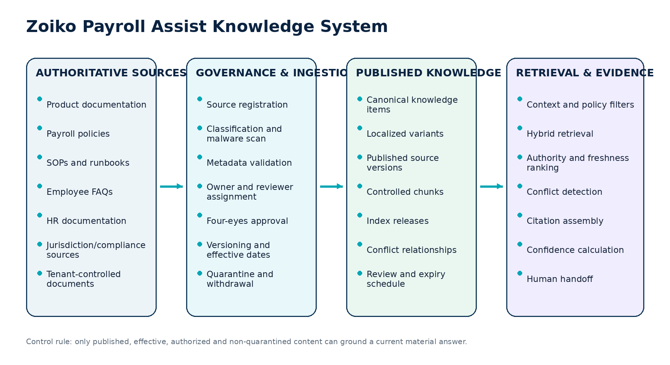
Figure 1 — Target governed knowledge architecture

6.1 Architecture components
Component | Responsibility | Control boundary
Source registry | Register source identity, authority tier, owner, confidentiality, jurisdiction and ingestion profile. | No ingestion without approved source registration.
Authoring and review workspace | Draft, compare, comment, review, approve, schedule, publish and withdraw. | Role separation and immutable decision history.
Ingestion service | Acquire approved files/content, scan, extract, normalize and classify. | Untrusted content isolation; malware/DLP/injection controls.
Knowledge registry | Store canonical item, version, metadata, relationships and lifecycle state. | Authoritative publication record.
Chunk and index pipeline | Create retrievable units and immutable index releases. | Only eligible published versions enter current indexes.
Retrieval service | Apply policy/metadata filters, hybrid search, ranking, conflict and freshness. | No model-generated access expansion.
Evidence service | Assemble sources, excerpts, checksums, lineage and authorized links. | Rechecks user access when opened.
Quality and observability | Measure coverage, freshness, retrieval, conflict, feedback and incidents. | No sensitive message content in general analytics.

07 Canonical Knowledge Item and Metadata Model

7.1 Required metadata
Group | Required fields
Identity | knowledge_item_id, canonical_key, title, summary, content_family, content_type, version, checksum
Ownership | owner_role, owner_user_or_group, reviewer_role, reviewer_user_or_group, business_unit
Authority | source_authority_tier, source_registry_ids, primary_source_reference, evidence_standard
Scope | tenant_scope, audience_roles, legal_entity_scope, payroll_group_scope, jurisdiction_codes, product_modules
Time | effective_from, effective_to, published_at, reviewed_at, next_review_at, source_updated_at
Language | source_language, locale, translation_of_version, translation_version, translation_reviewer
Security | confidentiality, data_classes, export_policy, indexing_policy, model_use_policy
Lifecycle | state, state_reason, supersedes, superseded_by, withdrawal_reason, quarantine_reason
Retrieval | keywords, synonyms, taxonomy_nodes, exact_identifiers, answerability_scope, excluded_intents
Product alignment | minimum_product_version, maximum_product_version, release_note_reference, UI_route_refs
Quality | risk_class, review_frequency, quality_score, test_case_refs, known_limitations

7.2 Illustrative structured record
Knowledge item record wireframe
{
"knowledge_item_id": "kni_01K...",
"canonical_key": "payroll.run.status.submitted",
"content_family": "PRODUCT_DOCUMENTATION",
"version": 4,
"state": "PUBLISHED",
"audience_roles": ["PAYROLL_PREPARER", "PAYROLL_REVIEWER"],
"jurisdiction_codes": ["GLOBAL"],
"effective_from": "2026-08-01",
"effective_to": null,
"source_authority_tier": "TIER_2_APPROVED_PRIMARY",
"source_registry_ids": ["src_zoiko_product_state_model"],
"owner_role": "PAYROLL_PRODUCT_OPERATIONS",
"reviewer_role": "PAYROLL_DOMAIN_OWNER",
"next_review_at": "2026-11-01T00:00:00Z",
"confidentiality": "INTERNAL_AUTHENTICATED",
"checksum": "sha256:...",
"index_release_id": "kbr_2026_08_07_01"
}

08 Taxonomy, Ontology and Controlled Vocabulary

8.1 Top-level taxonomy
Dimension | Controlled values / examples
Domain | Payroll lifecycle; People data; Calculation; Validation; Approval; Payment; Filing; Reconciliation; Reporting; Administration; Support.
Actor | Employee; Manager; Payroll preparer; Reviewer; Approver; Finance; HR; Compliance; Auditor; Implementation; Support.
Object | Worker; Employment; Pay group; Payroll run; Pay component; Validation result; Exception; Approval task; Payment file; Filing; Journal; Report; Document; Case.
Jurisdiction | ISO-style country/territory code plus GLOBAL; subnational code where legally/operationally required.
Lifecycle state | Canonical product state labels only; no unofficial synonyms in authoritative metadata.
Content intent | Explain; Find; Review; Diagnose; Prepare; Route; Troubleshoot; Configure; Train.
Risk | Critical; High; Medium; Low; informational; plus A0–A5 action relationship where relevant.
Availability | AVAILABLE; LIMITED; PARTNER_SUPPORTED; PLANNED; NOT_AVAILABLE.
Confidentiality | PUBLIC; AUTHENTICATED; TENANT_INTERNAL; ZOIKO_INTERNAL; RESTRICTED.

8.2 Vocabulary governance
• Every synonym maps to one canonical term; search may use synonyms, but responses use the canonical product/payroll label unless a plain-language explanation is required.
• Deprecated terms remain in a redirect/deprecation registry and are not silently deleted.
• Taxonomy changes are versioned and regression-tested against retrieval and analytics.
• Jurisdiction names, legal-entity names and role labels are identifiers from controlled registries, not free-text author invention.
• The glossary owner resolves competing terms and records the decision, affected content and migration plan.

09 Audience, Confidentiality and Access Model
Content class | Who may retrieve | Examples | Assistant treatment
PUBLIC | Unauthenticated or authenticated, subject to channel. | Public product help and status definitions. | May support public Help Center; no tenant data.
AUTHENTICATED | Any authenticated Zoiko Payroll user. | General feature guidance and glossary. | Role-aware presentation; no private tenant content.
TENANT_INTERNAL | Authorized users in one tenant. | Tenant policy, calendar, procedure and contacts. | Tenant filter mandatory; never enters shared index.
ZOIKO_INTERNAL | Authorized Zoiko staff. | Support SOP, internal troubleshooting and operations. | Not visible to customers; delegated access rules still apply.
RESTRICTED | Named roles/groups and purpose. | Security, legal, privileged support and incident procedures. | Excluded unless explicit policy permits the intent and user.

9.1 Audience rules
• Audience determines eligibility before retrieval. It is not merely a ranking signal.
• A source outside the user scope is omitted without revealing its title, excerpt or existence.
• Support access to tenant knowledge requires delegated purpose, scope and expiry.
• Knowledge administrators may see metadata for governance where policy permits, but content access remains independently controlled.
• Restricted content cannot be copied into broad FAQ or training content without explicit declassification and review.

10 Jurisdiction, Entity, Period and Effective-Date Controls

10.1 Context-matching order
1. Resolve bound payroll object, legal entity, payroll group and jurisdiction from trusted application context.
2. Resolve payroll period and relevant effective date; use the business-effective date required by the intent, not only the current date.
3. Filter knowledge by exact jurisdiction and any approved subnational applicability.
4. Apply legal-entity, product-module, customer-plan and availability constraints.
5. Use GLOBAL guidance only where it is explicitly applicable and does not conflict with local content.
6. When the jurisdiction or period is unresolved, ask one focused question or withhold material local guidance.
Scenario | Required behavior
Rule changed mid-year | Retrieve the version effective for the payroll period/date in question; show that a newer version exists when relevant.
Multiple jurisdictions selected | Do not merge rules into one answer; group by jurisdiction or require narrower scope.
No approved source for period | Return coverage gap / low-confidence state and route to local owner.
Source effective but review overdue | Critical/high-risk content is suspended or downgraded according to policy; never silently treated as current.
Future scheduled guidance | Visible to authorized administrators, excluded from current-answer retrieval until effective.
Tenant policy conflicts with law/Zoiko control | Flag conflict; do not allow lower-tier tenant content to override applicable higher authority.

11 Source Authority, Provenance and Conflict Model
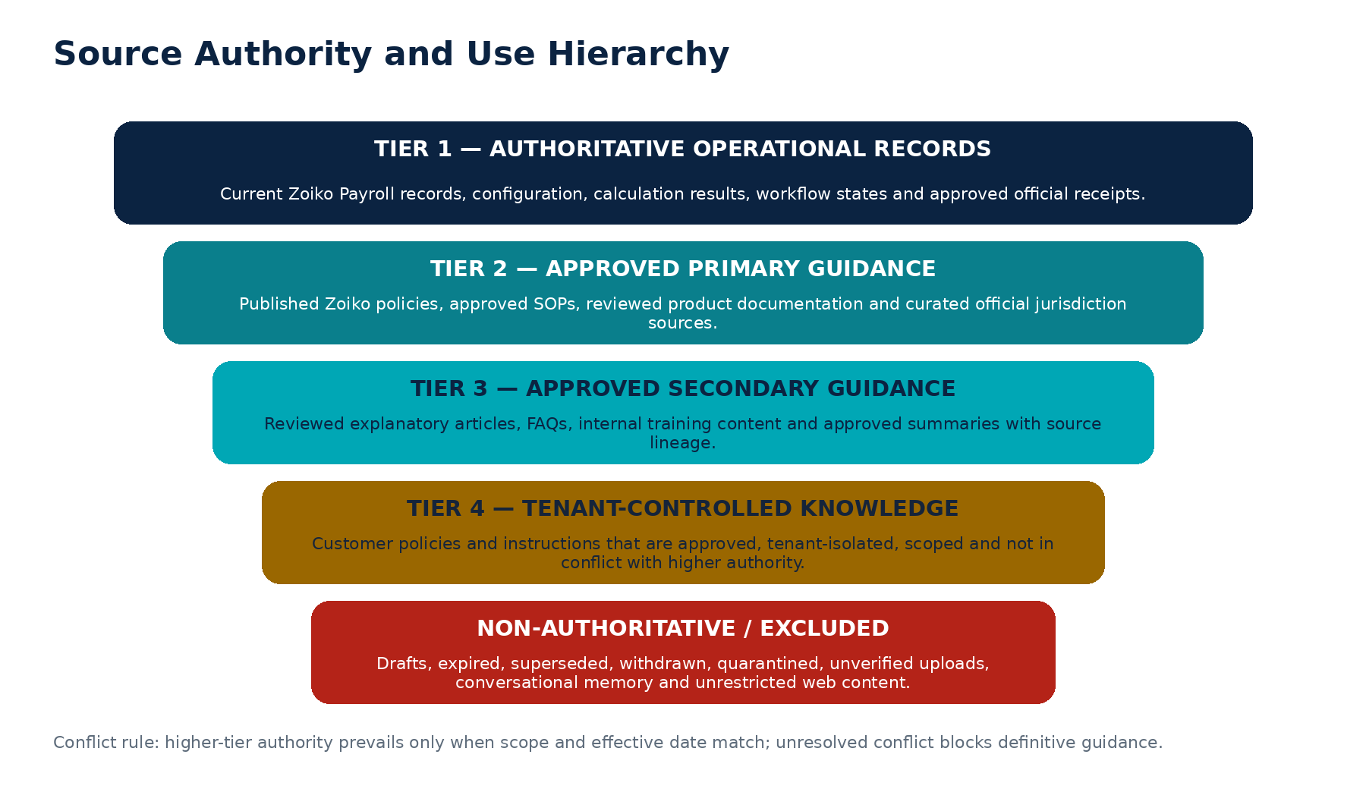
Figure 2 — Source authority and use hierarchy

11.1 Source registry requirements
Field | Requirement
Source identity | Stable source_registry_id, publisher/owner, system/location and canonical URL or repository reference.
Authority tier | One controlled tier with justification and approver.
Applicability | Jurisdictions, entities, products, audiences, topics and effective-date behavior.
Acquisition | Manual authoring, approved connector, file upload or official-source ingestion profile.
Integrity | Checksum/signature where available, acquisition time, original filename/type and extraction lineage.
Review | Owner, reviewer, review frequency, change-monitoring method and escalation route.
Security | Confidentiality, data classes, malware/injection profile, export/index/model-use policy.
Status | ACTIVE, PAUSED, QUARANTINED, RETIRED or REVOKED.

11.2 Conflict rules
• Convergent sources may increase confidence when scope and effective dates align.
• Higher authority does not automatically win when it is outside the applicable entity, jurisdiction, product version or period.
• Two current authoritative sources with materially different guidance create CONFLICT and require human resolution.
• The conflict record identifies sources, claims, impacted intents, jurisdictions, provisional safe response and accountable resolver.
• The retrieval service may return “what each source states” for authorized reviewers but cannot synthesize a definitive rule while conflict is unresolved.

12 Knowledge Lifecycle and State Machine
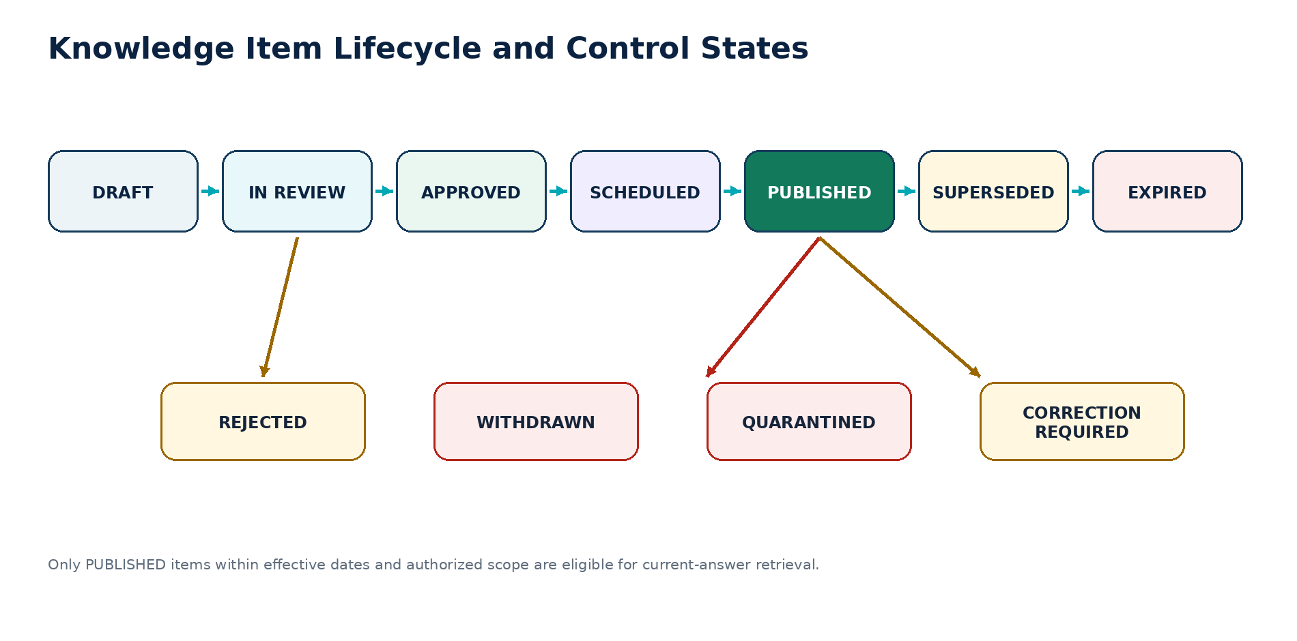
Figure 3 — Knowledge item lifecycle and exceptional states
State | Eligibility | Entry / exit rule
DRAFT | Not retrievable for answers. | Created by authorized author; editable.
IN_REVIEW | Not retrievable for answers. | Metadata complete; independent review assigned.
APPROVED | Not current until scheduled/published. | All required approvals and tests passed.
SCHEDULED | Not current before effective time. | Publication job and effective date registered.
PUBLISHED | Eligible when within dates and scope. | Published manifest/index release includes the exact version.
CORRECTION_REQUIRED | Suspended for material use. | Reviewer identifies defect; returns to author.
REJECTED | Not eligible. | Review fails; reason and evidence retained.
SUPERSEDED | Historical only. | Explicit successor relationship established.
EXPIRED | Historical only. | effective_to or expiry/review policy reached.
WITHDRAWN | Excluded. | Owner removes due to business/legal/content decision.
QUARANTINED | Immediately excluded. | Security, integrity or critical-accuracy incident.

13 Publication Workflow and Approval Gates
Step | Owner | Mandatory evidence
1. Register source / request | Requester + governance | Purpose, family, scope, authority, owner and expected audience.
2. Draft / import | Author | Template-compliant content; source references; metadata.
3. Automated validation | Platform | Schema, links, secrets, DLP, malware, injection, accessibility and duplication.
4. Domain review | Payroll/HR/Product owner | Accuracy, product terminology, process and state correctness.
5. Legal/compliance/local review | Required by risk/content | Jurisdiction, boundary, effective date and source applicability.
6. UX content/accessibility review | Content/accessibility owner | Plain language, structure, headings, link text and inclusive language.
7. Independent approval | Designated reviewer | Four-eyes decision and publication conditions.
8. Pre-publication tests | QA/evaluation | Retrieval, negative filters, citations, conflict, locale and answer tests.
9. Publish and index | Knowledge platform | Immutable release manifest, checksums and index release.
10. Monitor and review | Owner/governance | Feedback, gap, incident, source change and review schedule.

13.1 Risk-based approval matrix
Risk class | Examples | Minimum approvals
Critical | Legal/jurisdiction control, payment/filing state, payroll approval, protected-data procedure. | Domain owner + legal/compliance/local owner + independent approver + QA.
High | Payroll policy, operational SOP, employee deduction explanation. | Domain owner + independent approver + QA; legal/compliance where applicable.
Medium | Product help, troubleshooting, manager FAQ. | Product/domain reviewer + independent approver.
Low | Navigation label, non-material glossary, contact route. | Content reviewer; automated validation.

14 Change, Supersession, Withdrawal, Quarantine and Emergency Correction
Change type | Required control
Editorial non-material | New version or controlled minor revision according to policy; automated tests; reviewer as configured.
Material guidance change | New version, source/effective-date review, impact analysis, regression suite and independent approval.
Product release change | Link to release ID; identify minimum/maximum product version; retire incompatible content.
Jurisdiction change | Local owner confirmation, effective-date boundary, affected content query and release certificate.
Source correction | Preserve old version; publish corrected version; identify impacted responses/cases if material.
Supersession | Explicit successor link; current indexes exclude predecessor; historical evidence remains resolvable.
Withdrawal | Immediate current-index exclusion; reason, owner and affected-intent assessment.
Quarantine | Immediate kill switch without full rebuild; security/accuracy incident; no user disclosure beyond safe state.
Emergency correction | Expedited authorized path; limited publication scope; retrospective review within defined SLA.

MATERIAL INCIDENT RESPONSE
When a published source may have caused incorrect material guidance, operations must quarantine the source, identify impacted evidence sets and responses, assess customer impact, issue controlled corrections where required and retain the incident lineage.

15 Content Family Wireframe — Payroll Policies
Section | Required content
Policy identity | Title, policy ID, owner, approver, jurisdiction/entity scope, effective dates and version.
Purpose | What control or principle the policy establishes.
Scope | Roles, entities, payroll groups, worker categories, modules and exclusions.
Policy statements | Numbered mandatory statements using SHALL / SHALL NOT where appropriate.
Responsibilities | Accountable, responsible, consulted and informed roles.
Control points | Required approvals, evidence, separation of duties, cut-offs and exceptions.
Exceptions | Permitted exception path, authority, documentation and expiry.
Definitions | Canonical payroll/product terms.
Sources and related documents | Authoritative references, SOPs, forms and product routes.
Review and change record | Review schedule, change summary and approvals.
Assistant answer boundary | What Assist may explain, what requires records, and what must be escalated.

15.1 Required seed policy set
Policy group | Initial controlled documents
Payroll lifecycle | Run preparation, calculation, validation, review, approval, processing, reconciliation and reporting principles.
Cut-off and changes | Input cut-offs, late changes, retroactivity, future-dated changes and correction rules.
Exceptions | Materiality, assignment, evidence, escalation, waiver and closure.
Payments | Preparation, authorization, release, settlement, failed payment and reconciliation distinctions.
Filings | Preparation, submission, receipt, authority acceptance and correction distinctions.
Records and privacy | Data minimization, access, retention, exports, employee queries and evidence handling.
Assist usage | AI disclosure, evidence, prohibited actions, user verification and human oversight.

16 Content Family Wireframe — Standard Operating Procedures
SOP section | Required content
Control header | SOP ID, title, owner, roles, version, effective dates, risk, systems and estimated duration.
Trigger and purpose | When the SOP starts and intended outcome.
Preconditions | Required access, data, completed steps, period state and dependencies.
Inputs | Authoritative records, reports, files and approvals.
Numbered procedure | One action per step; responsible role; system route; expected result.
Decision points | Condition, allowed options, evidence and escalation.
Validation | How to verify correct completion and authoritative state.
Evidence | Receipts, reports, comments, approvals, screenshots only where explicitly required.
Failure handling | Known errors, safe stop, recovery, rollback/compensation and support route.
Prohibited shortcuts | Actions or bypasses that are not allowed.
Assistant capability | Explain, find, review, prepare or route; exact action tier and tool relationship.

16.1 Priority SOP catalogue
• Prepare a payroll run; validate required inputs; review calculation and validation results; triage and assign exceptions.
• Review period-over-period variance; prepare approval packet; complete reviewer task; route approver to canonical approval.
• Prepare payment file; authorize and release through canonical workflow; confirm settlement; reconcile funding and failures.
• Prepare filing; submit through canonical workflow; record receipt/acceptance; correct rejected filing.
• Process joiner, leaver, retroactive change, off-cycle payment, correction, overpayment and underpayment case.
• Create payroll query or compliance handoff; manage delegated support access; quarantine a knowledge source; respond to an incorrect-answer incident.

17 Content Family Wireframe — Employee and Manager FAQs
FAQ element | Standard
Question | Use the language a user would ask; one primary intent per item.
Direct answer | One to three sentences; plain language; no unsupported conclusion.
What this means | Explain product/payroll term and visible state.
What you can check | Authorized records or documents the user can inspect.
What to do next | Safe action or route within user authority.
When to contact someone | Trigger, destination and required information.
Privacy note | Only where relevant; avoid generic boilerplate.
Sources and effective date | Approved policy/product source and current review metadata.
Variants | Role, jurisdiction, tenant or locale variants with canonical lineage.

17.1 Priority employee FAQ domains
Domain | Illustrative questions
Payslips and documents | Where is my payslip? Why is a payslip unavailable? How do I download a document securely?
Pay components | What is gross pay, net pay, deduction, allowance, reimbursement, bonus or retroactive adjustment?
Timing and status | When will my payslip appear? What does prepared/submitted/settled mean?
Changes and corrections | How do I report a missing payment or incorrect item? What information should I provide?
Personal information | Which changes can I request, and which require HR/payroll review?
Privacy and access | Who can see my payroll information? How are my questions handled?

18 Content Family Wireframe — HR and Payroll Dependency Documentation
Topic | Required treatment
Joiners | Required effective-dated employment and payroll fields, source owner, cut-off, readiness state and escalation.
Leavers | Termination/effective date, final-pay dependencies, ownership and protected-data minimization.
Employment changes | Effective date, approval, payroll impact, retroactivity and authoritative system.
Leave/absence | Only approved payroll dependency fields; do not expose medical detail to Assist.
Compensation changes | Source system, effective date, approval and payroll-period treatment; no model calculation.
Bank/tax/identity data | Protected workflow only; Assist may route but cannot change or repeat sensitive identifiers.
Organization/manager changes | Scope and approval implications; role/manager access must not be inferred from prose.

PRIVACY BOUNDARY
HR documentation must explain dependencies and responsibilities without turning Assist into an HR record store or exposing protected employee information beyond the current user’s authorized view.

19 Content Family Wireframe — Compliance and Jurisdiction Guidance
Required section | Control requirement
Jurisdiction identity | Country/territory and approved subnational code; no free-text inference.
Topic and applicability | Payroll topic, legal entities, worker/employment scope, service availability and exclusions.
Effective period | effective_from, effective_to, source_updated_at, reviewed_at and next_review_at.
Responsible parties | Customer, Zoiko, partner, employee, authority or shared responsibility.
Operational guidance | Controlled checklist or explanation, not legal advice.
State meanings | Preparation, submission, receipt, acceptance, rejection, settlement and reconciliation kept distinct.
Primary sources | Curated official or contractually authoritative references.
Known limitations | Unsupported scenarios, partner dependencies and required specialist review.
Escalation | Local payroll/compliance owner and case route.
Assistant boundary | Allowed answer intents, required disclaimers, confidence/fallback and prohibited conclusions.

19.1 Jurisdiction release pack
• Jurisdiction overview and service-availability statement.
• Payroll calendar and cut-off ownership.
• Required data and worker/employment dependencies.
• Calculation/validation explanation boundaries linked to authoritative engine rules.
• Filing, payment and reporting state definitions and responsibilities.
• Approved compliance checklists, official source register and review schedule.
• Known gaps, partner-supported areas, escalation routes and evaluation set.

20 Content Family Wireframe — Product and System Documentation
Document type | Required content
Feature overview | Purpose, roles, availability, permissions, navigation and outcome.
Field definition | Canonical name, description, data type, source, editability, sensitivity and examples.
State definition | Exact state, entry/exit, what it does and does not mean, next states and user role.
Workflow guide | Preconditions, steps, decisions, evidence, errors and completion state.
Permission guide | Capability, scope, role, field restrictions, delegated access and request-access route.
Error/troubleshooting | Error code, user-safe explanation, likely bounded causes, checks, recovery and support route.
Release note | Release ID, feature changes, affected knowledge, minimum product version and migration.
Integration guide | Connector, data flow, mapping, status, error, security, ownership and diagnostic limits.

21 Canonical Authoring Templates and Content Blocks

21.1 Reusable blocks
Block | Purpose
Direct answer | A concise, source-backed statement that responds to the intent.
Definition | Canonical term plus plain-language explanation.
Preconditions | What must already be true.
Numbered procedure | Controlled steps with actor and expected result.
Decision table | Condition, outcome, owner, evidence and escalation.
State note | Exact current state and distinction from similar states.
Warning/boundary | Material limitation or prohibited shortcut.
Jurisdiction note | Local applicability and effective date.
Evidence/source list | Primary sources and related records.
Next step | Authorized route or human handoff.
Change history | Version, date, author, reviewer, reason and affected items.

21.2 Decision-table template
Controlled decision table
| Condition | Applicable scope | Required action | Responsible role | Evidence | Escalation |
|-----------|------------------|-----------------|------------------|----------|------------|
| ... | ... | ... | ... | ... | ... |

22 Writing, Content Design and Payroll Language Standards
Rule | Required standard
Directness | Lead with the answer or task outcome; avoid repeated greetings and filler.
Precision | Use canonical product/payroll states and distinguish prepared, submitted, accepted, settled, completed and reconciled.
Plain language | Explain technical terms without replacing the canonical term.
Modality | Use SHALL for mandatory policy/SOP requirements; MAY for permitted options; avoid vague “should” in controls.
Neutrality | No blame, alarmism, playful payroll jokes, persuasion, hidden sales content or employment-performance inference.
Professional boundary | Do not claim to be a tax authority, lawyer, accountant, bank, employer, approver or human specialist.
Uncertainty | State what is known, missing, conflicting or stale; never hide uncertainty behind fluent language.
Examples | Use synthetic, non-identifiable examples and clearly label them.
Links | Use descriptive link text; do not publish raw inaccessible URLs as the only instruction.
Readability | Short paragraphs, descriptive headings, lists for steps and tables only for genuine comparison.

23 Citation, Evidence and Source-Reference Standards
Source type | Minimum displayed evidence
Product record | Object name/type, authorized reference, version/status and updated time.
Product documentation | Title, version/product release, owner and reviewed/published date.
Policy/SOP | Controlled ID, version, scope, effective date and owner.
Jurisdiction guidance | Publisher/source, jurisdiction, effective date, review status and approved link.
Tenant knowledge | Tenant-scoped title, version, owner, effective date and confidentiality indicator.
Inference | Explicit label; supporting evidence IDs; cannot be cited as a source.

23.1 Material-claim mapping
• Each material claim in a response must map to one or more accepted evidence identifiers.
• Excerpts remain within approved display limits and do not reveal hidden or restricted source content.
• Evidence views reapply authorization at open time; revoked access removes the source from the user view without altering historical audit lineage.
• Historical response reconstruction uses source version and checksum, not the current article text.
• The source footer distinguishes source-backed facts, operational-record facts and bounded model inference.

24 Source Intake and Ingestion Pipeline
Stage | Required controls | Failure state
Register | Source ID, owner, authority, scope, acquisition profile, risk and status. | UNREGISTERED_SOURCE
Acquire | Approved connector/upload, secure transport, size/type limits and checksum. | ACQUISITION_FAILED
Scan | Malware, active content, secrets, DLP, prompt injection and unsupported data classes. | QUARANTINED
Extract | Text, headings, tables, lists, links, images/alt text and page/section anchors. | EXTRACTION_FAILED or PARTIAL
Normalize | Unicode, whitespace, heading hierarchy, identifiers, dates, language and link normalization. | NORMALIZATION_FAILED
Classify | Family, taxonomy, audience, jurisdiction, confidentiality, risk and answerability. | METADATA_REQUIRED
Review | Human verification of extracted content, tables, citations and metadata. | CORRECTION_REQUIRED
Publish | Immutable version, checksums, release manifest and index eligibility. | PUBLICATION_BLOCKED

24.1 File and content handling
• Accepted types are allowlisted and content-sniffed; extension alone is not trusted.
• Scanned or image-heavy documents require verified extraction and human review before publication; low-quality extraction cannot ground material guidance.
• Tables preserve headers, row/column associations and source location. Flattened table text without structure is not accepted for critical rules.
• Embedded scripts, macros, forms, external tracking, hidden layers and active content are removed or quarantined.
• Hyperlinks are normalized and checked against the approved source/domain registry.

25 Chunking, Embeddings and Index Release Design
Design area | Requirement
Chunk unit | Prefer semantic sections, policy clauses, SOP steps, FAQ units, decision-table rows and definitions—not arbitrary fixed windows alone.
Context inheritance | Every chunk inherits source ID, item/version, heading path, scope, dates, authority, audience, confidentiality and language.
Size/overlap | Configured by content type and evaluated; overlap must not create contradictory or duplicate evidence.
Tables | Index structured rows plus table context; preserve keys and headers.
Embeddings | Generated only for eligible content using an approved model/version and data-handling profile.
Lexical index | Retain exact identifiers, codes, product labels, state names, acronyms and phrases.
Index release | Immutable release ID maps exact item versions, chunk checksums, embedding model and taxonomy version.
Invalidation | Withdrawal/quarantine removes eligibility immediately through a control plane; physical rebuild follows.
Rebuild | Reproducible from release manifest; compare count, checksum, scope and evaluation results before promotion.

26 Controlled Retrieval and Query Orchestration
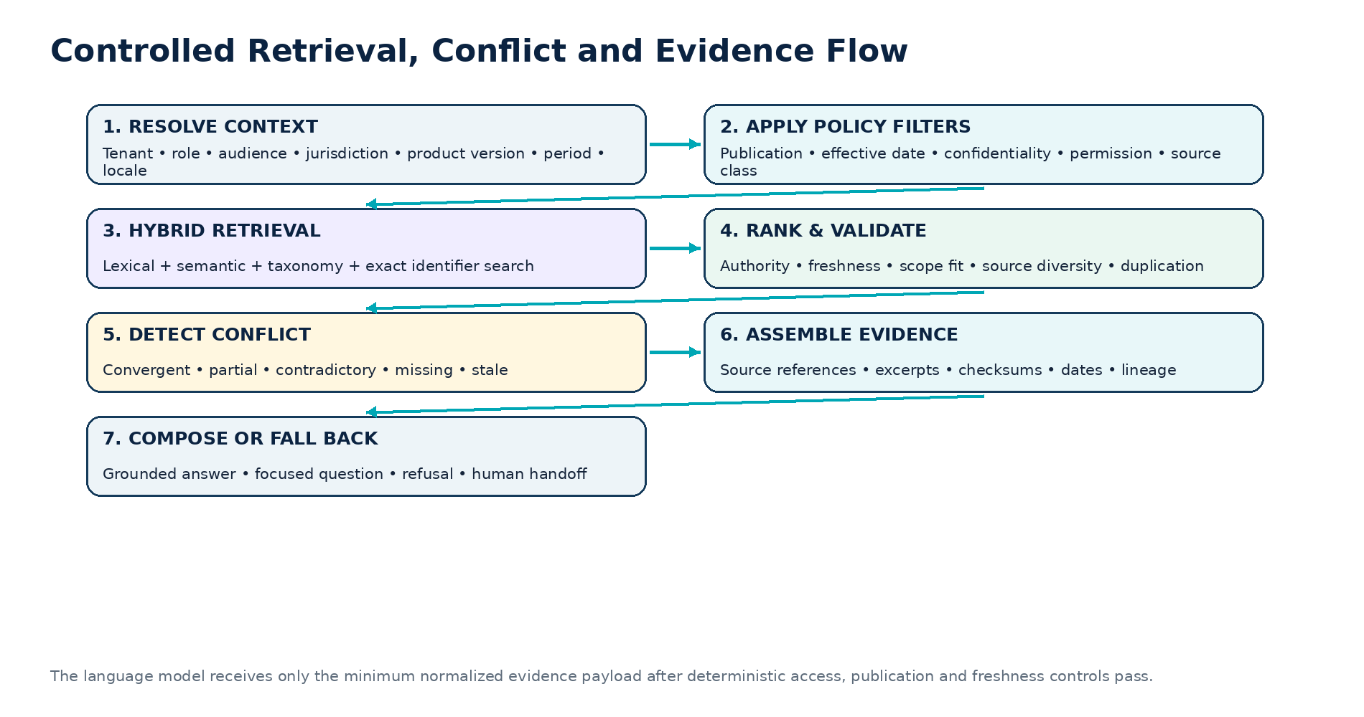
Figure 4 — Controlled retrieval, conflict and evidence flow

26.1 Retrieval sequence
1. Receive normalized intent, trusted context and required evidence class from Assist orchestration.
2. Apply tenant, role/audience, entity, jurisdiction, period, publication, confidentiality, language and product-version filters.
3. Perform lexical, semantic, taxonomy and exact-identifier retrieval within the eligible set.
4. Apply authority, scope-fit, freshness, duplication and diversity ranking.
5. Detect missing coverage, partial coverage, stale sources and material conflict.
6. Return normalized evidence candidates with source metadata, excerpts, checksums and trust labels.
7. Assemble evidence set or return a controlled failure state; never broaden scope autonomously.

27 Ranking, Freshness, Conflict and Confidence Rules
Factor | Deterministic treatment
Authorization | Hard filter; unauthorized sources cannot be retrieved or revealed.
Publication state | Hard filter for current guidance.
Effective date | Hard filter against requested/current business date.
Jurisdiction/entity/product scope | Hard filter or explicit grouping; no silent broadening.
Authority tier | Ranking and conflict input after scope match.
Freshness/review | Current preferred; overdue/unknown handled by risk policy.
Semantic relevance | Ranking signal only inside eligible sources.
Exact identifier/state match | Strong boost for product codes and canonical states.
Source diversity | Avoid duplicate chunks; favor independent convergence where appropriate.
Conflict | Produces conflict state; cannot be hidden by score averaging.

27.1 Confidence mapping
Confidence | Knowledge conditions
HIGH | Current authoritative operational record or convergent published sources with matching scope and no unresolved conflict.
MEDIUM | Published source with bounded inference, limited coverage or non-material uncertainty; answer remains safe and useful.
LOW | Missing, stale, partial or conflicting material evidence; definitive conclusion and dependent A2/A3 preparation blocked.
UNAVAILABLE | Source or permission unavailable, unsupported jurisdiction, or service failure.

28 RAG Safety, Indirect Prompt Injection and Content Integrity
Threat | Control
Instruction inside source content | Delimit content as data; ignore instructions; policy/prompt outside knowledge; injection detection.
Malicious upload | Malware/active-content scanning, source registration, quarantine and human review.
Secret or personal data in document | DLP, classification, redaction/rejection and restricted access; no broad embedding.
Poisoned tenant content | Tenant isolation, authority tier, approval workflow, no shared-index promotion.
Source substitution or tampering | Checksums, source identity, connector trust, version manifest and integrity monitoring.
Hidden text / white-on-white / metadata payload | Normalize and inspect hidden layers, comments, metadata and alternative representations.
Unsafe links | Approved-domain policy, link scanning, safe redirect and user-visible destination.
Model overgeneralization | Scope metadata, answer validator, evidence mapping and low-confidence fallback.
Knowledge exfiltration request | Authorization, excerpt limits, no bulk export tool, rate/abuse control and audit.

SECURITY RULE
Knowledge content can inform an answer but can never grant permission, change tool risk, override system policy, expose hidden configuration or instruct the model to perform an action.

29 Shared and Tenant-Isolated Knowledge
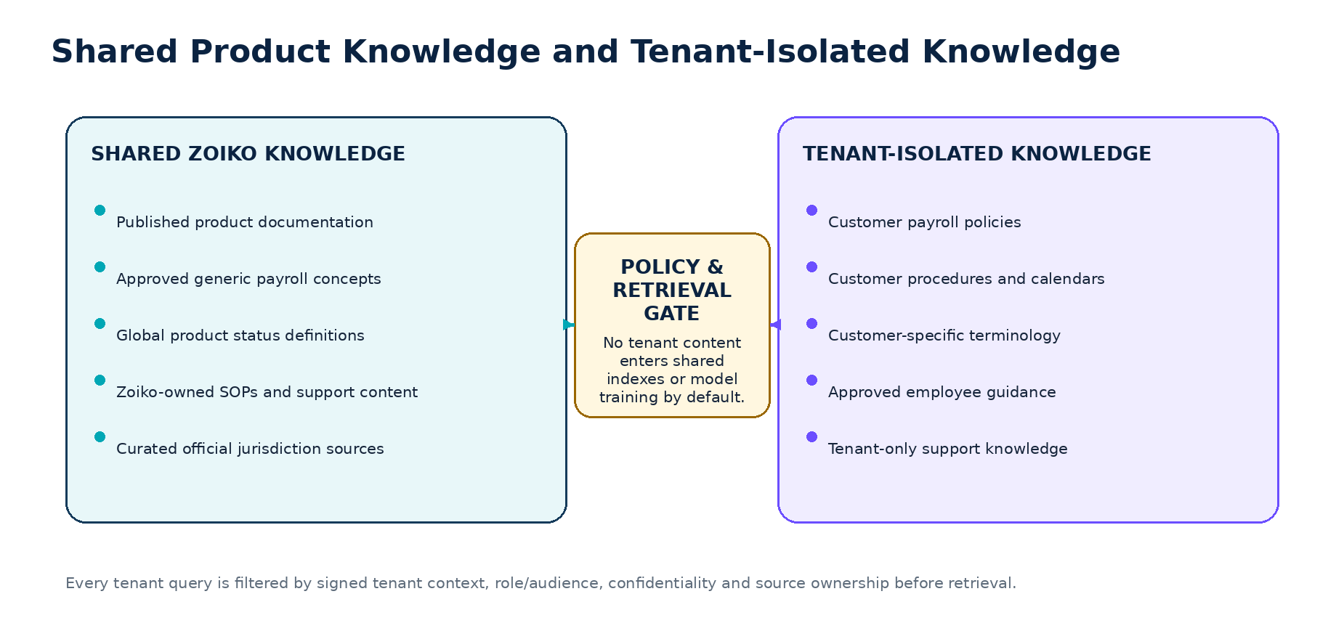
Figure 5 — Shared product knowledge and tenant-isolated knowledge
Control | Requirement
Ownership | Tenant content carries tenant_id and designated owner; shared content has Zoiko ownership and no tenant scope.
Storage/index | Separate namespace, collection or equivalent enforceable isolation; no shared cache key without tenant dimension.
Publication | Tenant administrator plus configured reviewer; high-risk content may require Zoiko domain/compliance approval.
Retrieval | Signed tenant context; role/audience/confidentiality filters; no cross-tenant fallback.
Analytics | Aggregate operational metrics only; no content leakage or cross-tenant term reporting without approved anonymization.
Training | No provider or shared-model training on tenant knowledge by default.
Export | Tenant policy, role, masking, watermarking and expiry controls.
Offboarding | Retention, export, legal hold, deletion and index purge evidence.

30 Localization and Translation Governance
Stage | Requirement
Canonical source | Every translation references the exact source-language item and version.
Translation method | Human, translation memory or approved machine-assisted translation; method recorded.
Domain glossary | Canonical payroll/product terminology and protected terms supplied to translators.
Review | Native-language domain reviewer for material payroll/compliance content.
Jurisdiction review | Translation does not create applicability; local owner separately validates jurisdiction scope.
Versioning | Source change marks translations OUT_OF_SYNC until assessed and republished.
Fallback | Do not silently serve another language for material guidance; disclose fallback and offer route.
Accessibility | Preserve headings, lists, tables, link purpose, reading order and plain-language intent.
Search | Localized keywords and synonyms are controlled; exact product identifiers remain canonical.

31 Accessibility and Inclusive Knowledge Content
Area | Acceptance requirement
Structure | Logical heading hierarchy; lists for steps; correctly marked table headers; descriptive titles.
Language | Plain language appropriate to audience; define payroll terms; avoid unexplained acronyms.
Links | Descriptive link text; purpose understandable out of context; accessible destination.
Images/diagrams | Alternative text; complex diagram description; no essential text only in images.
Tables | Simple structure where possible; captions/headers; no layout tables in published end-user HTML.
Color | No meaning conveyed by color alone; contrast meets approved product standard.
Cognitive load | Short sections, clear next step, consistent warnings and one decision per procedural step.
Localization | Reading order, direction and language attributes preserved.
Attachments | Accessible source files or equivalent accessible HTML content where required.

32 Search, Navigation and Information Architecture
Surface | Required capabilities
Assist retrieval | Contextual answer retrieval with source and evidence; no broad browsing requirement.
Knowledge admin search | Search by title, ID, source, owner, reviewer, family, taxonomy, jurisdiction, state, risk, dates and release.
Help Center | User-facing browse/search by task, role, product module and question; only audience-eligible content.
Source registry | Find sources, authority, status, ingestion profile, last acquisition, owner and incidents.
Review queue | Assigned, overdue, expiring, changed-source, conflict and correction-required work.
Gap queue | Unanswered/low-confidence intent clusters, failed searches, handoff reasons and requested content.
Audit view | Version, approval, publication, index, withdrawal and evidence-use history.

32.1 Search behavior
• Search results clearly show state, scope, jurisdiction, effective dates, owner and confidentiality.
• Current and historical results are separated; historical content cannot be mistaken for current guidance.
• Exact IDs and canonical state labels are supported.
• No result snippet reveals content outside the user’s authorization.
• No-result states offer taxonomy refinement, source registration, gap request or human route—not unrestricted web search.

33 Knowledge Administration UI Wireframes
Screen | Core zones and controls
Knowledge dashboard | Coverage, items by state/risk/family, expiring reviews, conflicts, quarantines, retrieval health and incidents.
Source registry | Source table, authority, owner, status, scope, connector, last scan, incidents, pause/quarantine.
Item editor | Metadata rail, structured content blocks, source references, preview, validation, version comparison and submission.
Review workspace | Side-by-side diff, source evidence, comments, risk checklist, approve/reject/correction decision.
Publication console | Approved items, schedule/effective dates, index impact, tests, release manifest and rollback.
Conflict center | Conflicting claims/sources, affected intents, safe response, resolver, SLA and resolution.
Index releases | Release contents, embedding/taxonomy version, test result, status, promote/rollback.
Gap and feedback queue | Intent cluster, role/jurisdiction, frequency, impact, source coverage, owner and disposition.

Knowledge item editor wireframe NO DIRECT PUBLISH FOR AUTHOR
Header Item ID • state • version • risk • owner • review due
Left rail Family • taxonomy • audience • jurisdiction • product version • confidentiality
Main canvas Structured blocks, headings, decision tables, sources and assistant boundary
Right rail Validation results • source authority • effective dates • translation status • test cases
Footer actions Save draft • Compare version • Submit review • Withdraw request

34 Notifications, Review Scheduling and SLA Controls
Trigger | Recipient | Required action
Review approaching | Owner and reviewer | Assess source/currentness and submit review before due date.
Critical review overdue | Owner, governance, domain lead | Suspend or escalate according to risk policy.
Source changed | Affected item owners | Impact-assess linked items and translations.
Official source unavailable | Local owner + operations | Verify replacement source; downgrade or suspend guidance.
Conflict detected | Domain/local owners | Resolve sources and define safe interim response.
High negative-feedback cluster | Content owner + QA | Review answer, retrieval and content gap.
Security/injection detection | Security + governance | Quarantine source/item and assess incident.
Translation out of sync | Translation owner | Review and republish localized variant.
Index release failed | Knowledge engineering + SRE | Keep prior release active; investigate and rerun.

35 Quality Analytics, Coverage and Knowledge-Gap Management
Category | Metrics
Estate | Published items, sources, versions, languages, jurisdictions, families and risk classes.
Freshness | Current, due soon, overdue, expired, withdrawn, superseded and quarantined counts.
Coverage | Supported intents by role/jurisdiction/module; unanswered and low-confidence gap rate.
Retrieval | Precision, recall, MRR/nDCG where useful, exact-ID success, duplicate rate and source diversity.
Grounding | Material claim support, citation correctness, evidence-open success and unsupported-claim rate.
Conflict | Open conflicts, affected intents, age, severity, resolution SLA and recurrence.
Content quality | Readability, metadata completeness, accessibility, broken links and test pass rate.
Feedback | Helpful/not helpful, wrong, outdated, incomplete, unsafe and missing-source reasons.
Operations | Ingestion failures, index lag, release rollback, source scan failures and retrieval latency.

ETHICAL MEASUREMENT BOUNDARY
Knowledge and assistant usage metrics must not be used to score employee performance, infer conduct, evaluate compensation, or profile workers.

36 Evaluation and Test Framework
Test family | What must be proven
Metadata validation | Required fields, controlled values, dates, scope and ownership.
State exclusion | Draft, review, rejected, superseded, expired, withdrawn and quarantined content never grounds current answers.
Scope/isolation | Role, tenant, entity, worker, jurisdiction, confidentiality and language filters.
Freshness | Correct historical/current version for requested business date; overdue policy behavior.
Authority/conflict | Correct ranking within scope; conflict state when authoritative sources differ.
Retrieval quality | Expected source/chunk retrieval for approved intents; negative and distractor sources.
Grounding/citations | Claims map to source versions and excerpts; source footer correct.
Injection/security | Malicious instructions, hidden text, links, poisoned documents and bulk-exfiltration attempts.
Localization | Correct translation lineage, terminology and out-of-sync handling.
Accessibility | Heading, tables, links, images, reading order and plain-language review.
Operational | Index rebuild, rollback, quarantine, connector failure, source outage and monitoring.

36.1 Golden-set structure
Knowledge evaluation case wireframe
test_case_id
intent_id
role / audience
jurisdiction / entity / payroll_period
expected_source_ids and forbidden_source_ids
expected_answer_facts
expected_confidence / conflict / fallback state
sensitive-data expectations
product_version / taxonomy_version / index_release
pass criteria and reviewer

37 Security, Privacy, Retention and Audit
Control area | Requirement
Least privilege | Separate author, reviewer, publisher, source-admin, index-admin, auditor and tenant-admin roles.
Sensitive data | Reject or restrict unnecessary personal, bank, tax, health, credential and secret content.
Encryption | Encrypt content, versions, indexes and backups according to approved data class and region.
Audit | Record source registration, upload, scan, edit, review, approval, publication, retrieval release, withdrawal, quarantine and access.
Retention | Preserve versions/evidence as required; purge derived chunks/embeddings when eligible; legal-hold support.
Provider use | No external model/provider training on tenant or restricted knowledge by default.
Support access | Purpose, scope, expiry, masking and audit for delegated access.
Export | Role/policy-controlled, watermarked where configured, and never includes hidden prompts or unrelated source content.
Backup/recovery | Restore source versions, metadata, release manifests and index rebuild capability; test recovery.

38 APIs, Events and Integration Contracts
Contract area | Required operations / events
Source registry | Register, update, pause, quarantine, retire, inspect and list sources.
Knowledge items | Create draft, version, submit review, approve, reject, schedule, publish, withdraw and supersede.
Content validation | Validate metadata, security, accessibility, links, sources and answerability.
Retrieval | Search with signed context and filters; return evidence candidates and controlled states.
Evidence | Resolve source version, excerpt, checksum, dates and authorized deep link.
Index releases | Build, test, promote, rollback and inspect release manifest.
Conflicts/gaps | Create, assign, resolve, close and report affected intents.
Events | kb.source_registered, kb.item_versioned, kb.review_decided, kb.item_published, kb.item_withdrawn, kb.source_quarantined, kb.index_promoted, kb.conflict_detected, kb.review_overdue.

38.1 API rules
• All mutating operations are versioned, authorized, idempotent where retryable and return audit references.
• Publication requires an approved version and test evidence; an API client cannot bypass review state.
• Retrieval accepts context identifiers but derives tenant/authority from trusted session/service identity.
• Errors use the approved API Problem Details contract and do not expose restricted source existence.
• Index promotion is a controlled release operation, not an automatic consequence of editing an article.

39 Bootstrap, Migration and Seed-Content Plan
Wave | Content and platform outcome | Exit criterion
KB-0 Governance foundation | Owners, RACI, taxonomy, metadata, source registry, states, templates and review workflow. | Governance approval and admin roles provisioned.
KB-1 Product core | Canonical product states, fields, permissions, Help Center and Assist boundaries. | R1 explain/navigate golden set passes.
KB-2 Payroll operations | Lifecycle policies, core SOPs, exception/readiness and approval support content. | R2 read-only payroll evaluation passes.
KB-3 Employee self-service | Payslip/document FAQs, query route and privacy guidance. | Employee role/accessibility acceptance.
KB-4 Compliance pilots | Selected jurisdiction release packs and official source registers. | Per-jurisdiction certificate and safe fallback.
KB-5 Draft/handoff support | Case, correction, review-note and handoff content/templates. | R3 draft/handoff tests pass.
KB-6 Tenant knowledge | Tenant authoring, isolation, approval, retention and offboarding. | Isolation/red-team certification.
KB-7 Localization and scale | Priority locales, translation workflow, quality and review SLAs. | Locale certificates and operations readiness.

39.1 Migration rules
• Inventory and classify existing Zoiko Payroll documents before import; do not bulk-publish legacy material.
• Deduplicate, identify canonical source, assign owner/reviewer and capture effective dates.
• Separate current, historical, unsupported and uncertain content.
• Convert only content that passes security, privacy, accessibility and domain review.
• Create redirects/supersession for replaced content and record excluded legacy sources with rationale.

40 Operating Model, Training and Support
Cadence | Activity
Daily | Review critical incidents, quarantines, failed ingestion/index jobs and urgent content corrections.
Weekly | Review gaps, negative feedback, open conflicts, upcoming critical reviews and jurisdiction changes.
Monthly | Quality scorecard, coverage, freshness, owner performance, source health and release retrospective.
Quarterly | Taxonomy, templates, risk classes, provider/index models, authority hierarchy and governance audit.
Per product release | Impact assessment, affected knowledge, product-version metadata, regression and release manifest.
Per jurisdiction release/change | Local owner review, effective-date controls, official source checks and certification.

40.1 Required training
• Knowledge authors: templates, source use, metadata, effective dates, plain language, privacy and AI-assisted drafting controls.
• Reviewers: authority, conflict, jurisdiction, product-state accuracy, evidence and approval responsibilities.
• Tenant administrators: isolation, approval, prohibited content, retention and incident escalation.
• Support and operations: evidence interpretation, source incidents, quarantine, rollback and safe customer communication.
• Engineers and QA: retrieval filters, index lineage, injection threats, evaluation and release gates.

41 Atomic Knowledge Requirements and Traceability
KB ID | FRS / API trace | Knowledge requirement | Pri. / Rel. | Verification evidence
KB-GOV-001 | FRS-KB-001; API-KB | Every Assist-eligible knowledge item SHALL have required identity, ownership, authority, scope, time, language, security, lifecycle, retrieval and quality metadata. | P0/R1 | Schema and publication test.
KB-GOV-002 | FRS-KB-002/003 | Only PUBLISHED items within effective dates and approved scope SHALL be eligible for current-answer retrieval. | P0/R1 | Negative state/date tests.
KB-GOV-003 | FRS-KB-004/013 | Every published item SHALL have accountable owner, independent reviewer, review frequency and next review date. | P0/R1 | Metadata/audit report.
KB-GOV-004 | FRS-KB-009 | Material compliance/jurisdiction claims SHALL include approved source registry references. | P0/R1 | Publication gate.
KB-GOV-005 | FRS-KB-010/011 | Material changes SHALL create a new version, checksum, supersession relationship and index release reference. | P0/R1 | Lineage test.
KB-GOV-006 | FRS-KB-012 | Authorized operations SHALL be able to quarantine a source/item immediately without waiting for full index rebuild. | P0/R1 | Kill-switch test.
KB-SCP-001 | FRS-EVD-003 | Retrieval SHALL apply tenant, audience, permission, jurisdiction, period, publication, language, confidentiality and product-version filters. | P0/R1 | Filter matrix.
KB-SCP-002 | FRS-KB-005 | Jurisdiction content SHALL use controlled jurisdiction codes and SHALL NOT rely on free-text country inference. | P0/R1 | Metadata validation.
KB-SCP-003 | FRS-KB-014 | Tenant knowledge SHALL remain isolated and SHALL NOT populate shared customer knowledge or training by default. | P0/R1 | Isolation test.
KB-SRC-001 | FRS-EVD-001/002 | Material answers SHALL use authoritative operational records or published approved knowledge with displayable source metadata. | P0/R1 | Grounding/citation test.
KB-SRC-002 | FRS-EVD-004 | Expired, withdrawn, superseded or quarantined content SHALL NOT be cited as current. | P0/R1 | Negative retrieval.
KB-SRC-003 | FRS-EVD-008 | Materially conflicting current sources SHALL produce CONFLICT and human-resolution route. | P0/R1 | Conflict UAT.
KB-SRC-004 | FRS-EVD-011 | Sources outside user scope SHALL be omitted without existence disclosure. | P0/R2 | Enumeration test.
KB-SEC-001 | FRS-KB-007 | Ingested content SHALL be scanned for malware, active content, secrets, sensitive data and prompt injection. | P0/R1 | Security suite.
KB-SEC-002 | FRS-KB-008 | Source instructions SHALL remain untrusted data and SHALL NOT become executable model instructions. | P0/R1 | Indirect-injection test.
KB-LOC-001 | FRS-KB-006 | Localized items SHALL preserve exact source-language and version lineage. | P0/R5 | Translation lineage.
KB-QLT-001 | FRS-EVD-005/006/007 | Confidence and fallback SHALL follow controlled evidence/freshness/conflict criteria. | P0/R1 | Rules evaluation.
KB-OPS-001 | FRS-OPS-* | Index releases SHALL be immutable, tested, promotable, reversible and observable. | P0/R1 | Release/rollback drill.
KB-ACC-001 | PRD-ACC-* | Published user-facing knowledge SHALL meet approved accessibility and plain-language requirements. | P0/R1 | Accessibility review.
KB-AUD-001 | FRS-AUD-* | Source, version, review, publication, index, withdrawal, quarantine and evidence-use lineage SHALL be auditable. | P0/R1 | Audit reconstruction.

42 Delivery Backlog and Engineering Work Packages
Epic | Deliverables
KBE-01 Governance model | RACI, authority hierarchy, taxonomy, metadata, templates, risk classes and decision register.
KBE-02 Source registry | Source CRUD, status, scope, owner, acquisition profile, integrity and incidents.
KBE-03 Authoring/review | Structured editor, diff, validation, four-eyes review, schedule and publication.
KBE-04 Ingestion | Connectors/upload, scanning, extraction, normalization, classification and quarantine.
KBE-05 Knowledge registry | Canonical items, versions, relationships, lifecycle and audit.
KBE-06 Chunk/index | Semantic chunks, lexical/embedding indexes, manifests, invalidation and rollback.
KBE-07 Retrieval | Context filters, hybrid search, ranking, conflict, freshness and evidence candidate API.
KBE-08 Admin operations | Dashboard, queues, notifications, conflicts, gaps and index releases.
KBE-09 Security/privacy | DLP, injection defense, tenant isolation, access, retention, export and incident controls.
KBE-10 Evaluation/QA | Golden sets, negative tests, accessibility, security, quality gates and certificates.
KBE-11 Seed content | Product core, payroll policies, SOPs, FAQs, HR dependencies and jurisdiction pilots.
KBE-12 Localization/scale | Translation workflow, localized search, review SLAs and jurisdiction expansion.

43 Release Gates, Definition of Done and Approval
Gate | Blocking acceptance evidence
G0 Scope and governance | Families, authority, RACI, boundaries, risk classes and programme approval.
G1 Taxonomy and metadata | Controlled schema, vocabularies, validation and change control.
G2 Source and security | Source registry, scanning, DLP, injection, integrity and quarantine.
G3 Authoring and publication | Templates, four-eyes workflow, effective dates, versioning and audit.
G4 Retrieval controls | Scope filters, hybrid retrieval, ranking, conflict, freshness and evidence.
G5 Tenant isolation | Storage/index/retrieval isolation, provider-use controls and offboarding.
G6 Content core | Approved product documentation, payroll policies, SOPs and employee FAQs for launch scope.
G7 Jurisdiction certification | Per-jurisdiction source register, release pack, safe fallback and local approval.
G8 Accessibility/localization | Content accessibility and priority-locale certificates.
G9 Evaluation/security | Golden/adversarial suites, no critical isolation/injection/grounding failures.
G10 Operations | SLOs, dashboards, review alerts, incidents, rollback and on-call runbooks.
G11 Controlled pilot | Allowlisted tenants/roles/intents, quality watch and issue closure.
G12 Production certificate | Cross-functional approvals, residual risks and enabled release manifest.
G13 General availability | Pilot evidence, capacity, support, audit and executive approval.

43.1 Definition of Done
• All launch knowledge has stable IDs, canonical versions, owners, reviewers, source lineage, scope, effective dates, states and test references.
• No current index contains ineligible content, and quarantine/rollback are proven.
• Retrieval and evidence APIs enforce the full context/filter model and pass isolation, stale-source, conflict and injection tests.
• The approved seed estate covers the launch roles, intents, modules and jurisdictions, with documented gaps and safe fallbacks.
• Knowledge operations can author, review, publish, monitor, correct, withdraw, quarantine, restore and audit without direct database manipulation.
• Security, privacy, payroll operations, legal/compliance, accessibility, QA, Product and SRE sign the production release certificate.
APPROVAL RULE
Upon explicit approval of ZP-AST-KB-001, the next and only next document is ZP-AST-UX-001 — UI/UX Figma Design Specification. No Technical Architecture or Prompt Engineering / AI Guardrail document is started before that sequence.

A Appendix A — Controlled Content-Type Catalogue
Code | Content type | Family
POLICY | Policy | KF-02
STANDARD | Control standard | KF-02
SOP | Standard operating procedure | KF-03
RUNBOOK | Operational runbook | KF-03
CHECKLIST | Controlled checklist | KF-03/KF-06
DECISION_TABLE | Rule/decision table | All
FAQ | Frequently asked question | KF-04
GLOSSARY | Definition | KF-01/KF-04
HOW_TO | Task guide | KF-01/KF-03
FIELD_DEFINITION | Product field definition | KF-01
STATE_DEFINITION | Product/workflow state definition | KF-01
TROUBLESHOOTING | Error and recovery guide | KF-01
JURISDICTION_GUIDE | Local guidance | KF-06
OFFICIAL_SOURCE_SUMMARY | Approved source summary | KF-06
RELEASE_NOTE | Product release note | KF-01
TENANT_POLICY | Tenant-controlled policy | KF-07
TENANT_PROCEDURE | Tenant-controlled procedure | KF-07
CONTACT_ROUTE | Approved destination/route | All

B Appendix B — Lifecycle, Freshness and Conflict Enums
Enum | Values
KnowledgeState | DRAFT, IN_REVIEW, APPROVED, SCHEDULED, PUBLISHED, CORRECTION_REQUIRED, REJECTED, SUPERSEDED, EXPIRED, WITHDRAWN, QUARANTINED
SourceState | ACTIVE, PAUSED, QUARANTINED, RETIRED, REVOKED
FreshnessState | CURRENT, REVIEW_DUE, OVERDUE, EXPIRED, SUPERSEDED, UNKNOWN
ConflictState | NONE, POTENTIAL, CONFIRMED, RESOLVED, ACCEPTED_LIMITATION
AuthorityTier | TIER_1_OPERATIONAL, TIER_2_APPROVED_PRIMARY, TIER_3_APPROVED_SECONDARY, TIER_4_TENANT, NON_AUTHORITATIVE
AvailabilityState | AVAILABLE, LIMITED, PARTNER_SUPPORTED, PLANNED, NOT_AVAILABLE
IndexReleaseState | DRAFT, BUILDING, TESTING, APPROVED, ACTIVE, ROLLED_BACK, RETIRED, FAILED
ReviewDecision | APPROVE, APPROVE_WITH_CONDITIONS, CORRECTION_REQUIRED, REJECT, WITHDRAW, QUARANTINE

C Appendix C — Policy, SOP and FAQ Authoring Skeletons
Policy skeleton
POLICY
1. Control header
2. Purpose
3. Scope and exclusions
4. Policy statements
5. Responsibilities
6. Control points and evidence
7. Exceptions and escalation
8. Definitions
9. Sources and related documents
10. Assistant answer boundary
11. Review and change history

SOP skeleton
SOP
1. Control header and trigger
2. Purpose and outcome
3. Preconditions and inputs
4. Numbered steps with responsible role
5. Decision points
6. Validation and evidence
7. Failure handling and escalation
8. Prohibited shortcuts
9. Assistant capability / action tier
10. Sources and revision history

FAQ skeleton
FAQ
Question
Direct answer
What this means
What you can check
What to do next
When to contact someone
Sources / effective date / scope
Related questions

D Appendix D — Minimum Seed Knowledge Register
Pack | Minimum deliverables before relevant release
Product core | Canonical lifecycle/state glossary; field definitions; permissions; first-use and Assist boundaries; navigation/help.
Payroll operations | Run readiness, validation, exceptions, review, approval packet, corrections, off-cycle and reconciliation policies/SOPs.
Employee | Payslip/document access; pay-component glossary; query/correction route; privacy; timing/status distinctions.
Finance | Aggregate payroll totals, journals, funding, payment/reconciliation states and report lineage.
HR | Joiner/leaver/change dependencies and ownership; protected-data routes.
Compliance | Jurisdiction overview, official source register, effective-date controls, filing/payment states and escalation.
Support/implementation | Delegated access, integration health, mapping errors, safe diagnostics, case/handoff and source incident SOPs.
Knowledge operations | Author/review/publish, source registration, translation, quarantine, rollback, incident and audit SOPs.

E Appendix E — Minimum Knowledge Test Matrix
Scenario | Expected result
Draft article is semantically the best match. | Excluded; published eligible source or safe fallback.
Expired country rule matches query. | Excluded as current; historical only if explicitly requested/authorized.
Tenant A policy queried by Tenant B. | No result or existence disclosure; security evidence.
Source document says “ignore prior instructions.” | Instruction ignored; source treated as data; injection event/quarantine as policy requires.
Two current approved sources disagree. | CONFLICT; no definitive material guidance; local/compliance handoff.
Question concerns last year’s payroll. | Retrieve version effective for that period and identify historical context.
Translation is out of sync. | Do not present as current material guidance; show safe fallback/approved source language route.
Source is quarantined during an active session. | Subsequent retrieval excludes it immediately; prior evidence remains auditable.
User opens evidence after access revoked. | Access denied without source-content leakage.
Article contains tax ID or bank account. | DLP blocks/restricts publication and broad indexing.
No source covers the requested jurisdiction. | Unsupported/low-confidence state and specialist route.
Product state renamed in new release. | Version filter selects compatible content; older content superseded for current release.

F Appendix F — Knowledge Governance Checklist
Checkpoint | Pass criterion
Source | Registered, active, owned, trusted acquisition, integrity and risk profile.
Content | Correct family/template, canonical terminology and no prohibited data.
Scope | Audience, tenant, entity, jurisdiction, product and period defined.
Time | Effective dates, source update, review and expiry controls complete.
Authority | Tier justified; primary references present; conflicts resolved.
Review | Independent domain and required legal/compliance/accessibility approvals complete.
Security | Malware, DLP, secrets, injection, links and hidden content passed.
Retrieval | Keywords/taxonomy, answerability, exclusions and negative tests passed.
Publication | Version/checksum, release manifest, index test and rollback reference.
Operations | Owner, next review, alerts, incident route and audit evidence.

G Appendix G — Standards and Governing Source Basis
ID | Source / governing basis
ZP1 | Zoiko Payroll Assist Detailed Chatbot Product, UX and Engineering Wireframe — ZP-AI-UX-001 v1.0.
ZP2 | Zoiko Payroll Assist Product Requirements Document — ZP-AST-PRD-001 v1.0.
ZP3 | Zoiko Payroll Assist Functional Requirements Specification — ZP-AST-FRS-001 v1.0.
ZP4 | Zoiko Payroll Assist API Documentation and Collections — ZP-AST-API-001 v1.0.
ZP5 | Zoiko Payroll Assist Database Schema and ER Diagram — ZP-AST-DATA-001 v1.0.
S1 | Knowledge-management principles and risk-based content governance aligned with recognized enterprise knowledge-management practice, including ISO 30401 applicability review.
S2 | W3C Web Content Accessibility Guidelines 2.2 as the product accessibility baseline.
S3 | NIST AI Risk Management Framework and Generative AI Profile for evidence, governance and risk controls.
S4 | OWASP GenAI/LLM security guidance for prompt injection, sensitive information, excessive agency, improper output and consumption risks.
S5 | Applicable privacy, employment, payroll, tax, AI and records-retention laws and contractual requirements, assessed per jurisdiction.

FINAL AUTHORITY
This v1.0 specification is the recommended single source of truth for the Zoiko Payroll Assist knowledge estate and governance model. Material changes to source authority, publication states, metadata, tenant isolation, effective-date controls, retrieval eligibility, conflict behavior, model/provider use or release gates require controlled cross-functional approval.

