ZOIKO GROUP / ZOIKO TECH INC.
ZOIKO PAYROLL ASSIST™
UI/UX Figma Design Specification
Detailed Wireframe and Design-to-Engineering Handoff Blueprint
The authoritative design blueprint defining the Figma project architecture, visual foundations, components, screens, states, responsive behavior, accessibility, prototypes, content, engineering handoff and release acceptance required to implement Zoiko Payroll Assist.
DOCUMENT PROGRAMME DECISION
This is Document 6 of 8. It converts the approved product, functional, API, data and knowledge requirements into a complete design system and implementation-ready Figma specification. It does not claim that cloud Figma files already exist, authorize unreviewed visual changes, define deployment topology or replace the separate AI guardrail specification.

6  programme position | 8  controlled Figma files | 100+  screen and state frames | 15  release gates

Document field | Controlled value
Document ID | ZP-AST-UX-001
Version | 1.0 — Detailed Wireframe and Proposed Canonical Baseline
Date | August 7, 2026
Programme position | Document 6 of 8 — UI/UX Figma Design Specification
Status | Submitted for Founder / Executive approval; do not advance until approved
Predecessors | ZP-AI-UX-001 v1.0; ZP-AST-PRD-001 v1.0; ZP-AST-FRS-001 v1.0; ZP-AST-API-001 v1.0; ZP-AST-DATA-001 v1.0; ZP-AST-KB-001 v1.0
Executive sponsor | Lennox G. McLeod, Founder and Executive Chairman, Zoiko Group
Product | Zoiko Payroll Assist™ (compact interface label: Assist)
Document owner | Zoiko Payroll Product Design and Design Systems
Technical co-owner | Global CTO / Frontend and Mobile Architecture
Required reviewers | Product, Payroll Operations, UX Research, UX Content, Design Systems, Frontend, Mobile, Accessibility, Security, Privacy, AI Platform, Knowledge Operations, QA, SRE, Support, Legal and Compliance
Design baseline | Responsive web and mobile application; WCAG 2.2 AA; tokenized design system; role-, context- and jurisdiction-aware states
Language | American English master; controlled localizations and bidirectional readiness
Classification | Confidential — internal product, design, engineering and governance

00 Programme Register, Approval Rule and Document Boundaries
PROGRAMME RULE
Each supporting document is produced separately and individually. Approval of this UI/UX Figma Design Specification is the gate to begin Document 7 — Technical Architecture Documentation.

Seq. | Document | Document ID | Current control status
1 | Product Requirements Document | ZP-AST-PRD-001 | APPROVED / predecessor baseline
2 | Functional Requirements Specification | ZP-AST-FRS-001 | APPROVED / predecessor baseline
3 | API Documentation and Collections | ZP-AST-API-001 | APPROVED / predecessor baseline
4 | Database Schema and ER Diagram | ZP-AST-DATA-001 | APPROVED / predecessor baseline
5 | Knowledge Base Governance and Content Specification | ZP-AST-KB-001 | APPROVED / predecessor baseline
6 | UI/UX Figma Design Specification | ZP-AST-UX-001 | CURRENT — submitted for approval
7 | Technical Architecture Documentation | ZP-AST-ARCH-001 | BLOCKED pending UX approval
8 | Prompt Engineering and AI Guardrail Specification | ZP-AST-AIG-001 | BLOCKED

0.1 Controlled boundary
• This document defines the complete Figma file architecture, page structure, token model, component system, screens, user flows, states, responsive rules, content behavior, accessibility annotations, prototypes, design QA and engineering handoff package.
• The document is a detailed design wireframe. It does not represent a completed hosted Figma project, final production artwork, a source-code implementation, or approval to release any feature.
• Final permissions, API behavior, data ownership and knowledge authority remain controlled by the approved predecessor documents. A visual frame cannot grant access, calculate payroll or change a prohibited action into an allowed one.
• The future architecture document controls deployment and runtime topology. The future AI guardrail document controls detailed prompt, model, policy and safeguard implementation.
• No later document or implementation may weaken the user authority, evidence, human control, accessibility, privacy or action-risk requirements encoded here.

01 Critical Analysis and Incorporated Refinements
Initial request / risk | Why an informal response would fail | Final refined decision
“Share the Figma files” | A designer could create attractive screens without complete roles, states, evidence, errors or engineering contracts. | Create a controlled Figma design specification with required files, frames, states, annotations and gates before any implementation authority.
One giant Figma file | Libraries, product screens, prototypes and archives become slow, ambiguous and difficult to govern. | Use eight controlled files with separate foundations, components, product experiences, admin, research, handoff and archive responsibilities.
High-fidelity happy paths only | Engineering invents empty, loading, denied, stale, conflict, degraded and accessibility behavior. | Every feature requires a state matrix and dev-ready frames for all release-blocking states.
Visual design before interaction logic | Polished frames can contradict permissions, API contracts, payroll states and action boundaries. | Trace every frame and component to approved FRS, API, data and knowledge controls.
Figma as the only source of truth | Tokens, copy, events and behavior drift from code and specifications. | Figma is the visual interaction authority; versioned manifests and predecessor documents remain authoritative for contracts and policy.
Color-based status design | Users with color-vision differences and assistive technologies may miss material state. | Require icon, label, structure and accessible name in addition to color for every status.
Chat bubble pattern copied from consumer apps | Payroll workflows need evidence, tables, context, action previews and audit information. | Use a payroll-grade work surface: panel, workspace, evidence pane, result cards and governed actions.
Dark patterns in confirmations | Users could approve unintended changes under urgency or ambiguity. | Use explicit verbs, before/after values, target scope, cancel parity and no timers or preselection.
Desktop-first shrink-to-mobile | Complex evidence and confirmations become unusable on small screens. | Design mobile as a deliberate full-height route/sheet with one-column evidence and confirmation flows.
Uncontrolled component detachment | Product frames drift from the system and cannot be updated safely. | No detached instances in dev-ready screens except documented exceptions approved by Design Systems.
“Pixel perfect” without accessible reflow | Static pixels can fail at zoom, text expansion, locale length and assistive technology. | Define resilient constraints, responsive rules, text expansion, focus order and 400% reflow acceptance.
Design handoff as screenshots | Screenshots omit states, tokens, APIs, events, copy sources and accessibility notes. | Issue signed Dev Ready releases with annotated frames, prototype flows, manifests and acceptance evidence.

REFINED CONCLUSION
Zoiko Payroll Assist requires a controlled design system and evidence-backed interaction specification, not a collection of chatbot mock-ups. Design quality is measured by correct behavior, clarity, safety, accessibility and engineering traceability—not visual polish alone.

02 Purpose, Authority and Design Standard

2.1 Purpose
Define the complete user-experience and interface system required to implement Zoiko Payroll Assist consistently across authenticated desktop, responsive web and mobile surfaces, including every material state, interaction, component, role experience, evidence treatment, confirmation, handoff, administrative view and engineering handoff asset.

2.2 Design authority
This document becomes the controlled design baseline after approval. The actual Figma project shall implement this specification and may not silently alter payroll terminology, role boundaries, source treatment, action risk, confirmation behavior, accessibility or privacy behavior.

2.3 Normative language
Term | Meaning
MUST / SHALL | Mandatory design or handoff requirement. Release-blocking unless an approved exception exists.
SHOULD | Expected enterprise-quality implementation. Deviation requires written design and technical rationale.
MAY | Optional behavior that must not weaken a mandatory control.
MUST NOT / PROHIBITED | Hard boundary. No Figma variant, feature flag or tenant setting may bypass it without controlled revision.
DEV READY | Cross-functionally reviewed frame/component with complete annotations, states, tokens and release manifest.
REFERENCE ONLY | Non-authoritative concept or research artifact that engineering must not implement.

2.4 Design principles
1. Payroll truth before conversational fluency.
2. Recognition before recall; context is visible and removable.
3. Direct answer before explanation; evidence before confidence.
4. Human decision rights before automation convenience.
5. Progressive disclosure before information overload.
6. Consistent payroll states before creative language.
7. Resilient layouts before pixel-fixed composition.
8. Accessible by default, not remediated after build.
9. Privacy and minimization visible in the experience.
10. Every dev-ready frame is traceable, testable and versioned.

03 Governing Inputs and Cross-Document Traceability
Governing input | Design obligations
ZP-AI-UX-001 | Product identity, surfaces, role model, response anatomy, action tiers, evidence, content, security and operational UX.
ZP-AST-PRD-001 | Users, outcomes, scope, priorities, success measures, product boundaries and release conditions.
ZP-AST-FRS-001 | Functional behavior, state machines, permissions, errors, accessibility, admin behavior and acceptance evidence.
ZP-AST-API-001 | Available operations, schemas, streaming events, errors, concurrency, idempotency and source/action receipts.
ZP-AST-DATA-001 | Persistent entities, state values, retention, audit, tenant isolation and evidence/action relationships.
ZP-AST-KB-001 | Knowledge families, source authority, publication states, effective dates, conflicts, localization and administration.
Zoiko Payroll product system | Global navigation, shell, product typography, existing components, permissions, routes and responsive conventions.

3.1 Frame annotation trace model
Mandatory frame metadata DEV READY ANNOTATION
frame_id • screen_id • route_or_surface • role • tenant_scope • object_context
primary_frs_ids • api_operations • data_entities • knowledge_types • analytics_events
state • breakpoint • locale • theme_mode • density_mode • data_classification
component_release • content_version • prototype_link • owner • review_status • release_id

3.2 Conflict rule
PRECEDENCE
A Figma frame may clarify presentation and interaction, but it cannot contradict an approved product, functional, API, data or knowledge rule. Any conflict is logged and resolved through controlled change before the frame becomes Dev Ready.

04 Experience Architecture and Surface Taxonomy
Surface | Purpose | Primary roles | Design form
Global launcher | Open Assist from any eligible authenticated page. | All authenticated roles | Toolbar or floating control that never obscures critical controls.
Context panel | Fast page-aware explanation, navigation, review and safe preparation. | Employees and operational roles | Resizable 440 px desktop panel; overlay drawer at smaller widths.
Full Assist workspace | Extended conversation, multi-record review, evidence inspection and handoff. | Payroll, finance, HR, compliance, audit, support | Three-zone workspace: conversation rail, main thread, evidence pane.
Embedded assist pattern | Explain a field, exception, metric or workflow step in place. | All roles | Bound card/drawer opened from the current object.
Mobile Assist route | One-column conversation, evidence and confirmations. | All mobile users | Full-height sheet or dedicated route; no compressed desktop panel.
Employee self-service | Own payslips, documents, explanations and payroll queries. | Employee | Plain-language, personal scope, privacy-protective.
Administration | Notices, capabilities, knowledge, conflicts, index releases, quality and incident controls. | Authorized admins and operators | Dense enterprise tables and governed action screens.
Public Help assistant | Approved product help without tenant payroll data. | Prospects and unauthenticated visitors where approved | Separate anonymous policy and data boundary; not the authenticated product assistant.

4.1 Surface continuity
• Promotion from context panel to full workspace preserves the same session, context, evidence, draft and scroll position.
• Moving from mobile to desktop may restore the session only after identity, tenant and retention checks.
• Every surface uses the same source, confidence, action and refusal semantics.
• Users can always open the canonical Zoiko Payroll route for critical work.

05 Controlled Figma Project Architecture
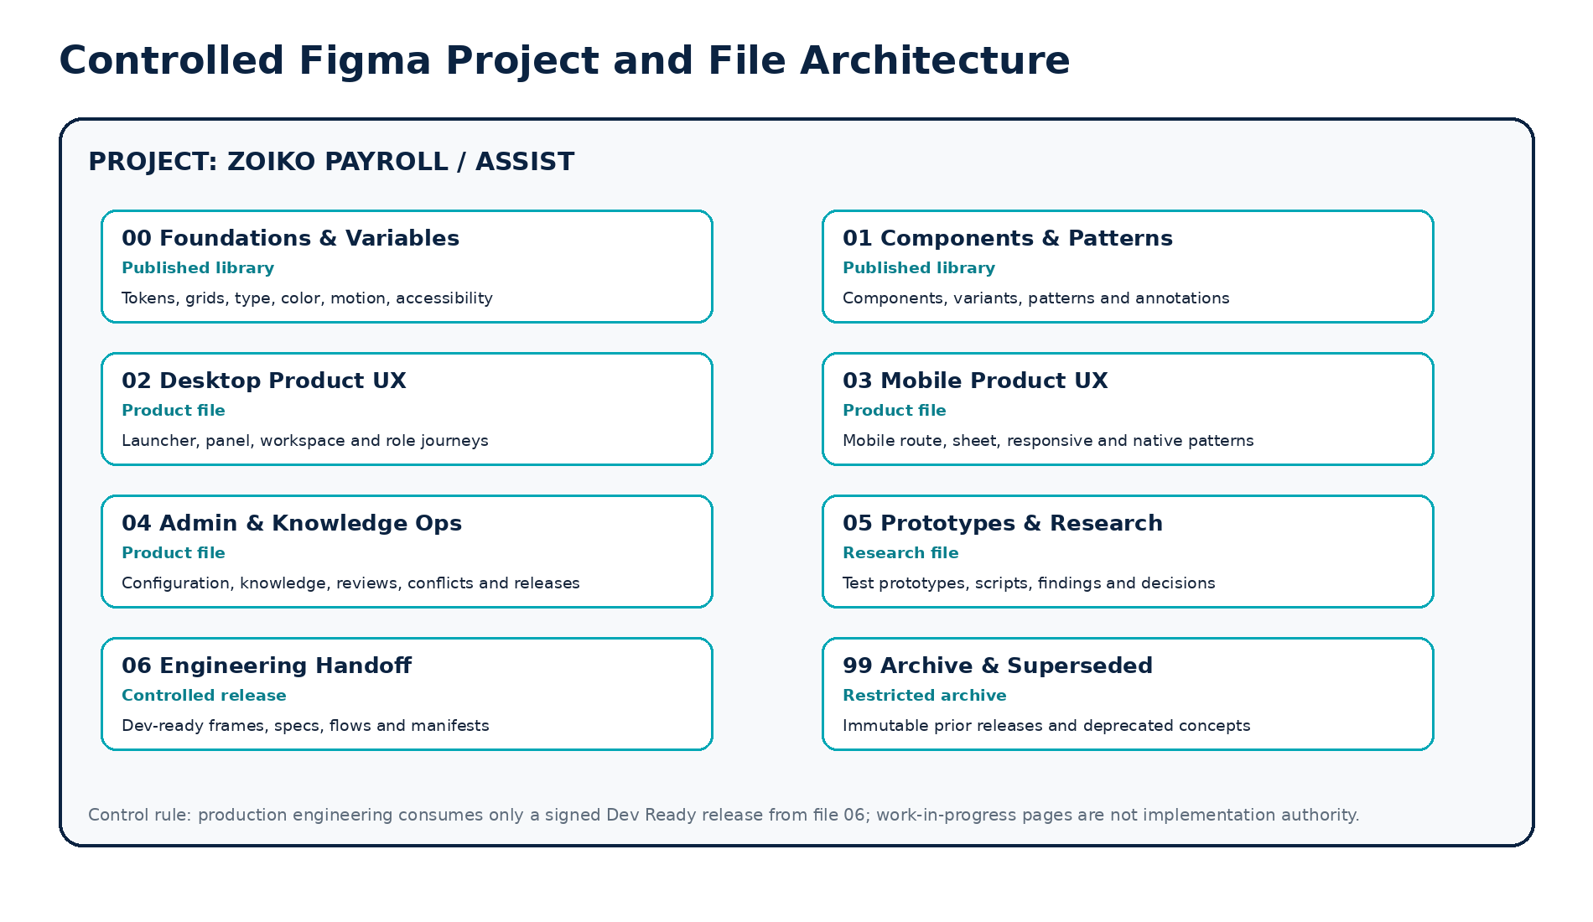
Figure 1 — Controlled Figma project and file architecture

5.1 Figma project controls
• Project access is least privilege: viewers, designers, library publishers and administrators have distinct roles.
• Production libraries are published only from protected main branches by approved Design Systems owners.
• Feature work uses branches or isolated work pages; no unreviewed changes are made directly to published components.
• Dev Ready frames are copied or referenced into the controlled handoff file and frozen under a release identifier.
• Archive files are read-only and preserve superseded releases, decisions and migration notes.
• External sharing, public links, community publishing and plugin access require explicit security and privacy approval.

06 Figma Pages, Sections, Naming and Status System
File | Required pages / sections
00 Foundations & Variables | 00 Cover & release • 01 Brand • 02 Color • 03 Typography • 04 Spacing & sizing • 05 Grids • 06 Elevation • 07 Motion • 08 Iconography • 09 Accessibility • 10 Variables • 90 Changelog
01 Components & Patterns | 00 Cover • 01 Primitives • 02 Navigation • 03 Conversation • 04 Evidence • 05 Results • 06 Actions • 07 Feedback • 08 Errors • 09 Admin • 10 Mobile • 11 Patterns • 90 Deprecated • 99 QA
02 Desktop Product UX | 00 Cover • 01 Shell • 02 Launcher • 03 First Use • 04 Context Panel • 05 Workspace • 06 Role Journeys • 07 Evidence • 08 Actions • 09 Handoff • 10 Edge States • 11 Responsive • 99 Release Frames
03 Mobile Product UX | 00 Cover • 01 Entry • 02 Conversation • 03 Evidence • 04 Actions • 05 Employee • 06 Admin responsive • 07 Offline/degraded • 08 Accessibility • 99 Release Frames
04 Admin & Knowledge Ops | 00 Cover • 01 Assist settings • 02 Notices • 03 Capabilities • 04 Source registry • 05 Editor • 06 Review queue • 07 Conflicts • 08 Index release • 09 Analytics • 10 Incidents • 99 Release Frames
05 Prototypes & Research | 00 Research plan • 01 Concepts • 02 Moderated prototypes • 03 Accessibility studies • 04 Findings • 05 Decisions • 90 Rejected concepts
06 Engineering Handoff | 00 Release manifest • 01 Flows • 02 Desktop • 03 Mobile • 04 Admin • 05 Components • 06 Tokens • 07 Copy • 08 Analytics • 09 Accessibility • 10 Deviations • 99 Sign-off
99 Archive & Superseded | Release folders by semantic version and date; no active implementation links.

6.1 Naming convention
Canonical Figma object naming
File: ZP Assist — 02 Desktop Product UX
Page: 04 Context Panel
Section: Payroll Run / Readiness
Frame: ZPA-DSK-PNL-READINESS-DEFAULT-1440-LTR-LIGHT
Component: Assist/Response/SourceFooter
Variant properties: state=complete, confidence=high, sourceCount=3, density=comfortable
Flow: FLW-PAYROLL-READINESS-001
Release: UX-1.0.0

6.2 Status labels
Status | Color-independent label | Engineering authority
WIP | WIP • owner • date | None.
DESIGN REVIEW | REVIEW • reviewer group | None.
VALIDATION | VALIDATION • research/accessibility/security | None.
APPROVED | APPROVED • decision ID | May proceed to handoff preparation.
DEV READY | DEV READY • release ID • checksum | Authoritative for scoped implementation.
IMPLEMENTED | IMPLEMENTED • build/version | Reference for parity testing.
DEPRECATED | DEPRECATED • replacement • removal date | Must not be used for new work.

07 Design Tokens, Variables and Theme Modes
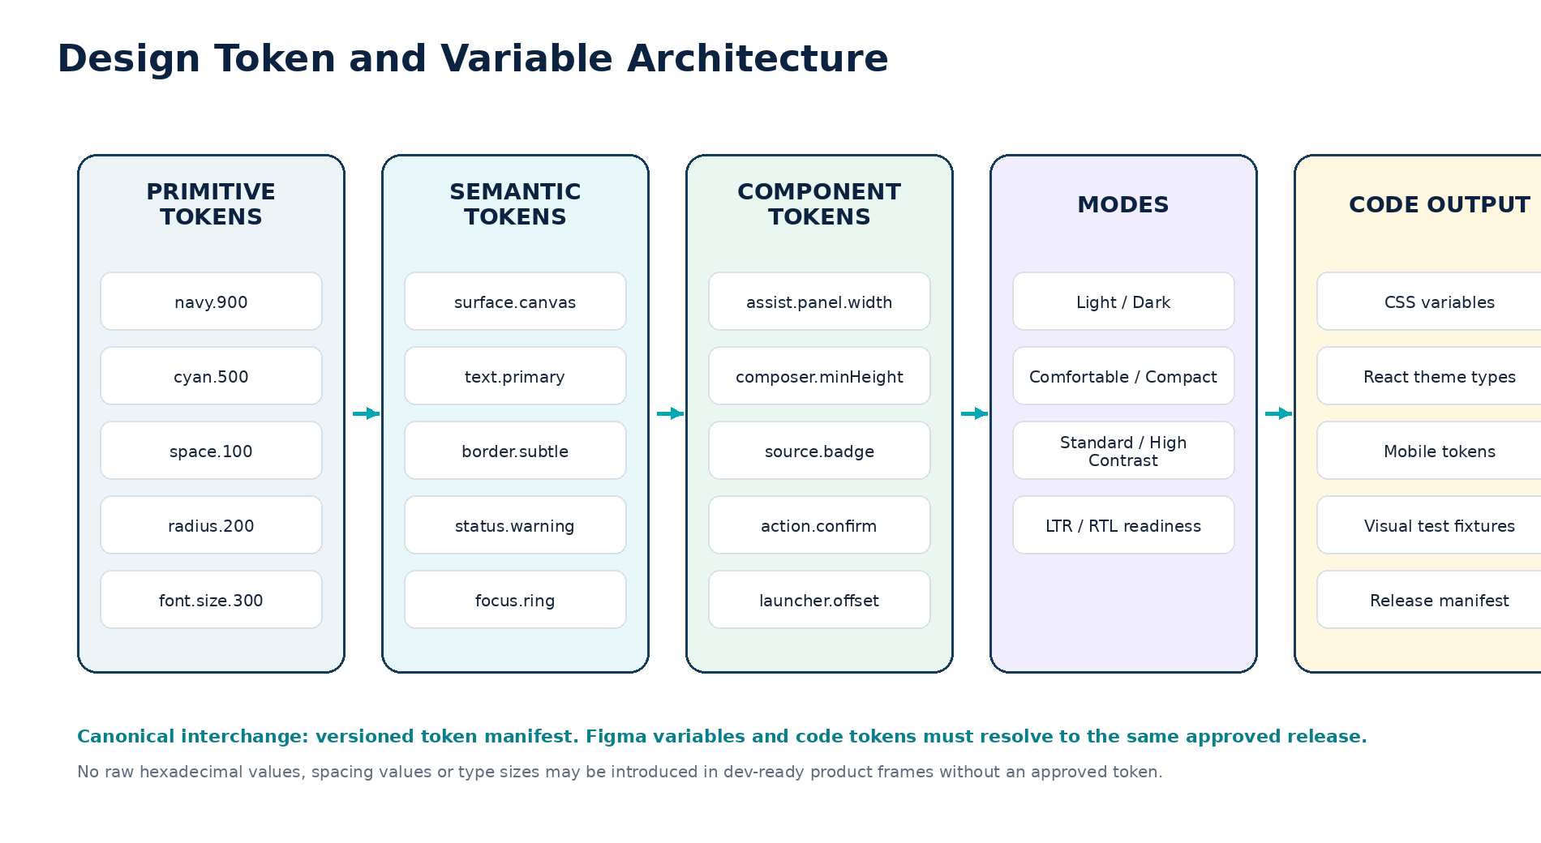
Figure 2 — Design token and variable architecture

7.1 Token governance
• A versioned token manifest is the canonical interchange between design and code. Figma variables and product code must resolve to the same approved release.
• Primitive values are not used directly in product frames. Components use semantic or component tokens.
• Token changes include impact analysis, screenshots, contrast validation, component tests, migration notes and semantic versioning.
• No design plugin may rewrite the production token library without approval and review.
• High-contrast and dark modes must preserve semantic meaning and accessibility, not merely invert colors.

7.2 Required variable collections
Collection | Modes | Examples
Color / semantic | Light, Dark, High Contrast Light, High Contrast Dark | surface.canvas, text.primary, border.subtle, status.warning.surface, focus.ring
Spacing / sizing | Standard | space.0-1200, control.height.sm/md/lg, panel.width.min/default/max
Typography | Standard, Large Text review | type.body.md, type.label.sm, type.heading.lg, lineHeight, tracking
Density | Comfortable, Compact | row.height, card.padding, list.gap; confirmations remain comfortable
Motion | Standard, Reduced | duration.fast, duration.standard, easing.enter, motion.none
Elevation | Light, Dark | surface.overlay, shadow.panel, border.overlay
Localization | LTR, RTL readiness | start/end spacing, icon mirroring, alignment behavior
Platform | Web, iOS, Android | safe-area, navigation, keyboard and native control differences

08 Grid, Spacing, Typography, Color, Iconography and Motion
Foundation | Controlled baseline
Spacing | 4 px base grid; preferred component rhythm in 8 px increments; optical exceptions documented.
Desktop grid | 12 columns; 24 px gutters; 32-64 px outer margins by viewport; content maximums defined per surface.
Tablet grid | 8 columns; 20 px gutters; Assist uses overlay or dedicated route based on task complexity.
Mobile grid | 4 columns; 16 px gutters; safe-area aware; no edge-to-edge material confirmation controls.
Typography | Zoiko Payroll canonical UI family; reference fallback Inter. Body 16 px; metadata 14 px; minimum effective 12 px only for non-critical supplementary labels.
Line length | Approximately 55-85 characters for explanatory text; narrower for dense evidence cards.
Color | Zoiko navy/cyan system with semantic success, warning, critical and neutral tokens. Status never relies on color alone.
Iconography | Consistent 20/24 px stroke family; icons have labels or accessible names; no decorative ambiguity in material actions.
Radius | 8-12 px controls/cards; 16-20 px large surfaces; no excessive consumer-style bubble shapes for payroll evidence.
Elevation | Borders preferred over heavy shadows; overlays have clear modality and focus containment.
Motion | 120-200 ms for standard transitions; specific progress states; reduced-motion mode removes non-essential movement.
Target size | Internal minimum 44 x 44 CSS px for interactive targets; spacing prevents accidental activation.

8.1 Reference color tokens
Token | Reference value | Use
brand.navy.900 | #0B2341 | Primary shell, headings and high-emphasis controls.
brand.cyan.500 | #00A7B5 | Focus, active accents, selected context and links.
brand.teal.600 | #0A7F8C | Secondary action and evidence emphasis.
semantic.success | #13795B | Successful completed state with icon and label.
semantic.warning | #9A6700 | Review required, stale or caution state.
semantic.critical | #B42318 | Blocked, unsafe or destructive state.
neutral.canvas | #F7F9FB | Application and panel surfaces.
neutral.text | #15243A | Primary text.

BRAND INTEGRATION
Reference values are the current Zoiko Payroll Assist baseline. The final Figma library shall inherit the approved Zoiko Payroll brand system where an enterprise token already exists, without weakening contrast or semantic-state requirements.

09 Component Architecture, Variants and Maturity
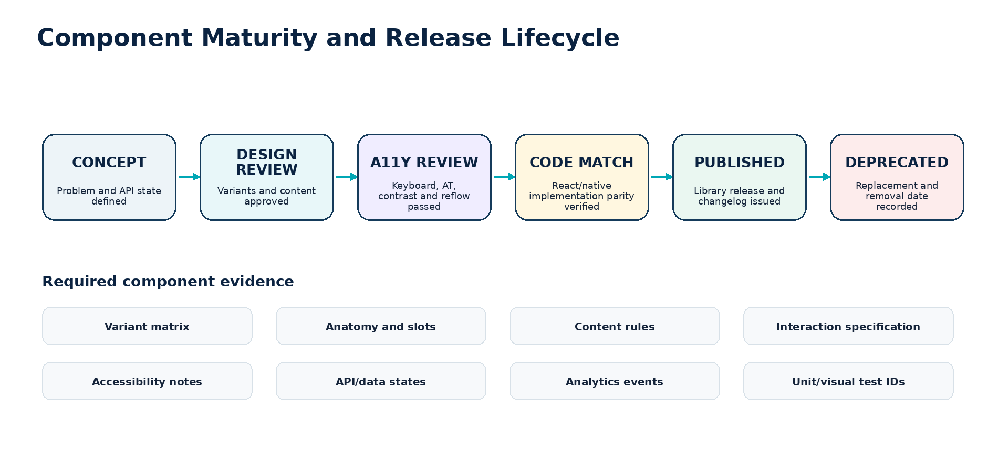
Figure 3 — Component maturity and release lifecycle

9.1 Component rules
• Every repeated control or pattern is a component or documented composition; one-off copies are prohibited in Dev Ready frames.
• Variant properties represent real behavior or visual state, not arbitrary combinations that cannot exist in product.
• Component slots define allowed content length, icon use, optional metadata and responsive behavior.
• Components expose focus, hover, pressed, disabled, loading, error and selected states where applicable.
• Interactive components include keyboard behavior, screen-reader name/description, focus order and motion notes.
• Components that display data identify API fields, empty/null behavior, masking, truncation and overflow treatment.
• Design and code component names are mapped in the handoff manifest.

9.2 Required component metadata
Component documentation PUBLISHED LIBRARY EVIDENCE
name • purpose • anatomy • slots • variants • properties • default state
content rules • length guidance • keyboard behavior • focus behavior • accessible name
responsive behavior • data/API dependencies • analytics events • privacy classification
design owner • code owner • maturity state • version • replacement / deprecation path

10 Core Component and Pattern Inventory
Family | Required components / patterns
Entry and shell | AssistLauncher, LauncherAttention, ToolbarEntry, MobileEntry, AssistPanel, AssistWorkspace, PanelResizeHandle, SurfaceHeader, SurfaceFooter
Context | ContextChip, ContextSummary, ContextSelector, ContextWarning, ScopeBadge, JurisdictionBadge, RoleBadge, DelegatedAccessBanner
Conversation | ConversationRail, ConversationListItem, ConversationHeader, MessageGroup, UserMessage, AssistantResponse, SystemMessage, ProgressMessage, StreamingIndicator
Composer | Composer, SendButton, StopButton, AttachmentButton, AttachmentTray, CharacterLimit, InputWarning, PromptSuggestion, PromptGroup, FollowUpQuestion
Response | AnswerSummary, OrderedFactList, NextStepBlock, PayrollStateBadge, InlineDefinition, ComparisonTable, DataCard, ResultList, DeepLinkAction
Evidence | SourceFooter, SourceBadge, SourceCard, EvidenceDrawer, EvidencePane, SourceExcerpt, FreshnessBadge, AuthorityBadge, ConflictBanner, ConfidenceBadge, AuditReference
Actions | ActionCard, DraftPreview, ActionPreview, ChangeComparison, ConfirmationSheet, ReauthenticationGate, ExecutionProgress, ActionReceipt, ConflictRecovery
Handoff | HandoffCard, DestinationPicker, HandoffPreview, CaseReceipt, OwnershipStatus, SLABadge, EscalationReason
Feedback | ResponseFeedback, FeedbackReason, ReportProblemDialog, CorrectionCapture, FeedbackSuccess
States | EmptyState, RestrictedState, UnsupportedJurisdiction, LowConfidence, SourceConflict, StaleSource, OfflineState, DependencyDegraded, ModelUnavailable, ToolUnavailable
Admin | MetricCard, SourceTable, ReviewQueue, ContentEditor, MetadataPanel, ConflictCenter, IndexReleaseCard, CapabilityToggle, KillSwitchBanner, AuditTable
Foundation | Button, IconButton, Link, Input, TextArea, Select, Combobox, Checkbox, Radio, Toggle, Tabs, Table, Pagination, Tooltip, Popover, Menu, Dialog, Drawer, Toast, Banner, Skeleton

10.1 Component scale
INVENTORY CONTROL
The initial library shall contain the minimum components needed by approved screens. Component count is not a success metric; semantic consistency, accessible behavior, code parity and low duplication are.

11 Global Launcher and Zoiko Payroll Shell Integration
State | Required design | Acceptance
First sessions | Icon plus “Ask Assist” label. | Discoverable without obstructing product tasks.
Established use | Icon-only may be permitted with tooltip and accessible name. | User preference and responsive rules respected.
Authorized attention | Label states an existing task count or status. | Task is visible to user; no marketing or fabricated urgency.
Restricted page | Launcher opens a scope explanation. | No protected page content enters conversation context.
Unavailable | Neutral unavailable state with status/standard route. | No fake online state or silent failure.
Mobile | Toolbar item or approved floating control. | Safe area, keyboard and bottom navigation respected.
Critical workflow | Launcher position changes or collapses. | Never covers approval, consent, validation, payment or filing controls.

11.1 Shell annotation requirements
• Launcher offset from viewport and product controls at every breakpoint.
• Z-index and overlay order relative to menus, dialogs, banners and confirmation flows.
• Focus entry and focus return behavior.
• Unread/attention badge semantics and maximum count display.
• Keyboard shortcut only when it does not conflict with browser, operating system or assistive technology.

12 First-Use Disclosure, About Assist and Consent-Adjacent UX
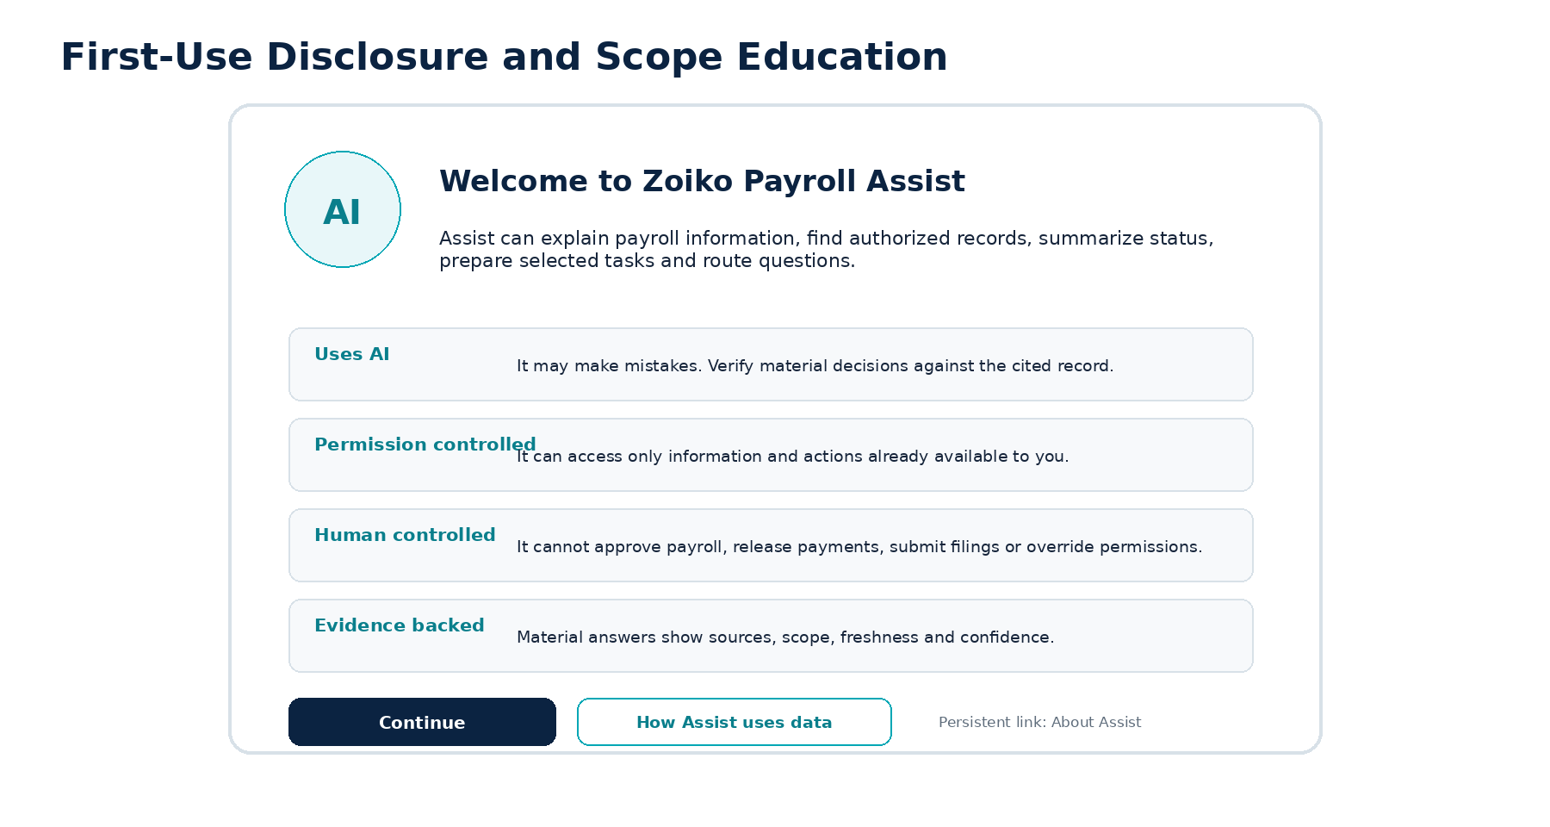
Figure 4 — First-use disclosure and scope education

12.1 First-use requirements
• Identify Assist as an AI assistant in the title and persistent About Assist surface.
• Explain supported jobs, material limitations, permission control, evidence and human control in plain language.
• Provide “Continue” and “How Assist uses data” actions; do not frame the notice as consent to train on payroll data.
• Record notice version, locale, user, tenant, channel and completion timestamp.
• Use approved locale-specific additions where required; never create legal copy directly in Figma without a controlled source.
• First-use dismissal must not prevent access to the persistent About Assist information.

12.2 About Assist information architecture
Section | Required content
What Assist can do | Explain, find, review, prepare selected drafts/actions and create approved handoffs.
What Assist cannot do | Approve payroll, release payments, submit filings, override permissions or provide professional advice.
How answers are produced | Authorized context, approved records/knowledge, evidence and confidence.
How data is used | Purpose, minimization, provider profile, retention and support access in approved wording.
Feedback and correction | Report wrong, unsafe, outdated, incomplete or failed-action responses.
Support | Standard support, payroll owner, compliance or privacy routes as configured.

13 Desktop Context Panel Wireframe and State Model
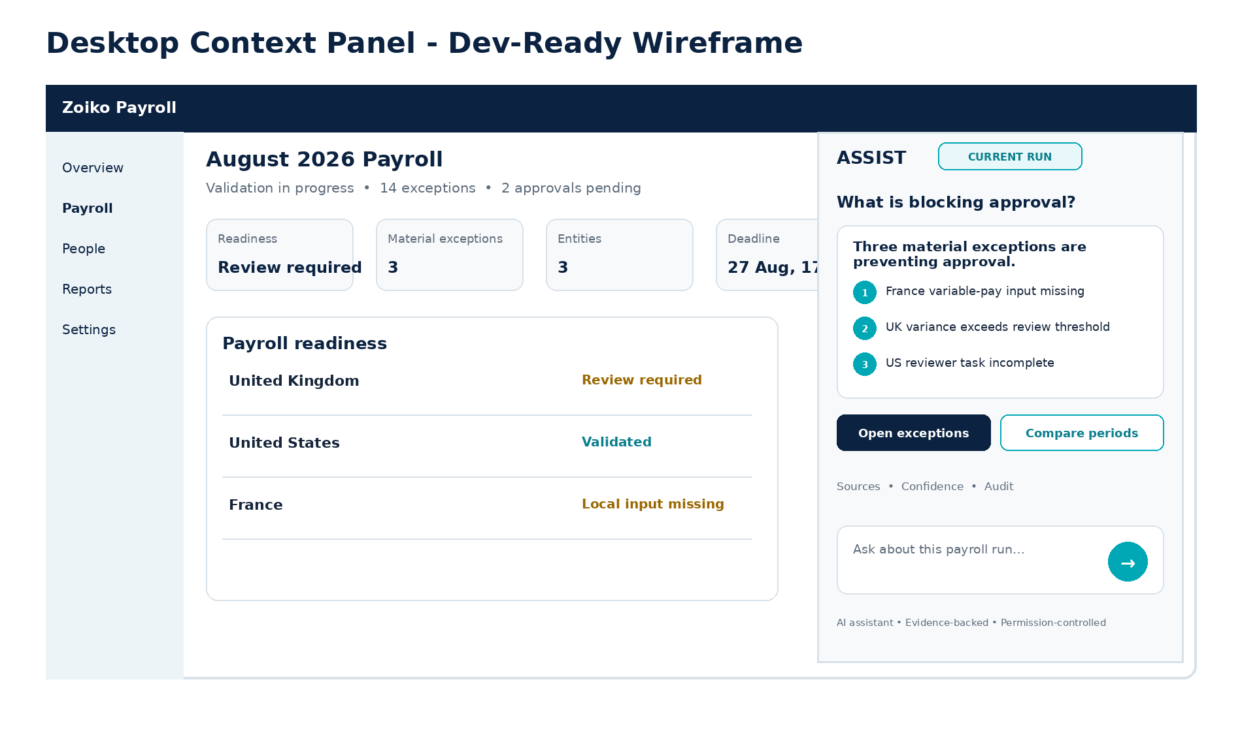
Figure 5 — Desktop context panel dev-ready wireframe

13.1 Panel dimensions and behavior
Property | Specification
Default width | 440 px.
Minimum / maximum | 360 px / 560 px.
Resize | Mouse, touch and keyboard operable; stored per device where permitted.
Breakpoint behavior | Overlay drawer below the desktop fit threshold; dedicated route for complex tasks.
Header | Assist, current context, session menu, expand, minimize and close.
Composer | Sticky while reading except during blocking confirmation or reauthentication.
Underlying app | Remains usable where viewport permits; focus and scroll regions are independent.
Context removal | User can inspect and clear bound context; subsequent requests exclude cleared context.

13.2 Panel states
Required states: closed, opening, first use, empty contextual, active conversation, retrieving, tool in progress, confirmation blocking, minimized, expanded, dependency degraded, offline cached, permission restricted and session expired.

14 Full Assist Workspace Wireframe
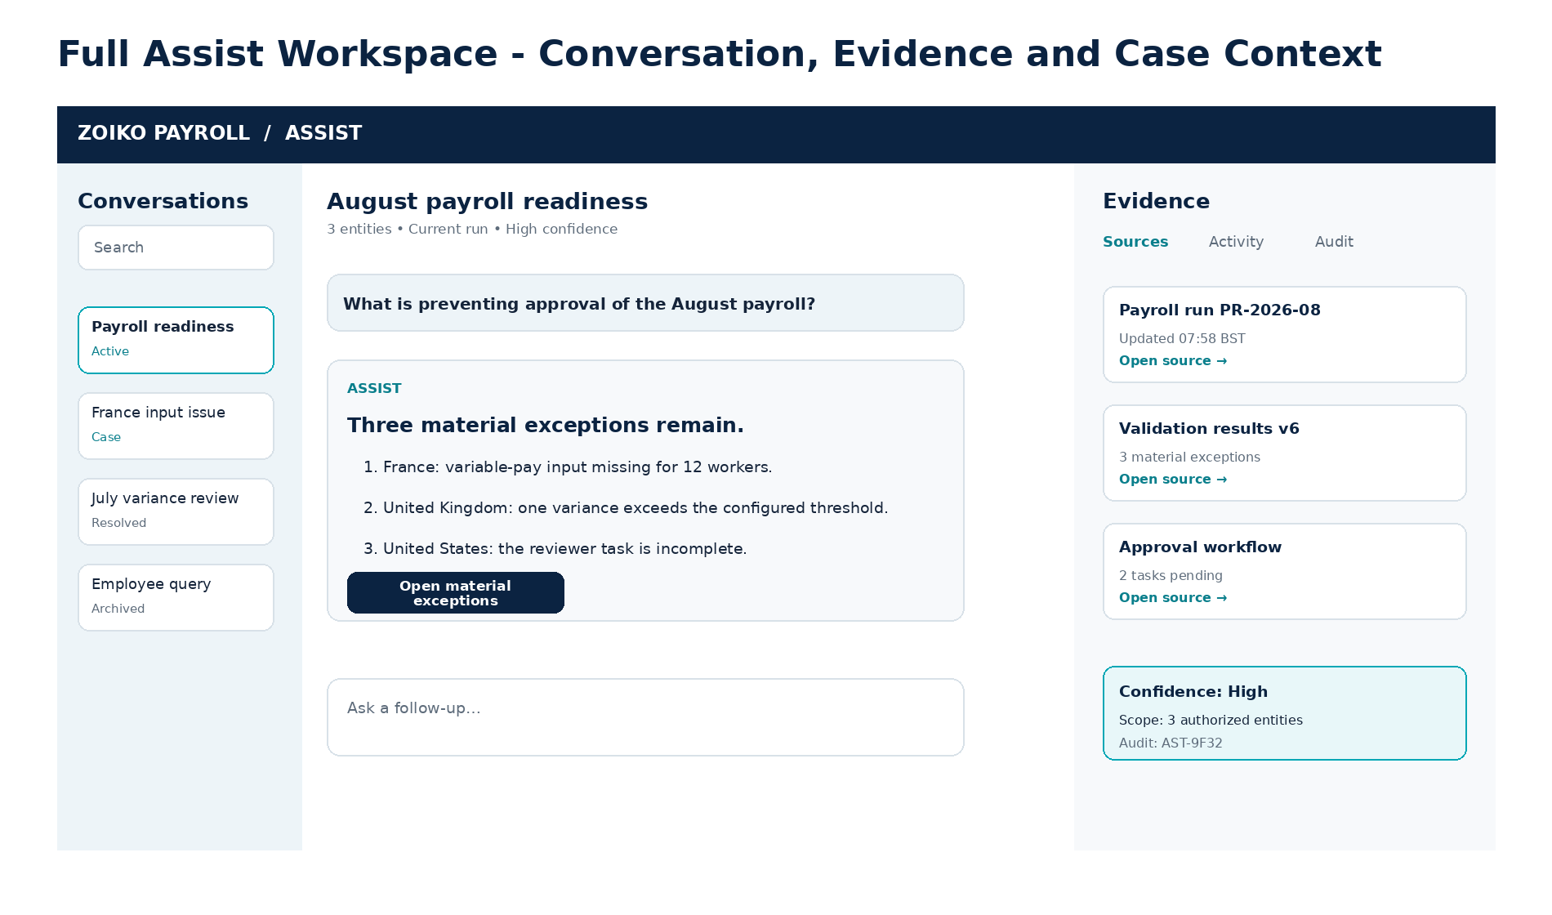
Figure 6 — Full Assist workspace

14.1 Workspace zones
Zone | Desktop width / behavior | Required content
Conversation rail | 260-300 px; collapsible. | Search, pinned, active, case-linked, resolved and archived sessions; privacy-safe previews.
Main conversation | Flexible; readable content column 640-760 px. | Messages, tables, cards, action previews, composer and system states.
Evidence pane | 320-420 px; collapsible or drawer. | Sources, activity, audit, freshness, confidence and tool receipts.
Header | Full width. | Title, scope, jurisdiction, session controls, allowed export/share and service state.
Responsive | Two-zone then one-zone. | Evidence becomes drawer; rail becomes overlay; no hidden controls.

14.2 Conversation history privacy
• History list items show neutral titles or approved summaries and never expose sensitive payroll values in a collapsed rail.
• Role, tenant, delegated-access and retention policies are re-evaluated when opening a prior conversation.
• Case-linked and archived states are clearly labeled; archive does not imply deletion.
• Export/share controls appear only when policy allows and show classification and scope before completion.

15 Mobile Product Experience
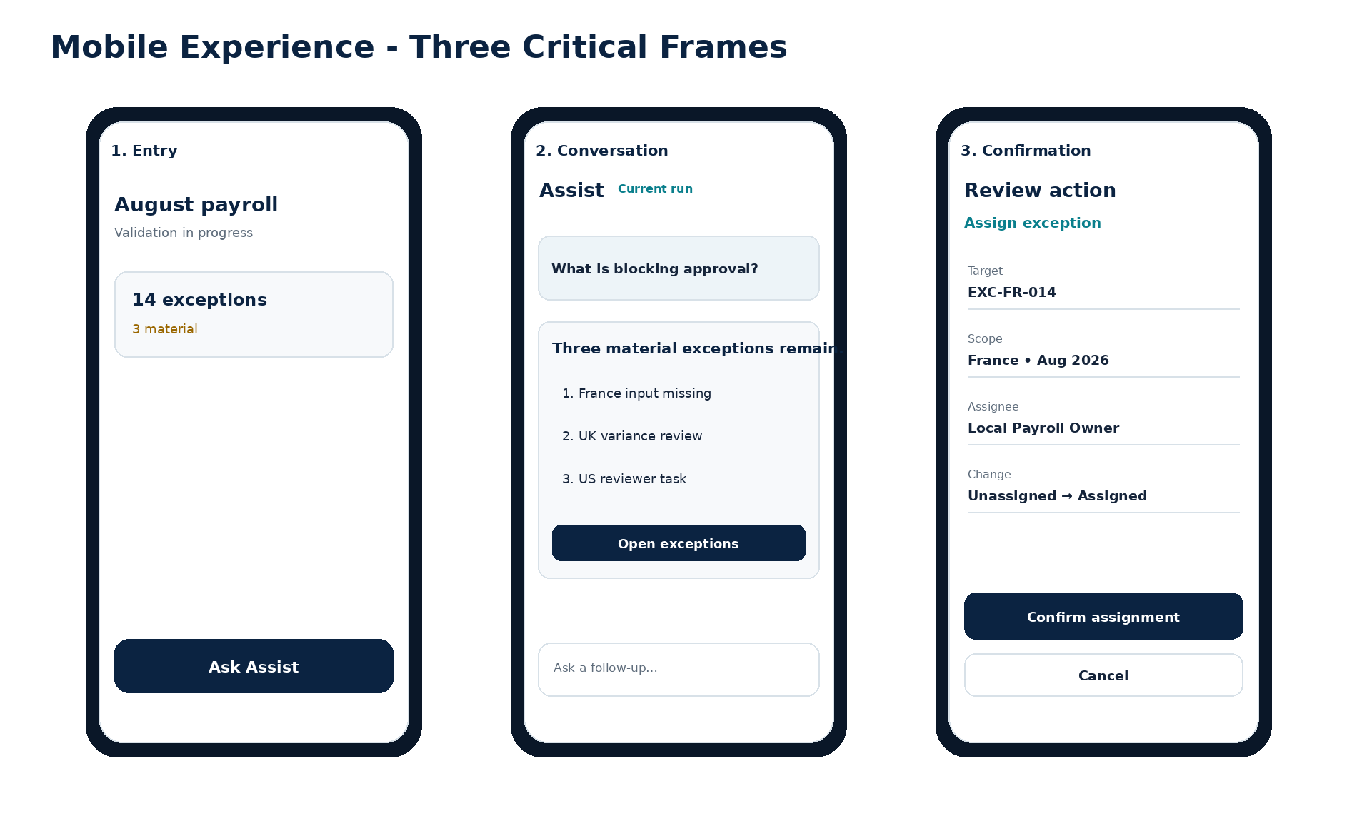
Figure 7 — Mobile critical frames

15.1 Mobile interaction standard
• Complex conversations use a full-screen route or full-height sheet, not a small floating bubble.
• Evidence, source details and confirmations use a one-column reading order with sticky but non-obstructive primary controls.
• Back navigation closes nested evidence or confirmation before leaving the conversation.
• Composer respects the software keyboard, safe areas, input-method editors and dynamic text size.
• Offline design distinguishes cached content from current payroll state and disables current-state claims/actions.
• No swipe-to-confirm, press-and-hold or hidden gesture is used for material actions.
• Platform-native conventions may differ, but payroll terminology, evidence and safety semantics remain identical.

15.2 Mobile frame matrix
Frame group | Required states
Entry | default, attention, restricted, unavailable, first use
Conversation | empty, suggestion, user message, retrieving, complete, stopped, follow-up
Evidence | collapsed footer, source list, source detail, conflict, stale, unavailable
Action | draft preview, A3 preview, reauthentication, confirmed, conflict, receipt, failure
Handoff | preview, destination selection, case created, ownership/SLA
Connectivity | offline, reconnecting, stale cache, provider degraded, tool unavailable

16 Composer, Suggested Prompts and Input States
Element / state | Design requirement
Placeholder | Contextual and specific: “Ask about this payroll run…”; never a vague “Message Assist” where context is known.
Multiline input | Grows to controlled maximum; internal scrolling thereafter; supports IME and dictation preferences.
Send | Disabled until context and input validation permit; accessible reason available.
Stop | Visible during generation; stops presentation and uncommitted downstream work only.
Attachments | Disabled by default; when enabled, show accepted type, size, scanning, classification, extraction and removal.
Paste warning | Inline warning for secrets, protected identifiers, oversized content or suspected embedded instructions.
Suggested prompts | Controlled registry, role/context filtered, keyboard accessible and never promotional.
Character/token limit | Explain in user language; preserve draft; offer approved summarization or attachment route.
Error | Input preserved; clear correction; no loss on recoverable failure.
Confirmation lock | Composer unavailable while a blocking confirmation or reauthentication flow is active.

16.1 Suggested prompt content rules
• Suggestions use approved verbs: summarize, explain, find, compare, prepare, open, assign, create case.
• Suggestions never offer an unauthorized or prohibited action.
• Suggestions are suppressed when a safe next step cannot be determined.
• Prompt selection analytics record intent ID and position, not prompt content or payroll values.

17 Assistant Response Anatomy and Content Hierarchy
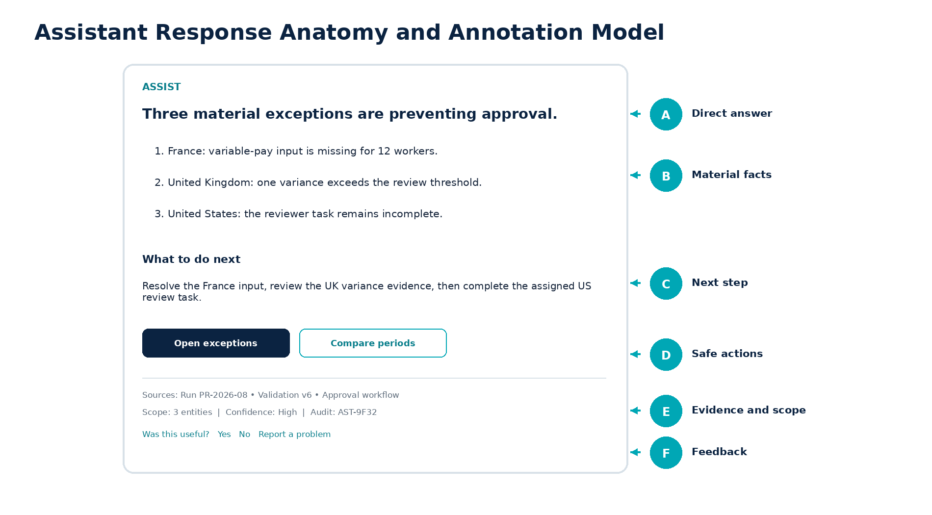
Figure 8 — Assistant response anatomy

17.1 Mandatory hierarchy
1. Direct answer or outcome.
2. Material facts, exceptions, comparison or explanation.
3. Recommended next step within the user’s authority.
4. Safe navigation, draft or controlled action controls.
5. Sources, effective time, scope, confidence and audit reference.
6. Boundary or disclaimer only where relevant.
7. Response-level feedback.

17.2 Responsive response behavior
• Comparison tables become stacked cards or horizontally scrollable regions with explicit labels; critical values remain visible.
• Long evidence lists collapse after the first three sources with a clear source count.
• Action controls wrap in logical order; primary action remains after content, not detached above context.
• Response metadata is readable and available to assistive technology; it is not relegated to inaccessible tooltips.

18 Sources, Evidence, Confidence, Freshness and Conflict UX
State / component | Required presentation
Product record | Object name, ID/reference, status, updated time, source type and deep link.
Calculation/validation result | Run, version, result/rule reference, generated time and authority.
Configuration | Tenant/entity/jurisdiction scope, setting, version and effective period.
Knowledge source | Title, owner/publisher, jurisdiction, effective date, review state and controlled link.
Confidence: High | Label plus explanation available; standard source footer.
Confidence: Medium | Amber icon/label; state what is missing or inferred; one focused follow-up or route.
Confidence: Low | Withhold material conclusion; identify evidence gap and safe handoff.
Stale source | Warning banner, stale date and exclusion/review behavior; never silently use.
Source conflict | Name conflicting sources and scopes; block definitive conclusion.
Permission-limited | State that available scope is limited without revealing hidden records.
Unavailable | Name affected source capability and standard non-AI route.

18.1 Evidence interaction
• Clicking a source opens evidence without losing the conversation position.
• Source detail shows excerpts only when licensing, confidentiality and permission allow.
• Users can copy approved citation text without copying hidden payroll data.
• Evidence pane preserves semantic reading order and supports keyboard navigation between sources.

19 Find, Navigate, Result Cards and Comparison Patterns
Pattern | Use | Required fields
Object result card | Find a payroll run, exception, employee-owned document, task or report. | Type, name, scoped status, period/entity, updated time, authorized deep link.
Navigation answer | Route a user to a canonical product screen. | Destination, reason, required permission, current context and open action.
Grouped result list | Multiple authorized matches. | Group by type/scope; cursor/pagination; no hidden-data count.
Comparison table | Period/entity/configuration comparison. | Column definitions, source version, missing/partial states, no invented driver.
Metric explanation | Explain a chart or report value. | Definition, period/scope, calculation source, exceptions and drill-down.
No result | No authorized/verified match. | Do not reveal whether a hidden record exists; offer safe refinement or route.

19.1 Deep-link rules
• Deep links resolve through approved route helpers and recheck permission at destination.
• Critical action cards always include the canonical Zoiko Payroll workflow route.
• Link labels name the destination or action; “click here” is prohibited.
• Opening a new tab/window is announced and used only where product conventions require.

20 Controlled Actions, Drafts and Confirmation UX
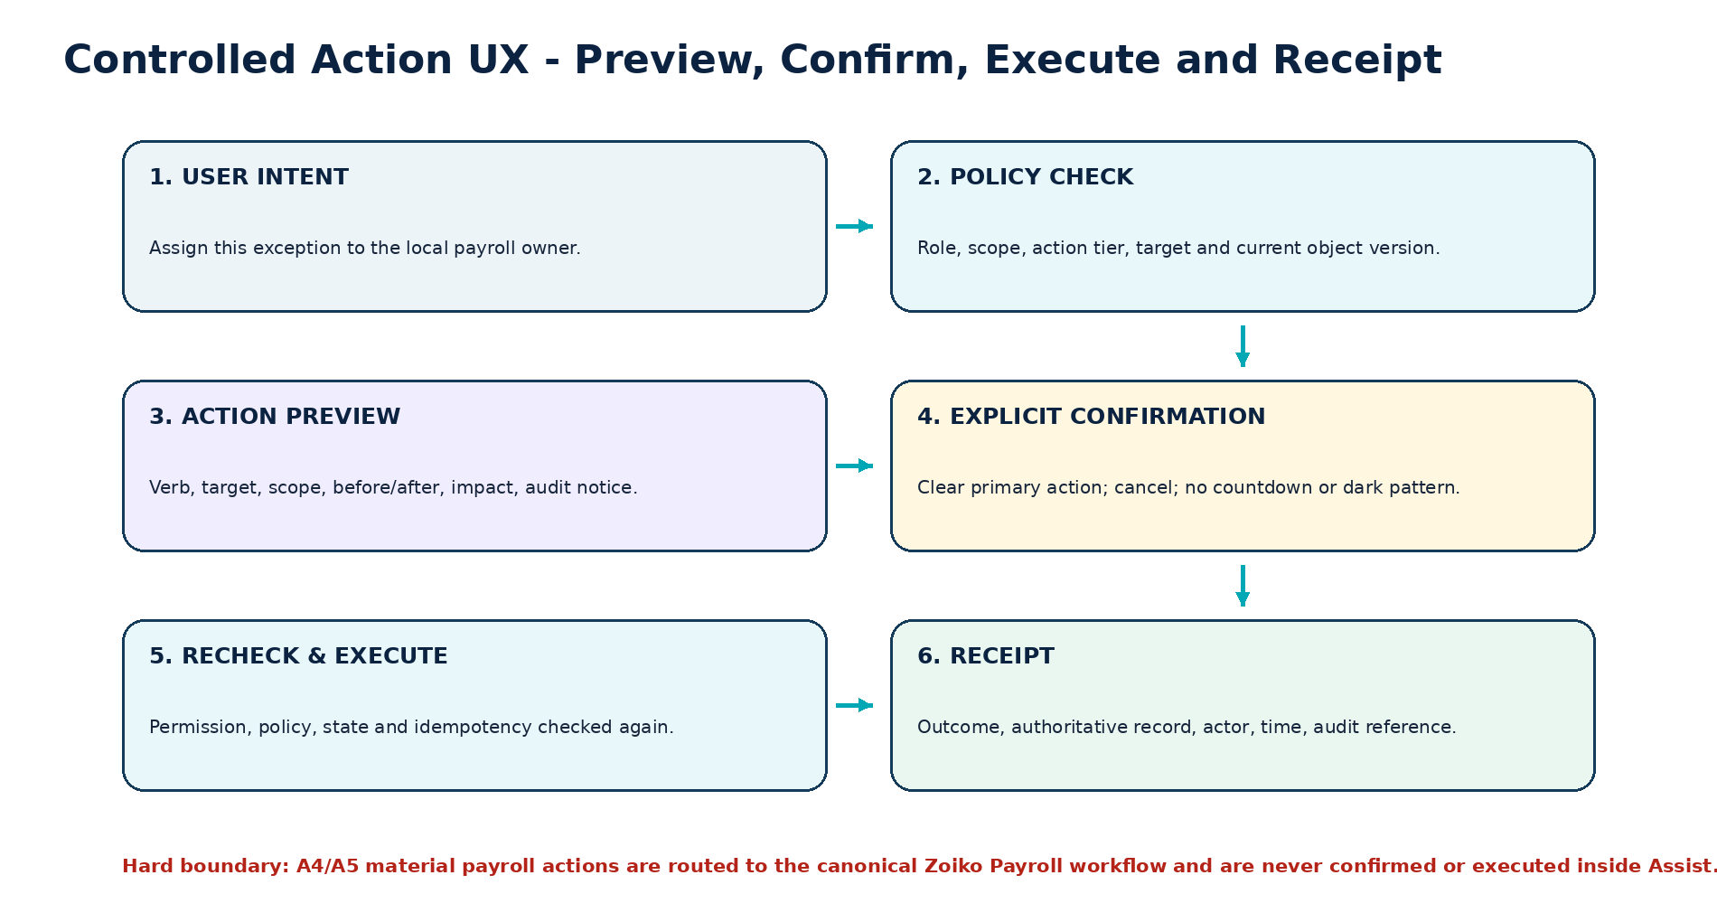
Figure 9 — Controlled action UX flow

20.1 Action preview anatomy
Element | Required content
Action verb | Specific, reversible verb: Assign, Add note, Save filter, Create case.
Target | Object type, visible identifier and current state.
Scope | Tenant/entity/jurisdiction/payroll period as applicable.
Before / after | Current and proposed values using comparable presentation.
Impact | What will change and what will not change.
Authorization | User identity and any step-up authentication requirement.
Audit | Notice that confirmation, policy result and outcome are recorded.
Primary / secondary | Explicit confirm label and equally discoverable cancel.
Expiry / conflict | Preview expiry and object-version conflict behavior.

20.2 Prohibited confirmation designs
■ No generic “Yes” for a material action.
■ No preselected confirmation, countdown, autoplay, swipe-to-confirm, double negative or hidden cancel.
■ No confirmation inside a transient toast.
■ No chat control for final payroll approval, payment release, filing submission, permission change or protected bank/tax/identity change.

21 Human Handoff, Case and Task Experience
Stage | Required UX
Reason | Explain why handoff is recommended: low confidence, conflict, specialist review, unsupported jurisdiction, operational issue.
Destination | Show approved responsible role/team and alternative destinations where authorized.
Package preview | User question, approved summary, source references, object IDs and intended recipients.
Data minimization | Show excluded sensitive/unrelated information and allow removal of optional context.
Confirmation | Create case/task with explicit action and no implied resolution.
Receipt | Case/task ID, owner, state, SLA/expected response, created time and canonical link.
Follow-up | Conversation may link to the case; it does not fabricate case progress.
Failure | Preserve package; show specific dependency failure and standard manual route.

21.1 Handoff card states
• suggested
• preview
• destination required
• ready
• creating
• created
• assignment pending
• SLA at risk
• resolved
• creation failed
• permission denied

22 Employee Self-Service Experience
Screen / journey | Required frames and safeguards
Employee welcome | Own-record scope, suggested tasks, privacy and About Assist.
Find payslip | Period list, secure document link, unavailable document, access-expired and download policy.
Explain pay component | Visible line item, approved definition, period/context, no independent model calculation.
Document list | Metadata only by default; status, period, document type and secure open.
Raise payroll query | Category, description, attachment policy, summary preview, case receipt and SLA.
Correction request | Explain difference between question, request and authoritative data change; route to approved workflow.
Sensitive values | Masked until user requests and policy permits; no shoulder-surfing disclosure in list previews.
No other worker data | No search results, counts or existence confirmation for other workers.

22.1 Employee content tone
• Plain language first; canonical payroll term in parentheses when useful.
• No blame or implication that the employee caused an error.
• No financial, tax, legal or employment advice.
• Clear route to employer payroll/HR support for disputes or personal circumstances.

23 Payroll Preparer and Administrator Experience
Journey | Required experience
Run readiness | Status summary, entity scope, blockers, materiality, source versions and next actions.
Exception triage | Filter/group by materiality, jurisdiction, owner and state; explain exception; open evidence; prepare assignment/note.
Data dependency review | Missing inputs, responsible owner, deadline and approved source; no speculative cause.
Period comparison | Current/prior approved periods, partial-data state, deterministic differences and source references.
Approval preparation | Readiness packet and unresolved risks; Assist never recommends or performs final approval.
Reconciliation | Unmatched categories, source and payroll totals, status and report routes.
Configuration explanation | Current scoped setting, effective period, owner and controlled route; no direct protected configuration change.
Bulk views | Pagination/virtualization, selection rules and no bulk A3 action unless separately approved.

24 Reviewer, Approver and Finance Experience
Role | Primary frames | Decision-right protection
Reviewer | Variance comparison, evidence set, unresolved exceptions, review note draft, canonical review task. | Assist may summarize and prepare; reviewer submits the review.
Approver | Readiness, sign-offs, high-risk unresolved items, version, deadline, approval route. | No approve button in chat; no “ready to approve” decision claim beyond configured deterministic readiness.
Finance | Totals, funding status, journal/reconciliation state, period/entity comparison and report routes. | Use aggregates/minimum personal data; no unnecessary worker detail.
Executive view | High-level payroll status and material risks where authorized. | No hidden drill-through; no employee-level exposure without permission.

24.1 Materiality visual standard
• Materiality is a configured product state, not a model-generated visual judgment.
• Cards show threshold source/version and the observed value or exception class where permitted.
• Warning and critical styles use icon, label, explanation and ordering; color alone is insufficient.

25 HR, Compliance, Auditor, Implementation and Support Experiences
Role | Screens / patterns | Special controls
HR / People | Joiner/leaver readiness, payroll-impacting changes, missing dependencies and owner routing. | No bank/tax detail unless explicitly authorized.
Compliance / local payroll | Jurisdiction scope, effective guidance, source conflict, filing status and specialist handoff. | No cross-country generalization; effective date is visible.
Auditor / assurance | Read-only evidence, approval history, configuration versions, action receipts and audit references. | Time-bounded approved scope; export controls and watermarking.
Implementation | Integration health, mapping, migration and setup guidance. | Synthetic/example data in design; delegated tenant access is explicit.
Support | Diagnostic status, safe logs, case summary and escalation. | Purpose, expiry and masking for support access; no provider prompts/secrets.
Knowledge operator | Source registry, editor, review queue, conflict center, index release and emergency withdrawal. | Four-eyes publication; role segregation and full audit.

26 Assist Administration and Knowledge Operations UI
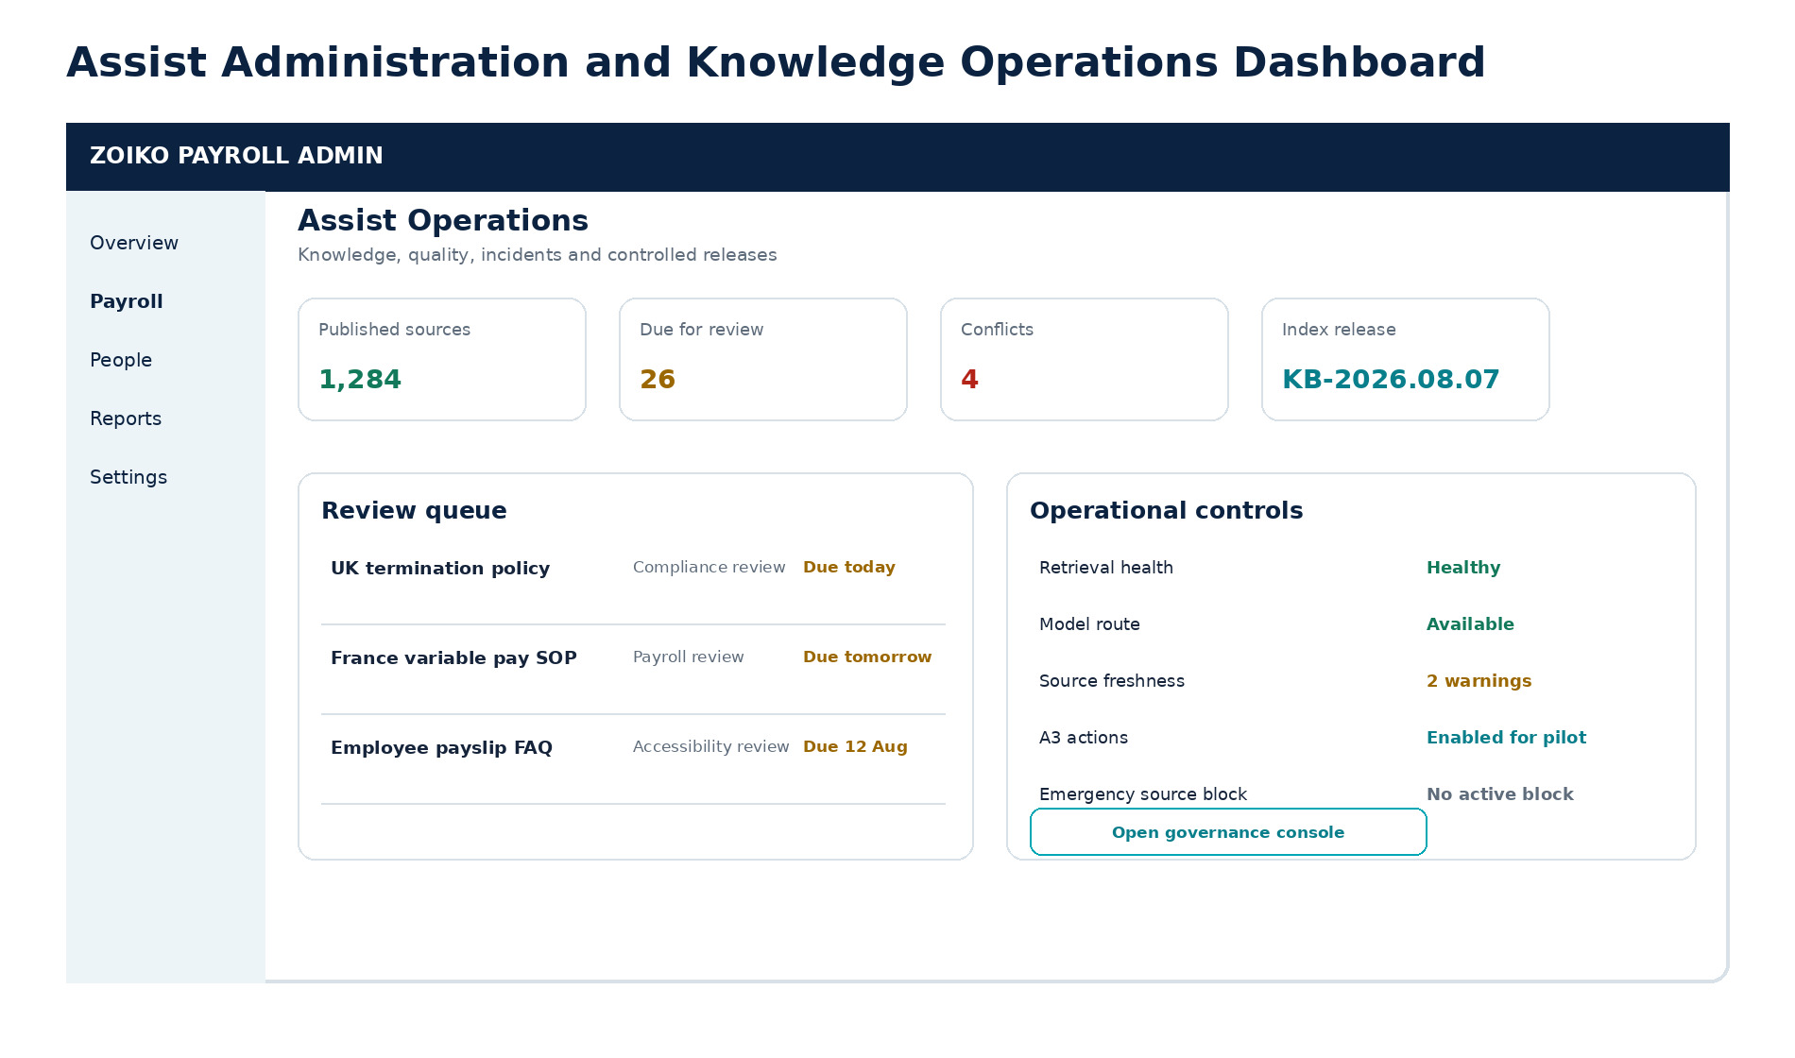
Figure 10 — Assist administration and knowledge operations dashboard

26.1 Administration modules
Module | Required screens
Overview | Health, source freshness, conflicts, action status, quality signals and current release.
Notices | First-use and About Assist notice versions, locales, status and audit.
Capabilities | Role/tenant/jurisdiction availability, release phase and effective date; no policy bypass.
Knowledge sources | Registry, source detail, ownership, authority, classification, effective dates and ingestion state.
Content editor | Template, metadata, preview, differences, validation and controlled submission.
Review queue | Assignment, due date, risk, comments, approval/reject/request changes.
Conflict center | Conflicting sources, scope/effective dates, resolution owner, quarantine/withdraw.
Index releases | Manifest, source/version membership, test results, approval, activate/rollback.
Quality and feedback | Grounding, gaps, outdated reports, safety reports and case linkage.
Incidents and kill switches | Restricted, high-friction controls with reason, scope, expiry, second approval and audit.

27 Errors, Refusals, Uncertainty and Degraded States
State | Canonical design pattern | Primary action
Permission denied | Neutral restricted card; no hidden-record existence disclosure. | Open access help or approved request route.
Unsupported jurisdiction | Jurisdiction/period shown; no generalized local guidance. | Open jurisdiction directory or specialist handoff.
Low confidence | Known facts, missing evidence and reason conclusion is withheld. | Answer one focused question or create handoff.
Source conflict | Conflicting sources and scope; definitive answer blocked. | Open evidence or escalate.
Stale source | Effective/review date and exclusion warning. | Open current source search or owner task.
Tool unavailable | Affected capability and current data risk named. | Use standard Zoiko Payroll route.
Model unavailable | No fabricated answer. | Deterministic search/navigation or standard UI.
Offline | Cached state clearly labeled; no current-state claim/action. | Reconnect or open cached document where allowed.
Action conflict | Record changed after preview; current state displayed. | Rebuild preview.
Unsafe/prohibited request | Clear boundary without exposing internal policy detail. | Authorized route.
Unexpected safe failure | Correlation ID; user input preserved. | Retry or contact support.

27.1 Error content rules
• Name the problem and affected capability; do not blame the user.
• Preserve input and context on recoverable failure.
• Never imply success without an authoritative receipt.
• Material errors do not auto-dismiss or rely on transient toast alone.
• Use stable error/reference IDs only where useful to support; do not expose provider internals.

28 Attachments, Pasted Content and File-Processing UX
Stage | Required state and copy
Selection | Allowed types, size and purpose; remove control.
Uploading | Progress and cancel; no implication content is accepted.
Security scan | Virus/malware and active-content scan state.
Classification / DLP | Sensitive-data warning, blocked field class or approved processing scope.
Extraction | Text/table/image extraction status; page or section references.
Prompt-injection review | Source treated as untrusted data; suspicious instructions ignored/quarantined.
Ready | Filename, type, size, classification and included scope.
Partial | Some pages/content unavailable; explain effect on answer confidence.
Rejected | Reason, safe alternatives and no retained usable content beyond policy.
Retention | How long the file/derived content is retained and where to manage it.

MVP POSITION
Attachment controls remain hidden or disabled until the security, privacy, extraction, retention, knowledge and guardrail requirements for the relevant content type are approved and implemented.

29 Responsive Layout, Breakpoints and Reflow
Viewport class | Reference width | Experience behavior
Small mobile | 320-479 px | Dedicated full-screen Assist route; one column; sticky composer; evidence/action sheets.
Large mobile | 480-767 px | Same one-column model with wider cards and optional split list/detail only if accessible.
Tablet | 768-1023 px | Overlay panel for short tasks; full route for workspace/evidence; admin tables become cards or horizontal regions.
Small desktop | 1024-1279 px | Panel overlay or narrowed product content; no obscured canonical controls.
Desktop | 1280-1439 px | 440 px resizable context panel; full workspace supports rail/main/evidence based on available width.
Large desktop | 1440 px+ | Three-zone workspace; max reading width; no uncontrolled whitespace stretching.
200% zoom | Effective viewport rules apply. | No loss of content or operation.
400% reflow | Single column. | No hidden controls, two-dimensional scrolling only for essential tables with labels.

29.1 Text expansion
• Frames are validated at 200% text expansion for common controls and at representative long-string locales.
• Buttons grow or wrap; text is not truncated where it changes meaning.
• Tables define priority columns and responsive alternatives; arbitrary ellipsis is prohibited for material states.
• Icons do not replace required labels solely to save space in critical workflows.

30 Accessibility and Inclusive Design Specification
Area | Figma annotation and acceptance evidence
Keyboard | Tab order, arrow-key patterns, Escape behavior, panel focus entry/return and no keyboard trap.
Screen reader | Landmarks, headings, live-region timing, accessible names/descriptions, source and status semantics.
Focus | Visible token, logical order, restoration after dialog/drawer/close and no focus loss during streaming.
Zoom/reflow | 200% zoom and 400% reflow annotated for every critical surface.
Contrast | Text, controls, focus and non-text contrast validated in each theme and state.
Color independence | Status uses icon, label and structure in addition to color.
Motion | Reduced-motion variants and no information conveyed solely by animation.
Target size | 44 x 44 px internal standard and adequate spacing.
Cognitive | One primary decision per confirmation, plain language, progressive disclosure and stable placement.
Errors | Persistent material error, associated field, correction guidance and preserved input.
Dynamic content | Streaming and progress announcements are concise and do not repeatedly reread the response.
Assistive technology | Manual testing with representative screen readers, keyboard-only, zoom and mobile accessibility services.

ACCESSIBILITY GATE
Automated plugin checks are supporting evidence only. Dev Ready status requires manual design review and implemented assistive-technology acceptance for critical flows.

31 Localization, Internationalization and Jurisdiction UX
Design concern | Requirement
Locale vs jurisdiction | Displayed independently. Language/currency does not determine local payroll guidance.
Date/time | Locale format plus time zone where ambiguity matters; effective date is explicit.
Currency | Currency code/symbol and rounding conventions from authoritative product data; no conversion by design layer.
Numbers | Locale grouping/decimal display; machine identifiers remain stable.
Text expansion | Test long strings and multi-line controls; 30-50% expansion target for common labels.
Bidirectional readiness | Use start/end constraints, mirroring rules and non-directional icons; release only after language review.
Canonical terms | Approved payroll terms may remain in source language with explanation when translation could change meaning.
Unsupported language | Transparent fallback to approved language without implying jurisdiction support.
Translation status | Source language, translation version, reviewer and legal-review state available in evidence/admin views.
Mixed jurisdiction | Scope selector and badges; no silent combination of rules.

32 Content Design, Payroll Language and Microcopy Governance
Use | Avoid | Reason
“The payment file was prepared.” | “Employees were paid.” | Prepared is not settled.
“The filing was submitted.” | “The filing is complete.” | Submission is not acceptance.
“The calculation result shows…” | “I calculated…” | The payroll engine, not Assist, calculates.
“Based on the available records…” | “Definitely…” | Distinguishes evidence from inference.
“Open the approval screen.” | “I can approve this.” | Preserves human decision rights.
“Current approved guidance for the UK…” | “Payroll law says…” | Shows jurisdiction, source and time scope.
“I could not verify this.” | Plausible unsupported answer | Makes uncertainty visible.
“Review required” | “Problem” by default | Uses canonical state without blame.

32.1 Copy source control
• Interface copy lives in a controlled content catalogue with stable content IDs; Figma displays the approved version.
• Legal, privacy, security and jurisdiction copy identifies owner, locale, version and effective date.
• Figma comments are not an approved source for production copy.
• Examples and synthetic payroll values are clearly marked and never use real employee data.

33 Privacy, Security and Trust UX
Control | Visible UX behavior
Data minimization | Scope and sources are shown; unnecessary fields are absent rather than merely hidden after retrieval.
Sensitive masking | Bank, tax, government, address, medical/absence and authentication information masked in lists/previews.
Step-up authentication | Reason, protected action/data and expiry explained; returns user to prior state.
Delegated support access | Banner shows purpose, tenant, agent, expiry and exit control.
Session risk/expiry | Neutral reauthentication state; unsent draft retained where safe.
Export/share | Classification, content scope, recipient/channel and watermark/retention warning before completion.
Prompt injection | No attack details exposed; untrusted source warning/quarantine shown to authorized operators.
Incident/degradation | Accurate status and standard route; no silent fail-open.
No worker surveillance | Assistant usage is not framed as performance scoring; employee feedback remains neutral.

34 Analytics and Telemetry Design Annotations
UX event family | Annotated triggers / privacy rule
Launcher | opened, attention selected, restricted/unavailable; no payroll content.
Prompt | suggestion viewed/selected and intent ID; no text.
Conversation | message submitted, response completed/stopped, fallback; length band only.
Evidence | source footer expanded, source opened, conflict/freshness viewed; source ID hashed where required.
Action | previewed, confirmed, canceled, conflict, receipt; tool/risk/outcome, no before/after values in analytics.
Handoff | suggested, previewed, created, failed; destination/reason code.
Feedback | helpful/not helpful and reason; optional comment handled through restricted path.
Accessibility | keyboard path completion, reduced-motion mode, errors discovered in testing; no individual employee profiling.
Admin | source reviewed, conflict resolved, release activated/rolled back, kill switch; full audit separate from product analytics.

34.1 Annotation format
Example analytics annotation
Event: assistant_source_opened
Trigger: Source card primary link activation
Parameters: source_type, jurisdiction, freshness_state, surface, intent_id
Prohibited parameters: worker_name, pay_value, message_text, source_excerpt
FRS trace: FRS-ANL-* / FRS-EVD-*

35 Prototype Strategy, User Research and Human-Factors Validation
Prototype level | Purpose | Exit evidence
L0 static concept | Validate information architecture and terminology. | Product/payroll review decision.
L1 clickable task flow | Validate navigation, panel/workspace continuity and action order. | Moderated usability findings.
L2 state-complete prototype | Validate loading, error, evidence, conflict, confirmation and handoff. | Task success and comprehension metrics.
L3 coded prototype | Validate streaming, keyboard, screen reader, responsive and API fixtures. | Accessibility and technical feasibility.
Pilot production | Validate real role tasks under feature flags. | Quality, safety, support and operational evidence.

35.1 Required research audiences
• Employees with varied payroll literacy and assistive-technology needs.
• Payroll preparers, reviewers and approvers across representative jurisdictions.
• Finance and HR users with different data permissions.
• Compliance/local payroll owners and auditors.
• Implementation/support users under delegated-access conditions.

35.2 Core research questions
1. Do users understand what Assist can and cannot do?
2. Can users identify context, scope, evidence, confidence and freshness?
3. Do users distinguish prepared, submitted, approved, settled and completed states?
4. Can users recover from permission, conflict, stale-source and dependency failures?
5. Do confirmations produce informed intentional action without pressure?
6. Can keyboard and screen-reader users complete the same critical flows?
7. Does mobile preserve clarity and human control under constrained space?

36 Design System Governance, Contribution and Change Control
Change class | Required approval
Patch | Non-semantic correction with no behavior/token/API impact; Design Systems review.
Minor | New backward-compatible variant/component/screen state; Product, Design Systems, Engineering and Accessibility.
Major | Breaking component/token/interaction change; cross-functional approval and migration plan.
Payroll state/terminology | Payroll Operations and Product approval regardless of visual size.
Permission/action/evidence change | FRS/API/Architecture/Guardrail change control before design approval.
Legal/privacy/security copy | Source owner and required counsel/privacy/security approval.
Emergency fix | Scoped temporary release, incident reference, expiry and post-incident review.

36.1 Contribution workflow
1. Submit problem statement, requirement IDs and proposed scope.
2. Confirm existing component/pattern cannot satisfy the need.
3. Create branch or work page with component and usage examples.
4. Complete content, responsive, accessibility, security/privacy and code-feasibility review.
5. Validate code parity and visual regression fixtures.
6. Publish version, changelog and migration guidance.
7. Update handoff manifest and deprecation register where applicable.

37 Engineering Handoff, Dev Mode and Design-to-Code Contract
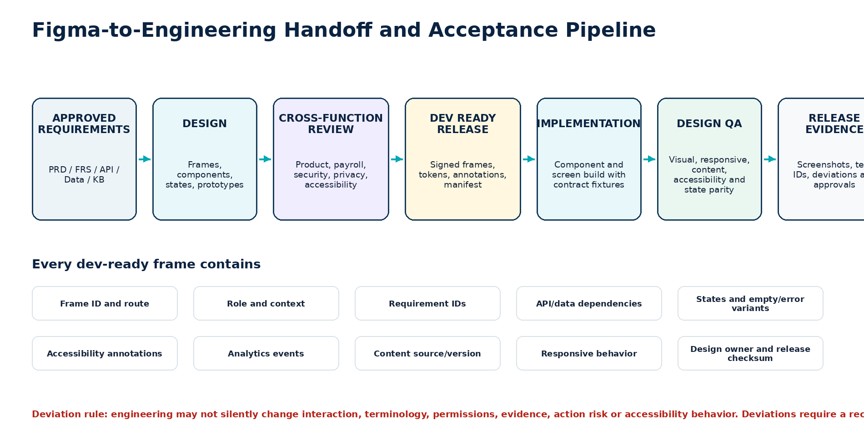
Figure 11 — Figma-to-engineering handoff pipeline

37.1 Dev Ready frame package
Artifact | Required contents
Release manifest | Release ID, scope, files/pages/frames/components, versions, checksums, owners and approval state.
Annotated frames | Routes/surfaces, roles, context, states, requirements, APIs, data, events, copy IDs and accessibility.
Prototype flows | Critical paths, decision points, error recovery, evidence, confirmation and handoff.
Token package | Versioned variables/token manifest and platform outputs.
Component mapping | Figma component ↔ web/mobile code component ↔ story/test IDs.
Content catalogue | Content IDs, approved copy, locale, source owner/version and fallback.
Asset package | Approved icons/illustrations only; optimized formats, naming, licensing and alt/decorative status.
Test fixtures | Synthetic states and payloads for visual, responsive, accessibility and contract tests.
Deviation register | Accepted differences with owner, rationale, expiry and follow-up.

37.2 Handoff restrictions
• Engineering must not implement WIP, reference-only, rejected or archived frames.
• Measurements are consumed through tokens/constraints, not manual pixel transcription where a component exists.
• No screenshot is accepted as the sole specification for a dynamic component.
• No hidden Figma comment contains a mandatory requirement; requirements appear in annotations or controlled documents.
• Implemented components are reviewed against the same state fixtures used in Figma.

38 Design QA, Visual Regression and Acceptance Testing
QA family | Required evidence
Design-system parity | Correct component instance/version; no detached or local duplicate in Dev Ready screens.
Visual parity | Reference viewport screenshots within approved tolerance; no clipping, overlap or token drift.
Responsive | All breakpoint, zoom, reflow and text-expansion states.
Interaction | Keyboard, focus, hover/press, loading, streaming, dialogs, drawers, confirmation and recovery.
Content | Canonical terms, copy IDs, truncation, empty/null, long string and locale.
Accessibility | Contrast, names, roles, focus order, live regions, target size, reduced motion and AT testing.
Data/API | Field mapping, masking, missing/partial/error/permission and stale/conflict states.
Security/privacy | No real data in design/test; sensitive masking; export/share; delegated access; safe errors.
Analytics | Correct trigger/parameters and prohibited-data review.
Cross-platform | Web and mobile semantic consistency; approved platform-native differences.

38.1 Visual regression strategy
• Each coded component has story/test fixtures matching the Figma variant matrix.
• Critical screens are captured at representative breakpoints, themes, density, locales and states.
• Intentional visual changes require baseline update approval and linked design release.
• Visual regression does not replace functional or accessibility testing.

39 Atomic UI/UX Design Requirements
UX ID | FRS trace | Design requirement | Pri. / Rel. | Figma / QA evidence
UXD-FIG-001 | FRS-UX-* | The project SHALL use the eight-file controlled Figma architecture defined in this specification. | P0/R1 | Project structure audit.
UXD-FIG-002 | FRS-AUD-* | Every Dev Ready frame SHALL include release ID, owner, status and requirement trace. | P0/R1 | Frame metadata audit.
UXD-FIG-003 | FRS-UX-* | WIP, reference, rejected and archived frames SHALL be visually and structurally separated from Dev Ready frames. | P0/R1 | Engineering handoff audit.
UXD-TOK-001 | FRS-ACC-* | All production colors, spacing, type, motion and component values SHALL use approved variables/tokens. | P0/R1 | Variable usage audit.
UXD-TOK-002 | FRS-ACC-005 | Status SHALL use icon, label and structure in addition to color. | P0/R1 | State review.
UXD-TOK-003 | FRS-ACC-006 | Reduced-motion variants SHALL preserve information and operation. | P0/R1 | Prototype acceptance.
UXD-CMP-001 | FRS-UX-* | Repeated patterns SHALL use published components; detached instances require a recorded exception. | P0/R1 | Instance audit.
UXD-CMP-002 | FRS-ERR-* | Interactive components SHALL include loading, error, disabled and permission states where applicable. | P0/R1 | Variant matrix.
UXD-ENT-001 | FRS-UX-003 | The launcher SHALL never obscure validation, consent, approval, payment or filing controls. | P0/R1 | Responsive overlay test.
UXD-ENT-002 | FRS-UX-004 | Attention states SHALL be tied to authorized existing tasks and SHALL NOT use marketing urgency. | P0/R1 | Task trace and content review.
UXD-FST-001 | FRS-UX-001 | First use SHALL identify Assist as AI and explain supported jobs and material limitations. | P0/R1 | All locale frames.
UXD-FST-002 | FRS-UX-016 | A persistent About Assist control SHALL be available on every Assist surface. | P0/R1 | Surface matrix.
UXD-PNL-001 | FRS-UX-005 | Desktop SHALL provide a resizable context panel with 360/440/560 px min/default/max. | P1/R3 | Resize prototype.
UXD-PNL-002 | FRS-UX-006 | Panel-to-workspace promotion SHALL preserve session, context, evidence and draft state. | P1/R3 | Flow prototype.
UXD-MOB-001 | FRS-UX-007 | Mobile complex tasks SHALL use a full-height route or sheet. | P0/R1 | Mobile viewport test.
UXD-MOB-002 | FRS-ACT-* | Mobile material confirmation SHALL use explicit buttons and SHALL NOT use swipe or gesture confirmation. | P0/R1 | Action flow review.
UXD-CMP-003 | FRS-UX-009 | The composer SHALL remain available while reading except during blocking confirmation or reauthentication. | P0/R1 | Scroll/focus prototype.
UXD-RSP-001 | FRS-RSP-* | Material responses SHALL follow the direct-answer, facts, next-step, action, evidence and feedback hierarchy. | P0/R1 | Response anatomy audit.
UXD-RSP-002 | FRS-EVD-* | Material answers SHALL visibly expose sources, scope, freshness, confidence and audit reference. | P0/R1 | Evidence frame acceptance.
UXD-RSP-003 | FRS-RSP-* | The design SHALL distinguish observed record, approved guidance and inference. | P0/R1 | Content/state review.
UXD-EVD-001 | FRS-EVD-* | Stale, conflicting, withdrawn or unavailable sources SHALL have distinct non-color-only states. | P0/R1 | Evidence state matrix.
UXD-EVD-002 | FRS-EVD-* | Low-confidence states SHALL withhold a material conclusion and offer a focused question or handoff. | P0/R1 | Adversarial prototype.
UXD-ACT-001 | FRS-ACT-* | A3 previews SHALL show action, target, scope, before/after, impact, audit and explicit confirm/cancel. | P0/R5 | Action preview frames.
UXD-ACT-002 | FRS-ACT-* | No Assist frame SHALL expose an execution control for A4/A5 actions. | P0/R1 | Screen/component search audit.
UXD-ACT-003 | FRS-ACT-* | Action conflicts SHALL show current state and require a new preview. | P0/R5 | Conflict flow.
UXD-HOF-001 | FRS-HOF-* | Handoff preview SHALL show destination, approved summary, included/excluded data and case action. | P0/R4 | Handoff prototype.
UXD-ESS-001 | FRS-ESS-* | Employee surfaces SHALL remain own-record scoped and privacy-protective. | P0/R2 | Role/permission test frames.
UXD-ERR-001 | FRS-ERR-* | Unavailable/degraded states SHALL name the affected capability and show the standard non-AI route. | P0/R1 | Dependency-state frames.
UXD-ERR-002 | FRS-ERR-* | Material errors SHALL persist and preserve recoverable input. | P0/R1 | Error recovery prototype.
UXD-ACC-001 | FRS-ACC-001 | All critical surfaces SHALL be designed and annotated to WCAG 2.2 AA baseline. | P0/R1 | Accessibility review.
UXD-ACC-002 | FRS-ACC-002 | All controls, messages, evidence, actions and confirmations SHALL be keyboard operable. | P0/R1 | Keyboard flow map.
UXD-ACC-003 | FRS-ACC-003 | Focus SHALL be visible, logical and restored after drawers/dialogs/panel close. | P0/R1 | Focus annotations.
UXD-ACC-004 | FRS-ACC-004 | Critical surfaces SHALL support 200% zoom and 400% reflow without loss. | P0/R1 | Reflow frames.
UXD-LOC-001 | FRS-ACC-008 | Locale, language, time zone, number/currency display and jurisdiction SHALL be independently represented. | P0/R1 | Locale matrix.
UXD-LOC-002 | FRS-ACC-009 | Design SHALL NOT imply jurisdiction from IP, language, currency or nationality. | P0/R1 | Context mismatch test.
UXD-SEC-001 | FRS-SEC-* | Sensitive values SHALL be masked in list, history and preview states unless authorized display is required. | P0/R1 | Privacy screen review.
UXD-ANL-001 | FRS-ANL-* | Analytics annotations SHALL exclude message text, pay values and worker identifiers by default. | P0/R1 | Event annotation audit.
UXD-ADM-001 | FRS-ADM-* | Administration SHALL include source, review, conflict, release, quality and incident states. | P1/R6 | Admin screen inventory.
UXD-HND-001 | FRS-AUD-* | Engineering SHALL consume only a signed Dev Ready release manifest. | P0/R1 | Handoff gate.
UXD-QA-001 | FRS-OPS-* | Every critical screen SHALL have responsive, state, accessibility and visual-regression fixtures. | P0/R1 | QA matrix.

40 Screen and State Inventory
Group | Minimum frames | Required coverage
G01 Launcher & shell | 12 | default, first-session label, established icon, attention, task count, restricted, unavailable, mobile, keyboard focus, critical-control collision, high contrast, dark
G02 First use & About | 10 | welcome, data-use, limitations, permission, evidence, locale notice, notice updated, About Assist, privacy route, support route
G03 Context panel | 18 | empty, contextual suggestions, user message, retrieving, complete, evidence open, action preview, confirm, conflict, receipt, handoff, denied, low confidence, source conflict, degraded, minimized, expanded, resized
G04 Full workspace | 18 | rail states, search, pinned, active, case-linked, resolved, archived, conversation, evidence tabs, comparison, report, action, handoff, export, share restricted, single-column, degraded, retention expired
G05 Mobile | 18 | entry, first use, conversation states, evidence, source detail, action preview, reauth, receipt, handoff, employee, offline, reconnecting, tool unavailable, keyboard open, dynamic text, high contrast
G06 Employee | 12 | welcome, document list, payslip metadata, explanation, unavailable document, query form, attachment, preview, receipt, denied-other-worker, correction route, privacy info
G07 Payroll operations | 16 | run readiness, exceptions list/detail, materiality, input dependencies, assignment preview, note draft, period comparison, approval packet, reconciliation, report route, config explanation, partial data, no results, source conflict, handoff, degraded
G08 Reviewer/finance/HR/compliance | 16 | reviewer evidence, review note, approver readiness, approval route, finance totals, funding, journal, HR joiners, leavers, dependency, compliance guide, unsupported jurisdiction, filing state, auditor evidence, support diagnostics, delegated access
G09 Admin & knowledge | 20 | overview, notices, capabilities, source registry/detail, upload, editor, metadata validation, review queue/detail, approve, reject, request changes, conflicts, resolve, quarantine, index build, activate, rollback, quality, incidents
G10 Edge and accessibility | 20 | permission denied, session expired, stale source, conflicting source, no confidence, empty, loading, slow, model unavailable, retrieval unavailable, tool unavailable, offline cache, action expired, action conflict, partial success, 200% zoom, 400% reflow, screen-reader order, reduced motion, RTL readiness

MINIMUM INVENTORY
The screen programme contains at least 160 explicitly designed frames/states before locale, theme and breakpoint variants. The exact count may increase; no state may be omitted solely to reduce Figma volume.

41 Critical Prototype and User-Flow Catalogue
Flow ID | Critical flow | Completion evidence
FLW-001 | First use → About data use → continue → contextual suggestions. | Notice version recorded; focus and return verified.
FLW-002 | Payroll run → ask readiness → evidence → open material exceptions. | Context and source continuity.
FLW-003 | Exception → explain → prepare assignment → confirm A3 → receipt. | Preview, recheck, idempotent receipt and canonical record.
FLW-004 | Approver asks to approve payroll → refusal → readiness summary → canonical approval route. | No chat approval control.
FLW-005 | Employee asks about payslip line → own record → approved definition → secure document. | Own-record scope and no model calculation.
FLW-006 | Unsupported jurisdiction → safe fallback → specialist handoff → case receipt. | No generalized guidance.
FLW-007 | Conflicting sources → evidence comparison → escalation. | Definitive answer blocked.
FLW-008 | Model outage → deterministic navigation/search → standard UI. | No fabricated response.
FLW-009 | Mobile action preview → reauthentication → confirm → conflict → rebuild preview. | Mobile safety and recovery.
FLW-010 | Knowledge source → review → publish → index release → rollback. | Four-eyes and release evidence.
FLW-011 | Keyboard-only panel open → source → confirmation cancel → close → focus return. | Complete keyboard path.
FLW-012 | 400% reflow workspace → conversation → evidence → composer. | Single-column, no hidden operation.

42 Design Implementation Roadmap and Work Packages
Work package | Scope | Exit condition
UX-WP01 Governance and setup | Project/files, permissions, status, naming, branching, release manifest. | Project audit passes.
UX-WP02 Foundations | Tokens, variables, grids, type, color, motion, icon and accessibility foundations. | Token/code strategy approved.
UX-WP03 Components | Core primitives, Assist components and state matrices. | Published library and code mapping.
UX-WP04 Desktop R1 | Launcher, first use, basic panel, explain/navigate and degraded states. | P0 R1 flows tested.
UX-WP05 Mobile R1 | Mobile entry, conversation, evidence and first-use parity. | Mobile accessibility acceptance.
UX-WP06 Read-only payroll | Run, exception, employee and evidence experiences. | Role/permission and data-state acceptance.
UX-WP07 Workspace R3 | Conversation rail, full workspace, comparison and evidence pane. | Cross-surface continuity.
UX-WP08 Draft/handoff R4 | Drafts, handoff, case receipt and support routes. | Privacy and ownership acceptance.
UX-WP09 A3 actions R5 | Preview, confirmation, reauth, conflict, receipt and failure. | Action-safety/red-team acceptance.
UX-WP10 Admin R6 | Knowledge, notices, capabilities, releases, quality and incidents. | Role segregation and audit acceptance.
UX-WP11 Localization | Locale variants, long strings, bidirectional readiness and jurisdiction states. | Per-locale release evidence.
UX-WP12 Handoff/QA | Dev Ready package, visual fixtures, design QA and sign-off. | Release manifest signed.

43 Release Gates, Definition of Done and Approval
Gate | Required approval evidence
G0 Predecessor baseline | PRD, FRS, API, data and knowledge documents approved; UX-impact deviations resolved.
G1 Project governance | Files, pages, access, branching, naming, statuses, archive and release process approved.
G2 Foundations | Tokens, variables, grids, typography, color, icon, motion and mode strategy accepted.
G3 Components | Required component variants, content, accessibility, data and code mapping complete.
G4 Screen completeness | All P0/P1 screens and release-blocking states represented; no happy-path-only gaps.
G5 Role and permission | Employee, payroll, reviewer, approver, finance, HR, compliance, auditor, support and admin experiences accepted.
G6 Evidence and knowledge | Source, confidence, freshness, conflict, jurisdiction and knowledge-admin UX accepted.
G7 Action safety | Draft/A3 preview-confirm-receipt flows pass; no A4/A5 execution control exists.
G8 Accessibility | WCAG 2.2 AA design audit, keyboard/focus maps, zoom/reflow, contrast, motion and AT prototype evidence.
G9 Responsive/localization | Mobile/tablet/desktop, text expansion, locale and bidirectional-readiness evidence accepted.
G10 Security/privacy | Masking, delegated access, export/share, error, attachment and incident UX accepted.
G11 Research | Critical role comprehension, task success, action intention and evidence understanding meet thresholds.
G12 Handoff | Dev Ready frames, manifest, tokens, copy, events, fixtures and deviation register complete.
G13 Design QA | Implemented component/screen parity, responsive, visual and accessibility tests pass.
G14 Executive approval | Founder / Executive Sponsor and required cross-functional owners approve baseline and residual risks.

43.1 UI/UX Figma Definition of Done
1. All eight controlled Figma files are created, permissioned, named and governed as specified.
2. Every approved P0/P1 requirement and critical state maps to a Dev Ready frame, component or documented non-visual behavior.
3. The component library and token release are versioned and mapped to code components/tokens.
4. No detached, hidden, unreviewed or reference-only design is included in the engineering release.
5. All role, permission, evidence, source, action, error, privacy, accessibility, responsive and localization obligations are represented.
6. Critical prototypes are tested with representative users and assistive technologies; decisions and residual risks are recorded.
7. The engineering handoff manifest, fixtures, content IDs, events, annotations and approvals are complete.
8. Document 7 is not started until this document is explicitly approved.
APPROVAL RULE
Upon explicit approval, the next and only next document is ZP-AST-ARCH-001 — Technical Architecture Documentation Detailed Wireframe. Document 8 remains blocked.

A Appendix A — Figma File and Page Checklist
Control | Pass criteria
Cover | File purpose, owner, release, status, links to governing documents and changelog.
Page order | Matches controlled file architecture; no personal scratch pages in production files.
Frame naming | Canonical screen/state/breakpoint/mode naming; unique IDs.
Components | Published instances; variant properties meaningful; no hidden duplicate sets.
Variables | Approved collections/modes; no unexplained raw values.
Annotations | Requirements, API/data, events, content, accessibility and responsive notes.
Prototype links | Named flows; start points; no dead-end critical path.
Data | Synthetic only; no real payroll/employee/customer data.
Status | Every section/frame clearly WIP, review, approved, Dev Ready or deprecated.
Archive | Superseded release preserved and implementation links updated.

B Appendix B — Component Documentation Template
Assist/ComponentName PUBLISHED COMPONENT TEMPLATE
Purpose One sentence defining the user problem and when the component is used.
Anatomy Numbered parts, slots, optional/required elements and nested components.
Variants State, size, density, theme, confidence, source count, permission or platform properties.
Behavior Pointer, touch, keyboard, focus, scroll, loading, async and error behavior.
Content Canonical labels, length limits, truncation/wrapping and localization guidance.
Data API fields, null/partial/masked states and classification.
Accessibility Name, role, state, description, focus and live-region behavior.
Analytics Event names, triggers and prohibited data.
Release Figma version, code component, tests, owner and deprecation path.

C Appendix C — Dev Ready Frame Annotation Template
Canonical frame annotation
FRAME ID: ZPA-DSK-PNL-EXCEPTION-PREVIEW-1440-LTR-LIGHT
STATUS: DEV READY | UX release UX-1.0.0
ROUTE/SURFACE: /payroll/runs/{id}/exceptions/{id} + Assist context panel
ROLE: Payroll Preparer
CONTEXT: tenant, entity, jurisdiction, payroll run, exception
FRS: FRS-ACT-*, FRS-EVD-*, FRS-UX-*
API: payroll.getException, payroll.assignException
DATA: exception_ref, owner_ref, object_version, evidence_set_id
STATE: A3 action preview
ANALYTICS: assistant_action_previewed
A11Y: focus enters heading; summary before controls; confirm and cancel labels
CONTENT IDS: AST-ACT-ASSIGN-TITLE, AST-ACT-AUDIT-NOTICE
OWNER: Product Design / Payroll UX
REVIEW: Product, Payroll, Security, Accessibility, Frontend
CHECKSUM: <release-generated>

D Appendix D — State Coverage Matrix
Feature | Default | Loading | Empty | Partial | Denied | Conflict / stale | Degraded | Success / receipt
Launcher | ✓ | — | — | — | ✓ | — | ✓ | —
Conversation | ✓ | ✓ | ✓ | ✓ | ✓ | ✓ | ✓ | ✓
Evidence | ✓ | ✓ | ✓ | ✓ | ✓ | ✓ | ✓ | —
Search/results | ✓ | ✓ | ✓ | ✓ | ✓ | ✓ | ✓ | —
Draft | ✓ | ✓ | ✓ | ✓ | ✓ | ✓ | ✓ | ✓
A3 action | ✓ | ✓ | — | ✓ | ✓ | ✓ | ✓ | ✓
Handoff | ✓ | ✓ | — | ✓ | ✓ | ✓ | ✓ | ✓
Knowledge review | ✓ | ✓ | ✓ | ✓ | ✓ | ✓ | ✓ | ✓
Index release | ✓ | ✓ | ✓ | ✓ | ✓ | ✓ | ✓ | ✓

E Appendix E — Reference Design Token Catalogue
Category | Representative tokens
Surfaces | surface.canvas, surface.subtle, surface.raised, surface.overlay, surface.inverse
Text | text.primary, text.secondary, text.muted, text.inverse, text.link, text.critical
Borders/focus | border.subtle, border.strong, border.selected, focus.ring, focus.offset
Status | status.success.*, status.warning.*, status.critical.*, status.info.*, status.neutral.*
Spacing | space.0, 25, 50, 75, 100, 150, 200, 300, 400, 600, 800, 1200
Sizing | control.height.sm/md/lg, icon.16/20/24, panel.width.min/default/max, content.max
Radius | radius.100/200/300/round
Type | type.caption, label, body.sm/md/lg, heading.sm/md/lg, display
Motion | duration.fast/standard/slow, easing.enter/exit/standard, motion.none
Assist component | assist.launcher.offset, assist.composer.minHeight, assist.evidence.width, assist.message.gap

F Appendix F — Design QA Checklist
Question | Decision
Does the screen use approved components and tokens? | Pass / Fail / Exception ID
Are role, context, tenant, jurisdiction and permission assumptions explicit? | Pass / Fail
Are loading, empty, partial, denied, conflict, stale, degraded and success states covered? | Pass / Fail / N/A justified
Are sources, confidence, freshness and audit visible for material responses? | Pass / Fail
Does the flow preserve A0-A5 action boundaries and human decision rights? | Pass / Fail
Are keyboard, focus, screen-reader, contrast, target-size, motion and reflow annotated? | Pass / Fail
Are mobile, text expansion, locale and long-string states validated? | Pass / Fail
Does copy use canonical payroll states and approved content IDs? | Pass / Fail
Are data fields, masking, API operations and analytics events mapped? | Pass / Fail
Are only synthetic data and approved assets used? | Pass / Fail
Is the frame included in a signed Dev Ready release? | Pass / Fail

G Appendix G — Standards and Governing Source Basis
ID | Source / governing basis
ZP1 | Zoiko Payroll Assist Detailed Chatbot Product, UX and Engineering Wireframe — ZP-AI-UX-001 v1.0.
ZP2 | Zoiko Payroll Assist Product Requirements Document — ZP-AST-PRD-001 v1.0.
ZP3 | Zoiko Payroll Assist Functional Requirements Specification — ZP-AST-FRS-001 v1.0.
ZP4 | Zoiko Payroll Assist API Documentation and Collections — ZP-AST-API-001 v1.0.
ZP5 | Zoiko Payroll Assist Database Schema and ER Diagram — ZP-AST-DATA-001 v1.0.
ZP6 | Zoiko Payroll Assist Knowledge Base Governance and Content Specification — ZP-AST-KB-001 v1.0.
S1 | W3C Web Content Accessibility Guidelines 2.2 as the product accessibility baseline.
S2 | WAI-ARIA Authoring Practices and platform accessibility guidance, applied through implementation testing rather than copied mechanically.
S3 | NIST AI Risk Management Framework and Generative AI Profile for trust, transparency and human-control design implications.
S4 | OWASP GenAI/LLM and conventional application/API security guidance for injection, disclosure, excessive agency and safe errors.
S5 | Applicable privacy, employment, payroll, tax, AI, accessibility and consumer-protection requirements assessed per market.
S6 | Zoiko Group Software Delivery Standard ZG-SDS-01 v1.0: Understand before building; agree before integrating; test throughout; demonstrate outcomes; release only against evidence.

FINAL AUTHORITY
This v1.0 specification is the recommended controlled baseline for the Zoiko Payroll Assist UI/UX and Figma design system. Material changes to surface architecture, interaction, tokens, components, role behavior, evidence, action boundaries, accessibility, privacy, localization or handoff gates require controlled cross-functional approval.

