BUG REPORT
Zoiko Payroll Platform – Chatbot (Global Payroll AI Concierge)
Project | Zoiko Payroll Platform Chatbot
Prepared By | Siddhartha, Automation Test Engineer
Date | October 30, 2026
Total Bugs | 2

Bug Summary
ID | Title | Severity | Status
BUG-01 | Chatbot does not generate answers for some questions | High | Open
BUG-02 | "Check your country" section is disabled | High | Open

BUG-01: Chatbot does not generate answers for some questions
Bug ID | BUG-01
Severity | High
Status | Open
Description | For some questions, such as "What are your pricing plans?" and "How do I book a demo?", the chatbot replies "No matching knowledge article was found" instead of an answer. Even suggested questions from the Pricing & Demos topic fail to return a response.
Screenshots
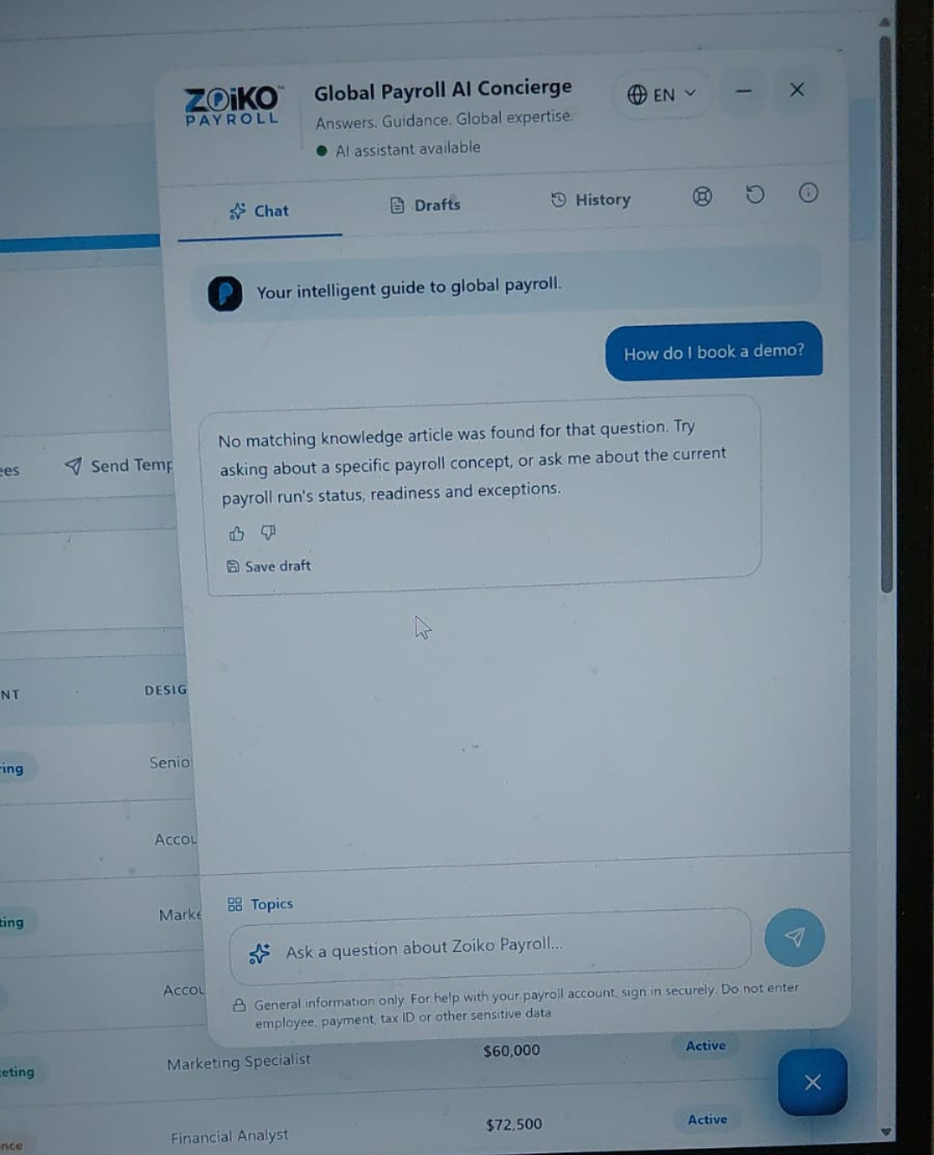  Figure 1: No answer for "How do I book a demo?" | 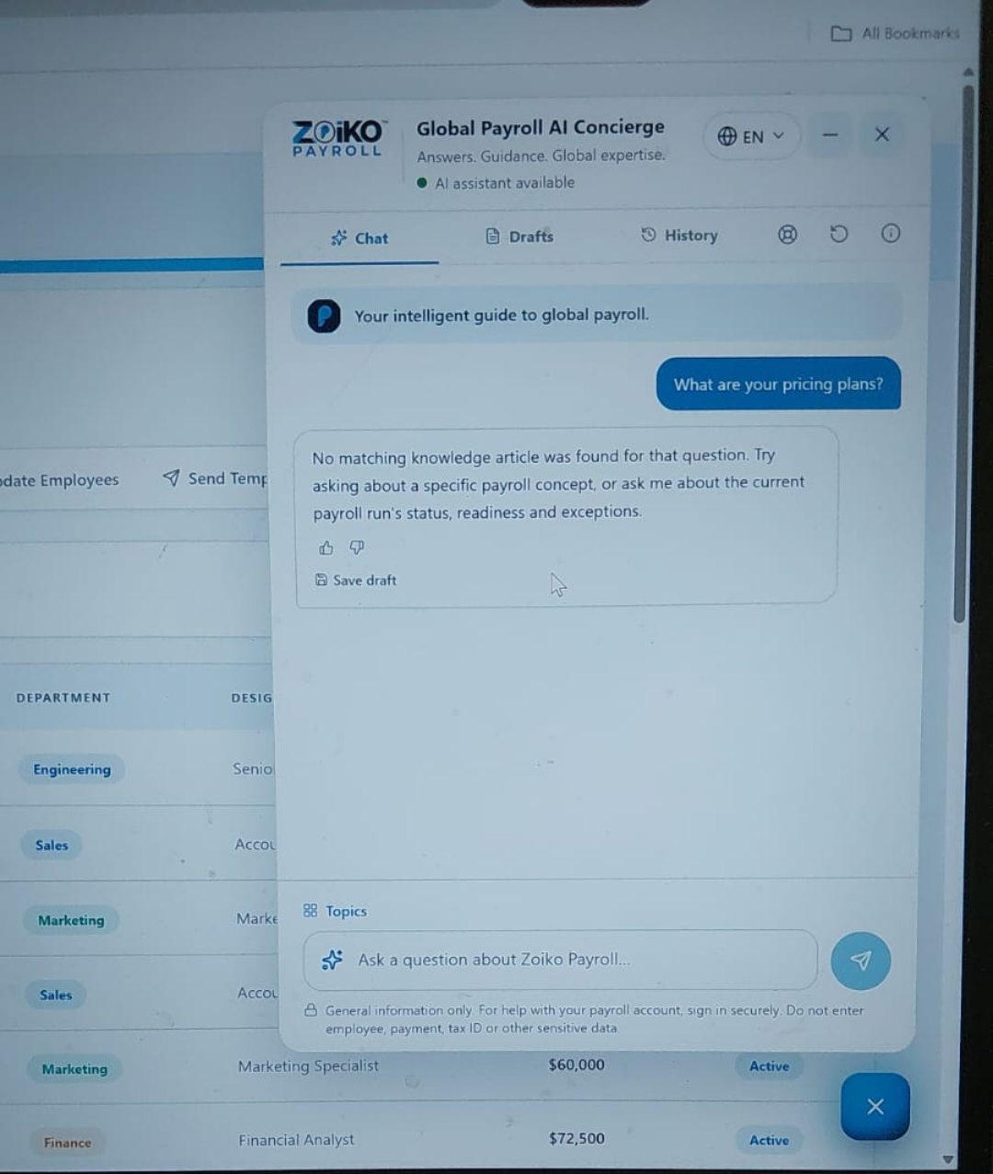  Figure 2: No answer for "What are your pricing plans?"
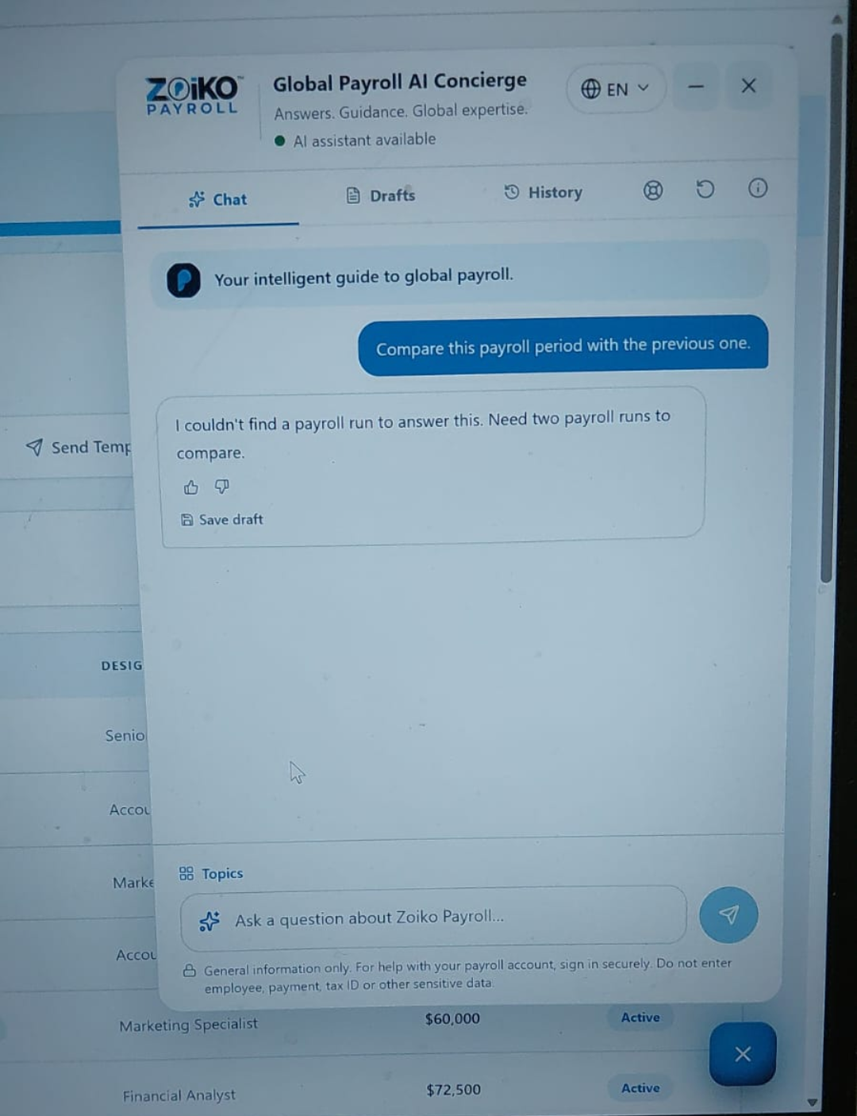
Figure 3: "Compare this payroll period with the previous one" returns no usable answer

BUG-02: "Check your country" section is disabled
Bug ID | BUG-02
Severity | High
Status | Open
Description | In the "Check your country" section, the "Search a country…" field is disabled (a not-allowed cursor appears), so a country cannot be selected. Users therefore cannot check country support or view local payroll and compliance information.
Screenshots
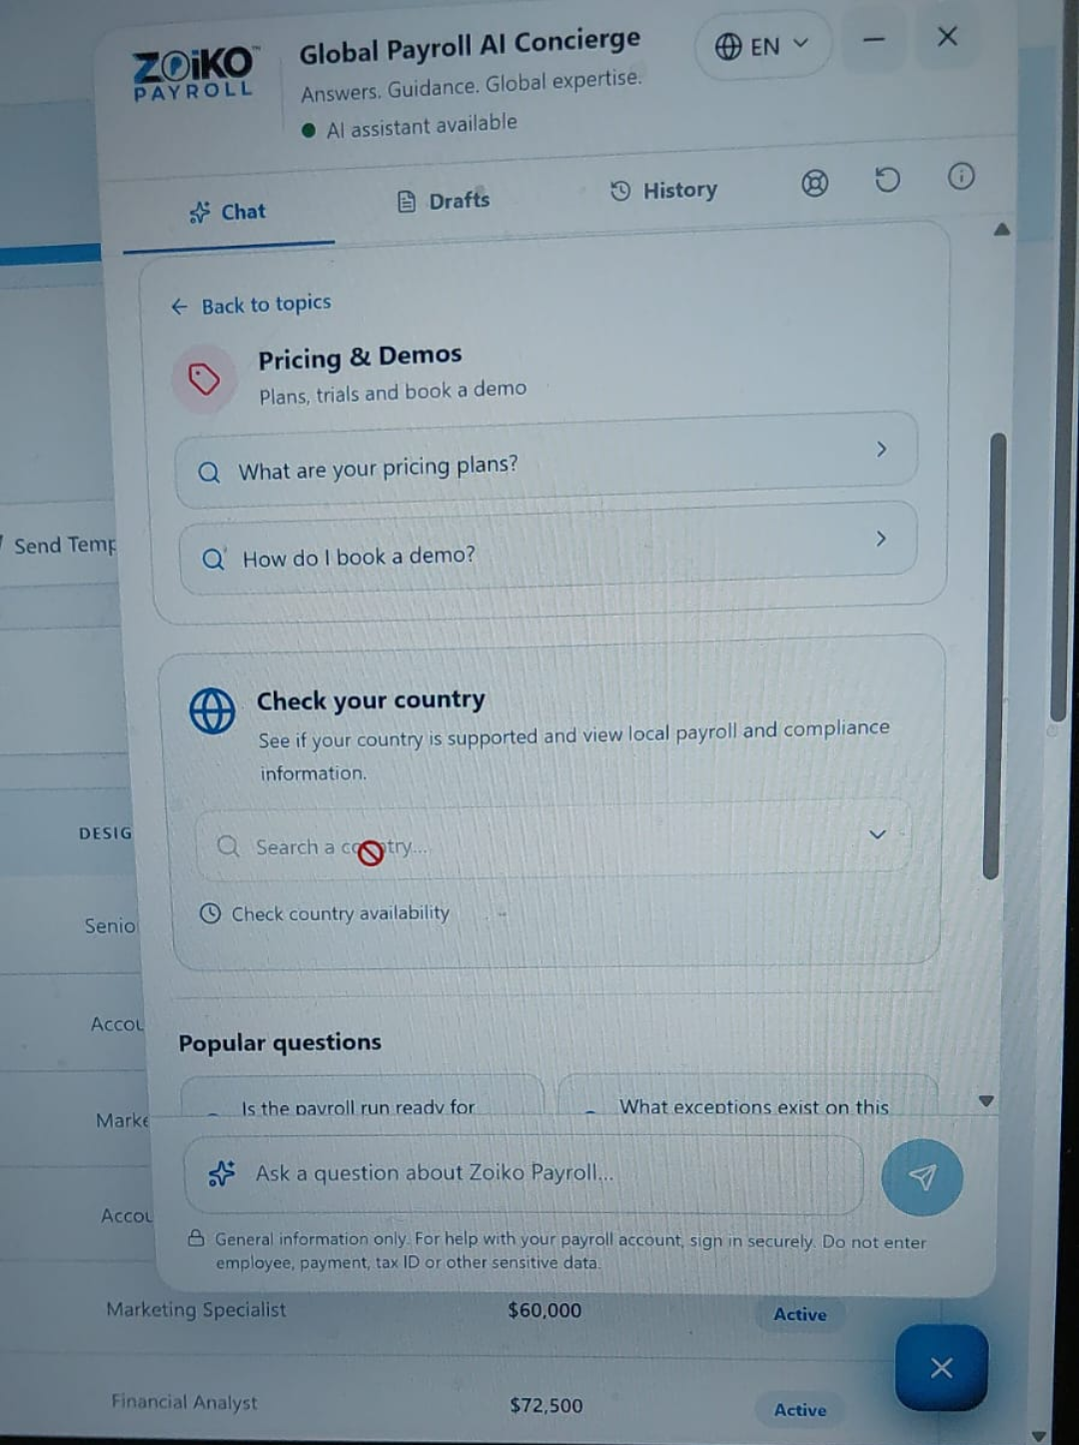  Figure 4: Country search field disabled (Pricing & Demos topic view) | 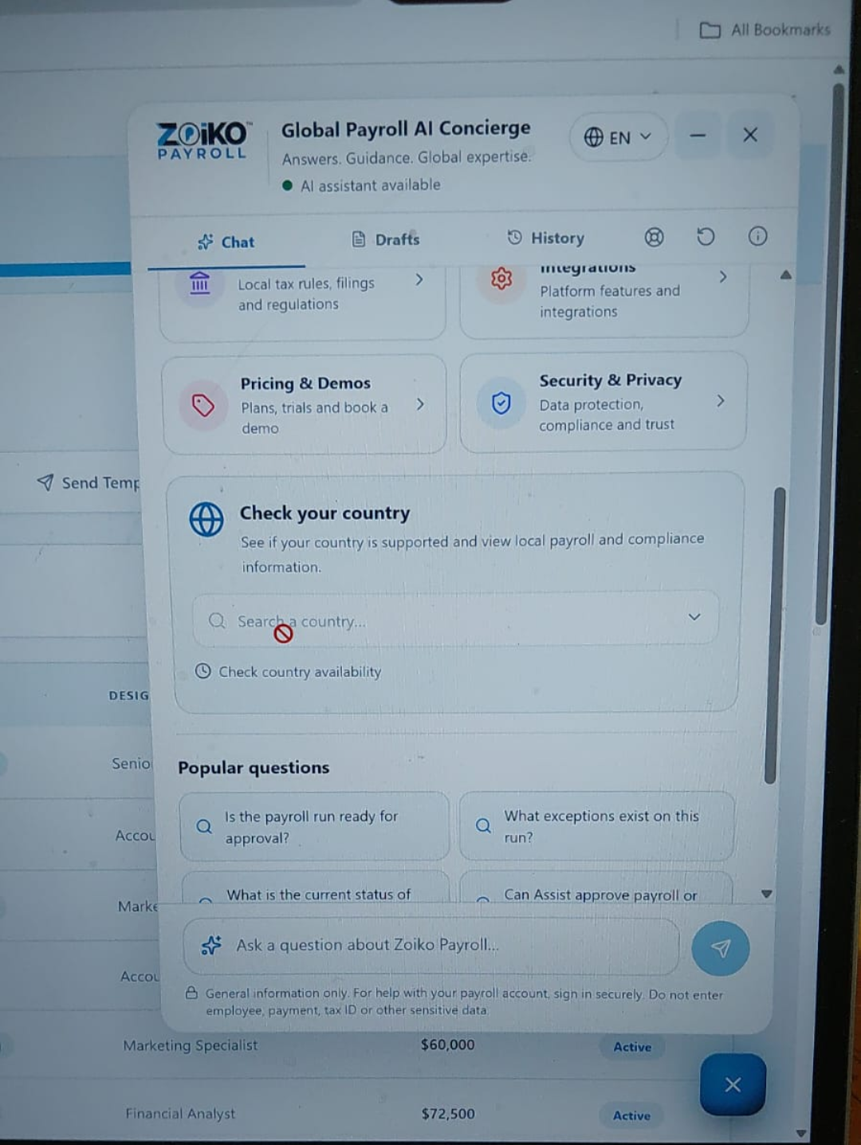  Figure 5: Country search field disabled (topics home view)

