ENGINEERING WIREFRAME & VERIFICATION CONTRACT / DOCUMENT 03

Durable Telemetry Ingestion,
Backpressure & Controlled Replay
G03 • P0 release gate • Version 1.0 • 31 October 2026 • Confidential
DECISION Keep shield-ingest and the existing /ingestion and /connectors experiences. Implement or prove a durable receipt boundary, tenant-safe backpressure, replay and quarantine, end-to-end reconciliation, and live measured latency. No added microservice or dashboard.

1. The only gap this document closes
The existing October 13 architecture and 26-screen demo describe a NestJS shield-ingest service, an OCSF 1.1 normalizer, connector activation and synthetic streams. They do not independently establish persistence/ACK ordering, live-source continuity, durable offset management, poisoning/replay controls, or sustained real-world throughput. The reported 60,000+ evaluations/sec and sub-millisecond P99 have not been validated by artifacts available for this review.

2. Acceptance and non-duplication rule
Included now — G03 | Explicitly excluded to avoid overlap
End-to-end receipt → normalize → evaluate → case/no-alert lineage; reliable retries, quarantine, replay, backpressure, source continuity and verifiable throughput. | G02 physical residency/isolation implementation; this document depends on G02 and tests only the ingestion boundary.
Only source-level test fixtures needed to prove an operational real-feed path. | G09 connector catalog, full credential lifecycle and private runner specifications.
Enforced downstream dispositions, not detection-quality changes. | G07 full detection pack, precision/recall, ATT&CK content and tuning.
Operational retention needed to prove durable replay in the test window. | G08 full hot/cold storage, long-term retention and data-unit economics.

3. Release status
HOLD / UNVERIFIED. G03 may pass only on production-equivalent, separately identified real-source and fault-injection evidence. Synthetic “200 OK” demos, UI counters or unsupported latency claims never constitute the acceptance result.

01 Engineering boundaries and existing system mapping
Existing capability / location | Authoritative requirement / proposed change
shield-ingest :3002; existing /api/v1/ingestion/webhooks/:connectorId | Authenticate source and tenant; generate stable receipt; acknowledge only after durable replicated write or equivalent configured durability guarantee.
OCSF v1.1.0 normalization in shield-ingest | Pin validator and mapping versions; preserve original payload hash/reference; quarantine invalid mappings without losing accepted source records.
Windowed detection and shield-core cases | Persist terminal disposition for every accepted event: EVALUATED_NO_ALERT, ALERT_LINKED, CASE_LINKED, QUARANTINED, or actionable exception. Case creation idempotent.
Existing /connectors, /ingestion and /alerts /cases | Expose source continuity, backlog, receipt link and bounded replay controls. Do not create a new sidebar destination.
Existing PostgreSQL, cloud services and operational monitors | Inventory actual broker/queue, retention, cursor store, failover domain and logs. Kafka, Kinesis and OpenSearch references in older guides are NOT proof of deployment.
Cedar authorization and tenant governance | Require server-side policies and G02 boundary checks for receipt queries, quarantine content, replay, permissions and cross-region routing.

Required environment-specific decisions before writing code
Confirm the deployed durable transport (if any), source polling/webhook semantics, broker replication and acknowledgement mode, cloud regions, offset/cursor store, quarantine payload storage, maximum allowed source-to-detection delay, tenant rate entitlements and actual critical source priority. The chosen architecture must satisfy the invariants below; this specification does not prescribe an unnecessary replacement broker.
SAFETY Do not make the public or customer-facing “lossless”, “exactly once”, “60,000+ evaluations/sec”, “sub-ms P99” or “all connectors live” statements without a matching signed evidence package specifying the measurement scope.

02 Required data plane state machine and invariants
Canonical flow: SOURCE → transport authentication → tenant/region binding → durable ingress receipt → versioned OCSF normalization OR quarantine → idempotent evaluation → persisted no-alert / alert / case disposition → reconciled audit trace. Refused requests do not count as accepted; all accepted receipts must have a trackable terminal or escalated exception state.
Rule | Non-negotiable invariant | Failure behavior
I01 | No acceptance without durable, recoverable storage of receipt, original source envelope or retention-safe reference and integrity digest. | 503/Retry-After; never return successful ACK for volatile memory-only enqueue.
I02 | Tenant context comes from authenticated, authorized connector binding, not a user-submitted tenant ID. | 401/403; isolate response; auditable reject.
I03 | Stable source identity: connector ID + provider native event ID, or documented deterministic hash fallback when absent. | Duplicated identical event returns same logical receipt; payload conflict never silently merged.
I04 | Schema and mapping versions pinned to each receipt. Preserve original source chronology and record processing chronology separately. | Invalid schema → durable quarantine with actionable reason and safe retry plan.
I05 | A read is not processed until the downstream offset and effective disposition are recoverable and atomically linked where feasible. | Restart from last durable checkpoint; replay idempotently.
I06 | Priority and fair-use backpressure isolate a noisy tenant; preserve records already accepted. | 429/503 for unaccepted traffic; publish explicit source gap/pressure signal.
I07 | Replaying an event preserves original lineage; suppress duplicate alerts/cases and never fires external SOAR effects implicitly. | Replay aborts on missing authorization; audit every action.
I08 | Every accepted event is reconcilable from source receipt to a real persisted downstream disposition. | Unreconciled age becomes on-call incident, never automatic green status.

Required distinction: delivery guarantee versus downstream effect
Use at-least-once ingestion plus application-level deduplication as the default portable design. Broker “exactly once” features, where deployed, do not automatically give exactly-once outcomes in PostgreSQL, OpenSearch, cases, notifications or SOAR. This follows Apache Kafka’s documented boundary on external destinations [S2].

03 Minimum persistence, cursor and API contract
Extend current ingest/notification storage and service routes only as necessary. Names below are proposed logical contracts, NOT asserted existing tables or deployed endpoints. Prefer the current schema modules and G1 evidence ledger; avoid a parallel event store or another authorization service.
Logical record | Minimum immutable / controlled fields | Reason
IngressReceipt | receipt_id, tenant_ref, connector_ref, native_event_id/idempotency_key, source_timestamp, accepted_at, source_hash, payload_ref, schema_mapping_version, region_ref, trace_id, durable_cursor | Stable reconciliation and dedupe.
CursorCheckpoint | connector_ref, partition/stream, source_cursor, durable_offset, checkpoint_at, lease/fencing_token, last_source_event_at, observed_gap_reason | No cursor advancement ahead of persistence.
ProcessingDisposition | receipt_id, stage, result_type, alert_ref/case_ref, evaluated_at, worker_version, source_digest, error_code, terminal_flag | Explain every accepted event.
QuarantineEntry | receipt_ref, reason_code, masked_payload_ref, policy_version, retry_eligible, attempts, first_seen/last_seen, next_action | No disappearance of malformed accepted records.
ReplayJob | job_id, scope, receipt_set_digest, requester, approver, reason/ticket, preview_impact, run_status, start/end, outcome_digest | Controlled operator replay and audit trail.

API behavior (maintain compatibility; exact path names subject to code review)
Existing / proposed route | Required success or failure contract
POST /api/v1/ingestion/webhooks/:connectorId [EXISTING in demo] | 202 ACCEPTED only after durable store, with stable receipt_id and disposition=ACCEPTED_DURABLE. Valid duplicate returns original receipt; conflicting key/hash → 409. Unaccepted capacity failure → 429/503 + Retry-After.
GET /api/v1/ingestion/receipts/:id [PROPOSED] | Tenant-scoped lineage and evidence references; 404 for non-visible; no raw secrets in default response.
GET /api/v1/ingestion/pipeline-health [PROPOSED] | Source gaps, durable offsets, queue age, accepted/reconciled counts, ingestion-to-evaluation percentiles with last measured timestamp and sample/synthetic flag.
POST /api/v1/ingestion/replays/preview; POST /replays [PROPOSED] | Preview affected receipts/cases; require policy authorization, ticket and immutable reason; deny expired approval or G02 region mismatch. State machine visible in existing drawer.

04 WF-G03-01 — Ingestion pipeline health and lineage (existing screen)
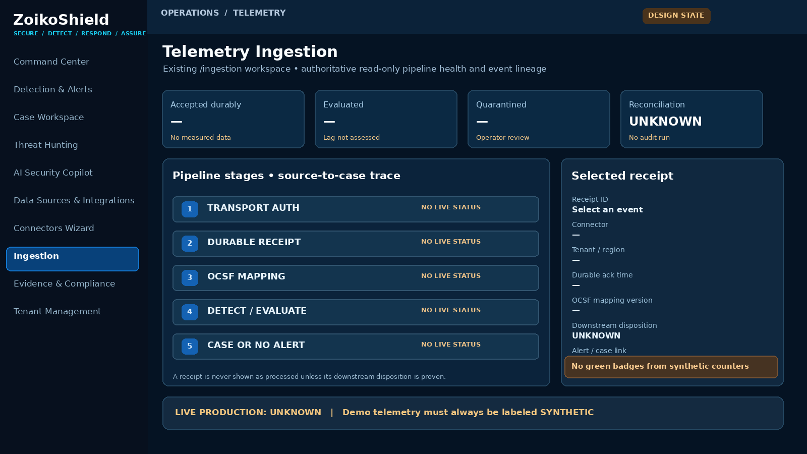
Design schematic only • Sample values intentionally blank / UNKNOWN; not a production health claim
Pin | Interaction requirement | Authoritative source
01 | Summary cards must distinguish durable accepted, evaluated, quarantined and unreconciled, with time range and “last measured” watermark. | Server-side counters; not optimistic client totals.
02 | Select a receipt to inspect stage timestamps, original digest, mapping version and final disposition. | Tenant-scoped receipt detail and downstream references.
03 | If data is stale/unavailable or synthetic, status is explicit. Never display HEALTHY because a polling request succeeded. | Timestamp+trust status; baseline UI taxonomy to be reconciled under G11.
04 | Drill through to existing /alerts or /cases only when a real persisted link exists. | Signed entity reference, role-enforced navigation.

05 WF-G03-02 — Connector continuity and source freshness (existing screen)
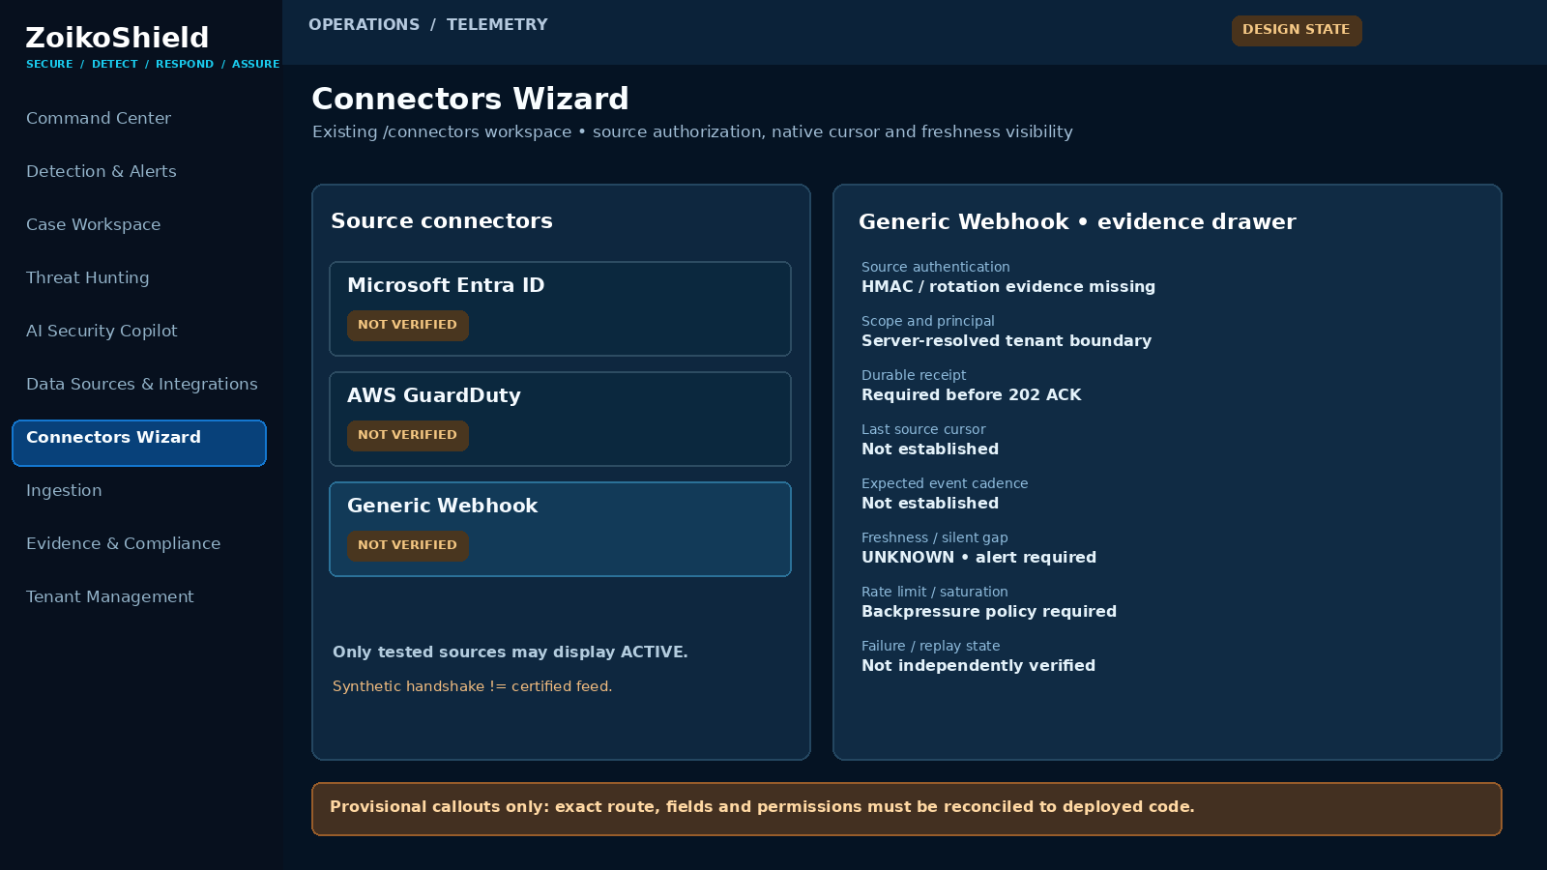
Design schematic only • Preserve existing Connectors Wizard; details drawer carries proof of source coverage
Pin | Interaction requirement | Authoritative source
05 | “Connected” means transport authentication verified; “Receiving” requires recent authentic source data; “Complete” requires checkpoint evidence. | Per-connector health model; no inferred all-green status.
06 | Expose source-specific cursor/gap or heartbeat, retry-after, authorization scope and rotation evidence status. | Connector worker receipt and source metadata; G09 remains owner of detailed compatibility.
07 | API/permissions/region failures show degraded reason and assigned remediation action; never silently reset cursor. | Worker health and G02 tenant boundary check.
08 | Display source limit and quota exhaustion separately from ingestion failures. | Token-bucket/quota enforcement and retry signals.

06 WF-G03-03 — Quarantine, controlled replay and audit (existing drawer)
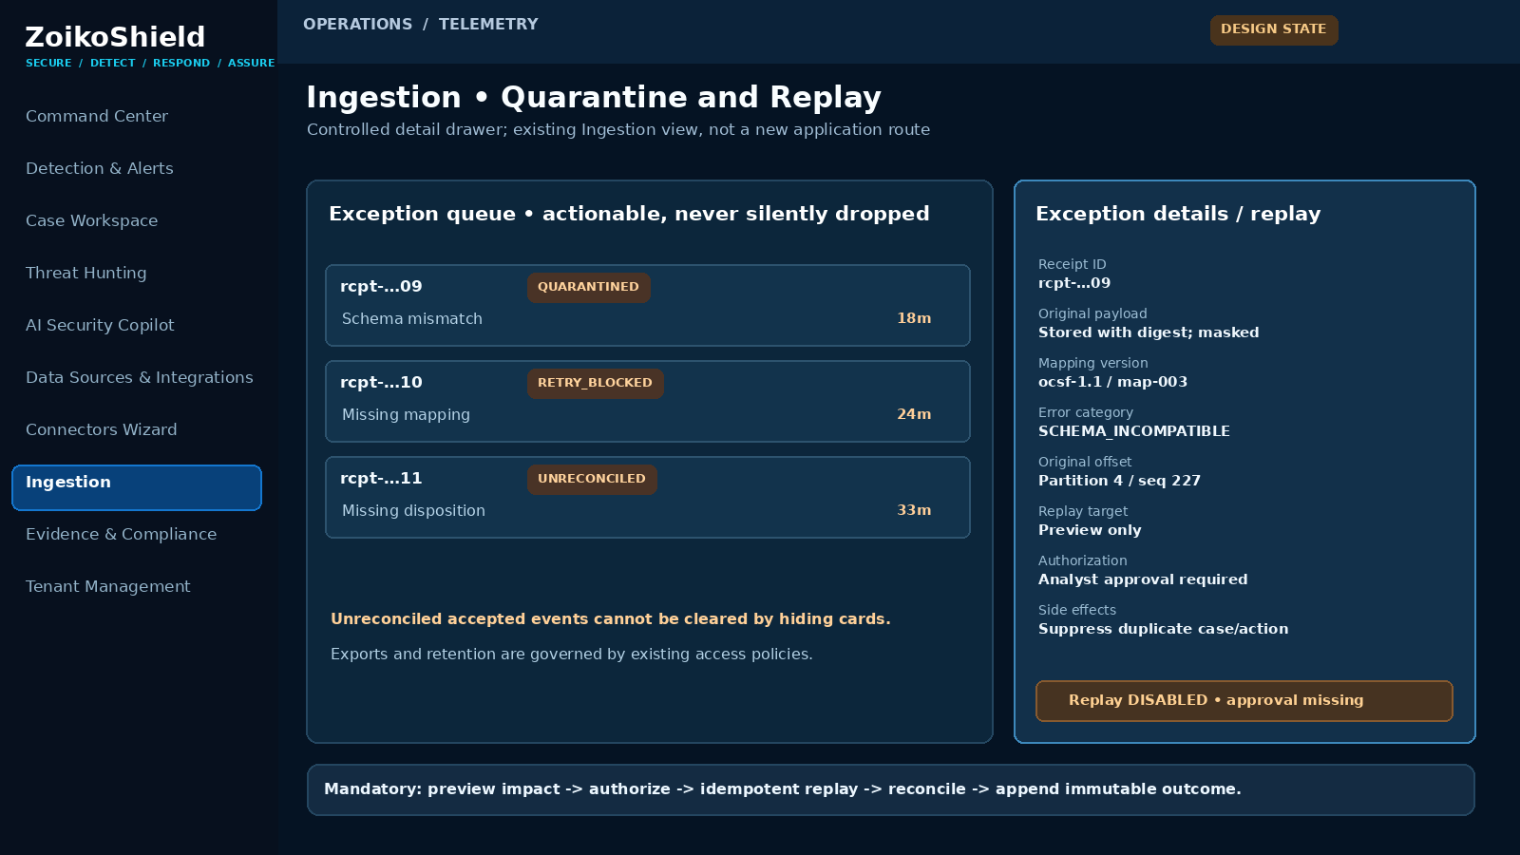
Design schematic only • Existing Ingestion page receives an authorized drawer, not a new dashboard
Pin | Interaction requirement | Backend rule
09 | Exception list shows immutable receipt, first-seen age, exact failure stage, tenant-safe status and next safe action. | Expose only masked/authorized payload metadata.
10 | Preview impact lists potential alert/case changes and excludes external effects by default. | Read-only analysis; no replay command from prompt or URL mutation.
11 | Replay requires RBAC/ABAC, step-up based on risk, actor reason, ticket and server-recorded approver where configured. | Distinct requester/approver policy; lease/fencing + idempotent replay job.
12 | User sees RUNNING, PARTIAL, COMPLETED or BLOCKED with receipt-level reconciliation. | Persist each transition and retained audit evidence; respect legal holds and G02 residency.

07 Operator state and failure-response contract
Condition / trigger | Service obligation | Visible operator state / escalation
Transport signature invalid, expired or forged | Reject before ingest; rate-limit attempts, avoid leaking valid key or tenant details. | AUTH_REJECTED; security log and attack-rate alert.
Queue, database or object store cannot durably accept | Do not ACK; retry safely with bounded jitter; preserve accepted receipts. | INGEST_BLOCKED / DEGRADDED; SRE page if within critical feed.
OCSF parser or mapping fails | Never drop accepted payload; quarantine with mapping version/reason and trace. | QUARANTINED; repair mapping and authorize replay.
Source stops sending but endpoint health passes | Detect missing heartbeat or watermark gap relative to source’s documented cadence. | SOURCE_STALE; source owner plus SOC/SRE triage.
Consumer restarts or partition reassignment | Resume only after durable offset and disposition reconciliation; fence old worker. | RECOVERING, then measured RECONCILED.
Per-tenant burst or shared broker saturation | Apply bounded queues and tenant fairness; refuse unaccepted traffic with retry guidance. | BACKPRESSURE_ACTIVE; quota or infrastructure alert.
Duplicate event or replayed cursor | Return the original receipt; do not duplicate alert, case or SOAR effect. | DUPLICATE_IDENTIFIED; visible in receipt lineage.
Existing case / alert destination fails | Leave durable event and actionable outstanding disposition; retry with idempotency and DLQ. | UNRECONCILED; time-to-recovery and escalation timer.

Operator access and data protection
Connector owners can view scoped freshness and retry outcomes; SOC analysts can investigate only their tenant’s receipts; security administrators can approve elevated replays; support viewers cannot open raw payloads or replay. All mutations use existing server-side Cedar authorization. Raw security events can contain personal data and credentials: restrict field exposure, maintain separate masked previews and audit access. G02’s regional boundary is inherited, not redefined.

08 Observability, SLIs and alerts that must be real
Metric / instrument | Definition and required dimension | Initial acceptance rule
Durable-ACK validity | Count ACKs with persisted receipt and recoverable payload/offset proof; tenant, source, environment. | 100% in deterministic controlled tests; all violations P0.
Accepted-to-disposition reconciliation | Accepted count vs terminal dispositions + currently actionable pending; oldest unaccounted age. | Zero unexplained missing receipts after bounded drain; deterministic counts.
End-to-end ingestion lag | Source event time → durable receipt → evaluation → alert/case, with separate clock-skew flag; p50/p95/p99. | Measured and signed per first-customer SLO; no fabricated sub-ms figure.
Queue age / saturation | Oldest pending age, depth, partition lag, throttling, tenant fair-share and capacity headroom. | Alert above pre-agreed budget; failed capacity never silently ACKed.
Freshness / source gaps | Last authentic event/heartbeat, provider sequence gap or continuity gap; source expected cadence. | Page or ticket by feed criticality when source freshness budget exceeded.
Quarantine / replay | Entries by reason, oldest age, retries, successful recovery, permanently unresolved reasons. | No accepted record disappears; every manual replay has approval and immutable outcome.
Data lineage trace | Correlate receipt_id through normalization/evaluation/case with sampled distributed trace plus full persisted logical IDs. | Traceable exemplars across every service, including failure/restart path.

SLO policy
SLO numbers are not invented in this document. Before tests, Product, SOC and SRE sign the customer-critical event freshness budget, expected events/sec, worst-case bursts, source availability assumptions, tolerated quarantine age and restore/drain target. Observe the same thresholds under normal, degraded and recovery modes; pin benchmark software versions and metric definitions. OpenTelemetry messaging semconv currently contains evolving components; lock the emitted version, and do not silently change dashboards or metric keys [S3].

09 Adversarial verification matrix — security, durability and poison data
ID | Injection / test setup | Pass oracle + required evidence
T01 | Forged/expired webhook signature; valid-shaped payload | No accepted receipt; auth rejection + audit; indistinguishable tenant error.
T02 | Spoof tenant_id/header with valid connector signature | Server-bound tenant prevails; attempted cross-tenant access denied.
T03 | Crash after 202 ACK before normalizer commits | Receipt survives, replays and reconciles without duplicate case.
T04 | Fail durable broker/database before ACK | 503/429; no 202 and no count as accepted; verified source retry.
T05 | Duplicate source event, same native ID + digest | Same logical receipt/disposition; no duplicated downstream record.
T06 | Same native ID with conflicting digest | 409 or quarantined conflict per documented provider policy; not silent merge.
T07 | OCSF schema mismatch, malformed accepted payload | Immutable quarantine, reason/version/digest; no silent loss.
T08 | Mapping repair and replay approved by distinct role | Reprocess once; old receipt preserved; clean audit lineage.
T09 | Cross-tenant replay/receipt read | Deny, 404/403 as policy dictates; no payload/reference leak.
T10 | Cross-region routing / wrong data sink | Deny; G02 region proof; no retained cross-border copy.
Each case must retain test run ID, deployed commit, region, source, input/receipt digest, timeline trace, audit record, raw result and reviewer signature. Expected results must be fixed before execution.

10 Adversarial verification matrix — pressure, recovery and continuity
ID | Injection / test setup | Pass oracle + required evidence
T11 | Broker saturation/tenant burst above declared quota | No successful volatile ACK; bounded backpressure; Retry-After and fairness.
T12 | Noisy tenant alongside protected customer | Other tenant meets agreed critical-feed SLO or explicitly measured degradation.
T13 | Pull source partition cursor gap and worker crash | Checkpoint only after durability; resume without unexplained lost ranges.
T14 | Out-of-order event, clock skew and late arrival | Original time retained; processing time separate; no false freshness health.
T15 | Downstream alert/case sink unavailable | Pending disposition recoverable; eventual exactly-one logical case.
T16 | Replay approval expired / rescinded mid-run | Stop future batches; fence worker; record partial effects and reconcile.
T17 | Operator tries replay via UI bypass/API mutation | Server denies without authorization; auditable rejection.
T18 | Critical source silent; endpoint health healthy | SOURCE_STALE escalates via measured watermark/heartbeat.
T19 | Restart/partition reassignment during buffered ingest | No accepted-record loss; deterministic drain; no dual-active offset owner.
T20 | Full source → receipt → alert → case/no-alert trace | Reconciliation proof; all stage links real, signed/archived.

Independent operator walkthrough
Run one verified live-source event with an identifiable, non-sensitive marker. The tester must find its origin, authenticated connector, 202 receipt (or a proven refusal), persistent envelope, schema mapping, evaluation result, and generated alert/case if applicable. Repeat with a failing mapping, a restart and an approved replay. Capture read-only UI and backend traces. Synthetic workflows alone do not pass G03.

11 Load testing, claims and minimum deliverable evidence
Test / evidence | Execution contract | Go/no-go interpretation
B01 • Baseline | Measure genuine first-customer source mix, payload distribution, schema mapping complexity, detection count and sink writes; disclose instance class, AZs, storage, network and software. | Report accepted/sec AND evaluated/sec separately; percentiles with sampling window.
B02 • Burst | Sustain agreed burst multiplier against contracted peak; document admission, 429/503, queue depth and drain time. | Zero silent ACK loss; fair allocation; threshold met or scoped HOLD.
B03 • Soak | 24-hour minimum recommended soak on production-equivalent topology and target mix; include rotation/retry windows. | Leak, queue growth, silent source gaps, DLQ accumulation and P99 tracked.
B04 • Fault injection | Drop broker node, consumer process, network dependency, source access, DB writes, mapping version; simulate recovery. | Deterministic receipt reconciliation and documented recovery times.
B05 • Public claim | If guide claims “60,000+ evaluations/sec” or “sub-ms P99,” isolate exact operation, test design, batch size, percentile, fleet and degradation behavior. | Claim remains unverified and unpublished until independently reproducible.

Required immutable G1 evidence attachment
One bounded G03 evidence folder in existing G1, not another documentation program: A) deployed topology and configuration snapshot; B) source compatibility proof for one real launch feed; C) test cases T01–T20 with raw results; D) B01–B05 runs and monitoring traces; E) reconciliation ledger signed by Data Platform; F) prioritized residual risks and expiry dates; G) Security/SRE/SOC sign-off; H) any product/website claim corrections handed to G01.
NO-GO A test with no artifact is UNKNOWN/HOLD. Any accepted-but-unrecoverable event, unauthorized replay, cross-tenant/cross-region read/write, or fabricated green operational status is a hard release blocker.

12 Ownership, implementation sequence and final decision
Phase | Engineering deliverable | Evidence / accountable owner
1 • Inventory | Reconcile as-built broker, storage, source profiles and worker routing; inspect existing repo and deployment manifests. | Signed as-built note / Data Platform + SRE.
2 • Contract | Implement durable-ACK and cursor checkpoint, stable receipt, processor disposition and quarantine where absent; version OCSF mapping. | Code diff + migration + contract tests / Ingest + Security.
3 • Operator UX | Wireframe callouts WF01–WF03 implemented inside current screens; strict synthetic/unknown markings; no new navigation. | Before/after screenshots + API traces / Frontend + Product.
4 • Controlled replay | Preview, approve, fence and reprocess with idempotent case/effect behavior; G02 policy enforcement. | Audit trail and adversarial T08/T16/T17 / SecEng + SOC.
5 • Prove | Execute T01–T20 and B01–B05 on declared topology; attach evidence to G1 and correct unproven claims. | Independent QA + SRE review + signed G1 evidence.
6 • Release | Go only when every hard fail closed and customer-specific quantitative budgets are met and documented. | G1 signers, with CISO/SRE/SOC explicit acceptance.

Decisions requiring named approval
D1: Deployed durable broker and configured write durability. D2: Real first-customer source, source-generated ID guarantees and acceptable cursor/gap logic. D3: Customer-critical latency/availability and quota budgets. D4: Retained payload window sufficient for authorized replay, consistent with G08. D5: Replay approval threshold and who may see unmasked payloads. Until decided, the system stays HOLD; no arbitrary engineering defaults will be advertised as contractual guarantees.

Provenance and factual guardrails
Internal baselines: ZoikoShield Enterprise Architecture & Infrastructure Gap Analysis v1.0 (31 Oct 2026), G01 Trust Claim Remediation v1.0, G02 Tenant Isolation Detailed Wireframe v1.0; user-supplied ZOIKOSHIELD_LIVE_DEMO_MASTER_GUIDE.md and ZOIKOSHIELD_STEP_BY_STEP_DEMO_LINKS.md (13 Oct 2026). These demonstrate intended application and demo design, not audited production readiness.
[S1] OCSF Schema repository and versioning: https://github.com/ocsf/ocsf-schema — version/schema mappings must be pinned for receipts, not silently updated.
[S2] Apache Kafka design, Message Delivery Semantics: https://github.com/apache/kafka/blob/trunk/docs/design/design.md — exactly-once Kafka processing does not unconditionally extend to external sinks.
[S3] OpenTelemetry Messaging Semantic Conventions: https://opentelemetry.io/docs/specs/semconv/messaging/ — terminology and attribute keys are versioned, not proof of an operational monitoring system.
STOP RULE Document 03 is the only deliverable in this turn. No G04 document, redesign or additional dashboard is authorized until the user approves this one.

