ZOIKO TECH INC. / ENTERPRISE RELEASE ASSURANCE

G06 | Cryptographic evidence integrity
& independent offline verification
Detailed engineering wireframe & release acceptance specification • Version 1.0 • 31 October 2026
P0 / HOLD | The final original P0 gap: proof validity, signer/TSA trust, key continuity, package completeness, omission detection and independently reproducible verification have not been externally evidenced.

Executive implementation decision
Preserve shield-anchor (port 3005), the existing ZS-MERKLE-V1 format where already deployed, the sealed audit-package process, and the standalone verifier-cli. Upgrade evidence construction, trust and validation within existing /audit, /ledger, Evidence & Compliance, Audit & Verifier and G1 workflows. Do not add a new evidence microservice or dashboard.
Decision | Required result
What this document delivers | Four annotated wireframes; canonical package/verification boundary; explicit trust and completeness semantics; CLI/API requirements; 24 adversarial tests; signed G1 evidence checklist.
What it does NOT assume | Prior slides, demo badges and user-supplied descriptions do not independently prove production Merkle correctness, trusted timestamping, key custody or auditor acceptance.
Core risk addressed | An internally consistent but omitted, reordered, untrusted, stale, forged or cryptographically invalid bundle must never render an unconditional VERIFIED badge.
Dependency boundary | G02 governs tenant/residency access; G03 source IDs and durable counters; G04 approvals/action receipts; G05 restore continuity; G01 external marketing assertions.

Pass condition
A separate verifier in an offline environment accepts a genuine, appropriately scoped bundle; rejects malicious alterations; exposes unproven coverage as INDETERMINATE; validates pinned trust, time and key histories; produces reproducible machine-readable results and an independent review receipt.

01 Controlling baseline and scope firewall
Inherited system / approved source | Documented behavior | G06 closure obligation
Locked Master Demo Guide (13 Oct) | shield-anchor constructs ZS-MERKLE-V1, RFC 3161 tokens, sealed audit packages and a standalone verifier-cli. | Verify the exact wire format, leaf ordering, canonicalization, signed root, TSA integration and separation of package versus trust. No silent format rewrite.
26-screen Demo Links (13 Oct) | /audit, /ledger, /verify-certificate and case evidence views; demonstrations show cryptographic inclusion verification. | Prove these operations with actual byte-level vectors, independent tooling and malicious-package tests rather than green UI messages.
ZoikoShield GAP Analysis v1.0 (31 Oct) | G06: missing adversarial proof of key rotation, trust anchors, revocation, export completeness and omission detection. | Release-blocking G06 gate; independently checked package, verifier and signer/TSA lifecycle.
Existing Audit & Verifier experience | Export package, audit readiness and evidence detail already designed. | Add explicit scope/counters, trust status, verification result breakdown and reason-coded findings; no new navigation.
G03 / G04 / G05 closures | Durable ingestion, signed response intent and restore continuity defined separately. | Consume their artifact IDs and hashes; DO NOT redefine ingestion guarantees, SOAR approvals or backup execution.
G01 public-claim program | Claims such as “post-quantum” require separate reviewed proof. | Do not claim post-quantum cryptography, evidence completeness, regulatory certification or legal admissibility merely because SHA-256/Merkle/RFC3161 passed.

FORMAT LOCK | Keep ZS-MERKLE-V1 byte semantics immutable. If a design defect requires new canonicalization, version the migration (e.g., V2) with backward-compatible verifier support and separate approved test vectors. RFC 8785 is a possible NEW manifest canonicalization profile, not a claim about existing V1.

02 Four independent proof claims and required result states
Proof dimension | What positive verification legitimately establishes | What it does NOT establish
INTEGRITY | Bytes and Merkle inclusion under a specified hash algorithm/root; valid signed manifest when separately checked. | Whether the source events reflect real-world truth; whether every event was recorded; whether data was authorized to collect.
AUTHENTICITY / TIME | Manifest signer identity/path, intended key purpose, TSA token/message imprint/policy and historical status as-of trusted time. | That a signer is a regulator or that the operator had appropriate authority absent governance evidence.
COMPLETENESS / SCOPE | An agreed event/tenant/time boundary reconciles against signed source counters, offsets, exclusions and independent checkpoints. | Coverage of unseen systems or sources outside the declared capture scope.
CHAIN OF CUSTODY | Identified actors, timestamped transitions, approvals and export/handling receipts with verifiable references. | Legal admissibility or unchanged physical-world facts; these depend on jurisdiction and case-specific review.

Mandatory status semantics
Status | Machine meaning | UI / release behavior
PASS | All checks applicable to the exact declared dimension pass with sufficiently trusted evidence. | Green only for that specific dimension; report scope, time and trust IDs.
FAIL | A verified contradiction, mismatch, invalid signature, malicious archive or violated policy exists. | Red and release HOLD. No override-to-pass switch.
INDETERMINATE | Required trust material, source counters, historical revocation status or complete export scope unavailable. | Amber, remediation required; never marketed as “verified complete.”
ERROR | Tool/parser/infrastructure fault prevented trustworthy decision. | Grey/amber; do not infer PASS or FAIL until rerun safely.

GLOBAL VERDICT | Full VERIFIED applies only if all mandatory dimensions return PASS for the explicitly declared bundle scope. FAIL dominates; otherwise INDETERMINATE/ERROR prevents release. Legal admissibility is never a verifier verdict.

03 Minimum export format, provenance and validation lifecycle
Mandatory logical field / artifact | Required content and security rule | Acceptance / owner
manifest.json | schema_version, package_id, tenant/environment, UTC start/end, source inventory/filters/exclusions, byte digests, leaf algorithm, root, epoch IDs, signing_key_id, TSA policy ID, verifier profile. | Deterministic canonical bytes. Duplicate JSON keys, unsupported algorithms or ambiguous encodings rejected.
objects/ + index | Raw or authorized redacted evidence bytes with size, SHA digest, normalized event refs, case/decision/action refs and stable unique IDs. | Exactly defined root leaf set; no path traversal, duplicate archive entries or hidden omissions.
proofs/ + checkpoint | Leaf hashes and Merkle paths; signed root/checkpoint sequence; independently pinned checkpoint hash/receipt outside package. | Inclusion proof must be verified from bundle bytes, not from displayed root.
timestamp/ | Original RFC 3161 DER token(s), imprint/hash OID, TSA policy, signer certificate path and usable historical revocation records where required. | Validate DER signature and TSA path, nonce if used, imprint and time policy; no clock-only shortcut.
trust/ references | Identifiers and immutable digests for external signer/TSA policy and approved trust-store versions; do not self-authorize via bundled keys. | Verifier loads separately authenticated trust anchors; missing => INDETERMINATE.
coverage.json | G03 source IDs, counters/sequence ranges, high-watermarks, rejected/quarantined and excluded IDs, source cutoff and reconciliation receipt. | Discrepancy unresolved => FAIL or INDETERMINATE by rule, never complete.
receipt.json | Export actor, authorized reviewer, build digest, timestamp, scope digest, key versions, file inventory and verification result references. | Immutable after sealing; every re-export is new package version / digest.

Construction lifecycle
REQUESTED → SCOPE_LOCKED → SOURCE_RECONCILED → MANIFEST_CANONICALIZED → ROOT_SIGNED → TSA_VALIDATED → SEALED → INDEPENDENTLY_VERIFIED → RELEASED. Any failed prerequisite produces BLOCKED/INDETERMINATE with an immutable reason receipt; no UI-side success fabrication.

04 WF-G06-01 — Scoped package creation in existing Audit & Verifier
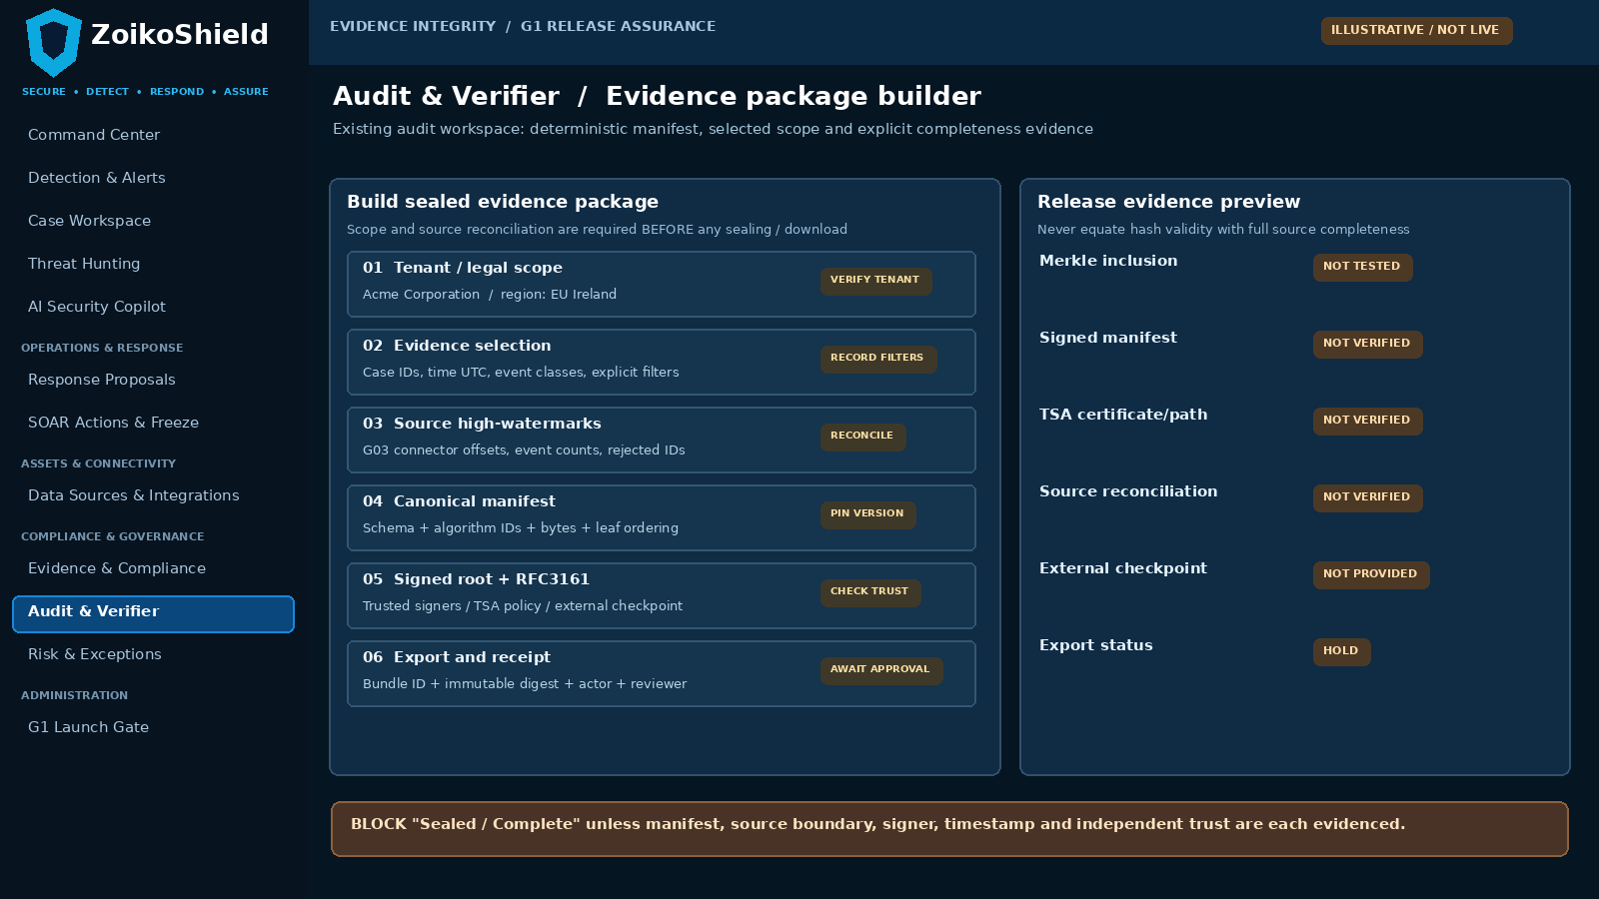
Annotated design for the current Audit & Verifier export view. Example tenant, region and statuses are illustrative only; no assertion of live proof.
Pin | Interaction and expected UI behavior | Server-side invariant
01–02 | Choose one authorized tenant, region, UTC range and sources; show every exclusion. | G02 guard on read/export; sign and freeze exact canonical scope before collection.
03–04 | Show source counters/cutoffs; calculate deterministic root/manifest from actual bytes. | G03 reconciliation and pinned hashing profile; refuse unknown source gap as complete.
05–06 | Show signer, independent checkpoint and RFC 3161 trust before sealing; generate receipt. | External trust/version lookup; anti-replay and reviewer approval; bind package ID to immutable digest.

05 WF-G06-02 — Source-to-proof chain in existing Evidence view
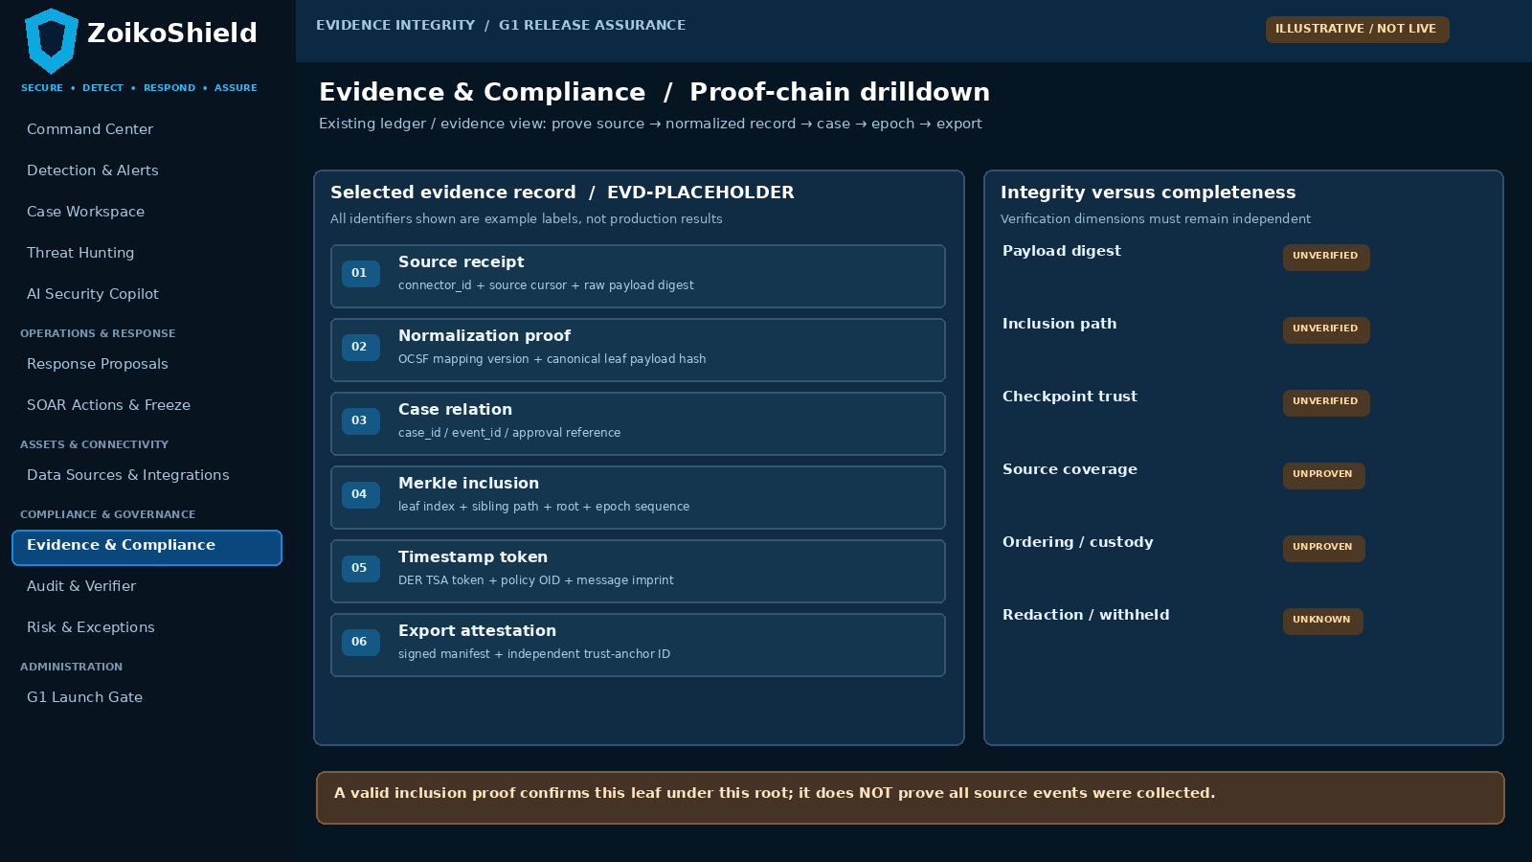
Design augmentation to the existing Evidence & Compliance and /ledger views; shows traceability without asserting completeness from an inclusion proof alone.
Pin | User-visible requirement | Verification enforcement
07 | Evidence detail links original source receipt and normalized bytes to case/action record IDs. | Rehash original bytes, trace G03 source cursor + G04 intent/receipt; no fabricated node.
08 | Show Merkle leaf index, sibling path, algorithm, epoch and root with checkpoint identifier. | Recalculate inclusion using locked ZS-MERKLE-V1 ordering; reject swapped/truncated/reordered proof.
09 | Separate integrity, checkpoint trust and completeness statuses with full reason codes. | Trust anchor must be independent of package; signed source coverage required for complete verdict.

06 WF-G06-03 — Air-gapped verifier-cli experience
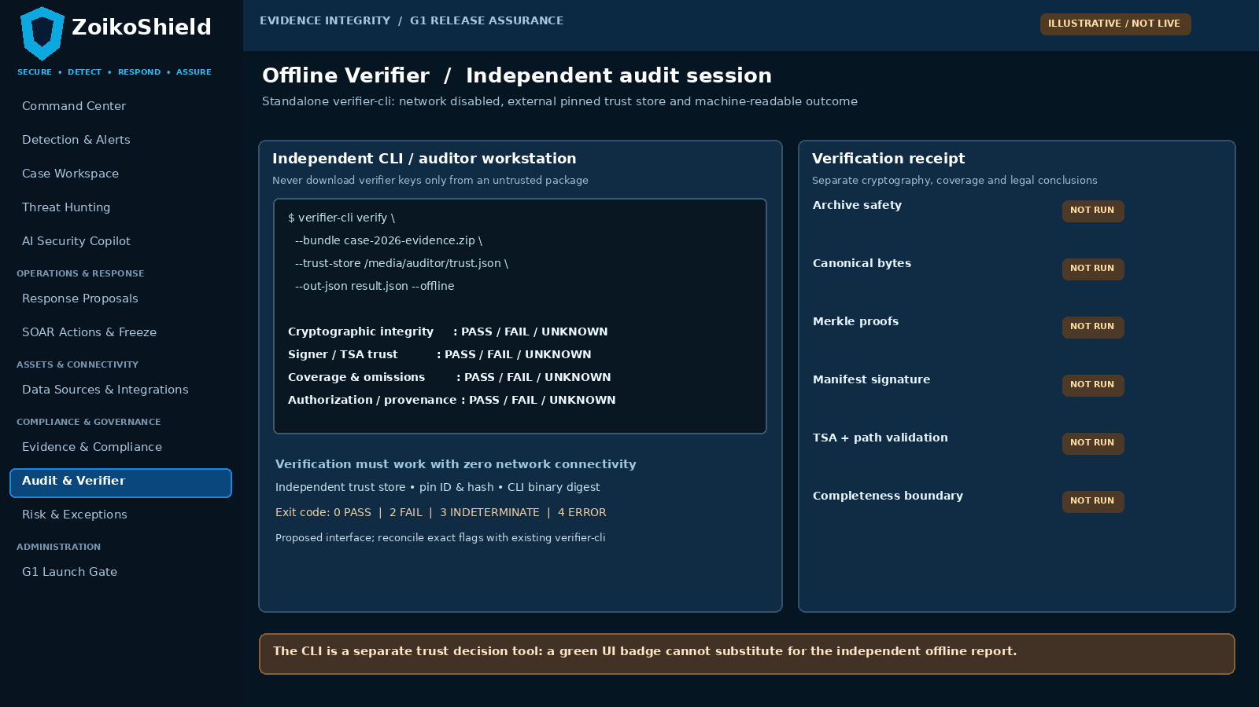
Proposed verifier-cli command and offline receipt; exact CLI flags/exit codes are a G06 target contract and must be reconciled with the shipped implementation.
Pin | Auditor task / expected result | Independent control
10 | Run verifier on a separate machine with network disabled and separately provisioned trust store. | CLI must not fetch signer/TSA trust from ZoikoShield or auto-trust bundle-provided root.
11 | Display dimensional PASS/FAIL/INDETERMINATE/ERROR and stable reason codes. | Exit code and JSON report deterministically reflect checks, failure precedence and scope.
12 | Export full machine-readable and human-readable receipts with tool/build digest. | Signed/integrity-protected external reviewer receipt; no secrets or raw tenant events logged.

07 WF-G06-04 — Exceptions, trust history and review gate
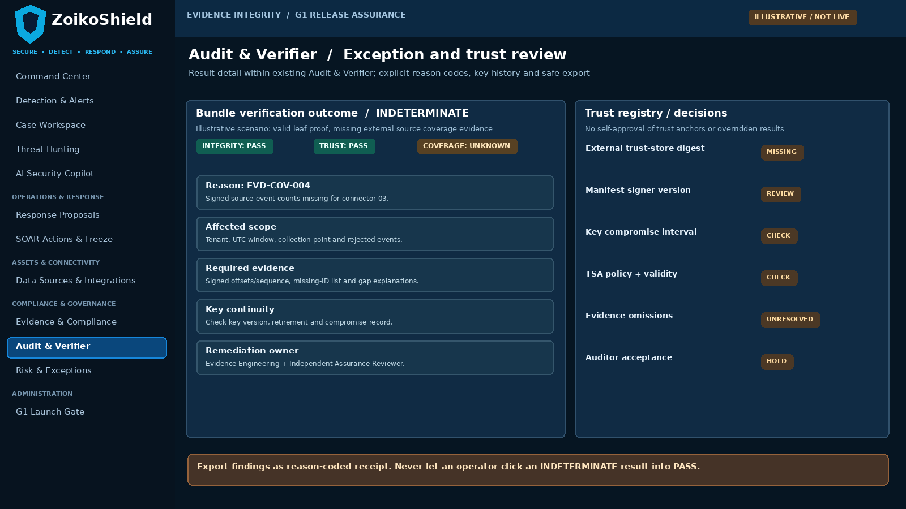
Result panel for the existing Audit & Verifier experience; no operator-driven conversion of insufficient coverage into a PASS state.
Pin | Required UI / workflow | Server-side safety rule
13 | When data coverage is unknown, display integrity-pass and coverage-indeterminate separately. | Show missing counters, source, UTC boundary, exclusions and impacted downstream claims.
14 | Expose signer/TSA identity, key version, effective/compromise dates and historical trust decision. | Evaluate as-of signature/timestamp + current compromise disposition; fail closed on unknown trust.
15 | Offer “Export findings” and create corrective item; never “Accept anyway” for a P0 trust failure. | G1 gate reads immutable verification report and reviewer ID; failed P0 cannot be waived.

08 Minimal API, CLI and persistence contracts
Contract or record | Request / principal fields | Required response or failure semantics
Existing audit-package create action | Tenant, case/source list, UTC scope, exclusions, client request ID; bound to actor + policy version. | Returns package job ID with state; cannot return SEALED until source reconciliation and signature/TSA proof pass.
Proposed package inspect/download semantics | package_id, tenant, signed scope digest, export authorization; no raw secret in URL. | Immutable digest, schema/profile/key IDs, size and freshness. Download tamper attempts rejected.
Existing /ledger proof inspection | epoch, leaf ID, immutable root, checkpoint pointer; tenant/reviewer authority. | Inclusion and signing chain with independently verifiable fields; incomplete proof yields FAIL.
Proposed verifier CLI profile | verify(bundle_path, external_trust_store, offline=true, output_json); no cloud login required. | exit 0 only all required pass; 2 invalid; 3 insufficient proof; 4 tool error. Exact names proposed.
VerificationReport entity | Package digest, verifier binary hash, trust-store digest, UTC run ID, dimension statuses, reason codes, coverage. | Append-only, reviewer cannot edit underlying result; never allow UI to set PASS.
KeyHistory / TrustPolicy record | Key ID, issuer, allowed purpose, activation, retirement, revocation/compromise, independent policy/anchor version. | Historical checks and anchored policy snapshots; no private key material in bundle/report.
CoverageReceipt entity | G03 source boundary, source count/cursor signatures, rejects/filters, signed checkpoint, reconciled leaf refs. | Unknown source offsets or omitted exclusions prevents completeness pass.

Suggested reason-code families
EVD-ARC (archive/parser), EVD-HSH (digest/canonical), EVD-MKL (Merkle inclusion), EVD-SIG (manifest signing), EVD-TSA (timestamp chain), EVD-TRU (trust anchor/key history), EVD-COV (scope/omission), EVD-TEN (tenant boundary), EVD-SRC (source reconciliation). Each report includes expected, observed, affected artifact and remediation owner without leaking credentials or sensitive payloads.

09 Trust anchors, key rotation and timestamp validation
Security boundary | Mandatory engineering condition | Adversarial proof
External trust anchor | Verifier trust-store provenance is independent of archive, pinned by approved auditor with digest/policy version. | Swap bundled and trusted keys: forged archive cannot bootstrap its own trust.
Manifest signer | Purpose-scoped public/private signing keys; private key in controlled KMS/HSM as evidenced, never file export. | Attempt unsigned/new-key/forged key ID; verify independent binding and access log.
Rotation history | Preserve pre- and post-rotation validation, effective dates, algorithm IDs and revoked/compromised key rules. | Old valid package remains verifiable within approved historical policy; compromise is flagged.
RFC 3161 timestamp | Verify CMS signature, message imprint, TSA name/cert path, intended EKU/policy and nonce when included; apply allowed time window. | Wrong root, policy or nonce or self-signed TSA => FAIL; missing historical revocation proof => INDETERMINATE.
As-of-time validity | Determine signer/TSA cert validity at claimed signing time; evaluate revocation/compromise effective times. | Expired now does not automatically invalidate historical signature, but historical revocation/unknown status must be handled.
Signer/approver separation | Signing identity and reviewer authority are distinct roles, with G04 dual-approval reused where required. | Same-person approval or stale policy cannot force sealed/verified status.
Algorithm agility | Hash/signature algorithm OIDs and profile versions explicit; reject weak or unrecognized algorithms and downgrade. | Tamper profile tag, omit algorithm or propose deprecated algorithm; return FAIL/INDETERMINATE.
Post-quantum claims | Neither a Merkle tree nor an RFC 3161 token alone substantiates post-quantum signatures. | No public post-quantum label absent separate implementation, algorithm/key attestation and interoperability evidence.

CRYPTO REVIEW | An independent cryptography reviewer must inspect canonicalization, domain separation, leaf/parent ordering, signature context, trust chain and timestamp semantics using independent positive/negative vectors. No self-attested vendor-only PASS.

10 Completeness, archive safety, privacy and recovery contracts
Risk area | Required control | Failure behavior
Omitted or selectively filtered source events | Signed source inventory, UTC cutoffs, high-watermarks, event counters, quarantine/reject counts, explicit excludes and independent checkpoint/offset provenance. | No external source coverage => INDETERMINATE; observed undisclosed gap => FAIL.
Selective-package proof | Root and inclusion proof are not sufficient: reconcile expected source/event ID set and leaf IDs, plus justified exclusions. | Incomplete disclosure never displayed as “all evidence verified.”
Untrusted ZIP data | Limit total compressed/uncompressed bytes, ratio, file count, parse depth and time; reject zip-slip, absolute paths, symlinks, dup names, unexpected file types and bombs. | Controlled error, no filesystem escape or execution.
PII / legal hold / redaction | Export only authorized tenant and purpose. Bind redaction policy, transform version and pre/post-redaction hashes where lawfully permissible. | Unauthorized export blocked; unverified redaction provenance disclosed.
Offline compatibility | Verifier must be portable, stream large files, run without network, no online PKI assumptions and provide reproducible decisions. | Missing trust evidence => INDETERMINATE, not hidden online retry.
Restored evidence G05 | Run offline verifier against restored package and pre-restore independent checkpoint/trust records. | Restoration is not COMPLETE if evidence links or signer trust fail.
Reproducibility | Canonical manifest/root/receipt digests stable for identical declared inputs, algorithms and ordering; ZIP metadata may vary unless explicitly normalized. | Golden vectors and deterministic logical digests required; do not promise byte-identical ZIP without normalization.

11 Adversarial verification tests V01–V12
ID | Attack or evidence scenario | Binding pass criterion
V01 | Independent auditor checks genuine golden bundle while offline. | All required dimensions PASS with pinned external trust, signed scope and reproducible JSON receipt.
V02 | Modify one byte of included evidence file. | Hash mismatch => FAIL and affected leaf/object identified.
V03 | Delete a leaf or referenced evidence object. | Missing manifest object/proof => FAIL, no silent skip.
V04 | Replace one raw object and recompute an attacker-owned root. | Trusted manifest/checkpoint fails; self-signed substitution rejected.
V05 | Duplicate same leaf ID or ZIP path with different contents. | Parser or index rejects duplicate/ambiguous identity; no first-wins behavior.
V06 | Reorder leaves/sibling paths and preserve displayed root text. | Locked V1 ordering and computed inclusion rejects invalid proof.
V07 | Alter leaf index, path position or epoch ID. | Verifier detects impossible membership/epoch binding; FAIL.
V08 | Swap manifest signing key for archive-provided new key. | Independent pinned trust denies bootstrap; forged manifest FAIL.
V09 | Change scope filters/time range after signing. | Canonical digest/signature mismatch => FAIL.
V10 | Timestamp contains wrong root imprint or unknown hash OID. | TSA imprint/policy check FAIL; no “timestamp valid” shortcut.
V11 | Timestamp nonce changed or missing when requested. | Protocol verification rejects nonce mismatch; reason code recorded.
V12 | Inject untrusted/self-signed TSA chain or incorrect EKU. | Certificate/policy chain FAIL against external store.

12 Adversarial verification tests V13–V24
ID | Attack or evidence scenario | Binding pass criterion
V13 | Timestamp/signing certificate historically revoked before signing. | FAIL under approved historical trust policy, with as-of-time finding.
V14 | Revocation evidence absent in fully offline review. | INDETERMINATE where policy requires historical revocation proof; never green.
V15 | Rotate signer key; verify historical valid package after retirement. | V1 bundle verifies under preserved trusted history if policy permits; key provenance explicit.
V16 | Simulate confirmed signer compromise and later policy update. | Compromised interval and retrospective review invalidate or flag affected bundles.
V17 | Change hash/signature algorithm version to unsupported/weak value. | Reject downgrade or unknown algorithm; no silent permissive fallback.
V18 | Remove source counter or checkpoint for one declared connector. | Integrity may PASS, but completeness INDETERMINATE; overall not VERIFIED.
V19 | Exclude captured event ID without signed, declared exclusion. | Reconciliation finds omission and returns FAIL with source cursor.
V20 | Insert evidence from another tenant or region into a bundle. | G02 tenant-scope guard denies export; verifier detects manifest scope contradiction.
V21 | Try ZIP path traversal, duplicate filename, symlink or expansion bomb. | No arbitrary file write/execution or unbounded resource use; safe FAIL/ERROR.
V22 | Air-gap workstation; prohibit all outgoing network calls. | Verification completes independently with supplied pinned trust and historical proof material.
V23 | Export same logical evidence twice with differing ZIP metadata. | Canonical manifest/root hash stable; documented byte-level ZIP policy respected.
V24 | Restore evidence from G05 recovery snapshot and re-verify. | Original independent checkpoint matches; correct integrity/trust/coverage result and immutable receipt.

Execution rule: automate positive/negative vectors, include malformed parser fuzz cases and test exact CLI exit code + JSON reason code. Each run captures repository commit, binary digest, test data digest, trust-store version, platform, UTC time and an independent reviewer.

13 G1 evidence register, acceptance order and RACI
Evidence ID | Only necessary G06 artifact | Accountable acceptance owner
G06-E01 | Versioned V1 format profile, deterministic canonical manifest/leaf/root test vectors and interoperability report. | Cryptography Lead + independent Security QA.
G06-E02 | Signed source reconciliation and representative complete/incomplete scope cases using G03 receipts. | Data Ingestion Lead + SOC QA.
G06-E03 | Real signed package and immutable independent checkpoint; actual signer custody and key registry references. | Evidence Service Owner + Security Architect.
G06-E04 | TSA policy, tokens, certificate chain, historical revocation proofs and offline trust-store approval. | Security PKI Owner + independent reviewer.
G06-E05 | Verifier-cli portable binary/build provenance, offline run transcript, golden JSON/exit-code test results. | Verifier Lead + external/independent auditor.
G06-E06 | 24 negative/positive vectors, fuzz/archive-safety results and cross-tenant tests, each with raw reproducible output. | Security QA + AppSec + G02 reviewer.
G06-E07 | Key rotation/compromise simulation, legacy package validation and recovery/G05 continuity evidence. | PKI Owner + SRE + independent QA.
G06-E08 | G1 immutable evidence index, high-risk findings disposition, signed decision and bounded residual-risk register. | Existing G1 owner + CISO + external assurance reviewer.

Minimal engineering execution order
1. Freeze and inspect deployed ZS-MERKLE-V1 format and independent checkpoint availability. 2. Define exact signed manifest and source-boundary reconciliation. 3. Establish external trust-store and historical signing/TSA policy. 4. Complete four targeted UI refinements and verifier CLI results. 5. Run V01–V24 + independent reproducibility/recovery audit. 6. Attach evidence to existing G1 gate.
NO EXTRA ESTATE | No additional dashboards, new evidence microservices, certificate marketing page, full PKI platform, unrelated AI features or new documentation series. Maintain one G06 engineering implementation pack and existing G1 evidence links.

14 Final release gate, claim boundaries and references
Final decision | Binding interpretation
G06 GO | V01–V24 pass on actual release candidate; external trust policy approved; signer/TSA histories usable offline; completeness reconciled for declared scope; package/reports reproducible; G1 reviewers sign.
G06 HOLD | Untrusted self-contained anchors; missing source coverage; unverifiable timestamp/key status; altered bundle accepted; key compromise ignored; cross-tenant export; offline verifier still requires platform access; no independent review.
Permitted non-P0 exception | Only bounded visual/disclosure refinements outside the trust, isolation, data integrity, source coverage or security decision path; documented owner/expiry/reviewer. No P0 bypass.
Public claim boundary | Permitted: “tamper-evident package subject to independent verification,” once proven. Not permitted solely from G06: “post-quantum,” “complete immutable history,” “legally admissible evidence,” “certified compliant.”
Current status | Engineering design and acceptance specification, NOT completed cryptographic certification, penetration test, production audit, external auditor endorsement or evidence of a shipped pass.

Authoritative ZoikoShield source baseline
[P1] ZOIKOSHIELD_LIVE_DEMO_MASTER_GUIDE.md, locked user-supplied architecture and demonstration playbook, 13 October 2026. [P2] ZOIKOSHIELD_STEP_BY_STEP_DEMO_LINKS.md, locked 26-screen guide, 13 October 2026. [P3] ZoikoShield Enterprise Architecture & Infrastructure GAP Analysis v1.0, 31 October 2026 — finding G06. [P4] G01–G05 closure engineering documents, 31 October 2026 — dependencies only, not replaced.

Normative and professional design references
[S1] RFC 3161 — Internet X.509 Public Key Infrastructure Time-Stamp Protocol: https://www.rfc-editor.org/rfc/rfc3161.html
[S2] RFC 8785 — JSON Canonicalization Scheme (proposed only for a versioned manifest): https://www.rfc-editor.org/rfc/rfc8785.html
[S3] RFC 5280 — X.509 certificate path and CRL profile: https://www.rfc-editor.org/rfc/rfc5280.html
[S4] NIST SP 800-57 Part 1 Rev. 5 — key management: https://csrc.nist.gov/pubs/sp/800/57/pt1/r5/final
Legal and technical status: this document defines controls to implement and evidence; it does not establish a verified production state. Release is HOLD until independent reviewer acceptance within the existing G1 process.

