ZOIKO TECH INC. / CONTROLLED PRODUCT GAP CLOSURE

G08 | Search, retention, archival,
legal hold & storage economics
Detailed engineering wireframes & verifiable release acceptance specification • Version 1.0 • 31 October 2026
P1 / SCOPE | Scoped enterprise launch requirement for actual retained security data, hunting results and contractually offered retention. This is not a mandate for a new SIEM or a twelve-month all-hot search engine.

Executive implementation decision
Extend existing Threat Hunting, Tenant Management, Evidence & Compliance, Data Sources & Integrations and Audit & Verifier views. Define one enforceable lifecycle for raw telemetry, normalized events, indices, search artefacts, archives, holds, deletion and tenant-bounded usage. Keep G02 residency, G03 durable ingestion, G06 proof verification and G12 pricing as separate controlling contracts.
Decision | Precise engineering implication
Implement | Four annotated refinements of existing screens; explicit data-tier and coverage states; retention/hold model; search workload guards; cost ledger, 24 acceptance tests and G1 evidence mapping.
Do not assume | OpenSearch/Kafka/object storage deployment, object-lock mode, region placement, ingest volume, maximum search horizon, restore speed or provider charge rates have NOT been independently verified here.
Scope limiting | No new data lake vendor, global federated search platform, unbounded historical analytics, automatic indefinite legal hold, a new billing engine or additional top-level navigation.
Release posture | GO only for customer datasets, regions, retention classes, search operations and limits with real end-to-end evidence; unsupported combinations must be blocked or labelled.

Definition of done
A customer can discover exactly what security data exists, where it is stored, what can be searched, how long it is retained, whether a hold restricts disposition, what restoration would require and what usage has actually been measured. No user can bypass tenant/residency restrictions or destroy preserved evidence through index expiration.

01 Scope firewall and ownership of inherited controls
Existing component / gate | Confirmed reference / responsibility | Only new G08 extension
shield-ingest :3002 + G03 | OCSF normalization and durable receipts; source IDs, replay and queue handling are specified in G03. | Emit immutable storage-class, tenant, region, object-version and normalized-event references; avoid a second ingest contract.
Threat Hunting /hunting | Search/hunt cockpit exists as demo architecture; actual search-cluster throughput and range unverified. | Tier-aware bounded search with completeness signals, quotas, audit and explicit archive retrieval.
Tenant Management | Existing tenant scope and sovereignty interfaces; G02 controls region and access checks. | Record-class policy editor with signed effective versions and enforced residency / purpose.
Evidence & Compliance / Audit & Verifier | Existing cryptographic case and export pathways; G06 owns proof / offline verification. | Preservation scope, legally approved holds, and disposition trace only; no new hash algorithm.
Data Sources & Integrations | Existing connector health and source inventory; G03 owns freshness and DLQ. | Source-level measured bytes, index footprints, archive volumes, costs and query usage with uncertainty labels.
G1 enterprise gate + G12 | Existing release evidence approval and separate commercial entitlement plans. | Attach true usage / privacy / lifecycle acceptance receipts, not a new pricing matrix or release council.

ARCHITECTURE | The baseline mentions Kafka and OpenSearch in demonstration/DR narratives; this document specifies behavior independent of vendor until Deployment Engineering supplies actual topology and target infrastructure.

02 Data class register and lifecycle decision table
Data class | System of record / access contract | Lifecycle / case and hold semantics
RAW_SECURITY_EVENT | Original payload / source hash; append-only, tenant+region-scoped object and provider version ID. | Never treat normalized/indexed copy as equivalent to raw; archive / disposition by approved schedule; scoped preservation before hot index delete.
NORMALIZED_OCSF_EVENT | Derived event + schema/parser version, event-time, received-time and reference to raw version. | Searchable index is rebuildable only from authorized source; derived erasure or hold must honor raw data lifecycle and privacy policy.
DETECTION_AND_CASE | Alert/case outputs with stable G07 rule+source lineage, comments and action receipts. | Distinct approved case retention and G06 integrity conditions, not blindly inherited telemetry TTL.
EVIDENCE_BUNDLE | Proof manifest, hashes, timestamp chains, sealed export references under G06. | Legal/contract retention separate from raw payload; cryptographic proof retention must not accidentally preserve unnecessary personal data.
SEARCH_JOB_OUTPUT | Saved query spec, job receipt, count and access-sensitive result pointers. | Short-lived derived artefacts; invalidate cache when underlying access or deletion changes; no indefinite client-side copies.
CONNECTOR_META_AND_USAGE | Configuration metadata, health and per-tenant metering. | Minimize secrets and identifiers; distinct audit/accounting retention with documented purpose and access.
BACKUP_AND_SNAPSHOT | Disaster recovery copies, snapshots, index replicas and recovery manifests. | G05 backup policy and retention must be reconciled with deletion and holds; no fictitious immediate full purge claim.

MUST DECIDE | Product, Privacy/Legal and Security must approve per-class purpose, retention start event, hot-search duration, archive eligibility, maximum hold scope, legal exceptions, deletion mechanics and region before actual data is onboarded.

03 Proposed tiered data-flow and deletion authority
Stage | Input → output and integrity condition | Stop/fail rule
1. ACCEPT | G03 verified event receipt → classified RAW_SECURITY_EVENT, canonical tenant, region, source and object-version pointer. | Unclassified/invalid-region payload quarantined; do not index or claim persisted with no durable proof.
2. NORMALIZE | Versioned OCSF event, parser and raw pointer; privacy minimization happens before broad searchable access. | Parser failure remains G03 quarantine; never erase raw because normalization failed.
3. HOT INDEX | Authorized search-optimized representation; tiered range chosen by approved policy, resource and measured workload. | Unverified/indexing gaps produce PARTIAL / NOT_AVAILABLE; no silently extended hot retention.
4. ARCHIVE | Durable encrypted source with retention/hold metadata, checksum and version; legal approval for WORM mode. | Do not infer archiving from index snapshot success alone; archive receipt + restore test required.
5. SEARCH/REHYDRATE | Bounded jobs against approved hot index or controlled archive restore, with result completeness watermark and query receipt. | Reject unauthorized scope, region, expired records, unknown costs or unbounded scan.
6. DISPOSITION | Retention evaluator computes eligible / blocked by hold / awaiting approval, across raw, index, snapshots and derived copies. | Never delete preserved object/version; irreversibility requires policy version, approval, preflight and receipt.
7. RECONCILE | Verify physical deletion or legally justified retained exception; invalidate cache and pointers; record minimal disposition evidence. | If provider confirmation/restore coverage missing, mark PENDING / PARTIAL / EXCEPTION, not DELETED.
8. VERIFY | G06 cryptographic evidence links and G1 test evidence; review true provider usage and deployment state. | Hash validity alone does not prove full source completeness, retention lawfulness or proper erasure.

Proposed control-plane states: POLICY_DRAFT / APPROVAL_PENDING / ACTIVE / SUPERSEDED; SEARCH_PLANNED / RUNNING / PARTIAL / COMPLETE / DENIED / EXPIRED; ARCHIVE_STAGED / VERIFIED / RESTORE_PENDING / RESTORED / FAILED; HOLD_PROPOSED / ACTIVE / RELEASE_PENDING / RELEASED; DISPOSITION_ELIGIBLE / BLOCKED_HOLD / PENDING_PURGE / CONFIRMED / EXCEPTION.

04 WF-G08-01 — Bounded and explainable threat search
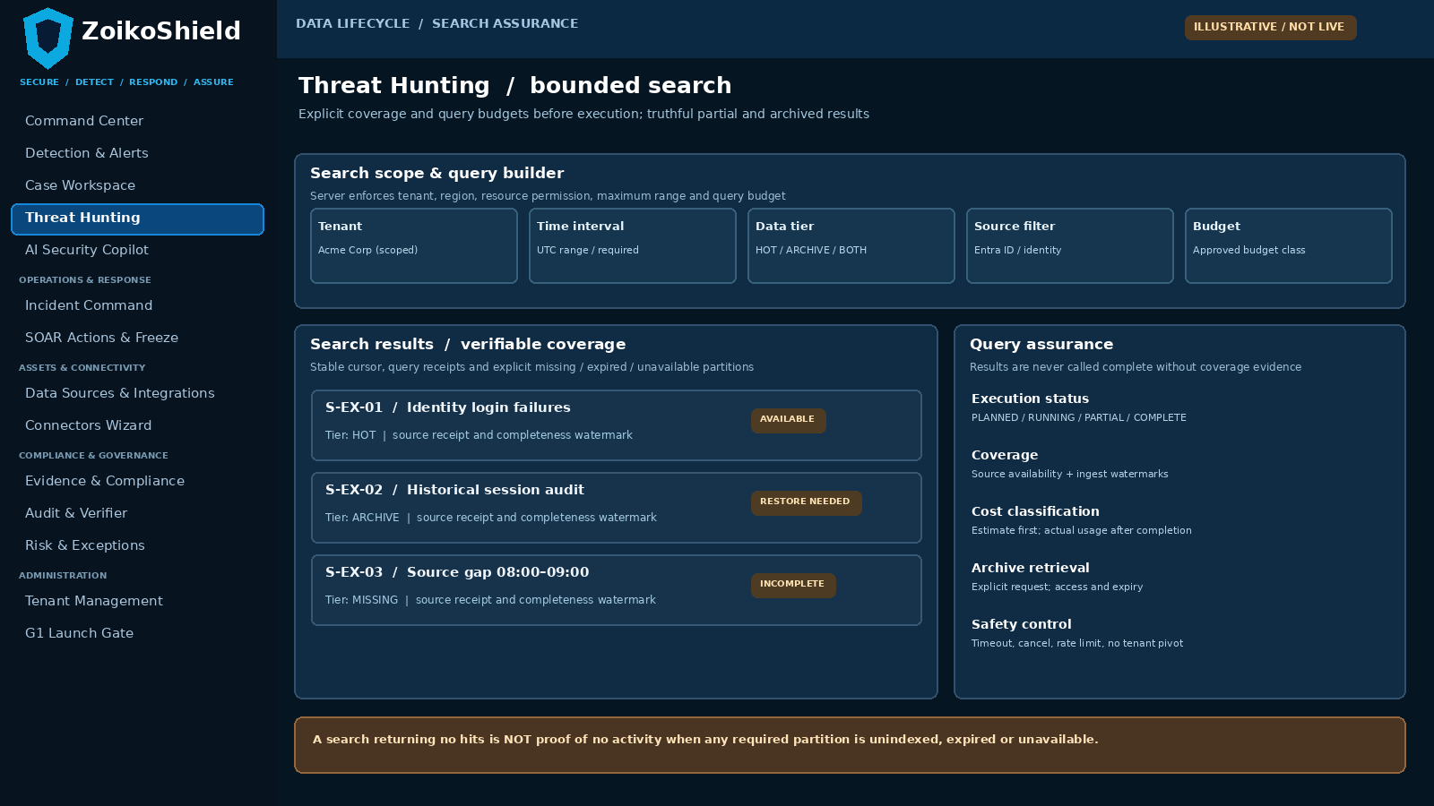
Refinement of the existing Threat Hunting screen. Inputs, tier eligibility, cost preview, completeness and missing-source status must all come from the backend; values are illustrative.
Pin | User interaction | Server-verified condition
01 | Choose tenant-bound source, UTC window, supported fields and HOT / ARCHIVE / BOTH. | G02 ABAC and residency restrictions on every query and result page; deny cross-tenant cursor reuse.
02 | Preflight displays scan ceiling, timeout, expected tier, completeness scope and explicit retrieval approval. | G03 source watermark, budget and actual index coverage; missing partitions produce a warning or block.
03 | Return results with provenance, partial/status markers, cost/usage receipt and archive restoration progress. | Stable cursor, revalidation on pagination, no “no incident” or “fully searched” assertion for incomplete scope.

05 WF-G08-02 — Versioned tenant retention policies
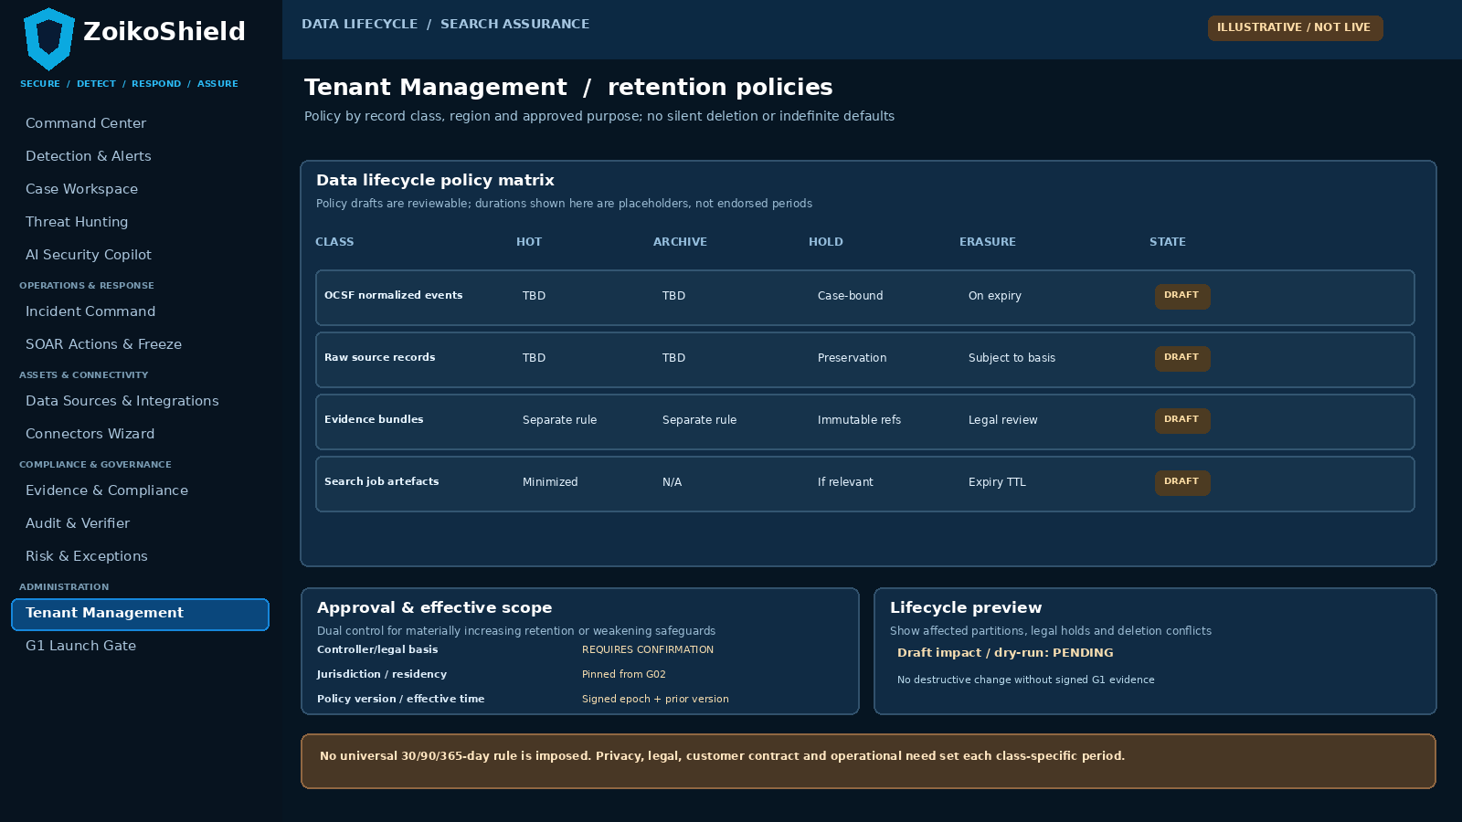
Nested policy matrix in existing Tenant Management. Periods are deliberately undecided until legally and commercially approved for each data class and region.
Pin | Operator journey | Enforced behavior
04 | Review each data class, approved purpose, region, hot duration, archive period, deletion mechanism and exception. | Versioned policy is enforceable in raw store, index lifecycle, archive, backup and derived artefacts.
05 | Change retention by draft → impact/dry-run → legal/security review → approval → effective activation. | Reducing retention cannot destroy data on active hold; increases require privacy/contractual basis and costing review.
06 | Inspect policy conflicts, aged partitions and deletions pending provider confirmation. | Fail closed on unknown region or missing policy; show partial disposition instead of claiming erasure.

06 WF-G08-03 — Legal hold and defensible disposition
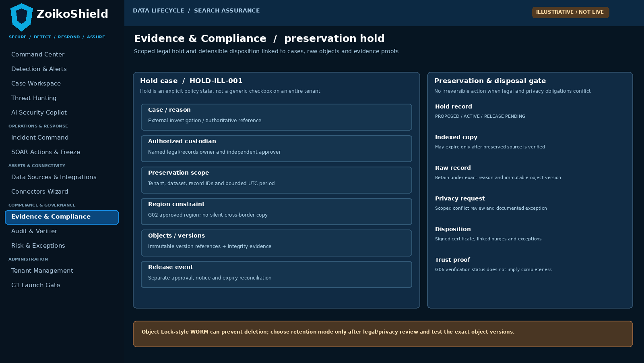
Scoped legal hold is accessed from existing Evidence & Compliance / cases. WORM retention and privacy requests require legal decision records and exact object version references.
Pin | User action | Irreducible backend proof
07 | Select case/legal basis, accountable custodian, tenant, region, exact records, versions and UTC period. | G02 authority; preserve only eligible scope; tamper-evident, time-stamped hold creation.
08 | Review preservation conflicts, pending erasure requests, immutable object modes and archive state. | Preflight must detect a held object version even when indexes/cache are expiring and cross-service purge is queued.
09 | Release hold under independent approval; run post-hold retention evaluator and record final disposition. | Release is not instant erasure; apply remaining policy and provider operations, document exceptions and confirmation.

07 WF-G08-04 — Usage, storage and query economics
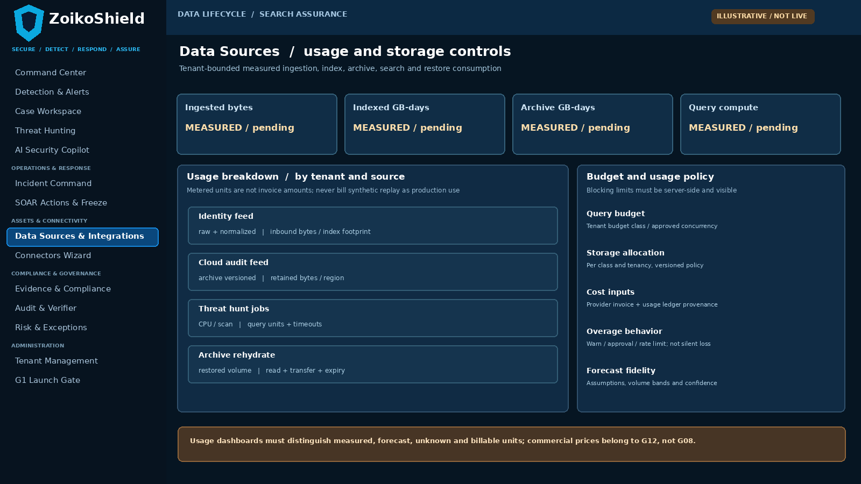
Add measured usage and budget behavior to the existing Data Sources & Integrations screen. The UI may show forecasts but must clearly distinguish actuals, estimates and billable amounts.
Pin | Visible user information | Server and accounting condition
10 | Source cards show raw inbound volume, index footprint, archive GB-days and cumulative query units by tenant. | Meter from trusted system events and infrastructure counters with attribution version; simulated events separately tagged.
11 | Preview query budget and restore resource envelope before long-running searches. | Rate/concurrency limits and cancellation apply at API and workers, not just in frontend.
12 | Explain forecast assumptions, variable provider costs and unsupported volume profiles. | No invented dollars/GB, margin or customer invoice; G12 owns package entitlement and pricing enforcement.

08 Required query engine contract — deliberately technology-neutral
Contract field | Required invariant and lifecycle | Failure/test branch
search_job_id, request_digest | Immutable job ID, normalized query digest, requesting actor, tenant, region, time window, source filters, tier preference, creation UTC. | Reject query mutation in pagination, resume or export; prevent cursor hopping across tenants.
policy_context | G02 authorized resource scope, permitted data classes and signed G08 policy version; G12 commercial budget class only if approved. | Policy changed mid-search => re-evaluate and fail or narrow consistently; no stale authorization.
completeness_vector | Per source: expected coverage start/end, G03 earliest/latest durable receipt, index availability, archive availability, known gaps. | Zero matches + unavailable source => PARTIAL / NOT_EVALUABLE, not empty-complete.
query plan and controls | Predicate allowlist, bounded lookback, scanned-byte/time/CPU ceilings, concurrency, timeout, cancellation token and export bound. | Oversized wildcard, abusive aggregation or multi-source fan-out is rejected before chargeable work.
cursor and rows | Server-signed opaque cursor, stable ordering, row origin, raw event reference, schema/parser version, collection and archive tier. | Expired/revoked cursor, old session and missing raw provenance rejected.
archive restoration | Explicit decision and consent/authorization for storage-class transition; job expiry, cleanup and temporary index tenancy. | Restore cannot write cross-region or persist indefinitely; interrupted restore idempotently reconciled.
receipt and disclosure | Actual measured usage, duration, result count, scanned bytes, warnings, record lineage and missing-scope reason. | Never report partial as COMPLETE; billable units not sourced from frontend estimates.

NON-GOAL | No requirement for SQL, KQL, SPL or YARA-L syntactic parity. Initial release can offer a safe constrained query builder over the minimum verified security event classes and customer search scenarios.

09 Policy, legal-hold and erasure conflict engine
Policy / operation | Mandatory rule | Negative test
Retention policy lookup | tenant + region + data class + purpose + effective policy version; default DENY/HOLD-REVIEW for unknowns. | Unlabeled records cannot silently inherit longest retention or be deleted.
Time and data class | Separate event-time, received-time and policy-start clock. UTC recording; timezone conversions display-only. | Backfill with old event timestamp must not skip durable archival or hold check.
Object version preservation | Hold references immutable physical object version, key/region and integrity proof; retain raw material needed for lawful case. | New latest object version, delete marker or index deletion cannot mask an older held version.
WORM / Object Lock | Mode requires prior legal/privacy approval. Compliance mode can be non-shortenable, governance mode can allow privileged bypass. | No generic “delete all” toggle; failed revocation does not hide conflicting hold.
Right to erasure / correction | Classify request and exemptions by controller, location and legal basis; review holds, snapshots, replicas and derived copies. | Deletion only from UI/cache cannot be described as complete erasure.
Backup and snapshots | G05 recovery images have separate lifecycle, restoration constraints and documented expiry/exception handling. | Restored snapshot must not resurrect previously deleted records into production availability.
Deletion execution | Dry-run inventory; confirmed authority; conditional deletes; provider receipts, cache invalidation and verification. | Partial provider failure => EXCEPTION; never mark CONFIRMED without evidence.
Post-hold release | Release event triggers reevaluation, not immediate purge; document remaining statutory / contractual retention. | Early release cannot bypass a still-active WORM retain-until timestamp.

LEGAL BOUNDARY | No law universally mandates a fixed 30/90/365-day retention period for security logs. ICO storage-limitation guidance requires purpose-based justification, documented periods and review; legal counsel decides exceptions and WORM adoption.

10 Persistence, lifecycle jobs and authorization interfaces
Logical record / operation | Minimum required fields | Validation / invariants
storage_object_ref | tenant, region, data_class, raw_event_id, object_uri+version, checksum, provider, receipt ID, immutable flag, creation UTC. | No secret credentials in metadata; object refs never resolve outside tenant/region; G03 mapping intact.
search_index_partition | tenant, region, source, OCSF version, index/alias ID, min/max indexed times, source watermark, coverage state, expiry. | Index lifecycle only after materialized hold/archive preflight; no false completeness on skipped shards.
retention_policy | policy_id, immutable version/digest, class, purpose, approved period rules, effective epoch, region, legal basis, approvals. | No in-place overwrite of approved policy; prior versions remain auditable.
legal_hold | hold_id, case, authority, justification, tenant/region, exact scope/object versions, start, review date, approvals, release. | Approval separated from creator; no tenant-wide hold by default; revocation is audited.
disposition_job | job_id, policy version, affected IDs, dry-run, blockers, provider request and outcome receipts, reviewer, completed UTC. | Idempotent retries; provider/object versions confirmed; fail closed on unresolved hold.
query_job | job_id, tenant, request digest, actor, policy snapshot, query tier/budget, completeness vector, result manifest, actual metering. | Tokenized cursor and bounded budget; API and background worker authorize consistently.
metering_event | event_id, tenant/region, source and unit (byte, GB-day, scan/CPU, egress), quantity, epoch, origin, actual/forecast flag. | No double-charging replays; report unknown/unattributed quantities rather than hiding them.
evidence_anchor | Reference only to existing G06 manifest, content and verification receipts, data-class retention exception. | Hash/proof retention not a blanket entitlement to preserve raw personal data forever.

11 Measurable performance and economics — release inputs
Measure / cost driver | Required measurement and environment | Acceptance decision
Source throughput & volume | Daily and peak ingest bytes by source, raw/compressed ratio, indexed OCSF bytes, source variability and data skew. | First-customer volume model approved; synthetic-only throughput cannot substantiate enterprise promises.
Search service levels | Representative fixed queries and populations: selectivity, time range, tenant size, hot-tier and archive result latency distributions. | P50/P95/P99 criteria set from customer requirements before testing; unsupported classes explicitly bounded.
Retention / scaling | Index storage over time; replica overhead; archive copy cost; object/version counts; snapshots and data restoration time. | Observed tier transition, retention expiry and restore reconciliation for target volume.
Cost allocation | Storage GB-days by type, index nodes/replicas, query scanned bytes and CPU, object requests, archive retrieval/egress and KMS. | Unit cost model signed by Finance/Platform, reconciled with provider bill; no hidden shared-cost assumption.
Query controls | Max range/scanned bytes/CPU, concurrent jobs, user and tenant rate quotas, cancellation and retry limits. | Workers demonstrably enforce server-side limits, with denial and transparent user messaging.
Privacy and disposition | Exact physical data replicas/copies, held/versioned objects, backup expiry and deletion timestamps. | G02 region and Legal review, physical purge/exception evidence; exceptions surfaced.
Billing separation | Measured usage vs allocated COGS vs customer billable metric vs plan entitlement. | Only G12 decides invoice charges; zero assumption about committed plan prices or overage.
Scale milestone | Initial target dataset and p95 query profile, later load band and fail-under-capacity behavior. | No petabyte-scale, unrestricted multi-year search claim absent documented capacity test.

NO FABRICATION | Targets for days, p95/p99 latency, throughput, raw data size, currency, unit price and legal hold expiry remain explicit APPROVAL REQUIRED inputs. Do not fill presentation dashboards with invented measurements.

12 Adversarial and functional tests G08-T01–T12
ID | Controlled scenario | Mandatory observed result
T01 | Read identical entity/event IDs from two separate tenant datasets. | Search/index/cache/cursor remain tenant-scoped; no row, count, metadata or restore leakage.
T02 | Create source coverage gap due to G03 DLQ, then run zero-hit hunt. | Status PARTIAL or INCOMPLETE with source/watermark warning; no “no events” assurance.
T03 | Query beyond hot retention with valid archived raw data. | Preflight offers authorized archive flow, not fake empty result; restore bounded and auditable.
T04 | Query window crosses old archived and current hot partitions. | Federated job returns correct segmented coverage and provenance; duplicates collapsed deterministically.
T05 | Issue broad wildcard scan exceeding tenant budget or concurrency. | Bounded server-side rejection/limiting; no unbounded work or silent charge.
T06 | Reuse an opaque pagination cursor with different tenant, role or updated policy. | Reject/re-authorize and report policy change; never leak cached page.
T07 | Index rollover and partial shard outage during active search. | Consistent observed coverage state, partial receipt, stable retries; no false COMPLETE.
T08 | Attempt policy editing with analyst rights or bypass frontend API. | G02/G04 server-side denial, review receipt; no lifecycle job dispatched.
T09 | Change approved retention period and inspect an older partition. | Effective policy version, prior state and impacted object list available; approved transition only.
T10 | Expired index deletion scheduled while a relevant original object is held. | Held object/version preserved and indexed-copy deletion follows explicit policy without breaking preserved evidence.
T11 | Attempt direct immutable-object deletion before approved retain-until. | Provider refuses; platform retains BLOCKED_HOLD / RETENTION_LOCKED and actionable evidence.
T12 | Submit erasure request that affects a backup and active legal hold. | Explicit exception and backup lifecycle reconciliation; never report full erasure prematurely.

13 Adversarial, scale and economics tests G08-T13–T24
ID | Controlled scenario | Mandatory observed result
T13 | Release a hold while different retain-until and contractual periods remain. | Re-evaluate all controls; no premature purge; approvals and UTC receipt intact.
T14 | Delete latest object version while older protected version survives. | Version-specific hold inventory reports preserved record; no false physical deletion.
T15 | Duplicate G03 event replay reaches raw/index/metering jobs. | One logical raw event lineage and no duplicate billable usage; exact-once billing semantics via idempotent ledger.
T16 | Restore archived tenant dataset in a non-approved region. | Hard G02 residency denial with no temporary spill into forbidden region.
T17 | Archive retrieval interrupted at half completion then retried. | Idempotent state, verified checksums, expired temporary data cleanup and accurate usage receipt.
T18 | One-byte raw event corruption after archive transfer. | G06 verification fails; search warns corrupted archive, excludes false positive COMPLETE.
T19 | Run representative measured hot queries against agreed initial customer volumes. | Observed p50/p95/p99, concurrency and scan costs attached to target environment; gate compares preapproved thresholds.
T20 | Search returns old cached rows after permissions or retention change. | Cache invalidation or live authorization hides revoked/deleted records from user/export.
T21 | Test privacy deletion with replica, snapshot and restore route present. | Every copy accounted for; unavoidable retained backup exception documented; no resurrection after recovery.
T22 | Provider metering event delayed, missing or double-sent. | Usage reconciliation flags UNKNOWN/ESTIMATED and deduplicates actual charge units; no silent invoice truth.
T23 | Switch demo fixture to a production tenant dashboard context. | Synthetic sample usage is clearly segregated and excluded from customer billable production totals.
T24 | Produce signed end-to-end G1 evidence for approved launch scope. | Search and lifecycle tests pass; privacy/legal, security, SRE and commercial attribution approval or HOLD.

14 Minimum evidence, owner, and implementation handoff
Evidence ID | Artifact required to make claim demonstrably true | Review owner
G08-E01 | Actual storage and query deployment inventory (versions/providers/regions), data-class mapping and raw→normalized→index→archive lineage. | Data Platform Lead + Cloud SRE.
G08-E02 | Signed purpose-based retention schedule per tenant/region/data class; impact analysis, privacy exceptions and Legal approval. | Privacy Lead / Legal + Product.
G08-E03 | Query coverage/zero-match/partial-source negative tests, permitted result export and tenant-bound cursor proofs. | Search Engineering + Tenant Security QA.
G08-E04 | Archived raw object/version checksums, rehydrate tests, index expiry and G06 integrity verification receipts. | Platform SRE + Evidence Service Owner.
G08-E05 | Legal-hold creation/release, privacy/deletion conflicts, backup/snapshot disposition and confirmed provider outcomes. | Legal / Records Owner + Privacy QA.
G08-E06 | Signed representative target workload, p50/p95/p99 query results, concurrency limits and tested failure behavior. | Performance Engineering + SOC.
G08-E07 | Tenant usage ledger: received/indexed/archive GB-days, query units and restores, provider invoice reconciliation, measured/forecast separation. | FinOps + Finance + G12 Commercial.
G08-E08 | Signed G1 outcome for specific customer, region, volume and features, with all exceptions/unsupported queries disclosed. | G1 Owner + Security + Product.

Lean execution order
1. Confirm legal/classification schedule and deployment topology. 2. Bind raw/index/archive pointers to G03 receipts. 3. Add server-enforced query plan and coverage state to Threat Hunting. 4. Add policy and hold management to existing views. 5. Instrument usage/COGS without changing billing. 6. Run 24 controlled tests and provide eight evidence references to existing G1.
SCOPE STOP | If a first customer has no archive, hold or long-range search contractual requirement, implement the invariant and clearly defer that tier/UI action. Do not build an expensive generalized lake or legal-case management product solely to fill a checklist.

15 Release go/hold and authoritative references
Decision | Strict interpretation
G08 GO — scoped | Class-specific and legally approved retention; verified source-to-search coverage; approved tenant/region boundaries; bounded queries; tested preservation/deletion; measured customer workload and transparent usage metering.
G08 HOLD | Unknown policy or legal basis; silent dropped partitions; “all clear” on partial data; cross-tenant or cross-region reads; index expiry destroys held originals; unverifiable archive; false purge claim; unbounded query cost.
Legitimate defer | Uncontracted archive tiers, universal multi-year hot search, arbitrary petabyte datasets, broader analytics language compatibility, new lake or billing platform remain optional.
Scope uncertainty | The existing demo guides and architecture describe components and screens; they do not independently establish actual archive object modes, provider bills, production dataset sizes, search latency or signed legal-retention schedules.
Status | G08 is engineering guidance and a proposed acceptance contract. It is not code inspection, legal advice, customer contract approval, production certification or proof of implementation.

Locked ZoikoShield source baseline
[P1] ZoikoShield Enterprise Architecture & Infrastructure GAP Analysis v1.0 (31 October 2026), finding G08. [P2] ZOIKOSHIELD_LIVE_DEMO_MASTER_GUIDE.md and ZOIKOSHIELD_STEP_BY_STEP_DEMO_LINKS.md (13 October 2026). [P3] G02 tenant isolation, G03 ingestion, G05 DR, G06 evidence, G07 detection closure specifications; existing screen designs. Commercial G12 governs actual billing.

Official technical and legal reference points
[S1] OpenSearch Index State Management (rollover, snapshot, deletion policy): https://docs.opensearch.org/latest/im-plugin/ism/index/ (accessed 31 October 2026).
[S2] AWS S3 Object Lock — retention, version-specific holds, governance and compliance modes: https://docs.aws.amazon.com/AmazonS3/latest/userguide/object-lock.html (accessed 31 October 2026).
[S3] UK Information Commissioner’s Office — UK GDPR storage limitation, proportionate periods and erasure review: https://ico.org.uk/for-organisations/uk-gdpr-guidance-and-resources/data-protection-principles/a-guide-to-the-data-protection-principles/storage-limitation/ (accessed 31 October 2026; guidance marked under review).
External sources illustrate mechanisms and compliance considerations, not a conclusion that ZoikoShield deploys a named product or meets a legal obligation. All tenant terms and evidence remain subject to the relevant controller’s sign-off.

