ZOIKO TECH INC. / CONTROLLED PRODUCT GAP CLOSURE

G09 | Connector certification,
credential lifecycle & private-network integration
Detailed engineering wireframes & evidence-bound production certification contract • Version 1.0 • 31 October 2026
P1 / SCOPE | A narrow, customer-led connector trust and operational support closure. An item in the catalog, a successful synthetic demonstration or an implemented adapter is not a production-certified source.

Executive implementation decision
Extend the existing Data Sources & Integrations and Connectors Wizard surfaces. Require signed permission manifests, minimal privileges, actual-source validation, secure credential replacement/revocation, and visible degradation. Support a private egress-only runner ONLY where a committed initial customer requires it. Do not build a universal integration platform.
Decision | Engineering implication
Required | One launch connector assurance register; provider-version permission manifest; safe enrollment, real-source tests, credential lifecycle; conditional runner controls; 24 negative/functional tests and G1 evidence.
Reuse | shield-ingest provider registry/permission drift, current /connectors list/test/sync/activate and G03 ingest receipts; G02 tenant/regional enforcement; G04 external-action boundary; G05 operational health.
Do not assume | 42 UI connector categories means 42 production-certified connectors; current code inventory proves live provider privileges; any private runner exists or is approved; real customer API tests already passed.
Not authorized | Additional top-level navigation, generic remote shell, always-on bidirectional tunnel, vendor-agnostic "all connectors" claim, new SIEM/EDR agents, or live containment through shield-ingest.

Definition of done
For every connector sold or activated, its provider/version, tenant, region, granted privileges, schema compatibility, credential state, real event coverage, limits and support owner are demonstrably known. Failures are visible, bounded and revocable; an unverified connector can never silently appear fully healthy.

01 Source baseline, scope exclusions & authority
Existing platform component | Grounded baseline | What G09 adds / who owns it
Connectors Wizard /connectors | Six-step UI and connector configuration form; source inventory indicates list/test/sync/activate flows and write-only secret fields. | Keep these controls; add certification, permission diff, credentials, and independently verified activation readiness. UX + Connectors Engineering.
Data Sources & Integrations | Catalog, source health, event samples and data format panels; screenshot shows many entries and aggregate counts. | Add visible distinction between CATALOG, IMPLEMENTED, CUSTOMER-TESTED and APPROVED_FOR_PRODUCTION. Product + Security.
shield-ingest :3002 | Connector registry/runtime, OCSF normalization, permission drift, idempotency, Kafka/outbox referenced in internal service inventory. | Implement provider-scoped certification enforcement, lifecycle state, secret-ref access, kill/suspend and evidence emission.
G02 + G03 + G08 | G02 owns cross-tenant/residency; G03 owns durable intake and freshness; G08 owns retention and storage cost. | Reference their tests/receipts; do not duplicate event store, geographic routing, query metering or lifecycle policies.
shield-action + G04 | External containment mutations require policy, signed authority and G1 gates. Existing execution adapters remain simulation-scoped pending approval. | Private runner is READ-ONLY ingest by default; never route live containment through this connector path.
G1 release authority | Existing eight-signer release gate plus assurance evidence. | A provider may enter APPROVED_FOR_PRODUCTION only with bound scope, versions, tests, approval and current expiration.

PROVENANCE | Baseline references are the October 2026 Master Demo Guide, current frontend/backend guide and Services Overview (last independently audited ZIP, not a live audit of this turn). Final integration status requires fresh code, environment and provider evidence.

02 Launch connector boundary & certification classes
Launch candidate | Required observation / permission class | Release disposition
Microsoft Entra ID | Identity/sign-in or security-event read-only data; API permissions verified against actual current provider requirements and tenant consent; no directory mutation permission. | QUALIFY if an initial customer requires it; exact OAuth scopes captured in signed manifest after testing.
AWS GuardDuty + CloudTrail | Read-only finding/log source permissions, appropriate per-account role and AWS region; separate CloudTrail and GuardDuty tests, not one inferred from the other. | QUALIFY only the customer-approved AWS services and collection paths.
Generic signed webhook | Source-specific shared-key/signature policy; raw-body HMAC, timestamp, nonce/replay and accepted-event proof. | QUALIFY as its own versioned connector; do not claim every webhook format is understood.
One endpoint EDR partner | Choose CrowdStrike OR Cortex XDR (or another approved customer EDR), according to first pilots, API entitlements and legal commercial access. | SELECT ONE for initial scope; built adapter does not constitute certification.
Jira, Snyk, GitHub, Microsoft Defender, GCP SCC, others | Inventory shows modules or dashboard entries for several additional providers; actual released versions and permissions vary. | DEFER unless a launch buyer has a documented high-priority use case and full G09 evidence.
Private on-prem / network runner | No general-purpose remote administration; outbound-only fixed trust scope and restricted read-only collection. | CONDITIONAL. Do not implement without signed customer dependency and security review.

RELEASE RULE | A signed, valid connector qualification record must bind provider product, API version, plugin/adapter digest, OCSF parser version, permission manifest digest, customer tier, allowed region, supported data family and test evidence. One provider permission pass does not certify a different provider/API version.

03 Security trust flow and service contract boundaries
Boundary | Enforced responsibility | Negative behavior
Browser → Next.js proxy | Tenant membership, operator authority and typed request validation. Never send credential values back to the UI after write. | Any tenant-id override, unauthorized write or secret-reveal request rejected and audited.
shield-core → shield-ingest | Tenant+region+connector identity bound to policy; command sent with workload identity and traceable request ID. | Reject spoofed service identity, unsupported provider version, cross-tenant and stale approval.
Provider → connector worker | OAuth/service role/webhook signature or service-specific protocol validated; actual permissions compared against manifest. | Insufficient/excess permissions or invalid token: pause/degrade, no false healthy indicator.
Connector worker → G03 | Deliver authenticated, attributable source receipts; G03 handles durable accept, parse/quarantine, replay and freshness. | A successful handshake is NOT an event-ingestion success; a synthetic event is NOT production source verification.
Runner → ingress gateway (optional) | Mutually authenticated outbound HTTPS, certificate-bound workload identity, pinned tenant/region/egress targets. | Reject inbound control ports, arbitrary command, cross-region stream and wrong binary version.
shield-action → customer mutations | Only G04/G1 can authorize a live containment effect, through signed and governed action adapters. | Read-only runner can never execute remote shell or mutate customer resources.

Minimum event records
CONNECTOR_CERTIFICATION_DECIDED, PERMISSION_DRIFT_DETECTED, CREDENTIAL_ROTATION_STARTED / COMPLETED / UNCERTAIN, CONNECTOR_DEGRADED, CONNECTOR_REVOKED, RUNNER_ENROLLMENT_REJECTED, RUNNER_STOPPED. Each carries tenant, region, actor/service identity, connector ID, manifest/version, result, event time, trace ID and non-secret evidence reference.

04 WF-G09-01 | Certification register / Data Sources
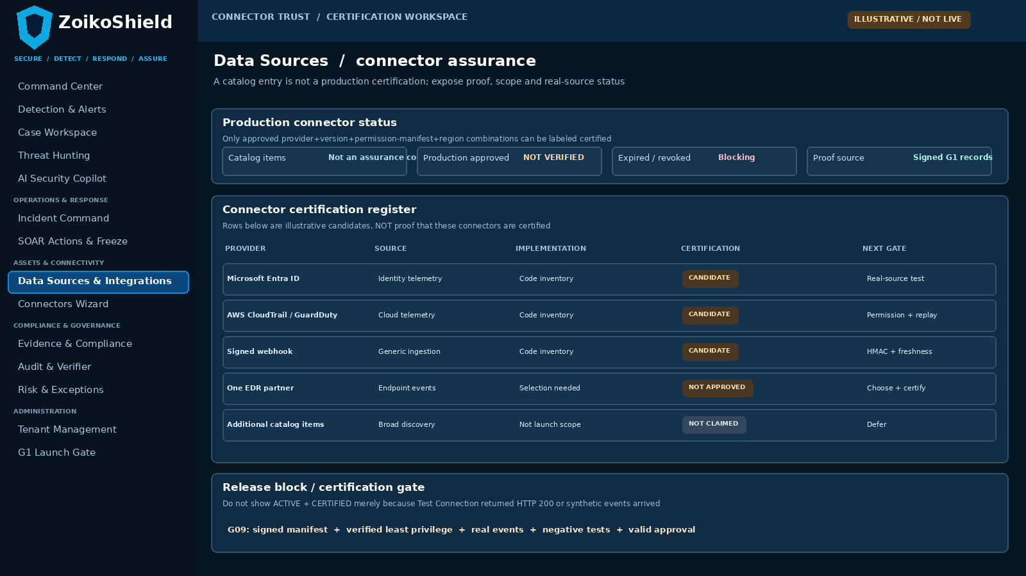
WF-G09-01 • Existing Data Sources & Integrations page enhanced with a bounded certification register (illustrative states only).
Annotation / field | Required behavior
A. Catalog versus approved | Clearly separate discovered/listed provider types from implemented adapters, tested installations and release-authorized certifications.
B. Versioned test evidence | Every Approved state links to real-source trace IDs, signed manifest, test date, region and certifier; never a naked green status.
C. Unknown, expired, revoked | Default to NOT APPROVED / EXPIRED / REVOKED; do not silently downgrade the requirement to merely a successful connection test.

05 WF-G09-02 | Permission-aware activation wizard
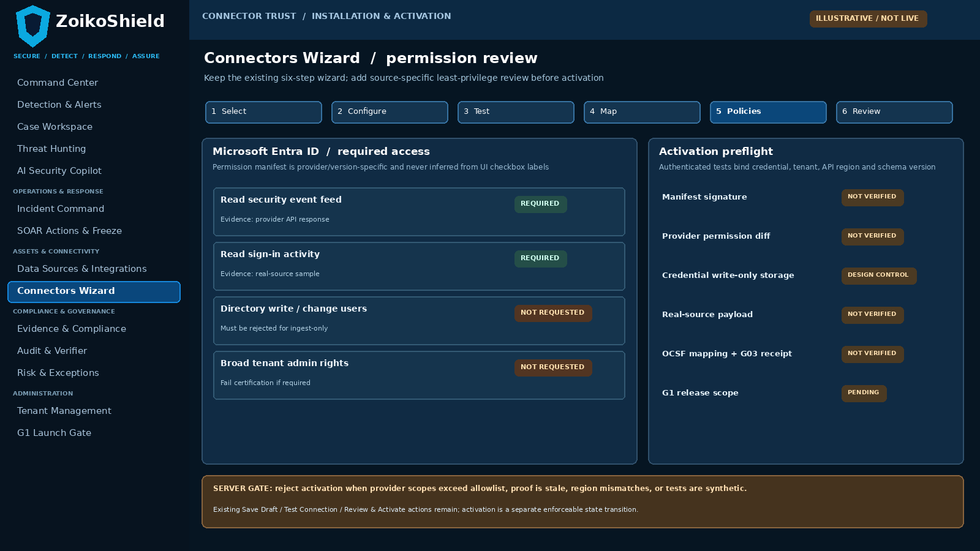
WF-G09-02 • Existing Connectors Wizard step 5 / step 6; exact scope values sourced from approved provider manifests.
Annotation / field | Required behavior
A. Required versus forbidden grants | Show required permissions, provider descriptions, test evidence and permissions explicitly NOT requested; no fabricated universal scopes.
B. Gate activation | Server must verify tenant/region, approved adapter digest, permissions, source payload and G03 persisted receipt before ACTIVE_VERIFIED.
C. Failure response | Incomplete permissions, expired authorization, consent mismatch or synthetic-only proof means draft, pending or degraded state. No activation shortcut.

06 WF-G09-03 | Credential rotation and revocation
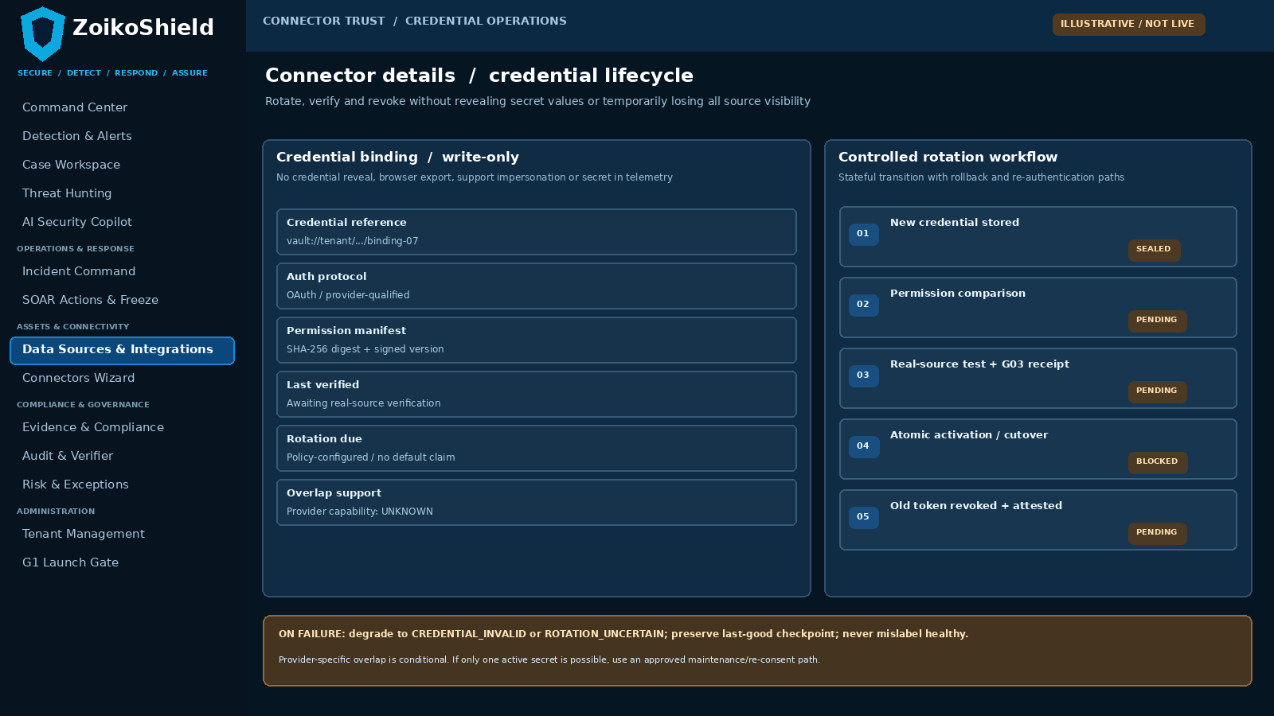
WF-G09-03 • Data Sources > connector detail > existing configuration/health area; all secrets remain write-only.
Annotation / field | Required behavior
A. Vault reference | Show opaque secret reference and access/rotation metadata; forbid browser reveal, logs, copy, CSV export and support-user disclosure.
B. Conditional overlap | If provider supports two active keys, test new one before switch; otherwise use planned re-consent / maintenance with staleness warning.
C. External revocation | After cutover, revoke former provider credential, assert rejection and record proof; uncertain revocation is a blocking exception.

07 WF-G09-04 | Private-network runner (conditional)
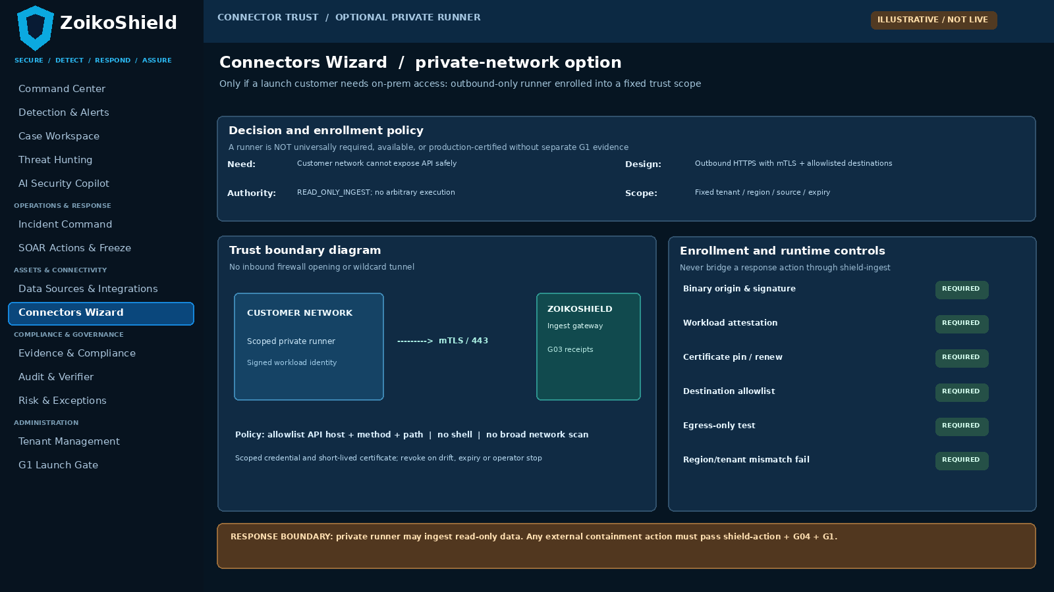
WF-G09-04 • Optional Connectors Wizard enrollment panel; NOT a new sidebar item or mandatory platform service.
Annotation / field | Required behavior
A. Outbound-only channel | Runner establishes mutual-authenticated HTTPS egress to allowlisted ingress; no inbound admin listener or unrestricted reverse tunnel.
B. Bounded host permissions | Pin tenant, region, source(s), API routes, allowed destinations and run identity; reject unsigned upgrades and arbitrary execution.
C. Strict action boundary | Read-only ingestion only. Any remote user/device mutation remains G04/shield-action and must be independently approved.

08 Certification state machine and minimal data model
Object / state | Mandatory fields or transitions | Invariant
ConnectorDefinition | provider_id, product, adapter_version/digest, API_profile, parser_version, supported data families, runner_required. | Catalog entries cannot inherit production approval from category labels.
PermissionManifest | manifest_id, revision, declared required/forbidden privilege, consent model, API endpoints, approver, signature/hash, effective/expiry. | Provider-specific effective privilege diff is mandatory; broad admin scope denied by default.
ConnectorInstance | tenant_id, region, environment, provider definition, endpoint/role ref, source identity, state, assigned owner. | Unique binding; never use client-supplied tenant ID as authorization proof.
CredentialBinding | vault_reference, type, scope digest, version, issued/expires_at, rotation outcome, revocation receipt. | No plaintext credential in database UI fields, logs, crash reports or G1 packets.
CertificationRecord | instance/provider/API version, manifests, adapter digest, test suite version, real-source receipt, decision, expiry, release scope. | Immutable revision; automatically cease Approved status after expiry/revocation or incompatible code change.
PrivateRunnerRegistration | instance_id, agent build digest, workload identity, trust cert, egress allowlist, tenant/region and expiration. | Conditional; never grant cross-tenant or generalized remote shell capability.

TWO STATE TRACKS | Operational lifecycle: DRAFT → CONFIGURED → TESTING → ACTIVE_VERIFIED / DEGRADED / PAUSED → REVOKED / RETIRED. Independent certification lifecycle: CANDIDATE → TESTED → APPROVED → EXPIRED / REVOKED. Changing adapter, permission manifest or API version forces requalification.

09 Credential & webhook security implementation rules
Control | Implementation requirement | Pass evidence
Least privilege | Use exact vendor/API-specific read permissions, restricted audiences, admin consent trace where needed; no wildcard tenant-admin role if not justified. | Granted-vs-required permission diff and negative overprivilege test.
OAuth security | For OAuth-based providers, follow RFC 9700: suitable authorization-code/PKCE where applicable, exact redirect matching, token replay defenses and safe refresh rotation or sender constraint where supported. | Recorded protocol configuration, token security tests and re-consent result.
Secret lifecycle | KMS/vault secret ref, envelope encryption, workload-only unseal, audited access, redacted errors, provider revoke and continuous expiry monitoring. | Rotate + provider rejection of old token + no leaked bytes in traces.
Webhook authenticity | Validate request HMAC/signature over raw bytes with canonical message format, timestamp bound, nonce replay cache, key version, body size and 429/rate protections. | Tampered body/timestamp/replay and secret-rotation negative tests.
SSRF/egress | Deny private/reserved IP ranges unless explicit private-runner allowlist, forbid DNS rebinding or unreviewed URL redirects; fixed provider endpoints and cert verification. | DNS switch, redirect and alternate host negative tests.
Permission drift | Compare live privileges to signed manifest; on loss or unexpected gain, classify degraded, block prohibited operations and require human resolution. | Time-stamped drift observation, notification and effective access state.
Support controls | No reveal/show-secret icon in production; support can inspect status metadata only and request authorized customer rotation. | UI API and audit proof under least-privileged support role.

PROTOCOL NOTE | RFC 9700 provides OAuth security baseline; exact OAuth support, scopes, vendor key rotation and private-network behavior must be established per-provider, not assumed universally.

10 API additions / integration contracts (proposed)
Operation / path (illustrative) | Input and fail-closed behavior | Expected evidence/state
GET /api/v1/connectors | List only authorized tenant/region; include separate capability, operational and certification states. No secret fields. | Tenant-safe catalog + certification/credential references.
POST /api/v1/connectors/:id/test | Test the current bound provider and manifest, not a hard-coded success; return test ID and per-stage outcomes. | TESTING → TEST_FAILED / TEST_PASSED (not certified by itself).
POST /api/v1/connectors/:id/permission-review | Compare observed provider permissions against signed manifest; reject excessive or absent grants. | Stored permission-diff artifact and prior/new digest.
POST /api/v1/connectors/:id/activate | Idempotent authenticated transition; G02 scope + certification + G03 real receipt + validated credential must all pass. | ACTIVE_VERIFIED or typed 403/409/422 failure.
POST /api/v1/connectors/:id/rotate | Submit new write-only secret/token binding; never return value; verified cutover and provider-side revoke. | ROTATION_STARTED → ROTATED / ROTATION_UNCERTAIN.
POST /api/v1/connectors/:id/revoke | Hard stop scheduled polls and future ingestion authorization; revoke provider token where supported; preserve audit/evidence. | REVOKED + revocation-confirmation or uncertainty record.
POST /api/v1/connectors/:id/runner-enroll | Conditional entitlement; signed binary identity, egress policy, bounded cert and tenant region binding. | ENROLLED / REJECTED with attestation proof.
GET /api/v1/connectors/:id/health | Return last actual source success, age, API quota/rate-limit, permission drift, backlog G03 link, runner reachability. | HEALTHY / STALE / DEGRADED / CREDENTIAL_INVALID / UNAVAILABLE.

These are proposed contract shapes, not verified existing route implementations. Engineering must map them onto the actual NestJS controller names and prevent duplicate handlers. No endpoint is approved without a typed schema, authorization middleware, idempotency behavior and audit event.

11 Acceptance criteria: activation, tenancy & permission
ID | Test | Adversarial action | Must demonstrate
G09-T01 | Cross-tenant activation | Tenant A token attempts to activate tenant B connector | 403 + no change + tenant-bound audit
G09-T02 | Wrong-region source | Correct token with source region not entitled by G02 | Fail closed; no active ingestion outside scope
G09-T03 | Catalog ≠ certified | Listed but no signed production record | Shows NOT APPROVED; Activate blocked
G09-T04 | Unapproved adapter digest | Signed provider manifest but runtime digest changed | Requalification required; no silent auto-approval
G09-T05 | Missing read permission | Provider consent omits an essential grant | Permission diff + DEGRADED / BLOCKED
G09-T06 | Excess write privilege | Provider token has unjustified mutation authority | Reject approval or require exceptional reviewed scope
G09-T07 | Synthetic-only success | Connector returns only synthetic test payloads | No production certified state
G09-T08 | No durable receipt | Source API returns events but G03 accept fails | Cannot mark ACTIVE_VERIFIED; explicit degraded state

TEST EVIDENCE | Every case records environment, build/version, provider and account test fixture, actor/role, region, request/trace ID, observed API result, screenshot/log digest and QA sign-off. Tests are not accepted as PASSED based solely on a design mockup.

12 Acceptance criteria: secret, OAuth & webhook lifecycle
ID | Test | Adversarial action | Must demonstrate
G09-T09 | Write-only secret | Operator/support retrieves connector configuration and API export | No secret byte or reversible token presented
G09-T10 | Leaked log protection | Fail token refresh and crash handler with fake credential | No token in logs, error text, tracing, DLQ or notifications
G09-T11 | OAuth redirect | Redirect URI variation / unapproved open redirect | Exact redirect validation and rejection
G09-T12 | Refresh replay | Reuse replaced refresh token in supported provider test | Detected/revoked or correctly sender-constrained by provider
G09-T13 | Rotation success | Install second key when provider supports overlap | Real-source test new key; old revoked and rejected
G09-T14 | Rotation uncertainty | Network loss after provider revocation request | ROTATION_UNCERTAIN and safe fallback; no false success
G09-T15 | Webhook tampering | Mutate raw body/signature, timestamp or nonce | 401/403; no accepted event; auditable reason
G09-T16 | Webhook replay/DoS | Reuse valid signed payload, flood invalid requests | Duplicate rejected; rate controls and no tenant bleed

CONDITIONAL | Where a provider does not issue refresh tokens or support overlapping keys, record NOT_APPLICABLE with provider evidence and test its supported alternative. Never label an untestable flow passed.

13 Acceptance criteria: operations & private runner
ID | Test | Adversarial action | Must demonstrate
G09-T17 | Source staleness | Pause provider feed without breaking TCP connection | Health degrades by measured event freshness, not just HTTP check
G09-T18 | Permission gain drift | Add unexpected grant after activation | Drift alert + suspend privileged behavior until reviewed
G09-T19 | Rate-limit recovery | Provider returns 429 and retry-after | Bounded retries; G03 backlog visibility; no silent loss
G09-T20 | Source schema change | Provider changes event field/version | Quarantine/revalidate mapping; requalify if material
G09-T21 | Runner egress | Attempt inbound control or unallowlisted outbound host | Blocked by runtime/network policy with trace
G09-T22 | Runner counterfeit | Unsigned binary, expired cert or wrong tenant / region | Handshake rejected and attested audit
G09-T23 | Runner command abuse | Attempt shell/user change or remote containment through ingest | Denied; cannot bypass shield-action / G04
G09-T24 | Revocation at runtime | Operator revokes connector while poll/backfill in flight | No subsequent new authorization; safe settle; preserved G03 receipts

G1 CONDITION | Runner tests G09-T21 to T23 are required ONLY if private runner is offered in the launch scope; otherwise mark NOT_APPLICABLE with documented exclusion and disable all enrollment UI/API paths.

14 Eight G1 evidence deliverables & accountable owners
Evidence ID | Required immutable evidence | Accountable team
G09-E01 | Signed launch connector list and provider/API version matrix; excludes the broad catalog from production claims. | Product + SOC Lead
G09-E02 | Signed provider-specific permission manifests, exact consent evidence and least-privilege drift/negative case. | Platform Security + Connector Lead
G09-E03 | Real-source installation and event-receipt fixture including G03 durable accept, source freshness and OCSF lineage. | Connector Lead + QA
G09-E04 | Credential vault/role review; real rotate/revoke tests, token-replay findings and redacted logging trace. | Security Engineering + SRE
G09-E05 | Webhook authentication, tamper/replay, SSRF, TLS and provider rate-limit results. | Security QA
G09-E06 | Private-runner architecture, binary/SBOM, workload certificate/egress controls and penetration review IF launched; otherwise approved exclusion. | Security Architecture + SRE
G09-E07 | Negative cross-tenant/region/rate-limit/credential-expiry suite with executed results and trace bundle; no unsupported "PASS". | QA Lead
G09-E08 | Release ratification: signed specific connector+adapter digest+region+entitlement/version+expiry, support owner and rollback runbook. | Product + G1 approvers

Evidence handling
Record manifest and report hashes, build IDs, provider/API versions, environment, test timestamps, authorized tenant and region, and pass/fail state. Preserve only redacted token hints, never credentials. Link verification records into the existing G1 gate and G06 evidence package rather than opening another sign-off dashboard.

15 Engineering work order, release gates and reference register
Sequence / owner | Implementation deliverable | Stop condition / acceptance
1 Product + SOC Lead | Choose buyer-supported minimal provider matrix and one EDR; document unsupported connector rows. | No commercial availability claims outside verified scope.
2 Connector Engineering | Reconcile actual code/modules, provider APIs, signed permission manifests and adapter digests. | No hard-coded universal scopes; no broad access defaults.
3 Platform Security | Enforce vault-only secret lifecycle, OAuth/webhook security, endpoint/egress policies and privilege-drift stop. | Pass G09-T01–T16 for each sold provider.
4 QA + SRE | Execute provider real-source E2E, schema change, rate-limit, staleness and rotation/revocation drills. | Pass G09-T17–T20 and 24; produce G09-E01–E05, E07.
5 Security Architecture (if needed) | Implement outbound-only read-only runner under separately approved customer need. | Pass T21–T23 and E06 or record explicit N/A.
6 G1 Release Council | Approve bound product + source + adapter/version + region + permission manifest and expiration. | No G1 decision inferred from green demo indicators.

Reference baseline and external security standards
Internal: ZoikoShield Enterprise Architecture GAP Analysis v1.0, G09 row (31 Oct 2026); ZOIKOSHIELD_LIVE_DEMO_MASTER_GUIDE.md (13 Oct); ZOIKOSHIELD_STEP_BY_STEP_DEMO_LINKS.md (13 Oct); ZoikoShield Complete Frontend/Backend Guide v3; ZoikoShield Platform Services Overview (last audited ZIP snapshot); existing Connectors Wizard and Data Sources UI baselines; G02, G03, G04 and G08 specifications.
External: RFC 9700, Best Current Practice for OAuth 2.0 Security (IETF, Jan 2025), https://www.rfc-editor.org/info/rfc9700/ ; RFC 9449, OAuth 2.0 Demonstrating Proof of Possession (2023), https://www.rfc-editor.org/info/rfc9449/. These guide protocol selection; they do not certify any ZoikoShield implementation.
CONTROLLED CLOSURE | This is Document 09 of a maximum 10 planned standalone gap-closure specifications. Document 10 (AI security) requires separate approval; G11/G12 should be reconciled against existing frontend/commercial/G1 documents rather than expanded into unneeded wireframes.

