ENGINEERING WIREFRAME / DOCUMENT 02

Tenant Isolation & Data Residency
Detailed frontend control flow, backend enforcement contract and adversarial release tests
ZoikoShield™ • G02 (P0) • Version 1.0 • October 31, 2026 • Confidential
Decision Preserve the existing 5-step onboarding experience and Tenant Management navigation. Never equate a selected region, UI badge or billing tier with demonstrated sovereignty. Production activation is blocked until the effective boundary is technically proven.

Purpose and non-duplication rule
This single document closes the missing UX-to-enforcement design for G02. It is a detailed wireframe and acceptance contract for EXISTING screens; it is not a new dashboard, competing architecture, or certificate of implemented production isolation.
Control | Scope retained | Required modification
Onboarding | Existing Organization → Plan & Region → Connectors → Security Setup → Review & Launch wizard | Expose physical residency scope and isolation proof; block activation on unverified boundaries.
Tenant Management | Existing tenant table, filters and detail experience | Add controlled boundary-evidence detail drawer; distinguish actual runtime scope from product selections.
Security / Platform | shield-core, PostgreSQL RLS, Cedar ABAC, backend service boundary | Enforce region/tenant immutably server side; negative-test every storage and execution surface.
Governance | Existing G1 eight-role ratification and G01 approved-claims process | Attach evidence hashes and decision; do not create a separate release gate.

Gate summary
P0 / HOLD until the G02 test matrix has complete production-equivalent evidence: cross-tenant isolation, cross-region data flow, backup and recovery location, key isolation, support/JIT access, and data-processing terms.
Evidence basis: user-supplied October 13 architecture and 26-screen demo guide; G02 observations from the October 31 enterprise gap analysis; existing Organization Onboarding dashboard reference. None was treated as an independent production audit.

01 Current-state constraints and implementation boundary
Architecture baseline: Next.js 14 front end and /api/v1 proxy; NestJS shield-core (:3001); PostgreSQL tenant controls documented as RLS; Cedar policies; WebAuthn; tenant onboarding endpoint POST /api/v1/onboarding/organization. These are documented claims that must be verified against deployed code, configuration, IAM and tests.
Item | AS-IS context | G02 final design rule
Navigation | Organization Onboarding exists under Administration; Tenant Management exists under Compliance & Governance. | Keep both locations and the five-step wizard. No 29th dashboard or extra sidebar tab.
Region | Demo labels eu-west-1 as “Frankfurt / Dublin”. | eu-west-1 = AWS Europe (Ireland); eu-central-1 = AWS Europe (Frankfurt). Display the region code, provider name and exact region. Do not imply sovereign guarantees.
Isolation | RLS and “segregated database containers” appear in different sources. | Expose a versioned effective isolation profile backed by deployment inventory; claims of dedicated resource separation require evidence.
Data scope | Demo mainly shows primary region selection. | Enumerate primary DB, object storage, search index, queues/cache, backups, ledger, logs, AI subprocessors, support and exports, with transfer/exception map.
Activation | A successful demo onboarding flow appears operational. | Back end refuses activation until completeness, legal applicability and technical proof pass; UI reflects authoritative gate result.

Key ownership and responsibilities
Authority | Accountability
Cloud / SRE | Physical region, service deployment topology, backups, KMS and operational logs.
Security Engineering | RLS, ABAC, service-to-service authorization, escalation boundaries and negative tests.
Privacy / Legal | DPA, subprocessors, transfers, retention and legally accurate residency language.
Product / UX | No optimistic activation, no fake badges, clear controls and accessibility.
QA / G1 reviewers | Immutable proof record, repeatable tests and approval against deployed build.

Boundary note A region selection is a request, not proof. Neither PostgreSQL RLS alone nor a regional AWS label proves exclusive tenant keys, no international processing, or physical sovereign deployment.

02 WF-G02-01 — Plan & Region (existing step 2)
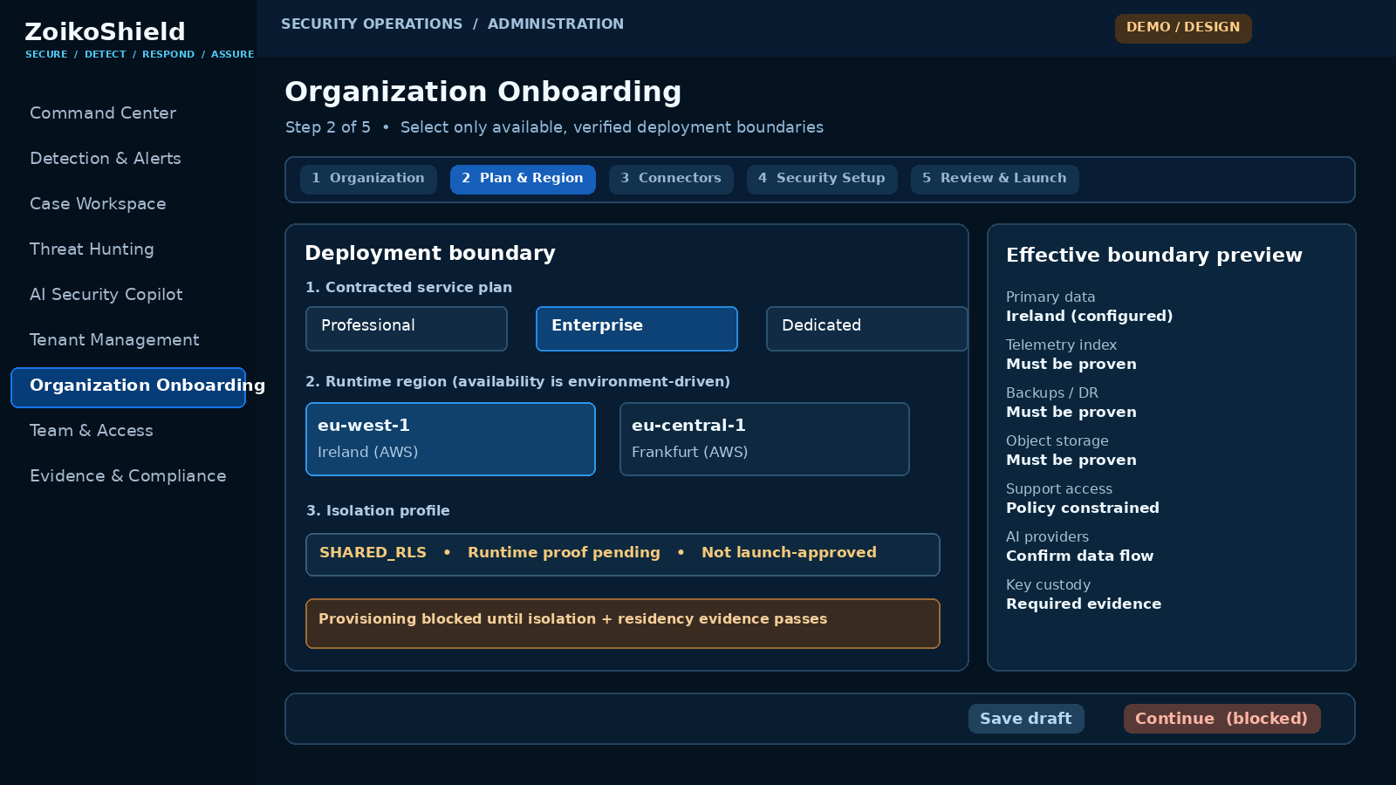
Annotated schematic for the existing Organization Onboarding wizard • State shown: mandatory isolation proof missing
ID | Component / behavior | Server-side rule
R01 | Plan and isolation are separate decisions; plan never implicitly supplies physical isolation. | Return only profiles actually deployed and licensed for the customer and region.
R02 | Region dropdown/cards display exact provider region code and human-readable location. | Resolve against immutable region catalog; invalid/unavailable region → 422, no provisioning.
R03 | Boundary preview lists ALL data classes with disclosed locations or clear “Unverified” labels. | Read from signed infra inventory; no frontend-only field may make “verified”.
R04 | Continue/Activate is unavailable for unverified or legally disallowed configuration. | POST/activate must independently re-check all gates; UI disable is not the security control.

03 WF-G02-02 — Review & Launch (existing step 5)
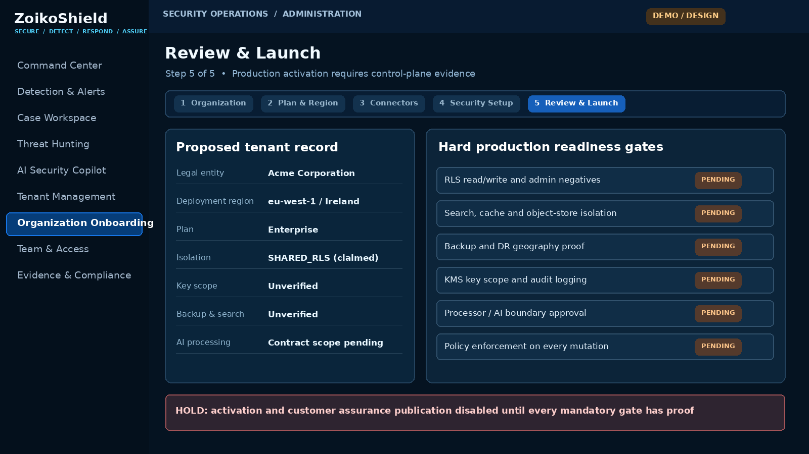
Production activation control • No green badge or successful launch state while mandatory proof is missing
ID | Component / behavior | Failure / audit invariant
L01 | Summary shows effective region, isolation profile, export restrictions and relevant contractual scope. | Values are server-derived; a changed choice re-runs required validation.
L02 | Gate checklist includes data-plane, backup, search, key and processor boundaries. | Each line links to reviewable evidence and its recorded version/expiry.
L03 | Activate remains HOLD when any required gate is absent, expired or invalid. | Fail closed on timeout or stale evidence; no partial production activation.
L04 | A passed activation writes an immutable G1-linked decision receipt. | Record build/config hash, tenant, effective region, approver, proof IDs and timestamp.

04 WF-G02-03 — Tenant boundary evidence (existing Tenant Management)
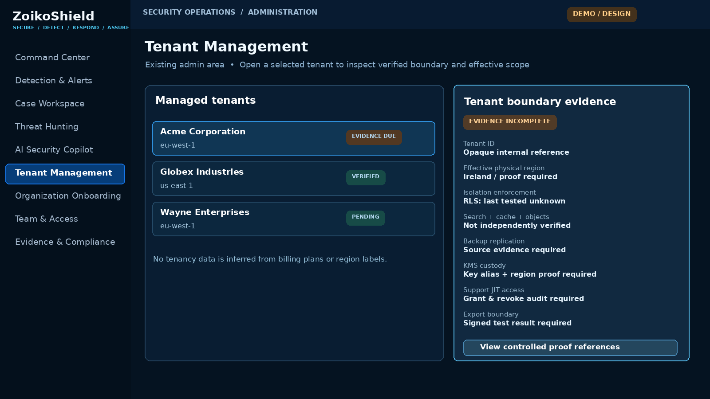
Existing Tenant Management screen with a non-public, role-restricted side drawer • This is not a new navigation destination
ID | Component / behavior | Access / audit invariant
T01 | Display effective physical region, resource scopes and residency proof, not marketing plan labels. | Require security/admin authorization; no cross-tenant list or object access.
T02 | Controlled evidence link opens existing evidence repository with proof ID, freshness and access rules. | Sensitive maps/keys are not returned to ordinary analysts or client viewers.
T03 | Support access uses existing JIT + tenant consent/authorization controls, never unrestricted super-admin. | Record grant, purpose, target tenant, actor, expiration and revocation.
T04 | Any unknown state renders UNVERIFIED, STALE or UNAVAILABLE, not “protected/verified.” | No optimistic fallback or cached green status after expiry.

05 WF-G02-04 — Region migration / exceptional state
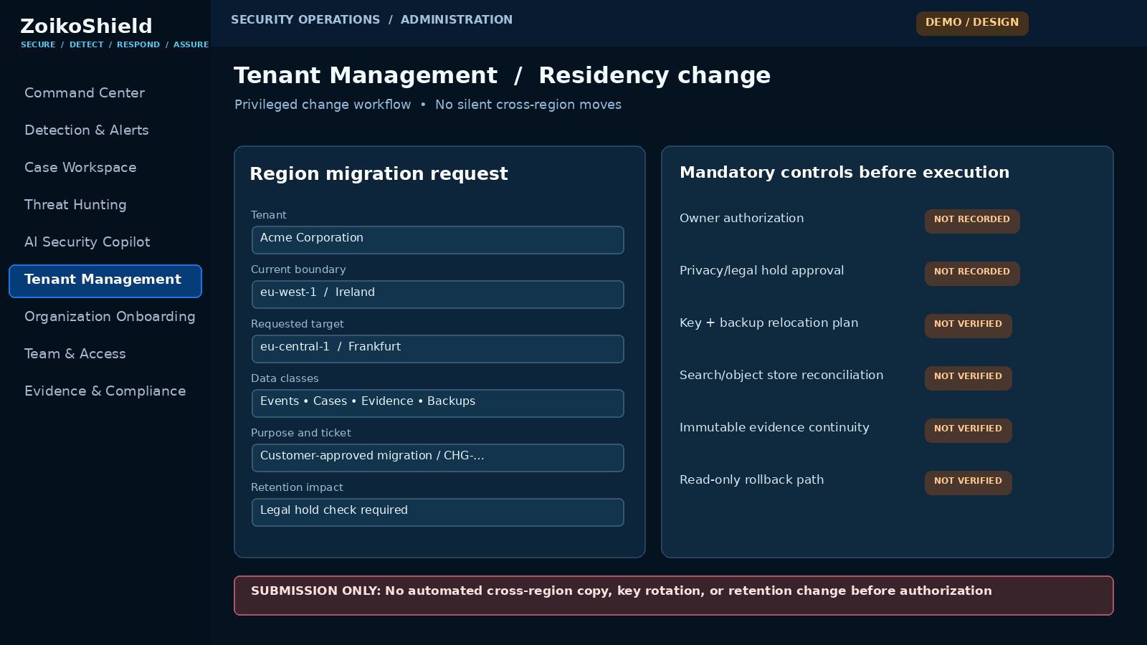
Constrained privileged request on existing Tenant Management • Migration execution is outside this wireframe and disabled until controls pass
ID | Component / behavior | Safety invariant
M01 | Changing region opens a controlled change request; no edit-in-place relocation. | Treat residency as immutable post-activation except through approved workflow.
M02 | Preview all affected classes: data, caches, indexes, backups, logs, evidence and AI context. | No data-copy action triggered by client-side change or unapproved draft.
M03 | Require customer authority, Legal/Privacy, SRE and Security approval as applicable. | No requester self-approval; unique approvers, expiry and revocation checks.
M04 | Execute only by separately authorized operational service with rollback/reconciliation. | No silent rekeying or original-region deletion; legal holds and retention win.

06 Interaction contract — permissions, states and accessibility
Actor / scenario | Visible action | Mandatory API enforcement
Tenant owner | Request onboarding region and inspect allowed summary. | Scoped tenant identity; only available regions; no raw key IDs or internal resource identifiers.
Platform security admin | Inspect boundary evidence and trigger approved remediation. | JIT + Cedar ABAC + purpose binding; cross-tenant privilege not implicit.
Authorized privacy reviewer | View DPA, transfer and support-access scope. | Selective read; no security control override or deployment mutation.
Support operator | Request time-limited support view with customer authority. | Approval chain, lease expiry, scoped break-glass, complete audit trail.
Unauthorized / foreign tenant | Access denied with no foreign record details. | 401 for no valid session; non-enumerating 404 for foreign IDs; 403 for known in-scope forbidden actions.
Stale / unavailable proof service | Neutral error with retry and correlation ID. | No release/activation; refresh only after authoritative source recovers.

UI state machine
State | Allowed UI | Not allowed
DRAFT / REQUESTED | Save choices, see explicit “Not verified,” reopen selection. | No claim of provisioned region or deployed isolation.
VALIDATING | Read-only checks, discreet progress, cancel when safe. | No side-effecting retries without idempotency key.
BLOCKED / UNVERIFIED | List failed control IDs and responsible owner; save draft. | No Activate; no bypass link.
READY_FOR_APPROVAL | Present signed proof/summary and authorized action. | No assumption that ready means activated.
ACTIVE / VERIFIED | Show actual effective boundary, proof freshness and signed receipt. | No lingering green badge after service or evidence changes.
DEGRADED / STALE / UNAVAILABLE | Clearly label uncertainty and next safe action. | No silent fallback to last healthy state.
Accessibility and UX: visible labels, keyboard-operable inputs, focus retention after errors, no color-only readiness signaling, meaningful announcement for failed gate and status changes, predictable modal focus, and explicit “customer-facing data location vs processing/transfers” language. WCAG 2.2 AA is the design target; it is not asserted as achieved.

07 Minimum backend and data contract — no parallel service
Implementation reuses shield-core/tenant, authorization and onboarding modules and existing evidence/G1 mechanisms. Endpoint names below are proposed contract additions or extensions, not claims about existing deployed endpoints.
Boundary / operation | Proposed API / payload | Mandatory invariant
Read available profile | GET /api/v1/deployment-profiles?region={code} | Authorized, environment-actual profiles only; no secret topology details.
Create or amend draft | POST /api/v1/onboarding/organization or PATCH /api/v1/onboarding/drafts/{id} | Bound auth principal + tenant namespace; region catalog check; idempotency.
Read boundary proof | GET /api/v1/tenants/{tenantId}/boundary-evidence | Audience-scoped redaction; proof digest, state, as-of and expiry.
Validate before launch | POST /api/v1/onboarding/drafts/{id}/validate | Reconcile infra inventory, policies, backup locations, DPA and evidence freshness.
Activate | POST /api/v1/onboarding/drafts/{id}/activate | Transactionally enforce server-side release gate + idempotency; emit immutable receipt.
Change-region draft | POST /api/v1/tenants/{tenantId}/region-change-requests | No mutation of residency; distinct approval and migration workstream.
Read health of proof | GET /api/v1/tenants/{tenantId}/boundary-status | Fail-closed semantics; expose sanitized state/correlation ID only.

Minimum data model extensions
Record | Minimum fields / requirements
TenantBoundary | tenant_id, deployed_environment, provider, primary_region_code, profile_code, configuration_digest, state, signed_at, effective_at
BoundaryDataFlow | tenant_id, data_class, resource_group, origin_region, processing_region(s), backup_region(s), purpose, transfer_legal_basis_ref, retention_rule_ref
BoundaryEvidence | evidence_id, tenant_id, gate_id, artifact_digest, issuer/owner, test_environment, test_version, validated_at, expires_at, reviewer, decision
BoundaryChangeRequest | request_id, tenant_id, from/to region, dependency inventory, legal_hold_flag, authority_grants, unique approvals, execution/rollback status
BoundaryDecisionReceipt | tenant_id, actor, effective policy version, build/config hash, gate results, proof IDs, request id, timestamp and immutable audit link
Security implementation constraints: derive tenant context from the authenticated server principal; never trust tenant_id in request body; enable and FORCE RLS where applicable, use least-privilege DB roles, define connection-pool tenant context reset, service-account scoping and isolated signed background jobs. A generic RLS check is insufficient without cache, search, object-store, event-bus, logs and export checks.

08 Cross-surface isolation and residency coverage map
Engineering inventories every physical resource and processor that can contain customer data or evidence. “In region” is proven per data class, not inferred from a tenancy row or an AWS account label.
Surface | Isolation proof required | Geography / data movement proof
Primary PostgreSQL | FORCE RLS coverage; tenant context; pool reset; admin/bypass role tests. | DB instance/account/region inventory; replicas and snapshots.
Object store / exports | Bucket prefix + IAM policy + signed URL scope/expiry + cross-tenant deny. | Bucket region, replication and lifecycle deletion.
Search/analytics | Index aliases, document-level access, query execution and reindex/replay tenancy. | Actual storage cluster and cross-region replication.
Queue / stream / DLQ | Partition/consumer group and event tenant assertions; poison-message quarantine. | Broker/buffer/retention regions and regional recovery.
Cache / sessions | Tenant-scoped keys, logout and role-change invalidation, shared cache denial. | Cache/session placement and failover geography.
Evidence vault / verifier | Tenant-bound object access; sealed package content; external recipient policy. | Root-hash witness, TSA and export destinations; identify cross-border processors.
Backups / DR | Restore to segregated tenant; encrypted backup, immutable inventory and test replay. | Backup region, disaster failover, access and deletion schedule.
Telemetry/metrics/logs | No sensitive fields in shared traces; sanitization and support-access checks. | Collector regions and external observability processors.
AI models / embeddings | Prompt, response, vector index and tool-call tenancy; content isolation. | Provider location, retention, subprocessors and transfer basis.
Support/admin systems | JIT grants, step-up, consent/authority, case and export access logs. | Operator location, ticket attachments and permitted access boundaries.

Architecture choice A truly sovereign or dedicated offer is a separate deployment/contract configuration requiring proof of every connected processing surface. Do not label shared RLS tenancy “physically segregated” or “sovereign” by default.

09 Adversarial negative tests and production launch criteria
ID | Test stimulus | PASS requires
G02-T01 | Foreign principal requests tenant metadata and case by known ID. | Deny; non-enumerating response; no body or timing-leak of foreign data.
G02-T02 | Cross-tenant read/write via API, worker, direct DB and privileged service role. | No unauthorized row read/write; RLS and elevated role exception audited.
G02-T03 | Connection-pool reuse and stale tenant context after failure/retry. | Tenant context cleared; no prior-tenant query visibility.
G02-T04 | Foreign object, export URL, evidence package and search-index query. | All denied or empty without existence leak; no downloadable bytes.
G02-T05 | Cache key collision, stale session, role revocation. | No access after revoke; stale or shared key never serves foreign data.
G02-T06 | Replay/poison cross-tenant job and queue/DLQ message. | Quarantine; never act under receiving tenant; logged correlation ID.
G02-T07 | Configure region not deployed or inconsistent region code. | Reject before provisioning; no resources created in unintended region.
G02-T08 | Inspect KMS/backup/replica/evidence/log region inventory. | All declared locations match actual resource/API inventory or documented approved exception.
G02-T09 | Kill evidence or policy dependency during activation. | Fail closed; tenant cannot become ACTIVE; no partial customer-facing success.
G02-T10 | Unauthorized support admin / expired JIT / self-approval. | Access and escalation rejected; audit record emitted.
G02-T11 | Request region change with live evidence/legal hold. | Draft only; no move without approval, dependency inventory and retention safeguards.
G02-T12 | Try non-resident AI/telemetry processor or exported diagnostic bundle. | Blocked where contractual policy disallows; explicit approved exceptions else.
G02-T13 | Attempt UI manipulation or direct Activate API while gate is HOLD. | Server rejects, regardless of client button state; no signed green receipt.
G02-T14 | Load stale boundary badge from CDN, browser cache or API. | Show STALE/UNVERIFIED; green badge suppressed automatically.
G02-T15 | Restore a tenant from backup in isolated test environment. | No foreign records; recorded restore destination, encryption and cleanup proof.
Evidence minimum: signed test run IDs, commit/build digest, environment, policy/DB role versions, tenant A/B synthetic fixtures, direct evidence of actual resource region, negative request traces, expected vs observed results, open defects and independent reviewer. An empty checklist or screenshot cannot pass.

10 Closure evidence, ownership and decision authority
Deliverable artifact in existing G1 evidence store | Required reviewer / criterion
E01 — Actual tenancy/profile topology + region and resource inventory | Cloud/SRE — immutable regional mapping; accurately identifies unavailable tiers.
E02 — Tenant + role authorization matrix; RLS SQL/role configuration | Security Engineering — reviewed authorization behavior, no bypass.
E03 — Data-flow and processor map for all surfaces in Section 08 | Privacy/Legal — scope, transfer and subprocessor agreement reviewed.
E04 — KMS key/replica, backup, search, object store and queue placement evidence | SRE + Security — exact environment and dates recorded.
E05 — G02-T01 to T15 negative test evidence with replayable scripts | Independent QA/Security — no unresolved tenant-boundary severity P0/P1 defects.
E06 — UI preflight, denied activation, stale proof and role-based states | Product/Accessibility — checked on production-equivalent staging.
E07 — Scoped customer wording / DPA alignment and publish-safe claims | Legal/CISO — synchronized with G01; no unsupported sovereignty assertion.
E08 — Existing G1 ratification decision linking E01–E07 | Authorized eight-role launch gate — HOLD if any required proof unavailable.

Unresolved decisions (these are not engineering assumptions)
Product, Cloud and Legal must decide which isolation/deployment profiles are actually offered; whether any region-specific processing, backup or support exceptions are contractually permissible; and whether cross-region migration is part of launch scope. Until then, expose only technically verified choices, keep exceptions explicit, and do not sell sovereign tiers as implemented.

Do not produce / do not expand
No new dashboard, no “sovereignty score,” no duplicate G1 release management, no new microservice, no unverified dedicated-cloud promise, and no out-of-scope regional migration automation. Reuse the current onboard/tenant/admin surfaces. All checks that can be expressed by existing platform components belong there.

Reference and provenance
Internal: ZoikoShield Enterprise Architecture & Infrastructure GAP Analysis v1.0 (October 31, 2026), G02; ZOIKOSHIELD_LIVE_DEMO_MASTER_GUIDE.md and ZOIKOSHIELD_STEP_BY_STEP_DEMO_LINKS.md (October 13, 2026); existing Organization Onboarding Dashboard reference (visual baseline). Public region terminology: AWS official region catalog, https://docs.aws.amazon.com/global-infrastructure/latest/regions/aws-regions.html.
Final approval rule Document 02 specifies closure; it does not attest implementation. Treat G02 as OPEN until E01–E08 are validated and recorded in existing G1. Do not advance to another document until founder approval.

