ZOIKO TECH INC. / CONTROLLED PRODUCT GAP CLOSURE

G07 | Detection content, entity risk
& quality assurance
Detailed engineering wireframe & measured release acceptance specification • Version 1.0 • 31 October 2026
P1 / SCOPE | G07 is the first scope-dependent gap following G01–G06. It is a launch blocker only for the detection functions and first-customer use cases ZoikoShield elects to sell, demonstrate as live, or contractually guarantee.

Executive implementation decision
Preserve the existing shield-ingest detection capability, OCSF v1.1 normalization, Detection & Alerts, Case Workspace, Threat Hunting and Simulation & Training. Add a small versioned content pack, tenant-bounded entity correlation, interpretable risk evidence and reproducible replay assurance. No new SIEM, detection microservice, sidebar tab or global content catalogue.
Decision | Engineering consequence
Deliverable | Four annotated refinements to existing user screens; rule/content lifecycle, entity-resolution and risk-scoring contracts; six illustrative pilot detections; 24 targeted acceptance tests; G1 evidence checklist.
Baseline caveat | The 13 October demo establishes design descriptions of threshold detections and MITRE tags; no independent precision/recall, live-source coverage or versioned rule regression artifacts have been reviewed.
Product focus | Identity + cloud administrative attack paths first, subject to verified connector event fields and first-customer telemetry. Do not market “all threats detected” or all ATT&CK coverage.
Cross-gap boundary | G02 isolation; G03 delivery/parsing; G04 response authorization; G06 evidence anchors; G08 storage/retention; G10 AI safety; G11 UI fidelity. This document must not rewrite them.

Definition of done
Each in-scope shipped detection has a frozen source requirement, deterministic implementation and identifier, labelled true-positive/benign/missing-data fixtures, stable risk/entity semantics, measured results, rollback evidence and SOC-approved release receipt. Alerts link back to G03 inputs and G06 evidence references.

01 Scope firewall and inherited architecture
Existing component / decision | Documented reference | Only new G07 requirement
shield-ingest :3002 | OCSF v1.1 normalizer, stream/windowed threshold detection and connector telemetry. | Versioned detection contracts, source readiness gating and deterministic event-time windows; rely on G03 for durability and replay receipt.
Detection & Alerts /alerts | Alert triage and deep dive (26-screen demo routes 6–7); selected MITRE mappings. | Display risk explanation, source health, rule version, suppression lineage and measured vs unmeasured quality truth.
Case Workspace /cases | Investigations, timelines, evidence ledger, promotion of alerts to cases. | Entity risk storyline and data-source/case links; no case schema rewrite beyond necessary risk references.
Threat Hunting /hunting | Hypothesis-led hunts and link to cases; AI investigations available elsewhere. | Analyst corroboration; searches and AI-generated conclusions not treated as detection ground truth.
Simulation & Training | Existing UI design for simulation and controlled response training. | Isolated labelled-fixture replay and quality gate; never dispatch real SOAR or contact external assets.
G01–G06 closure documents | Trust/tenant/ingest/action/DR/evidence security contracts. | Consume existing proof IDs and enforced controls, not duplicate authorization, persistence, data-residency or cryptographic design.

STOP RULE | If the first-customer launch scope excludes a scenario or its source has not been connected with real data, mark NOT SUPPORTED or DEFERRED. Do not add generic threat categories to fill a marketing feature count.

02 Small first-segment detection pack: six candidates
Candidate ID / scenario | Required event evidence + logical trigger | Technique hypothesis / release condition
ZS-DET-ID-001 Password spray | Repeated failed authentication across a distinct-user set and source IP within a pinned event-time window; approved proxy identity handling. | ATT&CK T1110.003. Ship only if the IdP feed supplies actor, outcome, time, IP and distinct-user fields.
ZS-DET-ID-002 Failure then success | Material failed attempts followed by successful authentication for the same confidently resolved identity; include device/IP and time context. | T1110 with potential T1078. Requires benign helpdesk/typo fixtures and late-arrival tests.
ZS-DET-ID-003 Privileged role change | Identity/cloud-control-plane role grant or permission escalation inconsistent with approved administrative context; captures actor and target. | T1098 candidate. Requires actual supported audit operation IDs and approved-administrator exceptions.
ZS-DET-ID-004 Excess MFA prompting | Unusual repeated or denied MFA challenges with stable user/session link and reasonable windowing. | T1621 hypothesis. Source must expose challenge outcome and recipient identity; avoid pure volume thresholds.
ZS-DET-ID-005 Credential lifecycle change | Unexpected change in service-account/application credential, token or authorization grant with source and role context. | T1098 family hypothesis. Ship only when exact provider audit semantics are confirmed.
ZS-DET-CLOUD-006 Audit visibility reduced | Cloud security logging, monitoring or detection setting modified/disabled by a privileged principal. | T1562 family hypothesis. Require real administrative audit events and exclusions for planned changes.

These six are proposed candidates, not a claim of six implemented or accurate live rules. The launch pack may be smaller. Prioritize two fully proven end-to-end detections over six unverified alerts.
CONTENT RIGHTS | ATT&CK identifiers and vendor telemetry fields are references to documented behavior. Implement original ZoikoShield logic; avoid copying third-party proprietary Splunk/XSIAM/CrowdStrike rules or claiming Sigma compatibility unless verified.

03 Rule package and test fixture contract
Schema object / field | Exact semantic contract | Failure / release behavior
rule_id, version, digest | Stable immutable rule ID; semver version; signed normalized definition digest; author, reviewers, owning team, changed fields. | No in-place production edits; any semantic change gets a new version and regression.
scope + source prerequisites | Tenant/region; OCSF class/field mapping; connector ID/type/version; source event completeness and freshness thresholds. | Missing data => NOT_EVALUABLE, never “no threat.” Unsupported source suppresses marketing claims.
execution logic | Event-time window, clock-skew tolerance, watermarks, threshold/aggregation parameters, entity keys, exclusion references. | Late events reopen/recompute deterministically; dedup once; window policy explicit.
classification + versioned mapping | Detection type; ATT&CK version; technique IDs; rationale; required source fields; outcome/status vocabulary. | No ungrounded “complete ATT&CK coverage”; check current technique versions during review.
risk contribution | Entity type and stable key, base risk factor, severity, corroboration source, uncertainty, decay and cap, suppression reason. | Score cannot be fabricated in UI; deterministic calculation and explanation.
fixtures + golden outcomes | Data set ID, source+schema versions, signed content hash, ground-truth provenance, label taxonomy, expected findings/none. | Ambiguous or unlabeled fixtures excluded from statistical denominators.
rollout/rollback | draft → tested → reviewed → canary → active → retired; allowed cohort, UTC change and prior version pointer. | Atomic activation with G04 authorization; disable or roll back on quality degradation.
quality receipt | TP, FP, FN, TN where knowable; benign suppression, duplicate counts, delayed-event errors, source coverage and SOC review. | Report CIs/denominators; small-N warnings. No self-approved PASS based on synthetic-only data.

04 WF-G07-01 — Risk-qualified Detection & Alerts triage
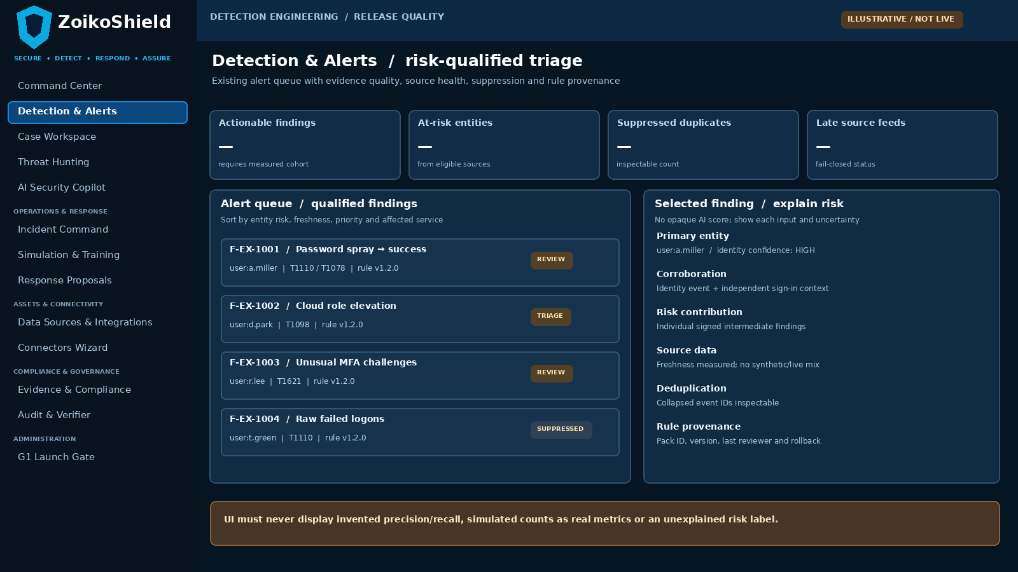
Existing Detection & Alerts page, refined to surface source health, rule provenance, entity confidence and deduplication. All examples are illustrative.
Pin | Required interaction and copy | Non-negotiable backend truth
01 | Findings show named entity, rule version, ATT&CK hypothesis, latest source timestamp and raw event link. | G02 actor/tenant scoping; G03 source/event pointers; no fabricated values.
02 | Filter/sort by actionable risk, source freshness, suppression, data readiness and analytic version. | Persisted server query with stable pagination; role-based access and bounded query cost.
03 | Explain risk as intermediate contributions and corroboration; open linked case, no auto-SOAR. | Calculated signed finding inputs; G04 actions require separate human approval.

05 WF-G07-02 — Rule governance in existing alert workspace
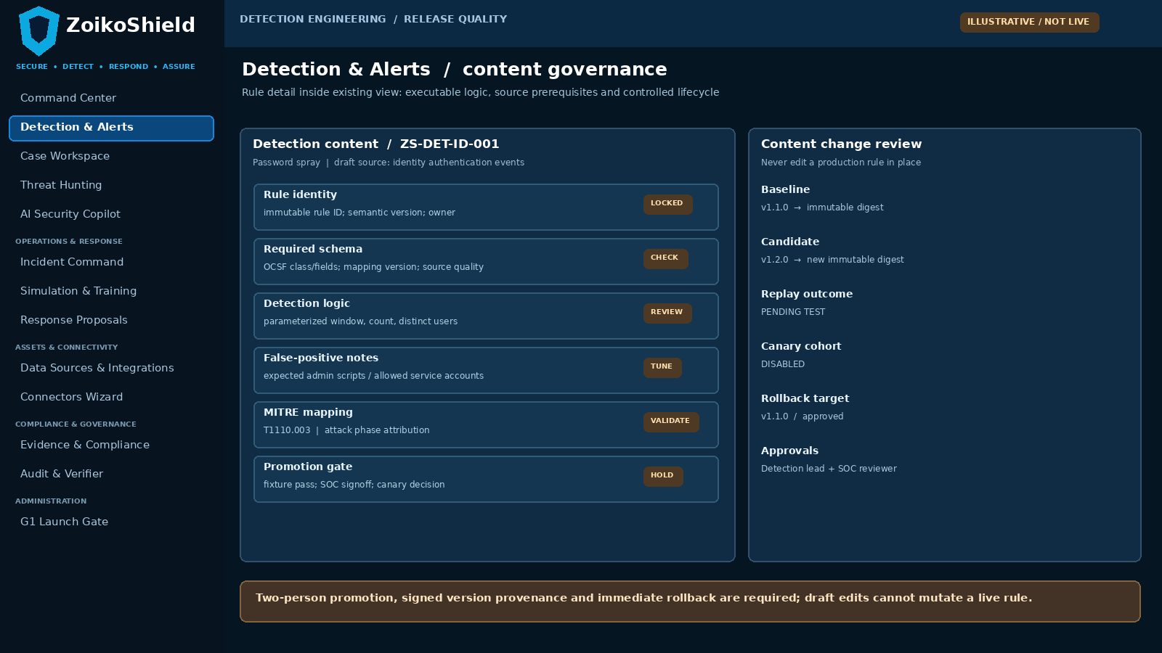
Versioned rule detail is a nested view of Detection & Alerts, not a new top-level navigation entry. Promoted versions are immutable.
Pin | Operator journey | Required policy and lifecycle enforcement
04 | Open rule from finding, inspect exact version, source prerequisites, false-positive rationale and affected tenants. | No display-only authority; editor, reviewer and approver are separately authorized.
05 | Create candidate fork, diff scope/threshold/window against previous version, attach replay receipt. | Immutable rule digest; test fixture/source versions pinned; no untracked production edits.
06 | Canary selected tenant cohort; measure recall/false positives before promotion and retain rollback target. | Rollback or fail-closed on drift, source loss, false-positive spike or revocation.

06 WF-G07-03 — Explainable case/entity risk storyline
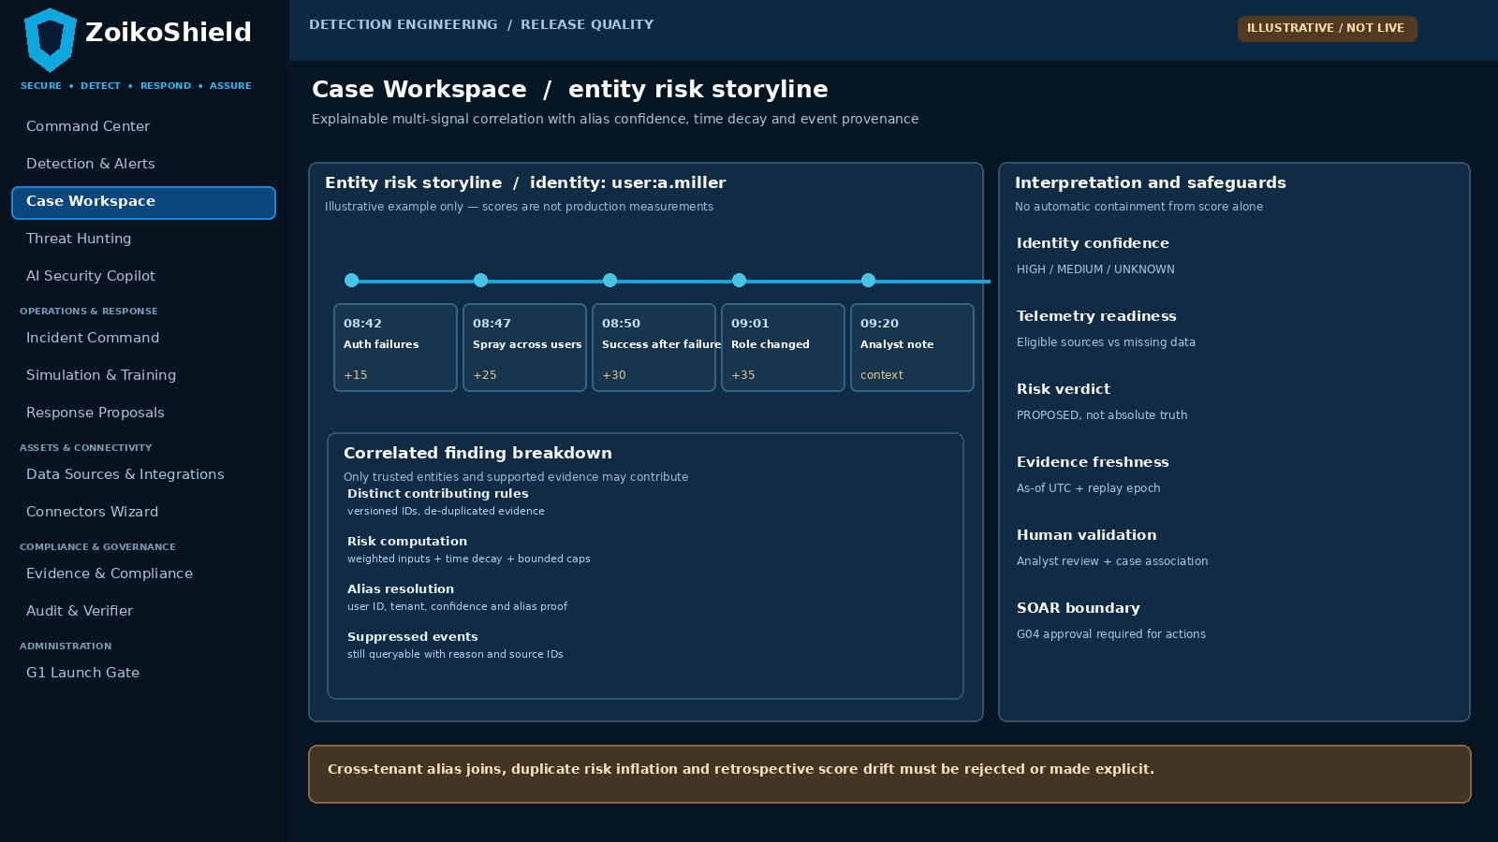
The existing case workspace may show a risk storyline; correlation requires identity assurance and does not bypass SOAR authorization.
Pin | Analyst-facing behavior | Server-side correlation contract
07 | List intermediate rule findings with UTC event time, risk contribution, data source and identity confidence. | Only same tenant and sufficiently trusted entity aliases contribute; risk event linked to input IDs.
08 | Expose deterministic aggregation, time decay, duplicate collapse and suppressed findings. | Scores recompute on late events and replays without accumulating duplicate risk.
09 | Allow analyst notes and case association, but not edits to event history or raw risk computation. | Append-only review annotations; score adjustments require approved rule/version change.

07 WF-G07-04 — Isolated replay and quality review
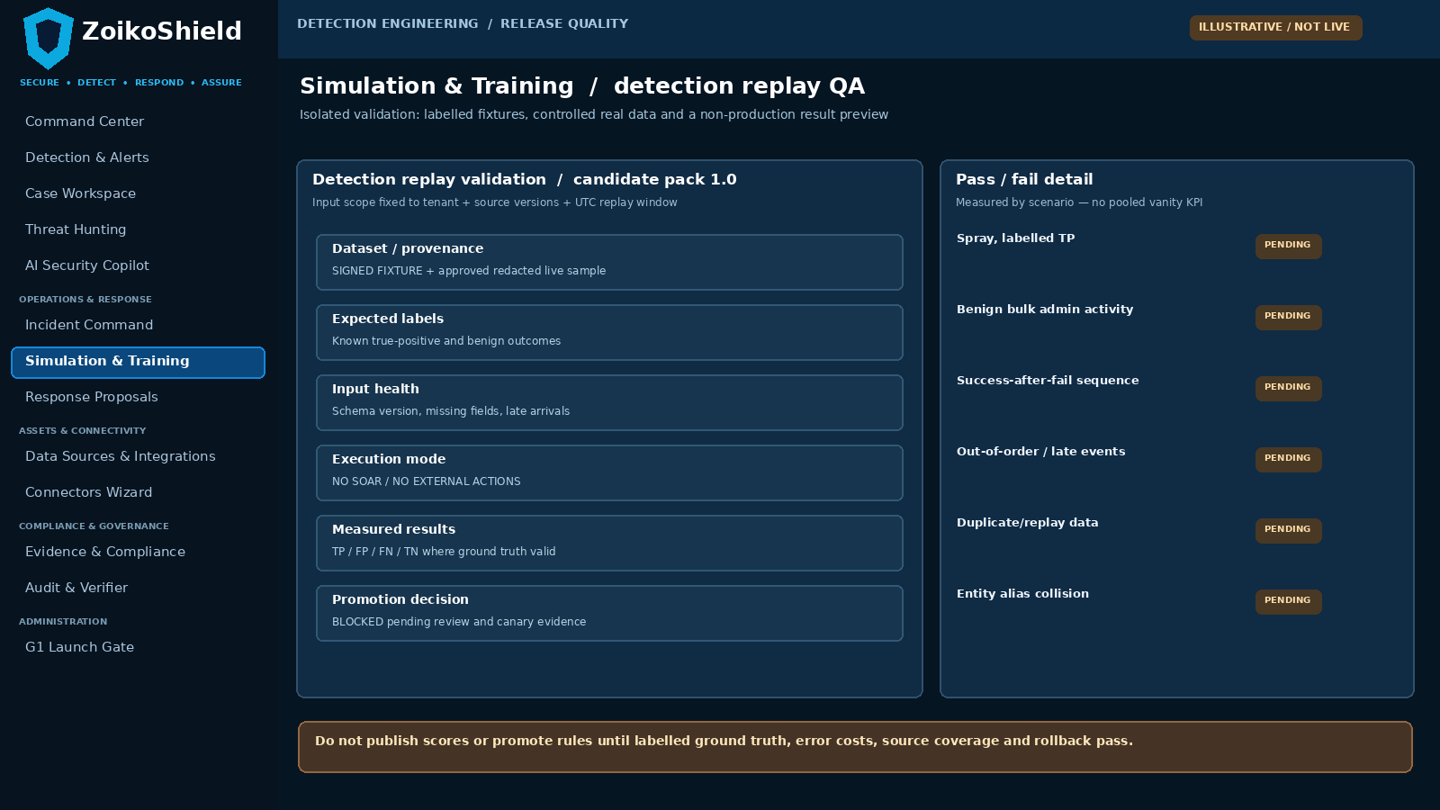
Simulation & Training extends to a scoped detection replay view. All data remains simulated or explicitly labelled controlled-live; no external action APIs are called.
Pin | Expected review flow | Release enforcement
10 | Select signed fixture and pinned source/OCSF/rule versions; show missing fields and known-label coverage. | No cross-tenant export, masked sensitive data, no actions, no billable production ingestion.
11 | Compare generated findings with labelled outcomes; show TP/FP/FN/TN only where truth is available. | Deterministic test harness with reproducible metrics and negative cases.
12 | Two-person SOC/Detection promotion, canary, change receipt and rollback view. | G1 references immutable results; failed gate cannot be bypassed by UI toggle.

08 Entity identity resolution, suppression and scoring
Boundary | Required design decision | Negative case that must be handled
Canonical entity ID | Risk partition key = tenant_id + entity_type + canonical_entity_id + confidence_policy_version. Preserve original aliases, source IDs and resolution decisions. | Same email string in two tenants; re-used device hostname; account rename and recycled username.
Confidence states | HIGH: verified immutable external ID; MEDIUM: corroborated stable mapping; LOW/UNKNOWN: ambiguous. Policy explicitly excludes ambiguous joins from high-impact aggregation. | Multiple users share NAT IP; guest identity looks identical to internal; partial device IDs.
Risk increment | Separate intermediate risk events from entity aggregate; each has rule ID+version, source event fingerprint, event-time and factor. | Replayed same packet or multiple connectors forwarding same underlying source action.
Temporal aggregation | Use event-time, bounded windows/decay and saturation caps. Preserve policy version and computed as-of timestamp; correct late records deterministically. | Out-of-order evidence; backfill after finding; daylight-saving ambiguity.
Dedup and suppression | Suppress on deterministic tenant + rule/version + entity + source event/cluster identity; preserve suppressed evidence and reason. | Different attackers share an IP; suppression hides a new high-confidence source.
Risk interpretation | Entity risk is a prioritization aid, not proof of compromise, a compliance certification or SOAR authorization. Show contributions and confidence. | Scoring with missing source; synthetic replay inflates live entity risk; analyst changes annotation.
False-positive exclusions | Document approved scheduled admin changes, expected bulk processes, service accounts and scope; exceptions expire and are reviewed. | Permanent blanket allowlist hides new attacks; user overrides production baseline without review.

SCORE POLICY | A particular “70/100” score, threshold, weighting or decay is NOT predetermined here: Detection Engineering must propose data-driven constants, test them on labelled cohorts and obtain SOC approval before launch. No fictional confidence % or absolute accuracy claim.

09 Deterministic processing sequence and stable states
Step | Input / computation | Output and consistency condition
1 Ready source | G03 durable receipt, tenant/region, OCSF version, connector freshness and required fields. | NOT_EVALUABLE with exact missing reason if prerequisites absent.
2 Candidate rule | Signed immutable rule ID/version, pinned parameters and approved applicable tenant cohort. | Reject unknown/retired/unsigned content or policy-disabled rule.
3 Window evaluation | Event-time windows with watermark/lateness and repeatable deterministic ordering. | Intermediate detection event with stable fingerprint; no duplicate effect.
4 Resolve entity | Source immutable identity, aliases, confidence and collision policy. | Attributed canonical ID or UNKNOWN; do not merge on weak IP/email alone.
5 Correlate risk | Deduplicated intermediate risk events across independent rules/sources; bounded scoring/decay. | Transparent, versioned risk contributions and current calculation state.
6 Emit finding | Risk threshold or explicit high-criticality rule; suppression and missing-data rules applied. | Alert + full input/source/rule linkage; separate affected entity and case association.
7 Analyst disposition | Benign/true positive/uncertain with reviewer ID, UTC and labelled-evidence scope. | Learning feedback append-only; never rewrite historical detection result.
8 Evidence and release | G06 audit references, G04 controlled action boundary, G1 signed quality change. | Immutable release/tuning receipt; G1 not passed on demo/synthetic data alone.

Required state vocabulary
CANDIDATE / NOT_EVALUABLE / EVALUATED_NO_MATCH / INTERMEDIATE_RISK / FINDING_OPEN / SUPPRESSED_WITH_REASON / RECOMPUTED / REVIEWED / RETIRED. Distinguish “no detection” from “no source data”; each transition records timestamp, rule+schema version and responsible process.

10 Minimal API and persistence contracts (implementation target)
Logical existing view / proposed extension | Request or record content | Required response / fail semantics
/alerts list/detail (existing) | Tenant, range, entity, rule ID/version, risk band, freshness and suppression filters; cursor. | Server-authorized stable page, finding ID, source-event refs, risk breakdown; no unauthorized tenant pivot.
Rule inspect/version proposal (nested) | rule_id, version, full immutable digest, owner, source contract, lineage, candidate diff, approval refs. | State + reviewer + test receipt; invalid schema/unsigned proposal rejected; no PUT-to-overwrite active rule.
Risk finding reference | finding_id, tenant, canonical entity ID, confidence, rule inputs, dedup key, event-time, computed_as_of. | Versioned deterministic computation; append-only correction/recompute receipts and source links.
Replay job (existing Simulation area) | Signed fixture ID+hash, schema+connector versions, candidate rule digests, replay policy, no-external-actions flag. | Job ID, pinned snapshot, bounded CPU/time, outcome and immutable result digest. Isolated from production.
Label/disposition | Finding ID, reviewer, label meaning, support evidence, review policy; event-time + review-time. | No direct edit to raw events; conflict and unknown labels kept, not overwritten.
Rule promotion/rollback | Current+target digests, canary tenant set, signed approvals, previous version, UTC deployment epoch. | G04 policy, no dual-role self approval, immutable receipt; automatic rollback criteria.
Evidence linkage | G03 raw receipt/event IDs, normalized event digests; G06 package/case references when present. | Failure to resolve provenance => display UNVERIFIED and block claim of verified detection.
Quality summary | Fixture/real cohort, ground-truth source, TP FP FN TN denominators, CI, sampling bias, launch segment. | Report metric only where mathematically defined; do not combine incomparable cohorts or report 100% from no tests.

API NOTE | Method names and routes for rule/replay/promotion are target logical contracts, not assertions that these endpoints already exist. Engineering must reconcile and extend current controllers instead of introducing conflicting parallel APIs.

11 Detection quality measurement and promotion gates
Metric / control | Definition / reporting requirement | Promotion requirement
Precision (PPV) | TP/(TP+FP) on labelled positive findings; report numerator, denominator, confidence interval, cohort and base-rate caveat. | Threshold decided by SOC per scenario BEFORE observing test results; not set globally by document.
Recall / sensitivity | TP/(TP+FN) on a labelled population that includes known attacks and detectable negatives. | Do not claim recall if negatives/unseen attacks are unlabelled; include coverage limitation.
False-positive workload | False alerts per tenant/day and per 1,000 eligible events, analyst handling time, suppression reason and source cohort. | Must remain within customer SOC service-budget approved before canary.
Timeliness | Event time→durable ingestion→rule evaluation→alert→case timestamps, P50/P95/P99 and missing data. | SLO based on representative load and G03 instrumentation, not simulated latency badges.
Coverage | Eligible connectors, required fields, source-quality states and technique scenario mapping; not a count of ATT&CK tags. | Ship only scenarios for which source prerequisites and tests pass.
Regression and drift | Stable fixture suite + controlled live replay + approved risk/suppression policy; compare against last release. | No material unexplained degradation; signed SOC disposition of any change.
Change accountability | Two distinct authorized persons approve test and promotion; preserve rollout, rollback, version and signature. | Canary + rollback tested; no elevated self-approval and no direct action bypass.
Truthful status | Report NOT_EVALUABLE and UNKNOWN distinctly from zero findings and PASS. | Source drop or invalid schema cannot produce a green “zero threats” claim.

Pilot acceptance values are intentionally unfilled pending the first customer’s event volume, risk appetite, SOC staffing and labelled ground truth. Choosing numerical targets without these inputs would manufacture precision. The signed acceptance record must contain the agreed values prior to testing.

12 Adversarial and functional acceptance tests D01–D12
ID | Controlled scenario | Required observed result
D01 | Password spray fixture across many users, distinct IPs and expected attack interval. | Exactly expected finding(s); correct T1110.003 mapping, linked source events and identity attribution.
D02 | Human typographical errors and permitted login retry benign fixture. | No high-severity false finding; suppression/explanation and labelled benign outcome visible.
D03 | Repeated failures followed by login success, with mixed-outcome sources. | Bounded correlation with source/event context; no claim of confirmed compromise without validation.
D04 | Administrator-approved cloud role change vs unauthorized analogous change. | Benign control and malicious candidate differentiated by available context; missing context shown UNKNOWN.
D05 | Burst of MFA challenges with legitimate access and explicit push-fatigue attack fixture. | Source-dependent logic produces expected distinctions or NOT_EVALUABLE if fields absent.
D06 | Duplicate events through webhook and API, including re-ingestion after failure. | One semantic intermediate risk event; all provenance refs preserved; no double counting.
D07 | Out-of-order events and late-arriving success changing window outcome. | Deterministic replay/backfill recomputation with supersession receipt, no silent stale alert.
D08 | Schema omission/unknown value in required OCSF fields. | Rule reports NOT_EVALUABLE with missing-field reason, never silent no-hit result.
D09 | Same email / host alias in two unrelated tenant IDs. | No cross-tenant entity join, risk aggregation or result disclosure.
D10 | Ambiguous aliases behind shared NAT IP and reassigned account name. | Confidence policy blocks unsafe risk fusion; source aliases and decision trace retained.
D11 | Suppress a known false-positive pattern then replay new independent source evidence. | Suppression does not hide new corroborated malicious behavior; suppression reason auditable.
D12 | Attempt activation with unsigned or retired rule definition. | Hard rejection with version/digest policy error, despite a success-looking UI state.

13 Adversarial and release acceptance tests D13–D24
ID | Controlled scenario | Required observed result
D13 | Rule threshold edited without version bump, fixture diff or reviewer. | Active rule immutable; attempt denied, audit receipt generated.
D14 | Same person proposes and approves sensitive rule deployment. | Reject dual-role self approval via backend G04 policy; UI cannot override.
D15 | Run replay with no-external-actions flag and dangerous SOAR proposal in result. | No real network change, no external API calls; only synthetic/isolated finding preview.
D16 | Synthetic replay events share entity ID with a real tenant user. | Replay namespace isolated; never increases production risk, billing counts or incidents.
D17 | Signed fixture changed by one byte / sample label altered post-hoc. | Digest mismatch blocks evaluation or marks results invalid; metrics cannot be self-adjusted.
D18 | Low-sample/no known negative test cohort submitted as 100% accuracy. | System refuses misleading pooled metrics; outputs undefined metric + denominator warning.
D19 | Source connector stale/disabled while an earlier detection rule remains enabled. | Readiness shows STALE/NOT_EVALUABLE and alerts customer operations, not “no threats.”
D20 | Unexpected false-positive burst in limited pilot canary. | Measured regression alert, canary hold/rollback, owner and signed evidence.
D21 | Rollback from candidate to last approved rule while historical alerts remain. | Prior rule reactivated without rewriting earlier finding/risk receipts; versions traceable.
D22 | Risk score cap/decay crossed by repeated duplicate or expired inputs. | Aggregation consistent with versioned formula; expired contributions removed without phantom accumulation.
D23 | Finding promoted to case with raw event then exported in G06 bundle. | Traceable source→rule→entity risk→finding→case/evidence, with verified provenance scope.
D24 | Re-run complete pack on release candidate, representative data and negative control sources. | Pre-agreed quality gates pass; independent SOC sign-off and G1 evidence receipt, or HOLD with reason.

14 Minimum evidence and engineering ownership
Evidence ID | Precisely required artifact / reproducibility basis | Review and acceptance owner
G07-E01 | Signed inventory of in-scope launch detections; immutable rule IDs/digests, owner, preconditions, ATT&CK mapping rationale. | Detection Engineering Lead + Threat Research.
G07-E02 | Versioned source field-mapping inventory and real connector readiness; missing-field / stale-source samples. | G03 Data Platform owner + Detection QA.
G07-E03 | Versioned, labelled true-positive and benign fixtures with signed digest, labels, origin, consent and privacy scope. | Independent Security QA + Privacy where applicable.
G07-E04 | Per-scenario TP/FP/FN/TN and bounded cohort precision/recall estimates; denominators, bias notes and source health. | SOC Lead + Detection Quality reviewer.
G07-E05 | Entity resolution/confidence/alias tests, dedup evidence, replay consistency and recomputation receipts. | Data Engineering + Tenant Security QA.
G07-E06 | Rule promotion/rollback, reviewer separation, canary monitoring and exception register. | Platform Security + SOC Operations.
G07-E07 | End-to-end G03 event → detection → case → G06 provenance links; isolation and no-external-action replays. | Integration QA + Evidence Service Owner.
G07-E08 | Existing G1 immutable record with customer-segment scope, approved quality thresholds, final outcome and signed SOC release. | Product Owner + CISO delegate + G1 owner.

Lean execution sequence
1. Confirm the first-customer attack scenarios and actual live connector fields. 2. Implement the smallest complete pack (initially up to six proposals, fewer where required). 3. Bind entity/dedup/risk semantics. 4. Extend only four existing views. 5. Establish independent, labelled replay and measured SOC gates. 6. Canary, roll back deliberately, and sign the existing G1 evidence receipt.
NO EXTRA ESTATE | No UEBA-wide rebuild, additional detection service, 1000-rule catalogue, new dashboard, separate rule-editor platform or new architecture series. If a requirement is already implemented, attach measured proof rather than reimplement it.

15 Final G07 go/hold rule and authoritative references
Release decision | Strict interpretation
G07 GO — scoped | At least one approved, high-value initial-customer attack journey is proven end to end; all marketed scenarios have source readiness, labelled positives/benign controls, risk provenance, repeatability, sign-offs and canary/rollback evidence.
G07 HOLD — marketed scope | Missing ground truth or source fields; inability to reproduce detections; serious false-positive regression; unsafe entity merge; cross-tenant leak; synthetic-live mixing; unsigned rule promotion; no rollback; G1 evidence absent.
Legitimate defer | Uncontracted sectors, unavailable cloud sources, broad ATT&CK coverage, global threat-content breadth and advanced UEBA need not be shipped; explicitly mark unsupported rather than imply coverage.
Non-security UI issue | Minor cosmetics may be triaged by the existing G11 UI/QA program, but not if they hide source staleness, missing proof, unsafe actions or false confidence.
Current status | This document is a detailed implementation and test specification, not evidence of completed detection implementation, independently observed accuracy, red-team success or release approval.

Source baseline
[P1] ZoikoShield Enterprise Architecture & Infrastructure Gap Analysis v1.0, 31 October 2026, finding G07. [P2] ZOIKOSHIELD_LIVE_DEMO_MASTER_GUIDE.md and ZOIKOSHIELD_STEP_BY_STEP_DEMO_LINKS.md, user-supplied, 13 October 2026. [P3] G02–G06 closure specifications, 31 October 2026. Existing Detection & Alerts, Case Workspace, Threat Hunting and Simulation & Training designs remain the starting UI baseline.

Official technical references reviewed
[S1] MITRE ATT&CK, Valid Accounts (T1078) and Brute Force (T1110): https://attack.mitre.org/techniques/T1078/ ; https://attack.mitre.org/techniques/T1110/
[S2] Sigma Detection Format — rule metadata, identifiers, status and logsource concepts: https://sigmahq.io/docs/basics/rules.html
[S3] Splunk Enterprise Security — risk-based alerting as a competitor design reference, not a copied implementation: https://help.splunk.com/en/splunk-enterprise-security-8/user-guide/8.5/mission-control/analyze-risk-with-risk-based-alerting-in-splunk-enterprise-security
Legal/technical boundary: MITRE mappings are hypotheses, not proof of threat coverage. Metrics and threat labels are not certified accuracy claims. G07 production readiness is HOLD until the signed evidence package is accepted in G1.

