ZOIKO TECH INC. / ENGINEERING RELEASE CONTROL

G04 | Control-plane authorization
& real-world SOAR action safety
Detailed engineering wireframe & adversarial acceptance specification • Version 1.0 • 31 October 2026
P0 / HOLD | Release-blocking until runtime authorization, quorum, JIT leases, production/sandbox separation, outbound effect control and emergency freeze are independently evidenced.

Executive implementation decision
Do not redesign ZoikoShield’s established security operations estate. Strengthen the already documented Cedar policy engine in shield-core, action broker in shield-action, evidence linkage in shield-anchor, and existing Response Proposals / JIT Elevation / SOAR Actions & Freeze interfaces. External mutating actions stay disabled until this gate passes.
Decided now | Meaning for engineering
Scope | One release-blocking G04 closure specification. No new microservice, sidebar item, dashboard family, AI autonomy tier or speculative integration.
What is independently known | October 13 project demo describes features and a localhost flow; the current review does not independently establish runtime policy and external-effect safety.
What is not permitted | No real-world isolate, disable, revoke, reset, terminate or other mutating provider call based only on a UI approval, synthetic response or simulated pass.
Outcome | Reproducible deny/allow and effects evidence with a signed gate record in the existing G1 release register.

Acceptance headline
Zero unauthorized external mutations, zero successful self-approval or expired-lease dispatch, zero duplicate side effects on retry and proven freeze fencing for every in-scope connector/action family. A missing test or unobserved provider outcome is HOLD — never PASS.

01 Baseline inheritance, coverage and exclusions
Existing component / route | Inherited design baseline | Minimum G04 change or verification
shield-core :3001 | Identity, WebAuthn / federation, Cedar ABAC, roles, JIT elevation and dual custody. | Authorize every mutating resource/action at the backend; bind each approval to one hashed intent, tenant, principal and expiring assurance session.
shield-action :3004 | WASM sandbox simulation, cloud signing, action broker, kill switch. | Preserve sandbox/prod boundary; implement final fence check, dispatch intent ledger, provider effect reconciliation and revocation.
shield-anchor :3005 | Merkle anchored evidence/receipts and offline export. | Link action-decision/intent/provider-result digests; G06 retains ownership of cryptographic proof validation.
/response-proposals | Existing proposal, impact, approver and approval control. | Explicit prerequisites, approval binding, no direct execution on client state and actionable denied/error states.
/admin/jit-elevation | Existing dual-approver and active lease experience. | Scope lease to tenant/resource/action/intent; use server-authoritative expiry and invalidation; never accept UI countdown.
SOAR Actions & Freeze /admin | Existing queue, execution and freeze controls; deployed route must be confirmed. | Display authoritative dispatch fences, unknown outcomes, freeze epochs, in-flight reconciliation and signed operator receipts.
/policies | Existing Cedar diff, approval and canary workflow. | Policy version must be pinned in decisions; fail closed on invalid/missing context and detect policy changes before dispatch.

SCOPE FENCE | G02 remains accountable for cross-tenant and region enforcement, G03 for telemetry arrival, G05 for HA/DR, and G06 for independent evidence-bundle validation. G04 checks these contracts at dispatch but does not recreate them.

02 Authorization path: no bypass around the server
All UI, API, playbook, AI-copilot, queue-worker, scheduled and service-to-service mutation paths must enter the same authoritative decision-and-dispatch boundary. A frontend-disabled button is not an authorization control.
Checkpoint | Enforced authority | Deny / hold condition
A. Request authentication | shield-core validates session, step-up age, service identity and origin without trusting client-supplied role. | Missing or stale identity; unauthenticated service principal.
B. Tenant & resource binding | Server resolves tenant, region, target ownership and external provider account; G02 prevents cross-boundary use. | Unknown or mismatched target, tenant or region.
C. Cedar PARC decision | Evaluate Principal–Action–Resource–Context, validate required attributes and diagnostics, and log policy version/hash. | Any explicit forbid; no permit; policy error or missing context on high-risk mutation.
D. Unique independent quorum | Proposer != approver(s); eligible distinct human identities; approval is request-bound, one-time and unexpired. | Self-approval; double counting two sessions of same person; revoked role; changed proposal digest.
E. JIT privilege lease | Lease has exact scope, maximum duration, granted time, expiration, revocation state and signed reference. | Missing, overbroad, expired, revoked or re-used lease.
F. Freeze + intent fence | Read latest global/tenant/connector freeze epoch and compare a committed immutable action fingerprint. | Freeze active, version mismatch, altered intent, stale preflight.
G. Provider dispatch | shield-action owns single fenced attempt and idempotent provider envelope where supported. | No durable attempt record; unsafe retry; live credentials in simulation.
H. Effect reconciliation | Read external authoritative status; append outcome or EFFECT_UNKNOWN with operator escalation. | Timeout/network uncertainty cannot be shown as FAILED/SUCCEEDED or silently retried.

Cedar’s documented default-deny semantics and forbid-overrides-permit rule are baseline protections. Its policy evaluation may skip an individual erroring policy, so ZoikoShield must additionally treat high-risk evaluation diagnostics or missing critical attributes as a hard application-level denial [S1].

03 Required action lifecycle and immutable invariants
The documented playbook and response flows can retain their screens; the backend needs a strict persisted lifecycle. Each transition must be atomic or recovered by an idempotent reconciliation protocol.
Stage | Allowed transition | Blocking rule / operator state
DRAFT → PREFLIGHTED | Policy/target checks + non-mutating simulation snapshot. | Any change to target, operation, parameters, policy version or severity invalidates prior preflight.
PREFLIGHTED → APPROVAL_PENDING | Persist canonical request digest + required human roles. | Proposer cannot count as approver, regardless of session or alias.
APPROVAL_PENDING → APPROVED | All required independent role approvals and step-up attestations verify; bind to the exact digest. | Expired approvals, revoked member, non-unique human, stale challenge or digest mismatch.
APPROVED → READY | Just-in-time scoped lease minted; backend re-evaluates current policy and freeze state. | No reusable broad execute-any-action token.
READY → DISPATCHING | Durably reserve unique intent/effect attempt; record freeze epoch and action principal. | Any concurrent competing worker loses via transaction/fencing.
DISPATCHING → SUCCEEDED / FAILED | Provider gives definitive structured outcome linked to target and provider operation ID. | Network timeout is NOT definitive failure.
DISPATCHING → EFFECT_UNKNOWN | Timeout, ambiguous provider result or missing delivery acknowledgment. | Stop automatic retries; reconcile by provider query or authorized manual review.
EFFECT_UNKNOWN → RECONCILED / COMPENSATED | External state confirmed and auditable decision taken; compensation independently authorized. | Never assume rollback can restore every provider mutation.
Any pre-dispatch state → REVOKED/EXPIRED/FROZEN | Human revocation, approval expiry or freeze prevents future dispatch. | Freeze does not retroactively reverse an already-applied external effect.

NON-NEGOTIABLE | Exactly-once *external effect* is not generally guaranteed by internal workflow execution. G04 requires a single durable intent, provider idempotency where supported, and reconciliation whenever delivery outcome is uncertain [S4].

04 WF-G04-01 — Response Proposal: authorization and approval binding
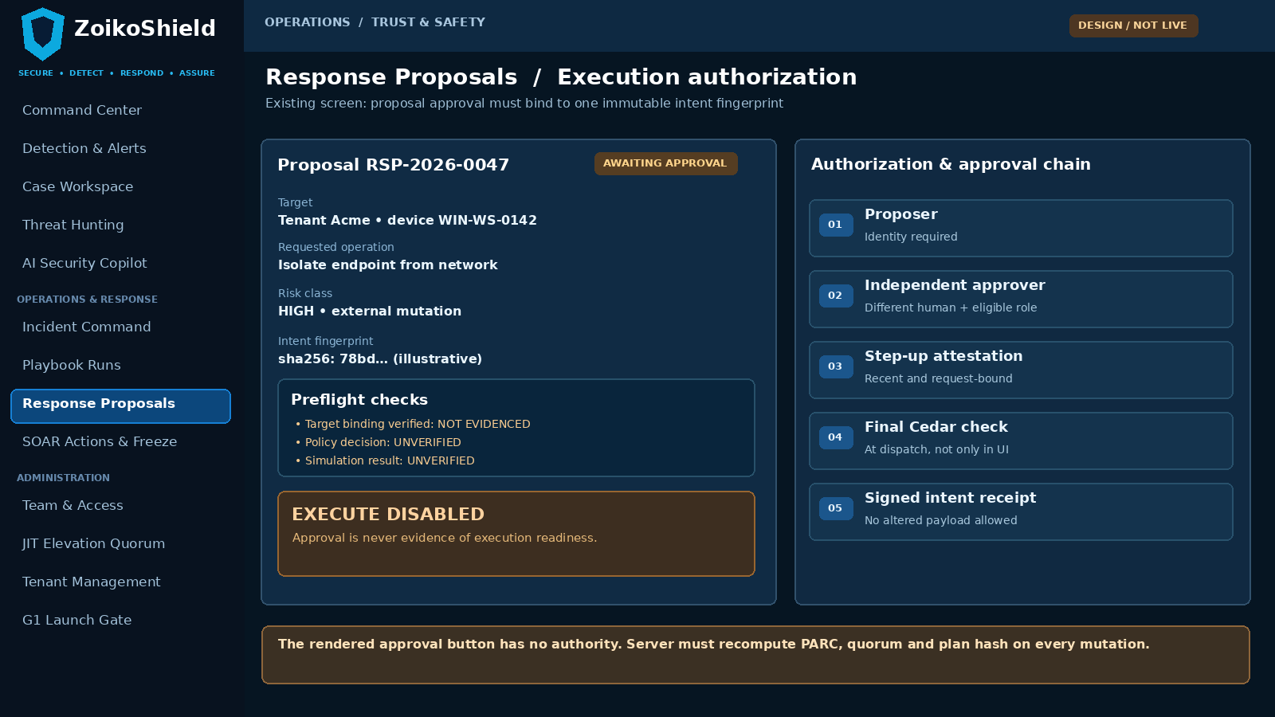
Annotated design schematic for the EXISTING Response Proposals screen; values and statuses are illustrative, not live platform evidence.
Pin | Behavior or safeguard | Backend authority
01 | Approver identity, tenant, eligible role and separation of duties must be computed on the server; no optimistic approval success. | shield-core signed decision + current identity directory.
02 | Show canonical target, operation, risk, proposal hash and impact; any material edit invalidates approvals. | Persisted IntentSnapshot and approval binding.
03 | Simulation is independent from approval; both may be required but neither alone permits dispatch. | WASM result signed to exact intent + simulation build/version.
04 | No “Execute” enablement until the final dispatch guard passes. Denied actions show a stable reason code without sensitive policy internals. | shield-action pre-dispatch admission verdict.

05 WF-G04-02 — JIT privilege lease and quorum uniqueness
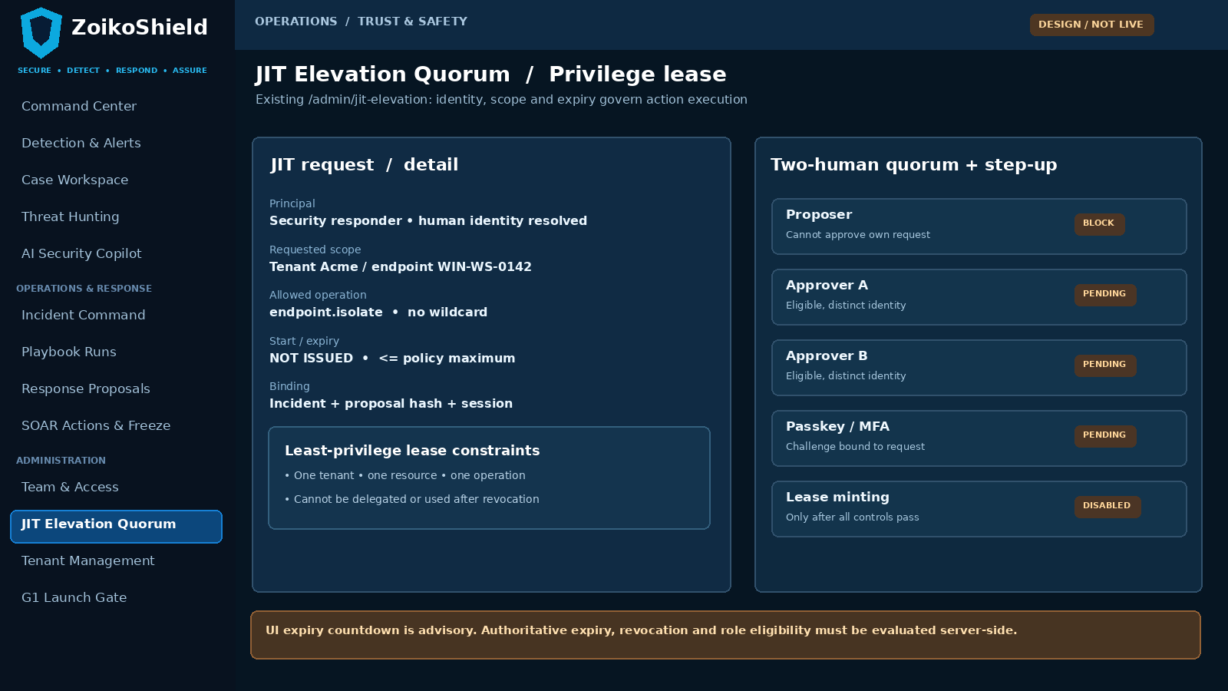
Annotated design schematic for EXISTING JIT Elevation Quorum; production identities, expiry and role names require deployed-code reconciliation.
Pin | Interaction requirement | Hard server-side control
05 | Request shows exact tenant, region, resource, command family, risk, incident and intent digest. | No cross-resource or wildcard lease reuse.
06 | Two-person quorum counts distinct human identities, not two devices, sessions, service accounts or aliases. | Stable person ID + role/SoD verification; self-approval denied.
07 | Require a recent, action-bound step-up at the policy-defined risk threshold; revoked credentials force reapproval. | Signed challenge ID bound to intent digest and finite expiry.
08 | Lease expiry and revocation must be enforced at dispatch and during any attempt to renew/continue. | Server monotonic clock, revocation version and policy cap.

06 WF-G04-03 — SOAR dispatch guard and effect reconciliation
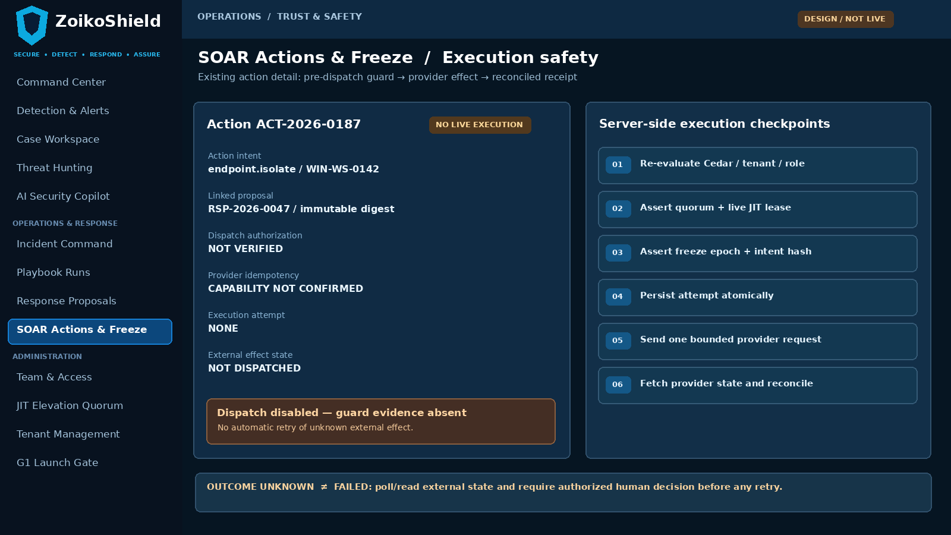
Annotated design schematic for EXISTING SOAR Actions & Freeze action detail, not a new route or independent execution service.
Pin | Interaction requirement | Proof to retain
09 | Present state of each required pre-dispatch check and explicitly distinguish simulation from a live provider operation. | Versioned policy/target/lease/freeze verdict IDs.
10 | Expose one immutable effect attempt ID and provider operation ID when actually available. | Durable intent/effect ledger; idempotency key and attempt fence.
11 | Do not auto-retry timeout or ambiguous results. Surface EFFECT_UNKNOWN with owner and next reconciliation step. | Original request digest; provider lookup; authorized recovery decision.
12 | Show final provider-state confirmation and any bounded compensation as separate events. | Evidence event chain; resource confirmation and operator receipt.

07 WF-G04-04 — Emergency freeze and in-flight work
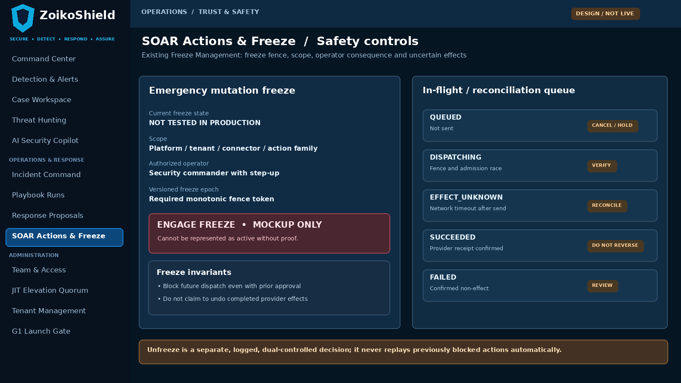
Annotated design schematic for EXISTING Safety Controls / Freeze Management. A UI toggle alone must never be represented as an effective freeze.
Pin | Interaction requirement | Hard server-side control
13 | Scope and reason mandatory; freeze commit must return authoritative version/fence token. | Signed freeze record and ordered monotonic epoch.
14 | The outbound dispatcher checks the latest freeze fence immediately before every new provider send. | Atomic admission fence; worker-local cache cannot override active freeze.
15 | Already-dispatched uncertain operations remain visible and require reconciliation; do not label them canceled. | Provider execution state, timestamps and investigator assignment.
16 | Unfreeze requires separate authorized step-up and explicit decision; it must not auto-dispatch queued historical requests. | Two distinct state transitions and preserved blocked actions.

08 Minimum persisted records and secure command contracts
These are logical entities and proposed changes within existing services, NOT claims that similarly named tables or endpoints are already deployed. Reconcile names and migrations against the actual repository before implementation.
Record / immutable reference | Required minimum data | Security invariant
ActionIntent | intent_id, tenant/region, case, target URI/provider account, action+params canonical hash, risk, proposer, policy version, created/expires, state. | Any material mutation produces a new version and invalidates approval.
AuthorizationDecision | request/decision ID, principal, action, resource, context digest, Cedar policy hash, diagnostics, allow/deny, time, trace. | Every mutation and dispatch is reviewable; no raw credentials.
ApprovalAttestation | intent hash, immutable human ID, eligibility role, challenge/step-up ref, issued/expires, decision, revocation state. | No self-approval or alias reuse; current role on dispatch.
PrivilegeLease | lease ID, principal, intent, tenant, resource, operation, nbf, exp, revocation version, issuance policy. | Cannot replay on another resource or after expiry.
EffectAttempt | unique intent+operation idempotency key, dispatch fence, provider request hash, attempt state, provider op ID, timestamps. | At most one actively admitted attempt per reserved intent.
EffectReconciliation | provider status evidence, latest observed state, method, human owner, decision, resolution, compensation ref. | EFFECT_UNKNOWN never silently becomes success/failure.
FreezeEpoch | scope, activation/version, reason, operator ID, step-up ref, activation and release timestamps, affected counts. | Global and scoped dispatches share the same authoritative fence.

Minimum command obligations
Command names are PROPOSED contracts, not existing route assertions: validateIntent(intent); simulateIntent(intent); attestApproval(intentHash); issueLease(intentHash); authorizeAndReserveDispatch(intentHash, freezeVersion); reconcileEffect(effectId); engageFreeze(scope); releaseFreeze(scope). Every command requires authenticated principal, scoped resource, idempotency key, trace ID and an auditable denied response. Bind all reads/writes to G02 tenant and region controls.

09 Runtime policy, lease, signing and connector adapter requirements
Control | Implementation obligation | Evidence / deny expectation
Cedar policy entry points | Authorize create/modify/submit/approve/reject/cancel/simulate/dispatch/freeze/unfreeze/reconcile and all internal workers. | Direct API call and worker-only paths obey same policy; no route bypass.
Cedar validation and error handling | Schema-validate policies before promotion. On P0 mutation, any critical evaluation diagnostic/missing PARC field fails closed even if another policy permits. | Policy error injection returns DENY and no effect.
Two-person quorum | Define authorized roles in current policy register; enforce no proposer==approver and human ID uniqueness. | Parallel approvals and duplicate devices count once.
Passkey, federation and JIT | Risk-tier step-up freshness, expiry and assurance defined by policy; lease narrow and nontransferable. | Expired, revoked, cross-target and cross-tenant lease rejected.
Signed immutable intent | Create canonical semantic payload and digest including tenant, account, region, target, command, parameters, duration, policy and approval refs. | Any changed byte-semantic operation must require new approval.
Simulation boundary | No production provider credentials, mutation network egress or real assets in WASM simulation; label all outputs simulation. | Break-glass/test flags cannot route sandbox commands to real provider.
Connector adapter | Allowlisted operations, credential scopes, outbound destination, timeouts and provider idempotency/lookup capabilities registered. | Missing safety capability must disable that action family.
Freeze admission | Fencing check at final dispatch and per safe step; persisted cancellation, not UI-only. | Freeze confirmed before attempt => no external send.
Provider uncertainty | Bounded retries only when provider dedupe contract applies; unknown outcome triggers provider read and controlled review. | No guessed success and no unsafe duplicate effect.
Audit secrets | Hash or redact payloads; never log bearer tokens, personal recovery codes, provider secrets or unrestricted PII. | Evidentiary trail remains useful without secret exposure.

10 Failure semantics and operational control table
Fault / attack | Expected fail-safe result | Visibility / evidence
Client forges “approved=true” or changes target after approval | Reject server-side. Invalidate old approval and require new risk/impact review. | DENIED / INTENT_MISMATCH; no provider request.
Cedar evaluates permit, but required forbid policy errors | Application-level DENY for a high-risk mutation on diagnostics/configuration fault. | Policy diagnostic ID; no leak of hidden policy internals.
Approver A and B same person using separate sessions | Count one approver; block quorum completion. | QUORUM_NOT_DISTINCT.
Lease expired between queue insertion and dispatch | Reject at last moment; no outbound provider call. | LEASE_EXPIRED and timestamp proof.
Freeze committed while work awaits dispatch | Fenced dispatcher must not send after freeze commit; preserve blocked request. | Freeze epoch / queue sequence.
Freeze after a provider request has already left system | Do not claim cancellation. Resolve provider state and contain new work. | IN_FLIGHT / EFFECT_UNKNOWN or definitive result.
Provider succeeds but response is lost | Do not send blind retry; query by operation ID or idempotency key, escalate unknown. | Reconciliation decision + external state evidence.
Two workers pick same action simultaneously | Only one wins durable attempt reservation; other must observe existing attempt. | Unique constraint / fence + concurrent trace.
Provider idempotency key unsupported | Disable unbounded retry; mark unresolved on timeouts until reconciled manually. | Adapter capability record and action gating.
Step-up credential revoked after approval | Force final re-check; revoke affected lease and block new dispatch. | Revocation version and deny result.
Unfreeze accidentally triggers backlog | No automatic dispatch or replay; explicit re-authorization of every preserved request. | Zero post-unfreeze sends without fresh request.
Audit storage temporarily unavailable | High-risk mutation pauses unless durable audit + effect-intent record can be committed together. | FAIL_CLOSED / audit dependency.

11 Adversarial acceptance tests A01–A12
Test | Execution stimulus | Pass condition / independent evidence
A01 | Change intent target, parameter or risk after approval. | No effect; stale approval invalidated; new hash and explicit reapproval.
A02 | Call dispatch route directly with only a valid analyst session. | 403 / denies and no provider API call; policy decision captured.
A03 | Create two approval sessions tied to the same human identity. | One vote; no quorum; identity graph/person-ID evidence.
A04 | Submit approval using unauthorized role or revoked membership. | Server refuses; action held; current directory/role lookup shown.
A05 | Cross-tenant/cross-region target or switched session context. | No read/mutation; G02 boundary test linked; all IDs pinned.
A06 | Omit Cedar policy; corrupt required policy context; introduce an evaluation error. | Fail closed for high-risk action; verified no external send.
A07 | Expire JIT lease between approval and dispatch. | No effect; lease version/expiry compared on final guard.
A08 | Revoke step-up/passkey credential after grant, before provider send. | No effect; fresh attestation required.
A09 | Run a malicious simulation that attempts network call or production-secret read. | WASM sandbox blocks egress/secrets; zero real effect.
A10 | Send two competing dispatches at the exact same time. | One reservation; zero duplicate provider effects; DB/worker traces.
A11 | Replay same dispatch request with old signed intent ID/key. | Existing result returned; no new attempt/effect.
A12 | Tamper signed intent or change policy version between guard and send. | Signature/fence fails; no outbound request; immutable audit event.

12 Adversarial acceptance tests A13–A24
Test | Execution stimulus | Pass condition / independent evidence
A13 | Engage freeze before a queued worker obtains dispatch fence. | Zero post-freeze sends; freeze commit and worker times verified.
A14 | Engage freeze during provider operation; external response delayed. | No false cancellation; in-flight effect reconciled; future sends blocked.
A15 | Turn off/pause message bus while freeze propagates. | No worker bypass through stale cache; fail-closed until authoritative check.
A16 | Release freeze then restart queued workers. | Zero auto-dispatch of previously blocked work; new explicit operator approval.
A17 | Simulate 504 after actual provider success; provider supports status lookup. | One effect; reconciliation identifies success without duplicate.
A18 | Timeout provider request with no idempotency/status endpoint. | EFFECT_UNKNOWN, manual escalation; no blind automatic retry.
A19 | Force connector 429/5xx and policy-defined safe retry. | Bounded exponential backoff only for provably idempotent action; safe limits.
A20 | Terminate worker after durable reservation, before external send. | Recovered reservation; deterministic safe continuation, never double-send.
A21 | Terminate worker after external send, before result persistence. | Provider lookup or unknown hold; no false negative/duplicate.
A22 | Run AI copilot suggestion and attempt direct tool execute. | Proposal only; no bypass of policy/quorum/lease/freeze.
A23 | Run scripted SOAR path and UI path for same intent concurrently. | Single centralized guard and effect record.
A24 | Attempt compensation/rollback without distinct approval. | Denied; independent authority, scope and evidence required.

Acceptance rule
Every case requires tenant/region, principal, trace IDs, signed intent fingerprint, source control version, expected/observed provider calls, audit receipt and a reviewer signature. “Passed” is allowed only where exact deployed connector behavior is observed. Test failures are tracked in the existing G1 register.

13 Production evidence pack and operational runbook
Evidence ID | Single required artifact | Minimum reviewer expectation
G04-E01 | Complete mutation-entry-point inventory with code references and service identities. | All frontend, API, worker, scheduler, AI-tool and internal action paths reconciled.
G04-E02 | Cedar schema/policy hashes + authorization matrix and negative-test logs. | No bypass and evaluated diagnostics; sign-off by Platform Security.
G04-E03 | Real passkey/step-up, quorum uniqueness, JIT expiry/revocation evidence. | Screenshots alone are not proof; server and identity logs included.
G04-E04 | Immutable intent and effect ledger extracts plus provider request-response digests. | Exactly one canonical action instance, lineage and no sensitive secrets.
G04-E05 | Production-equivalent sandbox/production credential boundary proof. | Separate key scopes, egress, provider accounts and non-mutating simulation.
G04-E06 | Connector adapter contract matrix for first-wave action families. | Provider idempotency, status lookup, rollback, quotas and failure modes stated.
G04-E07 | Freeze race/fault-injection record with observed propagation times. | No post-fence dispatch; in-flight actions accounted for.
G04-E08 | 24 executed adversarial test cases; defect closure links and owner sign-offs. | Independent QA reproduces results from environment manifests and logs.
G04-E09 | G1 decision receipt with security and response owners, outstanding exceptions. | No production real-world external mutation until all safety evidence accepted.

Operator incident procedure for EFFECT_UNKNOWN
- 1. Place the exact action instance and affected target into a guarded, non-retry state; preserve tenant and case context.
- 2. Read the provider’s authoritative operation/resource status, if supported, using a read-only privileged route.
- 3. If outcome remains ambiguous, assign Security Lead ownership and block any re-execution pending a documented decision.
- 4. If compensation is possible, propose and authorize it as a new independent action with its own impact and approval.
- 5. Append a reconciled state and raw evidence references; export via the existing evidence route only after G06 validation.

14 G1 decision and implementation sequence
Order | Engineering action | Stop condition / exit output
1. Reconcile | Inventory all actual mutating entry points, Cedar versions, existing roles, action families and production vs sandbox connectors. | Cannot enumerate a route/adapter → block that family; deliver G04-E01.
2. Enforce | Apply one server-only PARC and tenant/region authorizer to all action transitions; implement unique human quorum and step-up/JIT binding. | A single high-risk bypass blocks release; deliver G04-E02/E03.
3. Fence | Bind immutable intent digest to approval; persist unique outbound effect attempt and final freeze epoch check. | Any duplicate or post-freeze send blocks release; deliver G04-E04/E07.
4. Reconcile | Implement adapter-specific provider outcome verification and hold on uncertainty. | Blind retry or fictitious rollback blocks release; deliver G04-E06.
5. Prove | Execute A01–A24 on production-equivalent isolation and permitted representative real or controlled provider operations. | Synthetic UI-only pass is insufficient; deliver G04-E05/E08.
6. Sign | Security, SOAR, independent QA and G1 accountable roles review evidence and either ACCEPT or HOLD. | No claim of G04 closure before genuine evidence and release signature.

ARCHITECTURE FREEZE | No new ZoikoShield dashboard, microservice, generic SOAR plugin framework or additional G04 specification is authorized by this document. If an existing implementation already meets a contract, provide proof instead of rewriting it.

Definition of done
G04 is CLOSED only when the mandatory authority boundary is demonstrated for every launch-enabled mutating action family, 24 adversarial checks have reproducible signed outcomes, a freeze and uncertain-provider-outcome drill are observed, and the existing G1 gate records approval. Otherwise, remain HOLD and keep outbound mutations disabled.

Supporting references and scope notes
[I1] ZoikoShield Enterprise Platform — Complete Architecture Analysis & Master Demo Playbook (user-supplied baseline, October 13, 2026). [I2] Live Demo Step-by-Step Links Guide (user-supplied baseline, October 13, 2026). [I3] ZoikoShield Enterprise Architecture & Infrastructure Gap Analysis v1.0 (October 31, 2026), G04. [I4] Existing Response Proposals, SOAR Actions & Freeze and JIT Elevation UI baseline screenshots (ZoikoShield Project).
[S1] Cedar Policy Language Reference — Authorization & Validation, https://docs.cedarpolicy.com/auth/authorization.html and https://docs.cedarpolicy.com/policies/validation.html. [S2] OWASP API Security Top 10 (2023), https://api-security.owasp.org/editions/2023/en/0x11-t10/. [S3] Cedar Best Practices, https://docs.cedarpolicy.com/bestpractices/bp-overview.html. [S4] AWS Step Functions execution/worker retry semantics, https://docs.aws.amazon.com/step-functions/latest/dg/concepts-error-handling.html. Accessed October 31, 2026; applies as engineering guidance, not a claim about ZoikoShield’s deployed cloud services.

