ZOIKO TECH INC. / ENTERPRISE RELEASE ASSURANCE

G05 | Production resilience, disaster
recovery & incident operations
Detailed engineering wireframe & acceptance specification • Version 1.0 • 31 October 2026
P0 / HOLD | Release-blocking until production topology, tested backups, measured recovery objectives, alert/on-call routing and independently reviewed recovery evidence are available.

Executive implementation decision
Do not create another observability platform or redesign the existing dashboards. Use shield-core, shield-ingest, shield-ai, shield-action and shield-anchor; adapt the existing /admin/platform-health and Incident Command experiences; attach proof to the existing G1 gate. Recovery must preserve tenant residency, access controls, action safety and the ability to verify evidence.
Decision | Practical consequence
Deliverable boundary | One focused G05 closure document: operational architecture discovery, failure handling, isolated restore drill, timed recovery testing, incident operations and proof. No new microservice or sidebar item.
Evidence status | The locked October 13 demo baseline documents service health, simulated/non-destructive restore and localhost flows. It does not independently prove production high availability or recoverability.
Safe design doctrine | Claims of “backup validated”, “multi-zone”, “regional failover” or uptime must be published only from attributable production records (G01).
Release verdict | Default HOLD until each mandatory control is passed or an accountable executive signs a bounded, documented exception that does not override a security safety stop.

Pass condition
A successful demo or HTTP 200 health check is insufficient. Operators must restore a clean isolated environment, measure and compare RTO/RPO against approved objectives, verify tenant/data integrity and safe mutation controls, and respond to real alerts under a signed incident runbook.

01 Source baseline, inherited components and scope firewall
Existing source / component | Known design in project baseline | Exactly what G05 verifies or adds
Locked Master Demo Guide (13 Oct) | Next.js 14 UI + proxy, five NestJS services and offline verifier; routes include /admin/platform-health and /admin/g1-gate. | Reconcile documented services to actual deployed inventory, zones, environments, dependencies, health probes and backups.
26-screen Demo Links (13 Oct) | Platform Health describes a “non-destructive DR restore drill”; presenter claims coverage of PostgreSQL, Kafka and OpenSearch. | Distinguish mocked vs executed drill. Confirm Kafka/OpenSearch are actually deployed before including them in recovery scope.
shield-core :3001 | Identity, tenant governance, cases, policies, notification. | Prove database recovery, authorization continuity, customer isolation and service-level degraded behavior.
shield-ingest :3002 | Telemetry and connectors; G03 defines durable acceptance / replay. | Prove loss/duplicate control and restart/backlog recovery against G03, not rewrite G03’s ingestion contract.
shield-ai :3003 | Governed AI investigation and safety gates. | Fail gracefully when external model provider unavailable; never bypass risk controls or claim successful AI operation.
shield-action :3004 | Action broker, emergency freeze. G04 owns action dispatch safety. | During failover no stale workers may dispatch; freeze state and effect reconciliation persist through restart.
shield-anchor :3005 + verifier-cli | Evidence anchoring and standalone verification. G06 owns cryptographic adversarial tests. | Restore provenance, keys, manifest references and evidence continuity; defer third-party proof-validity judgment to G06.
Existing Incident Command + G1 | Operator workflow and eight-signer enterprise gate. | Append recovery incident and independent results to these existing surfaces; do not add a separate incident product.

SCOPE FENCE | G01 owns public claims; G02 data residency/tenant isolation; G03 ingestion replay; G04 authorization and freeze; G06 evidence verifier validity. G05 tests dependencies on those contracts but never duplicates their functional specifications.

02 Recovery criticality, objectives and service safety
Proposed service objectives below are planning candidates, not measured performance or customer commitments. SRE + Product + Legal must approve per product tier, geography and contract before deployment or publication.
Protected capability | Desired recovery behavior | Objective / sign-off rule
Customer login, policy and tenant controls | Multi-instance where justified, independent health and safe deny for policy failure; no unsafe privilege elevation. | Critical service RTO/RPO values: OWNER TO APPROVE based on observed architecture and pilot contract.
SOAR emergency freeze + action admission | Block new external mutations under dependency uncertainty; restore authoritative freeze version and reconcile in-flight effects. | Safety invariant: no unauthorized or duplicate provider mutations. G04 pass mandatory.
Telemetry acceptance, queue, rules | Preserve acknowledged events, isolate failed payloads, controlled backfill and gap disclosure. | RPO for acknowledged events verified at G03; target cannot be inferred from queue SLA.
Incidents, cases, policy versions and audit receipts | Restore durable records and sequence/order; compare pre/post crash point-in-time boundaries. | Classify lost or inconsistent committed security records as release blocker.
Evidence vault, timestamp authority keys | Recover backed-up evidence and trust metadata with verifiable pointers; preserve key custody and revocation state. | G06 independently validates resumed evidence proofs before release.
AI copilot and external intelligence | Read-only experience and deterministic analysis remain available where safe; display degraded status. | Noncritical provider unavailability cannot disable human-led SOC review.
Notifications, email, reporting | Queue safely, expose retry status, reconcile unsent/delivered states. | Separate lower-priority objective; no false “delivered” signal on outage.

Initial proposed targets — pending measured feasibility
For an enterprise pilot, SRE may propose a 99.9% monthly control-plane availability SLO and a priority recovery exercise objective of RTO ≤ 60 minutes / RPO ≤ 15 minutes for committed operational records. These are targets for review, not verified capabilities, SLA commitments or authorizations for cross-border replication. If measured feasibility disagrees, revise the proposed target transparently before a contract is signed.

03 Actual topology discovery and failover admission contract
Do not select active-active, warm standby or additional regions merely to match competitors. First record the AS-DEPLOYED topology and business impact; choose the least complex resilience strategy meeting approved recovery objectives and residency boundaries.
Layer to inventory | Engineering discovery fields | Fail-safe / exercise to prove
Compute and deployment | Cloud account/subscription, region/AZ, orchestrator, replica count, autoscaling, image/build digest, readiness and liveness probes. | Single process/node and availability-zone failure; capacity remains sufficient or expected degradation is explicit.
DNS, edge and routing | Provider, TLS termination, WAF, health thresholds, routing TTL, cache behavior, failback path. | No stale traffic to dead region/zone; safe, documented manual override with owner.
PostgreSQL + backups | HA mode, instance/cluster, primary election, replication lag, WAL/PITR window, encryption and key restore permissions. | Failover preserves isolation; timed restore reaches a checked consistent point in time.
Broker / search (if deployed) | Real technology/config (Kafka, OpenSearch or other), partitions, retention, replication, reindex/replay contract. | Recover from broker/search unavailability without silent event loss or false backlog-cleared label.
External dependencies | KMS/HSM, IdP, secret store, timestamp provider, cloud control plane, network egress and AI providers. | Map critical dependency outage behavior; do not declare healthy because app responds while essential security dependency is down.
Backups and recovery environment | Source location/classification, immutable backup policy, encryption, destination, operator access, isolated network, lifecycle/cleanup. | Restore from a clean independently selected point; prove that recovery test is non-destructive.
Region/tenant policy | G02 tenant jurisdiction/allowed destinations, backup and support access metadata. | No automatic cross-border DR path or customer-data copy beyond authorized region.

RESILIENCE CHOICE | Backup-and-restore, pilot light, warm standby and multi-region active-active have substantially different costs and RTO/RPO properties. Select and evidence one per approved geography; do not pre-commit to active-active [S3].

04 WF-G05-01 — Platform Health recovery assurance overview
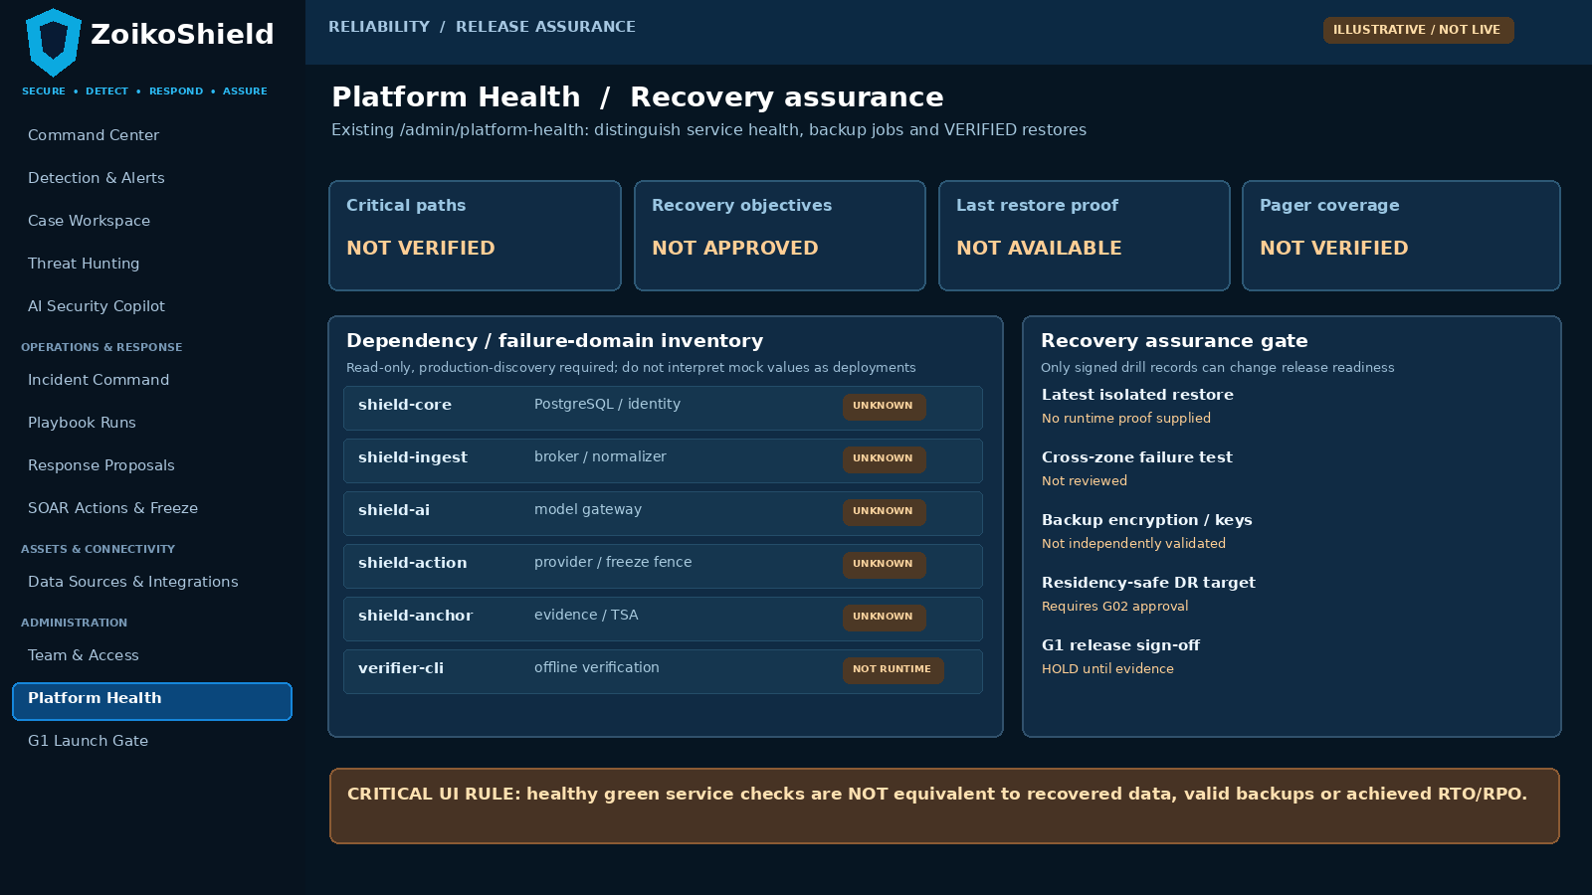
Existing /admin/platform-health: proposed evidence-oriented redesign. All data shown is placeholder UI, NOT actual availability or backup evidence.
Pin | User interaction / view rule | Backend provenance and acceptance
01 | Display critical service health separately from approved SLO, backup job and verified restore. | Health probe != restored data; service availability derived from defined monitored window.
02 | Each status has observed timestamp, environment, failure domain and test-run reference. | Never render success from seeded fixtures without DEMO label.
03 | Show release HOLD whenever restore evidence, on-call coverage or safe data region is unknown. | G1 gate references signed drill run and independent QA result.

05 WF-G05-02 — Service dependency / failure-domain drilldown
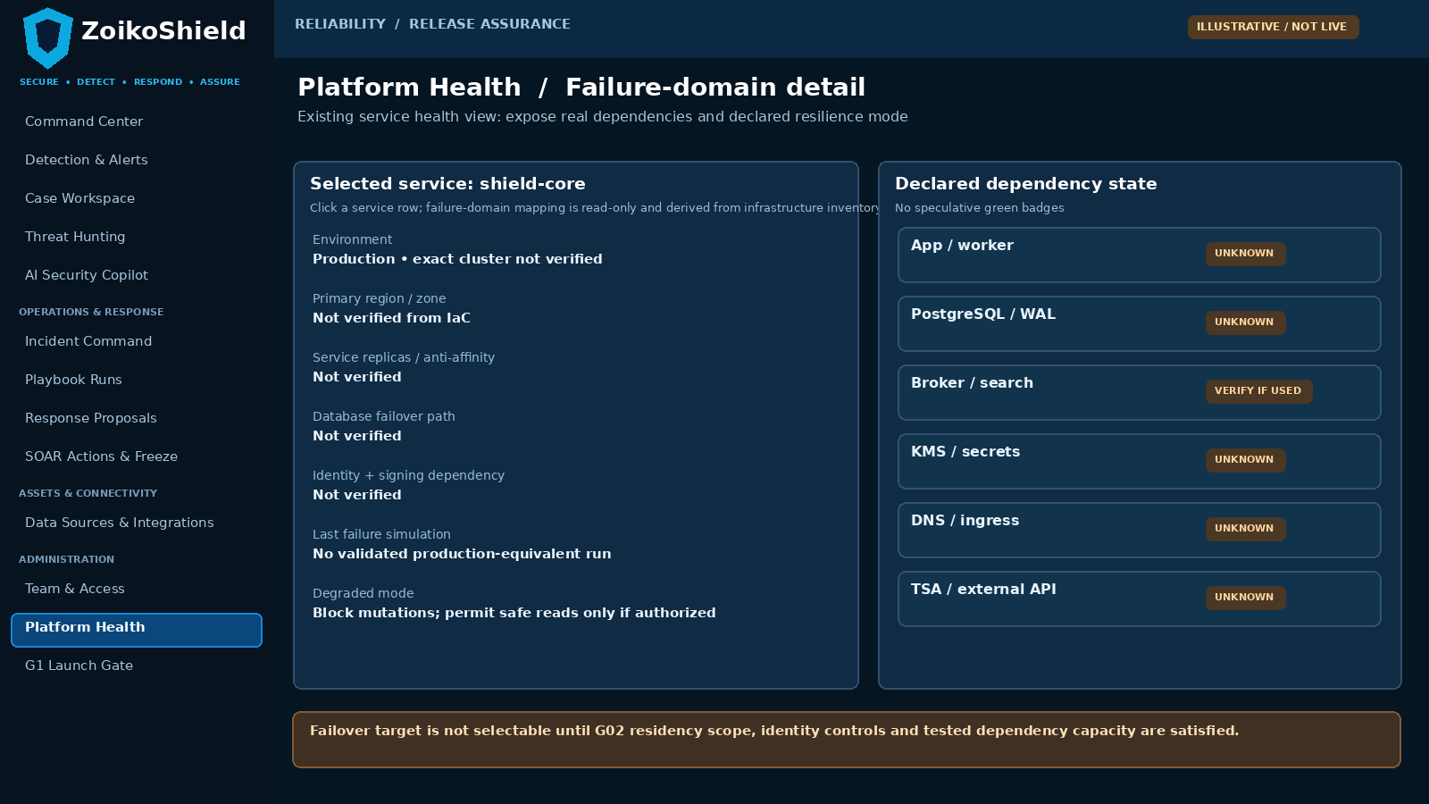
Proposed detail within the EXISTING Platform Health screen; dependency values must be sourced from observed infrastructure, not presentation copy.
Pin | Required interaction | Required authority
04 | Select one service and show primary AZ/region, replica policy, database/broker/KMS dependencies and observable degraded mode. | Read service inventory and deployment attestations; no cross-tenant secrets in UI.
05 | Link deployment digest, on-call owner, last failure rehearsal and error-budget status to service. | SRE-controlled inventory + immutable test/run IDs.
06 | Failover action unavailable until residency authorization, safe service mode, destination capacity and approvals are verified. | G02 and G04 hard guards; fail-closed if control plane uncertain.

06 WF-G05-03 — Isolated DR restore wizard and result receipt
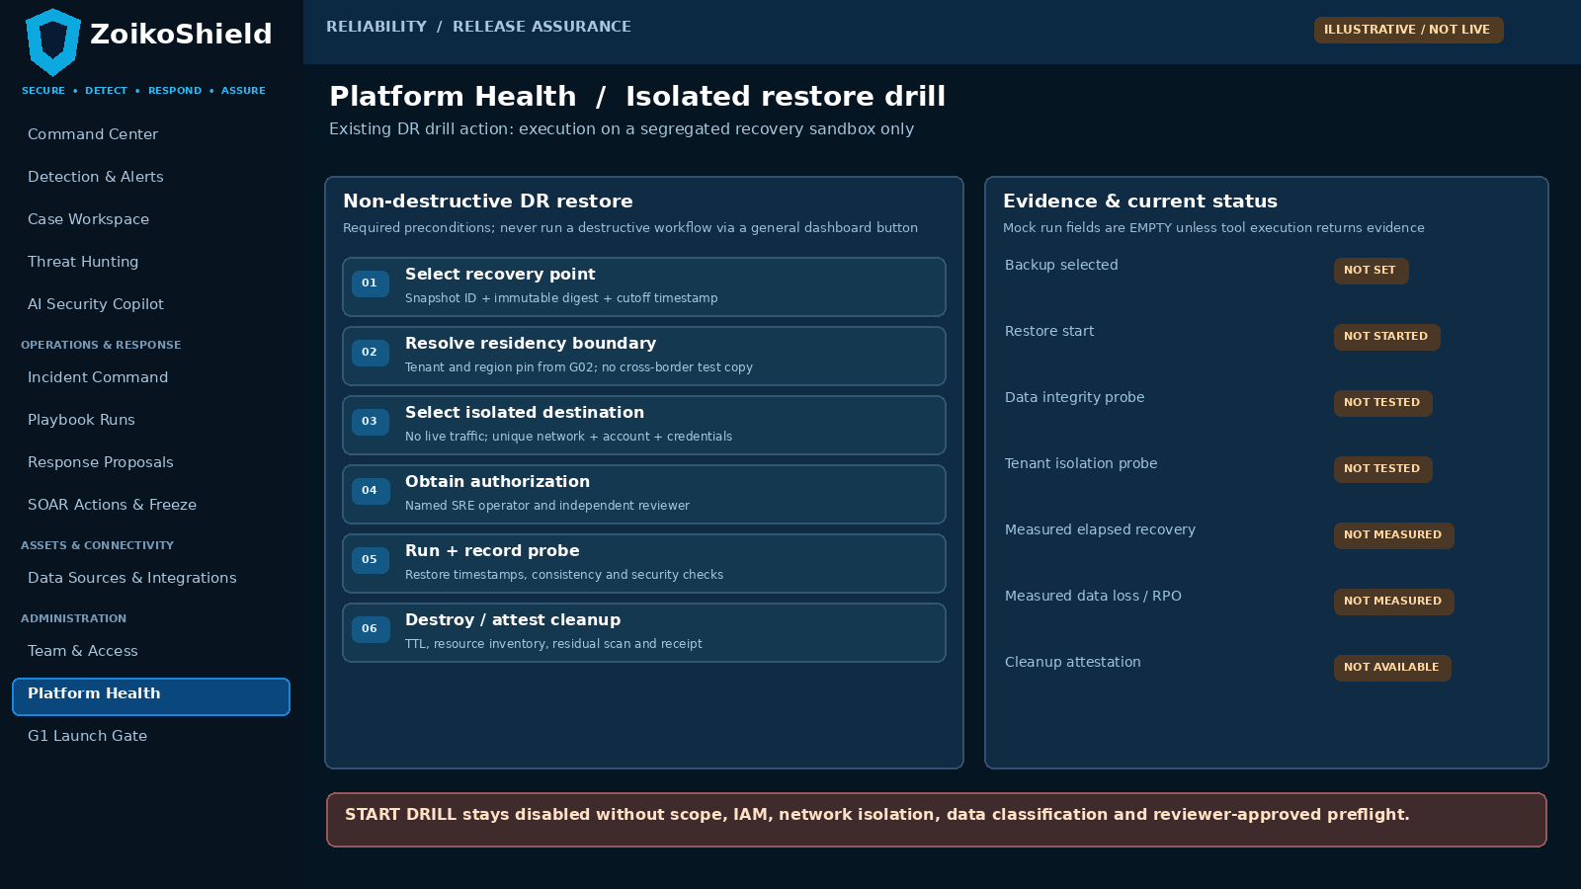
Proposed gated flow replacing any cosmetic “Trigger DR Drill” success on /admin/platform-health. Illustrative steps, not proof of execution.
Pin | Interaction contract | Evidence / safety condition
07 | Recovery point must show source backup ID, timestamp, checksum and allowed residency; no default to newest when corruption suspected. | Backup manifest, data classification and G02 region entitlement.
08 | Create isolated destination via IaC with no live tenant route, live write credentials or production provider mutation capability. | Network policy, IAM least privilege, reviewer approval, bounded resource TTL.
09 | Record timed restore, DB consistency, tenant isolation, data completeness, crypto references and cleanup; prohibit “PASS” if any missing. | Signed recovery-run artifact with probes and independent reviewer.

07 WF-G05-04 — Incident Command restoration decision
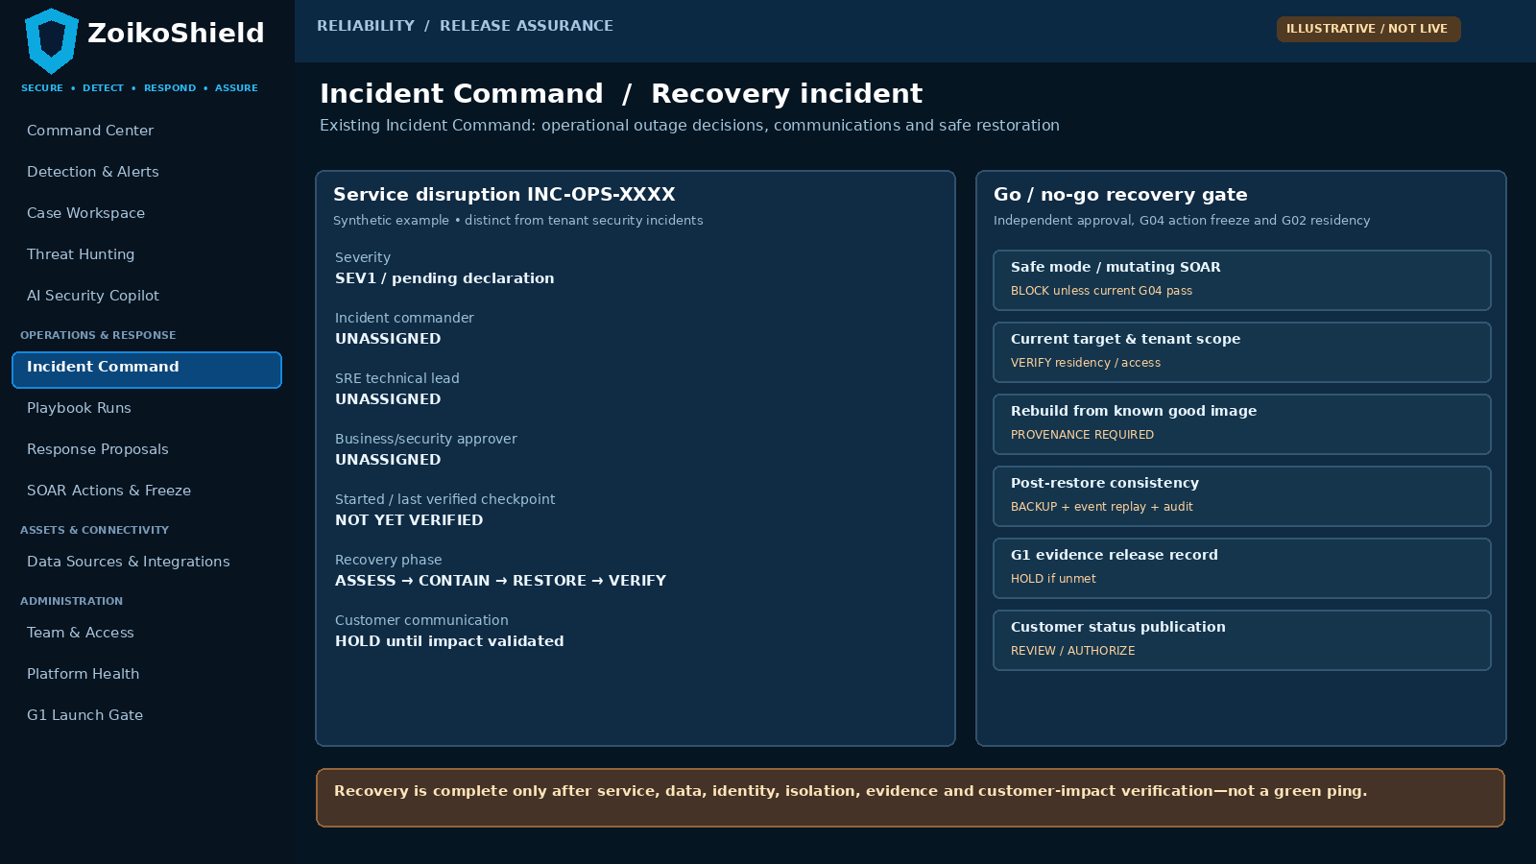
Existing Incident Command page, with resilience decision rail; incident details are fictitious and status indicators intentionally unverified.
Pin | Operator action / visible state | Safety and evidence
10 | Declare SEV, assign unique incident commander, deputy, SRE lead and communications authority; open timeline. | Immutable declaration and acknowledgment receipts.
11 | Present containment → restore → verify → resume in order; independent approval to exit safe mode. | G04 action freeze and G02 residency still enforced across restart.
12 | Expose customer impact, freshness of updates, recovery proofs and G1 gate linkage without publishing unsupported percentages. | Timestamped source-of-truth records, comms approval and after-action owner.

08 Recovery workflow, state machine and no-false-success rules
The restore workflow is a controlled operation with an immutable run identifier and a human stop condition. Full automation may stage infrastructure, but cannot skip approval for customer data, destination scope, production failover or public status statements.
State / transition | Who and what may advance it | Failure / deny behavior
DRAFT → PRECHECKED | SRE submits BIA, scope, source snapshot and destination; system checks G02 residency, encryption, IAM and test isolation. | Missing source hash, destination boundary or reviewer => BLOCKED.
PRECHECKED → AUTHORIZED | Separate qualified SRE reviewer approves scoped execution; must not be same person who requests sensitive production operations. | Approval expires, scope changes or credential revoked => reauthorization.
AUTHORIZED → RESTORING | Scoped automation creates isolated destination and starts instrumentation before restore. | Unexpected live ingress/egress or permission creep => HALT + SEV notification.
RESTORING → VERIFYING | Restore completes and time measured from incident threshold/declared restore point; evidence captured. | No elapsed time, no source metadata, incomplete replay => FAIL.
VERIFYING → PASSED | Independent automated probes and reviewer validate consistency, tenant, crypto, app functions and cleanup plan. | No single green health ping can make PASS.
VERIFYING → FAILED / INCONCLUSIVE | Record mismatch, timeout, missing trusted logs or unknown external state. | Never silently rerun under same ID or overwrite failed attempts.
PASSED → CLOSED | Cleanup completed, artifacts sealed, after-action and follow-up owner assigned. | Orphaned resources, secrets or pending actions => remain OPEN.
PROD FAILOVER (separate) | Incident commander + authorized business/security officer approve target and rollback after independent preflight. | No automatic cross-region migration; stale SOAR dispatch remains disabled.

09 Minimal logical records, UI data rules and API contracts
Names below describe logical contracts to be adapted to the current repository. They are NOT claims that these tables, APIs or event schemas already exist. Prefer adding fields to existing Platform Health and G1 implementations rather than building a new service.
Logical record / call | Required fields or semantics | Integrity / access invariant
RecoveryObjective | service_id, tenant/tier scope, owner, SLI/SLO, RTO and RPO target, effective version, approver. | Unset objectives are displayed UNAPPROVED.
ServiceDependencyInventory | service_id, runtime, region, zones, deployment digest, dependencies, business criticality, evidence date. | Discovery-derived; service-account secrets redacted.
BackupManifest | source DB/stream, time/cutoff, digest, key reference, region, encryption, retention, source state. | Versioned immutable reference; does not expose raw encryption keys.
RecoveryDrillRun | run_id, env, source, target, operator, reviewer, timeline, probes, RTO/RPO measured, status and cleanup receipt. | Write-once event trail; absent probe = not passed.
OperationalIncident | incident_id, SEV, commander, SRE, affected dependencies, declared impact, phases, comms, recovery and closure. | Append-only decisions with role-aware access.
GET /admin/platform-health/recovery | Proposal: summaries from deployed sources + evidence freshness and provenance. | Tenant/role scope, no fabricated health status.
POST /admin/platform-health/drills | Proposal: request bounded isolated restore with idempotency key, scope and signed preflight. | SRE-only, independent reviewer, no prod egress.
POST /admin/incidents/:id/recovery-decision | Proposal: scoped signed resume/failback decision linked to G02 and G04. | Two-person authority and monotonic freeze fence.
POST /admin/g1/evidence-link | Proposal: attach immutable tested run and independent reviewer signature. | Cannot pass gate on self-attested screenshot or simulated DR.

10 Backup integrity, consistency and recovery verification
Check | Required engineering behavior | Acceptance evidence
Authoritative backup boundary | Capture DB snapshot/WAL or equivalent proven PITR with consistent timestamp; verify backup metadata against actual committed state. | Backup/restore IDs, PITR cutoff and transaction sample.
Independent recovery destination | Restore to isolated account/VPC/namespace with restricted network egress; no accidental customer notifications. | IaC run and network-deny tests.
Encryption + keys | Confirm recovery principal can decrypt only approved scope using managed key procedure; test unavailable/rotated-key failure. | Key access log, approved key policy, decrypt result.
Tenant isolation | Run cross-tenant negative tests post restore, including admin privilege and RLS ownership in restored database. | G02 pass transcript with tenant-scoped canaries.
Search and queues | For actually deployed broker/index dependencies, distinguish replayable derived index from unique authoritative data and measure backlog catch-up. | True deployment manifest and gap/replay counts.
Events and accepted data | Prove no unexplained lost acknowledged security events and no silent duplicate alerts after restore. | G03 reconciliation and accepted-ID comparison.
Evidence continuity | Check anchor references, TSA token availability, exported manifest and offline verifier after recovery. | Forward G06 verification vector; do not claim proof validity here.
SOAR mutation safety | Restore freeze version, live lease revocation and pending effect records before any action worker is unblocked. | G04 no-external-mutation test and provider-state checks.
Cleanup + secret hygiene | Expire test credentials; remove restored classified copies; record retention exemption if mandated. | Infrastructure destroy log, residual sweep and reviewer signature.

11 Observability, paging and incident command minimums
Operational trigger | Who gets paged / clock | Required operator response
Control-plane authentication or policy service unavailable | On-call SRE + Security (24x7 roster must be confirmed); SEV1 if customer security operations affected. | Declare impact and safe mode; no bypass to privileged actions.
SOAR freeze authority unavailable or inconsistent | SRE + SOC commander; immediate P0 safety stop. | Block outbound mutations until authoritative state is recovered; review in-flight effects.
Unrecoverable/replication lag or backup aging | DB/platform SRE; page based on approved RPO and freshness threshold. | Start protect/repair; do not show backup badge as green.
Ingestion backlog and source freshness breach | Ingestion SRE + SOC duty lead; threshold derived from G03 objective. | Preserve acceptance and replay data; communicate detection degradation.
Evidence anchoring or external TSA failure | Evidence service owner + SOC risk; severity based on affected controls. | Mark evidence creation degraded; retain pending cryptographic work, no false verification.
Primary AZ failure or major network route outage | Incident commander + SRE; auto-remediation only if authorized and tested. | Assess healthy failover within region and launch logged command bridge.
DR drill missed or failed by release deadline | G1 release owner + QA + CISO delegate. | Mark release HOLD; open corrective work item; no cosmetic pass.

On-call and publication rules
One primary and deputy for each critical service must acknowledge the rota, escalation timing and runbook version. Severity table and customer comms timing are approved by the incident commander and legal/comms owner, not inferred from a demo. Public status uses only verifiable production incidents and measured event windows, consistent with G01 and NIST SP 800-61 Rev. 3 [S2].

12 Adversarial and failure exercises R01–R12
ID | Injected condition / exercise | Binary pass condition with evidence
R01 | Crash shield-core instance mid authenticated operation. | Fail closed on authorization uncertainty; recovery proves session/tenant isolation and no mutation bypass.
R02 | Terminate one service node while requests in flight. | Measured recovery/degraded response; no unrecoverable committed-case corruption.
R03 | Simulate loss of single availability zone in test-equivalent stack. | Record elapsed recovery and achieved service capacity; no unapproved region switch.
R04 | Disable primary database and trigger documented HA/election procedure. | No split-brain or cross-tenant query leakage; recovery path recorded.
R05 | Corrupt last backup or alter expected checksum. | Refuse restore/use; older known-good checkpoint selected with approver.
R06 | Restore isolated DB from approved point-in-time backup. | Exact elapsed RTO/RPO observed; consistent critical-record sample and source cutoffs.
R07 | Revoke/unavailable KMS key during restore. | No silent fallback to insecure key or unencrypted store; fail visibly with incident.
R08 | Place restore destination outside approved tenant region. | G02 denies copy and failover; audit log proves no cross-border transfer.
R09 | Drop connection mid-replay of committed telemetry. | G03 reconciliation finds all acknowledged IDs or reports exact violation; no silent gaps.
R10 | Restart SOAR workers after outage with stale freeze epoch. | G04 denies provider calls; stale lease and pending effects cannot execute.
R11 | Remove core external IdP or TSA dependency. | Clear degraded mode; operator recovery path; no false authenticated or cryptographic success.
R12 | Let all primary alert notifications fail delivery. | Escalation to verified secondary channel with receipt; no “paged” status without acknowledgment.

13 Adversarial and failure exercises R13–R24
ID | Injected condition / exercise | Binary pass condition with evidence
R13 | Rebuild service using wrong image/config digest. | Block readiness; compare signed IaC/deployment manifest and restored secrets.
R14 | Force out-of-order DB/WAL restore or broken replication point. | Reject inconsistent point; record failed integrity probe and alternative checkpoint.
R15 | Inject malicious test dataset and attempt live provider egress. | Isolated environment denies outbound production effect; alert and stop.
R16 | Trigger restore with unapproved operator or same-person reviewer. | API authorization denies; no restore resources created.
R17 | Simulate monitor reporting green while datastore is inaccessible. | Synthetic transaction probe fails; state DEGRADED/UNAVAILABLE, not healthy.
R18 | Attempt to mark restore PASSED with missing tenant isolation probe. | PASS rejected; gate shows INCONCLUSIVE / HOLD.
R19 | Expire backup retention before required recovery-point period. | Freshness and contractual retention alert; cannot pass G1.
R20 | Pause incident command and on-call handoff during SEV1 exercise. | Deputy escalation evidenced; no orphaned critical incident owner.
R21 | Run failure during maintenance and simultaneous deploy/rollback. | Version/fence prevents concurrent unsafe restoration; one incident owner.
R22 | Measure failure and full restoration against approved objectives. | RTO/RPO calculated from known timestamps; unmet thresholds => FAIL, not waived silently.
R23 | Verify checksum/manifest after restore then mutate evidence files. | Integrity or verification check detects change; G06 independently reviews proof boundary.
R24 | Complete incident, test cleanup and public recovery message. | Clean resource sweep, verified customer-impact summary and independent closure approval.

Test evidence standard: record build, environment, tenant test identifiers, fault-injection timestamps, observed service metrics, recovery point IDs, protected-record reconciliation, actual alerts/acknowledgments, G02/G03/G04 dependencies and independent reviewer. Unsupported “pass” is HOLD.

14 G1 evidence pack, sign-off and engineering delivery order
Evidence ID | Single necessary artifact | Gate owner and accept/reject
G05-E01 | As-deployed topology + dataflow, cloud accounts/regions/AZs, each critical dependency and risk/ownership. | Infrastructure Architect + SRE; compare IaC to runtime.
G05-E02 | Approved service criticality, SLI/SLO, RTO/RPO, retention and alert thresholds; no public promises by default. | Product + SRE + Legal/commercial.
G05-E03 | Backup manifest, actual PITR/restore proof, elapsed timings, source cutoffs and data-consistency/tenant tests. | DB SRE + independent QA.
G05-E04 | One service and zone failure rehearsal + signed application safe-mode observations. | SRE + Security QA.
G05-E05 | G03 queue recovery and G04 action fence/reconciliation results after outage. | Ingestion + SOAR leads.
G05-E06 | On-call ownership, paging history, incident timelines, status-communication and postmortem runbook. | SOC Operations + SRE on-call lead.
G05-E07 | Isolated drill network/key policy, approvals and cleanup attestation. | Security Engineering + DPO/G02 delegate.
G05-E08 | G1 final evidence index, reviewer findings and dated 8-signer decision record. | Existing G1 release owner; any P0 unsatisfied => HOLD.

Minimum implementation order
1. Inventory live deployment and failover dependencies; reconcile demo-only claims. 2. Approve recovery objectives and data region constraints. 3. Implement minimal telemetry, restore-run receipts, role-gated UI fields and on-call routing in existing surfaces. 4. Execute isolated restore + failure injection. 5. Cross-check G02/G03/G04/G06 security invariants and independently sign G1.
NO NEW ESTATE | No additional dashboard, microservice, status page, documentation series or commercial feature is authorized by G05. Any new infrastructure is justified only by measured recovery requirements, not assumed market parity.

15 Binding acceptance rules, ownership and sources
Control | Decision
Release GO | Only if approved objectives have measured pass evidence for all critical scopes, recovery tested without unauthorized data moves, incident paging works, security dependency tests pass and G1 signers approve.
Release HOLD | Any unverified restore, unmeasured RPO/RTO, unexplained acknowledged-event loss, unsafe SOAR state, cross-region uncertainty, missing pager owner, self-attested result or failing adversarial control.
Permissible exception | Only for a non-P0, bounded, time-limited control not involving unsafe data/external mutations; named owner, compensating control, expiry and explicit G1 signature.
Primary owners | SRE / Platform Infrastructure accountable; DB Ops, Security, SOC Operations, Product and independent QA provide dependent proof. G1 release owner holds final gate.
Status at issue | Engineering design only. No source repository, cloud account, production monitoring, external SOC evidence or actual restore was audited in this engagement.

Controlling project evidence
[P1] ZoikoShield Enterprise Platform — Complete Architecture Analysis & Master Demo Playbook, user-provided baseline dated 13 October 2026. [P2] ZoikoShield Live Demo Screen-by-Screen Links Guide, user-provided 13 October 2026. [P3] ZoikoShield Enterprise Architecture & Infrastructure GAP Analysis v1.0, 31 October 2026, finding G05. [P4] G01–G04 signed-off/issued engineering closure documents; they remain authoritative in their respective boundaries.

External design references (not evidence of ZoikoShield deployment)
[S1] NIST SP 800-34 Rev. 1, Contingency Planning Guide for Federal Information Systems (2010): https://csrc.nist.gov/pubs/sp/800/34/r1/upd1/final
[S2] NIST SP 800-61 Rev. 3, Incident Response Recommendations and Considerations for Cybersecurity Risk Management (2025): https://csrc.nist.gov/pubs/sp/800/61/r3/final
[S3] AWS Well-Architected Framework REL13-BP02, Use defined recovery strategies to meet recovery objectives: https://docs.aws.amazon.com/wellarchitected/latest/framework/rel_planning_for_recovery_disaster_recovery.html
Architecture assurance principle: implementation and independent runtime evidence must be provided before any G05 closure, customer certification claim or production availability assurance.

