Bug Report
ZoikoShield Platform
Platform | ZoikoShield
Prepared by | Siddhartha, Automation Test Engineer
Date | November 5, 2026
Total bugs reported | 3

Summary
ID | Bug | Module
BUG-01 | Past notifications delivered 4–5 hours earlier are not returned by Notification search | Overview > Notifications
BUG-02 | No information displayed in the Findings section | Detect & Investigate > Findings
BUG-03 | No information displayed in the Executive Risk section | Overview > Executive Risk

BUG-01: Past notifications delivered 4–5 hours earlier are not returned by Notification search
Module | Overview > Notifications
Status | Open
Description
While searching past notifications in the Notification Inbox (All notifications tab), notifications delivered 4–5 hours earlier are not displayed.
The inbox returns “No records match the current filters” even though the header counter shows 3 records and a notification is listed as selected.
Search should return previously delivered notifications; as it stands, users cannot look up or review recent alerts.
Screenshot
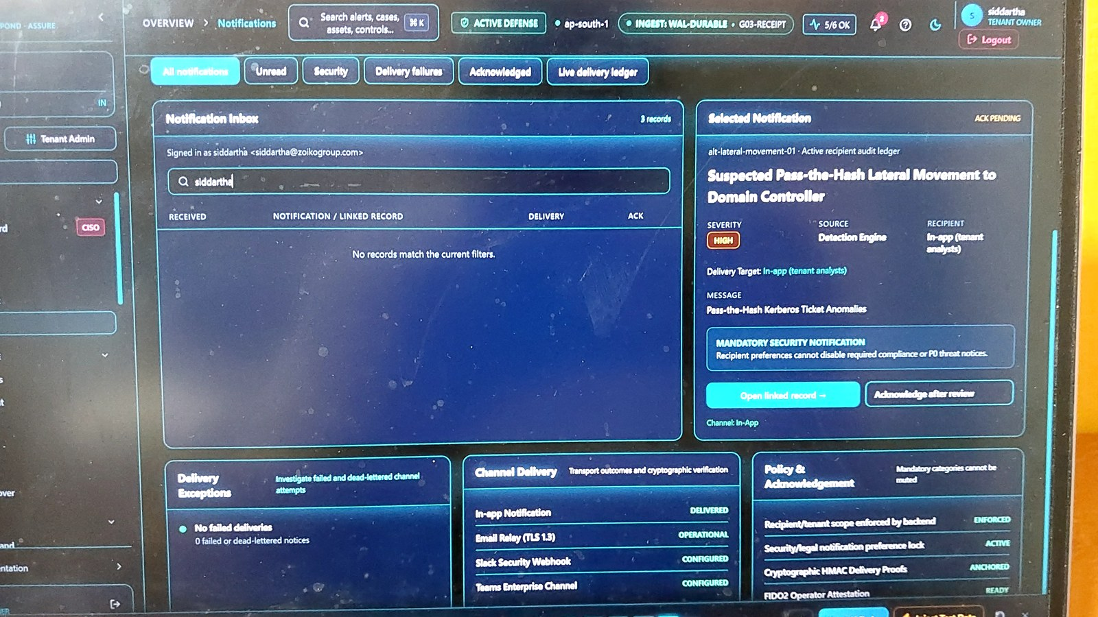
Figure 1: Notification Inbox shows “No records match the current filters” for the search term.

BUG-02: No information displayed in the Findings section
Module | Detect & Investigate > Findings
Status | Open
Description
The Findings page loads with all counters (Open, Stale assertions, Ageing, Unscored, Scored over unknowns, Unresolved asset) showing “unknown”.
The page displays “No findings match”, so no findings data is shown even though the provenance line reports 2/2 sources answered.
Users cannot view or triage exposure findings, which blocks vulnerability review from this section.
Screenshot
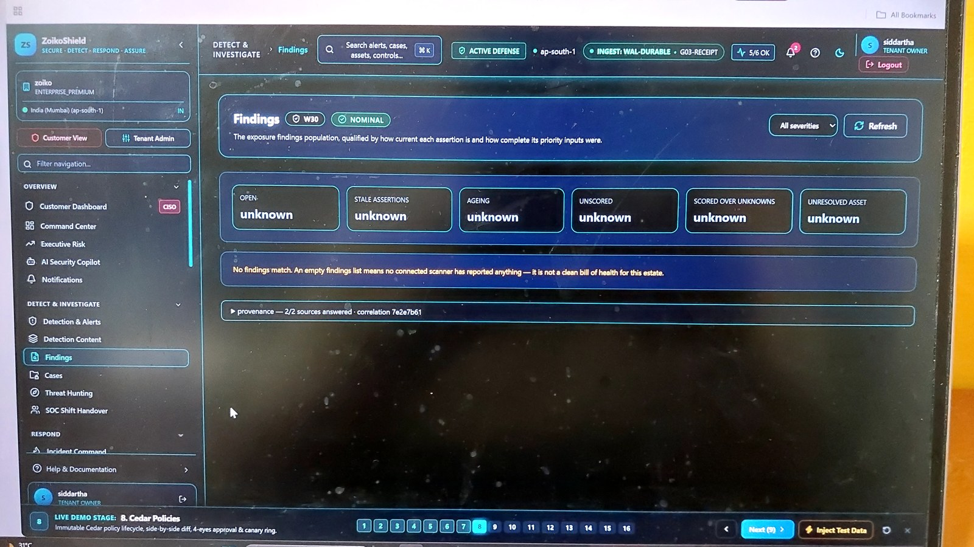
Figure 2: Findings page shows every metric as “unknown” and “No findings match”.

BUG-03: No information displayed in the Executive Risk section
Module | Overview > Executive Risk
Status | Open
Description
The Executive Risk command center shows “unknown” for all Incident cards (Open alerts, Critical alerts, Open cases, Awaiting customer) and all Controls cards.
In Residual risk, Open risks and Without factor breakdown show 0 while Expired acceptances and Expired exceptions show “unknown”.
No usable risk data is presented, so executives cannot assess the current security posture from this page.
Screenshot
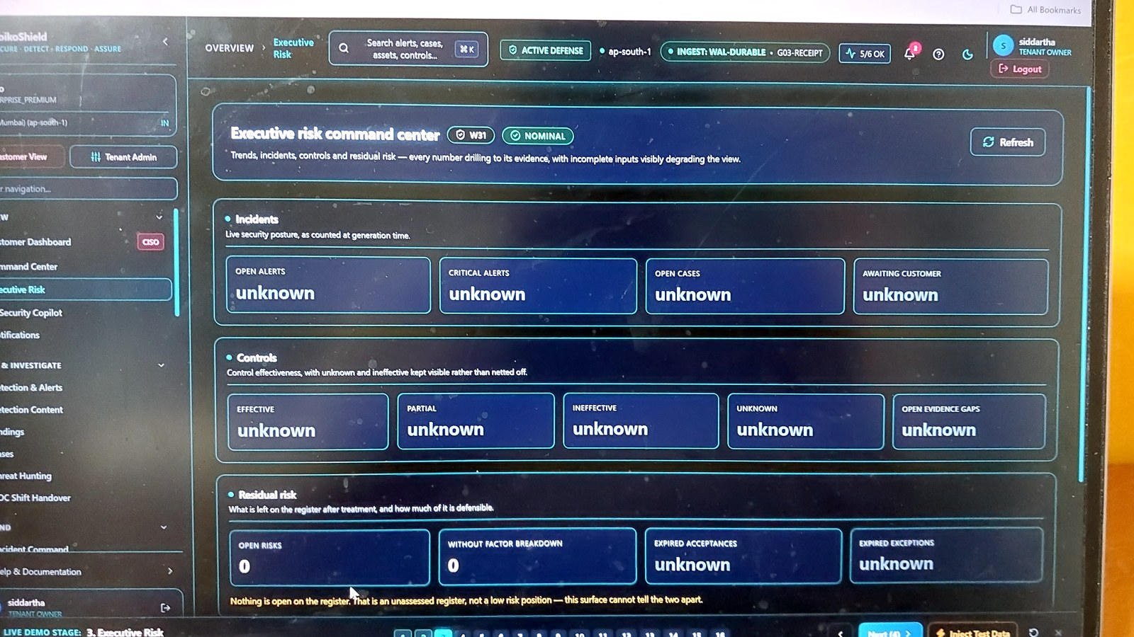
Figure 3: Executive risk command center shows “unknown” across Incidents, Controls and Residual risk.

