ZOIKOSUITE

Platform Configuration, Feature Flag,
Environment & Change Control
Detailed Service Specifications
ZS-SVC-AA-001
Version 1.0 - CFG-01 through CFG-05 Build-Ready Shared Control Baseline
24 August 2026

GOVERNING DOCTRINE
ZoikoSuite must resolve runtime configuration from immutable, versioned definitions and explicitly permitted scope overrides. A configuration value or feature flag may select only behavior that is already authorized by IAM, commercial entitlement, privacy, policy and domain rules. No configuration path may silently broaden authority, rewrite historical business truth, expose secrets, bypass environment boundaries or create an untraceable production change.

Control | Baseline
Status | Build-ready shared platform control; vendor selection and quantitative SLO ratification remain controlled implementation decisions.
Owner | Platform Architecture / SRE / Security Engineering
Applies to | All ZoikoSuite services, tenant-facing applications, worker/agent runtimes, APIs and controlled administrative tooling.
Language | American English
Classification | Internal Engineering / Architecture Control
Supersession | New canonical shared-service specification; does not supersede domain configuration specifications that comply with this authority model.
Prepared for Engineering, SRE, Security, Product, Finance Systems, HR/Payroll Engineering, Legal/Compliance, QA and Operations.

0. Executive Decision
Why this control plane is still absolutely necessary
BOARD / CTO ANSWER
Configuration is executable control. In a multi-tenant accounting, payroll, HR, legal and business platform, a single bad override can change tax behavior, expose a feature to the wrong tenant, route traffic incorrectly or disable a safety control without a code deployment. CFG makes those runtime decisions versioned, bounded, attributable, testable and reversible.

Question | Decision
Why not application environment variables? | Environment variables are deployment inputs, not a governed tenant-aware configuration authority. They lack schema-level scope rules, bitemporal history, resolution evidence, safe rollout semantics and cross-service change governance.
Why not use the feature-flag vendor as authority? | A vendor may be an implementation provider. ZoikoSuite retains the canonical definition, scope, approval, evidence and fallback contract so vendor replacement cannot change business authority.
Why not let each service own configuration? | Services may define domain-local keys, but all material keys must register against the canonical schema, scope and change-control contracts to avoid incompatible precedence, hidden overrides and uncontrolled drift.
Why separate from PDC? | PDC determines applicable rules and authoritative policy. CFG selects permitted technical/product behavior. A flag cannot amend law, tax rules or rights-affecting policy.
Why separate from COM entitlements? | A paid plan is commercial eligibility. CFG may hide or release a feature only after COM confirms entitlement; a flag cannot grant a higher plan.
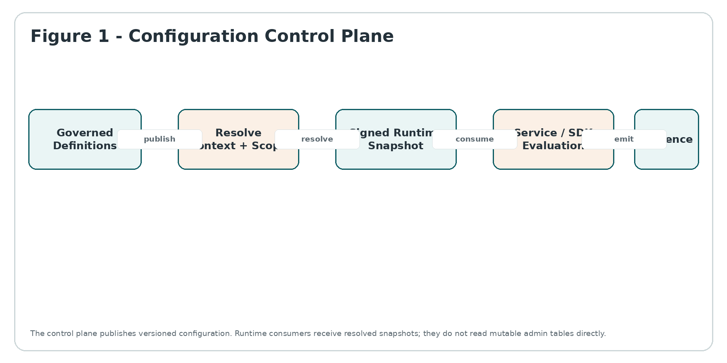
Figure 1 - Configuration Control Plane

0.1 Canonical services
Service | Canonical responsibility | Explicitly does not own
CFG-01 | Configuration Schema, Baseline & Version Registry | Defines typed keys, defaults, scope, override policy, sensitivity, safety class, fallback behavior, compatibility and immutable published versions. It does not replace IAM/PDC/PRV/COM/domain authority.
CFG-02 | Effective Configuration Resolution & Tenant Override Service | Resolves the exact value for an environment/service/tenant/org/user context with deterministic precedence, effective dating, lineage and snapshot identity. It does not replace IAM/PDC/PRV/COM/domain authority.
CFG-03 | Feature Flag, Release & Experiment Control Service | Governs release flags, operational kill switches, migrations, targeting, deterministic rollout, variants, expiry and retirement. It does not replace IAM/PDC/PRV/COM/domain authority.
CFG-04 | Environment, Secret Reference & Promotion Boundary Service | Enforces environment namespaces, promotion contracts, secret references, residency/region constraints and lower-environment protections. It does not replace IAM/PDC/PRV/COM/domain authority.
CFG-05 | Change, Rollback, Drift & Emergency Control Service | Classifies changes, binds WFC approvals, publishes, verifies propagation, detects drift, supports constrained rollback and governs break-glass changes. It does not replace IAM/PDC/PRV/COM/domain authority.

1. Scope, Boundaries & Non-Goals

1.1 In scope
- Typed platform, service and tenant configuration definitions; immutable version publication; effective-dated changes; compatibility rules.
- Allowed override scopes and deterministic precedence across environment, service, tenant, organizational unit and user-preference layers.
- Feature flags, release gates, operational kill switches, migration flags and low-risk experimentation where explicitly permitted.
- Runtime snapshot distribution, caching, freshness, safe fallback, monotonic versioning and evaluation evidence.
- Environment namespace separation, promotion, configuration-as-code ingestion, secret references and region/residency metadata.
- Change classification, approval binding, emergency changes, rollback points, drift detection, runtime verification and flag debt retirement.

1.2 Explicitly out of scope
- Identity, role, session or authorization policy (IAM).
- Product plans, price books or commercial entitlement decisions (COM).
- Jurisdictional law, tax policy, employment policy, accounting policy or other executable rules (PDC).
- Privacy permission, consent or purpose decisions (PRV).
- Secrets, private keys, credentials or certificates themselves; CFG stores references/metadata only.
- Domain transactions, ledger postings, payroll calculations, tax determinations, HR decisions, legal matters or records.
- Deployment artifact build/release orchestration, Kubernetes/host configuration management or generic infrastructure-as-code execution, except where they consume CFG promotion metadata.
- Observability, audit ledger or workflow as authorities; CFG emits evidence and invokes those planes.
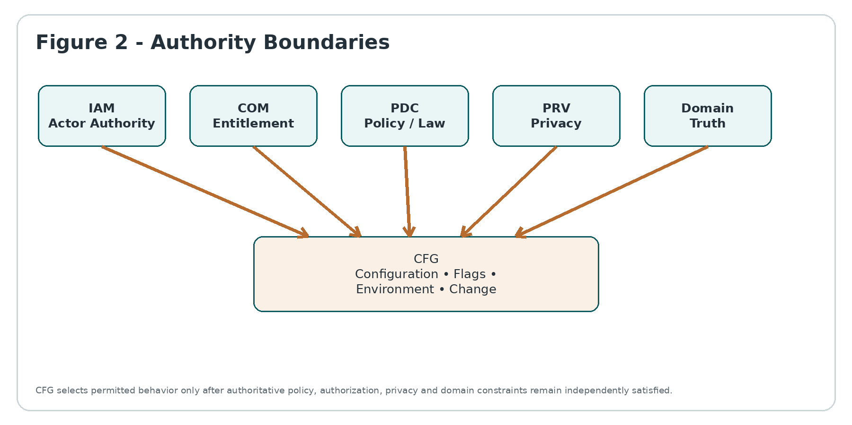
Figure 2 - Authority Boundaries

1.3 Required decision ordering
NO CONFIGURATION-BASED PRIVILEGE ESCALATION
For a protected action, the effective decision is the intersection of independent authorities. A feature flag can further restrict or select behavior; it cannot turn a denied IAM, COM, PRV or PDC decision into an allowed action.

Canonical evaluation order:
1. Resolve trusted actor, tenant, environment and service context.
2. Evaluate IAM authorization and session constraints.
3. Evaluate commercial entitlement where the capability is plan-controlled.
4. Evaluate PDC jurisdictional/policy constraints and PRV privacy-use constraints where applicable.
5. Resolve CFG key/flag against the remaining permitted behavior space.
6. Invoke the domain service, which revalidates its own invariants before committing any business outcome.

2. Canonical Concepts, State & Data Model

2.1 Core entities
Entity | Purpose
ConfigDefinition | Stable key identity, type, owner, safety class, allowed scopes, override policy, fallback semantics, sensitivity and lifecycle.
ConfigVersion | Immutable published schema/default/constraint version with effective and knowledge timestamps.
BaselineSet | Named environment/service baseline containing exact ConfigVersion references.
OverrideSet | Effective-dated values at an explicitly allowed scope with source, approver/change reference and expiry where required.
ResolutionContext | Trusted environment, service, region, tenant, legal entity/org scope, user preference scope and request attributes allowed by schema.
ResolvedConfigSnapshot | Exact deterministic result plus source lineage, version/hash, freshness and expiration metadata.
FlagDefinition / FlagVersion | Feature flag identity, type, variants, targeting model, owner, safety class, expiry, fallback and immutable published version.
ReleasePlan | Scheduled or progressive activation rules, eligibility constraints, deterministic bucket definition, pause/rollback controls.
EnvironmentProfile | Canonical environment/region namespace, promotion policy, secret-store binding, data classification and production protections.
SecretReference | Provider-neutral reference to Vault/KMS/secret manager path/version; never secret material.
ChangeSet | Atomic proposed configuration changes, impact analysis, approvals, planned effective time, rollback point and evidence.
DriftFinding | Desired-versus-observed divergence with scope, runtime identity, severity, freshness and remediation path.
EmergencyChange | Time-boxed break-glass mutation with reason, restricted actor set, expiry and mandatory retrospective review.
EvaluationEvidence | Key/flag, exact version, context hash, variant/value, reason, snapshot identity and evaluation timestamp.

2.2 Orthogonal state dimensions
Dimension | Canonical states / semantics
Definition lifecycle | DRAFT -> REVIEW -> PUBLISHED -> DEPRECATED -> RETIRED
Override lifecycle | DRAFT -> APPROVED -> SCHEDULED -> ACTIVE -> EXPIRED / SUPERSEDED / REVOKED
Flag lifecycle | DRAFT -> CERTIFIED -> SCHEDULED -> ACTIVE -> PAUSED -> RETIRED -> REMOVED
Distribution health | CURRENT / PROPAGATING / STALE / UNKNOWN / DRIFTED
Change lifecycle | PROPOSED -> VALIDATED -> APPROVED -> SCHEDULED -> APPLYING -> VERIFIED / FAILED / ROLLED_BACK
Emergency lifecycle | OPEN -> ACTIVE -> EXPIRED -> RETROSPECTIVE_PENDING -> CLOSED
Evaluation outcome | VALUE / SAFE_DEFAULT / BLOCKED / INDETERMINATE

ORTHOGONAL, NOT ONE OVERLOADED STATUS
A flag can be ACTIVE while a runtime is STALE. An override can be APPROVED but not yet effective. A change can be VERIFIED while an emergency retrospective remains pending. These states must never be collapsed.

2.3 Bitemporal and as-issued semantics
- effective_at / effective_until express when a configuration or override is intended to apply.
- recorded_at / superseded_at preserve when ZoikoSuite learned, approved and published that configuration.
- Historical transaction evidence pins the resolved snapshot/config version used at the time of the business action.
- A later correction to configuration never rewrites the configuration basis of an already issued invoice, posted journal, paid payroll, filed return, signed contract or historical decision evidence.
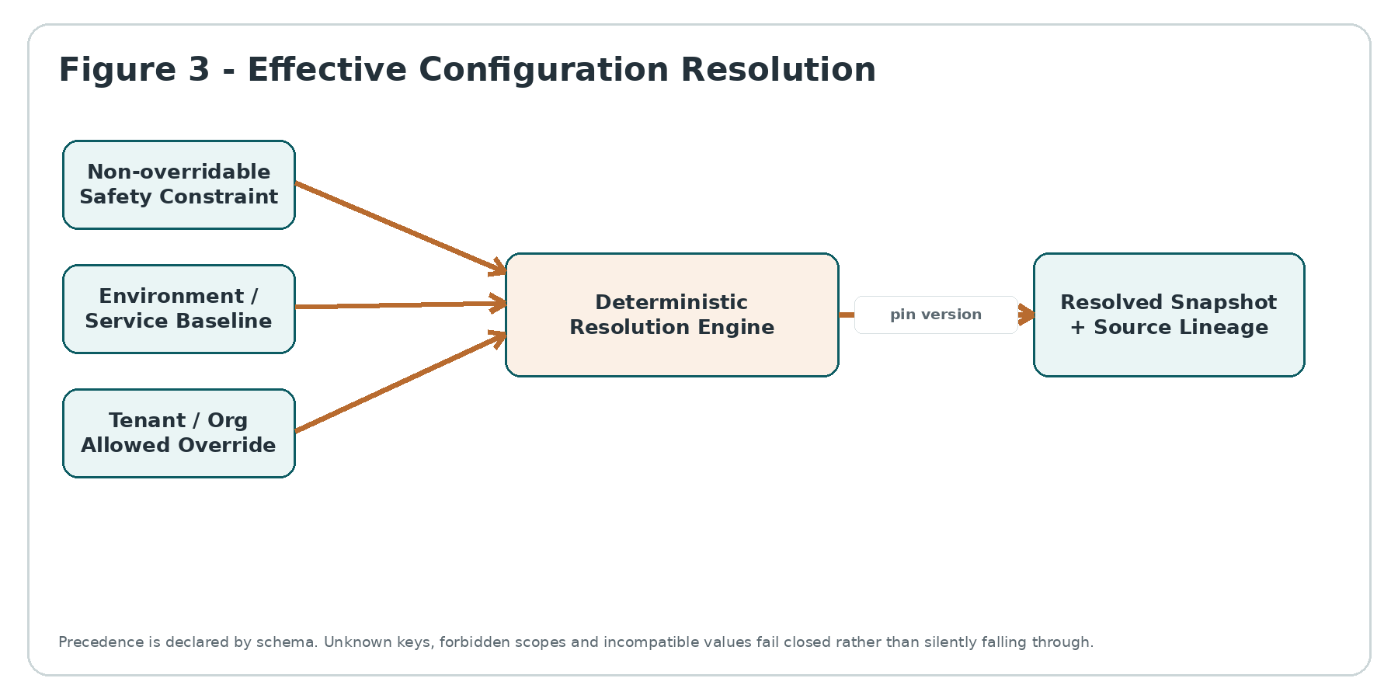
Figure 3 - Effective Configuration Resolution

3. Non-Bypassable Platform Invariants
ID | Invariant
INV-01 | A configuration value never grants IAM authorization.
INV-02 | A feature flag never grants a commercial entitlement absent COM approval.
INV-03 | A configuration value never overrides PDC law/policy or PRV privacy restrictions.
INV-04 | Published ConfigVersion and FlagVersion objects are immutable.
INV-05 | Unknown configuration keys fail validation; they are never silently accepted into production.
INV-06 | Every key declares type, owner, allowed scopes, fallback and safety class before publication.
INV-07 | Override precedence is schema-defined and deterministic; last-write-wins across arbitrary scopes is forbidden.
INV-08 | A scope may override a key only when the key explicitly permits that scope.
INV-09 | Secret values are never stored in CFG persistence, logs, events, snapshots or evidence.
INV-10 | Production secret references resolve only inside approved production secret stores and identities.
INV-11 | Production configuration cannot be copied into lower environments if it would expose production secrets or personal/regulated data.
INV-12 | Runtime evaluation pins an exact snapshot/version; mutable admin records are never read as execution truth.
INV-13 | Stale or invalid configuration cannot silently enable a protected feature.
INV-14 | Every material production change has an attributable actor/change identity and before/after values or hashes.
INV-15 | Emergency configuration has explicit expiry and mandatory retrospective review.
INV-16 | A kill switch may only execute a predefined safe disable/degrade behavior.
INV-17 | Rollback restores configuration state; it never reverses irreversible domain side effects.
INV-18 | Flag targeting must not use uncontrolled sensitive attributes or infer protected characteristics.
INV-19 | Randomized experimentation is prohibited for legal, tax, payroll, accounting, privacy, security or rights-affecting outcomes.
INV-20 | Feature flags used for temporary release control require owner, created date and retirement deadline.
INV-21 | Flag removal requires consumer/code dependency verification; RETIRED is not equivalent to REMOVED.
INV-22 | Configuration distribution is monotonic per namespace; an older snapshot cannot silently overwrite a newer one.
INV-23 | Drift detection compares desired and observed exact versions/hashes, not merely human-readable labels.
INV-24 | Drift remediation cannot mutate material production configuration outside the approved change class.
INV-25 | A tenant override cannot cross tenant boundaries or alter another tenant resolution result.
INV-26 | Environment, region and residency constraints are evaluated before secret attachment or runtime delivery.
INV-27 | Configuration cache entries carry version and freshness metadata; indefinite stale caches are forbidden.
INV-28 | A control-plane outage follows per-key safe fallback; there is no platform-wide fail-open default.
INV-29 | Evaluation evidence must be sufficient to reproduce why a material flag/config value was selected.
INV-30 | Current configuration never rewrites historical as-issued evidence for completed business transactions.

4. CFG-01 - Configuration Schema, Baseline & Version Registry
SERVICE CONTRACT
CFG-01 is the design-time authority for configuration keys and immutable published definitions. A runtime must never infer configuration semantics from an ad-hoc JSON blob or administrative UI field.

4.1 Definition schema
Field | Requirement
config_key | Globally stable within namespace; lowercase dotted form recommended; never reused for a different semantic meaning.
value_type | BOOLEAN / INTEGER / DECIMAL / STRING / ENUM / DURATION / URI / CIDR_SET / STRING_SET / STRUCTURED.
owner | Service/team plus accountable business/security owner for material keys.
safety_class | S0 cosmetic; S1 operational low risk; S2 material tenant behavior; S3 security/privacy/financial/regulated adjacent.
allowed_scopes | Explicit ordered set from PLATFORM, ENVIRONMENT, REGION, SERVICE, TENANT, ORG_UNIT, USER_PREFERENCE.
default_value | Typed safe default, or REQUIRED with no default.
fallback_policy | USE_CACHED_WITH_MAX_AGE / SAFE_DEFAULT / BLOCK / DEGRADE.
validation | Bounds, regex/enum, dependency constraints, incompatible values, required companion keys.
sensitivity | PUBLIC_CONFIG / INTERNAL / RESTRICTED_METADATA / SECRET_REFERENCE_ONLY.
effective model | Immediate, scheduled or period/effective-dated; bitemporal history always retained.
deprecation | Replacement key, migration plan, consumer inventory and removal conditions.

4.2 Publication gates
- Schema/type validation and canonical serialization.
- Default/fallback safety review; S2/S3 keys require explicit failure behavior.
- Scope/override review to prevent privilege, plan or policy bypass.
- Backward/forward compatibility check against known consumers.
- Security/privacy review for context attributes and secret/reference behavior.
- Owner and operational runbook present; temporary definitions require expiry.
- Immutable digest/signature generated before PUBLISHED state.

4.3 Baseline sets
A BaselineSet is a versioned, named composition of exact ConfigVersion references for an environment/service family. Baselines are promoted, never edited in place. A “current baseline” pointer is convenience metadata only; historical execution always resolves to an exact baseline ID and digest.

5. CFG-02 - Effective Configuration Resolution & Tenant Override Service
SERVER-AUTHORITATIVE RESOLUTION
Client-side hints may improve UX, but material configuration decisions are re-evaluated server-side from trusted context. A browser/local app must not be able to assert tenant, plan, jurisdiction or protected targeting attributes.

5.1 Resolution contract
Input | Rule
environment_id | Trusted deployment identity, never user-supplied.
service_id / config_namespace | Registered consuming service and namespace.
region/residency context | Resolved from GTRM/platform context, not arbitrary request headers.
tenant_id | Trusted tenancy resolution.
org_unit / legal_entity | Optional MDM-backed scope when the key permits it.
user preference scope | Only for keys explicitly classified as user preferences; no authority-bearing attributes.
as_of_effective_time | Defaults to controlled server time; historical resolution allowed only to authorized callers.
known_snapshot/version | Optional optimistic cache/freshness hint.

5.2 Deterministic precedence
1. Non-overridable platform safety constraint.
2. Environment/region baseline.
3. Service baseline.
4. Tenant override only where allowed.
5. Organizational-unit/legal-entity override only where allowed.
6. User preference only for preference-class keys.
7. No arbitrary request/session override in production; test override channels are environment-restricted and separately audited.

5.3 Resolution result
Output | Meaning
resolved_value | Canonical typed value or explicit absence.
resolution_reason | DEFAULT / BASELINE / OVERRIDE / SAFE_DEFAULT / BLOCKED / INDETERMINATE.
source_chain | Ordered exact definition/baseline/override IDs that produced the value.
snapshot_id / digest | Immutable identity for a set of resolved keys.
effective_at / expires_at | Temporal validity.
freshness_deadline | Latest time a cached result may be trusted for this key/safety class.
policy/entitlement references | Optional correlation evidence only; CFG does not own those decisions.

6. CFG-03 - Feature Flag, Release & Experiment Control Service
FEATURE FLAG IS NOT AUTHORITY
Flags decouple deployment from release. They do not replace permissions, plans, privacy rules, legal policy or domain validation. A disabled flag may deny a path; an enabled flag does not make an otherwise forbidden path lawful or authorized.

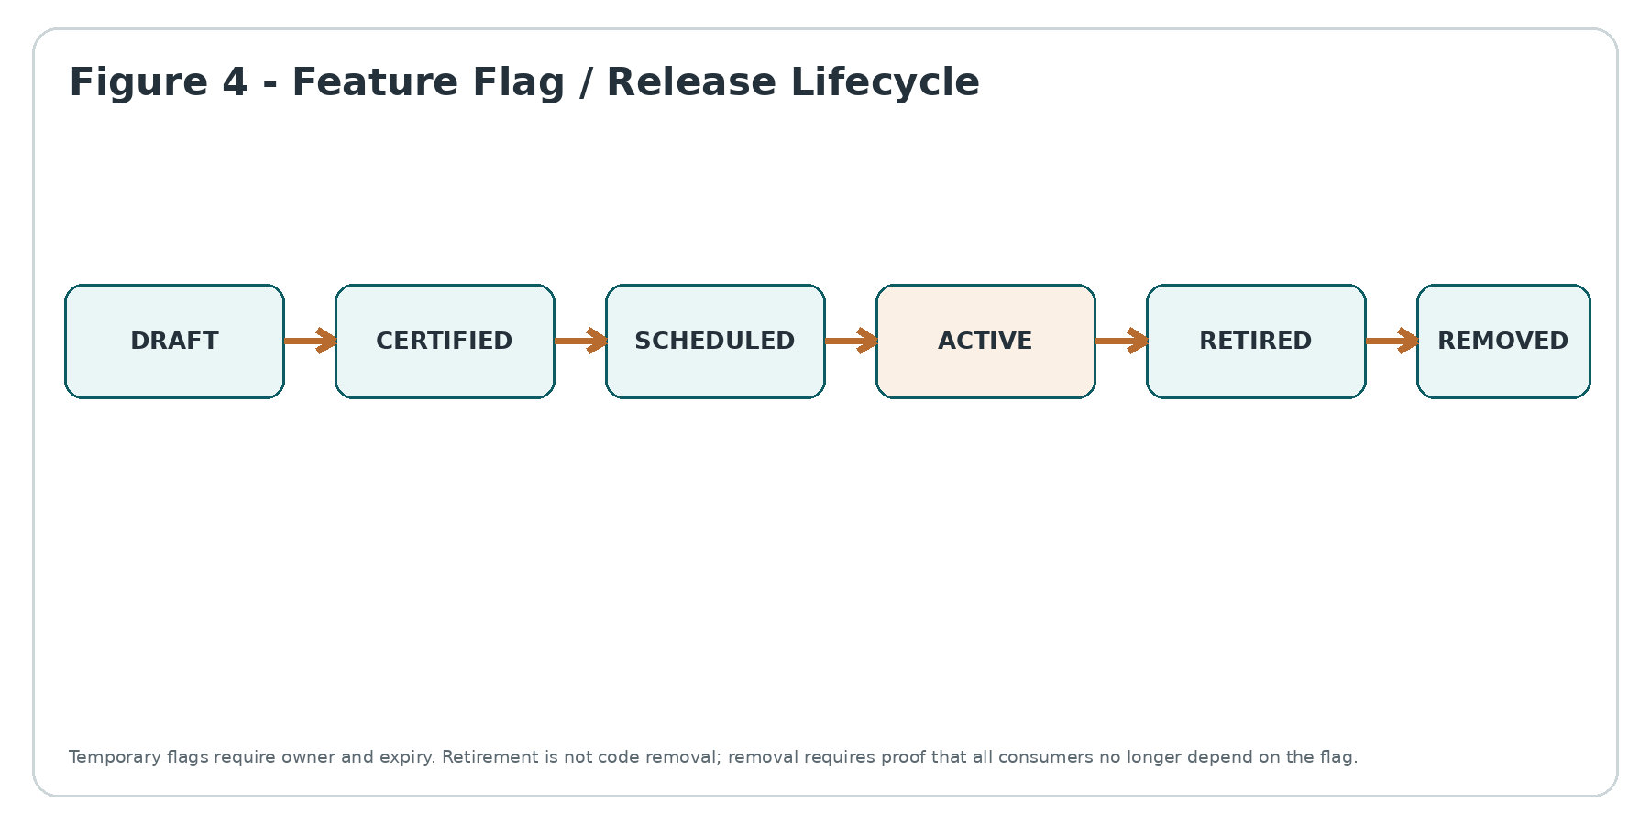
Figure 4 - Feature Flag / Release Lifecycle

6.1 Flag classes
Class | Permitted use | Special control
RELEASE | Progressive availability of already-authorized product behavior. | Owner, rollback, target cohort and retirement date required for material releases.
OPS_KILL_SWITCH | Disable/degrade a predefined risky or unavailable path. | Default must be safe; activation is high priority and separately observable.
MIGRATION | Select old/new implementation during controlled data/service migration. | Requires equivalence/reconciliation plan and explicit cutover/removal criteria.
EXPERIMENT | Low-risk UX/business experiment. | PRV-approved attributes; no regulated/rights-affecting outcomes; deterministic bucketing.
COMPATIBILITY | Temporary behavior for client/protocol version compatibility. | Expiry and consumer-version inventory mandatory.

6.2 Targeting and rollout
- Targeting rules are immutable per published FlagVersion and use only registered context attributes.
- Bucketing is deterministic for a stable subject/key and salt version so the same eligible subject does not oscillate variants.
- Percentage rollout applies only after explicit eligibility filters; “10% of all users” is invalid where tenant/region/plan/policy restrictions apply.
- Sensitive or protected attributes are not used for experimentation unless an independently approved lawful purpose exists; indirect proxies are reviewed.
- High-risk and rights-affecting domains use deterministic all-or-nothing certified activation, not randomized canaries.
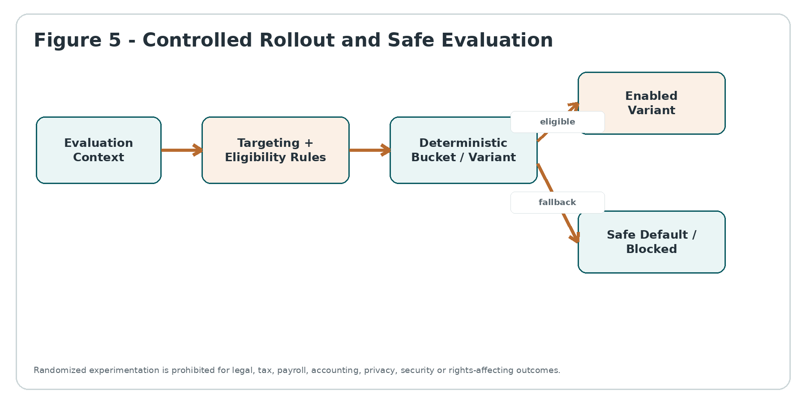
Figure 5 - Controlled Rollout and Safe Evaluation

6.3 Flag debt and retirement
Control | Requirement
TTL | Every temporary flag has an owner and target retirement date.
Usage inventory | Known SDK/service consumers and evaluation volume tracked.
Stale flag alert | Expired or zero-usage flags surface to owner and platform governance.
Retirement | Flag forced to final intended value and targeting disabled.
Removal | Code/config references removed, consumer scan clean, then definition enters REMOVED tombstone state; key cannot be immediately reused.

7. CFG-04 - Environment, Secret Reference & Promotion Boundary Service
ENVIRONMENT SEPARATION
Development, test, stage and production are separate control namespaces. Promotion moves an approved specification/version forward; it does not copy mutable runtime state, production credentials or tenant personal data backward.

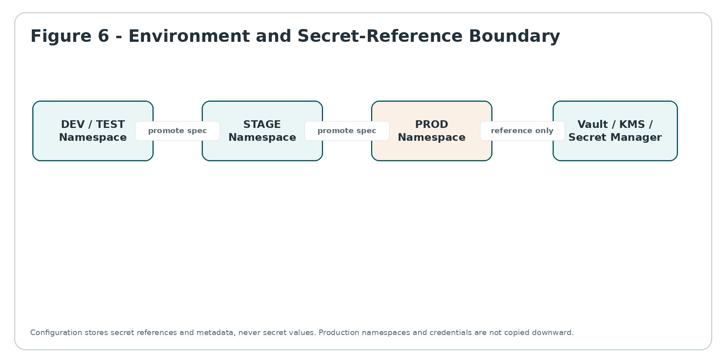
Figure 6 - Environment and Secret-Reference Boundary

7.1 Environment profile
Attribute | Requirement
environment_class | DEV / TEST / STAGE / PROD / DR_SANDBOX as explicitly registered.
region/residency | Bound to approved deployment region/cell and GTRM policy.
config namespace | Cryptographically and logically distinct namespace; production identifiers cannot resolve against lower-env stores.
secret_store_binding | Approved Vault/KMS/secret manager endpoint and workload identity; CFG stores reference metadata only.
data classification | Allowed data classes and masking/synthetic-data requirements.
promotion policy | Required source environment, validations, approvals and artifact/config compatibility checks.
test override policy | Allowed only outside production unless an explicitly registered production diagnostic key exists with strict TTL.

7.2 Secret-reference contract
- Reference contains provider/store identity, logical secret name/path, optional pinned version, purpose metadata and rotation expectations.
- Secret material is resolved at runtime by an authorized workload identity directly from the secret authority.
- CFG APIs, events, audit evidence and administrative views redact or omit any secret payload.
- A reference valid in STAGE is not automatically valid in PROD; environment binding is part of authorization.
- Rotation can update the referenced secret version without exposing secret material; changes still follow declared change class.

7.3 Promotion gates
- Schema compatibility with target environment/service version.
- No unresolved S2/S3 validation findings.
- No production-only reference accidentally pointing to lower environment or vice versa.
- Required WFC approvals and change window satisfied.
- Rollback point and safe fallback recorded.
- Post-promotion propagation verification scheduled before change is VERIFIED.

8. CFG-05 - Change, Rollback, Drift & Emergency Control Service
CONFIGURATION IS A PRODUCTION CHANGE
Changing a runtime value can be as consequential as deploying code. S2/S3 changes therefore have impact analysis, approval, effective time, propagation verification, rollback strategy and evidence even when no software artifact changes.

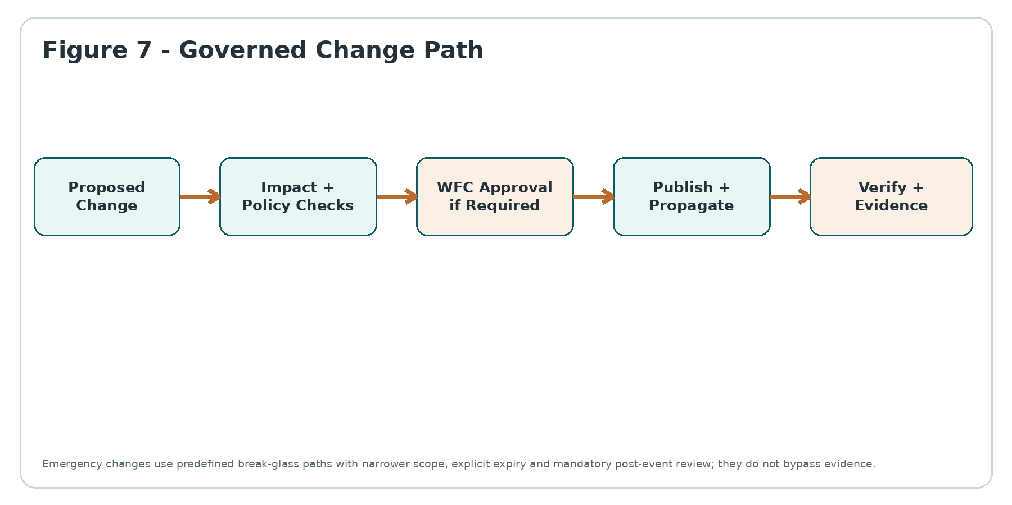
Figure 7 - Governed Change Path

8.1 Change classes
Class | Examples | Minimum control
C0 - Cosmetic | Copy, non-material presentation defaults. | Automated validation + attributable publish; rollback available.
C1 - Operational | Timeout within approved range, non-material batching, UI release flag. | Peer review, validation, bounded scope, verification.
C2 - Material | Tenant behavior, financial workflow threshold, production integration mode. | Impact analysis + WFC approval + scheduled change + rollback + monitoring.
C3 - Critical | Security/privacy safeguard, broad kill switch, regulated workflow control, cross-region behavior. | Segregated approval, change window or emergency protocol, enhanced evidence and retrospective review.

8.2 Rollback semantics
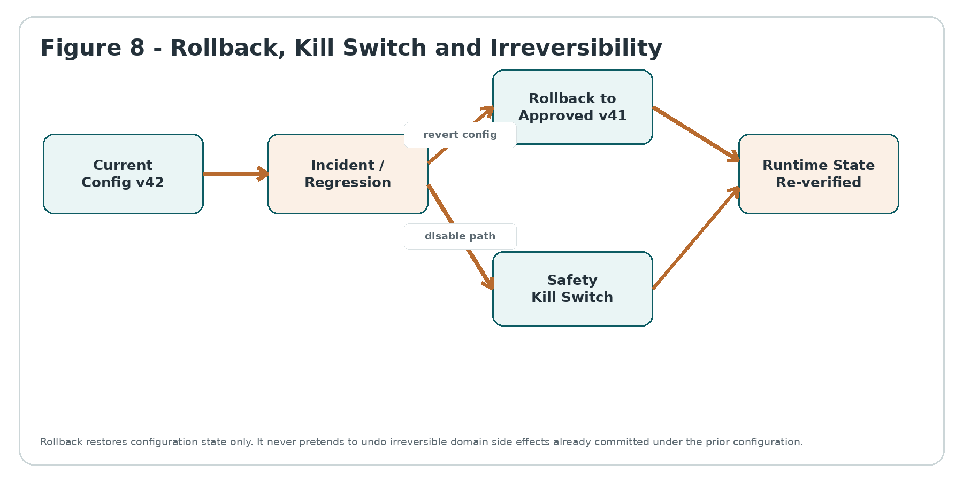
Figure 8 - Rollback, Kill Switch and Irreversibility
- Rollback target must be a previously approved compatible version or an explicitly certified safe baseline.
- Rollback cannot cross a schema/consumer incompatibility boundary without validation.
- Rollback does not delete the failed change, evidence, or its evaluation history.
- If the prior config caused irreversible domain effects, those effects are handled through the domain correction process, not by CFG history editing.
- Kill switches are predeclared, narrow, observable and default to disabling/degrading the risky path rather than broadening access.

8.3 Drift detection and runtime attestation
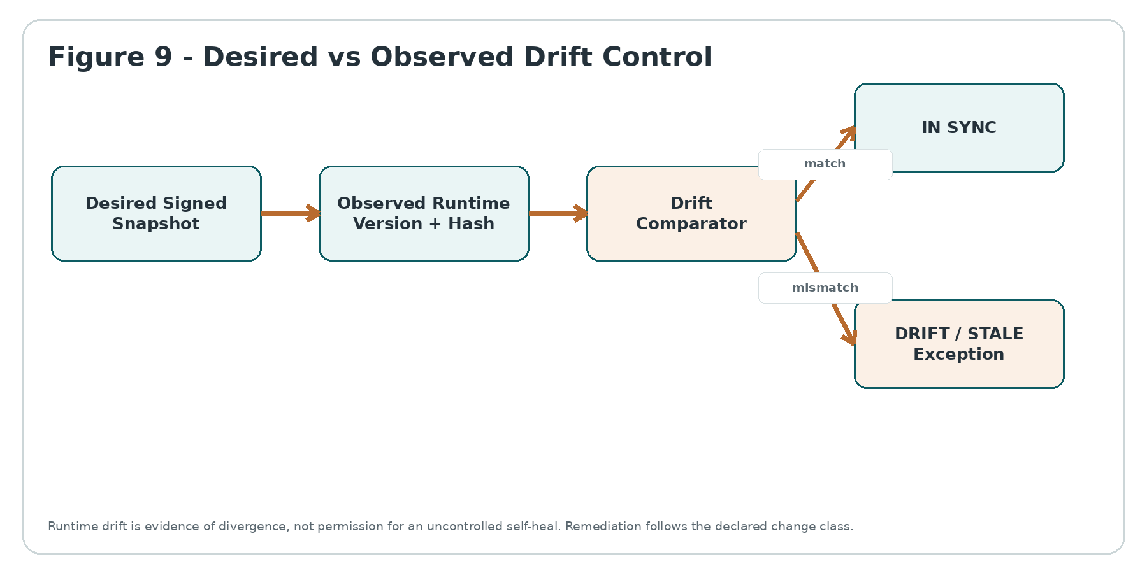
Figure 9 - Desired vs Observed Drift Control
Drift class | Examples | Response
STALE | Runtime has older valid snapshot past freshness deadline. | Block/degrade per key; refresh; escalate if safety class requires.
UNAUTHORIZED | Runtime value/hash has no published CFG provenance. | High-severity exception; isolate path; investigate tampering/manual mutation.
PARTIAL | Multi-instance service has mixed config versions beyond rollout window. | Pause rollout; reconcile instance set; do not mark change VERIFIED.
INCOMPATIBLE | Runtime consumer rejects current schema/version. | Serve last compatible safe snapshot where policy permits; block otherwise; open incident.
UNKNOWN | Runtime cannot attest current version/hash. | Treat as unverified; high-risk actions use safe fallback.

8.4 Emergency / break-glass change
- Restricted to predefined C2/C3 keys and designated emergency actors; IAM break-glass session required.
- Reason, incident ID, intended scope, expiry and safe rollback point captured before activation where technically possible.
- No bypass of immutable safety constraints, tenant isolation, secret separation or PDC/PRV/COM/IAM authority.
- Automatic expiry/reversion unless explicitly converted to a normal approved change before deadline.
- Mandatory retrospective review, evidence closure and root-cause linkage in WFC/incident process.

9. Runtime Distribution, Caching & Failure Semantics
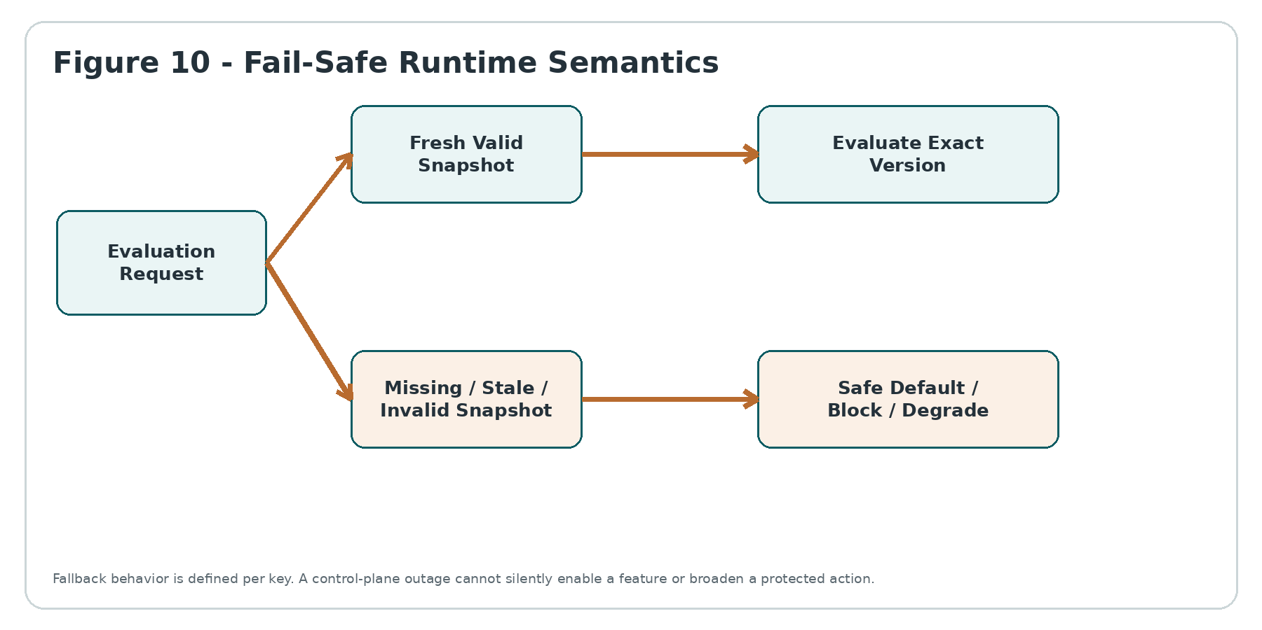
Figure 10 - Fail-Safe Runtime Semantics

9.1 Distribution model
- Control plane publishes immutable snapshot manifests through a durable distribution channel; consumers never require synchronous database access for every request.
- Snapshot carries namespace, version/epoch, digest/signature, issued_at, effective_at, expires/freshness deadline and compatible schema version.
- Consumers accept monotonic versions, validate signature/digest and atomically replace the prior snapshot.
- Push invalidation may accelerate updates, but pull/refresh and freshness deadlines remain the correctness backstop.
- Material evaluations emit reason/version/snapshot identifiers without logging sensitive targeting context.

9.2 Failure matrix
Failure | Required behavior
Control plane unreachable | Continue only within per-key cached max-age; otherwise SAFE_DEFAULT/BLOCK/DEGRADE. Never globally fail open.
Invalid signature/digest | Reject snapshot; retain last known valid within freshness policy; raise security/operations event.
Unknown key | Return explicit KEY_NOT_REGISTERED; do not invent default unless caller provided a non-authoritative UI fallback.
Type mismatch | BLOCK evaluation for material key; developer/operator error surfaced.
Targeting context missing | Follow key-specific MISSING_CONTEXT behavior; never assume eligibility.
Mixed fleet versions | Remain PROPAGATING until allowed convergence; if window breached, mark PARTIAL drift and pause change.
Clock anomaly | Use trusted monotonic/server time source; do not activate scheduled material change from an untrusted client clock.
Provider/vendor outage | Vendor abstraction may fall back to locally cached canonical snapshot; vendor error cannot redefine canonical values.

10. API, Event & SDK Contracts

10.1 Canonical APIs
API | Purpose | Key controls
POST /config/definitions | Create draft ConfigDefinition. | Schema, owner, scope and type validation; idempotency key.
POST /config/definitions/{id}/publish | Publish immutable version. | Approval binding for S2/S3; digest/signature; no in-place edit.
PUT /config/overrides/{scope} | Create effective-dated override set. | Scope allowlist; tenant isolation; impact/change classification.
POST /config/resolve | Resolve keys for trusted context. | Server-authenticated context; deterministic precedence; snapshot lineage.
GET /config/snapshots/{id} | Fetch immutable signed snapshot. | Access-controlled; cacheable; no secret values.
POST /flags | Create draft flag. | Class, owner, variants, fallback, expiry for temporary flags.
POST /flags/{id}/release-plans | Create rollout/targeting plan. | Eligibility first; deterministic buckets; experiment restrictions.
POST /changes | Create atomic ChangeSet. | Before/after, validation, approvals, rollout and rollback.
POST /changes/{id}/activate | Activate scheduled/approved change. | Effective time, authorization, idempotency, monotonic version.
POST /emergency-changes | Break-glass change. | Restricted actors/keys, TTL, incident reference, retrospective required.
POST /runtime/attest | Report observed snapshot/version/hash. | Workload identity; anti-replay; drift correlation.

10.2 Events
Event | Minimum payload
config.version.published | definition_id, version, digest, safety_class, actor/change_id, effective_at
config.override.activated | scope_type/id, key/version, effective_at, expires_at, change_id
config.snapshot.published | namespace, environment, snapshot_id, epoch, digest, issued_at
flag.release.activated | flag_id/version, release_plan_id, cohort rule hash, effective_at
flag.kill_switch.activated | flag_id, reason/incident, actor, scope, expires_at
config.change.verified | change_id, expected snapshot, observed fleet convergence, verification_time
config.drift.detected | runtime_id, desired/observed version/hash, drift_class, severity
config.emergency.expired | emergency_change_id, revert/result, retrospective_due_at

10.3 SDK requirements
- Typed accessors generated or validated from ConfigDefinition/flag manifests where practical.
- No direct vendor SDK usage for authoritative application decisions unless wrapped by the ZoikoSuite provider abstraction and canonical context/evidence hooks.
- Server SDKs expose resolution details and reason codes, not only raw values.
- Client SDKs receive only client-safe flags/configs; sensitive server-only keys never ship to browsers/mobile clients.
- SDK telemetry must not emit tenant secrets, raw personal attributes or full evaluation contexts.

11. Cross-Domain Adoption Contracts
Domain | Binding contract
Accounting | CFG may select UI/workflow implementation variants, posting service endpoint or safe operational thresholds only where accounting policy and ledger invariants remain authoritative. It cannot alter journal balance rules, period closure authority or historic posted data.
Billing | CFG may release invoice UI or route a payment-provider integration after COM/PDC controls. It cannot create plan entitlement, change accepted price versions or make an UNKNOWN payment safe to retry.
Payroll | CFG may select approved engine implementation, rollout new payslip UX or activate a country adapter only after PDC/payroll rules. It cannot alter statutory rates or gross-to-net formulas as ad-hoc config.
HR | CFG may release workflow UX and optional modules after entitlement/privacy checks. It cannot bypass role permissions, employment-law rules or make AI decisions authoritative.
Tax | CFG may activate a certified tax-engine adapter/version by jurisdiction. Statutory rates, thresholds and applicability remain PDC/domain rule artifacts, not mutable flags.
Legal | CFG may control availability of drafting/search tooling. It cannot waive legal hold, privilege, signature authority or service-of-notice requirements.
AI | CFG may select an already-approved model/provider deployment within AIG policy. It cannot approve a model, broaden prompt data access or disable human oversight required by AIG/PDC.
Privacy | CFG may implement UI preference presentation. It cannot manufacture consent, lawful basis or override a PRV BLOCK/RESTRICT decision.
Integration | CFG may choose among pre-approved XIC connector endpoints/modes. It cannot attach arbitrary destinations, credentials or bypass egress/residency controls.
Search/Reporting future planes | CFG may release an index/query/report implementation, but secure retrieval/semantic metric authority remains with those control planes when implemented.

12. Security, Privacy, Residency & Abuse Controls

Security
- Management APIs require strong IAM, privileged-session controls and fine-grained change permissions.
- S2/S3 definitions and changes use segregation of duties; author and sole approver cannot be the same actor where WFC policy forbids.
- Snapshot/signature keys are separately managed; compromise rotation has a documented recovery procedure.
- Admin surfaces never expose secret values; secret reference metadata is access-controlled and redacted where sensitive.
- Mass override/export endpoints are rate-limited, purpose-limited and evidence-producing.

Privacy
- Targeting context is data-minimized; attributes are registered with purpose and PRV review where personal data is involved.
- Experiment bucketing uses stable pseudonymous identifiers where possible; raw email, phone, health, religion or similar sensitive attributes are prohibited as generic flag keys.
- Evaluation logs store context hashes/reason metadata rather than raw personal context except when explicitly necessary and governed.
- Tenant administrators cannot use flags as an undeclared employee/customer profiling system.

Residency
- Configuration metadata is routed to the approved region/cell where tenant or regulatory policy requires.
- Secret references resolve only against environment/region-approved secret stores.
- Global replication contains only data classified for global control-plane replication; tenant-sensitive overrides may remain region-local with global metadata pointers.
- Disaster recovery does not silently move restricted configuration/targeting data across a prohibited boundary.

13. Observability, SLOs & Operational Runbooks

13.1 Required signals
Signal | Purpose
snapshot_publish_latency | Time from approved effective change to signed snapshot availability.
fleet_convergence | Percent of expected runtimes attesting target version within rollout window.
stale_evaluation_rate | Evaluations served from snapshots older than target freshness; segmented by safety class.
safe_fallback_rate | How often SAFE_DEFAULT/BLOCK/DEGRADE paths activate.
flag_evaluation_error_rate | Type/context/provider/evaluation failures by flag and SDK/service.
drift_findings | Unauthorized, stale, partial, incompatible and unknown runtime states.
emergency_change_age | Open emergency changes and time to expiry/retrospective closure.
flag_debt | Flags past retirement date, zero-usage flags, flags without known consumers.
override_churn | High-frequency tenant/service overrides indicating unstable or abused configuration.

13.2 SLO policy
Numeric objectives remain controlled deployment decisions because they depend on topology and safety class. The implementation MUST define and ratify at least: publication durability, P95/P99 propagation latency, high-risk snapshot freshness, evaluation availability, drift-detection latency, emergency kill-switch propagation, recovery point/objective for the control plane, and fleet-convergence thresholds.

13.3 Minimum runbooks
- Control-plane unavailable / runtime cache approaching max age.
- Bad configuration or flag causes production regression.
- Unauthorized/manual runtime drift detected.
- Snapshot signing key or provider credential suspected compromised.
- Partial multi-region propagation or split fleet.
- Emergency kill switch activation and expiry.
- Tenant-scoped misconfiguration with possible cross-tenant impact.
- Feature-flag provider outage/migration.
- Expired flag / configuration debt cleanup.

14. Negative-Path Certification Matrix

14.1 Scenarios NP-01 to NP-10
ID | Negative path | Required certification outcome
NP-01 | Tenant attempts to override a PLATFORM_ONLY safety key. | BLOCK / SAFE DEFAULT / CONTROLLED EXCEPTION; preserve evidence; govern remediation.
NP-02 | Service receives unknown config key and tries to invent a default. | BLOCK / SAFE DEFAULT / CONTROLLED EXCEPTION; preserve evidence; govern remediation.
NP-03 | Boolean key is published with string value through raw API. | BLOCK / SAFE DEFAULT / CONTROLLED EXCEPTION; preserve evidence; govern remediation.
NP-04 | Published ConfigVersion is edited in place. | BLOCK / SAFE DEFAULT / CONTROLLED EXCEPTION; preserve evidence; govern remediation.
NP-05 | Two equal-precedence overrides exist for same scope/time. | BLOCK / SAFE DEFAULT / CONTROLLED EXCEPTION; preserve evidence; govern remediation.
NP-06 | Tenant A override appears in Tenant B resolution. | BLOCK / SAFE DEFAULT / CONTROLLED EXCEPTION; preserve evidence; govern remediation.
NP-07 | User preference tries to modify authority-bearing S2 key. | BLOCK / SAFE DEFAULT / CONTROLLED EXCEPTION; preserve evidence; govern remediation.
NP-08 | Client asserts a higher plan context to enable a feature. | BLOCK / SAFE DEFAULT / CONTROLLED EXCEPTION; preserve evidence; govern remediation.
NP-09 | Flag enablement is treated as IAM permission. | BLOCK / SAFE DEFAULT / CONTROLLED EXCEPTION; preserve evidence; govern remediation.
NP-10 | Flag enablement bypasses COM entitlement. | BLOCK / SAFE DEFAULT / CONTROLLED EXCEPTION; preserve evidence; govern remediation.

14.2 Scenarios NP-11 to NP-20
ID | Negative path | Required certification outcome
NP-11 | Flag tries to override PDC jurisdictional BLOCK. | BLOCK / SAFE DEFAULT / CONTROLLED EXCEPTION; preserve evidence; govern remediation.
NP-12 | Flag tries to override PRV privacy restriction. | BLOCK / SAFE DEFAULT / CONTROLLED EXCEPTION; preserve evidence; govern remediation.
NP-13 | Experiment uses protected characteristic without approved purpose. | BLOCK / SAFE DEFAULT / CONTROLLED EXCEPTION; preserve evidence; govern remediation.
NP-14 | Payroll calculation variant is randomly A/B tested. | BLOCK / SAFE DEFAULT / CONTROLLED EXCEPTION; preserve evidence; govern remediation.
NP-15 | Tax-rate behavior is randomized across equivalent taxpayers. | BLOCK / SAFE DEFAULT / CONTROLLED EXCEPTION; preserve evidence; govern remediation.
NP-16 | Accounting posting rule is changed via ad-hoc config. | BLOCK / SAFE DEFAULT / CONTROLLED EXCEPTION; preserve evidence; govern remediation.
NP-17 | Legal notice requirement is disabled by UI flag. | BLOCK / SAFE DEFAULT / CONTROLLED EXCEPTION; preserve evidence; govern remediation.
NP-18 | Security MFA requirement is disabled by tenant config. | BLOCK / SAFE DEFAULT / CONTROLLED EXCEPTION; preserve evidence; govern remediation.
NP-19 | Temporary flag has no owner or expiry. | BLOCK / SAFE DEFAULT / CONTROLLED EXCEPTION; preserve evidence; govern remediation.
NP-20 | Retired flag key is immediately reused for different semantics. | REJECT change/removal; retain dependency/tombstone evidence; require verified migration.

14.3 Scenarios NP-21 to NP-30
ID | Negative path | Required certification outcome
NP-21 | Control plane outage causes all flags to default true. | BLOCK / SAFE DEFAULT / CONTROLLED EXCEPTION; preserve evidence; govern remediation.
NP-22 | Stale cached snapshot remains trusted indefinitely. | BLOCK / SAFE DEFAULT / CONTROLLED EXCEPTION; preserve evidence; govern remediation.
NP-23 | Runtime accepts older snapshot after newer version. | BLOCK / SAFE DEFAULT / CONTROLLED EXCEPTION; preserve evidence; govern remediation.
NP-24 | Snapshot digest/signature validation fails but runtime continues with new payload. | BLOCK / SAFE DEFAULT / CONTROLLED EXCEPTION; preserve evidence; govern remediation.
NP-25 | Mixed fleet remains beyond rollout window but change is marked VERIFIED. | BLOCK / SAFE DEFAULT / CONTROLLED EXCEPTION; preserve evidence; govern remediation.
NP-26 | Runtime cannot attest version yet system assumes current. | BLOCK / SAFE DEFAULT / CONTROLLED EXCEPTION; preserve evidence; govern remediation.
NP-27 | Unauthorized local environment variable overrides canonical S3 key. | BLOCK / SAFE DEFAULT / CONTROLLED EXCEPTION; preserve evidence; govern remediation.
NP-28 | Provider vendor returns a different default than canonical definition. | BLOCK / SAFE DEFAULT / CONTROLLED EXCEPTION; preserve evidence; govern remediation.
NP-29 | Unknown targeting attribute silently makes user eligible. | BLOCK / SAFE DEFAULT / CONTROLLED EXCEPTION; preserve evidence; govern remediation.
NP-30 | Missing targeting context silently selects privileged variant. | BLOCK / SAFE DEFAULT / CONTROLLED EXCEPTION; preserve evidence; govern remediation.

14.4 Scenarios NP-31 to NP-40
ID | Negative path | Required certification outcome
NP-31 | Production secret value is stored directly in CFG database. | BLOCK / SAFE DEFAULT / CONTROLLED EXCEPTION; preserve evidence; govern remediation.
NP-32 | Production secret is emitted in config event/log. | BLOCK / SAFE DEFAULT / CONTROLLED EXCEPTION; preserve evidence; govern remediation.
NP-33 | Stage secret reference resolves against production secret store. | BLOCK / SAFE DEFAULT / CONTROLLED EXCEPTION; preserve evidence; govern remediation.
NP-34 | Production configuration copy exposes real tenant data in test. | BLOCK / SAFE DEFAULT / CONTROLLED EXCEPTION; preserve evidence; govern remediation.
NP-35 | Dev/test override channel is reachable in production. | BLOCK / SAFE DEFAULT / CONTROLLED EXCEPTION; preserve evidence; govern remediation.
NP-36 | Cross-region failover uses configuration disallowed by residency policy. | BLOCK / SAFE DEFAULT / CONTROLLED EXCEPTION; preserve evidence; govern remediation.
NP-37 | Promotion copies mutable runtime state instead of exact published spec. | BLOCK / SAFE DEFAULT / CONTROLLED EXCEPTION; preserve evidence; govern remediation.
NP-38 | Secret rotation bypasses workload authorization. | BLOCK / SAFE DEFAULT / CONTROLLED EXCEPTION; preserve evidence; govern remediation.
NP-39 | Client-safe snapshot includes server-only credential reference metadata. | BLOCK / SAFE DEFAULT / CONTROLLED EXCEPTION; preserve evidence; govern remediation.
NP-40 | Configuration export leaks restricted tenant targeting data. | BLOCK / SAFE DEFAULT / CONTROLLED EXCEPTION; preserve evidence; govern remediation.

14.5 Scenarios NP-41 to NP-50
ID | Negative path | Required certification outcome
NP-41 | C3 production change occurs without required WFC approval. | BLOCK / SAFE DEFAULT / CONTROLLED EXCEPTION; preserve evidence; govern remediation.
NP-42 | Emergency actor changes a key outside emergency allowlist. | BLOCK / SAFE DEFAULT / CONTROLLED EXCEPTION; preserve evidence; govern remediation.
NP-43 | Emergency change has no expiry. | BLOCK / SAFE DEFAULT / CONTROLLED EXCEPTION; preserve evidence; govern remediation.
NP-44 | Emergency change expires but is silently left active. | BLOCK / SAFE DEFAULT / CONTROLLED EXCEPTION; preserve evidence; govern remediation.
NP-45 | Break-glass change bypasses non-overridable safety constraint. | BLOCK / SAFE DEFAULT / CONTROLLED EXCEPTION; preserve evidence; govern remediation.
NP-46 | Rollback target is schema-incompatible with running consumers. | BLOCK / SAFE DEFAULT / CONTROLLED EXCEPTION; preserve evidence; govern remediation.
NP-47 | Rollback deletes evidence of failed change. | BLOCK / SAFE DEFAULT / CONTROLLED EXCEPTION; preserve evidence; govern remediation.
NP-48 | Rollback is claimed to undo already posted domain transactions. | BLOCK / SAFE DEFAULT / CONTROLLED EXCEPTION; preserve evidence; govern remediation.
NP-49 | Kill switch broadens access instead of disabling/degrading path. | REJECT change/removal; retain dependency/tombstone evidence; require verified migration.
NP-50 | Drift detector self-heals material config outside approved policy. | BLOCK / SAFE DEFAULT / CONTROLLED EXCEPTION; preserve evidence; govern remediation.

14.6 Scenarios NP-51 to NP-60
ID | Negative path | Required certification outcome
NP-51 | Drift comparison uses labels and misses changed hash. | BLOCK / SAFE DEFAULT / CONTROLLED EXCEPTION; preserve evidence; govern remediation.
NP-52 | Partial region propagation creates different legal behavior across same jurisdiction. | BLOCK / SAFE DEFAULT / CONTROLLED EXCEPTION; preserve evidence; govern remediation.
NP-53 | Scheduled activation uses untrusted client clock. | BLOCK / SAFE DEFAULT / CONTROLLED EXCEPTION; preserve evidence; govern remediation.
NP-54 | Change is marked VERIFIED before expected runtimes converge. | BLOCK / SAFE DEFAULT / CONTROLLED EXCEPTION; preserve evidence; govern remediation.
NP-55 | Current config rewrites historical invoice/payroll/tax decision evidence. | BLOCK / SAFE DEFAULT / CONTROLLED EXCEPTION; preserve evidence; govern remediation.
NP-56 | Config admin changes another tenant without explicit privileged cross-tenant scope. | BLOCK / SAFE DEFAULT / CONTROLLED EXCEPTION; preserve evidence; govern remediation.
NP-57 | Flag provider outage changes semantic default. | BLOCK / SAFE DEFAULT / CONTROLLED EXCEPTION; preserve evidence; govern remediation.
NP-58 | Deprecated key is removed while known consumers remain. | REJECT change/removal; retain dependency/tombstone evidence; require verified migration.
NP-59 | Material config change has no before/after or snapshot evidence. | BLOCK / SAFE DEFAULT / CONTROLLED EXCEPTION; preserve evidence; govern remediation.
NP-60 | Audit/evidence event omits exact config/flag version used. | BLOCK / SAFE DEFAULT / CONTROLLED EXCEPTION; preserve evidence; govern remediation.

15. Stable Error / Reason Codes
Code | Meaning
CFG-001 | KEY_NOT_REGISTERED
CFG-002 | TYPE_MISMATCH
CFG-003 | SCOPE_NOT_ALLOWED
CFG-004 | OVERRIDE_CONFLICT
CFG-005 | VALUE_CONSTRAINT_FAILED
CFG-006 | VERSION_IMMUTABLE
CFG-007 | SNAPSHOT_STALE
CFG-008 | SNAPSHOT_INVALID
CFG-009 | SNAPSHOT_ROLLBACK_REJECTED
CFG-010 | CONTEXT_INCOMPLETE
CFG-011 | TARGETING_NOT_PERMITTED
CFG-012 | ENTITLEMENT_DENIED
CFG-013 | POLICY_OR_PRIVACY_DENIED
CFG-014 | ENVIRONMENT_BOUNDARY_VIOLATION
CFG-015 | SECRET_VALUE_PROHIBITED
CFG-016 | CHANGE_APPROVAL_REQUIRED
CFG-017 | EMERGENCY_SCOPE_DENIED
CFG-018 | DRIFT_DETECTED
CFG-019 | CONSUMER_INCOMPATIBLE
CFG-020 | SAFE_FALLBACK_ACTIVE

16. Traceability & Evidence Requirements
Control | Requirement
TC-01 | Every material evaluation pins config/flag version and snapshot ID.
TC-02 | Every published version has immutable digest and publisher/change identity.
TC-03 | Every override records exact scope, source and effective interval.
TC-04 | Every S2/S3 change links required WFC approvals.
TC-05 | Every flag release pins release-plan version and targeting-rule hash.
TC-06 | Every experiment records purpose, eligibility and PRV approval/reference where applicable.
TC-07 | Every runtime attestation identifies observed version/hash and workload identity.
TC-08 | Every drift finding records desired and observed state.
TC-09 | Every rollback records source/target versions and reason.
TC-10 | Every emergency change records incident, actor, scope, TTL and retrospective due date.
TC-11 | Every secret reference identifies store/environment metadata without secret value.
TC-12 | Every promotion records source and target environment plus compatibility evidence.
TC-13 | Every material safe fallback is observable with reason and affected scope.
TC-14 | Every historical domain artifact can retain the config snapshot/version basis used.
TC-15 | Every definition deprecation identifies replacement and consumer migration status.
TC-16 | Every flag retirement/removal records consumer/dependency verification.
TC-17 | Every provider/vendor response is normalized to canonical reason semantics.
TC-18 | Every cross-region config copy records residency classification and route.
TC-19 | Every privileged cross-tenant change has explicit scope and evidence.
TC-20 | Evidence export contains canonical IDs/hashes, not mutable display names alone.

17. Controlled Open Decisions
ID | Decision requiring controlled closure before affected implementation
OD-01 | Primary control-plane implementation: in-house authority with vendor flag provider vs fully self-hosted stack.
OD-02 | Canonical persistence topology and regional replication model for tenant-sensitive overrides.
OD-03 | Snapshot signing mechanism and key hierarchy/rotation process.
OD-04 | Quantitative freshness budgets by safety class S0-S3.
OD-05 | P95/P99 propagation and fleet-convergence SLOs by region.
OD-06 | OpenFeature SDK/provider adoption scope and OFREP compatibility target.
OD-07 | Deterministic bucketing hash/salt rotation design that preserves cohort stability.
OD-08 | Configuration-as-code ingress format and repository/promotion integration.
OD-09 | Which S1 changes may use fully automated approval/promotion.
OD-10 | Emergency change allowlist and maximum TTL by key class.
OD-11 | Client-side flag allowlist and privacy-safe context schema.
OD-12 | Runtime attestation mechanism for stateless/serverless workloads.
OD-13 | Disaster-recovery behavior when regional configuration authority is unavailable.
OD-14 | Flag/config debt thresholds that become release blockers.
OD-15 | Final numeric RTO/RPO, availability and audit retention targets.

18. Standards & External Engineering Baseline
The following external references inform the engineering baseline; they do not supersede ZoikoSuite authority boundaries or jurisdiction-specific controls.
Reference | Use in this specification
NIST SP 800-53 Rev. 5 / current 5.1 control catalog - Configuration Management family | Supports baseline configuration, configuration change control, testing/validation, access restrictions and retained previous configuration patterns (notably CM-2 through CM-5).
CIS Critical Security Controls v8.1 - Control 4 | Supports establishing and maintaining secure configuration processes and governed configuration updates across enterprise assets/software.
OpenFeature Specification / OpenFeature 0.9.0 (August 2026) | Vendor-neutral feature-flag evaluation interface reference. ZoikoSuite may adopt its APIs/providers where compatible, while retaining canonical flag definitions, authority and evidence in CFG.
OpenFeature Remote Evaluation Protocol (OFREP) | Potential vendor-neutral remote evaluation protocol; adoption remains OD-06 because protocol maturity/fit must be certified before production dependence.
Sources reviewed 24 August 2026: NIST CSRC SP 800-53 controls; CIS Controls v8.1 and Control 4; OpenFeature specification and 12 August 2026 project update. Engineering must revalidate versions before implementation freeze.

19. Definition of Ready / Definition of Done

19.1 Definition of Ready
- CFG service ownership and authority boundaries approved.
- Canonical key/flag naming, safety classes and scope taxonomy approved.
- At least one representative S0-S3 key and release flag modeled end to end.
- IAM/WFC/PDC/PRV/COM integration contracts available for material decision paths.
- Environment and secret-store bindings defined for initial regions.
- Snapshot signing/distribution approach selected enough to build a vertical slice.
- Negative-path matrix incorporated into QA plan.
- Open decisions blocking Wave 1-3 explicitly closed or time-boxed with owner.

19.2 Definition of Done
- All five services implemented with canonical APIs/events and tenant isolation.
- Published versions and snapshots are immutable, signed/digested and reproducible.
- S2/S3 changes cannot bypass required approvals or safety constraints.
- Feature flags cannot bypass IAM/COM/PDC/PRV/domain controls.
- Secrets never transit CFG data stores/logs/events; references resolve through approved secret authority.
- Runtime caching/fallback/monotonic version rules pass failure-injection testing.
- Drift and partial propagation are detected and operationally actionable.
- All NP-01 through NP-60 certification scenarios pass.
- Observability, runbooks, backup/restore, DR and evidence export are production-ready.
- Accessibility/security/privacy engineering reviews and final architecture acceptance are signed off.

20. Eight-Wave Implementation Sequence
Wave | Deliverable
Wave 1 - Authority & Schema | CFG-01 core schema registry; safety classes; scope taxonomy; immutable version publication; audit/evidence hooks.
Wave 2 - Resolution | CFG-02 deterministic precedence, tenant isolation, bitemporal overrides, snapshot model and historical resolution.
Wave 3 - Distribution | Signed/digested snapshots, SDK cache/freshness, monotonic update, safe fallback and runtime evidence.
Wave 4 - Feature Flags | CFG-03 release/ops/migration flag lifecycle, targeting, deterministic rollout, expiry and debt controls.
Wave 5 - Environments & Secrets | CFG-04 environment profiles, promotion gates, secret-reference adapters, region/residency constraints.
Wave 6 - Change & Drift | CFG-05 change classification, WFC approvals, rollback, emergency change, attestation and drift detection.
Wave 7 - Domain Adoption | Migrate representative Accounting/Billing, Payroll/HR, Legal/Tax, XIC and AIG configuration paths behind CFG contracts; remove shadow authorities.
Wave 8 - Certification & Scale | Run NP-01..60, chaos/failure injection, multi-region convergence, DR, provider failover, performance/SLO validation and production governance sign-off.

21. Engineering Acceptance Checklist
# | Acceptance criterion
1 | No service reads mutable admin configuration tables directly for material runtime decisions.
2 | No configuration or flag grants authorization/entitlement/policy/privacy permission.
3 | Every material config key is typed, owned, scoped, versioned and has explicit fallback semantics.
4 | Every temporary flag has expiry and removal plan.
5 | Every runtime can report or prove the snapshot/version it is using.
6 | Every material production change is attributable and reproducible.
7 | Environment namespaces and secret stores are cryptographically/logically separated.
8 | Secret values never appear in CFG persistence or telemetry.
9 | Stale/invalid configuration fails safely according to key class.
10 | Rollback and kill-switch behavior is validated before production need.
11 | Drift, partial rollout and emergency-change expiry produce actionable operational signals.
12 | Historical domain evidence remains bound to as-issued config versions.
13 | All 30 invariants and 60 negative-path scenarios are testable in CI/certification.
14 | No unresolved open decision is silently implemented by engineer convention.
15 | Document is traceable into service backlog, test IDs, runbooks and ownership.

STOP CONDITION
After ZS-SVC-AA-001, only the two previously identified shared-service gaps remain candidates for this catalogue: secure enterprise search/retrieval and governed reporting/analytics. No additional shared-service wireframe should be created without a fresh dependency proof.

