ZOIKOSUITE

Enterprise Search, Indexing, Query &
Secure Retrieval Control
Detailed Service Specifications
ZS-SVC-AB-001
Version 1.0 - ESR-01 through ESR-05 Build-Ready Shared Search Control Baseline
24 August 2026

GOVERNING DOCTRINE
ZoikoSuite search is a rebuildable, policy-bound projection over authoritative sources. An index entry, vector, snippet, facet, ranking position or cached result never becomes source-of-truth authority and never grants access. Every material retrieval must remain tenant-scoped, purpose-aware, current-policy authorized and traceable to its authoritative source.

Control | Baseline
Status | Build-ready shared control plane. Search-engine vendor, quantitative SLOs and final capacity topology remain controlled implementation decisions.
Owner | Platform Architecture / Search Platform / Security Engineering
Applies to | All ZoikoSuite cross-domain search, command palettes, case/document lookup, evidence discovery, administrative retrieval and AI/RAG retrieval paths.
Classification | Internal Engineering / Architecture Control
Language | American English
Supersession | New canonical shared-service specification. Domain-local search is permitted only where it consumes these authority and security contracts.
Prepared for Engineering, Security, Privacy, Records, Legal/Compliance, Accounting/Payroll/HR Product Engineering, AI Platform, QA, SRE and Operations.

0. Executive Decision
Why secure enterprise retrieval remains absolutely necessary
BOARD / CTO ANSWER
ZoikoSuite now has authoritative records, master data, workflow, privacy, policy, AI and data-quality controls. Without one secure retrieval plane, each domain would still build its own index, access filter, snippet logic, deletion propagation and RAG retrieval path. That creates one of the most dangerous enterprise SaaS failure classes: data that is protected in the source system but still discoverable through search.

Question | Decision
Why not let each domain use its own Elasticsearch/OpenSearch cluster? | Technology choice is not the control problem. Every implementation must share tenant isolation, source lineage, current authorization, restriction propagation, deletion semantics, evidence and operational certification.
Why is the index not authoritative? | Search is optimized for discovery and may lag, denormalize, tokenize or omit fields. Business truth remains in the domain/record authority.
Why re-authorize at retrieval time? | Access can change after indexing. A stale index hit must not preserve access that IAM, PRV, DRC or the domain has since revoked.
Why separate search from AI governance? | ESR retrieves eligible evidence. AIG governs prompts, models, agent tools and human oversight. This prevents an AI path from becoming a privileged search bypass.
Why a shared plane now? | The platform has enough cross-domain information that secure discovery is foundational. Implementing reports or AI assistants without this plane would replicate unsafe retrieval logic.
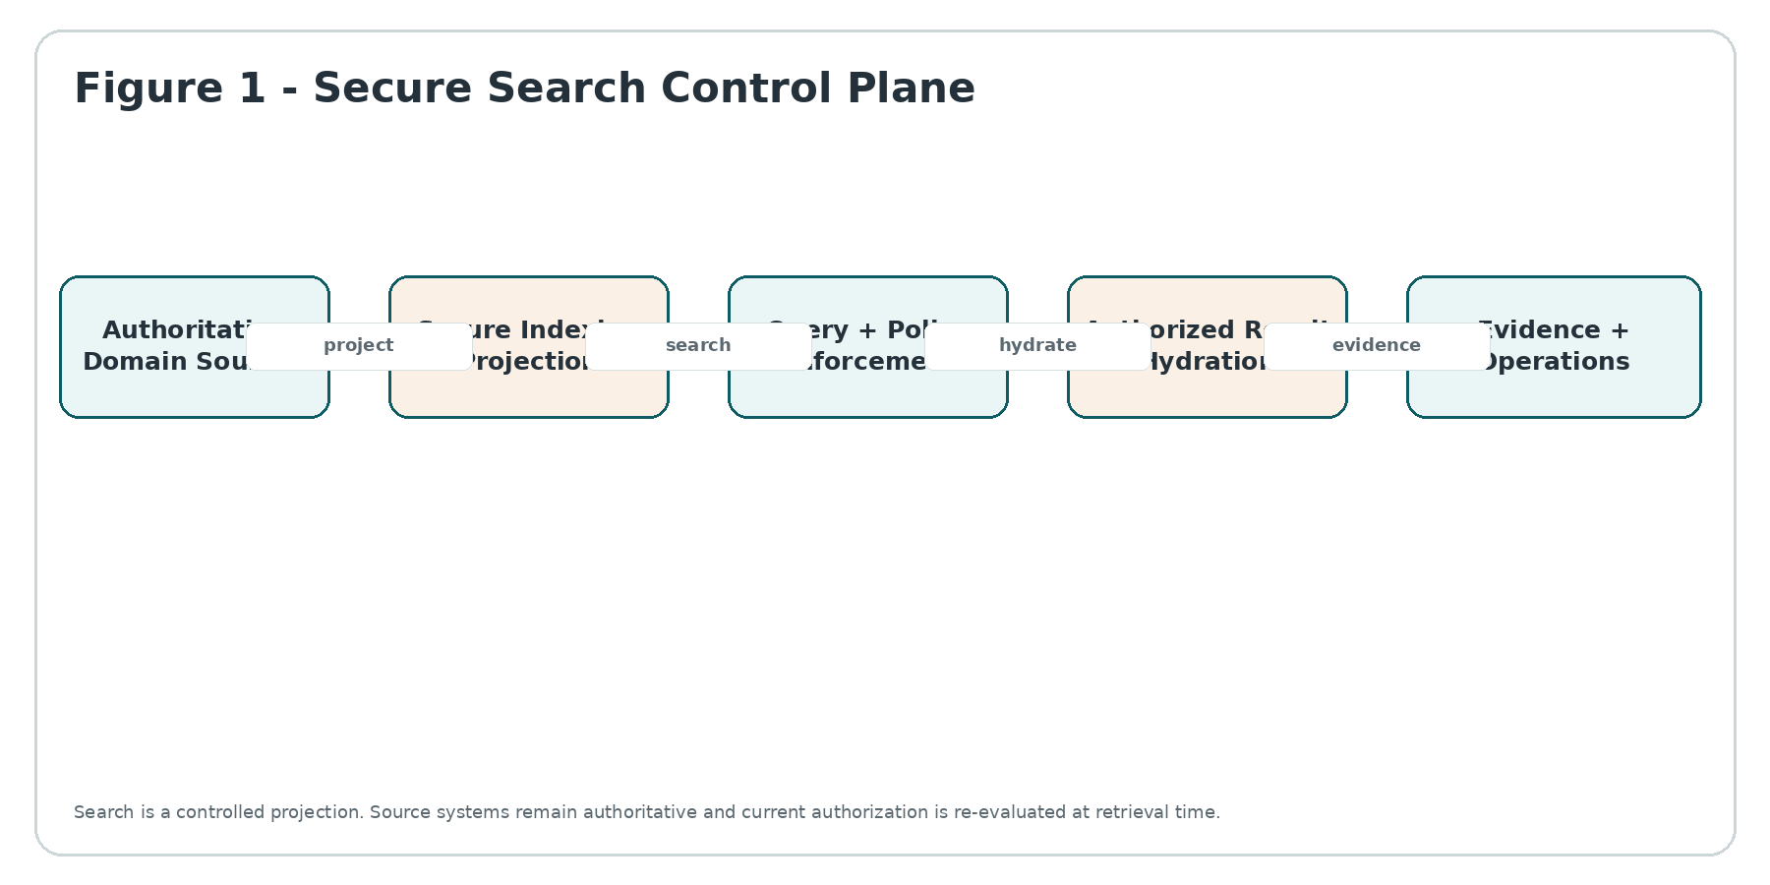
Figure 1 - Secure Search Control Plane

0.1 Canonical services
Service | Canonical responsibility | Explicitly does not own
ESR-01 | Search Source, Schema & Index Contract Registry | Registers searchable sources, fields, sensitivity classes, tokenization/analyzer profile, tenant/residency partition rules, freshness class and compatibility. It does not own source-domain truth, IAM policy, privacy policy, records retention or AI behavior.
ESR-02 | Secure Indexing, Projection & Propagation Service | Consumes committed source changes/snapshots, validates contracts, builds searchable projections, enforces partitions, records checkpoints and prioritizes restriction/deletion updates. It does not own source-domain truth, IAM policy, privacy policy, records retention or AI behavior.
ESR-03 | Query Planning, Authorization & Search Execution Gateway | Resolves trusted actor/tenant/purpose context, compiles mandatory security predicates, constrains query syntax and executes only against eligible index partitions. It does not own source-domain truth, IAM policy, privacy policy, records retention or AI behavior.
ESR-04 | Result Hydration, Snippet, Facet & Secure Retrieval Service | Re-authorizes candidate resources, retrieves current source state where required, produces safe snippets/facets and returns source-linked results without overexposure. It does not own source-domain truth, IAM policy, privacy policy, records retention or AI behavior.
ESR-05 | Index Lifecycle, Reindex, Drift & Search Operations Service | Controls index versions, rebuilds, validation, alias swap, deletion/restriction propagation, drift detection, backup/recovery and degraded-mode evidence. It does not own source-domain truth, IAM policy, privacy policy, records retention or AI behavior.

1. Scope, Boundaries & Non-Goals

1.1 In scope
- Cross-domain keyword, structured, faceted and semantic retrieval over registered ZoikoSuite sources.
- Search/index contracts, field exposure classes, analyzers/tokenization, language profile, source lineage and index-version compatibility.
- Tenant, region/residency, legal-entity and sensitivity partitioning; mandatory system-generated security filters.
- Indexing from durable source events and controlled snapshots; checkpoints, replay, reindex and reconciliation.
- Query parsing, complexity budgets, secure filters, pagination/cursors, ranking controls, safe snippets/highlights and facet privacy.
- Current resource authorization/hydration for material results; result evidence and exact source identifiers.
- Priority propagation for access revocation, privacy restriction, record disposition/deletion and source removal.
- Search platform SLOs, drift/staleness detection, alias/version management, recovery and operational certification.
- Authorized retrieval contracts for AIG/RAG without granting the AI plane broader search authority.

1.2 Explicitly out of scope
- Owning source data, accounting postings, payroll calculations, HR records, legal matters, tax filings, contracts or declared records.
- IAM authentication/authorization policy; ESR consumes and enforces decisions but does not author identity policy.
- Privacy lawful basis/purpose; PRV remains authoritative for privacy-use permission.
- Records retention, legal hold, disposition and signed-record authority; DRC remains authoritative.
- Legal/policy interpretation; PDC owns executable policy and applicability.
- AI prompts, model selection, tool calls or agent execution; AIG consumes ESR results.
- Analytics/BI semantic metrics; the next reporting control plane owns certified metrics and aggregates.
- Generic database query access, raw data-lake access, ad hoc SQL consoles or developer production inspection.
- Search-engine vendor administration exposed directly to tenant users.
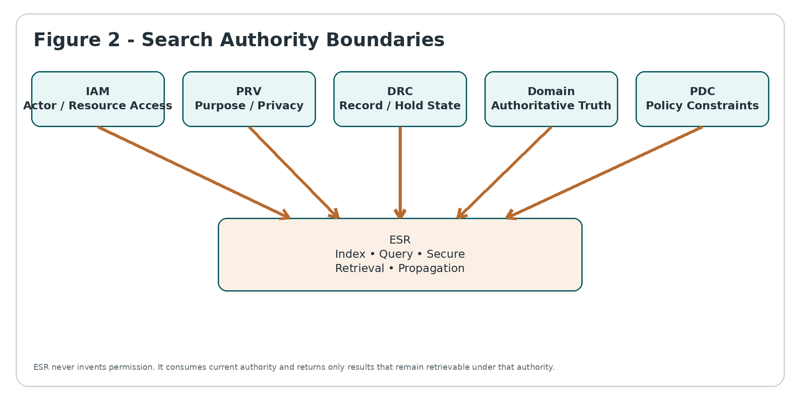
Figure 2 - Search Authority Boundaries

1.3 Required decision ordering
- Resolve authenticated actor/workload, tenant and environment from trusted context.
- Resolve declared purpose/use-case and privacy constraints where personal data is involved.
- Resolve requested search scope against product/domain capability and current IAM/resource policy.
- Select only eligible tenant/region/sensitivity index partitions from server-owned routing metadata.
- Compile mandatory security and policy filters that cannot be removed by user syntax.
- Execute bounded search, producing candidate source identifiers and search evidence.
- For material/sensitive results, re-authorize and hydrate from the authoritative source before returning content.
- Apply snippet/redaction/facet policy and return exact source lineage plus freshness status.

2. Canonical Concepts, State & Data Model

2.1 Core entities
Entity | Purpose | Minimum canonical fields
SearchSource | Registered authoritative source eligible for indexing. | source_id, owner_service, tenant_scope, region, sensitivity ceiling, source_contract_version
SearchFieldDefinition | Field-level search/exposure contract. | field_id, type, searchable, filterable, facetable, sortable, snippet_allowed, sensitivity_class, analyzer_profile
IndexContract | Immutable composition of source/field/analyzer/partition rules. | contract_id/version, schema_digest, compatibility, freshness_class, publication_state
IndexGeneration | Concrete searchable index version. | generation_id, contract_version, engine_ref, partition, build_from, checkpoint, validation_state
ProjectionDocument | Searchable projection keyed to source truth. | tenant_id, source_type/id, source_version, projection_version, acl_refs, restriction_epoch, content_hash
IndexCheckpoint | Source-to-index progress evidence. | source_partition, sequence/watermark, committed_at, observed_at, lag_ms
SearchRequest | Canonical query envelope. | request_id, actor/workload, tenant, purpose, scope, query_digest, pagination, requested_fields
QueryPlan | Server-compiled execution plan. | plan_id, mandatory_filters_digest, partition_set, complexity_score, timeout, result_budget
SearchHit | Candidate result reference, not authorization. | source_ref, score, matched_fields, index_generation, indexed_source_version
RetrievalDecision | Current authorization/hydration outcome. | source_ref, policy versions, PERMIT/SUPPRESS/INDETERMINATE, reason_codes
SearchEvidence | Replay/audit evidence. | request_digest, plan_digest, index versions, policy refs, result refs/hashes, timing, trace_id
RestrictionTombstone | Priority visibility removal marker. | source_ref, reason, effective_at, source_event_id, propagated_at, verified_at

2.2 Orthogonal state dimensions
Dimension | States / examples | Rule
Contract state | DRAFT / CERTIFIED / PUBLISHED / RETIRED | Only published contracts may build production generations.
Index build state | PLANNED / BUILDING / VALIDATING / READY / ACTIVE / FAILED / RETIRED | ACTIVE is separate from READY; cutover requires explicit validation.
Source freshness | CURRENT / LAGGING / STALE / UNKNOWN | UNKNOWN is never represented as CURRENT.
Retrieval authorization | PERMIT / SUPPRESS / REVIEW_REQUIRED / INDETERMINATE | INDETERMINATE fails closed for protected content.
Restriction propagation | PENDING / APPLIED / VERIFIED / FAILED | APPLIED is not VERIFIED until search visibility is tested.
Search completeness | COMPLETE / PARTIAL / DEGRADED / UNKNOWN | Partial results must be surfaced as partial, not silently presented as exhaustive.

2.3 Temporal and as-issued semantics
- indexed_source_version records the source version projected into a specific index generation.
- restriction_epoch changes whenever visibility-affecting state changes; stale projections are rejected when epochs do not match current authority where such checking is required.
- search evidence pins the exact index generation and policy references used for a request, enabling post-incident reconstruction.
- Historical search evidence never changes merely because a source later changes; current retrieval never assumes historical authorization is still valid.
- Search is not the mechanism for reconstructing an as-issued invoice, payroll, filing or signed record; the authoritative domain/DRC snapshot remains controlling.
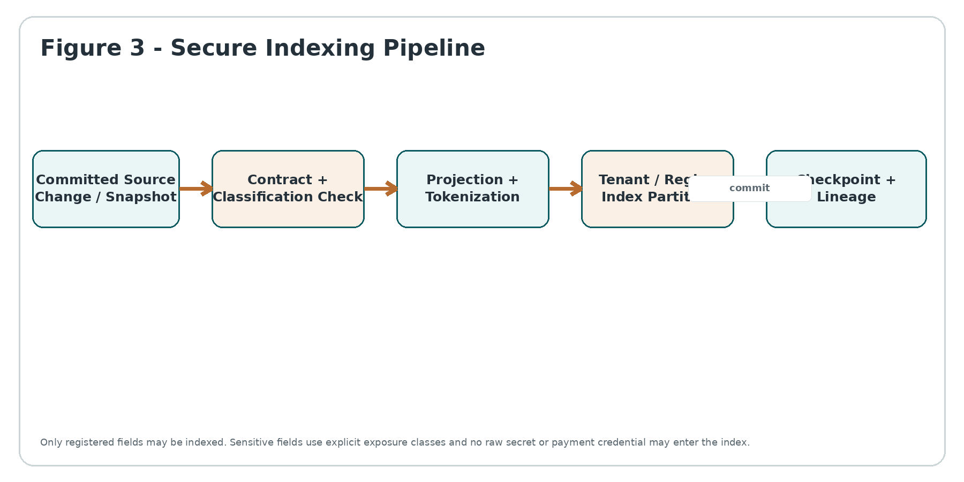
Figure 3 - Secure Indexing Pipeline

3. Non-Bypassable Platform Invariants
Invariant | Non-bypassable requirement
INV-01 | An index is never the authoritative source of business truth.
INV-02 | Every projection document carries trusted tenant identity; tenant is never inferred solely from user query text.
INV-03 | User-supplied index/alias names cannot select a broader tenant or residency partition.
INV-04 | Mandatory authorization filters are server-generated and cannot be removed, negated or overridden by query syntax.
INV-05 | Access is validated at request time; material retrieval is re-authorized against current source/resource authority before content return.
INV-06 | An index hit is not evidence that a user may open the underlying resource.
INV-07 | Unknown or unavailable authorization fails closed for protected content.
INV-08 | Fields not explicitly registered as searchable/exposable are absent from searchable projections.
INV-09 | Secrets, private keys, raw payment credentials and equivalent prohibited fields never enter search indexes.
INV-10 | Highly sensitive personal/HR/legal content requires explicit exposure class and purpose-aware retrieval policy.
INV-11 | Cross-tenant joins, suggestions, facets, caches and semantic-neighbor retrieval are prohibited unless the canonical cross-tenant authority explicitly permits them.
INV-12 | Autocomplete/typeahead follows the same security boundary as full search and may not leak protected names or terms.
INV-13 | Snippets/highlights may expose only fields and spans permitted for the caller and result context.
INV-14 | Facet counts and aggregations may not reveal existence of records the caller cannot retrieve.
INV-15 | Ranking score never creates business authority, recommendation authority or legal significance.
INV-16 | Relevance tuning cannot promote a result that failed eligibility or authorization.
INV-17 | Query logs never store prohibited sensitive query text where a digest/classification is sufficient.
INV-18 | Privacy restriction, access revocation and deletion events use priority propagation and are independently verified.
INV-19 | Legal hold does not make content more discoverable; it only changes retention/disposition authority in DRC.
INV-20 | Removing a record from search is not record deletion and cannot satisfy a DRC/PRV deletion obligation by itself.
INV-21 | Reindexing is non-destructive and cannot replace the active generation until completeness and security validation pass.
INV-22 | A failed reindex leaves the last validated generation active unless its use would itself be unsafe.
INV-23 | Index drift/staleness is observable and bounded by declared freshness class.
INV-24 | Search degradation or partial results are explicit and never silently represented as complete evidence.
INV-25 | Caching cannot outlive authorization/restriction epochs for protected content.
INV-26 | Semantic/vector indexes inherit the same tenant, residency, field-classification and deletion controls as lexical indexes.
INV-27 | Retrieved text supplied to AI is untrusted data, not executable instructions.
INV-28 | AI/RAG search cannot bypass current actor/workload authorization or use a more privileged service identity to expand evidence.
INV-29 | Search exports/downloads require separate export authorization; search permission does not imply bulk-exfiltration permission.
INV-30 | Administrative search-engine consoles are never a tenant-facing authority and production access is privileged, monitored and break-glass governed.

4. ESR-01 - Search Source, Schema & Index Contract Registry
SERVICE PURPOSE
Define what may be indexed, how it may be queried and what may be exposed before any source content enters a search engine.

4.1 Search-source registration
Contract field | Required behavior
Source authority | Exact source service/record class and immutable identifier semantics.
Tenant model | Single-tenant, tenant-sharded or explicitly governed shared reference source.
Residency model | Permitted index regions and cross-region replication constraints.
Freshness class | Maximum acceptable lag, restriction-propagation objective and rebuild cadence.
Field map | Typed field definitions with searchable/filterable/facetable/sortable/snippet/export permissions.
Sensitivity | Per-field and document-level classification including personal, HR, financial, legal/privileged and secret-prohibited classes.
Analyzer profile | Language/locale normalization, tokenization, stemming/synonym policy and version.
Authorization binding | Resource/relationship attributes that must accompany the projection for secure filtering/re-authorization.
Deletion/restriction contract | Source events and authoritative hooks that remove visibility.
Compatibility | Allowed additive/breaking changes and required reindex behavior.

4.2 Publication gates
- Source owner, Security, Privacy/Records and Search Platform approval appropriate to sensitivity.
- No prohibited fields or secret-bearing payloads; sample payload inspection passes.
- Tenant/residency routing and authorization attributes are complete and immutable for the generation.
- Analyzer and normalization behavior is deterministic and version-pinned.
- Deletion/restriction propagation path is testable before production indexing.
- Backward compatibility or explicit reindex/migration plan is recorded.
- Query and result-field budgets are declared to prevent accidental full-document exposure.

4.3 Analyzer and language rules
Analyzer configuration is part of the immutable IndexContract. Changing tokenization, normalization, synonym sets, locale segmentation or embedding model creates a new contract/index generation where results can materially change. Search behavior is therefore reproducible rather than silently drifting with vendor defaults.

5. ESR-02 - Secure Indexing, Projection & Propagation Service
SERVICE PURPOSE
Create searchable projections from committed authoritative data without leaking prohibited fields or losing source lineage.


Figure 3 - Secure Indexing Pipeline

5.1 Ingestion contracts
Input mode | Required controls
Durable domain event | Idempotent event ID, source version/sequence, tenant ID from trusted envelope, schema version and outbox/commit evidence.
Controlled snapshot | Stable source boundary, manifest/counts/checksum, tenant/partition inventory and reproducible extraction query or export version.
Backfill/replay | Explicit range, reason, operator/workflow authority, no duplicate visibility and exact source-version preservation.
Restriction priority event | Delete/restrict/revoke/hold-related visibility event uses a higher-priority lane with propagation verification.

5.2 Projection rules
- Projection includes only registered fields; unknown fields are ignored or quarantined according to contract, never opportunistically indexed.
- Source identifiers and source_version remain available for re-authorization and hydration.
- ACL/resource attributes in the projection are hints for candidate filtering, not the final authority for material retrieval.
- Sensitive free text may require extracted safe search fields rather than raw body indexing.
- Attachments are indexed only after DRC/security classification and text-extraction controls; extraction output never replaces the original record.
- Embedding/vector generation uses only fields allowed for semantic indexing and records model/version lineage.
- Index writes are idempotent by tenant + source_ref + source_version/projection_version.
- A newer restriction/deletion tombstone cannot be overwritten by an older replay event.

5.3 Checkpoint and completeness certification
Measure | Required evidence
Population count | Source eligible count vs indexed live/tombstoned count by tenant/partition.
Sequence/watermark | Highest committed source position represented in the index.
Hash/sample | Deterministic field hash or sampled source-to-index comparison for material classes.
Restriction verification | Known restricted/deleted test refs cannot be retrieved after propagation.
Lag | Current source-to-index lag by freshness class and partition.

6. ESR-03 - Query Planning, Authorization & Search Execution Gateway
SERVICE PURPOSE
Make every search request a policy-bound server-side query plan rather than allowing arbitrary client query power.

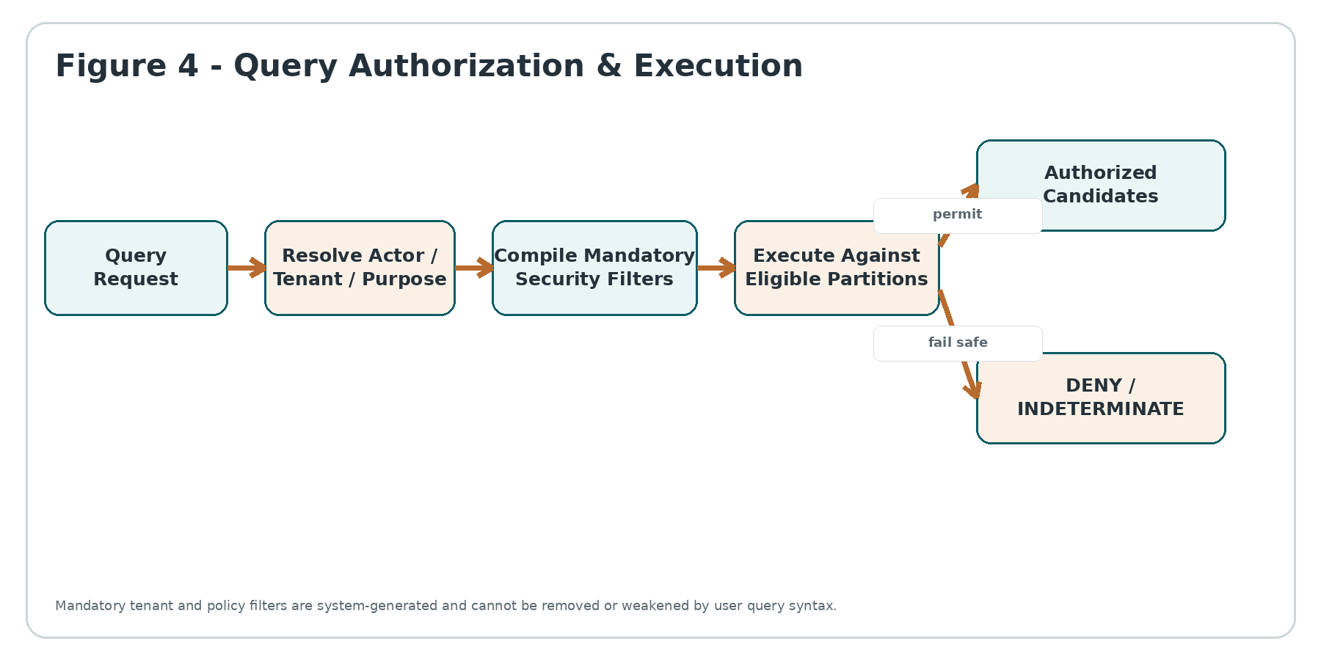
Figure 4 - Query Authorization & Execution

6.1 Canonical request envelope
Field | Requirement
actor/workload | Resolved from authenticated session/service identity, never from client body.
tenant_id | Trusted routing context; immutable for the request.
purpose/use_case | Registered reason for search; required for sensitive/privacy-controlled corpora.
scope | Named search surface such as records, people, invoices, matters or cross-domain global search.
query | Structured request with bounded text/filter/sort operators.
requested_fields | Allowlisted result projection; full source object is not the default.
pagination | Signed/opaque cursor; no unbounded offsets for protected or high-volume scopes.
trace/evidence | Correlation ID, client surface, configuration and policy versions.

6.2 Query safety and complexity
- Deny by default: scopes, filters, fields, sort keys and operators must be registered.
- Reject leading-wildcard/regex/script/query-string constructs where they can bypass budgets or expose engine internals.
- Enforce per-scope token, clause, expansion, aggregation, result-window and execution-time budgets.
- Normalize Unicode and locale behavior consistently; do not perform security decisions on unnormalized user strings.
- Rate limits apply by actor/workload, tenant, scope and cost score rather than requests per second alone.
- Query suggestions/autocomplete are separately budgeted and security-filtered.
- No user query can specify raw engine index names, routing shards or hidden system fields.

6.3 Mandatory filter compilation
Filter layer | Examples | Authority
Tenant/partition | tenant_id, residency region, index family | Trusted tenancy/GTRM/CFG context
Resource authorization | owner, membership, matter ACL, employee relationship, ledger scope | IAM/domain resource policy
Privacy/purpose | purpose allowed, restricted subject/data category | PRV/PDC
Record state | disposed, restricted, sealed, privilege class | DRC/domain
Commercial/product scope | feature/search surface entitlement where applicable | COM + domain capability
Operational | active generation, freshness acceptable, not quarantined | ESR-05

7. ESR-04 - Result Hydration, Snippet, Facet & Secure Retrieval Service
SERVICE PURPOSE
Turn search candidates into safe, current, source-linked results without leaking fields, snippets, counts or stale permissions.

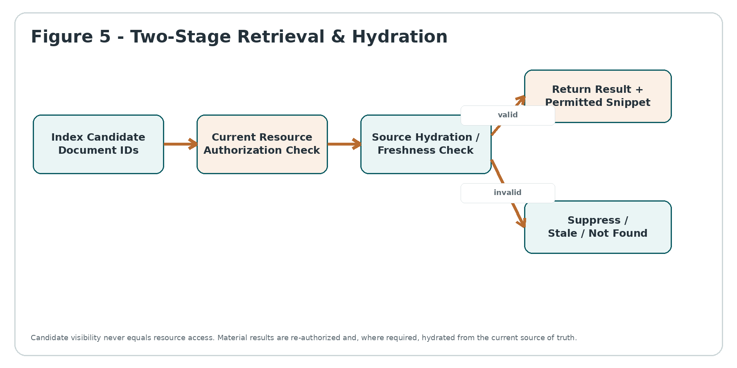
Figure 5 - Two-Stage Retrieval & Hydration

7.1 Retrieval classes
Class | Behavior | Typical use
R0 - Metadata-safe | Return pre-approved minimal metadata after query-time policy; no source hydration required if restriction epoch is current. | Low-sensitivity navigation.
R1 - Re-authorized | Candidate must pass current resource authorization before searchable metadata/snippet is returned. | HR, legal, finance, customer records.
R2 - Source-hydrated | Current source object/record excerpt is retrieved after authorization; index content is not trusted as current display value. | Material financial/legal record views.
R3 - Explicit export | Separate bulk/export authorization, purpose and evidence; not implied by search access. | Audits, disclosures, legal exports.

7.2 Snippet and highlight controls
- Snippet generation is field-policy aware; a matching sensitive term does not authorize surrounding text disclosure.
- Redaction happens before snippet return and follows the same source version/current policy as hydration.
- HTML is escaped/sanitized; stored source markup cannot execute in the client.
- Hidden matched fields may contribute to eligibility/ranking only if policy permits; the client is not told which hidden field matched when that would leak information.
- No query echo in page title, URL, telemetry or browser history where the search terms may contain sensitive personal/legal/HR data.
- Cached snippets are keyed by authorization/restriction epoch and expire within the declared freshness window.

7.3 Facet and count privacy
Facets, counts and “zero/one result” behavior can reveal protected record existence. ESR therefore computes facets only over the caller-eligible candidate set, applies minimum-cell or suppression rules where required, and never exposes global corpus cardinality to a tenant unless that corpus is explicitly public/reference data.
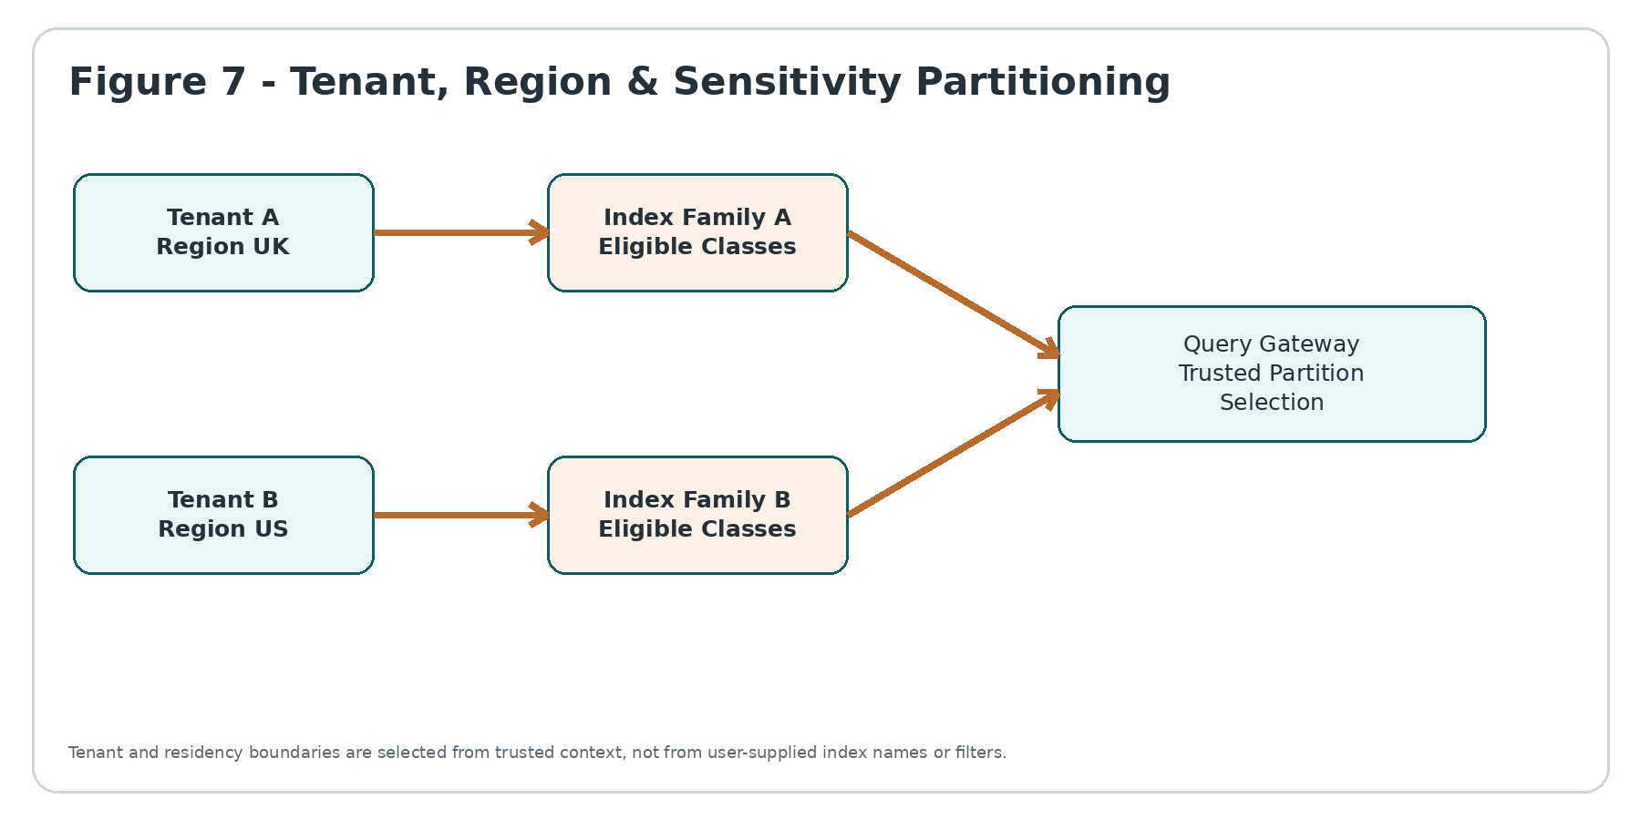
Figure 7 - Tenant, Region & Sensitivity Partitioning

8. ESR-05 - Index Lifecycle, Reindex, Drift & Search Operations Service
SERVICE PURPOSE
Keep search infrastructure rebuildable, current and recoverable while proving which generation served each request.

8.1 Generation lifecycle
State | Entry gate | Exit / transition
PLANNED | Published contract and capacity/topology plan. | BUILDING after source boundary fixed.
BUILDING | Generation ID, immutable contract, source snapshot/checkpoint. | VALIDATING when ingestion closes or reaches defined live boundary.
VALIDATING | Completeness, restriction, authorization, analyzer and sample checks running. | READY only if mandatory certification passes.
READY | Validated but not serving. | ACTIVE by controlled alias/router switch.
ACTIVE | Serving eligible traffic. | RETIRED after replacement and rollback window.
FAILED | Build/validation unsafe. | Rebuild new generation; never patch into ACTIVE authority silently.
RETIRED | No new queries. | Disposed after retention/rollback requirements satisfied.
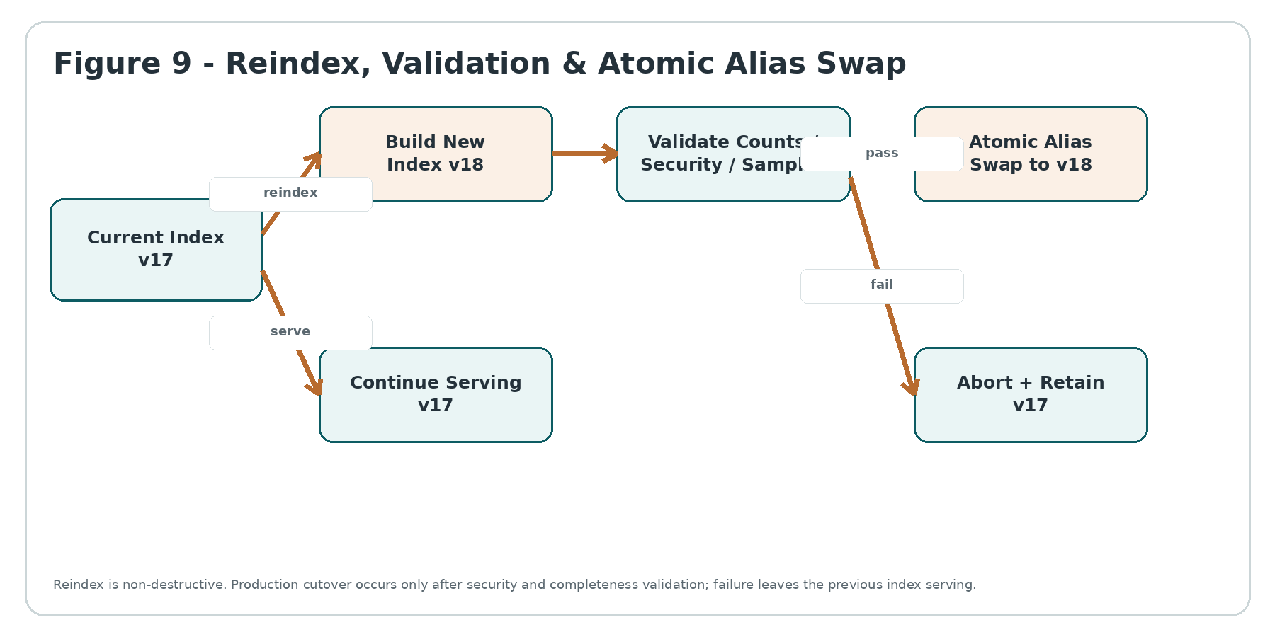
Figure 9 - Reindex, Validation & Atomic Alias Swap

8.2 Restriction and deletion propagation
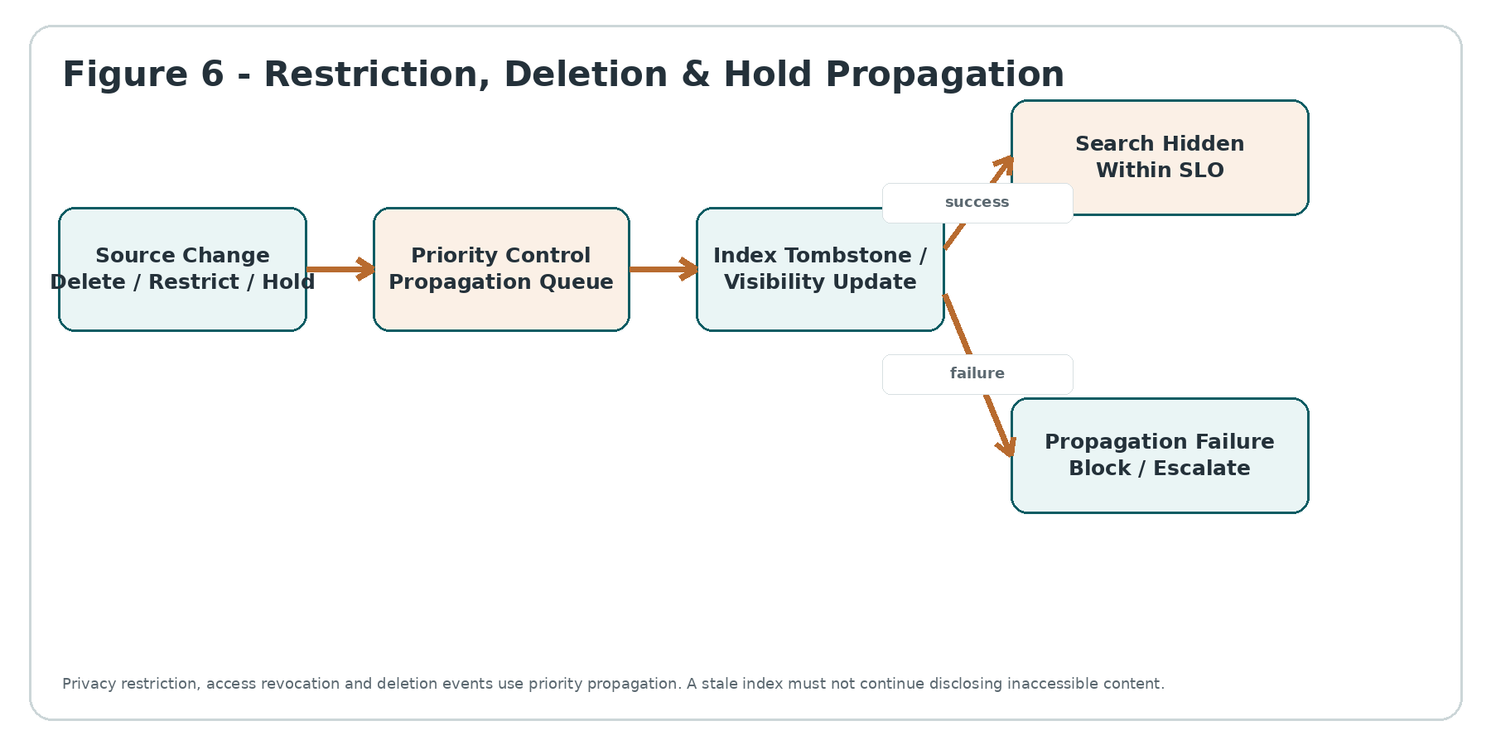
Figure 6 - Restriction, Deletion & Hold Propagation
- Visibility-reducing events outrank normal indexing backlog.
- Propagation SLO is defined by sensitivity class and legal/privacy risk, not merely by normal indexing freshness.
- Tombstone precedence prevents late/out-of-order source events from resurrecting removed visibility.
- Verification performs a controlled retrieval test or authoritative index lookup to prove the content is no longer discoverable.
- If verification fails beyond threshold, affected search scope can be blocked/degraded rather than continuing known over-disclosure.
- Source deletion remains the domain/DRC responsibility; ESR records projection removal evidence only.

8.3 Drift and recovery
Failure | Required behavior
Checkpoint stalls | Alert by freshness class; scope marked LAGGING/STALE; protected results may require source hydration or block.
Alias drift | Detect serving generation differs from desired signed generation; freeze automated cutover and open incident.
Partition loss | Restore/rebuild from source; indexes are disposable projections, not the sole backup.
Authorization policy unavailable | Fail closed for protected content; public/reference search may continue only under explicit safe class.
Engine partial outage | Return explicit DEGRADED/PARTIAL status if allowed; never claim exhaustive search.
Corrupt generation | Remove from eligible routing, preserve evidence, rebuild from authoritative source.
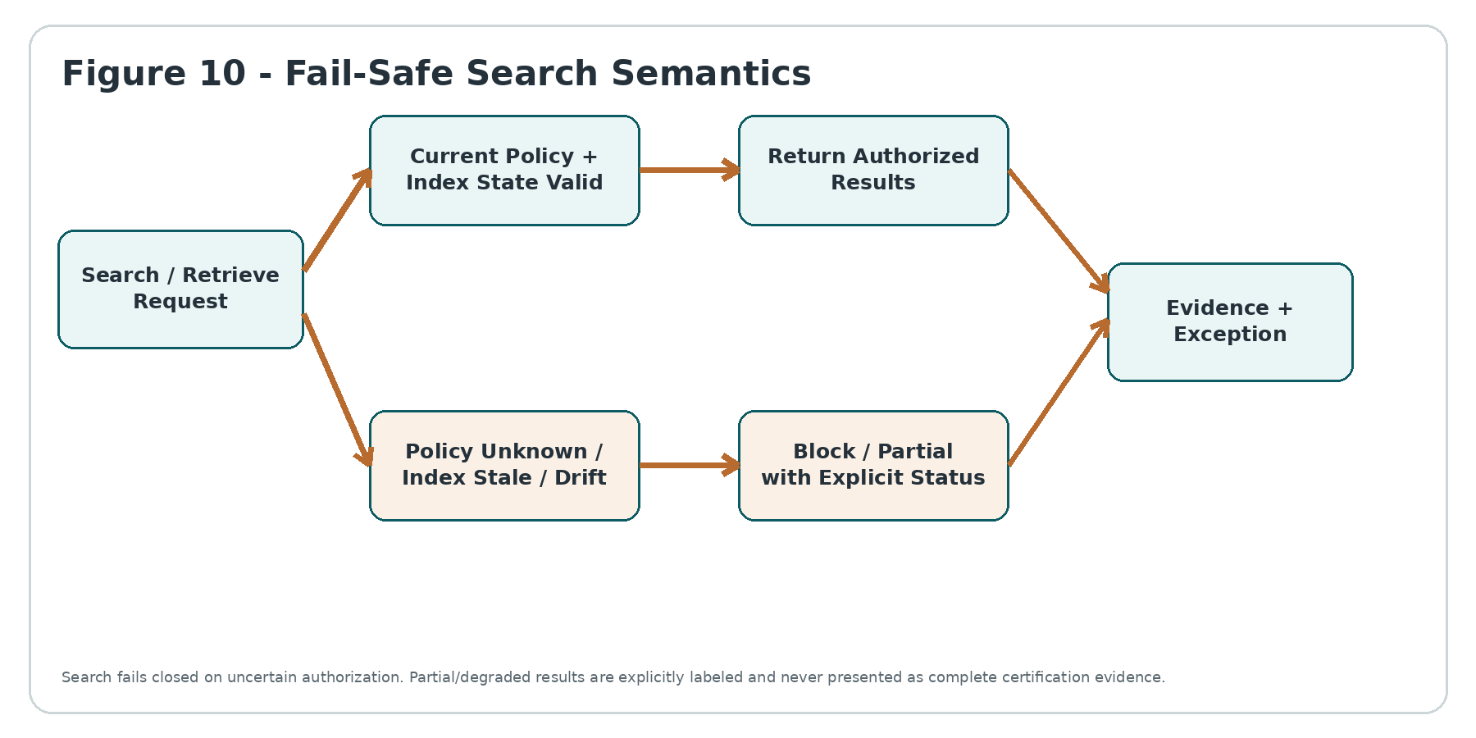
Figure 10 - Fail-Safe Search Semantics

9. Cross-Cutting Security, Privacy & Data Protection

9.1 Zero-trust retrieval principles
- No implicit trust from network location, service ownership or possession of an index credential.
- Service identities are least-privilege and partition-specific; indexing writers do not automatically receive query/read access.
- Query gateway and source-hydration identity are distinct where separation reduces blast radius.
- Authorization is validated on every protected request and again for source hydration where required.
- Opaque identifiers and mandatory filters prevent insecure direct object/index reference patterns.
- Administrative engine endpoints are isolated from tenant/application traffic and require privileged operational access.

9.2 Privacy-by-design
- Search query text is personal data when it can reveal a person, condition, employment matter, legal issue or financial fact; logging is minimized accordingly.
- Search history, recent queries and personalization are separate optional features with explicit purpose/retention controls.
- Indexing a field for discovery is a distinct processing purpose from exposing that field in results.
- Data-subject restriction/erasure workflows include search projection discovery and verified propagation, subject to DRC hold/retention authority.
- Cross-region replication is governed by PRV/GTRM; engine convenience replication cannot override transfer or residency constraints.
- Embeddings are treated as derived personal/sensitive data where source semantics warrant it and follow the source restriction/deletion lifecycle.

9.3 Search abuse and inference resistance
Threat | Control
Enumeration | Rate/cost limits, opaque cursors, minimum query constraints, no raw total where unsafe.
Existence inference | Security-filtered facets/counts; suppression/minimum-cell rules; consistent error behavior.
Query injection / engine escape | Typed query DSL; no arbitrary engine scripts, raw query-string or index selection.
Sensitive autocomplete | Same auth/purpose filters as results; restricted corpora excluded unless explicitly designed.
Cache leakage | Tenant/policy/restriction-aware cache keys; no shared fragment cache for protected results.
Relevance manipulation | Tuning changes versioned/evaluated; no user-controlled boosts over security eligibility.

10. Semantic / Vector Search and AI Retrieval Boundary
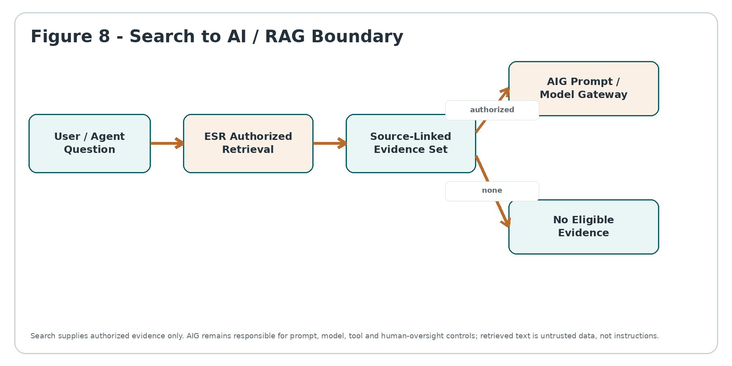
Figure 8 - Search to AI / RAG Boundary

10.1 Vector index controls
- Embedding model/version and preprocessing are pinned in the IndexContract.
- Vector entries carry the same tenant, region, source_ref, sensitivity, restriction epoch and source-version lineage as lexical projections.
- Approximate-nearest-neighbor execution occurs only within server-selected eligible partitions/filter sets.
- Similarity score is not authorization and cannot be used to pull a neighboring document from another tenant or policy class.
- Deletion/restriction propagation removes or tombstones vectors as well as lexical documents.
- Model migration requires parallel rebuild and retrieval-evaluation certification before cutover.

10.2 RAG contract
Boundary | Rule
Caller authority | AIG passes the real actor/workload/tenant/purpose context; it may not substitute a broader platform identity for retrieval.
Evidence | ESR returns source-linked eligible passages/document refs plus freshness and policy evidence.
Prompt injection | Retrieved text is labeled as untrusted content; AIG decides how models handle instructions found in sources.
No evidence | AIG cannot broaden scope or use hidden admin search to “find something.” It must respond under its own no-evidence policy.
Citations | Where user-facing answers cite sources, references resolve through normal source authorization at click/open time.

11. API & Event Contracts

11.1 Canonical APIs
API | Purpose | Idempotency / security
POST /v1/search | Execute governed search request. | Request ID + canonical query digest; actor/tenant derived from trusted context.
POST /v1/search/semantic | Semantic/hybrid retrieval for registered scopes. | Same policy envelope as lexical search; embedding model fixed by scope.
POST /v1/retrieve | Hydrate/re-authorize specific candidate refs. | Each resource re-authorized; bulk limits enforced.
POST /v1/index-contracts | Create draft source/index contract. | Privileged control-plane API; immutable after publication.
POST /v1/index-generations | Start controlled build/reindex. | Generation ID idempotency; published contract required.
POST /v1/restrictions | Apply priority projection restriction/tombstone. | Source event ID idempotency; older writes cannot resurrect visibility.
GET /v1/checkpoints | Read index freshness/checkpoint health. | Operational access; tenant-filtered where exposed.
POST /v1/search-exports | Request controlled export of authorized result set. | Separate export permission, purpose, size and DRC evidence.

11.2 Canonical events
Event | Minimum payload | Consumers
esr.index_generation.ready | generation, contract, partition, validation digest | CFG/router, SRE, audit
esr.index_generation.activated | old/new generation, actor/workflow, activation time | SRE, evidence
esr.index_checkpoint.advanced | source partition, watermark, lag, generation | DQC, SRE
esr.restriction.propagated | source_ref, reason, source_event, verified_at | PRV/DRC/domain, evidence
esr.restriction.failed | source_ref/partition, age, blast radius, reason | WFC incident, SRE, Security
esr.search.degraded | scope, partitions, cause, completeness state | NCD/SRE/operations
esr.security_filter.denied | scope, reason code, actor/workload hash | Security/audit
esr.reindex.failed | generation, validation stage, reason | WFC/SRE/Search Platform

11.3 Stable reason/error codes
Code | Canonical meaning
ESR-001 | TENANT_CONTEXT_MISSING
ESR-002 | SCOPE_NOT_REGISTERED
ESR-003 | QUERY_OPERATOR_FORBIDDEN
ESR-004 | QUERY_COMPLEXITY_EXCEEDED
ESR-005 | FIELD_NOT_SEARCHABLE
ESR-006 | FIELD_NOT_RETURNABLE
ESR-007 | PARTITION_NOT_AUTHORIZED
ESR-008 | AUTHORIZATION_INDETERMINATE
ESR-009 | PRIVACY_PURPOSE_BLOCKED
ESR-010 | SOURCE_RESOURCE_SUPPRESSED
ESR-011 | INDEX_GENERATION_NOT_ACTIVE
ESR-012 | INDEX_STALE_FOR_SCOPE
ESR-013 | RESTRICTION_EPOCH_MISMATCH
ESR-014 | SOURCE_HYDRATION_FAILED
ESR-015 | RESULT_WINDOW_EXCEEDED
ESR-016 | EXPORT_AUTHORIZATION_REQUIRED
ESR-017 | REINDEX_VALIDATION_FAILED
ESR-018 | RESTRICTION_PROPAGATION_FAILED
ESR-019 | SEMANTIC_MODEL_MISMATCH
ESR-020 | SEARCH_DEGRADED_PARTIAL

12. Domain Adoption Contracts
Domain / surface | Searchable examples | Mandatory controls
Accounting & Billing | Invoices, journals, customers, suppliers, payments, reconciliation evidence. | Legal entity/tenant scope, period/currency metadata, no hidden ledger access, current source hydration for material amounts.
Payroll | Pay runs, payslips, workers, statutory submissions. | Strict worker/employer relationship, HR/privacy purpose, sensitive field suppression, no global employee enumeration.
HR | People, cases, policies, leave, onboarding/offboarding records. | Employee relationship/role policy, special-category restrictions, safe autocomplete, subject-sensitive snippets.
Tax | Returns, filings, registrations, evidence packages. | Jurisdiction/entity scope, filing status, privileged/restricted evidence handling.
Legal | Matters, contracts, notices, privileged documents. | Matter ACL/ethical wall, privilege class, legal-hold neutrality, explicit export/disclosure authorization.
Records / DRC | Declared records, document metadata, retention classifications. | Record-state awareness, restriction/disposition propagation, source-linked exact version.
AI / RAG | Evidence retrieval for assistants and copilots. | Caller identity preserved, source-linked passages, no service-account privilege escalation, AIG guardrails.
Global command/search | Cross-domain navigation. | Minimal metadata, domain-by-domain policy filters, no unauthorized result-count leakage, source deep link re-authorized.

13. Observability, SLOs & Operational Runbooks

13.1 Required telemetry
Signal | Examples | Why it matters
Freshness | source-to-index lag p50/p95/p99 by contract/partition | Detect stale or incomplete discovery.
Restriction lag | time from authoritative revoke/delete/restrict event to verified invisibility | Measures over-disclosure exposure window.
Authorization outcomes | permit/suppress/indeterminate by scope and reason code | Detect policy failures or privilege anomalies.
Search quality | zero-result rate, click/open after authorization, abandoned queries, relevance eval suite | Relevance without using protected behavior as an unchecked signal.
Completeness | indexed/source count deltas, checkpoint gaps, tombstone backlog | Detect missing data.
Engine health | latency, timeout, shard/partition errors, cache hit, circuit-breaker trips | Operational reliability.
Security abuse | enumeration patterns, high-cost queries, forbidden operator attempts | Threat detection.
Reindex certification | build duration, validation pass/fail, security sample failures | Safe lifecycle control.

13.2 SLO classes
Class | Illustrative objective category | Examples
S0 public/reference | Availability/relevance focused; tolerant of longer freshness. | Public help/reference catalogs.
S1 business | Minutes-scale freshness, bounded partial behavior. | Customers, invoices, routine HR navigation.
S2 sensitive | Tight restriction propagation and source reauthorization. | Payroll, employee files, legal matters.
S3 critical/privileged | Strict fail-closed, priority restriction lane, smallest disclosure window. | Privilege-restricted legal/HR/security evidence.
Numeric SLOs are deliberately left as controlled implementation decisions until workload, data-classification and provider capacity testing are complete. The architecture requires separate normal-indexing freshness and visibility-reduction propagation objectives so revocation is not hidden inside a generic “eventual consistency” SLA.

13.3 Mandatory runbooks
- Authorization service outage / INDETERMINATE spike.
- Restriction/deletion propagation backlog or failed verification.
- Cross-tenant search result incident or suspected cache leakage.
- Index generation corruption / accidental alias switch.
- Source-to-index checkpoint stall or partial partition loss.
- Semantic model migration regression or vector partition contamination.
- Query abuse / enumeration / expensive-query incident.
- Emergency global search disable or sensitive-scope kill switch via CFG.

14. Negative-Path Certification Matrix
Scenario | Failure / attack path | Required certified behavior
NP-01 | Client supplies another tenant_id in body. | Reject/ignore client tenant; trusted context wins; no cross-tenant query.
NP-02 | Client supplies raw engine index name. | Reject; partition selection is server-owned.
NP-03 | User negates mandatory ACL filter. | Impossible in compiled query plan; reject unsupported syntax.
NP-04 | IAM decision unavailable. | Protected search returns INDETERMINATE/BLOCK, not broad results.
NP-05 | Index contains stale access attributes after role revocation. | Current re-authorization suppresses material result; restriction propagation follows.
NP-06 | Search cache contains result from previous permission epoch. | Cache key/epoch mismatch invalidates entry.
NP-07 | Autocomplete tries to reveal protected employee name. | Same authorization filter as search; no suggestion.
NP-08 | Facet count reveals one privileged legal matter. | Compute over authorized set/suppress unsafe count.
NP-09 | Query asks for non-returnable sensitive field. | ESR-006; field omitted/blocked.
NP-10 | Secret field appears in source schema unexpectedly. | Contract violation; quarantine/reject projection; never index opportunistically.
Scenario | Failure / attack path | Required certified behavior
NP-11 | Older replay event arrives after deletion tombstone. | Tombstone/restriction epoch wins; no resurrection.
NP-12 | Restriction propagation exceeds S3 objective. | Escalate; block/degrade affected scope if safe retrieval cannot be guaranteed.
NP-13 | DRC legal hold added. | Retention changes in DRC; search visibility does not expand.
NP-14 | DRC record disposed/deleted. | Projection removal verified; search removal not treated as DRC disposition proof.
NP-15 | PRV restricts processing purpose. | Query/retrieval blocked for that purpose; index may remain only if another lawful purpose/retention allows.
NP-16 | Cross-region replica would violate residency. | Partition not eligible; reindex/replication blocked.
NP-17 | Index checkpoint falsely advances past missing events. | DQC/source reconciliation detects gap; generation not certified CURRENT.
NP-18 | Index build omits one tenant partition. | Completeness validation fails; no activation.
NP-19 | Engine returns partial shards but HTTP 200. | Mark PARTIAL/DEGRADED; do not present as complete.
NP-20 | Source hydration fails after candidate hit. | Suppress material content / return explicit unavailable; never trust stale index as authoritative.
Scenario | Failure / attack path | Required certified behavior
NP-21 | User requests unbounded result window. | Reject/cursor enforce; no deep unbounded offset.
NP-22 | Regex/wildcard query causes extreme expansion. | Complexity budget rejects or bounds.
NP-23 | Search query contains special-category personal data. | Minimize/redact telemetry; purpose/retention policy applies.
NP-24 | HTML/script stored in indexed body. | Escaped/sanitized snippet; no client execution.
NP-25 | Hidden field matched and UI exposes field name. | Do not reveal hidden match source unless policy permits.
NP-26 | Ranking tuner boosts unauthorized result. | Eligibility filters apply before ranking; impossible to promote denied candidate.
NP-27 | Synonym update materially changes legal-document retrieval. | New analyzer/contract version; eval and reindex before activation.
NP-28 | Index engine auto-upgrade changes analyzer default. | Pinned analyzer prevents silent behavior drift; compatibility test blocks cutover.
NP-29 | Search-export request uses normal search permission. | Require explicit export authority/purpose/size policy.
NP-30 | Bulk export includes a result revoked mid-job. | Revalidate at export boundary/chunk; suppress revoked items and record variance.
Scenario | Failure / attack path | Required certified behavior
NP-31 | AI agent calls ESR with privileged platform service identity. | Reject unless workload is registered to act on behalf of real actor with constrained scope.
NP-32 | Retrieved document contains “ignore previous instructions.” | Returned as untrusted content; AIG prompt-injection controls remain authoritative.
NP-33 | Vector similarity crosses tenant boundary. | ANN partition/filter prevents cross-tenant candidates; certification test required.
NP-34 | Vector deleted but lexical doc remains. | Restriction event updates all representations; verification checks both.
NP-35 | Embedding model changes silently at provider. | Pinned model/version mismatch blocks indexing/query generation.
NP-36 | No eligible RAG evidence. | Return empty evidence set; AI cannot broaden scope.
NP-37 | AI citation deep link opened after access revoked. | Source open path re-authorizes and denies.
NP-38 | Search personalization profile exists without purpose. | Feature disabled/no profile; PRV purpose required.
NP-39 | Recent-query history leaks between shared-device sessions. | Actor/session isolation and retention controls; no shared cache.
NP-40 | Global search result count includes inaccessible domains. | Counts computed only after domain eligibility filters or omitted.
Scenario | Failure / attack path | Required certified behavior
NP-41 | Reindex validation finds cross-tenant sample. | Fail generation; never activate; security incident workflow.
NP-42 | Alias switched before validation completes. | Control-plane state forbids activation; rollback/incident if external drift occurs.
NP-43 | Active generation corrupt but old generation stale on permissions. | Do not blindly roll back; evaluate safety, rebuild or block affected scope.
NP-44 | Search engine outage affects only one partition. | Explicit PARTIAL if scope permits; otherwise block exhaustive operation.
NP-45 | Index backup is mistaken for authoritative backup. | Recovery rebuilds from source; index snapshot is convenience only.
NP-46 | Admin queries raw production engine and exports tenant data. | Privileged break-glass access, monitoring, purpose and DRC evidence; no routine path.
NP-47 | Restriction event duplicate/replayed. | Idempotent by source event/tombstone version.
NP-48 | Restriction events arrive out of order. | Monotonic epoch/version prevents visibility resurrection.
NP-49 | Tenant is moved between residency cells. | Controlled dual-read/reindex/cutover; no cross-region leakage during migration.
NP-50 | Index schema removes field still required by active UI. | Compatibility gate blocks retirement until consumers migrated.
Scenario | Failure / attack path | Required certified behavior
NP-51 | Source sends unknown new field marked searchable by vendor dynamic mapping. | Dynamic mapping disabled/ignored; contract publication required.
NP-52 | Search total count is used as financial reconciliation evidence. | Reject as authoritative control; DQC/domain totals are controlling.
NP-53 | User sorts by hidden salary field. | Sort key not registered/authorized; reject without leaking field existence.
NP-54 | One-character queries enumerate person directory. | Minimum query/rate/inference controls apply by scope.
NP-55 | Current source is deleted between query and hydration. | Hydration returns NOT_FOUND/SUPPRESS; no stale result body.
NP-56 | Source authorization changes during paginated search. | Each page/cursor enforces current policy; prior cursor does not freeze permission.
NP-57 | Cursor is modified to increase scope/tenant. | Signed opaque cursor fails integrity validation.
NP-58 | Engine returns duplicate docs after shard retry. | Deduplicate by canonical source_ref; preserve evidence.
NP-59 | Search scope is marked CURRENT while restriction queue is failing. | Health model separates normal freshness from restriction safety; scope becomes unsafe/degraded.
NP-60 | Operator marks failed restriction as accepted risk and restores PASS. | Accepted risk cannot relabel unsafe visibility as PASS; exception remains explicit and governed.

15. Traceability Controls
Control | Traceability requirement
TC-01 | Every returned result traces to tenant + source_type + source_id + source_version.
TC-02 | Every search traces to exact active index generation(s).
TC-03 | Every index generation traces to published IndexContract version.
TC-04 | Every projection traces to source event/checkpoint/snapshot boundary.
TC-05 | Every material retrieval traces to current authorization outcome and policy versions.
TC-06 | Every suppressed result can emit a non-sensitive reason code without revealing forbidden existence details.
TC-07 | Every restriction tombstone traces to authoritative source event/reason.
TC-08 | Every restriction verification records when invisibility was proven.
TC-09 | Every reindex activation traces to validation digest and WFC/change authority.
TC-10 | Every query plan records mandatory-filter digest and eligible partition set.
TC-11 | Every semantic query traces to embedding model/version and preprocessing contract.
TC-12 | Every snippet traces to source/result field policy and redaction version.
TC-13 | Every search export traces to separate export authorization and exact result population.
TC-14 | Every degraded/partial response records completeness status and affected partitions.
TC-15 | Every query log record follows minimization/classification policy.
TC-16 | Every index/admin access uses named workload/operator identity and environment.
TC-17 | Every cross-region index replica traces to residency/transfer authorization.
TC-18 | Every analyzer/synonym change is versioned and linked to relevance/security evaluation.
TC-19 | Every stale/drift incident records desired vs observed generation/checkpoint.
TC-20 | Every AI/RAG retrieval traces real caller/workload, purpose, evidence refs and AIG execution context.

16. Controlled Open Decisions
Decision | Open item | Closure authority
OD-01 | Primary search-engine/provider topology | Select after tenant isolation, residency, capacity, encryption and operational certification.
OD-02 | Physical tenant partition strategy by tier/sensitivity | Shared shard vs tenant index vs cell-based partition must preserve identical logical controls.
OD-03 | Normal indexing freshness SLOs | Ratify by domain/source class after load tests.
OD-04 | Restriction/deletion propagation SLOs | Ratify separately and more strictly for sensitive classes.
OD-05 | R0/R1/R2 retrieval classification per source | Source owner + Security/Privacy approval.
OD-06 | Supported query DSL/operator set | Minimal allowlist based on product UX and abuse tests.
OD-07 | Autocomplete eligibility by domain | Especially HR/legal/person directory inference risk.
OD-08 | Facet minimum-cell/suppression thresholds | PDC/PRV/domain decision by jurisdiction/data class.
OD-09 | Search telemetry retention | PRV/DRC purpose and minimization decision.
OD-10 | Semantic/vector search provider/model | AIG/Privacy/Security/data-residency evaluation.
OD-11 | Embedding storage and encryption topology | Must match source sensitivity/residency.
OD-12 | Historical search replay depth | Operational/audit need vs privacy/storage cost.
OD-13 | Search export maximums and async thresholds | Domain/security/commercial operating decision.
OD-14 | Production engine administrative-access model | Break-glass/JIT/PAM implementation selection.
OD-15 | Quantitative relevance certification thresholds | Define gold sets per search surface without weakening security gates.

17. Standards & Engineering Baseline
The control plane is vendor-neutral. The following external references guide security posture and implementation testing; they do not replace ZoikoSuite authority contracts.
Reference | Application to ESR
NIST SP 800-207 - Zero Trust Architecture | No implicit trust from network location or service ownership; resource access is evaluated explicitly before protected retrieval.
NIST SP 800-207A - Zero Trust Access Control for Cloud-Native Applications | Supports identity-centric service-to-service policy enforcement for distributed retrieval/hydration paths.
OWASP Authorization Cheat Sheet | Deny by default, validate permissions on every request, enforce least privilege and test authorization logic, including object-level access.
ISO/IEC 27001:2022 control framework | Search is treated as an information-access path subject to access control, logging, data protection and operational change governance.
Unicode normalization/segmentation specifications | Analyzer implementations must pin normalization/tokenization behavior so query/index treatment is deterministic and security checks do not depend on ambiguous text forms.

IMPLEMENTATION NOTE
The search-engine vendor may provide field-level security, document-level security, aliases, vector search and audit logs. Those are enforcement mechanisms, not the canonical business authority. ZoikoSuite still owns trusted tenant context, policy composition, result hydration, source lineage and restriction certification.

18. Definition of Ready / Definition of Done

18.1 Definition of Ready
- At least one source domain has an approved SearchSource/IndexContract including fields, sensitivity, tenant/residency and deletion/restriction contract.
- IAM resource-authorization integration and PRV/DRC dependency contracts are testable.
- Search engine topology demonstrates hard tenant/region partition controls and separate privileged admin plane.
- Normal indexing and priority restriction propagation paths are implemented with durable source sequencing.
- Query gateway supports server-generated mandatory filters and disallows raw index selection.
- R1/R2 source re-authorization/hydration path is implemented for at least one sensitive domain.
- Negative-path harness can test cross-tenant, stale-permission, facet/snippet leakage and restriction resurrection scenarios.

18.2 Definition of Done
- INV-01 through INV-30 automated or mechanically evidenced with no bypass path.
- NP-01 through NP-60 pass in CI/pre-production certification for applicable source classes.
- Index generation lifecycle supports parallel build, validation, atomic activation and safe abort.
- Restriction propagation is independently verified and produces measurable evidence.
- Current-authorization retrieval works across keyword, autocomplete, facet and semantic paths.
- Search logs/telemetry pass privacy minimization review and do not leak prohibited content.
- Cross-domain global search cannot reveal inaccessible existence/count/snippet information.
- Runbooks, SLOs, dashboards, alerting, rollback and emergency disable paths are exercised.
- DQC reconciliation confirms source-to-index completeness and no cross-tenant contamination.
- Production release approved by Platform Architecture, Security, Privacy/Records and representative domain owners.

19. Eight-Wave Implementation Sequence
Wave | Objective | Exit gate
Wave 1 | Authority & contract foundation | Implement ESR-01, field exposure classes, source registration, tenant/residency partition metadata and reason-code taxonomy.
Wave 2 | Secure indexing core | Implement durable source ingestion, projection rules, checkpoints, tombstones and source-to-index reconciliation.
Wave 3 | Query gateway | Implement trusted context, scope registry, mandatory filter compiler, complexity budgets, cursors and lexical search.
Wave 4 | Secure retrieval | Implement current resource re-authorization, source hydration, snippets/redaction, safe facets/counts and export boundary.
Wave 5 | Lifecycle & operations | Implement generation build/validate/activate/retire, drift, recovery, degraded modes and priority restriction SLOs.
Wave 6 | Sensitive-domain adoption | Onboard Accounting/Billing, HR/Payroll, Legal/Records and Tax with domain-specific security certification.
Wave 7 | Semantic / RAG retrieval | Add vector/hybrid search with AIG boundary, model lineage, tenant filtering and deletion propagation parity.
Wave 8 | Global search certification | Enable cross-domain navigation only after NP-01-NP-60, performance, relevance, privacy and red-team certification pass.

20. Engineering Handoff
FINAL ARCHITECTURE DECISION
Build ESR as a secure discovery and retrieval control plane, not as a universal datastore and not as a privileged shortcut around domain APIs. Searchable projections must be disposable and rebuildable; authorization, privacy, records state and source truth remain independently authoritative.

Handoff artifact | Engineering requirement
Service contracts | ESR-01 through ESR-05 APIs/events/states/reason codes implemented against this specification.
Data model | SearchSource, SearchFieldDefinition, IndexContract, IndexGeneration, ProjectionDocument, Checkpoint, QueryPlan, RetrievalDecision and SearchEvidence persisted with tenant/region lineage.
Security | Mandatory filter compiler, re-authorization/hydration, admin-plane isolation and cross-tenant negative tests are release blockers.
Operations | Freshness, restriction propagation, partial/degraded state, reindex and drift runbooks are exercised before production.
Domain adoption | No domain/global/RAG search enters production without a published IndexContract and source-owner/security approval.
Next catalogue dependency | After this document, only the final governed Reporting, Analytics, Semantic Metrics & Export Control wireframe remains under the agreed hard ceiling.
End of ZS-SVC-AB-001

