ZOIKOSUITE

Governed Reporting, Analytics,
Semantic Metrics & Export Control
Detailed Service Specifications
ZS-SVC-AC-001
Version 1.0 - RAE-01 through RAE-05 Build-Ready Shared Reporting Control Baseline
24 August 2026

GOVERNING DOCTRINE
ZoikoSuite reports, dashboards, metrics and exports are reproducible presentations over authoritative domain truth. Every material analytical result must bind an immutable semantic definition, exact source/snapshot context, period/as-of semantics, current authorization and complete lineage. A dashboard, report, spreadsheet or structured filing package never becomes an alternative ledger, payroll record, HR record, legal record, tax authority or permission boundary.

Control | Baseline
Status | Build-ready final shared-service control plane. BI/semantic-layer vendor, quantitative SLOs and final warehouse topology remain controlled implementation decisions.
Owner | Platform Architecture / Data & Analytics Platform / Finance Systems Architecture
Applies to | Cross-domain dashboards, management reporting, operational analytics, statutory/reporting packages, KPI APIs, drill-through and controlled exports.
Classification | Internal Engineering / Architecture Control
Language | American English
Supersession | New canonical shared-service specification. Domain-local reporting may exist only where it consumes the canonical semantic, authorization, snapshot and export contracts.
Prepared for Engineering, Accounting/Finance, Payroll, HR, Tax, Legal/Compliance, Product, Data Platform, Security, Privacy, QA, SRE and Operations.

0. Executive Decision
Why this is the final absolutely necessary shared-service wireframe
BOARD / CTO ANSWER
ZoikoSuite can now govern transactions, records, workflow, policy, privacy, integration, master data, AI, communications, data quality, configuration and secure search. The final horizontal gap is analytical meaning: ensuring that two dashboards, reports or exports asking the same governed question produce the same defensible answer from the same semantic contract and period context. Without this plane, every domain can remain individually correct while the enterprise reports contradictory numbers.

Question | Decision
Why not let each product build its own dashboards? | Presentation may remain domain-owned, but metric definitions, time/as-of semantics, security, source lineage, certification and export controls must be shared or identical business questions will diverge.
Why is a report not authoritative truth? | Reports denormalize, aggregate and present authoritative transactions/records. Posting and record authorities remain in their owning domains.
Why separate current from as-issued reporting? | Corrections and late facts may change current truth. Previously issued financial, payroll, tax, legal or compliance artifacts must remain reproducible exactly as issued.
Why is export a separate permission? | Interactive access to ten rows does not imply permission to extract ten million rows, sensitive dimensions or an entire tenant dataset.
Why is this the final catalogue dependency? | After governed analytical semantics and exports are closed, remaining work is domain implementation, product UI, capacity/SLO tuning or vendor selection rather than a missing horizontal authority.
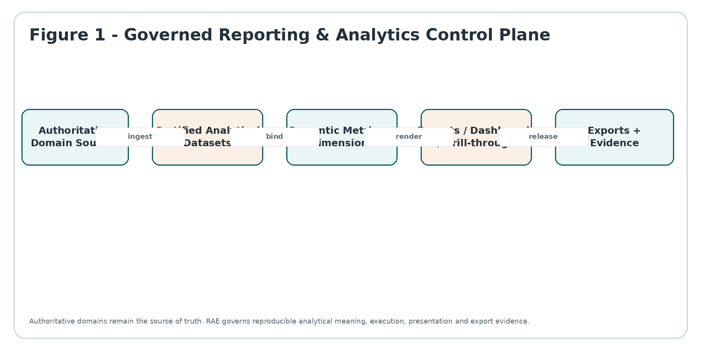
Figure 1 - Governed Reporting & Analytics Control Plane

0.1 Canonical services
Service | Canonical responsibility | Explicitly does not own
RAE-01 | Semantic Metric, Measure & Dimension Registry | Defines immutable published metrics, measures, dimensions, grains, units, currency/rounding, null treatment, aggregation behavior and compatibility. It does not own source-domain transactions, IAM policy, privacy policy, statutory interpretation, records retention or external transmission.
RAE-02 | Analytical Dataset, Period & Snapshot Service | Builds governed analytical datasets/snapshots with source lineage, period/as-of context, certification state, bitemporal knowledge and reproducibility. It does not own source-domain transactions, IAM policy, privacy policy, statutory interpretation, records retention or external transmission.
RAE-03 | Governed Query, Aggregation & Drill-through Service | Compiles semantic queries, enforces tenant/access/purpose controls, applies aggregation rules, returns completeness status and re-authorizes drill-through. It does not own source-domain transactions, IAM policy, privacy policy, statutory interpretation, records retention or external transmission.
RAE-04 | Report, Dashboard & Certification Service | Versions report definitions/layout bindings, executes against pinned semantics/snapshots, controls certification/publication/restatement and preserves as-issued evidence. It does not own source-domain transactions, IAM policy, privacy policy, statutory interpretation, records retention or external transmission.
RAE-05 | Export, Distribution & Structured Reporting Package Service | Authorizes bulk export separately, applies redaction/limits, packages CSV/XLSX/PDF/XBRL/iXBRL outputs, hashes evidence and hands records/submissions to DRC/XIC. It does not own source-domain transactions, IAM policy, privacy policy, statutory interpretation, records retention or external transmission.

1. Scope, Boundaries & Non-Goals

1.1 In scope
- Canonical metric, measure, KPI and dimension definitions with immutable published versions and governed aliases/deprecations.
- Analytical dataset contracts, grains, source facts, period calendars, as-of time, currency/unit semantics, restatement and certification state.
- Cross-domain aggregation/query execution over approved analytical sources; row/column security and privacy-purpose constraints.
- Drill-through from aggregate to underlying authorized transactions/documents without treating aggregate visibility as detail permission.
- Report/dashboard definitions, parameter contracts, pinned semantic versions, rendering provenance, certification and as-issued reproduction.
- Management, operational, accounting, payroll, HR, tax, legal/compliance and board reporting patterns without moving domain authority into RAE.
- Controlled exports, downloads, scheduled packages and machine-readable structured-reporting packages.
- Lineage from report cell/metric to exact source population, semantic version, dataset snapshot, transformations and quality/certification evidence.
- Partial/stale/uncertified input semantics, completeness indicators, reconciliation gates, restatement and re-publication evidence.

1.2 Explicitly out of scope
- Owning journals, invoices, payroll results, employee records, tax returns, legal matters, contracts or declared records.
- Authoring accounting/tax/legal rules; PDC remains authoritative for policy and jurisdiction applicability.
- Data quality/reconciliation authority; DQC certifies source-to-dataset completeness and control totals.
- IAM/resource authorization or privacy lawful basis/purpose; RAE consumes current IAM/PRV decisions.
- Retention/legal hold; DRC owns record declaration, retention, hold and disposition.
- External filing/transport; XIC owns submission/connectivity. RAE creates the governed package and evidence.
- Notification delivery; NCD may distribute alerts/links but cannot become report authority.
- Search indexing; ESR provides secure discovery. Analytical queries use approved datasets/semantic contracts.
- Ad hoc unrestricted production SQL, notebook access, or tenant-visible data-warehouse administration.
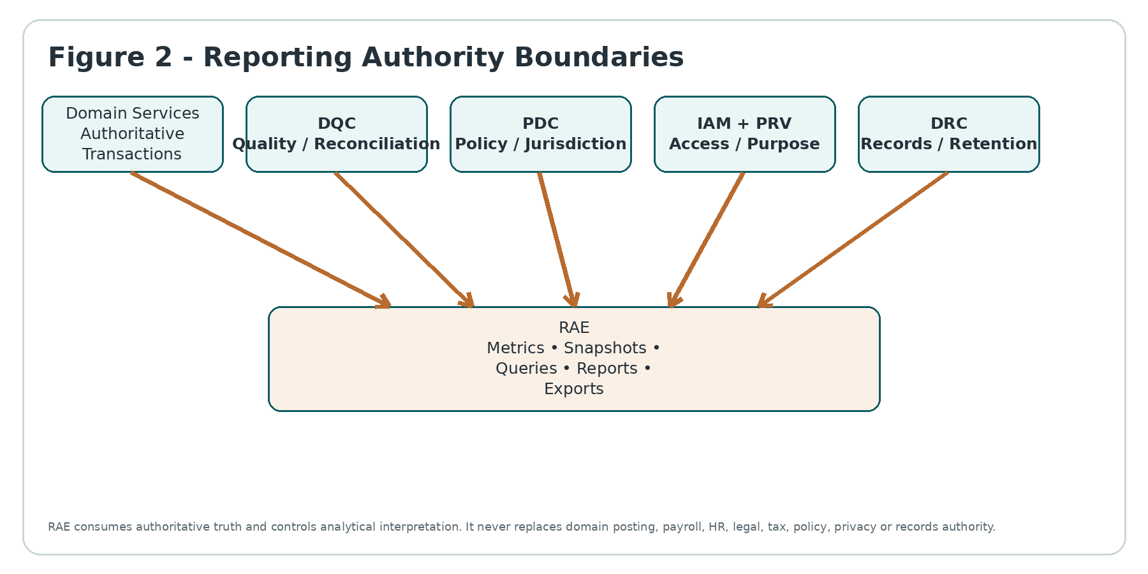
Figure 2 - Reporting Authority Boundaries

1.3 Required decision ordering
- Resolve authenticated actor/workload, tenant, environment and requested analytical purpose from trusted context.
- Resolve report/metric identity to an immutable published semantic version; reject mutable or unpublished production definitions.
- Resolve analytical dataset version, period, as-of/knowledge time, entity, currency/unit and required certification state.
- Apply IAM/PRV security and purpose restrictions before analytical execution; never rely solely on precomputed dashboard visibility.
- Compile the governed expression/aggregation with explicit null, rounding, sign, currency and dimensional behavior.
- Execute against eligible certified data; record partial/stale/indeterminate status rather than fabricating completeness.
- For drill-through or export, perform independent authorization against requested detail/scope.
- Return/render with source lineage, semantic version, data freshness/certification state and evidence identifiers.

2. Canonical Concepts & State Model
Concept | Canonical meaning
MetricDefinition | Versioned business/operational metric contract: formula, grain, source measures, allowed dimensions, unit, aggregation and null/rounding semantics.
MeasureDefinition | Atomic or derived numeric/non-numeric measure with declared type, unit, aggregation behavior and source lineage.
DimensionDefinition | Governed slicing/grouping attribute with hierarchy, member semantics, sensitivity and temporal behavior.
AnalyticalDataset | Versioned, bounded analytical population assembled from authoritative sources under a published dataset contract.
DatasetSnapshot | Immutable snapshot/checkpoint for a period/as-of context, including source high-water marks and DQC certification references.
ReportDefinition | Versioned report/dashboard contract: metrics, dimensions, filters, parameters, layout bindings, disclosure rules and intended audience.
ReportRun | One execution of a report definition against pinned semantic/dataset versions and security context.
IssuedReport | Certified/released report artifact whose exact facts, versions, rendering and evidence are immutable.
ExportPackage | Controlled materialization of permitted results into CSV/XLSX/PDF/JSON/XBRL/iXBRL or other approved format.
Restatement | New report/version that supersedes or corrects a prior issued artifact without deleting/replacing its historical evidence.
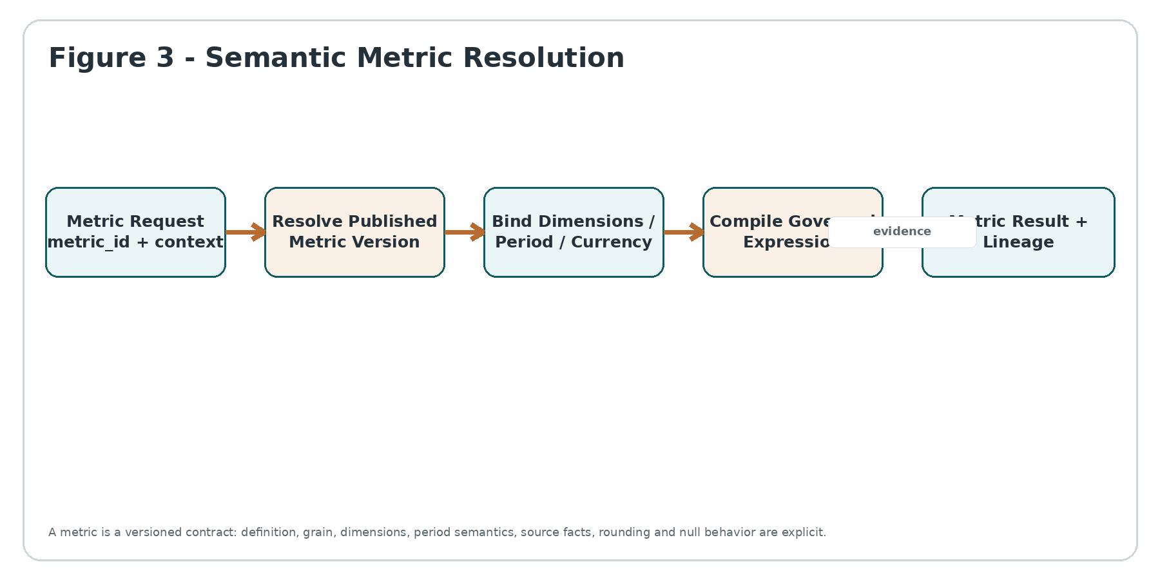
Figure 3 - Semantic Metric Resolution

2.1 Orthogonal state dimensions
State family | States / semantics
Metric lifecycle | DRAFT -> REVIEW -> PUBLISHED -> DEPRECATED -> RETIRED. PUBLISHED versions are immutable.
Dataset snapshot | BUILDING -> VALIDATING -> CERTIFIED | DEGRADED | REJECTED -> SUPERSEDED.
Report run | REQUESTED -> EXECUTING -> COMPLETE | PARTIAL | INDETERMINATE | FAILED.
Report issue lifecycle | DRAFT -> REVIEW -> CERTIFIED -> ISSUED/PUBLISHED -> SUPERSEDED/RESTATED.
Export lifecycle | REQUESTED -> AUTHORIZED -> GENERATING -> READY -> RELEASED | EXPIRED | REVOKED/FAILED.
Freshness/completeness | CURRENT / STALE / PARTIAL / UNKNOWN. Never hidden inside a generic SUCCESS flag.

2.2 Bitemporal reporting truth
RAE must preserve both the time a fact was economically/operationally effective and the time ZoikoSuite knew or certified it. This permits current reporting, historical as-of analysis and exact reproduction of reports issued before later corrections arrived.
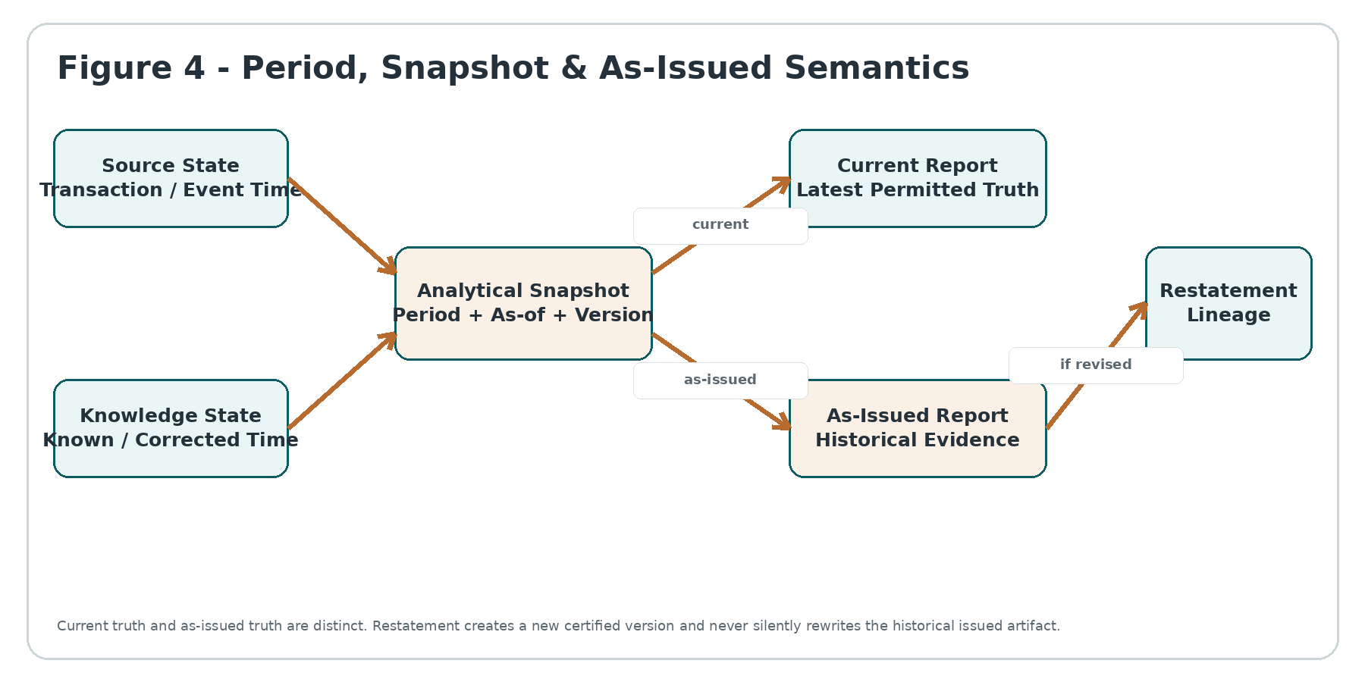
Figure 4 - Period, Snapshot & As-Issued Semantics

3. Non-Bypassable Invariants
ID | Invariant
INV-01 | A report, dashboard, metric result or export never becomes authoritative domain truth.
INV-02 | Published metric/report/dataset definitions are immutable; change requires a new version.
INV-03 | Metric identity alone is insufficient; every result pins the exact metric version.
INV-04 | Every material result has explicit tenant, entity, period/as-of and dataset context.
INV-05 | Null, missing, zero and not-applicable are distinct states.
INV-06 | Currency, unit, scale, sign and rounding behavior are explicit and versioned.
INV-07 | A measure may aggregate only according to its declared aggregation behavior; non-additive measures cannot be blindly summed.
INV-08 | Dimensions/hierarchies are versioned/effective-dated where membership changes over time.
INV-09 | Current organizational/master hierarchy cannot silently reconstruct a historical reporting period.
INV-10 | Uncertified or incomplete input cannot silently produce a COMPLETE certified result.
INV-11 | DQC failure cannot be cosmetically hidden by presentation or aggregation.
INV-12 | A dashboard cache cannot outlive its security/purpose or semantic/data-version validity.
INV-13 | Aggregate visibility does not grant drill-through visibility.
INV-14 | Interactive report permission does not imply bulk-export permission.
INV-15 | Cross-tenant aggregation is prohibited unless an explicit platform-level authority contract permits it and tenant data is legally/contractually eligible.
INV-16 | Report parameters cannot override server-enforced tenant, entity, residency, privacy or access scope.
INV-17 | As-issued reports remain reproducible after later corrections or semantic changes.
INV-18 | Restatement creates a new issued version and permanent lineage; it never overwrites the prior issue.
INV-19 | Rendered PDF/XLSX success does not equal report certification.
INV-20 | Certification is distinct from publication/distribution.
INV-21 | A scheduled report executes under a named workload identity and current authority, not the scheduler owner's stale permissions.
INV-22 | Export packages are immutable after release; correction requires a new package/version.
INV-23 | Export/download URLs are capability-scoped, short-lived and never substitute for source authorization.
INV-24 | Structured-reporting taxonomy/version is pinned; tags are not guessed from labels.
INV-25 | XBRL/iXBRL validation success does not itself prove accounting/legal correctness.
INV-26 | AI may explain/report narrative but cannot silently alter certified figures or semantic definitions.
INV-27 | Metrics used for rights-affecting HR/legal decisions must retain lineage and human-governance boundaries.
INV-28 | Every material metric/report result can trace to source population, transformation/semantic version and certification evidence.
INV-29 | PARTIAL, STALE and INDETERMINATE are first-class statuses and cannot be relabeled COMPLETE.
INV-30 | No domain can bypass RAE semantic/export controls by embedding a competing ungoverned metric engine in UI code.

4. RAE-01 - Semantic Metric, Measure & Dimension Registry
SERVICE AUTHORITY
RAE-01 is the canonical registry for analytical meaning. It defines what a metric means, at what grain, from which measures, across which dimensions, with what unit/currency/time/null/rounding behavior. It does not define underlying legal/accounting rules or own source facts.

4.1 Required objects
Object | Required fields / control
MetricDefinition | metric_id, version, canonical_name, description, domain_owner, expression_ref, grain, unit, aggregation_type, allowed_dimensions, required_filters, null_policy, rounding_policy, period_semantics, status.
MeasureDefinition | measure_id/version, data_type, unit/currency behavior, source_contract, aggregation_behavior, sign convention, sensitivity, null/zero semantics.
DimensionDefinition | dimension_id/version, member key, hierarchy, temporal membership, sensitivity, display/ordering semantics, master-data binding.
SemanticPackage | Immutable set of compatible metric/measure/dimension versions with dependency graph and release digest.
Alias/Deprecation | Human-friendly name maps to canonical ID/version policy; alias cannot silently redirect historical issued reports.

4.2 Aggregation classes
Class | Examples | Rule
ADDITIVE | Revenue, hours, transaction count | May sum across declared dimensions/time only where unit/currency compatibility holds.
SEMI_ADDITIVE | Balance, headcount at date | May aggregate across some dimensions but not blindly across time.
NON_ADDITIVE | Ratios, percentages, averages | Must recompute from governed numerator/denominator or approved formula; never sum displayed values.
DISTINCT / SET | Unique workers/customers | Requires governed key, population and deduplication semantics.
STATUS / TEXT | Compliance state, classification | Uses declared precedence/selection logic; numeric aggregation prohibited.

4.3 Publication controls
- Draft definitions may be edited but are never executable in production certified reporting.
- Publication requires dependency closure, sample calculations, backward-compatibility classification and owner approval.
- Material definition changes create a new version even when the human-facing metric name is unchanged.
- Deprecation does not alter historical reports; retirement blocks new uses after the governed effective date.
- Metric descriptions shown to users are generated from/pinned to the same published semantic version as the result.

5. RAE-02 - Analytical Dataset, Period & Snapshot Service
SERVICE AUTHORITY
RAE-02 creates reproducible analytical populations and snapshots from authoritative source contracts. It records what source state, period, entity scope, transformation version and quality certification were used. It cannot invent or repair source truth.

Capability | Engineering requirement
Dataset contract | Declare source domains/tables/events, grain, join keys, temporal behavior, required DQC controls, sensitivity/residency and freshness class.
Snapshot identity | snapshot_id + dataset_contract_version + tenant/entity scope + period + as_of_at + knowledge_cutoff + source watermarks + build_digest.
Late-arriving data | Creates a new current snapshot/restatement candidate; never mutates the bytes/evidence of a snapshot already used for an issued report.
Historical hierarchy | Resolve MDM/reference membership effective for the reporting period, not simply latest hierarchy.
Currency conversion | Pin rate source, rate type, date/time, source/target currency, precision and rounding; preserve original amount/currency.
Quality state | CERTIFIED only when required DQC controls pass; DEGRADED/PARTIAL/UNKNOWN remain visible to RAE-03/04.
Retention | DRC governs retained issued snapshots/artifacts; transient analytical copies follow approved data-lifecycle policy.

5.1 Snapshot fingerprint
A material report run must be reproducible from a fingerprint containing semantic_package_digest, dataset_snapshot_ids, source high-water marks, period/as-of context, MDM/reference versions, FX/rate references where relevant, PDC policy references where applicable, and DQC certification IDs.

6. RAE-03 - Governed Query, Aggregation & Drill-through Service
SERVICE AUTHORITY
RAE-03 is the server-authoritative analytical execution gateway. It compiles only registered semantic queries, applies current access/purpose controls, binds exact metric/dataset versions and returns explicit completeness/freshness state.

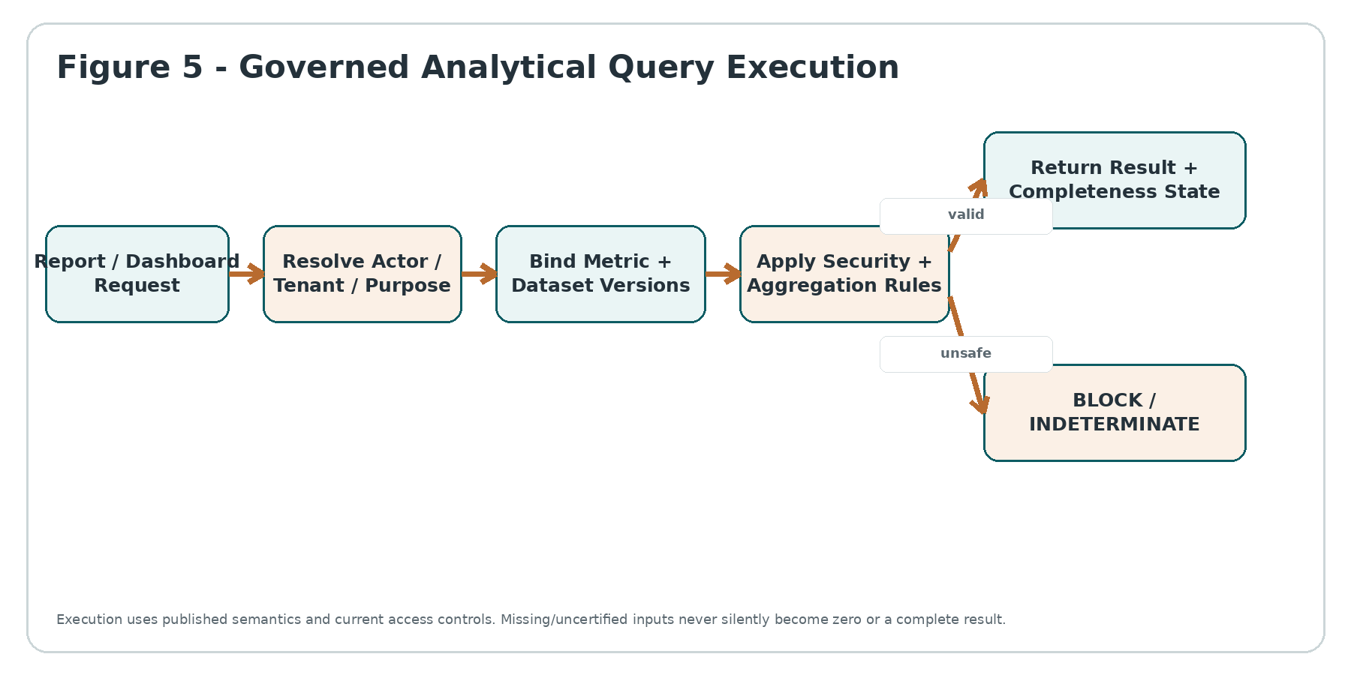
Figure 5 - Governed Analytical Query Execution

6.1 Query contract
Field | Requirement
metric_ids | Canonical IDs; optional version only if caller is authorized to pin historical semantics. Default resolution is governed, never UI-local.
dimensions | Allowlisted dimension IDs; sensitivity and cardinality controls apply.
filters | Typed semantic filters only; raw SQL/warehouse identifiers prohibited from tenant-facing APIs.
period_context | Calendar/fiscal period, timezone where relevant, as_of_at/knowledge cutoff and comparative basis.
entity_context | Tenant + legal entity/business unit/population resolved through trusted MDM/domain context.
security_context | Actor/workload, purpose, resource policy epoch and privacy constraints supplied server-side.
response_state | COMPLETE/PARTIAL/STALE/INDETERMINATE plus source freshness/certification references.

6.2 Drill-through
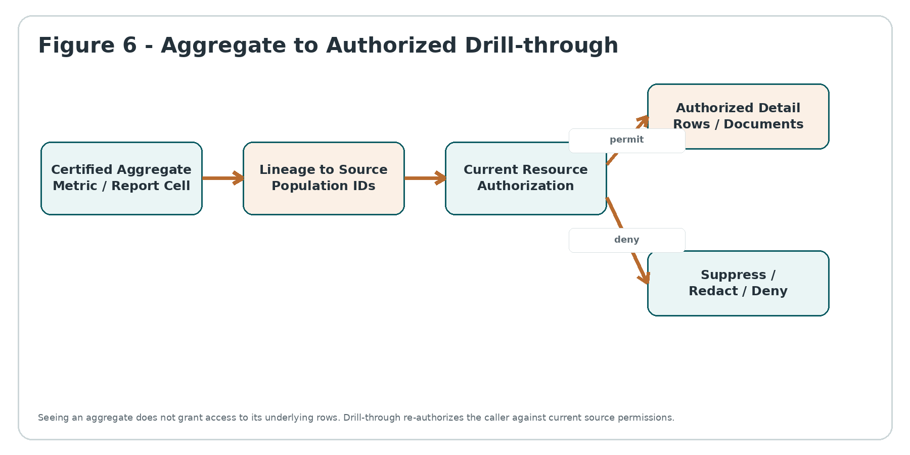
Figure 6 - Aggregate to Authorized Drill-through
- Every report cell/metric result that supports drill-through stores a lineage handle to its source population, not an unrestricted warehouse query.
- RAE requests current resource authorization from the owning domain/IAM/PRV path before exposing rows/documents.
- Suppressed, privileged, legal-hold or special-category detail may remain excluded even when its contribution is present in an authorized aggregate.
- Facet/count and small-cell inference controls may suppress detail or exact counts where privacy/policy requires.
- Drill-through cannot mutate source data; edits route back to the authoritative domain application.

6.3 Query safety
- Per-tenant/workload concurrency and cost budgets.
- No unbounded scans from interactive UI; large analytical jobs become governed asynchronous workloads.
- Deterministic decimal arithmetic for financial/payroll/tax metrics where monetary values are involved.
- Timezone and fiscal-calendar semantics pinned to authoritative reference versions.
- Caching keys include tenant, actor/policy epoch or safe aggregate scope, semantic version, dataset snapshot and parameter digest.

7. RAE-04 - Report, Dashboard & Certification Service
SERVICE AUTHORITY
RAE-04 versions report/dashboard definitions and governs execution, review, certification, issue/publication and restatement. Rendering is presentation; certification is an explicit governed state transition.

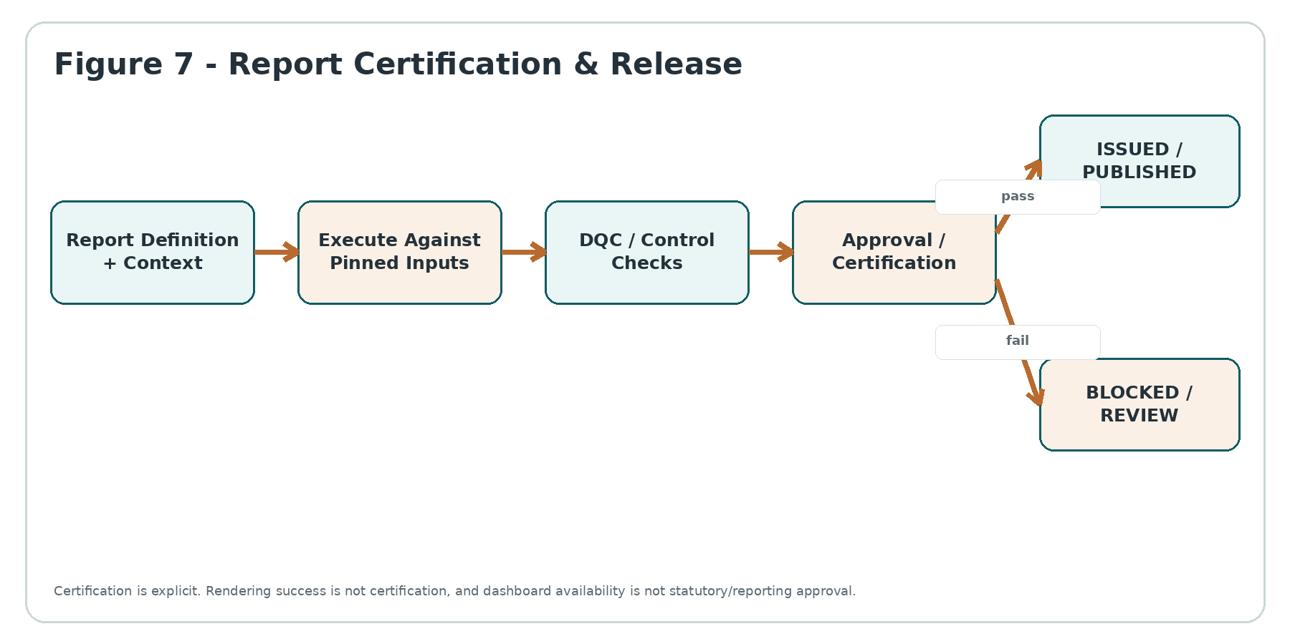
Figure 7 - Report Certification & Release

7.1 Report definition contract
Element | Control
Definition | report_id/version, purpose/class, audience, metric bindings, dimensions, parameters, layout/presentation schema, required certification gates.
Parameters | Typed and allowlisted. Cannot override tenant/security/purpose or select arbitrary semantic/dataset versions.
Comparatives | Prior period/year/budget/scenario basis is explicit and versioned; current hierarchy cannot silently reclassify historical comparative.
Presentation | Units, scale, decimal places, sign, labels and suppressed/zero/null display rules derive from governed semantics.
Certification | Required DQC, reviewer/approver roles, WFC process, source completeness and policy references.
Issue | Exact report run, rendered artifacts, semantic/dataset fingerprints, approval evidence and hash are frozen.

7.2 Dashboard semantics
- Dashboards may be live/current and need not be "issued," but each tile still shows or can expose freshness and semantic provenance.
- A dashboard cannot silently mix metrics calculated under incompatible periods, entity scopes or semantic versions without explicit labeling.
- Threshold colors/status badges are governed presentation rules; they are not legal/compliance determinations unless PDC/domain authority explicitly provides that determination.
- User-created views may rearrange or filter approved metrics but cannot redefine canonical metric formulas under the same metric ID.
- Executive/board packs that are formally released transition into issued artifacts with immutable evidence.

7.3 Restatement
- A discovered error opens a controlled correction/restatement process; the original issued report remains retained and referenceable.
- Restated report links original_issue_id, reason, changed facts/semantics, approvers, issue date and supersession statement.
- Comparative reporting can choose "as originally issued" or "restated current basis" only through an explicit parameter/definition contract.
- Silent replacement of an externally or board-issued file at the same immutable URL/object is prohibited.

8. RAE-05 - Export, Distribution & Structured Reporting Package Service
SERVICE AUTHORITY
RAE-05 converts an authorized analytical result or certified report into a controlled export/package. Export is a separate data-release event with its own scope, limits, purpose, evidence and retention.

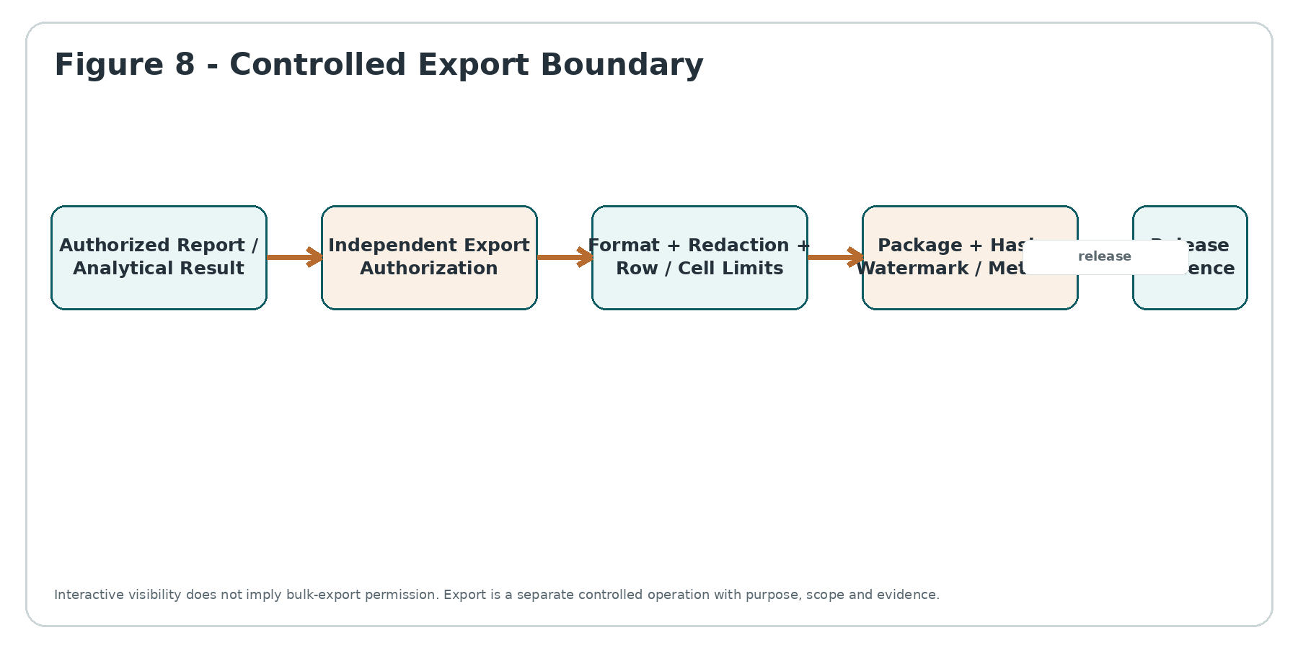
Figure 8 - Controlled Export Boundary

8.1 Export controls
Control | Requirement
Independent authorization | Export capability, data classes, maximum scope and intended purpose evaluated independently from interactive view permission.
Formats | CSV/XLSX/JSON/PDF and structured-reporting formats are allowlisted by report/use-case. Macros/executable content prohibited by default.
Scope limits | Rows, columns, dimensions, time range, file size and asynchronous thresholds governed by policy/tier/security class.
Sensitive data | Column/row suppression, masking/redaction, watermark/metadata and recipient constraints applied before package release.
Formula injection | Spreadsheet text beginning with formula-trigger characters is neutralized according to export policy.
Package evidence | export_id, requester/workload, purpose, source report/query fingerprint, exact population, format, hash, expiry and release event.
Download | Short-lived capability, bound to tenant/actor or approved recipient; no public guessable URL.
Retention | Export artifact retention/record declaration is DRC-governed; temporary packages expire and are securely removed.

8.2 Structured reporting / XBRL
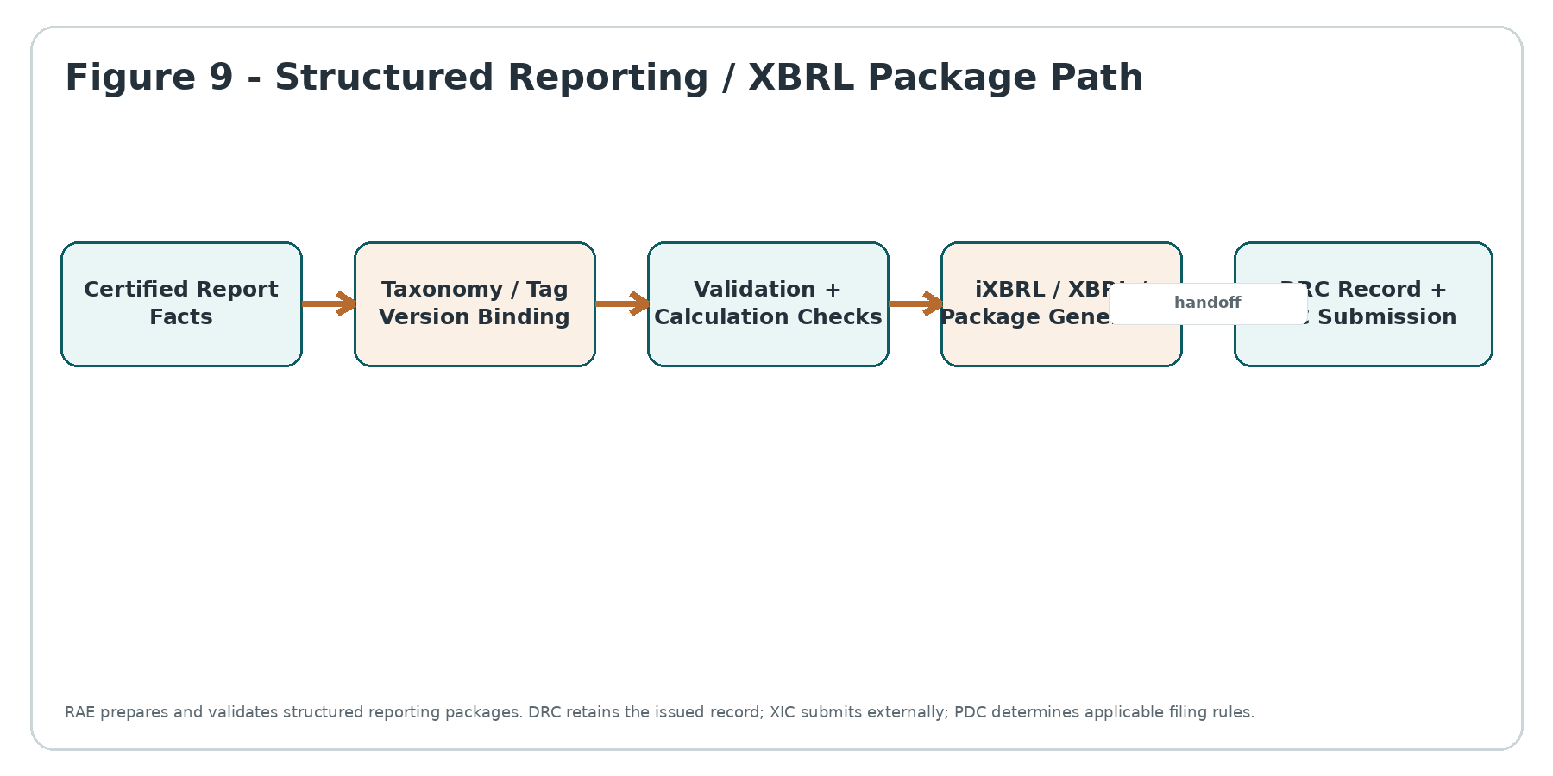
Figure 9 - Structured Reporting / XBRL Package Path
- Taxonomy/report-package versions are immutable inputs to a generated filing package and are selected under jurisdiction/reporting policy.
- Tag mapping is explicit and reviewable; labels or AI similarity cannot auto-authorize a material taxonomy mapping in production.
- Validation errors block certification/submission packaging unless a jurisdiction-specific governed rule explicitly permits a warning.
- RAE creates the structured package; XIC handles filing-channel transport and acknowledgments; DRC retains the filed/issued record.
- The IFRS Accounting Taxonomy version or local taxonomy is not ZoikoSuite's internal semantic model; mappings bridge the internal semantic registry to the required external taxonomy.

9. Canonical Data Model
Entity | Key fields
metric_definition | tenant/global scope, metric_id, version, name, expression_ref, grain, unit, aggregation, null_policy, rounding_policy, period_semantics, status, effective/knowledge times
measure_definition | measure_id/version, source_ref, datatype, unit/currency policy, aggregation_class, sign, sensitivity
dimension_definition | dimension_id/version, hierarchy_ref, source/master binding, sensitivity, temporal_policy
semantic_package | package_id/version, dependency manifest, digest, status, approvals
dataset_contract | dataset_id/version, grain, sources, joins, transformations, DQC requirements, residency/sensitivity
dataset_snapshot | snapshot_id, contract_version, tenant/entity, period, as_of_at, knowledge_cutoff, watermarks, build_digest, certification_state
report_definition | report_id/version, class, audience, metric bindings, parameters, layout schema, certification gates
report_run | run_id, definition_version, caller/workload, context, semantic/dataset fingerprint, state, result_digest
issued_report | issue_id, run_id, approval/evidence refs, artifact hashes, issue_at, status, supersedes/superseded_by
export_package | export_id, source_result_ref, authorization_ref, format, scope digest, hash, expiry, release state
structured_mapping | mapping_id/version, internal fact/metric, external taxonomy element, dimensions/context rule, approval state
analytical_evidence | evidence_id, object/run/export refs, source lineage, policy/security epochs, DQC refs, timestamps, digests

9.1 Storage separation
- Semantic definitions and report definitions live in the RAE control-plane store; published versions are append-only.
- Large analytical data lives in governed analytical stores/warehouses by region/cell, never in the control-plane metadata database.
- Issued artifacts and regulated report packages are handed to DRC for records retention/hold controls.
- Secrets/warehouse credentials remain in Vault/KMS/secret management; RAE stores only references.
- Audit/event evidence is emitted to the immutable evidence/audit authority rather than treated as mutable report metadata.

10. API & Event Contracts
API / event | Purpose | Critical controls
POST /rae/v1/metrics:resolve | Resolve metric/version under context | Published version only; compatibility/effective-time rules; evidence.
POST /rae/v1/query | Execute governed analytical query | Trusted tenant/actor; semantic DSL only; security/purpose; cost budget; explicit result state.
POST /rae/v1/drillthrough | Resolve authorized underlying population | Current resource authorization; small-cell/privacy controls; no source mutation.
POST /rae/v1/reports/{id}:run | Execute report definition | Pinned definition/semantic/dataset; idempotent request key; explicit run state.
POST /rae/v1/report-runs/{id}:certify | Certify completed run | WFC approval; required DQC gates; immutable evidence.
POST /rae/v1/report-runs/{id}:issue | Issue/publish certified artifact | No issue from non-certified run; DRC artifact handoff.
POST /rae/v1/exports | Create controlled export | Separate authorization; scope/format limits; purpose; async for large jobs.
POST /rae/v1/structured-packages | Generate XBRL/iXBRL/report package | Pinned taxonomy/mapping; validation; certification refs.
MetricPublished | New immutable semantic version | Consumers invalidate compatible caches and adopt via governed release.
DatasetSnapshotCertified | Analytical snapshot certified | Carries snapshot fingerprint and DQC refs; no raw sensitive data.
ReportIssued / ReportRestated | Issued/restated artifact state | Carries immutable IDs/hashes/evidence refs; NCD/DRC consumers may act.
ExportReleased / ExportExpired | Export lifecycle evidence | No credentials or raw data in event payload.

10.1 Idempotency and ambiguity
- Report run creation and export/package generation use caller-provided or server-stable idempotency keys.
- Rendering worker timeout is UNKNOWN until the durable run/package is resolved; no blind duplicate issue/release.
- Issue/publication transitions are compare-and-set against certification state and immutable run digest.
- External submission ambiguity belongs to XIC; RAE package identity remains stable so XIC resolves the original submission attempt.

11. Security, Privacy & Residency
Threat / control area | Required behavior
Tenant isolation | Tenant/entity scope from trusted context; no caller-selected warehouse/schema able to cross tenant boundary.
Row/column security | Current IAM/domain/PRV decisions apply to query, drill-through and export; report caches cannot bypass policy epochs.
Inference | Small-cell, high-cardinality and sensitive dimension controls suppress or generalize results where policy requires.
Export exfiltration | Separate export permission, scope ceilings, DLP/redaction, package expiry and auditable release.
Spreadsheet injection | Neutralize formula-triggering values for CSV/XLSX according to safe export policy.
Residency | Dataset, compute, cache and export staging remain in permitted region/cell; cross-region analytics requires explicit authority.
Telemetry | Query parameters/filters containing personal or legal-sensitive data are minimized/redacted; no raw report data in logs.
Privileged BI access | Administrative/warehouse access uses named workload/JIT operator identity, PAM/break-glass and separate production controls.

11.1 Scheduled reporting
A schedule is not perpetual authorization. Each scheduled run resolves a named workload identity, tenant, purpose, current report definition, security/policy state and allowed recipients/export scope at execution time. Disabled users, revoked scopes or changed privacy rules can therefore block a previously valid schedule.

12. Cross-Domain Adoption Contracts
Domain | RAE adoption contract
Accounting / Finance | Financial statements, trial-balance views, management P&L/cash/KPI reports derive from posted/accounting-authoritative facts and preserve entity/period/currency/consolidation basis. RAE cannot post or adjust journals.
Billing / Commercial | MRR/ARR, invoicing, collections and usage analytics bind the platform-commercial plane separately from tenant financial operations; no cross-plane metric contamination.
Payroll | Payroll/headcount/cost reports distinguish calculated, approved, paid and corrected payroll states; sensitive pay detail obeys row/column/export controls.
HR | Workforce metrics define population, effective dates and denominators; rights-affecting decisions remain HR/PDC/AIG/human-governed, not KPI-driven automation.
Tax | Tax reporting binds jurisdiction, tax period, filing version and source determination; RAE does not determine liability or file returns.
Legal / Compliance | Matter/obligation/compliance reporting respects privilege and restricted-case visibility; aggregate visibility never grants matter/document access.
Executive / Board | Board packs use certified report runs/issued artifacts with explicit as-of date, scope, semantic versions and restatement lineage.
AI assistants | AIG may explain authorized RAE results and source lineage; AI cannot redefine metrics or alter certified figures.

13. Observability, SLOs & Runbooks

13.1 SLO classes
Class | Examples | Engineering objective
R0 - Interactive | Dashboard tile, KPI query | Low latency, bounded compute, explicit freshness; no silent fallback to incompatible cache.
R1 - Material management | Finance/HR/payroll management report | Reproducibility and completeness over raw latency; block/label if required snapshot uncertified.
R2 - Issued / regulated | Board pack, statutory/structured package | Deterministic pinned inputs, certification and durable evidence mandatory.
R3 - Bulk analytical export | Large CSV/XLSX/JSON extract | Asynchronous, separately authorized, resource-limited, expiry and release evidence.

13.2 Required telemetry
- Query/report latency, semantic cache hit/miss, warehouse execution cost, timeout/cancellation and concurrency by tenant/workload.
- Dataset snapshot age, source watermark lag, DQC certification state and stale/partial result counts.
- Metric/report version adoption, deprecated-definition use and compatibility failures.
- Drill-through denials/suppression and small-cell/privacy-control activations without logging protected values.
- Export volume, rows/bytes, format, purpose class, release/expiry and policy-denied export attempts.
- Issued/restated reports, failed certification gates, structured-report validation errors and XIC handoff status.

13.3 Runbooks
Runbook | Minimum response
RB-01 Semantic defect | Freeze new certification/issue for affected metric versions; identify impacted reports; publish corrected version; evaluate restatement.
RB-02 Dataset incompleteness | Mark snapshots/report results PARTIAL/INDETERMINATE; block R2 certification; reconcile through DQC.
RB-03 Warehouse/query outage | Use only previously certified caches/snapshots where contract permits and label freshness; otherwise fail explicitly.
RB-04 Permission leakage | Disable affected query/export path, invalidate caches, investigate scope, emit security/privacy incident evidence.
RB-05 Export exfiltration | Revoke remaining capability where possible, preserve evidence, activate Security/PRV response; do not falsify release history.
RB-06 Issued report error | Preserve original, initiate WFC restatement, generate corrected issue with supersession lineage and controlled notification.
RB-07 Structured package rejection | Keep package/submission attempt IDs stable; correct mapping/package via new version and XIC-governed resubmission.
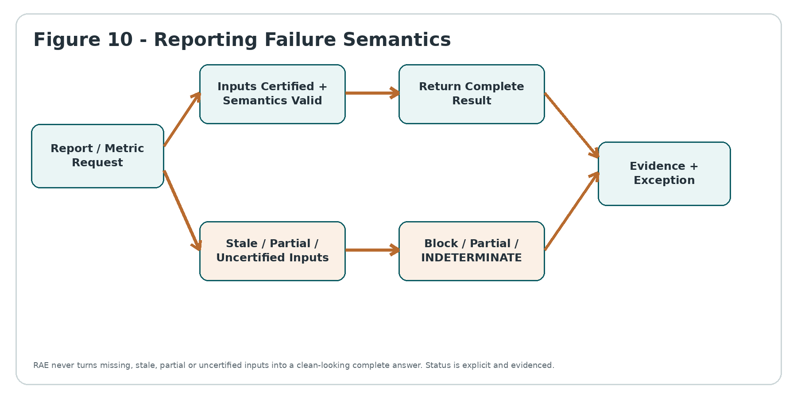
Figure 10 - Reporting Failure Semantics

14. Stable Error / Reason Taxonomy
Code | Meaning
RAE-001 | METRIC_NOT_FOUND
RAE-002 | METRIC_VERSION_NOT_PUBLISHED
RAE-003 | SEMANTIC_INCOMPATIBLE
RAE-004 | DIMENSION_NOT_ALLOWED
RAE-005 | INVALID_PERIOD_CONTEXT
RAE-006 | DATASET_NOT_ELIGIBLE
RAE-007 | SNAPSHOT_NOT_CERTIFIED
RAE-008 | SOURCE_INCOMPLETE
RAE-009 | AUTHORIZATION_DENIED
RAE-010 | PRIVACY_RESTRICTED
RAE-011 | QUERY_COST_LIMIT
RAE-012 | NON_ADDITIVE_AGGREGATION
RAE-013 | CURRENCY_CONTEXT_REQUIRED
RAE-014 | DRILLTHROUGH_DENIED
RAE-015 | REPORT_NOT_CERTIFIABLE
RAE-016 | ISSUE_STATE_CONFLICT
RAE-017 | EXPORT_NOT_AUTHORIZED
RAE-018 | EXPORT_SCOPE_LIMIT
RAE-019 | STRUCTURED_PACKAGE_INVALID
RAE-020 | RESULT_INDETERMINATE

15. Negative-Path Certification Matrix
Scenario | Failure injection | Required outcome
NP-01 | UI submits its own formula for canonical metric ID. | Reject; canonical published semantic definition wins.
NP-02 | Metric definition changed in place after report issue. | Impossible; published version immutable; new version required.
NP-03 | Null source value treated as zero by visualization library. | Prevent/flag; null policy from metric contract controls display/calculation.
NP-04 | Percentage metric values are summed across departments. | RAE-012; recompute from governed numerator/denominator or reject.
NP-05 | Balance metric summed across monthly periods. | Reject unless declared valid aggregation; semi-additive time rule applies.
NP-06 | Currency amounts combined without conversion context. | RAE-013; explicit rate source/date/type required.
NP-07 | Frontend rounds inputs before ratio calculation. | Canonical server-side decimal calculation from full precision; presentation rounding only after calculation.
NP-08 | Dimension hierarchy changed after historical period. | Resolve effective-dated historical hierarchy; do not silently use latest.
NP-09 | Deprecated metric alias redirects historical report. | Issued report pins exact version; no redirect.
NP-10 | Unpublished draft metric appears in production dashboard. | Block; production certified paths use published versions only.
Scenario | Failure injection | Required outcome
NP-11 | Source event gap exists but dataset job completed. | DQC certification fails; snapshot not CERTIFIED.
NP-12 | One source system stale while others current. | Result STALE/PARTIAL per contract; cannot present COMPLETE.
NP-13 | Late transaction arrives after issued month-end report. | Current snapshot may change; issued artifact unchanged; restatement process if required.
NP-14 | Historical report rebuilt using current MDM organization. | Reject/mismatch; pin historical MDM/reference version.
NP-15 | FX rate revised after issue. | As-issued retains original pinned rate; restated/current basis explicit.
NP-16 | Dataset snapshot overwritten to save storage. | Prohibited for issued/certified evidence; immutable fingerprint/version.
NP-17 | Warehouse has duplicate rows that net to same total. | DQC/detail controls detect; aggregate match alone not sufficient.
NP-18 | Dataset crosses residency boundary for cheaper compute. | Block unless explicit residency/transfer authority permits.
NP-19 | Transient analytical copy outlives approved purpose. | Lifecycle enforcement removes; DRC/PRV rules apply.
NP-20 | DQC service unavailable for R2 report. | INDETERMINATE/BLOCK certification; never assume pass.
Scenario | Failure injection | Required outcome
NP-21 | Caller supplies another tenant_id in query filter. | Trusted context wins; reject/ignore client tenant scope.
NP-22 | Caller injects raw SQL/warehouse table name. | Reject; semantic DSL only.
NP-23 | User removes row-level security filter from dashboard URL. | Mandatory server filters immutable; no effect.
NP-24 | Cached dashboard result from prior role remains visible after revocation. | Policy/cache epoch invalidates; reauthorize.
NP-25 | Aggregate visible but underlying salary rows restricted. | Aggregate may remain if policy permits; drill-through denied/redacted.
NP-26 | Small team headcount exposes sensitive individual inference. | Suppression/generalization per PRV/PDC threshold.
NP-27 | Query exceeds tenant resource budget. | RAE-011; queue/async/reject without affecting others.
NP-28 | Warehouse returns partial partitions with HTTP success. | Mark PARTIAL; do not certify COMPLETE.
NP-29 | Timezone omitted for daily operational metric. | Use contract/default only if authoritative; otherwise invalid context.
NP-30 | Fiscal calendar changes mid-year. | Pin/reference version and effective dates; no silent period shift.
Scenario | Failure injection | Required outcome
NP-31 | Report PDF rendered correctly but DQC failed. | Cannot certify/issue; rendering success is irrelevant.
NP-32 | Approver changes a figure manually in exported PDF. | Artifact hash mismatch; cannot become issued report through RAE.
NP-33 | Issued board pack replaced in storage with corrected file. | Prohibited; new restated issue with lineage.
NP-34 | Dashboard threshold color implies legal non-compliance. | Only if PDC/domain provides authoritative determination; otherwise presentation label must not claim legal conclusion.
NP-35 | Scheduled report executes after owner leaves company. | Named workload/current authorization evaluated; schedule blocks if invalid.
NP-36 | User-created custom view saves a changed formula under canonical name. | Custom derived metric gets separate non-canonical ID or is prohibited; cannot shadow canonical ID.
NP-37 | Comparative period uses different semantic version without disclosure. | Block or explicitly label controlled basis; certification requires compatibility.
NP-38 | Report issue attempted twice after timeout. | Resolve durable original issue/run; no blind duplicate issue.
NP-39 | Report marked certified by client-side flag. | Ignored/rejected; server state transition with WFC/DQC evidence only.
NP-40 | Restatement deletes original evidence. | Prohibited; preserve original and link supersession.
Scenario | Failure injection | Required outcome
NP-41 | User can view dashboard but requests full CSV of sensitive rows. | RAE-017 unless separate export authority permits.
NP-42 | CSV cell begins =HYPERLINK(...) from source data. | Neutralize formula injection according to export policy.
NP-43 | Export URL forwarded to unauthorized user. | Short-lived actor/recipient-bound capability; access denied.
NP-44 | Export generation includes hidden columns not shown in UI. | Only explicitly authorized export schema; hidden source columns excluded.
NP-45 | Large export bypasses row ceiling via repeated pagination. | Aggregate rate/scope controls and export-specific authorization; abuse detection.
NP-46 | Expired export artifact remains downloadable from object-store path. | Capability invalid and object lifecycle removes/locks per policy.
NP-47 | Structured package maps metric to taxonomy element by AI similarity. | No production activation without approved mapping/version.
NP-48 | XBRL validation passes but underlying numbers not certified. | Package not issuable; RAE/DQC certification still required.
NP-49 | External filer rejects package after timeout ambiguity. | XIC resolves original submission; RAE package identity unchanged.
NP-50 | Taxonomy version changes after draft preparation. | Pinned package version remains; applicability/transition handled through governed new package/version.
Scenario | Failure injection | Required outcome
NP-51 | Cross-tenant executive analytics accidentally unions tenant datasets. | Hard tenant partitions and authority checks prevent; incident if attempted.
NP-52 | AI assistant requests privileged KPI by service identity. | AIG passes real caller/purpose; RAE authorization denies excess scope.
NP-53 | AI-generated narrative changes a certified number textually. | Certified numeric values are machine-bound; narrative validation/human review prevents divergence.
NP-54 | Legal matter aggregate includes privileged matter count exposing existence. | Facet/small-cell/privilege controls suppress where required.
NP-55 | HR attrition metric denominator silently changes definition. | New semantic version required; historical comparatives disclose basis.
NP-56 | Payroll report mixes calculated and paid payroll states. | Metric/report contract specifies state population; incompatible mix rejected/labeled.
NP-57 | Accounting dashboard includes platform SaaS revenue in tenant ledger analytics. | Commercial/tenant plane separation enforced in dataset contracts.
NP-58 | Current report reconstructed from archived export spreadsheet rather than source/snapshot. | Export is not source truth; rebuild from pinned analytical/source contracts.
NP-59 | PARTIAL result is downloaded with filename implying Final. | Package status/metadata prevents misleading certified/final labeling.
NP-60 | Operator manually sets report state COMPLETE during incident. | No bypass; state derived from execution/certification evidence; privileged correction is audited and cannot fabricate source completeness.

16. Traceability Controls
Control | Traceability requirement
TC-01 | Every metric result records metric_id/version and semantic package digest.
TC-02 | Every result records tenant/entity, period/as-of and dataset snapshot IDs.
TC-03 | Every monetary conversion records source/target currency, rate source/date/type, precision and rounding.
TC-04 | Every report run records report definition/version and parameter digest.
TC-05 | Every certified/issued report records required DQC control evidence.
TC-06 | Every report issue records approval/WFC evidence and artifact hashes.
TC-07 | Every restatement links prior issue, reason, changed basis/facts and approvers.
TC-08 | Every drill-through request links aggregate lineage handle and current authorization result.
TC-09 | Every export records separate authorization, purpose, schema, scope, row/byte counts and package hash.
TC-10 | Every structured package records taxonomy/report-package version and mapping-set digest.
TC-11 | Every scheduled run records named workload identity and current authority context.
TC-12 | Every cached result records semantic/data/policy epochs required for invalidation.
TC-13 | Every PARTIAL/STALE/INDETERMINATE result records exact missing/stale inputs.
TC-14 | Every dataset snapshot records source watermarks and transformation/build digest.
TC-15 | Every historical report reconstruction records whether basis is as-issued, restated or current.
TC-16 | Every sensitive aggregate suppression records policy/reason without leaking suppressed facts.
TC-17 | Every report/export access event records tenant, actor/workload, resource and purpose at a minimized level.
TC-18 | Every semantic definition change links review, compatibility classification and publication authority.
TC-19 | Every report artifact retained as a record links DRC record/version identifiers.
TC-20 | Every external submission handoff links immutable RAE package ID to XIC attempt/reconciliation identifiers.

17. Controlled Open Decisions
Decision | Open item | Closure authority
OD-01 | Semantic layer / BI engine vendor | Select after conformance to versioning, row/column security, lineage and multi-tenant controls.
OD-02 | Warehouse/lakehouse topology by region/cell | Must preserve residency, tenant isolation, workload governance and reproducibility.
OD-03 | Canonical fiscal/calendar service integration | Choose ownership interface without duplicating MDM/reference/calendar authority.
OD-04 | Metric expression language | Select deterministic, reviewable language/IR with decimal/time semantics and dependency graph.
OD-05 | Interactive query SLOs and cost budgets | Ratify by workload class after representative load testing.
OD-06 | Snapshot materialization policy | Determine which reports require physical immutable snapshot versus reproducible logical snapshot/fingerprint.
OD-07 | Small-cell/inference thresholds | PDC/PRV/domain decision by data class and jurisdiction.
OD-08 | User-defined metric capability | Define sandbox/non-canonical boundary and promotion workflow.
OD-09 | Export row/byte ceilings by role/tier | Security/product/commercial decision; must not weaken privacy controls.
OD-10 | Default report artifact formats | Define PDF/XLSX/CSV/JSON availability by class and accessibility requirements.
OD-11 | Structured reporting toolchain | Select XBRL/iXBRL validation/generation technology after conformance testing.
OD-12 | IFRS/local taxonomy mapping ownership | Finance/Reporting Governance + jurisdiction owner + engineering stewardship.
OD-13 | Historical analytical retention depth | Balance audit/reproduction need, privacy/retention and storage cost.
OD-14 | Board/external report digital signature/seal policy | Legal/Finance/DRC decision; integrate with signature control if required.
OD-15 | Quantitative certification tolerances | DQC/domain owners define by report class; zero default only where appropriate.

18. Standards & Structured Reporting Baseline
RAE remains vendor-neutral and jurisdiction-neutral. External standards are integration/reporting targets, not substitutes for ZoikoSuite internal semantic authority.
Reference | Application to RAE
IFRS Accounting Taxonomy 2025 | The IFRS Foundation states the 2025 taxonomy remains the current IFRS Accounting Taxonomy for 2026 reporting periods; RAE pins taxonomy/package versions when generating IFRS digital reporting outputs.
XBRL 2.1 + XBRL Dimensions | Foundation of the XBRL Standard for concepts, facts and multidimensional reporting; used where a filing/reporting regime requires XBRL-compatible output.
Inline XBRL 1.1 | Current Inline XBRL specification; enables human-readable HTML reports with embedded machine-readable XBRL facts.
ISO 8601-1:2019 / IANA timezone rules | Time/as-of fields use explicit date/time representation and governed civil-time zones; fiscal calendars remain business/reference data rather than hard-coded offsets.
WCAG 2.2 AA | Human-facing reports/dashboards and downloadable accessible artifacts must meet applicable accessibility requirements; presentation accessibility never alters underlying facts.

STRUCTURED REPORTING RULE
ZoikoSuite internal semantic IDs must remain stable even when an external taxonomy changes. External taxonomy elements are governed mappings. A regulator or accounting taxonomy update therefore creates a new mapping/package version rather than forcing internal business semantics to inherit external identifiers.

19. Definition of Ready / Definition of Done

19.1 Definition of Ready
- At least one representative metric/report from Accounting and one from HR/Payroll have approved source and semantic contracts.
- DQC snapshot certification, IAM/PRV authorization, MDM/reference period/entity and DRC record handoff contracts are testable.
- Semantic registry supports immutable publication and dependency/version resolution.
- Analytical query path enforces tenant/row/column/purpose controls without exposing raw warehouse access.
- Report run/certification/issue lifecycle is durable and idempotent.
- Export path has independent authorization and safe CSV/XLSX handling.
- Negative-path harness can test semantic drift, partial inputs, permission revocation, inference, export exfiltration and restatement.

19.2 Definition of Done
- INV-01 through INV-30 mechanically enforced or evidenced with no UI/domain bypass.
- NP-01 through NP-60 pass for applicable report classes.
- Same governed metric returns identical value for same pinned context across dashboard, API, report and export surfaces.
- As-issued report reproduction remains byte/fact-equivalent or deterministically equivalent with recorded renderer version where exact bytes are not required.
- DQC failures/partial source states propagate visibly and block R2 certification as specified.
- Drill-through and export pass current authorization/privacy controls and tenant-isolation tests.
- Restatement preserves prior issue and complete supersession lineage.
- Structured report packages pin taxonomy/mapping versions and pass conformance validation before XIC handoff.
- Runbooks, SLOs, observability, recovery and emergency disable paths are exercised.
- Production release approved by Platform Architecture, Finance/Reporting Governance, Security/Privacy and representative domain owners.

20. Eight-Wave Implementation Sequence
Wave | Objective | Exit gate
Wave 1 | Semantic foundation | Implement RAE-01 metric/measure/dimension registry, immutable publication, dependency graph and reason taxonomy.
Wave 2 | Dataset & snapshot foundation | Implement RAE-02 dataset contracts, snapshots, period/as-of semantics, source watermarks and DQC certification integration.
Wave 3 | Governed query gateway | Implement RAE-03 semantic query compilation, tenant/row/column security, decimal/time rules, cost controls and explicit completeness states.
Wave 4 | Reports & dashboards | Implement RAE-04 report definitions/runs, dashboard semantic binding, current/as-issued basis and approval/certification lifecycle.
Wave 5 | Exports & evidence | Implement RAE-05 independent export authorization, safe file generation, expiry, hashes, DRC handoff and release evidence.
Wave 6 | Financial / workforce adoption | Onboard Accounting/Billing and Payroll/HR reporting with cross-surface value-equivalence and negative-path certification.
Wave 7 | Structured & regulated reporting | Implement taxonomy mapping, XBRL/iXBRL/report-package validation and XIC submission handoff for approved jurisdictions.
Wave 8 | Enterprise analytics certification | Complete Tax/Legal/Compliance/Board adoption, NP-01-NP-60, performance, privacy, accessibility, resilience and catalogue closure sign-off.

21. Engineering Handoff & Catalogue Closure
FINAL ARCHITECTURE DECISION
Build RAE as the canonical analytical-meaning and report/export control plane, not as a shadow transactional system. Domain services remain authoritative; DQC proves input quality; RAE makes analytical meaning reproducible; DRC preserves issued records; XIC submits externally. The same governed question must yield the same defensible answer across every ZoikoSuite surface.

Handoff artifact | Engineering requirement
Service contracts | RAE-01 through RAE-05 APIs/events/states/reason codes implemented against this specification.
Semantic model | Metric, measure, dimension and semantic-package versions are immutable, dependency-resolved and testable.
Data model | Datasets/snapshots preserve exact source watermarks, period/as-of/knowledge context and DQC evidence.
Security | Tenant, row/column, drill-through, inference and export controls are release blockers, not UI conveniences.
Reporting | Report run/certification/issue/restatement states remain orthogonal and evidence-backed.
Structured reporting | External taxonomy mappings are versioned adapters; package generation is validated before DRC/XIC handoff.
Catalogue status | This is the final absolutely necessary shared-service wireframe under the approved hard ceiling. No further horizontal Services Requirements Catalogue document should be produced without a new, demonstrable architectural dependency.

21.1 Catalogue closure gate
Candidate for a future horizontal catalogue document | Required decision
A newly discovered authority is used by multiple ZoikoSuite domains and no approved control plane owns it. | Architecture may reopen the catalogue only after documenting the unresolved authority, cross-domain dependency and non-duplication case.
The need can be implemented inside an existing control plane without changing its authority boundary. | Do not create a new catalogue document; update the owning service specification/change record instead.
The need is a vendor, database, queue, cache, BI tool, warehouse, OCR engine, PDF renderer or other implementation technology. | Do not create a horizontal catalogue document; treat as an implementation/ADR/procurement decision.
The need is one dashboard, report, metric, filing, HR workflow, legal workflow, tax form or accounting statement. | Do not create a horizontal catalogue document; implement under the relevant domain plus RAE/PDC/DQC/DRC controls.
The need is product UI, admin UX, capacity tuning, SLO calibration or regional rollout. | Do not create a new shared-service authority document; use product, operational or deployment specifications.

21.2 External reference notes
Current-reference verification performed 24 August 2026. Engineering must re-verify standards/taxonomy applicability before each regulated reporting launch.
Reference | Verified source
IFRS Accounting Taxonomy 2025 remains current for 2026 reporting periods | IFRS Foundation - "IFRS Accounting Taxonomy 2025 to remain current for 2026 reporting" (2026).
XBRL technical baseline | XBRL International specifications index: XBRL 2.1, Dimensions and related modular specifications.
Inline XBRL 1.1 | XBRL International specifications index; current edited recommendation updated 14 July 2026.
End of ZS-SVC-AC-001 - Shared Services Requirements Catalogue horizontal-control baseline complete.

