ZOIKOSUITE
WORKFLOW, APPROVAL, CASE &
OBLIGATION CONTROL
Detailed Service Specifications
Version 1.0 — WFC-01 through WFC-05 Build-Ready Shared Control Baseline

EXECUTIVE DOCTRINE
ZoikoSuite must have one server-authoritative control plane for material workflow state, approvals, cases, obligations and deadline clocks across accounting, tax, payroll, HR, legal, compliance and business operations. A domain may own its business outcome, but it may not silently invent a competing approval path, deadline rule, exception lifecycle or maker-checker standard when the canonical control plane applies.

Field | Value
Document ID | ZS-SVC-R-001
Version | 1.0 — Shared Control Plane Launch Baseline
Date | August 24, 2026
Status | Build-ready engineering specification; production activation remains subject to integration certification, jurisdiction rule approval, numeric SLO ratification and formal go-live approval.
Owner | ZoikoSuite Platform Architecture / Governance Operations
Prepared for | Engineering, Product, Security, Legal/Compliance, Finance, Accounting, Tax, Payroll, HR, Business Operations, SRE, QA, Support, Data Governance
Language | American English
Scope | Global, multi-tenant, multi-jurisdiction, multi-domain SaaS control plane

0. Critical Analysis and Architecture Decision
The remaining dependency is not a new user-facing module. It is a control-plane problem. ZoikoSuite can only operate as a coherent Tier-1 accounting, HR, legal and business platform if approvals, long-running work, cases, exceptions and deadlines have one canonical execution model. Otherwise, each domain will independently create “pending,” “approved,” “overdue,” “reopened,” “waived,” “escalated,” and “completed” states with incompatible semantics.

0.1 Failure modes this specification prevents
Failure mode | Why it is unacceptable | Required correction
Domain-local approval logic | Creates inconsistent maker-checker rules, self-approval paths and stale approvals. | WFC-03 is the canonical approval service; domain services supply subject context and commit commands.
One overloaded workflow status | “Pending” cannot safely represent execution, approval, case, billing, legal-clock and document states at once. | State dimensions remain orthogonal and independently queryable.
Deadline stored as a date field | Loses jurisdiction, timezone, business-day, trigger, rule version and recalculation provenance. | WFC-05 stores a versioned deadline clock with full computation evidence.
Blind retries after timeout | Can duplicate payroll runs, journal postings, filings, terminations, payouts or legal actions. | Every action declares idempotency and unknown-outcome resolution; no blind retry of unsafe effects.
Approval after material edit | Allows approval to authorize content, amounts or facts the approver never reviewed. | Approval binds to subject_version/hash; material changes invalidate stale decisions.
Internal SLA overrides statutory deadline | A tenant-configurable service target can accidentally soften a legal obligation. | Clock classes are explicit; HARD_LEGAL rules cannot be relaxed by tenant configuration.
Audit log used as workflow state | Evidence becomes mutable operational state or operations become dependent on an append-only store. | Operational state and evidence are separate; every material transition produces evidence references.
Scheduler is the source of truth | Missed jobs can erase or defer obligations. | Deadline state is durable; schedulers are workers over authoritative clock records.

Architecture decision
Proceed with ZS-SVC-R-001 as the next necessary shared service pack. Do not create separate accounting, HR, legal, payroll or compliance workflow engines unless a documented exception is approved by Platform Architecture and the domain can prove why the canonical control plane cannot satisfy the requirement.

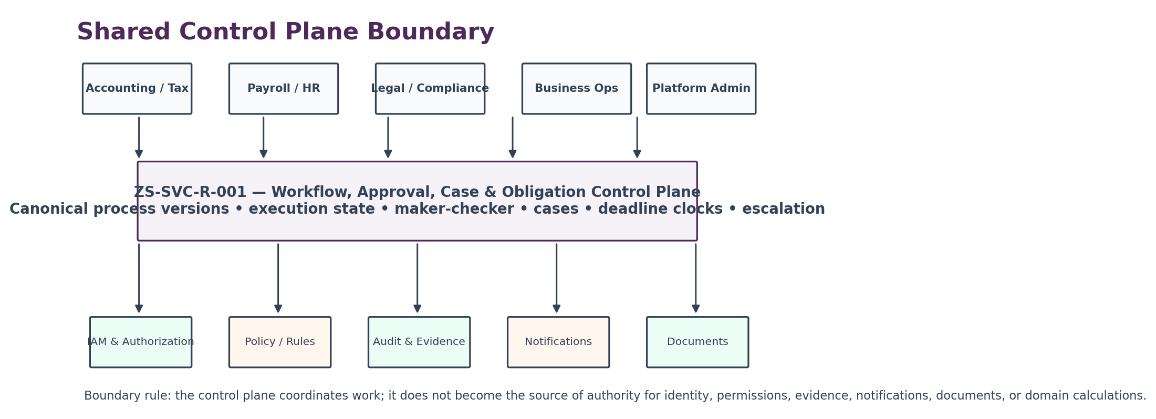
Figure 1 — Shared control-plane boundary

1. Scope, Boundaries and Service Catalogue

1.1 In scope
- Versioned process definitions and governed publication.
- Durable long-running workflow execution with deterministic step contracts.
- Human and machine work items, assignment and queue ownership.
- Maker-checker, quorum, sequential/parallel and risk/amount-based approvals.
- Case and exception lifecycle management with controlled reopen and closure.
- Obligation creation, jurisdiction-aware deadline computation and escalation clocks.
- Idempotency, retry, timeout resolution, compensation coordination and recovery.
- Cross-domain correlation, audit/evidence linkage, operational metrics and certification.

1.2 Explicitly out of scope
Capability | Authoritative owner | ZS-SVC-R-001 behavior
Identity, authentication, roles and permissions | IAM / Authorization services | Consumes actor identity and authorization decisions; never grants business permission itself.
Commercial plan entitlement | COM-03 Entitlement | May require an entitlement precondition; never equates plan possession with business authorization.
Domain calculation or posting | Accounting, payroll, tax, HR, legal or other domain service | Coordinates the command; the domain remains authoritative for the business effect.
Policy/rules authoring | Policy / jurisdiction / rules services | Consumes approved rule outputs and version references.
Audit evidence source of truth | Audit & Evidence Ledger | Emits evidence-linked events; operational state remains in control-plane stores.
Notification delivery | Notification / communications service | Requests delivery; does not own email/SMS/push provider logic.
Document content / e-signature | Document / records / signature services | References document/artifact IDs and signature states only.
Calendar source data | Jurisdiction/calendar service | Consumes versioned timezone/holiday/business-day data.
Analytics warehouse | Analytics platform | Publishes governed events and metrics; no direct mutation from analytics.

1.3 Canonical services
ID | Service | Authority | Must not become
WFC-01 | Process Definition & Version Registry | Canonical definition, schema, step graph, activation window, compatibility and publication state. | Low-code scripting environment with arbitrary code execution.
WFC-02 | Workflow Execution & Work Item Orchestrator | Durable workflow instance state, step execution, wait/retry/compensation and work-item lifecycle. | Business-domain database or uncontrolled job queue.
WFC-03 | Approval & Segregation-of-Duties Service | Approval requirement resolution, independence checks, quorum, decisions and expiry. | IAM system or substitute for domain authorization.
WFC-04 | Case & Exception Management Service | Canonical cross-domain case container, assignment, evidence refs, resolution and reopen governance. | Generic CRM or document repository.
WFC-05 | Obligation, Deadline & Escalation Service | Obligation instances, deadline clocks, warning/escalation schedule, satisfaction and waiver evidence. | Source of legal rules or tenant notification delivery.

2. Non-Bypassable Invariants
ID | Invariant
R-INV-01 | A production workflow instance references one immutable process_version_id for its execution semantics.
R-INV-02 | Publishing a new process version never mutates running instances unless an explicit governed migration is performed.
R-INV-03 | Workflow execution state, approval state, case state, obligation state and domain state are never collapsed into one generic status.
R-INV-04 | Every mutating step has an idempotency contract before production use.
R-INV-05 | A timeout is UNKNOWN until the original action is resolved; it is not automatically FAILED.
R-INV-06 | The orchestrator never directly writes authoritative accounting, payroll, HR, legal, tax or commercial domain tables.
R-INV-07 | Approval is bound to subject_id + subject_version/hash + material context + approval_policy_version.
R-INV-08 | A requester may not approve their own action where independence is required; service accounts cannot satisfy human independence.
R-INV-09 | A role permission alone does not prove approver independence; actor relationship/conflict checks are evaluated separately.
R-INV-10 | A material subject change invalidates unconsumed approvals unless policy explicitly classifies the change as non-material.
R-INV-11 | No expired approval can authorize a later commit.
R-INV-12 | Emergency/break-glass actions are narrowing, time-bounded and automatically queued for post-action review.
R-INV-13 | A case cannot be silently deleted; closure, reopening, merge and split are evented and evidence-linked.
R-INV-14 | An obligation cannot be marked FULFILLED without a fulfillment evidence reference or approved evidence-exempt reason.
R-INV-15 | A HARD_LEGAL deadline cannot be extended by a tenant SLA or operational preference.
R-INV-16 | Deadline computation preserves jurisdiction, timezone, trigger, rule version, calendar version and formula provenance.
R-INV-17 | Recalculation supersedes a clock; historical due_at values remain reconstructable.
R-INV-18 | DST and timezone conversion occur from a declared canonical timezone policy; local-time ambiguity cannot be guessed.
R-INV-19 | Escalation is not fulfillment; notifying an owner cannot close an obligation.
R-INV-20 | Every user-visible “completed” workflow has either a successful terminal domain outcome or an explicit no-op/waiver result.
R-INV-21 | Compensation creates new domain actions; it never deletes the original effect or evidence.
R-INV-22 | Cross-tenant workflow references are rejected at service boundary and again at persistence boundary.
R-INV-23 | Business state + workflow state + outbox event commit atomically for control-plane-owned transitions.
R-INV-24 | No production process definition may call an unregistered service action or event contract.
R-INV-25 | Manual operator intervention is represented as a governed action with actor, reason, scope and evidence; database edits are not an operational workflow.
R-INV-26 | A stuck scheduler or worker cannot alter the authoritative due date or hide overdue status.
R-INV-27 | Case severity and legal deadline urgency are separate dimensions; one cannot be inferred from the other.
R-INV-28 | Cancellation rules are explicit per step; already-committed domain effects are not assumed reversible.
R-INV-29 | Historic replay uses the original process, policy, calendar and jurisdiction versions, not current configuration.
R-INV-30 | No analytics, notification or UI consumer may mutate workflow state outside versioned command APIs.

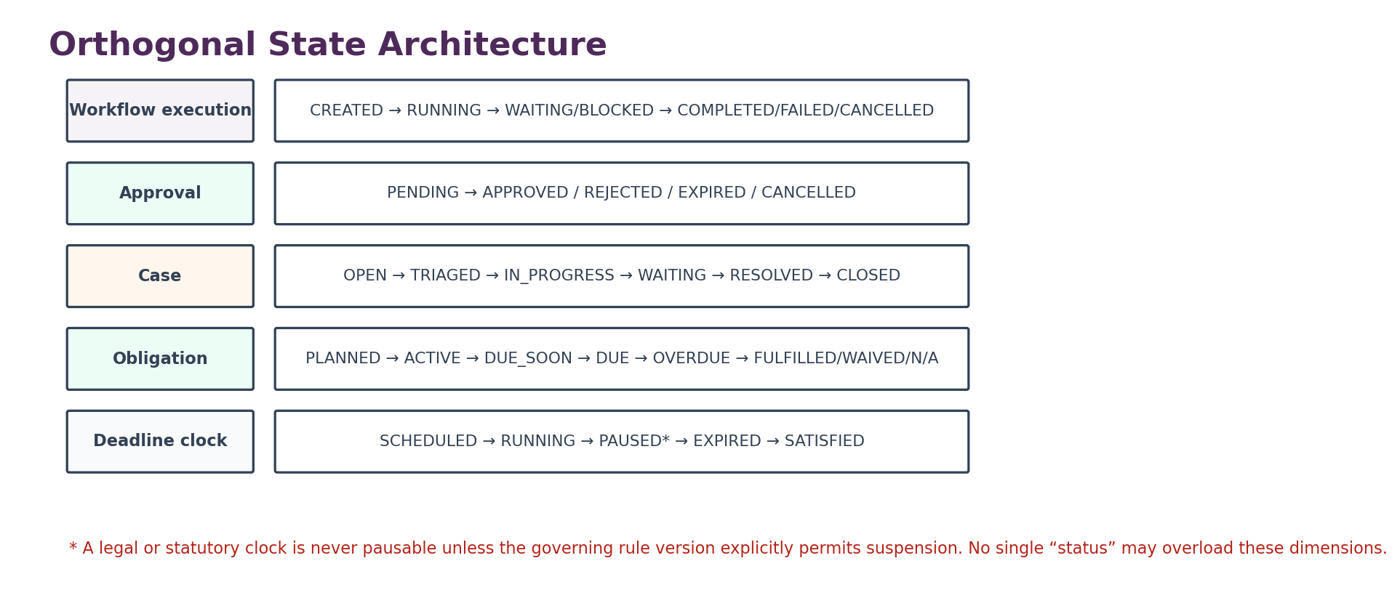
Figure 2 — Orthogonal state architecture

3. WFC-01 — Process Definition & Version Registry

3.1 Purpose
WFC-01 is the only production authority for reusable workflow definitions. Definitions describe orchestration; they do not contain arbitrary executable business code. A process version is a signed, immutable contract that names step types, registered actions, inputs, outputs, retries, timers, approval gates, compensation behavior, events, evidence requirements and compatibility constraints.

3.2 Definition lifecycle
State | Meaning | Allowed next states | Production effect
DRAFT | Editable, incomplete definition. | VALIDATION_PENDING, RETIRED | Cannot create production instances.
VALIDATION_PENDING | Static validation, graph, contract and policy checks executing. | VALIDATED, DRAFT | No production use.
VALIDATED | Technically valid but not yet approved. | APPROVAL_PENDING, DRAFT | No production use.
APPROVAL_PENDING | Maker-checker and control owners reviewing. | PUBLISHED, REJECTED | No production use.
PUBLISHED | May start new instances inside effective window. | SUPERSEDED, SUSPENDED | Existing instances remain bound.
SUSPENDED | New starts blocked due to incident/control issue. | PUBLISHED, SUPERSEDED, RETIRED | Running-instance disposition is explicit.
SUPERSEDED | New version replaces it for future starts. | RETIRED | Historic/running references remain valid.
RETIRED | No new starts; retained for replay and evidence. | None | Never deleted while referenced.

3.3 Required definition contract
Field family | Minimum content
Identity | process_definition_id, process_version_id, semantic version, domain, tenant scope model, owner, status.
Activation | effective_from, effective_to, jurisdiction scopes, feature flag, minimum service versions.
Graph | step_id, type, predecessor/successor, branches, join semantics, terminal states, loop bounds.
Action contract | registered_action_id, input schema, output schema, timeout, retry class, idempotency mode, unknown-outcome resolver.
Human work | work item type, queue, assignment policy, completion schema, escalation policy.
Approval | approval policy id/version, material-context hash inputs, expiry, quorum, independence rules.
Timers | timer type, timezone semantics, persistence, cancellation behavior.
Compensation | compensating action, preconditions, order, max attempts, escalation path.
Evidence | required audit event names, evidence refs, completion evidence schema.
Data controls | data class, retention class, residency compatibility, fields prohibited from workflow payload.
Observability | SLO class, business correlation tags, alert thresholds, stuck-instance threshold.
Compatibility | allowed predecessor versions, migration path, event schema versions, deprecation constraints.

3.4 Validation gates
- Graph has at least one reachable terminal state and no unbounded loop.
- Every external action exists in the service action registry and declares idempotency + timeout semantics.
- Every branch condition is deterministic and policy-safe; no arbitrary code, network call or secret access.
- Every approval gate names a valid policy and stale-approval invalidation rule.
- Every deadline/timer declares a clock class and timezone semantics.
- Every compensation path is ordered and its non-compensable effects are identified.
- All emitted events exist in the canonical event catalogue.
- Cross-region calls, restricted data and tenant scope pass architecture policy checks.

4. WFC-02 — Workflow Execution & Work Item Orchestrator
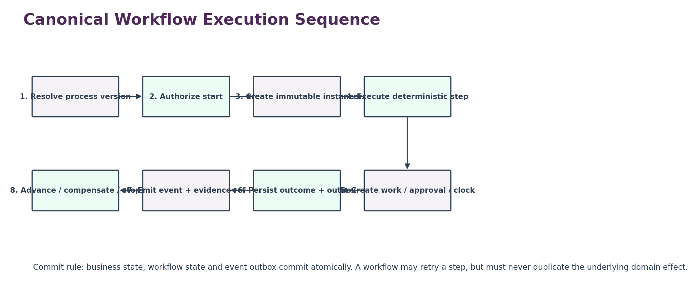
Figure 3 — Canonical workflow execution sequence

4.1 Workflow instance lifecycle
State | Definition | Examples of allowed transitions
CREATED | Durable instance exists; execution has not started. | RUNNING, CANCELLED
RUNNING | A step may execute or be scheduled. | WAITING, BLOCKED, COMPENSATING, COMPLETED, FAILED, CANCELLED
WAITING | Waiting for human work, approval, timer or external callback. | RUNNING, BLOCKED, CANCELLED
BLOCKED | Cannot proceed due to unresolved control/dependency condition. | RUNNING, COMPENSATING, FAILED, CANCELLED
COMPENSATING | Executing defined compensating actions. | FAILED, CANCELLED, COMPLETED_WITH_COMPENSATION
COMPLETED | All terminal conditions satisfied. | None
COMPLETED_WITH_COMPENSATION | Final approved outcome reached after compensation path. | None
FAILED | Terminal failure after retry/compensation policy. | Manual retry only through new governed operation
CANCELLED | Cancellation completed under process rules. | None

4.2 Work item contract
Property | Requirement
Assignment | Queue, role, skill, tenant, jurisdiction, workload and conflict rules; explicit unassigned state.
Claiming | Optimistic concurrency; one current assignee unless collaborative mode is defined.
Due time | Internal SLA or inherited obligation warning; does not alter legal due_at.
Completion | Typed completion schema; free text alone cannot satisfy structured control evidence where required.
Reassignment | Reason, actor, previous/new owner and timing event required.
Delegation | Time-bounded and scope-specific; delegated actor must still satisfy authorization and SoD checks.
Escalation | Can change queue/priority/owner but cannot silently complete or waive the underlying work.
Cancellation | Only when parent workflow permits; already-submitted decisions remain evidence.
Bulk actions | Restricted to explicitly bulk-safe work types; per-item authorization and result evidence required.

4.3 Atomicity and outbox
Commit pattern
For state owned by WFC-02, the new workflow state, step result, idempotency record and outbox event must commit in one transaction. Event publication may retry independently. Consumers must accept duplicate delivery and deduplicate by event_id/idempotency key.

4.4 Stuck-instance recovery
- Every non-terminal instance has next_action_at or an explicit external wait condition.
- A reconciler detects instances beyond threshold with no eligible worker claim, callback, timer or dependency resolution.
- Recovery first resolves current/unknown actions before deciding to retry.
- Manual repair uses an operator command API with reason + evidence; direct database edits are prohibited.
- Recovery never changes process_version_id or historical step results silently.

5. WFC-03 — Approval & Segregation-of-Duties Service
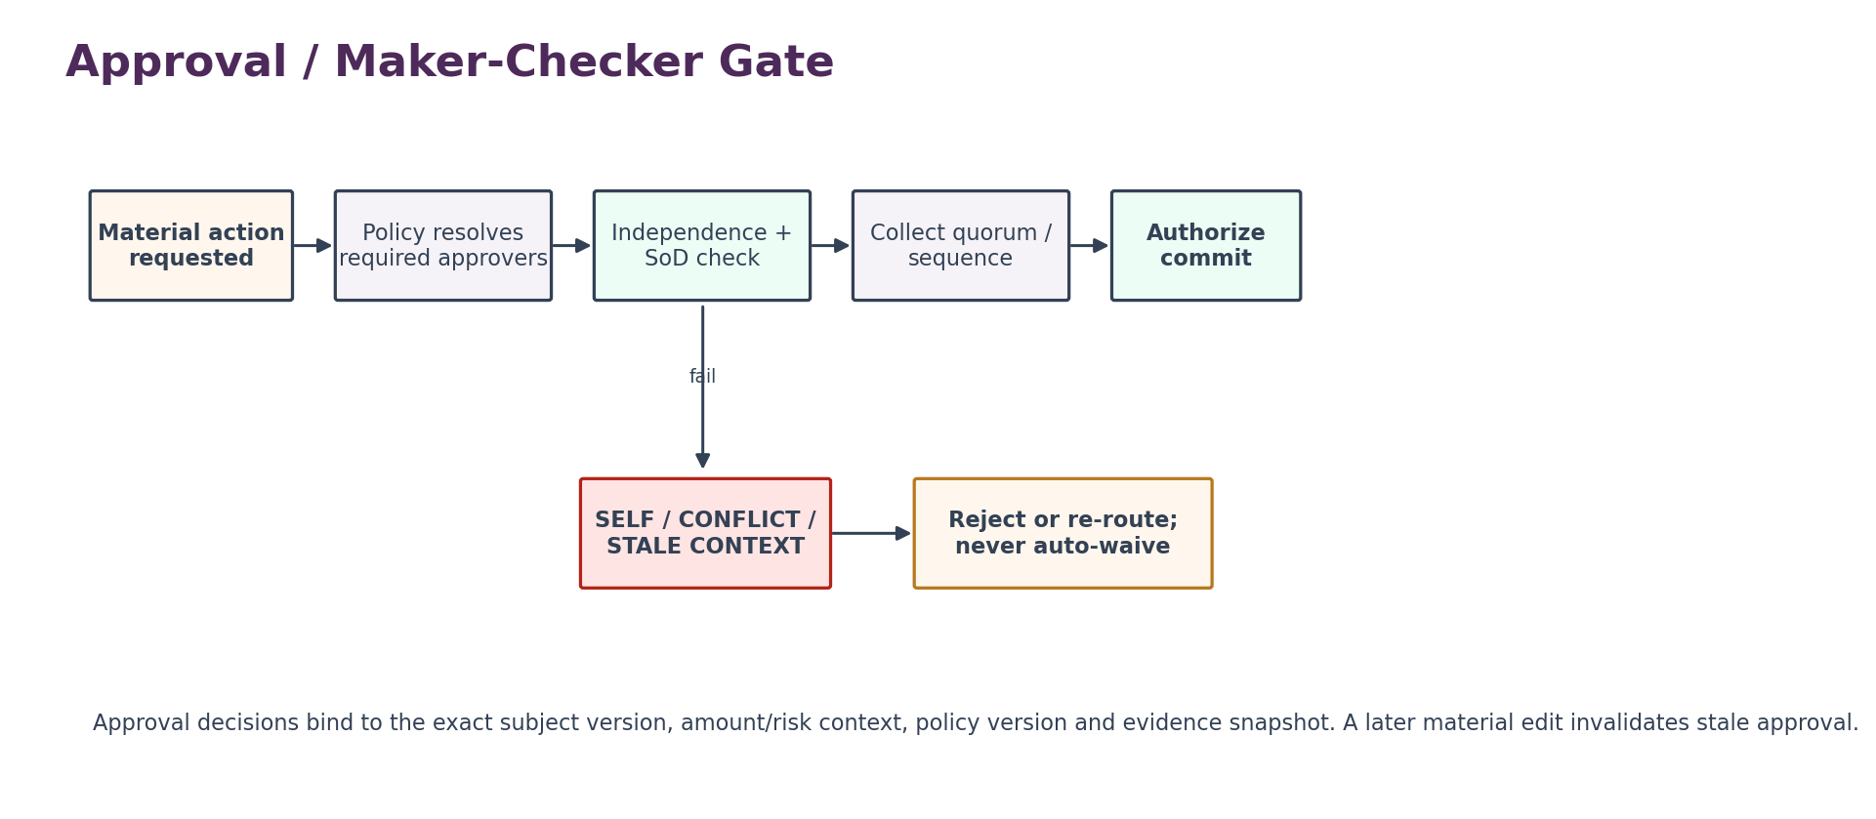
Figure 4 — Approval / maker-checker gate

5.1 Approval dimensions
Dimension | Examples | Control rule
Subject | Journal posting, payroll approval, termination, tax filing, contract execution, policy change, user privilege change. | Approval names exact subject_type and subject_id.
Material context | Amount, currency, employee population, jurisdiction, legal entity, risk class, document hash, period. | Context fields included in approval_context_hash.
Approver requirement | Named role, named person, independent role, quorum, sequential chain, external signatory. | Policy returns requirements; service evaluates current candidates.
Independence | Requester ≠ approver, preparer ≠ reviewer, conflicting reporting line, shared service-account restrictions. | Relationship/SoD check before decision acceptance.
Expiry | Absolute deadline, elapsed duration, subject change, period close, policy change. | Expired/stale decision cannot authorize commit.
Decision | APPROVE, REJECT, REQUEST_CHANGES, ABSTAIN where enabled. | Decision schema fixed by approval type; no hidden “soft approval.”

5.2 Approval lifecycle
State | Meaning | Terminal?
PENDING | Awaiting eligible decisions. | No
PARTIALLY_APPROVED | Some required approvals collected; quorum/sequence incomplete. | No
APPROVED | Required approvals complete for current subject context. | Yes for decision collection; consumable until expiry/material change
REJECTED | Required policy treats a rejection as terminal. | Yes
CHANGES_REQUESTED | Subject must change and be resubmitted under new context hash. | Yes
EXPIRED | Time/policy/subject condition expired approval. | Yes
CANCELLED | Parent action withdrawn before consumption. | Yes

5.3 Material edit invalidation
Each approval type declares material_edit_fields and material_edit_rules. The service stores the approved context hash. When the subject changes, the domain service submits a change descriptor. If any material field changed, the approval becomes stale and a new approval request is required. Cosmetic metadata may remain non-material only when the approval policy explicitly permits it.

5.4 Emergency approval
- Emergency paths cannot widen the actor’s base authorization; they may only bypass a timing or quorum condition expressly designated for emergency use.
- Emergency authorization has start/end time, reason code, incident/case reference, scope and maximum impact.
- Every use generates a mandatory post-action review work item and cannot be self-reviewed.
- A tenant cannot configure emergency mode for HARD_LEGAL, security-root, money movement or other protected controls unless the controlling policy explicitly permits it.

6. WFC-04 — Case & Exception Management Service

6.1 Purpose
WFC-04 provides a durable cross-domain container for matters that require investigation, collaboration, human judgment, evidence gathering or exception resolution. It is not a CRM and does not replace domain records. The case points to authoritative domain objects and evidence rather than copying them into an uncontrolled notes store.

6.2 Case types
Case family | Representative examples | Required separation
Financial exception | Reconciliation break, posting mismatch, payment ambiguity, close exception. | Case resolution does not directly mutate ledger/bank/invoice state.
Payroll / HR | Payroll variance, employee data exception, leave/pay conflict, offboarding exception. | HR/payroll records remain domain authoritative; sensitive access is case-scoped.
Legal / compliance | Contract exception, regulatory request, filing exception, policy breach. | Legal privilege/confidentiality labels and restricted membership may apply.
Security / privacy | Access anomaly, DSR exception, incident follow-up. | Security incident system may be controlling source; case links rather than duplicates forensic evidence.
Operational | Integration failure, stuck workflow, manual repair request. | Operations can repair coordination state only through governed commands.

6.3 Case lifecycle
State | Control meaning
OPEN | Case created with type, source, tenant, scope and initial severity.
TRIAGED | Owner, severity, confidentiality, jurisdiction and target resolution policy confirmed.
IN_PROGRESS | Active investigation or remediation.
WAITING_INTERNAL | Blocked on internal work/approval/evidence.
WAITING_EXTERNAL | Blocked on customer, regulator, provider or other external party.
RESOLVED | Resolution recorded with outcome code and evidence; closure checks pending.
CLOSED | Closure gate passed; no active mandatory work remains.
REOPENED | Controlled transition creates new reopen event/reason and re-establishes active ownership.

6.4 Case integrity controls
- Case notes are additive and versioned; edits preserve prior versions where material.
- Case merge creates canonical_case_id and preserves aliases/source lineage.
- Case split preserves source-case relationship and evidence scope.
- Legal privilege / restricted confidentiality labels drive access and export policy; UI labels alone are not enforcement.
- Closure requires all mandatory child work items and control obligations satisfied, waived or transferred through approved rules.
- Case severity does not alter the legal due date; escalation may accelerate internal work only.

7. WFC-05 — Obligation, Deadline & Escalation Service
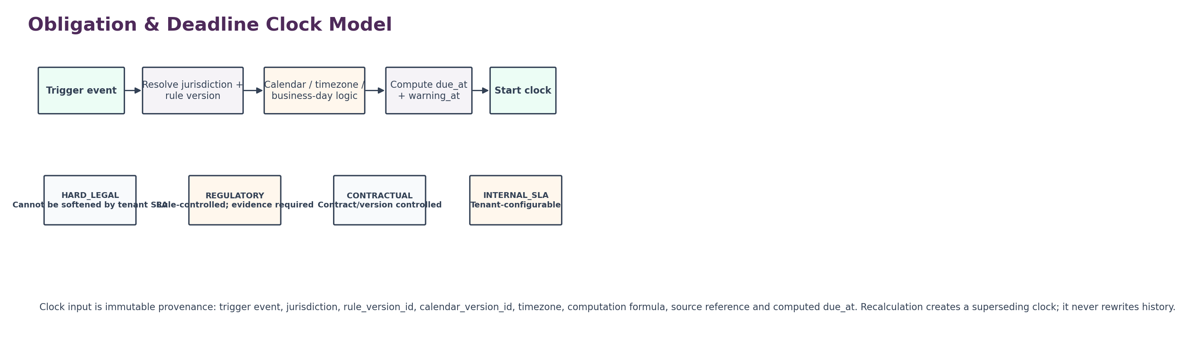
Figure 5 — Obligation & deadline clock model

7.1 Obligation model
Element | Requirement
Obligation definition | Stable obligation type and owner; versioned trigger, scope, due-date formula, evidence and satisfaction rules.
Obligation instance | Created from a qualified trigger event for a specific subject/entity/jurisdiction.
Clock class | HARD_LEGAL, REGULATORY, CONTRACTUAL, INTERNAL_SLA, ADVISORY.
Trigger evidence | event_id + event_time + source object/version; backdated corrections cannot erase original trigger.
Computation | Rule version, timezone, calendar version, business-day convention, offsets and rounding.
Warning schedule | Independent from due_at; multiple warning/escalation milestones allowed.
Satisfaction | Evidence type(s), domain confirmation, actor/service, satisfied_at, subject state.
Waiver / not applicable | Requires policy authority, reason code, approver and evidence; cannot be a hidden admin toggle.
Supersession | Recalculation/new governing rule creates successor link; old due date remains reconstructable.

7.2 Deadline lifecycle and lateness
State | Meaning | Key rule
PLANNED | Known future obligation, trigger not yet active where model permits. | Cannot be treated as fulfilled.
ACTIVE | Trigger occurred and clock exists. | Authoritative due_at fixed for current clock version.
DUE_SOON | Warning threshold reached. | Escalate internal action; due_at unchanged.
DUE | Due point reached. | No grace implied unless rule version defines it.
OVERDUE | Current time > due_at and not satisfied/waived/N/A. | Scheduler delay cannot suppress this computed state.
FULFILLED | Satisfaction evidence accepted. | Must preserve fulfilled_at and evidence refs.
WAIVED | Authorized waiver applied. | Waiver authority/evidence mandatory.
NOT_APPLICABLE | Applicability resolved false under governing rule. | Decision evidence mandatory.
SUPERSEDED | A newer obligation/clock replaces this instance. | History retained.

7.3 Time semantics
- Persist canonical instants in UTC and persist the governing local timezone/locale semantics needed to reconstruct the result.
- Never compute statutory/legal deadlines from browser timezone.
- Ambiguous or nonexistent local times around DST transitions use a documented deterministic rule from the jurisdiction/calendar service; ambiguity is not guessed at runtime.
- Holiday/business-day calculations bind to calendar_version_id. A corrected holiday calendar can trigger governed recalculation, producing a superseding clock.
- If a source event is late-arriving, obligation creation uses business_event_time where the governing rule requires it and records detection/ingestion latency separately.

7.4 Escalation
Escalation policies may raise priority, add owners, page an operational team, open a case, request notifications or require an approval. Escalation never changes the obligation’s legal meaning and never counts as satisfaction.

8. Distributed Execution, Idempotency and Compensation
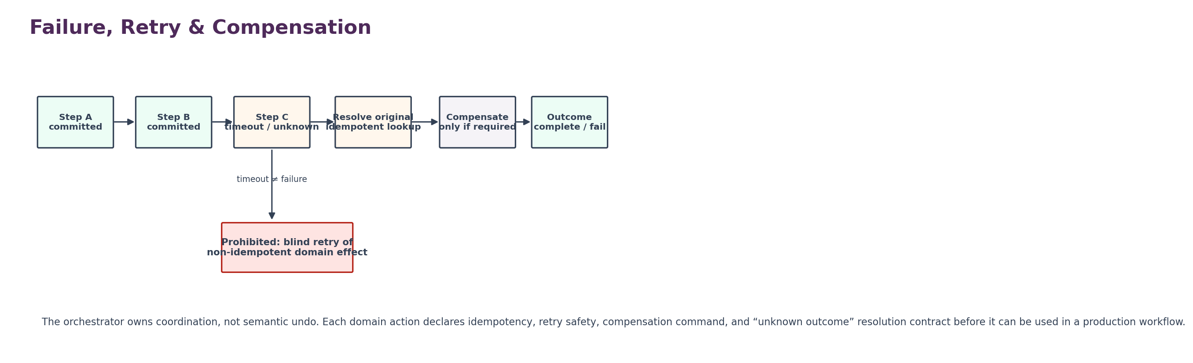
Figure 6 — Failure, retry and compensation model

8.1 Action contract classes
Class | Meaning | Retry behavior
PURE | No external mutation; deterministic calculation/read. | Safe retry subject to data-version rules.
IDEMPOTENT_MUTATION | Mutation accepts idempotency key and returns same semantic result for repeats. | Safe retry with original key.
QUERY_THEN_RESOLVE | Provider/domain may return timeout but supports lookup by attempt/reference. | Resolve original attempt before any retry.
NON_IDEMPOTENT_WITH_COMPENSATION | Mutation cannot be made fully idempotent but has controlled compensating action. | No blind retry; operator/compensation policy required.
NON_COMPENSABLE | Irreversible or legally significant action. | Single controlled submission + durable resolution; human escalation on unknown.

8.2 Saga / compensation rules
- Compensation order is explicitly declared and generally reverses dependent effects in reverse commitment order unless domain semantics require otherwise.
- Compensation itself is a new action with its own idempotency key, authorization and evidence.
- The orchestrator does not assume “refund,” “reverse,” “delete” or “unfile” semantics; each domain publishes a valid compensating command if one exists.
- Partial compensation produces a distinct terminal state and opens an exception case when required.
- A workflow cannot mark COMPLETED merely because compensation succeeded; terminal outcome must match process policy.

8.3 Concurrency
- Each workflow instance uses versioned optimistic concurrency or equivalent serialization at state transition boundaries.
- Work item claim and approval decision acceptance reject stale row/version tokens.
- Parallel branches use explicit join semantics: ALL, ANY, QUORUM or policy-driven; default is not inferred.
- Duplicate callbacks are deduplicated by callback_id/source event ID and instance correlation.

9. Canonical Data Model
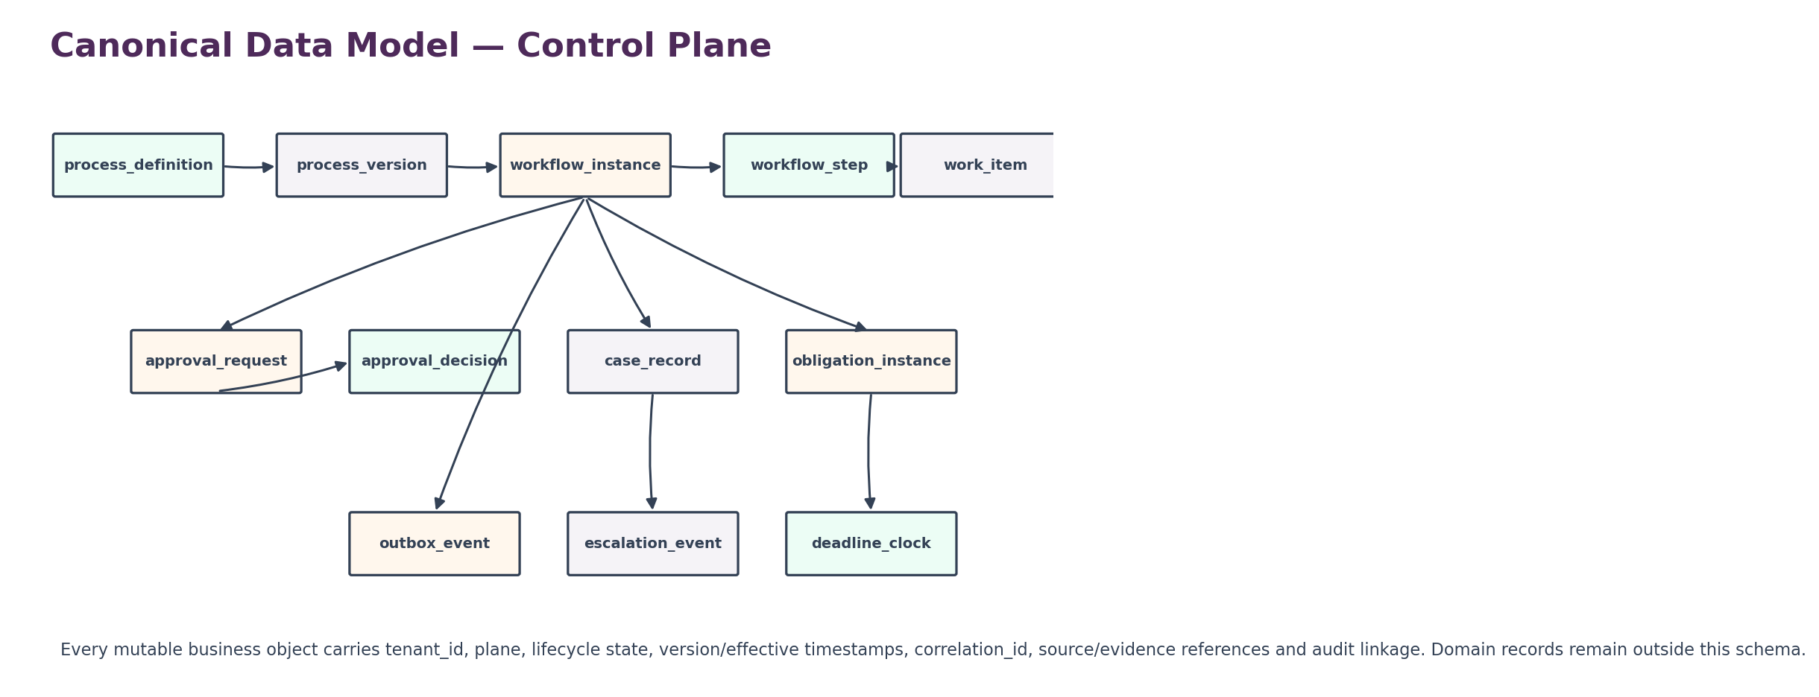
Figure 7 — Canonical control-plane data model
Entity | Minimum purpose
process_definition | Stable identity, owner, domain, tenant applicability, lifecycle.
process_version | Immutable graph/spec, semantic version, effective window, checksum/signature, publication evidence.
workflow_instance | tenant_id, plane, process_version_id, subject refs, state, correlation_id, start/end timestamps.
workflow_step | instance_id, step_id, attempt, state, input/output hashes, action refs, timing, error class.
work_item | type, queue, assignee, due_at, claim token, completion payload/version.
approval_request | subject/version/context hash, policy version, required approvers/quorum, expiry.
approval_decision | approver, role snapshot, independence result, decision, reason/evidence, timestamp.
case_record | case type, severity, confidentiality, owner/team, lifecycle, canonical/merge refs.
case_note | versioned additive narrative/structured entry with author, visibility, evidence refs.
obligation_definition | versioned applicability, trigger, due-date formula, evidence/satisfaction rules.
obligation_instance | subject, jurisdiction, trigger refs, state, current_clock_id, evidence status.
deadline_clock | clock class, rule/calendar versions, timezone, computed due_at, warnings, supersedes_id.
escalation_policy | versioned milestones, destinations, actions, severity transforms.
escalation_event | clock/case/work ref, milestone, action request/result, evidence refs.
idempotency_record | action scope, key, request hash, outcome state, resolved result ref, expiry.
outbox_event | event_id, event name/schema version, aggregate ref, payload hash, publish state.

9.1 Common columns
All tenant-scoped mutable records require tenant_id, plane, created_at, updated_at, row_version, correlation_id, data_class, residency_region and created_by/updated_by service or actor references where applicable. Terminal/historic records retain immutable version references needed for replay. Soft deletion is not a substitute for lifecycle state.

9.2 Plane model
Plane | Examples | Isolation requirement
TENANT_BUSINESS | Tenant payroll approval, journal review, HR case, legal obligation. | Bound to tenant_id; platform staff require explicit support/break-glass route.
PLATFORM_COMMERCIAL | ZoikoSuite subscription commercial exception or dunning workflow. | May coordinate COM services but cannot read/write tenant business ledgers.
PLATFORM_CONTROL | Security, release, provider, configuration or operational governance. | GLOBAL_CONTROL scope with restricted admin authorization; never masquerades as tenant action.

10. API and Event Contracts
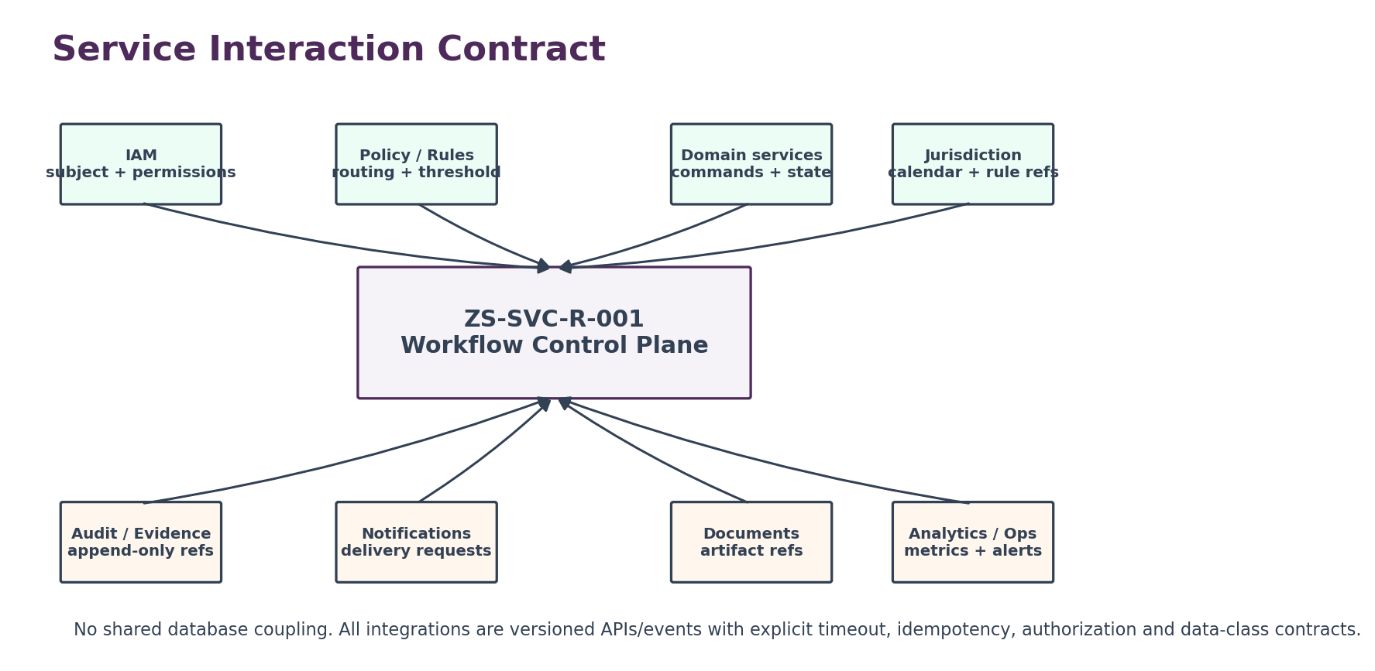
Figure 8 — Service interaction contract

10.1 Representative command APIs
Method / path | Purpose | Critical controls
POST /v1/workflows | Start governed workflow instance. | tenant + plane, process version resolution, start authorization, idempotency key.
GET /v1/workflows/{id} | Read instance and step summary. | tenant scope, field-level visibility, no hidden evidence leakage.
POST /v1/workflows/{id}/commands/cancel | Request cancellation. | process cancellation policy, actor authorization, committed-effect analysis.
POST /v1/work-items/{id}/claim | Claim human work item. | eligibility, queue, concurrency token.
POST /v1/work-items/{id}/complete | Complete typed work item. | completion schema, actor/SoD, optimistic concurrency.
POST /v1/approvals | Create approval request. | subject context hash, policy version, idempotency.
POST /v1/approvals/{id}/decisions | Submit approval decision. | authorization + independence + stale-context check.
POST /v1/cases | Open case. | type/scope authorization, duplicate/merge hint, confidentiality.
POST /v1/cases/{id}/resolve | Record resolution. | required child work/evidence gate.
POST /v1/obligations/evaluate | Create/evaluate obligation from trigger. | rule/jurisdiction/calendar versions, event provenance.
POST /v1/obligations/{id}/satisfy | Submit fulfillment evidence. | evidence policy, subject state, idempotency.
POST /v1/operator-actions/{id} | Governed repair/retry/reconcile command. | privileged role, reason, scope, evidence, four-eyes where required.

10.2 Event families
Family | Representative events
Definition | process_version_published, process_version_suspended, process_version_superseded
Execution | workflow_started, workflow_step_started, workflow_step_waiting, workflow_step_failed, workflow_completed, workflow_cancelled
Work | work_item_created, work_item_claimed, work_item_reassigned, work_item_completed, work_item_overdue
Approval | approval_requested, approval_decision_recorded, self_approval_blocked, approval_stale_invalidated, approval_expired
Case | case_opened, case_triaged, case_waiting, case_resolved, case_closed, case_reopened, case_merged
Obligation | obligation_created, deadline_clock_started, obligation_due_soon, obligation_due, obligation_overdue, obligation_fulfilled, obligation_waived
Recovery | action_outcome_unknown, original_attempt_resolved, compensation_started, compensation_failed, stuck_workflow_detected
Security/control | cross_tenant_reference_blocked, unauthorized_operator_action_blocked, break_glass_action_invoked

10.3 Event envelope minimum
event_id, event_name, payload_schema_version, event_time, emitted_at, emitting_service, tenant_id or GLOBAL_CONTROL, plane, actor/service identity, subject type/id/version, workflow_instance_id where applicable, correlation_id, causation_id, process_version_id, policy/rule version refs, data_class, residency_region, evidence_ref(s), idempotency key/ref, and payload hash.

11. Security, Authorization and Data Protection Controls

11.1 Authorization model
- Every mutating command performs tenant/plane authorization before object lookup details are disclosed.
- Commercial entitlement is checked only where the feature is plan-gated; it never replaces IAM/domain permission.
- Object-level authorization includes tenant, legal entity/business unit, jurisdiction, confidentiality and case membership where applicable.
- Approver eligibility is evaluated at decision time, not frozen merely because the actor was eligible when request was created.
- Support/admin access uses time-bounded support session or break-glass mechanism and is visible in evidence.

11.2 Sensitive workflow payloads
The control plane stores the minimum orchestration context required to route and prove work. Full payroll files, legal documents, medical/benefit details, financial workpapers, contracts and accounting ledgers remain in their owning systems. Workflow payload schemas therefore use references, hashes and classification tags whenever full content is unnecessary.

11.3 Threat model
Threat | Control
Cross-tenant identifier substitution | Tenant-scoped object resolution, composite keys/partitioning, authorization before response, negative isolation tests.
Approval spoofing | Signed session/service identity, approver eligibility recheck, immutable decision evidence.
Self approval through delegation | Delegation relationship included in SoD graph; service account and shared inbox cannot satisfy independent-human requirement.
Replay of completion callback | Callback idempotency key + source signature + instance/step binding.
Workflow definition tampering | Immutable published versions, checksums/signatures, maker-checker publication, audit evidence.
Deadline manipulation | due_at only computed from approved rule/calendar versions; tenant edits create governed superseding records where allowed.
Operator repair abuse | Privileged command catalogue, reason/evidence, scoped effects, four-eyes for high-risk actions, all actions evented.
Notes data leakage | Structured data minimization, confidentiality labels, access filtering, export controls, retention policy.

11.4 Data retention and legal hold
Retention is inherited from controlling records and evidence policy. Legal hold can freeze deletion/archival but does not freeze operational case/workflow progress unless a separate policy requires it. Retention expiration must not remove process definitions, approval decisions, deadline computations or evidence links required to reconstruct a still-retained domain outcome.

12. Observability, SLOs and Operational Control
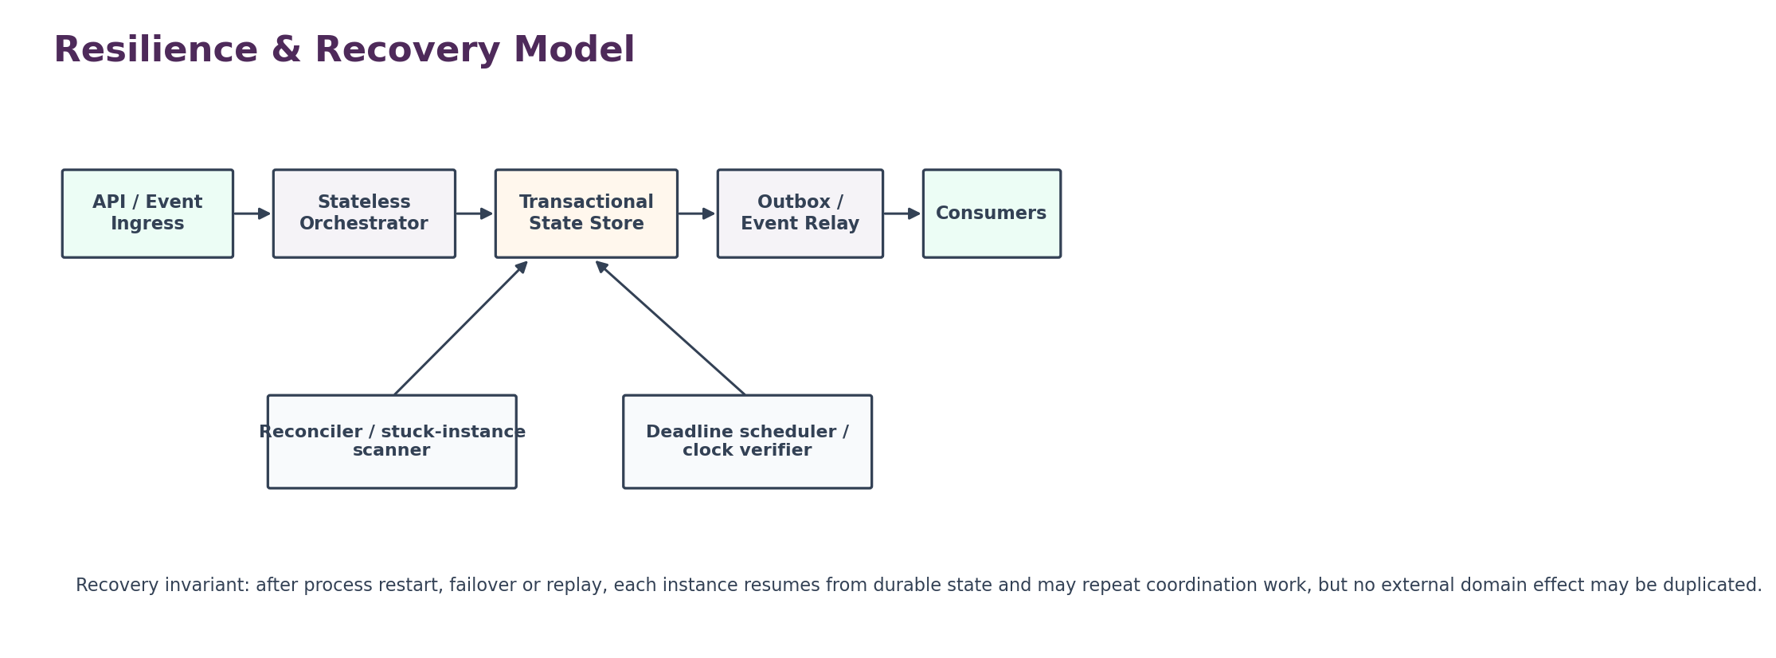
Figure 9 — Resilience and recovery model

12.1 Minimum service indicators
Signal | Measure | Why it matters
Start acceptance | p50/p95/p99 workflow start API latency and error rate. | User/API responsiveness; not a completion metric.
Runnable-to-claimed delay | Time eligible step waits for worker. | Detect worker starvation and queue backlogs.
Timer accuracy | Difference between scheduled_at and picked_at / deadline transition time. | Critical for SLA and legal-clock operational confidence.
Unknown action count | Number/age of unresolved external attempts. | Prevents duplicate-effect pressure and hidden ambiguity.
Stuck workflows | Instances beyond next_action threshold by reason. | Operational recovery backlog.
Approval aging | Pending approvals by age/risk/expiry. | Control bottleneck visibility.
Overdue obligations | Count and age by clock class/jurisdiction/owner. | Compliance operations visibility.
Compensation failures | Compensations requiring manual resolution. | Signals partial business effects.
Cross-tenant blocks | Denied cross-tenant/object-reference attempts. | Security anomaly detection.
Definition drift | Running instance counts by old/suspended/superseded version. | Migration and technical debt control.

12.2 Numeric targets
No invented SLOs
This specification defines the metric families and blocking failure classes. Numeric p95/p99, worker-lag, timer-accuracy, RTO/RPO and backlog thresholds must be ratified in the platform SLO register before production launch. An unapproved number must not be presented as a production commitment.

12.3 Alert priorities
Priority | Representative trigger
P0 | Cross-tenant workflow execution, duplicated protected domain effect, deadline engine systemic corruption, lost approval/evidence integrity.
P1 | Material deadline scheduler outage, large stuck-workflow backlog, approval service unavailable for protected workflows, repeated unknown high-risk actions.
P2 | Localized queue backlog, notification dependency degradation with durable work intact, elevated retries with no duplicated outcomes.
P3 | Non-material latency or UI/read-model lag with authoritative state healthy.

13. Negative-Path Certification Matrix
ID | Scenario | Expected result
NP-01 | Duplicate start request with same idempotency key | One workflow instance; same semantic response.
NP-02 | Duplicate start with same key but different payload hash | Reject conflict; do not create second instance.
NP-03 | Worker crashes after domain commit before orchestration acknowledgement | Resolve original action; no duplicate commit.
NP-04 | External domain timeout | Set UNKNOWN; lookup original attempt before retry.
NP-05 | Approval submitted by requester where SoD applies | Reject and emit self_approval_blocked.
NP-06 | Approver loses role before decision | Recheck eligibility; reject decision.
NP-07 | Subject amount changes after first approval | Invalidate stale approval where material; require new decision.
NP-08 | Approval expires one second before commit | Commit blocked; reacquire approval.
NP-09 | Parallel approvers submit simultaneously | Concurrency-safe quorum; no double counting.
NP-10 | Case close attempted with open mandatory child task | Block closure.
NP-11 | Case merge across tenants | Reject; security event.
NP-12 | Obligation trigger arrives late | Compute from governing business event time when rule requires; record latency.
NP-13 | DST nonexistent local time | Use deterministic calendar/timezone rule; no silent guess.
NP-14 | Holiday calendar corrected after clock creation | Governed recalculation creates successor; historical clock retained.
NP-15 | Tenant changes internal SLA on HARD_LEGAL clock | No effect on statutory due_at.
NP-16 | Scheduler offline past due time | On recovery, authoritative clock reads OVERDUE; no due-date shift.
NP-17 | Fulfillment attempted without required evidence | Reject satisfaction.
NP-18 | Waiver attempted by unauthorized admin | Reject; evidence event.
NP-19 | Compensation command times out | Resolve original compensation attempt; do not duplicate.
NP-20 | Cancellation requested after irreversible step | Apply defined policy: block/partial cancel/exception; never pretend full rollback.
NP-21 | Process definition references unregistered action | Publication validation fails.
NP-22 | Process version suspended while instances run | New starts blocked; running disposition follows suspension policy.
NP-23 | Replay uses current calendar instead of original version | Certification fail.
NP-24 | Analytics consumer attempts state mutation | Authorization/API boundary blocks.
NP-25 | Notification failure | Workflow/obligation state remains correct; delivery retries independently.
NP-26 | Audit ledger temporarily unavailable | Apply defined fail-closed/degraded policy by event class; never silently drop mandatory evidence.
NP-27 | Cross-region action violates residency policy | Block before payload transfer; case/escalation as configured.
NP-28 | Bulk completion includes one unauthorized item | Per-item authorization; unauthorized item fails without over-broad success.
NP-29 | Delegated approver is conflict-related to requester | Independence check rejects.
NP-30 | Operator manually patches DB to close stuck workflow | Operational procedure fails certification; governed repair API required.
NP-31 | Concurrent reopen and close requests | Version check serializes; one wins, loser receives conflict.
NP-32 | Clock recalculation changes due date | Old and new clock versions both reconstructable with reason/evidence.
NP-33 | Unknown workflow callback references wrong step | Reject binding mismatch.
NP-34 | Case note contains prohibited restricted payload field | Schema/classification validation rejects or redacts per policy.
NP-35 | Approval policy changes while request pending | Apply declared version/invalidating rule; never silently reinterpret.
NP-36 | Instance migration changes step semantics mid-flight | Requires governed migration with compatibility proof/evidence; otherwise reject.
NP-37 | Service restart during timer firing | At-least-once pickup but exactly-once semantic transition via durable guard.
NP-38 | Obligation satisfied after overdue | Record both overdue period and later fulfillment; history not erased.
NP-39 | Reassignment hides prior owner | Fail; assignment history must remain evidence.
NP-40 | Case resolution attempts to directly write domain object | Architecture boundary violation; only domain command API allowed.

14. Domain Adoption Patterns

14.1 Accounting / finance
Pattern | Control-plane use | Domain authority retained
Journal approval | Prepare → risk/threshold rule → independent approval → post command. | Journal engine owns journal validity, period rules and ledger posting.
Period close task | Workflow coordinates checklist, evidence and dependencies. | Close engine/general ledger owns period state.
Reconciliation exception | Case + work items + escalation. | Reconciliation service owns matching and balance result.
Payment ambiguity | UNKNOWN action resolution + case if unresolved. | Payment/bank service owns payment state.

14.2 Payroll / HR
Pattern | Control-plane use | Domain authority retained
Payroll run | Prepare → variance review → approvals → submit/commit → reconciliation. | Payroll engine owns calculations, statutory deductions and payroll ledger.
Employee offboarding | Workflow coordinates approvals, access removal, payroll/final pay and documents. | HR, IAM, payroll and document services each own their records.
Leave exception | Case/workflow coordinates review and evidence. | HR/leave service owns entitlement and balance.
Sensitive HR case | Restricted case membership + work items + evidence refs. | HR case content/documents remain in controlled domain stores as defined.

14.3 Legal / compliance
Pattern | Control-plane use | Domain authority retained
Contract approval | Approval chain tied to document/version hash and legal entity. | Contract/document service owns content/signature state.
Regulatory obligation | Trigger → deadline clock → work → evidence → fulfill. | Jurisdiction/rules service owns governing rule; filing service owns submission.
Policy exception | Case + approval + expiry/renewal clock. | Policy service owns policy text and exception authority.
Legal hold workflow | Coordinate hold request, approvals and downstream commands. | Records/evidence services own hold enforcement on their data.

Adoption rule: Domains integrate through registered action contracts and references. They do not copy their core records into the workflow database to make orchestration convenient.

15. Implementation Sequence and Engineering Handoff
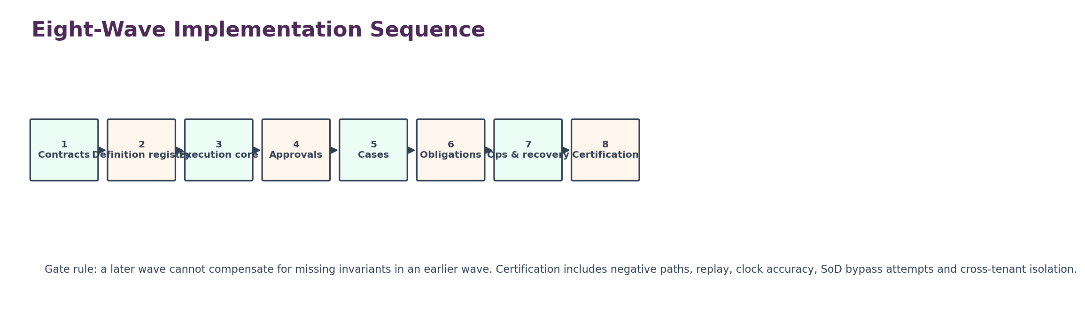
Figure 10 — Eight-wave implementation sequence
Wave | Deliverable | Exit gate
1 | Canonical action/event contracts; idempotency classes; tenant/plane model. | No unresolved authority boundary or external-action semantics.
2 | WFC-01 definition/version registry and publication validation. | Immutable published version + rollback/suspension path proven.
3 | WFC-02 durable execution core, work items, outbox and reconciler. | Crash/restart/replay tests show no duplicated domain effects.
4 | WFC-03 approvals, SoD graph, quorum, expiry and material-change invalidation. | Self-approval/stale-approval negative suite passes.
5 | WFC-04 cases, assignment, confidentiality, merge/split/reopen/closure controls. | Case integrity + cross-tenant tests pass.
6 | WFC-05 obligations, versioned clocks, calendar/timezone integration, escalation. | Clock accuracy and scheduler-outage recovery pass.
7 | Operational tooling: stuck-instance console, governed repair commands, metrics, alerts, runbooks. | No direct DB operational dependency.
8 | Cross-domain certification with Accounting, Payroll/HR and Legal/Compliance reference workflows. | Definition of Done, security, recovery, a11y/admin UI and release evidence complete.

15.1 Definition of Ready
- Service ownership and on-call ownership named.
- Canonical event/action registry available and versioned.
- IAM/object authorization contracts available.
- Audit/evidence event contract available.
- Jurisdiction/calendar version service available for WFC-05 or a controlled stub with production block.
- Domain reference workflows selected for certification.
- Data classification/residency requirements approved.
- Numeric SLO register owners named; provisional targets clearly labeled until ratified.

15.2 Definition of Done
- All 30 invariants implemented as automated tests or enforceable runtime controls.
- All 40 negative-path scenarios pass in CI/certification environment.
- Cross-tenant isolation tests pass at API, worker, persistence, callback and recovery layers.
- Crash/restart/failover tests prove durable resume and no duplicate protected effects.
- Approval stale-context, SoD and delegation tests pass.
- Deadline clock tests cover timezone, DST, holiday-version change, late events and scheduler outage.
- Operator repair actions are governed, evidence-linked and role-limited; no runbook requires direct production DB mutation.
- Reference workflows from accounting, payroll/HR and legal/compliance pass end-to-end.
- Observability dashboards, alert routes and incident runbooks are exercised.
- Production release has architecture, security, Legal/Compliance, QA and SRE sign-off.

16. Open Decisions Register
ID | Decision | Owner | Required before
R-OD-01 | Final technology choice for orchestration runtime / durable execution engine. | CTO + Chief Architect | WFC-02 implementation
R-OD-02 | Canonical policy/rules interface for approval routing and material-edit classification. | Chief Architect + Legal/Compliance + Product | WFC-03 beta
R-OD-03 | Relationship graph source for segregation-of-duties and conflict checks. | IAM Lead + HR Architecture + Security | WFC-03 beta
R-OD-04 | Jurisdiction/calendar service interface and approved timezone/holiday source hierarchy. | Legal/Compliance + Platform Architecture | WFC-05 beta
R-OD-05 | Clock classes permitted to pause/suspend and exact pause semantics. | Legal/Compliance + Domain Owners | WFC-05 production
R-OD-06 | Required evidence classes for obligation satisfaction by domain/jurisdiction. | Legal/Compliance + Data Governance + Domain Leads | First regulated workflow
R-OD-07 | Case confidentiality taxonomy and restricted-case membership model. | Legal/Compliance + HR + Security | WFC-04 production
R-OD-08 | Definition of material subject change per approval family. | Domain Owners + Legal/Compliance + Finance | Each approval type activation
R-OD-09 | Numeric SLO/RTO/RPO and timer-accuracy targets. | SRE + CTO + Product | Production readiness
R-OD-10 | Maximum workflow-instance retention and archive strategy by record class. | Data Governance + Legal/Compliance | Production data policy
R-OD-11 | Support/break-glass operator command approval thresholds. | Security + SRE + Legal/Compliance | Operations launch
R-OD-12 | Cross-region execution policy for workflows referencing multi-region domain objects. | Security + Privacy + Chief Architect | Multi-region launch

17. Final Build Doctrine
Final doctrine
ZS-SVC-R-001 is build-ready only when ZoikoSuite can prove that every material cross-domain workflow uses a known immutable process version; every action has explicit retry/idempotency semantics; every approval is current, authorized and independent where required; every case preserves controlled lifecycle and evidence; every obligation has reconstructable jurisdiction/time computation; every deadline can survive worker/scheduler failure without being softened; every failure can resolve, compensate or escalate without duplicating protected business effects; and every transition remains tenant-isolated, evidence-linked and operationally recoverable.

This control plane is not the authority for the business outcome. Its purpose is to make the route to that outcome deterministic, governable, recoverable and provable across a global multi-domain SaaS estate.

17.1 Acceptance statement
Approve this specification only when Product, CTO, Architecture, Engineering, Security, Legal/Compliance, Finance, Accounting, Tax, Payroll, HR, Data Governance, QA, SRE and Support can implement WFC-01 through WFC-05 without guessing process version semantics, external action retry safety, approval independence, stale-approval behavior, case closure rules, deadline computation provenance, legal-clock precedence, compensation behavior, tenant isolation, operational repair controls, event contracts or release evidence.

17.2 Catalogue continuation rule
Do not continue the Services Requirements Catalogue mechanically. A subsequent pack should be produced only if it closes a remaining shared architectural dependency that cannot safely be owned inside an existing service family or domain platform.

Appendix A — Engineering Quick Reference
Concern | Canonical answer
Process logic | Immutable published process_version_id.
Business effect | Owning domain service only.
Retry after timeout | Resolve original attempt first.
Approval | Subject/version/context-bound; SoD evaluated at decision time.
Legal deadline | Versioned clock from jurisdiction/rule/calendar provenance.
Case | Durable investigation/exception container; no direct domain mutation.
Events | Transactional outbox; at-least-once delivery; consumers dedupe.
Replay | Original process/policy/rule/calendar versions.
Operator repair | Governed command API with reason, scope and evidence.
Tenant boundary | Enforced at API + persistence + worker/callback paths.
Entitlement | Commercial feature check only; never business authorization.
Audit | Evidence sink/ledger, not mutable workflow state.

