ZOIKOSUITE
DOCUMENT, RECORD, RETENTION &
LEGAL-HOLD CONTROL
Detailed Service Specifications
Version 1.0 — DRC-01 through DRC-05 Build-Ready Controlled Records Baseline
EXECUTIVE DOCTRINE
ZoikoSuite must preserve one provable content and records truth from creation through versioning, record declaration, retention, legal hold, preservation, signature, disclosure and lawful disposition. Domains may own the business meaning of a document, but they may not silently rewrite declared records, override retention or hold controls, replace signed artifacts, or create competing record lifecycles outside the canonical control plane.

Field | Value
Document ID | ZS-SVC-S-001
Version | 1.0 — Controlled Records Launch Baseline
Date | August 24, 2026
Status | Build-ready engineering specification; production activation remains subject to jurisdiction retention-rule approval, trust-provider validation, storage/security certification and formal go-live approval.
Owner | ZoikoSuite Platform Architecture / Data Governance / Legal & Compliance
Prepared for | Engineering, Product, Security, Privacy, Legal/Compliance, Finance, Accounting, Tax, Payroll, HR, Business Operations, SRE, QA, Support, Data Governance
Language | American English
Scope | Global, multi-tenant, multi-jurisdiction, multi-domain SaaS document and records control plane

0. Critical Analysis and Architecture Decision
The next shared dependency after workflow/approval control is not collaboration, search, OCR or another domain feature. It is controlled record truth. ZoikoSuite will hold accounting workpapers, tax filings, payroll outputs, employment records, contracts, legal matter evidence, compliance documents and corporate records whose evidentiary value depends on exact version identity, retention provenance, hold status and preservation integrity. If those semantics are implemented separately in each product, the platform cannot prove which bytes were authoritative, which retention rule applied, whether a record was under hold, or whether a signed artifact was later altered.
This specification therefore creates one provider-neutral control plane for document versions and records while preserving boundaries with IAM, workflow, audit evidence, policy/rules, notifications and domain ledgers. It is intentionally narrower than a generic enterprise content-management suite: only controls that are necessary to make ZoikoSuite records trustworthy, governable and globally deployable are included.
SELECTION DECISION
ZS-SVC-S-001 is necessary because every regulated ZoikoSuite domain needs the same answer to five questions: What exact content is this? Is it a record? How long must or may it be kept? Is any hold or disposition restriction active? Can its integrity and signature evidence be proved later?

0.1 Failure modes this specification prevents
Failure | Risk | Required correction
Silent replacement | An attachment path remains constant while underlying bytes change. | Every committed version is immutable and content-addressed; replacement creates a new version.
Record/document confusion | Working drafts are treated as formal records or declared records remain editable. | Document state and record state are separate; declaration captures an exact immutable version.
Hard-coded retention | Engineering embeds “7 years” or similar periods in code. | Retention schedules are versioned policy data with jurisdiction, basis and trigger metadata.
Naive longest-period rule | Conflicting legal requirements are resolved by retaining forever. | Rule conflicts use deterministic precedence and block for legal review when unresolved.
Hold bypass | Deletion/DSR workflow destroys evidence covered by a legal hold. | Hold overlay blocks disposition and routes privacy/legal conflicts for controlled resolution.
Derivative becomes original | OCR text, preview PDF or redacted copy silently becomes the authoritative record. | Original, preservation rendition and access rendition are separate objects with lineage.
Signature theater | UI shows “signed” based only on provider status. | Completion requires signed-artifact capture, hash validation and evidence/validation record.
Cross-tenant object leakage | Object URLs or caches bypass tenant scope. | Every content object, version, record, export and signature transaction is tenant-bound and policy-gated.

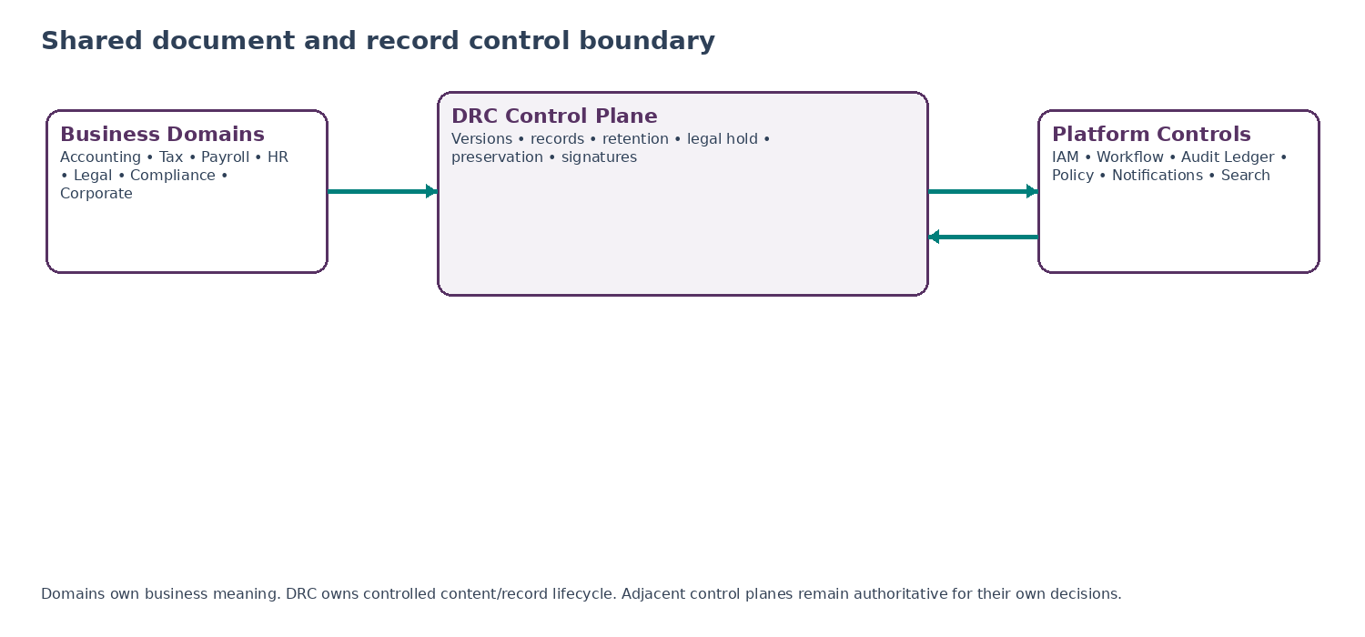
Figure 1 — Shared document and record control boundary

0.2 Standards and legal-design basis
The architecture is standards-informed, not standards-by-assertion. ISO 15489-1:2016 remains a published and confirmed international records-management standard covering records, metadata, record controls, and processes for creating, capturing and managing records. ISO 19005-4:2020 defines PDF/A-4 for long-term preservation of static page-based electronic documents. Privacy retention must remain purpose- and jurisdiction-aware rather than indefinite by default. Trust-service and electronic-signature requirements vary by jurisdiction and use case, so DRC-05 orchestrates assurance profiles instead of hard-coding one signature type globally.
ISO 15489-1:2016: Information and documentation — Records management — Part 1: Concepts and principles; status Published/Confirmed. Source
ISO 19005-4:2020: Document management — Electronic document file format for long-term preservation — Part 4 (PDF/A-4). Source
ICO storage limitation: Retention periods should be justified, documented and reviewed; personal data should not be kept longer than necessary for the purpose. Source
EU eIDAS: Electronic signatures are governed by assurance level and legal context; qualified electronic signatures receive the equivalent legal effect of handwritten signatures across EU Member States. Source

1. Scope, Boundaries and Canonical Service Catalogue

1.1 In scope
- Tenant-scoped document objects, immutable content versions, integrity hashes and metadata contracts.
- Record declaration, classification, file-plan mapping, record relationships and supersession lineage.
- Versioned retention schedules, event-based retention triggers, disposition review/execution and defensible deletion evidence.
- Legal hold creation, target resolution, propagation, release and precedence over ordinary disposition.
- Original-object preservation, policy-required long-term renditions, fixity verification, redaction/access renditions and export manifests.
- Provider-neutral electronic signature, seal and attestation orchestration with signed-artifact and validation evidence capture.
- Malware/quarantine gates, content-type verification, tenant isolation, regional storage policy, encryption references and recovery controls.
- Canonical APIs/events, observability, reconciliation, negative-path certification and domain adoption contracts.

1.2 Explicitly out of scope
Excluded authority | Boundary
IAM / authorization | Identity, authentication, role assignment, policy decision and step-up authentication remain owned by IAM/authorization services.
Workflow / approval | Approval chains, maker-checker and case/obligation orchestration remain owned by ZS-SVC-R-001; DRC consumes decisions.
Audit / evidence ledger | The immutable event evidence ledger records material actions; DRC owns content/version/record truth, not the platform audit log.
Domain accounting/legal truth | DRC does not determine accounting recognition, tax treatment, payroll calculation, HR outcome or legal conclusion.
OCR / extraction / AI | OCR, classification suggestions, semantic extraction and AI summaries are optional consumers/producers; their output is non-authoritative unless separately declared.
Enterprise search / RAG | Search and semantic retrieval may index permitted DRC metadata/content but cannot mutate DRC records or retention state.
Collaborative editing | Real-time editor behavior is not specified; editors must commit content as controlled versions before record use.
Trust provider legal status | DRC-05 stores provider eligibility/profile references but does not itself become a qualified trust service provider.
Hard-coded retention law | Legal owners maintain approved retention schedules; engineering implements deterministic execution and evidence.
Raw object-store administration | Bucket topology, vendor-specific lifecycle syntax and KMS implementation are infrastructure concerns governed by platform security standards.

1.3 Canonical services
ID | Service | Authority
DRC-01 | Document Object & Version Registry | Creates tenant-scoped document identities, immutable content versions, content integrity metadata and version concurrency rules.
DRC-02 | Record Declaration & Classification Service | Converts exact document versions into governed records; owns record class/file-plan mapping, declaration evidence and supersession relationships.
DRC-03 | Retention, Disposition & Legal Hold Service | Resolves versioned retention rules, computes disposition eligibility, overlays legal holds and controls destruction/release.
DRC-04 | Preservation, Rendition & Content Integrity Service | Preserves originals, manages approved preservation/access renditions, verifies fixity and creates controlled export/redaction packages.
DRC-05 | Signature, Seal & Attestation Orchestrator | Routes signing/sealing/attestation transactions through approved providers and captures authoritative signed artifacts plus validation evidence.

BOUNDARY RULE
A domain may create and reference content, but only DRC may establish the canonical document version and record lifecycle. Conversely, DRC must never infer a business outcome merely because a document exists, is signed, is retained, or is under hold.

2. Non-Bypassable Records Invariants
Invariant | Engineering rule
DRC-I01 | A committed document_version_id always resolves to the same bytes and content hash.
DRC-I02 | Existing version bytes are never overwritten; correction creates a new version.
DRC-I03 | Declared records reference exact immutable versions, not mutable document aliases.
DRC-I04 | A declared record cannot be “edited”; correction uses supersession, annotation or a new related record.
DRC-I05 | Tenant scope is enforced at metadata, object storage, cache, export and provider transaction layers.
DRC-I06 | A document path, filename, UI title or folder is not an identity or retention authority.
DRC-I07 | Retention schedules are versioned and effective-dated; historical records preserve the rule version actually applied.
DRC-I08 | Retention dates are derived from explicit trigger events/dates; they are not guessed from upload time unless the approved schedule says so.
DRC-I09 | No code path may convert an unresolved retention-rule conflict into silent indefinite retention or silent deletion.
DRC-I10 | Legal hold blocks ordinary disposition for every resolved target and descendant/version scope defined by the hold.
DRC-I11 | Hold release never directly deletes content; it causes retention/disposition re-evaluation.
DRC-I12 | A privacy erasure request cannot bypass a lawful hold or mandatory retention rule; conflicts enter governed review.
DRC-I13 | Disposition requires authorization appropriate to record class/risk and produces proof of attempted/executed deletion.
DRC-I14 | Backup/archive deletion semantics are explicit; “removed from UI” is never treated as proof of deletion.
DRC-I15 | Original content and derivative renditions are distinct objects with parent lineage and separate hashes.
DRC-I16 | OCR/extracted text is not authoritative record content unless explicitly captured as its own governed record.
DRC-I17 | Redaction creates a controlled derivative; it never overwrites the protected source record.
DRC-I18 | Malware/quarantined content cannot become ACTIVE or be supplied to ordinary downstream consumers.
DRC-I19 | MIME/content-type disagreement is validated by policy; declared MIME alone is not trusted.
DRC-I20 | Every preservation copy has a fixity manifest and can be verified against the source or approved transformation lineage.
DRC-I21 | A signed state cannot be established solely from a provider webhook/status flag.
DRC-I22 | Signature completion captures signed artifact hash, original hash, provider transaction ID and validation evidence.
DRC-I23 | Post-signature content change invalidates the prior signature relationship; amendment requires a new artifact/version and signing flow.
DRC-I24 | Provider timeout/ambiguity enters UNKNOWN and resolves the original transaction before any potentially duplicative action.
DRC-I25 | DRC cannot grant access; it enforces an authorization decision supplied by the canonical authorization service.
DRC-I26 | Audit events cannot be used as a substitute for preserved content, and preserved content cannot substitute for audit events.
DRC-I27 | Every export/disclosure package identifies exact included versions, redactions, omissions and package hash.
DRC-I28 | No domain may store a shadow mutable “official attachment” that bypasses DRC for a controlled record class.
DRC-I29 | Cross-region copy/processing obeys tenant residency and transfer policy before content movement occurs.
DRC-I30 | All destructive or irreversible operations are idempotent, evidence-producing and recoverable to a known failure state.

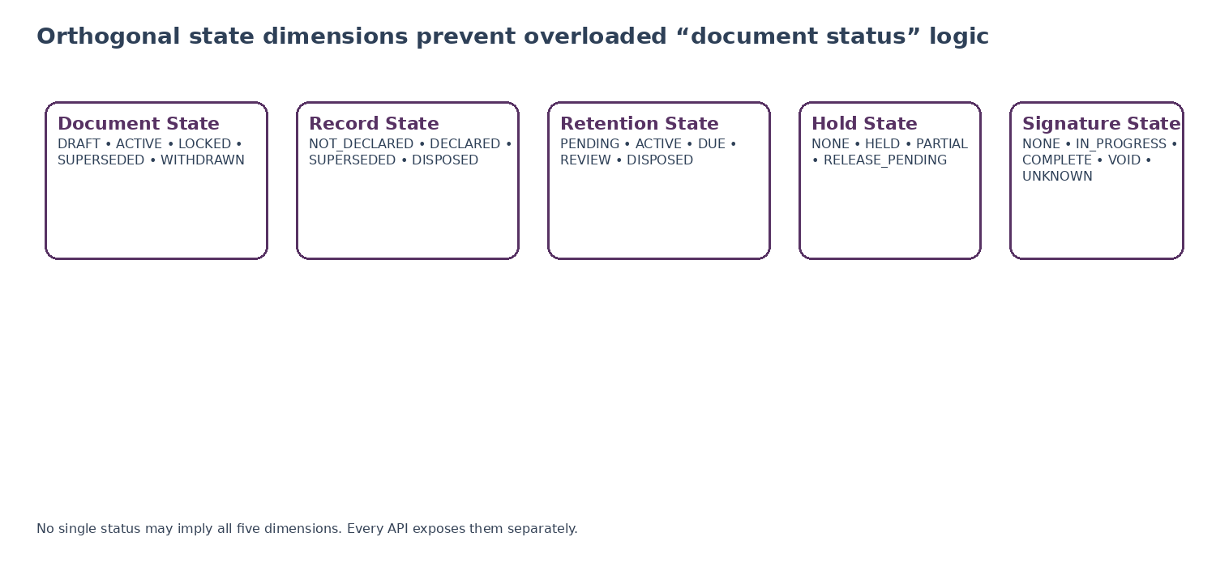
Figure 2 — Orthogonal state architecture

3. DRC-01 — Document Object & Version Registry

3.1 Purpose
DRC-01 is the canonical authority for logical document identities and immutable content versions. A logical document may evolve while it is being prepared, but every committed version is immutable. Downstream business records, approvals, filings, signatures and evidence references must cite a version_id or record_id, never only a filename or “latest” alias.
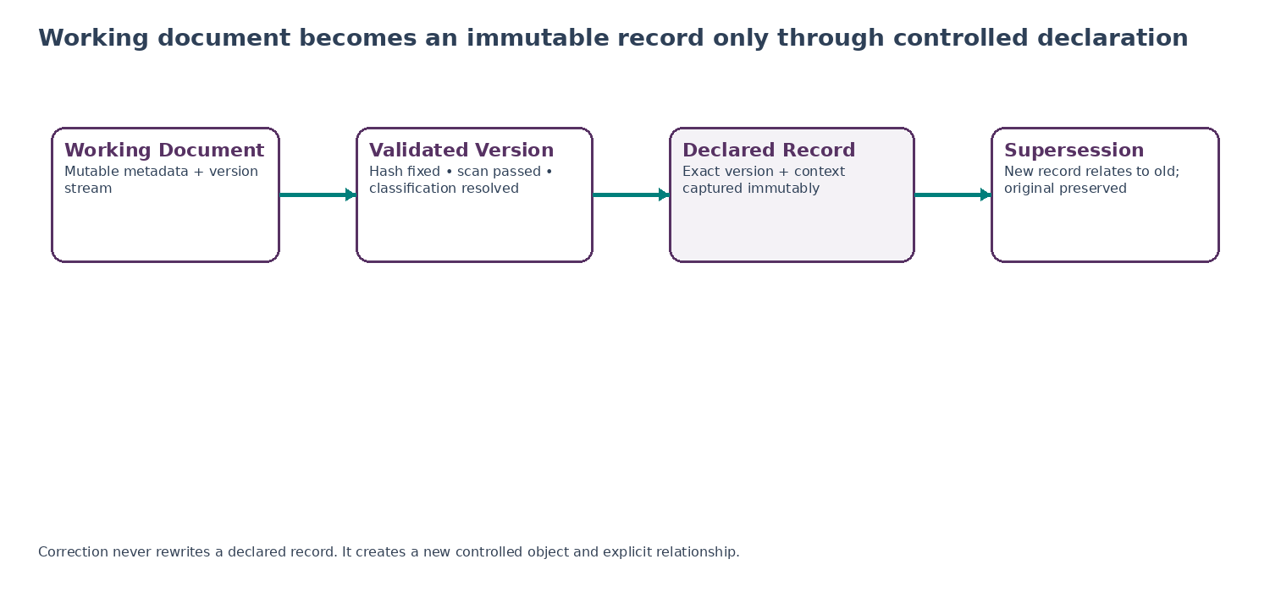
Figure 3 — Document-to-record lifecycle

3.2 Canonical document contract
Field | Type | Rule
document_id | UUIDv7 | Stable logical identity; tenant-scoped.
tenant_id | UUIDv7 | Mandatory tenant boundary.
domain_owner | enum/string | Accounting, Tax, Payroll, HR, Legal, Compliance, Corporate, etc.
business_object_type / id | string / UUID | Optional authoritative domain linkage; no cross-tenant target.
title | string | Human-readable label; not an identity.
classification_id | UUID | Reference to approved information classification.
current_version_id | UUID | Convenience pointer; never used where exact evidence is required.
document_state | enum | DRAFT, ACTIVE, LOCKED, SUPERSEDED, WITHDRAWN, QUARANTINED.
created_by / created_at | actor_ref / timestamptz | Attribution and server time.
row_version | integer | Optimistic-concurrency token; increments on mutable metadata changes.

3.3 Immutable version contract
Field | Type | Rule
version_id | UUIDv7 | Primary immutable content-version identity.
document_id | UUIDv7 | Parent logical document.
version_number | integer/string | Monotonic per document; presentation only.
content_object_id | UUIDv7 | Pointer to encrypted object-store object.
content_hash | SHA-256 or approved successor | Computed server-side after complete upload.
byte_length | bigint | Must match stored object.
declared_mime_type | string | Client declaration; never trusted alone.
detected_mime_type | string | Server inspection result.
malware_status | enum | PENDING, CLEAN, QUARANTINED, BLOCKED, ERROR.
encryption_key_ref | reference | KMS reference only; no raw key.
region | region code | Physical storage region approved for tenant/data class.
created_from_version_id | UUID? | Lineage where derived from prior working version.
commit_status | enum | RESERVED, UPLOADING, VALIDATING, COMMITTED, FAILED, QUARANTINED.
committed_at | timestamptz? | Set only after integrity + security gates pass.

3.4 Secure upload and commit sequence
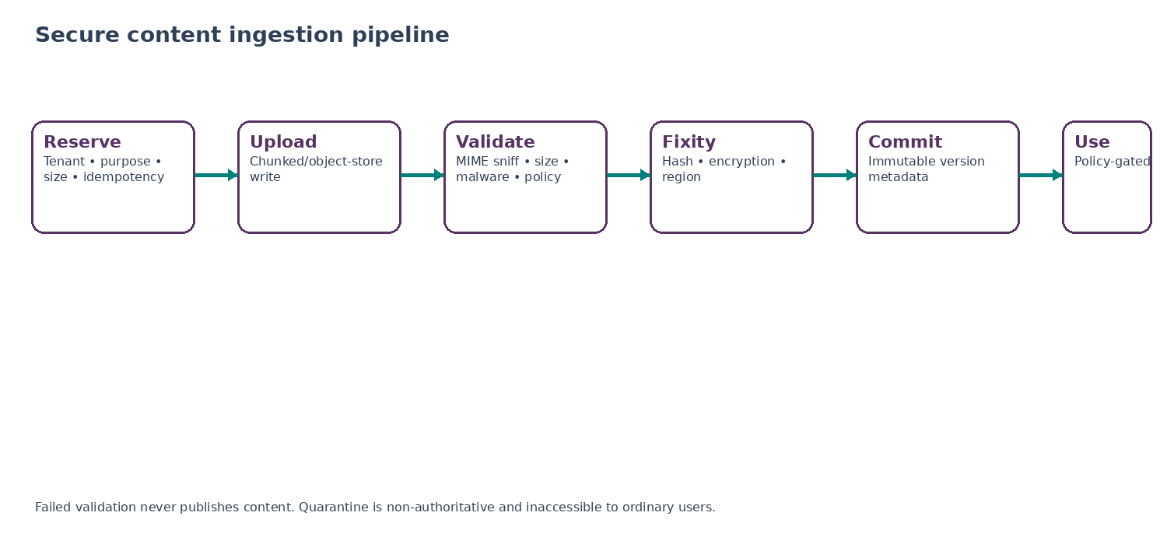
Figure 4 — Secure content ingestion pipeline
- Client reserves an upload with tenant, intended purpose, expected size, declared content type and idempotency key.
- Service authorizes the request and issues scoped upload instructions; object-store credentials are short-lived and object-specific.
- On completion, DRC validates byte count, computes server-side hash, detects content type, runs malware/content policy and confirms region/encryption posture.
- If validation passes, DRC commits immutable version metadata atomically with an outbox event; the object becomes addressable by version_id.
- If validation fails or remains uncertain, the object is quarantined or failed; ordinary consumers receive no read capability.
- Any retry resolves the reservation/idempotency key first so the same logical upload cannot create unintended duplicate records.

3.5 Concurrency and “latest” semantics
- Metadata edits use If-Match/row_version; stale updates receive 409/412 and must be reconciled.
- New content versions may be created concurrently only when domain policy permits branching; otherwise parent_version_id mismatch is rejected.
- “Latest” is a convenience projection for ordinary UI. Approval, signature, record declaration, export and filing APIs require exact version_id.
- LOCKED prevents ordinary version creation while a protected process is active, but does not itself imply record declaration or retention.

3.6 DRC-01 API surface
Endpoint | Purpose | Critical rule
POST /v1/documents | Create logical document metadata. | Idempotency-Key required.
POST /v1/documents/{id}/upload-reservations | Reserve version upload. | Returns scoped upload contract.
POST /v1/upload-reservations/{id}/complete | Finalize and validate upload. | May return PENDING_VALIDATION.
GET /v1/document-versions/{version_id} | Read exact immutable version metadata. | No “latest” substitution.
PATCH /v1/documents/{id} | Change mutable document metadata. | If-Match required.
POST /v1/documents/{id}/lock | Apply controlled logical lock. | Consumes authorization/workflow decision.
POST /v1/documents/{id}/withdraw | Withdraw working document from normal use. | Does not destroy declared records.

4. DRC-02 — Record Declaration & Classification Service

4.1 Purpose
DRC-02 establishes when content becomes a formal record. Record declaration captures the exact version, business context, classification, applicable file-plan node and declaration evidence. From that point forward, content integrity is immutable. A later correction may supersede or annotate the record, but it may not erase the historical fact of what was captured.

4.2 Record declaration gates
Gate | Requirement | Failure behavior
Exact content | version_id is COMMITTED, hash present and malware/content policy passed. | Block
Business context | Domain object, record purpose and declared record class are complete. | Block
Classification | Information/security classification resolved. | Block
File plan | Approved record_class_id and schedule eligibility established. | Block
Retention inputs | Required trigger date/event fields are available or explicitly pending. | Block or PENDING_TRIGGER per class
Residency | Current storage region is allowed for tenant, classification and record class. | Block
Authorization | Actor is authorized to declare this record type. | Block
Duplicate detection | Same version/business object/class combination checked for prior declaration. | Idempotent return or conflict
Audit/outbox | record_declared event can be durably emitted. | Block commit if transactional guarantee unavailable

4.3 Canonical record schema
Field | Type | Rule
record_id | UUIDv7 | Permanent record identity.
tenant_id | UUIDv7 | Tenant boundary.
version_id | UUIDv7 | Exact immutable content version.
record_class_id | UUIDv7 | Versioned file-plan classification.
business_context | structured ref | Domain, business object, entity, period/matter as permitted.
jurisdiction_scope | set/code | Jurisdictions relevant to retention/record controls; not inferred solely from tenant address.
declared_at | timestamptz | Server time of successful declaration.
declared_by | actor_ref | Human/service actor.
declaration_reason | enum/string | Business trigger or mandated capture reason.
retention_schedule_version_id | UUID? | Resolved schedule version when available.
record_state | enum | DECLARED, SUPERSEDED, DISPOSED; no mutable “draft record”.
supersedes_record_id | UUID? | Explicit correction/supersession relation.
audit_ref | reference | Immutable audit/evidence event reference.

4.4 Record classes and file-plan governance
Illustrative class | Owner | Required context
ACCOUNTING_WORKPAPER | Accounting | Close evidence, reconciliations, journals support; period/entity context mandatory.
TAX_RETURN_SUPPORT | Tax | Return, filing support, authority receipt; jurisdiction and tax period mandatory.
PAYROLL_OUTPUT | Payroll | Payslips, payroll registers, filings, payment reports; payroll period + employer entity.
EMPLOYMENT_RECORD | HR | Contract, change letter, policy acknowledgment, performance/disciplinary record; workforce privacy class.
LEGAL_CONTRACT | Legal | Executed contract/amendment; counterparties, effective date and governing-law context where known.
LEGAL_MATTER_RECORD | Legal | Matter/case evidence; privilege/confidentiality classification may apply.
COMPLIANCE_EVIDENCE | Compliance | Control evidence, attestations, submissions, regulator correspondence.
CORPORATE_RECORD | Corporate | Board/shareholder minutes, resolutions, constitutional/governance documents.

CONFIGURATION RULE
These classes are an initial taxonomy, not a universal legal retention schedule. Each production record class must map to approved tenant/jurisdiction schedule rules before automatic disposition can operate.

4.5 Supersession, annotation and relationship semantics
Relationship | Meaning
SUPERSEDES | New record formally replaces prior record for future use; prior record remains preserved.
CORRECTS | New record corrects an error but original remains part of evidence chain.
AMENDS | New record changes a contract/policy/document while preserving original and amendment.
ATTACHES_TO | Supporting record attached to a primary record without changing authority.
EVIDENCES | Record provides evidence for a business event/control/case.
DERIVED_FROM | Controlled transformation/rendition relationship; derivative does not automatically inherit authority.
DUPLICATE_OF | Confirmed duplicate content retained or dispositioned according to policy; identity not merged silently.

5. DRC-03 — Retention, Disposition & Legal Hold Service

5.1 Purpose
DRC-03 is the sole platform authority for applying approved retention schedules to declared records, computing disposition eligibility, managing legal-hold overlays and executing authorized disposition. It does not decide the substantive law. Legal/Compliance and Data Governance publish the rules; DRC-03 executes them deterministically and preserves the applied rule version as evidence.

5.2 Retention rule version contract
Field | Requirement
retention_rule_version_id | Immutable rule version ID.
record_class_id | Record class/file-plan node to which rule applies.
jurisdiction_selector | Jurisdiction/applicability expression; must be deterministic and policy-safe.
legal_basis_ref | Source or approved counsel/policy reference; required for mandatory rules.
purpose_ref | Business/privacy purpose supporting retention.
trigger_type | CREATED_AT, DECLARED_AT, PERIOD_END, TAX_YEAR_END, EMPLOYMENT_END, CONTRACT_END, MATTER_CLOSED, CUSTOM_EVENT, etc.
trigger_field/event | Exact field/event contract used to establish the clock.
duration | Structured years/months/days or event-until condition; never free-form prose only.
disposition_action | DELETE, DESTROY, ANONYMIZE, REVIEW, ARCHIVE/TRANSFER where permitted.
priority / rule_class | Statutory/regulatory, litigation, contractual, business policy, privacy minimization.
effective_from / to | Version applicability dates.
approved_by / approval_ref | Controlled publication evidence.
status | DRAFT, APPROVED, ACTIVE, SUPERSEDED, WITHDRAWN.

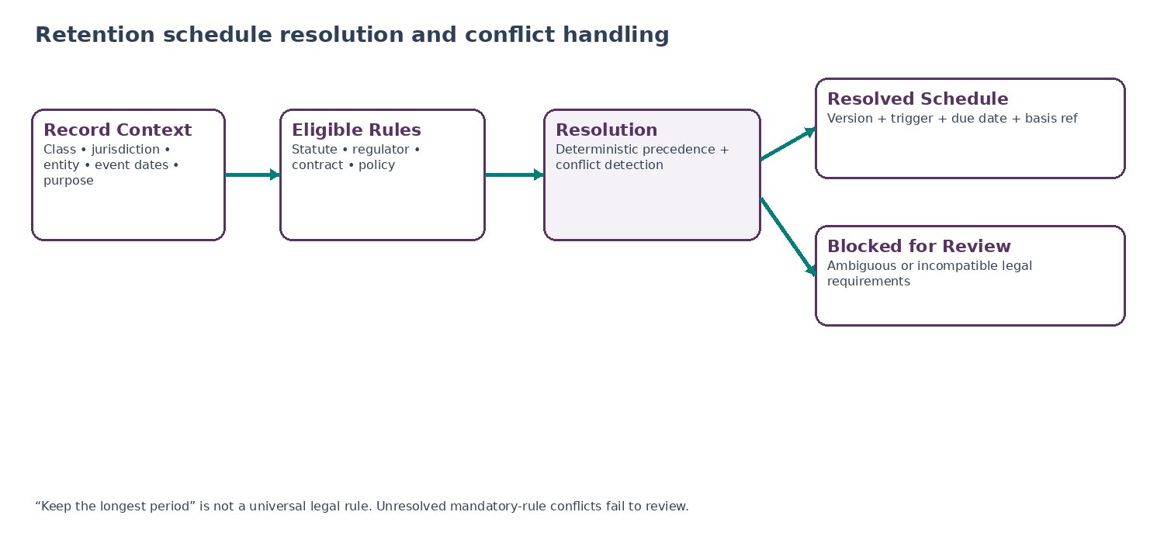
Figure 5 — Retention schedule resolution

5.3 Rule resolution principles
- Applicability is evaluated against record class, jurisdiction, legal entity, business context, data class and effective date.
- A mandatory legal/regulatory requirement cannot be shortened by tenant convenience or ordinary business policy.
- A privacy-minimization requirement cannot be defeated by a vague “keep forever” business preference.
- The engine must not assume the longest duration is always legally correct; conflicting mandatory requirements create RETENTION_CONFLICT and a legal/compliance case.
- Where multiple compatible bases apply, the resolved schedule stores each contributing rule and the reason the final disposition date/action was chosen.
- Historical records stay linked to the resolved schedule version and may be re-evaluated only under a governed migration/change rule.

5.4 Retention lifecycle
State | Meaning | Required action
WAITING_FOR_TRIGGER | Record declared but required retention trigger has not occurred/been supplied. | Watch registered event/field; do not guess.
ACTIVE | Trigger resolved and disposition date/condition computed. | Recompute only on approved rule migration or corrected trigger.
DUE | Retention requirement completed and no blocking hold. | Create disposition candidate.
REVIEW_REQUIRED | Rule conflict, policy condition or class requires human review. | Route through WFC control.
APPROVED_FOR_DISPOSITION | Required approval complete and context hash unchanged. | Execute idempotently.
DISPOSITION_IN_PROGRESS | Delete/anonymize/archive steps executing. | Track each storage replica/derivative/provider target.
DISPOSED | Required targets completed and evidence recorded. | Record metadata tombstone/evidence retained as policy allows.
DISPOSITION_FAILED | One or more required targets failed or ambiguous. | Do not claim deletion; recover/reconcile.

5.5 Legal hold model
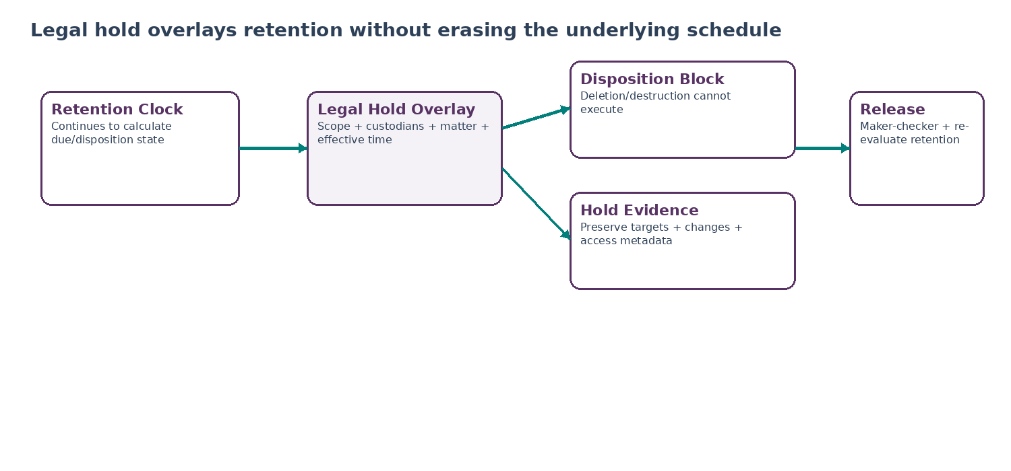
Figure 6 — Legal-hold overlay
Hold field | Rule
hold_id | Stable hold identity.
tenant_id | Mandatory tenant scope.
matter_ref / authority_ref | Legal matter, investigation, regulator request or approved internal authority.
scope_selector | Explicit objects, custodians, entities, record classes, date ranges, matter tags or approved query snapshot.
effective_at | Time from which preservation applies; supports retroactive preservation searches where legally required.
status | DRAFT, ACTIVE, PARTIALLY_APPLIED, RELEASE_PENDING, RELEASED, ERROR.
hold_reason_code | Controlled reason; free text supplemental only.
issued_by / approved_by | Authorized roles; maker-checker per policy.
release_approved_by | Separate release authority; self-release restrictions apply.
audit_refs | Creation, scope expansion/reduction, target resolution, failed preservation, release and post-release review.

5.6 Hold propagation and target resolution
- Hold target resolution produces an immutable resolution snapshot plus incremental watch criteria for later-matching records when scope is ongoing.
- Existing versions, declared records, approved renditions and signing artifacts within scope are preserved; working drafts are included only where hold scope/policy says so.
- A partially applied hold is a P1 operational/legal condition. The system must expose unresolved targets rather than presenting the hold as complete.
- Release removes the overlay only after approved release; the underlying retention schedule is then re-evaluated and may immediately become due, but deletion still requires the normal disposition path.
- Hold changes are additive/narrowing through new hold versions; historical hold scope remains replayable.

5.7 Privacy erasure and hold/retention conflict
CONFLICT DOCTRINE
A data-subject erasure request, tenant deletion request or ordinary offboarding job must never call object deletion directly for controlled records. The request is evaluated against mandatory retention and legal hold. If a lawful exception blocks erasure, the privacy workflow records the restricted outcome; if no basis remains, DRC disposition executes the required deletion/anonymization.

6. DRC-04 — Preservation, Rendition & Content Integrity Service

6.1 Purpose
DRC-04 ensures that the bytes ZoikoSuite claims to preserve can be verified later, and that derivative files do not accidentally become sources of truth. It manages preservation renditions, previews/redactions, fixity manifests, integrity verification, controlled export packaging and recovery of damaged or unavailable stored objects.
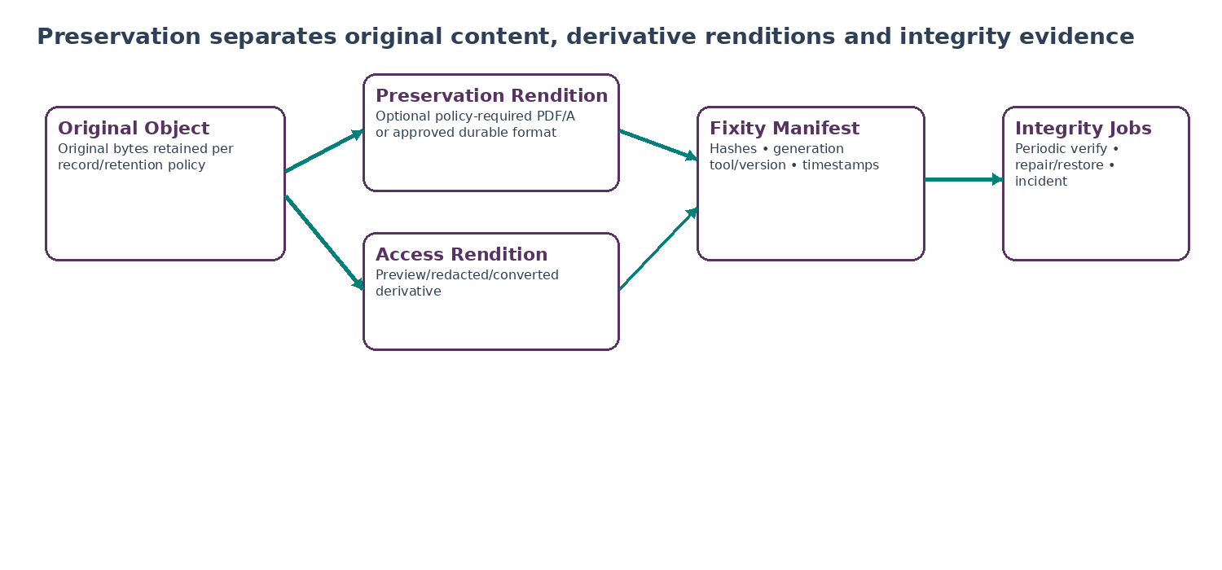
Figure 7 — Preservation and rendition model

6.2 Original vs rendition authority
Object class | Definition | Authority
ORIGINAL | Exact bytes committed in DRC-01. | Primary source object unless domain policy expressly designates another captured artifact.
PRESERVATION_RENDITION | Policy-approved durable representation, e.g., PDF/A where suitable. | Derivative with transformation evidence; does not erase need to preserve original when required.
ACCESS_RENDITION | Preview, thumbnail, browser-compatible conversion. | Convenience only; never evidence authority by itself.
REDACTED_RENDITION | Recipient/scope-specific controlled disclosure copy. | Must store redaction profile/reason and parent version; never overwrite original.
OCR_TEXT | Extracted text for accessibility/search/workflow. | Non-authoritative unless separately declared as a record.
NORMALIZED_DATA | Structured extraction used by business/AI services. | Derived data with provenance; cannot silently replace source record.

6.3 Fixity manifest
Field | Requirement
manifest_id | Unique manifest identity.
source_version_id | Exact source version.
source_hash / algorithm | Hash and approved algorithm.
rendition_id / hash | For each derivative included.
transformation_profile | Converter/tool/version/configuration hash.
generated_at / by | Trusted server time and service identity.
signature_validation_ref | Optional validation evidence for signed artifacts.
storage_region / class | Residency and storage tier at generation.
integrity_state | VERIFIED, MISMATCH, MISSING, UNREADABLE, REPAIRING.
last_verified_at | Last successful/failed fixity check time.
repair_source_ref | If repaired, approved source/replica and repair audit reference.

6.4 Long-term format policy
- The preservation profile is record-class and jurisdiction/policy driven. PDF/A-4 may be selected for suitable page-based documents requiring long-term static visual preservation.
- DRC does not convert every file to PDF/A. Native spreadsheets, signed containers, machine-readable filings, images, structured XML/JSON and specialist legal formats may require original-format retention plus an approved viewing rendition.
- Any transformation records tool/version, profile, source hash, output hash and validation result.
- A failed transformation does not destroy or downgrade the original. It creates a preservation exception for governed resolution.
- Password-protected or encrypted user files must follow approved decrypt/escrow/reject paths; services must not retain unknown passwords in metadata or logs.

6.5 Redaction and disclosure
Control | Requirement
Redaction profile | Names purpose, recipient class, fields/regions removed, method, approver and legal/privacy basis.
Irreversibility | Recipient copy must not contain recoverable hidden layers, comments, metadata or embedded originals where policy requires irreversible redaction.
Source preservation | Unredacted source stays protected according to its own access/hold/retention state.
Manifest | Export identifies source version, redacted rendition hash, redaction profile/version and omissions.
Authorization | DRC consumes authorization/workflow approval; it cannot self-authorize a disclosure.
Audit | Audit Ledger receives read/export/redaction events with purpose and recipient scope; sensitive content is referenced, not duplicated unnecessarily.

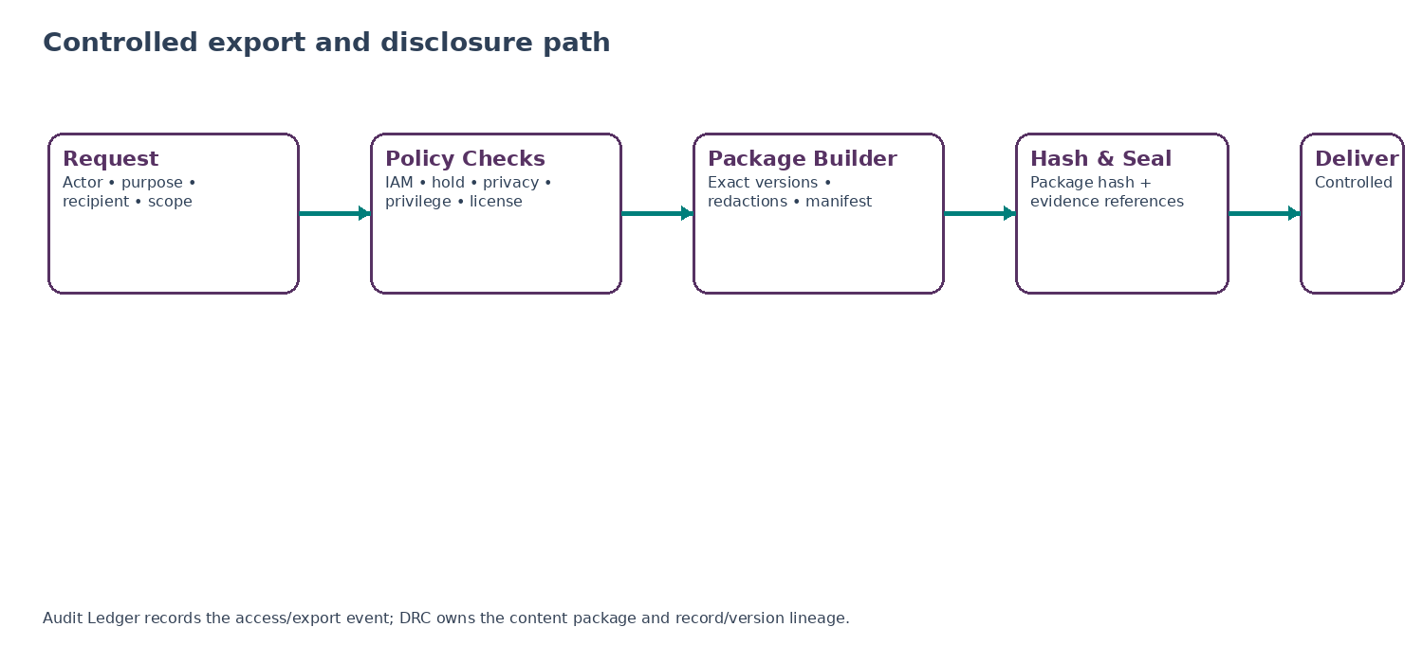
Figure 8 — Controlled export and disclosure

6.6 Integrity verification and repair
- Scheduled fixity verification is risk/tier based and samples or verifies according to approved storage durability policy; legal-hold/high-value records may require stricter cadence.
- MISMATCH, MISSING or UNREADABLE states are incidents. Automatic repair may use a verified replica only when hashes/provenance establish the correct source.
- Repair never rewrites metadata to make a corrupted hash “match.” It restores correct bytes or creates a transparent unrecoverable-loss state.
- Every repair action records source replica, previous/current hash, operator/service identity, incident reference and post-repair verification result.
- Integrity dashboards separate storage availability from fixity correctness; “download succeeded” is not proof of content integrity.

7. DRC-05 — Signature, Seal & Attestation Orchestrator

7.1 Purpose
DRC-05 provides one provider-neutral orchestration layer for electronic signatures, electronic seals and controlled attestations. The service binds an assurance profile to an exact document version, routes the transaction through an approved provider, validates the returned result, preserves the signed artifact and evidence, then allows DRC-02 to declare the resulting artifact as a formal record where required.
LEGAL POSTURE
Electronic form alone is not the engineering assurance level. The required signature/seal profile is selected by jurisdiction, transaction type, party type, contract/regulatory policy and risk. DRC-05 must support stronger profiles where required without claiming that every completed provider transaction has the same legal effect.

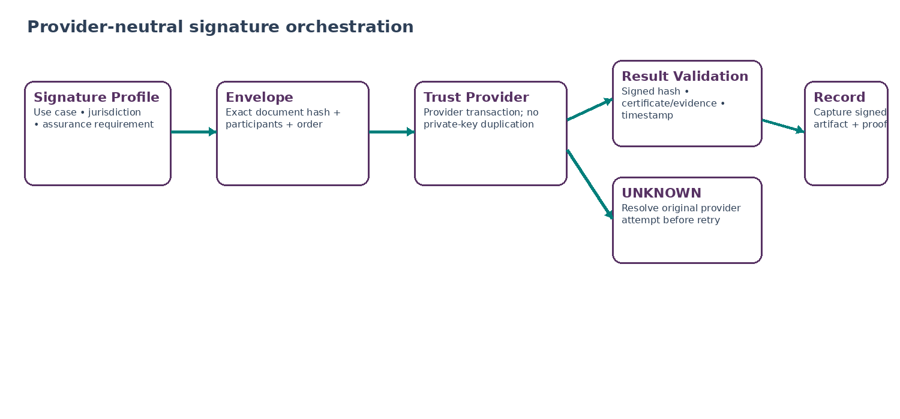
Figure 9 — Provider-neutral signature orchestration

7.2 Signature profile contract
Field | Requirement
signature_profile_id | Versioned profile defining assurance requirements.
jurisdiction_scope | Applicable countries/regions/legal entities; may be multi-jurisdiction.
use_case | Employment contract, supplier agreement, board resolution, policy acknowledgement, tax form, etc.
party_type | Natural person, legal entity, internal officer, witness, counterparty.
assurance_level | Platform-normalized level mapped to provider capabilities and local policy.
identity_requirements | Authentication/identity proofing attributes required from provider/IAM.
timestamp_requirement | None/basic/qualified or policy-defined evidence requirement.
seal_requirement | Whether organizational seal is required/allowed.
witness/notary requirement | Structured routing requirement where legally applicable; no generic assumption.
provider_eligibility_policy | Allowed providers/regions based on diligence and tenant policy.
retention_class | Record class for envelope/signed artifact/evidence.
validation_policy | Required checks before COMPLETED can become authoritative.

7.3 Orthogonal signature states
Dimension | States
Envelope lifecycle | DRAFT, READY, SENT, PARTIALLY_COMPLETED, COMPLETED, DECLINED, EXPIRED, VOIDED, FAILED, UNKNOWN.
Provider attempt | CREATED, SUBMITTED, ACKNOWLEDGED, CALLBACK_PENDING, RESOLVED, ERROR, UNKNOWN.
Artifact validation | PENDING, VALID, INVALID, INDETERMINATE.
Record capture | NOT_DECLARED, DECLARED, CAPTURE_FAILED.
Participant state | PENDING, VIEWED, SIGNED/SEALED/ATTESTED, DECLINED, EXPIRED as supported and normalized.

7.4 Completion evidence minimum
- Exact original version_id and original content hash.
- Signed/sealed artifact version/object ID and hash.
- Provider and provider transaction/envelope ID.
- Signature profile version and normalized assurance level.
- Participant identities/references at the minimum necessary level, signing order and outcome.
- Provider validation/verification report, certificate/trust-chain metadata where applicable, and timestamp evidence reference.
- Consent/authentication method evidence references as required by the profile.
- Webhook/API receipt evidence and final reconciliation result.
- Any validation limitations or INDETERMINATE result; UI must not simplify these to “valid.”

7.5 Provider ambiguity and idempotency
Durable Signature Attempt → Submit → Pending / UNKNOWN → Resolve Original Provider Transaction → Completed | Failed | Declined | Expired
- Envelope creation uses a client operation/idempotency key and stores the provider transaction ID before assuming success.
- HTTP timeout after submit is UNKNOWN, not FAILED. Reconciliation queries provider state using the original attempt/reference.
- Webhook receipt is verified for authenticity, replay window and event identity, then deduplicated.
- A duplicate webhook or polling result cannot create a second signed artifact/version or duplicate participant completion.
- Provider says COMPLETED but signed artifact cannot be retrieved/validated: state is CAPTURE_FAILED or VALIDATION_PENDING, not authoritative COMPLETED.
- Provider private signing keys are not copied into ZoikoSuite. Any local key custody would require a separate approved security/trust architecture not defined here.

7.6 Amendment and voiding rules
Scenario | Required behavior
Pre-sign content change | Envelope becomes stale; create new exact version and new/updated envelope under policy.
Post-sign content change | Never mutate signed bytes. Create amendment/new version, preserve original and sign again if required.
Void before completion | Provider void action plus durable local state; participants notified via notification service as policy requires.
Void after completion | Does not erase executed signed record. Business/legal process may create rescission/termination/amendment record.
Participant identity change | Requires profile re-evaluation and usually new participant transaction; never rewrite prior signer evidence.

8. Canonical Data Model and Storage Architecture

8.1 Core entities
Entity | Authority
documents | Logical document identity and mutable descriptive metadata.
document_versions | Immutable committed version metadata and content hash.
content_objects | Object-store locator, storage class, encryption/region and byte integrity state.
record_classes | Versioned file-plan taxonomy and required metadata schema.
records | Declared record linking exact version to business context/classification.
record_relationships | Supersedes/corrects/amends/attaches/evidences/derived-from relationships.
retention_rule_versions | Approved effective-dated retention rule definitions.
record_retention_states | Resolved schedule, trigger, due date/condition and lifecycle.
legal_holds | Hold authority, scope, lifecycle and release state.
legal_hold_targets | Resolved record/version/object targets and preservation outcome.
disposition_actions | Planned/executed disposition steps by storage/derivative/provider target.
renditions | Preservation/access/redaction/OCR derivative metadata.
fixity_manifests | Hashes, transformations and verification/repair lineage.
export_packages | Exact disclosure package manifest, redactions, exclusions and package hash.
signature_profiles | Versioned assurance/routing requirements.
signature_envelopes | Exact source version, participants, provider and lifecycle.
signature_attempts | Durable provider attempt, idempotency and unknown-resolution state.
signature_artifacts | Returned signed/sealed artifact and validation evidence references.

8.2 Storage separation
Layer | Rule
Metadata database | Document/record/retention/hold/signature state. Strong consistency and transactional outbox for critical transitions.
Object storage | Encrypted binary content objects. Access by scoped service identity/presigned token only; no public bucket paths.
Quarantine storage | Physically/logically isolated content pending malware/security decision. Not exposed to ordinary downstream consumers.
Preservation tier | Policy-approved storage tier/region with fixity and recovery controls; may differ from active-access tier.
Audit ledger | Separate append-only control plane for events/evidence; references DRC IDs/hashes rather than storing all file bytes.
Search index | Derived, rebuildable projection containing only permitted metadata/content. Search deletion or lag cannot change record truth.

8.3 Referential integrity rules
- No record points to RESERVED, FAILED or QUARANTINED content.
- Every content_object belongs to exactly one tenant and region policy scope; shared deduplication across tenants is prohibited unless a future cryptographic design is explicitly approved.
- record_retention_state must reference the schedule version and trigger evidence used to compute its date/condition.
- legal_hold_target cannot be hard-deleted while the hold or post-release evidence retention period requires it.
- signature_artifact references both original source version and returned signed object; validation evidence must be tied to the exact signed hash.
- Export package items reference exact versions/renditions; no runtime “latest” resolution occurs during package regeneration without a new package version.

9. API, Event and Integration Contracts

9.1 Platform API rules
- REST/gRPC contracts are tenant-context bound; tenant_id in payload is validated against authenticated service context and cannot switch tenant authority.
- Every mutating command accepts/derives operation_id and idempotency key. Retried commands return the prior authoritative result where safe.
- Destructive/irreversible commands require exact object IDs, expected state/version and a workflow/authorization decision reference.
- No bulk endpoint may degrade per-item authorization, retention/hold checks or audit semantics for convenience.
- Provider callbacks enter through dedicated signed webhook endpoints and are normalized before state transition.

9.2 Critical endpoints
Endpoint | Purpose | Control
POST /v1/records:declare | Declare exact version as record. | Exact version, record class, business context, idempotency.
POST /v1/records/{id}:supersede | Create explicit supersession relation. | New record must already exist or be atomically declared.
POST /v1/retention:evaluate | Resolve schedule for record(s). | Returns rule versions + conflict states; no silent defaults.
POST /v1/dispositions | Create disposition candidate/job. | Hold check + expected retention state.
POST /v1/dispositions/{id}:approve | Consume approval decision. | Maker-checker from WFC; no self-approval logic duplicated here.
POST /v1/legal-holds | Create draft/active hold. | Authorized legal/compliance route only.
POST /v1/legal-holds/{id}:resolve-targets | Resolve/refresh scope. | Records result snapshot and partial failures.
POST /v1/legal-holds/{id}:release | Release hold overlay. | Approval ref; triggers retention re-evaluation.
POST /v1/renditions | Create approved derivative. | Source exact version + rendition profile.
POST /v1/exports | Build controlled export package. | Recipient/purpose + exact scope + redaction policy.
POST /v1/signature-envelopes | Create envelope. | Exact version + signature profile + participants.
POST /v1/signature-envelopes/{id}:send | Submit durable provider attempt. | Idempotent; UNKNOWN resolution semantics.
POST /v1/signature-callbacks/{provider} | Provider webhook. | Signature verification + dedupe + normalization.

9.3 Canonical events
Event | Minimum payload anchors
document_created | document_id, tenant_id, classification_id
document_version_committed | version_id, document_id, content_hash, region
document_version_quarantined | version_id, reason_code
record_declared | record_id, version_id, record_class_id, schedule_state
record_superseded | new_record_id, prior_record_id, relation_type
retention_schedule_resolved | record_id, schedule_version_id, trigger, due_at/condition
retention_conflict_detected | record_id, contributing_rule_ids, conflict_code
record_disposition_due | record_id, due_at, hold_state
disposition_started | disposition_id, record_id, target_count
disposition_completed | disposition_id, record_id, evidence_ref
disposition_failed | disposition_id, failed_targets, ambiguity_state
legal_hold_activated | hold_id, scope_version, authority_ref
legal_hold_target_added | hold_id, record_id/version_id
legal_hold_partial_application | hold_id, unresolved_targets
legal_hold_released | hold_id, release_approval_ref
rendition_created | rendition_id, source_version_id, profile_id, output_hash
integrity_check_failed | object_id/version_id, expected_hash, incident_ref
export_package_created | package_id, item_count, package_hash, recipient_scope
signature_envelope_submitted | envelope_id, provider_attempt_id
signature_provider_state_unknown | envelope_id, provider_attempt_id
signature_artifact_validated | envelope_id, artifact_version_id, validation_state
signature_envelope_completed | envelope_id, artifact_version_id, profile_version_id

EVENT CONTRACT
All events require canonical envelope fields: event_id, payload_schema_version, tenant_id or GLOBAL_CONTROL, actor/service identity, correlation_id, causation_id, occurred_at, recorded_at, emitting_service, environment and audit/evidence reference as applicable.

10. Security, Privacy, Residency and Privilege Controls

10.1 Security controls
Area | Minimum control
Tenant isolation | Tenant scoping at API, DB row policy, object path/key policy, cache key, export and provider mapping. Cross-tenant object references rejected before storage access.
Encryption | TLS in transit; approved encryption at rest; key references scoped by tenant/region/data class where platform policy requires.
Malware/content safety | Quarantine before commit/use; scanning engines are not trusted to grant authorization and their outage has fail-closed behavior for controlled classes.
Secrets | Passwords, signing private keys, tokens and object-store credentials prohibited in ordinary metadata/logs. Use vault/KMS/provider custody.
Privileged access | Break-glass/time-bound support access with scope/reason/approval and audit; cannot bypass hold/retention/privilege rules.
Download controls | Scoped, short-lived service-mediated URLs; content disposition/security headers; no predictable public object paths.
Metadata minimization | Avoid sensitive party/content details in object keys, URLs, logs, event names or filenames where not needed.
Integrity | Server-side hash, immutable version metadata, fixity checks, provider signature validation and tamper incident route.

10.2 Privacy and retention discipline
- Retention purpose/basis is explicit per schedule; “platform analytics” does not automatically justify keeping user/employee/legal records.
- Where personal data no longer has a valid purpose or mandatory retention/hold basis, disposition should erase or anonymize according to approved policy and evidence the outcome.
- Pseudonymized data may remain personal data; pseudonymization is not treated as automatic release from retention obligations.
- DSR/export responses use controlled disclosure packages and minimization/redaction policies; unrelated records are not exposed merely because the requester appears in metadata.
- Special-category/highly sensitive workforce/legal records use stricter classification, access, export and support controls.
- Legal privilege/work-product labels are metadata controls, not legal determinations made by DRC. The Legal domain/policy service owns the substantive privilege decision.

10.3 Residency and cross-border movement
Movement | Control
Upload destination | Region resolved before scoped upload is issued; client cannot select arbitrary bucket/region.
Rendition/OCR/signature provider | Processing location checked before content leaves approved region; provider eligibility and transfer policy enforced.
Backups/replicas | Replica regions documented in residency map; restore cannot place protected tenant content into unauthorized region.
Export | Human-approved disclosure may cross region only under permitted recipient/transfer policy; export event/evidence records destination scope.
Migration | Region migration is controlled project with copy verification, cutover, old-region disposition/retention handling and replay evidence.

11. Failure Semantics, Negative Paths and Error Taxonomy

11.1 Canonical error/failure codes
Code | State | Trigger | Required response
DRC-001 | VERSION_IMMUTABLE | Attempt to replace bytes or immutable version metadata. | Reject 409; require new version.
DRC-002 | UPLOAD_VALIDATION_FAILED | Size/hash/content-type/policy failed. | Fail/quarantine; no publish.
DRC-003 | MALWARE_QUARANTINED | Scanner indicates malicious/suspicious content. | Quarantine + security event.
DRC-004 | TENANT_SCOPE_MISMATCH | Referenced object/record belongs to another tenant. | Reject + security telemetry.
DRC-005 | RECORD_DECLARATION_INCOMPLETE | Class/context/retention input missing. | Reject or pending trigger only if class allows.
DRC-006 | RETENTION_CONFLICT | Applicable rules cannot be deterministically reconciled. | Block disposition; legal review case.
DRC-007 | RETENTION_TRIGGER_MISSING | Required event/date absent. | WAITING_FOR_TRIGGER; alert if overdue.
DRC-008 | LEGAL_HOLD_BLOCK | Disposition target is covered by active hold. | Block with hold ref; do not mutate.
DRC-009 | HOLD_PARTIAL_APPLICATION | Some hold targets unresolved/preserve failed. | P1 alert + retry/review.
DRC-010 | DISPOSITION_AMBIGUOUS | Delete/anonymize target result unknown. | Resolve original attempt; do not claim completed.
DRC-011 | FIXITY_MISMATCH | Stored bytes do not match expected hash. | Security/data-integrity incident.
DRC-012 | RENDITION_VALIDATION_FAILED | Transformation output invalid/nonconforming. | Preserve source; exception.
DRC-013 | SIGNATURE_PROVIDER_UNKNOWN | Provider request timed out/ambiguous. | Resolve original attempt.
DRC-014 | SIGNED_ARTIFACT_CAPTURE_FAILED | Provider completed but artifact/evidence unavailable. | Do not mark authoritative completed.
DRC-015 | SIGNATURE_VALIDATION_INDETERMINATE | Validation cannot establish required profile. | Review/retry; surface limitation.
DRC-016 | EXPORT_POLICY_BLOCK | Recipient/purpose/privacy/privilege/hold policy disallows export. | Reject + evidence.
DRC-017 | REGION_POLICY_BLOCK | Requested processing/storage route violates region policy. | Fail closed; alternate allowed route only.
DRC-018 | STALE_APPROVAL_CONTEXT | Record/hold/disposition/signature context changed after approval. | Invalidate approval; re-run WFC.
DRC-019 | OBJECT_MISSING | Metadata exists but binary object unavailable. | Incident/recovery; no silent null content.
DRC-020 | AUDIT_OUTBOX_UNAVAILABLE | Critical state cannot durably publish required event. | Block commit or use transactional outbox local durability.

11.2 Negative-path certification scenarios
- Retry the same completed upload reservation 20 times; only one committed version exists.
- Change bytes behind a committed object locator; fixity mismatch is detected and no metadata hash is rewritten.
- Upload executable content with a benign extension; content sniff/malware policy prevents ordinary publication.
- Malware scanner is unavailable; controlled record classes fail closed rather than auto-approve.
- Client declares PDF but payload is another format; policy path is deterministic and auditable.
- Cross-tenant version_id supplied to record declaration; request fails before object read.
- Declare the same version/class/business context twice with same idempotency key; same record returned.
- Declare the same version as two incompatible record classes; policy conflict is surfaced, not silently duplicated.
- Edit a declared record’s source bytes; operation is rejected.
- Correct a declared record; prior record remains and explicit CORRECTS/SUPERSEDES relationship exists.
- Retention trigger is employment termination but employee remains active; no date guessed from upload/declaration.
- Termination event arrives late; schedule computes from authoritative termination date and records late-resolution evidence.
- Two mandatory retention rules conflict on action/duration; RETENTION_CONFLICT blocks auto-disposition.
- Tenant policy requests earlier deletion than mandatory rule; mandatory rule prevails with evidence.
- Tenant policy requests indefinite retention without approved purpose; privacy/policy review required.
- Record becomes due while legal hold is active; disposition remains blocked.
- Hold scope expansion includes existing and future matching records; both snapshot and watch behavior are proven.
- One storage replica cannot be placed under hold; hold state is PARTIALLY_APPLIED and escalated.
- Hold release approved by unauthorized/self-approving actor; release blocked.
- Hold release occurs after retention expiry; record enters normal disposition review, not immediate hidden deletion.
- DSR erasure request targets held record; privacy workflow receives lawful-block/review result and object remains preserved.
- Disposition delete call times out; state becomes ambiguous and reconciles original attempt before retry.
- Primary object deleted but backup/replica target fails; disposition not marked complete.
- Search index still contains stale derived text after record disposition; index repair/delete is required and tracked.
- Preview rendition differs visually from source; preview is quarantined/rebuilt without changing source.
- Redacted PDF contains recoverable hidden layer/attachment; export gate fails.
- PDF/A transformation fails; original remains available and preservation exception is created.
- Scheduled fixity check detects single-bit corruption; repair uses verified replica and post-repair hash matches.
- No good replica exists after corruption; unrecoverable state and incident evidence are preserved.
- Signature submit times out after provider accepted transaction; system resolves original provider ID and does not create duplicate envelope.
- Forged/replayed provider webhook fails signature/replay validation and cannot change envelope state.
- Provider reports complete but artifact hash differs from expected provider manifest; completion blocked.
- Signed file capture succeeds but validation is INDETERMINATE; UI/API do not expose fully valid status.
- Underlying document version changes after envelope approval but before send; approval context becomes stale.
- Completed signed document is amended; original signed record remains and amendment uses new version/envelope.
- Provider sends duplicate completion callbacks; one signed artifact record exists.
- Export requested with “latest” document alias after approval; exact approved version is used or request is rejected.
- Export includes a privilege-protected/legal record outside recipient scope; package builder blocks or applies approved redaction/omission.
- Export package build partially fails; no incomplete package is mislabeled complete.
- Region migration restores backup into prohibited region; restore validation blocks activation.
- Object key/filename contains sensitive data; metadata policy flags and prevents propagation into logs/URLs where prohibited.
- Support break-glass accesses protected record; scope/expiry/evidence present and hold/retention cannot be bypassed.
- Object storage returns successful download with corrupted bytes; hash verification catches mismatch.
- Database restore points current_version_id to missing version; reconciliation detects referential failure before tenant activation.
- Rule version is superseded; historical record still shows original schedule version and legal basis.
- Rule change requires re-evaluation; migration only affects approved population and records before/after decision remain replayable.
- Bulk disposition of 10,000 records encounters one held record; held item fails safely without bypassing per-record checks.
- Bulk export of mixed classifications does not collapse item-level authorization into one coarse tenant permission.
- Clock skew causes inconsistent due-time computation; server clock/legal-time controls detect and block incorrect disposition.
- Notification delivery fails after hold creation; hold remains active because notification is not the source of truth.
- Audit sink temporarily unavailable; transactional outbox preserves critical DRC event for later delivery without losing state evidence.

12. Reliability, Reconciliation and Observability

12.1 Reliability model
Capability | Reliability requirement
Metadata commit | Strongly consistent primary transaction plus outbox for material transitions. No record declaration without durable metadata commit.
Binary object commit | Two-phase reserve/upload/validate/commit; uncommitted objects garbage-collected only after safe window and no hold/evidence dependency.
Provider calls | Durable attempt record before external submit; UNKNOWN resolution; idempotent callback handling.
Disposition | Per-target progress with completion evidence; partial/ambiguous targets keep overall job non-complete.
Fixity | Background verification with alert/recovery; critical records may use stricter verification and replicated sources.
Restore | Restore validation verifies DB/object referential integrity, tenant isolation, region, holds, retention state, hashes and audit continuity before traffic.

12.2 Reconciliation jobs
Reconciliation | Required proof
Metadata ↔ object | Every COMMITTED version has exactly one expected content object/hash; detect orphan/missing objects.
Record ↔ version | Every declared record resolves to committed immutable version.
Retention ↔ rules | Every applicable record has resolved schedule, explicit waiting trigger or review/conflict state.
Hold ↔ targets | Active hold target resolver continuously checks unresolved/new matches and failed preservation.
Disposition ↔ storage | Each requested target reports terminal success/failure/unknown; no aggregate false-complete.
Rendition ↔ source | Every rendition has valid parent and transformation/fixity manifest.
Signature ↔ provider | Non-terminal/UNKNOWN envelopes reconcile with provider; completed state has artifact+validation evidence.
Search/cache ↔ record state | Disposed/withdrawn/restricted content is removed or access-blocked in derived indexes/caches within governed lag.

12.3 Operational metrics
Metric | Dimensions / use
Upload commit success/latency | By tenant, region, data class, content type and size band.
Quarantine rate | Malware, MIME mismatch, scanner error, policy block.
Orphan object count | Uncommitted objects past safe cleanup window and missing-object anomalies.
Record declaration failure | By missing class/context/retention/region/auth reason.
Retention unresolved backlog | WAITING_FOR_TRIGGER, conflict, review-required and overdue-resolution counts.
Disposition due backlog | Age, class, tenant, hold-blocked vs workflow-blocked.
Hold coverage completeness | Resolved targets, new matches, partial failures, time to preserve.
Fixity failures | Mismatch/missing/unreadable by storage tier/region and time to repair.
Signature UNKNOWN age | Provider attempts unresolved beyond expected callback window.
Signed artifact validation failures | Invalid/indeterminate/capture failure by provider/profile.
Export policy blocks | By reason code, not protected content.
Region policy blocks | Attempted incompatible storage/processing routes.

12.4 Proposed launch SLOs — require formal ratification
SLO / control | Baseline
Record metadata availability | ≥99.95% monthly for read APIs excluding planned maintenance; final service tier ratification required.
Committed metadata durability | No acknowledged record/version state loss within primary transactional system; restore evidence required.
Hold activation control path | P1 if active hold target application cannot progress; maximum internal response objective to be ratified by Legal/SRE.
Disposition correctness | Zero tolerance for unauthorized destruction, held-record destruction or false COMPLETE state.
Tenant isolation | Zero tolerance for cross-tenant content/metadata disclosure.
Signature duplicate execution | Zero tolerance for duplicate authoritative envelope/artifact caused by retry logic.
Fixity mismatch handling | Every detected mismatch creates incident/evidence; repair objective depends on record tier.
Reconciliation | Daily minimum for global integrity reconciliations; higher cadence for UNKNOWN provider/hold/disposition states.

NO INVENTED PRECISION
Numeric latency, RPO/RTO, preservation verification cadence, provider callback grace periods and legal-hold response clocks must be ratified against deployment topology, contracts and legal obligations before production. The architecture defines hard correctness invariants now and leaves environment-specific numbers as controlled decisions.

13. Cross-Domain Adoption Contracts
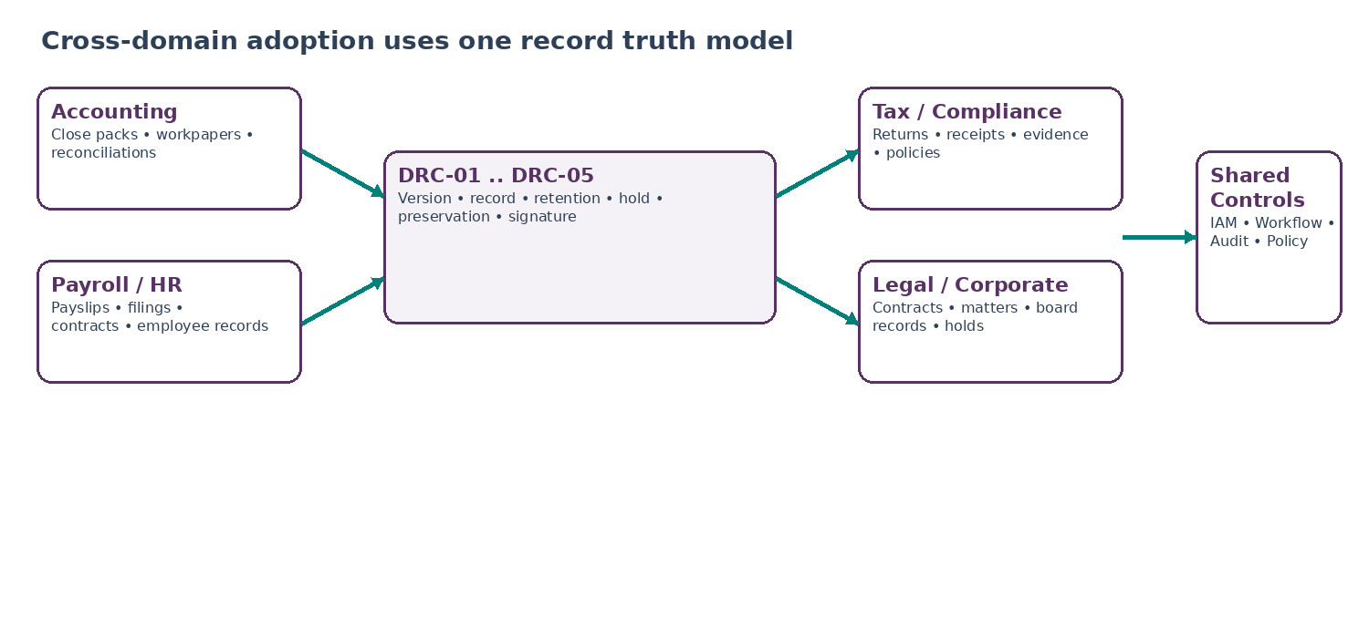
Figure 10 — Cross-domain adoption

13.1 Accounting and finance
Use case | DRC contract
Close/workpaper | Domain creates workpaper version; approval references exact version; approved workpaper is declared record with period/entity context.
Journal support | Attachments are DRC versions; ledger posting stores record/version reference, never uncontrolled binary.
Financial statements | Final approved/signed statement version declared as record; drafts remain working documents.
Reconciliation evidence | Evidence pack may include exact source/working records; export uses controlled manifest.
Audit request | Auditor disclosure package is permission/redaction scoped; audit event and package hash retained.

13.2 Tax and statutory compliance
Use case | DRC contract
Return filing | Exact filed artifact and authority receipt captured as separate related records.
Tax evidence | Record class requires jurisdiction, tax period and entity; retention schedule derives from approved local rules.
Correction/amendment | Amended filing supersedes/relates to prior; original filing evidence remains preserved.
Authority correspondence | Inbound/outbound correspondence captured with matter/entity context; no email attachment shadow store as official record.

13.3 Payroll and HR
Use case | DRC contract
Payslip/payroll report | Generated immutable version; distribution copy can be derivative but payroll record references exact source.
Employment contract | Draft versions may iterate; executed signed artifact is captured and declared as record.
Policy acknowledgment | Attestation/signature evidence references exact policy version; later policy version does not rewrite historic acknowledgment.
Right-to-work/identity evidence | Sensitive classification, strict access/retention; DRC does not infer employment eligibility outcome.
Disciplinary/performance record | Hold/privilege/privacy and jurisdiction schedules applied through record class; correction uses explicit relation.

13.4 Legal, compliance and corporate
Use case | DRC contract
Contract lifecycle | Business/legal domain owns negotiation/outcome; DRC preserves exact drafts if required, executed version, amendments and signature evidence.
Legal matter | Matter service supplies hold scope/authority; DRC resolves/preserves target records and reports coverage failures.
Board records | Approved minutes/resolutions declared as corporate records; draft minutes remain versioned working documents until approval.
Compliance evidence | Control/evidence objects captured with control-period context and exported through manifest-backed packages.
Regulatory submission | Submitted artifact + acknowledgement/receipt are distinct related records; failed submission is not treated as filed merely because a PDF exists.

14. Operational Runbooks and Recovery Procedures

14.1 P0/P1 runbooks
Incident | First response
Cross-tenant exposure suspected | Stop affected read/export paths; revoke scoped URLs/tokens; preserve evidence; engage Security/Privacy; identify affected objects and access events; tenant/regulatory incident process decides notifications.
Unauthorized/held record destruction suspected | Freeze disposition globally or affected scope; preserve job logs/audit/outbox; restore from verified replica if allowed; Legal/Data Governance assess evidence and remediation.
Fixity mismatch | Block authoritative use/export of affected object; compare replicas/manifests; restore only from verified source; record incident and post-repair hash verification.
Hold partial application | Escalate P1; retry target resolution/storage preservation; produce explicit unresolved target list; do not represent hold as complete.
Signature provider ambiguity spike | Pause blind retries; reconcile existing attempts by provider transaction IDs; switch provider only for new transactions under approved policy.
Object storage regional outage | Serve/restore only from approved replica/region; verify hashes and residency; do not bypass region rules to restore convenience.
Retention engine defect | Freeze automatic disposition, not retention evidence; identify affected rule versions/records; recompute in dry-run; approve controlled replay before restart.
Export/redaction defect | Disable affected export profile; preserve package hashes/recipient history; assess disclosure incident; regenerate only under corrected version with new package ID.

14.2 Recovery order
- Stabilize: stop the potentially destructive/leaking control path while leaving read-only evidence available to authorized responders.
- Preserve: freeze relevant DRC metadata, object versions, provider attempts, audit/outbox records and configuration versions.
- Determine authority: identify exact record/version/hold/schedule/signature profile and deployment/config state involved.
- Reconcile external truth: object store, signature provider, replica, archive or delivery endpoint is queried using original durable IDs.
- Repair only from verified sources: never repair hashes/metadata to fit damaged content.
- Replay controlled work: idempotent jobs resume from known step state and emit repair/recovery events.
- Verify: fixity, tenant scope, region, hold, retention and referential integrity tests pass before reopening writes.
- Close: incident/case records include impact, evidence, root cause, corrective action and regression test.

14.3 Administrative controls
- No direct database or object-store mutation is an approved recovery method for controlled records.
- Operator tools call privileged repair APIs that enforce reason, scope, step-up authorization, maker-checker where required and audit evidence.
- Mass backfill/migration jobs run in dry-run/report mode before execute mode and support exact resume checkpoints.
- Support UI never exposes raw object credentials, signing secrets, cross-tenant search or unrestricted legal-hold content.

15. Engineering Certification, Definition of Ready and Definition of Done

15.1 Definition of Ready
Readiness area | Required evidence
Service contracts | DRC-01..05 API schemas, events, idempotency, state machines and ownership ratified.
Record taxonomy | Initial production record classes and required business context fields approved.
Retention schedules | Launch-jurisdiction schedules have owner, legal/policy basis, trigger, duration/action, effective dates and approval.
Hold authority | Roles, maker-checker, scope semantics and target resolver behavior approved by Legal/Security.
Storage/residency | Object stores, regions, encryption/KMS, backup/replica topology and deletion semantics certified.
Malware/content pipeline | Approved scanners/policies, fail-closed behavior and quarantine operations ready.
Preservation profiles | Format/rendition rules and validation tools approved for launch record classes.
Signature providers | Provider due diligence, regional availability, profile mapping, webhook/security and validation behavior certified.
Workflow/IAM/Audit integration | Exact authorization, approval and audit event contracts implemented; no duplicate authority.
Test fixtures | Golden documents, signed artifacts, corrupted objects, hold/retention conflict cases and cross-tenant adversarial fixtures available.

15.2 Definition of Done
Completion gate | Pass standard
Immutable versions | Byte immutability and hash invariants proven under retry, concurrency, migration and restore.
Record declaration | Exact-version record capture, duplicate/idempotent handling and supersession proven.
Retention | Rule resolution, triggers, conflicts, migration and historical version lineage pass certification.
Legal hold | Target resolution, future matching, partial failure, release and disposition block pass certification.
Disposition | Per-target deletion/anonymization evidence, partial/unknown recovery and backup/index propagation pass.
Preservation | Original/rendition lineage, PDF/A where configured, fixity and repair pass.
Signature | Provider ambiguity, webhook replay, artifact capture, validation and amendment paths pass.
Security/privacy | Tenant isolation, malware, break-glass, sensitive metadata, DSR conflict, privilege/export redaction tests pass.
DR/restore | Restored environment passes hash, region, hold, retention, signature and audit continuity checks.
Observability/runbooks | Dashboards, alerts, reconciliations and P0/P1 runbooks rehearsed.
Accessibility/API docs | Admin/user surfaces meet platform accessibility standard; OpenAPI/event docs generated and versioned.
No bypasses | Domain integration tests prove no shadow official attachments or direct destructive object-store paths exist for governed classes.

15.3 Required release blockers
- Any cross-tenant content read/write path.
- Any code path capable of overwriting committed version bytes.
- Any automatic disposition path without retention version + hold check + authorization evidence.
- Any hold state capable of reporting ACTIVE/complete while known unresolved targets are hidden.
- Any signature COMPLETED state without authoritative signed artifact and required validation evidence.
- Any retention schedule using unapproved hard-coded duration for regulated/mandatory classes.
- Any redaction/export path proven to leak hidden source content or protected metadata.
- Any restore procedure that cannot prove hashes, tenant isolation and active holds before service reopening.

16. Eight-Wave Implementation Sequence
Wave | Build scope | Exit gate
Wave 1 — Foundations | document/content IDs, immutable version schema, object-store abstraction, tenant/region/encryption contracts, upload reservation/commit and transactional outbox. | No downstream record features before byte identity is trustworthy.
Wave 2 — Record Capture | record classes, declaration, business-context schemas, relationships/supersession, domain adapters. | Accounting/HR/Legal pilot records can be captured immutably.
Wave 3 — Retention Engine | retention rule registry, trigger contracts, resolver, conflict states, dry-run evaluation. | Automatic deletion remains disabled.
Wave 4 — Legal Hold | hold lifecycle, target resolver/watch, storage-preservation integration, partial-application monitoring, release re-evaluation. | Disposition still dry-run only.
Wave 5 — Preservation & Export | rendition profiles, fixity manifests/jobs, redaction/export package builder, integrity repair APIs. | At least one controlled record class passes preservation/export certification.
Wave 6 — Signature Orchestration | signature profiles, provider abstraction, durable attempts, webhook normalization, artifact capture/validation, record declaration integration. | Provider-specific code stays behind adapter contract.
Wave 7 — Disposition Activation | per-target disposition, backup/index/provider propagation, WFC approval integration, evidence and reconciliation. | Enable only for approved low-risk launch classes first.
Wave 8 — Multi-Domain Certification | Accounting, Tax, Payroll, HR, Legal, Compliance and Corporate adoption; restore/DR, adversarial security, migration and operational rehearsals. | Production go-live only after no-bypass and negative-path gates pass.

16.1 Dependency order
- IAM/authorization, tenant context, policy/rules registry, event catalogue/audit outbox and object-store security primitives must exist before DRC production write paths.
- ZS-SVC-R-001 Workflow/Approval is required before destructive disposition, high-risk export, legal-hold release and controlled signature exceptions can enter production.
- Domain services should integrate after DRC-01/02 contracts stabilize; they must not wait for every advanced preservation/signature capability if their launch class does not require it.
- Automatic disposition is deliberately late because wrong retention logic can destroy evidence irreversibly; dry-run and review modes precede execution.

17. Controlled Open Decisions — Required Before Relevant Production Scope
ID | Decision | Owner | Required before
OD-S01 | Final launch record-class taxonomy and owners. | Data Governance + domain owners | Before domain record declaration.
OD-S02 | Jurisdiction-specific retention schedules, authoritative basis references and effective dates. | Legal/Compliance + domain owners | Before automatic retention evaluation for that jurisdiction.
OD-S03 | Retention rule precedence/conflict matrix for each launch jurisdiction. | Legal/Compliance + Privacy | Before automatic disposition eligibility.
OD-S04 | Hold scope query language and maximum complexity/size safeguards. | Legal + Architecture + SRE | Before large-matter holds.
OD-S05 | Backup/replica deletion and “beyond use” evidence model by storage provider. | Security + Privacy + SRE | Before production disposition.
OD-S06 | Preservation format profiles per record class; whether/where PDF/A-4 is mandatory. | Data Governance + Legal + domain owners | Before preservation automation.
OD-S07 | Fixity verification cadence by record tier and storage class. | SRE + Security + Data Governance | Before long-term preservation SLA.
OD-S08 | Redaction technology/profile and irreversible-redaction validator. | Security + Privacy + Legal | Before protected disclosure export.
OD-S09 | Initial signature/trust providers and jurisdiction/profile eligibility matrix. | Security + Legal + Procurement | Before production e-signature.
OD-S10 | Normalized assurance-level taxonomy and mapping to each provider/jurisdiction. | Legal + Architecture | Before signature profile activation.
OD-S11 | Provider UNKNOWN reconciliation windows/escalation thresholds. | SRE + provider owner | Before signature high-volume launch.
OD-S12 | Object-size limits, file-type allow/block list and encrypted/password-protected file policy. | Security + Product | Before broad upload rollout.
OD-S13 | Archival/tenant offboarding export format and customer handover contract. | Product + Legal + Data Governance | Before enterprise offboarding.
OD-S14 | Whether cryptographic sealing/time-stamping is required for specified record classes beyond provider signature evidence. | Legal + Security | Before those classes launch.
OD-S15 | Formal SLO/RPO/RTO and incident response objectives. | SRE + CTO + Legal where time-sensitive | Before production go-live.

OPEN-DECISION RULE
An open decision blocks only the scope that depends on it. Engineering must not fill a legal, retention, assurance or residency gap with a convenient default. Unresolved mandatory behavior fails closed or remains in review/dry-run mode.

18. Control Matrix and Traceability
Control | Objective | Owner | Invariant | Certification
C01 | Immutable content versions | DRC-01 | DRC-I01–I04 | Version overwrite/retry/concurrency tests.
C02 | Secure upload/quarantine | DRC-01 | DRC-I18–I19 | MIME/malware/scanner outage tests.
C03 | Tenant/region isolation | All | DRC-I05, I29 | Cross-tenant and region-policy adversarial tests.
C04 | Record declaration | DRC-02 | DRC-I03–I04 | Exact-version/duplicate/supersession tests.
C05 | Record classification | DRC-02 | DRC-I06–I08 | Class/file-plan/context validation tests.
C06 | Retention versioning | DRC-03 | DRC-I07–I09 | Historical rule/re-evaluation tests.
C07 | Trigger computation | DRC-03 | DRC-I08 | Late/missing/corrected trigger tests.
C08 | Retention conflict | DRC-03 | DRC-I09 | Mandatory conflict review tests.
C09 | Legal hold | DRC-03 | DRC-I10–I12 | Target/partial/release/DSR tests.
C10 | Disposition evidence | DRC-03 | DRC-I13–I14, I30 | Partial/unknown/backup propagation tests.
C11 | Original vs derivative | DRC-04 | DRC-I15–I17 | OCR/redaction/rendition lineage tests.
C12 | Preservation/fixity | DRC-04 | DRC-I20 | Corruption/repair/format validation tests.
C13 | Controlled export | DRC-04 | DRC-I27 | Redaction/recipient/partial package tests.
C14 | Signature binding | DRC-05 | DRC-I21–I23 | Exact hash/amendment/provider artifact tests.
C15 | Signature ambiguity | DRC-05 | DRC-I24, I30 | Timeout/webhook replay/dedupe tests.
C16 | Authorization boundary | All | DRC-I25 | IAM deny/step-up/break-glass tests.
C17 | Audit boundary | All | DRC-I26 | Outbox failure/audit delivery/replay tests.
C18 | Domain anti-bypass | All | DRC-I28 | Integration scans/contracts for shadow storage.
C19 | Restore integrity | All | DRC-I01, I05, I10, I20 | DR restore activation gate.
C20 | Operational reconciliation | All | DRC-I30 | Metadata/object/hold/provider/index reconciliations.

18.1 Decision rights
Role / service | Authority
Domain owner | Defines business meaning, record capture trigger and required business context; cannot bypass record/retention controls.
Data Governance | Owns record taxonomy, metadata standards, preservation profiles and governance of retention schedule registry.
Legal/Compliance | Owns legal basis, hold authority, legal retention requirements, signature legal-profile interpretation and conflict resolution.
Privacy | Owns storage-limitation/privacy retention posture, DSR conflict interpretation, minimization/redaction policy.
Security | Owns storage/key/security architecture, malware, provider security, privileged access and integrity incident response.
Platform Architecture | Owns service boundaries, APIs/events, idempotency, state machines and integration contracts.
SRE | Owns availability, reconciliation, repair/restore, operational alerting and provider/storage incident execution.
QA | Owns negative-path certification, release blockers, regression packs and evidence of no bypass.
Workflow control | Owns maker-checker/approval/case orchestration; DRC consumes approved decisions.
Audit/Evidence Ledger | Owns immutable event evidence; DRC supplies IDs/hashes and does not duplicate ledger authority.

19. Reference Architecture, Standards Notes and Final Build Position

19.1 Standards notes
Reference | Engineering implication
ISO 15489-1:2016 | Use as the records-management conceptual baseline for records, metadata, controls, responsibility and capture/management processes. Do not claim certification merely from architectural alignment.
ISO 19005-4:2020 (PDF/A-4) | Use as one approved long-term preservation format for suitable page-based documents where record-class policy selects it. It is not the universal format for all ZoikoSuite records.
UK GDPR / ICO storage limitation | Retention periods require purpose-based justification and review; engineering must support schedules, erasure/anonymization and lawful exceptions rather than indefinite default retention.
EU eIDAS / EUDI trust framework | Signature/seal assurance has specific legal effects and provider requirements. DRC-05 must map use cases to approved profiles/providers rather than flattening all e-signatures into one status.

19.2 Source links — verified August 24, 2026
ISO 15489-1:2016: ISO standard page; published/confirmed records-management standard. Source
ISO 19005-4:2020: ISO standard page for PDF/A-4 long-term preservation. Source
ICO storage limitation: UK data-protection guidance on retention schedules, review, erasure/anonymization and purpose limitation. Source
EUR-Lex eIDAS: Consolidated Regulation (EU) No 910/2014, amended by Regulation (EU) 2024/1183. Source
European Commission eSignature FAQ: Explanation of legal effects of electronic and qualified electronic signatures/seals. Source

19.3 Final engineering position
BUILD POSITION
Approve ZS-SVC-S-001 as the canonical ZoikoSuite document and records control baseline. Build DRC-01 and DRC-02 first; implement DRC-03 in dry-run before destructive disposition; then DRC-04 preservation/export and DRC-05 provider-neutral signature orchestration. No domain may treat an uncontrolled attachment store, mutable file path, email copy, OCR result, signature-provider status or search index as the authoritative record system for governed content.

The catalogue should not automatically continue after this pack. The next candidate must be tested against the same threshold: it must close a shared architectural dependency that accounting, tax, payroll, HR, legal, compliance and business operations cannot safely or efficiently implement independently. A convenience service is not sufficient reason for another controlled wireframe.

