ZOIKOSUITE

Data Quality, Reconciliation, Lineage
& Control Totals Control
Detailed Service Specifications
Version 1.0 — DQC-01 through DQC-05 Build-Ready Shared Control Baseline
GOVERNING DOCTRINE
ZoikoSuite must be able to prove that material data is complete, valid, balanced, traceable and reproducible from source through transformation to domain outcome. Data-quality controls may detect, quarantine, reconcile and certify; they may never silently rewrite authoritative business truth merely to make a control pass.

Control | Value
Document ID | ZS-SVC-Z-001
Version | 1.0
Status | Build-ready shared control baseline
Owner | ZoikoSuite Platform Architecture / Data Governance
Prepared for | Engineering, Accounting, Finance, Payroll, HR, Tax, Legal, Compliance, Security, Data, QA, Operations
Language | American English
Classification | Internal — Engineering / Architecture Control
Date | 24 August 2026

0. Executive necessity gate
Why this control plane exists — and why it is the next necessary shared dependency.
The approved ZoikoSuite architecture already separates identity, commercial entitlement, workflow, records, integration, master data, policy, privacy, AI and communication authority. Those controls still rely on one unanswered platform question: can ZoikoSuite prove that the data moving between them is complete, valid, balanced, traceable and historically reproducible?
NECESSITY TEST
Without a canonical data-quality and reconciliation plane, every domain would independently implement schema checks, duplicate detection, control totals, balancing, source-to-target reconciliation, lineage, data-quality exceptions and certification. That creates incompatible evidence and makes cross-domain failures extremely difficult to isolate.

Candidate responsibility | Decision
Data validation / quality contracts | IN SCOPE — shared and unavoidable
Cross-system reconciliation and control totals | IN SCOPE — shared and unavoidable
Data lineage / provenance | IN SCOPE — required for auditability and incident isolation
Remediation workflow | OUT — WFC owns workflow; DQC raises governed exceptions
Master-record correction | OUT — MDM/domain authority owns correction
Accounting balancing/posting | OUT — accounting domain owns ledger truth
ETL / transport | OUT — XIC/data pipeline owns movement; DQC observes and certifies
Analytics / BI | OUT — consumer; cannot become quality authority
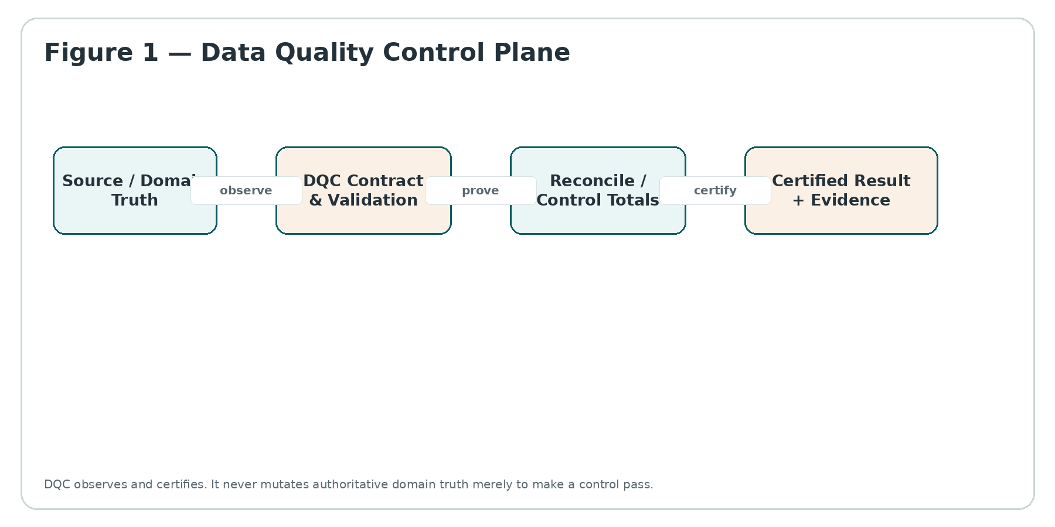
Figure 1 — Data Quality Control Plane

1. Scope, boundaries and operating doctrine
ZS-SVC-Z-001 defines the server-authoritative shared control plane for data-quality contracts, validation evidence, reconciliation/control totals, lineage/provenance, certification and controlled data-quality exceptions. It is intentionally not a data warehouse, integration platform, master-data hub, workflow engine or domain ledger.
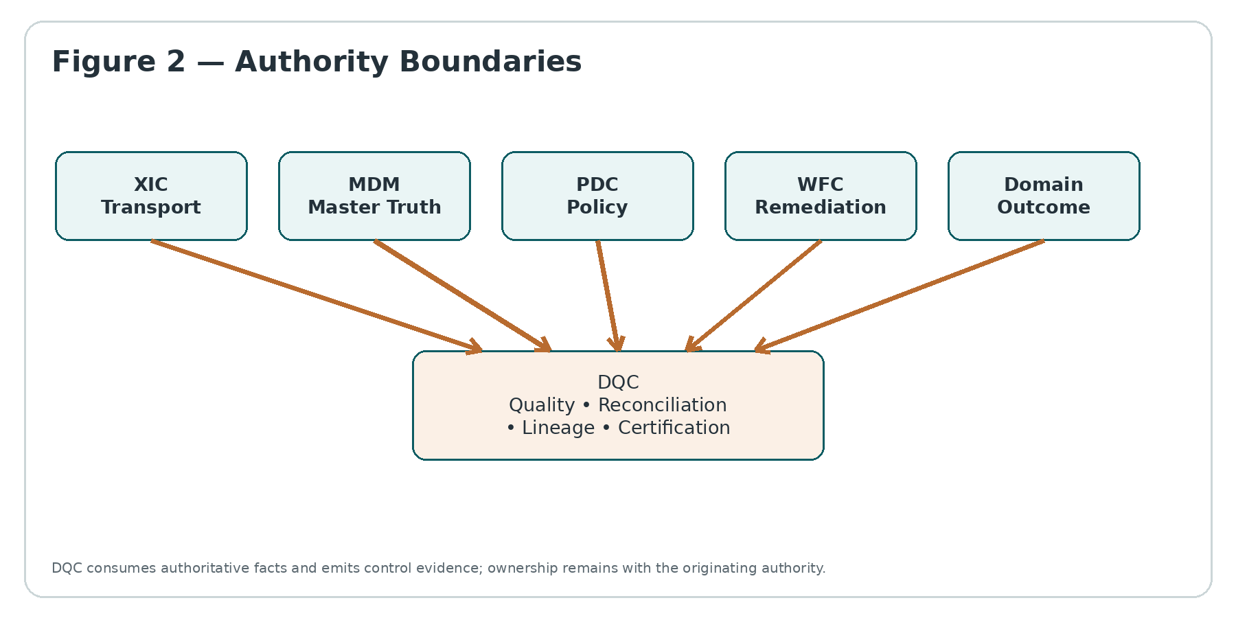
Figure 2 — Authority Boundaries
Authority | Owns | DQC relationship
XIC | Transport, connector contracts, replay, external exchange | DQC validates payload/data outcomes after or during controlled exchange; it does not own connectivity.
MDM | Canonical party/entity/reference truth | DQC can test conformance and stale/invalid references; it cannot overwrite master truth.
PDC | Policy/rule applicability and deterministic policy decisions | DQC may execute technical quality predicates and bind to PDC policy decisions; it does not author statutory rules.
WFC | Workflow, approvals, cases and obligations | DQC raises exceptions/certification blockers; WFC orchestrates remediation.
DRC | Records, retention, hold, signed/declared record lifecycle | DQC stores references/hashes to retained evidence; it does not become record authority.
PRV | Purpose, privacy permission, rights and transfer privacy governance | DQC data access is purpose-scoped and must consume PRV decisions where personal data is involved.
Domain services | Business truth, calculation, posting, filing, payroll, contract outcome | DQC may block certification or downstream consumption but never rewrites the domain outcome to force balance.

2. Canonical service catalogue
Service | Canonical name | Authoritative responsibility
DQC-01 | Data Contract & Quality Rule Registry | Immutable, versioned technical data contracts, quality dimensions, thresholds, tolerances and certification profiles.
DQC-02 | Validation, Profiling & Quarantine Service | Runtime observation, schema/semantic validation, profiling, duplicate/anomaly evidence and controlled quarantine.
DQC-03 | Reconciliation, Control Total & Balance Certification Service | Source-to-target reconciliation, control totals, multi-currency/period dimensions, tolerances and variance certification.
DQC-04 | Lineage, Provenance & Transformation Trace Service | Dataset/job/run lineage, field-level provenance where required, code/config versions and source-to-outcome traceability.
DQC-05 | Quality Exception, Certification & Remediation Control Service | Quality incident state, certification gates, exception evidence, WFC handoff, re-test and governed closure.
SERVER-AUTHORITATIVE RULE
A UI badge, dashboard percentage, ETL “success” flag, provider response or analyst spreadsheet can never promote a dataset or reconciliation run to CERTIFIED. Only DQC may issue a DQC certification outcome, and only when its exact evidence requirements are satisfied.

3. Canonical state architecture
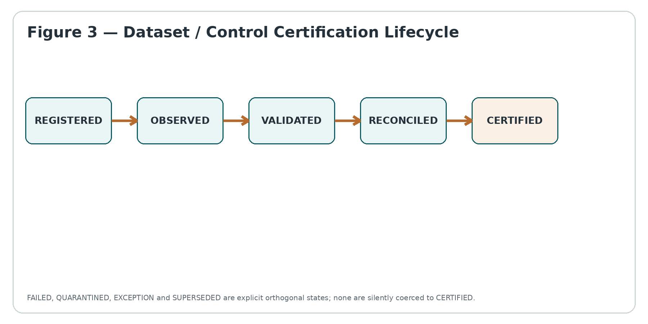
Figure 3 — Dataset / Control Certification Lifecycle
State dimension | Representative states | Rule
Observation | NOT_OBSERVED / OBSERVED / STALE | Observation only proves evidence exists; it does not imply quality.
Validation | NOT_RUN / PASS / FAIL / INDETERMINATE | INDETERMINATE is never coerced to PASS.
Reconciliation | NOT_RUN / MATCH / VARIANCE / INDETERMINATE | MATCH is only within the versioned control definition and tolerance.
Quarantine | NONE / PARTIAL / FULL / RELEASE_PENDING | Release requires governed evidence; quarantine is not deletion.
Certification | UNCERTIFIED / ELIGIBLE / CERTIFIED / REVOKED / SUPERSEDED | Certification binds exact evidence, contracts and lineage.
Exception | NONE / OPEN / INVESTIGATING / REMEDIATED / ACCEPTED_RISK / CLOSED | Accepted risk never silently changes a FAIL into PASS.

4. Canonical data model and persistence boundaries
Entity | Purpose
DataAsset | Stable identity for a dataset, topic, file class, API payload class, report extract or domain control population.
DataContractVersion | Immutable published contract: schema, dimensions, rules, thresholds, tolerance and certification profile.
ObservationRun | Exact observation window, source identity, watermarks, counts, hashes and evidence references.
ValidationResult | Rule-level PASS/FAIL/INDETERMINATE with observed values, threshold, severity and evidence.
ReconciliationDefinition | Versioned source/target populations, keys, dimensions, control totals, tolerances and timing semantics.
ReconciliationRun | Exact execution against pinned populations and definition version.
Variance | Unresolved mismatch with dimension/key, expected/actual values, materiality and root-cause state.
LineageNode | Dataset/job/domain-result identity and version.
LineageEdge | Produced-from/consumed-by relation with run identity, code/config version and time semantics.
Certification | Signed/immutable certification record binding exact evidence set and authority.
QualityException | Governed issue identity; references WFC case when remediation is required.
ControlEvidenceRef | Hash/URI/reference into immutable audit/record authority; never a mutable “latest” pointer.
HISTORICAL RULE
A later contract, tolerance or transformation change never rewrites the certification basis of a posted journal, issued invoice, paid payroll result, filed return, signed contract or previously certified dataset. Reproduction pins the exact historical contract and lineage run.

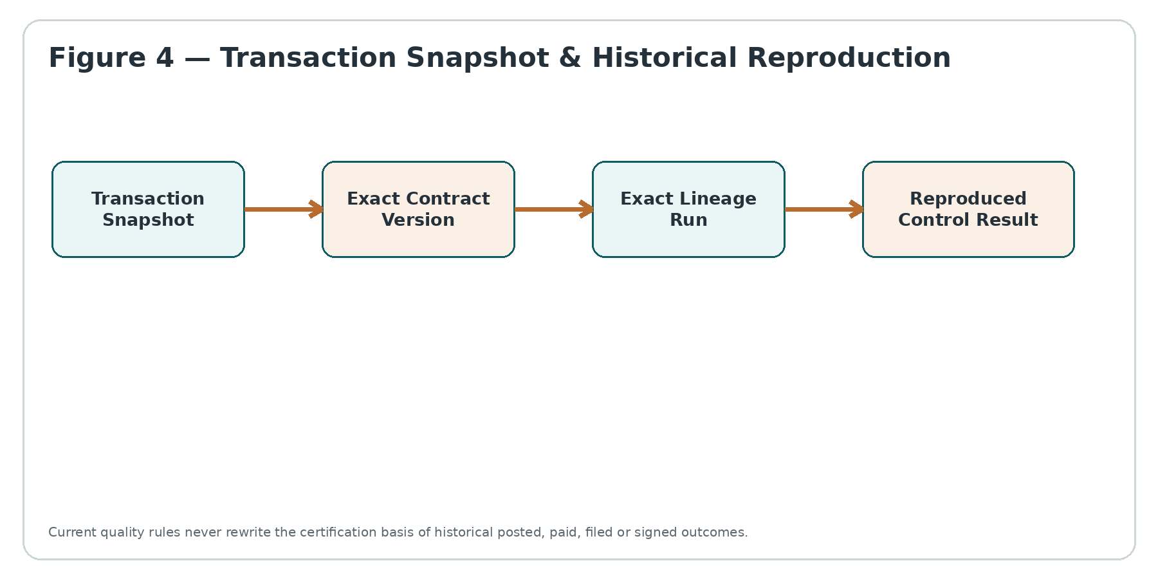
Figure 4 — Transaction Snapshot & Historical Reproduction

5. DQC-01 — Data Contract & Quality Rule Registry
DQC-01 owns the technical contract that tells ZoikoSuite what data is expected and how its quality is measured. It is not a statutory/legal policy engine; legal applicability remains in PDC. A DQC contract can reference a PDC decision or domain policy version when technical quality requirements depend on them.
Contract component | Required behavior
Asset identity | Stable DataAsset ID; no environment-local free-text as the sole identity.
Schema | Field/type/nullability/format constraints with explicit compatibility mode.
Semantic predicates | Cross-field/domain technical predicates; deterministic and versioned.
Quality dimensions | Completeness, validity, consistency, uniqueness, accuracy proxies, timeliness, integrity and traceability.
Severity | INFO / WARNING / ERROR / BLOCKER; severity is versioned and cannot be edited retroactively.
Tolerance | Explicit numeric or percentage tolerance, scale/rounding semantics and population definition.
Certification profile | Which rules/evidence are mandatory before eligible for certification.
Publication | DRAFT → REVIEW → PUBLISHED → DEPRECATED / RETIRED; published versions immutable.
Compatibility | Backward/forward/full/none declared and tested; unknown-breaking changes block release.
API | Purpose | Critical semantics
POST /dqc/contracts | Create draft | No production use until published.
POST /dqc/contracts/{id}/publish | Publish immutable version | Requires maker-checker / WFC approval where classified material.
GET /dqc/contracts/{id}/versions/{v} | Read exact version | Historical versions never resolve through “latest”.
POST /dqc/contracts/{id}/compatibility-check | Evaluate change | Returns explicit breaking-change evidence.

6. DQC-02 — Validation, Profiling & Quarantine Service
DQC-02 observes material data and evaluates it against an exact DQC-01 contract. It captures rule-level evidence and can quarantine suspect data from downstream certified use. Quarantine is a control state, not deletion and not a domain correction mechanism.
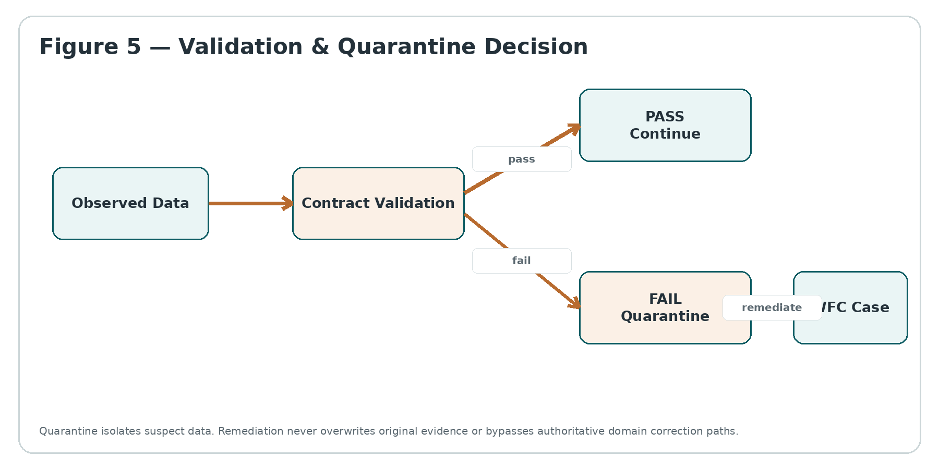
Figure 5 — Validation & Quarantine Decision
Validation class | Examples | Behavior
Structural | Required fields, type, format, schema version | Fail closed for BLOCKER rules; unknown schema is not guessed.
Completeness | Population counts, mandatory coverage, missing periods | Uses explicit denominator/population; no misleading percentage from filtered rows.
Uniqueness | Primary/business keys, duplicate event keys | Dedup evidence preserved; DQC cannot arbitrarily delete duplicate source records.
Consistency | Cross-field, cross-table, master-reference checks | References exact MDM/domain snapshots.
Timeliness | Freshness, watermark, expected arrival window | Stale data cannot be silently treated as current.
Distribution/anomaly | Unexpected ranges or statistical shifts | Advisory unless contract explicitly makes it blocking; model thresholds are versioned.
Integrity | Hash/checksum, referential integrity, sequence continuity | Evidence includes algorithm/version and source boundary.
QUARANTINE INVARIANT
Quarantine can block a dataset or subset from certified downstream use. It cannot manufacture a replacement record, alter a ledger/payroll/tax outcome, or silently discard the original evidence.

7. DQC-03 — Reconciliation, Control Total & Balance Certification Service
DQC-03 proves that two or more independently identified populations agree within an explicit versioned reconciliation definition. “Balanced” always means balanced for a stated population, dimension, currency, period, tolerance and evidence window — never a generic boolean.
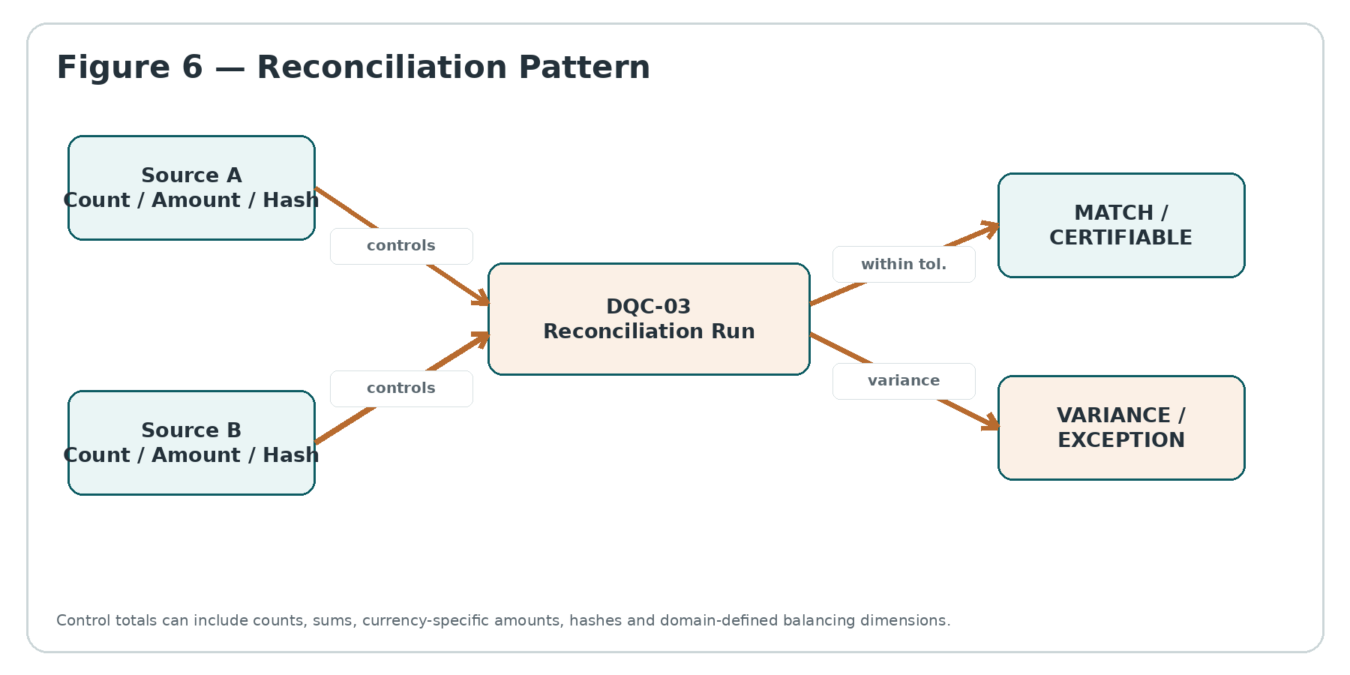
Figure 6 — Reconciliation Pattern
Control-total type | Examples | Required safeguards
Record count | Rows/events/items by period/entity | Population and dedup basis pinned.
Monetary sum | Debit/credit, gross/net, invoice/payment | Currency, scale, rounding and sign convention explicit.
Hash total | Stable hash over selected canonical fields | Canonical serialization and algorithm/version pinned.
Sequence total | Event/statement sequence continuity | Gaps/duplicates explicit; wrap/reset semantics defined.
Dimensional balance | By entity, account, worker, tax authority, bank account | No aggregate-only pass when material sub-dimension is out of balance.
Cross-period roll-forward | Opening + movement = closing | Opening provenance and correction windows explicit.
Reconciliation result | Meaning
MATCH | All mandatory controls are within explicit tolerance and evidence is complete.
VARIANCE | At least one control exceeds tolerance; cannot be certified as match.
INDETERMINATE | Required source/evidence unavailable or stale; cannot be coerced to MATCH.
PARTIAL | Only defined subset matched; never presented as full population certification.
SUPERSEDED | Re-run exists with corrected source/version; earlier evidence remains immutable.

8. DQC-04 — Lineage, Provenance & Transformation Trace Service
DQC-04 provides the evidentiary graph from source data through transformations to canonical datasets and material domain outputs. The graph is intentionally evidence-oriented: lineage proves what fed what; it does not grant access or authorize a business action.
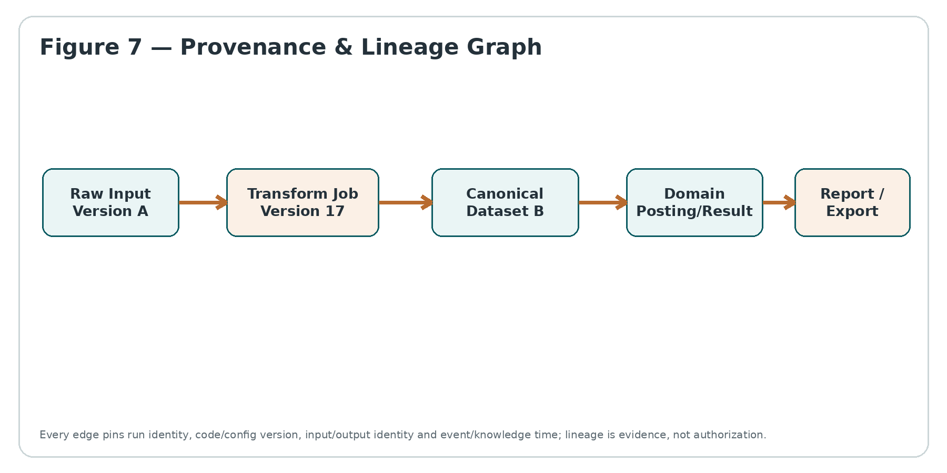
Figure 7 — Provenance & Lineage Graph
Lineage fact | Minimum captured fields
Dataset identity | Namespace, asset ID, physical locator reference, schema/contract version.
Job identity | Stable job ID, deployment/build version, configuration hash.
Run identity | Unique run ID, start/end/event time, status, environment, region.
Input edge | Exact input version/watermark/snapshot, consumed columns where material.
Output edge | Exact output version/watermark/snapshot, produced columns where material.
Code/config provenance | Commit/build/package identifiers and immutable configuration digest.
Human/manual intervention | Actor, approved action, before/after references and WFC/audit evidence.
Domain result edge | Exact journal batch, payroll run, invoice set, filing package or legal artifact reference.
ACCESS BOUNDARY
Lineage metadata must never become a side channel for cross-tenant, privileged, personal or legally protected data. Search/display of lineage remains subject to IAM, PRV, residency and domain authorization.

9. DQC-05 — Quality Exception, Certification & Remediation Control Service
DQC-05 converts DQC evidence into a governed certification or exception outcome. It owns the quality exception identity and certification state; WFC owns the remediation workflow and approvals. A quality exception can be accepted as risk only through a defined authority path and cannot be relabeled PASS.
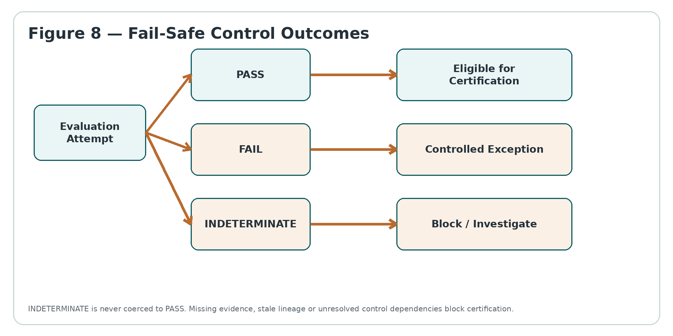
Figure 8 — Fail-Safe Control Outcomes
Certification requirement | Rule
Pinned evidence | Exact observation, validation, reconciliation, lineage and contract versions.
Authority | Named certifier role/service; IAM authorization checked at action time.
Freshness | Evidence freshness window is explicit; stale evidence invalidates eligibility.
Open blockers | No unresolved BLOCKER exception unless certification profile explicitly permits and records governed risk acceptance.
Signature/hash | Certification payload is integrity-protected and audit-evidenced.
Revocation | New material evidence may revoke certification prospectively; prior certification history remains.
Re-test | Remediation requires new evidence run; closing a WFC case alone does not change DQC outcome.

10. Non-bypassable invariants
- INV-01 Published DQC contract versions are immutable.
- INV-02 Historical certification resolves exact contract versions, never mutable latest pointers.
- INV-03 DQC never mutates authoritative domain truth merely to make a control pass.
- INV-04 PASS requires complete mandatory evidence; missing evidence yields INDETERMINATE or FAIL as defined.
- INV-05 INDETERMINATE can never be coerced to PASS or MATCH.
- INV-06 Transport success never implies data-quality success.
- INV-07 ETL/job success never implies reconciliation success.
- INV-08 Aggregate balance cannot conceal a material sub-dimension variance.
- INV-09 Tolerance, rounding, scale and population are explicit and versioned.
- INV-10 Currency totals never combine different currencies without an explicit conversion contract and rate provenance.
- INV-11 Quarantine never deletes original evidence.
- INV-12 Quarantine release cannot bypass authoritative domain correction and re-validation.
- INV-13 Duplicate detection does not authorize deletion of source records.
- INV-14 Stale data cannot be silently treated as current.
- INV-15 Unknown schema or contract versions are never guessed.
- INV-16 Lineage metadata is evidence, not authorization.
- INV-17 Cross-tenant lineage, quality evidence and exceptions are isolated by tenant boundary.
- INV-18 Manual overrides require actor, reason, authority and immutable evidence.
- INV-19 Accepted risk never changes a failed rule to PASS.
- INV-20 Closing a remediation workflow does not automatically certify data.
- INV-21 Certification binds exact observation/reconciliation/lineage evidence.
- INV-22 A later contract change never rewrites historical certification.
- INV-23 A re-run never deletes or overwrites the earlier run.
- INV-24 Control-total hashes pin canonical serialization and algorithm version.
- INV-25 Control populations must be independently identifiable and reproducible.
- INV-26 A partial reconciliation cannot be represented as full certification.
- INV-27 Quality dashboards are projections and cannot mutate authoritative DQC state.
- INV-28 AI/anomaly models may flag quality risk but cannot independently certify material data.
- INV-29 Privacy, residency, legal hold and access controls apply to DQC evidence and lineage.
- INV-30 Certification/revocation events are durable, idempotent and audit-evidenced.

11. API contracts and idempotency
Endpoint | Idempotency / concurrency rule | Output
POST /dqc/observations | Idempotency key required per asset + window + source watermark | ObservationRun
POST /dqc/validate | Same pinned asset/contract/evidence returns same logical result | ValidationRun
POST /dqc/reconciliations/{id}/runs | Run key pins definition + populations + window | ReconciliationRun
POST /dqc/certifications | Unique certification basis hash; conflict returns existing certification or 409 | Certification
POST /dqc/exceptions | Dedup key prevents alert storms for same control/root evidence | QualityException
POST /dqc/quarantine/release | Optimistic concurrency + authority check + reason required | Release decision
GET /dqc/lineage | Read-only projection; authorization filtered | Lineage graph
SIDE-EFFECT RULE
DQC APIs can create DQC evidence, quarantine/control state and governed exceptions. They cannot directly post accounting entries, alter payroll, re-file tax, amend contracts, rewrite master data or change external-provider state.

12. Event contracts and ordering
Event | Producer | Key required fields
dqc.observation.completed | DQC-02 | tenant_id, asset_id, observation_run_id, window, watermark, evidence_hash
dqc.validation.completed | DQC-02 | contract_version, result, blocking_rules, evidence_refs
dqc.reconciliation.completed | DQC-03 | definition_version, result, variance_count, control_totals
dqc.lineage.recorded | DQC-04 | run_id, input/output node IDs, code/config digest
dqc.exception.opened | DQC-05 | exception_id, severity, control_id, evidence_refs, WFC case ref if any
dqc.certification.issued | DQC-05 | certification_id, basis_hash, certifier, scope, evidence refs
dqc.certification.revoked | DQC-05 | prior certification ID, reason, effective time
Ordering is per material control key, not globally. Consumers must be idempotent. Late-arriving evidence creates a new observation/reconciliation/certification transition; it never mutates an already emitted historical event.

13. Cross-domain adoption contracts
Domain | Representative control | Boundary
Accounting / Close | Trial balance, journal batches, subledger-to-GL, opening/closing balances | DQC certifies control totals and lineage; accounting owns postings and close approval.
Billing / Collections | Rated usage → invoice, invoice → payment/processor, settlement reconciliation | DQC proves populations and variances; commercial billing owns invoice/payment state.
Payroll | Input population → gross-to-net output → payment file → bank result | DQC checks completeness/control totals; payroll engine owns calculations and payroll state.
Tax | Source transactions → return workpaper → filing package → authority acknowledgment | DQC proves coverage and trace; tax domain/PDC owns tax determination and filing authority.
HR | Worker/position/leave/benefit datasets across HR processes | DQC detects missing/inconsistent records; HR owns employment facts and decisions.
Legal / Compliance | Obligation populations, contract registers, legal-hold coverage, disclosure sets | DQC proves population completeness/traceability; Legal/DRC/WFC own legal outcomes.
External Integration | Inbound/outbound payloads, batch manifests, provider reconciliation | XIC moves data; DQC validates/reconciles material business populations.

14. Security, privacy, residency and evidence
- DQC stores only the data necessary to evaluate and evidence controls. High-volume raw payloads should remain in authoritative/controlled stores; DQC persists hashes, metrics, sample references or privacy-approved excerpts where sufficient.
- Quality evidence inherits tenant, region/residency, classification, legal-hold and privacy-purpose constraints. Cross-region centralization of raw quality samples is prohibited unless explicitly authorized.
- Lineage graphs must be authorization-filtered. The existence of a privileged dataset, legal matter, employee case or sensitive field can itself be confidential metadata.
- Credentials, provider secrets and database passwords are never stored in DQC contracts or lineage metadata; references resolve through approved secret/config authorities.
- All certification, override, quarantine-release and accepted-risk actions require server-side IAM authorization and durable audit evidence.

15. Observability, SLOs and operational runbooks
Signal | Required metric / control
Freshness | Age since last successful observation per critical asset; breach by certification profile.
Validation | PASS/FAIL/INDETERMINATE rates by rule severity and asset.
Reconciliation | Variance count/value, unresolved materiality, aging and repeat variance signature.
Lineage | Coverage of material outputs with complete source/run provenance.
Quarantine | Population size, age, release attempts and downstream blocked consumers.
Certification | Eligible/certified/revoked counts and evidence age.
Platform | Latency, throughput, backlog, retry, error and storage-integrity metrics.
Runbook | Trigger | Mandatory first actions
RB-01 Missing source population | Expected watermark/window absent | Mark INDETERMINATE; block affected certification; confirm XIC/source state.
RB-02 Material variance | Tolerance exceeded | Freeze certification, capture evidence, open DQC exception/WFC case, isolate dimension.
RB-03 Lineage gap | Material output has no complete provenance | Block certification; identify missing run/edge; do not infer lineage.
RB-04 Contract-breaking change | Producer emits incompatible schema | Quarantine affected data; pin failing version; coordinate producer rollback/new contract.
RB-05 Suspected false PASS | Control defect discovered | Revoke affected certification prospectively, preserve prior evidence, assess blast radius.
RB-06 Cross-tenant evidence leak | Unauthorized metadata/data exposure | Contain access, notify security/privacy control plane, preserve incident evidence.

16. Negative-path certification matrix — 60 mandatory scenarios
ID | Class | Scenario | Required outcome
NP-01 | Contract & schema | Unknown contract version received | Must fail safe; preserve evidence; block or isolate affected certification; raise governed exception where material.
NP-02 | Contract & schema | Published contract edited in place | Must fail safe; preserve evidence; block or isolate affected certification; raise governed exception where material.
NP-03 | Contract & schema | Required field disappears without compatibility approval | Must fail safe; preserve evidence; block or isolate affected certification; raise governed exception where material.
NP-04 | Contract & schema | Producer changes scale/precision silently | Must fail safe; preserve evidence; block or isolate affected certification; raise governed exception where material.
NP-05 | Contract & schema | Nullability widened for blocking field | Must fail safe; preserve evidence; block or isolate affected certification; raise governed exception where material.
NP-06 | Contract & schema | Enum value outside governed domain | Must fail safe; preserve evidence; block or isolate affected certification; raise governed exception where material.
NP-07 | Contract & schema | Schema fingerprint mismatch | Must fail safe; preserve evidence; block or isolate affected certification; raise governed exception where material.
NP-08 | Contract & schema | Wrong tenant contract applied | Must fail safe; preserve evidence; block or isolate affected certification; raise governed exception where material.
NP-09 | Contract & schema | Deprecated contract used after cutoff | Must fail safe; preserve evidence; block or isolate affected certification; raise governed exception where material.
NP-10 | Contract & schema | Contract publish bypasses required maker-checker | Must fail safe; preserve evidence; block or isolate affected certification; raise governed exception where material.
ID | Class | Scenario | Required outcome
NP-11 | Validation & quarantine | Missing mandatory population | Must fail safe; preserve evidence; block or isolate affected certification; raise governed exception where material.
NP-12 | Validation & quarantine | Duplicate business key burst | Must fail safe; preserve evidence; block or isolate affected certification; raise governed exception where material.
NP-13 | Validation & quarantine | Stale watermark presented as current | Must fail safe; preserve evidence; block or isolate affected certification; raise governed exception where material.
NP-14 | Validation & quarantine | Hash/checksum mismatch | Must fail safe; preserve evidence; block or isolate affected certification; raise governed exception where material.
NP-15 | Validation & quarantine | Quarantined rows leak to certified consumer | Must fail safe; preserve evidence; block or isolate affected certification; raise governed exception where material.
NP-16 | Validation & quarantine | Operator releases quarantine without authority | Must fail safe; preserve evidence; block or isolate affected certification; raise governed exception where material.
NP-17 | Validation & quarantine | Remediation overwrites original evidence | Must fail safe; preserve evidence; block or isolate affected certification; raise governed exception where material.
NP-18 | Validation & quarantine | Anomaly model alone marks PASS | Must fail safe; preserve evidence; block or isolate affected certification; raise governed exception where material.
NP-19 | Validation & quarantine | Sample validation represented as full population | Must fail safe; preserve evidence; block or isolate affected certification; raise governed exception where material.
NP-20 | Validation & quarantine | Failed rule hidden from dashboard/certification | Must fail safe; preserve evidence; block or isolate affected certification; raise governed exception where material.
ID | Class | Scenario | Required outcome
NP-21 | Reconciliation | Aggregate total matches but entity sub-total does not | Must fail safe; preserve evidence; block or isolate affected certification; raise governed exception where material.
NP-22 | Reconciliation | Cross-currency values summed without conversion contract | Must fail safe; preserve evidence; block or isolate affected certification; raise governed exception where material.
NP-23 | Reconciliation | Tolerance altered after run to force match | Must fail safe; preserve evidence; block or isolate affected certification; raise governed exception where material.
NP-24 | Reconciliation | Rounding mode differs source vs target | Must fail safe; preserve evidence; block or isolate affected certification; raise governed exception where material.
NP-25 | Reconciliation | Source window and target window misaligned | Must fail safe; preserve evidence; block or isolate affected certification; raise governed exception where material.
NP-26 | Reconciliation | Partial population labeled full match | Must fail safe; preserve evidence; block or isolate affected certification; raise governed exception where material.
NP-27 | Reconciliation | Missing source coerced to zero | Must fail safe; preserve evidence; block or isolate affected certification; raise governed exception where material.
NP-28 | Reconciliation | Re-run overwrites earlier variance evidence | Must fail safe; preserve evidence; block or isolate affected certification; raise governed exception where material.
NP-29 | Reconciliation | Manual plug entry used only to make control pass | Must fail safe; preserve evidence; block or isolate affected certification; raise governed exception where material.
NP-30 | Reconciliation | Bank/provider timeout treated as reconciled failure/success | Must fail safe; preserve evidence; block or isolate affected certification; raise governed exception where material.
ID | Class | Scenario | Required outcome
NP-31 | Lineage & provenance | Output has no input lineage | Must fail safe; preserve evidence; block or isolate affected certification; raise governed exception where material.
NP-32 | Lineage & provenance | Lineage points to mutable latest dataset | Must fail safe; preserve evidence; block or isolate affected certification; raise governed exception where material.
NP-33 | Lineage & provenance | Job version missing | Must fail safe; preserve evidence; block or isolate affected certification; raise governed exception where material.
NP-34 | Lineage & provenance | Config digest missing | Must fail safe; preserve evidence; block or isolate affected certification; raise governed exception where material.
NP-35 | Lineage & provenance | Field-level lineage fabricated from naming convention | Must fail safe; preserve evidence; block or isolate affected certification; raise governed exception where material.
NP-36 | Lineage & provenance | Cross-tenant lineage edge created | Must fail safe; preserve evidence; block or isolate affected certification; raise governed exception where material.
NP-37 | Lineage & provenance | Privileged dataset name disclosed to unauthorized user | Must fail safe; preserve evidence; block or isolate affected certification; raise governed exception where material.
NP-38 | Lineage & provenance | Manual transformation lacks actor/evidence | Must fail safe; preserve evidence; block or isolate affected certification; raise governed exception where material.
NP-39 | Lineage & provenance | Backfill lineage rewrites original run history | Must fail safe; preserve evidence; block or isolate affected certification; raise governed exception where material.
NP-40 | Lineage & provenance | Lineage metadata treated as authorization | Must fail safe; preserve evidence; block or isolate affected certification; raise governed exception where material.
ID | Class | Scenario | Required outcome
NP-41 | Certification & exception | INDETERMINATE coerced to PASS | Must fail safe; preserve evidence; block or isolate affected certification; raise governed exception where material.
NP-42 | Certification & exception | Open blocker ignored during certification | Must fail safe; preserve evidence; block or isolate affected certification; raise governed exception where material.
NP-43 | Certification & exception | Expired evidence used to certify | Must fail safe; preserve evidence; block or isolate affected certification; raise governed exception where material.
NP-44 | Certification & exception | Accepted risk relabeled PASS | Must fail safe; preserve evidence; block or isolate affected certification; raise governed exception where material.
NP-45 | Certification & exception | WFC case closure auto-certifies without re-test | Must fail safe; preserve evidence; block or isolate affected certification; raise governed exception where material.
NP-46 | Certification & exception | Certification basis uses mixed contract versions | Must fail safe; preserve evidence; block or isolate affected certification; raise governed exception where material.
NP-47 | Certification & exception | Certification revoked with no reason/evidence | Must fail safe; preserve evidence; block or isolate affected certification; raise governed exception where material.
NP-48 | Certification & exception | Dashboard directly edits certification state | Must fail safe; preserve evidence; block or isolate affected certification; raise governed exception where material.
NP-49 | Certification & exception | Unauthorized certifier issues certification | Must fail safe; preserve evidence; block or isolate affected certification; raise governed exception where material.
NP-50 | Certification & exception | Late evidence silently rewrites prior certification | Must fail safe; preserve evidence; block or isolate affected certification; raise governed exception where material.
ID | Class | Scenario | Required outcome
NP-51 | Cross-domain / resilience | Payroll file count differs bank payment count | Must fail safe; preserve evidence; block or isolate affected certification; raise governed exception where material.
NP-52 | Cross-domain / resilience | Subledger-to-GL variance hidden by aggregate balancing | Must fail safe; preserve evidence; block or isolate affected certification; raise governed exception where material.
NP-53 | Cross-domain / resilience | Filed tax population omits source transactions | Must fail safe; preserve evidence; block or isolate affected certification; raise governed exception where material.
NP-54 | Cross-domain / resilience | Billing usage event replay duplicates invoiced population | Must fail safe; preserve evidence; block or isolate affected certification; raise governed exception where material.
NP-55 | Cross-domain / resilience | HR termination record missing downstream payroll stop | Must fail safe; preserve evidence; block or isolate affected certification; raise governed exception where material.
NP-56 | Cross-domain / resilience | Legal-hold population omits known custodian dataset | Must fail safe; preserve evidence; block or isolate affected certification; raise governed exception where material.
NP-57 | Cross-domain / resilience | Integration replay duplicates historical domain effects | Must fail safe; preserve evidence; block or isolate affected certification; raise governed exception where material.
NP-58 | Cross-domain / resilience | Region failover loses quality evidence watermark | Must fail safe; preserve evidence; block or isolate affected certification; raise governed exception where material.
NP-59 | Cross-domain / resilience | DQC outage causes domain to assume PASS | Must fail safe; preserve evidence; block or isolate affected certification; raise governed exception where material.
NP-60 | Cross-domain / resilience | Backup restore loses lineage/certification linkage | Must fail safe; preserve evidence; block or isolate affected certification; raise governed exception where material.

17. Stable error and reason code catalogue
Code | Stable meaning
DQC-001 | CONTRACT_NOT_FOUND
DQC-002 | CONTRACT_VERSION_UNKNOWN
DQC-003 | SCHEMA_INCOMPATIBLE
DQC-004 | VALIDATION_FAILED
DQC-005 | VALIDATION_INDETERMINATE
DQC-006 | DATA_STALE
DQC-007 | DUPLICATE_DETECTED
DQC-008 | QUARANTINED
DQC-009 | QUARANTINE_RELEASE_DENIED
DQC-010 | RECONCILIATION_VARIANCE
DQC-011 | RECONCILIATION_INDETERMINATE
DQC-012 | CONTROL_POPULATION_MISMATCH
DQC-013 | LINEAGE_INCOMPLETE
DQC-014 | PROVENANCE_MISMATCH
DQC-015 | CERTIFICATION_BLOCKED
DQC-016 | CERTIFICATION_STALE
DQC-017 | CERTIFICATION_REVOKED
DQC-018 | EVIDENCE_INCOMPLETE
DQC-019 | CROSS_TENANT_DENIED
DQC-020 | POLICY_OR_AUTHORITY_DENIED

18. Traceability controls
ID | Control
TC-01 | Every material DataAsset has an owner, tenant scope, classification and authoritative source.
TC-02 | Every production observation pins the exact DataContractVersion.
TC-03 | Every rule result stores expected predicate/threshold and observed evidence.
TC-04 | Every reconciliation run pins source/target populations and windows.
TC-05 | Every monetary total stores currency, scale and rounding semantics.
TC-06 | Every tolerance is versioned and included in the basis hash.
TC-07 | Every quarantine action records affected population and immutable evidence.
TC-08 | Every quarantine release records authority, reason and re-validation result.
TC-09 | Every lineage edge pins run identity and code/config version.
TC-10 | Every material manual intervention has actor + before/after references.
TC-11 | Every DQC exception references originating rule/control and evidence.
TC-12 | Every WFC remediation case links back to the DQC exception.
TC-13 | Every certification binds exact evidence set and freshness state.
TC-14 | Every certification/revocation is audit-evidenced.
TC-15 | Every historical reproduction uses as-of contract/lineage, not current configuration.
TC-16 | Every cross-domain quality assertion identifies the domain authority it observes.
TC-17 | Every accepted-risk decision preserves failed rule state.
TC-18 | Every exported quality report is a projection with generation time and basis ID.
TC-19 | Every restore/backfill test proves lineage and certification referential integrity.
TC-20 | Every critical control has owner, SLO, runbook and negative-path test coverage.

19. Controlled open decisions — must close before production
ID | Decision
OD-01 | Critical DataAsset classification taxonomy and default certification profiles.
OD-02 | Central versus federated DQC execution topology by residency region.
OD-03 | Canonical serialization for hash totals and evidence digests.
OD-04 | Maximum raw/sample data retained in DQC versus references only.
OD-05 | Field-level lineage minimum scope for Tier-1 financial/payroll/tax controls.
OD-06 | Default tolerance governance and materiality approval authorities.
OD-07 | Quality-rule authoring language/DSL and sandbox model.
OD-08 | OpenLineage compatibility/adaptor boundary versus ZoikoSuite-native event model.
OD-09 | Reconciliation engine treatment of late-arriving/corrected populations.
OD-10 | Certification signature/seal mechanism and evidence-ledger integration.
OD-11 | Standardized control-total library for financial, payroll, billing and tax domains.
OD-12 | Quarantine storage pattern by data class and residency region.
OD-13 | Anomaly-detection use cases that remain advisory versus blocking.
OD-14 | Enterprise export/API rate and evidence retention policy.
OD-15 | Independent validation/assurance ownership for production material controls.

20. Definition of Ready / Definition of Done

Definition of Ready
- Named service owner and domain consumers identified.
- DataAsset and contract taxonomy approved.
- Tenant/residency/privacy classification mapped.
- Authoritative source and correction authority identified.
- Control population, tolerance, timing and freshness semantics defined.
- Failure/INDETERMINATE behavior agreed and tested.
- WFC remediation and audit/DRC evidence handoffs designed.
- Negative-path tests mapped to service acceptance criteria.

Definition of Done
- Published contracts are immutable and compatibility-tested.
- All five DQC services enforce tenant isolation and server-side authorization.
- Reconciliation is reproducible from exact population snapshots/control totals.
- Lineage reaches every designated material domain outcome.
- INDETERMINATE cannot become PASS through UI, API or operator shortcut.
- 60 negative-path scenarios pass in CI/certification harness.
- Operational dashboards cannot mutate authoritative DQC state.
- Restore/backfill/replay tests preserve historical evidence and idempotency.
- Runbooks and SLO alerts are exercised in a production-like environment.
- Security/privacy/accessibility and package integrity gates are complete.

21. Eight-wave implementation sequence
Wave | Focus | Exit outcome
Wave 1 | Foundations | DataAsset identity, persistence, tenant/residency boundaries, evidence references, event envelope.
Wave 2 | DQC-01 Registry | Contract lifecycle, immutable versions, compatibility checks, authoring governance.
Wave 3 | DQC-02 Validation | Observation, validation, profiling, quarantine, rule-level evidence.
Wave 4 | DQC-03 Reconciliation | Control totals, dimensional reconciliation, variance model, financial-grade arithmetic semantics.
Wave 5 | DQC-04 Lineage | Dataset/job/run provenance, domain-result edges, historical reproduction.
Wave 6 | DQC-05 Certification | Exception state, WFC handoff, certification/revocation, risk acceptance.
Wave 7 | Domain adoption | Accounting, billing, payroll, tax, HR, legal and XIC control integrations.
Wave 8 | Assurance & hardening | 60 negative paths, disaster recovery, scale, privacy/security, independent certification readiness.

22. Standards and reference baseline
These references guide implementation quality and interoperability; they do not replace ZoikoSuite domain authority, legal interpretation or controlled policy decisions.
Reference | Current position used by this specification | Engineering relevance
ISO 8000-61:2016 | Published and current; last reviewed/confirmed in 2022. | Process reference model for data-quality management.
ISO/IEC 25012:2008 | Published and current; reviewed/confirmed in 2025. | General data-quality model and quality characteristics.
OpenLineage 1.52.0 | Release dated 23 July 2026. | Interoperable lineage concepts for jobs, runs, datasets and extensible facets; adoption remains an OD-08 decision.

Reference URLs:
- https://www.iso.org/standard/63086.html
- https://www.iso.org/standard/35736.html
- https://openlineage.io/docs/releases/1_52_0/
- https://openlineage.io/docs/spec/facets/

23. Engineering acceptance statement
BUILD-READY BASELINE
ZS-SVC-Z-001 is ready to serve as the shared ZoikoSuite engineering baseline for data-quality contracts, validation, reconciliation/control totals, provenance/lineage and certification. Production activation remains contingent on closing OD-01 through OD-15, completing domain mappings and passing all mandatory negative-path scenarios.

This document intentionally ends the specification at the shared control boundary. It does not create additional analytics, warehouse, ETL, reporting or domain-specific data-quality documents. Those should be produced only where a concrete domain implementation requires a separate build artifact.

