ZOIKOSUITE

Accounting & Record-to-Report
Detailed Service Specifications
ACC-01 through ACC-18 — Build-Ready Engineering Wireframe

Field | Value
Document ID | ZS-SVC-B-001
Version | 1.0 — Accounting & Record-to-Report Baseline
Date | 24 August 2026
Status | Engineering baseline — subject to approval
Scope | ACC-01 through ACC-18 only
Parent Standards | ZS-ARCH-SVC-001; ZS-SVC-SPEC-001; ZS-DATA-001; ZS-ACC-KERNEL-001; ZS-STATE-001; ZS-API-001; ZS-EVENT-001; ZS-IAM-001; ZS-JUR-001; ZS-CONTROL-001; ZS-SEC-001; ZS-QA-001; ZS-MIG-001; ZS-NFR-001; ZS-OPS-001; ZS-DATA-GOV-001
Classification | Internal Engineering / Architecture Control

Document Roadmap & Engineering Use
This pack instantiates the approved ZoikoSuite service-specification standard for the authoritative Accounting & Record-to-Report domain. It does not require 18 separately deployed microservices. It does require that the authority, contracts, states, evidence, controls, service identities, negative paths and operational obligations of ACC-01 through ACC-18 remain separately testable and non-bypassable regardless of physical deployment grouping.
Accounting truth flows in one direction: governed source fact → deterministic posting → append-only ledger → reconciliation/control → period close → trial balance/snapshot → reporting. No reporting, migration, consolidation or administrative component may write around that chain.

1. Critical Analysis & Refinements Incorporated
Refinement | Engineering consequence
One posting authority | ACC-04 is the only accounting translation authority. Source domains emit governed facts; they do not invent ledger entries.
Ledger is truth, not workflow | ACC-05 accepts only committed postings from ACC-04. It has no generic user-write surface.
Journal ≠ ledger entry | ACC-03 owns journal proposal/lifecycle. Posted accounting truth remains in ACC-05.
Read models cannot become ledgers | ACC-15 Trial Balance and reporting projections are reproducible views over authoritative entries/watermarks.
Snapshot before external reliance | Filed/signed/audited reporting should reference ACC-16 immutable snapshots rather than mutable live queries.
Close is a control state machine | ACC-14 close consumes mandatory reconciliations and blockers; a UI checklist cannot override posting rules.
Consolidation is book-separated | ACC-12 top-side/elimination adjustments post only to consolidation books and never rewrite entity statutory ledgers.
Opening balances follow the kernel | ACC-17 migration accounting still validates mappings, control accounts, period and reconciliation before ACC-04 posting.
Corrections preserve history | Posted records are never edited in place; reversal/adjustment/supersession/reopen patterns create new governed facts.
Framework-neutral core | The kernel stores policy/rule versions and supports multiple books; IFRS/GAAP/tax requirements are configuration/jurisdiction responsibilities, not hard-coded ledger branches.
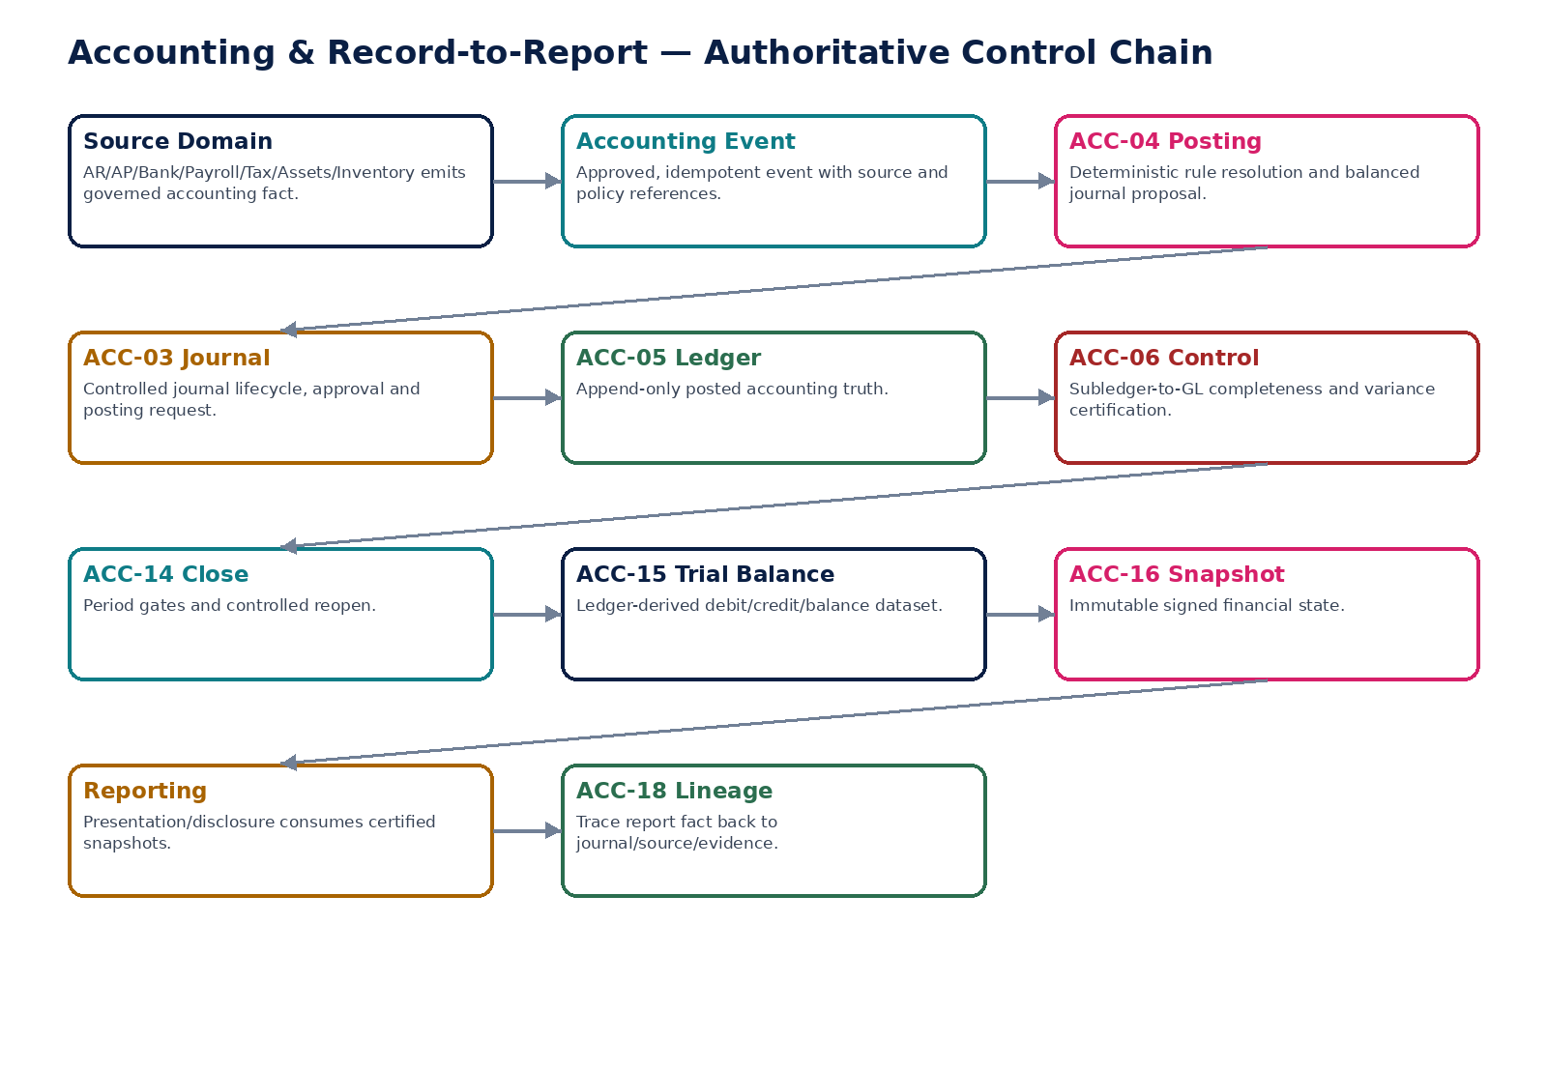
Figure 1 — Accounting authority chain from source fact to certified reporting and lineage.

2. Domain Constitution & Non-Negotiable Invariants
# | Invariant
1 | Every posted journal is balanced under the applicable book/currency balancing rule.
2 | No posted ledger line is edited or deleted in place.
3 | ACC-04 posting is idempotent at source-event + accounting-book + consequence level.
4 | A posting either commits its entire balanced consequence or commits nothing.
5 | Account, mapping, posting-rule, FX, period and accounting-policy versions used are persisted with the posting.
6 | Hard-closed periods reject ordinary posting; reopen is explicit, scoped, approved and evidenced.
7 | Control accounts cannot be bypassed by ordinary manual journals where policy restricts direct posting.
8 | Transaction, functional and presentation currencies remain distinct concepts.
9 | Consolidation-only entries never contaminate entity statutory books.
10 | Unmatched intercompany balances remain visible and are not silently eliminated.
11 | Trial balances reconcile to an explicit ledger watermark.
12 | Externally relied-on financial states reference immutable signed snapshots.
13 | Opening balances and migrated open items are separately reconciled to prevent double counting.
14 | Every reportable amount can be traced to ledger, journal, source event/document and governing versions.
15 | AI may classify/propose/explain but cannot become posting, close, certification or adjustment authority.
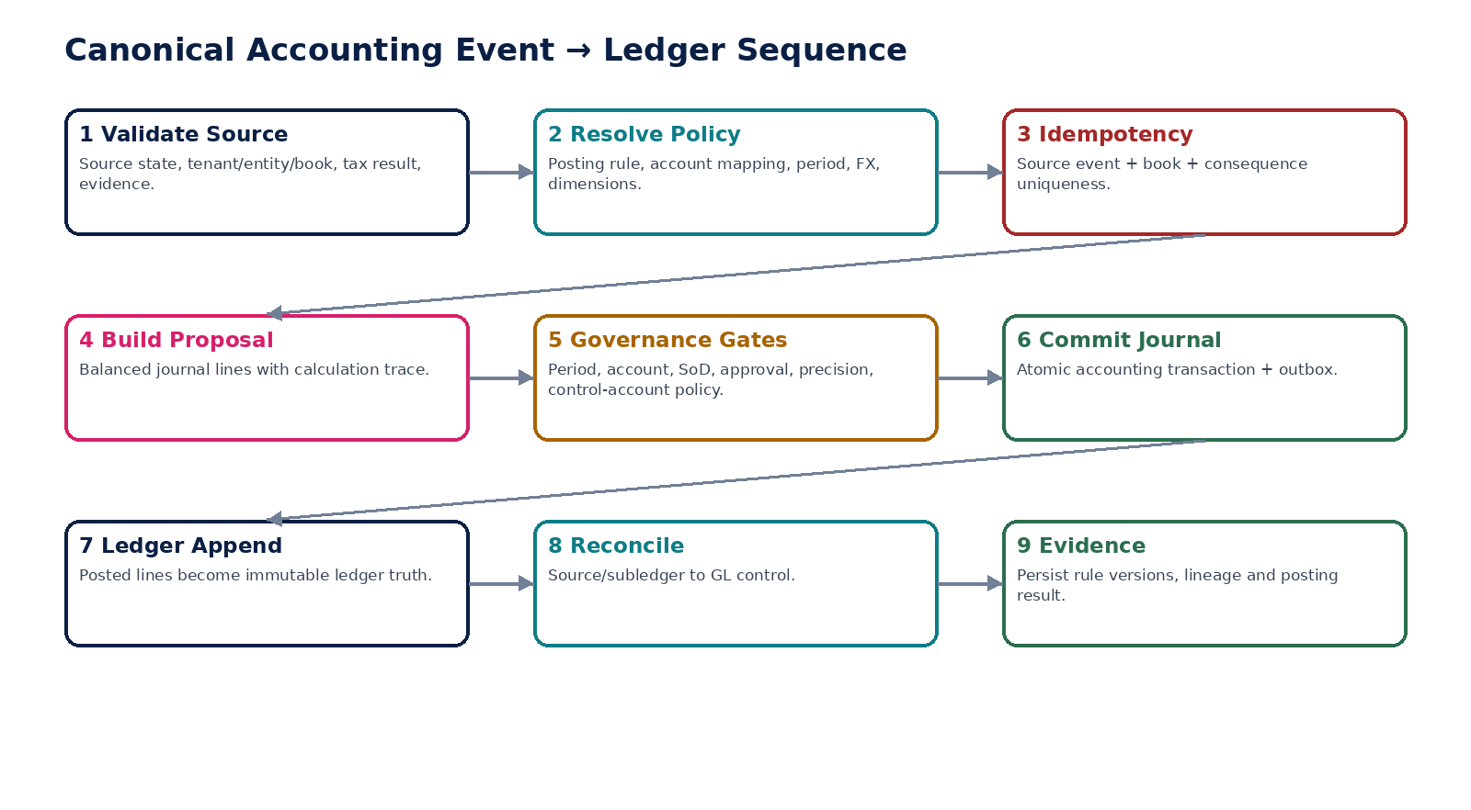
Figure 2 — Canonical accounting event-to-ledger processing sequence.

3. Cross-Service Accounting Authority Matrix
Service | Authoritative ownership | Must never own / bypass
ACC-01 | Posting account master/hierarchy/restrictions | Journal state, posting consequence, report presentation
ACC-02 | Effective-dated account mapping | Ledger entry, source business fact
ACC-03 | Journal proposal/lifecycle | Append-only ledger truth
ACC-04 | Posting execution/calculation/rule consequence | Source business fact, tax determination
ACC-05 | Posted ledger entries/balances | Draft journals or source workflow
ACC-06 | Subledger-to-GL control runs/exceptions | Underlying subledger/ledger values
ACC-07 | Accrual schedules/instances | Direct ledger writes
ACC-08 | Prepayment/deferral schedules | Direct ledger writes
ACC-09 | Allocation rules/runs | Source population or ledger truth
ACC-10 | FX revaluation runs/item calculations | FX reference master or ledger write bypass
ACC-11 | Intercompany pair/match state | Local entity source accounting
ACC-12 | Consolidation adjustment lifecycle | Entity statutory ledgers
ACC-13 | Consolidation run/group balances/provenance | Source entity balances
ACC-14 | Period close/reopen control state | Posted accounting entries
ACC-15 | Trial-balance datasets/watermarks | Ledger truth
ACC-16 | Signed financial snapshots/manifests | Mutable live balances
ACC-17 | Migration accounting batch/crosswalk/certification | Bypass of ACC-04/05
ACC-18 | Lineage graph/index | Underlying accounting/business facts
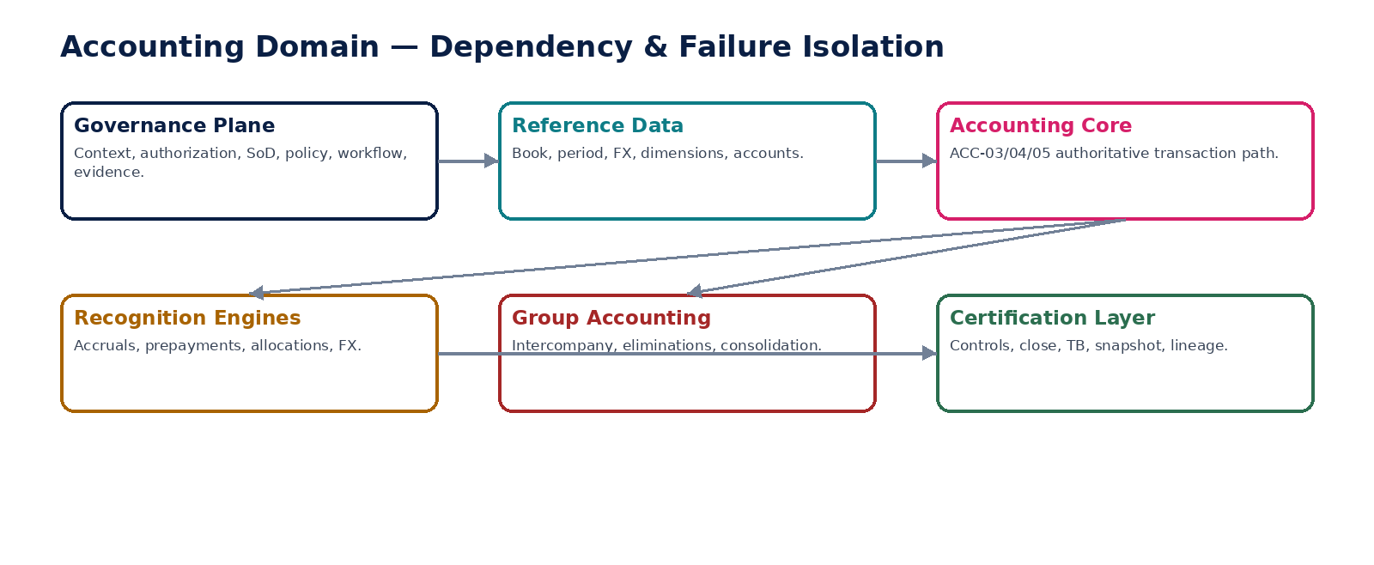
Figure 3 — Accounting service dependencies and failure isolation.

4. ACC-01 — Chart of Accounts
Maintain the versioned posting-account master and hierarchy for each legal entity and accounting book.

Contract field | Specification
Service ID / owner | ACC-01 — Accounting & Record-to-Report; accountable engineering/product/control owner recorded in service registry.
Purpose / bounded scope | Maintain the versioned posting-account master and hierarchy for each legal entity and accounting book.
Authoritative ownership | AccountMaster, AccountHierarchyVersion, posting/control-account restrictions and effective-dated account state; does not own reporting presentation labels.
Required source inputs | entity_id; book_id; account_code; account_name; account class/type; normal balance; parent account; effective dates; posting restrictions; rationale/evidence.
Server-resolved / derived context | accounting framework/policy; book currency; allowed dimensions; control-account classification; jurisdiction/book constraints.
Commands | CreateAccount; AmendAccountVersion; ActivateAccount; DeactivateAccount; ReparentAccount
Queries / read contracts | GetAccount; ListAccounts; ResolvePostingEligibility; GetAccountAsOf
State model | Draft → Approved → Active → Inactive/Superseded; historical versions queryable.
Authorization / permissions | accounting.config.manage; accounting.config.approve for activation/high-risk changes.
Segregation of duties | Creator cannot approve material control-account or hierarchy change where maker-checker is configured.
Events produced | AccountCreated; AccountActivated; AccountDeactivated; AccountHierarchyChanged
Dependencies | Organization/Book master; GOV policy/workflow/evidence; dimension/reference services.
Failure / degradation semantics | Inactive/non-posting/control-restricted account blocks posting; deletion forbidden once referenced; ambiguous hierarchy fails validation.
Evidence / lineage | Exact account version, approver, reason, effective dates and source policy retained with every material change.
NFR / recovery profile | C1 authoritative configuration; strong consistency for writes; historical reads; RPO ≤15m engineering target.

Engineering Interaction Wireframe
Type | Operation | Illustrative contract surface | Mandatory controls
QUERY | GetAccount | GET/POST /internal/v1/acc01/getAccount | Scoped read; correlation + auth context
QUERY | ListAccounts | GET/POST /internal/v1/acc01/listAccounts | Scoped read; correlation + auth context
QUERY | ResolvePostingEligibility | GET/POST /internal/v1/acc01/resolvePostingEligibility | Scoped read; correlation + auth context
QUERY | GetAccountAsOf | GET/POST /internal/v1/acc01/getAccountAsOf | Scoped read; correlation + auth context
COMMAND | CreateAccount | POST /internal/v1/acc01/commands/createAccount | Idempotency-Key; expected_version where stateful
COMMAND | AmendAccountVersion | POST /internal/v1/acc01/commands/amendAccountVersion | Idempotency-Key; expected_version where stateful
COMMAND | ActivateAccount | POST /internal/v1/acc01/commands/activateAccount | Idempotency-Key; expected_version where stateful
COMMAND | DeactivateAccount | POST /internal/v1/acc01/commands/deactivateAccount | Idempotency-Key; expected_version where stateful

Minimum Negative-Path Acceptance
# | Scenario | Required result
1 | Post to inactive account | Block/deny/quarantine or preserve safe state; stable error/evidence; no unauthorized or duplicate accounting consequence.
2 | Delete account referenced by posted journal | Block/deny/quarantine or preserve safe state; stable error/evidence; no unauthorized or duplicate accounting consequence.
3 | Backdate hierarchy change across closed period | Block/deny/quarantine or preserve safe state; stable error/evidence; no unauthorized or duplicate accounting consequence.
4 | Activate duplicate account code | Block/deny/quarantine or preserve safe state; stable error/evidence; no unauthorized or duplicate accounting consequence.
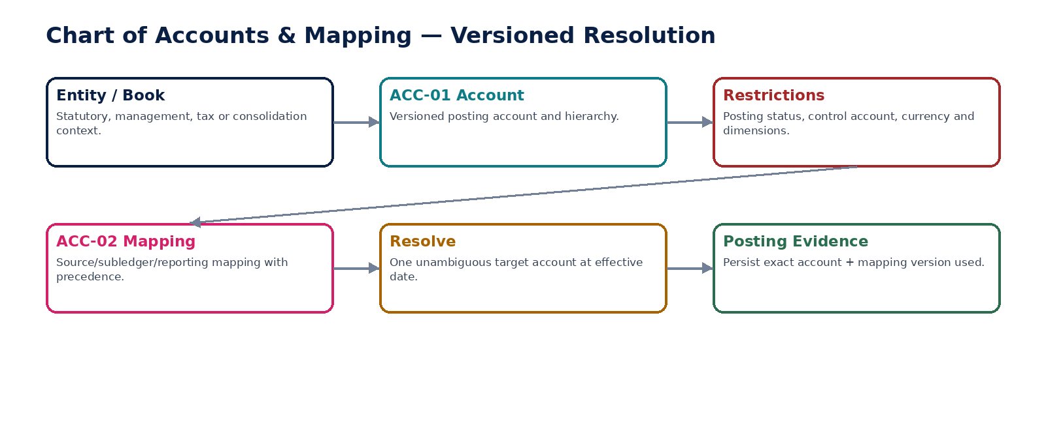
Figure 4 — Versioned chart-of-accounts and mapping resolution.

5. ACC-02 — Account Mapping
Maintain deterministic effective-dated mappings from source/subledger/reporting account identities to target book accounts.

Contract field | Specification
Service ID / owner | ACC-02 — Accounting & Record-to-Report; accountable engineering/product/control owner recorded in service registry.
Purpose / bounded scope | Maintain deterministic effective-dated mappings from source/subledger/reporting account identities to target book accounts.
Authoritative ownership | AccountMappingVersion, precedence and mapping rationale.
Required source inputs | source_system/type/account; target entity/book/account; effective interval; source context; rationale.
Server-resolved / derived context | mapping precedence; policy; migration state; source/subledger type; jurisdiction/book rules.
Commands | CreateMapping; ApproveMapping; ActivateMapping; SupersedeMapping
Queries / read contracts | ResolveAccountMapping; GetMappingAsOf; ExplainMapping; ListAmbiguities
State model | Draft → Approved → Active → Superseded.
Authorization / permissions | accounting.mapping.manage; accounting.mapping.approve.
Segregation of duties | Mapping author cannot approve high-risk mappings to cash/tax/control accounts where configured.
Events produced | AccountMappingCreated; AccountMappingActivated; AccountMappingSuperseded; MappingAmbiguityDetected
Dependencies | ACC-01; policy registry; migration crosswalk; source-domain catalogue.
Failure / degradation semantics | Zero or multiple equally applicable mappings block automated posting; no fallback guessing.
Evidence / lineage | Persist mapping version and resolution path on every posting.
NFR / recovery profile | C1; low-latency deterministic resolution; cache only with version-aware invalidation.

Engineering Interaction Wireframe
Type | Operation | Illustrative contract surface | Mandatory controls
QUERY | ResolveAccountMapping | GET/POST /internal/v1/acc02/resolveAccountMapping | Scoped read; correlation + auth context
QUERY | GetMappingAsOf | GET/POST /internal/v1/acc02/getMappingAsOf | Scoped read; correlation + auth context
QUERY | ExplainMapping | GET/POST /internal/v1/acc02/explainMapping | Scoped read; correlation + auth context
QUERY | ListAmbiguities | GET/POST /internal/v1/acc02/listAmbiguities | Scoped read; correlation + auth context
COMMAND | CreateMapping | POST /internal/v1/acc02/commands/createMapping | Idempotency-Key; expected_version where stateful
COMMAND | ApproveMapping | POST /internal/v1/acc02/commands/approveMapping | Idempotency-Key; expected_version where stateful
COMMAND | ActivateMapping | POST /internal/v1/acc02/commands/activateMapping | Idempotency-Key; expected_version where stateful
COMMAND | SupersedeMapping | POST /internal/v1/acc02/commands/supersedeMapping | Idempotency-Key; expected_version where stateful

Minimum Negative-Path Acceptance
# | Scenario | Required result
1 | Two active mappings with same precedence | Block/deny/quarantine or preserve safe state; stable error/evidence; no unauthorized or duplicate accounting consequence.
2 | Mapping target becomes inactive | Block/deny/quarantine or preserve safe state; stable error/evidence; no unauthorized or duplicate accounting consequence.
3 | Source account unmapped | Block/deny/quarantine or preserve safe state; stable error/evidence; no unauthorized or duplicate accounting consequence.
4 | Stale cache after mapping supersession | Block/deny/quarantine or preserve safe state; stable error/evidence; no unauthorized or duplicate accounting consequence.

6. ACC-03 — Journal Entry
Create, govern and preserve manual/system journal proposals and their lifecycle without owning posted ledger truth.

Contract field | Specification
Service ID / owner | ACC-03 — Accounting & Record-to-Report; accountable engineering/product/control owner recorded in service registry.
Purpose / bounded scope | Create, govern and preserve manual/system journal proposals and their lifecycle without owning posted ledger truth.
Authoritative ownership | JournalHeader, JournalLine proposal, journal lifecycle state, approval subject fingerprint and posting reference.
Required source inputs | entity/book; journal type; document/transaction/posting dates; currency; debit/credit lines; accounts; dimensions; description; source/evidence.
Server-resolved / derived context | period state; account eligibility; FX; approval route; policy version; control-account restrictions.
Commands | CreateJournal; AmendDraftJournal; SubmitJournal; ApproveJournal; RejectJournal; RequestPosting; RequestCorrection
Queries / read contracts | GetJournal; ListJournals; GetAvailableActions; GetJournalHistory
State model | Draft → PendingApproval → Approved → PostingRequested → Posted; rejected/cancelled before posting; corrections create new journals.
Authorization / permissions | journal.create; journal.submit; journal.approve; journal.post.request.
Segregation of duties | Maker/checker for configured journal classes; preparer cannot approve own protected journal; dynamic SoD against posting/close roles.
Events produced | JournalCreated; JournalSubmitted; JournalApproved; JournalRejected; JournalPostingRequested; JournalPostedReferenceAttached
Dependencies | ACC-01/02; ACC-04; GOV workflow/IAM/SoD/evidence; period/book/FX services.
Failure / degradation semantics | Unbalanced, stale-version, closed-period or invalid-account journal is blocked; no in-place edits after approval without approval invalidation.
Evidence / lineage | Store source, actor, line-level facts, approvals, fingerprint, versions, posting result and correction chain.
NFR / recovery profile | C0/C1 depending journal class; zero tolerated duplicate posting consequence.

Engineering Interaction Wireframe
Type | Operation | Illustrative contract surface | Mandatory controls
QUERY | GetJournal | GET/POST /internal/v1/acc03/getJournal | Scoped read; correlation + auth context
QUERY | ListJournals | GET/POST /internal/v1/acc03/listJournals | Scoped read; correlation + auth context
QUERY | GetAvailableActions | GET/POST /internal/v1/acc03/getAvailableActions | Scoped read; correlation + auth context
QUERY | GetJournalHistory | GET/POST /internal/v1/acc03/getJournalHistory | Scoped read; correlation + auth context
COMMAND | CreateJournal | POST /internal/v1/acc03/commands/createJournal | Idempotency-Key; expected_version where stateful
COMMAND | AmendDraftJournal | POST /internal/v1/acc03/commands/amendDraftJournal | Idempotency-Key; expected_version where stateful
COMMAND | SubmitJournal | POST /internal/v1/acc03/commands/submitJournal | Idempotency-Key; expected_version where stateful
COMMAND | ApproveJournal | POST /internal/v1/acc03/commands/approveJournal | Idempotency-Key; expected_version where stateful

Minimum Negative-Path Acceptance
# | Scenario | Required result
1 | Debit/credit imbalance | Block/deny/quarantine or preserve safe state; stable error/evidence; no unauthorized or duplicate accounting consequence.
2 | Journal changed after approval | Block/deny/quarantine or preserve safe state; stable error/evidence; no unauthorized or duplicate accounting consequence.
3 | Preparer self-approves protected journal | Block/deny/quarantine or preserve safe state; stable error/evidence; no unauthorized or duplicate accounting consequence.
4 | Attempt edit after posting | Block/deny/quarantine or preserve safe state; stable error/evidence; no unauthorized or duplicate accounting consequence.
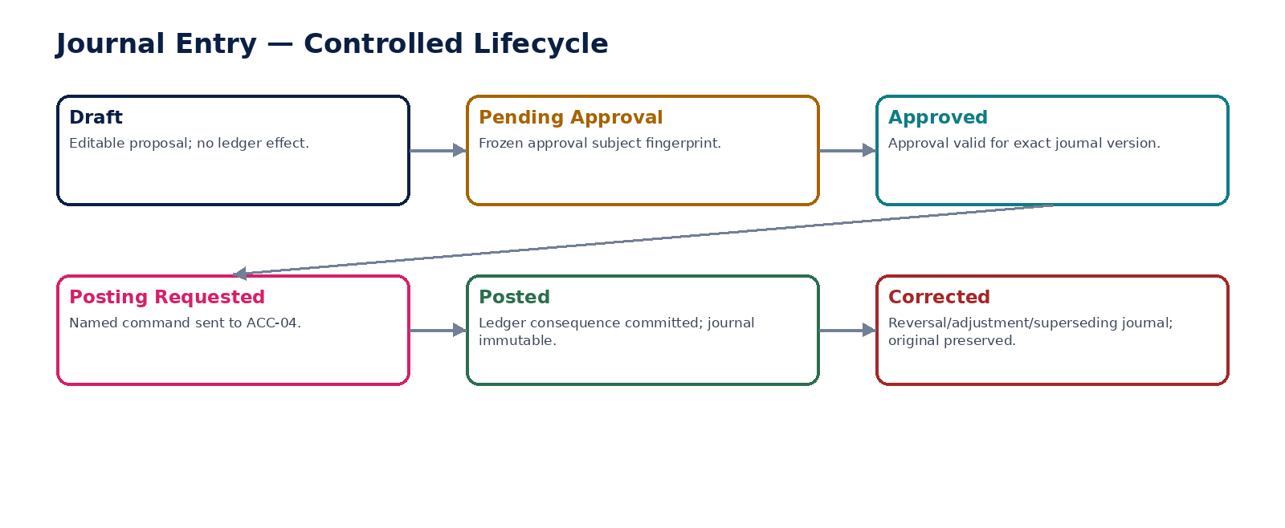
Figure 5 — Controlled journal lifecycle.

7. ACC-04 — Posting Engine
Transform governed accounting events and approved journals into deterministic, balanced, atomic ledger postings.

Contract field | Specification
Service ID / owner | ACC-04 — Accounting & Record-to-Report; accountable engineering/product/control owner recorded in service registry.
Purpose / bounded scope | Transform governed accounting events and approved journals into deterministic, balanced, atomic ledger postings.
Authoritative ownership | PostingExecution, calculation trace, rule resolution, posting batch and consequence uniqueness record; ledger entries are committed to ACC-05.
Required source inputs | approved accounting event/journal; entity/book; source amounts; dimensions; tax result; source references; idempotency key.
Server-resolved / derived context | posting rule; account mapping; accounting policy; period; FX; rounding; control-account restrictions; approval state.
Commands | PostAccountingEvent; PostApprovedJournal; CreateReversalPosting; ReprocessFailedPosting
Queries / read contracts | GetPostingExecution; ExplainPosting; GetPostingBySource; VerifyPostingUniqueness
State model | Submitted → Validating → Ready → Committed or Failed/Quarantined; no partial committed state.
Authorization / permissions | accounting.post.execute internal; reversal requires authorized correction command.
Segregation of duties | No human may bypass source approval/SoD by invoking posting directly; service identity least privilege.
Events produced | PostingStarted; PostingCommitted; PostingFailed; PostingDuplicateSuppressed; ReversalPostingCommitted
Dependencies | GOV control plane; ACC-01/02/03/05/14; FX/tax/reference services; outbox.
Failure / degradation semantics | Any validation failure aborts entire accounting transaction; duplicate source+book returns prior result; ambiguous rule/mapping blocks.
Evidence / lineage | Persist source IDs, rule/policy/mapping/FX versions, line calculations, idempotency, correlation and journal/ledger refs.
NFR / recovery profile | C0; correctness SLO dominates availability; strong atomicity; zero partial postings; recovery requires reconciliation.

Engineering Interaction Wireframe
Type | Operation | Illustrative contract surface | Mandatory controls
QUERY | GetPostingExecution | GET/POST /internal/v1/acc04/getPostingExecution | Scoped read; correlation + auth context
QUERY | ExplainPosting | GET/POST /internal/v1/acc04/explainPosting | Scoped read; correlation + auth context
QUERY | GetPostingBySource | GET/POST /internal/v1/acc04/getPostingBySource | Scoped read; correlation + auth context
QUERY | VerifyPostingUniqueness | GET/POST /internal/v1/acc04/verifyPostingUniqueness | Scoped read; correlation + auth context
COMMAND | PostAccountingEvent | POST /internal/v1/acc04/commands/postAccountingEvent | Idempotency-Key; expected_version where stateful
COMMAND | PostApprovedJournal | POST /internal/v1/acc04/commands/postApprovedJournal | Idempotency-Key; expected_version where stateful
COMMAND | CreateReversalPosting | POST /internal/v1/acc04/commands/createReversalPosting | Idempotency-Key; expected_version where stateful
COMMAND | ReprocessFailedPosting | POST /internal/v1/acc04/commands/reprocessFailedPosting | Idempotency-Key; expected_version where stateful

Minimum Negative-Path Acceptance
# | Scenario | Required result
1 | Duplicate source event | Block/deny/quarantine or preserve safe state; stable error/evidence; no unauthorized or duplicate accounting consequence.
2 | Posting rule ambiguity | Block/deny/quarantine or preserve safe state; stable error/evidence; no unauthorized or duplicate accounting consequence.
3 | Failure after half lines prepared | Block/deny/quarantine or preserve safe state; stable error/evidence; no unauthorized or duplicate accounting consequence.
4 | Closed period race during commit | Block/deny/quarantine or preserve safe state; stable error/evidence; no unauthorized or duplicate accounting consequence.

8. ACC-05 — General Ledger
Own append-only posted accounting lines and derived balances by entity, book, account, dimension and period.

Contract field | Specification
Service ID / owner | ACC-05 — Accounting & Record-to-Report; accountable engineering/product/control owner recorded in service registry.
Purpose / bounded scope | Own append-only posted accounting lines and derived balances by entity, book, account, dimension and period.
Authoritative ownership | LedgerEntry and authoritative posted balance state; no draft/manual business lifecycle.
Required source inputs | Posted journal lines from ACC-04 only.
Server-resolved / derived context | entity/book/period indexes; account/dimension keys; functional/transaction currencies; roll-forward logic.
Commands | AppendPostedJournal (internal only); RebuildDerivedBalanceProjection (controlled)
Queries / read contracts | QueryLedger; QueryAccountBalance; QuerySourceEntries; QueryLedgerAsOf
State model | Append-only committed entries; balance projections versioned/rebuildable from entries.
Authorization / permissions | No direct user write permission; read permission scoped by tenant/entity/book/account sensitivity.
Segregation of duties | No operator can both alter accounting source and directly inject ledger lines because direct injection is unavailable.
Events produced | LedgerEntriesAppended; LedgerBalanceProjectionRebuilt; LedgerIntegrityCheckFailed
Dependencies | ACC-04; book/period/reference; evidence/outbox; data warehouse projections.
Failure / degradation semantics | Reject any write not originating from authorized posting transaction; projection failure must not alter ledger entries.
Evidence / lineage | Journal/posting/source correlation retained on every entry; immutable timestamps and sequence/watermark.
NFR / recovery profile | C0; highest durability class; append truth recoverable independently of projections.

Engineering Interaction Wireframe
Type | Operation | Illustrative contract surface | Mandatory controls
QUERY | QueryLedger | GET/POST /internal/v1/acc05/queryLedger | Scoped read; correlation + auth context
QUERY | QueryAccountBalance | GET/POST /internal/v1/acc05/queryAccountBalance | Scoped read; correlation + auth context
QUERY | QuerySourceEntries | GET/POST /internal/v1/acc05/querySourceEntries | Scoped read; correlation + auth context
QUERY | QueryLedgerAsOf | GET/POST /internal/v1/acc05/queryLedgerAsOf | Scoped read; correlation + auth context
COMMAND | AppendPostedJournal (internal only) | POST /internal/v1/acc05/commands/appendPostedJournal (internal only) | Idempotency-Key; expected_version where stateful
COMMAND | RebuildDerivedBalanceProjection (controlled) | POST /internal/v1/acc05/commands/rebuildDerivedBalanceProjection (controlled) | Idempotency-Key; expected_version where stateful

Minimum Negative-Path Acceptance
# | Scenario | Required result
1 | Direct DB/API ledger write | Block/deny/quarantine or preserve safe state; stable error/evidence; no unauthorized or duplicate accounting consequence.
2 | Duplicate journal append | Block/deny/quarantine or preserve safe state; stable error/evidence; no unauthorized or duplicate accounting consequence.
3 | Balance projection corrupt while entries intact | Block/deny/quarantine or preserve safe state; stable error/evidence; no unauthorized or duplicate accounting consequence.
4 | Cross-book query leakage | Block/deny/quarantine or preserve safe state; stable error/evidence; no unauthorized or duplicate accounting consequence.

9. ACC-06 — Subledger Control
Prove completeness and agreement between authoritative subledgers/control accounts and the GL for defined periods and cutoffs.

Contract field | Specification
Service ID / owner | ACC-06 — Accounting & Record-to-Report; accountable engineering/product/control owner recorded in service registry.
Purpose / bounded scope | Prove completeness and agreement between authoritative subledgers/control accounts and the GL for defined periods and cutoffs.
Authoritative ownership | AccountingControlRun, population snapshot references, variance, exception and certification state.
Required source inputs | subledger totals/populations; GL control-account totals; entity/book/period; cutoff watermark.
Server-resolved / derived context | control-account mapping; tolerance/materiality; required assertion; owner; close gate.
Commands | StartControlRun; AssignException; RecordResolution; ReperformControl; CertifyControl; RejectControl
Queries / read contracts | GetControlRun; ListOpenExceptions; GetCloseBlockingControls; ExplainVariance
State model | Planned → Running → Exception/Passed → Reperformed → Certified or Failed.
Authorization / permissions | accounting.control.run; accounting.control.resolve; accounting.control.certify.
Segregation of duties | Preparer cannot certify own material control where maker-checker required; close role cannot waive unresolved mandatory break.
Events produced | AccountingControlRunStarted; ControlExceptionRaised; ControlReperformed; ControlCertified; ControlFailed
Dependencies | ACC-05; AR/AP/Payroll/Tax/Assets/Inventory; ZS-CONTROL engine; ACC-14.
Failure / degradation semantics | Matching totals alone insufficient if population assertion fails; unresolved material exceptions block certification/close.
Evidence / lineage | Freeze population/watermark, control definition version, totals, matching evidence, exceptions and approver.
NFR / recovery profile | C0 close-critical; scheduled and on-demand; deterministic re-performance.

Engineering Interaction Wireframe
Type | Operation | Illustrative contract surface | Mandatory controls
QUERY | GetControlRun | GET/POST /internal/v1/acc06/getControlRun | Scoped read; correlation + auth context
QUERY | ListOpenExceptions | GET/POST /internal/v1/acc06/listOpenExceptions | Scoped read; correlation + auth context
QUERY | GetCloseBlockingControls | GET/POST /internal/v1/acc06/getCloseBlockingControls | Scoped read; correlation + auth context
QUERY | ExplainVariance | GET/POST /internal/v1/acc06/explainVariance | Scoped read; correlation + auth context
COMMAND | StartControlRun | POST /internal/v1/acc06/commands/startControlRun | Idempotency-Key; expected_version where stateful
COMMAND | AssignException | POST /internal/v1/acc06/commands/assignException | Idempotency-Key; expected_version where stateful
COMMAND | RecordResolution | POST /internal/v1/acc06/commands/recordResolution | Idempotency-Key; expected_version where stateful
COMMAND | ReperformControl | POST /internal/v1/acc06/commands/reperformControl | Idempotency-Key; expected_version where stateful

Minimum Negative-Path Acceptance
# | Scenario | Required result
1 | Totals match but missing/duplicate items | Block/deny/quarantine or preserve safe state; stable error/evidence; no unauthorized or duplicate accounting consequence.
2 | Tolerance widened mid-run | Block/deny/quarantine or preserve safe state; stable error/evidence; no unauthorized or duplicate accounting consequence.
3 | Certify with unresolved material break | Block/deny/quarantine or preserve safe state; stable error/evidence; no unauthorized or duplicate accounting consequence.
4 | Late item after cutoff | Block/deny/quarantine or preserve safe state; stable error/evidence; no unauthorized or duplicate accounting consequence.

10. ACC-07 — Accruals
Create governed accrual schedules and recognition postings where policy requires recognition before invoice/cash timing.

Contract field | Specification
Service ID / owner | ACC-07 — Accounting & Record-to-Report; accountable engineering/product/control owner recorded in service registry.
Purpose / bounded scope | Create governed accrual schedules and recognition postings where policy requires recognition before invoice/cash timing.
Authoritative ownership | AccrualSchedule, basis/evidence, recognition instances and reversal plan.
Required source inputs | entity/book; amount/basis; period; accounts; dimensions; recognition/reversal method; source evidence.
Server-resolved / derived context | accounting policy; period calendar; approval; FX; materiality; reversal date.
Commands | CreateAccrual; AmendFutureSchedule; SubmitAccrual; ApproveAccrual; RunAccrualRecognition; CancelFutureAccrual
Queries / read contracts | GetAccrual; ListAccruals; GetRecognitionSchedule; ExplainAccrual
State model | Draft → PendingApproval → Approved → Active → Completed/Cancelled/Superseded.
Authorization / permissions | accrual.manage; accrual.approve; recognition.execute internal.
Segregation of duties | Requester/preparer separation for material/manual accruals; no self-certification where configured.
Events produced | AccrualCreated; AccrualApproved; AccrualRecognitionDue; AccrualRecognized; AccrualReversed
Dependencies | ACC-04; policy/period/FX; source/evidence domains.
Failure / degradation semantics | Missing basis/policy/period blocks recognition; automatic reversal uses same schedule identity and is idempotent.
Evidence / lineage | Retain estimate basis, policy version, approvals, recognition history and corrective changes.
NFR / recovery profile | C1; period-close peak capacity; idempotent scheduler.

Engineering Interaction Wireframe
Type | Operation | Illustrative contract surface | Mandatory controls
QUERY | GetAccrual | GET/POST /internal/v1/acc07/getAccrual | Scoped read; correlation + auth context
QUERY | ListAccruals | GET/POST /internal/v1/acc07/listAccruals | Scoped read; correlation + auth context
QUERY | GetRecognitionSchedule | GET/POST /internal/v1/acc07/getRecognitionSchedule | Scoped read; correlation + auth context
QUERY | ExplainAccrual | GET/POST /internal/v1/acc07/explainAccrual | Scoped read; correlation + auth context
COMMAND | CreateAccrual | POST /internal/v1/acc07/commands/createAccrual | Idempotency-Key; expected_version where stateful
COMMAND | AmendFutureSchedule | POST /internal/v1/acc07/commands/amendFutureSchedule | Idempotency-Key; expected_version where stateful
COMMAND | SubmitAccrual | POST /internal/v1/acc07/commands/submitAccrual | Idempotency-Key; expected_version where stateful
COMMAND | ApproveAccrual | POST /internal/v1/acc07/commands/approveAccrual | Idempotency-Key; expected_version where stateful

Minimum Negative-Path Acceptance
# | Scenario | Required result
1 | Recognition run replay | Block/deny/quarantine or preserve safe state; stable error/evidence; no unauthorized or duplicate accounting consequence.
2 | Accrual changed after some periods recognized | Block/deny/quarantine or preserve safe state; stable error/evidence; no unauthorized or duplicate accounting consequence.
3 | Auto-reversal duplicates | Block/deny/quarantine or preserve safe state; stable error/evidence; no unauthorized or duplicate accounting consequence.
4 | Accrual posted into hard-closed period | Block/deny/quarantine or preserve safe state; stable error/evidence; no unauthorized or duplicate accounting consequence.
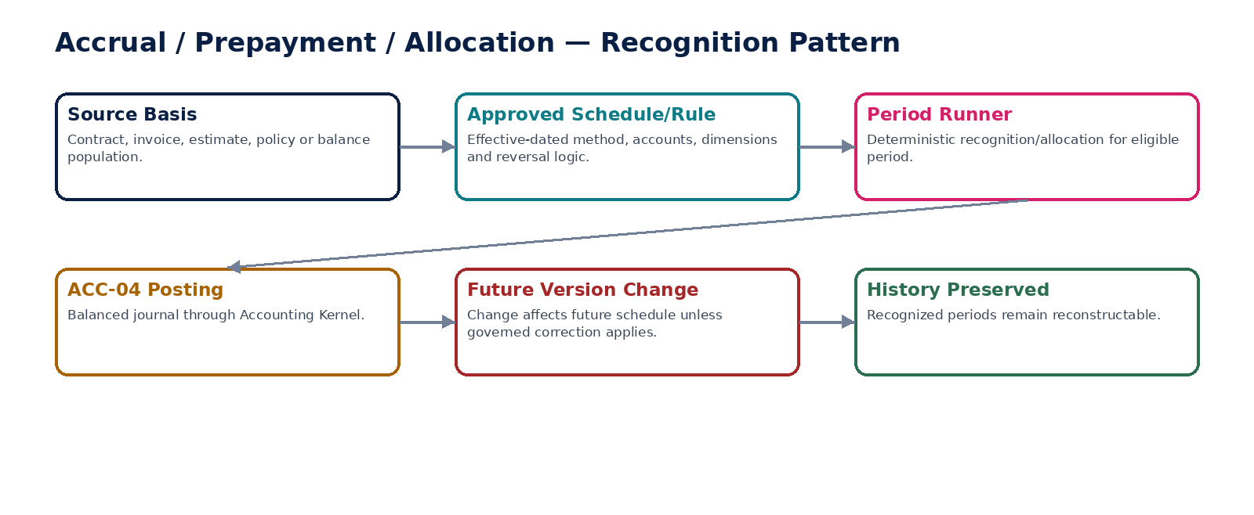
Figure 6 — Recognition engines preserve schedule history.

11. ACC-08 — Prepayments & Deferrals
Allocate prepaid/deferred balances over governed recognition periods while preserving already recognized history.

Contract field | Specification
Service ID / owner | ACC-08 — Accounting & Record-to-Report; accountable engineering/product/control owner recorded in service registry.
Purpose / bounded scope | Allocate prepaid/deferred balances over governed recognition periods while preserving already recognized history.
Authoritative ownership | RecognitionSchedule, remaining balance, period recognition instances and schedule versions.
Required source inputs | originating transaction; amount; recognition start/end; frequency; target accounts; dimensions; source reference.
Server-resolved / derived context | policy; period calendar; rounding; termination/impairment events; account eligibility.
Commands | CreateRecognitionSchedule; ApproveSchedule; ModifyFutureSchedule; RunRecognition; TerminateSchedule
Queries / read contracts | GetRecognitionSchedule; GetRemainingBalance; ListRecognitionInstances; ExplainScheduleVersion
State model | Draft → Approved → Active → Completed/Terminated/Superseded.
Authorization / permissions | deferral.manage; deferral.approve; recognition.execute internal.
Segregation of duties | Material manual schedule changes require independent approval.
Events produced | RecognitionScheduleCreated; RecognitionPeriodPosted; RecognitionScheduleModified; RecognitionScheduleCompleted
Dependencies | ACC-04; source transaction; policy/period/account services.
Failure / degradation semantics | Schedule version change cannot rewrite recognized history; rounding residual handled by explicit policy.
Evidence / lineage | Original source, schedule versions, per-period calculation, postings and remaining balance.
NFR / recovery profile | C1; scheduler resilient and restartable; period-close capacity.

Engineering Interaction Wireframe
Type | Operation | Illustrative contract surface | Mandatory controls
QUERY | GetRecognitionSchedule | GET/POST /internal/v1/acc08/getRecognitionSchedule | Scoped read; correlation + auth context
QUERY | GetRemainingBalance | GET/POST /internal/v1/acc08/getRemainingBalance | Scoped read; correlation + auth context
QUERY | ListRecognitionInstances | GET/POST /internal/v1/acc08/listRecognitionInstances | Scoped read; correlation + auth context
QUERY | ExplainScheduleVersion | GET/POST /internal/v1/acc08/explainScheduleVersion | Scoped read; correlation + auth context
COMMAND | CreateRecognitionSchedule | POST /internal/v1/acc08/commands/createRecognitionSchedule | Idempotency-Key; expected_version where stateful
COMMAND | ApproveSchedule | POST /internal/v1/acc08/commands/approveSchedule | Idempotency-Key; expected_version where stateful
COMMAND | ModifyFutureSchedule | POST /internal/v1/acc08/commands/modifyFutureSchedule | Idempotency-Key; expected_version where stateful
COMMAND | RunRecognition | POST /internal/v1/acc08/commands/runRecognition | Idempotency-Key; expected_version where stateful

Minimum Negative-Path Acceptance
# | Scenario | Required result
1 | Backdate schedule change over recognized periods | Block/deny/quarantine or preserve safe state; stable error/evidence; no unauthorized or duplicate accounting consequence.
2 | Rounding creates unallocated residual | Block/deny/quarantine or preserve safe state; stable error/evidence; no unauthorized or duplicate accounting consequence.
3 | Duplicate recognition run | Block/deny/quarantine or preserve safe state; stable error/evidence; no unauthorized or duplicate accounting consequence.
4 | Terminate without final balance treatment | Block/deny/quarantine or preserve safe state; stable error/evidence; no unauthorized or duplicate accounting consequence.

12. ACC-09 — Allocation Engine
Allocate shared balances or activity using approved deterministic drivers and reconcile allocated output to source.

Contract field | Specification
Service ID / owner | ACC-09 — Accounting & Record-to-Report; accountable engineering/product/control owner recorded in service registry.
Purpose / bounded scope | Allocate shared balances or activity using approved deterministic drivers and reconcile allocated output to source.
Authoritative ownership | AllocationRuleVersion, AllocationRun, driver snapshot, result lines and calculation evidence.
Required source inputs | source balance/population; allocation basis; recipients; drivers/percentages; period; dimensions.
Server-resolved / derived context | approved rule; exclusions; hierarchy; rounding; currency; period state.
Commands | CreateAllocationRule; ApproveAllocationRule; ExecuteAllocation; ReprocessAllocationRun; SupersedeAllocationRule
Queries / read contracts | GetAllocationRule; GetAllocationRun; ExplainAllocation; ListAllocationExceptions
State model | Rule: Draft→Approved→Active→Superseded; Run: Planned→Calculated→Posted/Failed.
Authorization / permissions | allocation.manage; allocation.approve; allocation.execute.
Segregation of duties | Rule author cannot approve material allocation where configured; run certifier separate from driver owner for high-risk pools.
Events produced | AllocationRuleActivated; AllocationRunCalculated; AllocationRunPosted; AllocationRunFailed
Dependencies | ACC-04/05; dimensions; source data; policy/period.
Failure / degradation semantics | Driver population incomplete or allocated total not reconciling to source blocks posting.
Evidence / lineage | Persist source watermark, driver values, rule version, rounding and posting refs.
NFR / recovery profile | C1; batch scalable; deterministic reruns.

Engineering Interaction Wireframe
Type | Operation | Illustrative contract surface | Mandatory controls
QUERY | GetAllocationRule | GET/POST /internal/v1/acc09/getAllocationRule | Scoped read; correlation + auth context
QUERY | GetAllocationRun | GET/POST /internal/v1/acc09/getAllocationRun | Scoped read; correlation + auth context
QUERY | ExplainAllocation | GET/POST /internal/v1/acc09/explainAllocation | Scoped read; correlation + auth context
QUERY | ListAllocationExceptions | GET/POST /internal/v1/acc09/listAllocationExceptions | Scoped read; correlation + auth context
COMMAND | CreateAllocationRule | POST /internal/v1/acc09/commands/createAllocationRule | Idempotency-Key; expected_version where stateful
COMMAND | ApproveAllocationRule | POST /internal/v1/acc09/commands/approveAllocationRule | Idempotency-Key; expected_version where stateful
COMMAND | ExecuteAllocation | POST /internal/v1/acc09/commands/executeAllocation | Idempotency-Key; expected_version where stateful
COMMAND | ReprocessAllocationRun | POST /internal/v1/acc09/commands/reprocessAllocationRun | Idempotency-Key; expected_version where stateful

Minimum Negative-Path Acceptance
# | Scenario | Required result
1 | Drivers do not sum/cover source | Block/deny/quarantine or preserve safe state; stable error/evidence; no unauthorized or duplicate accounting consequence.
2 | Driver changes after run starts | Block/deny/quarantine or preserve safe state; stable error/evidence; no unauthorized or duplicate accounting consequence.
3 | Rerun duplicates posting | Block/deny/quarantine or preserve safe state; stable error/evidence; no unauthorized or duplicate accounting consequence.
4 | Recipient dimension invalid | Block/deny/quarantine or preserve safe state; stable error/evidence; no unauthorized or duplicate accounting consequence.

13. ACC-10 — Foreign Currency Revaluation
Revalue eligible monetary balances using approved period-end rates and item-level calculation evidence.

Contract field | Specification
Service ID / owner | ACC-10 — Accounting & Record-to-Report; accountable engineering/product/control owner recorded in service registry.
Purpose / bounded scope | Revalue eligible monetary balances using approved period-end rates and item-level calculation evidence.
Authoritative ownership | RevaluationRun, item calculations, rate references, resulting posting refs.
Required source inputs | entity/book; open monetary balances; valuation date; approved rate set.
Server-resolved / derived context | monetary classification; accounting policy; gain/loss accounts; reversal policy; rounding.
Commands | StartRevaluation; ApproveRevaluation; PostRevaluation; ReversePriorRevaluation; ReprocessFailedRevaluation
Queries / read contracts | GetRevaluationRun; GetItemCalculation; ExplainRateUsage; ListExcludedItems
State model | Planned → Calculated → Review → Approved → Posted; corrected/reversed via new run.
Authorization / permissions | fx.revaluation.run; fx.revaluation.approve.
Segregation of duties | Rate-set approver and revaluation approver may be separated for material books.
Events produced | RevaluationCalculated; RevaluationApproved; RevaluationPosted; RevaluationReversed
Dependencies | ACC-04/05; FX reference; policy/period; AR/AP/bank/open-balance sources.
Failure / degradation semantics | Missing/unsupported rate or ambiguous monetary classification blocks affected run; non-monetary items excluded unless policy explicitly permits.
Evidence / lineage | Item amount, source balance, rate source/version, calculation, accounts, approvals and posting refs.
NFR / recovery profile | C0/C1 period-close critical; deterministic item-level replay.

Engineering Interaction Wireframe
Type | Operation | Illustrative contract surface | Mandatory controls
QUERY | GetRevaluationRun | GET/POST /internal/v1/acc10/getRevaluationRun | Scoped read; correlation + auth context
QUERY | GetItemCalculation | GET/POST /internal/v1/acc10/getItemCalculation | Scoped read; correlation + auth context
QUERY | ExplainRateUsage | GET/POST /internal/v1/acc10/explainRateUsage | Scoped read; correlation + auth context
QUERY | ListExcludedItems | GET/POST /internal/v1/acc10/listExcludedItems | Scoped read; correlation + auth context
COMMAND | StartRevaluation | POST /internal/v1/acc10/commands/startRevaluation | Idempotency-Key; expected_version where stateful
COMMAND | ApproveRevaluation | POST /internal/v1/acc10/commands/approveRevaluation | Idempotency-Key; expected_version where stateful
COMMAND | PostRevaluation | POST /internal/v1/acc10/commands/postRevaluation | Idempotency-Key; expected_version where stateful
COMMAND | ReversePriorRevaluation | POST /internal/v1/acc10/commands/reversePriorRevaluation | Idempotency-Key; expected_version where stateful

Minimum Negative-Path Acceptance
# | Scenario | Required result
1 | Rate set missing one currency | Block/deny/quarantine or preserve safe state; stable error/evidence; no unauthorized or duplicate accounting consequence.
2 | Non-monetary item included | Block/deny/quarantine or preserve safe state; stable error/evidence; no unauthorized or duplicate accounting consequence.
3 | Closing rate amended after approval | Block/deny/quarantine or preserve safe state; stable error/evidence; no unauthorized or duplicate accounting consequence.
4 | Revaluation replay duplicates journal | Block/deny/quarantine or preserve safe state; stable error/evidence; no unauthorized or duplicate accounting consequence.
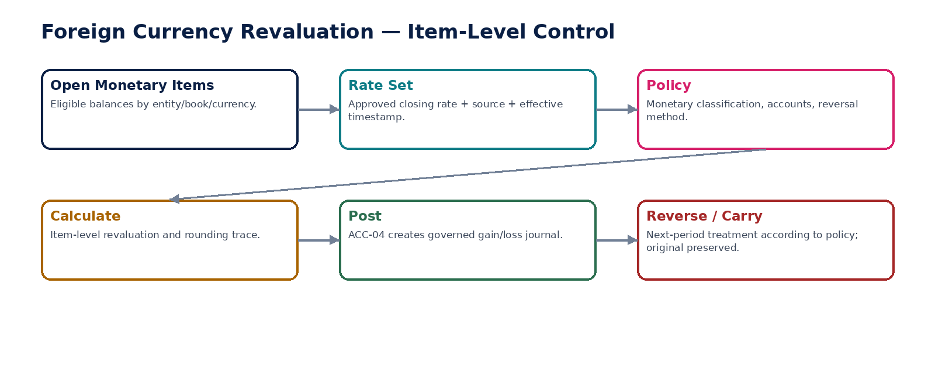
Figure 7 — Item-level FX revaluation with approved rate provenance.

14. ACC-11 — Intercompany Accounting
Create paired group-entity accounting identities and expose reciprocal transaction/balance matching status without contaminating local ledgers.

Contract field | Specification
Service ID / owner | ACC-11 — Accounting & Record-to-Report; accountable engineering/product/control owner recorded in service registry.
Purpose / bounded scope | Create paired group-entity accounting identities and expose reciprocal transaction/balance matching status without contaminating local ledgers.
Authoritative ownership | IntercompanyPair, reciprocal reference, matching/dispute state and group counterparty classification.
Required source inputs | originating entity; counterparty entity; source transaction; currencies; reciprocal refs; dimensions.
Server-resolved / derived context | intercompany accounts; ownership/group relationship; matching policy; transfer-pricing classification reference.
Commands | CreateIntercompanyPair; AcknowledgeCounterparty; MatchIntercompany; DisputeIntercompany; ResolveMismatch
Queries / read contracts | GetIntercompanyPair; ListUnmatchedIntercompany; GetReciprocalBalances; ExplainMismatch
State model | Open → AwaitingCounterparty → Matched / Mismatched / Disputed → Resolved/Closed.
Authorization / permissions | intercompany.manage; intercompany.match; intercompany.resolve.
Segregation of duties | One entity cannot certify both sides of material mismatch without compensating control.
Events produced | IntercompanyPairCreated; IntercompanyMatched; IntercompanyMismatchDetected; IntercompanyDisputeResolved
Dependencies | Entity ledgers; AR/AP; group structure; ACC-12/13; FX.
Failure / degradation semantics | Unmatched balances remain visible and ineligible for automatic elimination where policy requires match.
Evidence / lineage | Both entity/source references, amounts/currencies, matching rule, exceptions and resolution evidence.
NFR / recovery profile | C1; period-close peak; cross-entity isolation with authorized group scope.

Engineering Interaction Wireframe
Type | Operation | Illustrative contract surface | Mandatory controls
QUERY | GetIntercompanyPair | GET/POST /internal/v1/acc11/getIntercompanyPair | Scoped read; correlation + auth context
QUERY | ListUnmatchedIntercompany | GET/POST /internal/v1/acc11/listUnmatchedIntercompany | Scoped read; correlation + auth context
QUERY | GetReciprocalBalances | GET/POST /internal/v1/acc11/getReciprocalBalances | Scoped read; correlation + auth context
QUERY | ExplainMismatch | GET/POST /internal/v1/acc11/explainMismatch | Scoped read; correlation + auth context
COMMAND | CreateIntercompanyPair | POST /internal/v1/acc11/commands/createIntercompanyPair | Idempotency-Key; expected_version where stateful
COMMAND | AcknowledgeCounterparty | POST /internal/v1/acc11/commands/acknowledgeCounterparty | Idempotency-Key; expected_version where stateful
COMMAND | MatchIntercompany | POST /internal/v1/acc11/commands/matchIntercompany | Idempotency-Key; expected_version where stateful
COMMAND | DisputeIntercompany | POST /internal/v1/acc11/commands/disputeIntercompany | Idempotency-Key; expected_version where stateful

Minimum Negative-Path Acceptance
# | Scenario | Required result
1 | Counterparty amount differs | Block/deny/quarantine or preserve safe state; stable error/evidence; no unauthorized or duplicate accounting consequence.
2 | One side missing | Block/deny/quarantine or preserve safe state; stable error/evidence; no unauthorized or duplicate accounting consequence.
3 | Automatic elimination attempted while unmatched | Block/deny/quarantine or preserve safe state; stable error/evidence; no unauthorized or duplicate accounting consequence.
4 | Entity loses group relationship mid-period | Block/deny/quarantine or preserve safe state; stable error/evidence; no unauthorized or duplicate accounting consequence.
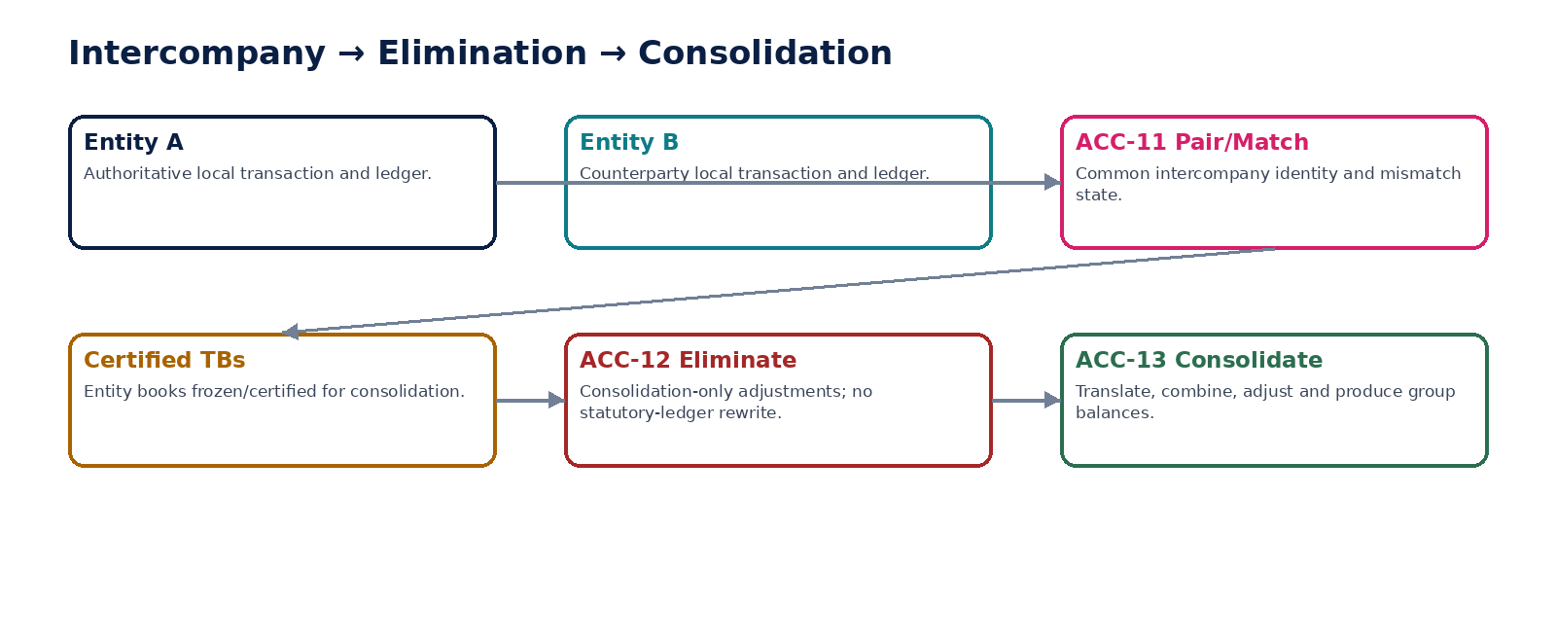
Figure 8 — Intercompany matching feeds consolidation-only elimination.

15. ACC-12 — Elimination & Consolidation Adjustments
Create approved consolidation-only elimination and adjustment journals without changing source entity statutory books.

Contract field | Specification
Service ID / owner | ACC-12 — Accounting & Record-to-Report; accountable engineering/product/control owner recorded in service registry.
Purpose / bounded scope | Create approved consolidation-only elimination and adjustment journals without changing source entity statutory books.
Authoritative ownership | ConsolidationAdjustment, elimination rule version, approval state and consolidation-book journal ref.
Required source inputs | group/consolidation book; period; balances/transactions; adjustment reason; evidence.
Server-resolved / derived context | ownership; consolidation policy; reporting currency; intercompany match status; elimination mapping.
Commands | CreateEliminationProposal; ApproveConsolidationAdjustment; PostConsolidationAdjustment; ReverseConsolidationAdjustment
Queries / read contracts | GetConsolidationAdjustment; ListEliminations; ExplainElimination; GetAdjustmentHistory
State model | Draft → PendingApproval → Approved → Posted → Reversed/Superseded.
Authorization / permissions | consolidation.adjust.manage; consolidation.adjust.approve; consolidation.adjust.post.
Segregation of duties | Preparer cannot approve protected top-side adjustment; no source-entity operator can rewrite statutory ledger through this service.
Events produced | ConsolidationAdjustmentCreated; ConsolidationAdjustmentApproved; ConsolidationAdjustmentPosted; ConsolidationAdjustmentReversed
Dependencies | ACC-11/13; ACC-04/05 consolidation book; group structure; FX/policy.
Failure / degradation semantics | Attempt to target entity statutory book is denied; unmatched intercompany may block rule-based elimination.
Evidence / lineage | Adjustment purpose, source balances, ownership/rule versions, approvers and consolidation-book posting.
NFR / recovery profile | C0 reporting-critical; strong controls and historical reconstruction.

Engineering Interaction Wireframe
Type | Operation | Illustrative contract surface | Mandatory controls
QUERY | GetConsolidationAdjustment | GET/POST /internal/v1/acc12/getConsolidationAdjustment | Scoped read; correlation + auth context
QUERY | ListEliminations | GET/POST /internal/v1/acc12/listEliminations | Scoped read; correlation + auth context
QUERY | ExplainElimination | GET/POST /internal/v1/acc12/explainElimination | Scoped read; correlation + auth context
QUERY | GetAdjustmentHistory | GET/POST /internal/v1/acc12/getAdjustmentHistory | Scoped read; correlation + auth context
COMMAND | CreateEliminationProposal | POST /internal/v1/acc12/commands/createEliminationProposal | Idempotency-Key; expected_version where stateful
COMMAND | ApproveConsolidationAdjustment | POST /internal/v1/acc12/commands/approveConsolidationAdjustment | Idempotency-Key; expected_version where stateful
COMMAND | PostConsolidationAdjustment | POST /internal/v1/acc12/commands/postConsolidationAdjustment | Idempotency-Key; expected_version where stateful
COMMAND | ReverseConsolidationAdjustment | POST /internal/v1/acc12/commands/reverseConsolidationAdjustment | Idempotency-Key; expected_version where stateful

Minimum Negative-Path Acceptance
# | Scenario | Required result
1 | Adjustment targets statutory book | Block/deny/quarantine or preserve safe state; stable error/evidence; no unauthorized or duplicate accounting consequence.
2 | Top-side journal self-approved | Block/deny/quarantine or preserve safe state; stable error/evidence; no unauthorized or duplicate accounting consequence.
3 | Elimination exceeds matched reciprocal balance | Block/deny/quarantine or preserve safe state; stable error/evidence; no unauthorized or duplicate accounting consequence.
4 | Reverse after snapshot without supersession | Block/deny/quarantine or preserve safe state; stable error/evidence; no unauthorized or duplicate accounting consequence.

16. ACC-13 — Consolidation
Combine certified entity books into governed group balances using effective-dated ownership, translation, elimination and adjustment rules.

Contract field | Specification
Service ID / owner | ACC-13 — Accounting & Record-to-Report; accountable engineering/product/control owner recorded in service registry.
Purpose / bounded scope | Combine certified entity books into governed group balances using effective-dated ownership, translation, elimination and adjustment rules.
Authoritative ownership | ConsolidationRun, translated entity balances, group balances, provenance graph and certification state.
Required source inputs | group structure; certified entity TB/snapshots; period; reporting currency; ownership; mappings; adjustments.
Server-resolved / derived context | FX translation policy; consolidation method; elimination status; NCI/ownership; effective dates.
Commands | StartConsolidation; LockInputs; TranslateEntities; ApplyEliminations; ApplyAdjustments; CertifyConsolidation; SupersedeConsolidation
Queries / read contracts | GetConsolidationRun; GetGroupBalance; DrillEntityContribution; ExplainTranslation
State model | Draft → CollectingInputs → Locked → Processing → Review → Certified/Superseded.
Authorization / permissions | consolidation.run; consolidation.review; consolidation.certify.
Segregation of duties | Entity preparers cannot certify group run alone; adjustment approvers follow SoD.
Events produced | ConsolidationStarted; ConsolidationInputsLocked; ConsolidationCertified; ConsolidationSuperseded
Dependencies | ACC-12/15/16; group/ownership data; FX; reporting.
Failure / degradation semantics | Uncertified/missing entity inputs, unresolved elimination blockers or ownership ambiguity block certification.
Evidence / lineage | Exact input snapshots, ownership/mapping/FX versions, adjustments and output hashes.
NFR / recovery profile | C0 reporting-critical; deterministic as-of ownership; batch recoverability.

Engineering Interaction Wireframe
Type | Operation | Illustrative contract surface | Mandatory controls
QUERY | GetConsolidationRun | GET/POST /internal/v1/acc13/getConsolidationRun | Scoped read; correlation + auth context
QUERY | GetGroupBalance | GET/POST /internal/v1/acc13/getGroupBalance | Scoped read; correlation + auth context
QUERY | DrillEntityContribution | GET/POST /internal/v1/acc13/drillEntityContribution | Scoped read; correlation + auth context
QUERY | ExplainTranslation | GET/POST /internal/v1/acc13/explainTranslation | Scoped read; correlation + auth context
COMMAND | StartConsolidation | POST /internal/v1/acc13/commands/startConsolidation | Idempotency-Key; expected_version where stateful
COMMAND | LockInputs | POST /internal/v1/acc13/commands/lockInputs | Idempotency-Key; expected_version where stateful
COMMAND | TranslateEntities | POST /internal/v1/acc13/commands/translateEntities | Idempotency-Key; expected_version where stateful
COMMAND | ApplyEliminations | POST /internal/v1/acc13/commands/applyEliminations | Idempotency-Key; expected_version where stateful

Minimum Negative-Path Acceptance
# | Scenario | Required result
1 | Input TB changes after lock | Block/deny/quarantine or preserve safe state; stable error/evidence; no unauthorized or duplicate accounting consequence.
2 | Ownership changes mid-period | Block/deny/quarantine or preserve safe state; stable error/evidence; no unauthorized or duplicate accounting consequence.
3 | Missing entity snapshot | Block/deny/quarantine or preserve safe state; stable error/evidence; no unauthorized or duplicate accounting consequence.
4 | Elimination run incomplete but certification attempted | Block/deny/quarantine or preserve safe state; stable error/evidence; no unauthorized or duplicate accounting consequence.

17. ACC-14 — Period Close
Orchestrate accounting period close, enforce module/control gates and govern explicit reopen/reclose.

Contract field | Specification
Service ID / owner | ACC-14 — Accounting & Record-to-Report; accountable engineering/product/control owner recorded in service registry.
Purpose / bounded scope | Orchestrate accounting period close, enforce module/control gates and govern explicit reopen/reclose.
Authoritative ownership | AccountingPeriodCloseState, blockers, checklist items, approvals, close/reopen evidence.
Required source inputs | entity/book; period; requested close stage; checklist evidence; reason for reopen.
Server-resolved / derived context | subledger controls; bank recon; tax/payroll/assets/inventory status; unresolved exceptions; approvals; posting backlog.
Commands | StartSoftClose; EnterCloseReview; HardClosePeriod; RequestReopen; ApproveReopen; ReclosePeriod
Queries / read contracts | GetPeriodState; GetCloseBlockers; GetAvailableCloseActions; GetCloseHistory
State model | Open → SoftClose → CloseReview → HardClosed → AuthorizedReopen → ReClosed.
Authorization / permissions | period.close.manage; period.close.approve; period.reopen.request/approve.
Segregation of duties | Requester cannot unilaterally reopen hard-closed material book; close certifier independent from preparers where required.
Events produced | PeriodSoftClosed; PeriodCloseReviewStarted; PeriodHardClosed; PeriodReopened; PeriodReclosed
Dependencies | ACC-06/05; all subledgers; GOV workflow/SoD/evidence; ZS-CONTROL.
Failure / degradation semantics | Mandatory unresolved control, unposted material events or failed certification blocks close; ordinary postings denied in HardClosed.
Evidence / lineage | Blocker snapshot, approvals, evidence package, watermark, reopen scope and reperformed controls.
NFR / recovery profile | C0 close-critical; highly observable; recovery does not auto-open closed periods.

Engineering Interaction Wireframe
Type | Operation | Illustrative contract surface | Mandatory controls
QUERY | GetPeriodState | GET/POST /internal/v1/acc14/getPeriodState | Scoped read; correlation + auth context
QUERY | GetCloseBlockers | GET/POST /internal/v1/acc14/getCloseBlockers | Scoped read; correlation + auth context
QUERY | GetAvailableCloseActions | GET/POST /internal/v1/acc14/getAvailableCloseActions | Scoped read; correlation + auth context
QUERY | GetCloseHistory | GET/POST /internal/v1/acc14/getCloseHistory | Scoped read; correlation + auth context
COMMAND | StartSoftClose | POST /internal/v1/acc14/commands/startSoftClose | Idempotency-Key; expected_version where stateful
COMMAND | EnterCloseReview | POST /internal/v1/acc14/commands/enterCloseReview | Idempotency-Key; expected_version where stateful
COMMAND | HardClosePeriod | POST /internal/v1/acc14/commands/hardClosePeriod | Idempotency-Key; expected_version where stateful
COMMAND | RequestReopen | POST /internal/v1/acc14/commands/requestReopen | Idempotency-Key; expected_version where stateful

Minimum Negative-Path Acceptance
# | Scenario | Required result
1 | Hard close with unresolved bank break | Block/deny/quarantine or preserve safe state; stable error/evidence; no unauthorized or duplicate accounting consequence.
2 | Posting races close transition | Block/deny/quarantine or preserve safe state; stable error/evidence; no unauthorized or duplicate accounting consequence.
3 | Reopen without approval | Block/deny/quarantine or preserve safe state; stable error/evidence; no unauthorized or duplicate accounting consequence.
4 | Reclose without reperformance | Block/deny/quarantine or preserve safe state; stable error/evidence; no unauthorized or duplicate accounting consequence.
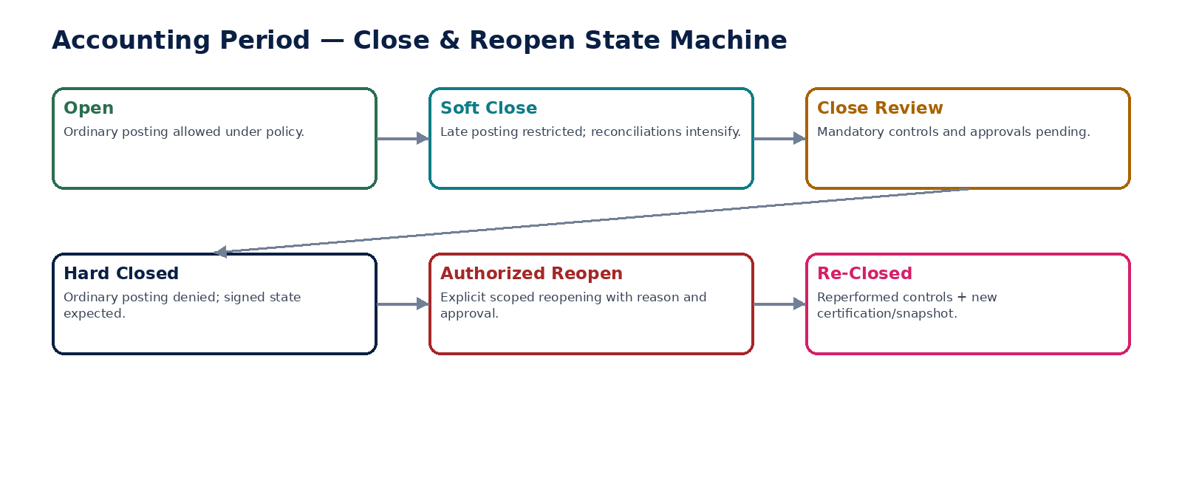
Figure 9 — Period close and governed reopen state machine.

18. ACC-15 — Trial Balance
Generate controlled ledger-derived debit, credit and balance datasets at an explicit watermark for entity, book or group scope.

Contract field | Specification
Service ID / owner | ACC-15 — Accounting & Record-to-Report; accountable engineering/product/control owner recorded in service registry.
Purpose / bounded scope | Generate controlled ledger-derived debit, credit and balance datasets at an explicit watermark for entity, book or group scope.
Authoritative ownership | TrialBalanceDataset, generation watermark and reconciliation metadata; not ledger truth.
Required source inputs | entity/group; book; period/date; account/dimension scope; currency view.
Server-resolved / derived context | ledger watermark; opening balances; currency/presentation rules; filter permissions.
Commands | GenerateTrialBalance; ValidateTrialBalance; RebuildTrialBalanceProjection
Queries / read contracts | GetTrialBalance; DrillAccountBalance; ExportTrialBalance; GetGenerationMetadata
State model | Generated → Validated → Superseded/Expired when newer watermark selected; immutable generation metadata.
Authorization / permissions | trialbalance.read; trialbalance.generate/export.
Segregation of duties | No write-side accounting permission implied by access to TB; sensitive account scopes remain enforced.
Events produced | TrialBalanceGenerated; TrialBalanceValidated; TrialBalanceMismatchDetected
Dependencies | ACC-05; FX/presentation rules; ACC-13 for group; ACC-16.
Failure / degradation semantics | Dataset must reconcile to ledger watermark; projection mismatch blocks snapshot certification.
Evidence / lineage | Persist query scope, watermark, totals, validation result and creator.
NFR / recovery profile | C1/C0 at close; large reads optimized without sacrificing traceability.

Engineering Interaction Wireframe
Type | Operation | Illustrative contract surface | Mandatory controls
QUERY | GetTrialBalance | GET/POST /internal/v1/acc15/getTrialBalance | Scoped read; correlation + auth context
QUERY | DrillAccountBalance | GET/POST /internal/v1/acc15/drillAccountBalance | Scoped read; correlation + auth context
QUERY | ExportTrialBalance | GET/POST /internal/v1/acc15/exportTrialBalance | Scoped read; correlation + auth context
QUERY | GetGenerationMetadata | GET/POST /internal/v1/acc15/getGenerationMetadata | Scoped read; correlation + auth context
COMMAND | GenerateTrialBalance | POST /internal/v1/acc15/commands/generateTrialBalance | Idempotency-Key; expected_version where stateful
COMMAND | ValidateTrialBalance | POST /internal/v1/acc15/commands/validateTrialBalance | Idempotency-Key; expected_version where stateful
COMMAND | RebuildTrialBalanceProjection | POST /internal/v1/acc15/commands/rebuildTrialBalanceProjection | Idempotency-Key; expected_version where stateful

Minimum Negative-Path Acceptance
# | Scenario | Required result
1 | TB totals differ from ledger | Block/deny/quarantine or preserve safe state; stable error/evidence; no unauthorized or duplicate accounting consequence.
2 | Watermark omitted | Block/deny/quarantine or preserve safe state; stable error/evidence; no unauthorized or duplicate accounting consequence.
3 | Unauthorized sensitive account export | Block/deny/quarantine or preserve safe state; stable error/evidence; no unauthorized or duplicate accounting consequence.
4 | Snapshot built from unvalidated TB | Block/deny/quarantine or preserve safe state; stable error/evidence; no unauthorized or duplicate accounting consequence.

19. ACC-16 — Signed Financial Snapshot
Seal a verifiable immutable financial state for reporting, audit, filing or certification using explicit source watermarks and hashes/signatures.

Contract field | Specification
Service ID / owner | ACC-16 — Accounting & Record-to-Report; accountable engineering/product/control owner recorded in service registry.
Purpose / bounded scope | Seal a verifiable immutable financial state for reporting, audit, filing or certification using explicit source watermarks and hashes/signatures.
Authoritative ownership | FinancialSnapshot, manifest, content hash/signature, purpose, source references and supersession chain.
Required source inputs | entity/book/group; period; validated TB/report data; snapshot purpose.
Server-resolved / derived context | ledger/consolidation watermark; exception policy; signer/key profile; certification authority.
Commands | CreateFinancialSnapshot; SealSnapshot; CertifySnapshot; SupersedeSnapshot; VerifySnapshot
Queries / read contracts | GetSnapshot; VerifySnapshotIntegrity; GetSnapshotManifest; ListSnapshotSupersession
State model | Draft → Sealed → Certified → Superseded; sealed content never edited in place.
Authorization / permissions | snapshot.create; snapshot.seal; snapshot.certify; snapshot.verify.
Segregation of duties | Snapshot preparer and certifier separated for material external reporting; signer authority independently validated.
Events produced | FinancialSnapshotCreated; FinancialSnapshotSealed; FinancialSnapshotCertified; SnapshotIntegrityFailed
Dependencies | ACC-15/13; evidence/crypto; reporting; retention/legal hold.
Failure / degradation semantics | Hash/signature mismatch fails verification; external reporting cannot silently fall back to mutable live query.
Evidence / lineage | Manifest contains input watermarks, hashes, policy versions, signer, purpose and certification.
NFR / recovery profile | C0 evidence-critical; long-term verifiability and crypto agility.

Engineering Interaction Wireframe
Type | Operation | Illustrative contract surface | Mandatory controls
QUERY | GetSnapshot | GET/POST /internal/v1/acc16/getSnapshot | Scoped read; correlation + auth context
QUERY | VerifySnapshotIntegrity | GET/POST /internal/v1/acc16/verifySnapshotIntegrity | Scoped read; correlation + auth context
QUERY | GetSnapshotManifest | GET/POST /internal/v1/acc16/getSnapshotManifest | Scoped read; correlation + auth context
QUERY | ListSnapshotSupersession | GET/POST /internal/v1/acc16/listSnapshotSupersession | Scoped read; correlation + auth context
COMMAND | CreateFinancialSnapshot | POST /internal/v1/acc16/commands/createFinancialSnapshot | Idempotency-Key; expected_version where stateful
COMMAND | SealSnapshot | POST /internal/v1/acc16/commands/sealSnapshot | Idempotency-Key; expected_version where stateful
COMMAND | CertifySnapshot | POST /internal/v1/acc16/commands/certifySnapshot | Idempotency-Key; expected_version where stateful
COMMAND | SupersedeSnapshot | POST /internal/v1/acc16/commands/supersedeSnapshot | Idempotency-Key; expected_version where stateful

Minimum Negative-Path Acceptance
# | Scenario | Required result
1 | Alter snapshot content after seal | Block/deny/quarantine or preserve safe state; stable error/evidence; no unauthorized or duplicate accounting consequence.
2 | Signing key invalid/revoked | Block/deny/quarantine or preserve safe state; stable error/evidence; no unauthorized or duplicate accounting consequence.
3 | Certify snapshot with unresolved prohibited exception | Block/deny/quarantine or preserve safe state; stable error/evidence; no unauthorized or duplicate accounting consequence.
4 | Report references live query instead of snapshot | Block/deny/quarantine or preserve safe state; stable error/evidence; no unauthorized or duplicate accounting consequence.
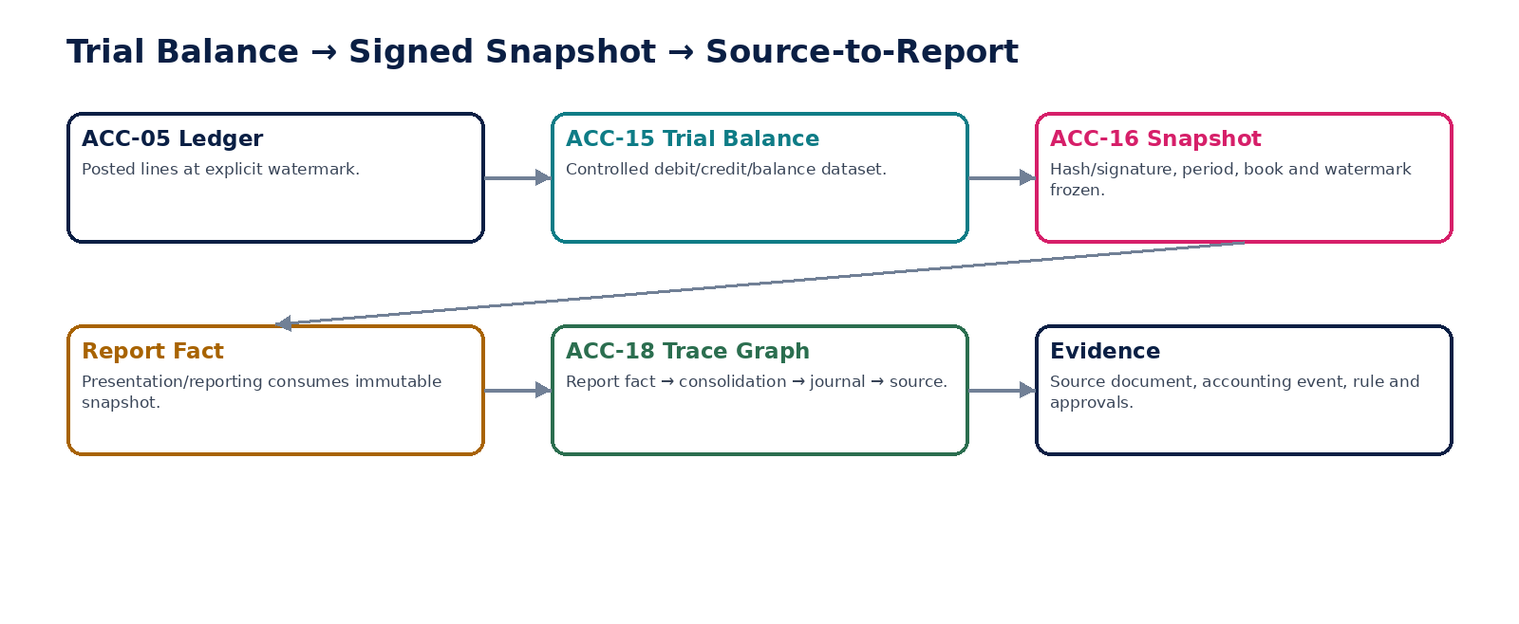
Figure 10 — Trial balance, signed snapshot and source-to-report lineage.

20. ACC-17 — Opening Balance & Migration
Establish controlled opening accounting state from legacy systems without bypassing posting, control-account or reconciliation rules.

Contract field | Specification
Service ID / owner | ACC-17 — Accounting & Record-to-Report; accountable engineering/product/control owner recorded in service registry.
Purpose / bounded scope | Establish controlled opening accounting state from legacy systems without bypassing posting, control-account or reconciliation rules.
Authoritative ownership | MigrationAccountingBatch, opening journal proposals, source crosswalk and reconciliation/certification refs.
Required source inputs | source system; cutover date; opening TB; open AR/AP; bank/tax balances; source IDs; mappings; source control totals.
Server-resolved / derived context | entity/book/account validation; migration mapping; period; approval; control-account strategy.
Commands | CreateMigrationAccountingBatch; ValidateOpeningBalances; ApproveMigrationBatch; CommitOpeningPosting; CertifyMigrationAccounting
Queries / read contracts | GetMigrationBatch; GetSourceTargetCrosswalk; GetMigrationExceptions; GetMigrationReconciliation
State model | Planned → Loaded → Validated → Approved → Posted → Reconciled → Certified; failed/quarantined as needed.
Authorization / permissions | migration.accounting.manage; migration.accounting.approve/certify.
Segregation of duties | Migration preparer cannot certify own material cutover; production posting still routed through ACC-04.
Events produced | MigrationAccountingBatchCreated; OpeningPostingCommitted; MigrationReconciliationFailed; MigrationAccountingCertified
Dependencies | ZS-MIG; ACC-01/02/04/05/06; AR/AP/Bank/Tax source domains.
Failure / degradation semantics | No production acceptance without source-to-target reconciliation; unexplained balancing plug prohibited.
Evidence / lineage | Source extract hashes, crosswalk, mappings, exceptions, opening postings, reconciliations and certificate.
NFR / recovery profile | C0 cutover-critical; repeatable dry-run and deterministic rerun before go-live.

Engineering Interaction Wireframe
Type | Operation | Illustrative contract surface | Mandatory controls
QUERY | GetMigrationBatch | GET/POST /internal/v1/acc17/getMigrationBatch | Scoped read; correlation + auth context
QUERY | GetSourceTargetCrosswalk | GET/POST /internal/v1/acc17/getSourceTargetCrosswalk | Scoped read; correlation + auth context
QUERY | GetMigrationExceptions | GET/POST /internal/v1/acc17/getMigrationExceptions | Scoped read; correlation + auth context
QUERY | GetMigrationReconciliation | GET/POST /internal/v1/acc17/getMigrationReconciliation | Scoped read; correlation + auth context
COMMAND | CreateMigrationAccountingBatch | POST /internal/v1/acc17/commands/createMigrationAccountingBatch | Idempotency-Key; expected_version where stateful
COMMAND | ValidateOpeningBalances | POST /internal/v1/acc17/commands/validateOpeningBalances | Idempotency-Key; expected_version where stateful
COMMAND | ApproveMigrationBatch | POST /internal/v1/acc17/commands/approveMigrationBatch | Idempotency-Key; expected_version where stateful
COMMAND | CommitOpeningPosting | POST /internal/v1/acc17/commands/commitOpeningPosting | Idempotency-Key; expected_version where stateful

Minimum Negative-Path Acceptance
# | Scenario | Required result
1 | Opening TB forced with suspense plug | Block/deny/quarantine or preserve safe state; stable error/evidence; no unauthorized or duplicate accounting consequence.
2 | Open AR included both in history and opening state | Block/deny/quarantine or preserve safe state; stable error/evidence; no unauthorized or duplicate accounting consequence.
3 | Source-target row counts match but values differ | Block/deny/quarantine or preserve safe state; stable error/evidence; no unauthorized or duplicate accounting consequence.
4 | Commit repeated after timeout | Block/deny/quarantine or preserve safe state; stable error/evidence; no unauthorized or duplicate accounting consequence.
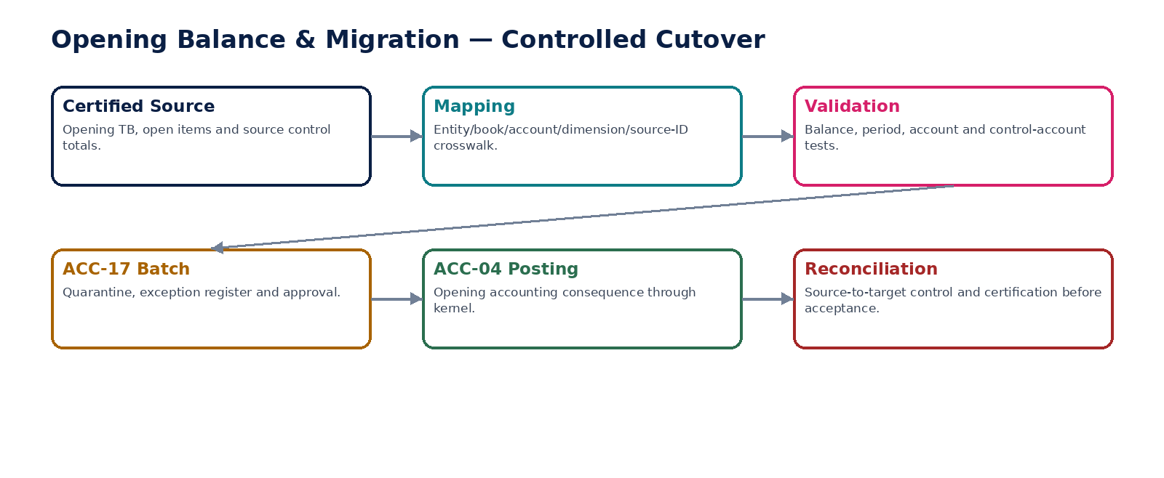
Figure 11 — Opening balance and migration accounting cutover.

21. ACC-18 — Source-to-Report Traceability
Provide permission-aware immutable lineage from reported facts and snapshots back through consolidation, ledger, journals, accounting events and source evidence.

Contract field | Specification
Service ID / owner | ACC-18 — Accounting & Record-to-Report; accountable engineering/product/control owner recorded in service registry.
Purpose / bounded scope | Provide permission-aware immutable lineage from reported facts and snapshots back through consolidation, ledger, journals, accounting events and source evidence.
Authoritative ownership | AccountingLineageGraph/index and verification results; does not own underlying business facts.
Required source inputs | report fact; report/snapshot ID; requested drill path; subject scope.
Server-resolved / derived context | report mapping; consolidation adjustments; ledger entries; journal/posting/source links; evidence references.
Commands | RebuildLineageProjection; VerifyTracePath; QuarantineBrokenLineage
Queries / read contracts | TraceReportFact; TraceJournalToSource; GetLineageAsOf; VerifyLineageCompleteness
State model | Projection: Current / Rebuilding / Degraded; historical lineage immutable even if access policy changes.
Authorization / permissions | lineage.read scoped by current authorization; rebuild restricted to service/admin workload.
Segregation of duties | Lineage visibility follows current permissions; historical links themselves are not rewritten to hide past relationships.
Events produced | LineageProjectionRebuilt; LineageGapDetected; LineageVerificationFailed
Dependencies | ACC-03/04/05/13/16; reporting; evidence/data-governance services.
Failure / degradation semantics | Missing mandatory lineage produces explicit gap, never fabricated path; projection outage does not alter source records.
Evidence / lineage | Store edge provenance, source IDs, event/journal/snapshot refs, version and verification state.
NFR / recovery profile | C1 audit-critical; high read scale; rebuildable from authoritative IDs/events.

Engineering Interaction Wireframe
Type | Operation | Illustrative contract surface | Mandatory controls
QUERY | TraceReportFact | GET/POST /internal/v1/acc18/traceReportFact | Scoped read; correlation + auth context
QUERY | TraceJournalToSource | GET/POST /internal/v1/acc18/traceJournalToSource | Scoped read; correlation + auth context
QUERY | GetLineageAsOf | GET/POST /internal/v1/acc18/getLineageAsOf | Scoped read; correlation + auth context
QUERY | VerifyLineageCompleteness | GET/POST /internal/v1/acc18/verifyLineageCompleteness | Scoped read; correlation + auth context
COMMAND | RebuildLineageProjection | POST /internal/v1/acc18/commands/rebuildLineageProjection | Idempotency-Key; expected_version where stateful
COMMAND | VerifyTracePath | POST /internal/v1/acc18/commands/verifyTracePath | Idempotency-Key; expected_version where stateful
COMMAND | QuarantineBrokenLineage | POST /internal/v1/acc18/commands/quarantineBrokenLineage | Idempotency-Key; expected_version where stateful

Minimum Negative-Path Acceptance
# | Scenario | Required result
1 | Missing journal-source link | Block/deny/quarantine or preserve safe state; stable error/evidence; no unauthorized or duplicate accounting consequence.
2 | User drills into unauthorized entity | Block/deny/quarantine or preserve safe state; stable error/evidence; no unauthorized or duplicate accounting consequence.
3 | Projection stale after adjustment | Block/deny/quarantine or preserve safe state; stable error/evidence; no unauthorized or duplicate accounting consequence.
4 | Lineage service invents inferred source | Block/deny/quarantine or preserve safe state; stable error/evidence; no unauthorized or duplicate accounting consequence.
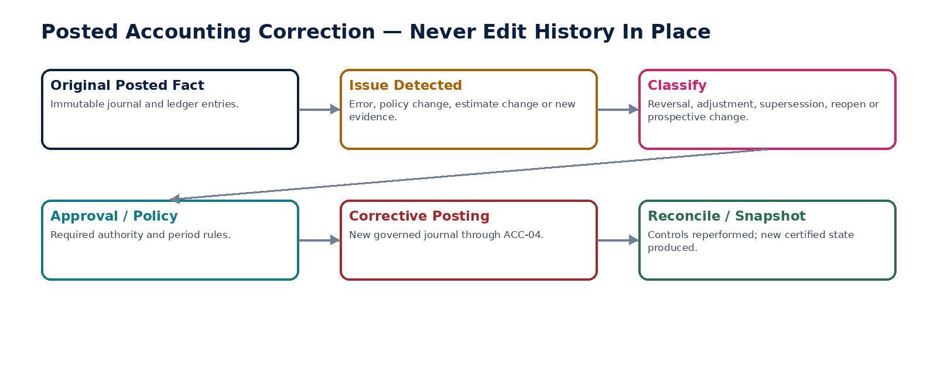
Figure 12 — Corrections create new governed facts; posted history is preserved.

22. Shared Accounting Command & Error Contract
Field | Accounting requirement
tenant_id / entity_id / book_id | Server-resolved and authorization-scoped; required for all material commands.
source_event_id / source_object_id | Stable authoritative source identity for posting/reconciliation/lineage.
accounting_date / posting_date | Explicit business/accounting dates; validated against period state.
transaction_currency / functional_currency | Distinct persisted currency contexts; presentation currency remains reporting/consolidation concern.
idempotency_key | Mandatory for I2–I4 accounting writes; request fingerprint retained.
expected_version | Required for mutable pre-posting state transitions.
policy_rule_versions | Exact posting/accounting/mapping/FX/workflow versions used.
correlation_id / causation_id | Propagated end-to-end through event, journal, posting, ledger and evidence.
reason_code / evidence_id | Mandatory for corrections, reopen, manual journals, adjustments and privileged actions.
ledger_watermark | Explicit on TB/snapshot/reconciliation outputs.
Stable error classes include ACCOUNT_INACTIVE, ACCOUNT_MAPPING_AMBIGUOUS, JOURNAL_UNBALANCED, APPROVAL_REQUIRED, APPROVAL_INVALIDATED, PERIOD_CLOSED, CONTROL_ACCOUNT_RESTRICTED, POSTING_RULE_MISSING, POSTING_DUPLICATE, POSTING_ATOMICITY_FAILED, FX_RATE_MISSING, RECONCILIATION_BREAK, INTERCOMPANY_UNMATCHED, CONSOLIDATION_INPUT_UNCERTIFIED, TRIAL_BALANCE_MISMATCH, SNAPSHOT_INTEGRITY_FAILED, MIGRATION_RECONCILIATION_FAILED and LINEAGE_INCOMPLETE.

23. Cross-Service Event Contract Baseline
Producer | Representative authoritative events | Primary consumers
ACC-01/02 | AccountActivated; AccountMappingActivated; MappingAmbiguityDetected | ACC-03/04, migration, reporting
ACC-03 | JournalSubmitted; JournalApproved; JournalPostingRequested | Workflow, ACC-04, evidence
ACC-04 | PostingCommitted; PostingFailed; PostingDuplicateSuppressed | ACC-03/05/06, source domains, evidence
ACC-05 | LedgerEntriesAppended; LedgerIntegrityCheckFailed | ACC-06/15/18, reporting
ACC-06 | ControlExceptionRaised; ControlCertified | ACC-14, close dashboard, evidence
ACC-07/08/09 | Recognition/AllocationDue; Recognition/AllocationPosted | ACC-04, close, evidence
ACC-10 | RevaluationCalculated; RevaluationPosted | ACC-04/14/15
ACC-11 | IntercompanyMatched; IntercompanyMismatchDetected | ACC-12/13, close
ACC-12/13 | ConsolidationAdjustmentPosted; ConsolidationCertified | ACC-15/16/18, reporting
ACC-14 | PeriodHardClosed; PeriodReopened; PeriodReclosed | ACC-03/04, all source domains, reporting
ACC-15/16 | TrialBalanceValidated; FinancialSnapshotCertified | Reporting, audit, tax, evidence
ACC-17 | OpeningPostingCommitted; MigrationAccountingCertified | ACC-05/06/14, migration ops
ACC-18 | LineageGapDetected; LineageVerificationFailed | Audit, data governance, reporting

24. Canonical Accounting Domain Data Model
Entity | Owner | Key fields / notes
AccountMaster / AccountVersion | ACC-01 | entity, book, code, class, parent, effective interval, posting/control restrictions
AccountMappingVersion | ACC-02 | source identity, target account, precedence, effective interval, rationale
Journal / JournalLine | ACC-03 | version, state, dates, currencies, accounts, dimensions, approvals, posting ref
PostingExecution | ACC-04 | source, book, rule/mapping/FX versions, idempotency, calculation trace, result
LedgerEntry | ACC-05 | journal/posting/source refs, account, dimensions, debit/credit, currencies, immutable sequence
AccountingControlRun | ACC-06 | population watermarks, assertions, totals, exceptions, certification
AccrualSchedule / RecognitionSchedule | ACC-07/08 | basis, schedule version, recognized/remaining amounts, posting refs
AllocationRule / AllocationRun | ACC-09 | drivers, source population, outputs, rounding, posting refs
RevaluationRun / Item | ACC-10 | monetary item, base amount, rate ref, difference, account/posting
IntercompanyPair | ACC-11 | entity A/B refs, currencies, reciprocal IDs, match/dispute state
ConsolidationAdjustment | ACC-12 | group/book, period, purpose, source balances, approvals, posting ref
ConsolidationRun | ACC-13 | input snapshots, ownership/FX, eliminations, adjustments, group balances
PeriodClose | ACC-14 | entity/book/period, state, blockers, approvals, watermarks, reopen scope
TrialBalanceDataset | ACC-15 | scope, watermark, debit/credit/balance totals, validation
FinancialSnapshot | ACC-16 | manifest, input hashes/watermarks, signature, purpose, supersession
MigrationAccountingBatch | ACC-17 | source extract, crosswalk, mappings, opening posting, reconciliation, certificate
AccountingLineageEdge | ACC-18 | from/to object IDs, edge type, provenance/version, verification state

25. Domain-Level Negative-Path Certification
# | Scenario | Certification requirement
1 | Post to inactive/non-posting account | Automated/controlled test proves fail-safe outcome, no duplicate/unauthorized accounting effect, stable error/evidence and recoverable state.
2 | Two active account mappings resolve equally | Automated/controlled test proves fail-safe outcome, no duplicate/unauthorized accounting effect, stable error/evidence and recoverable state.
3 | Journal debits and credits do not balance | Automated/controlled test proves fail-safe outcome, no duplicate/unauthorized accounting effect, stable error/evidence and recoverable state.
4 | Protected manual journal self-approved | Automated/controlled test proves fail-safe outcome, no duplicate/unauthorized accounting effect, stable error/evidence and recoverable state.
5 | Journal changed after approval but approval reused | Automated/controlled test proves fail-safe outcome, no duplicate/unauthorized accounting effect, stable error/evidence and recoverable state.
6 | Posting request replayed after timeout | Automated/controlled test proves fail-safe outcome, no duplicate/unauthorized accounting effect, stable error/evidence and recoverable state.
7 | Posting rule version unavailable | Automated/controlled test proves fail-safe outcome, no duplicate/unauthorized accounting effect, stable error/evidence and recoverable state.
8 | Period closes between validation and commit | Automated/controlled test proves fail-safe outcome, no duplicate/unauthorized accounting effect, stable error/evidence and recoverable state.
9 | Control-account direct manual posting attempted | Automated/controlled test proves fail-safe outcome, no duplicate/unauthorized accounting effect, stable error/evidence and recoverable state.
10 | Ledger API/database direct write attempted | Automated/controlled test proves fail-safe outcome, no duplicate/unauthorized accounting effect, stable error/evidence and recoverable state.
11 | Duplicate journal append reaches ledger | Automated/controlled test proves fail-safe outcome, no duplicate/unauthorized accounting effect, stable error/evidence and recoverable state.
12 | Subledger totals match GL while population contains duplicates/missing items | Automated/controlled test proves fail-safe outcome, no duplicate/unauthorized accounting effect, stable error/evidence and recoverable state.
13 | Control tolerance changed after run starts | Automated/controlled test proves fail-safe outcome, no duplicate/unauthorized accounting effect, stable error/evidence and recoverable state.
14 | Accrual recognition scheduler replays period | Automated/controlled test proves fail-safe outcome, no duplicate/unauthorized accounting effect, stable error/evidence and recoverable state.
15 | Prepayment schedule backdated over recognized history | Automated/controlled test proves fail-safe outcome, no duplicate/unauthorized accounting effect, stable error/evidence and recoverable state.
16 | Allocation drivers incomplete | Automated/controlled test proves fail-safe outcome, no duplicate/unauthorized accounting effect, stable error/evidence and recoverable state.
17 | Allocation result does not reconcile to source | Automated/controlled test proves fail-safe outcome, no duplicate/unauthorized accounting effect, stable error/evidence and recoverable state.
18 | FX rate missing for one currency | Automated/controlled test proves fail-safe outcome, no duplicate/unauthorized accounting effect, stable error/evidence and recoverable state.
19 | Non-monetary balance incorrectly included in revaluation | Automated/controlled test proves fail-safe outcome, no duplicate/unauthorized accounting effect, stable error/evidence and recoverable state.
20 | Revaluation repeated with new idempotency key for same consequence | Automated/controlled test proves fail-safe outcome, no duplicate/unauthorized accounting effect, stable error/evidence and recoverable state.
21 | Intercompany one-sided transaction | Automated/controlled test proves fail-safe outcome, no duplicate/unauthorized accounting effect, stable error/evidence and recoverable state.
22 | Intercompany mismatch silently eliminated | Automated/controlled test proves fail-safe outcome, no duplicate/unauthorized accounting effect, stable error/evidence and recoverable state.
23 | Consolidation adjustment targets entity statutory book | Automated/controlled test proves fail-safe outcome, no duplicate/unauthorized accounting effect, stable error/evidence and recoverable state.
24 | Top-side consolidation adjustment self-approved | Automated/controlled test proves fail-safe outcome, no duplicate/unauthorized accounting effect, stable error/evidence and recoverable state.
25 | Consolidation input changes after lock | Automated/controlled test proves fail-safe outcome, no duplicate/unauthorized accounting effect, stable error/evidence and recoverable state.
26 | Ownership effective date ambiguous | Automated/controlled test proves fail-safe outcome, no duplicate/unauthorized accounting effect, stable error/evidence and recoverable state.
27 | Hard close with unresolved mandatory reconciliation | Automated/controlled test proves fail-safe outcome, no duplicate/unauthorized accounting effect, stable error/evidence and recoverable state.
28 | Ordinary posting into hard-closed period | Automated/controlled test proves fail-safe outcome, no duplicate/unauthorized accounting effect, stable error/evidence and recoverable state.
29 | Reopen without independent approval | Automated/controlled test proves fail-safe outcome, no duplicate/unauthorized accounting effect, stable error/evidence and recoverable state.
30 | Reclose without re-performing controls | Automated/controlled test proves fail-safe outcome, no duplicate/unauthorized accounting effect, stable error/evidence and recoverable state.
31 | Trial balance differs from ledger watermark | Automated/controlled test proves fail-safe outcome, no duplicate/unauthorized accounting effect, stable error/evidence and recoverable state.
32 | Snapshot content changes after seal | Automated/controlled test proves fail-safe outcome, no duplicate/unauthorized accounting effect, stable error/evidence and recoverable state.
33 | Snapshot signing/verification key invalid | Automated/controlled test proves fail-safe outcome, no duplicate/unauthorized accounting effect, stable error/evidence and recoverable state.
34 | Migration opening balance uses unexplained plug | Automated/controlled test proves fail-safe outcome, no duplicate/unauthorized accounting effect, stable error/evidence and recoverable state.
35 | Open item counted both as migrated history and opening state | Automated/controlled test proves fail-safe outcome, no duplicate/unauthorized accounting effect, stable error/evidence and recoverable state.
36 | Source-to-report lineage gap hidden by inferred path | Automated/controlled test proves fail-safe outcome, no duplicate/unauthorized accounting effect, stable error/evidence and recoverable state.

26. Definition of Ready — Individual ACC Service
# | Ready gate
1 | Authoritative fact/write boundary approved
2 | Canonical 52-field service contract instantiated
3 | OpenAPI/AsyncAPI/schema drafts available
4 | Book/entity/period/currency semantics explicit
5 | Commands/queries and stable errors defined
6 | State machine and correction semantics defined
7 | Permissions and dynamic SoD specified
8 | Idempotency/concurrency classes specified
9 | Accounting/tax/control impacts and evidence mapped
10 | Dependencies/timeouts/degradation behavior specified
11 | SLO/RPO/RTO/capacity approved
12 | Positive and negative acceptance suites executable

27. Definition of Done — Individual ACC Service
# | Done gate
1 | Machine contract published and compatibility certified
2 | Authoritative datastore constraints implemented
3 | No generic API bypasses protected accounting command
4 | All writes resolve entity/book/period and policy server-side
5 | Outbox/inbox/idempotency tests pass
6 | Corrections preserve posted history
7 | Source-to-ledger/evidence lineage complete
8 | Reconciliation/control tests pass
9 | NFR/load/failure tests meet approved class
10 | Security/residency tests pass
11 | Runbooks and close/recovery procedures exercised
12 | Release certificate generated with no unresolved mandatory control

28. Recommended Engineering Sequence
Wave | Services | Reason
1 | ACC-01, ACC-02, ACC-05 | Define accounts/mappings and immutable ledger storage primitives.
2 | ACC-03, ACC-04 | Implement journal lifecycle and the single deterministic posting authority.
3 | ACC-06, ACC-14 | Make reconciliation and period-state controls non-bypassable before broad subledger integration.
4 | ACC-07, ACC-08, ACC-09, ACC-10 | Add governed recurring recognition, allocation and FX period-end processing.
5 | ACC-11, ACC-12, ACC-13 | Add group accounting with explicit book separation and certified inputs.
6 | ACC-15, ACC-16, ACC-18 | Build controlled TB, immutable snapshots and full source-to-report traceability.
7 | ACC-17 | Integrate opening-balance/migration accounting after the full posting/control chain is proven.

29. Controlled Open Decisions Before Production
Decision | Required owner / evidence
Physical deployment grouping of ACC logical services | Platform Architecture + Accounting Engineering; load/failure/residency evidence
Book taxonomy and permitted local/statutory/management/tax/group combinations | Finance Architecture + Product + Jurisdiction Governance
Control-account override policy | Finance Control + IAM/SoD; explicit exceptional use cases only
Journal classes requiring maker-checker/dual approval | Finance Control + Product; risk/materiality matrix
Posting rule expression/runtime technology | Architecture + Finance Engineering; determinism, sandboxing, versioning tests
FX source/rate hierarchy by book | Finance/Treasury + Jurisdiction policy
Consolidation ownership/NCI method data source | Group Finance + Organization domain
Snapshot signature/key profile | Security/Cryptography + Audit/Finance
Closed-period correction/reopen thresholds | Finance Control + Audit/Compliance
Retention period for ledger/journal/evidence by jurisdiction | Data Governance + Legal/Tax

30. Prohibited Accounting Anti-Patterns
# | Prohibited pattern
1 | Source domain writes ledger lines directly
2 | Posting logic duplicated inside AR/AP/Payroll/Tax services
3 | Ledger entry edited/deleted in place
4 | Generic PATCH changes posted or closed accounting state
5 | Hard-coded accounts inside business code without mapping/version evidence
6 | Floating-point arithmetic for financially material amounts
7 | “Exactly once” broker claim used instead of business idempotency
8 | Partial posting accepted after one journal line fails
9 | Control account manually posted without explicit policy/authority
10 | Closed period reopened implicitly by admin/database change
11 | Unmatched intercompany silently eliminated
12 | Consolidation adjustment posted to statutory entity book
13 | Trial balance treated as an independent ledger
14 | External report generated from mutable live query instead of governed snapshot
15 | Migration loader bypasses posting engine
16 | AI-generated numeric posting or close decision treated as authoritative
17 | Missing source-to-report lineage replaced by heuristic/inferred path

31. Current Accounting-Standards Architecture Anchors
These references inform capability and forward-compatibility requirements; they are not embedded as hard-coded accounting outcomes and do not replace jurisdiction/entity accounting-policy decisions.
Anchor | Architecture implication
IAS 8 — Basis of Preparation of Financial Statements | Versioned accounting policies and governed correction/estimate-change semantics must be representable without rewriting historical ledger facts.
IAS 21 — Effects of Changes in Foreign Exchange Rates | Transaction, functional and presentation currencies remain distinct; FX rate source/effective date/version must be preserved.
IFRS 10 — Consolidated Financial Statements | Consolidation requires effective-dated group/control relationships and separately governed consolidation adjustments rather than entity-ledger mutation.
IFRS 18 — Presentation and Disclosure in Financial Statements | Effective for annual periods beginning on/after 1 Jan 2027; presentation changes belong in reporting/taxonomy layers, so the accounting core must not hard-code an IAS 1-only presentation model.

32. Final Architecture Decision
APPROVED DESIGN BASELINE — ACC-01 through ACC-18 are logical accounting capabilities with one posting authority, one append-only ledger truth, explicit control/close gates, book-separated consolidation, immutable certified snapshots and source-to-report traceability. They may share runtime infrastructure, but no deployment choice may collapse or bypass these authority boundaries.

This pack is build-ready when engineering can generate machine contracts, schemas, posting rules, workflow/SoD policies, automated accounting/control tests, runbooks and release evidence for each ACC capability without inventing new accounting authority. Any divergence requires an architecture decision record and explicit Finance Architecture approval.

