ZOIKOSUITE

Banking, Cash & Treasury
Detailed Service Specifications
BNK-01 through BNK-10 • Build-Ready Money-Movement & Cash-Control Baseline

Field | Value
Document ID | ZS-SVC-E-001
Version | 1.0 — Banking, Cash & Treasury Engineering Baseline
Date | 24 August 2026
Status | Build-ready domain specification; launch-market banking regulation, licensed roles, bank/provider contracts, payment schemes, account verification methods, numeric SLOs, signing limits and cut-off calendars remain subject to certified launch configuration.
Owner | ZoikoSuite Product Architecture / Finance Platform Engineering
Applies to | Engineering, Product, Treasury, Finance, Banking Operations, AR/AP, Tax, Security, Compliance, QA, Support, Audit and Integration teams
Language | American English

Executive doctrine: ZoikoSuite Banking owns bank-account identity, consented connectivity, bank-source evidence, canonical bank transactions, reconciliation, payment submission attempts, external execution/finality state and controlled treasury facts. It does not become the bank, assume settlement finality without authoritative evidence, or write the General Ledger directly. Payment intent, submission, acceptance, settlement and accounting recognition are separate governed facts.

Document Roadmap & How to Use This Pack
This pack instantiates the approved ZoikoSuite service contract standard for BNK-01 through BNK-10. It is an engineering build contract, not a recommendation to deploy ten separate microservices. Physical deployment may group capabilities, but authority boundaries, commands, data ownership, state, events, external-attempt semantics, evidence, reconciliation and negative paths remain independently testable.
Banking truth flows in controlled stages: entity-owned bank account → authorized connection/source → immutable statement/payment evidence → canonical transaction/status → reconciliation/cash view → governed accounting event → Accounting Kernel → certified financial control. External money movement is initiated only from an exact approved instruction and remains Pending/Unknown whenever the bank/provider outcome is not yet authoritative.

1. Critical Analysis & Refinements Incorporated
Refinement | Engineering consequence
Separate payment intent from payment execution | AP/AR/Treasury own business intent/authorization. BNK-06 creates the durable external attempt. BNK-07 owns execution/finality state from authoritative provider/bank evidence.
UNKNOWN is a first-class financial state | Timeout, missing callback or ambiguous provider response never means Failed. The original attempt is resolved before any new irreversible submission can occur.
Bank statements are evidence, not mutable imports | BNK-03 preserves raw source/hash, source IDs, period/balances, parser version and import watermark. Reprocessing never changes original source evidence.
Normalization is versioned interpretation | BNK-04 can correct mappings by superseding canonical versions, while raw provider facts remain immutable.
Reconciliation certifies populations, not totals | BNK-05 freezes bank/book populations with hashes/counts/totals. Equal headline balances do not certify if underlying transactions differ.
Finality is rail/provider-specific and evidence-based | BNK-07 maps provider/bank states under versioned rules and prohibits out-of-order regressions of governed final states.
Cash position is analytical | BNK-08 exposes freshness and confidence. It cannot overwrite bank balance or ledger cash and cannot hide stale/partial sources.
Treasury transfer may create intercompany accounting | BNK-09 classifies source/destination ownership and invokes paired intercompany/accounting consequences when movement crosses legal entities.
FX exposure is analytical unless separately authorized | BNK-10 may calculate recognized/forecast exposure and scenarios, but it cannot autonomously create a payment, trade or hedge.
Bank API security is profile-driven | Where ecosystem/provider supports OAuth/Open Banking, high-value connectivity should use approved FAPI 2.0-style sender-constrained and message-security profiles rather than bespoke token handling.

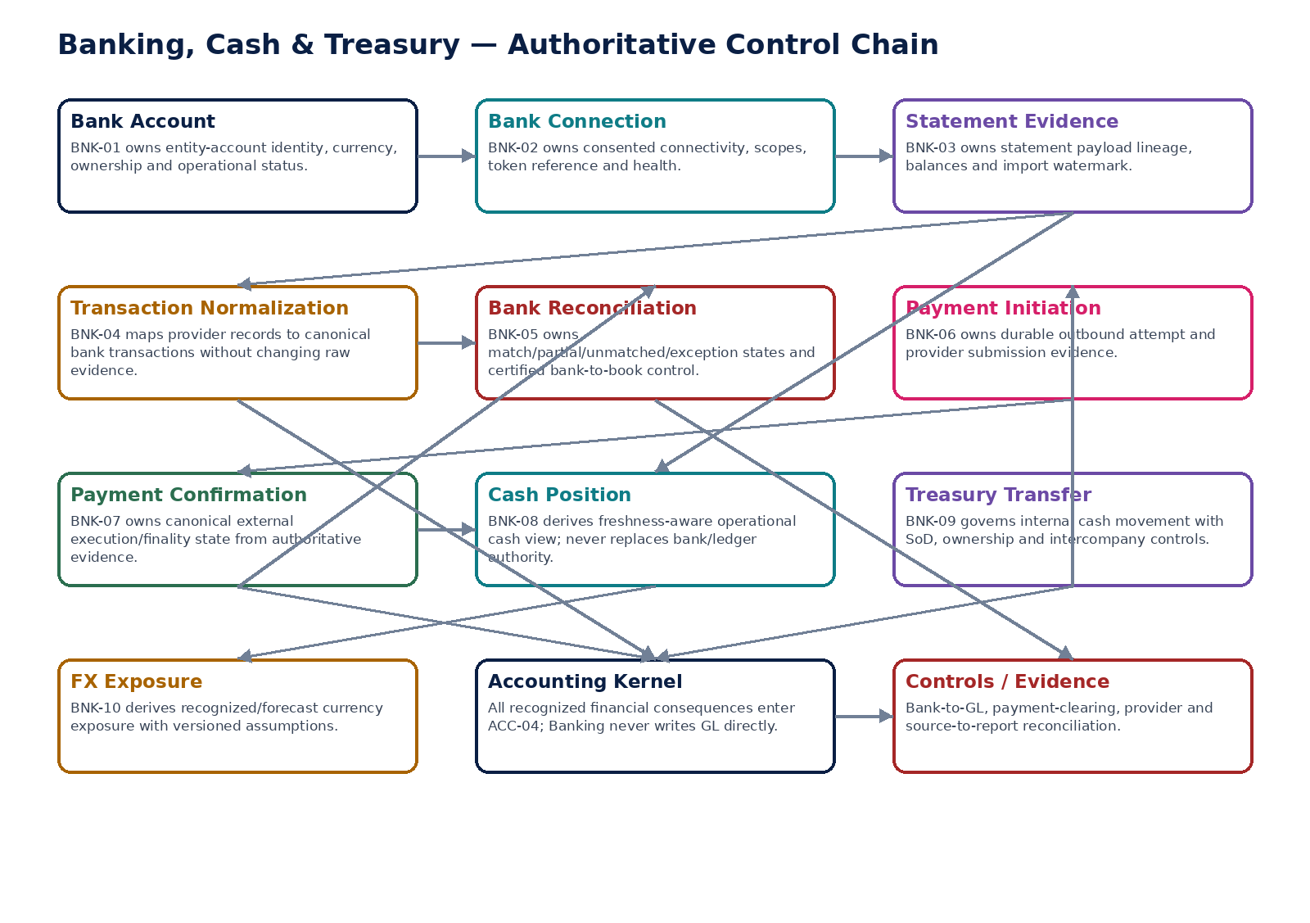
Figure 1 — Authoritative Banking, Cash & Treasury control chain.

2. Domain Constitution & Non-Negotiable Invariants
# | Invariant
1 | Bank account legal-entity ownership and operational status are server-authoritative and historically reconstructable.
2 | Sensitive bank-account identifiers are masked/tokenized; raw values never appear in ordinary logs, list APIs, search indexes or analytics.
3 | Connection tokens/credentials are stored only in approved secrets/KMS infrastructure and referenced from business records.
4 | Consent/scopes/expiry/revocation are versioned and enforceable; revoked access cannot continue silently.
5 | Accepted bank statements/raw provider evidence are immutable or verifiably referenced by cryptographic hash.
6 | Statement ingestion is idempotent and maintains a source/import watermark and completeness controls.
7 | Normalization never alters raw banking evidence; mapping/schema version is retained for every canonical transaction.
8 | Unknown/ambiguous transaction semantics are quarantined rather than guessed.
9 | Bank reconciliation certifies frozen populations, not merely matching totals.
10 | Matching tolerance and materiality policies are distinct and cannot be widened during a run.
11 | Manual bank matches retain actor, reason, evidence and approval where required.
12 | All unresolved material bank-reconciliation differences remain visible and may block period close.
13 | BNK-06 accepts only an exact, still-valid authorized payment instruction; it cannot mutate payer/payee/amount/currency/date/purpose.
14 | A durable payment-attempt record and idempotency identity exist before the external network side effect.
15 | A provider timeout or missing response is Pending/Unknown, never automatically Failed.
16 | No new payment attempt may be created for an unresolved original attempt unless an explicit rail/provider-safe duplicate-prevention rule allows it.
17 | BNK-07 authenticates/deduplicates callbacks and handles out-of-order statuses without regressing governed finality.
18 | Payment initiation does not equal payment settlement; accounting and AP/AR settlement consequences depend on governed state.
19 | Provider/bank evidence conflicts create an explicit exception and reconciliation path.
20 | Cash position exposes source freshness, restrictions and assumptions and never replaces bank/ledger authority.
21 | Treasury transfer authorization binds exact source/destination/amount/currency/value-date/purpose and is invalidated by protected-field change.
22 | Cross-entity treasury transfers cannot bypass intercompany classification and paired accounting/reconciliation.
23 | FX exposure retains source populations, rates, maturity/forecast assumptions and calculation version.
24 | No Banking service writes posted GL balances directly; accounting consequences enter through governed accounting events and ACC-04.
25 | AI may classify transactions or suggest matches, but cannot assert settlement finality, approve treasury transfers, alter bank identity, waive reconciliation or execute money autonomously.

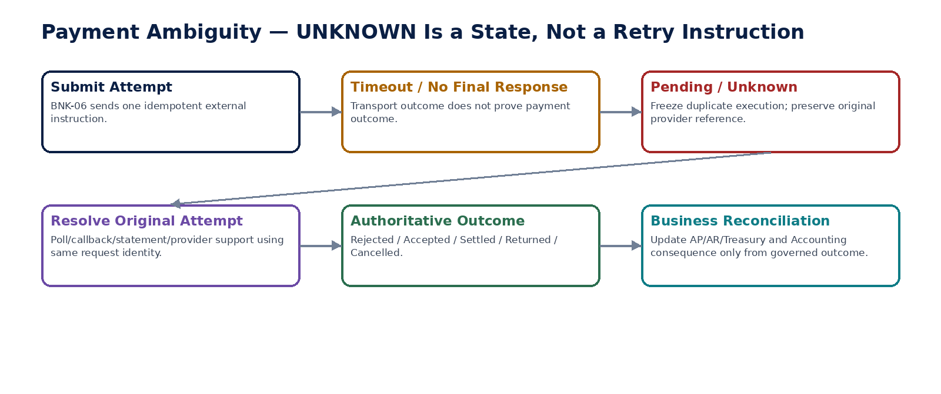
Figure 2 — Ambiguous external payment outcome remains Pending/Unknown until the original attempt is resolved.

3. Cross-Service Authority Matrix
Service | Authoritative ownership | Must never own / bypass
BNK-01 | Bank-account identity, ownership evidence, currency/type/status and permitted operational use | Legal-entity identity, free-text secrets, payment authorization, GL
BNK-02 | Connection/consent/scopes/token reference/expiry/health/revocation | Reusable plaintext secrets, bank-account ownership, payment settlement
BNK-03 | Statement/source evidence, balances, source IDs and import watermark | Normalization semantics, book match, mutable raw source
BNK-04 | Canonical bank transaction and normalization lineage/version | Raw-source mutation, accounting classification authority
BNK-05 | Bank-to-book match/exception/certificate state | Ledger edits, payment finality, tolerance self-waiver
BNK-06 | Durable approved payment submission attempt and provider receipt | Business payment approval, external finality, duplicate retry inference
BNK-07 | Canonical payment execution/finality status and evidence | Payment subject mutation, ledger write, business approval
BNK-08 | Freshness-aware cash position snapshot and analytical drill-through | Bank/ledger authoritative balance, accounting posting
BNK-09 | Treasury-transfer intent/approval/tracking and ownership relationship | Provider finality, direct GL/intercompany bypass
BNK-10 | Recognized/forecast FX exposure view and scenario assumptions | Trade/hedge/payment execution, rate-source mutation

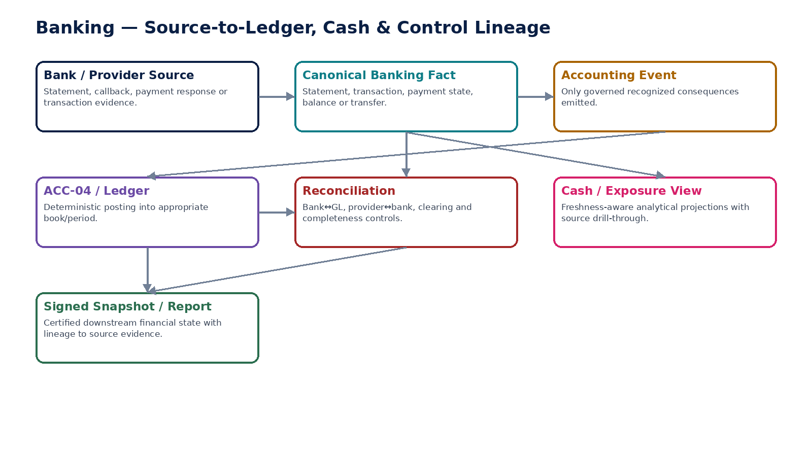
Figure 3 — Banking source-to-ledger, cash and control lineage.

4. Shared Command, Error & State Contract
Area | Required behavior
Context | Every protected command resolves tenant, legal entity, bank account, purpose, actor/workload, region/residency, correlation/causation and idempotency server-side.
Concurrency | Mutable aggregates use expected-version/ETag semantics. Approval/finality/certification commands bind a protected-field fingerprint.
Idempotency | External side-effect commands require durable idempotency. Duplicate calls return the original stable attempt/result rather than create a second effect.
Errors | Stable problem types include BANK_ACCOUNT_UNVERIFIED, CONNECTION_REVOKED, STATEMENT_DUPLICATE, NORMALIZATION_AMBIGUOUS, RECONCILIATION_UNRESOLVED, PAYMENT_SUBJECT_CHANGED, PAYMENT_OUTCOME_UNKNOWN, CALLBACK_REPLAYED, FINAL_STATE_CONFLICT, CASH_SOURCE_STALE and TREASURY_AUTH_INVALIDATED.
External state | Submitted/Accepted/Pending/Settled/Rejected/Returned/Cancelled are not inferred from transport success. Provider/native state plus source/finality evidence is retained.
Sensitive data | Bank account/token/certificate data is purpose-scoped and redacted from telemetry; secrets are never returned from business APIs.
Evidence | Every externally material command links request subject, approval/authorization fingerprint, attempt/result evidence, source hash/reference, actor/workload, versions and timestamps.

5. Canonical Banking Domain Data Model
Entity | Primary authority / purpose
BankAccount | BNK-01 — entity-owned account identity/status and sensitive identifier token
BankAccountOwnershipEvidence | BNK-01 — verification and effective ownership proof
BankConnection | BNK-02 — provider/institution/account connection and consent
BankConnectionCredentialRef | BNK-02 — vault/KMS reference only
BankStatement | BNK-03 — accepted statement/report population
BankStatementSource | BNK-03 — raw payload/file/provider source/hash/watermark
CanonicalBankTransaction | BNK-04 — canonical normalized bank transaction
BankNormalizationVersion | BNK-04 — mapping/schema/version lineage
BankReconciliationRun | BNK-05 — frozen population/control run
BankMatchGroup | BNK-05 — exact/partial/manual match and evidence
PaymentInitiationAttempt | BNK-06 — durable outbound attempt
PaymentExecutionState | BNK-07 — canonical status/finality history
CashPositionSnapshot | BNK-08 — freshness-aware analytical cash view
TreasuryTransfer | BNK-09 — controlled internal cash-movement subject
FXExposureSnapshot | BNK-10 — recognized/forecast exposure output

6. Canonical Banking Domain Events
Event | Minimum contract
BankAccountCreated | event_id; tenant/entity; aggregate_id/version; occurred_at; correlation/causation; producer; residency context; schema version; business-effective date where applicable; no plaintext secrets.
BankAccountOwnershipVerified | event_id; tenant/entity; aggregate_id/version; occurred_at; correlation/causation; producer; residency context; schema version; business-effective date where applicable; no plaintext secrets.
BankAccountSuspended | event_id; tenant/entity; aggregate_id/version; occurred_at; correlation/causation; producer; residency context; schema version; business-effective date where applicable; no plaintext secrets.
BankConnectionActivated | event_id; tenant/entity; aggregate_id/version; occurred_at; correlation/causation; producer; residency context; schema version; business-effective date where applicable; no plaintext secrets.
BankConnectionDegraded | event_id; tenant/entity; aggregate_id/version; occurred_at; correlation/causation; producer; residency context; schema version; business-effective date where applicable; no plaintext secrets.
BankConnectionRevoked | event_id; tenant/entity; aggregate_id/version; occurred_at; correlation/causation; producer; residency context; schema version; business-effective date where applicable; no plaintext secrets.
BankStatementAccepted | event_id; tenant/entity; aggregate_id/version; occurred_at; correlation/causation; producer; residency context; schema version; business-effective date where applicable; no plaintext secrets.
BankStatementQuarantined | event_id; tenant/entity; aggregate_id/version; occurred_at; correlation/causation; producer; residency context; schema version; business-effective date where applicable; no plaintext secrets.
BankTransactionNormalized | event_id; tenant/entity; aggregate_id/version; occurred_at; correlation/causation; producer; residency context; schema version; business-effective date where applicable; no plaintext secrets.
BankTransactionNormalizationSuperseded | event_id; tenant/entity; aggregate_id/version; occurred_at; correlation/causation; producer; residency context; schema version; business-effective date where applicable; no plaintext secrets.
BankReconciliationStarted | event_id; tenant/entity; aggregate_id/version; occurred_at; correlation/causation; producer; residency context; schema version; business-effective date where applicable; no plaintext secrets.
BankMatchExceptionRaised | event_id; tenant/entity; aggregate_id/version; occurred_at; correlation/causation; producer; residency context; schema version; business-effective date where applicable; no plaintext secrets.
BankReconciliationCertified | event_id; tenant/entity; aggregate_id/version; occurred_at; correlation/causation; producer; residency context; schema version; business-effective date where applicable; no plaintext secrets.
PaymentInitiationPrepared | event_id; tenant/entity; aggregate_id/version; occurred_at; correlation/causation; producer; residency context; schema version; business-effective date where applicable; no plaintext secrets.
PaymentSubmitted | event_id; tenant/entity; aggregate_id/version; occurred_at; correlation/causation; producer; residency context; schema version; business-effective date where applicable; no plaintext secrets.
PaymentSubmissionAmbiguous | event_id; tenant/entity; aggregate_id/version; occurred_at; correlation/causation; producer; residency context; schema version; business-effective date where applicable; no plaintext secrets.
PaymentAccepted | event_id; tenant/entity; aggregate_id/version; occurred_at; correlation/causation; producer; residency context; schema version; business-effective date where applicable; no plaintext secrets.
PaymentSettled | event_id; tenant/entity; aggregate_id/version; occurred_at; correlation/causation; producer; residency context; schema version; business-effective date where applicable; no plaintext secrets.
PaymentRejected | event_id; tenant/entity; aggregate_id/version; occurred_at; correlation/causation; producer; residency context; schema version; business-effective date where applicable; no plaintext secrets.
PaymentReturned | event_id; tenant/entity; aggregate_id/version; occurred_at; correlation/causation; producer; residency context; schema version; business-effective date where applicable; no plaintext secrets.
PaymentStatusConflictRaised | event_id; tenant/entity; aggregate_id/version; occurred_at; correlation/causation; producer; residency context; schema version; business-effective date where applicable; no plaintext secrets.
CashPositionPublished | event_id; tenant/entity; aggregate_id/version; occurred_at; correlation/causation; producer; residency context; schema version; business-effective date where applicable; no plaintext secrets.
CashPositionBecameStale | event_id; tenant/entity; aggregate_id/version; occurred_at; correlation/causation; producer; residency context; schema version; business-effective date where applicable; no plaintext secrets.
TreasuryTransferAuthorized | event_id; tenant/entity; aggregate_id/version; occurred_at; correlation/causation; producer; residency context; schema version; business-effective date where applicable; no plaintext secrets.
TreasuryTransferSubmitted | event_id; tenant/entity; aggregate_id/version; occurred_at; correlation/causation; producer; residency context; schema version; business-effective date where applicable; no plaintext secrets.
TreasuryTransferSettled | event_id; tenant/entity; aggregate_id/version; occurred_at; correlation/causation; producer; residency context; schema version; business-effective date where applicable; no plaintext secrets.
FXExposurePublished | event_id; tenant/entity; aggregate_id/version; occurred_at; correlation/causation; producer; residency context; schema version; business-effective date where applicable; no plaintext secrets.

7. Detailed Service Specifications — BNK-01 through BNK-10
The following service profiles are build contracts. A service may share a physical deployment with another capability, but its authoritative facts, commands, states, events, controls, evidence and certification requirements remain independent.

BNK-01 — Bank Account
Maintain legal-entity-owned financial accounts and the controlled identity, ownership, operational status and permitted usage required by Banking services.

Contract field | Build requirement
Authoritative ownership | BankAccount; institution/branch references; masked/tokenized account identifiers; currency; country; type; ownership status/evidence; inbound/outbound capabilities; operational status; account-version history.
Required business/source inputs | legal entity; bank/institution; account identifier/token; currency; country; account type; ownership evidence; requested operational use; effective date.
Server-resolved/derived context | entity ownership; verification result; sensitivity/residency classification; supported connection/payment options; scheme/routing metadata; authorization/SoD; legal-hold/retention context.
Explicit commands | CreateBankAccount; VerifyBankAccountOwnership; AmendBankAccountMetadata; ChangeOperationalUse; SuspendBankAccount; ReactivateBankAccount; CloseBankAccount; RotateAccountIdentifierToken
Queries/retrieval | GetBankAccount; GetBankAccountMasked; GetBankAccountAsOf; GetOwnershipEvidence; ListConnectionOptions; GetAvailableActions

Control field | Build requirement
State model | Draft → PendingVerification → Active → Suspended → Closed; ownership verification state is orthogonal and versioned.
Permissions | bank.account.read; bank.account.manage; bank.account.verify; bank.account.sensitive.read; bank.account.close.
Segregation of duties | Creator cannot approve own high-risk ownership change where maker-checker applies; sensitive identifier access requires purpose + step-up/JIT policy; entity ownership change requires independent evidence.
Events produced | BankAccountCreated; BankAccountOwnershipVerified; BankAccountChanged; BankAccountSuspended; BankAccountReactivated; BankAccountClosed
Dependencies | ORG Legal Entity; Reference Data; IAM/SoD; Security/KMS/Tokenization; Residency; Evidence.
Failure/degradation semantics | Unverified or suspended account blocks protected outbound use; sensitive values are never exposed in ordinary list/log/search APIs; no inferred account ownership from provider connectivity alone.

Evidence / NFR | Build requirement
Evidence & lineage | Ownership evidence, prior/new values, source, verifier, effective dates, masked/tokenized identifier, actor/approver and reason.
NFR / resilience profile | C0/C1 depending use; high durability; sensitive-data retrieval low volume and separately monitored; historical reconstruction mandatory.
Minimum negative-path certification | Account created under wrong entity; Unverified account used for payment; Sensitive account number returned in list API; Ownership changed without evidence/approval

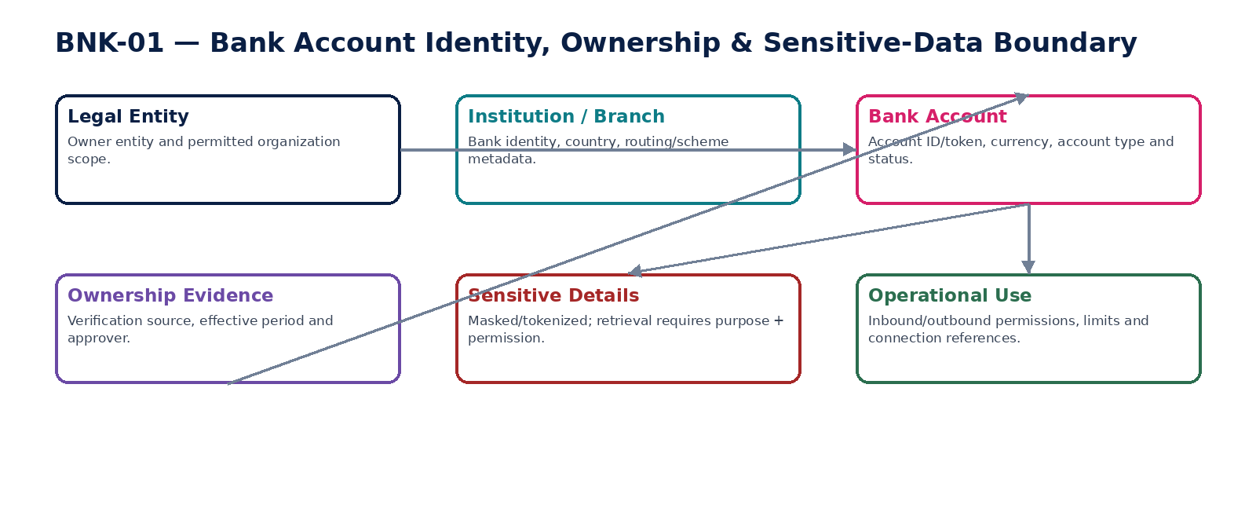
Figure 4 — Bank-account identity, ownership and sensitive-data boundary.

BNK-02 — Bank Connection
Establish, maintain and revoke consented connectivity to banks/open-banking/provider channels without storing reusable secrets in business records.

Contract field | Build requirement
Authoritative ownership | BankConnection; provider/institution/account binding; consent/scopes; token/secret reference; authorization method; consent expiry; connection health; reconnect/revocation history.
Required business/source inputs | provider; institution; bank account; user/admin authorization; requested scopes; purpose; redirect/callback context where applicable.
Server-resolved/derived context | provider approval; region/residency; consent lifetime; FAPI/OAuth security policy where applicable; token/certificate storage policy; connection capability map.
Explicit commands | CreateConnectionRequest; CompleteConnectionAuthorization; ActivateConnection; RefreshConnection; ReconsentConnection; SuspendConnection; RevokeConnection; ReconnectProvider; RotateConnectionCredential
Queries/retrieval | GetConnection; GetConnectionHealth; GetConnectionScopes; GetConsentHistory; ListConnections; GetAvailableActions

Control field | Build requirement
State model | Requested → Authorizing → Active → Degraded/Suspended → ReconsentRequired → Revoked; token/credential versions remain separate from business lifecycle.
Permissions | bank.connection.read/manage; bank.connection.authorize; bank.connection.revoke; bank.connection.support.
Segregation of duties | Connection administrator cannot self-approve elevated scope expansion where policy requires; support cannot retrieve raw tokens; revoked consent cannot be silently reactivated.
Events produced | BankConnectionRequested; BankConnectionActivated; BankConnectionDegraded; BankConnectionReconsentRequired; BankConnectionRevoked; BankConnectionCredentialRotated
Dependencies | BNK-01; Provider Adapter; IAM/SoD; Secrets Vault; Security/PKI; Residency/GTRM; Evidence.
Failure/degradation semantics | Token/consent expiry causes explicit degraded/reconsent state; no plaintext token fallback; provider-region conflict blocks activation; revocation must propagate and be verifiable.

Evidence / NFR | Build requirement
Evidence & lineage | Consent/scopes, authorization transaction, provider response, token reference (not secret), certificate/key reference, expiry, health transitions and revocation evidence.
NFR / resilience profile | C1 connectivity; high-security APIs; short-lived credentials preferred; health/freshness SLI; provider outage degradation supported.
Minimum negative-path certification | Revoked consent still accesses account; Token appears in logs/database; Scope expands without reauthorization; Connection routes through prohibited region

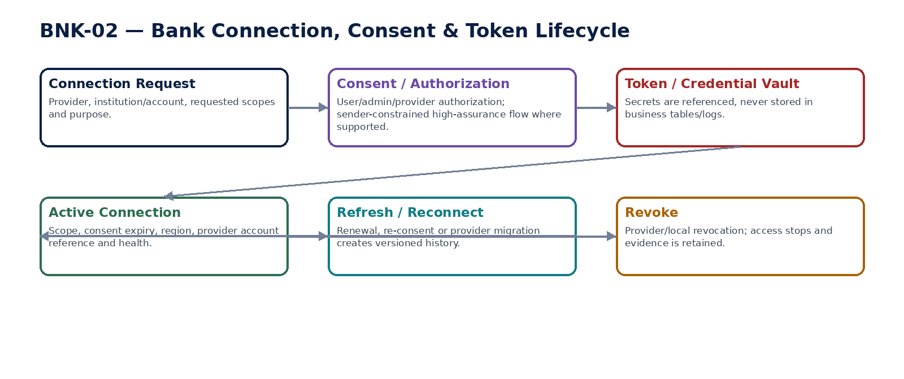
Figure 5 — Connection, consent and credential lifecycle.

BNK-03 — Statement Ingestion
Ingest bank statements and reports as immutable source evidence with reproducible account/period/balance/transaction completeness.

Contract field | Build requirement
Authoritative ownership | BankStatement; raw source reference/hash; provider/file source ID; statement period; opening/closing balances; transaction population; import watermark; ingestion/rejection/quarantine evidence.
Required business/source inputs | bank account; statement/report payload/file; opening/closing balances; transaction records; statement period; source/provider identifiers.
Server-resolved/derived context | format/schema version; account ownership; timezone; duplicate statement/overlap detection; parser version; prior watermark; file security scan; jurisdiction/retention policy.
Explicit commands | IngestStatement; ValidateStatement; ReprocessQuarantinedStatement; SupersedeStatementMapping; CloseStatementImport; QuarantineStatement
Queries/retrieval | GetStatement; GetStatementRawReference; ListStatements; GetImportWatermark; GetIngestionEvidence; ListQuarantinedStatements

Control field | Build requirement
State model | Received → Validating → Accepted / Quarantined / Rejected; accepted raw evidence immutable; mapping/parser correction produces superseding processed version.
Permissions | statement.read; statement.ingest; statement.quarantine.manage; statement.raw.read.
Segregation of duties | Ingestion operator cannot alter accepted raw source; raw payload access is restricted; manual duplicate override requires independent approval/evidence.
Events produced | BankStatementReceived; BankStatementAccepted; BankStatementQuarantined; BankStatementRejected; BankStatementSuperseded
Dependencies | BNK-01/02; File/API Integration; Security scanning; Schema Registry; Evidence; Retention.
Failure/degradation semantics | Duplicate/replayed source is idempotently rejected/replayed to stable result; balance inconsistency or wrong account quarantines; partial import cannot masquerade as complete.

Evidence / NFR | Build requirement
Evidence & lineage | Raw hash/reference, source IDs, parser/schema versions, row counts, control totals, opening/closing balances, rejected rows and watermark.
NFR / resilience profile | C0 for automated feeds; exact-once business effect via idempotency; ingest completeness/freshness SLI; high-volume batch support.
Minimum negative-path certification | Duplicate statement imported twice; Closing balance inconsistent with source population; Statement for wrong account accepted; Partial file marked complete

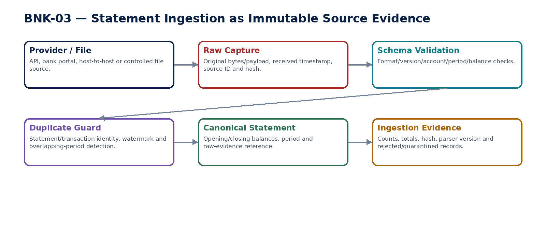
Figure 6 — Statement ingestion as immutable source evidence.

BNK-04 — Bank Transaction Normalization
Convert provider-specific transaction records into the canonical bank-transaction model while preserving immutable raw-source lineage and mapping-version reproducibility.

Contract field | Build requirement
Authoritative ownership | CanonicalBankTransaction; normalized amount/sign/currency; booking/value dates; bank code; narrative/reference; counterparty data; source statement/transaction ID; mapping version; supersession chain.
Required business/source inputs | raw transaction; amount; currency; booking/value dates; provider code; narrative; reference; source statement/account.
Server-resolved/derived context | provider/schema mapping; transaction-code dictionary; timezone/calendar; sign convention; enrichment policy; data classification; mapping version.
Explicit commands | NormalizeTransaction; ReNormalizeTransaction; QuarantineTransaction; SupersedeNormalization; ApproveMappingException
Queries/retrieval | GetBankTransaction; GetRawLineage; GetNormalizationVersion; ListTransactions; ListNormalizationExceptions

Control field | Build requirement
State model | RawCaptured → Normalized / Quarantined; canonical versions immutable; mapping correction creates superseding version and may trigger reconciliation re-performance.
Permissions | bank.transaction.read; bank.transaction.normalize; mapping.exception.approve.
Segregation of duties | Mapping author cannot self-approve material mapping changes affecting financial interpretation where policy requires; source raw fields are never overwritten.
Events produced | BankTransactionNormalized; BankTransactionQuarantined; BankTransactionNormalizationSuperseded
Dependencies | BNK-03; Reference Data; Schema/Mapping Registry; Evidence; Data Governance.
Failure/degradation semantics | Unknown code or ambiguous sign/date quarantines rather than inventing semantics; re-normalization preserves old version and downstream dependency impact.

Evidence / NFR | Build requirement
Evidence & lineage | Raw transaction hash/ID, canonical version, mapping/version, timezone/sign decisions, actor/system, exceptions and supersession links.
NFR / resilience profile | C0 canonical bank fact; deterministic/replayable; high-throughput; low-loss tolerance; reprocessing capacity sized for mapping corrections.
Minimum negative-path certification | Raw evidence changed during normalization; Unknown transaction code guessed silently; Mapping version not retained; Re-normalization overwrites prior canonical version

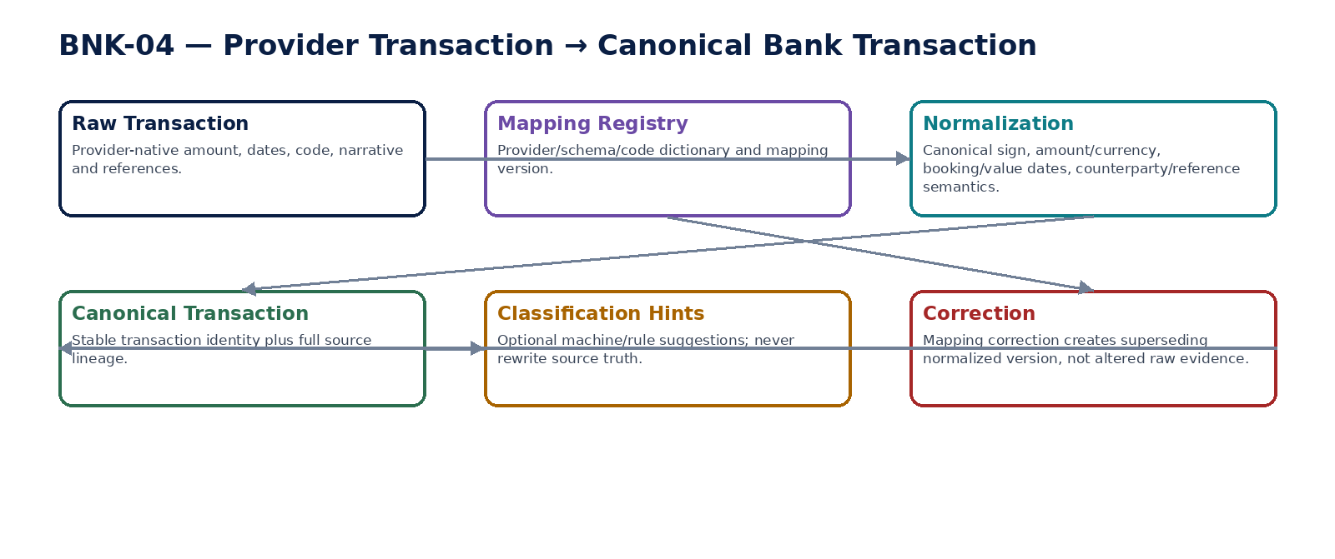
Figure 7 — Provider transaction normalization and superseding correction.

BNK-05 — Bank Reconciliation
Reconcile bank statement activity and balances to authoritative ledger/subledger/payment/receipt populations with reproducible matching, exceptions and close-gate certification.

Contract field | Build requirement
Authoritative ownership | BankReconciliationRun; population snapshots/hashes; match groups; exact/partial/unmatched/exception states; manual-match evidence; unresolved exposure; reconciliation certificate.
Required business/source inputs | statement transactions; ledger cash entries; payment/receipt facts; opening/closing balances; reconciliation period; account/book/entity scope.
Server-resolved/derived context | matching rules/tolerances; bank cut-off; materiality; entity/book; FX/fees policy; prior reconciliation state; late-arriving watermark.
Explicit commands | StartBankReconciliation; RunAutomaticMatching; ProposeManualMatch; ApproveManualMatch; RejectManualMatch; UnmatchWithReason; ReperformReconciliation; CertifyBankReconciliation; SupersedeReconciliation
Queries/retrieval | GetReconciliation; GetPopulationSnapshot; GetMatch; ListUnmatchedItems; GetExceptions; GetCertificate; GetAvailableActions

Control field | Build requirement
State model | Draft → Running → ExceptionsOpen → Reperformed → ReadyForCertification → Certified / Failed / Superseded. Result status (balanced/material exception) remains orthogonal.
Permissions | bank.recon.read/run; bank.recon.match; bank.recon.manual.approve; bank.recon.certify.
Segregation of duties | Manual matcher cannot certify same material reconciliation where maker-checker applies; tolerance cannot be widened during run; closed-period/control exceptions need authorized remediation.
Events produced | BankReconciliationStarted; BankMatchCreated; BankMatchExceptionRaised; BankReconciliationReperformed; BankReconciliationCertified; BankReconciliationSuperseded
Dependencies | BNK-03/04/07; ACC Ledger/Control; AR/AP cash/payment facts; DATA Reconciliation Engine; Workflow/SoD; Evidence.
Failure/degradation semantics | Equal headline totals do not certify if populations differ; late data cannot mutate certified population silently; unexplained material items block close according to policy.

Evidence / NFR | Build requirement
Evidence & lineage | Population IDs/hashes/counts/totals, rules/tolerance version, matches, manual reasons/approvals, unresolved exposure, reperformance and certificate.
NFR / resilience profile | C0 financial control; deterministic population reproduction; close-window capacity; freshness and unresolved-exposure SLI.
Minimum negative-path certification | Totals agree but population contains missing/duplicate items; Operator widens tolerance mid-run; Manual matcher self-certifies material control; Late bank item silently mutates certified run

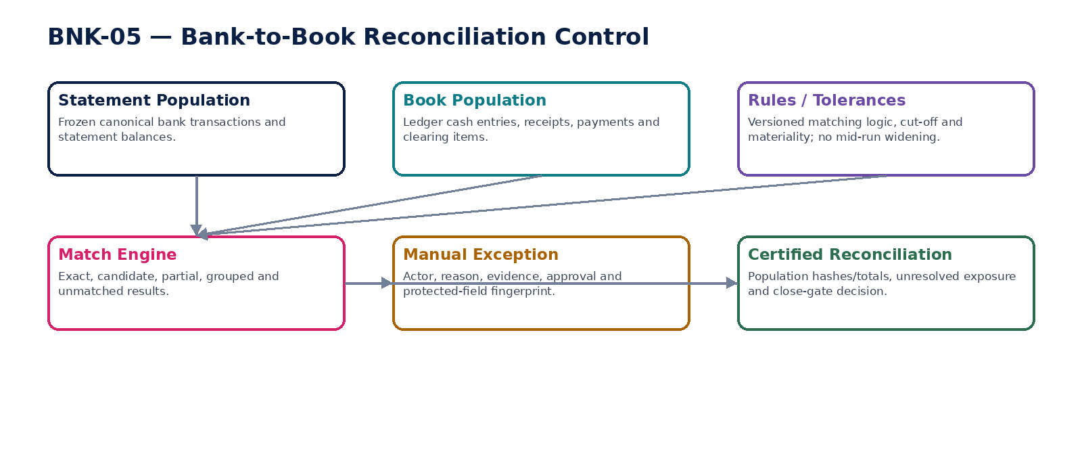
Figure 8 — Bank-to-book reconciliation and certification.

BNK-06 — Payment Initiation Adapter
Transmit an already approved payment instruction to a bank/PSP through a durable, idempotent external attempt while preserving exact authorization subject and provider evidence.

Contract field | Build requirement
Authoritative ownership | PaymentInitiationAttempt; approved-instruction fingerprint; payer account; payee reference; provider/scheme; provider request ID; submission state; raw/normalized response; receipt/evidence.
Required business/source inputs | approved payment instruction; payer account; payee; amount/currency; execution/value date; purpose/reference; authorization token/fingerprint.
Server-resolved/derived context | provider format/API; credential/token/certificate; cut-off/calendar; scheme constraints; payer-account capability; residency route; idempotency key; provider message version.
Explicit commands | InitiatePayment; RetrySamePaymentAttempt; CancelBeforeSubmission; ResolveAmbiguousSubmission; QuarantinePaymentAttempt
Queries/retrieval | GetPaymentAttempt; GetProviderReceipt; GetSubmissionState; GetAttemptEvidence; ListPaymentAttempts

Control field | Build requirement
State model | Prepared → Submitted / PendingUnknown / RejectedBeforeSubmission / Cancelled; external execution/finality belongs to BNK-07.
Permissions | payment.initiate; payment.attempt.read; payment.attempt.resolve; payment.cancel.presubmit.
Segregation of duties | Initiator cannot change protected authorized fields; provider credential users cannot change payment subject; retry of ambiguous attempt must reuse original idempotency/request identity.
Events produced | PaymentInitiationPrepared; PaymentSubmitted; PaymentSubmissionAmbiguous; PaymentSubmissionRejected; PaymentAttemptQuarantined
Dependencies | AP-10/AR refund/Treasury instruction source; BNK-01/02; Provider Adapter; IAM/SoD; Secrets/KMS; GTRM; Evidence.
Failure/degradation semantics | Timeout/connection loss creates Pending/Unknown, not Failed; no new attempt until original is resolved under policy; provider validation failure produces stable non-retryable status.

Evidence / NFR | Build requirement
Evidence & lineage | Authorization subject hash, attempt ID/idempotency key, request message/version/hash, transport/security evidence, provider ID, raw response reference and timestamps.
NFR / resilience profile | C0 irreversible side-effect path; durable attempt before network call; strict idempotency; low latency where rail permits; high availability with fail-safe duplicate protection.
Minimum negative-path certification | Payment amount changed after authorization; Provider timeout triggers new payment ID; Attempt record created after external call; Payment sent from suspended/unverified account

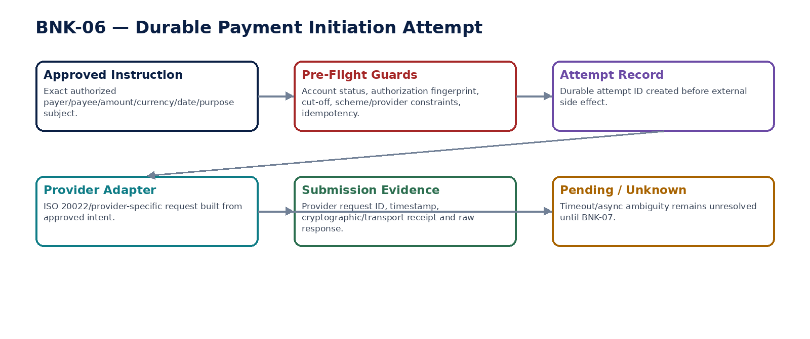
Figure 9 — Durable external payment initiation attempt.

BNK-07 — Payment Status & Confirmation
Resolve and preserve canonical provider/network payment execution state and finality from authenticated callbacks, polls, bank reports and statement evidence.

Contract field | Build requirement
Authoritative ownership | PaymentExecutionState; provider/bank references; canonical status; status history; finality basis; confirmation/return/reject evidence; effective timestamps; mapping version.
Required business/source inputs | provider request/payment ID; webhook/poll response; bank transaction reference; statement evidence; provider-native status/timestamp.
Server-resolved/derived context | provider status mapping; duplicate/replay detection; signature/authentication; ordering rules; final-state transition policy; rail-specific finality definition.
Explicit commands | RecordPaymentStatus; ProcessProviderCallback; PollPaymentStatus; LinkStatementConfirmation; ConfirmSettlement; RecordReturn; RecordRejection; CancelPaymentWhereSupported; ResolveStatusConflict
Queries/retrieval | GetPaymentStatus; GetStatusHistory; GetFinalityEvidence; GetProviderReference; ListUnresolvedPayments

Control field | Build requirement
State model | Prepared → Submitted → Accepted/Pending → Settled or Rejected/Returned/Cancelled; PendingUnknown may occur; governed final states cannot regress without explicit return/reversal semantics.
Permissions | payment.status.read; payment.status.ingest; payment.status.resolve; payment.finality.confirm.
Segregation of duties | Callback processor cannot alter authorized payment subject; manual finality override requires exceptional controlled workflow and evidence; same actor should not create payment and manually assert final settlement.
Events produced | PaymentAccepted; PaymentPending; PaymentSettled; PaymentRejected; PaymentReturned; PaymentCancelled; PaymentStatusConflictRaised
Dependencies | BNK-06/03/04; Provider/Bank; AP/AR/Treasury consumers; ACC; Evidence; Reconciliation.
Failure/degradation semantics | Out-of-order callbacks cannot regress final state; duplicate callback is idempotent; conflicting provider/statement evidence raises exception rather than silent overwrite.

Evidence / NFR | Build requirement
Evidence & lineage | Authenticated raw response/reference, mapping/version, sequence/order decision, provider/bank refs, finality source, timestamps and conflict resolution evidence.
NFR / resilience profile | C0 execution truth; near-real-time plus eventual statement confirmation; durable history; provider-lag/finality-freshness SLI.
Minimum negative-path certification | Forged callback accepted; Out-of-order status regresses settled payment; Duplicate callback creates duplicate accounting effect; Provider says settled but statement evidence conflicts and is ignored

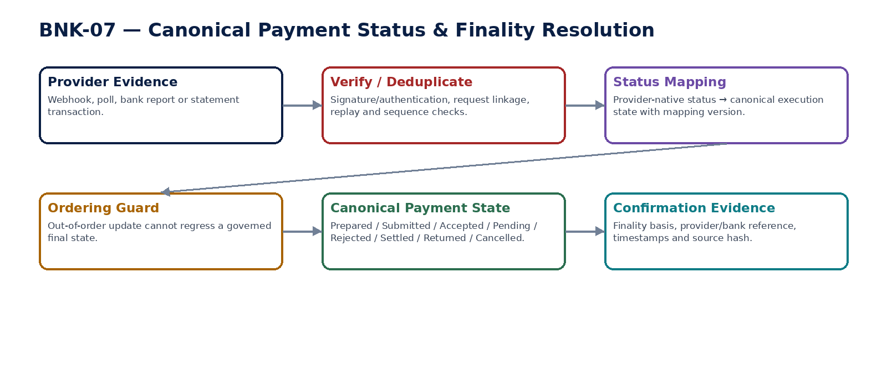
Figure 10 — Payment status/finality resolution and ordering guard.

BNK-08 — Cash Position
Calculate a freshness-aware operational cash-availability view from authoritative bank balances, ledger cash and pending flows without becoming a substitute ledger or bank balance.

Contract field | Build requirement
Authoritative ownership | CashPositionSnapshot; source components; available/restricted/pending amounts; reporting-currency translation; source freshness/confidence; drill-through lineage.
Required business/source inputs | bank balances; ledger cash; pending receipts/payments; treasury transfers; restricted/earmarked cash; selected reporting currency; as-of time.
Server-resolved/derived context | approved FX rates/source/version; account/entity scope; freshness thresholds; restricted-cash classification; pending-flow weighting policy; provider health.
Explicit commands | CalculateCashPosition; RefreshCashPosition; PublishCashPositionSnapshot; SupersedeCashPositionSnapshot
Queries/retrieval | GetCashPosition; GetCashPositionAsOf; GetSourceFreshness; GetAccountDrilldown; GetCurrencyBreakdown

Control field | Build requirement
State model | Calculated → Published → Stale / Superseded; stale is derived from source freshness, not operator choice.
Permissions | cash.position.read; cash.position.publish; restricted.cash.read.
Segregation of duties | Publisher cannot change underlying bank/ledger facts; restricted cash visibility is scope controlled; analytical adjustments cannot post accounting.
Events produced | CashPositionCalculated; CashPositionPublished; CashPositionBecameStale
Dependencies | BNK-01/02/03/07; ACC Ledger; AR/AP pending flows; REF FX; Treasury; Data Governance.
Failure/degradation semantics | If a critical source is stale/unavailable, view must show stale/partial confidence and may block treasury decisions by policy; never silently carry forward old bank balance as current.

Evidence / NFR | Build requirement
Evidence & lineage | Component source IDs/timestamps, FX rate/type/version, restrictions, pending-flow assumptions, calculation version and publication actor.
NFR / resilience profile | C1 analytical operational view; explicit freshness SLO; fast reads; recalculation on material bank/payment events.
Minimum negative-path certification | Stale bank balance displayed as current; Restricted cash counted as freely available; FX rate version missing; Cash position used to overwrite ledger balance

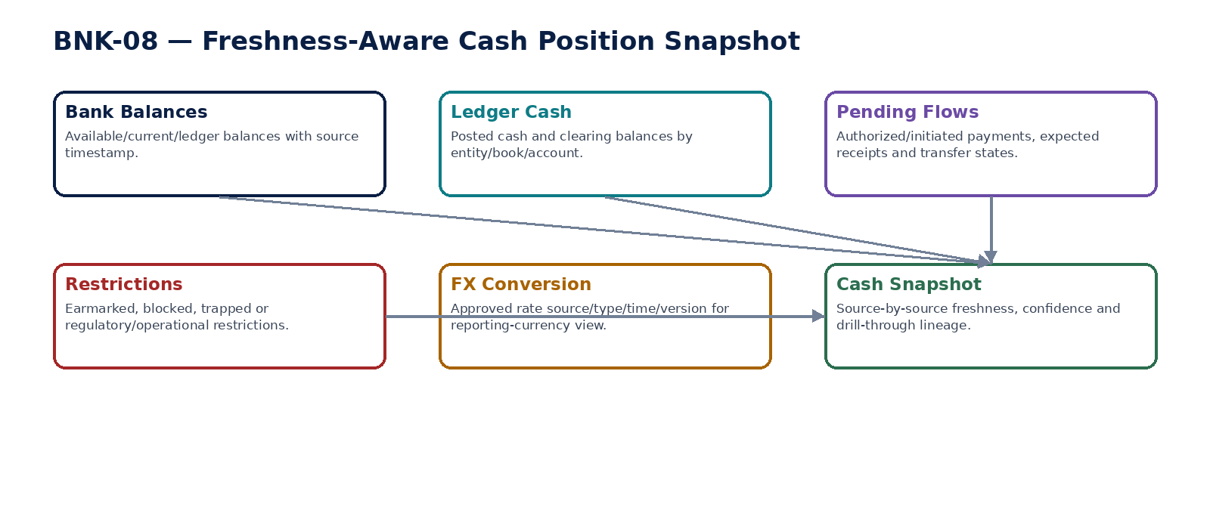
Figure 11 — Freshness-aware cash position snapshot.

BNK-09 — Treasury Transfer
Govern internal cash movement between controlled bank accounts, including same-entity, cross-entity and cross-currency transfers, while preserving authorization, liquidity and intercompany consequences.

Contract field | Build requirement
Authoritative ownership | TreasuryTransfer; source/destination accounts; ownership/relationship classification; amount/currency; value date; purpose; approvals; FX/fees; payment-instruction link; transfer lifecycle.
Required business/source inputs | source account; destination account; amount; currency; value date; purpose; requested FX/rate basis; transfer type.
Server-resolved/derived context | account ownership/status; same-entity/group relationship; approval/SoD/limits; available cash; cut-off; provider capability; FX/fee quote; intercompany policy/accounting rules.
Explicit commands | CreateTreasuryTransfer; AmendTreasuryTransfer; SubmitTransfer; ApproveTreasuryTransfer; RejectTreasuryTransfer; AuthorizeTreasuryTransfer; InitiateTreasuryTransfer; CancelBeforeSubmission; ResolveTreasuryTransfer
Queries/retrieval | GetTreasuryTransfer; GetTransferApproval; GetTransferExecution; GetAvailableActions; ListTransfers

Control field | Build requirement
State model | Draft → PendingApproval → Approved/Authorized → Submitted/Pending → Settled / Rejected / Returned / Cancelled; cross-entity accounting/reconciliation state is orthogonal.
Permissions | treasury.transfer.read/create; treasury.transfer.approve; treasury.transfer.authorize; treasury.transfer.cancel.
Segregation of duties | Maker cannot authorize own transfer where policy applies; source/destination ownership or amount/date change invalidates approval; cross-entity transfers may require dual-entity/controller approval.
Events produced | TreasuryTransferCreated; TreasuryTransferApproved; TreasuryTransferAuthorized; TreasuryTransferSubmitted; TreasuryTransferSettled; TreasuryTransferRejected; TreasuryTransferReturned
Dependencies | BNK-01/06/07/08; IAM/SoD; Policy; ACC Intercompany/Posting; REF FX; Evidence.
Failure/degradation semantics | Insufficient/uncertain liquidity, inactive account or unknown execution blocks completion; cross-entity movement cannot be disguised as same-entity transfer to bypass intercompany accounting.

Evidence / NFR | Build requirement
Evidence & lineage | Transfer subject hash, ownership relation, approvals, FX/fee basis, payment attempt/status refs, accounting/intercompany events and reconciliation evidence.
NFR / resilience profile | C0 value movement; strict idempotency and authorization invalidation; cross-entity dual-sided reconciliation; cut-off aware.
Minimum negative-path certification | Maker self-authorizes treasury transfer; Account ownership changed after approval; Cross-entity transfer omits intercompany accounting; Provider timeout causes duplicate transfer

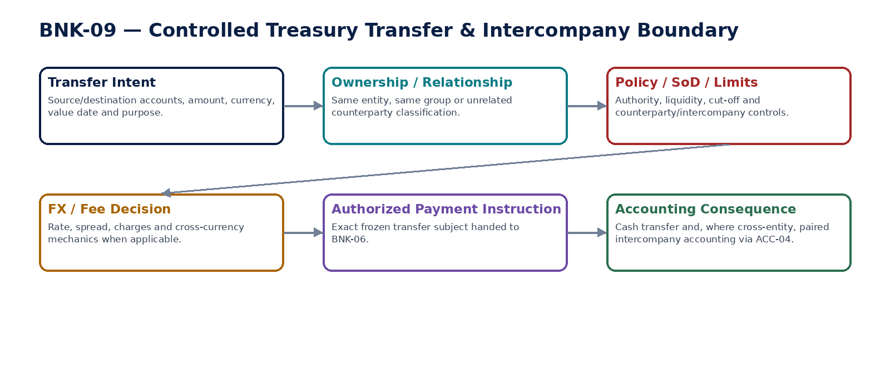
Figure 12 — Controlled treasury transfer and intercompany boundary.

BNK-10 — FX Exposure
Calculate recognized and forecast foreign-currency exposure by currency, entity and maturity using versioned source populations, rates and assumptions, without autonomously issuing trades or hedge instructions.

Contract field | Build requirement
Authoritative ownership | FXExposureSnapshot; recognized/forecast components; currency/entity/maturity buckets; gross/net exposure; reporting-currency translation; rate/assumption versions; confidence and lineage.
Required business/source inputs | foreign-currency bank balances; AR/AP/open financial items; intercompany/loan positions where integrated; approved forecast cash flows; reporting currency; horizon.
Server-resolved/derived context | functional currency; monetary/non-monetary classification where relevant; approved spot/forward/reference rates; entity/group scope; maturity buckets; forecast confidence; netting policy.
Explicit commands | CalculateFXExposure; RefreshFXExposure; PublishFXExposureSnapshot; RunFXScenario; SupersedeFXExposureSnapshot
Queries/retrieval | GetFXExposure; GetFXExposureAsOf; GetCurrencyBreakdown; GetMaturityProfile; GetScenario; GetSourceLineage

Control field | Build requirement
State model | Calculated → Published → Stale / Superseded; scenario outputs remain analytical and separate from approved treasury actions.
Permissions | fx.exposure.read; fx.exposure.calculate; fx.exposure.publish; fx.scenario.run.
Segregation of duties | Analyst cannot convert scenario into payment/trade execution; assumptions/rates cannot be altered retroactively in a published snapshot.
Events produced | FXExposureCalculated; FXExposurePublished; FXExposureBecameStale
Dependencies | BNK-08; ACC; AR/AP; FIN Forecast; REF FX; Intercompany; Data Governance.
Failure/degradation semantics | Missing/stale material source or rate reduces confidence/blocks publication per policy; no silent netting across entities/currencies without approved basis.

Evidence / NFR | Build requirement
Evidence & lineage | Source population hashes, rates/type/time/version, maturity/forecast assumptions, netting scope, calculation version and publication evidence.
NFR / resilience profile | C1 analytical risk view; explicit source freshness/confidence; scalable by entity/currency/horizon; historical reproducibility.
Minimum negative-path certification | Forecast assumption changed without versioning; Stale FX rate used without warning; Cross-entity exposure netted without policy; Exposure scenario automatically triggers payment/trade

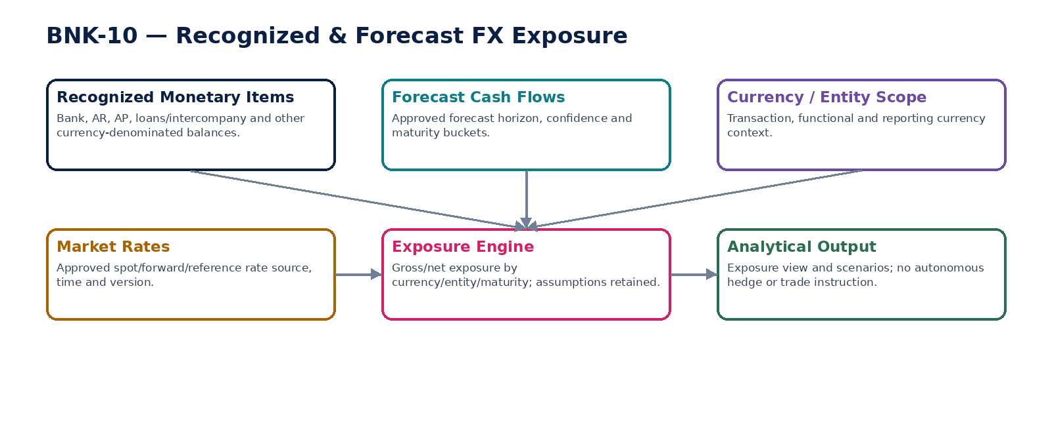
Figure 13 — Recognized and forecast FX exposure architecture.

8. Payment Execution State & Accounting Consequence Matrix
Canonical state | Meaning | Permitted downstream consequence
Prepared | Instruction validated internally but not yet externally submitted. | No settlement accounting; instruction may be cancelled/revised only under owning authorization rules.
Submitted | Provider/bank accepted transport/request receipt, but execution is not final. | May recognize in-transit/clearing only where approved accounting policy and evidence support it; never mark AP/AR settled solely from transport.
Accepted / Pending | Provider indicates instruction accepted/processing. | Keep business settlement pending; expose status/freshness; continue resolution.
Pending / Unknown | Outcome cannot be determined from available evidence. | Freeze duplicate execution; no invented failure/success; reconcile original attempt.
Settled | Authoritative rail/provider/bank evidence satisfies configured finality definition. | Apply settlement consequence; reconcile bank/provider/clearing and emit accounting event as configured.
Rejected | Instruction definitively not executed. | No settlement consequence; owning domain may reauthorize/retry through new governed instruction if appropriate.
Returned | Previously accepted/settled movement is reversed/returned by bank/rail. | Create return/reversal business event and accounting correction; do not rewrite prior history.
Cancelled | Rail/provider confirms cancellation under supported rules. | No settlement consequence except reversal of any prior in-transit representation according to policy.

9. Bank-to-Accounting & Cross-Domain Control Matrix
Source / control | Authoritative path | Mandatory reconciliation / guard
Bank statement | BNK-03 → BNK-04 canonical transactions | Statement opening + activity = closing; source count/hash/watermark preserved.
Cash ledger | Accounting events → ACC-04 → GL cash/control accounts | BNK-05 bank-to-GL population reconciliation by account/entity/book/period.
AP payment | AP authorization → BNK-06 → BNK-07 → AP/ACC consequence | Authorization subject hash, provider/bank confirmation, payment-clearing and AP open-item reconciliation.
AR receipt/refund | Bank transaction/payment state → AR application/refund + ACC | Bank evidence must precede authoritative cash application/refund settlement; AR-to-GL/cash control.
Treasury transfer | BNK-09 → BNK-06/07 → ACC | Source/destination bank reconciliation; intercompany paired accounting when cross-entity.
Provider status | BNK-07 canonical state | Provider request/status ↔ bank statement/transaction finality cross-check.
Cash position | BNK-08 projection only | Freshness/restriction/source lineage; never used as ledger or bank source of truth.
FX exposure | BNK-10 analytical view | Source population and rate/assumption versioning; no autonomous execution.

10. External Provider / Bank Adapter Requirements
Requirement | Engineering rule
Provider isolation | Provider-specific payloads, statuses, certificates, rate limits and error codes terminate at adapters; canonical domain contracts remain stable.
Message versioning | ISO 20022/provider message family/version is explicit and stored with request/response evidence; no parsing by string heuristics.
Security | Use mTLS/sender-constrained tokens/message signing where ecosystem/provider requires/supports it; credentials/certs are lifecycle-managed by ZS-SEC-001.
Idempotency | Provider idempotency/request ID is bound to ZoikoSuite attempt ID. Retries reuse the same external identity wherever supported.
Callbacks | Authenticate, replay-protect, deduplicate and correlate. Unknown callback references are quarantined, not auto-created.
Polling | Poll only within controlled rate/retry budget; polling does not bypass callback ordering/finality rules.
Cut-offs/calendars | Scheme/provider cut-off, holiday and value-date capability are server-resolved and evidence-versioned.
Residency | Bank/provider routes must satisfy GTRM/residency policy; hidden data egress is prohibited.
Failure | Provider outage degrades safely to pending/queued/blocked mode depending side-effect risk; never duplicate irreversible payments.

11. Banking Observability & Operational Evidence
Signal | Minimum requirement
Connection health | Active/degraded/reconsent/revoked; consent expiry horizon; last successful API call; provider region.
Statement freshness | Last accepted statement/transaction watermark by bank account; missing expected period/feed alert.
Normalization quality | Quarantine volume, unknown mapping codes, superseding normalization rate and source-to-canonical completeness.
Reconciliation | Matched %, unresolved amount/count, oldest unmatched, material exposure, certification state and close impact.
Payment execution | Attempts by state, Pending/Unknown age, duplicate-suppression events, callback lag, returns/rejections and provider status conflicts.
Cash position | Component freshness, stale/partial accounts, restricted cash and rate staleness.
Treasury | Transfers pending/unknown, approval invalidations, cross-entity items awaiting paired accounting/reconciliation.
FX exposure | Source freshness, missing rates, stale forecast populations and material changes by currency/entity.

12. Domain-Level Negative-Path Certification
# | Scenario | Certification requirement
1 | Bank account created under wrong legal entity | Automated/controlled test proves fail-safe behavior or explicit Pending/Unknown/quarantine state, preserves source/evidence, prevents unauthorized/duplicate money movement, and leaves bank/book/provider state reconciliable.
2 | Unverified bank account used for outbound payment | Automated/controlled test proves fail-safe behavior or explicit Pending/Unknown/quarantine state, preserves source/evidence, prevents unauthorized/duplicate money movement, and leaves bank/book/provider state reconciliable.
3 | Sensitive account number returned in list/search/log | Automated/controlled test proves fail-safe behavior or explicit Pending/Unknown/quarantine state, preserves source/evidence, prevents unauthorized/duplicate money movement, and leaves bank/book/provider state reconciliable.
4 | Ownership changed without independent evidence | Automated/controlled test proves fail-safe behavior or explicit Pending/Unknown/quarantine state, preserves source/evidence, prevents unauthorized/duplicate money movement, and leaves bank/book/provider state reconciliable.
5 | Revoked bank consent still used | Automated/controlled test proves fail-safe behavior or explicit Pending/Unknown/quarantine state, preserves source/evidence, prevents unauthorized/duplicate money movement, and leaves bank/book/provider state reconciliable.
6 | Connection token appears in business database or telemetry | Automated/controlled test proves fail-safe behavior or explicit Pending/Unknown/quarantine state, preserves source/evidence, prevents unauthorized/duplicate money movement, and leaves bank/book/provider state reconciliable.
7 | Connection scope expands without reauthorization | Automated/controlled test proves fail-safe behavior or explicit Pending/Unknown/quarantine state, preserves source/evidence, prevents unauthorized/duplicate money movement, and leaves bank/book/provider state reconciliable.
8 | Connection routes data through prohibited region | Automated/controlled test proves fail-safe behavior or explicit Pending/Unknown/quarantine state, preserves source/evidence, prevents unauthorized/duplicate money movement, and leaves bank/book/provider state reconciliable.
9 | Duplicate statement imported twice | Automated/controlled test proves fail-safe behavior or explicit Pending/Unknown/quarantine state, preserves source/evidence, prevents unauthorized/duplicate money movement, and leaves bank/book/provider state reconciliable.
10 | Statement closing balance inconsistent but accepted | Automated/controlled test proves fail-safe behavior or explicit Pending/Unknown/quarantine state, preserves source/evidence, prevents unauthorized/duplicate money movement, and leaves bank/book/provider state reconciliable.
11 | Statement for wrong account accepted | Automated/controlled test proves fail-safe behavior or explicit Pending/Unknown/quarantine state, preserves source/evidence, prevents unauthorized/duplicate money movement, and leaves bank/book/provider state reconciliable.
12 | Partial statement import marked complete | Automated/controlled test proves fail-safe behavior or explicit Pending/Unknown/quarantine state, preserves source/evidence, prevents unauthorized/duplicate money movement, and leaves bank/book/provider state reconciliable.
13 | Raw statement evidence altered during processing | Automated/controlled test proves fail-safe behavior or explicit Pending/Unknown/quarantine state, preserves source/evidence, prevents unauthorized/duplicate money movement, and leaves bank/book/provider state reconciliable.
14 | Unknown transaction code silently guessed | Automated/controlled test proves fail-safe behavior or explicit Pending/Unknown/quarantine state, preserves source/evidence, prevents unauthorized/duplicate money movement, and leaves bank/book/provider state reconciliable.
15 | Normalization mapping version missing | Automated/controlled test proves fail-safe behavior or explicit Pending/Unknown/quarantine state, preserves source/evidence, prevents unauthorized/duplicate money movement, and leaves bank/book/provider state reconciliable.
16 | Re-normalization overwrites historical canonical version | Automated/controlled test proves fail-safe behavior or explicit Pending/Unknown/quarantine state, preserves source/evidence, prevents unauthorized/duplicate money movement, and leaves bank/book/provider state reconciliable.
17 | Bank reconciliation totals agree while populations differ | Automated/controlled test proves fail-safe behavior or explicit Pending/Unknown/quarantine state, preserves source/evidence, prevents unauthorized/duplicate money movement, and leaves bank/book/provider state reconciliable.
18 | Tolerance widened mid-reconciliation | Automated/controlled test proves fail-safe behavior or explicit Pending/Unknown/quarantine state, preserves source/evidence, prevents unauthorized/duplicate money movement, and leaves bank/book/provider state reconciliable.
19 | Manual matcher certifies own material reconciliation | Automated/controlled test proves fail-safe behavior or explicit Pending/Unknown/quarantine state, preserves source/evidence, prevents unauthorized/duplicate money movement, and leaves bank/book/provider state reconciliable.
20 | Late statement transaction silently mutates certified population | Automated/controlled test proves fail-safe behavior or explicit Pending/Unknown/quarantine state, preserves source/evidence, prevents unauthorized/duplicate money movement, and leaves bank/book/provider state reconciliable.
21 | Payment subject changed after authorization | Automated/controlled test proves fail-safe behavior or explicit Pending/Unknown/quarantine state, preserves source/evidence, prevents unauthorized/duplicate money movement, and leaves bank/book/provider state reconciliable.
22 | Payment sent from suspended/unverified payer account | Automated/controlled test proves fail-safe behavior or explicit Pending/Unknown/quarantine state, preserves source/evidence, prevents unauthorized/duplicate money movement, and leaves bank/book/provider state reconciliable.
23 | External network call occurs before durable attempt commit | Automated/controlled test proves fail-safe behavior or explicit Pending/Unknown/quarantine state, preserves source/evidence, prevents unauthorized/duplicate money movement, and leaves bank/book/provider state reconciliable.
24 | Provider timeout creates a new payment instead of resolving original | Automated/controlled test proves fail-safe behavior or explicit Pending/Unknown/quarantine state, preserves source/evidence, prevents unauthorized/duplicate money movement, and leaves bank/book/provider state reconciliable.
25 | Pending/Unknown is treated as Failed | Automated/controlled test proves fail-safe behavior or explicit Pending/Unknown/quarantine state, preserves source/evidence, prevents unauthorized/duplicate money movement, and leaves bank/book/provider state reconciliable.
26 | Forged provider callback accepted | Automated/controlled test proves fail-safe behavior or explicit Pending/Unknown/quarantine state, preserves source/evidence, prevents unauthorized/duplicate money movement, and leaves bank/book/provider state reconciliable.
27 | Duplicate callback creates duplicate settlement/accounting effect | Automated/controlled test proves fail-safe behavior or explicit Pending/Unknown/quarantine state, preserves source/evidence, prevents unauthorized/duplicate money movement, and leaves bank/book/provider state reconciliable.
28 | Out-of-order callback regresses Settled to Pending | Automated/controlled test proves fail-safe behavior or explicit Pending/Unknown/quarantine state, preserves source/evidence, prevents unauthorized/duplicate money movement, and leaves bank/book/provider state reconciliable.
29 | Provider says Settled while statement evidence conflicts and no exception is raised | Automated/controlled test proves fail-safe behavior or explicit Pending/Unknown/quarantine state, preserves source/evidence, prevents unauthorized/duplicate money movement, and leaves bank/book/provider state reconciliable.
30 | Cash position displays stale balance as current | Automated/controlled test proves fail-safe behavior or explicit Pending/Unknown/quarantine state, preserves source/evidence, prevents unauthorized/duplicate money movement, and leaves bank/book/provider state reconciliable.
31 | Restricted cash counted as available | Automated/controlled test proves fail-safe behavior or explicit Pending/Unknown/quarantine state, preserves source/evidence, prevents unauthorized/duplicate money movement, and leaves bank/book/provider state reconciliable.
32 | Cash position overwrites ledger/bank source | Automated/controlled test proves fail-safe behavior or explicit Pending/Unknown/quarantine state, preserves source/evidence, prevents unauthorized/duplicate money movement, and leaves bank/book/provider state reconciliable.
33 | Treasury maker self-authorizes transfer | Automated/controlled test proves fail-safe behavior or explicit Pending/Unknown/quarantine state, preserves source/evidence, prevents unauthorized/duplicate money movement, and leaves bank/book/provider state reconciliable.
34 | Cross-entity transfer bypasses intercompany accounting | Automated/controlled test proves fail-safe behavior or explicit Pending/Unknown/quarantine state, preserves source/evidence, prevents unauthorized/duplicate money movement, and leaves bank/book/provider state reconciliable.
35 | Account ownership changes after transfer approval without invalidation | Automated/controlled test proves fail-safe behavior or explicit Pending/Unknown/quarantine state, preserves source/evidence, prevents unauthorized/duplicate money movement, and leaves bank/book/provider state reconciliable.
36 | Treasury timeout creates duplicate movement | Automated/controlled test proves fail-safe behavior or explicit Pending/Unknown/quarantine state, preserves source/evidence, prevents unauthorized/duplicate money movement, and leaves bank/book/provider state reconciliable.
37 | FX rate/assumption missing version | Automated/controlled test proves fail-safe behavior or explicit Pending/Unknown/quarantine state, preserves source/evidence, prevents unauthorized/duplicate money movement, and leaves bank/book/provider state reconciliable.
38 | Stale FX rate used without disclosure | Automated/controlled test proves fail-safe behavior or explicit Pending/Unknown/quarantine state, preserves source/evidence, prevents unauthorized/duplicate money movement, and leaves bank/book/provider state reconciliable.
39 | Cross-entity exposure netted without policy | Automated/controlled test proves fail-safe behavior or explicit Pending/Unknown/quarantine state, preserves source/evidence, prevents unauthorized/duplicate money movement, and leaves bank/book/provider state reconciliable.
40 | FX scenario autonomously triggers a payment/trade | Automated/controlled test proves fail-safe behavior or explicit Pending/Unknown/quarantine state, preserves source/evidence, prevents unauthorized/duplicate money movement, and leaves bank/book/provider state reconciliable.

13. Definition of Ready — Individual Banking Service
# | Ready gate
1 | Authoritative ownership/prohibited ownership approved
2 | Canonical command/query/state/error contract instantiated
3 | Bank account/entity/currency/date/region semantics explicit
4 | External provider message/status/finality contract documented
5 | Idempotency/concurrency and Pending/Unknown behavior specified
6 | Sensitive-data/secret/certificate handling mapped to ZS-SEC-001
7 | Permissions, maker-checker and dynamic SoD specified
8 | Residency/GTRM routing and provider egress approved
9 | Accounting event and reconciliation impacts mapped
10 | Evidence/retention/legal-hold behavior mapped
11 | SLO/RPO/RTO/capacity/provider-dependency behavior defined
12 | Positive/negative/contract/replay/failover test suites approved

14. Definition of Done — Individual Banking Service
# | Done gate
1 | Machine contracts published and compatibility certified
2 | Authoritative datastore constraints and tokenization/masking implemented
3 | No generic API bypasses protected account/payment/transfer/finality commands
4 | Outbox/inbox/idempotency/external-attempt tests pass
5 | Provider callbacks/polls pass authentication, replay and ordering tests
6 | Pending/Unknown and duplicate-suppression scenarios pass
7 | Bank statement/transaction lineage and normalization replay tests pass
8 | Bank-to-GL/provider/clearing reconciliation controls pass
9 | Authorization invalidation and SoD tests pass
10 | Security/residency/privacy/failover tests pass
11 | NFR/load/queue/provider-outage/runbook tests meet approved class
12 | Release certificate generated with no unresolved mandatory control

15. Recommended Engineering Sequence
Wave | Services | Reason
1 | BNK-01 + shared sensitive-account model | Establish entity-account ownership, verification, masking/tokenization and operational-use controls.
2 | BNK-02 | Build secure consented connectivity and provider credential lifecycle.
3 | BNK-03 + BNK-04 | Establish immutable source ingestion and deterministic canonical bank transactions.
4 | BNK-05 | Build bank-to-book reconciliation and close-gate controls before broad payment automation.
5 | BNK-06 + BNK-07 | Implement durable payment attempts, Pending/Unknown resolution, callback ordering and finality.
6 | BNK-08 | Add freshness-aware cash position after bank/payment facts are trustworthy.
7 | BNK-09 | Add governed treasury transfers and intercompany consequences.
8 | BNK-10 + domain certification | Add FX exposure analytics and complete performance/failure/reconciliation certification.

16. Controlled Pre-Production Decisions
Decision | Required owner / evidence
Supported banks/providers/open-banking ecosystems by launch market | Treasury/Product/Security/Legal/Compliance approval; provider due diligence, data residency, contract and conformance evidence.
Account ownership/verification methods | Treasury/Risk/Compliance approval by jurisdiction/account type; maker-checker and evidence requirements.
FAPI/OAuth/message-signing profile per provider | Security/Architecture approval; FAPI 2.0 conformance/certification where applicable or documented equivalent control.
Accepted statement formats and statement cadence | Treasury/Accounting approval; parser/schema tests and completeness expectations.
Normalization code dictionaries | Treasury/Accounting approval; mapping change governance and replay tests.
Reconciliation rules/tolerances/materiality | Controller/Treasury approval; representative bank populations and close-control tests.
Payment rail/provider finality definitions | Treasury/Accounting/Legal approval per scheme/provider; BNK-07 mapping and return/cancel semantics tested.
Payment cut-offs/calendars and retry/poll budgets | Treasury/Operations/SRE approval based on provider SLA and rail behavior.
Cash position freshness/confidence thresholds | Treasury/CFO/SRE approval; stale/partial behavior explicitly defined.
Cross-entity treasury/intercompany policy | Treasury/Controller/Tax/Legal approval; paired accounting and reconciliation tests.
FX rate sources/maturity buckets/netting policy | Treasury/Controller approval; REF/ACC/FIN source contracts and reproducibility tests.
Numeric SLOs/RPO/RTO/capacity/retention | SRE/Treasury/Compliance approval after representative load and legal analysis.

17. Prohibited Banking / Treasury Anti-Patterns
Anti-pattern | Why prohibited
Store plaintext bank account numbers/tokens in normal tables/logs | Expands breach scope and violates sensitive-data architecture.
Treat provider connection as proof of account ownership | Connectivity and ownership are distinct controls.
Mutate raw statement/provider evidence | Destroys auditability and replay/reconciliation reproducibility.
Guess unknown bank transaction semantics | Can corrupt reconciliation/accounting; ambiguous data must quarantine.
Reconcile only headline totals | Can hide missing/duplicated transactions even when balances agree.
Change tolerance to make reconciliation pass | Destroys control integrity and period-close evidence.
Create external payment attempt after sending network request | A crash can orphan an irreversible payment without durable identity.
Retry a payment because HTTP timed out | Transport failure does not prove payment failure and may cause duplicate money movement.
Callback directly mutates business/GL without status mapping/guard | Bypasses authentication, ordering, finality and accounting controls.
Regress settled payment to pending from late callback | Breaks governed finality; later events require explicit return/reversal semantics.
Cash position treated as ledger/bank source of truth | It is an analytical projection with freshness/assumptions.
Treasury transfer bypasses AP-style authorization controls | Internal cash movement remains high-risk money movement.
Cross-entity transfer treated as internal same-entity movement | Can conceal intercompany, tax and accounting consequences.
FX exposure triggers autonomous hedge/payment | Analytics cannot create regulated/value-moving action without a separate authorized workflow.
Banking service writes GL directly | All recognized accounting consequences must pass governed accounting events and ACC-04.

18. Current Interoperability & Security Architecture Notes
This domain pack intentionally separates ZoikoSuite business/payment authority from external financial-message and open-banking protocol implementations. Provider adapters own those protocol details and version them independently from the canonical Banking domain.
ISO 20022 remains the global financial-services messaging framework. The ISO 20022 Registration Authority states that the current edition contains nine parts published in April 2026. BNK-06/BNK-07 therefore retain message family/version and raw request/response evidence, while the canonical ZoikoSuite payment model remains stable across banks and schemes.

For open-banking/open-finance style API access, the OpenID Foundation published FAPI 2.0 Security Profile as Final in February 2025 and FAPI 2.0 Message Signing as Final in September 2025. The FAPI Working Group recommends FAPI 2.0 for new ecosystems. ZoikoSuite should use certified/conformant profiles where applicable rather than invent bespoke high-value OAuth security.

Engineering references: ISO 20022 Registration Authority — About ISO 20022; OpenID Foundation — FAPI 2.0 Security Profile and FAPI 2.0 Message Signing. Exact market licensing, open-banking obligations, payment-scheme rules and bank/provider contracts remain governed by ZS-JUR-001, ZS-SEC-001 and certified launch configuration.

19. Final Architecture Decision
APPROVED BASELINE: Banking, Cash & Treasury is implemented as an evidence-first money-movement control layer. Account ownership, provider consent, statement evidence, canonical bank transactions, bank reconciliation, durable payment attempts, external finality, cash position, treasury transfers and FX exposure remain separate governed facts. The domain is build-ready only when duplicate-prevention, Pending/Unknown handling, source immutability, callback ordering, finality mapping, bank-to-GL/provider/clearing reconciliation, residency and negative paths are enforced in code and certified end-to-end.

