ZOIKOSUITE

Business Object State Machine,
Workflow & Approval Catalogue
Detailed Engineering Wireframe · Accounting · Finance · Tax · Audit · Legal · Business Operations
EXECUTIVE DOCTRINE
A business object changes state only through an explicit, authorized, idempotent transition command evaluated by its authoritative domain service. Workflow coordinates; it does not own business truth. Approvals authorize a specific immutable subject version; material change invalidates the approval. No timeout, integration retry, UI edit or administrator action may silently bypass transition guards, segregation of duties, evidence or accounting/compliance controls.

Field | Value
Document ID | ZS-STATE-001
Version | 1.0 — Global Workflow & State Control Baseline
Date | August 24, 2026
Status | For architecture / engineering approval
Owner | ZoikoSuite Product / Platform Architecture
Prepared for | Engineering, Product, Accounting, Finance, Tax, Audit, Legal, Security, Data, QA, Operations
Classification | Confidential — Internal Engineering / Architecture Control
Parent documents | ZS-ARCH-SVC-001 v2.0; ZS-DATA-001 v1.0; ZS-ACC-KERNEL-001 v1.0
Language | American English

CONTROLLED BASELINE
This standard governs canonical state semantics, workflow orchestration and approval behavior. Domain teams may extend it only through reviewed, versioned specifications that preserve the invariants and transition contract defined here.

Document Roadmap & How to Use This Standard
This document sits between the canonical data model/accounting kernel and the service/API specifications. It turns business lifecycle language into deterministic state machines, approval gates and workflow contracts that engineering can implement and QA can certify.
Layer | Use this document to decide
1 — State semantics | Which state dimensions exist; which are authoritative versus derived; which domain owns them.
2 — Transition contract | Which command can move an object from one state to another, under which guards, version and authority.
3 — Workflow orchestration | How long-running human/system/external steps are coordinated without the workflow engine becoming a system of record.
4 — Approval controls | Who may approve; thresholds, quorum, maker-checker, delegation, expiry and reapproval behavior.
5 — Object catalogue | The canonical lifecycles for accounting, AR, AP, banking, tax, audit, legal, data and commercial objects.
6 — Engineering contracts | Commands, APIs, events, persistence, errors, observability, test gates and rollout sequence.

How to read a state model
Primary lifecycle state answers “what phase is this object in?” Approval, settlement/fulfillment, compliance/reconciliation and exception dimensions are modeled separately when they can vary independently. Time-derived labels such as Overdue are normally read-model classifications, not destructive lifecycle transitions.

Critical Analysis & Refinements Incorporated
The parent service catalogue correctly required state machines and non-arbitrary status changes. The accounting-kernel standard strengthened this for journals and periods. A global platform still needs one cross-domain control model so each team does not invent incompatible lifecycle semantics. The following issues were treated as architecture defects and resolved in this final wireframe.
Issue | Why it fails at Tier-1 scale | Refinement incorporated
One overloaded status field | Cannot represent approved + partially paid + disputed + overdue without contradictory enums. | Use orthogonal state dimensions with one primary lifecycle and separately owned approval, settlement/fulfillment, reconciliation/compliance and exception dimensions.
Workflow engine as record owner | A generic workflow database can drift from the domain system of record. | Workflow coordinates steps and stores orchestration state; only the authoritative domain service executes business transitions.
Approval tied only to object ID | A record can change materially after approval while retaining an apparently valid approval. | Bind approval to object version plus a canonical approval-subject fingerprint; material changes invalidate/supersede the request.
UI-driven state edits | Clients can bypass validation and create impossible combinations. | Expose transition commands, never unrestricted state-field PATCH operations.
Timeout = auto-approval | Creates hidden risk and regulatory/control failures. | Default timeout behavior is escalate, expire or pause. Auto-approval requires an explicit approved policy and risk classification.
Approval checked only once | Authority or delegation may expire between approval and execution. | Revalidate SoD, scope, limits and critical preconditions at release/execution time.
Generic “failed” state | Conceals whether failure is validation, external rejection, technical retry or business refusal. | Use structured exception classes and reason codes; preserve retryability and business meaning.
Terminal state revival | Creates audit ambiguity and destroys lifecycle evidence. | Terminal objects remain terminal unless an explicit controlled reopen transition exists; otherwise create a superseding object/version.
Cancellation, void, reversal conflated | Financial/legal consequences differ materially. | Define cancellation, void, reversal, return, write-off, amendment and supersession as separate controlled actions.
External callbacks trusted blindly | Duplicate/spoofed callbacks can mutate state incorrectly. | Verify source/signature, deduplicate, correlate to attempt, enforce allowed transition and persist provider evidence.
Workflow version drift | Long-running instances may change behavior after a deployment. | Pin every workflow instance to an immutable workflow-definition version and policy/rule versions.
Unstructured reasons | Free text cannot drive analytics, controls or reliable audit queries. | Require governed transition reason codes plus optional narrative/evidence.

1. Executive Doctrine & Scope
ZoikoSuite shall implement business lifecycles as explicit finite-state transition systems controlled by authoritative domain services. A state transition is a governed business command with preconditions, authorization, version checking, reason/evidence and deterministic side effects. Workflow orchestration may coordinate human approvals, timers, external providers and cross-domain sagas, but it never directly edits another domain’s authoritative state.

1.1 Objectives
- Provide one cross-platform vocabulary for lifecycle, approval, settlement/fulfillment, reconciliation/compliance and exception state.
- Prevent impossible, contradictory or unauditable state combinations.
- Make every material transition attributable, replay-safe, version-aware and evidence-producing.
- Implement maker-checker, dual control, quorum, amount thresholds, delegated authority and jurisdictional gates consistently.
- Allow long-running workflows and external callbacks without compromising authoritative domain ownership.
- Make state history reconstructible as-of any relevant point in time.
- Give QA a machine-testable transition catalogue and negative-path acceptance suite.

1.2 Non-goals
- This standard does not require one workflow engine product or one database technology.
- It does not make BPM/workflow state an alternative accounting, tax, legal or operational system of record.
- It does not hard-code every jurisdiction-specific approval; jurisdiction packs may add gates through controlled extension points.
- It does not permit AI to approve, release, post, file, sign or legally bind unless an explicitly governed deterministic policy authorizes a narrow system action.
- It does not treat presentation labels or dashboard badges as authoritative lifecycle states.

2. Non-Negotiable State & Workflow Invariants
ID | Invariant | Engineering requirement
I-01 | Single authoritative owner | Exactly one domain service owns each authoritative state dimension.
I-02 | Command-only transitions | Clients request named transitions; they do not set state values directly.
I-03 | Allowed edge only | A transition must exist in the active state-machine definition and originate from the current state.
I-04 | Optimistic concurrency | Expected object version must match before state change; stale commands fail.
I-05 | Idempotency | Every state-changing command has an idempotency key scoped to tenant + operation.
I-06 | Approval subject binding | Approval references a specific object version/fingerprint, amount/scope and policy version.
I-07 | Material-change invalidation | Material edits after approval invalidate/supersede approval and require re-evaluation.
I-08 | SoD at decision and release | Conflict/authority checks run at approval and again at execution/release for critical actions.
I-09 | No silent auto-approval | Timeout defaults to escalation/expiry; auto-approval must be explicitly authorized and evidenced.
I-10 | Terminal integrity | Terminal state is not reused as a draft. Corrections use controlled reopen, reversal, amendment or supersession.
I-11 | Reason/evidence | Material transitions require structured reason codes and evidence references where policy demands.
I-12 | Immutable transition history | Successful transitions append history; history is not overwritten.
I-13 | Event after commit | Domain event publication follows durable authoritative state change via outbox/equivalent.
I-14 | Workflow version pinning | Running workflow instances are pinned to immutable definition/policy versions.
I-15 | Verified external signals | External callbacks are authenticated, deduplicated and transition-validated.
I-16 | Derived state separation | Overdue, aging, SLA risk and similar labels are derived unless explicitly defined as authoritative.
I-17 | No generic failure ambiguity | Business rejection, validation failure, external rejection and technical failure have distinct reason classes.
I-18 | Residency and tenant scope | Workflow, approval and transition evidence inherits tenant/entity residency and access boundaries.

3. Canonical State Semantics
State is not one universal column. The model separates authoritative lifecycle facts that can vary independently. This prevents combinatorial “status explosion” and preserves domain meaning.
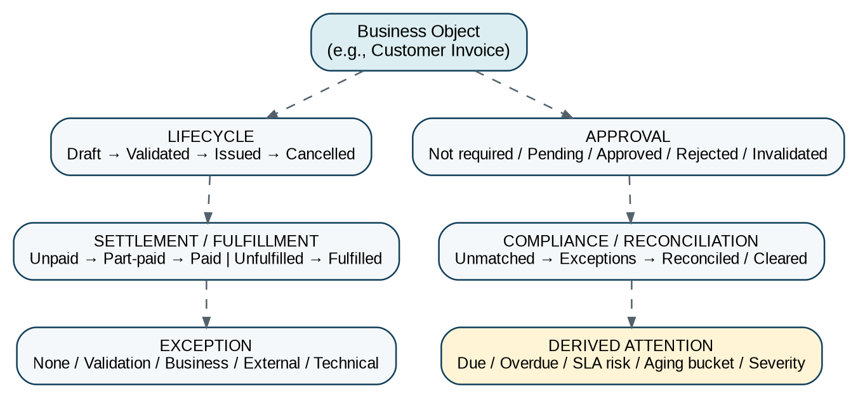
Figure 1 — Orthogonal state dimensions. Derived attention labels remain outside authoritative lifecycle state.
Dimension | Definition | Typical owner | Examples
Lifecycle | Primary business phase of the object. | Authoritative domain service | Draft, Validated, Issued, Executed, Closed.
Approval | Whether the current approval subject/version is authorized. | Workflow/approval authority with domain binding | Pending, Approved, Rejected, Returned, Invalidated.
Settlement / fulfillment | Economic/operational completion independent of lifecycle. | AR/AP/Banking/Fulfillment | Unpaid, Part-paid, Paid; Unfulfilled, Part-fulfilled, Fulfilled.
Compliance / reconciliation | Regulatory, matching or control posture. | Tax/Banking/Control domain | Unmatched, Exception, Reconciled, Cleared, Accepted.
Exception | Current blocking/non-blocking exception classification. | Owning domain | Validation, Business Rule, External, Technical.
Derived attention | Computed query/read-model labels; not usually transition-owned. | Read model / query service | Overdue, Aging 31–60, SLA Risk, Needs Attention.

3.1 State naming rules
- Use past participles or stable conditions for states: APPROVED, ISSUED, SETTLED, CLOSED—not commands such as APPROVE or PAY.
- Use commands as transition verbs: submit, validate, approve, issue, cancel, reverse, reopen.
- Do not encode dates, actors or reason text inside a state name.
- Do not encode “overdue” as a primary lifecycle state when it is derivable from due date + outstanding balance + current time.
- Use terminal states only when no ordinary forward transition remains; reopen must be explicit if supported.
- Use UNKNOWN only at an integration boundary/read model, never as an authoritative business state.

4. Canonical Transition Contract
Every authoritative transition command must carry enough context to prove what was requested, against which version, by whom, under which policy and with which reason/evidence. The owning service resolves all security- and policy-sensitive facts server-side.
TransitionCommand {
command_id UUIDv7
tenant_id UUIDv7
legal_entity_id UUIDv7? // where entity-scoped
object_type string
object_id UUIDv7
expected_object_version integer
transition string // e.g. issue_invoice
idempotency_key string
actor_subject_id UUIDv7
source_channel enum
effective_at timestamp?
reason_code string?
narrative string?
evidence_refs UUIDv7[]
workflow_instance_id UUIDv7?
approval_request_id UUIDv7?
correlation_id UUIDv7
causation_id UUIDv7?
}

Evaluation order | Mandatory check
1 | Resolve tenant, actor, object and authoritative owner.
2 | Load current object version and authoritative state dimensions.
3 | Reject stale expected_version / duplicate command mismatch.
4 | Verify transition edge exists in pinned state-machine definition.
5 | Validate object/business preconditions.
6 | Resolve jurisdiction, policy and workflow-definition versions.
7 | Evaluate RBAC/ABAC, SoD, delegation, value limits and approval requirements.
8 | Verify approval subject fingerprint/version if approval is required.
9 | Validate reason/evidence requirements and external proof where applicable.
10 | Apply atomic domain mutation + transition history + outbox record.
11 | Publish event after commit; update workflow/read models asynchronously.

Critical release rule
For payments, postings, tax filings, legal execution and other high-impact actions, approval is necessary but not sufficient. Authority, SoD, object version, material facts and execution preconditions are revalidated immediately before the irreversible release action.

5. Workflow Orchestration Architecture
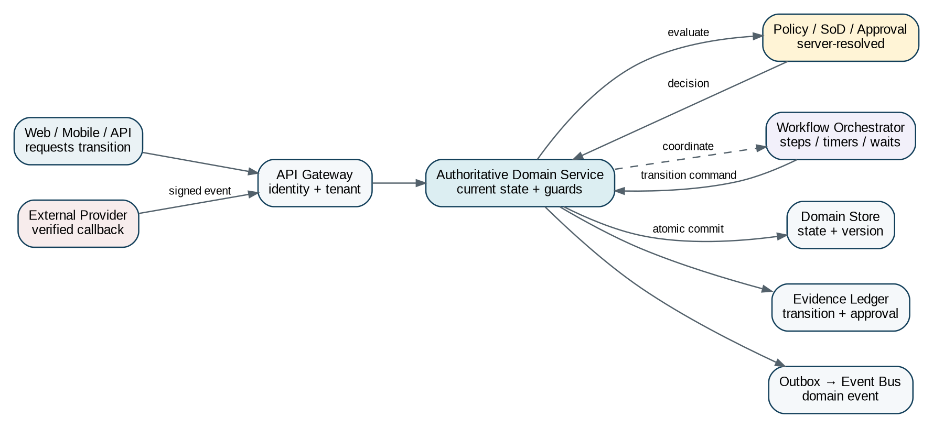
Figure 2 — Workflow coordinates the transition path; the authoritative domain service owns state and commits the transition.
A workflow instance is a durable orchestration record. It may wait for people, timers or external providers, but it must resume by issuing a command to the authoritative service. The workflow engine must never mutate a domain table directly.
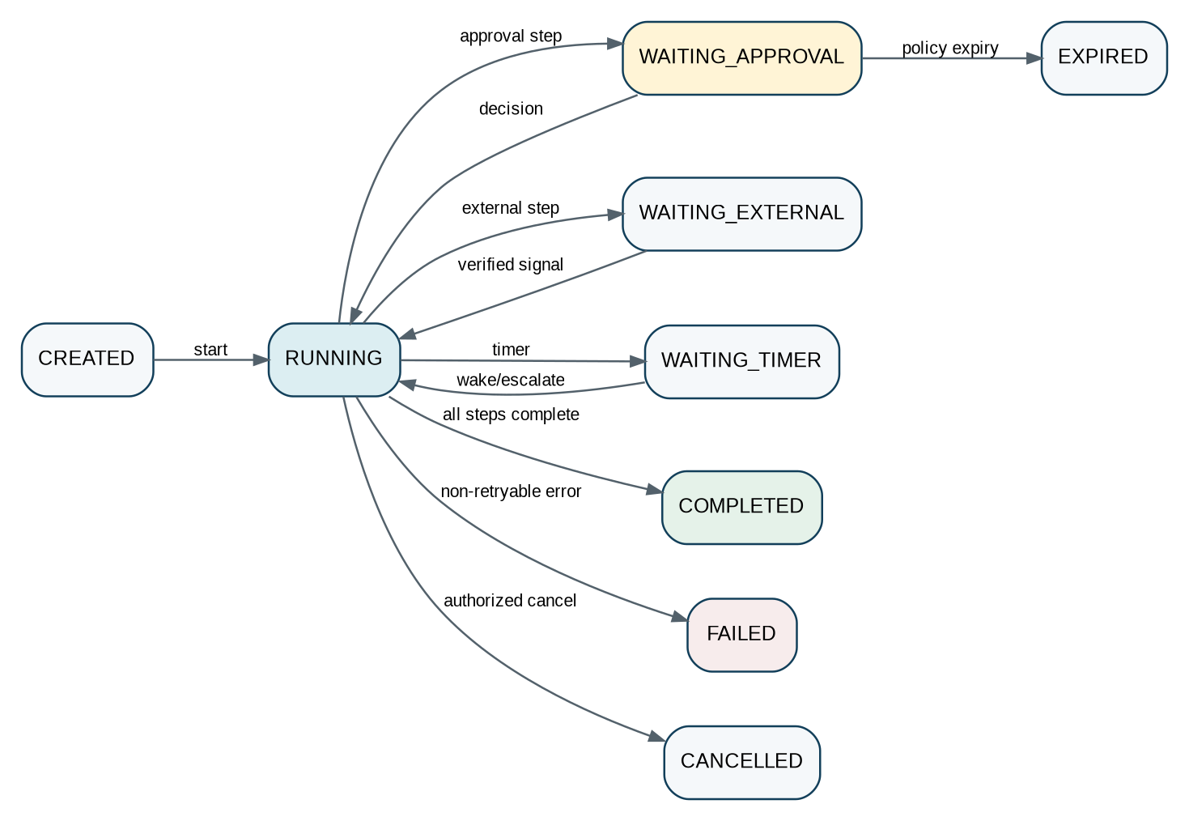
Figure 3 — Canonical workflow-instance lifecycle.

5.1 Workflow definition requirements
Requirement | Engineering rule
Immutable version | Every published workflow definition has a version; running instances remain pinned to it.
Step identity | Every step has stable `step_key`, type, owner/resolver, timeout and retry policy.
Deterministic routing | Routing conditions reference explicit facts/policy outputs, not UI-specific logic.
No hidden approvals | Every human/system approval step creates an ApprovalRequest or explicit NotRequired evidence.
Wait durability | WAITING_* states survive deploy/restart and store wake condition/deadline.
Retry classification | Only declared retryable technical failures retry automatically; business rejection does not.
Compensation | Long-running sagas define compensation/recovery actions where true rollback is impossible.
Version migration | Migration of live workflow instances requires explicit compatibility plan and evidence.

6. Global Approval Framework
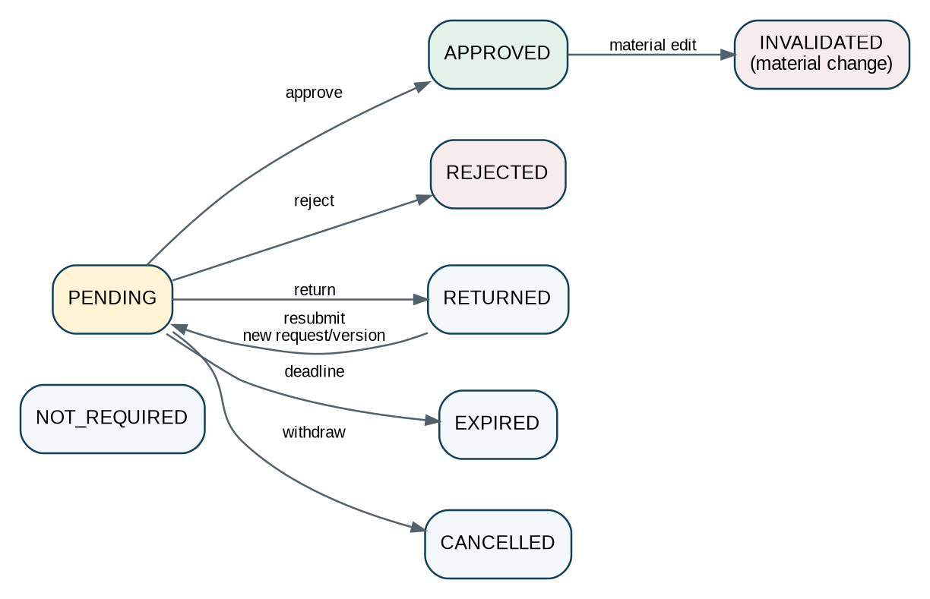
Figure 4 — Approval request lifecycle. An approved request may later be invalidated if the bound subject changes materially.
Approval is a reusable control primitive, not a boolean flag. An approval request binds the exact subject version, material attributes, required policy, approval chain and authority envelope.

6.1 Approval subject fingerprint
For every approval type, the owning service defines the material fields whose change invalidates approval. A canonical hash/fingerprint is calculated over normalized material facts and stored on the approval request. Examples: invoice total, currency, supplier bank account, payment destination, journal lines, tax return totals, contract version, legal entity and effective date.
ApprovalRequest {
approval_request_id
subject_type
subject_id
subject_version
subject_fingerprint
approval_type
policy_version
required_route_version
monetary_scope? // amount + currency
legal_entity_id?
jurisdiction_id?
requested_by
requested_at
expires_at?
state // PENDING ... INVALIDATED
}
ApprovalDecision {
decision_id
approval_request_id
step_key
decision // APPROVE / REJECT / RETURN / ABSTAIN
actor_subject_id
authority_snapshot_id
reason_code?
comment?
evidence_refs[]
decided_at
}

6.2 Supported approval patterns
Pattern | Required behavior
None / deterministic policy | System proves approval is not required; evidence still records policy result.
Single approver | One eligible actor decision.
Sequential | A → B → C; later steps open only after prior approval.
Parallel all | All required approvers must approve.
Quorum | N of M eligible members approve; abstentions/rejections handled by policy.
Maker-checker | Initiator/preparer cannot be final approver.
Dual control | Two distinct eligible actors required for release.
Threshold-based | Route changes by amount/value/risk band; amount converted using governed rate if cross-currency policy requires.
Role + named authority | Role must be eligible and actor must hold active delegated/signing authority.
Jurisdictional gate | Additional approval/evidence required by effective jurisdiction pack.
Committee / board vote | Meeting/resolution quorum, voting rights and outcome are separately evidenced.
External acceptance | External authority/provider acceptance is not an internal approval; model as verified external state.

6.3 Delegation, conflicts and absence
- Delegation is effective-dated, scope-limited and value-limited; the delegate cannot exceed the delegator’s authority.
- An approver cannot delegate around an SoD prohibition.
- Self-approval is denied unless an explicit low-risk policy permits it; high-impact actions must default to maker-checker or stronger control.
- If no eligible approver exists, the workflow escalates to an authorized resolver; it never silently selects a broader administrator.
- Conflict-of-interest declarations may remove an actor from an approval pool and must be evidenced.
- Approval eligibility is evaluated at decision time; execution authority is re-evaluated at release time.

7. Timeouts, Escalations, Exceptions & Compensation
Situation | Required default | Prohibited default
Approval deadline missed | Escalate, notify, expire or pause according to policy. | Automatic approval merely because time elapsed.
External provider timeout | Mark attempt pending/technical exception; reconcile before retry. | Assume success or failure without provider evidence.
Transient technical error | Retry under bounded policy with idempotency and backoff. | Create a second business object/financial effect.
Business rejection | Record reason; route back/cancel/new version per object model. | Technical retry.
Partial saga failure | Run defined compensation/recovery and surface exception. | Distributed “rollback” that hides external irreversible effects.
Material edit while approval pending | Invalidate or restart affected approval route. | Keep prior approval steps automatically valid unless policy explicitly allows unaffected-step reuse.
Material edit after approval | Invalidate approval before release. | Allow release against stale approved subject.

8. Detailed Business Object State Catalogue
The following catalogue defines the canonical baseline. Domain SRS documents may add intermediate states only where the additional state has distinct business meaning, controls or retry behavior. They must not collapse states in a way that removes evidence or creates ambiguous transitions.
Object | Canonical lifecycle | Exceptional / terminal | Owner | Correction / control rule
Accounting Event | RECEIVED → VALIDATED → RULE_RESOLVED → JOURNAL_PROPOSED → COMPLETED | Validation/technical exception | Accounting Kernel | Event payload/version immutable after acceptance.
Journal | DRAFT → VALIDATED → APPROVAL_PENDING → APPROVED → POSTED | REJECTED/REVERSED | Accounting Kernel | Posted journal immutable; correction = reversal/adjustment journal.
Accounting Period | OPEN → SOFT_CLOSE → CLOSE_REVIEW → HARD_CLOSED → AUTHORIZED_REOPEN → RE-CLOSED | Close exceptions | Accounting | Reopen exceptional, scoped and evidenced.
Reconciliation | OPEN → MATCHING → EXCEPTIONS/REVIEW_PENDING → RECONCILED → SIGNED_OFF → LOCKED | Exception items separate | Control/Reconciliation | Locked result tied to population watermark.
Quote / Estimate | DRAFT → INTERNALLY_APPROVED → SENT → ACCEPTED/REJECTED/EXPIRED → CONVERTED | Withdrawn | AR/Sales | Acceptance does not itself post accounting.
Sales Order | DRAFT → CONFIRMED → FULFILLMENT_IN_PROGRESS → FULFILLED → INVOICED → CLOSED | CANCELLED | Order/Fulfillment | Fulfillment axis may be separate for complex orders.
Customer Invoice | DRAFT → VALIDATED → APPROVAL_PENDING → APPROVED → ISSUED | CANCELLED pre-issue | AR | Settlement/collections modeled separately; post-issue correction via credit/debit note.
Credit / Debit Note | DRAFT → VALIDATED → APPROVED → ISSUED → APPLIED | CANCELLED pre-issue | AR | Must reference affected invoice/lines where applicable.
Receivable Settlement | UNPAID → PARTIALLY_PAID → PAID | OVERPAID / WRITTEN_OFF as controlled outcomes | AR | Overdue is derived from due date and outstanding balance.
Collection Case | OPEN → CONTACTING → PROMISE_TO_PAY / DISPUTE → RESOLVED → CLOSED | ESCALATED | Collections | Does not mutate invoice lifecycle.
Purchase Requisition | DRAFT → SUBMITTED → APPROVAL_PENDING → APPROVED → CONVERTED_TO_PO → CLOSED | REJECTED/CANCELLED | Procurement | Approval route by spend/category/entity.
Purchase Order | DRAFT → APPROVAL_PENDING → APPROVED → ISSUED → PART_RECEIVED → RECEIVED → CLOSED | CANCELLED | Procurement | Change order may invalidate approval.
Supplier Invoice | CAPTURED → VALIDATED → MATCHING → APPROVAL_PENDING → APPROVED → POSTED | MATCH_EXCEPTION / REJECTED | AP | Payment state separate; bank-detail change is risk gate.
Expense Claim | DRAFT → SUBMITTED → MANAGER_REVIEW → FINANCE_REVIEW → APPROVED → READY_TO_REIMBURSE → PAID | RETURNED/REJECTED/CANCELLED | Expenses | Receipt/tax evidence rules may vary by jurisdiction.
Payment Proposal | DRAFT → BUILT → REVIEW_PENDING → APPROVED → RELEASED_TO_INSTRUCTIONS | CANCELLED | AP/Treasury | Proposal approval does not prove each provider settlement.
Payment Instruction | DRAFT → VALIDATED → APPROVAL_PENDING → APPROVED → SUBMITTED → ACCEPTED → PROCESSING → SETTLED | FAILED/RETURNED/CANCELLED where reversible | Payments | Provider state verified; release rechecks authority and destination.
Bank Statement Import | RECEIVED → SCANNED → PARSED → VALIDATED → ACCEPTED | QUARANTINED/REJECTED | Banking | Raw statement/hash preserved.
Bank Reconciliation | OPEN → MATCHING → EXCEPTIONS → REVIEW_PENDING → RECONCILED → SIGNED_OFF → LOCKED | AUTHORIZED_REOPEN | Banking | Signed result tied to statement and ledger watermarks.
Tax Determination | REQUESTED → FACTS_VALIDATED → RULE_RESOLVED → CALCULATED → FINAL | EXCEPTION / SUPERSEDED | Tax | Final result immutable for bound transaction version.
Tax Return | DRAFT → PREPARED → VALIDATED → REVIEW_PENDING → APPROVED → READY_TO_FILE → FILED | RETURNED / SUPERSEDED_BY_AMENDMENT | Tax | Submission attempt modeled separately.
Tax Submission Attempt | PREPARED → SENT → ACKNOWLEDGED → ACCEPTED | REJECTED / TECHNICAL_FAILURE | Tax Adapter | Authority response is authoritative external evidence.
E-Invoice Submission | CREATED → VALIDATED → SUBMITTED → NETWORK_ACCEPTED → CLEARED/DELIVERED | NETWORK_REJECTED / AUTHORITY_REJECTED | E-Invoice Adapter | Separate from commercial invoice lifecycle.
Fixed Asset | REGISTERED → IN_SERVICE → HELD/IMPAIRED (if policy) → DISPOSED | CANCELLED pre-capitalization | Assets | Depreciation run state separate.
Inventory Count | PLANNED → IN_PROGRESS → SUBMITTED → REVIEW_PENDING → APPROVED → POSTED → CLOSED | CANCELLED | Inventory | Posting requires frozen count population/version.
Budget | DRAFT → SUBMITTED → REVIEW_PENDING → APPROVED → BASELINED | SUPERSEDED/CLOSED | FP&A | Approved baseline immutable; revision = new version.
Forecast | DRAFT → SUBMITTED → APPROVED → PUBLISHED | SUPERSEDED | FP&A | Scenario/version explicit.
Audit Engagement | PROPOSED → ACCEPTED → PLANNING → FIELDWORK → COMPLETION → ARCHIVED | CANCELLED | Audit | Independence/acceptance gates before fieldwork.
Audit Workpaper | DRAFT → PREPARED → REVIEW_PENDING → REVIEW_NOTES → CLEARED → SIGNED_OFF → LOCKED | AUTHORIZED_REOPEN | Audit | Reviewer/preparer SoD and sign-off evidence.
Audit Finding | DRAFT → VALIDATED → ISSUED_TO_MANAGEMENT → RESPONSE_RECEIVED → AGREED/DISPUTED → REMEDIATION_TRACKING → CLOSED | WITHDRAWN by authority | Audit | Severity changes preserved as history.
Contract | DRAFT → INTERNAL_REVIEW → COUNTERPARTY_REVIEW → APPROVAL_PENDING → APPROVED_FOR_SIGNATURE → SIGNATURE_PENDING → EXECUTED → ACTIVE → EXPIRED/TERMINATED | SUPERSEDED | Legal | Executed binary/version immutable; amendment creates new version/relationship.
Legal Matter | OPEN → ASSESSMENT → ACTIVE → STAYED (optional) → RESOLVED → CLOSED | AUTHORIZED_REOPEN | Legal | Privilege/access separate from lifecycle.
Corporate Resolution | DRAFT → CIRCULATED → VOTING → APPROVED/REJECTED → EXECUTED → RECORDED | SUPERSEDED | Corporate Governance | Quorum and voting rights evidenced.
Document | UPLOADED → SCANNED → CLASSIFIED → ACTIVE → SUPERSEDED/ARCHIVED | QUARANTINED | Document Service | Binary version immutable; disposition controlled by retention/legal hold.
Task / Case | OPEN → IN_PROGRESS → WAITING → RESOLVED → CLOSED | CANCELLED / REOPENED | Business Ops | Task state cannot replace authoritative object state.
Data Import Job | UPLOADED → SCANNED → MAPPED → VALIDATED → PREVIEW_READY → APPROVAL_PENDING → IMPORTING → IMPORTED → RECONCILED | QUARANTINED/FAILED | Integration/Data | Import not complete until reconciliation passes where financial.
Integration Sync Run | QUEUED → RUNNING → PARTIAL/COMPLETED | FAILED / CANCELLED | Integration | Cursor/watermark and per-record errors preserved.
Subscription | PENDING_ACTIVATION → ACTIVE → SUSPENDED → CANCEL_PENDING → ENDED | TERMINATED | Commercial Platform | Commercial plane separate from tenant accounting.
Entitlement Change | REQUESTED → VALIDATED → SCHEDULED/APPROVED → APPLIED | REJECTED/ROLLED_BACK if safe | Commercial Platform | Entitlements effective-dated and source-linked to commercial decision.

9. High-Risk Object Wireframes & Transition Matrices
The following high-risk models are prescriptive because a bad transition can create financial, regulatory, legal or audit consequences. Each transition remains subject to tenant/entity scope, optimistic concurrency and the canonical control order in Section 4.

9.1 Customer Invoice
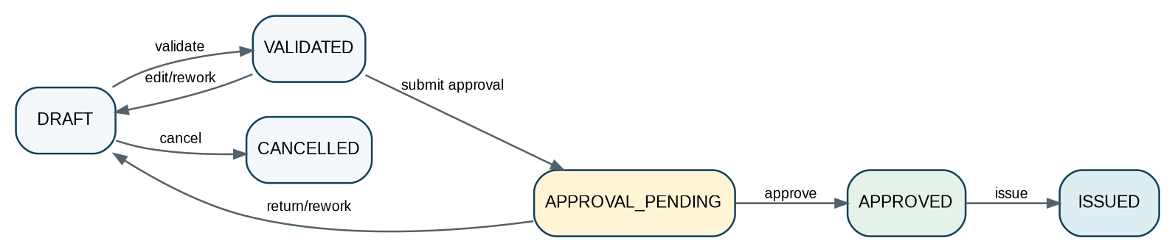
Figure 5 — Customer invoice primary lifecycle. Settlement and collections are separate state dimensions.
From | Command | To | Core guards | Approval / evidence
DRAFT | validate_invoice | VALIDATED | Required seller/buyer, dates, lines, currency, tax determination; number policy satisfied. | Validation evidence; no approval yet.
VALIDATED | submit_invoice_approval | APPROVAL_PENDING | No material validation errors; current version fingerprinted. | Approval request bound to total, currency, tax, buyer and legal entity.
APPROVAL_PENDING | approve_invoice | APPROVED | Eligible approver; SoD; subject fingerprint unchanged. | Immutable approval decision.
APPROVAL_PENDING | return_invoice | DRAFT | Authorized reviewer; reason required. | Return reason; prior approval request closed/superseded.
APPROVED | issue_invoice | ISSUED | Authority revalidated; period/tax/e-invoice prerequisites; subject unchanged. | Issue evidence; invoice domain event; accounting event.
DRAFT/VALIDATED | cancel_invoice | CANCELLED | Not issued; no downstream irrevocable effects. | Reason required.

Post-issue correction
An issued invoice is not returned to Draft. Commercial correction occurs through credit/debit note, cancellation/void only where legally permitted and explicitly modeled, or an amended/superseding document under jurisdiction rules.

9.2 Supplier Invoice
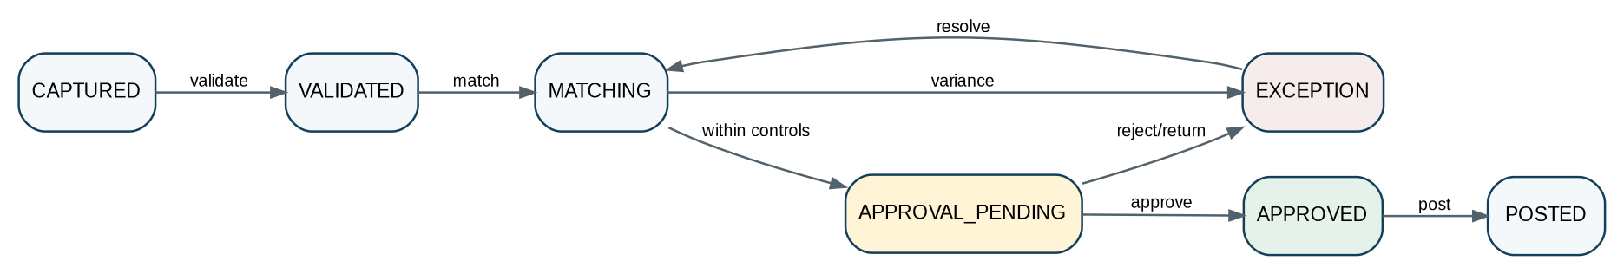
Figure 6 — Supplier invoice lifecycle with explicit matching exception path.
From | Command | To | Core guards | Control
CAPTURED | validate_supplier_invoice | VALIDATED | Supplier identity, duplicate detection, amounts, tax and document integrity. | Duplicate key + document hash checked.
VALIDATED | start_match | MATCHING | PO/receipt linkage or approved non-PO route. | Match policy version pinned.
MATCHING | raise_match_exception | EXCEPTION | Variance/tolerance/control failure. | Structured exception and ownership.
EXCEPTION | resolve_match_exception | MATCHING | Resolution evidence; adjusted facts/version. | Resolution may require revalidation.
MATCHING | submit_ap_approval | APPROVAL_PENDING | Matching complete/within tolerance. | Approval fingerprint includes supplier, amount, currency, bank-payment profile reference.
APPROVAL_PENDING | approve_supplier_invoice | APPROVED | SoD, limits, subject unchanged. | Decision evidence.
APPROVED | post_supplier_invoice | POSTED | Open period, accounting mapping, tax result, no blocking exception. | Accounting event + reconciliation control.

9.3 Payment Instruction
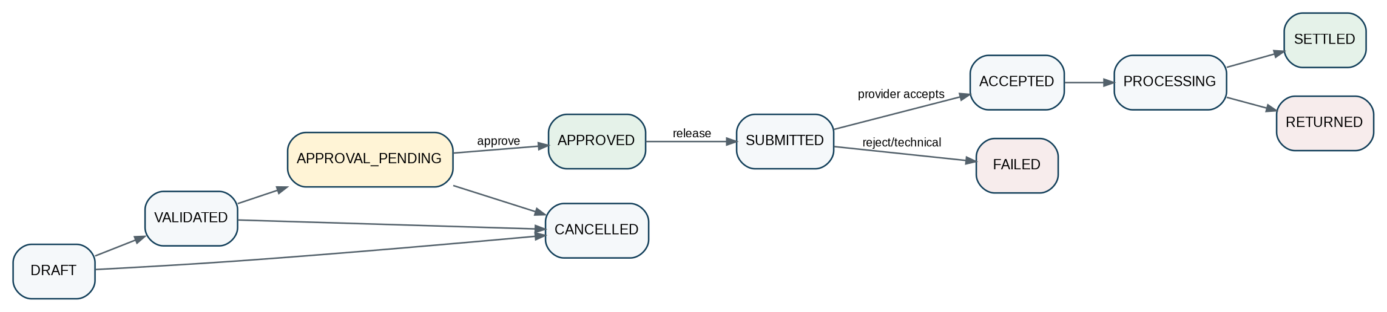
Figure 7 — Payment instruction separates internal approval/release from provider processing and settlement.
From | Command / signal | To | Irreversibility / guard | Required evidence
DRAFT | validate_payment | VALIDATED | Payee/destination, source account, amount, currency, sanctions/fraud/business controls as configured. | Validation result and destination fingerprint.
VALIDATED | submit_payment_approval | APPROVAL_PENDING | Release route resolved by amount/risk/entity. | Approval request.
APPROVAL_PENDING | approve_payment | APPROVED | Maker-checker/dual control as policy; approver limit. | Decision + authority snapshot.
APPROVED | release_payment | SUBMITTED | Recheck destination unchanged, funds/limits, authority, SoD and provider readiness. | Release evidence + provider request hash.
SUBMITTED | provider_accepts | ACCEPTED | Verified provider response, deduplicated. | Provider request/response IDs.
ACCEPTED | provider_processing | PROCESSING | Verified provider status. | Provider event.
PROCESSING | provider_settles | SETTLED | Verified final settlement evidence. | Settlement reference, value date.
SUBMITTED/PROCESSING | provider_failure_or_return | FAILED / RETURNED | Map provider reason and retryability. | Provider reason code; reconciliation required.

9.4 Journal
From | Command | To | Core guards | Correction doctrine
DRAFT | validate_journal | VALIDATED | Balanced, exact decimal, valid accounts/dimensions/book/period/currency, source evidence. | No posting yet.
VALIDATED | submit_journal_approval | APPROVAL_PENDING | Approval required by journal source/type/materiality policy. | Fingerprint covers all accounting lines and book.
APPROVAL_PENDING | approve_journal | APPROVED | Preparer ≠ final approver where SoD requires. | Immutable decision.
APPROVED | post_journal | POSTED | Period open, authority revalidated, version/fingerprint unchanged, idempotent posting. | Atomic posting + outbox + signed trace.
POSTED | reverse_journal | POSTED (new reversal journal) + original marked reversed relationship | Authorized reversal reason/effective period; original never edited. | Reversal journal and relationship.

9.5 Accounting Period Close
Figure 8 — Period close and exceptional reopen lifecycle.
From | Command | To | Mandatory gate
OPEN | start_soft_close | SOFT_CLOSE | Close calendar active; posting restrictions set by policy.
SOFT_CLOSE | submit_close_review | CLOSE_REVIEW | Subledgers, bank, tax, payroll, intercompany and required reconciliations complete; material exceptions resolved/accepted.
CLOSE_REVIEW | approve_hard_close | HARD_CLOSED | Eligible finance authority; signed balance snapshot/watermarks; no blocking controls.
HARD_CLOSED | authorize_reopen | AUTHORIZED_REOPEN | Exceptional reason, scoped book/period, dual approval where policy, audit notification/evidence.
AUTHORIZED_REOPEN | reclose_period | RE-CLOSED | Correction journals reconciled; impact assessed; new signed snapshot.

9.6 Reconciliation
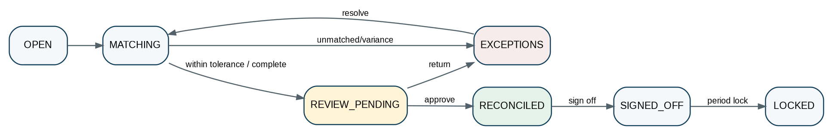
Figure 9 — Generic reconciliation lifecycle used by bank, subledger/GL, tax/GL, payroll/GL and other control reconciliations.
Transition | Guard / evidence
OPEN → MATCHING | Population definition, source watermarks and tolerance rule version frozen.
MATCHING → EXCEPTIONS | Unmatched/variance items materialized with reason class and owner.
EXCEPTIONS → MATCHING | Each exception resolved/accepted with evidence; population changes create controlled refresh/version.
MATCHING → REVIEW_PENDING | Completeness metrics pass and residual variance within permitted threshold.
REVIEW_PENDING → RECONCILED | Reviewer independent where required; no blocking unresolved exceptions.
RECONCILED → SIGNED_OFF | Control owner signs result tied to exact population hashes/watermarks.
SIGNED_OFF → LOCKED | Period/control lock; later change requires authorized reopen/new reconciliation version.

9.7 Tax Return & Submission
Figure 10 — Tax return lifecycle. Filing transport/authority acceptance is modeled through a separate submission-attempt state machine.
Return transition | Guard | Submission relationship
DRAFT → PREPARED | Required registrations/period/population loaded; preparer completes adjustments. | No authority submission.
PREPARED → VALIDATED | Rule-pack version, arithmetic, reconciliation and schema controls pass. | Filing package may be generated.
VALIDATED → REVIEW_PENDING | Material facts frozen/fingerprinted. | Approval request created.
REVIEW_PENDING → APPROVED | Authorized tax reviewer; SoD; subject unchanged. | Return approved, not yet filed.
APPROVED → READY_TO_FILE | Credentials/filing schema/authority endpoint and evidence package resolved. | Create submission attempt.
READY_TO_FILE → FILED | Only after accepted/legally successful authority result according to jurisdiction adapter. | Accepted submission ID/receipt bound to return.
FILED → SUPERSEDED_BY_AMENDMENT | New amended return approved/filed. | Original remains immutable and discoverable.

9.8 Contract
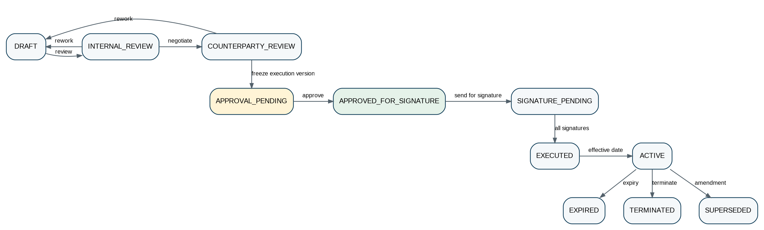
Figure 11 — Contract lifecycle separates drafting/review, approval, signature and legal effectiveness.
Transition | Key control
DRAFT → INTERNAL_REVIEW | Template/clause versions, parties, entity, governing law and commercial terms present.
INTERNAL_REVIEW ↔ COUNTERPARTY_REVIEW | Negotiation creates versioned redlines; material change may restart internal/legal approval.
COUNTERPARTY_REVIEW → APPROVAL_PENDING | Execution version frozen/fingerprinted.
APPROVAL_PENDING → APPROVED_FOR_SIGNATURE | Signing authority, value thresholds, legal review and SoD satisfied.
APPROVED_FOR_SIGNATURE → SIGNATURE_PENDING | Approved binary/hash sent to signature provider/signatories.
SIGNATURE_PENDING → EXECUTED | All required signatures verified; signed binary/hash stored.
EXECUTED → ACTIVE | Effective date/conditions precedent satisfied.
ACTIVE → EXPIRED / TERMINATED / SUPERSEDED | Expiry, authorized termination or executed amendment; original executed version remains immutable.

9.9 Audit Workpaper
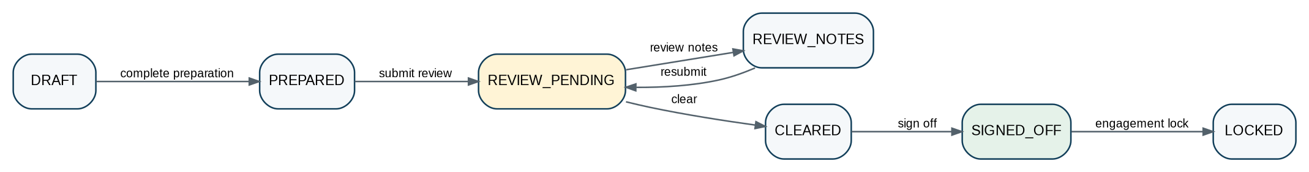
Figure 12 — Audit workpaper preparation, review, sign-off and lock lifecycle.
From → To | Guard / evidence
DRAFT → PREPARED | Objective, procedure, evidence references and preparer conclusion complete.
PREPARED → REVIEW_PENDING | Preparer signs/submits current version.
REVIEW_PENDING → REVIEW_NOTES | Reviewer records immutable note(s), severity/required action and due state.
REVIEW_NOTES → REVIEW_PENDING | Preparer responds; new workpaper version/evidence references preserved.
REVIEW_PENDING → CLEARED | All blocking review notes cleared; reviewer conclusion recorded.
CLEARED → SIGNED_OFF | Required review hierarchy/engagement authorization satisfied.
SIGNED_OFF → LOCKED | Engagement archive/lock policy; changes require explicit authorized reopen cycle.

9.10 Data Import
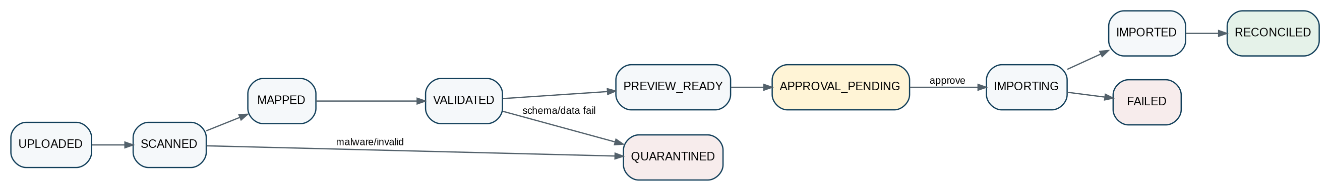
Figure 13 — Controlled import lifecycle. Financial migrations/imports are not complete until reconciliation passes.
State / edge | Required behavior
UPLOADED → SCANNED | Malware/file integrity and content-type checks before parsing.
SCANNED → MAPPED | Mapping definition version selected; source schema identified.
MAPPED → VALIDATED | Schema, referential, business and duplicate controls; failures quarantined, not partially hidden.
VALIDATED → PREVIEW_READY | Deterministic preview of creates/updates/rejections and financial effect where applicable.
PREVIEW_READY → APPROVAL_PENDING | Approval required according to risk/import type/volume.
APPROVAL_PENDING → IMPORTING | Approved exact file hash + mapping + preview fingerprint.
IMPORTING → IMPORTED | Idempotent per-record writes; source lineage retained.
IMPORTED → RECONCILED | Counts/totals/control balances agree with source and target; only then Complete/accepted.

10. Approval Routing & Decision Wireframe
Approval routing is resolved as data, not hard-coded UI branching. A route is produced from the object facts, risk/materiality, entity, jurisdiction, policy and active authority/delegation graph.
Routing input | Examples
Object facts | Type, total, currency, supplier/customer, journal type, contract value, tax period.
Risk facts | New bank account, unusual destination, exception severity, override, sensitive category.
Organizational scope | Tenant, legal entity, department, cost center, project.
Jurisdiction/policy | Local statutory gate, tax filing authorization, retention or board-approval requirement.
Authority graph | Role, delegated authority, value ceiling, signing authority, committee membership.
Conflict facts | Maker/preparer identity, prior decisions, related party/conflict declaration.

10.1 Route resolution output
ApprovalRoute {
route_version
policy_version
steps: [
{
step_key,
sequence,
decision_mode, // ANY_ONE | ALL | QUORUM | SYSTEM_POLICY
quorum_count?,
eligible_role_ids[],
eligible_subject_ids[]?,
excluded_subject_ids[],
amount_limit?,
due_at?,
escalation_rule_id?
}
]
}

11. State Machine Definition & Versioning
StateMachineDefinition {
object_type: "customer_invoice"
version: "3.2.0"
primary_dimension: "lifecycle_state"
states: [...]
terminal_states: ["CANCELLED"]
transitions: [
{
name: "issue_invoice",
from: ["APPROVED"],
to: "ISSUED",
guard_set: "AR-ISSUE-004",
approval_type: "INVOICE_ISSUE"?,
reason_requirement: "OPTIONAL",
evidence_requirement: ["tax_result"],
emitted_events: ["ar.invoice.issued.v1"]
}
]
}

- State-machine definitions are immutable once published; changes create a new version.
- An object records or can resolve the state-machine version under which each transition occurred.
- Backward compatibility is required for existing objects; migration is a deliberate command, not an automatic enum remap.
- Removed states remain interpretable for history even when no new object may enter them.
- Jurisdiction packs may add transition guards or required evidence through controlled extension hooks; they must not silently override core integrity invariants.

12. API & Command Surface
The API should make valid actions discoverable while preventing arbitrary state writes. Read endpoints expose current state dimensions and permitted actions for the current actor; command endpoints execute transitions.
Pattern | Example | Rule
Read object | GET /v1/ar/invoices/{id} | Returns lifecycle + orthogonal dimensions, version, derived labels and action links.
Discover actions | GET /v1/ar/invoices/{id}/available-actions | Server-evaluated actions for current actor/context; informative, not authorization proof for later execution.
Transition command | POST /v1/ar/invoices/{id}:issue | Requires expected_version + idempotency + reason/evidence as defined.
Approval decision | POST /v1/approvals/{id}:decide | Decision bound to approval request, step and current eligibility.
Workflow query | GET /v1/workflows/{id} | Read orchestration state, pending step, deadlines and linked object; no domain mutation endpoint.
History | GET /v1/{domain}/{object}/{id}/transitions | Authorized immutable transition history + evidence references.

PATCH prohibition
Generic `PATCH {status: ...}` is prohibited for authoritative business state. PATCH may edit mutable draft fields; state changes use named commands with transition-specific validation.

13. Canonical Transition & Workflow Events
Event family | Examples | Minimum payload
Domain transition | ar.invoice.issued.v1; ap.supplier_invoice.posted.v1 | object_id, prior_state, new_state, object_version, occurred_at, actor/system, correlation/causation, evidence refs.
Approval | workflow.approval.requested.v1; workflow.approval.decided.v1; workflow.approval.invalidated.v1 | request_id, subject/version/fingerprint, step, decision, authority/policy refs.
Workflow | workflow.instance.started.v1; waiting.v1; completed.v1; failed.v1 | workflow_instance_id, definition version, current step, linked object, reason.
External state | payments.provider_status.received.v1; tax.submission.response_received.v1 | provider/authority IDs, verified source, attempt ID, mapped status/reason, payload hash.
Control | reconciliation.signed_off.v1; period.hard_closed.v1 | population/snapshot refs, approver/control owner, policy version.

14. Persistence & Data Model Requirements
Record | Required fields / behavior
Business object | object_id, tenant/entity scope, lifecycle state, orthogonal state fields as appropriate, object_version, effective dates, state-machine version.
Transition history | transition_id, from/to, command, actor, object versions before/after, reason code, evidence refs, workflow/approval refs, policy/rule versions, timestamps, correlation/causation. Append-only.
Workflow definition | definition_id/version, step graph, routing predicates, timeout/retry/compensation policies, status. Immutable when published.
Workflow instance | definition version, linked subject, orchestration state, current step(s), wake/deadline, correlation, variables restricted to orchestration facts.
Approval request | subject version/fingerprint, route/policy version, state, requested_by/time, expiry.
Approval decision | request + step + actor + immutable authority snapshot + decision + reason/evidence + timestamp.
External attempt | provider/authority, request hash, external id, transport state, verified responses, retry classification.
Outbox/inbox | event/command id, aggregate/object, schema version, payload hash, published/consumed status, deduplication key.

14.1 Indexing / retrieval
- Index current work queues by tenant/entity, object type, lifecycle/approval state, assigned actor/pool, due_at and severity.
- Index transition history by object, transition name, actor, period/date range, reason code, policy version and correlation ID.
- Permit as-of reconstruction from object version/history where the domain’s temporal model requires it.
- Workflow/search read models may denormalize state but are not authoritative and must expose freshness/watermark.

15. Authorization, SoD & Privileged Intervention
Control | Requirement
Transition permission | Authorize `object_type + transition`, not only resource CRUD. “Can edit invoice” does not imply “can issue invoice.”
Field permission | Draft-field editability may be narrower/broader than transition authority and may vary by state.
Maker-checker | Preparer/initiator excluded from final approval/release where policy requires.
Dual control | Critical payment, period reopen, privileged data repair and comparable actions may require two distinct actors.
Break-glass | Creates privileged session, reason, approval/notification, bounded scope/time, complete evidence; cannot silently rewrite posted/terminal truth.
Admin boundary | Platform administrators do not automatically inherit tenant business approval authority.
Service identity | System transitions require workload identity plus explicit service authorization and policy basis.

16. Exception & Reason Taxonomy
Class | Examples | Retry behavior
VALIDATION | Missing required fact; schema error; invalid date/currency. | Correct input; no blind retry.
BUSINESS_RULE | Period closed; credit/limit policy; invalid state edge; duplicate business document. | Resolve business condition; resubmit explicit command.
AUTHORIZATION | Permission, SoD, authority, delegation or approval failure. | No technical retry; authority must change or request rerouted.
CONCURRENCY | Expected version stale. | Refresh current object; user/system decides whether to issue a new command.
EXTERNAL_REJECTION | Bank/network/tax authority rejects request. | Follow mapped reason; correction/new attempt where permitted.
TECHNICAL_TRANSIENT | Timeout, rate limit, temporary dependency outage. | Bounded idempotent retry.
TECHNICAL_PERMANENT | Unsupported schema/provider configuration, invalid credentials after policy threshold. | Stop; operator/configuration action.
CONTROL_EXCEPTION | Reconciliation variance, missing evidence, unresolved close item. | Resolve/accept under explicit control policy before progression.

Reason-code rule
Every business rejection, cancellation, reversal, reopen, write-off, override, return and privileged intervention uses a governed reason code. Free text may supplement the code but never replace it.

17. Observability, Work Queues & Operational Controls
Signal | Required telemetry
Transition latency | Command received → decision/commit; p50/p95/p99 by object/transition/region.
Approval aging | Pending count/age by route, approver pool, risk, entity and SLA; escalation state.
Workflow health | Running/waiting/stuck instances, timer lag, retry count, compensation count, definition version.
Invalid transition attempts | By object, actor/service, requested edge and reason. Security/control signal.
Concurrency conflicts | Expected-version failures by workflow/client to identify stale read/action patterns.
External bridge health | Pending provider attempts, callback verification failures, duplicate callbacks, unknown external status.
Control exceptions | Open reconciliation/close/import exceptions by materiality and owner.
Approval invalidations | Material edits after approval by object type—important process-quality/fraud signal.

18. Testing & Certification Framework
State correctness is primarily a negative-path problem. Every transition must be tested not only for the happy path but for forbidden edges, stale versions, duplicate commands, altered approval subjects, expired authority and external replay.
ID | Scenario | Test action | Expected invariant
T-01 | Illegal edge | Attempt ISSUED → DRAFT invoice transition. | Rejected; no mutation/event except security/audit attempt evidence.
T-02 | Stale version | Approve object with expected_version N after material edit to N+1. | 409/concurrency failure or approval invalidated; no approval applies to N+1.
T-03 | Duplicate command | Replay same idempotency key after successful issue/post/payment release. | Same prior result; no duplicate economic effect.
T-04 | Approval subject changed | Supplier bank account/amount changes after approval. | Approval invalidated; release blocked until new route approved.
T-05 | SoD violation | Preparer attempts final approval where maker-checker required. | Denied and evidenced.
T-06 | Delegation expired | Delegate decision after delegation end. | Denied; route re-resolved/escalated.
T-07 | Timeout | Approval deadline passes. | Escalate/expire according to policy; never implicit approval.
T-08 | Forged callback | Invalid provider signature attempts payment settlement. | Rejected; security event; payment unchanged.
T-09 | Duplicate external callback | Same accepted/settled event received repeatedly. | Deduplicated; one state change only.
T-10 | Out-of-order callback | SETTLED arrives before ACCEPTED due provider ordering. | Adapter/state bridge uses provider-specific allowed reconciliation policy; never creates impossible intermediate history silently.
T-11 | Period hard closed | Posting transition against closed book/period. | Blocked unless authorized correction/reopen path applies.
T-12 | Terminal correction | Attempt edit of posted journal/executed contract/filed return. | Blocked; user routed to reversal/amendment/supersession workflow.
T-13 | Workflow restart | Worker crashes while waiting after domain commit. | Instance resumes from durable state; command idempotency prevents replay side effect.
T-14 | Definition deployment | New workflow version published while old instances run. | Old instances remain pinned; new instances use new version.
T-15 | Reconciliation changed population | Source watermark changes after reviewer approval. | Approval/sign-off invalidated or new reconciliation version created.
T-16 | Import partial failure | Some records fail after import starts. | Per-record results preserved; no hidden “completed”; financial import requires reconciliation before accepted completion.

19. Definition of Ready — State/Workflow Feature
- Authoritative owner and state dimension(s) identified.
- Current and target states have unambiguous business definitions.
- Every transition has a named command, allowed source states and one deterministic target/response behavior.
- Preconditions, authorization, SoD, approval and evidence requirements defined.
- Material fields for approval fingerprint/invalidation defined.
- Terminal/correction/reopen behavior defined.
- Timeout, retry, external callback and compensation behavior defined where applicable.
- Reason codes and exception mapping defined.
- API, event schema, idempotency and concurrency semantics defined.
- Persistence/history, retention, residency and search requirements defined.
- Positive and negative acceptance tests approved by Product + domain control owner + Engineering.

20. Definition of Done — State/Workflow Feature
- Transition implementation accepts only named commands; direct state-field mutation is impossible outside controlled migration/repair tooling.
- All guards run server-side and are covered by unit/contract/integration tests.
- Idempotency, stale-version and concurrent-request tests pass.
- Approval binding/invalidation and SoD tests pass where applicable.
- Workflow restart/retry behavior proven under worker/process failure.
- External callbacks verified, deduplicated and mapped with reconciliation tests.
- Transition history, evidence and outbox event committed consistently.
- Dashboards/work queues derive from authoritative state with declared freshness.
- Observability, alerting and operational runbook complete.
- Security, privacy/residency and audit-control review passed.
- Golden negative-path scenarios pass in CI and pre-production certification.

21. Engineering Implementation Sequence
Wave | Deliverable
Wave 0 — Framework | Transition-command library; state-machine registry; optimistic concurrency; idempotency; transition history; reason-code registry.
Wave 1 — Approval core | Approval request/decision, authority snapshot, routing policy, SoD, delegation, invalidation, queues/escalation.
Wave 2 — Workflow core | Versioned definitions, durable instances, waits/timers, retries, compensation, orchestration events.
Wave 3 — Accounting & financial controls | Journal, period close, reconciliation, customer/supplier invoices, expenses and payment instructions.
Wave 4 — Tax and regulatory | Tax return/submission, e-invoice clearance, regulatory response bridge.
Wave 5 — Audit & legal | Workpapers/findings, contracts, legal matters, resolutions and signature bridge.
Wave 6 — Data/business/commercial | Imports, integrations, documents, task/case, subscription/entitlement transitions.
Wave 7 — Certification | Cross-domain replay, concurrency, failover, residency, scale and negative-path test harness.

22. Controlled Decisions Still Required Before Production
Decision | Owner | Must be resolved before
Workflow/orchestration technology and HA topology | Platform Architecture / SRE | Workflow framework production build.
Global approval authority/delegation data model integration | IAM / Governance / Product | High-risk approval rollout.
Canonical material-field sets for each approval type | Domain Product + Control Owner | Each object approval implementation.
Default timeout/escalation SLAs by object/risk | Operations + Domain Owner | Production queues.
Break-glass operating policy and dual-control thresholds | Security + Finance/Legal/Tax owners | Privileged intervention enablement.
Provider-specific irreversibility/status mapping for payments/e-invoice/tax | Integration + Domain Owner | External execution.
Retention periods for workflow/approval evidence by jurisdiction | Privacy/Legal/Compliance | Production data retention configuration.

23. Prohibited Anti-Patterns
- One universal `status` enum that combines lifecycle, approval, settlement and exceptions.
- Generic `PATCH status` endpoints or frontend-only state guards.
- Workflow engine writing directly to accounting, tax, legal, AR/AP or payment tables.
- Approval boolean stored on the object without approval request/decision/version evidence.
- Reusing an approval after material subject changes without explicit invalidation/re-evaluation.
- Auto-approving because an approver did not act before a deadline.
- Self-approval or admin override used to bypass maker-checker controls.
- Editing posted journals, issued regulated documents, filed returns or executed contracts back into draft state.
- Calling cancellation, reversal, write-off and amendment the same operation.
- Treating a transport timeout as proof of external failure or success.
- Accepting unsigned/unverified provider callbacks or applying duplicate callbacks repeatedly.
- Publishing domain transition events before authoritative state commit.
- Using free-text reasons where a governed reason code is required.
- Changing a published workflow/state-machine definition in place while instances are running.
- Allowing AI output alone to perform irreversible approvals, postings, filings, signatures or payment releases.

24. Final Architecture Decision
APPROVAL RECOMMENDATION
Adopt ZS-STATE-001 as the controlling cross-domain state, workflow and approval standard. Every ZoikoSuite domain SRS, API contract, event contract and UI action model must conform to this transition doctrine. Exceptions require Architecture + relevant control-owner approval and must be documented as versioned deviations.

The required end state is simple to state but demanding to implement: every material business transition must be intentional, authorized, version-correct, reproducible, evidence-backed and attributable. That control fabric is what allows ZoikoSuite to support global accounting, finance, tax, audit, legal and business workflows without sacrificing speed, automation or audit defensibility.

Appendix A — Canonical Transition History Record
TransitionHistory {
transition_id
tenant_id
legal_entity_id?
object_type
object_id
state_dimension
from_state
to_state
transition_name
object_version_before
object_version_after
actor_subject_id
workload_subject_id?
reason_code?
narrative?
approval_request_id?
workflow_instance_id?
policy_version?
rule_version?
evidence_refs[]
correlation_id
causation_id?
occurred_at
effective_at?
}

Appendix B — Transition Reason-Code Families
Family | Examples
CANCEL | CUSTOMER_REQUEST; DUPLICATE; COMMERCIAL_WITHDRAWAL; PRE_ISSUE_ERROR
RETURN | MISSING_EVIDENCE; DATA_CORRECTION_REQUIRED; POLICY_EXCEPTION; REVIEW_NOTES
REJECT | AUTHORITY_DENIED; CONTROL_FAILURE; POLICY_NOT_MET; COUNTERPARTY_REJECTED
REVERSE | POSTING_ERROR; WRONG_PERIOD; WRONG_ACCOUNT; DUPLICATE_POSTING
REOPEN | POST_CLOSE_ERROR; REGULATORY_ADJUSTMENT; AUDIT_ADJUSTMENT; AUTHORIZED_CORRECTION
WRITE_OFF | IMMATERIAL_BALANCE; BAD_DEBT_APPROVED; ROUNDING; STATUTORY_ADJUSTMENT
TERMINATE | CONVENIENCE; BREACH; REGULATORY; MUTUAL_AGREEMENT; END_OF_SERVICE
OVERRIDE | CONTROL_OWNER_OVERRIDE; EMERGENCY_OPERATION; AUTHORIZED_EXCEPTION
EXTERNAL | PROVIDER_REJECTED; AUTHORITY_REJECTED; RETURNED; NETWORK_FAILURE

Appendix C — UI/UX Action Contract for Designers
Although this is a backend control standard, frontend teams need one deterministic presentation contract. The UI never decides whether an action is allowed; it renders server-provided actions and captures transition-specific inputs.
UI element | Required behavior
Primary action | One clear action generated from server-available transitions; label uses business verb such as Approve, Issue, Post, File, Release.
Disabled action | If shown, explain the server-provided blocking reason; do not imply clicking can bypass it.
Approval panel | Show subject version/amount/key facts, approval path, completed steps, pending owner/pool and expiry/escalation.
State badges | Display separate lifecycle, approval and settlement/compliance badges where useful; do not concatenate into one fake state.
History timeline | Render authoritative transition history with actor/time/reason and evidence links subject to permissions.
Destructive/irreversible action | Require explicit confirmation and reason/evidence when policy requires; re-fetch current version/actions before submission.
Stale object | On concurrency failure, reload and show what changed; never automatically replay a materially different approval/release command.

