ZOIKOSUITE

Business Operations & Content Services
Detailed Service Specifications
ZS-SVC-P-001 • Version 1.0 • Build-Ready Business Operations Baseline
Executive doctrine — ZoikoSuite Business Operations provides governed content, forms, tasks, relationship context, offering metadata, deadlines, collaboration and notifications. It coordinates work around authoritative business objects but never becomes a shortcut around the domain that owns the actual transaction, balance, approval, legal right, tax result or payment state. Content, work coordination, business authority and evidential proof remain distinct.

Field | Value
Document ID | ZS-SVC-P-001
Version | 1.0 — Build-Ready Business Operations Baseline
Date | 24 August 2026
Status | Engineering baseline — production configuration, legal/privacy validation and go-live certification required
Owner | ZoikoSuite Product / Business Operations Architecture
Audience | Engineering, Product, Operations, Customer Success, Finance, Legal, Security, Privacy, QA, Support
Language | American English
Precedence | ZS-SVC-SPEC-001 plus ZS-DATA-001, ZS-IAM-001, ZS-DATA-GOV-001, ZS-STATE-001, ZS-API-001, ZS-EVENT-001, ZS-SEC-001, ZS-OPS-001 and applicable domain packs

0. Critical Analysis & Refined Architecture Decision
- Document Management owns binaries, document versions and document metadata; it does not own the authoritative business facts represented inside a document.
- Record Classification assigns governed record/sensitivity/purpose metadata and drives controls; classification itself does not grant access or create legal/tax/accounting conclusions.
- Templates are versioned content artifacts. They may generate documents/forms/messages, but they cannot silently create new pricing, tax, legal or accounting rules.
- Form submissions are validated candidate inputs. Protected business changes must re-enter the owning domain through its normal command, authorization, SoD, workflow and invariant checks.
- Task/case completion proves work status, not business-object approval. Closing a task cannot post a journal, mark an invoice paid, settle a tax obligation or terminate a contract.
- CRM/relationship records are commercial/operational context separate from ORG party identity and AR customer financial truth. An opportunity is not revenue; an interaction is not settlement.
- BIZ-07 Product & Service Catalog owns tenant/business offering identity and descriptive/operational attributes. COM-01 remains authoritative for ZoikoSuite SaaS plans/prices; AR/AP own transaction economics.
- BIZ-08 is a generic business deadline service only. TAX and LEG remain authoritative for statutory/legal deadlines; BIZ-08 may mirror certified deadlines for work coordination but cannot override them.
- Comments/collaboration are attributable discussion. Editing/deleting comments must preserve history and cannot alter the authoritative object being discussed.
- Notifications are delivery attempts and user communications. A delivered email/push/SMS does not prove that the recipient read it or that the underlying obligation was fulfilled.
- Search, AI/RAG, exports and notifications must respect the same tenant/entity/purpose/classification controls as the source content; derived copies do not escape governance.
- Business Operations is a coordination/content layer, not a second workflow engine, second CRM ledger, second product-price authority or catch-all database for unowned facts.
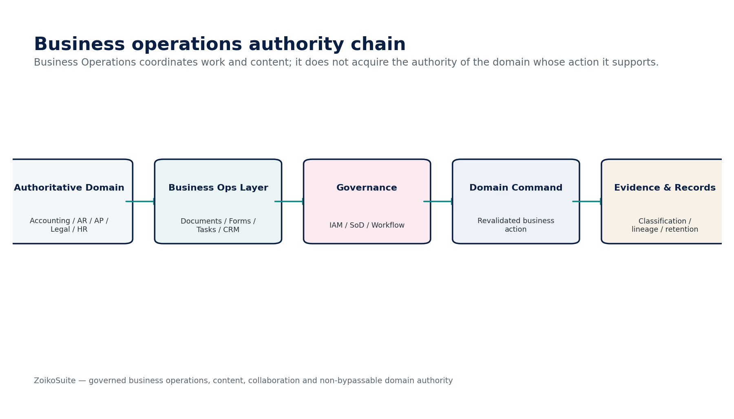
Figure 1 — Business Operations authority chain and target-domain boundary.
Critical decision — Business Operations may originate intent and coordinate work, but every protected consequence is committed only by the authoritative domain that owns the resulting business fact.

1. Domain Scope, Service Inventory & Authority Model
ID | Service | Authoritative role
BIZ-01 | Document Management | Own governed document binaries, versions, metadata, source provenance and secure retrieval across domains.
BIZ-02 | Record Classification | Own record/sensitivity/purpose classification assignments and their policy-resolution evidence; defer retention/disposition to Data Governance.
BIZ-03 | Template | Own approved document/form/message template versions, variables, locale/accessibility metadata and publication lifecycle.
BIZ-04 | Form Definition & Submission | Own form definitions and immutable submissions; produce validated candidate inputs for target domains.
BIZ-05 | Task / Case Management | Own operational work items/cases, assignment, SLA, evidence, escalation and completion state around linked business objects.
BIZ-06 | CRM / Relationship | Own prospect/account relationship context, activities, opportunities and interaction history separate from financial truth.
BIZ-07 | Product & Service Catalog | Own tenant/business offering identity, operational attributes, variants, units and versioned descriptive metadata.
BIZ-08 | Business Deadline | Own generic operational deadline instances and escalation evidence for non-tax/non-legal business obligations.
BIZ-09 | Comments & Collaboration | Own attributable contextual discussions, mentions, reactions, attachments and moderation history.
BIZ-10 | Notification | Own notification requests, template/render version, channel attempts and delivery outcomes without becoming business-outcome authority.

1.1 Non-bypassable Business Operations invariants
- No BIZ service SHALL directly post journals, release payments, determine tax, grant IAM privilege, alter payroll results or rewrite authoritative domain facts.
- Every object SHALL be tenant scoped and, where applicable, entity/purpose scoped; cross-tenant access SHALL fail even if the object identifier is known.
- Document binaries and versions SHALL retain digest/hash, source/provenance, creator/uploader and classification metadata.
- Declared records SHALL NOT be destructively overwritten; new content SHALL create a new version or superseding record as appropriate.
- Record classification SHALL be versioned and auditable; automatic classification below configured confidence SHALL require review or remain candidate state.
- Classification SHALL NOT itself create authorization; IAM/purpose controls remain independently evaluated.
- Template publication SHALL require versioned approval; generated artifacts SHALL retain the exact template version and input-data provenance.
- Form submissions SHALL be immutable after submission except through controlled correction/supersession; protected domain changes SHALL use target-domain commands.
- Task completion SHALL NOT automatically imply target-domain approval/settlement/close unless an explicit governed target-domain command succeeds.
- Case/task assignments SHALL respect authorization, SoD and sensitive-case purpose restrictions.
- CRM relationships SHALL link to canonical ORG parties and SHALL NOT create duplicate uncontrolled person/company identities.
- CRM pipeline/value data SHALL be labeled as operational/commercial context and SHALL NOT be represented as certified revenue or receivables.
- Product/service offering versions used by transactions SHALL be pinned; later catalog edits SHALL NOT rewrite historical transaction meaning.
- BIZ-08 SHALL NOT calculate statutory/legal deadlines independently when TAX/LEG is authoritative; mirrored deadlines SHALL retain source reference/version.
- Comments, mentions and collaboration attachments SHALL preserve edit/delete/moderation history and classification inheritance.
- Notification delivery success SHALL NOT mark the underlying business obligation complete.
- Notification retries SHALL be idempotent per recipient/channel/message subject and SHALL prevent accidental duplicate high-risk communications.
- Global search/AI indexing SHALL enforce classification, purpose, residency, retention and legal-hold constraints inherited from source content.
- Ordinary delete SHALL NOT destroy content protected by retention/legal hold or required evidence policies.
- External provider callbacks for notification/file delivery SHALL be authenticated/deduplicated when they influence delivery state.
- Business deadlines SHALL preserve timezone, business-calendar and source-trigger provenance.
- User-visible templates/forms/notifications SHALL meet configured accessibility/localization requirements before publication.
- Analytics or AI may summarize/route/classify BIZ objects but SHALL NOT invent authoritative business status or protected actions.
- All material business-ops actions SHALL emit attributable events/evidence linked to the originating source and resulting target-domain action where applicable.
- Every service SHALL expose stable failure semantics; ambiguous external outcomes SHALL remain Pending/Unknown rather than being guessed.
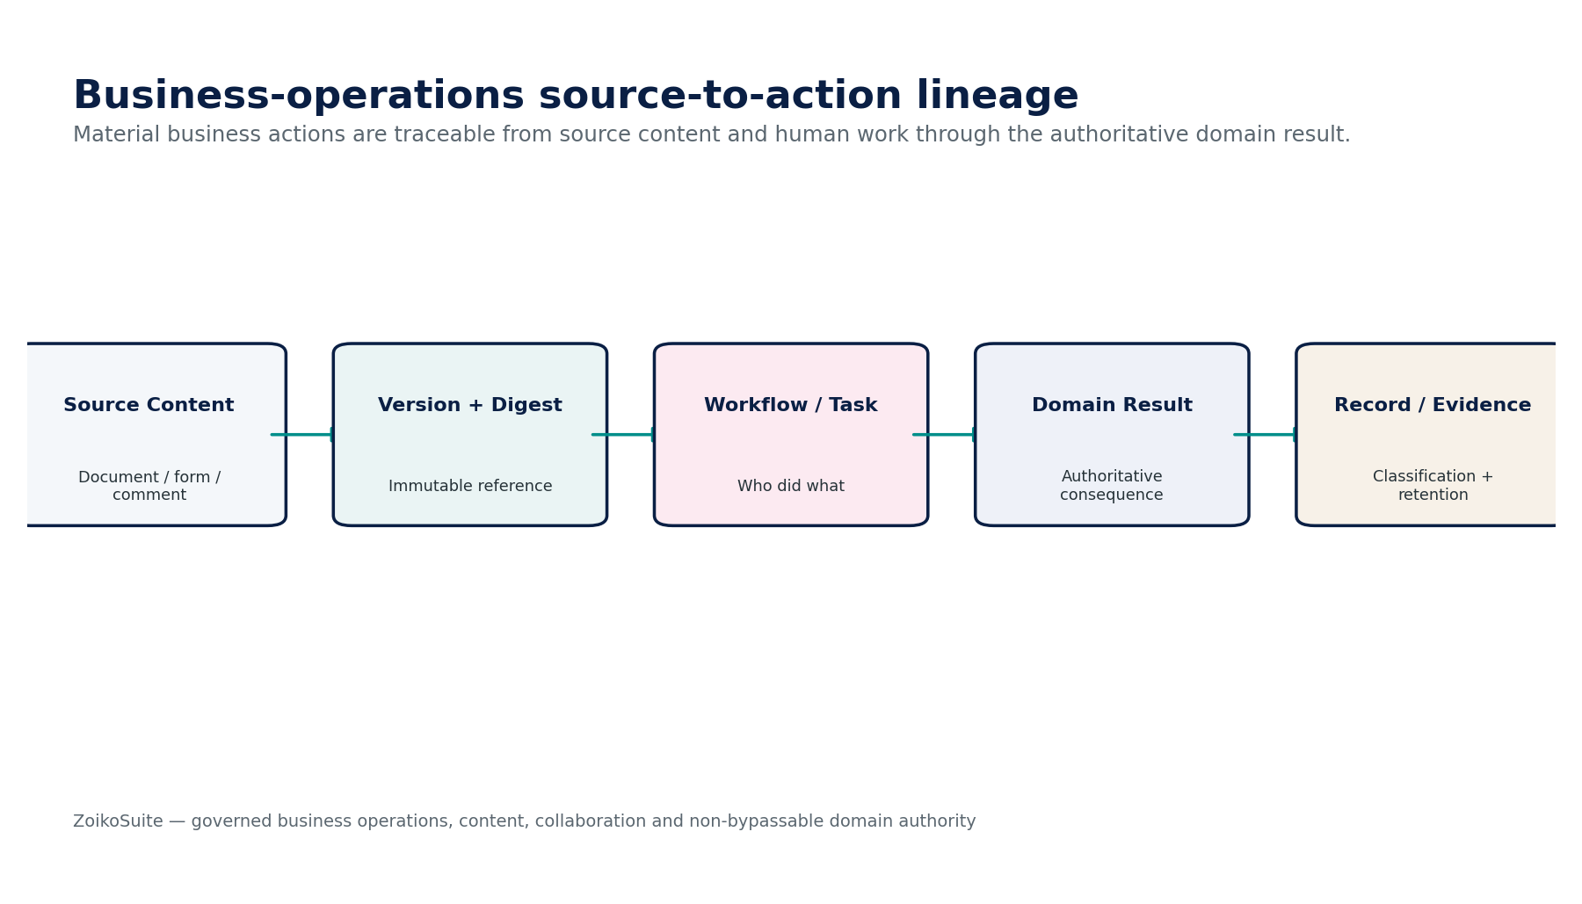
Figure 2 — Business-operations source-to-action evidence lineage.

1.2 Cross-domain authority matrix
Authority | Owns | BIZ boundary
ORG-01/03/07 | Identity, legal entity and party | BIZ links canonical identities; CRM/documents/forms do not create duplicate identity masters.
GOV-03/04/06 | Authorization, SoD and workflow | BIZ respects these controls; task/case status cannot substitute for protected approval.
DATA-GOV | Retention, legal hold and disposition | BIZ-02 supplies classification; governance engine decides retention/hold/disposition.
AR/AP/ACC/BNK/TAX/WFP | Financial/regulatory truth | Forms/tasks/CRM may originate intent; target domain remains authoritative.
LEG | Legal instruments/deadlines | BIZ-08 may mirror deadlines; LEG remains authoritative for legal obligations and legal effect.
COM-01 | ZoikoSuite SaaS product/price book | BIZ-07 does not own ZoikoSuite commercial plans/prices/entitlements.
DATA/AI | Search, analytics, RAG | May index/derive within inherited authorization/classification; cannot override BIZ/source authority.
INT | Providers/webhooks/files | Transports and evidences delivery; BIZ owns canonical content/task/notification semantics.

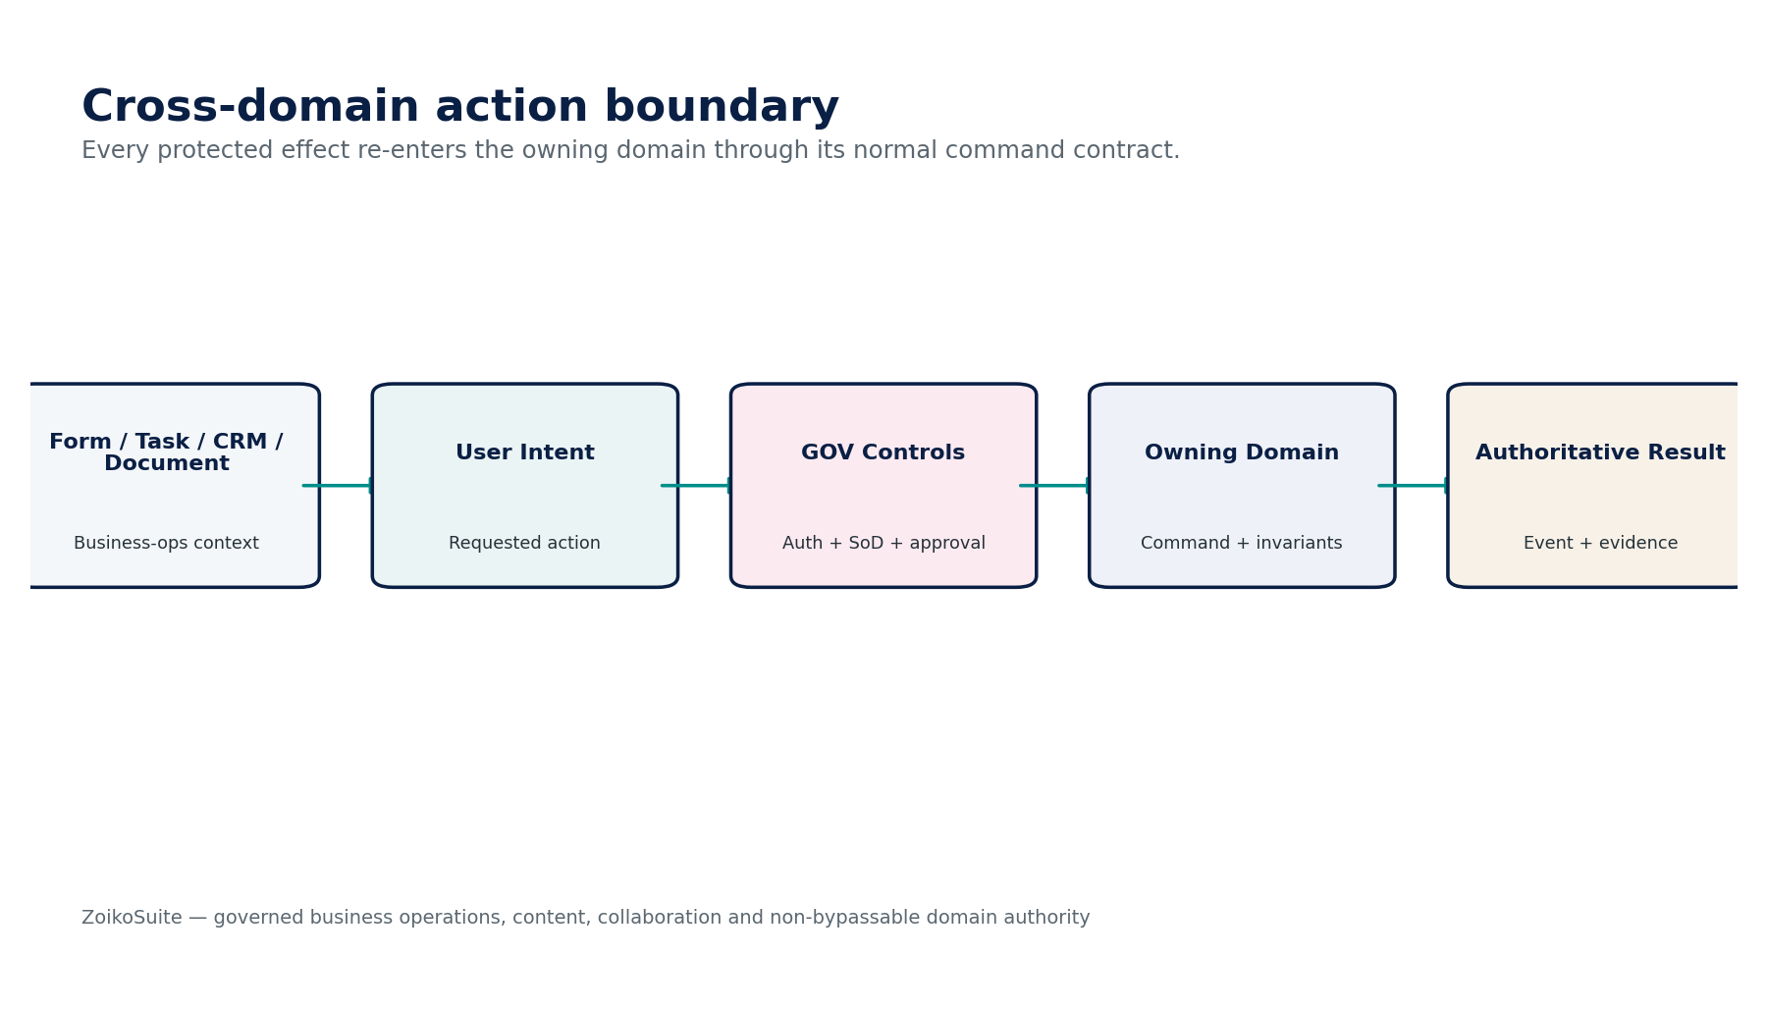
Figure 3 — Protected cross-domain action boundary.

2. Shared Business Operations Contract, Context & State Architecture

2.1 Trusted command context
Field | Engineering requirement
tenant_id | GOV-01 resolved; never trusted from unverified client context.
legal_entity_id | Server-resolved where the content/work object is entity scoped.
actor_subject | Authenticated human/workload identity with role, delegation and device/session assurance.
purpose | Approved business purpose for sensitive content/case/CRM access.
linked_object | Canonical target-domain object type/ID plus relationship role.
expected_version | Optimistic concurrency guard for material mutable objects.
idempotency_key | Required for submissions, task completion, notifications and external delivery attempts.
classification_context | Record/sensitivity/purpose class plus inherited source restrictions.
residency_context | Storage/index/provider region and permitted cross-border path.
evidence_context | Source, file digest, template/form version, workflow/task IDs and downstream result references.

2.2 Shared lifecycle dimensions
Dimension | States
Document | Draft / Active / Superseded / Declared Record / Archived / Disposed
Classification | Unclassified / Candidate / Confirmed / Superseded / Restricted
Template | Draft / Review / Approved / Published / Retired / Superseded
Form submission | Draft / Submitted / Validating / Accepted / Rejected / Superseded
Task/case | New / Assigned / In Progress / Blocked / Escalated / Completed / Cancelled / Closed
CRM | Prospect / Active Relationship / Dormant / Closed; opportunity stage separately versioned
Catalog | Draft / Approved / Active / Suspended / Retired / Superseded
Deadline | Scheduled / Upcoming / Due / Overdue / Completed / Waived / Cancelled / Superseded
Notification | Queued / Sending / Sent / Delivered / Failed / Pending-Unknown / Suppressed
Attention | Normal / Watch / Due Soon / Overdue / Blocked / Critical

Design rule — one overloaded status field is prohibited. Document lifecycle, record declaration, task state, target-domain outcome, notification delivery and deadline state evolve independently.

2.3 Shared commands and stable errors
Command family | Contract
Create / Upload / Revise | Create governed content/work candidate; preserve provenance and versioning.
Submit / Complete / Approve | Apply server validation and GOV controls; no target-domain effect unless an explicit target command succeeds.
Classify / Reclassify | Record policy decision with source, confidence/reviewer and version.
Publish / Retire | Make approved template/catalog artifact active or retire through supersession.
Assign / Escalate / Close | Operational work management with SLA/evidence; separate from linked domain state.
SendNotification | Create durable recipient/channel attempt with idempotency and template version.
Archive / Dispose | Delegate final disposition decision to Data Governance; ordinary delete prohibited where protected.

Error | Meaning
BIZ_CONTEXT_MISSING | Required tenant/entity/purpose/linked-object context unavailable.
CLASSIFICATION_REQUIRED | Required record/sensitivity classification unresolved.
PROTECTED_CONTENT_CHANGED | Approved template/form/document subject changed; reapproval required.
TARGET_DOMAIN_REJECTED | Downstream authoritative command rejected; BIZ state cannot pretend success.
RETENTION_HOLD_BLOCK | Delete/disposition blocked by policy or legal hold.
ACCESS_PURPOSE_DENIED | Actor is authenticated but purpose/scope/classification denies access.
DUPLICATE_SUBMISSION | Idempotent submission/message already accepted.
DEADLINE_SOURCE_CONFLICT | Mirrored deadline conflicts with authoritative TAX/LEG/business source.
DELIVERY_OUTCOME_UNKNOWN | Provider state ambiguous; original notification attempt must be resolved.
CATALOG_VERSION_INVALID | Offering version missing, inactive or incompatible with requested use.

3. BIZ-01 — Document Management
Contract field | Build-ready requirement
Authoritative ownership | Own governed document binaries, metadata, versions, digests, source links and retrieval state; does not own business facts represented inside documents.
Required inputs | User/domain upload; linked business object; file metadata; classification context; source/provenance; retention context.
Commands | UploadDocument; CreateVersion; DeclareRecord; SupersedeDocument; MoveToArchive; RequestDisposition.
Queries | GetDocument; GetVersion; ListVersions; VerifyDigest; GetLinkedObjects; GetAsOfDocument.
Lifecycle/state | Draft/Active → Superseded/Declared Record → Archived/Disposed; record declaration tracked separately.
Authorization / SoD | Document owner/uploader plus authorized domain users; sensitive records require purpose/classification checks; no destructive delete under hold/retention.
Events | DocumentUploaded; DocumentVersionCreated; RecordDeclared; DocumentSuperseded; DocumentArchived.
Dependencies | DATA-GOV, GOV-03/10, SEC, DATA-06 search, INT file exchange.
Failure / degradation | Malware/type/hash failure quarantines upload; provider/object-store uncertainty never produces a phantom successful version.
Evidence / lineage | Binary hash, uploader/source, metadata, linked object, classification, version chain, access history and retention/hold status.

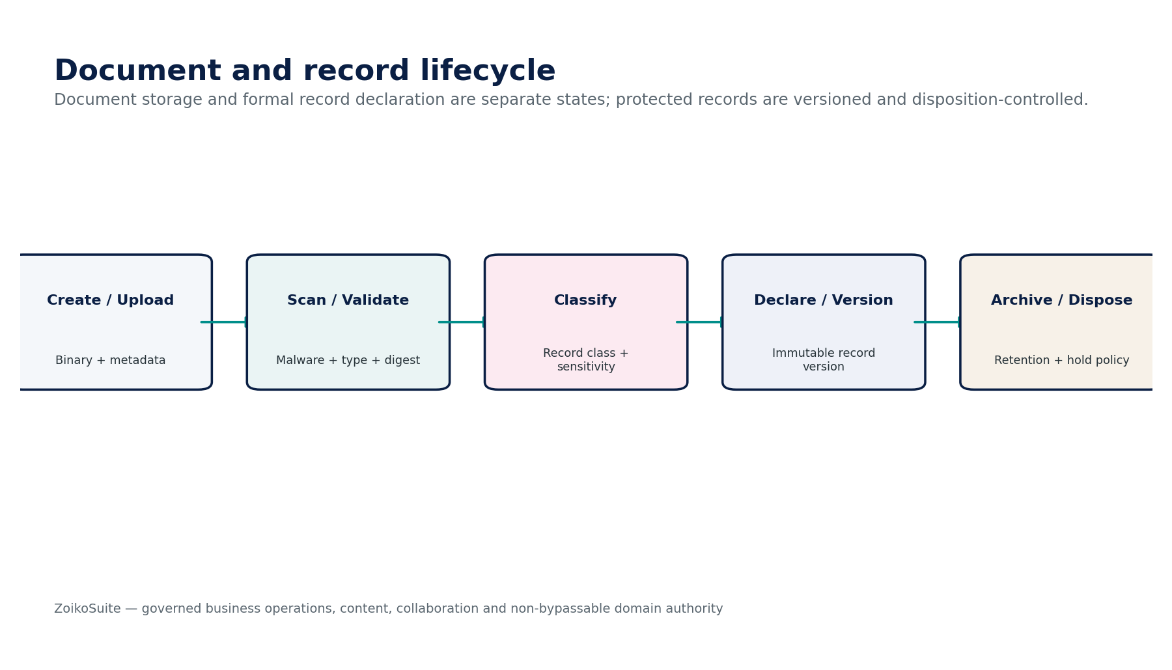
Figure 4 — Document Management engineering control flow.
Implementation gate — BIZ-01 must pass its authority-boundary, tenant isolation, classification/retention, negative-path and evidence-lineage tests before production certification.

4. BIZ-02 — Record Classification
Contract field | Build-ready requirement
Authoritative ownership | Own classification decisions and history for record class, sensitivity, purpose/use and downstream policy attributes; does not grant access itself.
Required inputs | Document/object metadata; source domain; content signals; jurisdiction/entity; human or AI candidate classification.
Commands | ClassifyRecord; ConfirmClassification; Reclassify; SupersedeClassification; BulkClassify.
Queries | GetClassification; GetAsOfClassification; ExplainPolicyMapping; ListUnclassified; ListClassificationHistory.
Lifecycle/state | Unclassified → Candidate → Confirmed → Superseded/Restricted.
Authorization / SoD | Records/Data Steward; automated classification only within confidence policy; security/privacy owner for restricted classes.
Events | ClassificationProposed; ClassificationConfirmed; RecordReclassified; ClassificationSuperseded.
Dependencies | DATA-GOV retention engine, GOV-03, SEC, AI-02 classification.
Failure / degradation | Low-confidence/ambiguous result stays candidate; policy engine failure blocks protected downstream actions rather than defaulting to public/internal.
Evidence / lineage | Classifier/reviewer, confidence, rule/model version, source evidence, effective dates and downstream policy decision IDs.

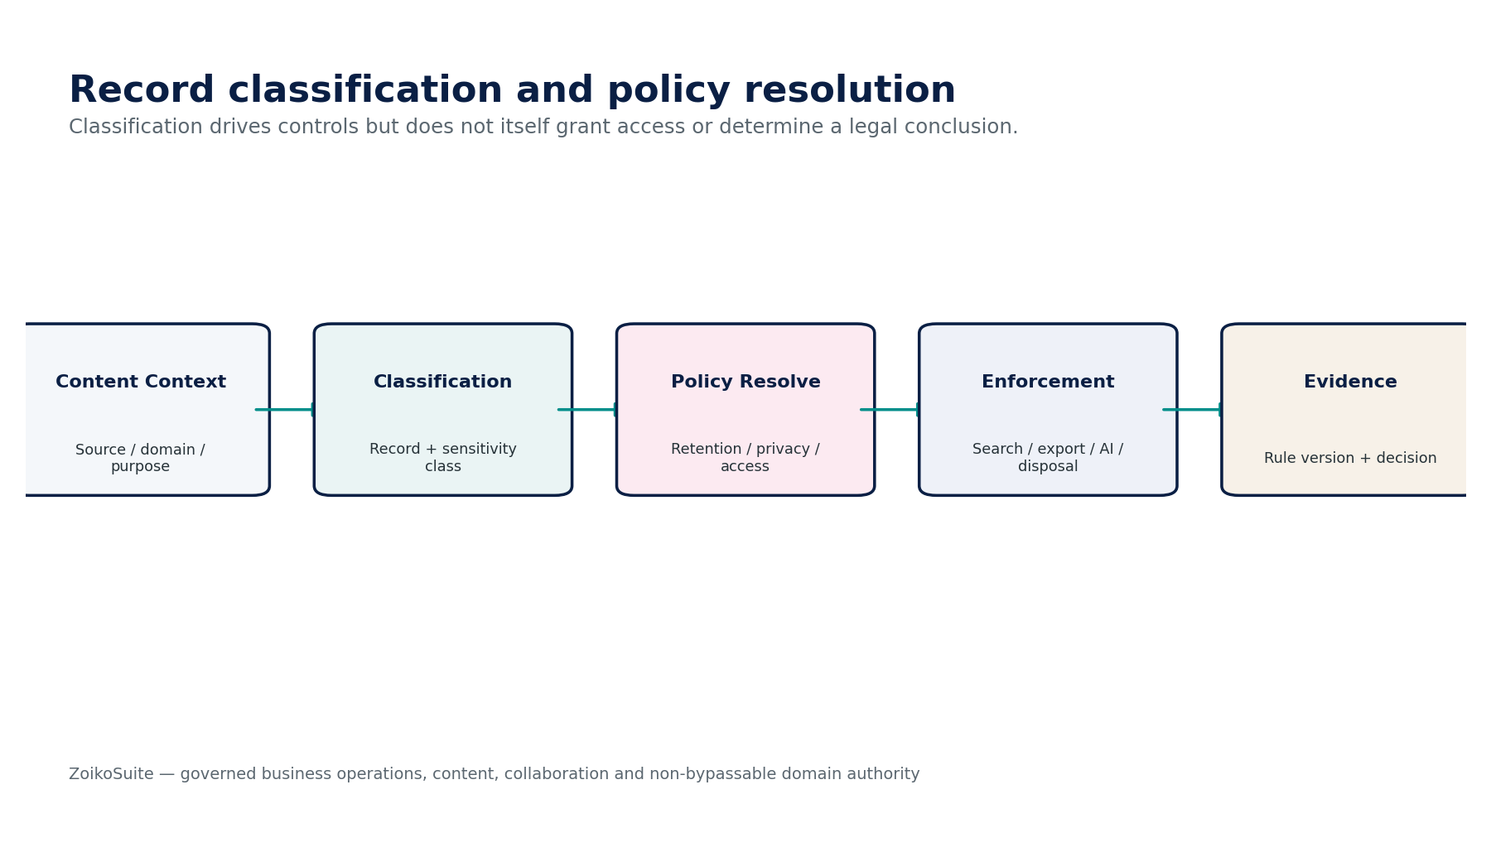
Figure 5 — Record Classification engineering control flow.
Implementation gate — BIZ-02 must pass its authority-boundary, tenant isolation, classification/retention, negative-path and evidence-lineage tests before production certification.

5. BIZ-03 — Template
Contract field | Build-ready requirement
Authoritative ownership | Own approved template definitions/versions for documents, forms and notifications, including variables, locale, branding/accessibility metadata and publication lifecycle.
Required inputs | Template content; variable schema; business purpose; locale; owner; accessibility requirements; approval policy.
Commands | CreateTemplate; CreateVersion; ValidateTemplate; ApproveTemplate; PublishTemplate; RetireTemplate.
Queries | GetTemplate; GetPublishedVersion; RenderPreview; CompareVersions; ListLocales.
Lifecycle/state | Draft → Review → Approved → Published → Retired/Superseded.
Authorization / SoD | Content owner + policy/domain approver; maker-checker for externally binding/regulatory templates.
Events | TemplateCreated; TemplateVersionApproved; TemplatePublished; TemplateRetired.
Dependencies | GOV-06, BIZ-04/BIZ-10, LEG/TAX/REP where specialized templates apply.
Failure / degradation | Missing variable schema, inaccessible critical template or protected text change after approval blocks publication.
Evidence / lineage | Content hash, variables/schema, locale, approval, accessibility result, publication dates and generated-artifact references.

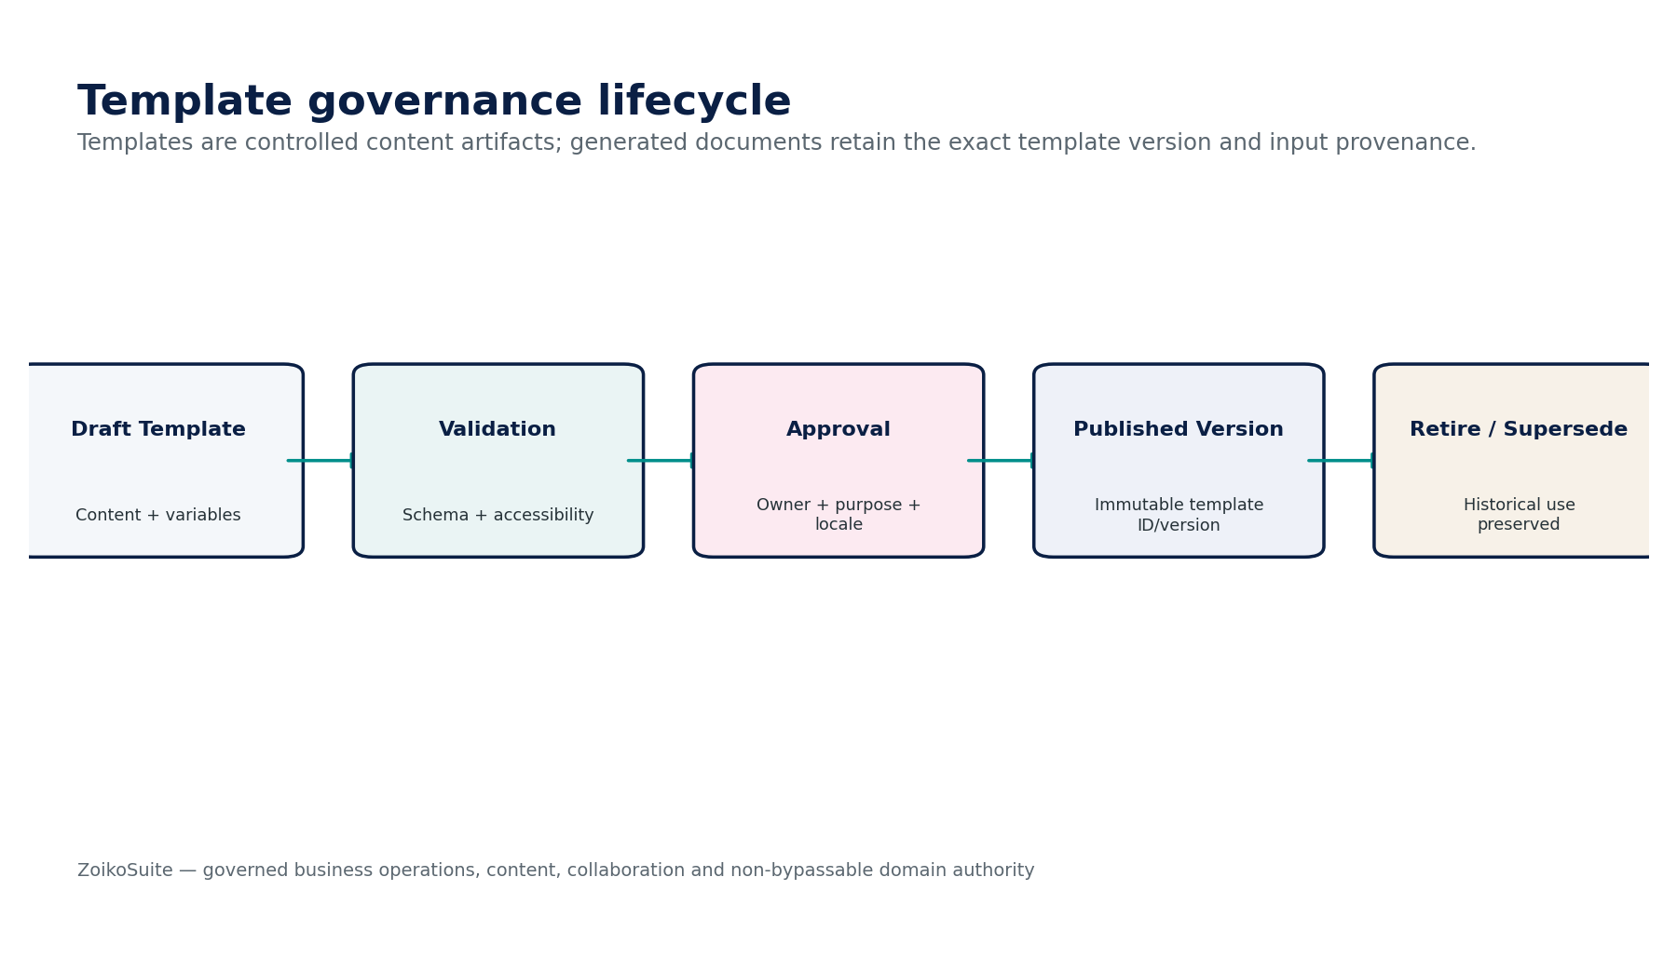
Figure 6 — Template engineering control flow.
Implementation gate — BIZ-03 must pass its authority-boundary, tenant isolation, classification/retention, negative-path and evidence-lineage tests before production certification.

6. BIZ-04 — Form Definition & Submission
Contract field | Build-ready requirement
Authoritative ownership | Own structured form definitions and immutable submissions; produce validated candidate business inputs for target-domain commands.
Required inputs | Form schema; purpose; target-domain mapping; user inputs; attachments; server context; consent/attestation where needed.
Commands | CreateForm; PublishForm; SaveDraft; SubmitForm; ValidateSubmission; SupersedeSubmission; RouteToDomain.
Queries | GetForm; GetSubmission; GetSubmissionVersion; GetValidationResult; ListPendingSubmissions.
Lifecycle/state | Definition: Draft→Published→Retired; Submission: Draft→Submitted→Validating→Accepted/Rejected→Superseded.
Authorization / SoD | Form owner + target-domain mapping approver; submitter cannot self-approve downstream protected action unless domain allows it.
Events | FormPublished; SubmissionReceived; SubmissionValidated; SubmissionRejected; SubmissionRouted.
Dependencies | GOV-03/06, BIZ-01 attachments, target-domain API, DATA/AI extraction optional.
Failure / degradation | Schema validation failure rejects; target-domain rejection leaves submission accepted as evidence but not as successful business action.
Evidence / lineage | Form/version, submitted values, attachments/digests, submitter, timestamps, validation result and downstream command/result IDs.

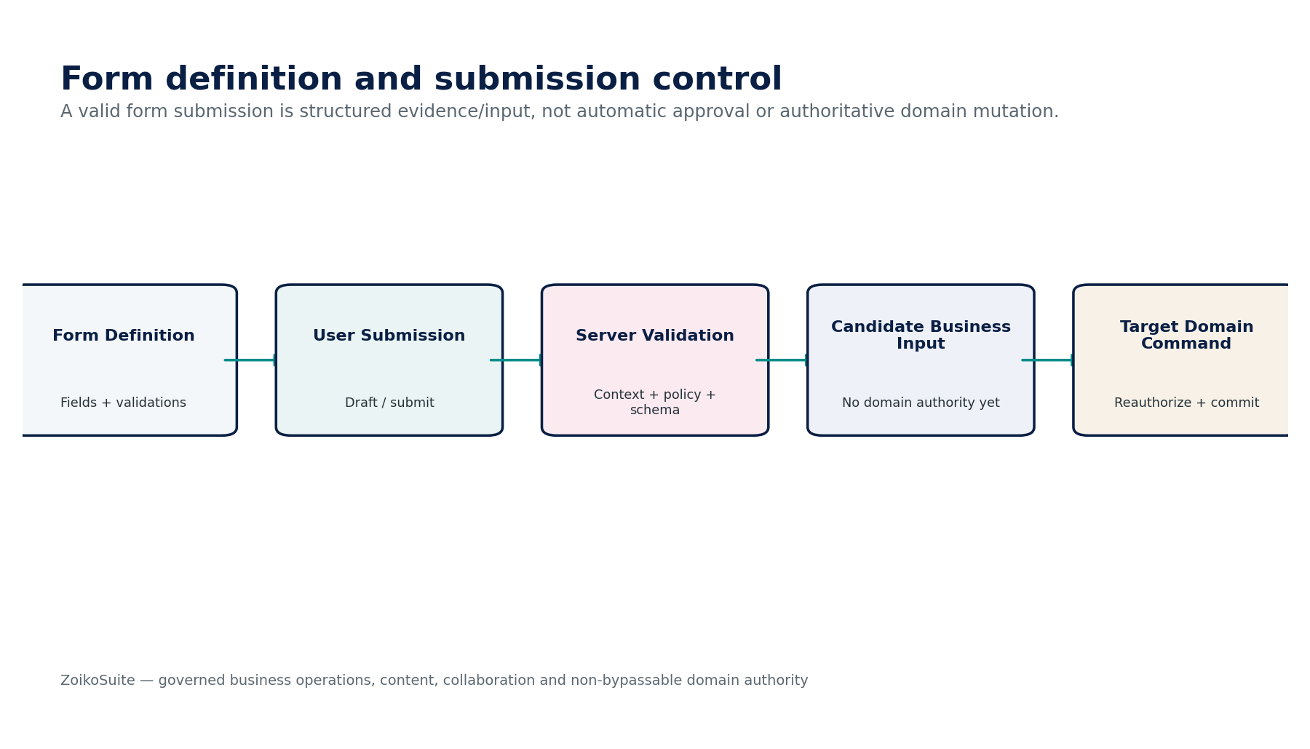
Figure 7 — Form Definition & Submission engineering control flow.
Implementation gate — BIZ-04 must pass its authority-boundary, tenant isolation, classification/retention, negative-path and evidence-lineage tests before production certification.

7. BIZ-05 — Task / Case Management
Contract field | Build-ready requirement
Authoritative ownership | Own operational work/case lifecycle, assignment, SLA, linked objects, evidence and escalation; does not own linked business-object state.
Required inputs | Business trigger; linked object; task/case type; priority; assignee/team; SLA/deadline; required evidence/actions.
Commands | CreateTask; Assign; Start; Block; Escalate; Complete; Reopen; CloseCase; Cancel.
Queries | GetTask; ListQueue; GetCase; GetSLAState; GetLinkedObjectStatus; GetHistory.
Lifecycle/state | New → Assigned → In Progress → Blocked/Escalated → Completed → Closed; Reopened as governed transition.
Authorization / SoD | Assignee/team + supervisor; sensitive case purpose restrictions; completion/closure authority configurable.
Events | TaskCreated; TaskAssigned; TaskEscalated; TaskCompleted; CaseClosed; TaskReopened.
Dependencies | GOV-06, BIZ-08 deadlines, BIZ-09 collaboration, target domains, OPS for operational cases.
Failure / degradation | Linked domain failure must be surfaced distinctly from task completion; SLA clock service failure does not silently close/escalate.
Evidence / lineage | Assignment history, SLA clocks, linked objects, actions, evidence attachments, completion criteria and downstream results.

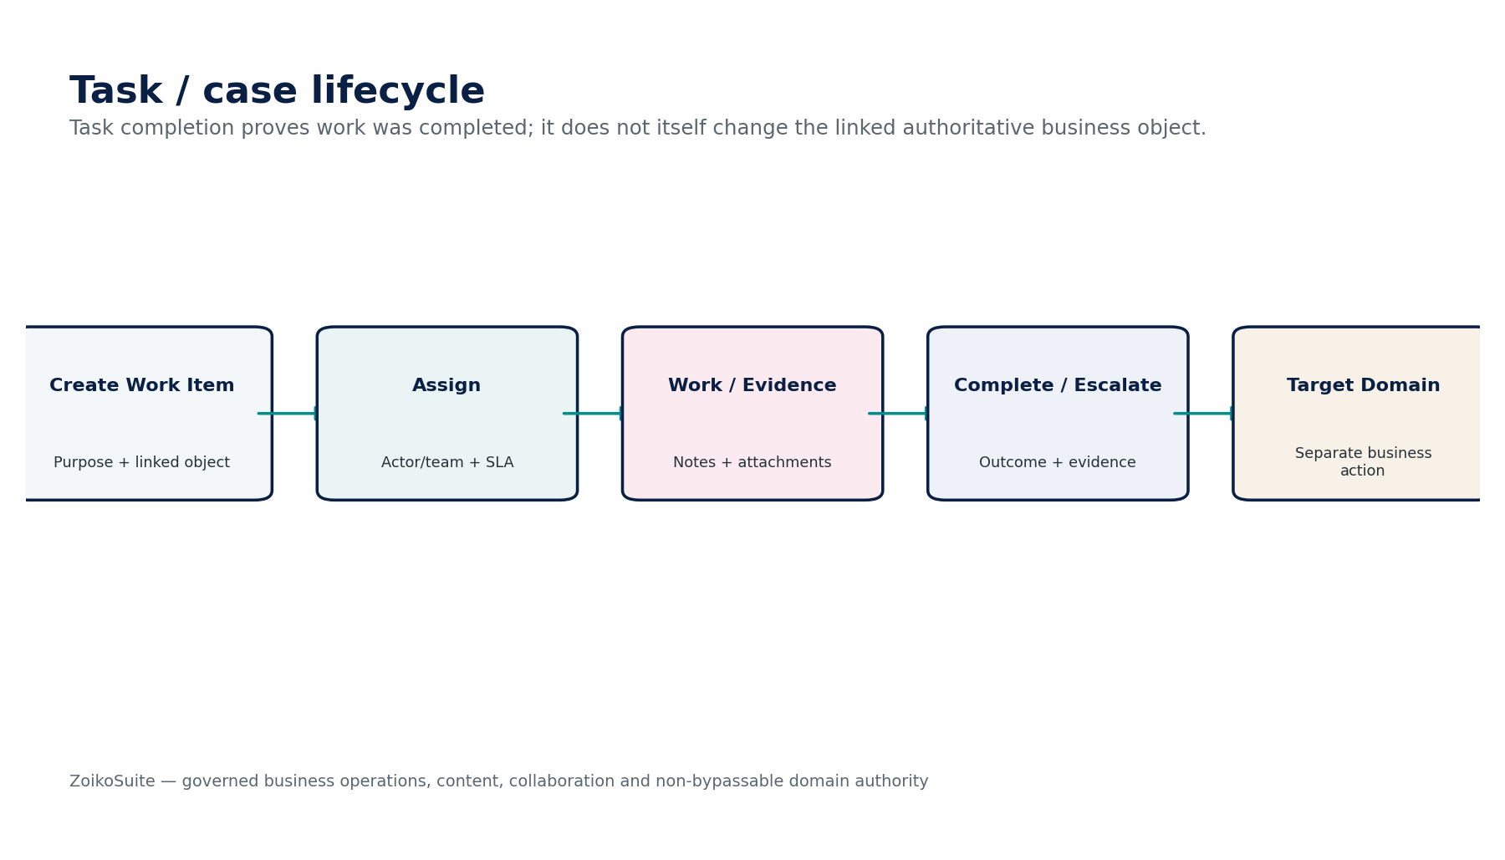
Figure 8 — Task / Case Management engineering control flow.
Implementation gate — BIZ-05 must pass its authority-boundary, tenant isolation, classification/retention, negative-path and evidence-lineage tests before production certification.

8. BIZ-06 — CRM / Relationship
Contract field | Build-ready requirement
Authoritative ownership | Own prospect/customer relationship context, contacts, interactions, opportunities and account activity separate from legal-party identity and financial truth.
Required inputs | ORG party/contact identity; user activity; lead/opportunity data; communication consent; source/channel; linked quotes/contracts/orders.
Commands | CreateRelationship; LogInteraction; CreateOpportunity; UpdateStage; MergeCRMProfile; CloseOpportunity; LinkCommercialObject.
Queries | GetRelationship; GetTimeline; GetOpportunity; ListPipeline; GetConsentContext; GetLinkedFinancialObjects.
Lifecycle/state | Relationship: Prospect→Active→Dormant/Closed; Opportunity stages versioned per approved pipeline.
Authorization / SoD | Sales/service teams within tenant/entity scope; restricted contact/consent data purpose controlled.
Events | RelationshipCreated; InteractionLogged; OpportunityCreated; OpportunityStageChanged; RelationshipClosed.
Dependencies | ORG-07, BIZ-09/10, AR/LEG/COM links, DATA analytics.
Failure / degradation | Duplicate party match remains unresolved candidate until ORG linkage confirmed; opportunity value never feeds certified revenue automatically.
Evidence / lineage | Party link, source, owner, interaction metadata, stage history, consent basis, linked commercial/financial objects.

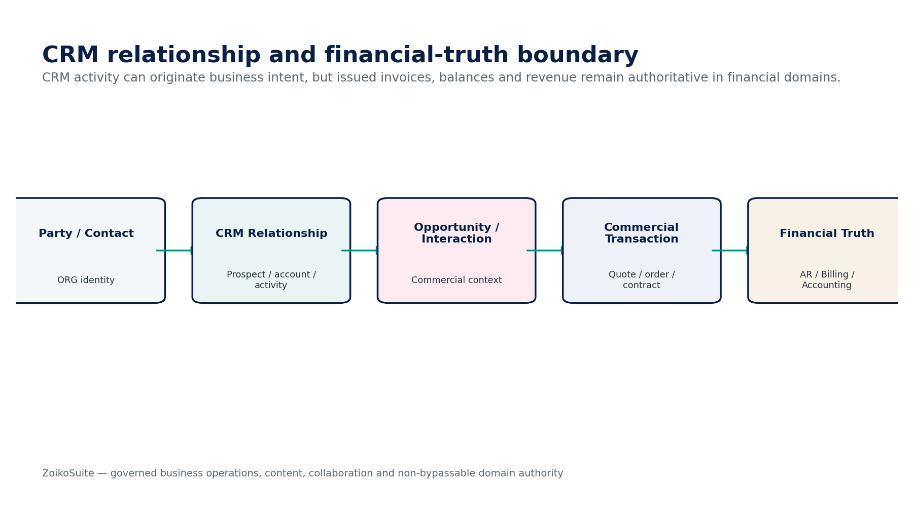
Figure 9 — CRM / Relationship engineering control flow.
Implementation gate — BIZ-06 must pass its authority-boundary, tenant isolation, classification/retention, negative-path and evidence-lineage tests before production certification.

9. BIZ-07 — Product & Service Catalog
Contract field | Build-ready requirement
Authoritative ownership | Own tenant/business offering identity, descriptions, variants, units, eligibility/operational attributes and version lifecycle; not ZoikoSuite SaaS price-book authority.
Required inputs | Offering owner; SKU/service code; category; unit; description; variants; availability rules; linked tax/accounting/product mappings.
Commands | CreateOffering; CreateVersion; ApproveOffering; Activate; Suspend; Retire; LinkMapping.
Queries | GetOffering; GetVersionAsOf; SearchCatalog; ListVariants; GetMappings.
Lifecycle/state | Draft → Approved → Active → Suspended/Retired → Superseded.
Authorization / SoD | Product/business owner + specialist review for tax/accounting/legal mappings; no self-activation when policy requires review.
Events | OfferingCreated; OfferingActivated; OfferingSuspended; OfferingRetired; OfferingVersionSuperseded.
Dependencies | REF-09 units, TAX mapping, ACC mapping, AR/AP transaction domains, COM-01 boundary.
Failure / degradation | Missing required mapping blocks use in protected transaction; historical transactions pin offering version rather than reading latest.
Evidence / lineage | Offering/version ID, owner, attributes, unit, mappings, approvals, effective dates and downstream usage references.

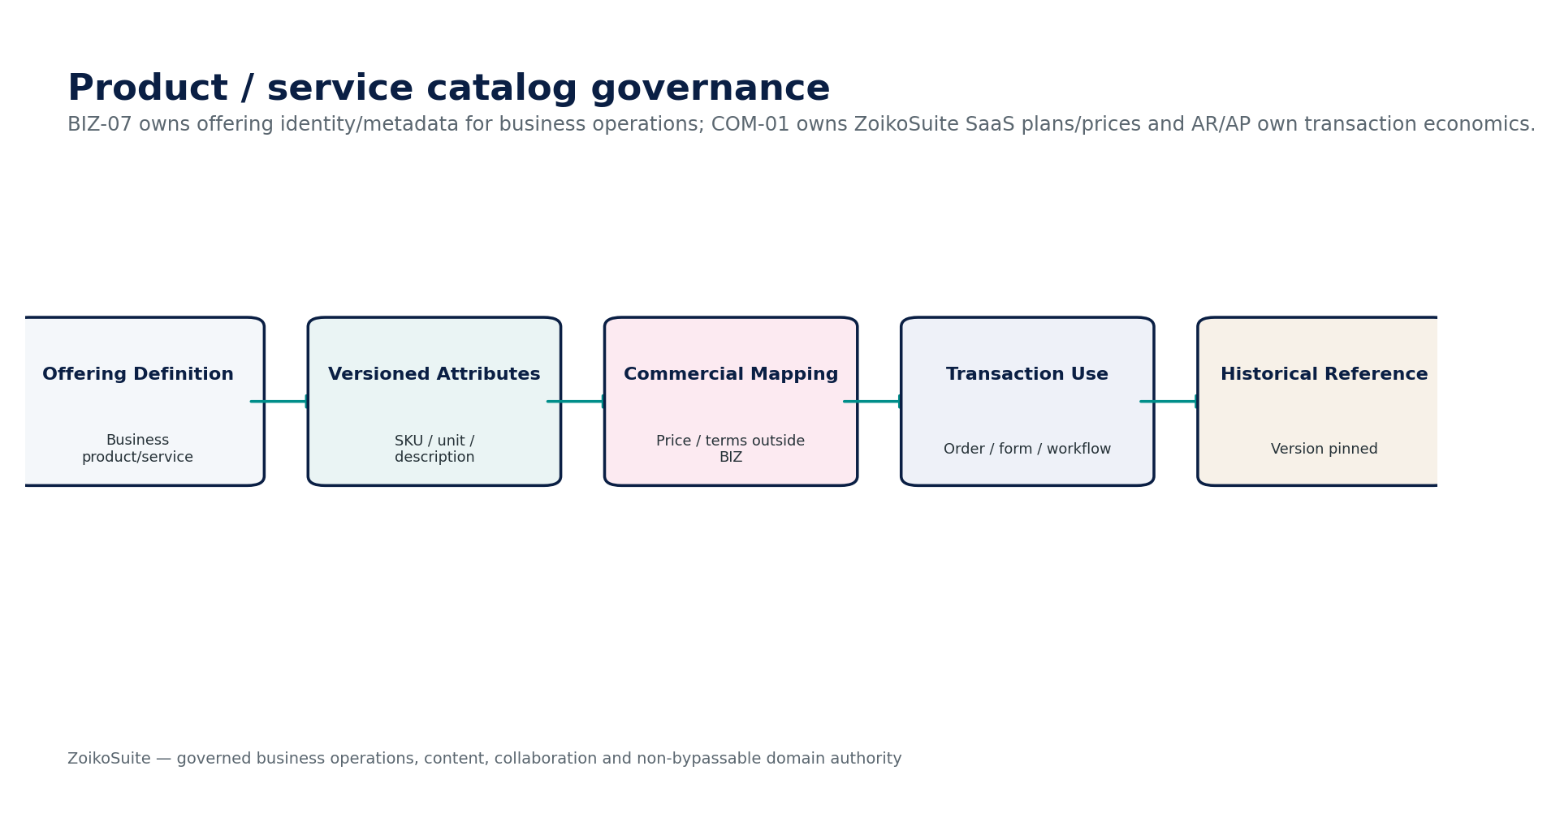
Figure 10 — Product & Service Catalog engineering control flow.
Implementation gate — BIZ-07 must pass its authority-boundary, tenant isolation, classification/retention, negative-path and evidence-lineage tests before production certification.

10. BIZ-08 — Business Deadline
Contract field | Build-ready requirement
Authoritative ownership | Own generic operational deadline instances and escalation state for non-tax/non-legal obligations; may mirror authoritative domain deadlines with source lock.
Required inputs | Source trigger; deadline rule/profile; business calendar; timezone; owner; escalation plan; linked object.
Commands | CreateDeadline; Recalculate; AssignOwner; Complete; Waive; Cancel; Escalate; MirrorAuthoritativeDeadline.
Queries | GetDeadline; ListUpcoming; ListOverdue; ExplainCalculation; GetSourceDeadline.
Lifecycle/state | Scheduled → Upcoming → Due → Overdue → Completed/Waived/Cancelled/Superseded.
Authorization / SoD | Owner + supervisor; manual override requires reason/authority; mirrored statutory/legal dates cannot be silently overridden.
Events | DeadlineCreated; DeadlineDueSoon; DeadlineOverdue; DeadlineCompleted; DeadlineSuperseded.
Dependencies | REF-10 calendar, TAX-12, LEG-12, GOV-05 rules, BIZ-05 tasks, BIZ-10 notification.
Failure / degradation | Timezone/calendar/rule ambiguity blocks certification; authoritative source conflict creates exception rather than overwriting source date.
Evidence / lineage | Source trigger/version, rule, calendar, timezone, due date calculation, overrides, escalation and completion evidence.

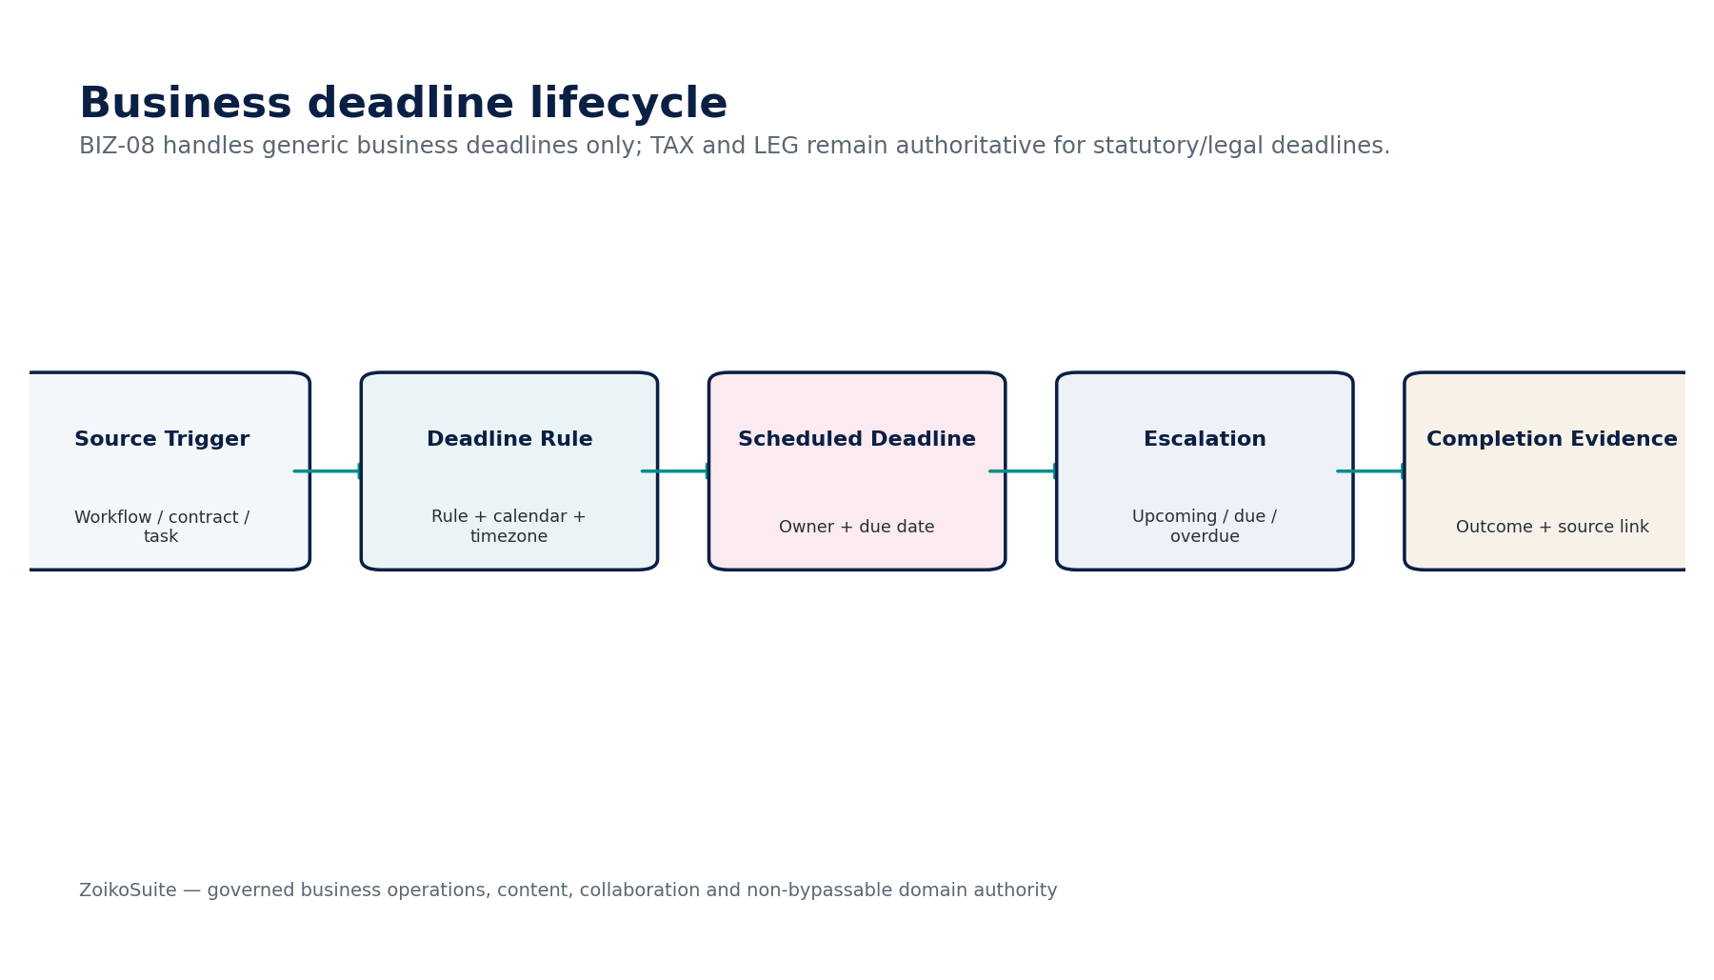
Figure 11 — Business Deadline engineering control flow.
Implementation gate — BIZ-08 must pass its authority-boundary, tenant isolation, classification/retention, negative-path and evidence-lineage tests before production certification.

11. BIZ-09 — Comments & Collaboration
Contract field | Build-ready requirement
Authoritative ownership | Own attributable contextual discussion, mentions, reactions, attachments/links and moderation/edit history linked to authorized business objects.
Required inputs | Authorized object context; actor; message; mentions; attachment/link; classification/purpose; collaboration policy.
Commands | AddComment; EditComment; DeleteComment; Mention; React; Moderate; ResolveThread; AttachReference.
Queries | GetThread; ListComments; GetCommentHistory; GetMentions; GetModerationTrail.
Lifecycle/state | Active / Edited / Resolved / Moderated / Deleted-Redacted; original history preserved per policy.
Authorization / SoD | Authorized participants; moderation separate from business authority; restricted threads require purpose and membership controls.
Events | CommentAdded; CommentEdited; CommentModerated; MentionCreated; ThreadResolved.
Dependencies | BIZ-01, BIZ-10, GOV-03, DATA-GOV, DATA-06 search, AI/RAG.
Failure / degradation | Unauthorized mention must not disclose object existence; delete under hold/retention becomes restricted/redacted treatment, not silent destruction.
Evidence / lineage | Author, timestamps, original/revised content, object link, mentions, attachments, moderation reason and retention status.

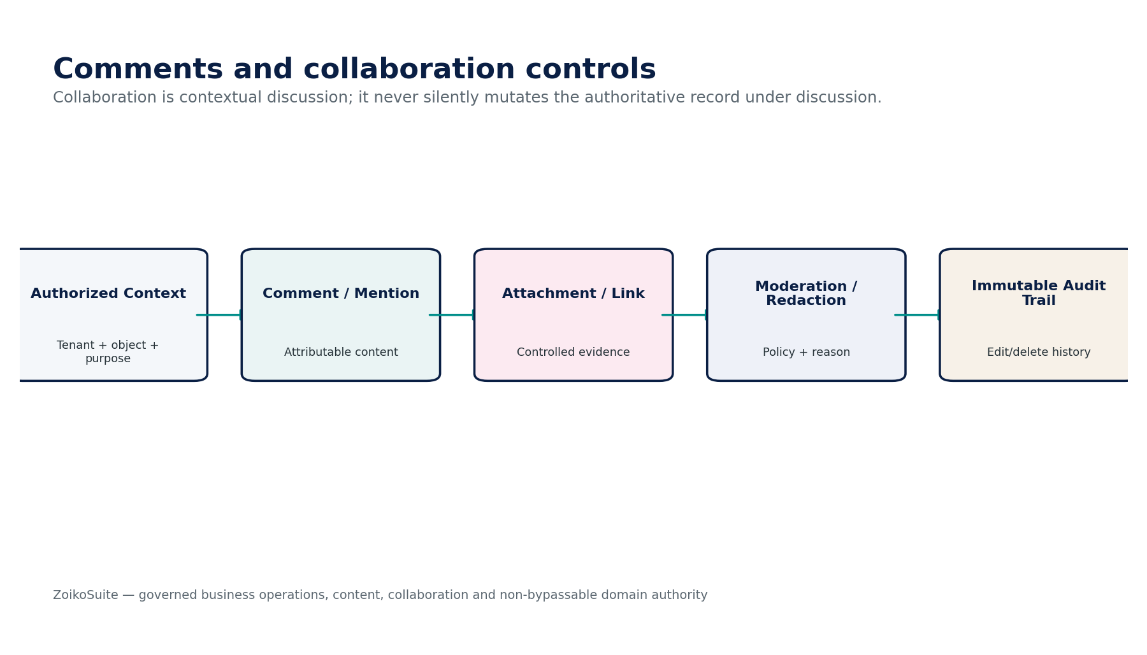
Figure 12 — Comments & Collaboration engineering control flow.
Implementation gate — BIZ-09 must pass its authority-boundary, tenant isolation, classification/retention, negative-path and evidence-lineage tests before production certification.

12. BIZ-10 — Notification
Contract field | Build-ready requirement
Authoritative ownership | Own notification intent, rendered message version, recipient/channel attempts, provider references and delivery outcomes; not underlying obligation state.
Required inputs | Authoritative trigger event; recipient/contact preference; approved template; locale; urgency; channel policy; sensitive-data rules.
Commands | QueueNotification; Render; Send; Retry; Suppress; Cancel; ResolveDeliveryOutcome.
Queries | GetNotification; GetAttempt; GetDeliveryStatus; ListFailures; GetRenderedMessage.
Lifecycle/state | Queued → Sending → Sent → Delivered/Failed/Pending-Unknown/Suppressed/Cancelled.
Authorization / SoD | System/domain producer + notification service; recipient preference and mandatory-notice policy evaluated separately.
Events | NotificationQueued; NotificationSent; NotificationDelivered; NotificationFailed; NotificationOutcomeUnknown.
Dependencies | BIZ-03 templates, ORG contact, INT provider adapter/webhook, GOV/SEC, domain event producers.
Failure / degradation | Provider timeout becomes Pending/Unknown; retries use same message subject/idempotency; no duplicate mandatory notice unless policy authorizes.
Evidence / lineage | Trigger event, recipient/channel, template/version, rendered hash, provider attempt/reference, timestamps and delivery evidence.

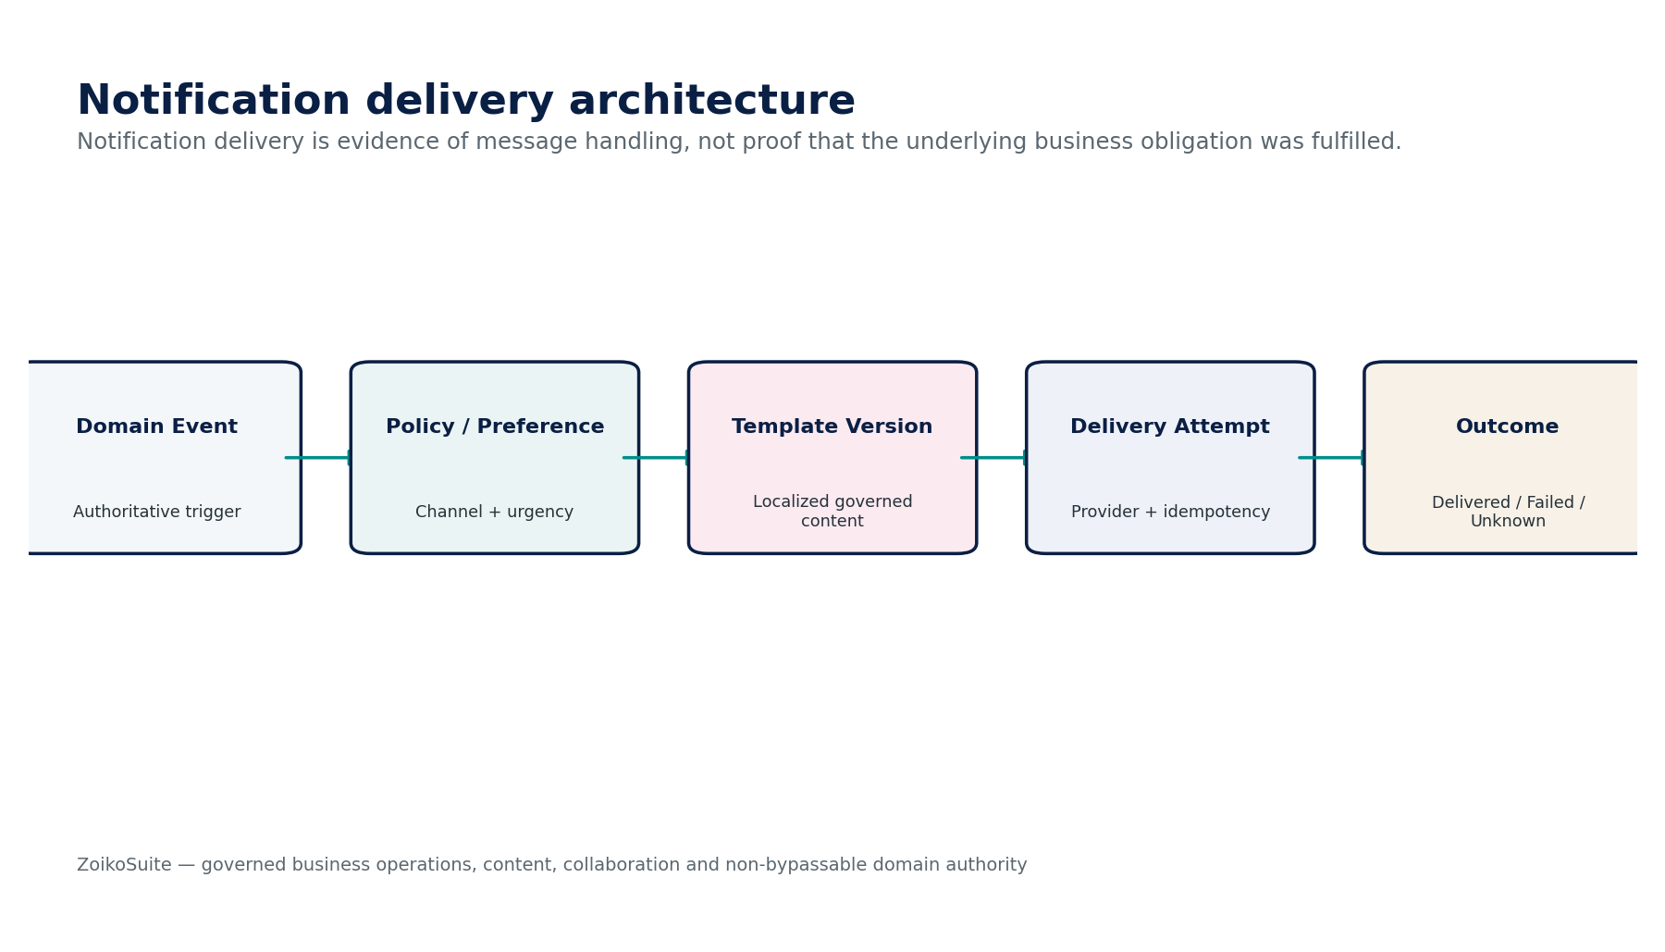
Figure 13 — Notification engineering control flow.
Implementation gate — BIZ-10 must pass its authority-boundary, tenant isolation, classification/retention, negative-path and evidence-lineage tests before production certification.

13. Canonical Data Model & Persistence Boundaries
Entity | Write owner | Boundary
Document | BIZ-01 | Logical document identity; no raw business fact ownership.
DocumentVersion | BIZ-01 | Immutable binary/content version with digest and provenance.
RecordClassification | BIZ-02 | Versioned record/sensitivity/purpose assignment.
TemplateDefinition | BIZ-03 | Template identity, purpose and owner.
TemplateVersion | BIZ-03 | Immutable content/variable schema/locale/accessibility version.
FormDefinition | BIZ-04 | Form identity and target mapping.
FormSubmission | BIZ-04 | Immutable submitted value set + evidence.
Task | BIZ-05 | Operational work item.
Case | BIZ-05 | Container for related tasks/events/evidence.
CRMRelationship | BIZ-06 | Party relationship context.
Opportunity | BIZ-06 | Operational sales/service opportunity, not revenue.
Offering | BIZ-07 | Product/service identity.
OfferingVersion | BIZ-07 | Versioned attributes/mappings.
BusinessDeadline | BIZ-08 | Operational deadline instance.
CommentThread | BIZ-09 | Collaboration context.
CommentVersion | BIZ-09 | Attributable comment revision history.
Notification | BIZ-10 | Message intent and rendered subject.
NotificationAttempt | BIZ-10 | Channel/provider delivery attempt.
LinkedObjectReference | Shared | Typed canonical link to authoritative domain object.
BusinessOpsEvidence | Shared | Cross-service evidence/lineage reference.

13.1 Persistence rules
- Binary storage, search indexes, caches and analytical projections are not independent systems of record.
- Every document/form/comment/notification derivative must retain source/tenant/classification lineage sufficient for policy convergence.
- Historical versions required for evidence may be immutable even when current-state metadata remains mutable through versioned transitions.
- Cross-domain links use typed IDs and cannot be inferred from free-text identifiers.
- Search/vector indexes must support policy-driven removal/restriction when classification, retention or legal-hold state changes.

14. API, Events, Idempotency & Integration Contract
Surface | Contract
POST /biz/documents | Create/upload document under verified context.
POST /biz/forms/{id}:submit | Create immutable form submission; idempotent.
POST /biz/tasks/{id}:complete | Complete operational work only; downstream action separately referenced.
POST /biz/notifications:send | Create durable notification request and channel attempts.
GET /biz/*?as_of= | Historical reconstruction for governed objects where supported.
GET /biz/deadlines:explain | Return source/rule/calendar/timezone evidence for computed due date.

Event | Meaning
biz.document.version_created | Document version committed.
biz.classification.confirmed | Classification decision effective.
biz.template.published | Approved template version published.
biz.form.submission_received | Immutable submission committed.
biz.task.completed | Operational work completed.
biz.crm.opportunity_stage_changed | CRM pipeline context changed.
biz.catalog.offering_activated | Offering version became active.
biz.deadline.overdue | Operational deadline overdue.
biz.comment.added | Authorized collaboration content added.
biz.notification.delivered | Provider delivery evidence resolved.

14.1 Idempotency classes
Class | Requirement
I0 | Read-only queries; repeatable without side effect.
I1 | Draft/metadata operations; retry safe through object/version key.
I2 | Submission/task/deadline state commands; explicit idempotency key + expected version.
I3 | Notification/provider delivery attempt; durable attempt created before external send.
I4 | Cross-domain protected action; BIZ request plus target-domain idempotency independently enforced.

15. Security, Privacy, Search, Retention & AI Boundaries
Control area | Requirement
Authorization | Object-level + field-level + purpose checks; search/result counts must not reveal unauthorized object existence.
Classification | BIZ-02 decision feeds security/privacy/retention; it never replaces IAM.
Files | Malware/content-type validation, digesting, quarantine, size limits, safe preview.
PII | Contact/CRM/form data minimized and purpose-bound; export/download governed.
Search | Index only policy-permitted fields; authorization before retrieval; cache keys tenant/classification safe.
AI/RAG | Candidate extraction/classification/summarization only; citations to source; no protected tool bypass.
Retention | DATA-GOV resolves retain/restrict/anonymize/archive/dispose; BIZ executes only authorized disposition.
Legal hold | Suspends disposition across documents, submissions, comments and derivatives without expanding access.
Residency | Documents, search, analytics, notification providers and backups honor residency policy.
Notification privacy | Sensitive fields excluded from insecure channels unless policy explicitly permits and content is minimized.

16. Canonical Business Operations Control Catalogue
Control ID | Mandatory control
BIZ-CTRL-001 | Document digest/provenance required before active version.
BIZ-CTRL-002 | Declared record cannot be destructively overwritten.
BIZ-CTRL-003 | Classification required for protected content before broad indexing/export.
BIZ-CTRL-004 | Low-confidence automated classification requires configured review.
BIZ-CTRL-005 | Template protected-field change invalidates approval.
BIZ-CTRL-006 | Published template version immutable.
BIZ-CTRL-007 | Form submission immutable after submit except supersession.
BIZ-CTRL-008 | Target-domain protected action must reauthorize independently.
BIZ-CTRL-009 | Task completion cannot impersonate domain completion.
BIZ-CTRL-010 | Case closure blocked by configured unresolved mandatory tasks.
BIZ-CTRL-011 | CRM party link must resolve to canonical ORG identity.
BIZ-CTRL-012 | CRM values labeled non-certified and excluded from statutory actuals.
BIZ-CTRL-013 | Catalog transaction usage pins offering version.
BIZ-CTRL-014 | Required catalog mapping missing blocks protected transaction.
BIZ-CTRL-015 | Business deadline stores rule/calendar/timezone/source provenance.
BIZ-CTRL-016 | Mirrored TAX/LEG deadline conflict creates exception.
BIZ-CTRL-017 | Comment edit/delete history preserved.
BIZ-CTRL-018 | Unauthorized mention cannot disclose object existence.
BIZ-CTRL-019 | Notification uses approved template/version and recipient policy.
BIZ-CTRL-020 | Notification provider timeout becomes Pending/Unknown.
BIZ-CTRL-021 | Notification retry is idempotent by message subject/recipient/channel.
BIZ-CTRL-022 | Delivery success does not complete underlying obligation.
BIZ-CTRL-023 | Search and AI respect source authorization/classification.
BIZ-CTRL-024 | Disposition blocked by retention/legal hold.
BIZ-CTRL-025 | Cross-tenant object IDs always denied.
BIZ-CTRL-026 | Attachment/file upload passes malware/type/size validation.
BIZ-CTRL-027 | Cross-domain link uses typed canonical ID.
BIZ-CTRL-028 | Provider callbacks authenticated/deduplicated where state-impacting.
BIZ-CTRL-029 | Sensitive notification channels receive minimized content.
BIZ-CTRL-030 | Bulk operations preserve per-item result/evidence; partial failure cannot return false success.
BIZ-CTRL-031 | As-of reconstruction available for protected versions/classifications.
BIZ-CTRL-032 | Collaboration content inherits linked-object classification unless stricter.
BIZ-CTRL-033 | Notification/template localization version pinned.
BIZ-CTRL-034 | Accessible user-facing forms/templates required before publication under configured policy.
BIZ-CTRL-035 | AI candidate cannot become authoritative business status without domain validation.
BIZ-CTRL-036 | Every material BIZ command emits attributable event/evidence.

17. Negative-Path Engineering Certification Scenarios
Test | Negative path | Expected control outcome
T01 | Cross-tenant document ID guessed | Deny without confirming existence.
T02 | Uploaded file hash changes after record declaration | Reject/tamper alert.
T03 | Malware scan unavailable | Quarantine; do not activate.
T04 | Declared record edited in place | Block; require new version/supersession.
T05 | AI classification confidence below threshold | Remain Candidate; no automatic restricted/public conclusion.
T06 | Classification changed to less restrictive without authority | Block/review.
T07 | Classification used as sole access grant | Fail; IAM/purpose still required.
T08 | Published template content changed directly | Block; create new version.
T09 | Template variables changed after approval | Invalidate approval.
T10 | Critical form template fails accessibility gate | Block publication under configured policy.
T11 | Form submission edited after submit | Block; supersede/correct through controlled path.
T12 | Form claims invoice approval and directly updates AR | Block; target-domain command required.
T13 | Duplicate form submit due retry | Deduplicate by idempotency key.
T14 | Target domain rejects routed form | Submission retained; business action marked rejected, not successful.
T15 | Task marked complete but target payment failed | Task and payment states remain distinct; surface exception.
T16 | Case closed with mandatory unresolved task | Block close.
T17 | Sensitive case assigned to unauthorized team | Deny.
T18 | CRM profile creates duplicate party instead of linking ORG | Block/merge candidate review.
T19 | Opportunity value included in certified revenue report | Fail assurance boundary.
T20 | CRM interaction lacks purpose/consent for marketing use | Block prohibited communication use.
T21 | Catalog version retired after transaction | Historical transaction still resolves pinned version.
T22 | Missing tax/accounting mapping on protected catalog item | Block transaction or require approved mapping.
T23 | BIZ catalog attempts to modify ZoikoSuite SaaS plan price | Reject; COM-01 authority.
T24 | Business deadline overrides LEG statutory due date | Block; create exception/mirror authoritative source.
T25 | Deadline recalculated in wrong timezone | Fail certification; recalculate with source evidence.
T26 | Manual due-date override loses original | Fail; preserve original + override lineage.
T27 | Comment edit erases prior version | Fail audit/history control.
T28 | Deleted comment under legal hold disappears | Block; retain restricted history.
T29 | Unauthorized user mentioned in restricted thread receives object title | Block mention/notification leakage.
T30 | Notification provider timeout marked Failed and resent immediately | Set Pending/Unknown; resolve original attempt.
T31 | Duplicate delivery webhook received | Deduplicate.
T32 | Forged delivery webhook | Reject/quarantine.
T33 | Notification Delivered auto-closes deadline | Fail; underlying obligation requires separate completion evidence.
T34 | Sensitive payroll/tax detail sent over unapproved channel | Suppress/minimize/block.
T35 | Template locale fallback uses unapproved text for legal notice | Block or use certified fallback policy.
T36 | Global search returns count of unauthorized documents | Block inference leakage.
T37 | RAG retrieves restricted comment into prompt | Block before retrieval.
T38 | Vector embedding retained after source disposition authorization | Fail convergence; remove/restrict derived representation.
T39 | Record disposition runs while legal hold active | Block.
T40 | Bulk import returns success although some form items failed | Fail; per-item results required.
T41 | Attachment reused across tenant through dedupe store without isolation | Block critical security defect.
T42 | Task SLA service outage silently marks overdue items complete | Fail; preserve state and surface clock uncertainty.
T43 | External notification provider silently changes region | Block/incident under residency policy.
T44 | CRM export includes restricted form submission fields | Block field/purpose policy.
T45 | AI assistant creates authoritative catalog price | Fail; BIZ-07 does not own transaction pricing and AI cannot authoritatively set it.
T46 | Comment moderation deletes evidence without reason | Fail; moderation history/reason required.
T47 | Document search index serves stale access after classification tightening | Block via invalidation/fresh authorization.
T48 | Archived record restored without reapplying current access/retention policy | Block restore until policy reevaluated.

18. Service Definition of Ready / Done & Implementation Sequence

18.1 Definition of Ready
- Authoritative ownership and cross-domain non-ownership agreed.
- Classification, retention, privacy, residency and legal-hold dependencies identified.
- Commands, states, protected fields, idempotency and SoD defined.
- File/content security and search/index implications defined.
- Template/form/notification accessibility/localization requirements agreed.
- Negative-path tests and control IDs mapped to requirements.
- NFR, provider, runbook and evidence requirements agreed.

18.2 Definition of Done
- OpenAPI/events/schemas versioned and contract-tested.
- All protected commands enforce tenant/auth/purpose/version/idempotency controls.
- Document/version/classification/as-of tests pass.
- Search, export, AI and derived-data policy convergence tests pass.
- Provider/webhook unknown-outcome and replay tests pass.
- All mandatory negative-path scenarios pass with evidence.
- Operational dashboards/runbooks exist for failed uploads, unclassified records, overdue tasks, deadline conflicts and notification unknowns.

18.3 Recommended implementation sequence
Wave | Scope
Wave 1 | Shared BIZ context, typed linked-object references, evidence model and content security.
Wave 2 | BIZ-01 Document Management + BIZ-02 Classification integrated with Data Governance.
Wave 3 | BIZ-03 Templates + BIZ-04 Forms/Submissions.
Wave 4 | BIZ-05 Task/Case + BIZ-08 Business Deadline.
Wave 5 | BIZ-09 Collaboration + BIZ-10 Notification.
Wave 6 | BIZ-06 CRM/Relationship.
Wave 7 | BIZ-07 Product & Service Catalog.
Wave 8 | Search/analytics/RAG integration after authorization/classification certification.
Wave 9 | Provider/channel optimization, bulk tooling and advanced automation after operational evidence is mature.

19. Controlled Decisions Before Production
Decision | Must be resolved
Record taxonomy | Approved record classes, sensitivity classes, default mappings and owners.
File/content policy | Allowed types/sizes, malware scanning, preview, quarantine and download rules.
Template governance | Approval tiers, locale policy, accessibility requirements and protected variables.
Form governance | Target-domain mappings, correction policy, consent/attestation patterns and abuse limits.
Task/case policy | Case types, SLAs, assignment rules, escalation and closure requirements.
CRM model | Pipeline stages, consent/purpose rules, dedupe/linking and analytics assurance labels.
Catalog model | Offering identifiers, versioning, unit/mapping requirements and COM boundary.
Deadline model | Generic business rules vs mirrored TAX/LEG deadlines; timezone/calendar governance.
Collaboration | Edit/delete/moderation policy, mentions and sensitive-thread controls.
Notification | Channels, providers, mandatory-vs-preference logic, template/locale policy and sensitive-data minimization.
Search/AI | Indexable fields, RAG eligibility, embeddings governance and purge/restriction convergence.

19.1 Prohibited anti-patterns
- Using document metadata as the authoritative business transaction.
- One generic status for document/task/domain/notification states.
- Treating task completion as approval or settlement.
- Using CRM pipeline values as certified financial actuals.
- Letting form submissions write protected domain tables directly.
- Letting catalog edits rewrite historical transactions.
- Recalculating legal/tax deadlines in BIZ-08 instead of consuming authoritative source.
- Deleting comments/documents under retention or legal hold.
- Sending sensitive values over insecure notification channels by default.
- Allowing search/RAG indexes to retain access after source classification/authorization changes.
- Treating notification delivered as read/acknowledged/completed.
- Letting AI classify, summarize or propose and then silently commit protected business actions.

20. Current External Standards / Reference Baseline
Reference | Engineering relevance / status | Official source
ISO 15489-1:2016 — Records management | Current published/confirmed edition; concepts and principles for creating, capturing and managing records across systems and forms. | https://www.iso.org/standard/62542.html
ISO 23081-1:2017 — Metadata for records | Current confirmed edition; principles governing records-management metadata across records, processes and systems. | https://www.iso.org/standard/73172.html
ISO 23081-2:2021 — Metadata implementation | Published implementation-oriented companion for metadata concepts and implementation issues. | https://www.iso.org/standard/81502.html
WCAG 2.2 — W3C Recommendation | Accessibility baseline for user-facing forms, templates and operational content where web/UI presentation is involved. | https://www.w3.org/TR/WCAG22/
OpenAPI 3.2.0 | Current HTTP contract baseline for BIZ APIs under ZS-API-001. | https://spec.openapis.org/oas/v3.2.0.html
CloudEvents 1.0.2 | Stable event-envelope baseline for BIZ domain events under ZS-EVENT-001. | https://github.com/cloudevents/spec

Scope note — This document defines software architecture and control requirements for Business Operations & Content Services. It does not replace domain-specific legal, tax, accounting, privacy, records-management or regulatory review, and it does not confer authority on BIZ services to override the authoritative business domains they support.

