ZOIKOSUITE

Commercial Platform Billing, Subscription & Entitlement
Detailed Service Specifications

ZS-SVC-Q-001 • Version 1.0 • Build-Ready SaaS Commercial Control Baseline
Executive doctrine — ZoikoSuite commercial billing must preserve one authoritative platform-commercial record from product/price basis through subscription, entitlement, usage, platform invoice, collection, outstanding balance, correction, reconciliation and evidence, while remaining completely isolated from each tenant’s own billing, tax, banking and accounting records.

Field | Value
Document ID | ZS-SVC-Q-001
Version | 1.0 — Build-Ready Commercial Platform Baseline
Date | 24 August 2026
Status | Engineering baseline — final price catalogue, merchant/tax configuration, provider certifications, numeric SLOs and go-live approval remain mandatory.
Owner | ZoikoSuite Product / Commercial Platform Architecture
Audience | Engineering, Finance, Product, Commercial, Billing Operations, Security, Privacy, Tax, Legal, QA, Support, Customer Success
Language | American English
Precedence | ZS-SVC-SPEC-001 plus ZS-DATA-001, ZS-ACC-KERNEL-001, ZS-STATE-001, ZS-API-001, ZS-EVENT-001, ZS-IAM-001, ZS-JUR-001, ZS-CONTROL-001, ZS-SEC-001, ZS-QA-001, ZS-NFR-001, ZS-OPS-001 and applicable domain packs

0. Critical Analysis & Refined Architecture Decision
- ZoikoSuite’s own SaaS commercial plane and each tenant’s business-finance plane are separate accounting, tax, payment and evidence contexts. Cross-plane posting or balance mutation is prohibited.
- COM-01 owns sellable product/plan identity, price versions and commercial terms; it does not calculate tax, execute payments or grant access by itself.
- Published price versions are immutable. Existing subscriptions remain bound to the accepted price/version until a governed effective-dated change or migration occurs.
- COM-02 owns subscription lifecycle and commercial agreement state. It does not itself decide runtime feature access; COM-03 does.
- COM-03 is the sole runtime entitlement decision service for commercial plan access/limits. Clients may display entitlements but cannot self-assert them.
- COM-04 measures registered billable usage only. UI counters, analytics dashboards and arbitrary domain events are not billable merely because they exist.
- Late or corrected usage cannot silently mutate a closed invoice population. Corrections create explicit adjustment lineage.
- COM-05 owns ZoikoSuite platform-commercial invoices, collection status and outstanding platform balance. It never writes a tenant’s AR/GL and never reads tenant billing configuration as its commercial basis.
- Platform merchant tax is resolved in ZoikoSuite seller context. Tenant tax settings must never influence ZoikoSuite subscription tax.
- Processor timeouts, asynchronous acknowledgements and missing callbacks create Pending/Unknown states; a new charge attempt is prohibited until the original attempt is resolved.
- Payment failure and entitlement restriction are related through explicit commercial policy. A processor failure does not automatically authorize destructive data loss or immediate full tenant shutdown.
- Commercial billing is not revenue recognition. Any accounting/revenue consequence for ZoikoSuite itself flows through ZoikoSuite’s seller accounting context and applicable accounting policy.
- Payment-card data scope is minimized through tokenization/provider-hosted collection; raw PAN/SAD storage is outside the target architecture.
- AI may explain plans, summarize billing history or assist support, but it cannot set prices, waive charges, alter entitlements, manufacture usage or approve refunds autonomously.
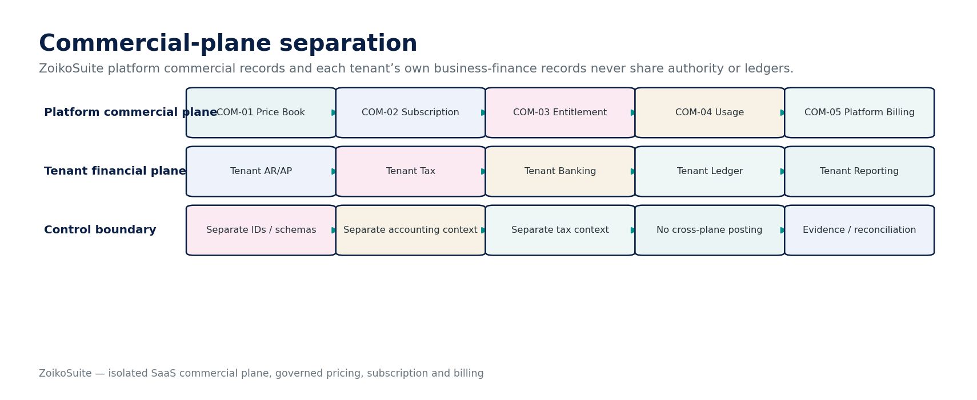
Figure 1 — Commercial plane separation.

1. Scope, Canonical Services & Non-Scope
ID | Service | Authoritative purpose
COM-01 | Product & Price Book | Maintain ZoikoSuite plans, prices, add-ons and effective-dated commercial terms.
COM-02 | Subscription | Maintain tenant subscription lifecycle and accepted commercial configuration.
COM-03 | Entitlement | Determine runtime platform feature access, limits and commercial capability exposure.
COM-04 | Usage Metering | Measure and certify billable ZoikoSuite platform usage under registered meter definitions.
COM-05 | Platform Commercial Billing | Rate, invoice, collect, correct and reconcile ZoikoSuite charges to tenants.

Explicit non-scope
- Tenant customer invoicing/AR, supplier AP, tenant tax, tenant banking and tenant GL are outside this commercial plane.
- Marketplace seller payouts, telecom BSS settlement, app-store revenue share and reseller settlement require separate adapters/contracts if introduced.
- Legal interpretation of customer contracts, tax nexus, revenue recognition and card-scheme compliance remain subject to approved professional/legal/accounting review.
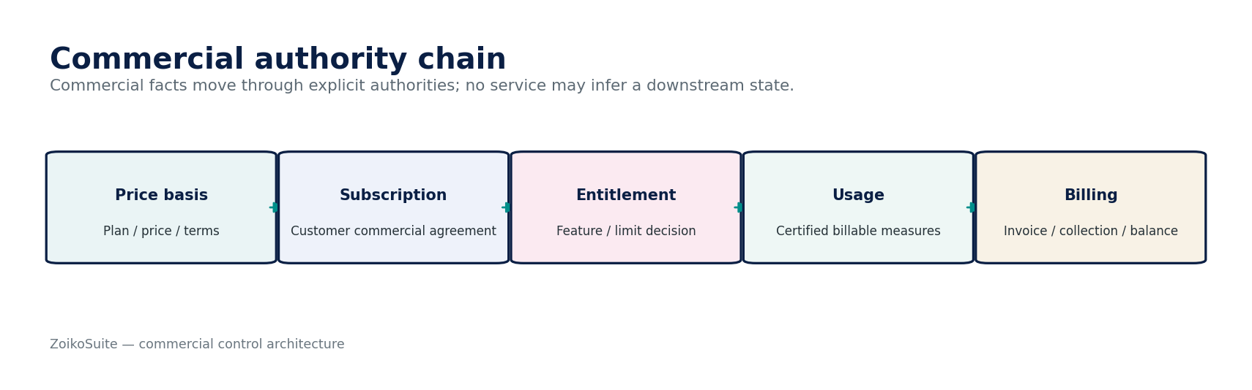
Figure 2 — Commercial authority chain.

2. Non-Bypassable Commercial Invariants
- No tenant-business invoice, payment or GL entry may change ZoikoSuite subscription state.
- No ZoikoSuite platform invoice may post into a tenant legal entity/book/ledger.
- Every subscription references an immutable ProductPriceVersion and accepted commercial terms.
- Published prices cannot be edited in place; corrections create new versions.
- No client-supplied plan, price, entitlement, tax rate, discount or usage quantity is authoritative without server validation.
- Runtime access decisions come from COM-03 using server-resolved tenant/product context.
- Entitlement snapshots are versioned/effective-dated and can be reconstructed as-of a prior time.
- Commercial feature access cannot exceed the effective subscription/add-on/grace-policy result.
- Usage is billable only under an active MeterDefinition and accepted source contract.
- Every billable usage event has a stable event/deduplication identity.
- Replayed usage cannot produce duplicate billable quantity.
- Late usage after invoice cutoff cannot rewrite the closed invoice population.
- Billing cutoff populations are frozen with watermark/count/control totals and evidence.
- Every invoice line traces to subscription/usage/price/discount/tax basis.
- Commercial discounts and credits require explicit authority and evidence.
- Platform merchant tax uses ZoikoSuite seller context, never tenant tax configuration.
- Payment attempts are durable and idempotent before external side effects.
- Processor timeout or missing callback is Pending/Unknown until resolved.
- No blind retry is permitted for an unresolved original payment attempt.
- Paid/settled state requires authoritative provider/bank evidence, not checkout completion.
- Chargeback/dispute/refund states remain distinct from invoice issuance and entitlement state.
- Payment delinquency affects entitlement only through versioned grace/restriction policy.
- Customer data retention/destruction is governed by data policy, not by a billing-state shortcut.
- Platform accounting events use ZoikoSuite seller accounting context only.
- AI cannot autonomously set price, grant free access, change usage, issue credit/refund, or override commercial controls.

3. Shared Commercial Context, State & Error Contract
Field | Required behavior
Commercial context | tenant_id, customer_account_id, product_id, subscription_id/version, selling_entity_id, billing_currency, locale, merchant/tax profile, request/effective time.
Price context | product_price_version_id, price component, billing interval, currency, quantity/seat basis, discount policy, trial policy, tax behavior.
Usage context | meter_definition_id/version, source_event_id, event_time, observed_at, quantity, dimensions, dedup key, source provenance.
Billing context | billing_period, usage cutoff/watermark, subscription versions in force, invoice candidate ID, tax result IDs, payment attempt IDs.
Concurrency | Expected version / ETag for mutable commercial aggregates; approval fingerprints invalidate on protected-field mutation.
Idempotency | Required for subscription changes, usage ingestion, invoice issue, payment collection, credits/refunds and external callbacks.
Errors | Stable codes: INVALID_COMMERCIAL_CONTEXT, PRICE_VERSION_INACTIVE, ENTITLEMENT_DENIED, METER_NOT_REGISTERED, DUPLICATE_USAGE, BILLING_POPULATION_CHANGED, PAYMENT_OUTCOME_UNKNOWN, CROSS_PLANE_ACCESS_DENIED.
Evidence | Actor/workload, tenant/customer scope, before/after versions, reason/approval, rule/policy versions, source IDs, provider refs, timestamps and hashes.
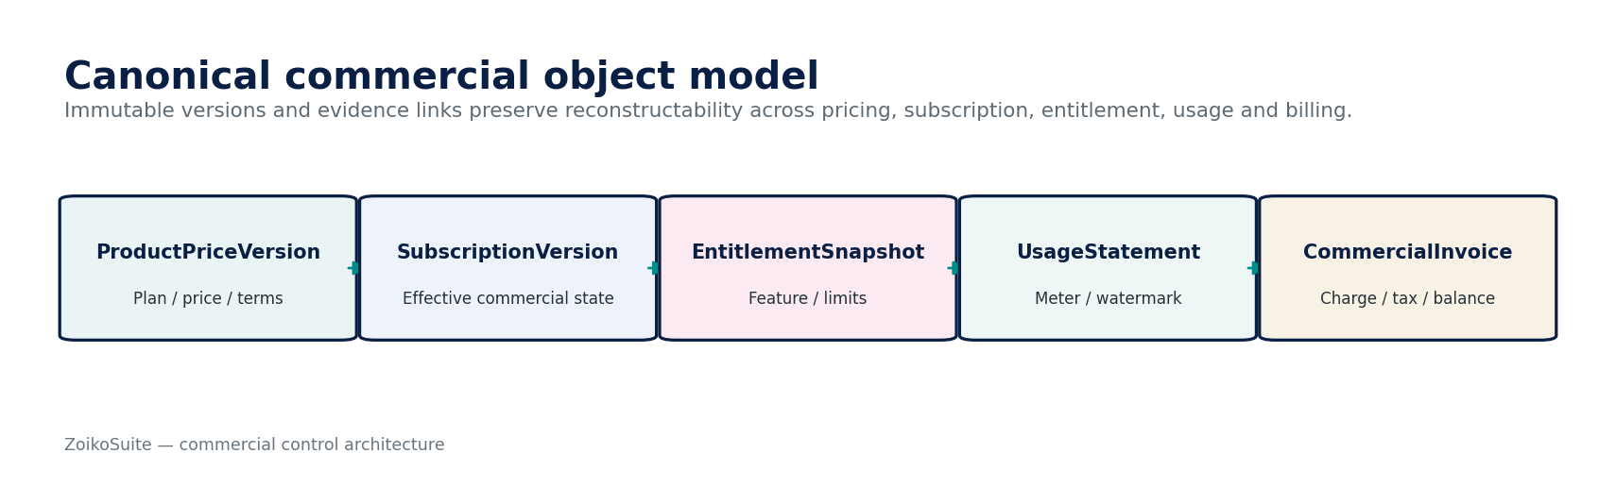
Figure 3 — Canonical commercial object model.

4. Detailed Service Specifications — COM-01 through COM-05
Each service below satisfies the master 52-field service contract through grouped implementation fields for readability. The grouping does not reduce any mandatory requirement from ZS-SVC-SPEC-001.

4.1 COM-01 — Product & Price Book
Contract field | Build-ready requirement
Purpose | Authoritative catalogue of ZoikoSuite products, plans, add-ons, prices, billing intervals, included quotas, overage rules, commercial terms and effective dates.
Owns | Product, Plan, PriceComponent, ProductPriceVersion, AddOn, DiscountPolicy, TrialPolicy, CommercialTermVersion, MeterBinding.
Must not own | Tenant subscription state, runtime entitlement decision, usage quantity, tax result, payment settlement, tenant product catalog or tenant financial records.
Required inputs | Product strategy approval, currency, billing interval, pricing unit, included quantity, overage bands, trial/discount policy, effective dates, market/jurisdiction availability.
Server-resolved context | Selling entity, currency eligibility, jurisdiction/market availability, commercial approval policy, entitlement feature identifiers, meter identifiers.
Commands | CreateDraftVersion; AddPriceComponent; SetCommercialTerms; SubmitForApproval; ApprovePriceVersion; PublishPriceVersion; RetirePriceVersion; CreateMigrationOffer.
Queries | GetPublishedProducts; GetPriceVersion; ResolveSellableOffer; CompareVersions; GetPriceHistory; GetPlanCapabilities.
State | Draft → Review → Approved → Published → Retired. Published versions immutable; retirement blocks new sales but preserves existing subscriptions/history.
Authorization/SoD | Product/Commercial may propose; Finance approves monetary terms; Legal/Tax review where required; publisher cannot self-approve material price changes.
Events | ProductPriceVersionCreated/Approved/Published/Retired; CommercialTermsChanged; MeterBindingChanged; MigrationOfferPublished.
Failure semantics | Missing price currency/unit/term version blocks publication. Existing subscriptions never silently switch because a newer price is published.
Evidence/NFR | Version manifest, approvers, change reason, effective dates, exact price matrix, hash, 99.95% read availability target; publication is low-frequency/high-integrity.
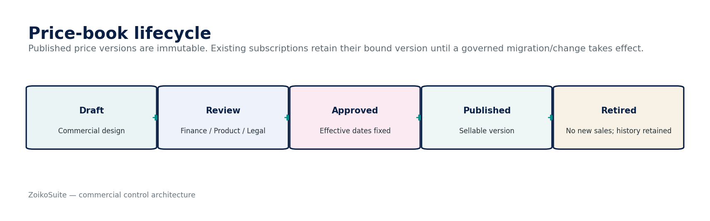
Figure 4 — Product & Price Book control flow.

Price component model
Component | Required attributes | Control
Recurring fixed | amount, currency, interval, billing-in-advance/arrears | Bound to immutable price version.
Per-unit / seat | unit, tier, minimum, included quantity, rounding | Quantity source and effective date must be explicit.
Metered usage | meter ID/version, aggregation method, included quota, overage bands | COM-04 certified usage only.
One-time | amount, trigger, eligibility, expiration | Explicit trigger/evidence; no hidden recurring conversion.
Discount/credit | type, value/cap, duration, eligibility, approval | Never embedded as mutable invoice-line override.
Trial | duration, entitlement scope, conversion/cancellation behavior | Defined by product policy; no undocumented auto-convert behavior.

4.2 COM-02 — Subscription
Contract field | Build-ready requirement
Purpose | Authoritative lifecycle and effective-dated commercial agreement between a ZoikoSuite customer account/tenant and a published product/price configuration.
Owns | Subscription, SubscriptionVersion, SubscriptionItem, RenewalTerm, CancellationInstruction, CommercialChangeRequest, TrialInstance where applicable.
Must not own | Feature authorization, billable usage, payment finality, tax amount, platform GL, tenant business billing.
Required inputs | Customer/tenant account, published offer/version, quantity/seat basis, add-ons, billing cadence, start date, accepted terms, trial/payment policy where applicable.
Server-resolved context | Sellable offer, customer market, merchant entity, entitlement features, commercial policy, minimum/maximum quantities, allowed transition rules.
Commands | StartSubscription; ActivateSubscription; RequestPlanChange; ScheduleDowngrade; Add/RemoveAddOn; ChangeQuantity; Renew; ScheduleCancellation; CancelNowWhenPermitted; Reactivate.
Queries | GetSubscription; GetEffectiveVersion; GetChangeHistory; PreviewPlanChange; GetRenewalState.
State | Lifecycle: Draft/Trialing/Pending/Active/CancelPending/Canceled/Expired. Billing health and provisioning health are separate dimensions.
Authorization/SoD | Customer admin or authorized sales/support paths; assisted changes require operator identity and customer basis; credits/free extensions require commercial authority.
Events | SubscriptionStarted/Activated/Changed/Renewed/CancellationScheduled/Canceled/Expired; QuantityChanged; AddOnChanged.
Failure semantics | Plan change is atomic with effective time. Partial update is prohibited. Changed protected terms after approval invalidate approval.
Evidence/NFR | Before/after subscription versions, accepted terms, actor/channel, effective time, proration policy and resulting commercial change ID.
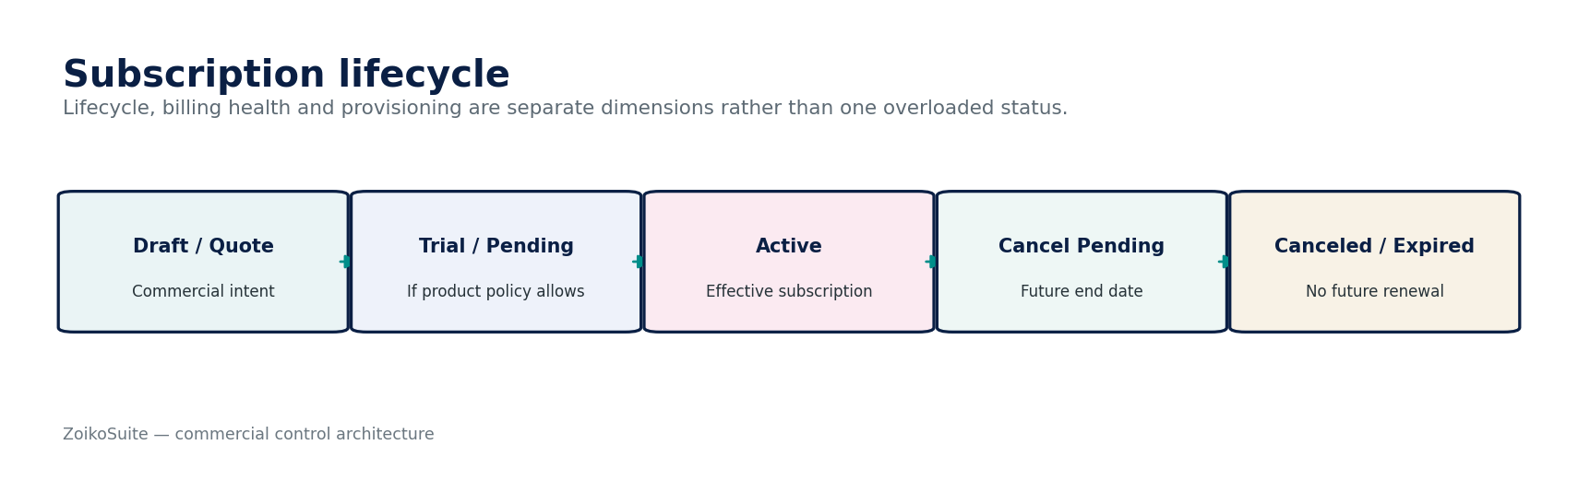
Figure 5 — Subscription control flow.
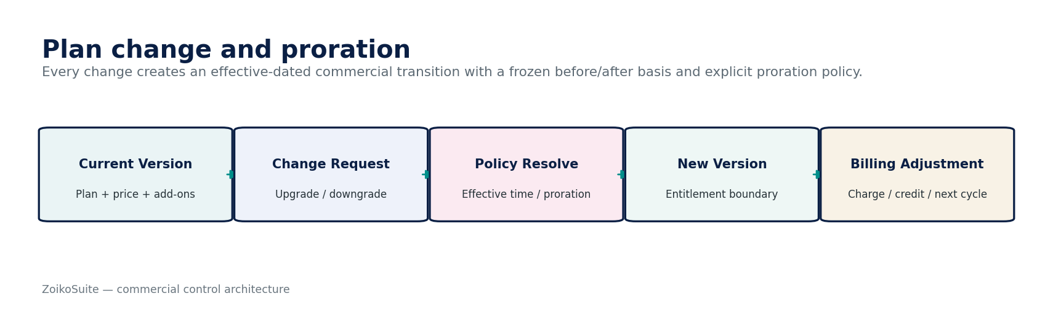
Figure 6 — Subscription change and proration control.

Plan transition rules
- Server time determines the effective boundary; client-device time never controls access or billing.
- Upgrade/downgrade treatment (immediate, next renewal, or contract date) is product policy and must be disclosed before confirmation.
- Proration uses the original and new immutable price versions and a documented proration convention.
- Transition must atomically update the subscription version and invalidate/recompute dependent entitlement state.
- Grandfathering is explicit through retained price versions; publishing a new public price never silently reprices existing customers.

4.3 COM-03 — Entitlement
Contract field | Build-ready requirement
Purpose | Authoritative runtime decision for whether a tenant/user/workspace may use a commercial capability and at what limit under the effective subscription.
Owns | EntitlementPolicyBinding, EntitlementSnapshot, LimitDecision, RestrictionDecision, GracePolicyOutcome, CommercialCapabilityExposure.
Must not own | IAM permission, domain authorization, product price, subscription agreement, business data, usage invoice, payment settlement.
Required inputs | tenant/customer context, product/capability, effective subscription version, add-ons, usage/quota state, commercial grace/restriction policy.
Server-resolved context | Feature registry, subscription effective time, plan capability matrix, tenant commercial standing, applicable limit policy, environment.
Commands | RecomputeEntitlements; ApplyCommercialRestriction; RemoveRestriction; CreateSnapshot. Runtime access is generally query/decision based.
Queries | EvaluateCapability; GetEffectiveEntitlements; GetLimit; ExplainDecision; GetEntitlementHistory.
State | Decision outcome: Allow/Deny/AllowWithLimit/ReadOnly/Restricted. Snapshot version changes only through effective subscription/policy/usage state.
Authorization/SoD | Commercial entitlement answers do not grant IAM permission. Final protected action still requires GOV authorization and domain invariants.
Events | EntitlementSnapshotChanged; CapabilityGranted/Restricted/Revoked; LimitChanged; GracePeriodStarted/Ended.
Failure semantics | Fail closed for paid-only capability escalation; safe cached last-known decision may be used only within approved freshness window for non-irreversible access.
Evidence/NFR | Decision input versions, policy version, reason code, source subscription version, usage snapshot ID, target p95 decision latency and cache revocation SLA defined per capability.
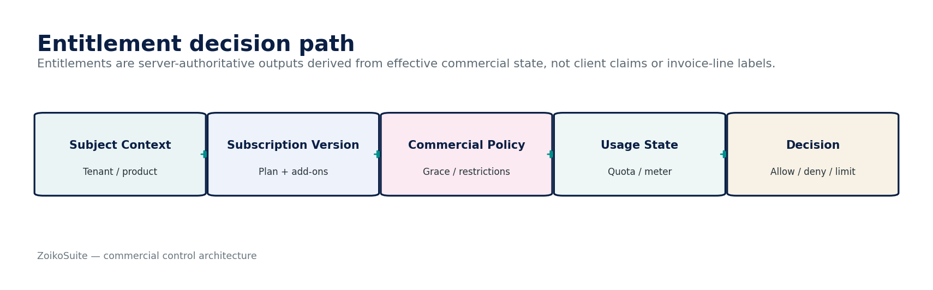
Figure 7 — Entitlement control flow.
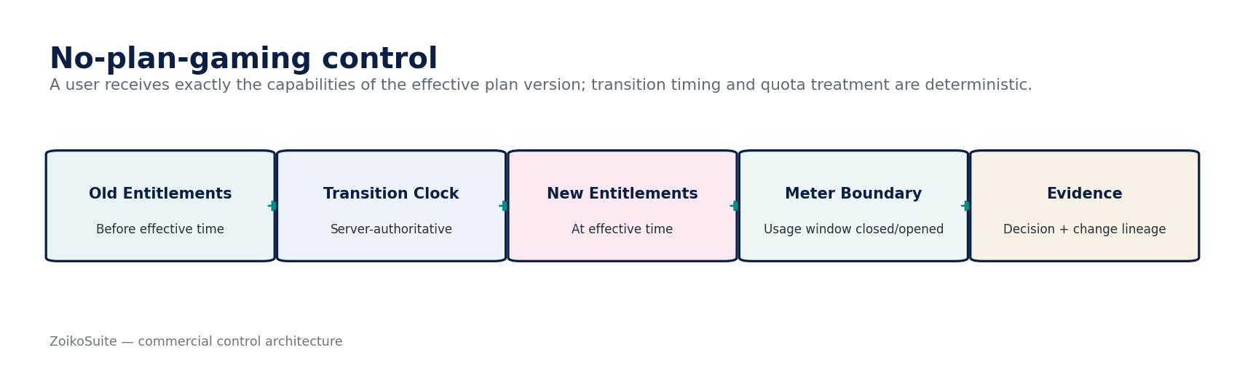
Figure 8 — No-plan-gaming control.

Commercial vs authorization decision
Layer | Question | Authority
Commercial entitlement | Is this feature/limit included in the customer’s effective commercial package? | COM-03
Identity/permission | May this subject use the feature for this tenant/entity/resource? | GOV-03 / GOV-04
Domain invariant | Is the requested business action valid in current state? | Owning domain
Feature exposure | Should capability be visible/rolled out in this environment/market? | GOV-11 Feature Policy

4.4 COM-04 — Usage Metering
Contract field | Build-ready requirement
Purpose | Authoritative measurement and certification of billable ZoikoSuite platform usage under registered meter definitions.
Owns | MeterDefinition, UsageEventRecord, UsageAggregation, UsageStatement, UsageAdjustment, MeterWatermark.
Must not own | Source business event, product price, subscription, invoice, entitlement policy, arbitrary analytics metrics.
Required inputs | Registered source event, event identity/time, tenant, metric, quantity, dimensions, meter definition/version, provenance.
Server-resolved context | Subscription/meter binding, unit normalization, billable filters, window/cycle, allowed dimensions, late-event policy, dedup scope.
Commands | RegisterUsageEvent; CorrectUsageEvent; CloseUsageWindow; CertifyUsageStatement; CreateUsageAdjustment; ReopenWindow only under controlled exception.
Queries | GetUsage; GetUsageStatement; GetMeterDefinition; ExplainAggregation; GetLateEvents; GetDedupStatus.
State | Usage event: Accepted/Rejected/Duplicate/Quarantined/Corrected. Statement: Open/Frozen/Certified/Adjusted/Superseded.
Authorization/SoD | Only approved workloads/providers may emit billable source events. Commercial operators cannot fabricate usage manually without controlled adjustment evidence.
Events | UsageAccepted/Duplicate/Quarantined; UsageWindowFrozen; UsageStatementCertified; UsageAdjustmentCreated.
Failure semantics | At-least-once intake with dedup. Negative/invalid quantities quarantine. Late events after certified cutoff create adjustment, not mutation.
Evidence/NFR | Source IDs/hashes, meter version, counts/totals, watermark, aggregation version, adjustment links; high-throughput horizontally scalable ingestion with deterministic replay.
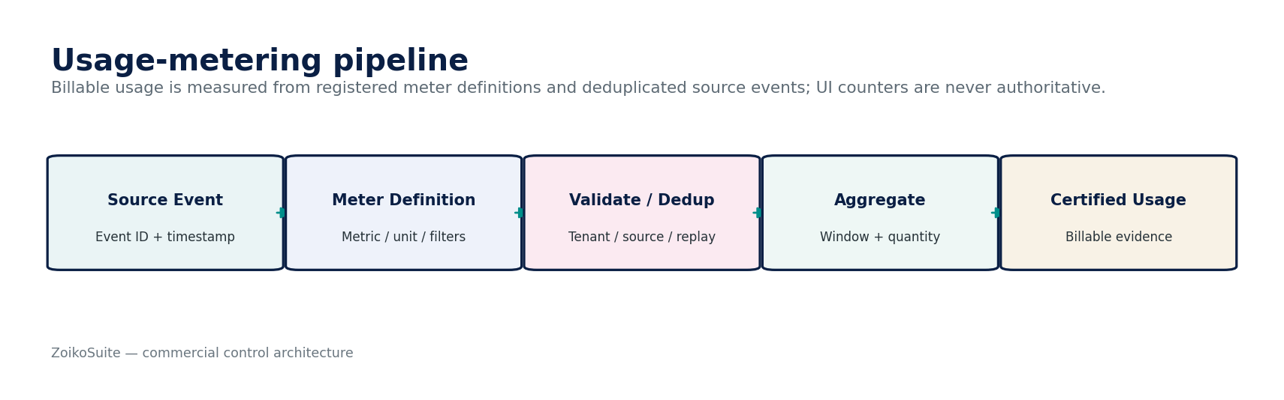
Figure 9 — Usage Metering control flow.
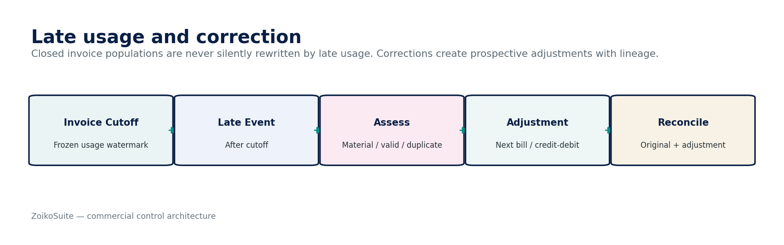
Figure 10 — Late usage and prospective correction.

Usage certification assertions
- Completeness: every eligible source event in the frozen interval was considered.
- Uniqueness: replay or duplicate events cannot increase billed quantity.
- Validity: only registered sources and meter-compatible quantities are accepted.
- Cutoff: event time and observation time are both retained; late events follow explicit policy.
- Aggregation: formula, tiering and dimensional grouping are versioned and reproducible.
- Reconciliation: raw accepted events → aggregation → certified usage statement totals are reconcilable.

4.5 COM-05 — Platform Commercial Billing
Contract field | Build-ready requirement
Purpose | Authoritative ZoikoSuite SaaS charge, invoice, collection, outstanding balance, credit/refund, dunning and commercial reconciliation for the platform seller plane.
Owns | BillingAccount, InvoiceCandidate, PlatformCommercialInvoice, InvoiceLine, CreditNote, PaymentAttemptRef, CollectionState, OutstandingBalance, DunningCase, CommercialReconciliation.
Must not own | Tenant AR/GL/tax/bank records, subscription feature decision, raw card credentials/PAN, tax rule logic, bank/provider settlement truth.
Required inputs | Subscription versions, certified usage statements, price/rating versions, authorized discounts/credits, merchant tax result, billing period/cutoff, customer billing profile.
Server-resolved context | ZoikoSuite selling entity, merchant/tax profile, billing currency, invoice numbering profile, payment provider, dunning/grace policy, accounting-event mapping.
Commands | GenerateInvoiceCandidate; ApproveInvoice; IssueInvoice; CollectPayment; RecordProviderOutcome; IssueCreditNote; RequestRefund; ApplyWriteOff; Start/StopDunning; ReconcileCommercialAccount.
Queries | GetInvoice; GetBalance; GetInvoiceBasis; GetPaymentAttempts; GetDunningState; GetCommercialReconciliation.
State | Invoice lifecycle, collection state, dispute/chargeback state and entitlement-impact state remain orthogonal. Payment attempt: Created/Submitted/PendingUnknown/Succeeded/Failed/Voided.
Authorization/SoD | Invoice issue may be automated only from certified basis. Manual credits/refunds/write-offs require delegated authority; refund destination changes invalidate approval.
Events | PlatformInvoiceIssued; PaymentAttemptCreated/OutcomeResolved; PlatformPaymentSettled; CreditNoteIssued; RefundRequested/Settled; DunningStarted/Ended; CommercialAccountReconciled.
Failure semantics | No blind processor retry. Closed invoice immutable; correction through credit/debit/adjustment. Platform billing outage must not corrupt tenant business data.
Evidence/NFR | Frozen invoice population, line-level basis, tax result, provider references, reconciliation to seller accounting; provider tokenization to minimize PCI scope; billing cutoffs and recovery SLOs defined before go-live.
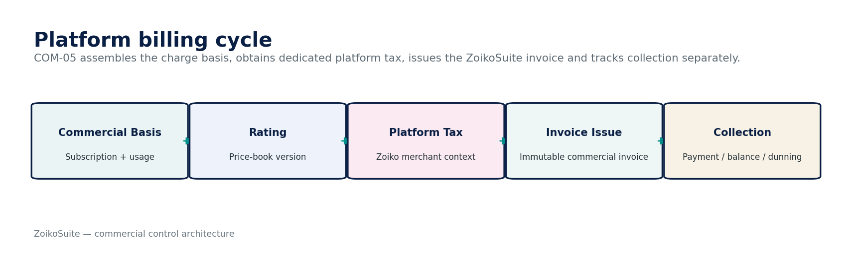
Figure 11 — Platform Commercial Billing control flow.
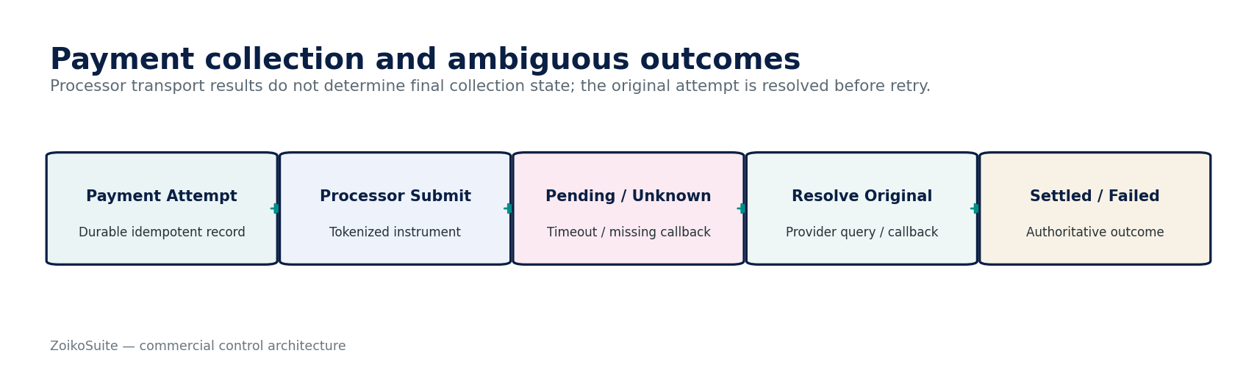
Figure 12 — Payment collection with Pending/Unknown state.
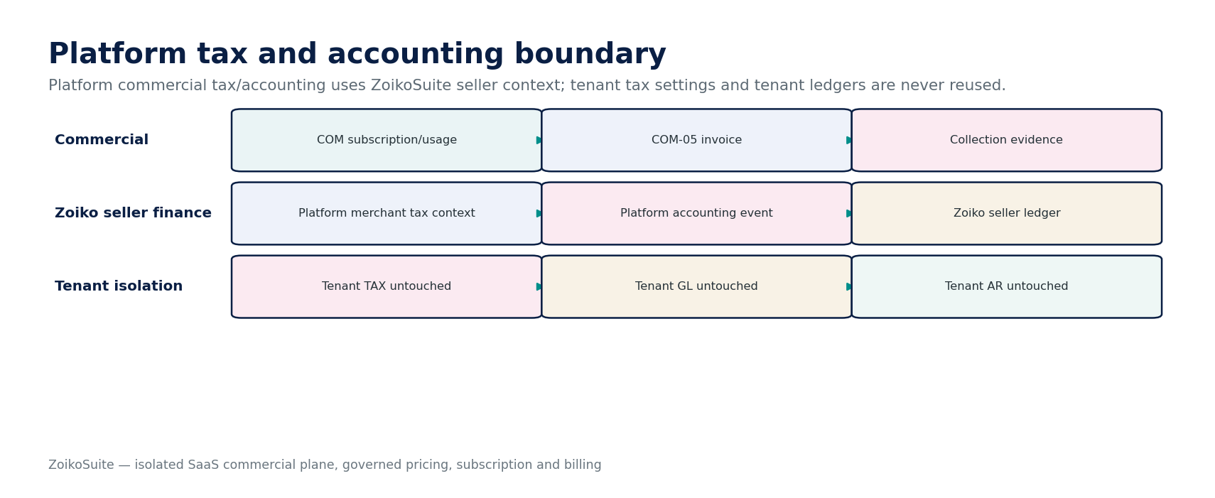
Figure 13 — Platform tax and accounting boundary.

5. Charge Basis, Rating, Invoice & Correction Doctrine
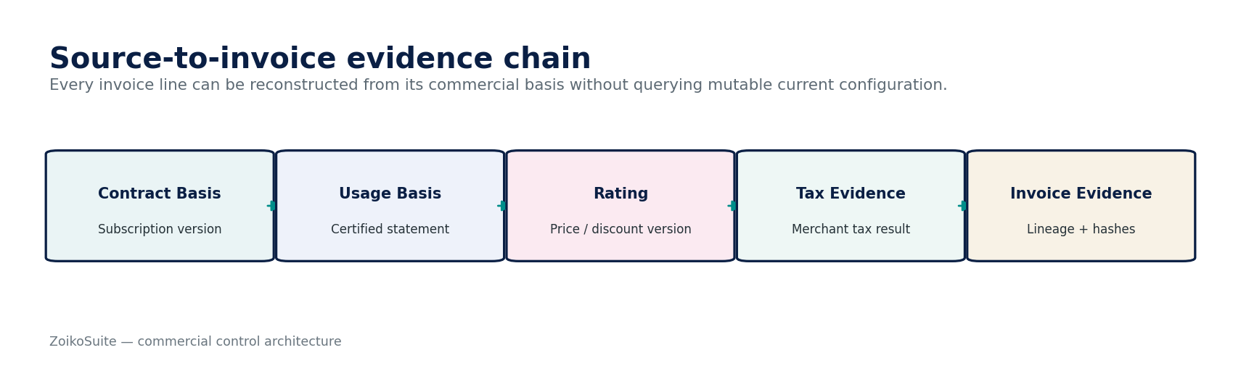
Figure 14 — Source-to-invoice evidence chain.
Stage | Authoritative input | Output / invariant
Commercial basis | Effective SubscriptionVersion + ProductPriceVersion | Exact accepted recurring/seat/add-on basis.
Usage basis | Certified UsageStatement(s) | Frozen quantity by meter/window; no dashboard counter.
Rating | Price component + quantity + discount policy versions | Deterministic line amount and rating evidence.
Tax | Dedicated ZoikoSuite merchant tax context/result | Tax jurisdiction/rate/result evidence; tenant tax config excluded.
Invoice issue | Approved invoice candidate + legal numbering profile | Immutable PlatformCommercialInvoice.
Collection | Durable provider attempt + tokenized instrument | Pending/Unknown/Succeeded/Failed outcome.
Correction | Original invoice + approved reason/basis | Credit/debit/adjustment; original never overwritten.
Reconciliation | Invoice/payment/balance + seller accounting | Commercial account certified or exception created.

6. Orthogonal Commercial State Model
Dimension | Illustrative states | Rule
Subscription lifecycle | Draft, Trialing, Pending, Active, CancelPending, Canceled, Expired | Commercial agreement state only.
Billing health | Current, PaymentPending, PastDue, Collections, WrittenOff | Does not itself determine runtime access.
Entitlement | Allow, AllowWithLimit, ReadOnly, Restricted, Deny | Computed by COM-03 from effective commercial policy.
Usage statement | Open, Frozen, Certified, Adjusted, Superseded | Certified population is immutable.
Invoice lifecycle | DraftCandidate, Approved, Issued, Corrected, VoidedIfLegallyPermitted | Issued invoice immutable.
Payment attempt | Created, Submitted, PendingUnknown, Succeeded, Failed, Voided | Provider ambiguity explicit.
Dispute/chargeback | None, Open, Won, Lost, Resolved | Independent from invoice issuance.
Dunning | None, Notice1, Notice2, Restricted, Suspended, Closed | Versioned commercial policy; does not delete data.

7. Canonical Commercial Data Model & Isolation
Canonical entity | Purpose
Product | Sellable ZoikoSuite product identity.
ProductPriceVersion | Immutable price/term version.
PriceComponent | Recurring/unit/metered/one-time component.
DiscountPolicy | Versioned discount eligibility/amount rules.
TrialPolicy | Versioned trial/access/conversion rules.
Subscription | Stable customer subscription identity.
SubscriptionVersion | Effective-dated plan/items/quantity/terms.
EntitlementSnapshot | Server-authoritative capability/limit state.
MeterDefinition | Registered billable metric contract.
UsageEventRecord | Deduplicated source usage event.
UsageStatement | Frozen/certified aggregated billing population.
BillingAccount | ZoikoSuite customer-commercial account.
InvoiceCandidate | Pre-issue rated/taxed candidate.
PlatformCommercialInvoice | Immutable issued ZoikoSuite invoice.
CreditNote | Controlled correction/credit document.
PaymentAttemptRef | Durable provider-attempt identity/outcome.
OutstandingBalance | Derived platform commercial balance.
DunningCase | Collections/restriction workflow.
CommercialReconciliation | Invoice/payment/balance/accounting control run.
CommercialEvidencePackage | Immutable manifest/source lineage package.

Isolation invariant — Commercial-plane entities use dedicated commercial identifiers, storage/schema boundaries, seller accounting context and merchant tax configuration. A tenant’s business invoice_id, customer_id or ledger_id is never accepted as a PlatformCommercialInvoice, BillingAccount or seller accounting identifier merely because the value is syntactically valid.

8. Canonical Commercial Control Catalogue
Control ID | Mandatory control
COM-CTRL-001 | Platform-vs-tenant financial-plane isolation
COM-CTRL-002 | Published price-version immutability
COM-CTRL-003 | Existing-subscription price binding
COM-CTRL-004 | Material price-change maker-checker
COM-CTRL-005 | Discount/credit delegated authority
COM-CTRL-006 | Trial-policy disclosure/versioning
COM-CTRL-007 | Subscription effective-time integrity
COM-CTRL-008 | Plan-change atomicity
COM-CTRL-009 | Proration reproducibility
COM-CTRL-010 | Entitlement server authority
COM-CTRL-011 | Entitlement/IAM separation
COM-CTRL-012 | Grace/restriction policy versioning
COM-CTRL-013 | Meter-definition registration
COM-CTRL-014 | Usage-event deduplication
COM-CTRL-015 | Usage-source authorization
COM-CTRL-016 | Usage cutoff/watermark freeze
COM-CTRL-017 | Late-usage prospective adjustment
COM-CTRL-018 | Usage statement reconciliation
COM-CTRL-019 | Invoice line-to-basis lineage
COM-CTRL-020 | Dedicated seller tax context
COM-CTRL-021 | Invoice numbering/sealing
COM-CTRL-022 | Issued-invoice immutability
COM-CTRL-023 | Durable payment attempt before submit
COM-CTRL-024 | Pending/Unknown external-state preservation
COM-CTRL-025 | Payment callback authenticity/replay protection
COM-CTRL-026 | No blind payment retry
COM-CTRL-027 | Settlement evidence before paid state
COM-CTRL-028 | Refund destination fingerprint
COM-CTRL-029 | Chargeback/dispute separation
COM-CTRL-030 | Dunning-entitlement policy boundary
COM-CTRL-031 | No billing-state-driven data deletion
COM-CTRL-032 | Commercial invoice/payment reconciliation
COM-CTRL-033 | Seller accounting-event isolation
COM-CTRL-034 | Cardholder-data minimization/tokenization
COM-CTRL-035 | Commercial support privileged-action evidence
COM-CTRL-036 | Commercial AI authority prohibition

9. Negative-Path Engineering Certification
# | Scenario | Required result
01 | Tenant AR invoice ID submitted to COM-05 as platform invoice | Reject cross-plane identity; no mutation.
02 | Platform invoice attempts posting into tenant ledger | Block and raise security/control exception.
03 | Operator edits published monthly price in place | Reject; new ProductPriceVersion required.
04 | New price published while existing subscriptions reference old price | Existing subscription remains unchanged until governed migration/change.
05 | Client sends cheaper price_id than server-resolved offer | Ignore/reject client price claim; resolve sellable server offer.
06 | Sales user approves own material discount | SoD denial.
07 | Trial end changed after customer acceptance without policy/version | Reject or require new accepted commercial change.
08 | Plan upgrade applies entitlements before effective timestamp | Deny until server-effective time.
09 | Downgrade scheduled but high-tier feature remains usable after effective time | COM-03 revokes/limits at boundary; stale cache invalidated.
10 | Client claims entitlement=true directly | Ignore; COM-03 authoritative evaluation required.
11 | Entitlement says allow but IAM denies user permission | Protected action denied by IAM/domain.
12 | Payment current but subscription canceled | No entitlement from payment status alone.
13 | Payment past due but grace policy allows read-only | Return policy-defined restricted entitlement, not arbitrary shutdown.
14 | Analytics metric emitted without MeterDefinition | Not billable; reject/quarantine.
15 | Same usage event delivered twice | Second event deduplicated; billed quantity unchanged.
16 | Usage event has negative quantity where meter disallows it | Quarantine/reject.
17 | Usage event from unauthorized workload | Reject and security alert.
18 | Late usage arrives after certified invoice cutoff | Create prospective adjustment; original invoice population unchanged.
19 | Operator edits certified UsageStatement total manually | Reject; correction via UsageAdjustment.
20 | Rating uses current price instead of subscription-bound price version | Fail billing candidate.
21 | Invoice tax calculation reads tenant TAX configuration | Block cross-plane tax context.
22 | Tax result changes after invoice approval | Invalidate candidate approval and rerun tax/rating as required.
23 | Invoice issue called twice with same idempotency key | Return original invoice result; no duplicate invoice.
24 | Issued invoice line edited in database/UI | Reject; correction document required.
25 | Processor returns HTTP 200 for payment intent but settlement unknown | Do not mark invoice paid.
26 | Processor request times out | PaymentAttempt becomes Pending/Unknown.
27 | System retries unresolved timed-out charge as new attempt | Block until original attempt resolved.
28 | Duplicate processor callback received | Deduplicate; no duplicate settlement effect.
29 | Out-of-order failed callback arrives after settled outcome | Ordering/finality rules prevent regression.
30 | Raw card PAN submitted to ordinary application log | Redact/block; incident if exposed.
31 | Refund destination changed after approval | Invalidate approval; reapprove protected subject.
32 | Chargeback opened on paid invoice | Preserve paid collection history and separate dispute state.
33 | Customer writes off platform balance via client API without authority | Deny; delegated commercial/finance approval required.
34 | Dunning policy changes mid-case | Case retains/apply policy version per governed effective rules; no silent retroactive mutation.
35 | Subscription canceled and system immediately deletes tenant accounting records | Block; retention/data policy governs data lifecycle.
36 | COM-05 outage occurs during tenant invoicing operations | Tenant business billing remains operational/isolated according to its own dependencies.
37 | Usage service replays source events after disaster recovery | Dedup/inbox identity prevents rebilling.
38 | Price migration offered to subset but eligibility rule missing | Block migration publication/execution.
39 | Commercial support grants paid feature manually outside COM-03 | Reject/bypass detection; use governed subscription/entitlement path.
40 | AI assistant offers unauthorized permanent discount | No effect; AI lacks command authority.
41 | AI creates refund because user complained | No effect; refund requires governed command/approval.
42 | Invoice population does not reconcile to subscription + usage basis | Block issue/certification and open exception.
43 | Payment settlements do not reconcile to commercial balance | Open reconciliation exception; do not hide difference.
44 | Seller accounting event references tenant accounting book | Block cross-plane accounting context.
45 | Historical invoice requested after price/plan retired | Render from bound historical versions/evidence.
46 | Currency amount uses floating-point arithmetic | Fail validation; fixed-precision decimal required.
47 | Current UI plan names differ from historical invoice plan label | Historical invoice uses stored/bound display/version data.
48 | Provider changes token/status schema unexpectedly | Adapter contract validation/quarantine; no guessed settlement.

10. Canonical Commands, APIs & Events
Service | Illustrative command surface | Important query/event surface
COM-01 | POST /commercial/price-versions; .../{id}:approve; .../{id}:publish | GET sellable-offers; ProductPriceVersionPublished
COM-02 | POST /subscriptions; .../{id}:change-plan; ...:schedule-cancellation | GET effective-version; SubscriptionChanged
COM-03 | POST /entitlements:evaluate; ...:recompute | GET effective-entitlements; EntitlementSnapshotChanged
COM-04 | POST /usage-events; .../usage-statements:freeze; ...:certify | GET usage-statements; UsageStatementCertified
COM-05 | POST /platform-invoices:generate; ...:issue; .../payments:collect; ...:credit | GET invoice/balance/payment-attempt; PlatformInvoiceIssued / PlatformPaymentSettled
All command endpoints inherit ZS-API-001 requirements for idempotency, concurrency and RFC 9457-compatible problem responses. Event envelopes inherit ZS-EVENT-001 / CloudEvents-aligned metadata. Provider callbacks are routed through INT adapter verification and cannot directly mutate final business state.

11. Reconciliation, Observability & Operational Runbooks
Control population | Required reconciliation / probe
Price / subscription | Effective subscription items and quantities resolve to exactly one valid price basis.
Subscription / entitlement | Entitlement snapshots correspond to the effective subscription/add-ons/policy.
Usage source / statement | Accepted raw events reconcile to certified aggregate by meter/window.
Usage / invoice | All usage-based invoice lines reference certified usage statements.
Invoice / payment | Settlements, refunds, chargebacks and outstanding balance reconcile.
Invoice / seller accounting | Platform invoice/payment accounting events reconcile to ZoikoSuite seller ledger, never tenant ledger.
Commercial evidence | Invoice can be reconstructed from immutable commercial versions without querying mutable current configuration.

Minimum operational runbooks
- Price publication rollback/supersession
- Subscription change stuck between approval and effective time
- Entitlement cache inconsistency/revocation lag
- Usage backlog/dedup anomaly
- Late usage after billing cutoff
- Invoice generation or numbering failure
- Platform tax provider failure
- Payment processor timeout/PendingUnknown
- Duplicate or out-of-order payment callback
- Chargeback/refund reconciliation break
- Dunning/grace-policy incident
- Commercial-to-seller-accounting reconciliation break

12. Definition of Ready, Definition of Done & Implementation Sequence

Definition of Ready
- Approved product/price taxonomy and commercial identifiers.
- Selling legal entity/merchant configuration and dedicated platform tax context identified.
- Price, subscription, entitlement, meter and billing ownership approved.
- Payment provider tokenization and PCI scope decision documented.
- Trial, cancellation, upgrade/downgrade, proration, grace/dunning and refund policies approved.
- Meter definitions and source-event contracts approved before metered charging.
- Seller accounting mappings and commercial reconciliation controls defined.
- Required APIs/events/security/residency/retention rules mapped to preceding standards.

Definition of Done
- All COM service contracts implemented and contract-tested.
- Cross-plane tenant-finance isolation tests pass.
- Published price versions immutable and historical subscription reconstruction proven.
- Entitlement decision and revocation paths meet approved SLOs.
- Usage replay/dedup/late-event tests pass at expected peak scale.
- Invoice basis/tax/payment/accounting reconciliation passes with no material unexplained difference.
- Payment Pending/Unknown recovery and duplicate-callback tests pass.
- PCI scope/tokenization controls validated where card payments are enabled.
- All 48 negative-path scenarios and applicable ZS-QA-001 certification gates pass.
- Operational runbooks, dashboards and support privileged-action controls are production-ready.

Recommended implementation sequence
Wave | Build scope | Exit gate
1 | Commercial identifiers, dedicated seller-plane storage/isolation, ProductPriceVersion | No cross-plane IDs/writes; price versioning proven.
2 | Subscription lifecycle/versioning and transition policies | Historical reconstruction + atomic change tests.
3 | Entitlement engine and cache/revocation | No plan gaming; IAM/domain boundary tests pass.
4 | Meter registry, usage ingestion/dedup/aggregation | Replay + late-event certification passes.
5 | Invoice candidate/rating + platform tax context | Lineage and tax isolation proven.
6 | Invoice issue, provider collection, PendingUnknown resolution | Duplicate-payment and callback tests pass.
7 | Credits/refunds/dunning/reconciliation + seller accounting events | Commercial control suite passes.
8 | Scale/resilience/security/operations certification | ZS-QA/NFR/OPS release certificate approved.

13. Prohibited Commercial Anti-Patterns
- One shared billing table/ledger for ZoikoSuite platform subscriptions and tenant customer invoices.
- Mutable public price rows used directly by existing subscriptions.
- Feature access controlled only by frontend plan labels or client flags.
- Inferring paid access from processor checkout success rather than effective subscription/entitlement state.
- Using arbitrary analytics counters as billable usage.
- Rewriting closed invoices when late usage arrives.
- Blindly retrying an ambiguous card/bank charge.
- Storing raw PAN or sensitive authentication data merely for convenience.
- Using tenant tax configuration to calculate ZoikoSuite seller tax.
- Allowing support staff to grant paid features, discounts, credits or refunds outside governed commands.
- Deleting customer financial records simply because a subscription is canceled.
- Treating billing as equivalent to revenue recognition.
- Letting AI negotiate or execute binding price/credit/refund changes without governed authority.

14. Current External Standards & Accounting Boundary
Reference | Engineering relevance | Status / source
PCI DSS v4.0.1 | If payment-card data enters ZoikoSuite scope, cardholder-data handling, service-provider relationships and security controls must align to the current PCI DSS baseline. Architecture minimizes scope through provider tokenization/hosted collection. | PCI SSC Document Library lists PCI DSS v4.0.1 (published June 2024) as the current standard in 2026.
IFRS 15 — Revenue from Contracts with Customers | Commercial invoice/collection state is not revenue recognition. Seller accounting must apply approved revenue-recognition policy based on performance obligations and satisfaction of those obligations. | IFRS Foundation; effective since 1 Jan 2018.
ZS-SEC-001 / ZS-IAM-001 | Cryptography, secrets, privileged support, tenant isolation, service identity and authorization remain inherited platform controls. | Internal mandatory ZoikoSuite standards.
ZS-ACC-KERNEL-001 / ZS-CONTROL-001 | ZoikoSuite seller accounting consequences route through governed accounting events and reconciliations; COM never directly mutates a ledger. | Internal mandatory ZoikoSuite standards.
Official sources: PCI Security Standards Council — PCI DSS Document Library | IFRS Foundation — IFRS 15

